Chapter 3
Research Methodology

Overview
The chapter begins with information on the sources of data used to develop the NN and the CDA Models. The methodologies used to develop the models are discussed in the subsequent sections. The chapter continues with the procedures used to compare the results of the models and to conduct the energy savings scenarios.

Sources of Data
Two sources of data were used for the development of the input units of the NN and the CDA Models: the data from the 1993 Survey of Household Energy Use (SHEU) database (Statistics Canada, 1993), and the weather and ground temperature data for 1993 (Environment Canada, 1999). The source of data for the output unit of the models was the actual energy billing data obtained from fuel suppliers and utility companies for a set of households from the 1993 SHEU.
The 1993 SHEU was conducted by Statistics Canada on behalf of Natural Resources Canada, in cooperation with the provinces of Nova Scotia, New Brunswick, Ontario, Manitoba, Saskatchewan, and with SaskPower. SHEU was commissioned to enrich the residential sector data in Canada. The target population for this survey was composed of all the housing units in Canada (excluding Yukon and North Western Territories) occupied as primary residences, both owned and rented. It is based on a mail out survey that included 376 questions. The database includes detailed information on 8,767 single-family houses from all provinces of Canada, and representative of the Canadian housing sector.
The 1993 SHEU database contains detailed information on house construction, space heating/cooling and DHW heating equipment, household appliances, and socio-economic characteristics of the occupants for 8,767 households in Canada. The actual energy billing data exist for 2,749 households of the 1993 SHEU database. With the permission of the occupants, Statistics Canada obtained the complete year energy billing data of each one of these households from their fuel suppliers and utility companies.
The weather and ground temperature data for the cities where the 2,749 households are located were obtained from Environment Canada (1999). The weather data obtained includes the local mean daily temperatures (MDTs) of the households for the year 1993. The MDTs were used to calculate the heating degree days (HDD) and cooling degree days (CDD) for the locations.

NN Model
As stated previously, there are 2,749 households with energy billing data. However, only 1,067 of these households have complete energy billing data for all types of fuels and energy sources used by the households. The number of households that use electricity for DHW and space heating is 594 in the set of 1,067 households. Hence their electricity billing data account for DHW, space heating, appliance, lighting, and space cooling energy consumption. Thus, the electricity billing data of the remaining 473 households in the set of 1,067 households represents the appliance, lighting, and space cooling energy consumption, while the natural gas or oil billing data represent the DHW and space heating energy consumption. A set of 473 households is not sufficient to develop a single NN model with three output units each representing specific end-use (i.e. DHW heating, space heating, and appliance, lighting, and cooling). Therefore, the NN Model developed in this thesis consists of three networks. Each network is used to predict a single end-use energy consumption. These are:
- Space heating (SH) end-use energy consumption,
- Domestic hot water (DHW) heating end-use energy consumption,
- Appliances, and lighting, and cooling (ALC) end-use energy consumption.
The development of the networks is similar and pursues the steps shown in Figure 3.1 as described below.

Development of Network Datasets
The selection of households for each network dataset was based on fuel type and energy source information, and availability of energy billing data. Fuel type and energy source information was taken from the 1993 SHEU database, and the energy billing data were obtained from Statistics Canada. Statistics.
The ALC network dataset contains 988 households with electricity bills from the 1993 SHEU database, that do not have electrical SH or DHW heating equipment. In the ALC dataset, there are 355 households that own space cooling equipment; thus, the electricity usage of these 355 households represents space cooling, appliance, and lighting energy consumption. The electricity usage of the remaining 633 households represents appliance and lighting energy consumption.
.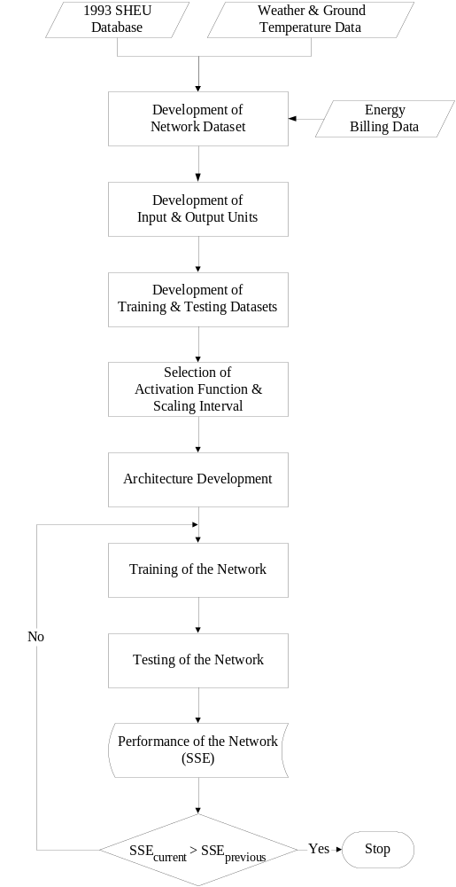
Figure 3.1. Flowchart diagram depicting the methodology used for the development of the NN Model
The number of households in the DHW dataset that use electricity or natural gas for DHW heating is 563. The dataset contains 388 households with electricity bills, and 175 with natural gas bills. Due to lack of data, households with oil bills could not be included to the DHW dataset, as explained in detail in Section 4.2.2.1.
The SH dataset contains 1,228 households with space heating billing data. There are 396 households with electricity billing data, 755 households with natural gas billing data, and 77 households with oil billing data for space heating, as explained in detail in Section 4.2.3.1.

Development of Input and Output Units
The input units of the networks describe:
- the construction details of the dwellings,
- the ownership, specifications, and usage of the space cooling equipment, appliances, and lighting,
- the specifications of the DHW and SH equipment,
- the socio-economic and behavioural characteristics of the occupants,
- the weather characteristics.
The number of input units is different for each network. Input units were selected based on their contribution to the specific end-use energy consumption. Since, the 1993 SHEU database has limited data on dwelling characteristics and heating equipment (for example, there is no detailed information on building envelope thermal characteristics), input units for these missing data were developed using information from other sources, such as HOT2000 users manual (NRCan, 1996), and studies conducted by Farahbakhsh (1997) and Farahbakhsh et al. (1997 and 1998). The actual energy consumption data for each household was used as the output (target) unit of the networks.

Development of the Testing and Training Datasets
The dataset of each network was divided into two sub-sets; one was used for the training of the networks and the other for the testing of the performance of the networks. As explained in Section 2.2.4, approximately, 70-80 percent of the dataset was used as the training set, and the remaining was used as the testing set. The households in each sub-set were selected randomly. However, special care was given to include the households with minimum and maximum input and output values into the training dataset. This is done to increase the estimation range of the NN Model.

Selection of the Activation Functions and Scaling Intervals
In this work, identity, logistic, and hyperbolic tangent functions were tested as the activation functions for the hidden and output layers. As it was pointed out in Section 2.2.3, these are the most commonly used activation functions for networks trained by backpropagation.
The training and testing datasets were scaled into the following intervals:
- [0.1 to 0.9]
- [-0.5 to 0.5]
- [0.0 to 1.0]
- [-1.0 to 1.0]
- [-0.9 to 0.9]
The following equations were used to scale the data into each interval:
- For the [0.1 to 0.9] interval:
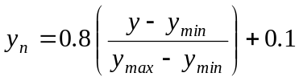 (3.1)

- For the [-0.5 to 0.5] interval:
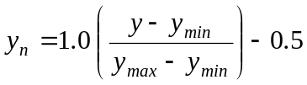 (3.2)
- For the [0.0 to 1.0] interval:
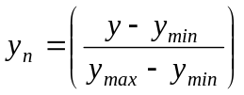 (3.3)
- For the [-1.0 to 1.0] interval:
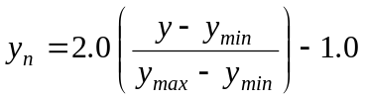 (3.4)
- For the [-0.9 to 0.9] interval:
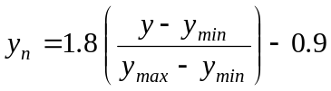 (3.5)
where,
y_{n}: value of the scaled input/output unit
y: value of the input/output unit
y_{min}: minimum value of the input/output unit
y_{max}: maximum value of the input/output unit
Another method used for scaling is the normalization of the input/output units by subtracting the mean and dividing by the standard deviation:
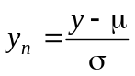 (3.6)
where,
μ: mean of the input/output unit
σ: standard deviation of the input/output unit
Two approaches are used in this work with respect to scaling:
- All of the data in the dataset were scaled into the intervals given above,
- Only continuous data in the dataset were scaled into the given intervals, and the discrete [0,1] data were left “as is”, without scaling.
With five scaling intervals to be compared, a total of 11 datasets were therefore generated:
- All data scaled to the [0.1 to 0.9] interval,
- Only continuous data scaled to the [0.1 to 0.9] interval,
- All data scaled to the [-0.5 to 0.5] interval,
- Only continuous data scaled to the [-0.5 to 0.5] interval,
- Only continuous data scaled to the [0.0 to 1.0] interval, since discrete data is already in the [0,1] range,
- All data scaled to the [-1.0 to 1.0] interval,
- Only continuous data scaled to the [-1.0 to 1.0] interval,
- All data scaled to the [-0.9 to 0.9] interval,
- Only continuous data scaled to the [-0.9 to 0.9] interval,
- All data normalized,
- Only continuous data normalized,
Identity, logistic, and hyperbolic tangent activation functions were used to develop eight networks with the configurations shown in Table 3.1. Each of the eight configurations given in Table 3.1 was tested for each of the eleven datasets that were scaled to different intervals.

Table 3.1. Network configurations tested
Network Name | Hidden Layer  Activation Function | Output Layer  Activation Function
Network-A | Logistic | Logistic
Network-B | Logistic | Hyperbolic Tangent
Network-C | Logistic | Identity
Network-D | Hyperbolic Tangent | Logistic
Network-E | Hyperbolic Tangent | Hyperbolic Tangent
Network-F | Hyperbolic Tangent | Identity
Network-G | Identity | Logistic
Network-H | Identity | Hyperbolic Tangent

Development of the Network Architecture
Since the number of input and output units are decided based on the available data and the desired output, respectively, only the number of units in the hidden layer(s) is left to be determined. Networks with the number of hidden layer units ranging from one to 30 or 40 were trained with each of the learning algorithm given in Section 2.2.3.1. The number of units in the hidden layer of the network and the learning algorithm resulting in the highest prediction performance was chosen as the network architecture for the NN Model.
After determining the number of hidden layer units and the learning algorithm resulting in the highest prediction performance, different networks with the number of hidden layer units in one, two or three layers were trained with the chosen learning algorithm to determine the best network architecture. The performance of the networks was improved by “fine-tuning” the parameters of the chosen learning algorithm given in Section 2.2.3.1. The “fine-tuning” is done by testing a wide range of values of the learning algorithm parameters.

Training of the Networks
The training of a NN is an iterative procedure, which follows the steps described below:
- Initialization of weights and biases:
All weights and biases are set to small random values between -1 and 1 (or some other suitable interval).
- Feedforward propagation:
Each input unit receives an input signal and sends the signal to all units in the hidden layer. Each hidden unit sums its weighted input signals with the bias contribution, applies its activation function to compute its output signal and sends this signal to the output unit. The output unit sums its weighted input signals with the bias contribution, and applies its activation function to compute the output of the network.
- Error calculation:
The output of the network, i.e. its prediction, and the output (target) parameter are used to compute the network error in terms of SSE. The error is used to compute the necessary changes of the weights and biases to minimize the error of the network.
- Backward propagation:
The weights and biases are adjusted in a way that minimizes the error. The learning algorithms used in this work are given in Section 2.2.3.1. The steps from (a) to (d) are repeated until the SSE of the testing dataset stops decreasing and starts to increase, which is an indication of overtraining.
Once the networks are complete, they are used to predict the end-use energy consumption of the households in the 1993 SHEU database that are not included in the training and the testing datasets.

Assessing the Prediction Performance of the NN Model
The prediction performance of the NN Model is assessed using SSE, R², RMS, and CV as explained in Section 2.2.5.

CDA Model
As stated in Section 3.3, there are 2,749 households with energy billing data. However, there are only 1,067 households with billing data for all types of fuels and energy sources used by the households. To develop a CDA model for estimating household energy consumption, a set of 1,067 households is not sufficient, especially when there is no metered data to be used for prior information.
There are 2,050 households with electricity billing data, 1,012 households with natural gas billing data, and 236 households with oil billing data. Thus, a CDA model is developed with three components. Each component of the model was used to disaggregate the energy consumption of the households with one type of energy billing data. These models are:
- Electricity model (EM),
- Natural gas model (NGM),
- Oil model (OM).
The process used in the development of the each component of the model is similar and pursues the steps shown in Figure 3.2, and described in the following sections.

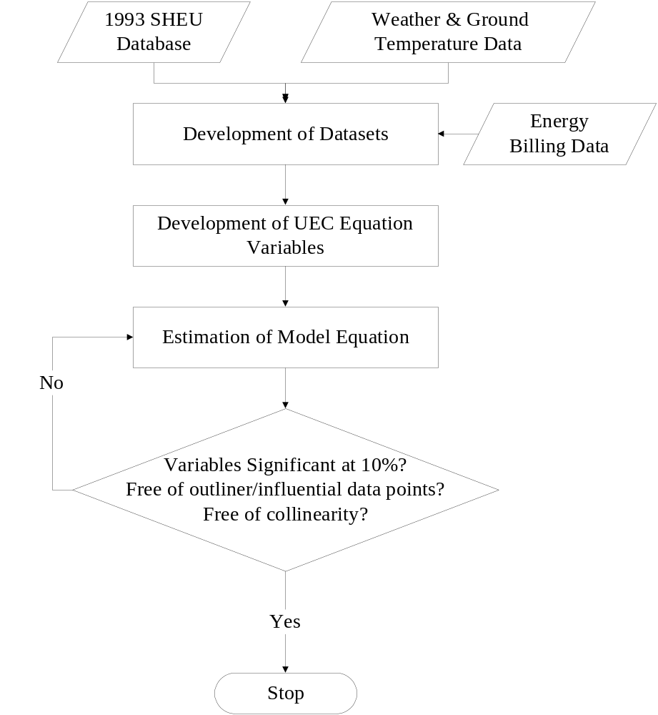
Figure 3.2. Flowchart diagram depicting the methodology used for the development of the CDA Model

Development of the Datasets
The households from the 1993 SHEU database with electricity, natural gas, or oil billing data were selected for the datasets of the CDA Model. Hence, the dataset of the Electricity CDA Model includes the households with electricity billing data, while the datasets of the natural gas and oil CDA Models include the households with natural gas and oil billing data, respectively.

Development of UEC Equations
The total energy consumption of a household is the cumulative of all energy consumed for the various end-uses in the household. As explained in Section 2.3.3, a unit energy consumption (UEC) equation is developed for each end-use. The 1993 SHEU database (Statistics Canada, 1993), and the 1993 weather and ground temperature data (Environment Canada, 1999) are the sources of information used in the development of the UEC equations.
The input variables of each end-use UEC equation were chosen taking into consideration the major determinants of the end-use consumption. For example, the input variables for the space heating UEC equation contain information on the structural features of the dwellings (such as heating area, type of foundation, the number of windows, doors, and floors, etc.), characteristics of the heating equipment, economic and demographic variables of the occupants, and weather conditions. After identifying the major determinants of the end-uses, the UEC equation for each end-use was developed as given in Equation 2.8.
The end-uses in the 1993 SHEU households are as follows:
- Electricity end-uses:
- Main and supplementary space heating,
- DHW heating,
- Space cooling,
- Major and minor appliances,
- Lighting.
- Natural gas end-uses:
- Main and supplementary space heating,
- DHW heating,
- Fireplaces,
- Cooking,
- Clothes drying,
- Pool heating.
- Oil end-uses:
- Main and supplementary space heating,
- DHW heating,
- Cooking,
- Pool heating.
Thus, a separate UEC equation was developed for each one of these end-uses. These are presented in Chapter 4.

Estimation of the Model Equation
As shown in detail in Chapter 4, the CDA Model equation of each component, given in Section 3.4, was developed combining the end-use UEC equations for each fuel type and energy source, as seen in Equation 2.10. Then, the actual energy consumption was regressed on the variables in the CDA Model equation by standard multivariate regression analysis using the SYSTAT software (SYSTAT, 1998).

Assessment of the Prediction Performance of the CDA Model
When a CDA model is first set up, it includes many variables that are expected to have an influence on the energy consumption. However, in reality, some variables have little or no influence. To test whether a variable has any influence, the student t-test is used (Johnston and DiNardo, 1997). The t-test identifies the coefficients that are not significant at a particular level. Thus, if the absolute value of the t-statistic exceeds the t-value, the hypothesis that the coefficient of a variable is zero would be rejected at a particular percent of significance. The “p-values” which are the probability of obtaining a variable as far or farther from zero (Johnston and DiNardo, 1997) are calculated by SYSTAT as part of the regression analysis. Thus, in this work, if the p-value of the variable is larger than 0.010, then the variable is not significant at 10% level, and the variable is excluded from the model equation.
As explained in Section 2.3.3, multicollinearity is a common problem in the CDA approach. Variables that cause multicollinearity are identified using the ”condition index” (CI). To determine the CI, variables matrix (X) is multiplied by its transpose (X^{T}), and the eigenvalues of this matrix multiplication (X^{T}X) is computed. The square root of the ratio of the largest eigenvalue to the smallest eigenvalue of this matrix multiplication represents the CI of the model (Weisberg, 1985). The variables that increase the CI are the sources of multicollinearity and are excluded from the model equation.
The data points that do not seem to follow the same patterns as the rest of the data are called outliers, and the data points whose removal causes major changes in the results of the regression analysis are called influential (Weisberg, 1985). Outlier and influential data points are identified by tests based on computing the studentized t-values and Cook’s distances (Weisberg, 1985; SYSTAT, 1998), and based on their effects on the end-use energy estimation, the data points that are identified as outlier or influential are removed one-at-a-time from the dataset.
The regression analysis is repeated by removing necessary variables from the model until all remaining variables are significant at the 10% level, there is no significant multicollinearity, and no outlier and influential data points are left. Significance level of 10% is chosen as this significance level is commonly used in estimating the end-use energy consumption in the residential sector (Lafrange and Perron, 1984; Blanet et al., 1994). Once the model is complete, it can be used to predict the energy consumption of the households in the 1993 SHEU database that are not used in the model development datasets.

Comparative Evaluation of Models
The annual end-use and household energy consumption of the households in the 1993 SHEU database estimated using the NN and CDA Models were compared with the estimates obtained from the Engineering Model (Farahbakhsh, 1997; Farahbakhsh et al., 1997, 1998), as well as with estimates reported in the literature. Comparisons were carried out for each category of households based on dwelling type (single detached and single attached) and vintage (before 1941, 1941-1960, 1960-1980, 1981-1995), province, and space heating fuel types and energy sources (electricity, oil, and natural gas).

Estimation of the Impact of Energy Saving Scenarios
The impact of energy saving scenarios on DHW and SH energy consumption was estimated by the NN and CDA Models, and the results were compared with those obtained from the Engineering Model. The energy saving scenarios include insulating hot water pipes, increasing the efficiencies of the DHW and SH equipment, upgrading the glazing of windows, and lowering the overnight temperature.
After identifying the households that could undertake energy saving scenarios, the input units of the NN Model and the variables of the CDA Model were changed to reflect the energy saving scenarios. For example, for the SH equipment efficiency upgrade scenario, the SH efficiency input unit in the SH dataset of households with standard efficiency was changed to high efficiency.
The DHW and SH energy consumption of the households that undertook the energy saving scenarios were estimated using the NN and CDA Models. The difference between the DHW and SH energy consumption estimates of the households before and after the energy efficiency upgrades provided the impact of energy saving scenarios on DHW and SH energy consumption.

Closing Remarks
In this chapter, methodologies used to develop the NN and the CDA Models are presented. Detailed information on the sources of data that will be used to develop the models, and procedures that will be used to assess the accuracy of the predictions of these models, as well as, procedures that will be used to evaluate the impact of various energy saving scenarios on the energy consumption in the residential sector are discussed. In the next chapter, the processes used in the development of the NN and CDA Models are described in detail.

A base value of 18ºC is taken for the HDD and CDD calculations. If the MDT is higher than 18ºC, then the day is said to be a cooling day, and will have (MDT - 18) cooling degree days. If the MDT is lower than 18ºC, then the day is said to be a heating day, and will have (18 - MDT) heating degree days. The annual CDD and HDD values for each city are calculated by summing the daily CDD and HDD values.

