Chapter 4
Development of the NN and CDA Models

Overview
This chapter presents the processes used in the development of the NN and the CDA Models. In the first section of this chapter, the development of the dataset for each network of the NN Model is presented, followed by detailed reviews of the development of the input and output units, testing and training datasets, and network architectures. In the second section of the chapter, the development of the dataset and UEC equations of each component of the CDA Model are presented.

Development of the NN Model
The NN model consists of three networks:
- Appliance, lighting, and space cooling (ALC) energy consumption network,
- Domestic hot water (DHW) heating energy consumption network,
- Space heating (SH) energy consumption network.
The processes used in the development of the ALC, DHW, and SH networks are presented in this section.

Appliance, Lighting, and Cooling (ALC) Network

Development of the ALC Network Dataset
The dataset used in the development of the ALC network is a subset of the 1993 SHEU database. There are 2,050 households in the 1993 SHEU database with electricity billing data. The electricity bills of these households account for the energy consumption for appliances, lighting, space and DHW heating (if electricity is used as the energy source), and space cooling. When these 2,050 households were categorized based on their space cooling equipment, and electric space and DHW heating equipment ownership, it was found that:
- There are 633 households that do not own space cooling equipment, or electric space and DHW heating equipment. Thus, the electricity usage of these households represents only the appliance and lighting energy consumption.
- There are 355 households that own space cooling equipment and do not use electricity for space and DHW heating equipment. Thus, the electricity usage of these households represents the space cooling, appliance, and lighting energy consumption.
Hence, the number of households with electricity billing data in the ALC network dataset is 988 (633+355). Details of the analyses of the electricity billing data are given in Appendix B.

Development of the ALC Network Input and Output Units
The input units of the ALC network dataset were developed using the information available from the 1993 SHEU database on appliances, lighting, and space cooling equipment of the households with electricity bills. The contribution of appliance, lighting, and space cooling energy consumption to the overall household energy consumption was considered during the selection and development of the input units.
The following sections present the final input unit dataset used for the development of the ALC NN Model. Various combinations of the input unit datasets were tested, however none produced better predictions than this presented final dataset. Some of the tested input unit datasets are given in Table 4.1.

Table 4.1. Some of the tested input unit datasets
Attempt # | Number of Input Units | Description
1 | 18 | Seven major, three minor¹, five miscellaneous¹ appliances, central A/C, lighting, and area
2 | 30 | Eight major, five minor, ten miscellaneous appliances, central and window A/C, CDD, lighting, area, income, and number of occupants
3 | 19 | Seven major, four minor, three miscellaneous appliances, central A/C, CDD, lighting, income, and number of occupants

Input Units for Appliances
In order to reflect the contribution of the appliance energy consumption to the total household energy consumption, input units reflecting ownership, size, and usage information are included in the ALC network. The 1993 SHEU database contains information on 40 appliances, and all 40 are included in the ALC network. The number of households in the ALC network dataset that own the 40 appliances is given in Table 4.2.

Table 4.2. Number and percentage of households in the ALC network dataset that own the 40 appliances (total number of households is 988)
Appliance | Number of households that own the appliance | Percentage of households that own the appliance
Main refrigerator | 985 | 99.7%
Clothes washer | 967 | 97.9%
Electrical cooking appliance | 931 | 94.2%
Color TV | 913 | 92.4%
Microwave | 880 | 89.1%
Clothes dryer | 861 | 87.1%
VCR | 835 | 84.5%
Main freezer | 826 | 83.6%
Furnace fan | 741 | 75.0%
Stereo | 668 | 67.6%
Kitchen exhaust fan | 603 | 61.0%
Dishwasher | 543 | 55.0%
Bathroom exhaust fan | 521 | 52.7%
Car block heater | 517 | 52.3%
Portable fan | 451 | 45.6%
Ceiling fan | 419 | 42.4%
CD player | 342 | 34.6%
Second refrigerator | 266 | 26.9%
Computer | 249 | 25.2%
Central electronic humidifier | 239 | 24.2%
Black and white TV | 202 | 20.4%
Portable electric heater | 202 | 20.4%
Central vacuum cleaner | 196 | 19.8%
Portable humidifier | 186 | 18.8%
Water softener | 185 | 18.7%
Water bed | 174 | 17.6%
Portable dehumidifier | 163 | 16.5%
Boiler pump | 137 | 13.9%
Sump pump | 135 | 13.7%
Interior car warmer | 118 | 11.9%
Electric blanket | 114 | 11.5%
Central electronic air filter | 99 | 10.0%
Central ventilation system | 75 | 7.6%
Second freezer | 74 | 7.5%
Jacuzzi | 72 | 7.3%
Fish tank | 64 | 6.5%
Central electronic dehumidifier | 21 | 2.1%
Heat recovery ventilation system | 19 | 1.9%
Water cooler | 12 | 1.2%
Sauna | 11 | 1.1%
Input units for appliances in the ALC network were developed from the appliance ownership, size, or usage information. A review of the ALC dataset indicated that households own only one of some appliances (e.g. clothes washer) and more than one of others (e.g. color TV). Out of the 40 appliances in the dataset, 23 appliances (main refrigerator, second refrigerator, electrical cooking appliance, dishwasher, main freezer, second freezer, clothes washer, clothes dryer, microwave, furnace fan, boiler pump, water cooler, kitchen exhaust fan, central electronic air filter, central electronic humidifier, central electronic dehumidifier, central ventilation system, heat recovery ventilation system, central vacuum cleaner, sump pump, water softener, Jacuzzi, and sauna) belong to the first category, and the remaining 17 (colour TV, black and white TV, portable electrical heater, VCR, CD player, stereo, computer, electrical blanket, water bed, portable humidifier, portable dehumidifier, car block heater, interior car warmer, fish tank, bathroom exhaust fan, ceiling fan, and portable fan) belong to the second.
To indicate the ownership of the appliances that a household owns only one of, binary variables zero and one were used as input units. Thus, the variable one was used if the household owns the appliance, and zero was used if it does not. For the appliances that the household may own more than one of, the number of units of the appliance that the household owns was used as the input unit.
Household appliance energy consumption depends on the properties and the usage pattern of the appliances. It is therefore possible to improve the prediction performance of the network by incorporating appliance properties and usage pattern information into the input units in addition to ownership.
The 1993 SHEU database, and consequently, the ALC network dataset, contains information on the size of the main and second refrigerators and freezers as shown in Tables 4.3 and 4.4, respectively. Input units reflecting the size, as well as ownership, of the main and second refrigerators are used as input units as shown in Table 4.5.

Table 4.3. Refrigerator size information from the 1993 SHEU database
Size | Ave. Volume | Number of Households
Size | Ave. Volume | Main Refrigerator | Second Refrigerator
Bar, less than 185 L | 170 L | 4 | 29
Small, 185 – 350 L | 285 L | 43 | 82
Medium, 350 – 470 L | 425 L | 504 | 116
Large, 470 – 570 L | 540 L | 414 | 38
Very large, more than 570 L | 625 L | 20 | 1

Table 4.4. Freezer size information from the 1993 SHEU database
Size | Ave. Volume | Number of Households
Size | Ave. Volume | Main Freezer | Second Freezer
Very small, less than 200 L | 185 L | 34 | 4
Small, 200 - 400 L | 310 L | 244 | 26
Medium, 400 - 510 L | 450 L | 323 | 28
Large, 510 - 650 L | 595 L | 182 | 15
Very large, more than 650 L | 710 L | 43 | 1

The 1993 SHEU database, and consequently, the ALC network dataset, contains information on the average weekly usage (in terms of number of loads) of dishwashers, clothes washers, and clothes dryers. The input units reflecting the number of loads per week, as well as ownership, of the dishwashers, clothes washers, and clothes dryers are used as input units as shown in Table 4.5.

Table 4.5. Input units used for appliances in the ALC network
Input Unit | Range
Boiler pump | 0 – 1
Central electronic air filter | 0 – 1
Central electronic dehumidifier | 0 – 1
Central electronic humidifier | 0 – 1
Central vacuum cleaner | 0 – 1
Table 4.5. (continued) Input units used for appliances in the ALC network
Input Unit | Range
Central ventilation system | 0 – 1
Electrical cooking appliance | 0 – 1
Furnace fan | 0 – 1
Heat recovery ventilation system | 0 – 1
Jacuzzi | 0 – 1
Kitchen exhaust fan | 0 – 1
Microwave | 0 – 1
Sauna | 0 – 1
Sump pump | 0 – 1
Water cooler | 0 – 1
Water softener | 0 – 1
Portable dehumidifier | 0 – 2
Black and white TV | 0 – 3
CD player | 0 – 3
Portable electric heater | 0 – 3
Portable humidifier | 0 – 3
Bathroom exhaust fan | 0 – 4
Computer | 0 – 4
Interior car warmer | 0 – 4
VCR | 0 – 4
Water bed | 0 – 4
Stereo | 0 – 6
Car block heater | 0 – 7
Ceiling fan | 0 – 7
Color TV | 0 – 7
Electric blanket | 0 – 7
Fish tank | 0 – 8
Portable fan | 0 – 8
Clothes dryer [loads/week] | 0 – 15
Clothes washer [loads/week] | 0 – 15
Dishwasher [loads/week] | 0 – 15
Main refrigerator [L] | 0 – 625
Second refrigerator [L] | 0 – 625
Main freezer [L] | 0 – 710
Second freezer [L] | 0 – 710

Input Unit for Air Conditioners
There are 275 households with central air conditioning (A/C) and 84 with window A/C units in the ALC network dataset. The information on A/C equipment is limited to the capacity and annual usage of central and window A/C equipment. Since not all of the households reported the capacity of their A/C units, it is not possible to include capacity as an input unit in the ALC network.
The information in the ALC network dataset on the annual usage of the central and window A/C units is in the form of:
- Never
- Only a few days
- Less than half of the summer
- About half of the summer
- Most of the summer
The number of hours that the A/C units were used in 1993 was estimated by assuming that the response “about half of the summer” in the 1993 SHEU corresponds to 750 hours/yr. The number of hours of usage for the other four categories were estimated based on this value. The number of households in the ALC network database with central or window A/C units, and their usage hours are given in Table 4.6.
Based on the available information in the dataset, only the annual usage of A/C equipment is used to reflect the contribution of the A/C units to the total household energy consumption. The input units that are used to represent the energy consumption of central and window A/C units are given in Table 4.7.

Table 4.6. Number of households with central and window A/C units and the corresponding annual usage hours
A/C Unit | Usage information in the 1993 SHEU Database | Usage Hours | Number of households
Central | Never | 0 hr/yr | 9
 | Only a few days | 0.25x750=187.5hr/yr | 157
 | Less than half of the summer | 0.50x750=375hr/yr | 67
 | About half of the summer | 750 hr/yr | 21
 | More than half of the summer | 1.50x750=1125hr/yr | 21
Window | Never | 0 hr/yr | 9
 | Only a few days | 0.25x750=187.5hr/yr | 44
 | Less than half of the summer | 0.50x750=375hr/yr | 22
 | About half of the summer | 750 hr/yr | 2
 | More than half of the summer | 1.50x750=1,125hr/yr | 7

Table 4.7. Input units used for A/C units in the ALC network
Input Unit | Range
Central A/C [hours/yr] | 0 – 1,125
Window A/C [hours/yr] | 0 – 1,125

Input Unit for Weather Effects
The outside temperature has an important effect on the space cooling energy consumption. Therefore, the cooling degree-day (CDD) is used as an input unit as shown in Table 4.8. For this purpose, the 1993 CDD data for the cities in which the households in the ALC network dataset are located were obtained from Environment Canada (Environment Canada, 1999).
As shown in Table 4.8, the heating degree-day (HDD) is also used as an input unit in the ALC network to reflect the temperature effect on the usage of portable electric heaters. The HDD data for the cities in the ALC network database were obtained from Environment Canada (Environment Canada, 1999).

Table 4.8. Input units used for weather effects in the ALC network
Input Unit | Range
HDD [ºC-day] | 2,930 – 6,128
CDD [ºC-day] | 3.7 – 405

Other Input Units
The lighting energy consumption is another contributor of household energy consumption. In order to reflect the effect of lighting energy consumption, the total number of halogen, fluorescent, and incandescent lights that households own are used as input units.
The other input units included in the dataset are total heated area, household income, dwelling type and ownership information, size of residence area information, number of children and adults, and ratio of employed adults in the household. These input units are given in Table 4.9. With the inclusion of these, the number of input units in the dataset increases to 55.

Output Unit
The annual electricity consumption for appliances, lighting, and space cooling is the output unit for the ALC network. Thus, the annual electricity consumption values obtained from the energy billing data for the 988 households are used as the output unit of the ALC network. The electricity consumption billing data covers the calendar year of 1993, and the consumption is given in kWh.

Table 4.9. Lighting and other input units used in the ALC network
Input Unit | Range
Halogen lights | 0 – 18
Fluorescent lights | 0 – 46
Incandescent lights | 0 – 106
Total heated area [m²] | 51.2 – 753
Income [$1,000/yr] | 10 – 85
Dwelling type:  1 if single-detached; 0 if single-attached | 0 – 1
Dwelling ownership: 1 if owner; 0 if renter | 0 – 1
Size of area of residence:  1 if population is less than 15,000  2 if population is between 15,000 and 100,000  3 if population is 100,000 or over | 1 – 3
Employed adult ratio:  Number of Employed Adults / Number of Adults | 0 – 1
Number of children | 0 – 6
Number of adults | 1 – 8

Development of the ALC Network Training and Testing Datasets
The ALC network dataset was divided into two subsets. One of these subsets was used for training (training set) and the other was used for testing (testing set) of the network. The training set contains 741 households (75% of all households in the dataset) and the testing set contains 247 households (25% of all households in the dataset). The households in each sub-set were chosen randomly.

Selection of Activation Functions and Scaling Intervals
The training and the testing datasets of the ALC network were scaled to the intervals given in Section 3.3.4 resulting in eleven datasets. Each of the eight configurations given in Table 3.1 was tested for each of the eleven datasets that were scaled to different intervals. Thus, a total of 88 networks were tested as follows: 11 scaling intervals x 8 network configurations = 88 networks.
A network with 55 input, 25 hidden, and one output units (55:25:1) trained by standard backpropagation learning algorithm with a learning rate of 0.02 was used to compare the various scaling intervals and activation functions with respect to their prediction performance.
The training of the 55:25:1 network was halted when the testing set SSE value stopped decreasing and started to increase, which is an indication of overtraining. The prediction performance and the number of cycles for each of the eight configurations that produced the best prediction performance for each of the eleven datasets are given in Table 4.10.
As seen in Table 4.10, normalization of the data did not produce good predictions, while the prediction performance of all other scaling and activation function combinations were very good with an R² of 0.875 or better (except one). The network with the best prediction performance (R² of 0.895) used data scaled to interval [–0.5 to 0.5], the logistic function for the hidden layers, and the identity function for the output layers. Thus, in the rest of the ALC network development, the logistic function was used as the activation function for the hidden layers, the identity function was used as the activation function for the output layer, and all data in the dataset were scaled to interval [–0.5 to 0.5].

Table 4.10. Comparison of scaling intervals and activation functions
Scaling Interval | Applied to | Network Configuration | R² | Cycles
0.1 to 0.9 | All data | Network G: Identity + Logistic | 0.876 | 318
0.1 to 0.9 | Only continuous | Network G: Identity + Logistic | 0.875 | 1093
-0.5 to 0.5 | All data | Network C: Logistic + Identity | 0.895 | 160
-0.5 to 0.5 | Only continuous | Network C: Logistic + Identity | 0.888 | 174
0.0 to 1.0 | All data | Network G: Identity + Logistic | 0.724 | 202
-1.0 to 1.0 | All data | Network C: Logistic + Identity | 0.888 | 49
-1.0 to 1.0 | Only continuous | Network C: Logistic + Identity | 0.890 | 79
-0.9 to 0.9 | All data | Network C: Logistic + Identity | 0.889 | 55
-0.9 to 0.9 | Only continuous | Network C: Logistic + Identity | 0.892 | 90
Normalization | all dataset | Network A: Logistic + Logistic | 0.215 | 156
Normalization | Only continuous | Network A: Logistic + Logistic | 0.221 | 87

Development of the ALC Network Architecture
There are 55 input data units and one output data unit in the ALC NN Model. In order to find the number of hidden layer units resulting in the best prediction performance, networks with the number of hidden layer units ranging from one to 30 were trained with the four different learning algorithms presented in Section 2.2.3.1. Thus, a total of 120 networks were tested as follows: 4 learning algorithms x 30 network configurations = 120 networks. The parameters of the learning algorithms used in the analysis are given in Table 4.11.

Table 4.11. Parameters of the learning algorithms used
Learning Algorithm | Parameters*
Standard Backpropagation | η : 0.010
Enhanced Backpropagation | η : 0.010, μ : 0.001, c : 0.04
Quickprop | η : 0.0015, ρ : 2.10, ν : 0.000015
Resilient Propagation | β: 1.10, φ_{initial} : 0.00075, φ_{max} : 30
*The definitions for the parameters of the learning algorithms are given in Appendix A.
Training was halted when the testing set SSE value stopped decreasing and started to increase, i.e. an indication of overtraining. The prediction performance in terms of SSE, R², RMS, and CV of the networks with the lowest testing set SSE values amongst the 30 networks for each of the four learning algorithms is presented in Table 4.12.
As seen from Table 4.12, all learning algorithms produced very good predictions with the lowest R² being 0.903. The network trained with the Quickprop learning algorithm with 27 hidden layer units results in the lowest testing set SSE, RMS, and CV, and highest R², indicating that this network has the highest prediction performance amongst the networks tested with the four learning algorithms given in Table 4.13.
Table 4.12. Performance of networks trained using four different learning algorithms
Network | Learning Algorithm | Number of Hidden Units | SSE | R² | RMS | CV | Number of Cycles
55:27:1 | Quickprop | 27 | 3.015 | 0.908 | 0.110 | 2.099 | 182
55:02:1 | Resilient Propagation | 2 | 3.084 | 0.906 | 0.112 | 2.123 | 90
55:02:1 | Enhanced Backprop. | 2 | 3.131 | 0.905 | 0.113 | 2.139 | 833
55:02:1 | Standard Backprop. | 2 | 3.208 | 0.903 | 0.114 | 2.165 | 1,280

To determine the network architecture that produces the best prediction performance, different network architectures with a total of 27 hidden layer units in one, two or three layers were trained with the Quickprop learning algorithm. The prediction performances of these networks are given in Table 4.13. The configuration with three hidden layers each having nine units achieved the highest prediction performance with a R² value of 0.909. Thus, the network with three hidden layers each having nine units (55:09:09:09:1) trained with the Quickprop learning algorithm, and using logistic function for the hidden layers, the identity function for the output layer, and dataset scaled to interval [-0.5 to 0.5] was found to be the most suitable network architecture to predict the energy consumption by household appliances, lighting, and space cooling in Canadian single family households. The architectural configuration of the ALC NN Model (55:09:09:09:1), as well as the values of the weights and biases, are given in Appendix E.
Table 4.13. Performance of networks with different architectures
Network | Number of Hidden  Layer Units |  |  | SSE | R² | RMS | CV | Number of Cycles
Network | Layer 1 | Layer 2 | Layer 3
55:27:27:1 | 27 | 27 |  | 3.295 | 0.900 | 0.116 | 2.195 | 164
55:27:27:27:1 | 27 | 27 | 27 | 3.749 | 0.886 | 0.123 | 2.341 | 451
55:10:17:1 | 10 | 17 |  | 3.371 | 0.898 | 0.117 | 2.220 | 170
55:17:10:1 | 17 | 10 |  | 3.412 | 0.896 | 0.118 | 2.233 | 96
55:09:09:09:1 | 9 | 9 | 9 | 3.001 | 0.909 | 0.110 | 2.094 | 173

Domestic Hot Water (DHW) Network

Development of the DHW Network Dataset
The dataset used in the development of the DHW network is a subset of the 1993 SHEU database. It is shown in Appendix C that:
- out of the 2,050 households with electricity bills, 1,037 have electrical DHW heating systems,
- out of the 1,012 households with natural gas bills, 942 have natural gas DHW heating systems,
- out of the 236 households with oil bills, 140 have oil DHW heating systems.
As shown in Appendix C, when the energy billing data of these households were analyzed, it was found that:
- out of the 1,037 households with electrical DHW heating systems, only 388 could be included in the DHW network dataset,
- out of the 942 households with natural gas DHW heating systems, only 175 could be included in the DHW network dataset,
- out of the 140 households with oil DHW heating systems, none of them could be included in the DHW network dataset.
Hence, the number of households in the DHW network dataset is 563 (388+175).
For households with electrical DHW heating systems in the database, the annual DHW electricity consumption was calculated by deducting the ALC electricity consumption estimated using the ALC NN Model from the total annual energy billing data. This introduces an error in the DHW electricity consumption data used in developing the DHW NN Model; however, this approach was used since disaggregated DHW electricity consumption data do no exist. Details of the analyses conducted to develop the DHW network dataset are given in Appendix C.

Development of the DHW Network Input and Output Units
The input units of the DHW network dataset were developed using the information on DHW heating system and equipment properties, DHW consumption patterns, and socio-economic characteristics of the households available from the 1993 SHEU database.

Input Units for DHW Heating System and Equipment Properties
The information available in the 1993 SHEU database on the DHW heating system and equipment properties are:
- the fuel types and energy sources used,
- number of water heaters,
- age of the system,
- size of the water tank,
- ownership information (single user or shared),
- insulation of hot water tank and hot water pipes.
Since the 1993 SHEU database does not contain information on the end-use efficiency of the DHW heating systems, the typical efficiency values given in HOT2000 (NRCan, 1996) for different types of DHW heating systems were used. These are given in Table 4.14.
Table 4.14. Typical efficiency values of the DHW heating systems (NRCan, 1996)
Energy Source or  Fuel Type | End-use efficiency of the DHW Heating System
Energy Source or  Fuel Type | With Tank | Without Tank
Electricity | 0.824 | 0.936
Oil | 0.530 | 0.450
Natural Gas/Propane | 0.554 | 0.460
Wood | 0.300 | -
All households in the DHW network dataset have DHW heating systems with tanks. Based on this information and typical end-use efficiency values given in HOT 2000 (NRCan, 1996), the end-use efficiency of the DHW heating systems of the 388 households with electricity bills were set to 0.824, the DHW heating system end-use efficiency of the 175 households with natural gas bills were set to 0.554. The data available in the DHW dataset on the distribution of DHW water tanks with respect to size and age are given in Tables 4.15 and 4.16.
Table 4.15. Water tank size information from the 1993 SHEU database
Size | Ave. Value | Number of households
Small | 130 L | 61
Medium | 180 L | 418
Large | 230 L | 37
Very large | 280 L | 47
Table 4.16. DHW heating system age information from the 1993 SHEU database
Age | Ave. Value | Number of households
1 year or less | 0.5 yrs | 52
2 years | 2 yrs | 39
3 years | 3 yrs | 43
4 years | 4 yrs | 27
5 years | 5 yrs | 44
6 – 7 years | 6.5 yrs | 41
8 – 10 years | 9 yrs | 112
11 – 15 years | 13 yrs | 120
16 years or more | 18 yrs | 85
The binary variables of zero and one are used as input units to indicate the presence of insulation around the hot water tank and hot water pipes, as well as the sharing of the DHW heating system by other dwellings. The variable one is used if there is insulation around the hot water tank or hot water pipes, and if the DHW heating system is shared by other dwellings, and zero is used if there is no insulation around the hot water tank or hot water pipes, and if the household is the single user of the DHW system. The input units representing the DHW heating system and equipment properties are given in Table 4.17.

Input Units for DHW Consumption Patterns
The 1993 SHEU database contains information on the factors affecting the DHW consumption; such as number of occupants, number of weekly clothes washer and dishwasher loads, and number of low-flow showerheads and aerators used by the household. The input units representing the DHW consumption pattern are given in Table 4.17.

Input Unit for Weather Effects
Ground temperature has an important effect on the DHW heating energy consumption. Therefore, the average annual ground temperature is used as an input unit. For this purpose, the 1993 average annual ground temperature data for the cities in which the households in the DHW network dataset are located were obtained from Environment Canada (Environment Canada, 1999).
Data on average annual ground temperatures were available for only 22 cities in 1993 from Environment Canada (Environment Canada, 1999). For those cities for which no ground temperature data exists, the data from neighbouring cities were used. The range of the ground temperature data is from 5 ºC to 12 ºC, as given in Table 4.17.

Other Input Units
The other input units included in the dataset are the household income, the dwelling type, dwelling ownership information, and size of residence area information. With the inclusion of these, the number of input units in the dataset increases to 18. These input units are given in Table 4.17. The size of area of residence is included into the input data set to reflect the socio-economic differences between the urban and rural population.

Table 4.17. DHW network input units
 | Input Unit | Range
DHW heating system and equipment properties | End-use efficiency of the system | 0.554 – 0.824
DHW heating system and equipment properties | Age of the system [years] | 0.5 – 18
DHW heating system and equipment properties | Size of the water tanks [L] | 130 – 280
DHW heating system and equipment properties | Number water heaters | 1 – 2
DHW heating system and equipment properties | Shared with other dwellings | 0 – 1
DHW heating system and equipment properties | Insulation around the water tank | 0 – 1
DHW heating system and equipment properties | Insulation around hot water pipes | 0 – 1
DHW consumption patterns | Number of children | 0 – 5
DHW consumption patterns | Number of adults | 1 – 8
DHW consumption patterns | Clothes washer [loads/week] | 0 - 15
DHW consumption patterns | Dishwasher [loads/week] | 0 - 15
DHW consumption patterns | Number of low-flow shower heads | 0 – 3
DHW consumption patterns | Number of aerators | 0 – 4
Weather effects | Ground temperature [ºC] | 5 - 12
Socio-economic characteristics of the households | Income [$1,000/yr] | 10 – 85
Socio-economic characteristics of the households | Dwelling type:  1 if single-detached; 0 if single-attached | 0 – 1
Socio-economic characteristics of the households | Dwelling ownership: 1 if owner; 0 if renter | 0 – 1
Socio-economic characteristics of the households | Size of area of residence:  1 if population is less than 15,000  2 if population is between 15,000 and 100,000  3 if population is 100,000 or over | 1 – 3

Output Unit
The annual DHW heating electricity and natural gas consumption is the output unit of the DHW network. Thus, the annual electricity and natural gas consumption values obtained from the energy billing data for the 563 households are used as the output unit of the DHW network. The electricity and natural gas consumption data cover the calendar year of 1993, and were converted to GJ.

Development of the DHW Network Training and Testing Datasets
The DHW network dataset was divided into two subsets. One of these subsets was used for training (training set) and the other was used for testing (testing set) of the network. The training set contains 422 households (75% of all households in the dataset) and the testing set contains 141 households (25% of all households in the dataset). The households in each sub-set were chosen randomly.

Selection of Activation Functions and Scaling Intervals
The training and the testing datasets of the DHW heating network were scaled to the intervals given in Section 3.3.4 resulting in eleven datasets. Each of the eight configurations given in Table 3.1 was tested for each of the eleven datasets that were scaled to different intervals. Thus, a total of 88 networks were tested (= 11 scaling intervals x 8 network configurations).
A network with 18 input, 10 hidden, and one output units (18:10:1) trained by standard backpropagation learning algorithm with a learning rate of 0.02 was used to compare the various scaling intervals and activation functions with respect to their prediction performance.
The training of the 18:10:1 network was halted when the testing set SSE value stopped decreasing and started to increase, which is an indication of overtraining. The prediction performance and the number of cycles for each of the eight configurations that produced the best prediction performance for each of the eleven datasets are given in Table 4.18.
As seen in Table 4.18, normalization of the data did not produce good predictions, which was also seen during the development of the ALC network. The other scaling and activation function combinations resulted in predictions with R² higher than 0.590. The network with the best prediction performance (R² of 0.863) used the dataset with only continuous data scaled to interval [0.1 to 0.9], and the logistic function for the hidden and output layers. Thus, in the rest of the DHW network development, the logistic function was used as the activation function for the hidden and output layer, and only continuous data in the sets were scaled to interval [0.1 to 0.9].
Table 4.18. Comparison of scaling intervals and activation functions
Scaling Interval | Applied to | Network Configuration | R² | Cycles
0.1 to 0.9 | All data | Network A: Logistic + Logistic | 0.862 | 438
0.1 to 0.9 | Only continuous | Network A: Logistic + Logistic | 0.863 | 442
-0.5 to 0.5 | All data | Network B: Logistic + TanH | 0.595 | 57
-0.5 to 0.5 | Only continuous | Network B: Logistic + TanH | 0.593 | 69
0.0 to 1.0 | All data | Network A: Logistic + Logistic | 0.766 | 315
-1.0 to 1.0 | All data | Network H: Identity + TanH | 0.608 | 191
-1.0 to 1.0 | Only continuous | Network H: Identity + TanH | 0.607 | 186
-0.9 to 0.9 | All data | Network H: Identity + TanH | 0.607 | 258
-0.9 to 0.9 | Only continuous | Network H: Identity + TanH | 0.607 | 244
Normalized | All dataset | Network D: TanH + Logistic | 0.179 | 16
Normalized | Only continuous | Network B: Logistic + TanH | 0.175 | 54

Development of the DHW Network Architecture
There are 18 input data units and one output data unit in the DHW NN Model. In order to find the number of hidden layer units resulting in the best prediction performance, networks with the number of hidden layer units ranging from one to 40 were trained with the four different learning algorithms presented in Section 2.2.3.1. Thus, a total of 160 networks were tested as follows: 4 learning algorithms x 40 network configurations = 160 networks. The parameters of the learning algorithms used in the analysis are given in Table 4.19.
Table 4.19. Parameters of the learning algorithms used
Learning Algorithm | Parameters*
Standard Backpropagation | η : 0.025
Enhanced Backpropagation | η : 0.015, μ : 0.1, c : 0.1
Quickprop | η : 0.005, ρ: 1.5, ν: 0.0005
Resilient Propagation | β: 1.7, φ_{initial}: 0.02, φ_{max}: 30
*The definitions for the parameters of the learning algorithms are given in Appendix A.
Training was halted when the testing set SSE value stopped decreasing and started to increase, which is an indication of overtraining. The prediction performance in terms of SSE, R², RMS, and CV of the networks with the lowest testing set SSE values amongst the 40 networks for each of the four learning algorithms is presented in Table 4.20.
As seen from Table 4.20, the learning algorithms produced good predictions within the range of R² of 0.869 to 0.871. The network trained with the Resilient Propagation learning algorithm with 29 hidden layer units resulted in the lowest testing set SSE, RMS, and CV, and highest R², indicating that this network has the highest prediction performance amongst the networks tested with the four learning algorithms given in Table 4.19.
Table 4.20. Performance of networks trained using four different learning algorithms
Network | Learning Algorithm | Number of Hidden Units | SSE | R² | RMS | CV | Number of Cycles
18:29:1 | Resilient Propagation | 29 | 2.518 | 0.871 | 0.134 | 3.337 | 28
18:29:1 | Quickprop | 29 | 2.521 | 0.871 | 0.134 | 3.340 | 21
18:29:1 | Enhanced Backprop. | 29 | 2.549 | 0.869 | 0.134 | 3.358 | 45
18:29:1 | Standard Backprop. | 29 | 2.551 | 0.869 | 0.135 | 3.360 | 57
To determine the network architecture that produces the best prediction performance, different network architectures with a total of 29 hidden layer units in one, two or three layers were trained with the Resilient Propagation learning algorithm. The prediction performances of these networks are given in Table 4.21. None of these configurations resulted in better prediction performance than the network with 29 hidden units in one hidden layer. Thus, the network with one hidden layer with 29 units (18:29:1) trained with the Resilient Propagation learning algorithm, and using logistic function for the hidden and output layers and dataset scaled to interval [0.1 to 0.9] was found to be the most suitable network architecture to predict the DHW heating energy consumption in Canadian single family households. The architectural configuration of the DHW NN Model (18:29:1), as well as the values of the weights and biases, are given in Appendix E.
Table 4.21. Performance of networks with different architectures
Network | Number of Hidden  Layer Units |  |  | SSE | R² | RMS | CV | Number of Cycles
Network | Layer 1 | Layer 2 | Layer 3
18:29:1 | 29 |  |  | 2.518 | 0.871 | 0.134 | 3.337 | 28
18:29:29:1 | 29 | 29 |  | 2.645 | 0.864 | 0.137 | 3.421 | 38
18:29:29:29:1 | 29 | 29 | 29 | 2.687 | 0.862 | 0.138 | 3.448 | 25
18:14:15:1 | 14 | 15 |  | 2.635 | 0.865 | 0.137 | 3.415 | 28
18:15:14:1 | 15 | 14 |  | 2.614 | 0.866 | 0.136 | 3.401 | 30
18:10:19:1 | 10 | 19 |  | 2.676 | 0.863 | 0.138 | 3.441 | 19
18:19:10:1 | 19 | 10 |  | 2.605 | 0.867 | 0.136 | 3.395 | 31
18:9:10:10:1 | 9 | 10 | 10 | 2.650 | 0.864 | 0.137 | 3.424 | 35
18:10:9:10:1 | 10 | 9 | 10 | 2.585 | 0.868 | 0.135 | 3.382 | 30
18:10:10:9:1 | 10 | 10 | 9 | 2.665 | 0.864 | 0.137 | 3.433 | 28

Space Heating (SH) Network

Development of the SH Network Dataset
The dataset used in the development of the SH network is a subset of the 1993 SHEU database. It is shown in Appendix D that:
- out of the 2,050 households with electricity bills, 556 have electrical SH systems,
- out of the 1,012 households with natural gas bills, 978 have natural gas SH systems,
- out of the 236 households with oil bills, 227 have oil SH systems.
As shown in Appendix D, when the energy billing data of these households were analyzed, it was found that:
- out of the 556 households with electrical SH systems, only 396 could be included in the SH network dataset,
- out of the 978 households with natural gas SH systems, only 755 could be included in the SH network dataset,
- out of the 227 households with oil SH systems, only 77 could be included in the SH network dataset.
Hence, the number of households in the SH network dataset is 1,228 (396+755+77).
For electrically heated households in the database, the annual SH electricity consumption was calculated by deducting the ALC and DHW heating electricity consumption estimated using the ALC and DHW NN Models from the total annual energy billing data. For natural gas heated households in the database, the annual SH natural gas consumption was calculated by deducting the DHW heating natural gas consumption estimated by the DHW NN Model from the total annual energy billing data. This introduces an error in the SH energy consumption data used in developing the SH NN Model; however, this approach was used since disaggregated SH energy consumption data do no exist.
The households with oil fuelled space and DHW heating systems could not be included in the SH NN database, because it was not possible to estimate their DHW heating energy consumption using the DHW NN model due to lack of data. The households using oil only for SH were included in the SH NN dataset. Details of the analyses conducted to develop the SH network dataset are given in Appendix D.

Development of the SH Network Input and Output Units
SH energy consumption of a dwelling can be determined by conducting an energy balance between heat losses and heat gains as follows:
(4.1)
where,
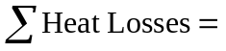Heat losses due to transmission through the building envelope
+ Heat loss due to infiltration and ventilation
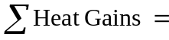 Internal heat gain from people, lighting, and appliances
+ Solar heat gain
The magnitude of the heat losses and gains depend on the building envelope thermal characteristics and area, envelope tightness, outdoor weather conditions, occupant behaviour, presence of electric appliances and lighting, and solar radiation. Detailed information on these factors is given below.
- Building envelope thermal characteristics and exposed area
The heat transferred through walls, ceiling, roof, widows, floors, and doors is estimated from
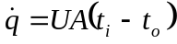 (4.2)
where is the heat transfer rate (W), U is the overall heat transfer coefficient (W/m²K), A (m²) is the net area for the given component for which U was calculated, and t_{i} and t_{o} (K) are the indoor and outdoor temperatures, respectively. The U-value of a component of a dwelling is determined by summing the resistances of the materials and surfaces involved, and then inverting this total resistance to give a transmittance or conductivity value.

- Building envelope tightness
One of the major heat losses in the dwelling is the heat required to warm outdoor air entering the dwelling through cracks and crevices around doors, windows, lighting fixtures, and joints between walls and floor, and through the building material itself.
- Internal and solar heat gains
Internal heat gains are from people, lighting, and appliances, whereas solar heat gain is a result of solar radiation entering a building through opaque and transparent surfaces such as fenestration, skylights, etc. Solar hear gain is a function of the location of the sun in the sky and the clearness of the atmosphere, as well as the nature and orientation of the glazing, and presence and type of blinds and other solar control devices.
- Outdoor weather conditions
Outdoor weather conditions such as wet and dry bulb temperatures, wind speed, humidity, and solar radiation determine the magnitude of heat losses and gains.
- Occupant behaviour
Occupant behaviour, such as temperature setting, opening of windows, orientation of blinds and curtains, influence the amount of energy used for SH.
The input units of the SH network dataset were developed taking into consideration the above factors and using the information available from the 1993 SHEU database.

Input Units for Building Envelope Thermal Characteristics
The following information on building characteristics is available in the 1993 SHEU database:
- dwelling type (single detached, double, row or terrace, duplex),
- number of storeys,
- exterior wall material types (aluminium/steel siding, brick, stucco, vinyl siding, stone/concrete, wood, log, asbestos shingle),
- number of doors,
- number of triple, double, and single glazed windows,
- total heated area excluding basement and garage,
- year dwelling was built,
- basement type and area,
- attic and roof type,
- presence and year of the improvements done to wall, roof, basement wall, and basement floor insulation,
- presence of heated basement and garage.
The 1993 SHEU database does not contain sufficient information on building envelope thermal characteristics to develop the overall heat transfer coefficients for each component of the envelope. The only information available is the type of material used in the exterior walls, but information on the thickness and type of the exterior wall and insulation materials is not given. Due to lack of direct information in the 1993 SHEU database to calculate the overall heat transfer coefficient values, the vintage of the envelope components is used as proxy for envelope thermal characteristics based on the work of Farahbakhsh (1997) and Farahbakhsh et al. (1997, and 1998).
As seen in Table 4.22, the year of construction of the dwellings is reported in six categories in the 1993 SHEU database. These categories are used in the input unit dataset to denote the ages of the dwellings. The year in which the insulation improvements were conducted is given in three categories as seen in Table 4.23. If a dwelling had undertaken any insulation improvement, the age category of that envelope component was increased as given in Table 4.24. The wall, basement wall, basement floor, and roof age categories were included as input units using this procedure. For example, if a dwelling was built before 1941 and its roof and walls were improved in 1980, age categories of the house, wall, roof, basement wall and floor would be 1, 4, 4, 1, and 1, respectively. The input units used for building envelope thermal characteristics are given in Table 4.26 along with all other input units used in the SH NN Model.
Table 4.22. Age categories based on the year of construction of the dwellings in the 1993 SHEU database
Years | Category for the year of construction
Before 1941 | 1
1941 – 1960 | 2
1961 – 1977 | 3
1978 – 1982 | 4
1983 – 1988 | 5
1989 or later | 6
Table 4.23. Age categories for the year of the insulation improvements in the 1993 SHEU database
Years | Category for the year of improvement
1977 or earlier | 1
1978 – 1983 | 2
1984 or later | 3
Table 4.24. Age categories of the envelope components with insulation improvements
Year of the insulation improvement | Updated age category
1977 or earlier | 3
1978 – 1983 | 4
1984 or later | 5

Input Units for Building Envelope Areas
The areas of the envelope components were calculated using the available information in the 1993 SHEU database and assumptions used in other similar studies (Farahbakhsh, 1997; Farahbakhsh et al., 1997 and 1998). The input units used for building envelope areas are given in Table 4.26. The assumptions and calculation procedures used in determining the envelope areas are given below.
Floor Area: The total heated area (excluding basement and garage) and number of storeys of the dwellings are available in the 1993 SHEU database. The floor area was calculated by dividing the total heated area by the number of storeys.
Wall Area: The wall area was calculated using Equation 4.3, assuming that the dwellings have square foot print and the height of the walls are 2.5 m. The number of walls is four for single detached, and three for single attached dwellings.
(4.3)
Basement Floor and Wall Area: The basement type and floor area are available in the 1993 SHEU database. Assuming that basement wall height is 2.5 m for full basements, 1.8 m for partial basements, and 0.6 m for crawl spaces, the basement wall areas were calculated using Equation 4.4:
(4.4)
Roof Area: The 1993 SHEU database contains information on the presence of an attic. If the dwelling has an attic, it was assumed that the ceiling is insulated, and the heat transfer area is taken to be equal to floor area of the dwelling. If the dwelling does not have an attic, then the roof area was calculated assuming that the dwelling has square foot print and a roof slope of 0.25. Therefore, Equation 4.5 gives the roof area:
(4.5)

Input Units for Windows and Doors
In the 1993 SHEU database, the number of single, double, triple windows and skylights, and the number of metal, wood, and patio doors are given. There is no information about the R-values, dimensions, or directions of the windows and doors. Therefore, as shown in Table 4.26, the number of doors and windows are used as input units representing the heat loss through these components.
Triple, double, and single glazed patio doors and skylights were considered as windows, and single glazed windows with storm windows were considered as double glazed windows.

Input Units for Heated Basements and Garages
The 1993 SHEU database contains qualitative information on the amount of heated basement area, which was converted to percentage values as shown in Table 4.25. Binary variables zero and one are used as input units for the heated garage ownership; the variable one is used if the household owns a heated garage, and zero is used if it does not. These input units are given in Table 4.26.
Table 4.25. Amount of basement area heated
Information in the 1993 SHEU database | Corresponding Percentage (%)
The whole basement | 100
More than one half | 75
About one half | 50
Less than half | 25

Table 4.26. SH network input units
 | Input Unit | Range
Dwelling Characteristics | Dwelling type:  1 if single-detached; 0 if single-attached | 0 – 1
Dwelling Characteristics | Number of doors | 1 – 11
Dwelling Characteristics | Number of triple glazed windows | 0 – 30
Dwelling Characteristics | Number of double glazed windows | 0 – 48
Dwelling Characteristics | Number of single glazed windows | 0 – 24
Dwelling Characteristics | Wall area [m²] | 71 - 733
Dwelling Characteristics | Floor area [m²] | 17 - 265
Dwelling Characteristics | Basement wall area [m²] | 0 - 163
Dwelling Characteristics | Basement floor area [m²] | 0 - 265
Dwelling Characteristics | Roof area [m²] | 17 - 265
Dwelling Characteristics | Dwelling age category | 1 - 6
Dwelling Characteristics | Wall age category | 1 - 6
Dwelling Characteristics | Roof age category | 1 - 6
Dwelling Characteristics | Basement wall age category | 0 - 6
Dwelling Characteristics | Basement floor age category | 0 - 6
Dwelling Characteristics | Percentage of the basement heated [%] | 0 – 100
Dwelling Characteristics | Heated garage: 1 if heated; 0 if not heated | 0 – 1
SH system and equipment properties | End-use efficiency of the SH equipment [%] | 65 – 100
SH system and equipment properties | Presence of heat recovery ventilation system | 0 – 1
SH system and equipment properties | Presence of programmable thermostats | 0 – 1
Indoor and outdoor temperatures | Average indoor temperature [ºC] | 16 – 24
Indoor and outdoor temperatures | Heating degree days [ºC-day] | 2,930 – 6,541
Socio-economic characteristics of the households | Income [$1,000/yr] | 10 – 85
Socio-economic characteristics of the households | Dwelling ownership: 1 if owner; 0 if renter | 0 – 1
Socio-economic characteristics of the households | Number of children | 0 - 6
Socio-economic characteristics of the households | Number of adults | 1 - 6
Socio-economic characteristics of the households | Daytime occupancy | 0 – 1
Socio-economic characteristics of the households | Size of area of residence:  1 if population is less than 15,000  2 if population is between 15,000 and 100,000  3 if population is 100,000 or over | 1 – 3

Input Unit for Dwelling Types
In the 1993 SHEU database, dwellings are classified into four categories: single detached, double, row or terrace, and duplex. In this study, double, row or terrace, and duplex dwellings are combined into one category called “single attached”. Binary variables zero and one are used as input units for the dwelling type; variable one is used if the dwelling is single-detached, and zero if it is single-attached, as shown in Table 4.26.

Input Units for SH System and Equipment Properties
The information available in the 1993 SHEU database on the SH system and equipment properties includes:
- type of SH equipment (furnace with hot air vents, boiler with hot water radiators, wood stove, electric baseboards, electric radiant heaters)
- fuel types and energy sources used for SH (natural gas, oil, electricity, wood, propane, coal)
- efficiency rating of the oil and natural gas SH equipment (standard, medium, high)
- age of the SH equipment,
- use of heat pump and back-up furnace,
- source, age, and power of heat pump system,
- fuel types and energy sources of the back-up furnaces (natural gas, oil, electricity, wood, propane, coal),
- use of programmable thermostat,
- use of heat recovery ventilation (HRV) system.
The 1993 SHEU database contains information on the efficiency ratings of the oil and natural gas fuelled SH equipment in three categories, which are standard (50-65%), medium (75-80%), and high (90% or higher) efficiency. The typical efficiency values given in HOT2000 (NRCan, 1996) for different types of oil and natural gas fuelled SH equipment are given in Table 4.27. Using the average values of the responses in the 1993 SHEU database, the HOT2000 default values from Table 4.27, and engineering judgment, the SH equipment efficiency values given in Table 4.28 were chosen to represent each efficiency rating, and energy source and fuel type. The end-use efficiency of the SH systems that use electricity were set to 100%. The input unit for the SH equipment efficiency is given in Table 4.26.
Table 4.27. Typical efficiency values for natural gas and oil SH equipment (NRCan, 1996)
Fuel Type | Equipment Type | Efficiency (%)
Natural Gas | 1. Furnace/boiler with continuous pilot | 78
Natural Gas | 2. Furnace/boiler with spark ignition | 78
Natural Gas | 3. Furnace/boiler with spark ignition, vent damper | 78
Natural Gas | 4. Induced draft fan furnace/boiler | 80
Natural Gas | 5. Condensing furnace/boiler | 94
Oil | 1. Furnace/boiler | 71
Oil | 2. Furnace/boiler with flue vent damper | 71
Oil | 3. Furnace/boiler with flame retention head | 83
Oil | 4. Mid efficiency furnace/boiler (no dilution air) | 85
Oil | 5. Direct vent, non-condensing | 87
Oil | 6. Condensing furnace/boiler (no chimney) | 93

Table 4.28. Efficiency values used for each efficiency rating and fuel type
 | Standard | Medium | High
Natural Gas | 70 % | 78 % | 94 %
Oil | 65 % | 75 % | 93 %
There are only a few households using heat pump systems for SH in the 1993 SHEU database. More than half of these households do not have information on the source and/or the power of their heat pump systems. Thus, the households with heat pump systems were excluded from the SH network dataset as explained in Appendix D. The programmable thermostat and HRV system ownerships are represented by binary variables zero and one as given in Table 4.26.

Input Units for Indoor and Outdoor Temperatures
The 1993 SHEU database contains information on the average indoor temperature during daytime (6 am – 6 pm), evening (6 pm – 10 pm), and overnight (10 pm – 6 am). The average indoor temperature was calculated using Equation 4.6.
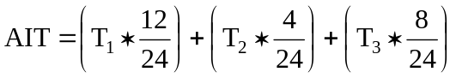 (4.6)
where,
AIT: average indoor temperature [ºC]
T₁: daytime (6 am – 6 pm) temperature [ºC]
T₂: evening (6 pm – 10 pm) temperature [ºC]
T₃: overnight (10 pm – 6 am) temperature [ºC]
The outside temperature has an important effect on the SH energy consumption. Therefore, heating degree-day (HDD) is used as an input unit as shown in Table 4.26. For this purpose, 1993 HDD data for the cities in which the households in the SH network dataset are located were obtained from Environment Canada (Environment Canada, 1999).

Other Input Units
The other input units included in the dataset are the household income, dwelling ownership information, number of children and adults in the households, daytime occupancy, and size of residence area information. The 1993 SHEU database contains information if the dwellings are occupied on average weekdays. Thus, binary variables one and zero are used to indicate if the dwellings are occupied on average weekdays as given in Table 4.26 (one indicates that dwelling is occupied, zero indicates unoccupied).

Output Unit
The annual electricity, natural gas, and oil consumption for SH is the output unit for the SH network. Thus, the annual SH electricity, natural gas, and oil consumption values obtained from the energy billing data for the 1,228 households are used as the output unit of the SH network. The SH consumption data of the households covers the calendar year of 1993, and were all converted to GJ.

Development of the SH Network Training and Testing Datasets
To facilitate the development of the SH NN Model, the SH network dataset was divided into two subsets. One of these subsets was used for training (training set) and the other was used for testing (testing set) of the network. The training set contains 921 households (75% of all households in the dataset) and the testing set contains 307 households (25% of all households in the dataset). The households in each sub-set were chosen randomly.

Selection of Activation Functions and Scaling Intervals
The training and the testing datasets of the SH network were scaled to the intervals given in Section 3.3.4 resulting in eleven datasets. Each of the eight configurations given in Table 3.1 was tested for each of the eleven datasets that were scaled to different intervals. Thus, a total of 88 networks were tested (= 11 scaling intervals x 8 network configurations).
A network with 28 input, two hidden, and one output units (28:2:1) trained by standard backpropagation learning algorithm with a learning rate of 0.02 was used to compare the various scaling intervals and activation functions with respect to their prediction performance.
The training of the 28:2:1 network was halted when the testing set SSE value stopped decreasing and started to increase, which is an indication of overtraining. The prediction performance and the number of cycles for each of the eight configurations that produced the best prediction performance for each of the eleven datasets are given in Table 4.29.
As seen in Table 4.29, normalization of the data produced poor predictions, which was also seen during the development of the ALC and DHW networks. The [–0.5 to 0.5], [–1.0 to 1.0], and [–0.9 to 0.9] scaling intervals also resulted in poor predictions with R² around 0.5. The [0.0 to 1.0], and [0.1 to 0.9] scaling intervals produced good predictions with R² higher than 0.85. The network with the best prediction performance (R² of 0.9064) used the data scaled to interval [0.1 to 0.9], the identity function for the hidden layers, and the logistic function for the output layers. Thus, in the rest of the SH network development, the identity function was used as the activation function for the hidden layers, the logistic function was used as the activation function for the output layer, and all data in the dataset were scaled to interval [0.1 to 0.9].
Table 4.29. Comparison of scaling intervals and activation functions
Scaling Interval | Applied to | Network Configuration | R² | Cycles
0.1 to 0.9 | All data | Network G: Identity + Logistic | 0.9064 | 2260
0.1 to 0.9 | Only continuous | Network G: Identity + Logistic | 0.9063 | 1564
-0.5 to 0.5 | All data | Network H: Identity + TanH | 0.5062 | 1259
-0.5 to 0.5 | Only continuous | Network H: Identity + TanH | 0.5055 | 1282
0.0 to 1.0 | All data | Network G: Identity + Logistic | 0.8517 | 1883
-1.0 to 1.0 | All data | Network E: TanH + TanH | 0.5122 | 1087
-1.0 to 1.0 | Only continuous | Network H: Identity + TanH | 0.4991 | 195
-0.9 to 0.9 | All data | Network E: TanH + TanH | 0.4979 | 514
-0.9 to 0.9 | Only continuous | Network C: Logistic + Identity | 0.4941 | 1276
Normalized | All dataset | Network B: Logistic + TanH | 0.3175 | 45
Normalized | Only continuous | Network H: Identity + TanH | 0.3340 | 24

Development of the SH Network Architecture
There are 28 input data units and one output data unit in the SH NN Model. In order to find the number of hidden layer units resulting in the best prediction performance, networks with the number of hidden layer units ranging from one to 40 were trained with the four different learning algorithms presented in Section 2.2.3.1. Thus, a total of 160 networks were tested as follows: 4 learning algorithms x 40 network configurations = 160 networks. The parameters of the learning algorithms used in the analysis are given in Table 4.30.
Table 4.30. Parameters of the learning algorithms used
Learning Algorithm | Parameters*
Standard Backpropagation | η : 0.0075
Enhanced Backpropagation | η : 0.0075, μ : 0.0005, c : 0.005
Quickprop | η : 0.001, ρ: 2.0, ν: 0.00001
Resilient Propagation | β: 1.1, φ_{initial}: 0.06, φ_{max}: 10
*The definitions for the parameters of the learning algorithms are given in Appendix A.
Training was halted when the testing set SSE value stopped decreasing and started to increase, which is an indication of overtraining. The prediction performance in terms of SSE, R², RMS, and CV of the networks with the lowest testing set SSE values amongst the 40 networks for each of the four learning algorithms is presented in Table 4.31.
As seen from Table 4.31, the learning algorithms produced good predictions within the range of R² of 0.907 to 0.908. The network trained with the Resilient Propagation learning algorithm with two hidden layer units resulted in the lowest testing set SSE, RMS, and CV, and highest R², indicating that this network has the highest prediction performance amongst the networks tested with the four learning algorithms given in Table 4.30. As seen in Table 4.30, the Resilient Propagation and Quickprop learning algorithms achieved convergence at lower number of cycles than the Standard and Enhanced Backpropagation learning algorithms due to the their mechanism of updating weights and biases as mentioned in Section 2.2.3.1 and Appendix A.

Table 4.31. Performance of networks trained using four different learning algorithms
Network | Learning Algorithm | Number of Hidden Units | SSE | R² | RMS | CV | Number of Cycles
28:2:1 | Resilient Propagation | 2 | 5.400 | 0.908 | 0.133 | 1.871 | 42
28:28:1 | Quickprop | 28 | 5.433 | 0.908 | 0.133 | 1.877 | 411
28:1:1 | Standard Backprop. | 1 | 5.508 | 0.907 | 0.134 | 1.890 | 3981
28:1:1 | Enhanced Backprop. | 1 | 5.508 | 0.907 | 0.134 | 1.890 | 3863
To determine the network architecture that produces the best prediction performance, different network architectures with a total of two hidden layer units in one, two or three layers were trained with the Resilient Propagation learning algorithm. The prediction performances of these networks are given in Table 4.32. None of these configurations resulted in better prediction performance than the network with two hidden units in one hidden layer. Thus, the network with one hidden layer with two units (28:2:1) trained with the Resilient Propagation learning algorithm, and using identity function for the hidden layer, the logistic function for the output layer, and dataset scaled to interval [0.1 to 0.9] was found to be the most suitable network architecture to predict the SH energy consumption in Canadian single family households. The architectural configuration of the SH NN Model (28:2:1), as well as the values of the weights and biases, are given in Appendix E.

Table 4.32. Performance of networks with different architectures
Network | Number of Hidden  Layer Units |  |  | SSE | R² | RMS | CV | Number of Cycles
Network | Layer 1 | Layer 2 | Layer 3
28:2:1 | 2 |  |  | 5.400 | 0.908 | 0.133 | 1.871 | 42
28:2:2:1 | 2 | 2 |  | 5.482 | 0.907 | 0.134 | 1.885 | 29
28:2:2:2:1 | 2 | 2 | 2 | 5.481 | 0.907 | 0.134 | 1.885 | 374
28:1:1:1 | 1 | 1 |  | 5.492 | 0.907 | 0.134 | 1.887 | 441

Development of the CDA Model
The CDA Model consists of three components:
- Electricity model (EM),
- Natural gas model (NGM),
- Oil model (OM).
The processes used in the development of the electricity, natural gas, and oil models are presented in this section.

Electricity Model

Development of the Electricity Model Dataset
The dataset used in the development of the CDA EM is a subset of the 1993 SHEU database. There are 2,050 households in the 1993 SHEU database with electricity billing data. The electricity bills of these households account for the energy consumption for major, minor, and miscellaneous appliances, lighting, space and DHW heating, and space cooling. The electricity billing data for these 2,050 households were used in the development of the CDA EM. Details of the analyses of the electricity billing data are given in Appendix B.

Development of the Electricity Model UEC Equations
The UEC equations for each end-use was developed using the information available from the 1993 SHEU database and 1993 weather and ground temperature data obtained from Environment Canada (Environment Canada, 1999). The CDA EM was developed by combining the UEC equations of the end-uses as given in Equation 4.7.
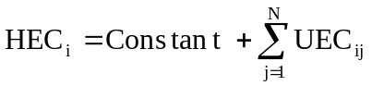 (4.7)
where,
HEC_{i}: Electricity consumption of household i [kWh/yr]
UEC_{ij}: End-use j unit energy consumption of household i [kWh/yr]
N: Number of electricity end-uses, i.e. main and supplementary space heating, DHW heating, space cooling, lighting, major and minor appliances.
The constant term in Equation 4.7 was included in the CDA EM to represent the electricity consumption by miscellaneous appliances. As seen in Equations 4.8 to 4.40, the CDA Model was developed as a linear model; however, a large variety of mathematically manipulated variables (for example by taking a power or a logarithm of one or more variables, or by cross multiplication of several variables) can be used. Use of such manipulated variables may improve the prediction performance of the CDA models.

Main and Supplementary Space Heating (SH) UEC Equations
The input variables of the SH UEC equations were chosen considering the structural features of the dwellings, economic and demographic characteristics of the occupants, and the weather conditions. The main and supplementary SH UEC equations used in the CDA EM are given in Equations 4.8 and 4.9, respectively, and the definitions of the commonly used variables in the equations are given in Table 4.33.

UEC_{SH} = SH * [a₀ + a₁ PROGT + a₂ HRV + a₃ AIT + a₄ DTYPE +
a₅ AREA + a₆ AGECAT + a₇ BSMNT + a₈ GARAGE +
a₉ ATTIC + a₁₀ TRIPLE + a₁₁ DOUBLE + a₁₂ SINGLE +
a₁₃ DOOR + a₁₄ HDD +a₁₅ OWNER + a₁₆ INCOME +
a₁₇ CHILD + a₁₈ ADULT +a₁₉ DAYTIME + a₂₀ POPUL] (4.8)
where,
UEC_{SH}: Space heating unit energy consumption [kWh/household/yr]
SH: Dummy variable: one if the household has electricity SH equipment, zero if not.
a₀, …, a₂₀: Regression coefficients of each variable.
UEC_{SSH} = SSH * [a₀ + a₁ AIT + a₂ AREA + a₃ HDD + a₄ CHILD +
a₅ ADULT + a₆ DAYTIME] (4.9)
where,
UEC_{SSH}: Supplementary space heating unit energy consumption [kWh/household/yr]
SSH: Dummy variable: one if the household has electricity supplementary SH equipment, zero if not.
a₀, …, a₆: Regression coefficients of each variable.
To simplify the UEC equations, the variables representing the number of single, double, and triple glazed windows were combined into one variable that represents the total number of windows (WINDOW). Similarly, the variables representing the number of adults and children were combined into one variable that represents the total number of occupants (HHSIZE). These two new variables were used in place of the corresponding variables in the end-use UEC equations.

DHW Heating UEC Equation
The input variables of the DHW heating UEC equation were chosen based on the available information on DHW heating system and equipment properties, DHW consumption patterns, economic and demographic characteristics of the occupants, and the weather conditions. The DHW heating UEC equation used in the CDA EM is given in Equation 4.10, and the definitions of the variables used in the equation are given in Table 4.33.
Table 4.33. Definitions of commonly used variables in UEC equations
Variable | Definition | Range
PROGT | Dummy variable: one if the household has programmable thermostat, zero if not. | 0 - 1
HRV | Dummy variable: one if the household has a heat recovery ventilation system, zero if not. | 0 - 1
EFF | Efficiency of the natural gas or oil furnace/boiler [%] | 65 - 94
SHAGE | Age of the natural gas or oil furnace/boiler [years] | 1 - 25
AIT | Average indoor temperature calculated using Equation 4.6 [ºC] | 16 - 24
DTYPE | Dummy variable: one if the dwelling type is single detached, zero if it is single attached. | 0 - 1
AREA | Heated living area [m²] | 51 - 502
AGECAT | Dwelling construction year category as given in Table 4. 22. | 1 - 6
BSMNT | Dummy variable: one if the household has a heated basement, zero if not. | 0 - 1
GARAGE | Dummy variable: one if the household has a heated garage, zero if not. | 0 - 1
ATTIC | Dummy variable: one if the household has an attic, zero if not. | 0 - 1
TRIPLE | Number of triple glazed windows | 0 – 30
DOUBLE | Number of double glazed windows | 0 – 60
SINGLE | Number of single glazed windows | 0 - 74
DOOR | Number of doors | 1 - 11
HDD | Heating degree days [ºC-day] | 2,930 – 6,541
OWNER | Dummy variable: one if owner, zero if renter. | 0 - 1
INCOME | Household income [$10,000/yr] | 10 - 85
Table 4.33. (continued) Definitions of commonly used variables in UEC equations
Variable | Definition | Range
CHILD | Number of children | 0 - 7
ADULT | Number of adults | 1 - 8
DAYTIME | Dummy variable: one if the dwelling is occupied daytime during weekdays, zero if not. | 0 - 1
POPUL | Size of area of residence:  1 if population is less than 15,000  2 if population is between 15,000 and 100,000  3 if population is 100,000 or over | 1 – 3
TANK | Size of the DHW tank [L] | 130 - 280
SYSAGE | Age of the DHW heating system [years] | 0.5 - 18
BLANKET | Dummy variable: one if there is an add-on insulation blanket around the outside of the DHW tank, zero if not. | 0 - 1
PIPEINS | Dummy variable: one if there is insulation around the DHW pipes, zero if not. | 0 - 1
AERATOR | Number of aerators | 0 – 7
LOWFLOW | Number of low-flow shower heads | 0 - 3
GT | Ground temperature [ºC] | 4 - 12
CWLOAD | Clothes washer [loads/week] | 0 – 15
DWLOAD | Dish washer [loads/week] | 0 – 15
CACUSE | Central A/C unit usage [hours/year] | 0 – 1,125
WACUSE | Window A/C unit usage [hours/year] | 0 – 1,125
VOLR1 | Volume of the main refrigerator [L] | 0 - 625
VOLR2 | Volume of the second refrigerator [L] | 0 - 625
FROSTR1 | Dummy variable: one if the main refrigerator is frost-free, zero if not. | 0 - 1
FROSTR2 | Dummy variable: one if the second refrigerator is frost-free, zero if not. | 0 - 1
HHSIZE | Number of occupants in the household | 1 - 11
VOLF1 | Volume of the main freezer [L] | 0 – 710
VOLF2 | Volume of the second freezer [L] | 0 - 710
MICROW | Dummy variable: one if the household has a microwave, zero if not. | 0 - 1
CDLOAD | Clothes dryer [loads/week] | 0 – 15
LIGHTS | Total number of incandescent, fluorescent, and halogen lamps | 7 - 132
WINDOW | Total number of single, double, and triple glazed windows | 4 - 76
UEC_{DHW} = DHW * [a₀ +a₁ TANK + a₂ SYSAGE + a₃ BLANKET +
a₄ PIPEINS + a₅ LOWFLOW + a₆ AERATOR + a₇ GT +
a₈ CWLOAD +a₉ DWLOAD + a₁₀ DTYPE +
a₁₁ OWNER + a₁₂ INCOME +a₁₃ CHILD +
a₁₄ ADULT] (4.10)
where,
UEC_{DHW}: DHW heating unit energy consumption [kWh/household/yr]
DHW: Dummy variable: one if the household has electricity DHW heating equipment, zero if not.
a₀, …, a₁₄: Regression coefficients of each variable.

Space Cooling UEC Equations
The input variables of the central and window A/C UEC equations were chosen based on the available information on space cooling system usage, structural features of the dwellings, economic and demographic characteristics of the occupants, and the weather conditions. The central and window A/C UEC equations used in the CDA EM are given in Equations 4.11 and 4.12, respectively, and the definitions of the variables used in the equations are given in Table 4.33.
UEC_{CAC} = CAC * [a₀ + a₁ CACUSE + a₂ DTYPE + a₃ AREA + a₄ AGECAT +
a₅ ATTIC + a₆ TRIPLE + a₇ DOUBLE + a₈ SINGLE +
a₉ DOOR + a₁₀ CDD + a₁₁ OWNER + a₁₂ INCOME +
a₁₃ CHILD + a₁₄ ADULT + a₁₅ DAYTIME] (4.11)
where,
UEC_{CAC}: Central A/C unit energy consumption [kWh/household/yr]
CAC Dummy variable: one if the household has central A/C unit, zero if not.
a₀, …, a₁₅: Regression coefficients of each variable.

UEC_{WAC} = WAC * [a₀ + a₁ WACUSE + a₂ AREA + a₃ AGECAT +
a₄ CDD + a₅ INCOME + a₆ CHILD + a₇ ADULT +
a₈ DAYTIME] (4.12)
where,
UEC_{WAC}: Window A/C unit energy consumption [kWh/household/yr]
WAC Dummy variable: one if the household has window A/C unit, zero if not.
a₀, …, a₈: Regression coefficients of each variable.

Major Appliances UEC Equations
The major appliances include the main and secondary refrigerators, main and secondary freezers, electric ranges, dishwashers, clothes washers, and electric clothes dryers. The input variables of the major appliances UEC equations were chosen based on the available information on appliance properties, and economic and demographic characteristics of the occupants. The major appliances UEC equations used in the CDA EM are given in Equations 4.13-4.20, and the definitions of the variables used in the equations are given in Table 4.33.
UEC_{REF1} = REF1 * [a₀ + a₁ VOLR1 + a₂ FROSTR1 + a₃ INCOME +
a₄ HHSIZE] (4.13)
UEC_{REF2} = REF2 * [a₀ + a₁ VOLR2 + a₂ FROSTR2 + a₃ INCOME +
a₄ HHSIZE] (4.14)
UEC_{FREZ1} = FREZ1 * [a₀ + a₁ VOLF1 + a₂ INCOME + a₃ HHSIZE] (4.15)
UEC_{FREZ2} = FREZ2 * [a₀ + a₁ VOLF2 + a₂ INCOME + a₃ HHSIZE] (4.16)
UEC_{COOK} = COOK * [a₀ + a₁ HHSIZE + a₂ MICROW] (4.17)
UEC_{DISH} = DISH * [a₀ + a₁ DWLOAD] (4.18)
UEC_{CLOTH} = CLOTH * [a₀ + a₁ CWLOAD] (4.19)
UEC_{DRYER} = DRYER * [a₀ + a₁ CDLOAD] (4.20)

where,
UEC_{REF1}: Main refrigerator unit energy consumption [kWh/household/yr]
UEC_{REF2}: Secondary refrigerator unit energy consumption, [kWh/household/yr]
UEC_{FREZ1}: Main freezer unit energy consumption [kWh/household/yr]
UEC_{FREZ2}: Secondary freezer unit energy consumption [kWh/household/yr]
UEC_{COOK}: Electric range unit energy consumption [kWh/household/yr]
UEC_{DISH}: Dishwasher unit energy consumption [kWh/household/yr]
UEC_{CLOTH}: Clothes washer unit energy consumption [kWh/household/yr]
UEC_{DRYER}: Electric clothes dryer unit energy consumption [kWh/household/yr]
REF1: Dummy variable: one if the household has a refrigerator, zero if not.
REF2: Dummy variable: one if the household has a secondary refrigerator, zero if not.
FREZ1: Dummy variable: one if the household has a freezer, zero if not.
FREZ2: Dummy variable: one if the household has a secondary freezer, zero if not.
COOK: Dummy variable: one if the household has an electric range, zero if not.
DISH: Dummy variable: one if the household has a dishwasher, zero if not.
CLOTH: Dummy variable: one if the household has a clothes washer, zero if not.
DRYER: Dummy variable: one if the household has an electric clothes dryer, zero if not.
a₀, …, a₄: Regression coefficients of each variable.

Minor Appliances UEC Equations
The minor appliances include microwaves, color TVs, black and white TVs, VCRs, furnace fans and boiler pumps. The input variables of the minor appliances UEC equations were chosen based on the available information on the demographic characteristics of the occupants and weather conditions. The minor appliances UEC equations used in the CDA EM are given in Equations 4.21-4.26, and the definitions of the variables used in the equations are given in Table 4.33.
UEC_{FF} = FF * [a₀ + a₁ AREA + a₂ HDD] (4.21)
UEC_{BP} = BP * [a₀ + a₁ AREA + a₂ HDD] (4.22)
UEC_{MICROW} = MICROW * [a₀ + a₁ HHSIZE] (4.23)
UEC_{CTV} = CTV * [a₀ + a₁ HHSIZE] (4.24)
UEC_{BWTV} = BWTV * [a₀ + a₁ HHSIZE] (4.25)
UEC_{VCR} = VCR * [a₀ + a₁ HHSIZE] (4.26)
where,
UEC_{FF}: Furnace fan unit energy consumption [kWh/household/yr]
UEC_{BP}: Boiler pump unit energy consumption [kWh/household/yr]
UEC_{MICROW}: Microwave unit energy consumption [kWh/household/yr]
UEC_{CTV}: Color TV unit energy consumption [kWh/household/yr]
UEC_{BWTV}: Black and white TV unit energy consumption [kWh/household/yr]
UEC_{VCR}: VCR unit energy consumption [kWh/household/yr]
FF: Dummy variable: one if the household has a furnace, zero if not.
BP: Dummy variable: one if the household has a boiler, zero if not.
MICROW: Dummy variable: one if the household has a microwave, zero if not.
CTV: Number of colour TVs owned by the household
BWTV: Number of black and white TVs owned by the household
VCR: Number of VCRs owned by the household
a₀, …, a₂: Regression coefficients of each variable.

Lighting UEC Equation
The input variables of the lighting UEC equation are the number of halogen, incandescent, and fluorescent lamps. The lighting UEC equation used in the CDA EM is given in Equation 4.27.
UEC_{LIGHT} = a₁ HALO+ a₂ INCA + a₃ FLOU (4.27)
where,
UEC_{LIGHT}: Lighting unit energy consumption [kWh/household/yr]
HALO: Number of halogen lamps owned by the household
INCA: Number of incandescent lamps owned by the household
FLOU: Number of fluorescent lamps owned by the household
a₁, …, a₃: Regression coefficients of each variable.
To simplify the UEC equations, the variables representing the number of halogen, incandescent, and fluorescent lamps were combined into one variable that represents the total number of lamps (LIGHTS). This new variable was used to replace the corresponding variables in Equation 4.27.

Estimation of the Electricity Model Equation
The end-use UEC equations given in Equations 4.8 to 4.27 were combined to develop the CDA EM. The model equation resulting from the integration of all individual end-use UEC equations is given in Figure F.1 of Appendix F. SYSTAT statistical software (SYSTAT, 1998) was used to regress the CDA EM equation, and the detailed output of the regression analysis is given in Figure F.2 of Appendix F. The model equation was reduced by removing the non-significant variables at 10% level, outlier and influential data points, and variables that increase multicollinearity. The resulting model equation is as follows:

HEC = 2128.65 + SH * [1.60 * HDD – 2516.01 * HRV + 1891.75 * DTYPE +
12.67 * AREA – 785.40 * AGECAT +
78.14 * INCOME] +
SSH * [8.13 * AREA + 569.33 * CHILD] +
DHW * [16.86 * TANK – 691.34 * LOWFLOW +
215.04 * DWLOAD + 752.83 * ADULT] +
CAC * [1.27 * CACUSE] +
REF1 * [1030.23 * FROSTR1] +
REF2 * [1636.48 * FROSTR2 + 28.24 * INCOME] +
FREZ1 * [1.50 * VOLF1] + COOK * [421.25 * HHSIZE] +
DRYER * [303.61 * CDLOAD] + 50.18 * LIGHTS (4.28)
As shown in Figure F.2 of Appendix F, the multiple coefficient of determination of the CDA EM is 0.66, which indicates that 66% of variation in the estimated household electricity consumption can be accounted for by the prediction based on the variables of the Equation 4.28.
As stated in Section 3.4.4, one way to measure multicollinearity is determining the condition indices (Weisberg, 1985). As shown in Figure F.3 of Appendix F, the condition index of the model is 15.865 suggesting a possible multicollinearity problem (SYTAT, 1998). The condition index of the model can be reduced by removing the variables that are highly correlated with others. However, the model has already been reduced to a minimum number of variables required to distinguish the electricity consumption into end-uses. Further reduction in the number of variables could restrict the capability of the model to estimate the consumption of major electricity end-uses.
With the multicollinearity problem, the estimation of the coefficients would still be unbiased (Johnston and DiNardo, 1997), but inferences from the standard errors are likely to be misleading. In other words, multicollinearity problem would not affect the predictions as long as estimates of the average household electricity consumption would be in the range of the original data. The derivations to prove that the estimations of the coefficients are still unbiased under multicollinearity are given in Appendix G.
As seen in Figure 4.1, the residuals (i.e. the errors) form an approximate straight line in the normal probability. This confirms that the errors are distributed normally.
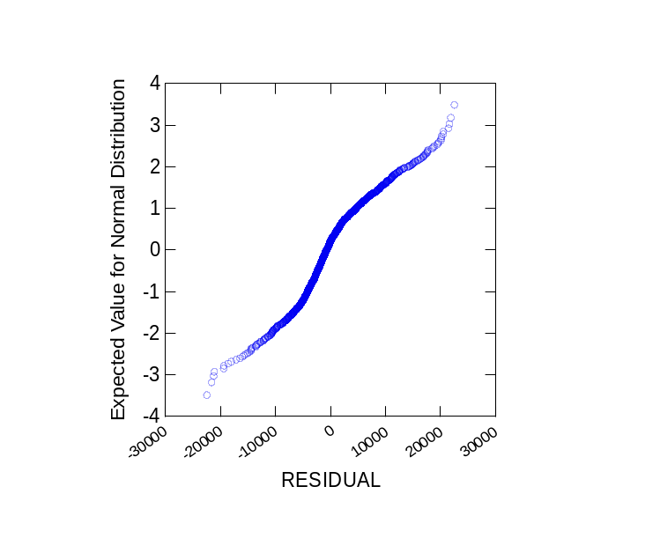
Figure 4.1. Normal probability plot of the residuals of the CDA EM
In order to check the assumption that the variability of the residuals is the same at all levels, the residuals were plotted against the estimated values as given in Figure 4.2. The plot shows that the errors might not have constant variance since the errors were not arranged in a horizontal band within two or three units around the zero line of the plot; instead a right opening megaphone structure was formed.
The White test (Johnston and DiNardo, 1997) was used to check the non-constant variance assumption of this model. The result of the test shows that the constant variance assumption was violated. However, the power of the White test diminishes as the number of variables of the model increases (Johnston and DiNardo, 1997). The CDA EM has 20 variables, thus the result of the test is not conclusive. In addition, the estimation of the coefficients would still be unbiased with the non-constant variance situation (Johnston and DiNardo, 1997).
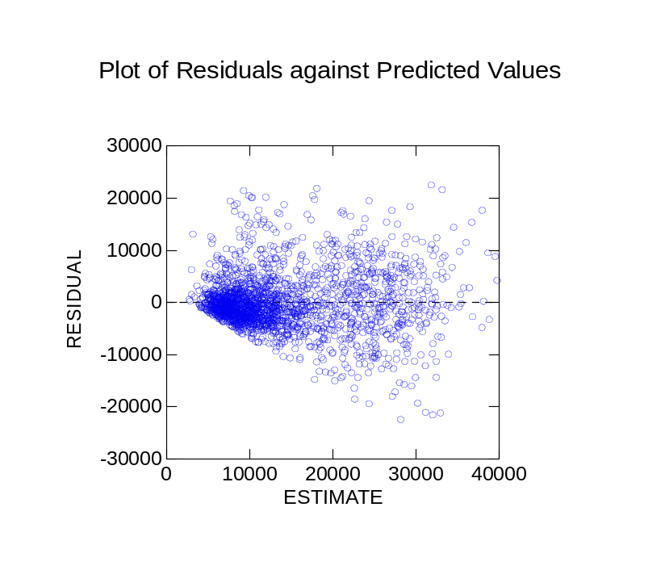
Figure 4.2. Plot of residuals of the CDA EM against estimated values

Natural Gas Model

Development of the Natural Gas Model Dataset
The dataset used in the development of the CDA NGM is a subset of the 1993 SHEU database. There are 1,012 households in the 1993 SHEU database with natural gas billing data, and four of these households have no natural gas end-uses reported in the 1993 SHEU database. The natural gas bills of the remaining 1,008 households account for the energy consumption for space and DHW heating, cooking, clothes drying, pool heating, and fireplaces. The natural gas billing data for these 1,008 households were used in the development of the CDA NGM. Details of the analyses of the natural gas billing data are given in Appendix B.

Development of the Natural Gas Model UEC Equations
The UEC equation for each end-use was developed using the information available from the 1993 SHEU database and 1993 weather and ground temperature data obtained from Environment Canada (Environment Canada, 1999). The CDA NGM was developed by combining the UEC equations of the end-uses as given in Equation 4.29. Since all natural gas end-uses were reported in the 1993 SHEU database, the constant term was not included in the model.
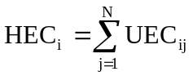 (4.29)
where,
HEC_{i}: Natural gas consumption of household i [m³/yr]
UEC_{ij}: End-use j unit natural gas consumption of household i [m³/yr]
N: Number of natural gas end-uses, i.e. main and supplementary space heating, DHW heating, clothes drying, cooking, pool heating, and fireplaces.

Main and Supplementary SH UEC Equations
The input variables of the SH UEC equations were chosen considering the end-use efficiency of the SH equipment, structural features of the dwellings, economic and demographic characteristics of the occupants, and the weather conditions. The supplementary SH UEC equation includes the households with natural gas supplementary SH units and fireplaces, since there are only eight households with natural gas supplementary heating systems and 37 households with natural gas fireplaces. The main and supplementary SH UEC equations used in the CDA NGM are given in Equations 4.30 and 4.31, respectively, and the definitions of the variables used in the equations are given in Table 4.33.

UEC_{SH} = SH * [a₀ + a₁ EFF + a₂ SHAGE + a₃ PROGT + a₄ AIT +
a₅ DTYPE + a₆ AREA + a₇ AGECAT + a₈ BSMNT +
a₉ GARAGE + a₁₀ ATTIC + a₁₁ TRIPLE + a₁₂ DOUBLE +
a₁₃ SINGLE + a₁₄ DOOR + a₁₅ HDD + a₁₆ OWNER +
a₁₇ INCOME + a₁₈ CHILD + a₁₉ ADULT + a₂₀ DAYTIME +
a₂₁ POPUL] (4.30)
where,
UEC_{SH}: Space heating unit energy consumption [m³/household/yr]
SH: Dummy variable: one if the household has natural gas SH equipment, zero if not.
a₀, …, a₂₁: Regression coefficients of each variable.

UEC_{SSH} = SSH * [a₀ + a₁ AIT + a₂ AREA + a₃ HDD + a₄ CHILD +
a₅ ADULT + a₆ DAYTIME] (4.31)
where,
UEC_{SSH}: Supplementary space heating unit energy consumption [m³/household/yr]
SSH: Dummy variable: one if the household has natural gas supplementary SH equipment and/or fireplace, zero if not.
a₀, …, a₆: Regression coefficients of each variable.

DHW Heating UEC Equation
The input variables of the DHW heating UEC equation were chosen based on the available information on DHW heating system and equipment properties, DHW consumption patterns, economic and demographic characteristics of the occupants, and the weather conditions. The DHW heating UEC equation used in the CDA NGM is given in Equation 4.32, and the definitions of the variables used in the equation are given in Table 4.33.
UEC_{DHW} = DHW * [a₀ + a₁ TANK + a₂ SYSAGE + a₃ BLANKET +
a₄ PIPEINS + a₅ LOWFLOW + a₆ AERATOR + a₇ GT +
a₈ CWLOAD + a₉ DWLOAD + a₁₀ DTYPE +
a₁₁ OWNER + a₁₂ INCOME + a₁₃ CHILD +
a₁₄ ADULT ] (4.32)
where,
UEC_{DHW}: DHW heating unit energy consumption [m³/household/yr]
DHW: Dummy variable: one if the household has natural gas DHW heating equipment, zero if not.
a₀, …, a₁₄: Regression coefficients of each variable.

Cooking, Clothes Drying, and Pool Heating UEC Equations
The input variables of the cooking, clothes drying, and pool heating UEC equations were chosen based on the available information on appliance usage, and economic and demographic characteristics of the occupants. The UEC equations used in the CDA NGM are given in Equations 4.33-4.35, and the definitions of the variables used in the equations are given in Table 4.33.
UEC_{COOK} = COOK * [a₀ + a₁ HHSIZE + a₂ MICROW] (4.33)
UEC_{DRYER} = DRYER * [a₀ + a₁ CDLOAD] (4.34)
UEC_{POOL} = POOL * [a₀ + a₁ INCOME] (4.35)
where,
UEC_{COOK}: Natural gas range unit energy consumption [m³/household/yr]
UEC_{DRYER}: Natural gas clothes dryer unit energy consumption [m³/household/yr]
UEC_{POOL}: Natural gas pool heating unit energy consumption [m³/household/yr]
COOK: Dummy variable: one if the household has a natural gas range, zero if not.
DRYER: Dummy variable: one if the household has a natural gas clothes dryer, zero if not.
POOL: Dummy variable: one if the household has a natural gas pool heater, zero if not.
a₀, …, a₂: Regression coefficients of each variable.

Estimation of the Natural Gas Model Equation
The end-use UEC equations given in Equations 4.30 to 4.35 were combined to develop the CDA NGM. The model equation resulting from the integration of all individual end-use UEC equations is given in Figure F.4 of Appendix F. The SYSTAT statistical software (SYSTAT, 1998) was used to regress the CDA NGM equation, and the output of the regression analysis is given in Figure F.5 of Appendix F. The model equation was reduced by removing the non-significant variables at 10% level, outlier and influential data points, and variables that increase multicollinearity. The resulting model equation is as follows:
HEC = SH * [-207.75 * PROGT + 129.84 * DOOR + 26.30 * WINDOW +
46.03 * SHAGE + 437.69 * GARAGE + 6.61 * AREA +
181.61 * ADULT] +
DHW * [13.21 * SYSAGE + 70.77 * HHSIZE + 720.97 * DTYPE] +
COOK * [94.04 * HHSIZE] + DRYER * [35.91 * CDLOAD] +
969.56 * POOL (4.36)
As shown in Figure F.5 of Appendix F, the multiple coefficient of determination of the CDA NGM is 0.92, which indicates that 92% of variation in the estimated household natural gas consumption can be accounted for by the prediction from the variables of the Equation 4.36. The condition index of the model is 10.27 indicating that there is not a significant multicollinearity problem as given in Figure F.6 of Appendix F.
The residuals (i.e. the errors) form an approximate straight line in the normal probability plot as seen in Figure 4.3. This confirms that the errors are distributed normally.
In order to check the assumption that the variability of the residuals is the same at all levels, the residuals were plotted against the estimated values as given in Figure 4.4. The plot shows that the errors have constant variance since the errors were arranged in a horizontal band within two or three units around the zero line of the plot. When the White test was applied to the CDA NGM, its result showed that the constant variance assumption was violated. However, the number of variables in the CDA NGM is high, therefore the power of the test tends to diminish and its result could be unreliable (Johnston and DiNardo, 1997).

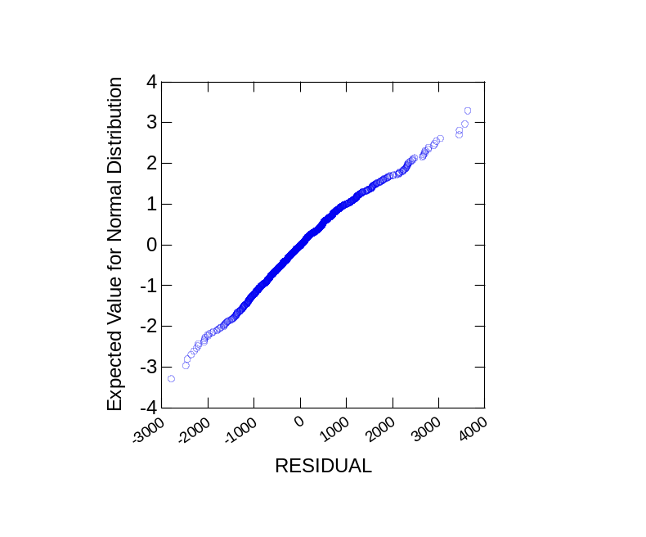
Figure 4.3. Normal probability plot of the residuals of the CDA NGM
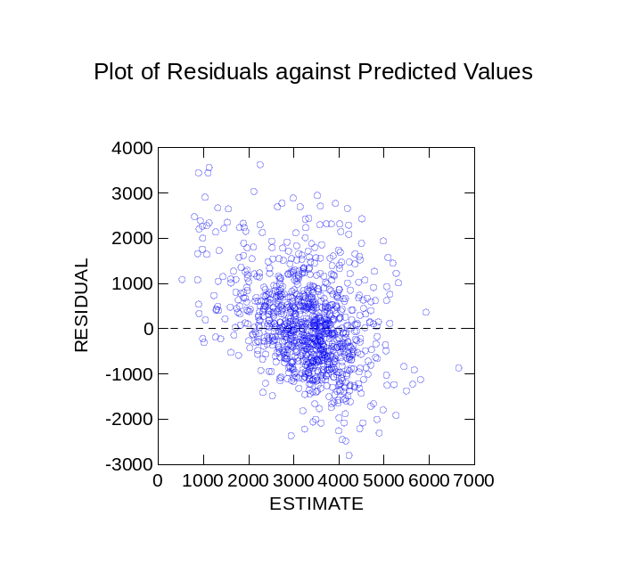
Figure 4.4. Plot of residuals of the CDA NGM against estimated values

Oil Model

Development of the Oil Model Dataset
The dataset used in the development of the CDA OM is a subset of the 1993 SHEU database. There are 236 households in the 1993 SHEU database with oil billing data, and five of these households have no oil end-uses reported in the 1993 SHEU database. The oil bills of the remaining 231 households account for the energy consumption for space and DHW heating, cooking, and pool heating. The oil billing data of these 231 households were used in the development of the CDA OM. Details of the analyses of the oil billing data are given in Appendix B.

Development of the Oil Model UEC Equations
There are only two households with oil cooking ranges or pool heaters in the database. Therefore, oil cooking and pool heating energy consumption are not addressed in the model. UEC equations for SH and DHW heating end-uses were developed using the information available from the 1993 SHEU database and 1993 weather and ground temperature data obtained from Environment Canada (Environment Canada, 1999). The CDA OM was developed by combining the UEC equations of the end-uses as given in Equation 4.37. Since all oil end-uses were reported in the 1993 SHEU database, the constant term was not included in the model.
(4.37)
where,
HEC_{i}: Oil consumption of household i [L/yr]
UEC_{ij}: End-use j unit oil consumption of household i [L/yr]
N: Number of oil end-uses, i.e. main and supplementary space heating, DHW heating, cooking, and pool heating.

SH UEC Equation
There are only two households with oil supplementary heating units in the CDA OM dataset. Thus, the oil supplementary space heating UEC equation is excluded from the analysis. The input variables of the SH UEC equation were chosen considering the end-use efficiency of the SH equipment, structural features of the dwellings, economic and demographic characteristics of the occupants, and the weather conditions. The SH UEC equation used in the CDA OM is given in Equation 4.38, and the definitions of the variables used in the equations are given in Table 4.33.
UEC_{SH} = SH * [a₀ + a₁ EFF + a₂ SHAGE + a₃ PROGT + a₄ AIT +
a₅ DTYPE + a₆ AREA + a₇ AGECAT + a₈ BSMNT +
a₉ GARAGE + a₁₀ ATTIC + a₁₁ TRIPLE + a₁₂ DOUBLE +
a₁₃ SINGLE + a₁₄ DOOR + a₁₅ HDD + a₁₆ OWNER +
a₁₇ INCOME + a₁₈ CHILD + a₁₉ ADULT + a₂₀ DAYTIME +
a₂₁ POPUL] (4.38)
where,
UEC_{SH}: Space heating unit energy consumption [L/household/yr]
SH: Dummy variable: one if the household has oil SH equipment, zero if not.
a₀, …, a₂₁: Regression coefficients of each variable.

DHW Heating UEC Equation
The input variables of the DHW heating UEC equation were chosen based on the available information on DHW heating system and equipment properties, DHW consumption patterns, economic and demographic characteristics of the occupants, and the weather conditions. The DHW heating UEC equation used in the CDA OM is given in Equation 4.39, and the definitions of the variables used in the equation are given in Table 4.33.

UEC_{DHW} = DHW * [a₀ + a₁ TANK + a₂ SYSAGE + a₃ BLANKET +
a₄ PIPEINS + a₅ LOWFLOW + a₆ AERATOR + a₇ GT +
a₈ CWLOAD + a₉ DWLOAD + a₁₀ DTYPE +
a₁₁ OWNER + a₁₂ INCOME + a₁₃ CHILD +
a₁₄ ADULT ] (4.39)
where,
UEC_{DHW}: DHW heating unit energy consumption [L/household/yr]
DHW: Dummy variable: one if the household has oil DHW heating equipment, zero if not.
a₀, …, a₁₄: Regression coefficients of each variable.

Estimation of the Oil Model Equation
The SH and DHW heating UEC equations given in Equations 4.38 and 4.39 were combined to develop the CDA OM. The model equation resulting from the integration of all individual end-use UEC equations is given in Figure F.7 of Appendix F. The SYSTAT statistical software (SYSTAT, 1998) was used to regress the CDA OM equation, and the ooutput of the regression analysis is given in Figure F.8 of Appendix F. The model equation was reduced by removing the non-significant variables at 10% level, outlier and influential data points, and variables that increase multicollinearity. The resulting model equation is as follows:
HEC = SH * [40.05 * SHAGE + 4.95 * AREA + 41.68 * WINDOW +
471.21 * DTYPE] +
DHW * [5.28 * TANK + 50.91 * DWLOAD] (4.40)
As shown in Figure F.8 of Appendix F, the multiple coefficient of determination of the CDA OM is 0.87, which indicates that 87% of variation in the estimated household oil consumption can be accounted for by the prediction from the variables of the Equation 4.40. The condition index of the model is 5.95 suggesting that there is no significant multicollinearity problem as given in Figure F.9 of Appendix F.
The residuals (i.e. the errors) form an approximate straight line in the normal probability plot as seen in Figure 4.5. This confirms that the errors are distributed normally.
In order to check the assumption that the variability of the residuals is the same at all levels, the residuals were plotted against the estimated values as given in Figure 4.6. The plot shows that the errors have constant variance since the errors were arranged in a horizontal band within two or three units around the zero line of the plot. When the White test was applied to the CDA OM, its result showed that the constant variance assumption was not violated. Since the number of variables in the CDA OM is not high, the result of the test is reliable.
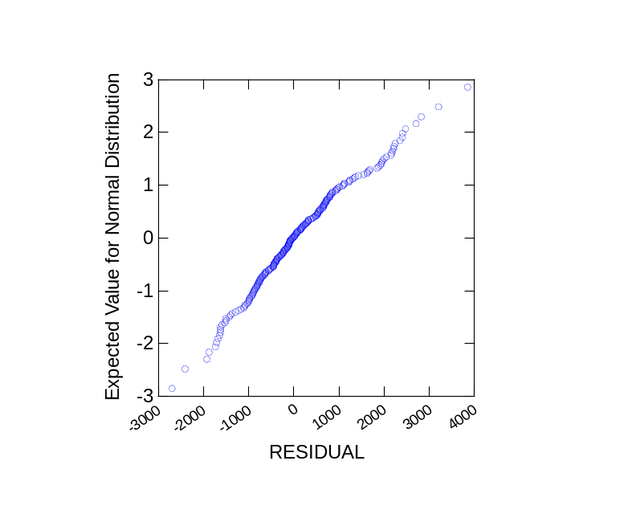
Figure 4.5. Normal probability plot of the residuals of the CDA OM

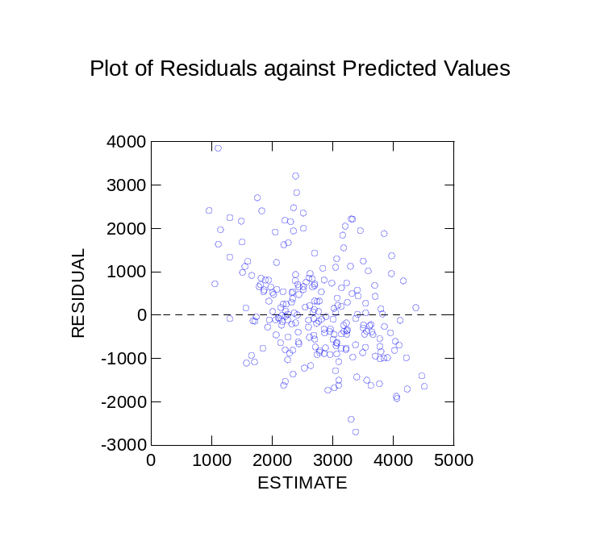
Figure 4.6. Plot of residuals of the CDA OM against estimated values

Closing Remarks
NN and CDA Models were developed to estimate the ALC, DHW, and SH energy consumption in single family residences in Canada. The NN Model is the first of its kind. Before this work, NNs were not used to model residential energy consumption at the national or regional level. Although the CDA modeling approach has been used to model residential energy consumption at the regional level, it was not used at the national level prior to this thesis. Thus, the CDA Model also represents an original addition to the state-of-the-art in energy modeling.
The ALC NN Model was developed using the available information in the subset of 988 households with electricity billing data in the 1993 SHEU database. The households in the ALC dataset do not have electrical DHW or space heating equipment, thus their electricity consumption billing data represent appliance, lighting, and space cooling electricity consumption. The model has 55 input units and three hidden layers each having nine units. The Quickprop learning algorithm was used to train the network with the training dataset of 741 households. The logistic function was used as the activation function for the hidden layers, the identity function was used as the activation function for the output layer, and all data in the dataset were scaled to interval [–0.5 to 0.5]. The ALC NN model achieved a high prediction performance (R² = 0.909) for a subset of households with electricity bills.
The DHW dataset was developed using the available information in the 1993 SHEU database of the 563 households with natural gas and electricity billing data that represent DHW heating energy consumption. For the DHW NN Model, the logistic function was used as the activation function for the hidden and output layers, and only continuous data in the datasets were scaled to interval [0.1 to 0.9]. The model has 18 input units and one hidden layer with 29 hidden units. The Resilient Propagation learning algorithm was used to train the network with the training dataset of 422 households. The DHW NN model achieved a high prediction performance (R² = 0.871) for a subset of households with natural gas and electricity bills.
The SH dataset used to develop the SH NN Model contains available information in the 1993 SHEU database of the 1,228 households with electricity, natural gas, and oil billing data. The NN Model achieved a high prediction performance (R² = 0.908) for a subset of households with electricity, natural gas, and oil bills for SH energy consumption. The model has 28 input units and one hidden layer with two units. The Resilient Propagation learning algorithm was used to train the network with the training dataset of 921 households. The identity function was used as the activation function for the hidden layer, the logistic function was used as the activation function for the output layer, and all data in the dataset were scaled to interval [0.1 to 0.9].
The DHW heating electricity consumption of the households in the DHW NN dataset were calculated by deducting the ALC electricity consumption estimated using the ALC NN Model from the total annual electricity billing data. Also, for electrically heated households, the annual SH electricity consumption was calculated by deducting the ALC and DHW heating electricity consumption estimated using the ALC and DHW NN Models from the total annual electricity billing data. For natural gas heated households, the annual SH natural gas consumption was calculated by deducting the DHW heating natural gas consumption estimated by the DHW NN Model from the total annual energy billing data. This introduces error in the DHW heating and SH energy consumption data used in developing the DHW and SH NN Models; however, this approach was used since disaggregated DHW heating and SH energy consumption data do no exist.
The CDA EM was developed with a constant term and a total of 20 variables from 12 electricity end-use UEC equations. The model achieved a multiple coefficient of determination of 0.66. The condition index of the model suggested a possible multicollinearity problem, however this problem would not effect the unbiased estimation of the coefficients. Despite the multicollinearity problem, the number of variables of the model was not reduced in order to retain the capability of the model to estimate the energy consumption for each end-use.
The graphical analysis of the residuals showed that the errors are normally distributed. However, the graphical analysis of the residuals and the White test result for the constant variance assumption showed that the residuals do not have constant variance. On the other hand, the estimation of the coefficients would still be unbiased with the non-constant variance situation (Johnston and DiNardo, 1997).
The CDA NGM was developed with a total of 13 variables from five natural gas end-use UEC equations. The CDA OM has six variables from two oil end-use UEC equations. The CDA natural gas and oil models achieved high values for multiple coefficient of determination, 0.97 and 0.82, respectively. Neither model faced the multicollinearity problem.
The CDA Model developed in this thesis is linear; however, a large variety of mathematically manipulated variables (for example by taking a power or a logarithm of one or more variables, or by cross multiplication of several variables) can be used. Use of such manipulated variables may improve the prediction performance of the CDA models.
It can thus be stated that the NN and CDA methods were shown to be suitable for the modeling of residential energy consumption at the national and regional levels. The models that were developed in this work demonstrated to have good prediction performance.
The comparisons of the prediction performance of the NN, CDA, and Engineering Models based on the metered energy consumption data and estimates are presented in the next chapter.

The major appliances are the refrigerators, freezers, ranges, dishwashers, clothes washers, and dryers. The minor appliances are the microwaves, TV’s, VCRs, furnace fans, and boiler pumps. The miscellaneous appliances are the remaining appliances owned by the households such humidifiers, coffee makers, etc.
750 hours/yr is calculated as follows: Summer months: May - August (123 days) A/C operation: During daytime (12 h/day) "Half of the summer": 1/2 x 123 days x 12 h/day = 738 h ~ 750 h
The relationship between the vintage of the dwellings and the overall heat transfer coefficient of each component of the envelope was studied by Farahbakhsh (1997) and Farahbakhsh et al. (1997 and 1998). A database was developed using the information available from the Modified STAR HOUSING database (Scanada Consultants, 1992), the 1993/94 “200-House Audit” project database (NRCan, 1994), and the 1994 New House Survey database (NRCan, 1996), and the thermal resistances (i.e. R-values) of building envelope components (e.g. walls, roofs, doors, windows, etc.) were categorized based on the vintage of the dwellings. It was found that R-values increase as the age of the dwellings decrease.
The a_{x} is used as a generic symbol to denote all regression coefficients in this work. Thus, a₁ in one given equation has a different value than another a₁ in another equation.

