Chapter 5
Comparison of the Models

Overview
In this chapter, a comparative evaluation of the NN, CDA, and Engineering Models is conducted by comparing their energy consumption estimates with actual energy consumption data, as well as by comparing their estimates with each other. Comparisons are carried out for the following end-uses:
- Appliance, lighting, and space cooling (ALC) energy consumption,
- Domestic hot water (DHW) heating energy consumption,
- Space heating (SH) energy consumption.
The Engineering Model developed by Farahbakhsh (1997) and Farahbakhsh et al. (1997, 1998) is used in the comparisons. In addition to the comparison of the models with respect to the accuracy of their predictions, a qualitative comparison is also carried out to show the relative strengths and weaknesses of each model, and its usefulness.
The chapter continues with a review and analysis of the household energy consumption estimates of the NN, CDA, and Engineering Models based on SH energy source and fuel type, dwelling type and age, and provincial distribution. In the last section of the chapter, the effects of some socio-economic factors on the mentioned end-uses are examined.

ALC Energy Consumption

Households with Energy Billing Data
The prediction performance of the NN, CDA, and Engineering Models was assessed by comparing the estimates of the models with actual energy consumption data from the 247 households in the ALC NN testing dataset. The results are presented in Table 5.1. The CDA and the Engineering Models have lower R² and higher CV values than the NN Model, which shows that the CDA and the Engineering Models have a lower prediction performance than the NN Model.
Table 5.1. Prediction performance of the NN, CDA, and Engineering Models- ALC
Model | R² | CV
Engineering | 0.780 | 3.463
CDA | 0.795 | 3.343
NN | 0.909 | 2.094
The estimates of the Engineering, CDA, and NN Models are plotted along with the actual energy consumption data for the 247 households in the ALC NN testing dataset in Figures 5.1 to 5.3, respectively. The NN Model, as well as the CDA and Engineering Models, were not able to predict the energy consumption of some households with high energy billing data as seen in Figure 5.1 to 5.3. When the input units of these households were examined, it was found that these households could not be expected to have such high ALC electricity consumption values. The number, size, and usage of appliances of these households are very close to the corresponding average values in the testing dataset. This shows that there are other factors affecting the electricity consumption than those reported in the 1993 SHEU database and represented by the input units in the model (such as workshops in garages) that would increase ALC electricity consumption of the households.
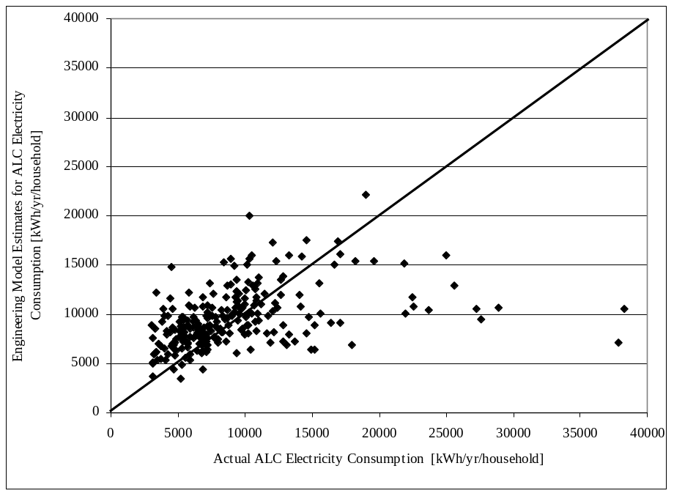
Figure 5.1. Actual billing data and Engineering Model estimates for ALC energy consumption of the households in the ALC NN testing dataset
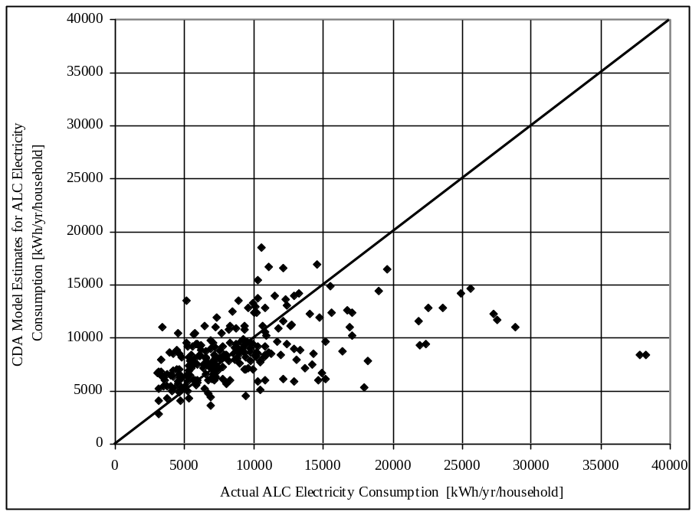
Figure 5.2. Actual billing data and CDA Model estimates for ALC energy consumption of the households in the ALC NN testing dataset
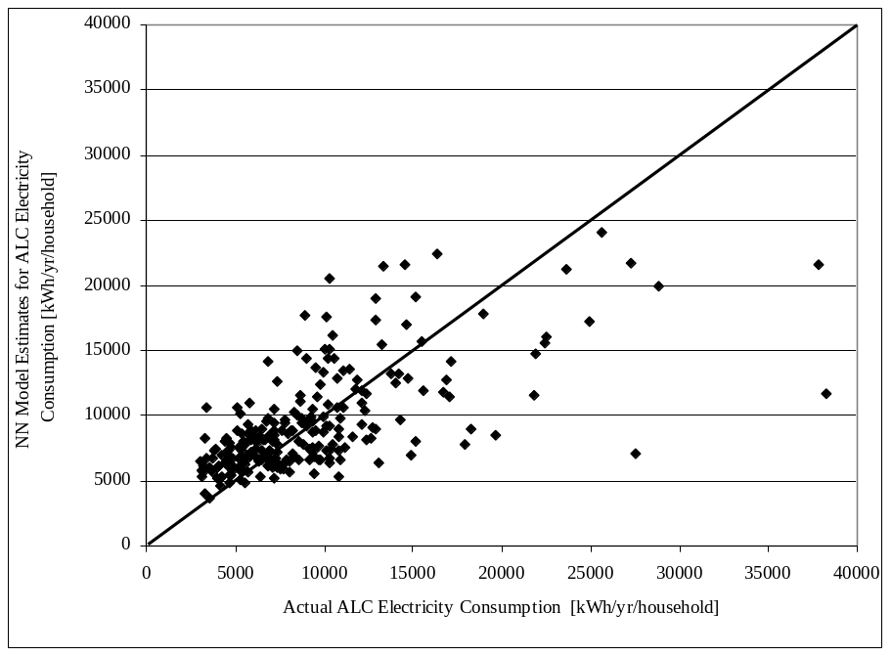
Figure 5.3. Actual billing data and NN Model estimates for ALC energy consumption of the households in the ALC NN testing dataset

Households without Energy Billing Data

Average Household ALC Electricity Consumption
The 1993 SHEU database has data on 8,767 households, and data on 988 of these were used to develop the ALC NN Model. These 988 households were not included in the dataset used in the predicting the various components of ALC electricity consumption. The “ALC prediction dataset” therefore includes the remaining 7,779 households. The NN and the CDA Models are used here to predict the ALC electricity consumption of these households. Since the 1993 SHEU database is representative of the Canadian housing stock, it is possible to extrapolate the predicted electricity consumption of the households in the 1993 SHEU database to the entire Canadian housing stock using weighting factors (Statistics Canada, 1993).
The weighted average ALC consumption estimated by the CDA, Engineering, and NN Models for the 7,779 households in the ALC prediction dataset, and the average percent deviations between the NN Model and Engineering Model, and between the NN Model and CDA Model calculated using Equations 5.1a and 5.1b, respectively, are given in Table 5.2. The ALC electricity consumption estimated by the Engineering Model is about 2.5% higher than the NN Model estimate, whereas the CDA Model estimate is 4.6% lower.
(5.1a)

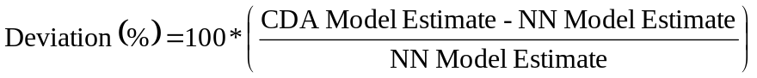 (5.1b)

Table 5.2. Weighted average ALC electricity consumption estimated by the Engineering, CDA, and NN Models for the 7,779 households and average percent deviations
Model | Weighted Average ALC Electricity Consumption [kWh/yr/household] | Average Deviation  [%]
NN | 8,791 | -
CDA | 8,391 | -4.6
Engineering | 9,012 | 2.5
The appliance and lighting energy consumption estimate used by NRCan’s EnerGuide for Houses program is 24 kWh/day/household, which is equivalent to 8,760 kWh/yr/household (NRCan, 2002). This estimate does not include the household space cooling energy consumption. However, the space cooling energy consumption accounted for about 0.5% of the total national residential energy consumption in 1993 (OEE, 2002). Therefore, the addition of space cooling energy consumption to the NRCan’s average household appliance and lighting energy consumption estimate of 8,760 kWh/yr/household would make an insignificant increase. As seen in Table 5.2, the estimates by all three models are close to the estimate by NRCan.

Scenarios to Predict Electricity Consumption of Some Appliances
The average electricity consumption of individual appliances in the ALC input unit dataset was estimated using the ALC NN Model. It was found that the NN model fails to accurately estimate the electricity consumption of appliances with high saturation values (e.g. main refrigerator). However, the model was able to reasonably predict the average electricity consumption of several major appliances as discussed below.

Central A/C Unit Electricity Consumption
There are 720 households with central A/C units in the ALC prediction dataset of 7,779 households. In order to estimate the central A/C electricity consumption, a dataset was developed by changing the central A/C input units from one to zero in the input files of the 720 households, and the ALC NN Model was applied to these files to estimate the household electricity consumption. Thus, as shown in Table 5.3, the difference between the predicted electricity consumption of the 720 households with and without the central A/C units provides the estimated electricity consumption by the central A/C units. As seen in Table 5.3, the average electricity consumption estimated by the ALC NN Model is 832 kWh/yr/household.

Table 5.3. Average ALC electricity consumption of 720 households in set of 7,779 households with and without central A/C units
 | Average Electricity Consumption [kWh/yr/household]
720 Households with central A/C units | 9,941
720 Households without central A/C units | 9,109
Electricity consumption difference ≈ Central A/C consumption | 832

As seen in Equation 4.28, the central A/C usage is one of the variables of the CDA EM. Thus, it was possible to estimate the average central A/C electricity consumption of the 720 households in the ALC prediction dataset using the CDA EM. The CDA EM estimate of 569 kWh/household/year is 32 % lower than estimate of the NN Model.
The average central A/C consumption for these 720 households was estimated by the Engineering Model to be 1,624 kWh/yr/household. However, the Engineering Model does not consider the central A/C usage characteristics (i.e. whether the central A/C unit is used continuously or intermittently). Based on the Engineering Model estimates, the central A/C consumption of the households in the 1993 SHEU database was estimated statistically by Aydinalp et al. (1998) to be 865 kWh/yr/household. This estimate took into consideration the central A/C usage characteristics of the households. The 865 kWh/yr/household estimate is slightly higher than the 832 kWh/yr/household estimate of the NN Model.
The CDA model developed by Lafrange and Perron (1994) using Hydro Quebec data estimated the central A/C consumption to be 1,662 kWh/yr/household without considering the usage characteristics of the central A/C unit. Another CDA model developed by Kellas (1993) using Manitoba Hydro data estimated the central A/C consumption to be 1,360 kWh/yr/household.
The central A/C unit electricity consumption estimates of the CDA models of Lafrange and Perron (1994) and Kellas (1993), and the Engineering Model are about 60 to 100% higher than that of the NN Model. This is largely owing to the fact that the central A/C electricity consumption was estimated by the CDA models and the Engineering Model taking into account only the central A/C unit ownership, and assuming a constant number of hours of central A/C usage. The estimates of the statistical model by Aydinalp et al. (1998), and the NN and CDA EM Models were developed considering the number of hours each household used the central A/C unit during the summer. Thus, the estimates obtained using the NN Model, as well as the CDA EM and the statistical model are more reasonable than those obtained using the CDA models by Lafrange and Perron (1994) and Kellas (1993), and the Engineering Model.

Second Refrigerator Electricity Consumption
There are 1,444 households with second refrigerators in the ALC prediction dataset of 7,779 households. In order to estimate the second refrigerator electricity consumption, a dataset was developed by changing the second refrigerator input units from one to zero in the input files of the 1,444 households, and the ALC NN Model was applied to these files to estimate the household electricity consumption. Thus, as shown in Table 5.4, the difference between the predicted electricity consumption of the 1,444 households with and without the second refrigerator provides the estimated electricity consumption by the second refrigerator. As seen in Table 5.4, the average electricity consumption estimated by the ALC NN is 755 kWh/yr/household.

Table 5.4. Average ALC electricity consumption of 1,444 households in the set of 7,779 households with and without second refrigerator
 | Average Electricity Consumption [kWh/yr/household]
1,444 Households with second refrigerator | 9,969
1,444 Households without second refrigerator | 9,214
Electricity consumption difference ≈ Second refrigerator consumption | 755
As seen in Equation 4.28, there are two variables in the CDA EM that are from the second refrigerator UEC equation (Equation 4.14). Thus, it was possible to estimate the average second refrigerator electricity consumption of the 1,444 households in the ALC prediction dataset using the CDA EM. The CDA EM estimate of 1,981 kWh/household/year is about 2.5 times higher than the estimate of NN Model. On the other hand, the CDA model developed by Kellas (1993) using Manitoba Hydro data estimated second refrigerator consumption to be 815 kWh/yr/household.
The size of the refrigerator is one of the factors affecting its electricity consumption. The average sizes for the main and second refrigerators in the SHEU 1993 database are 460 L and 375 L, respectively. Since the second refrigerators are smaller than the main refrigerators, their electricity consumption is expected to be lower than that of the main ones. Given that an average main refrigerator consumes around 1,330 kWh/yr/household (Fung et al., 1997; Ugursal and Fung, 1994), electricity consumption by the second refrigerator should be lower than 1,330 kWh/yr/household. This shows that the second refrigerator electricity consumption estimate of the CDA EM is high, while estimates of the NN Model and the CDA model developed by Kellas (1993) are reasonable.

DHW Heating Energy Consumption

Households with Energy Billing Data
The prediction performance of the NN, CDA, and Engineering Models was assessed by comparing the estimates of the models with actual energy consumption data from the 141 households in the DHW NN testing dataset. The results are presented in Table 5.5. The CDA and the Engineering Models have lower R² and higher CV values than the NN Model, which shows that the CDA and the Engineering Models have a lower prediction performance than the NN Model.
Table 5.5. Prediction performance of the NN, CDA, and Engineering Models- DHW
Model | R² | CV
Engineering | 0.828 | 3.898
CDA | 0.814 | 4.052
NN | 0.871 | 3.337
The estimates of the Engineering, CDA, and NN Models are plotted along with the actual energy consumption data for the 141 households in the DHW NN testing dataset in Figures 5.4 to 5.6, respectively. The DHW NN Model, as well as the Engineering and CDA Models, failed to accurately predict the DHW heating energy consumption of most of the households with consumption values lower than 15 GJ/yr as seen in Figures 5.4 to 5.6. When the input data for these households were analyzed, it was found that most of these households use electricity for DHW heating. As pointed out in Section 4.2.2.1, the amount of electricity consumed in these households for DHW heating was calculated by subtracting the ALC electricity consumption predicted by the ALC NN Model from the total billed electricity consumption. Therefore, the annual DHW heating electricity consumption of these households contain a cumulative error from the ALC and the DHW NN Models.
Out of 563 households in the DHW dataset, 388 have electricity bills, while the remaining 175 have natural gas bills. It was not possible to exclude the 391 households with electricity bills from the DHW dataset and develop a representative model with data from only 175 households with natural gas bills.
When the input units of these households were examined, it was found that based on the values of the input units these households could not be expected to have such low DHW heating energy consumption values. The age and size of the DHW heating systems, the annual ground water temperature, the number of clothes and dishwasher weekly loads, and the number of occupants of these households are either higher or very close to the corresponding average values in the testing dataset. This shows that there are other factors affecting the DHW heating energy consumption than those reported in the 1993 SHEU database and represented by the input units in the model that would decrease DHW load of the households (such as taking morning showers in the gym, or some people not taking as many showers).
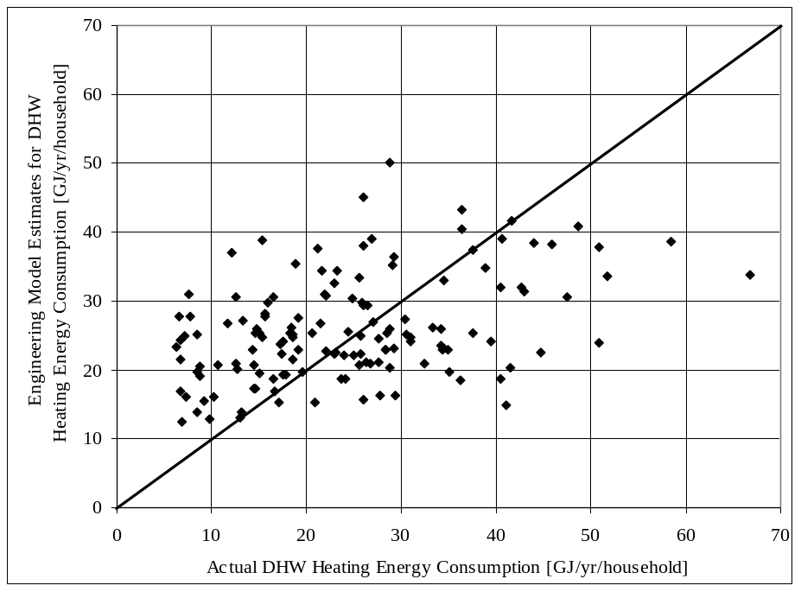
Figure 5.4. Actual billing data and Engineering Model estimates for DHW heating energy consumption of the households in the DHW NN testing dataset
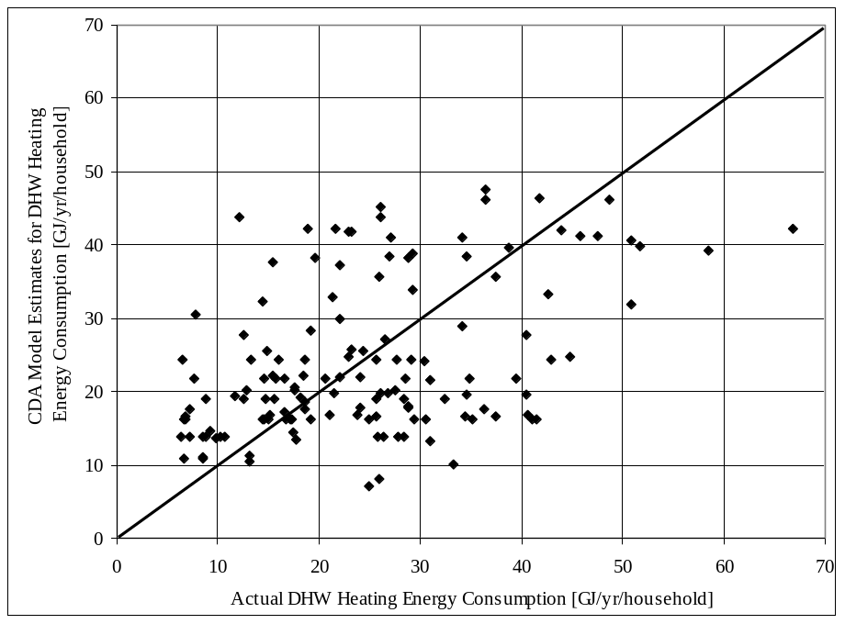
Figure 5.5. Actual billing data and CDA Model estimates for DHW heating energy consumption of the households in the DHW NN testing dataset
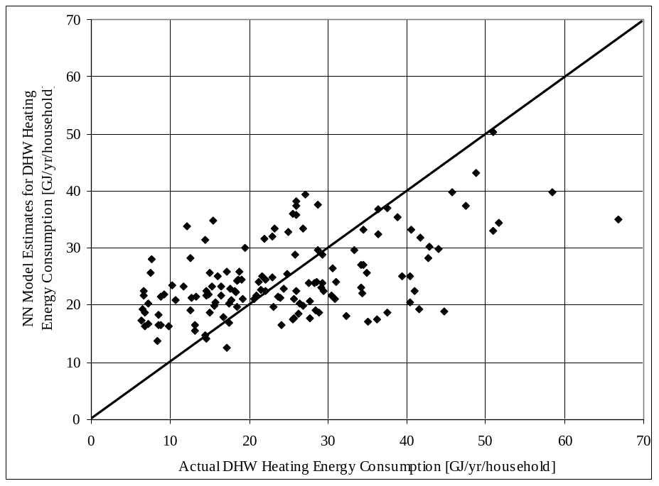
Figure 5.6. Actual billing data and NN Model estimates for DHW heating energy consumption of the households in the DHW NN testing dataset

Households without Energy Billing Data

Average Household DHW Heating Energy Consumption
The 1993 SHEU database has data on 8,767 households, and data on 563 of those were used to develop the DHW NN Model. There are 85 households without any DHW heating systems in the remaining 8,204 households in the 1993 SHEU database. The DHW heating prediction dataset was developed from the remaining households excluding the households using oil or wood fuelled, or tankless DHW heating systems, since these households were not represented in the DHW NN training dataset which was used in the development of the DHW NN Model. Thus, the DHW heating energy consumption of the remaining 7,070 households were estimated using the NN and CDA Models. The weighted average DHW heating energy consumption estimated by the CDA, Engineering, and NN Models for the 7,070 households, and the average percent deviations calculated using Equations 5.1a and 5.1b are given in Table 5.6. As seen in Table 5.6, the DHW heating energy consumption estimated by the CDA and the Engineering Models are 3.1% and 4.5% lower than the NN Model estimate, respectively.
Table 5.6. Weighted average DHW heating energy consumption estimated by the CDA, Engineering, and NN Models for the 7,070 households and average percent deviations
Model | Weighted Average DHW Heating Energy Consumption [GJ/yr/household] | Average Deviation  [%]
NN | 26 | -
CDA | 25 | -3.1
Engineering | 25 | -4.5
The OEE estimated the DHW heating end-use energy consumption in 1993 to be 284 PJ (OEE, 2002), while the total number of households in 1993 was estimated to be 10,359,216 by Statistics Canada (1993). Therefore, the average household DHW heating energy consumption in 1993 is 27 GJ/yr/household. As seen in Table 5.6, the NN Model DHW heating energy consumption estimate is the closest to the estimate by OEE.

DHW Heating Energy Consumption Categorized Based on Energy Source and Fuel Type
The weighted average DHW heating energy consumption of the 7,070 households categorized based on the energy source and fuel type used for DHW heating is given in Table 5.7. As seen in Table 5.7, the households using electricity for DHW heating have lower DHW heating energy consumption than those using natural gas or propane. This is largely due to the fact that the end-use efficiency of the DHW heating systems using electricity is higher than the DHW heating systems using natural gas or propane. As it was given in Table 4.14, the end-use efficiency of the DHW heating systems using electricity is 82.4%, and for the natural gas or propane systems this figure reduces to 55.4%. Therefore, the households using natural gas or propane would have higher DHW heating energy consumption values than the households using electricity, even if both households would have the same DHW consumption and average annual ground temperatures.
Table 5.7. Weighted average DHW heating energy consumption of the 7,070 households based on the DHW heating energy source and fuel type
DHW Energy Source and Fuel Type | Weighted Average DHW Heating Energy Consumption [GJ/yr/household]
DHW Energy Source and Fuel Type | NN Model | CDA Model | Engineering Model
Electricity | 21 | 19 | 21
Natural Gas | 32 | 33 | 30
Propane | 31 | 37 | 33
These figures show that the NN Model, together with the CDA and the Engineering Models, is capable of capturing the difference in the DHW heating energy consumption of the households using natural gas, propane, and electricity.

SH Energy Consumption

Households with Energy Billing Data
The prediction performance of the NN, CDA, and Engineering Models was assessed by comparing the estimates of the models with actual energy consumption data from the 307 households in the SH NN testing dataset. The results are presented in Table 5.8. As seen from Table 5.8, the CDA and the Engineering Models have lower R² and higher CV values than the NN Model, which shows that the CDA and the Engineering Models have a lower prediction performance than the NN Model.
Table 5.8. Prediction performance of the NN, CDA, and Engineering Models- SH
Model | R² | CV
Engineering Model | 0.778 | 2.877
CDA Model | 0.892 | 2.007
NN Model | 0.908 | 1.871
The estimates of the Engineering, CDA, and NN Models are plotted along with the actual energy consumption data for the 307 households in the SH NN testing dataset in Figures 5.7 to 5.9. The SH NN Model, as well as, the Engineering and the CDA Models, were unable to accurately predict the SH energy consumption of most of the households with consumption values lower than 30 GJ/yr as seen in Figures 5.7 to 5.9. When the input data for these households were analyzed, it was found that these households use electricity for SH. As stated in Section 4.2.3.1, the amount of electricity consumed in these households for SH was calculated by subtracting the ALC and DHW heating electricity consumption predicted by the ALC and DHW NN Models from the total billed electricity consumption. Therefore, the annual SH electricity consumption of these households contain the cumulative errors from the ALC and DHW NN Models.
When the input units of these households were examined, it was found that based on the values of the input units these households could not be expected to have such low SH energy consumption values. Most of these households are single-detached, located at areas with HDD values higher than 4,500 ºC-day, and have average wall areas. This shows that there are other factors affecting the SH energy consumption than those reported in the 1993 SHEU database and represented by the input units in the model (such as long vacations in winter months) that would decrease SH energy consumption of the households.

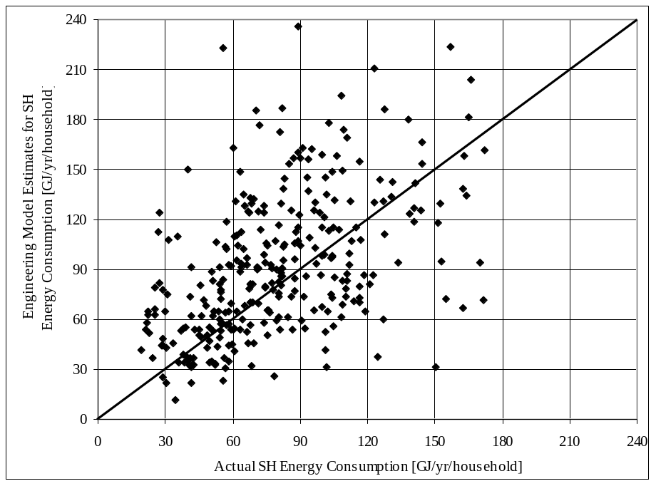
Figure 5.7. Actual billing data and Engineering Model estimates for SH energy consumption of the households in the SH NN testing dataset

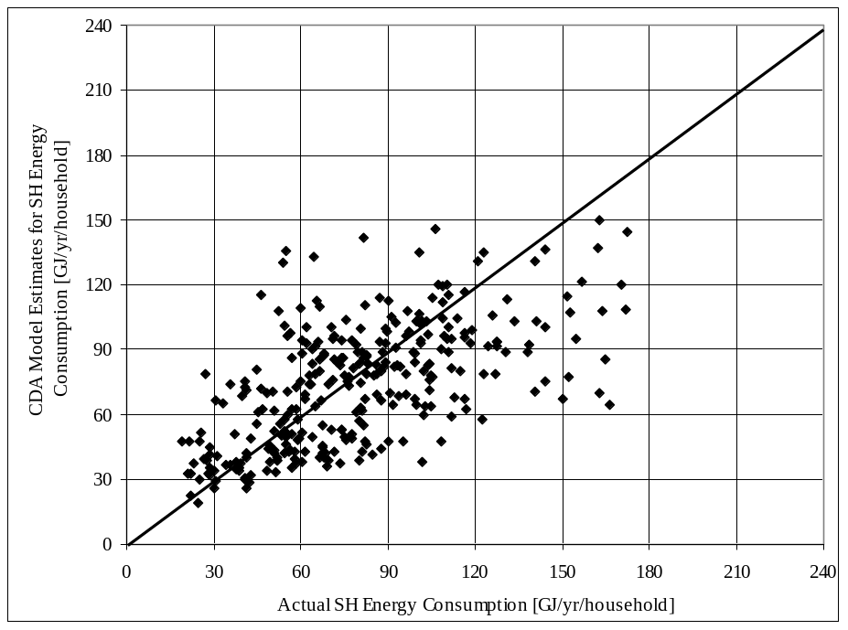
Figure 5.8. Actual billing data and CDA Model estimates for SH energy consumption of the households in the SH NN testing dataset
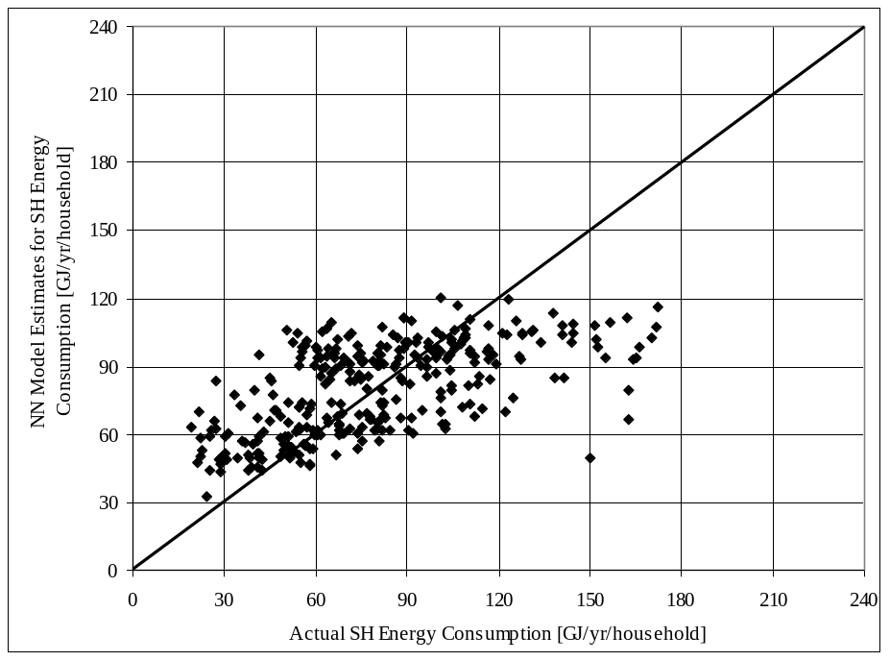
Figure 5.9. Actual billing data and NN Model estimates for SH energy consumption of the households in the SH NN testing dataset

Households without Energy Billing Data

Average Household SH Energy Consumption
The 1993 SHEU database has data on 8,767 households, and data on 1,228 of those were used to develop the SH NN Model. Out of the 7,439 remaining households, 987 use wood and 153 use heat pump SH systems. Since these households were not represented in the SH NN training dataset used in the development of the SH NN Model, they were removed from further analysis, and the SH energy consumption of the remaining 6,399 households were estimated using the NN and the CDA Models. The weighted average SH energy consumption estimated by the CDA, Engineering, and NN Models for the 6,399 households, and the average percent deviations calculated using Equations 5.1a and 5.1b are given in 5.9. As seen in Table 5.9, the SH energy consumption estimated by the CDA and the Engineering Models are 3.4% and 6.9% lower than the NN Model estimate, respectively.
Table 5.9. Weighted average SH energy consumption estimated by the CDA, Engineering, and NN Models for the 6,399 households and average percent deviations
Model | Weighted Average SH Energy Consumption [GJ/yr/household] | Average Deviation  [%]
NN | 80 | -
CDA | 75 | -6.9
Engineering | 77 | -3.4
The OEE estimated the SH end-use energy consumption in 1993 to be 837 PJ (OEE, 2002), while the total number of households in 1993 was estimated to be 10,359,216 by Statistics Canada (1993). Therefore, the average household SH energy consumption in 1993 is 81 GJ/yr/household. As seen in Table 5.9, the NN Model SH energy consumption estimate is the closest to the estimate by OEE.

SH Energy Consumption Categorized Based on Energy Source and Fuel Type, Dwelling Type and Age Category, and Wall Area
The weighted average SH energy consumption of the 6,399 households categorized based on the energy source and fuel type and end-use efficiency of the SH equipment is given in Table 5.10. As seen in Table 5.10, the weighted average SH energy consumption increases as the end-use efficiency of the SH equipment decreases. As expected, the NN Model SH energy consumption estimates increase smoothly as the end-use efficiency of the SH equipment decreases, whereas the CDA and Engineering Models appear to overestimate the reduction in end-use energy consumption as a result of using 100% efficient electric heating instead of high efficiency fossil fuel furnaces.
Table 5.10. Weighted average SH energy consumption of the 6,399 households based on energy source and fuel type and end-use efficiency of SH equipment
SH Energy Source and Fuel Type | End-use Efficiency  [%] | Weighted Average SH Energy Consumption [GJ/yr/household]
SH Energy Source and Fuel Type | End-use Efficiency  [%] | NN Model | CDA Model | Engineering Model
Electricity | 100 | 58 | 40 | 53
Oil, Natural Gas, Propane | High (90% or higher) | 68 | 81 | 71
Oil, Natural Gas, Propane | Medium (80-75%) | 89 | 91 | 91
Oil, Natural Gas, Propane | Standard (65-50%) | 98 | 92 | 93

The weighted average SH energy consumption of the 6,399 households based on dwelling type, dwelling age category, and wall area are given in Tables 5.11 to 5.13, respectively. As given in Table 5.11, the weighted average SH energy consumption estimates of all three models for single-detached dwellings are higher than that of single-attached dwellings. This is a reasonable outcome since a single detached dwelling has more exposed envelope area compared to a similarly sized single attached dwelling, and consequently, requires more energy for space heating.

Table 5.11. Weighted average SH energy consumption of the 6,399 households based on dwelling type
Dwelling Type | Weighted Average SH Energy Consumption [GJ/yr/household]
Dwelling Type | NN Model | CDA Model | Engineering Model
Single-attached | 67 | 55 | 61
Single-detached | 84 | 80 | 82
The weighted average SH energy consumption estimates of the models decrease as the dwellings get younger, and increase as the wall area of the dwellings increase, as seen in Table 5.12 and 5.13, respectively. These findings are also in agreement with expectations. The envelope integrity and insulation levels of newer buildings are higher than older ones, resulting in less energy consumption in newer residences; and wall area is directly proportional with envelope heat loss.
Table 5.12. Weighted average SH energy consumption of the 6,399 households based on dwelling age category
Year Category | Weighted Average SH Energy Consumption [GJ/yr/household]
Year Category | NN Model | CDA Model | Engineering Model
1. Before 1941 | 90 | 82 | 98
2. 1941 – 1960 | 85 | 77 | 80
3. 1961 – 1977 | 82 | 78 | 74
4. 1978 – 1982 | 75 | 69 | 70
5. 1983 – 1988 | 63 | 59 | 59
6. 1989 or later | 62 | 64 | 63

Table 5.13. Weighted average SH energy consumption of the 6,399 households based on wall area of the dwelling
Wall Area [m²] | Weighted Average SH Energy Consumption [GJ/yr/household]
Wall Area [m²] | NN Model | CDA Model | Engineering Model
Less than 100 | 75 | 61 | 58
100 – 130 | 80 | 72 | 82
More than 130 | 84 | 85 | 85
These figures show that the SH NN, CDA, and the Engineering Models are all capable of capturing the differences in the SH energy consumption of households with different SH equipment efficiencies, wall areas, and dwelling types and ages.

Household Energy Consumption
The DHW heating and SH energy consumption of 2,096 households in the 1993 SHEU database could not be estimated by the DHW and SH NN Models due to insufficient data. The household energy consumption of the remaining 6,671 households in the 1993 SHEU database were computed by combining the ALC, DHW heating, and SH energy consumption estimates of the NN and CDA Models. Table 5.14 gives the weighted average household energy consumption estimates of the NN, CDA, and Engineering Models, and the average percent deviations calculated using Equations 5.1a and 5.1b. As seen in Table 5.14, the household energy consumption estimated by the CDA and the Engineering Models are 5% and 2.8% lower than the NN Model estimate, respectively.

Table 5.14. Weighted average household energy consumption of the 6,671 households in the 1993 SHEU database and average percent deviations
Model | Weighted Average Household Energy Consumption [GJ/yr/household] | Average Deviation [%]
NN | 139 | -
CDA | 132 | -5.0
Engineering | 135 | -2.8
The OEE estimated the total household energy consumption in 1993 to be 1,386 PJ (OEE, 2002), while the total number of households in 1993 was estimated to be 10,359,216 by Statistics Canada (1993). Therefore, the average total household energy consumption in 1993 is 134 GJ/yr/household. As seen in Table 5.14, the estimates by all three models are close to the estimate by OEE.

Household Energy Consumption Categorized Based on SH Energy Source and Fuel Type, Dwelling Type and Age Category, and Province
The household energy consumption of the 6,671 households estimated by the NN, CDA, and the Engineering Models were categorized based on SH energy source and fuel type, dwelling type and age category. The results are presented in Tables 5.15 to 5.17.
Dwellings that are electrically heated, single attached, and built after 1988 have the lowest average weighted household energy consumption according to the NN, CDA, and Engineering Models estimates, as seen in Tables 5.15 to 5.17. Since, the SH end-use energy consumption accounts for about 60% of the total household energy consumption (OEE, 2002), trends similar to the SH energy consumption estimates given in Tables 5.10 to 5.12 are seen in Tables 5.15 to 5.17.
The CDA Model seem to estimate the energy consumption of the electrical heated households lower than the NN Model as seen in Table 5.15, similar to the estimates given in Table 5.10.
Since, the SH end-use energy consumption is a major component of the household energy consumption, single detached dwellings have higher energy consumption estimates as seen in Table 5.16. The estimates of all three models for the single detached dwellings are higher than the ones for single detached dwellings.

Table 5.15. Weighted average household energy consumption of the 6,671 households based on SH energy source and fuel type
SH Energy Source and Fuel Type | Weighted Average Household Energy Consumption [GJ/yr/household]
SH Energy Source and Fuel Type | NN Model | CDA Model | Engineering Model
Electricity | 107 | 89 | 107
Natural Gas | 155 | 155 | 150
Oil | 145 | 132 | 137
Propane | 142 | 147 | 153

Table 5.16. Weighted average household energy consumption of the 6,671 households based on dwelling type
Dwelling Type | Weighted Average Household Energy Consumption [GJ/yr/household]
Dwelling Type | NN Model | CDA Model | Engineering Model
Single-attached | 120 | 99 | 112
Single-detached | 144 | 140 | 141

As seen in Table 5.17, the households built after 1988 have the lowest average weighted household energy consumption estimates. There is not a smooth decrease in the household energy consumption estimates as the dwellings get younger, as seen in the SH estimates in Table 5.12. This is largely due to the differences in the distribution of dwelling types, wall areas, and energy sources and fuel types in each age category of households.
Table 5.17. Weighted average household energy consumption of the 6,671 households based on dwelling age category
Year Category | Weighted Average Household Energy Consumption [GJ/yr/household]
Year Category | NN Model | CDA Model | Engineering Model
1. Before 1941 | 141 | 135 | 149
2. 1941 – 1960 | 141 | 131 | 135
3. 1961 – 1977 | 144 | 135 | 135
4. 1978 – 1982 | 141 | 133 | 132
5. 1983 – 1988 | 128 | 127 | 124
6. 1989 or later | 121 | 120 | 124

The average household energy consumption in each province was calculated using the estimates of the NN, CDA, and Engineering Models. The results are presented in Figure 5.10. As seen in Figure 5.10, the estimates of the three models are in agreement. The average household energy consumption in Quebec is found to be the lowest, whereas Alberta and Saskatchewan have the highest household energy consumption.
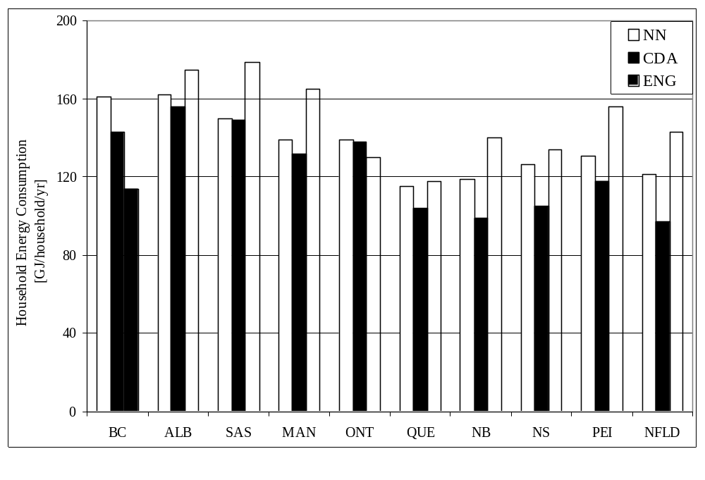
SH energy consumption accounts for about 60% of the total household energy consumption. Therefore, factors such as end-use efficiency, and energy source and fuel type of the SH equipment have significant effects on the total household energy consumption. Consequently, the trend seen in Figure 5.10 is mainly due to the fact that, in the 1993 SHEU database, 79% of the households in Quebec, and, respectively, 1% and 5% of the households in Alberta and Saskatchewan, have electrical SH equipment that have 100% end-use efficiency. In addition, 66% and 69% of the households in Alberta and Saskatchewan, respectively, have standard (50-65%) efficiency natural gas, oil, or propane fueled SH equipment. These explain the high household energy consumption trends in Alberta and Saskatchewan.
Figure 5.10. NN, CDA, and Engineering Models provincial household energy distribution

Assessment of Socio-economic Factors
The effects of the socio-economic factors, such as income, dwelling ownership, size of area of residence, on the ALC, DHW heating, and SH energy consumption of the households in the 1993 SHEU database were studied using the NN and CDA Models, and the results are presented in the following sections.

Impact of Socio-economic Factors on ALC Energy Consumption
The input dataset of the ALC NN Model contains information on the socio-economic characteristics of the households; such as household income (in $10,000 increments), dwelling ownership (rent or own), size of area of residence, dwelling type (single attached or single detached), and number of children and adults. The CDA Electricity Model given in Equation 4.28 includes the household income and the number of occupants as socio-economic factors on ALC electricity consumption. All other socio-economic factors that were initially included in the CDA EM equation (4.28) were eliminated as a result of statistical significance and multicollinearity problems as explained in Section 4.3.1.3. Therefore, the capability of the CDA Model to evaluate the effects of a large number of socio-economic factors on the ALC energy consumption is significantly reduced.
The effects of the socio-economic factors on the ALC electricity consumption were assessed using the NN and CDA Models. The results are plotted in Figures 5.11 and 5.17, respectively.
As seen from Figures 5.11 and 5.12, ALC electricity consumption of the households varies as follows:
- ALC electricity consumption of households increase with income. This is due to the fact that as income increases, number of appliances, living area, number of lights, and space cooling equipment load increase, and, consequently, the ALC electricity consumption increases. It is interesting to note that at low-income levels, the slope of the NN Model curve becomes less, indicating that the effect of income on the ALC electricity consumption is lower. In other words, as income decreases, the ALC energy consumption reaches a minimum and stays constant. On the other hand, the CDA Model income estimates form a straight line indicating that ALC electricity consumption decreases with a constant rate (i.e. with a slope of 0.0064) as income decreases, and does not stay constant at low income levels.
- NN Model ALC electricity consumption estimate of a single detached dwelling is higher than that of a single attached dwelling. This is due to the fact that single detached dwellings have larger living areas than single attached ones. As living area increases, the number of lights in the dwelling increases, as well as the space cooling load increases.
- NN Model ALC electricity consumption estimate of an owner occupied household is higher than that of a renter occupied household. In the 1993 SHEU database, the majority of the renter occupied households are single attached. As stated above, single attached dwellings have smaller living areas; consequently, they have lower ALC energy consumption.
- NN Model ALC electricity consumption estimate of a household decreases as the population of the area increases. This is due to the fact that almost all of the households located in areas with population less than 15,000 are single detached, and have larger living areas and more outdoor lamps than the single attached dwellings located at populated areas. Therefore, as the area and the number of lights increase, the ALC energy consumption increases.
- ALC electricity consumption of a household increases as the number of children and adults increase. The increase in the number of adults has a more significant influence on the ALC energy consumption than the increase due to the number of children. As the number of adults increases, the number of TVs, VCRs, stereos, and computers increase; also, the number of bedrooms increases, increasing the living area. However, the increase in the number of children does not generally increase the number of appliances and bedrooms. Therefore, the effect of an increase in the number of adults on the ALC energy consumption is more significant than the increase due to the increase in the number of children. The CDA Model estimates show a substantially higher increase in the ALC electricity consumption as the number of children increases, whereas the estimated effect of the increase in the number of adults is of similar magnitude for both models.

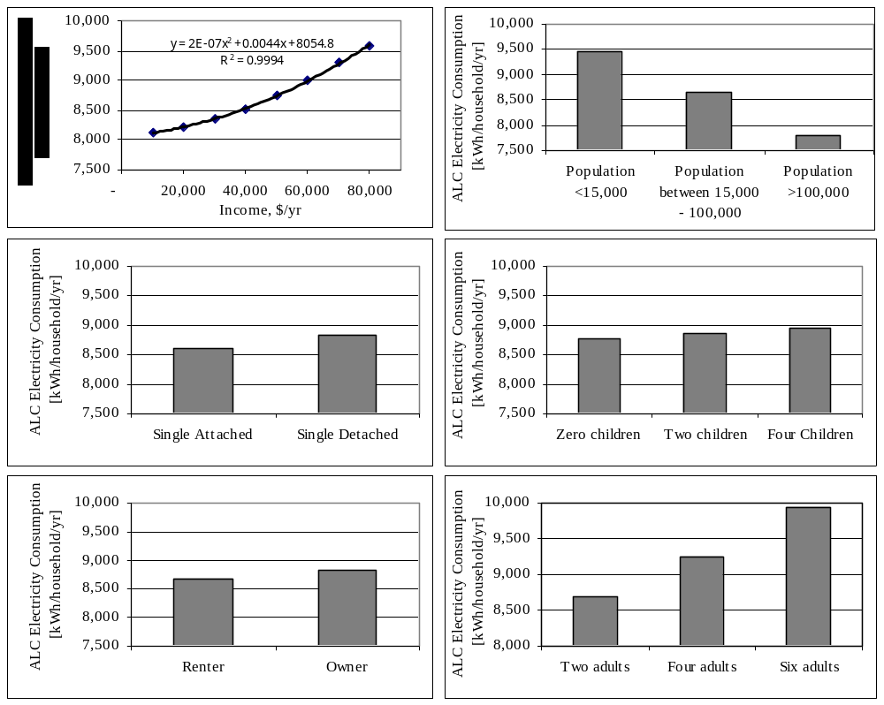

Figure 5.11. Effects of socio-economic factors on the ALC energy consumption of the households estimated by the NN Model

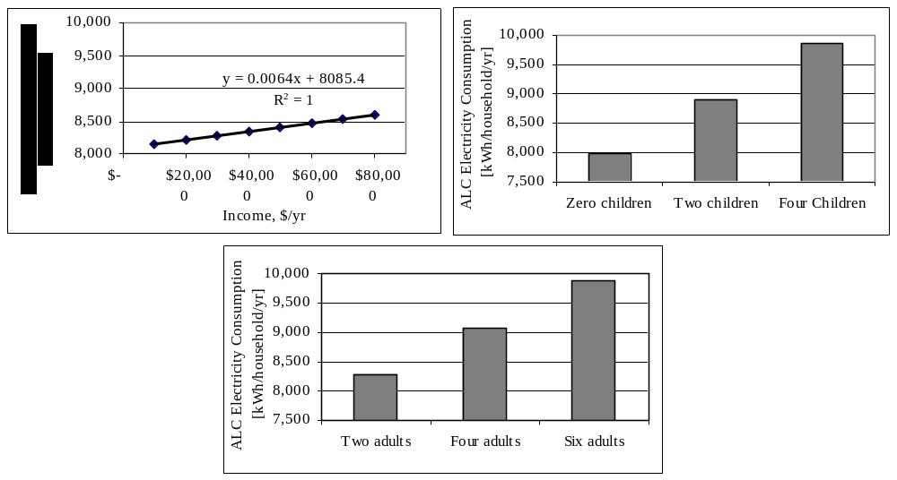

Figure 5.12. Effects of socio-economic factors on the ALC energy consumption of the households estimated by the CDA Model

Impact of Socio-economic Factors on DHW Heating Energy Consumption
The socio-economic factors included in the input dataset of the DHW NN Model are household income, dwelling type and ownership, and size of area of residence. The only socio-economic factor affecting the estimation of the DHW heating energy consumption in the CDA Model is the dwelling type of the households that use natural gas for DHW heating as seen in the CDA NGM given in Equation 4.36. All other socio-economic factors that were initially included in the CDA equations were eliminated as a result of statistical significance and multicollinearity problems as explained in Sections 4.3.1.3, 4.3.2.3, and 4.3.3.3. Thus, the capability of the CDA Model to evaluate the effects of socio-economic factors is significantly reduced.
The effects of the socio-economic factors on DHW heating energy consumption were examined and the results obtained from the NN Model are plotted in Figure 5.13. As seen from Figure 5.13, the estimated DHW heating energy consumption of the households varies as follows:
- DHW heating energy consumption increases linearly with a slope of 0.00004, as the income of the household increases.
- The average DHW heating energy consumption of a single detached dwelling is higher than that of a single attached dwelling. This is due to the fact that in the 1993 SHEU database as the number of occupants increases, the living area of the dwellings increases. As mentioned in Section 5.6.1, single detached dwellings have larger living areas than single attached ones. Consequently, the number of occupants is higher in single detached dwellings than in single attached ones, so is the DHW heating energy consumption.
- DHW heating energy consumption of an owner occupied household is higher than that of a renter occupied household. As mentioned in Section 5.6.1, the majority of the renter occupied households are single attached. Consequently, the single attached dwellings have smaller living areas, fewer number of occupants, and lower DHW heating energy consumption.
- DHW heating energy consumption decreases as the population of the area increases. As mentioned in Section 5.6.1, almost all of the households located in areas with population less than 15,000 are single detached, and have larger living areas, and consequently, higher number of occupants than the single attached dwellings located at populated areas. Therefore, as the number of occupants increases, DHW heating energy consumption increases.

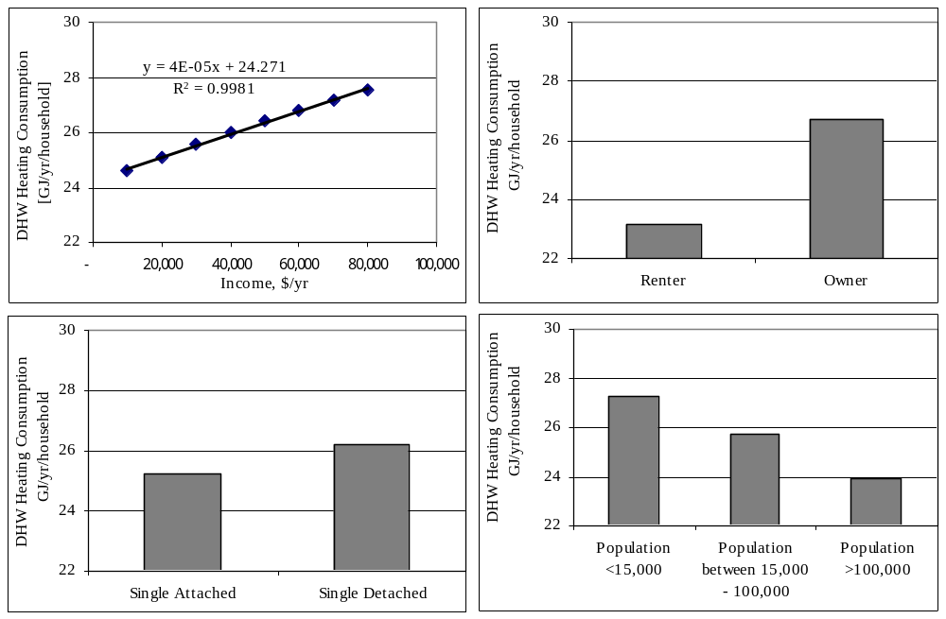

Figure 5.13. Effects of socio-economic factors on the DHW heating energy consumption of the households estimated by the NN Model
Natural gas consumption of single attached and single detached dwellings for DHW heating were estimated using the CDA NGM to be 11.32 GJ/yr/household and 38.18 GJ/yr/household. This corresponds to a difference of 27 GJ/yr/household, which is unacceptably high since the average natural gas consumption for DHW heating was estimated to be 33 GJ/yr/household using the CDA NGM, as given in Table 5.7, and the dwelling type can not have such a large impact on DHW heating energy consumption. On the other hand, the difference in the DHW heating natural gas consumption of the single attached and single detached dwellings was estimated using the NN Model to be 0.6 GJ/yr/household.

Impact of Socio-economic Factors on SH Energy Consumption
The input dataset of the SH NN Model contains information on the socio-economic characteristics of the households; such as household income, dwelling ownership, size of area of residence, and number of children and adults. The effects of the socio-economic factors on the SH energy consumption were examined, and the results obtained from the NN Model are plotted in Figure 5.14. As seen from Figure 5.14, SH energy consumption estimates vary as follows:
- SH energy consumption increases as income increases. This is due to the fact that households with higher income levels have larger dwellings. As the area of the dwelling increases, SH energy consumption increases linearly with a slope of 0.0001.
- SH energy consumption of an owner occupied household is higher than that of a renter occupied household. As mentioned in Sections 5.6.1 and 5.6.2, majority of the owner occupied dwellings are single detached, and the SH energy consumption of the single detached dwellings is higher than the single attached ones, as given in Table 5.11. Consequently, the SH energy consumption of owner occupied households is higher than renter occupied ones.
- SH energy consumption of a household decreases as the population of the area increases. As mentioned in Sections 5.6.1 and 5.6.2, almost all of the households located in areas with population less than 15,000 are single detached, and as given in Table 5.11, the SH energy consumption of single detached dwellings is higher than single attached ones. Therefore, SH energy consumption of the households located in rural areas is higher than those located in urban areas.
- SH energy consumption of a household increases as the number of children and adults increase. This is due to the fact that as the number of occupants increases, the living area increases, as does the SH energy consumption.

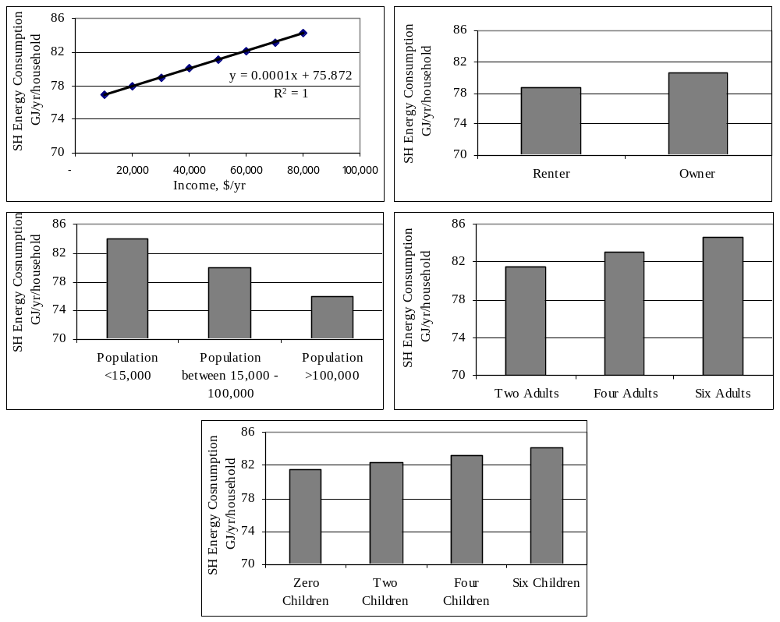

Figure 5.14. Effects of socio-economic factors on the SH energy consumption of the households estimated by the NN Model
The CDA EM given in Equation 4.28 includes the household income, and the CDA NGM given in Equation 4.36 includes the number of adults as socio-economic factors on the SH energy consumption. All other socio-economic factors that were initially included in the CDA equations were eliminated as a result of statistical significance and multicollinearity problems as explained in Sections 4.3.1.3, 4.3.2.3, and 4.3.3.3. Therefore, only household income and number of adults could be evaluated using the CDA Model. The results from the CDA EM and NGM are plotted in Figure 5.15. For comparison purposes, the effect of income on electrical heated households, and the effect of number of adults on natural gas heated households were estimated using the SH NN Model, and results are plotted in Figure 5.16.
As shown in Figures 5.15 and 5.16, as the income of the household increases, the electricity consumption for SH increases in a linear fashion. This is similar to the NN estimates given in Figure 5.14. However, the slope of the line plotted using the NN Model estimates is about one third of the one from the CDA EM.
As shown in Figures 5.15 and 5.16, as the number of adults increases, the natural gas consumption for SH increases, similar to the NN estimates given in Figure 5.14. Compared to NN SH Model estimates, the CDA NGM estimates show a substantially higher increase in the natural gas consumption for SH as the number of adults increases.
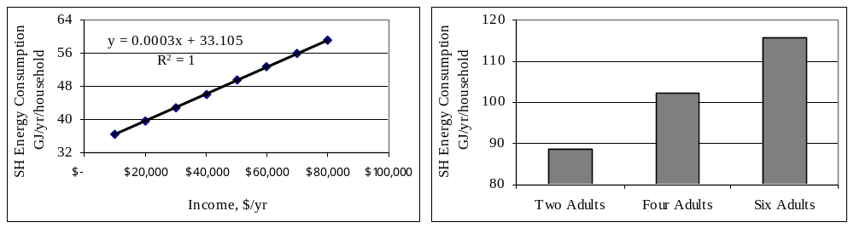

Figure 5.15. Effect of income on electrical SH energy consumption and effect of number of adults on natural gas SH energy consumption estimated by the CDA Model

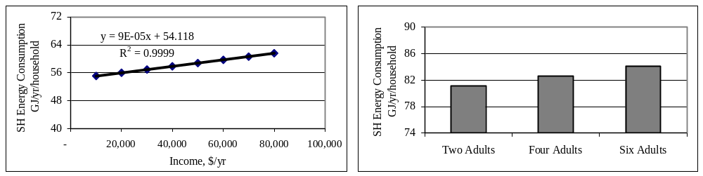
Figure 5.16. Effect of income on electrical SH energy consumption and effect of number of adults on natural gas SH energy consumption estimated by the SH NN Model

Closing Remarks
This chapter presents the results of the comparative assessment of the NN, CDA, and Engineering Models. The detailed information on the development of the NN and the CDA Models was given in Chapter 4. The Engineering Model was developed by Farahbakhsh (1997) and Farahbakhsh et al. (1997, 1998) using the 1993 SHEU database.
In the first section of the chapter, the prediction performance of the models were compared based on the actual and estimated end-use energy consumption of the households in the 1993 SHEU database. The prediction performance of the NN Model was found to be higher than those of the CDA and the Engineering Models.
The weighted average end-use energy consumption of the households without billing data was estimated by the models, and the average percent deviations between the estimates of the NN Model, and the CDA and Engineering Models were calculated for each end-use. The weighted average end-use energy consumption estimates of the models were found to be close to each other with percent deviations in the range of -6.9 to 2.5. The end-use estimates by the three models were also close to the estimates by NRCan and OEE.
The central A/C unit, second refrigerator, and the furnace fan/boiler pump electricity consumption were successfully estimated using the ALC NN Model, whereas the NN Model failed to accurately estimate the electricity consumption of appliances with high saturation values.
The weighted average DHW and SH end-use energy consumption of the households without billing data were categorized based on end-use energy source and fuel type, dwelling type and age. It was found that:
- The DHW NN Model, as well as the CDA and the Engineering Models, are capable of capturing the difference in the DHW heating energy consumption of households using DHW heating equipment with different efficiencies.
- The SH NN Model, together with the CDA and the Engineering Models, are capable of capturing the differences in the SH energy consumption of the households with different SH equipment efficiencies, wall areas, and dwelling types and ages.
In the second section of the chapter, the total energy consumption of the households in the 1993 SHEU database were computed by combining the ALC, DHW heating, and SH energy consumption estimates of the NN, CDA, and Engineering Models. The weighted average household energy consumption estimated by the NN, CDA, and Engineering Models were 139, 132, and 135 GJ/yr/household, respectively. The estimates of all three models are close to the OEE estimate of 134 GJ/yr/household.
The categorized household energy consumption estimates by all three models indicate that electrically heated, and single attached dwellings, and dwellings built after 1988 have the lowest average weighted household energy consumption. The provincial distribution of the household end-use energy consumption estimates demonstrated that households in Quebec have lower; and households in Alberta and Saskatchewan have higher end-use energy consumption. This is due to the fact that the majority of the households in Quebec, and minority of the households in Alberta and Saskatchewan have electrical SH equipment, which have 100% end-use efficiency. Also more than half of the households in Alberta and Saskatchewan have standard (50-65%) efficiency natural gas, oil, or propane fueled SH equipment resulting in high household end-use energy consumption trends in Alberta and Saskatchewan.
In the last section of the chapter, the effects of the socio-economic factors on the ALC, DHW heating, and SH end-use energy consumption of the households in the 1993 SHEU database were assessed by the NN and the CDA Models. It was found that end-use energy consumption of households increases as the household income, and the number of adults and children increase, and decreases as the population of the area increases. It was also found that the end-use energy consumption of single detached dwellings are higher than that of single attached ones, and owner occupied households have higher end-use energy consumption than renter-occupied ones.
The capability of the CDA Model to evaluate the effects of the socio-economic factors is significantly lower than the NN Model since majority of the socio-economic factors were excluded from the model equation to develop a model free of insignificant variables and multicollinearity. However, the NN Model has the capability to evaluate the effects of the socio-economic factors, which are included in the model. The effects of the socio-economic factors cannot be evaluated by the Engineering Model since these factors were not included into the model. However, if sufficient data on socio-economic factors is available, the Engineering Model can evaluate the effects of socio-economic factors when they are included into the model in the form of occupancy profiles or preference profiles.
The comparisons of the model estimates show that the NN Model has a higher prediction performance than the CDA and the Engineering Models, can estimate the energy consumption of individual appliances, can successfully evaluate the differences in end-use and total household energy consumption based on various categories, and has the capability to evaluate the effects of a large number of socio-economic factors.
In the following chapter, impacts of energy saving measures on DHW and SH energy consumption are assessed using the NN Model.

