APPENDIX D

development OF THE sH NETWORK DATASET
SH NETWORK DATASET
Billing data obtained from fuel suppliers and utility companies were available for a subset of 3,341 households in the 1993 SHEU database. As shown in Appendix B, a total of 3,298 bills from 2,749 households were considered reliable. Out of these 2,749 households, there are 2,050 households with electricity bills, 1,012 households with natural gas bills, and 236 households with oil bills. The screening processes used in the selection of the households with the billing data for the development of the SH network dataset are presented in the following sections.

1. Households with Electricity Bills
There are 2,050 households with electricity bills. The distribution of these households based on their end-use electricity consumption is given in Table B.2 of Appendix B. As seen in Table B.2 of Appendix B, there are 25 households using electricity for ALC and SH, and 531 households using electricity for ALC, DHW, and SH.
The ALC electricity consumption estimated by the ALC NN model was deducted from the annual electricity consumption of the 25 households which use electricity for ALC and SH, and 12 households were found to have negative values. Thus, these 12 households were excluded from the analysis.
There are 531 households using electricity for ALC, DHW, and SH in the billing dataset. The ALC and DHW NN models were used to estimate the ALC and DHW heating electricity consumption of these households, respectively. The SH electricity consumption of the 531 households were calculated by deducting the ALC and DHW heating electricity consumption estimates from the annual electricity consumption. From this calculation, 55 households were found to have negative values. Thus, these 55 households were excluded from the analysis.
The number of households with electricity bills reduced to 489 after excluding 67 (= 55 + 12) households as explained above. The distribution of the electricity billing data of the 489 households is given in Figure D.1.

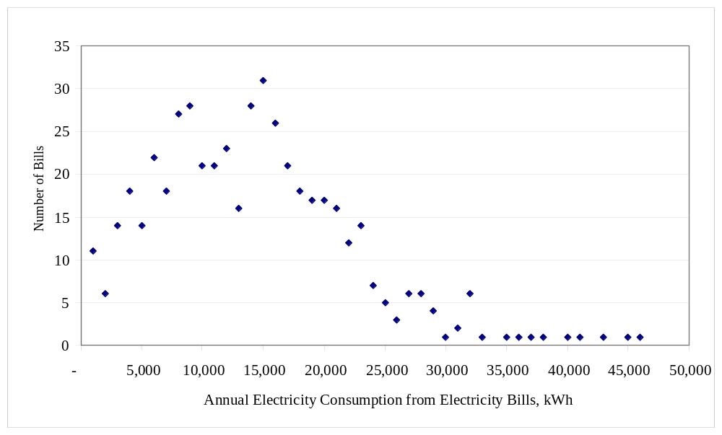
Figure D.1. Distribution of the electricity billing data of the 489 households
As seen from Figure D.1, the annual electricity consumption values of the 489 households are mostly between 5,000 kWh and 35,000 kWh. Thus, the 72 households with billing data less than 5,000 kWh or more than 35,000 kWh were excluded from the analysis. This left 417 households with electricity billing data in the analysis.

2. Households with Natural Gas Bills
There are 1,012 households with natural gas bills. The distribution of these households based on their end-use natural gas consumption is given in Table B.4 of Appendix B. As seen in Table B.4 of Appendix B, there are 63 households using natural gas only for SH, and there are 915 households using natural gas for DHW and SH. There are seven households with natural gas bills, but the data indicate that they do not use natural gas fueled space or DHW heating equipment, or any other natural gas fueled appliances.
There might be other sources of natural gas consumption in the households with natural gas bills other than the natural gas fueled space and DHW heating systems. The natural gas fueled appliances reported in the 1993 SHEU database that would contribute to the natural gas consumption of a household are:
- Oven/stove
- Dryer
- Pool heater
- Fire place
- Supplementary heater
There were 165 households with natural gas bills using one or more of the above natural gas fueled appliances. Thus, these 165 households were excluded from the analysis. This reduced the number of households with natural gas bills to 813: 53 of them use natural gas only for SH and 760 of them use natural gas for DHW and SH.
The DHW heating natural gas consumption of the 760 households was estimated by the DHW NN model. The SH natural gas consumption of these 760 households were calculated by deducting the DHW heating natural gas consumption estimates from the annual natural gas consumption. The distribution of the natural gas billing data of the 813 households is given in Figure D.2.
As seen from Figure D.2, the annual natural gas consumption values of the 813 households are mostly between 700 m³ and 5,000 m³. Thus, the 29 households with billing data less than 700 m³ or more than 5,000 m³ were excluded from the analysis. This left 784 households with natural gas billing data in the analysis.
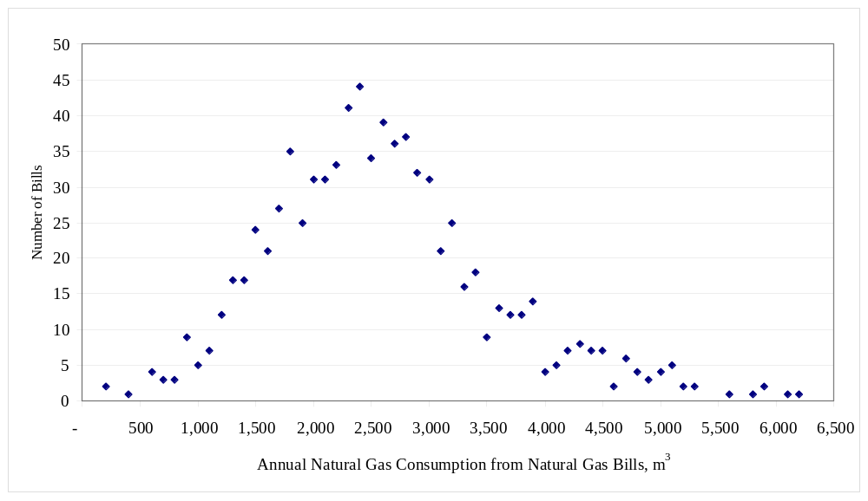
Figure D.2. Distribution of the natural gas billing data of the 813 households

3. Households with Oil Bills
There are 236 households with oil bills. The distribution of these households based on their end-use consumption is given in Table B.6 of Appendix B. As seen in Table B.6 of Appendix B, there are 90 households using oil only for SH and 137 households using oil for DHW and SH. There are six households with oil bills, but the data indicate that they do not use oil fueled space or DHW heating equipment, or any other oil fueled appliances.
The DHW heating energy consumption of the households using oil were not estimated by the DHW NN model, since the households using oil for DHW heating were not included in the dataset used to develop the DHW NN model. Therefore, the 137 households using oil for space and DHW could not be included in the dataset since their oil consumption for DHW heating were not estimated.
There might be other sources of oil consumption in the 90 households with oil bills other than the oil fueled SH systems. The oil fueled appliances reported in the 1993 SHEU database that would contribute to the oil consumption of a household are:
- Oven/stove
- Pool heater
- Fire place
- Supplementary heater
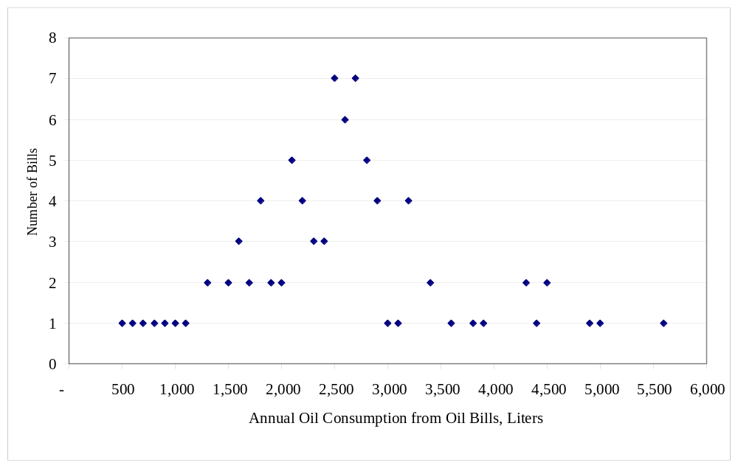
There were three households with oil bills using one or more of the above oil fueled appliances. Thus, these three households were excluded from the analysis. This reduced the number of households with oil bills to 87. The distribution of the oil billing data of the 87 households is given in Figure D.3.

Figure D.3. Distribution of the oil billing data of the 87 households
As seen from Figure D.3, the annual oil consumption values of the 87 households are mostly between 700 L and 4,500 L. Thus, the six households with billing data less than 700 L or more than 4,500 L were excluded from the analysis. This left 81 households with oil billing data in the analysis.

4. Final SH NN Model Dataset
These exclusions left 1,282 households in the analysis: 417 with electricity bills, 784 with natural gas bills, and 81 with oil bills. During the input unit selection step, it was found that 43 households in the dataset have missing information for the chosen input units in the 1993 SHEU database. Thus, these 43 households were excluded from the analysis.
A few number of households in the database use heat pump systems as their SH equipment. Due to the small number of households with these systems and lack of information on the coefficient of performance values of these systems, eleven households that use heat pump systems in the dataset were excluded from the analysis. Thus, the number of households left in the dataset is 1,228 (1282 - 43 –11): 396 with electricity bills, 755 with natural gas bills, and 77 with oil bills.

