Chapter 2
Review of NN and CDA Modeling Approaches

Overview
As presented in Chapter 1, the main objective of this study is to develop two new residential energy consumption models, one using the NN approach and the second one using the CDA approach. In this chapter, a brief background of NN and CDA modeling approaches is presented, followed by a literature review on their use in energy modeling. Next, a detailed overview of each modeling approach and information on estimating energy consumption using each model are presented.

Review of the NN Methodology

Background
A Neural Network (NN), also commonly referred to as an Artificial Neural Network, is an information-processing model inspired by the way the densely interconnected, parallel structure of the brain processes information. In other words, neural networks are simplified mathematical models of biological neural networks. The key element of the NN is the novel structure of the information processing system. It is composed of a large number of highly interconnected processing elements that are analogous to neurons, and tied together with weighted connections that are analogous to synapses.
NNs are capable of finding internal representations of interrelations within raw data. NN are considered to be intuitive because they learn by example rather than by following programmed rules. The ability to learn is one of the key aspects of NNs (Curtiss et al., 1996). This typical characteristic, together with the simplicity of building and training NNs, has encouraged their application to the task of prediction. Because of their inherent non-linearity, NNs are able to identify the complex interactions between independent variables without the need for complex functional models to describe the relationships between dependent and independent variables (AlFuhaid et al., 1997).
Recently, the NN approach has been proposed as a substitute for statistical approaches for classification and prediction problems. The advantages of NNs over statistical methods include the ability to classify in the presence of nonlinear relationships and the ability to perform reasonably well using incomplete databases. The comparison of the results from NNs and statistical approaches indicated that neural networks offer an accurate alternative to classical methods such as multiple regression or autoregressive models (Feuston and Thurtell, 1994; AlFuhaid et al., 1997).
Although the NN concept was first introduced in 1943 (McCulloh and Pitts, 1943), it was not used extensively until the mid-1980's owing to the lack of sophisticated algorithms for general applications, and its need for fast computing resources with large storage capacity. Since the 1980's, various NN architectures and algorithms were developed (e.g. the multi-layer perceptron (MLP) which is generally trained with the error backpropagation algorithm, Hopfield Network, Kohonen Network, etc. [Hassoun, 1995]). Consequently, NN models have been used extensively as a tool for modeling, control, forecasting, and optimization in many fields of engineering and sciences such as process control, manufacturing, nuclear engineering, and pattern recognition.

Use of NNs in Energy Modeling
In the area of end-use energy consumption modeling, the application of NN has been mainly limited to utility load forecasting. There are several hundred papers in the literature on the application of NN for utility load forecasting. These clearly show the superior capability of NN models over conventional methods (such as regression analysis). Park et al. (1991) were the first group of researchers to use NN for load forecasting. The authors used a 3-layer NN to forecast the electrical load in the Seattle/Tacoma area, 1-hour and 24-hours ahead of time. Using past and current ambient temperatures and electrical load, their NN model could forecast the future load with an absolute error of about 1-2% for 1-hour, and 4% for 24-hour ahead forecasts, respectively. For 24-hour load forecasting, Peng et al. (1992) used an improved NN that used an alternate formulation of the problem in which the input was mapped to the output by both linear and non-linear terms, and an improved method for selecting and scaling the input units. Consequently, the absolute error in their 24-hour forecasts was less than 3% for each day of the week, with some days less than 2%.
Kiartzis et al. (1995) also used a 3-layer NN with 24 output neurons, one for each hour of the day (i.e. their model could forecast the next 24-hour load profile on an hourly basis). With a NN made up of 63 input, 70 hidden, and 24 output neurons, the yearly average absolute error of their forecasts was 2.66%. The authors expected that incorporation of additional weather information such as cloud cover, humidity, rainfall, etc. would further reduce the forecast error. Chen et al. (1996) included humidity in their NN model in addition to ambient temperature to account for the effect of humidity on air-conditioning component of the load at three types of sub-stations (residential, commercial, and industrial). The authors used a functional link network algorithm (a combination of the time series and the backpropagation algorithms) to train the network due to its higher convergence speed and accuracy. The load forecasting errors were 1.93, 2, and 2.87% for residential, commercial, and industrial substations, respectively.
AlFuhaid et al. (1997) used a cascaded artificial NN (CANN) to forecast half-hourly loads for the next 24-hours. The CANN approach captured the sensitivity of the non-linear influence of temperature and humidity on the load. The authors used a 3-layer NN (16 input, 8 hidden, and 3 output neurons) as the lower NN, and a 4-layer NN (107 input, 70 hidden, and 48 output neurons) as the cascaded NN. The use of the cascaded NN approach as opposed to standard NN reduced the absolute error from 3.4% to 2.7%.
NN models were used to predict energy consumption of individual buildings since they have a high potential to model nonlinear processes such as building energy loads (Kawashima, 1994). NN applications specifically to building energy analysis were pioneered by the Joint Centre for Energy Management at the University of Colorado, Boulder, about a decade ago. It is reported by Krarti et al. (1998) that Kreider and Wang (1991) were the first to apply a NN model to predict the energy consumption of a building. The electricity consumption of a commercial building was predicted and the results showed that the prediction of the NN model was accurate. The authors indicated that NN was easier to use than classical regression methods since they learn from fact patterns, and there was no requirement for a priori statistical analysis. In a later study by the authors, the NN results were compared with statistical results for the same commercial building data (Kreider and Wang, 1992). The regression model attempted to fit all the data globally, but the accuracy at some specific points was not acceptable. The prediction of the NN model was high for those points where regression method completely missed.
Anstett and Kreider (1993) used NN to predict energy use (steam, natural gas, electricity, and water) in a complex institutional building. The authors used various network configurations, starting with a simple configuration with no hidden layers, moving progressively to more complex configurations with two or three hidden layers. The authors used the month, day of the month, day of the week, and outdoor (high, low, average) temperatures as input units, and evaluated several different training algorithms. The predictive quality of the NNs was found to be satisfactory.
In order to evaluate many of the analytical methods and to asses new methods not widely used in building data studies, an open competition was held in 1993 to identify the most accurate method for making hourly energy use predictions based on limited amount of measured data (Kreider and Haberl, 1994). More than 150 contestants requested the building data. The results of the top six models were presented in the study of Kreider and Haberl (1994). Excellent predictions were achieved by neural networks in all six models, with coefficient of variations ranging from 10% to 17%. The results of the competition indicated that NN of various designs and training methods obtained more accurate values than the traditional statistical methods.
Kreider et al. (1995) used NN to predict the energy consumption of a complex building without knowledge of past energy consumption patterns. In this case, the forecasting problem was more difficult because the forecast was several months into the future rather than few hours. Using dry bulb temperature, humidity ratio, horizontal solar flux, wind speed, hour of the day, and weekday/weekend binary flag as inputs and recurrent (feedback) NNs (with 1- or 2-hidden layers and five or nine neurons, respectively), the authors predicted future heating and cooling loads. The authors also used the NN method to estimate the building equivalent thermal resistance and thermal capacitance from time series data on energy consumption. The assumption was that the energy consumption data contains, or implicitly represents, the characteristics of the building and its usage. Their NN model was able to estimate both the building equivalent thermal resistance and thermal capacitance with less than 1% error.
Besides predicting building energy consumption, NN was also used to predict energy savings from building retrofits (Cohen and Krarti, 1995; Dodier and Henze, 1996). Cohen and Krarti (1995) developed a NN model from the monitored building end-use data available for a given period of time before the retrofit was implemented. Using the pre-retrofit NN model, the future building energy use without the retrofit was predicted. The energy savings were calculated from the difference between the actual post-retrofit measured data and the energy use prediction from the pre-retrofit NN model. In general, the NN model predicted savings within 10%.
Another NN approach to determine energy savings from building retrofits was proposed by Dodier and Henze (1996). The authors used one network for each energy end-use to estimate the pre-retrofit energy consumption of a commercial building. All networks had two hidden layers of 25 neurons each. The energy savings were estimated as the difference between the actual (i.e. measured) post-retrofit energy consumption of the building and the energy consumption predicted by the model for the pre-retrofit building. The energy savings predicted by the model obtained an average coefficient of variation of 17%.
NN approach was used by Olofsson and Andersson (2001) to predict annual energy demands of six Swedish single-family dwellings using data from daily measurements. The authors developed the NN model using daily indoor and outdoor temperature difference, as well as heating and internal use energy consumption data. The NN model had two hidden layers, each with 12 neurons, and trained with generalized delta learning algorithm¹. The authors achieved a deviation of 4 % between the predicated and measured daily energy demands of the dwellings on an annual basis.
As this literature review indicates, NN approach has been widely used for load forecasting. Recently, the approach has been used for estimating the energy consumption of various types of commercial and residential buildings; however, NNs have not yet been used to model the residential energy consumption at the regional or national scale.

Overview of the NN Model
NNs use simple processing units, called neurons, to combine data, and store relationships between independent and dependent variables. An NN consists of several layers of neurons that are connected to each other. This connection is an information transport link from one sending to one receiving neuron.
A widely used NN model called the multi-layer perceptron (MLP) NN is shown in Figure 2.1. The MLP type NN consists of one input layer, one or more hidden layers and one output layer. Each layer employs several neurons, and each neuron in a layer is connected to the neurons in the adjacent layer with different weights.
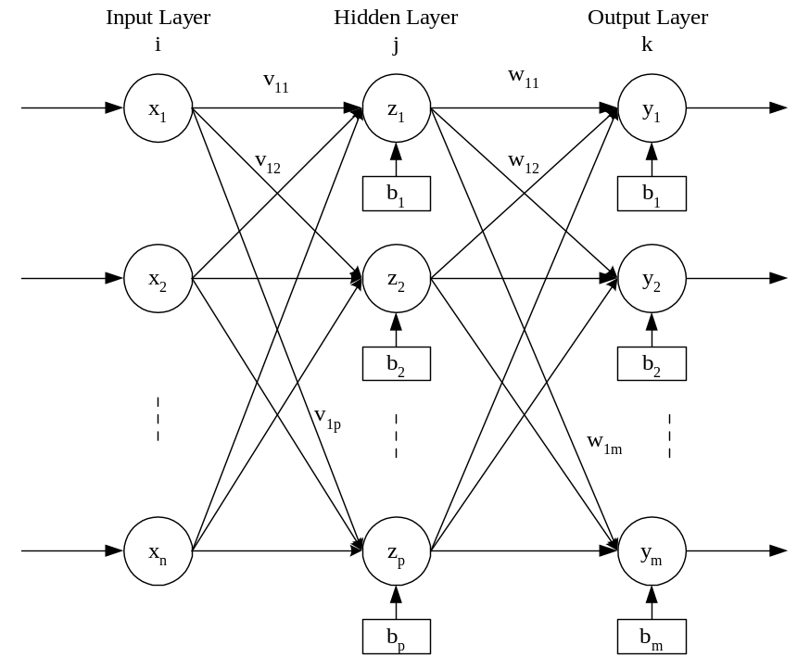
Figure 2.1. Architectural graph of an MLP with one hidden layer
Signals flow into the input layer, pass through the hidden layer(s), and arrive at the output layer. With the exception of the input layer, each neuron receives signals from the neurons of the previous layer. The incoming signals (x_{ij}) are multiplied by the weights (v_{ij}) and summed up with the bias (b_{j}) contribution.
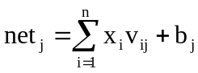 (2.1)
where,
net_{j}: total input of the hidden layer neuron j
x_{i}: input to the hidden layer neuron j from input layer neuron i
v_{ij}: weight between the input layer neuron i and hidden layer neuron j
b_{j}: bias of the hidden layer neuron j
n: number of neurons in the input layer
The output of a neuron is determined by applying an activation function to the total input (net_{j}) calculated using Equation 2.1. The bias (b_{j}) in Equation 2.1 has the effect of increasing or decreasing the total input to the activation function, depending on whether it has a positive or negative value, respectively, and can be evaluated similar to the intercept term in a linear regression model. The bias avoids the tendency of an activation function to get "stuck" in the saturated, limiting value area of the activation function (Kreider and Wang, 1992). The bias is actually a unit connected to a neuron with a weight of one.
Activation functions for the hidden units are needed to introduce nonlinearity into the network. Without nonlinearity, hidden units would not make MLPs more powerful than just plain networks which do not have any hidden layer units, just input and output units. The sigmoid functions, such as logistic and hyperbolic tangent functions, are the most commonly used activation functions in networks trained by backpropagation (Fausett, 1994). The logistic function with the output amplitude lying inside the range [0.0 to 1.0] is shown as:
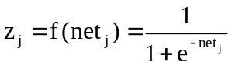 (2.2)
The output amplitude of the hyperbolic tangent function lies inside the range [-1.0 to 1.0], and is shown as:
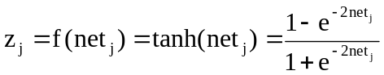 (2.3)
The outputs of the activation functions become the inputs to the layers downstream. The ultimate output of a NN model, y_{k}, is the output of the activation function at the output layer. The activation function for the output units is mostly chosen to be logistic, hyperbolic tangent or linear (identity) functions. The identity function can be shown as
z_{j} = f(net_{j}) = net_{j} (2.4)
If the computed outputs do not match the known (i.e. target) values, NN model is in error. Then, a portion of this error is propagated backward through the network. This error is used to adjust the weight and bias of each neuron throughout the network so the next iteration error will be less for the same units. The procedure is applied continuously and repetitively for each set of inputs until there are no measurable errors, or the total error is smaller than a specified value.
At this point, the net remembers the patterns for which it was trained and is able to recognize similar patterns in new sets of data. Once the structure and training are completed, predictions from a new set of data may be done, using the already trained network. During the training process, the neural network develops the capability of recognizing different patterns and capturing relevant relationships in the training dataset.
Therefore, the underlying assumption in using the NN model is that the relationships between the input and the output variables in the training dataset, the testing dataset, and prediction dataset are the same. This feature of the NN Models can also be seen in CDA models, but not in Engineering Models. The models based on the engineering approach have the capability to estimate a wide range of variables, as long as the detailed house description data are available.

Learning Algorithms
Brief explanations of the learning algorithms used for the training of the feedforward network model are given below, including references for further reading. Somewhat more detailed descriptions are given in Appendix A.

- Backpropagation Algorithms
- Standard (Plain Vanilla) Backpropagation
Vanilla backpropagation algorithm was introduced by Rumelhart and McClelland (1986) and is the most commonly used learning algorithm. During training, each output layer neuron compares its output with its target value to determine the associated error. Based on this error, the error information term is computed (derivation is given in Appendix A), which is used to distribute the error of output layer neuron back to all neurons in the hidden layer by updating the weights between the hidden layer and output layer. In a similar way, the error information term is computed for each hidden unit and used to update the weights between the hidden layer and input layer.
The weight correction term for each weight is computed by using the error information term. Also, a learning parameter which is usually taken as a positive number less than one, is added to the weight correction formula to reduce the changes in the weights, so that the instability (i.e. oscillation) of the network is prevented. The corrections to all weights are done simultaneously by adding the weight correction term to the old weight after each training pattern.

(b) Enhanced Backpropagation
This is an improved version of the standard (vanilla) backpropagation algorithm, which uses a momentum term and a flat spot elimination value. The momentum term introduces the old weight correction term as a parameter during the computation of the new weight correction term. This avoids the oscillation problem common with the standard backpropagation algorithm when the error surface has a very narrow minimum area, and keeps the weight changes going in the same direction (Anstett and Kreider, 1993).
The derivative of the activation function, which is used during the computation of the error information term, goes to zero as the unit's output approaches to the maximum and minimum values of the activation function. Thus, the flat spot elimination value is added to the derivative of the activation function to enable the network to overcome this "sticking weights" problem (SNNS, 1998). The formulae for the computation of weight correction term and error information term are given in Appendix A.

- Quickprop
One method to speed up the learning is to use the information about the curvature of the error surface. The Quickprop algorithm is based on the assumption that the error curve can be approximated by a quadratic polynomial (i.e. parabola), which is concave up (Fausett, 1994). The partial derivative of the error function with respect to the given weight summed over all training patterns is referred as slope and used in the algorithm. The slope term is calculated for all weights as given in Appendix A.
The weight correction term for the hidden and output layer weights is computed by using the information about the previous weight correction term together with the previous and current value of the slope. The initial weight correction term is computed by standard (vanilla) backpropagation algorithm. The computation of the weight correction term is given in Appendix A.

- Resilient Propagation (RPROP)
This algorithm was introduced by Riedmiller and Braun (1993). It performs a direct adaptation of the weight adjustment based on local gradient information. The main difference from other algorithms is that the adaptation is not blurred by gradient behaviour. In this algorithm, the size of the weight correction term is changed directly, i.e. without considering the size of the partial derivative, whose unforeseeable behaviour can disturb the adapted learning rate (Riedmiller and Braun, 1993).
Each weight is introduced by an individual update value, which determines the size of the weight correction term. The update value is computed during the learning process based on the local sign of the error function. Once the update value of each weight is adapted, the weight correction itself follows a very simple rule: if the derivative is positive (i.e. increasing error) the weight is decreased by its update value, if the derivative is negative, the update value is added. The formulae used for the computation of the weight update value and weight correction term are given in Appendix A.

Estimation by the NN Model
To develop an NN model, the dataset is first divided into two sets: one to be used for the training of the network, and the other for testing its performance. Approximately 70 or 80 percent of the dataset is used for training and the rest for testing (Anstett and Kreider, 1993).
After deciding which activation function to use for the hidden and output layer units, the datasets are scaled so that each value falls within the range for which the amplitude of the outputs of the chosen activation functions lie. This is done to prevent the simulated neurons from being driven too far into saturation (Highley and Hilmes, 1993), especially when the data span many orders of magnitude. Anstett and Kreider (1993) found that the [0.1 to 0.9] interval provided better results for their dataset, when logistic function and linear function were used as the activation functions for the hidden and output layer units, respectively. Kawashima (1994) scaled the input data in the [0.0 to 1.0] interval and the output data (target values) [0.1 to 0.9] interval for his network, which used logistic function for both hidden and output layer units. Thus, it is not possible to predict which activation and which scaling interval would be best suited for any given network, and these should be chosen after testing various combinations.
There are no rules to establish the number of hidden layers and the number of neurons for each hidden layer for a particular application. Generally, one hidden layer is sufficient for load prediction (Kawashima, 1994; Stevenson, 1994). Network architecture is decided basically by trial and error; comparing the performance of the nets with different number of neurons in the hidden layer(s).
The weights and the biases are initialized with distributed random values before the training starts. The learning algorithm resulting in the best performance when compared to those of the other algorithms is chosen for the training of the network. The training is repeated until the sum of the square of errors (SSE) for the entire training data is less than a specified value.
A smaller number of data that have never been shown to the network during training, i.e. the testing dataset, is used to test the prediction performance of the network after training is complete. The output of the network for the testing dataset is then descaled to get the original units.

Assessing the Prediction Performance of NNs
To judge the prediction performance of a network, several performance measures are used. Some of these measures are given in Table 2.1, where;
t_{i}: target value of the i^{th} pattern
: mean of the target values
y_{i}: predicted value of the i^{th} pattern
N: number of patterns

Table 2.1. Measures used to judge the performance of NNs
Name | Symbol | Formula | Reference
Fraction of Variance | R² | 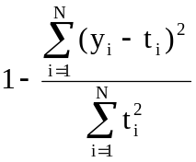 | Anstett and Kreider, 1993
Root Mean Square | RMS | 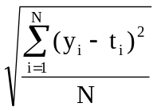 | Kreider and Wang, 1992
Coefficient of Variation | CV | 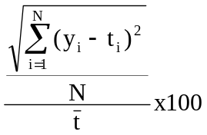 | Kreider and Haberl, 1994
Mean Bias Error | MBE | 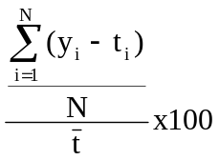 | Kawashima, 1994
Sum of Square of Errors | SSE | 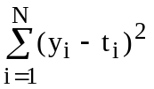

Review of the CDA Methodology

Background
CDA is a regression based econometric technique designed to decompose household energy consumption into appliance-specific components. The regression breaks down the consumption into major end-uses on the basis of the association between appliance holdings and household energy consumption.
CDA was first introduced by Parti and Parti in a study conducted for San Diego Gas & Electric Company in 1977 (Parti and Parti, 1980). The CDA model developed by the authors separated the total household energy consumption into 16 appliance categories based on the data from 5,286 households. Their estimates of appliance energy use were reasonably close to the engineering estimates. Similarly, their estimates for price and income elasticities lied within the range of estimates presented in previous studies.
Four kinds of data are generally used to develop a CDA model: household energy consumption, generally in the form of billing records; information on the household appliance holdings and economic/demographic features, obtained from appliance saturation surveys; weather data; and information on market conditions (e.g. energy prices).
Besides being used to estimate the end-use energy consumption of households (with different physical and demographic characteristics), CDA is used to estimate income and price elasticities (Parti and Parti, 1980), and the hourly load of major household appliances through the day (Aigner et al., 1984; Fiebeg et al., 1991; Blaney et al., 1994; Hsiao et al., 1995). CDA can also be used, to some extent, to assess the impacts of energy conservation measures, such as increasing building envelope insulation and appliance efficiencies.

Use of CDA in Energy Modeling
Aigner et al. (1984) used the CDA method and 15-minute demand data from 130 households to obtain hourly end-use load profiles. The authors used 24 regression equations, each representing an hour of the day, to estimate the consumption through the day. In order to generate more precise estimates, restrictions were imposed on the parameters of the hourly equations, assuming that some appliances were not used in the early hours of the morning and hence could be excluded from those particular equations. The equations were first estimated by Ordinary Least Square (OLS) method (well-known as Gauss and Markov Theorem [Johnston and DiNardo, 1997]) and the multiple coefficient of determination values of the equations ranged approximately from 0.55 to 0.80. Generalized Least Square (GLS) (Johnston and DiNardo, 1997) was also used for the estimation of the hourly end-use loads and the results showed that GLS method estimated the hourly loads lower than the ones estimated by OLS. The estimated hourly loads for most of the appliances were reasonable, whereas some hourly load estimates of dishwasher, clothes washer, cooking range, and clothes dryer were negative (i.e. unreasonable).
In order to improve the accuracy of estimates, Fiebig et al. (1991) reformulated the standard CDA model into a random coefficient framework (Swamy, 1970). During any particular hour, the intensity of use of a particular appliance varies from household to household, and the appliance dummy variables indicate only absence or presence of the appliance and do not allow for variation in size and capacity. Therefore, the authors treated the coefficients of appliance ownership dummy variables as random variables rather than fixed variables, which also enabled the integration of metered data. The authors used a sample of 348 households, with direct metering data for two appliances, namely main tariff water heater and off peak tariff water heater which was charged at a lower than normal rate. For off peak tariff water heater, a total of 125 out of 189 households owning the appliance were directly metered, while it was 21 out of 105 for main tariff water heater. The model obtained positive hourly estimates for all appliances except the freezer. The estimated hourly loads for the off peak tariff water heater was compared with the average hourly loads obtained from the direct metering data, and the estimated hourly loads obtained from a random coefficient model which was not integrated with direct metered data. The results showed that estimates from the model integrated with metered data were closer to the direct metered data than the ones obtained from the model without the integration of the direct metered data.
Bauwens et al. (1994) used a Bayesian approach (Zeller, 1971) to integrate the direct metering data by viewing the data as prior information on the energy consumption of a specific appliance. A sample of 174 households from the dataset used by Fiebeg et al. (1991) was used to estimate end-use consumption on weekdays and weekends. Direct metering data for the main and off peak tariff water heaters were available for 21 and 87 households, respectively. The results from the standard CDA contained negative estimates for freezer and pool pump for both weekdays and weekends, whereas, the CDA model reformulated using the Bayesian approach to integrate the direct metered data obtained no negative estimates for any appliance.
To estimate the hourly electricity use of 15 residential end-uses, Blaney et al. (1994) used a CDA model incorporated with Bayesian priors of electricity use for each end-use estimated using the results of a previous monthly CDA and load shape representations developed from an earlier residential household metering project. The database used in the model contained information on the electricity consumption, appliance stock, physical and demographic characteristic data for 181 households and actual hourly temperature for each household's region. The estimates obtained from standard CDA were statistically significant and had the right sign, however the estimated load shapes for highly saturated appliances, i.e. appliances owned by the majority of the households such as clothes washer and microwave, were not reasonable. The incorporation of the Bayesian priors greatly improved the estimated load shapes for these highly saturated appliances.
The metered data information from a 1986 survey that included space heating direct metering data for 30 and water heating direct metering data for 23 households were used by Hsiao et al. (1995) to form prior distributions of appliance consumption. Then, by applying Bayesian technique, these prior distributions were combined with the load, appliance ownership, and demographic data from a survey conducted in 1983 including 347 households. The model included the interactions of appliance dummy variables with socio-economic variables, and weather data as explanatory variables. The hourly water and space heating consumption estimates from standard conditional demand analysis approach were compared with the ones obtained from the proposed approach. The comparison done by evaluating the hourly consumption profiles showed that the proposed approach obtained more reasonable hourly estimates for water and space heating consumption.
Either random coefficient framework or Bayesian analysis were used by Fiebig et al. (1991), Bauwens et al. (1994), Blaney et al. (1994), and Hsiao et al. (1995) to integrate prior information on end-use energy consumption in terms of metered data into the CDA models to increase the accuracy and reliability of the estimates. The following studies integrated the estimates from the engineering models into their CDA models.
Caves et al. (1987) treated the information from the engineering approach as prior evidence on usage patterns for specific appliances, and by using Bayesian analysis, engineering estimates were integrated into CDA model to estimate hourly appliance consumption. The sample data of the analysis contained electric consumption and appliance ownership information for 129 households for two summer months in 1977. The engineering estimates were generated from a simulation program running twelve scenarios. Average loads for each of these appliances for the sample data were constructed using a weighted average of the twelve scenarios, where the weights reflected the housing type and size characteristics of the sample, and the distribution of the sample households between the weather districts. The dishwasher and central air conditioning hourly loads estimated by engineering simulation model and the proposed model were compared. For central air conditioning, both methods provided similar estimates, but for dishwasher the estimates differed considerably, since dishwasher consumption was more dependent on consumer behaviour than that of central air conditioning.
The Statistically Adjusted Engineering (SAE) model developed by Train (1992) combined engineering estimates of end-use loads with CDA. The survey data and consumption information at both the household and end-use levels of 800 households were used in the study. The engineering estimates of loads for each end-use were entered as explanatory variables in CDA model. The estimated coefficients of these variables adjusted the engineering loads statistically to reflect the actual total loads of households. These estimated loads and engineering loads were then compared with metered end-use loads for the same households. It was found that SAE model improved the engineering estimates considerably for space conditioning appliances, but added error to the engineering estimates for other appliances.
One of the Canadian CDA models was developed by Kellas (1993) using the data from the Residential Energy Use Survey conducted by Manitoba Hydro in 1991 together with the 1991 weather data. The model included 38 independent variables, including appliance ownership dummy, demographic, and weather variables, and achieved multiple coefficient of determination of 0.75. The estimates of the model showed an error of 2.8% when compared with the billing data. Due to the multicollinearity problem, the author faced difficulties in predicting the energy consumption of highly saturated appliances, such as refrigerator and clothes washers. The estimates for space and DHW heating energy consumption were reasonable, but the estimates for space cooling were high, i.e. about 1,360 kWh/yr/household.
Lafrange and Perron (1994) used the data from 1979, 1984 and 1989 large-scale surveys for Hydro-Quebec to estimate residential end-uses using CDA approach in Quebec. The surveys included technical characteristics of the dwellings and appliances, and demographic characteristics of the occupants. The estimates for DHW heating energy consumption were reasonable, however space heating estimates were low and cooling estimates were high. The estimates showed similarities with engineering model estimates, but the space heating estimate was lower than the engineering model estimate. Like other researchers, the authors had difficulties to estimate the consumption of highly saturated appliances.
This literature review indicates that in the 80’s and mid 90’s the CDA approach has been widely used to model energy consumption in the residential sector. Although various methods have been used to increase the accuracy of CDA models, and the reliability of the estimates, the CDA approach has not received wide acceptance due to its low prediction performance, and the high cost of obtaining prior information in terms of metered data or engineering estimates. Like the NN approach, the capability of the CDA models is limited to the variables used in the model equation, thus limited energy efficiency measures can be tested using the CDA approach.

Overview of the CDA Model
The energy consumption of a household can be expressed as a summation of the energy consumed by each of the appliances present in the household. Thus, the energy consumption of a household is directly related to the appliance stock present in the dwelling, specific features of these appliances, dwelling characteristics, and utilization patterns such as thermostat settings on water/space heaters, and behavioural patterns relating to the use of appliances.
The basic CDA model can therefore be represented in algebraic form as (EPRI, 1989):
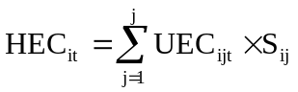 (2.5)
where,
HEC_{it}: energy consumption by household i in period t
UEC_{ijt}: end-use j unit energy consumption of household i in period t
S_{ij}: a binary indicator of household i's ownership of appliance j
To develop a CDA model, the data on household energy consumption (HEC_{it}) can be obtained from utility billing records and appliance stock (S_{ij}) information can be obtained through an appliance saturation survey.
The end-use energy consumption depends upon a variety of factors and this relationship can be formalized as:
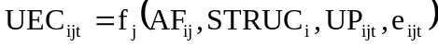 (2.6)
where,
AF_{ij}: features of household i's appliance j
STRUC_{i}: structural features of household i
UP_{ijt}: utilization patterns relating to appliance j
e_{ijt}: a random error term for the end-use
The effect of weather conditions (WC_{it}), market conditions (MC_{it}), and household's economic and demographic characteristics (EDC_{i}) on the end-use energy utilization pattern can be shown as:
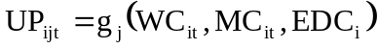 (2.7)
Substituting Equation 2.7 into Equation 2.6 yields:
(2.8)
And finally substituting Equation 2.8 into Equation 2.5 gives the general equation:
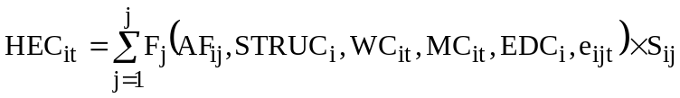 (2.9)
Since the individual error terms are additive within their respective UEC functions, the household energy consumption equation can then be written as:
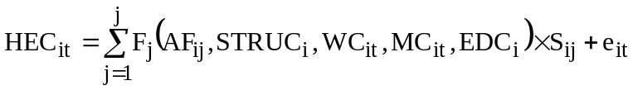 (2.10)
where 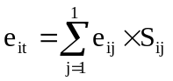
In most CDA models, multicollinearity problem arises, which is caused by correlation amongst the variables included in the CDA Model, limiting the capability of the regression to distinguish the impacts of these variables. Thus, the influence of some individual appliances on the total end-use energy consumption becomes difficult to separate. Mostly, appliances with high saturation cause multicollinearity problems. Moreover, it is not uncommon for this approach to yield unrealistic negative appliance consumption estimates, because of the high degree of multicollinearity.
The problem of multicollinearity is a gap between the information requirement of the model and the information provided by the sample data. The way to reduce this gap is to either expand the information content of the data, reduce the requirements of the model, or both. It is possible to reduce the problem of multicollinearity by expanding the sample size, as long as the configuration of appliance ownership is not of exactly the same pattern among individual observations. However, it requires an important expansion of sample size before a reasonable reduction in the degree of multicollinearity may be achieved (Hsiao et al., 1995). Therefore, as shown in the previous section, reduction in the requirements of the model through the use of prior information in the form of data obtained by directly metering specific appliances (Fiebeg et al., 1991; Bauwens et al., 1994; Blaney et al., 1994; Hsiao et al., 1995), or engineering estimates (Caves et al., 1987; Train, 1992) is an approach used by researchers with varying degrees of effectiveness.
In some cases metering data on one or more appliances is available only for a subset or a few of the total number of households, since direct metering of all of the houses in the database is not cost-effective. Thus, an appropriate method of incorporating limited direct metering data into the CDA model should be considered (Caves et al., 1987; Fiebeg et al., 1991; Train, 1992; Bauwens et al., 1994; Blaney et al., 1994; Hsiao et al., 1995).

Estimation of the CDA Model
The CDA model can be estimated statistically by standard multivariate regression analysis using data on household energy consumption, appliance saturation, and other variables given in Equation 2.10.
The overall fit of the CDA model depends on the model specification and data quality. In general, the multiple coefficient of determination values of these models range from 0.55 (Aigner et al., 1984) to 0.75 (Kellas, 1993). These values might seem low, but explaining the cross sectional behaviour of individual households is a difficult process since energy consumption is affected by many other factors that cannot be readily identified or quantified (tastes, habits, special circumstances), and consequently, can not be incorporated into the model. Similarly, it is not possible to incorporate all of the house characteristics (e.g. wall, roof, window, etc. areas, insulation values, infiltration, solar heat gains, climatic factors, etc.) into the regression model.
Once the CDA model is estimated statistically, it can be used to predict the UEC of individual households, as well as a designated group of households.

Closing Remarks
In this chapter, reviews of NN and CDA models used in energy consumption modeling are presented. Neural networks have been widely used in load forecasting, but there are only a few studies on commercial and residential energy consumption estimation. These few studies are limited to estimating the energy consumption of individual or a very small number of buildings.
The CDA approach has been used to disaggregate the whole house electricity consumption into end-uses. To increase the accuracy and reliability of the estimates, recent studies integrated metered data or engineering estimates into the CDA models using Bayesian or random coefficient framework techniques with varying levels of success. Despite these efforts, the CDA approach is not preferred due to the low accuracy of its estimates and the high cost of obtaining prior information in terms of metered data or engineering estimates.
The capability of the NN and the CDA approaches to estimate the impact of energy efficiency measures is limited to the input units included in the models and the dataset used to develop the models. However, the Engineering Models have the capability to estimate the impact of a wide range of measures, as long as detailed house description data are available. In the next chapter, the methodologies used to develop the NN and CDA models are presented.

The definitions of the NN terms such as input, output, and hidden layers, neurons, and learning algorithms are given in Section 2.2.3.
The definition of the coefficient of variation is given in Section 2.2.5.
The definitions of the datasets used in the NN development are given in Section 2.2.4.
Here the term "appliance" is used in the most general way, including the space and domestic hot water heating as well as space cooling equipment.

