Development of occupant-driven load profiles

for building simulation

Submitted to:

Alex Ferguson
CETC Buildings Group
Natural Resources Canada
13th Floor, 580 Booth Street
Ottawa, Ontario
K1A 0E4

CREEDAC Project Team:
Joel Good
Alan Fung
Haixiong Zhang

March, 2004

TABLE OF CONTENTS
LIST OF FIGURES ii
LIST OF TABLES iii
1 INTRODUCTION 1
2 Occupant driven Load profiles 1
2.1 identifying applicable accounts 2
2.2 identifying continuous furnace fan operation 3
2.3 Identifying the possibility of additional hvac applications 4
2.4 Determining a Load Value for Furnace Fan Operation 5
2.4.1 Determining a Load Value for Standby Power Requirements 8
2.4.2 Furnace Fan Operation Load Values 9
2.5 Creating an Occupant-Driven Load Profile 10
2.5.1 Proposed Alternate Procedure for Creating Occupant-Driven Load Profiles 11
3 Determination of Occupant-Driven Trends Among Household Classifications 12
3.1 Region 13
3.2 Number of Occupants 14
3.3 House Type 15
3.4 House Size 16
3.5 Space Heating Fuel Type 17
3.6 Total Annual Energy Use 18
4 Determining a Best-Match Profile for Occupant Driven Load ProfilES 19
5 Determining the Probability of Air-conditioning Usage 22
6 Literature Cited 27

LIST OF FIGURES
Figures 1 to 3: Furnace Fan Operation: Min & Avg Monthly Load Profiles
Figure 4: Average Daily Load Profiles: Region
Figure 5: Average Daily Load Profiles: Number of Occupants
Figure 6: Average Daily Load Profiles: House Size
Figure 7: Average Daily Load Profiles: SH Fuel Type
Figure 8: Average Daily Load Profiles: Annual Consumption
Figure 9: Best-Match Profiles: Actual vs. Avg Data
Figures 10 and 11: A/C Usage Load Profiles
Figures 12 and 13: A/C Usage Load Profiles
Figure 14: No A/C Usage Load Profile

LIST OF TABLES
Table 1: Applicable Accounts (Complete Data & Survey Information)
Table 2: Accounts with Continuous Furnace Fan Operation
Table 3: Systems and Fuels for Accounts with Continuous FF Operation
Table 4: Furnace Fan Load Values for Discernable Accounts
Table 5: Average Total Annual Energy Consumption by Group
Table 6: Sample Size of Regional Classification
Table 7: Sample Size of Occupant Classification
Table 8: Sample Size of House Size Classification
Table 9: Sample Size of Fuel Type Classification
Table 10: Sample Size of Annual Consumption Classification
Table 11: Best-Match Accounts by Grouping

INTRODUCTION
The second project task was to determine a set of occupant-driven load profiles suitable for use in building simulation, using whole-house electric load and demographic data collected by BC-Hydro. These load profiles will be categorized and analyzed to better understand the trends associated with electricity use and geographic, demographic, and physical differences between houses. A final task will assess the possibility that the house described by the profile uses an air-conditioner in the summer months.

Occupant driven Load profiles
In order to isolate the occupant-driven load profiles, the loads associated with HVAC operation are to be disaggregated from the total load data where possible. The procedure established to create this strictly occupant-driven load profile is described in the following subtasks to determine:
- all applicable accounts,
- the houses that operate a furnace fan at all times,
- whether the furnace fan is the only operating HVAC application,
- a load value for furnace fan operation,
- a load value for standby power requirements.

identifying applicable accounts
The first step in identifying an occupant-driven load is to determine which accounts are applicable to the study. The only accounts that can be used must have both complete survey responses as well as a complete yearly set of 15-minute load data. Thirty-two (32) separate accounts met these criteria providing a total of one-hundred-and-seven (107) individual yearly accounts. Six (6) of theses accounts had full data for all study years. A summary of the applicable accounts is provided in Table 1.

 | Availability of Survey Information for Study Years
Account ID | 1995-96 | 1996-97 | 1997-98 | 1999-00 | 2000-01
2001899
2002367
2002529
2002550
2002828
2003623
2003725
2003765
2003778
2003981
2004357
2004575
2004699
2004741
2004749
2005201
2005304
2005490
2005521
2005571
2005607
2005678
2006006
2006040
2767818
2983460
3091971
3898678
3909952
4236074
4854779
5142189
Table 1: Applicable Accounts (Complete Data & Survey Information)

identifying continuous furnace fan operation
In order to determine a furnace fan load value, accounts need to be identified where the operation of the furnace fan can be accurately determined. As the exact times that intermittent fan operation occurs is impossible to determine the only comparable accounts will be those that have continuous furnace fan operation, either year round or during the heating season.
Within the BC Hydro Residential End Use Survey, question 16c specifically asks: “how long does your furnace fan blower operate?”. The furnace operates continually if the homeowner selected 2) “continuously during the heating season to provide ventilation”, or 3) “continuously year round to provide ventilation”. Upon investigation, of the thirty-two (32) applicable accounts there were a total of three (3) houses that have a furnace fan that operates continuously year round and two (2) houses that have a furnace fan that operates continuously during the heating season only. The homes that have continuous fan operation are identified in Table 2.
Account ID | Continuous furnace fan operation
2002367 | During heating season only
2002550 | Year round
2004357 | During heating season only
2005304 | Year round
4854779 | Year round

Table 2: Accounts with Continuous Furnace Fan Operation

These five (5) accounts will be used to determine a value for furnace fan load, but first it must be verified that the furnace fan is the only HVAC operation for these homes.

Identifying the possibility of additional hvac applications
It was determined by a scan of the results of the BC-Hydro survey that, for the five houses with continuous furnace fan operation, the furnace fan is the only HVAC device. Investigation results are summarized in Table 3.

Account ID | Fuel used for Space Heating (Q13) | Type of Heating System Used (Q15) | Operation of Furnace Fan  (Q16 C) | Fuel used for heat hot water tank (Q18)
2002367 | Natural gas | Furnace (Central forced air only) | Continuously during the heating season to provide ventilation | Natural gas
2002550 | Natural gas | Furnace (Central forced air only) | Continuously year round to provide ventilation | Natural gas
2004357 | Natural gas | Furnace (Central forced air only) | Continuously during the heating season to provide ventilation | Natural gas
2005304 | Natural gas | Furnace (Central forced air only) | Continuously year round to provide ventilation | Natural gas
4854779 | Natural gas | Furnace (Central forced air only) | Continuously year round to provide ventilation | Natural gas
Table 3: Systems and Fuels for Accounts with Continuous FF Operation

With the furnace fan being identified as the only HVAC operation a load value can now be determined.

Determining a Load Value for Furnace Fan Operation
For the five homes identified as running their furnace fans continuously (either year round or for the heating season only) the load data will be reviewed to determine the load value of the furnace fan. The intent is to determine a time when the only electrical load in the home is the furnace fan. The time chosen when little other electrical activity is expected in the house is the period between 2:00 am and 5:00 am. By analyzing the monthly minimum load value for each 15-minute subsection of the described time period a typical minimum load will be established that can be attributed to the furnace fan operation.
There will be some error associated with this technique as there will also be standby load requirements for electronic equipment associated with this minimum value as well as non-continuous consumption by fridges, freezers, dhw heaters, and security lights. The latter three loads are assumed to be irrelevant as they are identified as having sporadic, non-continuous operation and by comparing just the minimum 15-minute load values over the 3-hour time span, the individual spikes of high electricity-use associated with these operations will be filtered out. Due to the continuous nature of the standby electricity requirements, an associated load value will be attempted to be determined in Section 2.4.1.
As well as the five identified houses the remaining twenty-seven accounts in the pool were analyzed in an attempt to identify similar differences between heating and cooling season, despite the unpredictable nature of their furnace fan operation. Two other houses showed potential for extracting a furnace fan load value, they are 2001899 and 2002529. These accounts will be used in conjunction with the other five to determine the furnace fan load.
The following graphs, Figures 1 - 3, show a sample of the minimum and average load profiles for the selected houses. It can be seen that a clear difference exists in the minimum values for the heating and non-heating season for houses that identified continuous operation for the heating season only. This difference is attributable to the furnace fan.
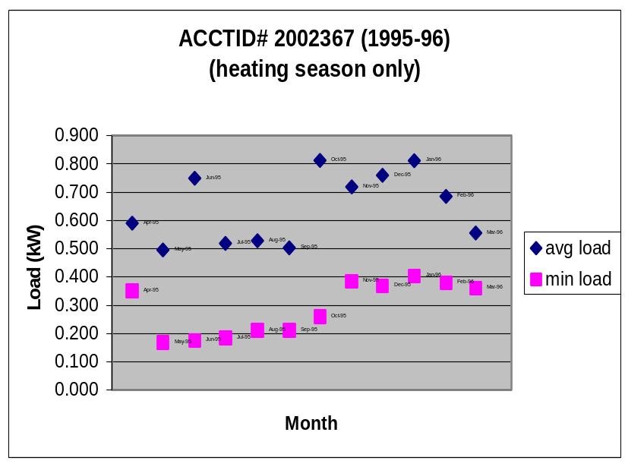

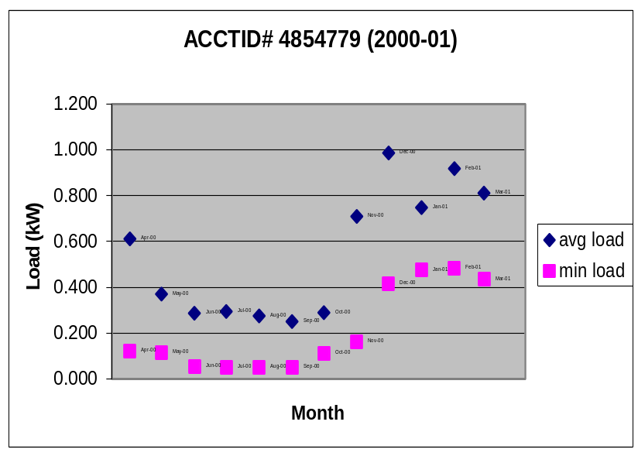
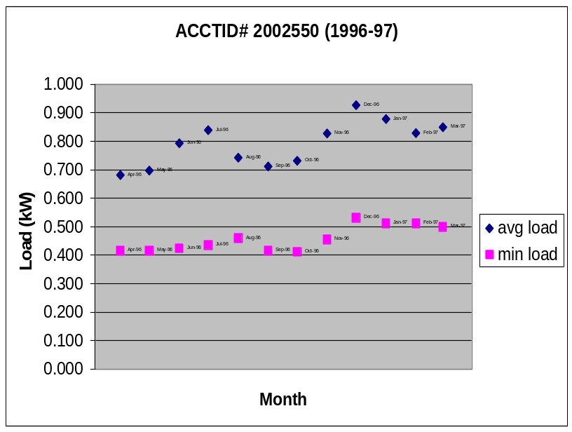
Figures 1 to 3: Furnace Fan Operation: Min & Avg Monthly Load Profiles

Unfortunately, only two of the accounts (ie. Figures 1 & 2) showed a discernable difference between seasonal minimum load values. The accounts that have continuous year-round furnace fan operation (ie. Figure 3) could not produce a seasonal load difference that could be considered attributable solely to the furnace fan operation. The minimum load would also include the loads associated with standby power requirements; this value will be disaggregated in the following section.

Determining a Load Value for Standby Power Requirements
In order to determine the occupant driven load more accurately a method was developed to determine a rough value for the standby power consumption. The survey results identified four houses (2004741, 2005201, 2005607 and 2006040) that use electricity to meet their space heating requirements. This means that no furnace fan is in operation. The resulting electric load for low occupant activity hours (designated as 2-5am) for these houses will then be due strictly to security lighting, domestic hot water heater, freezer and refrigerator operation, and standby power requirements. By taking a minimum value for this time period all other electrical requirements, aside from standby power, can be eliminated as the refrigerator, freezer and dhw heater operate cyclically and the security lights for each of the houses were surveyed as not operating for more than 2 hours a day. The standby power requirement should be constant year round.
Survey answers were found to be inaccurate as non-constant minimum load values indicated the existence of furnace fan operation. From the first set of complete data (1996-97) only one house (2006040) showed a constant value that could be considered solely due to standby power requirements; the value was between 50 and 55 W. This value was consistent with the data for the following year. A second account was determined as having no furnace fan operating (2005571) and the standby power requirements were similar to the previous account. These standby power requirements are consistent with other studies (CREEDAC, 2001; Fung et al., 2003) and will be used to create occupant driven load profiles for the houses with year-round, continuous furnace fan operation.

Furnace Fan Operation Load Values
Two techniques were used to determine furnace fan load values. For houses with continuous furnace fan operation for heating season only the difference between the seasonal minimum loads could be contributed solely to the furnace fan operation. For houses with continuous furnace fan operation for the entire year the furnace fan load was determined by removing the estimated standby power requirements from the otherwise constant minimum load values for the house. Table 4 displays the resulting furnace fan load values that were derived for each individual account.

Account ID | Year | Furnace Fan Load (W)
2002367 | 1995-96 | 186
2002367 | 1996-97 | 202
2002367 | 1997-98 | 173
2002367 | 1999-00 | 264
2002367 | 2000-01 | 243
2002550 | 1995-96 | Values too low – no fan
2002550 | 1996-97 | 408
2002550 | 1997-98 | 452
2002550 | 1999-00 | 520
2005304 | 1995-96 | 160
2005304 | 1996-97 | 83
2005304 | 1997-98 | 149
2005304 | 2000-01 | 105
4854779 | 2000-01 | 362
Table 4: Furnace Fan Load Values for Discernable Accounts
These values agree well with other published furnace fan consumption data (Proctor & Parker, 2001; CMHC, 2004).

Creating an Occupant-Driven Load Profile
In order to create a strictly occupant-driven load profile the HVAC related loads must be teased out of each load profile. It was determined in the previous sections that the only HVAC related load that could be accurately predicted was the load of the furnace fan. It would be ideal if the HVAC related load could be teased out of every household load profile but due to the unpredictable nature of furnace fan operation for most households the HVAC load could not be removed. The households that specified in the survey precisely when their furnace fan operates, either continuously year-round or during the heating season, are the only ones that can safely have the HVAC load deducted from the total load; five such households were identified. A furnace fan load, as determined in Section 2.4.2 (Table 4), was deducted from the household profiles creating a strictly occupant driven load profile. The assumption had to be made for the remaining accounts that the original load profiles are the best possible representation of an occupant-driven profile.

Proposed Alternate Procedure for Creating Occupant-Driven Load Profiles
It can be seen from the BC-Hydro survey responses and the corresponding load profiles that the most common HVAC control scenario is one in which the furnace fan operates intermittently, corresponding with furnace operation. The frequency with which a furnace operates is therefore dependant on the heat gain and heat load of each individual house. This made it impossible to accurately predict the times in which a furnace fan load could be removed from a house’s overall profile. An approach is therefore proposed, for simulation purposes, to more accurately discern HVAC related loads.
During simulation a heating energy demand value for a house can be determined for every 15-minute time-step. By determining the temperature difference that exists between the outdoor and indoor temperature, the corresponding period of operation for the furnace fan, over that time step, can be determined as well. The electrical consumption of the furnace fan can then be determined by multiplying this necessitated operation time by the furnace fan load. This load value could be the actual value (when available) or a typical load value, as determined in previous sections. The furnace fan load can then be subtracted from the overall electrical load for either the specified 15-minute time step or the following one (as outdoor temperature typically does not vary drastically during a 15-minute interval). The procedure is then iterated to create a modified load profile independent of the furnace fan load. The result will be a load profile that is not just an average offset of the total load curve but a profile with varying HVAC reductions that more accurately represent the operation of the furnace fan.

Determination of Occupant-Driven Trends Among Household Classifications
A set of load profiles now exist that best represent occupant–driven electricity usage. To be able to use the set of occupant driven load profiles for building simulation purposes descriptors must be attached to each profile to accurately represent geographic, demographic, and physical differences that exist between the profiles. Trends were investigated for the following classifications: region, number of occupants, house type, house size, space heating fuel type, and total annual energy use. For each of the groupings, the average was taken of the total annual energy consumption. This information is intended to help indicate general energy consumption trends across the groups, and has been included as Table 5.

Categorization | Grouping | Average Annual Energy Consumption for Group (kWh)  Group (kWh)
Region | LM | 12,938
Region | N | 7,898
Region | S | 11,698
Region | VI | 16,046
Annual Energy Consumption | 0 to 9,999 kWh | 7,726
Annual Energy Consumption | 10,000 to 19,999 kWh | 14,565
Annual Energy Consumption | 20,000 to 30,000 kWh | 24,021
House Size | 0 to 1,499 ft² | 9,039
House Size | 1,500 to 2,499 ft² | 13,466
House Size | 2,500 to 4,500 ft² | 14,117
Number of Occupants | 1 | 11,635
Number of Occupants | 2 | 11,145
Number of Occupants | 3 | 16,413
Number of Occupants | 4 | 14,482
Primary SH Fuel Type | Natural Gas | 10,690
Primary SH Fuel Type | Electricity | 22,959
Primary SH Fuel Type | Oil | 10,823
Table 5: Average Total Annual Energy Consumption by Group

Region
The BC-Hydro load profiles were already divided into four geographical regions. These represent Vancouver Island (VI), the Lower Mainland (LM), the Southern Interior (SI), and the North (N). Of the 32 profiles with survey information and complete load data the regional breakdown is: twelve (12) from VI, seven (7) from LM, five (5) from SI, and eight (8) from N. The make-up of the sample size is outlined in Table 5.
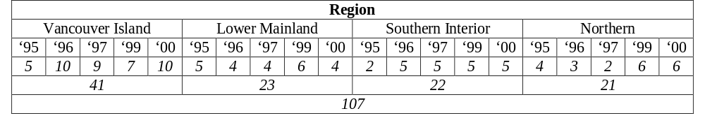
Table 6: Sample Size of Regional Classification

Figure 4 illustrates how the average occupant-driven load profiles vary based on the regional categorizations.
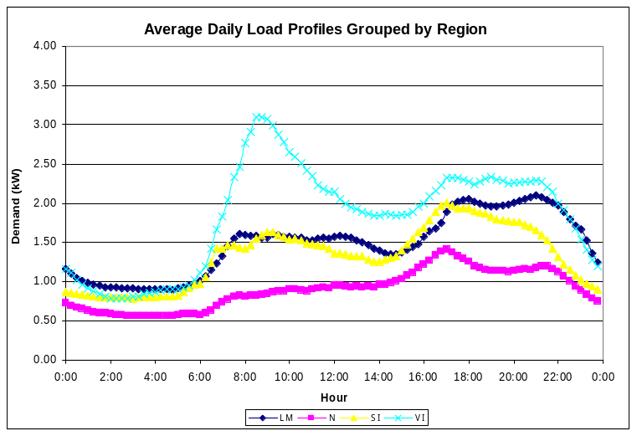
Figure 4: Average Daily Load Profiles: Region

Number of Occupants
The thirty-two accounts with survey information also provided information regarding number of occupants per household. For purposes of comparison the houses were grouped into four categories. Of the thirty-two houses, eight (8) had one occupant, twelve (12) had two occupants, five (5) had three occupants, and six (6) had four occupants. As well, one house was identified as having nine occupants but since this was found to be non-representative of the overall housing stock it was not considered in the comparative review. The make-up of the sample size is outlined in Table 6.
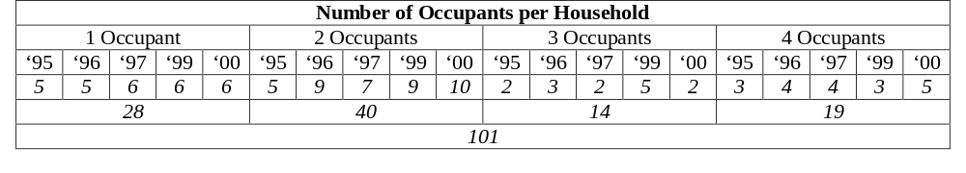Table 7: Sample Size of Occupant Classification

Figure 5 illustrates how the average occupant-driven load profiles vary based on the number of occupant categorizations.
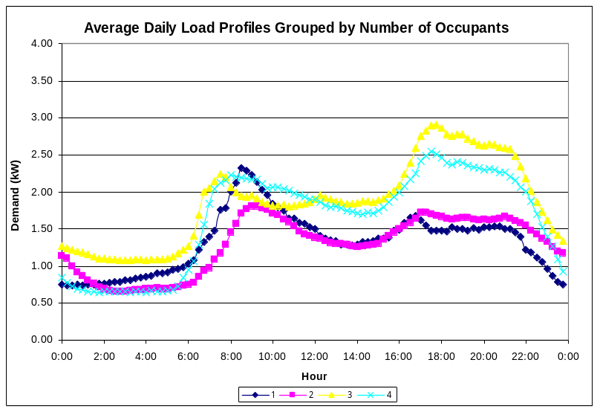
Figure 5: Average Daily Load Profiles: Number of Occupants

House Type
Of the thirty-two accounts that filled out the survey form regarding housing type, thirty-one specified single-detached houses and only one specified living in a duplex. Due to the impossibity of creating useful groupings it has been decided that no useful information could be discerned by a housing type comparison.

House Size
The BC-Hydro load data was also disaggregated by house size. Of the thirty-two accounts, only two (2) did not provide data on the square footage of their house, the remaining thirty were separated into three categories representing typical sizes for small, medium, and large homes in Canada. Eight (8) houses were in the range of 0 to 1,499 ft², eleven (11) between 1,500 and 2,499 ft², and eleven (11) between 2,500 and 4,500 ft². The make-up of the sample size is outlined in Table 7.
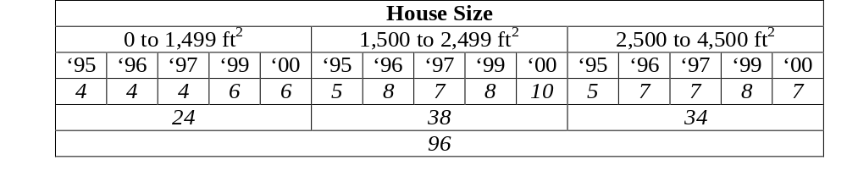 Table 8: Sample Size of House Size Classification

Figure 6 illustrates how the average occupant-driven load profiles vary based on the house size categorizations.
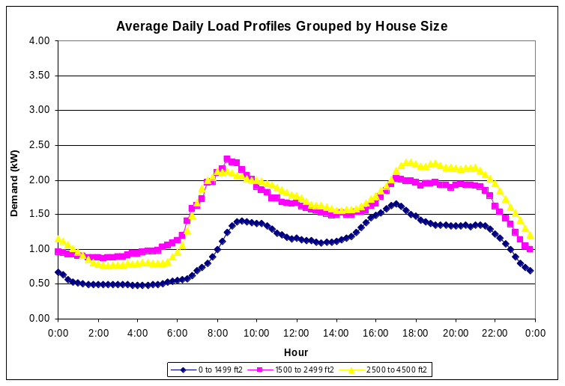
Figure 6: Average Daily Load Profiles: House Size

Space Heating Fuel Type
The thirty-two accounts with survey information each provided information regarding space heating fuel type. Both primary and secondary fuel types were identified for each house. For purposes of comparison it was decided to divide the houses based on primary fuel type, as specific combinations would result in small sample sizes. Of the thirty-two houses, twenty-one (21) were heated primarily with natural gas, five (5) with oil, five (5) with electricity, and one (1) with wood. Since one house cannot be relied upon to give an accurate representation of an entire group the one house that uses wood as its primary fuel type was not considered for the comparisons. The final make-up of the sample size is outlined in Table 8.
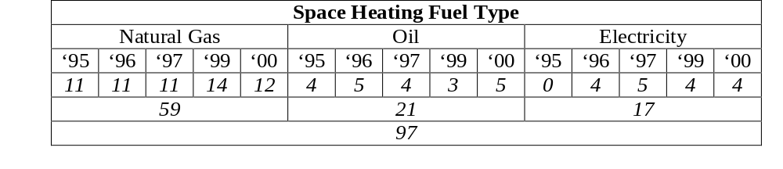Table 9: Sample Size of Fuel Type Classification

Figure 7 illustrates how the average occupant-driven load profiles vary based on the primary space heating fuel type categorizations. Note that all of the electricity accounts are from VI, therefore it is just a subset of the regional classification.
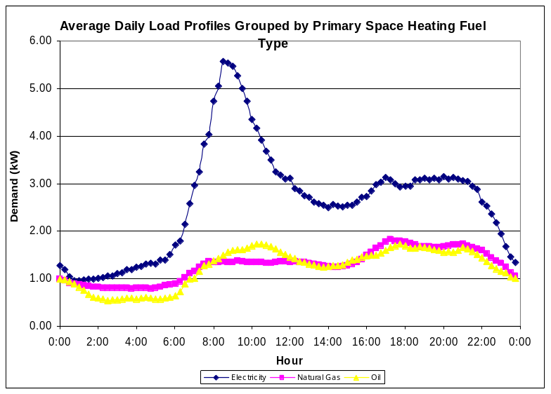
Figure 7: Average Daily Load Profiles: SH Fuel Type

Total Annual Energy Use
The comparison of housing accounts based on their total annual energy consumption will also be performed. The categorization occurred as follows: fifteen (15) accounts consumed between 0 and 9,999 kWh of electricity annually, eleven (11) consumed between 10,000 and 19,999 kWh, and five (5) consumed between 20,000 and 30,000 kWh. One house did not complete this portion of the survey. The make-up of the sample size is outlined in Table 9.
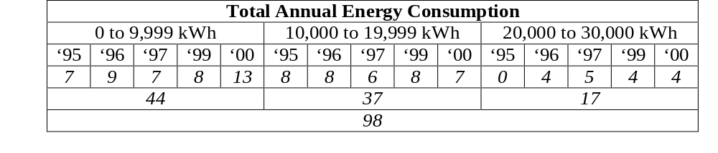Table 10: Sample Size of Annual Consumption Classification

Figure 8 illustrates how the average occupant-driven load profiles vary based on the total annual energy consumption categorizations.
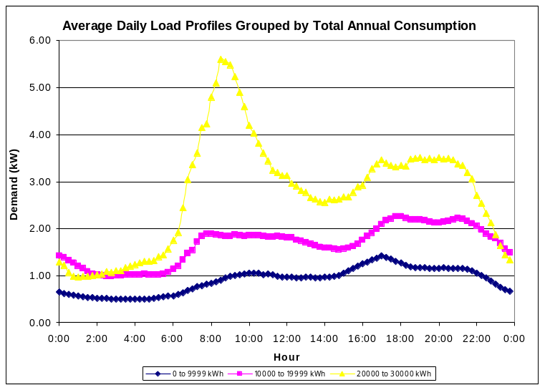
Figure 8: Average Daily Load Profiles: Annual Consumption

Determining a Best-Match Profile for Occupant Driven Load ProfilES
CREEDAC was asked to select from the load profile database actual profiles that best-match the average load profiles determined by each grouping. The average profiles for each grouping (as shown in Figures 4 to 8) were therefore compared with actual load data and a best match was selected based on the highest statistical correlation between the two data sets. This was performed in two ways: for the entire data set (whole data) as well as the average daily data. It should be noted that the best match is based on profile shape-matching and therefore does not necessarily result in values of similar scope. An example of the resulting profiles is shown in Figure 9.
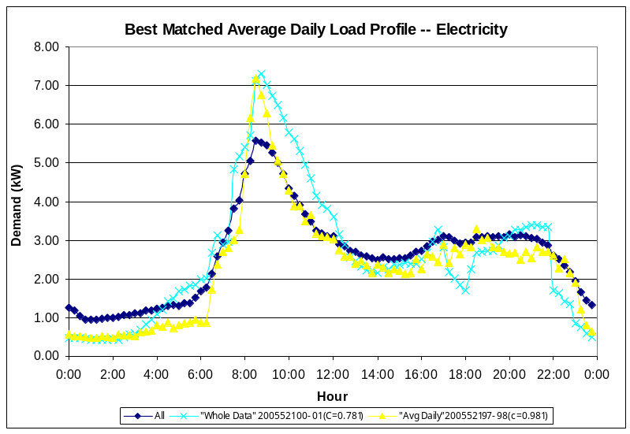
Figure 9: Best-Match Profiles: Actual vs. Avg Data

Table 10 shows the best-match profiles when the actual data was compared with the average data for each grouping.

Category | Grouping | Comparitive Technique | Best-Match Account
Region | Lower Mainland (LM) | Whole Data | 2002529 (1997-98)
Region | Lower Mainland (LM) | Average Daily | “ “
Region | Northern (N) | Whole Data | 3898678 (1999-00)
Region | Northern (N) | Average Daily | 2003623 (1995-96)
Region | Southern Interion (SI) | Whole Data | 2004741 (2000-01)
Region | Southern Interion (SI) | Average Daily | “ “
Region | Vancouver Island (VI) | Whole Data | 2005521 (1996-97)
Region | Vancouver Island (VI) | Average Daily | 2005201 (1996-97)
Annual Energy Consumption | 0 to 9,999 kWh | Whole Data | 3091971 (1996-97)
Annual Energy Consumption | 0 to 9,999 kWh | Average Daily | 3091971 (2000-01)
Annual Energy Consumption | 10,000 to 19,999 kWh | Whole Data | 2005201 (1997-98)
Annual Energy Consumption | 10,000 to 19,999 kWh | Average Daily | 2002529 (1997-98)
Annual Energy Consumption | 20,000 to 30,000 kWh | Whole Data | 2005521 (2000-01)
Annual Energy Consumption | 20,000 to 30,000 kWh | Average Daily | 2005521 (1997-98)
House Size | 0 to 1,499 ft² | Whole Data | 3091971 (1996-97)
House Size | 0 to 1,499 ft² | Average Daily | 3091971 (2000-01)
House Size | 1,500 to 2,499 ft² | Whole Data | 2005521 (2000-01)
House Size | 1,500 to 2,499 ft² | Average Daily | 2004741 (2000-01)
House Size | 2,500 to 4,500 ft² | Whole Data | 2006040 (2000-01)
House Size | 2,500 to 4,500 ft² | Average Daily | “ ”
Number of Occupants | One | Whole Data | 2005521 (2000-01)
Number of Occupants | One | Average Daily | 2005521 (1997-98)
Number of Occupants | Two | Whole Data | 2983460 (1996-97)_
Number of Occupants | Two | Average Daily | 2767818 (2000-01)
Number of Occupants | Three | Whole Data | 2004741 (1996-97)
Number of Occupants | Three | Average Daily | 2002529 (1995-96)
Number of Occupants | Four | Whole Data | 2006040 (2000-01)
Number of Occupants | Four | Average Daily | “ “
Primary Space Heating Fuel Type | Natural Gas | Whole Data | 2004741 (2000-01)
Primary Space Heating Fuel Type | Natural Gas | Average Daily | 2002529 (1997-98)
Primary Space Heating Fuel Type | Electricity | Whole Data | 2005521 (2000-01)
Primary Space Heating Fuel Type | Electricity | Average Daily | 2005521 (1997-98)
Primary Space Heating Fuel Type | Oil | Whole Data | 3091971 (1996-97)
Primary Space Heating Fuel Type | Oil | Average Daily | 2005678 (1995-96)
Table 11: Best-Match Accounts by Grouping

Determining the Probability of Air-conditioning Usage
CREEDAC has been asked to review each profile and assess the probability that the house described by the profile uses an air-conditioner in the summer months. The survey administered by BC Hydro specifically asks (question 45) whether a central or room air-conditioner is in use, the number of units, and the months of operation. Three houses responded affirmatively to the use of A/C during the summer months, these accounts are 2004357, 2004699, and 276818.
To determine whether any other accounts show signs of A/C usage the remaining profiles will be examined for telltale signs. The maximum, average, and minimum load values for the time period 4 pm to 8 pm, will be calculated and plotted. If there is a peak in the summer months it is likely that A/C is used as, typically, there is higher electricity usage in the winter months over this time period. This period was chosen as it represents a time span of high occupant electricity usage in the winter as well as representing the hottest period of the day in the summer, resulting in A/C operation. The three accounts with survey-verified A/C will be used to confirm these trends.
The accounts with survey verified A/C operation all showed average summer load values that peaked along with the winter months; non-heating / cooling months represented the minimum value curves. A clear representation of this type of load profile can be seen in Figures 10 and 11.
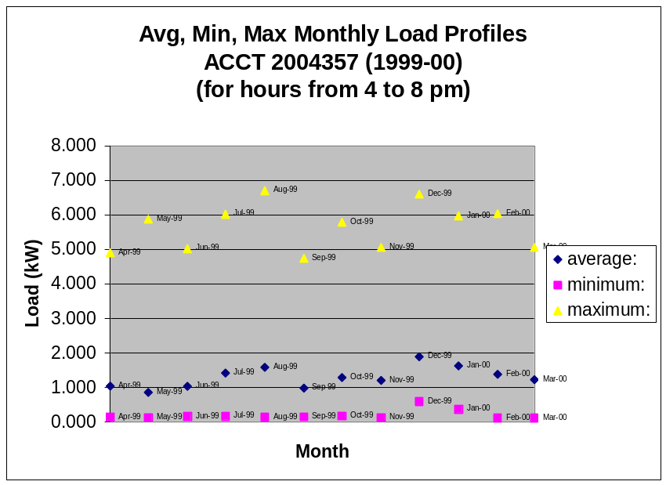
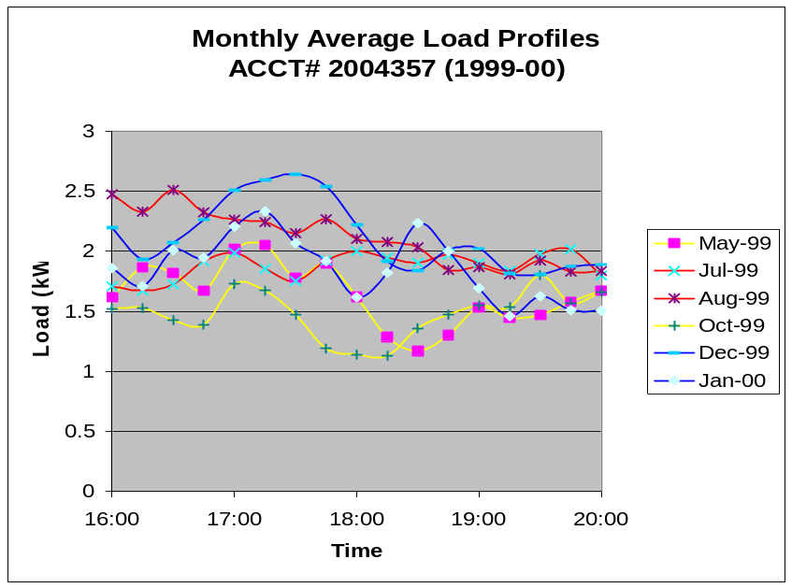
Figures 10 and 11: A/C Usage Load Profiles

These profile trends were very clear for two of the accounts (2004357 and 2004699) but while the third (2767818) showed similar peaks, they appeared muted (see Figures 12 and 13).
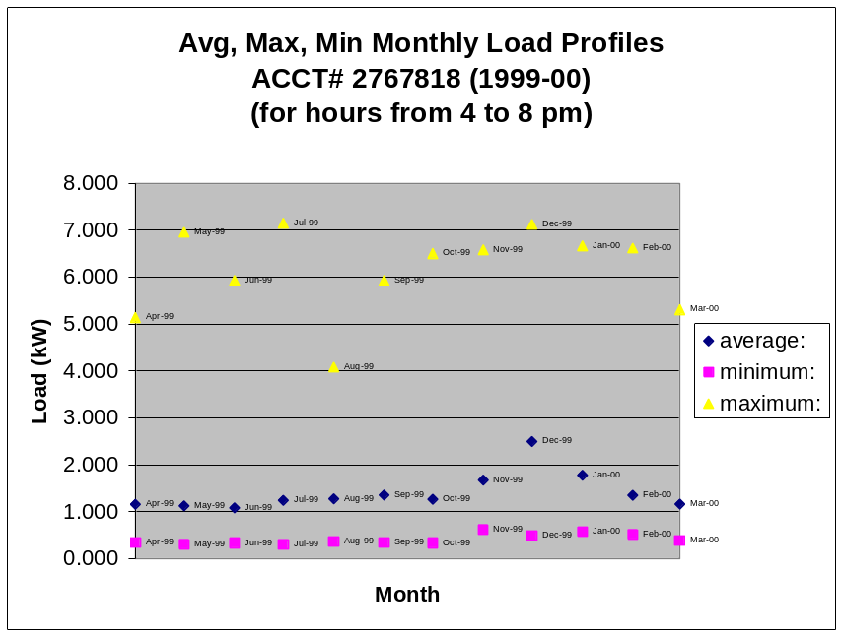
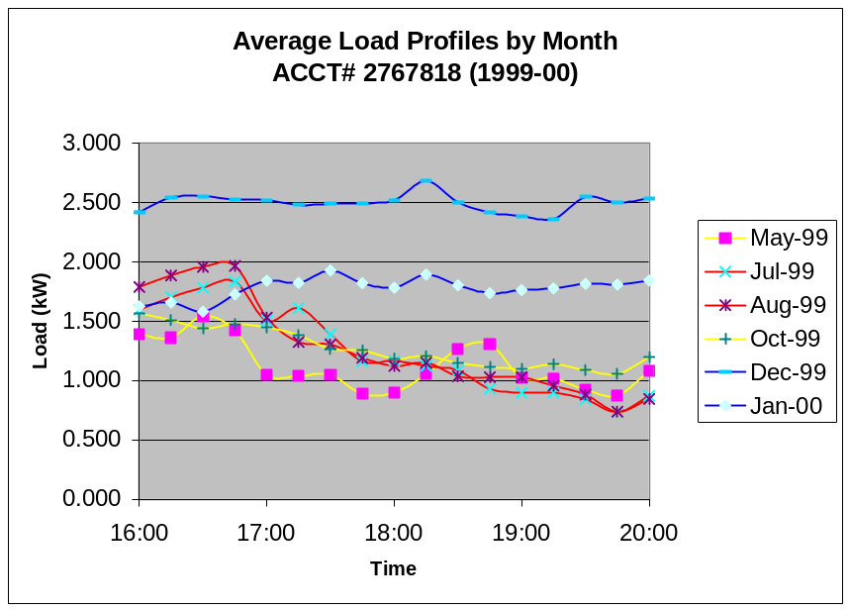
Figures 12 and 13: A/C Usage Load Profiles
It can be seen that there is a peak in the profiles of the summer months in the early hours of the evening but these trends do not show up clearly in the monthly average values. This could be explained by a cooler summer as the later account is from northern BC while the former two accounts are from the southern interior of BC, which typically has hotter summers.
According to the theory outlined above the summer peaks found within the monthly profiles with confirmed A/C usage should peak in the hot late-afternoon hours (at loads comparable to the winter months) and drop off towards late evening. Conversely, the profiles of non-A/C accounts should remain flat and have a lower average load during the outlined hours. To clarify what is being looked for an example of an account profile that clearly shows that A/C is not in use is shown in Figure 14.
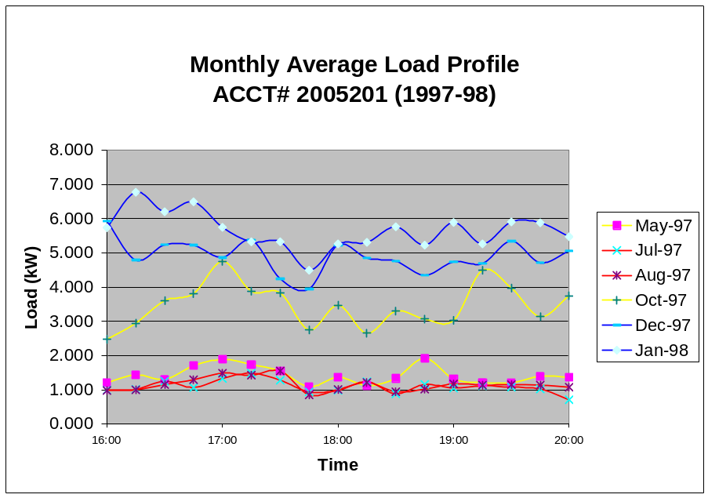
Figure 14: No A/C Usage Load Profile

The remaining accounts (those not identified as using A/C by the survey) were reviewed in an attempt to identify load profile characteristics that are indicative of A/C usage, despite their survey response. The result was that no other account profiles were found that showed significant A/C usage trends. The reason for this could be that, unlike furnace fan operation, the occupants are well aware if they have A/C or not and therefore the survey question concerning A/C was answered accurately. The method proved useful though, and can be used in future load profile analysis for the purpose of identifying A/C usage.

Literature Cited
CMHC, (2004). Replacing Your Furnace. Canadian Mortgage and Housing Corporation, Ottawa, ON. Retrieved 03/30/04 online at: www.cmhc.ca/en/burena/gesein/abhose/ce_048.cfm.
CREEDAC, (2001). Electronic Sources: Stand-by Power Requirements for Household Appliances. Canadian Residential Energy End-Use Data and Analysis Centre, Halifax, NS.
Fung, A.S, A. Auldnback, A. Ferguson, and V.I. Ugursal, (2003). Standby power requirements of household appliances in Canada. Energy and Buildings; 35, 217-228.
Proctor, J. and D. Parker, (2001). Hidden Power Drains: Trends in Residential Heating and Cooling Fan Watt Power Demand. FSEC-PF361-01, Florida Solar Energy Center, Cocoa, Florida.

