APPENDICES

APPENDIX A

NN Learning Algorithms
1. BACKPROPAGATION ALGORITHMS
The error signal of an output layer neuron is defined by (Rumelhart and McClelland, 1986; Fausett, 1994):
e_{k} = t_{k} - y_{k} (A.1)
where,
t_{k} : target value
y_{k} : predicted value
The total error is the sum of the square of the error signals for all of the output units:
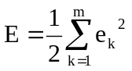 (A.2)
where,
E : total error or error function
m : number of output units
The factor of 1/2 in Equation A.2 is used for convenience in calculating derivatives later. Since an arbitrary constant will appear in the final result, the presence of this factor does not invalidate the derivation (Freeman and Skapura, 1991).
The input of an output layer neuron expressed as:
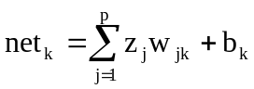 (A.3)
where,
net_{k} : total input of the output layer neuron k
z_{j} : input to the output layer neuron k from hidden layer neuron j
w_{jk} : weight between the hidden layer neuron j and output layer neuron k
b_{k} : bias value of the output layer neuron k
p : number of neurons in the hidden layer

Hence, the output of an output layer neuron becomes:
y_{k} = f(net_{k}) (A.4)
The weights between the hidden layer neurons and output layer neurons are corrected by applying a weight correction term, Δw_{jk}, which is proportional to the partial derivative ∂E/∂w_{jk}. By using the chain rule,
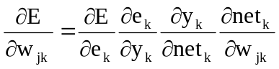 (A.5)
Differentiating both sides of Equation A.2 with respect to e_{k}:
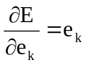 (A.6)
Differentiating both sides of Equation A.1 with respect to y_{k}:
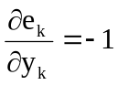 (A.7)
Differentiating both sides of Equation A.4 with respect to net_{k}:
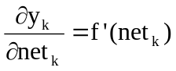 (A.8)
Finally, differentiating both sides of Equation A.3 with respect to w_{jk}:
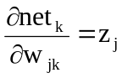 (A.9)
The substitution Equations A.6 to A.9 into Equation A.5 yields:
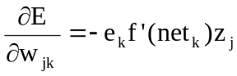 (A.10)
A new term called the error information term, δ_{k}, is defined as:
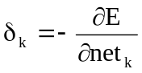 (A.11)
By using Equations A.6 to A.8 and chain rule, δ_{k} is expressed as:
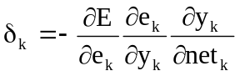 (A.12)
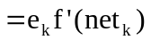
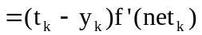
The calculation of error information terms for the hidden layer neurons is complicated, since there is no specified desired response for the hidden layer neurons. Even though hidden layer neurons are not directly accessible, they share responsibility for any error made at the output of the network. Thus, the error signal for a hidden layer neuron is determined in terms of the error signals of all the neurons to which the hidden layer neuron is directly connected. Hence, the error information term can be expressed as:
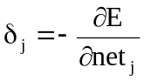 (A.13)
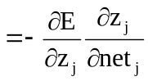
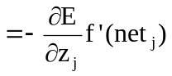
Differentiating Equation A.2 with respect to the functional signal f(net_{j}) = z_{j}:
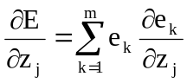 (A.14)
By using the chain rule for the partial derivative ∂e_{k}/∂z_{j}, Equation A.14 is rewritten as:
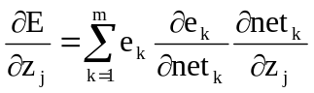 (A.15)
The substitution of Equation A.4 into Equation A.1 yields:
e_{k} = t_{k} - y_{k} (A.16)
= t_{k} - f(net_{k})
Hence the partial derivative ∂e_{k}/∂net_{k} becomes:
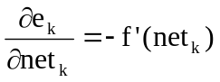 (A.17)
Also, the partial derivative ∂net_{k}/∂z_{j} can be written by using Equation A.3 as:
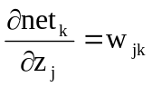 (A.18)
The substitution of Equations A.17 and A.18 into Equation A.15 yields:
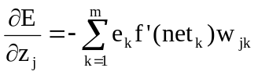 (A.19)
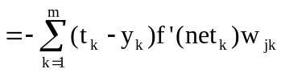
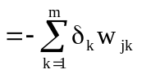

Finally, the substitution of Equation A.19 into Equation A.13 yields:
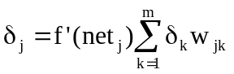 (A.20)

- Standard (Plain Vanilla) Backpropagation
For each output neuron, the error information term, δ_{k}, is computed, and the weights are adjusted as:
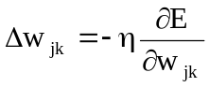 (A.21)
= η(t_{k} - y_{k}) f'(net_{k}) z_{j}
= η δ_{k} z_{j}
where,
η : learning parameter
Δw_{jk} : weight correction term for weights between the hidden units and output units
The learning parameter specifies the step width of the gradient descent, usually a small number in the order of 0.05 to 0.25 (SNNS, 1998). The use of the minus sign in Equation A.21 accounts for gradient descent in weight space, i.e., seeking a direction for weight change that reduces the value of E.
For the weights to the hidden units:
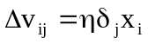 (A.22)
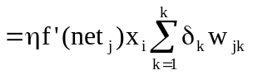
where,
Δv_{ij} : weight correction term for weights between the input units and hidden units

- Enhanced Backpropagation
The weight correction term is computed by using a momentum term and a flat spot elimination value for the weights to the output units as:
Δw_{jk}(t+1) = η δ_{k} z_{j} + μ Δw_{ik}(t) (A.23)
For the weights to the hidden units:
Δv_{ij}(t+1) = η δ_{j} x_{i} + μ Δv_{ij}(t) (A.24)
where,
μ : constant specifying the influence of the momentum.
The typical values for the momentum term, μ, are between zero and one (SNNS, 1998). The flat spot elimination value, c, is added to the derivative of the activation function. For the weights to the output units:
δ_{k} = f'(net_{k}+c) (t_{k} -y_{k}) (A.25)
For the weight to the hidden units:
δ_{j} = f'(net_{j}+c) (t_{k} -y_{k}) (A.26)
where,
c : flat spot elimination value with a typical value of 0.1 (SNNS, 1998).

2. QUICKPROP
The partial derivatives of the error function with respect to the given weight is summed over all training patterns, and is calculated as:
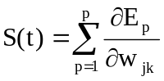 (A.29)
where,
S(t) : partial derivative of the error function
p : number of training patterns.
For a weight from a hidden unit to an output unit:
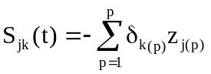 (A.30)
and similarly, for a weight from an input unit to a hidden unit:
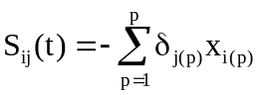 (A.31)
The initial weight change is calculated by standard (vanilla) backpropagation as:
Δw(0) = -ηS(0) (A.32)
The new weight change for weights to the output units is defined to be:
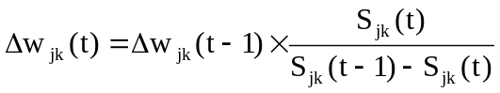 (A.33)
where,
Δw_{jk}(t) : weight correction term for the weights to the output units
Δw_{jk}(t-1) : previous weight correction term for the weights to the output units
S_{jk}(t) : partial derivative of the error function by w_{jk}
S_{jk}(t-1) : previous partial derivative of the error function by w_{jk}
The new weight change for weights to the hidden units is defined to be:
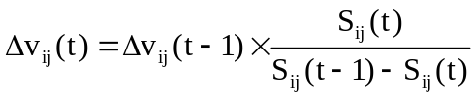 (A.34)
where,
Δv_{ij}(t) : weight update value for the weights to the hidden units
Δv_{ij}(t-1) : previous weight correction term for the weights to the hidden units
S_{ij}(t) : partial derivative of the error function by v_{ij}
S_{ij}(t-1) : previous partial derivative of the error function by v_{ij}
The weight correction term, Δ, is used to determine the coefficients of the polynomial. At the next step of iteration, the weight parameter is moved to the minimum of the parabola.
If the current slope term is in the same direction as the previous slope, and it has the same size or larger in magnitude than the previous slope, then the weight change would be infinite, or the weight would be moved away from the minimum and toward a maximum of the error (Fausett, 1994). To prevent this, weight change is limited by multiplying the previous step by the maximum growth parameter, ρ. The typical values of maximum growth parameter, ρ, are between 0.75 and 2.25 (SNNS, 1998).
A further refinement is used when the current slope has the same sign as the previous one. In this case, the current slope is multiplied by the weight decay term, ν, to prevent the weight changed from being frozen (Fausett, 1994). The typical value of weight decay term, ν, is 0.0001 (SNNS, 1998).

3. RESILIENT PROPAGATION (RPROP)
The update value, φ_{jk}, for each weight is computed as:
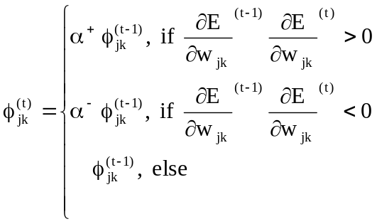 (A.35)
where,
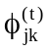 : update value
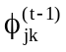 : previous update value
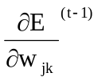: previous partial derivative of the error function of the corresponding weight w_{jk} summed over all training patterns
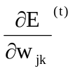: partial derivative of the error function of the corresponding weight w_{jk} summed over all training patterns
α : increase/decrease factor with a value of 0 < α⁻ < 1< α⁺.
After the update value of each weight is computed, the weight correction term is calculated as:
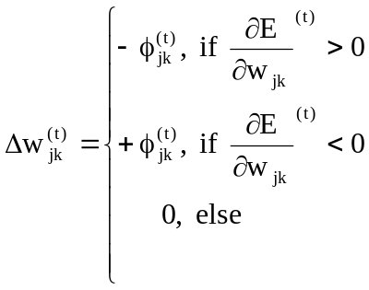 (A.36)

The increase and decrease factors are set to fixed values, i.e. 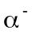= 0.5 and 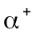= 1.2, in order to reduce the number of adjustable parameters (Riedmiller and Braun, 1993; SNNS, 1998).
Weight decay term, β, is introduced to the error function to reduce the size of the weight:
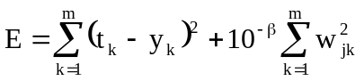 (A.37)
When learning starts, all update values are set to an initial value, φ_{initial}, which has a typical value of 0.01 (SNNS, 1998). In order to prevent the weights from becoming too large, the maximum weight step determined by the size of the update value is limited. The default value for the maximum update value, φ_{max}, is 50 (SNNS, 1998).

