**Introduction**

In this tutorial, I will show you how to run the driver on any TA machine. (I will use TA-1 through the tutorial.)

**Starting up The Driver**

1. When you log into TA-1, open up the terminal and type in: $ **crontab -e**
   1. 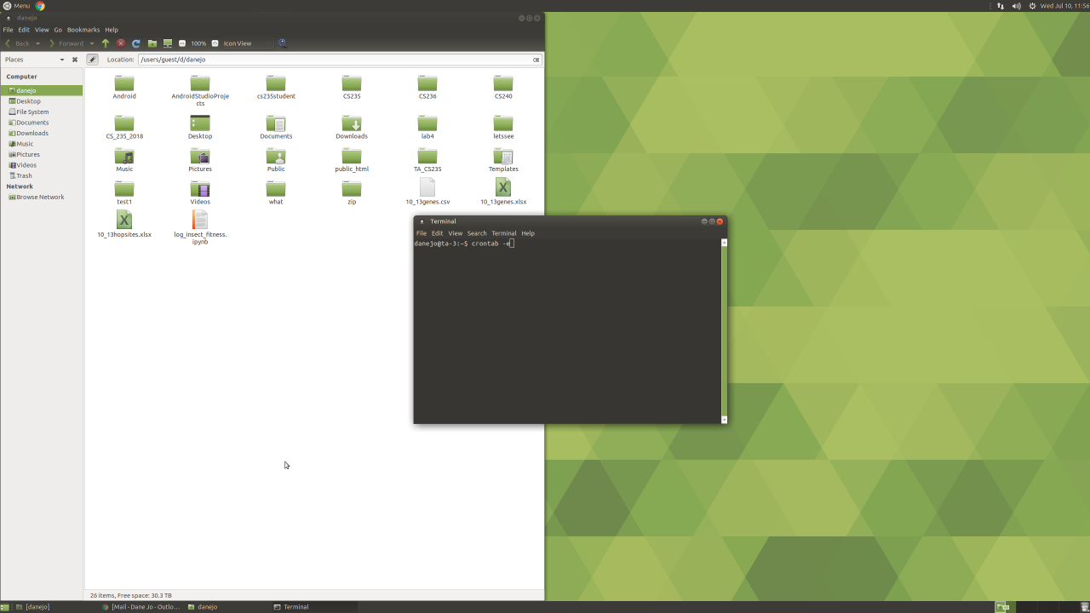
2. When you click 'enter', you'll be greeted to a text editor (that uses vim) inside the terminal.
   1. 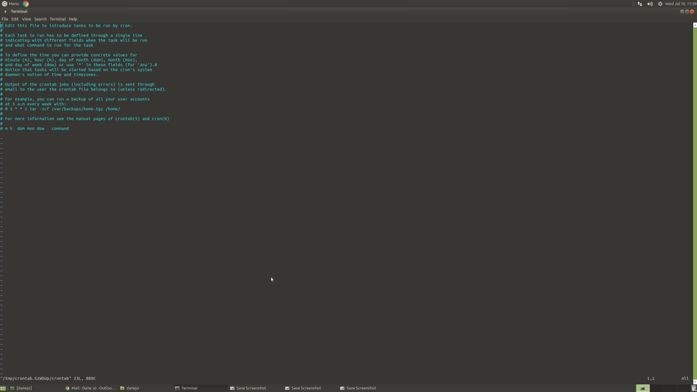
3. Next, we need to edit the text. Press 'i' on your keyboard to enable editing. You'll see at the bottom left corner of the text editor saying "-- INSERT --". This means that you are now able to edit the text.
   1. 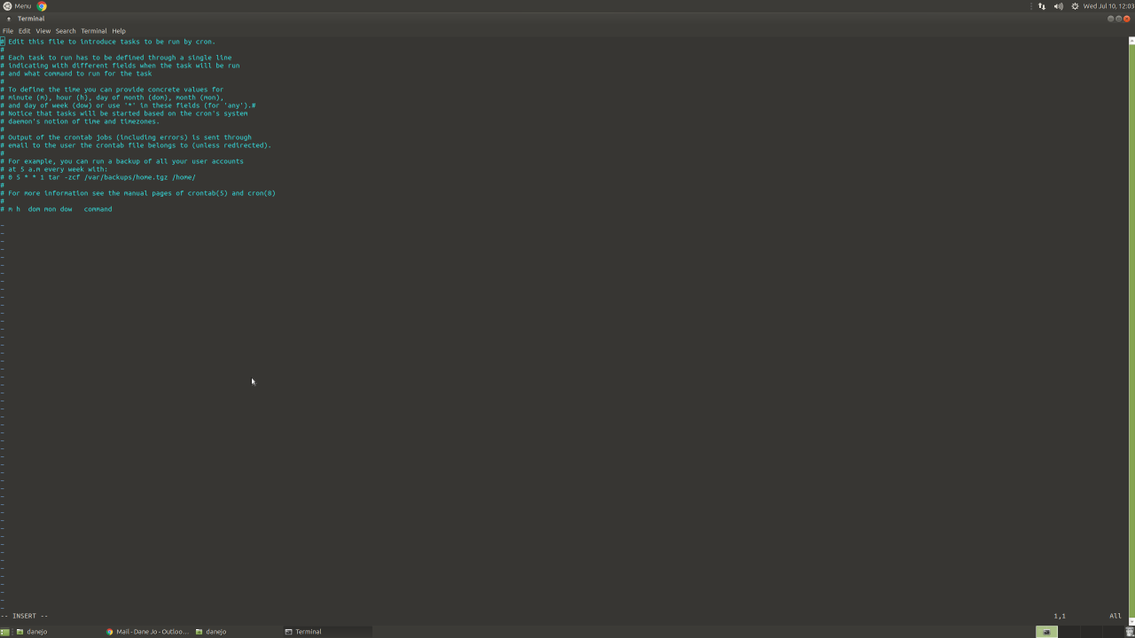
4. Scroll down to the bottom of the text and type in (or copy-paste) the following and make sure you type it **correctly**: * * * * * /users/groups/cs235ta/submission_driver/runCompileDriver.sh &>> /users/groups/cs235ta/submission_driver/cronLog.txt
   1. 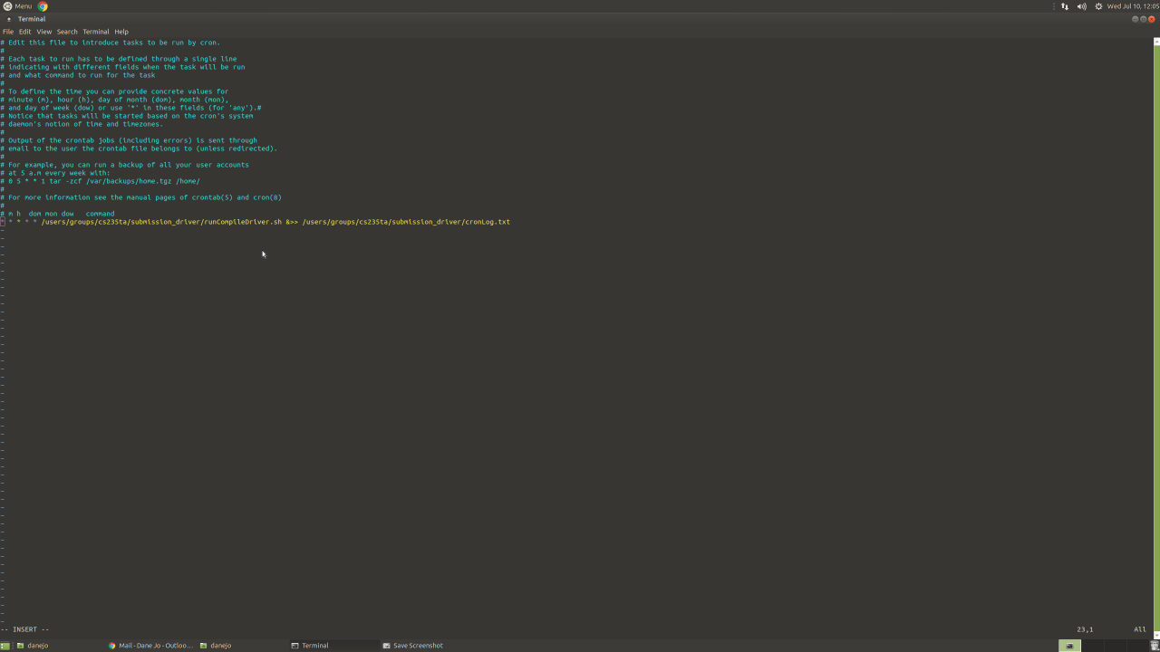
5. To save your edit, click the 'Esc' key on your keyboard and then click the 'Shift' + ';' keys to get the ':'. When you do this, you'll see at the bottom left corner a ':' with a flickering box waiting for you input.
   1. 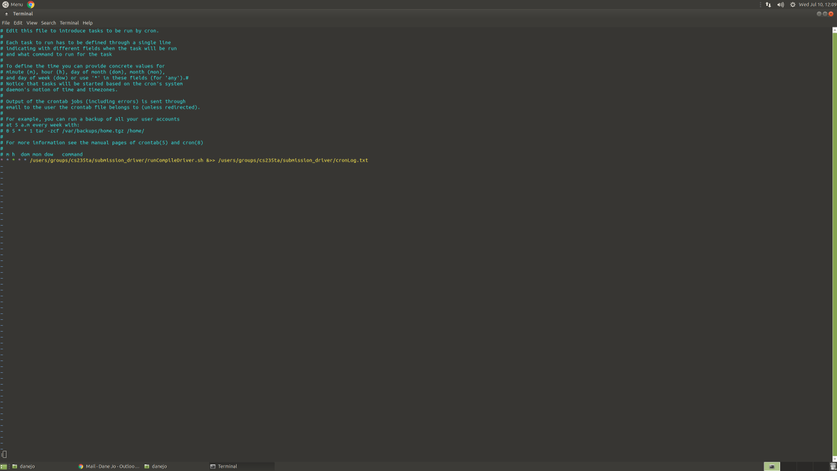
6. Next, type 'wq' (below is the picture of you typing 'wq') and press enter.
   1. 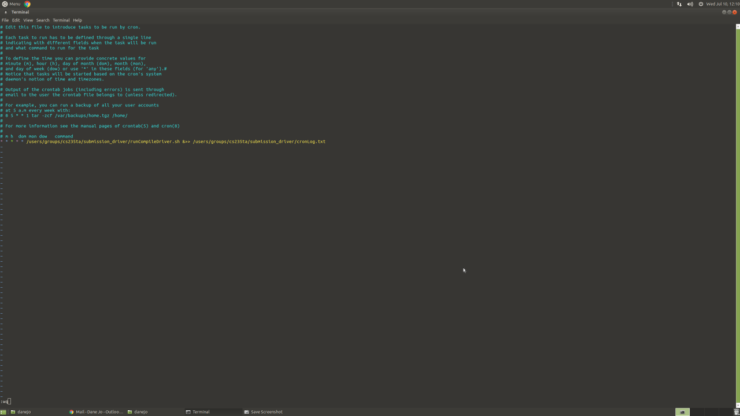
7. By doing the previous step, you'll go back to the terminal and in the terminal, it will way say, "crontab: installing new crontab".
   1. 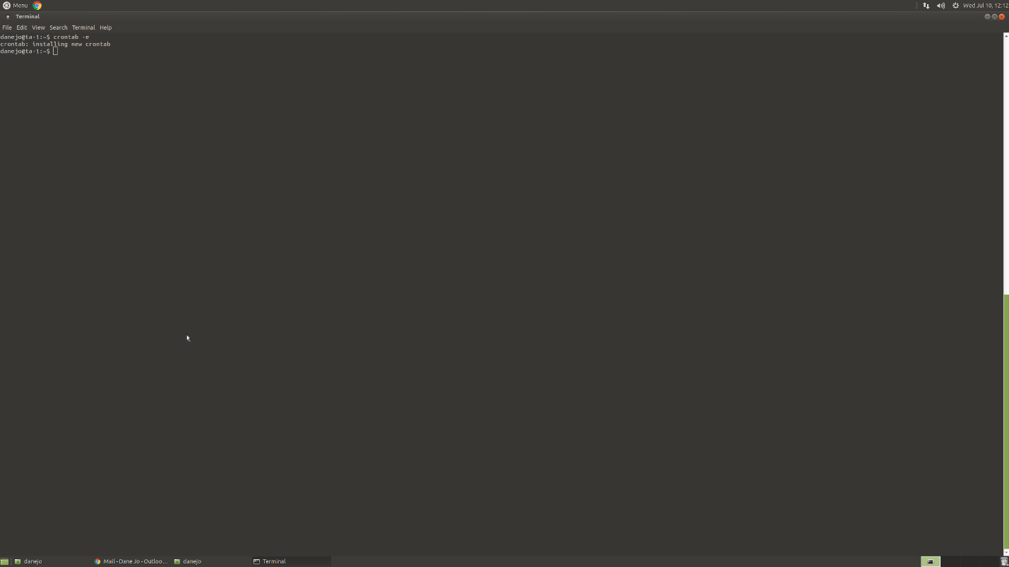
8. To check if the driver is running, type in terminal: $ ps -aux | grep Compile
   1. 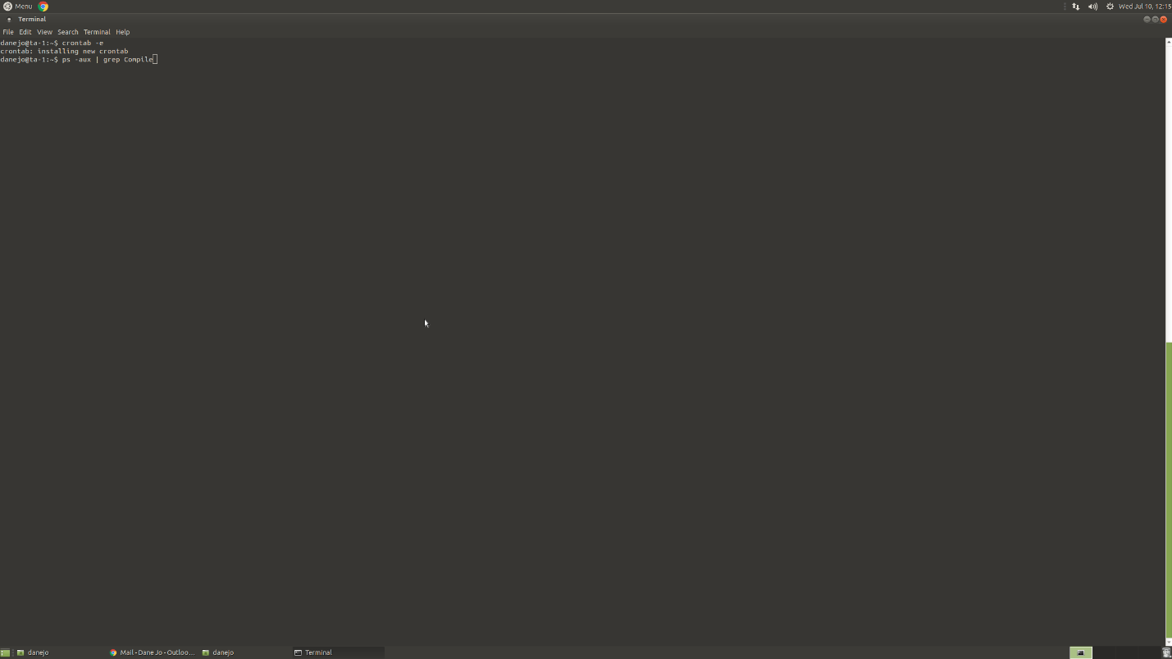
9. If you see **3 lines of tasks,** that means **the driver is running**(below is a picture of the driver now running). **If not, give the script a minute and try again.**
   1. 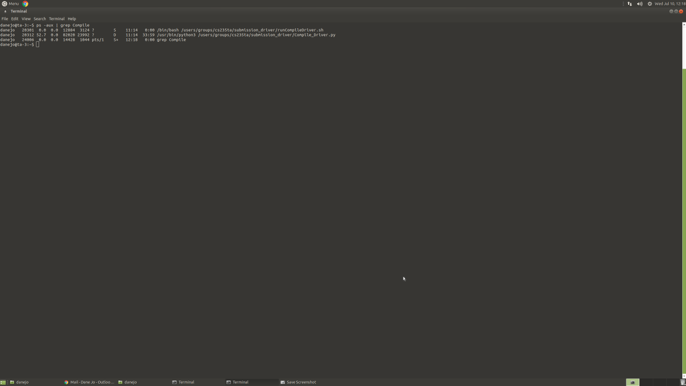
10. Once you see your job running, congratulations; you got the driver up and running!

**How to Kill the Driver Manually**

1. To kill the driver, first, access the computer's terminal where the driver is temporarily running.
2. Access the crontab by following step #1 again.
3. When you enter the text editor, enable editing and delete the command that is running the driver (see the command that we wrote on step #4).
4. Save your changes by following step #5 and #6.
5. Next, to actually kill the driver, type in the same command as step #8.
6. Again, you'll see all the current task running on the computer. **You'll only need to kill 1 task.** Notice that each task will have a netid and a unique task id number next to it. To kill the task (or in this case, the driver), type in the terminal:$ kill -9 _____type_in_the_unique_task_id_number_____
   1. For example; in the picture from step #9, we want to kill the task running '/usr/bin/python3 /users/groups/cs235ta/submission_driver/Compile_Driver.py'. So in the terminal, I would type, $ kill -9 20312
   2. 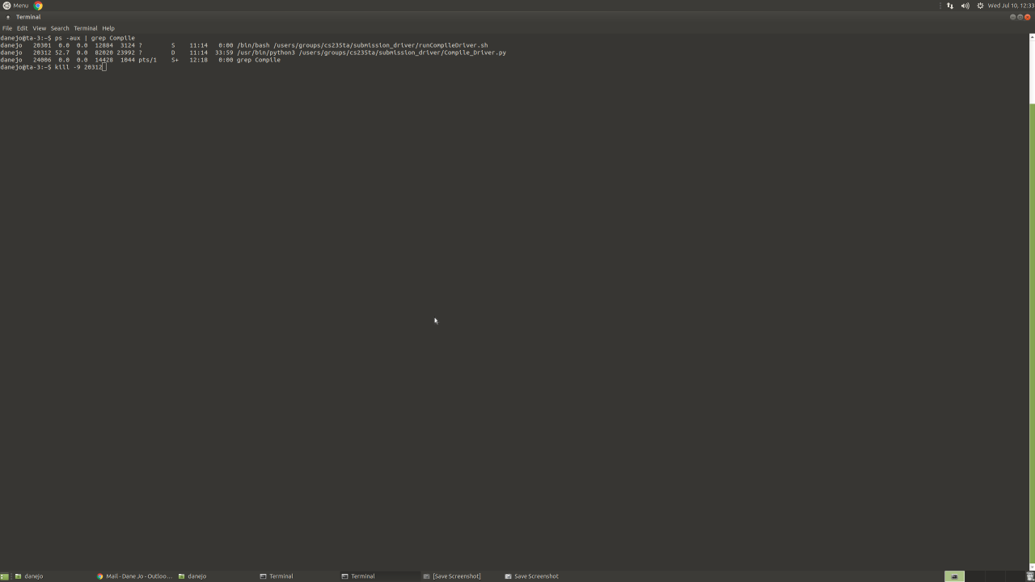
7. After you press enter, type in the same command as step #8.
8. You'll notice now that there will only be one task running (or was running. That was your last command--the 'ps -aux' one).
   1. 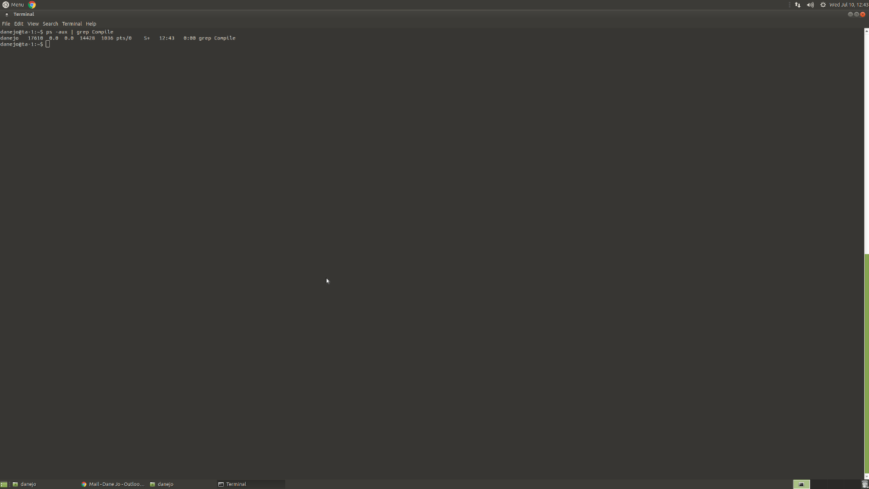
9. Congratulations! You have officially killed the temporary driver.