The results below show impact on student score when we replace the reading and math scores for ninth graders at Thomas High School with NaN. For each result, the first table represents the original modeule 4 lesson, while the second table is the mdified code.

Table 1: District Summary (PyCitySchools vs. PyCitySchools_Challenge )



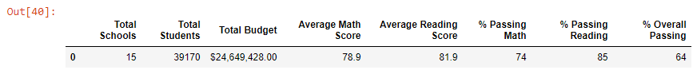

Table 2: School Summary (PyCitySchools vs. PyCitySchools_Challenge)

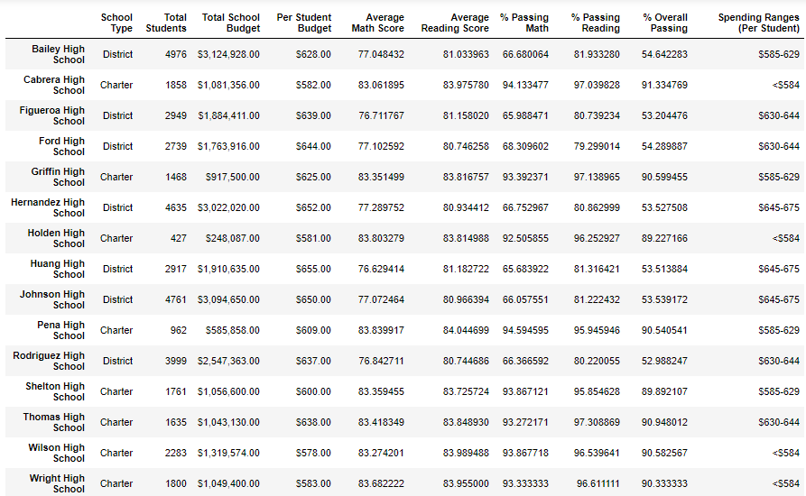

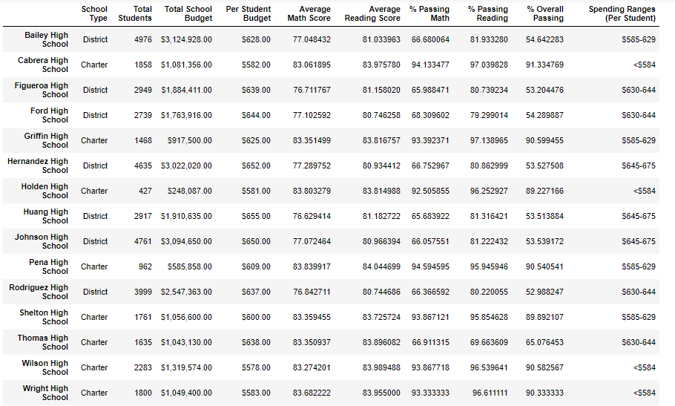

After replacing the ninth graders’ math and reading scores at Thomas High School, that school’s relative pefromance to the other schools was lowered? This conclusion is observed when looking at Thomas High School’s scores in the last two tables.

Table 3: Math and Reading Scores by Grade (PyCitySchools)

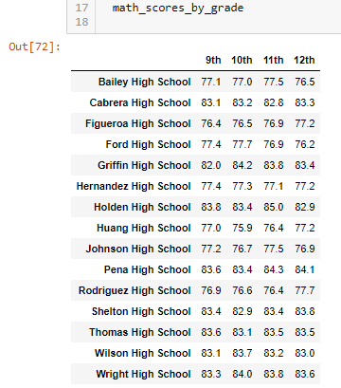 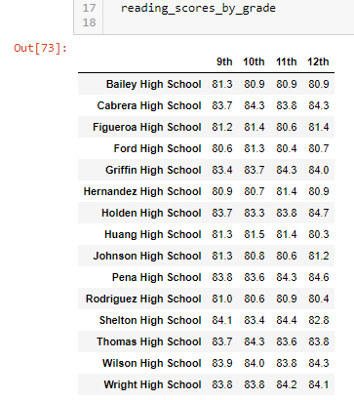

Table 4: Math and Reading Scores by Grade (PyCitySchools_Challenge )

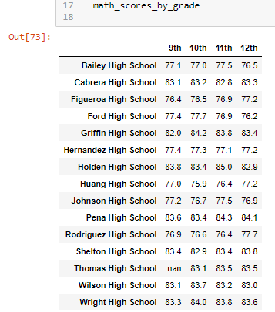 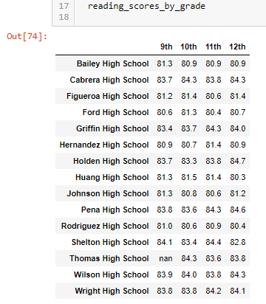

Table 3 and Table 4 show Thomas High School’s 9th grade math and reading scores. It Table 3 a grade is present, while in Table 4 the grade is repalced with NaN, as expected.

Refering to Tables 5-7 in the next page …..

… Table 5 results indicate that the “$630-$644 Spending Range per Student” category has lower relative scores compared to the other categories once we replaced the ninth graders’ math and reading scores at Thomas High School with NaN.

… similary, Table 6 results indicate that the “Medium School Size (1000-2000)” category has lower relative scores compared to the other categories as a result of the new code.

… and finally, Table 7 results indicate that the “Medium School Size (1000-2000)” category has lower relative scores compared to the other categories as a result of the new code.

Table 5: Scores by School Spending (PyCitySchools vs. PyCitySchools_Challenge )

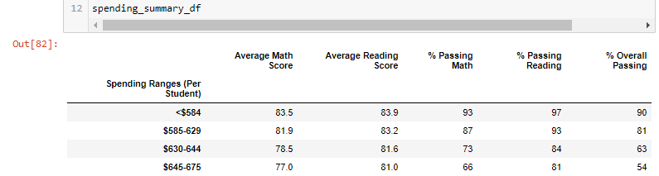

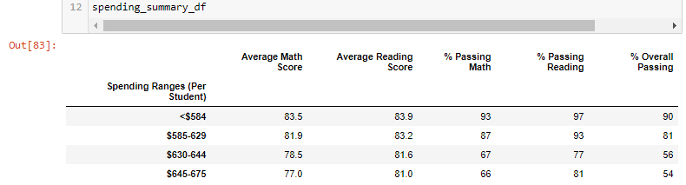

Table 6: Scores by School Size (PyCitySchools vs. PyCitySchools_Challenge )

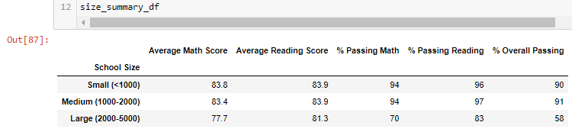

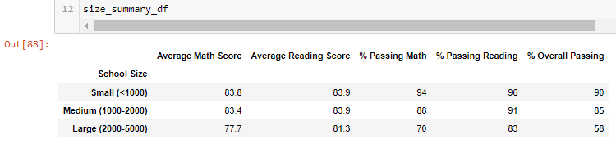

Table 7: Scores by School Type (PyCitySchools vs. PyCitySchools_Challenge )

