bikers_GoogleCapstone

Daniel Fidalgo

11/30/2021

## 1. Ask

### 1.1 The objective

* How do annual members and casual members use bikes differently?
* How to convert casual riders into annual members?

## 2. Prepare

### 2.1 Download the required data

In this case, we are using the last 12 months of data provided by the stakeholders company.

#Load the data from the last 12 months  
biker_10_2021 <- read_csv("bikers_data/202110-divvy-tripdata/202110-divvy-tripdata.csv") # October 2021

## Rows: 631226 Columns: 13

## -- Column specification --------------------------------------------------------  
## Delimiter: ","  
## chr (7): ride_id, rideable_type, start_station_name, start_station_id, end_...  
## dbl (4): start_lat, start_lng, end_lat, end_lng  
## dttm (2): started_at, ended_at

##   
## i Use `spec()` to retrieve the full column specification for this data.  
## i Specify the column types or set `show_col_types = FALSE` to quiet this message.

biker_09_2021 <- read_csv("bikers_data/202109-divvy-tripdata/202109-divvy-tripdata.csv") # September 2021

## Rows: 756147 Columns: 13

## -- Column specification --------------------------------------------------------  
## Delimiter: ","  
## chr (7): ride_id, rideable_type, start_station_name, start_station_id, end_...  
## dbl (4): start_lat, start_lng, end_lat, end_lng  
## dttm (2): started_at, ended_at

##   
## i Use `spec()` to retrieve the full column specification for this data.  
## i Specify the column types or set `show_col_types = FALSE` to quiet this message.

biker_08_2021 <- read_csv("bikers_data/202108-divvy-tripdata/202108-divvy-tripdata.csv") # August 2021

## Rows: 804352 Columns: 13

## -- Column specification --------------------------------------------------------  
## Delimiter: ","  
## chr (7): ride_id, rideable_type, start_station_name, start_station_id, end_...  
## dbl (4): start_lat, start_lng, end_lat, end_lng  
## dttm (2): started_at, ended_at

##   
## i Use `spec()` to retrieve the full column specification for this data.  
## i Specify the column types or set `show_col_types = FALSE` to quiet this message.

biker_07_2021 <- read_csv("bikers_data/202107-divvy-tripdata/202107-divvy-tripdata.csv") # July 2021

## Rows: 822410 Columns: 13

## -- Column specification --------------------------------------------------------  
## Delimiter: ","  
## chr (7): ride_id, rideable_type, start_station_name, start_station_id, end_...  
## dbl (4): start_lat, start_lng, end_lat, end_lng  
## dttm (2): started_at, ended_at

##   
## i Use `spec()` to retrieve the full column specification for this data.  
## i Specify the column types or set `show_col_types = FALSE` to quiet this message.

biker_06_2021 <- read_csv("bikers_data/202106-divvy-tripdata/202106-divvy-tripdata.csv") # June 2021

## Rows: 729595 Columns: 13

## -- Column specification --------------------------------------------------------  
## Delimiter: ","  
## chr (7): ride_id, rideable_type, start_station_name, start_station_id, end_...  
## dbl (4): start_lat, start_lng, end_lat, end_lng  
## dttm (2): started_at, ended_at

##   
## i Use `spec()` to retrieve the full column specification for this data.  
## i Specify the column types or set `show_col_types = FALSE` to quiet this message.

biker_05_2021 <- read_csv("bikers_data/202105-divvy-tripdata/202105-divvy-tripdata.csv") # May 2021

## Rows: 531633 Columns: 13

## -- Column specification --------------------------------------------------------  
## Delimiter: ","  
## chr (7): ride_id, rideable_type, start_station_name, start_station_id, end_...  
## dbl (4): start_lat, start_lng, end_lat, end_lng  
## dttm (2): started_at, ended_at

##   
## i Use `spec()` to retrieve the full column specification for this data.  
## i Specify the column types or set `show_col_types = FALSE` to quiet this message.

biker_04_2021 <- read_csv("bikers_data/202104-divvy-tripdata/202104-divvy-tripdata.csv") # April 2021

## Rows: 337230 Columns: 13

## -- Column specification --------------------------------------------------------  
## Delimiter: ","  
## chr (7): ride_id, rideable_type, start_station_name, start_station_id, end_...  
## dbl (4): start_lat, start_lng, end_lat, end_lng  
## dttm (2): started_at, ended_at

##   
## i Use `spec()` to retrieve the full column specification for this data.  
## i Specify the column types or set `show_col_types = FALSE` to quiet this message.

biker_03_2021 <- read_csv("bikers_data/202103-divvy-tripdata/202103-divvy-tripdata.csv") # March 2021

## Rows: 228496 Columns: 13

## -- Column specification --------------------------------------------------------  
## Delimiter: ","  
## chr (7): ride_id, rideable_type, start_station_name, start_station_id, end_...  
## dbl (4): start_lat, start_lng, end_lat, end_lng  
## dttm (2): started_at, ended_at

##   
## i Use `spec()` to retrieve the full column specification for this data.  
## i Specify the column types or set `show_col_types = FALSE` to quiet this message.

biker_02_2021 <- read_csv("bikers_data/202102-divvy-tripdata/202102-divvy-tripdata.csv") # February 2021

## Rows: 49622 Columns: 13

## -- Column specification --------------------------------------------------------  
## Delimiter: ","  
## chr (7): ride_id, rideable_type, start_station_name, start_station_id, end_...  
## dbl (4): start_lat, start_lng, end_lat, end_lng  
## dttm (2): started_at, ended_at

##   
## i Use `spec()` to retrieve the full column specification for this data.  
## i Specify the column types or set `show_col_types = FALSE` to quiet this message.

biker_01_2021 <- read_csv("bikers_data/202101-divvy-tripdata/202101-divvy-tripdata.csv") # January 2021

## Rows: 96834 Columns: 13

## -- Column specification --------------------------------------------------------  
## Delimiter: ","  
## chr (7): ride_id, rideable_type, start_station_name, start_station_id, end_...  
## dbl (4): start_lat, start_lng, end_lat, end_lng  
## dttm (2): started_at, ended_at

##   
## i Use `spec()` to retrieve the full column specification for this data.  
## i Specify the column types or set `show_col_types = FALSE` to quiet this message.

biker_12_2020 <- read_csv("bikers_data/202012-divvy-tripdata/202012-divvy-tripdata.csv") # December 2020

## Rows: 131573 Columns: 13

## -- Column specification --------------------------------------------------------  
## Delimiter: ","  
## chr (7): ride_id, rideable_type, start_station_name, start_station_id, end_...  
## dbl (4): start_lat, start_lng, end_lat, end_lng  
## dttm (2): started_at, ended_at

##   
## i Use `spec()` to retrieve the full column specification for this data.  
## i Specify the column types or set `show_col_types = FALSE` to quiet this message.

biker_11_2020 <- read_csv("bikers_data/202011-divvy-tripdata/202011-divvy-tripdata.csv") # November 2020

## Rows: 259716 Columns: 13

## -- Column specification --------------------------------------------------------  
## Delimiter: ","  
## chr (5): ride_id, rideable_type, start_station_name, end_station_name, memb...  
## dbl (6): start_station_id, end_station_id, start_lat, start_lng, end_lat, e...  
## dttm (2): started_at, ended_at

##   
## i Use `spec()` to retrieve the full column specification for this data.  
## i Specify the column types or set `show_col_types = FALSE` to quiet this message.

#Pool the data into a single data.frame  
bikers_pooled <- rbind(biker_10_2021, biker_09_2021, biker_08_2021, biker_07_2021, biker_06_2021, biker_05_2021, biker_04_2021, biker_03_2021, biker_02_2021,biker_01_2021, biker_12_2020, biker_11_2020)

### 2.2 Identify the how the data is organized

# Look at the data structure  
glimpse(bikers_pooled)

## Rows: 5,378,834  
## Columns: 13  
## $ ride_id <chr> "620BC6107255BF4C", "4471C70731AB2E45", "26CA69D43D~  
## $ rideable_type <chr> "electric_bike", "electric_bike", "electric_bike", ~  
## $ started_at <dttm> 2021-10-22 12:46:42, 2021-10-21 09:12:37, 2021-10-~  
## $ ended_at <dttm> 2021-10-22 12:49:50, 2021-10-21 09:14:14, 2021-10-~  
## $ start_station_name <chr> "Kingsbury St & Kinzie St", NA, NA, NA, NA, NA, NA,~  
## $ start_station_id <chr> "KA1503000043", NA, NA, NA, NA, NA, NA, NA, NA, NA,~  
## $ end_station_name <chr> NA, NA, NA, NA, NA, NA, NA, NA, NA, NA, NA, NA, NA,~  
## $ end_station_id <chr> NA, NA, NA, NA, NA, NA, NA, NA, NA, NA, NA, NA, NA,~  
## $ start_lat <dbl> 41.88919, 41.93000, 41.92000, 41.92000, 41.89000, 4~  
## $ start_lng <dbl> -87.63850, -87.70000, -87.70000, -87.69000, -87.710~  
## $ end_lat <dbl> 41.89000, 41.93000, 41.94000, 41.92000, 41.89000, 4~  
## $ end_lng <dbl> -87.63000, -87.71000, -87.72000, -87.69000, -87.690~  
## $ member_casual <chr> "member", "member", "member", "member", "member", "~

colnames(bikers_pooled)

## [1] "ride_id" "rideable_type" "started_at"   
## [4] "ended_at" "start_station_name" "start_station_id"   
## [7] "end_station_name" "end_station_id" "start_lat"   
## [10] "start_lng" "end_lat" "end_lng"   
## [13] "member_casual"

head(bikers_pooled)

## # A tibble: 6 x 13  
## ride_id rideable_type started_at ended_at start_station_n~  
## <chr> <chr> <dttm> <dttm> <chr>   
## 1 620BC6~ electric_bike 2021-10-22 12:46:42 2021-10-22 12:49:50 Kingsbury St & ~  
## 2 4471C7~ electric_bike 2021-10-21 09:12:37 2021-10-21 09:14:14 <NA>   
## 3 26CA69~ electric_bike 2021-10-16 16:28:39 2021-10-16 16:36:26 <NA>   
## 4 362947~ electric_bike 2021-10-16 16:17:48 2021-10-16 16:19:03 <NA>   
## 5 BB731D~ electric_bike 2021-10-20 23:17:54 2021-10-20 23:26:10 <NA>   
## 6 717630~ electric_bike 2021-10-21 16:57:37 2021-10-21 17:11:58 <NA>   
## # ... with 8 more variables: start_station_id <chr>, end_station_name <chr>,  
## # end_station_id <chr>, start_lat <dbl>, start_lng <dbl>, end_lat <dbl>,  
## # end_lng <dbl>, member_casual <chr>

# Look at missing data  
  
# table.NA function  
  
# This function automatically calculates the number and percentage of missing values for each column in a data frame.   
  
table_NA<- function(data){  
   
 require(ggplot2)  
   
 na.table<- matrix(NA,ncol(data),3)  
 na.table[,1] <- colnames(data)  
 na.table<- data.frame(na.table)  
 colnames(na.table)<- c("Variable","n_missing","missing_percent")  
   
 for (a in 1:(ncol(data))) {  
   
 na.table[a,2]<- sum(is.na(data[,a]))  
 na.table[a,3]<- paste(round((sum(is.na(data[,a]))/nrow(data)*100),1),"%")  
   
 }  
   
 return(table.NA = na.table)  
}  
  
table_NA(bikers_pooled)

## Variable n_missing missing_percent  
## 1 ride_id 0 0 %  
## 2 rideable_type 0 0 %  
## 3 started_at 0 0 %  
## 4 ended_at 0 0 %  
## 5 start_station_name 600479 11.2 %  
## 6 start_station_id 600586 11.2 %  
## 7 end_station_name 646471 12 %  
## 8 end_station_id 646548 12 %  
## 9 start_lat 0 0 %  
## 10 start_lng 0 0 %  
## 11 end_lat 4831 0.1 %  
## 12 end_lng 4831 0.1 %  
## 13 member_casual 0 0 %

### 2.3 Sort and filter the data

We are dropping all rows with any missing values. After removing them, we lost 16.47% of the rows, however a very large portion of the dataset is still intact.

# filter and drop NAs  
bikers_clean <- bikers_pooled%>%  
 select(member_casual,rideable_type,started_at,ended_at,start_station_name,  
 end_station_name)%>%  
 drop_na()  
  
# Percentage of the dataset that was removed  
((nrow(bikers_clean)-nrow(bikers_pooled))/nrow(bikers_pooled)*100)

## [1] -16.47123

# Arrange the data by started date  
bikers_clean<- bikers_clean%>%  
 arrange(started_at)

# Change characters to factors and check for naming errors   
bikers_clean$member_casual<- as.factor(bikers_clean$member_casual)  
levels(bikers_clean$member_casual)

## [1] "casual" "member"

bikers_clean$rideable_type<- as.factor(bikers_clean$rideable_type)  
levels(bikers_clean$rideable_type)

## [1] "classic_bike" "docked_bike" "electric_bike"

bikers_clean$start_station_name <- as.factor(bikers_clean$start_station_name)  
nlevels(bikers_clean$start_station_name)

## [1] 807

bikers_clean$end_station_name <- as.factor(bikers_clean$end_station_name)  
nlevels(bikers_clean$end_station_name)

## [1] 804

# Make sure all dates are in Year-month-day_hours_minutes_seconds  
bikers_clean$started_at<- ymd_hms(bikers_clean$started_at)  
bikers_clean$ended_at<- ymd_hms(bikers_clean$ended_at)  
  
# Clean the column names for possible inconsistencies  
bikers_clean<- clean_names(bikers_clean)

## 3. Process

### 3.1 Transform the data

After this are going to manipulate the data to create some more variables:

* A column for the day of the week each ride was taken.
* A column for the month each ride was taken.

# Create a column for day of the week, another for month, and another for time  
bikers_clean <- bikers_clean%>%  
 mutate(hour_start = hour(started_at),  
 week_day = wday(started_at,label = TRUE, abbr = FALSE),  
 month = month(started_at, label = TRUE,),  
 ride_length_mins = as.numeric(abs(round(difftime(started_at, ended_at, unit="mins"),1))))

#Remove rides whose length (in minutes) is greater than the mean plus two times the standard deviation  
  
mean_ride_length<- mean(bikers_clean$ride_length_mins)  
sd_ride_length<- sd((bikers_clean$ride_length_mins))  
  
outlier.index<- which(bikers_clean$ride_length_mins>mean_ride_length+sd_ride_length*2)  
  
bikers_clean<- bikers_clean[-outlier.index,]

# A function to calculate the mode for a given vector  
# This function does not for for entire data.frames, only single vectors.  
  
mode<- function(vector){  
   
 #transfor the vector into a factor   
 vector<- as.factor(vector)  
 #Use the table function to count each of the factor  
 table_vector<- table(vector)  
 #Which factor repeats itself the most  
 max_index<- max(table(vector))  
 #print the name of the factor  
 result<- names(which(table_vector==max_index))  
   
 return(result)  
}

### 3.3 Summarize data

# According to membership  
membership<- bikers_clean%>%  
 group_by(member_casual)%>%  
 summarize(N = n(),  
 average_ridelength_mins = mean(ride_length_mins),  
 sd_ridelength = sd(ride_length_mins),  
 max_ridelength = max(ride_length_mins),  
 mode_week = mode(week_day),  
 mode_start_station = mode(start_station_name),  
 mode_end_station = mode(end_station_name))%>%  
 ungroup()  
  
# According to membership AND type of bike  
membership_biketype<-   
 bikers_clean%>%  
 group_by(member_casual, rideable_type)%>%  
 summarize(N = n(),  
 average_ridelength_mins = mean(ride_length_mins),  
 sd_ridelength = sd(ride_length_mins),  
 max_ridelength = max(ride_length_mins),  
 mode_week = mode(week_day),  
 mode_start_station = mode(start_station_name),  
 mode_end_station = mode(end_station_name))%>%  
 ungroup()

## `summarise()` has grouped output by 'member_casual'. You can override using the `.groups` argument.

# According to membership AND Hours of the day  
membership_hours<-   
 bikers_clean%>%  
 group_by(member_casual, hour_start)%>%  
 summarize(N = n(),  
 average_ridelength_mins = mean(ride_length_mins),  
 sd_ridelength = sd(ride_length_mins),  
 max_ridelength = max(ride_length_mins),  
 mode_week = mode(week_day),  
 mode_start_station = mode(start_station_name),  
 mode_end_station = mode(end_station_name))%>%  
 ungroup()

## `summarise()` has grouped output by 'member_casual', 'hour_start'. You can override using the `.groups` argument.

# According to membership AND days of the week AND months  
membership_week_month<- bikers_clean%>%  
 group_by(member_casual,week_day,month) %>%  
 summarize(N = n(),  
 average_ridelength_mins = mean(ride_length_mins),  
 sd_ridelength = sd(ride_length_mins),  
 max_ridelength = max(ride_length_mins),  
 mode_week = mode(week_day),  
 mode_start_station = mode(start_station_name),  
 mode_end_station = mode(end_station_name))%>%  
 ungroup()

## `summarise()` has grouped output by 'member_casual', 'week_day', 'month'. You can override using the `.groups` argument.

## 4. Analyze

### 4.1 Are there differences in biking time and number of rides between members and casuals over the last year

Over the last year, casual members have ride a higher amount of time, but members lead the number of rides.

knitr::kable(membership)

| member_casual | N | average_ridelength_mins | sd_ridelength | max_ridelength | mode_week | mode_start_station | mode_end_station |
| --- | --- | --- | --- | --- | --- | --- | --- |
| casual | 2026898 | 27.35564 | 34.18203 | 631.3 | Saturday | Streeter Dr & Grand Ave | Streeter Dr & Grand Ave |
| member | 2461277 | 13.33710 | 13.42991 | 630.9 | Wednesday | Clark St & Elm St | Clark St & Elm St |

p1<- ggplot(membership, aes(x= member_casual,y=N, fill=member_casual))+  
 geom_col()+  
 labs(title = "Biker Casual Vs. Members",subtitle = "Total number of rides between 11-2020 and 10-2021",x="",y="Number of rides", caption = "data provided by Cyclistic, a bike-share company in Chicago",fill = "User")+  
 scale_fill_viridis_d()  
  
p2<- ggplot(membership, aes(x= member_casual,y=average_ridelength_mins, fill=member_casual))+  
 geom_col()+  
 labs(title = "Biker Casual Vs. Members",subtitle = "Ride time (minutes) between 11-2020 and 10-2021",x="",y="Average time of rides (minutes)",fill = "User")+  
 scale_fill_viridis_d()

### 4.2 Does bike type influences the length or number of rides between members and casuals?

* Casual members use bikes mostly on a Saturday independently of bike type.
* Classic bikes have the highest amount of rides independent of membership.
* Docked bikes have the lowest number of rides per type of bike independent of membership. But casuals using docked bikes the longest rides on average.
* Electric bikes always have the shortest rides, and their usage is between classic and docked bikes.

knitr::kable(membership_biketype)

| member_casual | rideable_type | N | average_ridelength_mins | sd_ridelength | max_ridelength | mode_week | mode_start_station | mode_end_station |
| --- | --- | --- | --- | --- | --- | --- | --- | --- |
| casual | classic_bike | 1220247 | 25.23462 | 30.78375 | 631.2 | Saturday | Streeter Dr & Grand Ave | Streeter Dr & Grand Ave |
| casual | docked_bike | 347613 | 43.88586 | 50.02930 | 631.3 | Saturday | Streeter Dr & Grand Ave | Streeter Dr & Grand Ave |
| casual | electric_bike | 459038 | 20.47614 | 21.87459 | 480.0 | Saturday | Streeter Dr & Grand Ave | Streeter Dr & Grand Ave |
| member | classic_bike | 1836733 | 13.57031 | 13.47103 | 630.9 | Wednesday | Clark St & Elm St | Clark St & Elm St |
| member | docked_bike | 113179 | 13.59348 | 13.40060 | 613.1 | Monday | Clark St & Elm St | Clark St & Elm St |
| member | electric_bike | 511365 | 12.44269 | 13.24969 | 478.0 | Wednesday | Wells St & Concord Ln | Dearborn St & Erie St |

p3<- ggplot(membership_biketype, aes(x= average_ridelength_mins, y= N, shape= rideable_type, color= mode_week))+  
 geom_point(size=6)+  
 labs(title = "Biker Casual Vs. Members",subtitle = "Rides in different bike types between 11-2020 and 10-2021",x="Average time of rides (minutes)",y="Number of Rides",caption = "data provided by Cyclistic, a bike-share company in Chicago",fill = "User")+  
 facet_wrap(~member_casual)+  
 scale_color_viridis_d()

### 4.3 Are the differences during the day that we should account for?

* Compared to Casuals, Members have the highest number of rides throughout the day, except during night time (approximately between 20.00h and 04.00h).
* Members always have the shortest rides throughout the day.
* In both cases, there is a spike in the number of rides during the afternoon, and a big decrease during the night.

knitr::kable(membership_hours)

| member_casual | hour_start | N | average_ridelength_mins | sd_ridelength | max_ridelength | mode_week | mode_start_station | mode_end_station |
| --- | --- | --- | --- | --- | --- | --- | --- | --- |
| casual | 0 | 41312 | 25.51452 | 42.93504 | 631.2 | Sunday | Wells St & Concord Ln | Wells St & Concord Ln |
| casual | 1 | 29797 | 25.07527 | 44.12535 | 631.3 | Sunday | Clark St & Elm St | Wabash Ave & Grand Ave |
| casual | 2 | 18849 | 25.52538 | 48.10865 | 626.3 | Sunday | Clark St & Elm St | Ashland Ave & Division St |
| casual | 3 | 9875 | 26.95957 | 53.12948 | 626.7 | Sunday | Clark St & Elm St | Wabash Ave & Grand Ave |
| casual | 4 | 6498 | 23.06919 | 43.61580 | 626.4 | Sunday | Winthrop Ave & Lawrence Ave | Southport Ave & Waveland Ave |
| casual | 5 | 8440 | 20.62052 | 37.34067 | 600.7 | Sunday | Indiana Ave & Roosevelt Rd | St. Clair St & Erie St |
| casual | 6 | 18881 | 18.33346 | 30.55585 | 594.3 | Tuesday | Kingsbury St & Erie St | St. Clair St & Erie St |
| casual | 7 | 34751 | 19.13813 | 30.29851 | 615.0 | Wednesday | Clark St & Elm St | Franklin St & Monroe St |
| casual | 7 | 34751 | 19.13813 | 30.29851 | 615.0 | Wednesday | St. Clair St & Erie St | Franklin St & Monroe St |
| casual | 8 | 48358 | 22.16271 | 32.88442 | 625.9 | Saturday | Michigan Ave & Oak St | Streeter Dr & Grand Ave |
| casual | 9 | 59989 | 28.10847 | 37.68076 | 627.0 | Saturday | Streeter Dr & Grand Ave | Streeter Dr & Grand Ave |
| casual | 10 | 84599 | 31.52452 | 39.27907 | 631.2 | Saturday | Streeter Dr & Grand Ave | Streeter Dr & Grand Ave |
| casual | 11 | 111949 | 32.04375 | 39.15804 | 626.5 | Saturday | Streeter Dr & Grand Ave | Streeter Dr & Grand Ave |
| casual | 12 | 133369 | 31.21265 | 36.66849 | 628.1 | Saturday | Streeter Dr & Grand Ave | Streeter Dr & Grand Ave |
| casual | 13 | 142659 | 32.09043 | 37.10496 | 626.6 | Saturday | Streeter Dr & Grand Ave | Streeter Dr & Grand Ave |
| casual | 14 | 147006 | 31.52289 | 35.45404 | 628.1 | Saturday | Streeter Dr & Grand Ave | Streeter Dr & Grand Ave |
| casual | 15 | 153670 | 29.83408 | 33.10108 | 567.1 | Saturday | Streeter Dr & Grand Ave | Streeter Dr & Grand Ave |
| casual | 16 | 167420 | 27.58348 | 31.14048 | 594.3 | Saturday | Streeter Dr & Grand Ave | Streeter Dr & Grand Ave |
| casual | 17 | 193350 | 25.26339 | 28.66270 | 627.7 | Saturday | Streeter Dr & Grand Ave | Streeter Dr & Grand Ave |
| casual | 18 | 173569 | 24.26470 | 27.33329 | 605.7 | Saturday | Streeter Dr & Grand Ave | Streeter Dr & Grand Ave |
| casual | 19 | 132873 | 24.69389 | 28.79210 | 615.5 | Saturday | Streeter Dr & Grand Ave | Streeter Dr & Grand Ave |
| casual | 20 | 96540 | 25.05298 | 30.47831 | 628.2 | Saturday | Streeter Dr & Grand Ave | Streeter Dr & Grand Ave |
| casual | 21 | 81072 | 24.45615 | 31.72411 | 630.3 | Saturday | Streeter Dr & Grand Ave | Streeter Dr & Grand Ave |
| casual | 22 | 74684 | 23.94015 | 33.00681 | 629.9 | Saturday | Streeter Dr & Grand Ave | Millennium Park |
| casual | 23 | 57388 | 24.51782 | 37.81784 | 631.0 | Saturday | Wells St & Concord Ln | Millennium Park |
| member | 0 | 23730 | 12.54491 | 18.14706 | 622.8 | Sunday | Wells St & Elm St | Clark St & Elm St |
| member | 1 | 15289 | 13.18611 | 20.51706 | 628.8 | Sunday | Halsted St & Roscoe St | Clark St & Elm St |
| member | 2 | 8472 | 13.26549 | 21.05645 | 566.2 | Sunday | Clark St & Elm St | Clark St & Elm St |
| member | 3 | 4788 | 13.45541 | 21.52032 | 522.5 | Sunday | Broadway & Waveland Ave | Clark St & Lincoln Ave |
| member | 3 | 4788 | 13.45541 | 21.52032 | 522.5 | Sunday | Broadway & Waveland Ave | Racine Ave & Fullerton Ave |
| member | 4 | 5759 | 11.98790 | 17.92796 | 537.9 | Sunday | Desplaines St & Jackson Blvd | St. Clair St & Erie St |
| member | 5 | 24010 | 10.84337 | 11.81297 | 512.5 | Tuesday | Columbus Dr & Randolph St | St. Clair St & Erie St |
| member | 6 | 68809 | 11.85968 | 12.33547 | 580.5 | Tuesday | Clinton St & Washington Blvd | St. Clair St & Erie St |
| member | 7 | 123657 | 12.02017 | 11.49526 | 621.6 | Tuesday | Clark St & Elm St | St. Clair St & Erie St |
| member | 8 | 139501 | 11.96851 | 12.16147 | 622.1 | Wednesday | Clinton St & Madison St | Clark St & Randolph St |
| member | 9 | 104290 | 12.59207 | 13.24105 | 605.8 | Saturday | Kingsbury St & Kinzie St | University Ave & 57th St |
| member | 10 | 103196 | 13.43348 | 14.43406 | 530.6 | Saturday | Kingsbury St & Kinzie St | Michigan Ave & Oak St |
| member | 11 | 125280 | 13.65760 | 14.19688 | 613.3 | Saturday | Wells St & Concord Ln | Kingsbury St & Kinzie St |
| member | 12 | 145718 | 13.47574 | 13.56394 | 600.9 | Saturday | Wells St & Concord Ln | Wells St & Concord Ln |
| member | 13 | 143198 | 13.82327 | 14.28531 | 626.8 | Saturday | Kingsbury St & Kinzie St | Theater on the Lake |
| member | 14 | 141344 | 14.16858 | 14.00049 | 627.5 | Saturday | Theater on the Lake | Wells St & Concord Ln |
| member | 15 | 162554 | 13.99325 | 13.21143 | 531.2 | Sunday | St. Clair St & Erie St | Clinton St & Washington Blvd |
| member | 16 | 211104 | 13.88413 | 13.03311 | 597.6 | Wednesday | St. Clair St & Erie St | Clark St & Elm St |
| member | 17 | 263927 | 13.86428 | 12.61197 | 605.1 | Wednesday | Kingsbury St & Kinzie St | Clark St & Elm St |
| member | 18 | 221497 | 13.66997 | 12.55825 | 576.4 | Wednesday | Clark St & Elm St | Wells St & Elm St |
| member | 19 | 156465 | 13.47879 | 12.82753 | 611.8 | Wednesday | Clark St & Elm St | Clark St & Elm St |
| member | 20 | 102303 | 13.30192 | 13.45624 | 630.9 | Wednesday | Wells St & Concord Ln | Clark St & Elm St |
| member | 21 | 73382 | 12.93562 | 13.81306 | 627.3 | Wednesday | Wells St & Concord Ln | Clark St & Elm St |
| member | 22 | 55270 | 12.81217 | 15.14352 | 630.2 | Saturday | Wells St & Concord Ln | Clark St & Elm St |
| member | 23 | 37734 | 12.52541 | 15.36043 | 629.1 | Saturday | Wells St & Concord Ln | Clark St & Elm St |

p4<- ggplot(membership_hours,aes(x=hour_start,y=N,color=member_casual))+  
 geom_line(size=3)+  
 labs(title = "Biker Casual Vs. Members",subtitle = "Number of rides per hour between 11-2020 and 10-2021",x="Hours",y="Number of rides", caption = "data provided by Cyclistic, a bike-share company in Chicago",fill = "User")+  
 scale_color_viridis_d()  
  
p5<- ggplot(membership_hours,aes(x=hour_start,y=average_ridelength_mins,color=member_casual))+  
 geom_line(size=3)+  
 labs(title = "Biker Casual Vs. Members",subtitle = "Length of rides per hour between 11-2020 and 10-2021",x="Hours",y="Average time of rides (minutes)", caption = "data provided by Cyclistic, a bike-share company in Chicago",fill = "User")+  
 scale_color_viridis_d()

### 4.4 Are the differences during the week days that we should account for?

* Although members have the overall highest number of rides, casuals surpass it on Fridays, Saturdays and Sundays.
* Casuals always have the longest bike rides in every day of the week.

knitr::kable(head(membership_week_month))

| member_casual | week_day | month | N | average_ridelength_mins | sd_ridelength | max_ridelength | mode_week | mode_start_station | mode_end_station |
| --- | --- | --- | --- | --- | --- | --- | --- | --- | --- |
| casual | Sunday | Jan | 2362 | 21.95174 | 26.91423 | 592.5 | Sunday | Wells St & Elm St | Lake Shore Dr & Monroe St |
| casual | Sunday | Feb | 1207 | 28.51939 | 35.29023 | 480.2 | Sunday | Millennium Park | Millennium Park |
| casual | Sunday | Mar | 15873 | 35.23982 | 37.48976 | 612.3 | Sunday | Lake Shore Dr & Monroe St | Lake Shore Dr & Monroe St |
| casual | Sunday | Apr | 22813 | 34.90732 | 39.13392 | 625.8 | Sunday | Lake Shore Dr & Monroe St | Lake Shore Dr & Monroe St |
| casual | Sunday | May | 53954 | 36.14129 | 40.52872 | 616.6 | Sunday | Streeter Dr & Grand Ave | Streeter Dr & Grand Ave |
| casual | Sunday | Jun | 58666 | 32.81691 | 40.37263 | 626.3 | Sunday | Streeter Dr & Grand Ave | Streeter Dr & Grand Ave |

p6<- ggplot(membership_week_month,aes(x=week_day,y=N,fill=member_casual))+  
 geom_col(size=3,position = position_dodge())+  
 labs(title = "Biker Casual Vs. Members",subtitle = "Number of rides per days of the week, between 11-2020 and 10-2021",x="",y="Number of rides", caption = "data provided by Cyclistic, a bike-share company in Chicago",fill = "User")+  
 scale_fill_viridis_d()  
  
  
p7<- ggplot(membership_week_month,aes(x=week_day,y=average_ridelength_mins,fill=member_casual))+  
 geom_col(size=3,position = position_dodge())+  
 labs(title = "Biker Casual Vs. Members",subtitle = "Length of rides per days of the week, between 11-2020 and 10-2021",x="",y="Average time of rides (minutes)", caption = "data provided by Cyclistic, a bike-share company in Chicago",fill = "User")+  
 scale_fill_viridis_d()

### 4.5 Are the differences during the months that we should account for?

* Number of rides fluctuate significantly during the year for both subscriptions. Both have a significant decrease in the number of rides between november 2020 and february 2021. Number of rides increase from march to july, and then start decreasing.
* For casuals, the number of rides peak in July.
* For members, the peak is in September, although this maximum is still lower than the number of casual rides.
* As for the length of the rides, the monthly average is always bigger for casual rather than members.
* The length of the rides is stable throuhout the year for members, while casuals have a higher fluctuation.

p8<- ggplot(membership_week_month,aes(x=month,y=N,fill=member_casual))+  
 geom_col(size=3,position = position_dodge())+  
 labs(title = "Biker Casual Vs. Members",subtitle = "Number of rides per month, between 11-2020 and 10-2021",x="",y="Number of rides", caption = "data provided by Cyclistic, a bike-share company in Chicago",fill = "User")+  
 scale_fill_viridis_d()  
  
p9<- ggplot(membership_week_month,aes(x=month,y=average_ridelength_mins,fill=member_casual))+  
 geom_col(size=3,position = position_dodge())+  
 labs(title = "Biker Casual Vs. Members",subtitle = "Length of rides per month, between 11-2020 and 10-2021",x="",y="Average time of rides (minutes)", caption = "data provided by Cyclistic, a bike-share company in Chicago",fill = "User")+  
 scale_fill_viridis_d()

## 5. Share

# Are there differences in biking time and number of rides between members and casuals over the last year  
grid.arrange(p1, p2, nrow = 1)

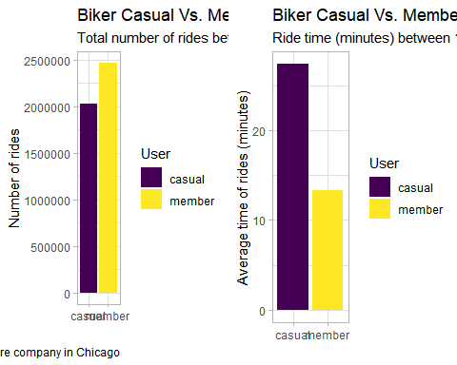

# Does bike type influences the length or number of rides between members and casuals?  
p3

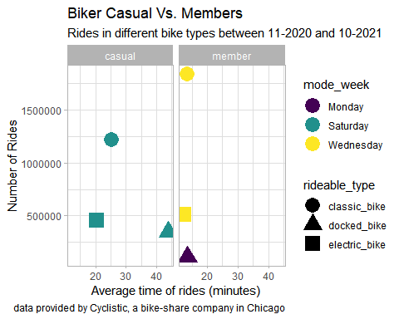

# Are the differences during the day that we should account for?  
p4

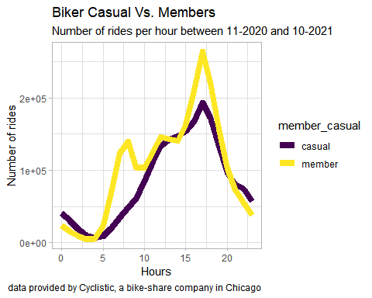

p5

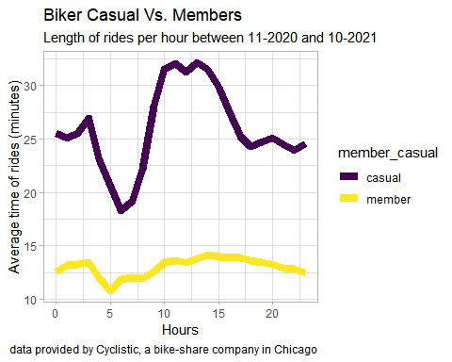

# Are the differences during the week days that we should account for?  
p6

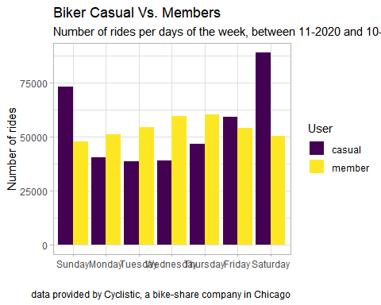

p7

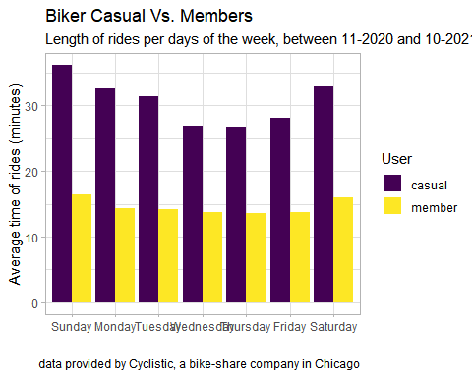

# Are the differences during the months that we should account for?  
p8

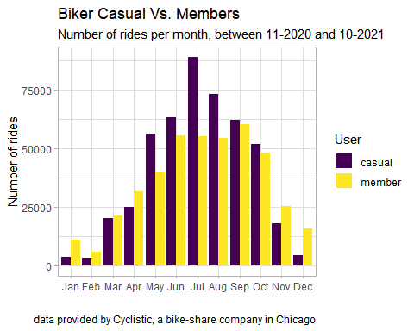

p9

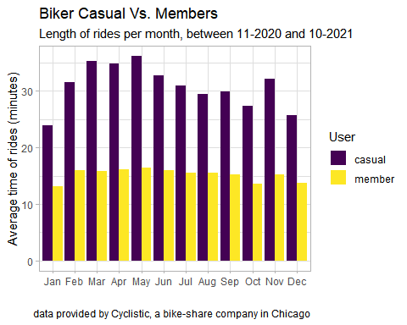

## 6. Act

### 6.1 Insights

In sum, the results of this analysis suggest the following profile for each type of consumer:

* **Casuals**: They have lower number of rides, but the longest ones (sometimes >20 minutes) when compared to members of this service. Nonetheless, their number of rides surpass Members during warmer months (March=August). There is a high fluctuation both on the length and number of rides over the year, low between November 2020 and March 2021, increases from April to July, and then progressively decreases. They use bikes mostly on Fridays, Saturdays and Sundays. Their peak of usage during the day is the afternoon, and prefer classic bikes over docker/ electric bikes.
* **Members**: They have the highest amount of rides, but these are usually shorter by comparison. Their usage of the service fluctuates significantly during the year, with barely use of bikes in February, and their peak of usage is in September. Nevertheless, unlike casuals, their ride length does not fluctuate significantly over the year. They use bikes throughout the week, and not just during weekends. Their peak of usage during the day is also in the afternoon, and they also prefer classic bikes over docker/ electric bikes.

### 6.2 Next steps

Design marketing strategies aimed at converting casual riders into annual members:

* Promote annual benefits for members during the weekends, which seems to be the favorite days for casuals.
* Focus these promotions between April and August, since its the peak of usage for both type of consumers.
* Focus the advertisement at Streeter Dr & Grand Ave, which the station most casuals use to both start and end most of the rides during the afternoon.

### 6.3 Additional data for future studies

* The trajectory of each ride.
* The cost of each ride for casuals.
* The cost of an annual subscription.