**ENSC 451-Assignment 3**

## Problem 1: PID Controller

## Problem 2: Project Documentation: Ball Levitation System

### Requirements

Table 1 explains the requirements for this system.

Table : Ball Levitation System Requirements

|  |  |
| --- | --- |
| **Name** | Ball Levitation System |
| **Purpose** | Levitate and hold ball at a selected height. |
| **Input** | Desired position selected via potentiometer and LCD. |
| **Output** | Ball stabilized at selected position and LCD indicates the actual position. |
| **Functions** | * Moves ball to desired height using PID Controller. * Displays selected and actual position on LCD display as the system moves. |
| **Performance** | * Moves ball to desired height within 2 seconds. * Stabilize to < 1cm error within 1 second. |
| **Manufacturing Cost** | N/A (System Provided to us from SFU) |
| **Power** | N/A (System Provided to us from SFU) |
| **Physical Size and Weight** | N/A (System Provided to us from SFU) |

### Specifications

#### Ball Levitation Program

The *ball levitation program* contains the initialization routine, which serves as the program entry point and the main function which calls all other functions.

#### User Interface

The *user Interface* section of the code is used to gather information from the user, such as where the desired position for the ball is (Set Point). It also, should display information to the user, such as the current position of the ball and the error between this position and the set point.

#### Control System

The *control system* section of the point is used to adjust the position of the ball used feedback information from the IRSensor. This is done by feeding the value of the IR Sensor, which represents the current position, into a PID Controller. The PID Controller uses Proportional, Integral and Derivative gains, to determine the appropriate duty cycle in an effort to reduce the difference between set point and current point.

#### PWMOut

The *PWM*Out function is used to drive the motor. This function takes in a duty cycle and sends a modulated signal to the motor.

#### *Potentiometer

The *Potentiometer* is a physical sensor that measures rotation and outputs a value to a pin. This value is used to select the Set Point.

#### *LCD

The *LCD* is a visual output that displays information to the user. This includes the set point, the current position and the error between the two.

#### *MotorizedFan

The *MotorizedFan* is a physical fan that pushes the ball up when powered. This serves as the actuator in this system.

#### UML Class Diagram



Figure : UML Class Diagram For Ball Levitation System

#### System FlowChart

Figure 2 shows the flow chart for our ball levitation system.

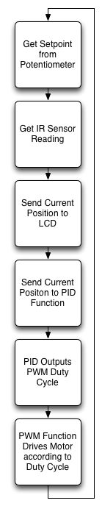

Figure : Ball Blower Flow Chart