Analysis

Ian Moore & Danny Foster

7/21/2020

Table of Contents

knitr::opts_chunk$set(echo = FALSE, warning = FALSE, message = FALSE)

# Setup

Load packages:

Load data:

Print session info:

## R version 3.6.3 (2020-02-29)  
## Platform: x86_64-pc-linux-gnu (64-bit)  
## Running under: Ubuntu 18.04.4 LTS  
##   
## Matrix products: default  
## BLAS: /usr/lib/x86_64-linux-gnu/blas/libblas.so.3.7.1  
## LAPACK: /usr/lib/x86_64-linux-gnu/lapack/liblapack.so.3.7.1  
##   
## locale:  
## [1] LC_CTYPE=en_US.UTF-8 LC_NUMERIC=C   
## [3] LC_TIME=en_US.UTF-8 LC_COLLATE=en_US.UTF-8   
## [5] LC_MONETARY=en_US.UTF-8 LC_MESSAGES=en_US.UTF-8   
## [7] LC_PAPER=en_US.UTF-8 LC_NAME=C   
## [9] LC_ADDRESS=C LC_TELEPHONE=C   
## [11] LC_MEASUREMENT=en_US.UTF-8 LC_IDENTIFICATION=C   
##   
## attached base packages:  
## [1] stats graphics grDevices utils datasets methods base   
##   
## other attached packages:  
## [1] glmmTMB_1.0.2.1 GGally_1.5.0 sf_0.9-2 forcats_0.4.0   
## [5] stringr_1.4.0 dplyr_0.8.5 purrr_0.3.4 readr_1.3.1   
## [9] tidyr_1.0.2 tibble_3.0.1 ggplot2_3.3.0 tidyverse_1.3.0  
## [13] here_0.1   
##   
## loaded via a namespace (and not attached):  
## [1] httr_1.4.1 jsonlite_1.6.1 splines_3.6.3   
## [4] modelr_0.1.5 assertthat_0.2.1 cellranger_1.1.0   
## [7] yaml_2.2.0 pillar_1.4.3 backports_1.1.6   
## [10] lattice_0.20-41 glue_1.4.0 digest_0.6.25   
## [13] RColorBrewer_1.1-2 rvest_0.3.5 minqa_1.2.4   
## [16] sandwich_2.5-1 colorspace_1.4-1 htmltools_0.3.6   
## [19] Matrix_1.2-18 plyr_1.8.6 pkgconfig_2.0.3   
## [22] broom_0.5.4 haven_2.2.0 xtable_1.8-4   
## [25] mvtnorm_1.1-0 scales_1.1.0 lme4_1.1-21   
## [28] emmeans_1.4.3.01 generics_0.0.2 ellipsis_0.3.0   
## [31] TH.data_1.0-10 withr_2.2.0 TMB_1.7.16   
## [34] cli_2.0.2 survival_3.1-12 magrittr_1.5   
## [37] crayon_1.3.4 readxl_1.3.1 estimability_1.3   
## [40] evaluate_0.14 fs_1.3.1 fansi_0.4.1   
## [43] nlme_3.1-147 MASS_7.3-51.6 xml2_1.2.2   
## [46] class_7.3-17 tools_3.6.3 hms_0.5.3   
## [49] multcomp_1.4-11 lifecycle_0.2.0 munsell_0.5.0   
## [52] reprex_0.3.0 compiler_3.6.3 e1071_1.7-3   
## [55] rlang_0.4.5 classInt_0.4-3 units_0.6-6   
## [58] grid_3.6.3 nloptr_1.2.1 rstudioapi_0.11   
## [61] rmarkdown_1.16 boot_1.3-25 codetools_0.2-16   
## [64] gtable_0.3.0 DBI_1.1.0 reshape_0.8.8   
## [67] R6_2.4.1 zoo_1.8-6 lubridate_1.7.4   
## [70] knitr_1.25 rprojroot_1.3-2 KernSmooth_2.23-17  
## [73] stringi_1.4.6 Rcpp_1.0.4.6 vctrs_0.2.4   
## [76] coda_0.19-3 dbplyr_1.4.2 tidyselect_1.0.0   
## [79] xfun_0.9

# Data exploration

Data exploration plots. Used to check assumptions and inform analysis, not intended for publication.

## Fuel loads

### Y distributions

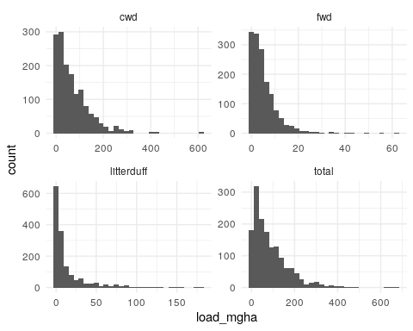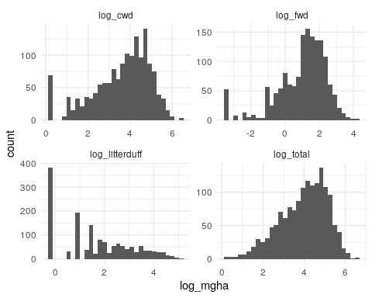

### X distributions

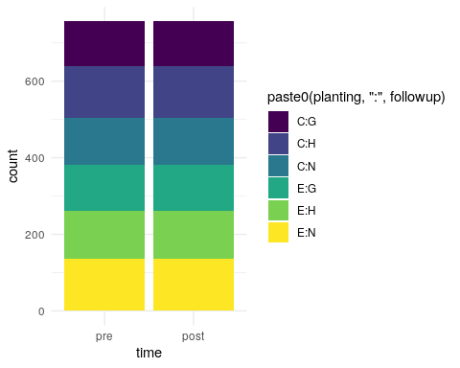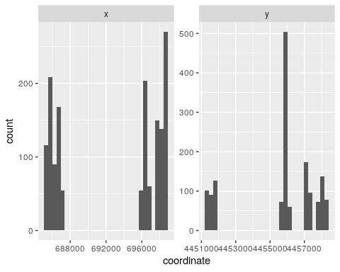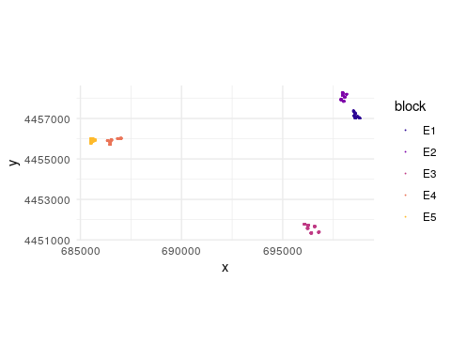

### XX relationships

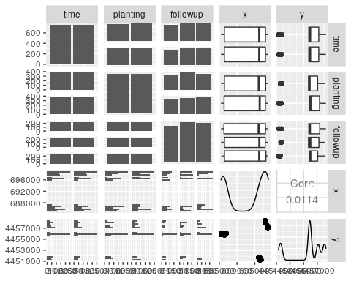

### XY relationships and interactions

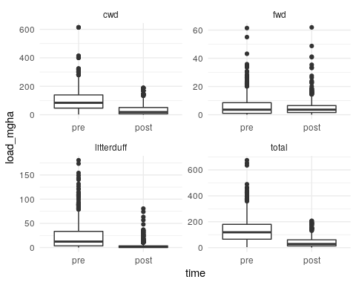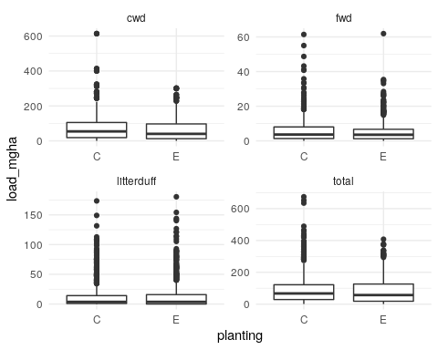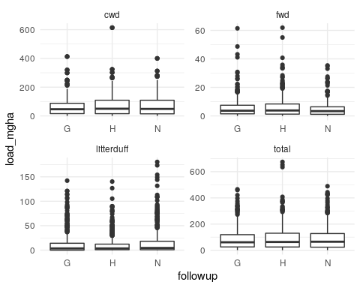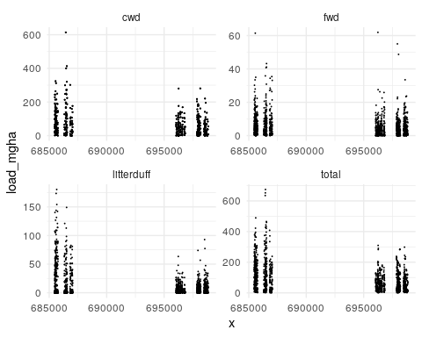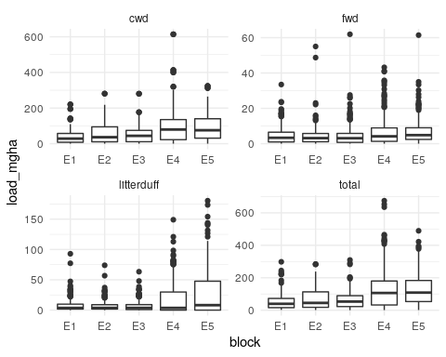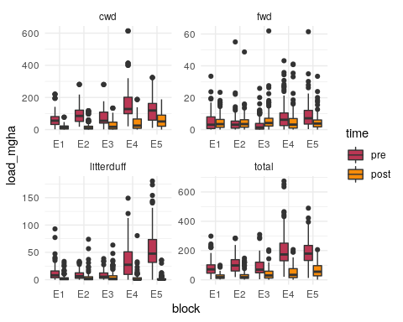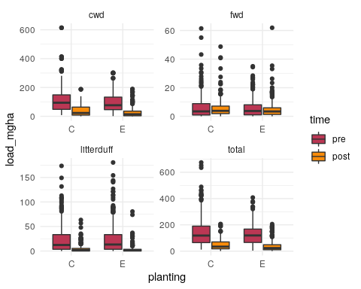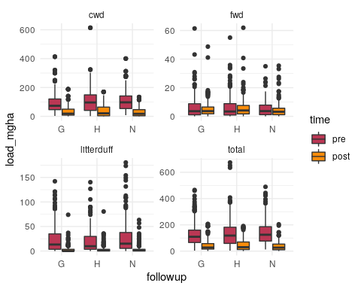

**Strongly** skewed fuel loads, even more so than is usual. Looks like time has an effect. Maybe 1 of the treatments too? Though the variation explained by treatment and block is similar. 1000h loads very strongly correlated with total loads, which makes sense given the fuel type (ots of down logs, not much FWD or litter / duff). Strong effect of time, but without clear interactions with planting and/or followup: Suggests that site-prep (which was applied universally) is most of the time effect.

## Cover continuity

I think it makes more sense to describe cover continuity in terms of the number of patches per transect, rather than as the size of patches. Here’s why:

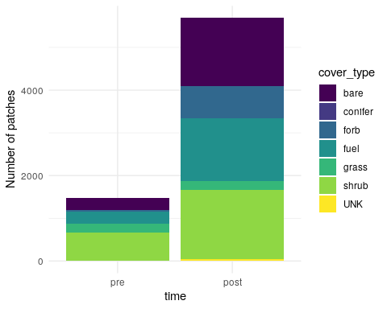

If we fit a model looking at the size of each patch, then the N for post-treatment (smaller patches) is way higher than for pre-treatment. I *think* LMEs can handle unbalanced data, but the LMEs I’ve run on patch size perform poorly on validation tests, even after log-transforming the sizes.

Instead, we treat model the number of distinct patches on each transect:

### Y distributions

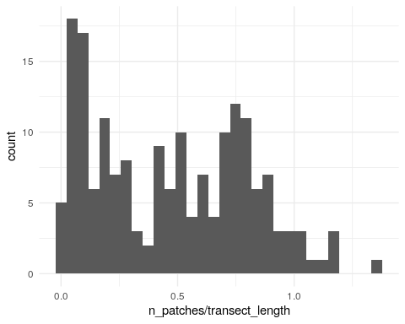

### X distributions and XX relationships

These are all categorical variables in the balanced study design:

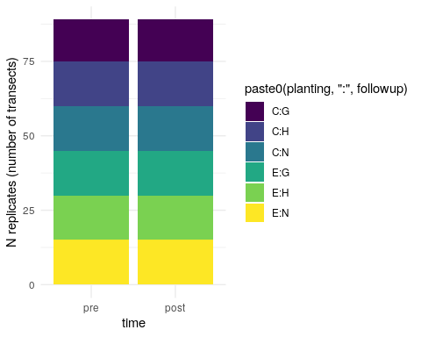

### XY Relationships and interactions

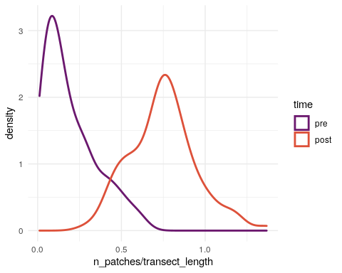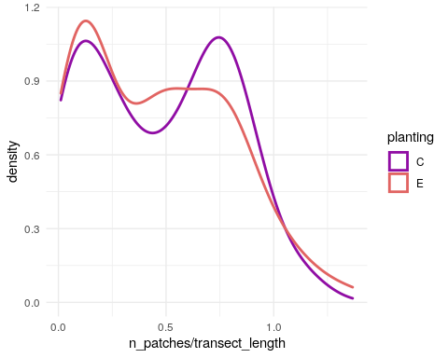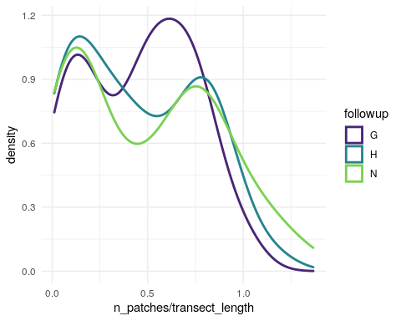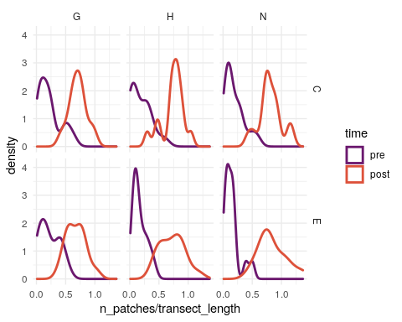

## Cover composition

### Y distributions

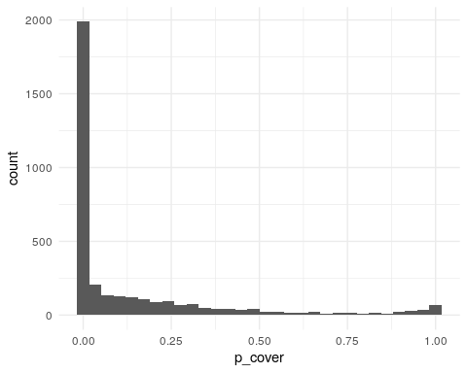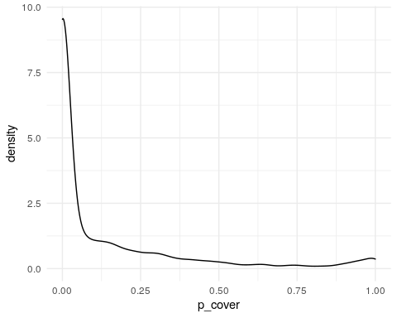

### X distributions and XX relationships

Again, all of the X variables are categorical variables and we have a balanced design. (Or mostly so; some subtransects are missing.)

### XY Relationships and interactions

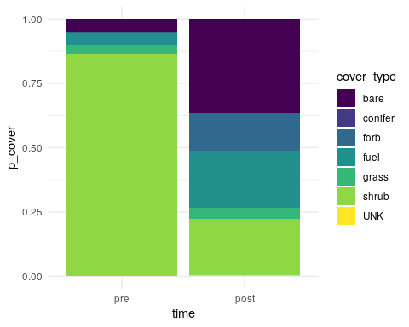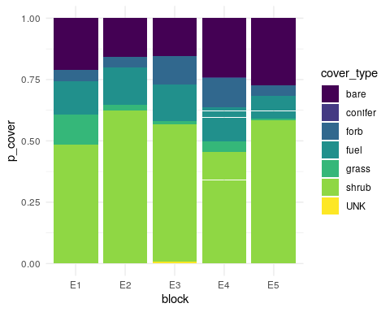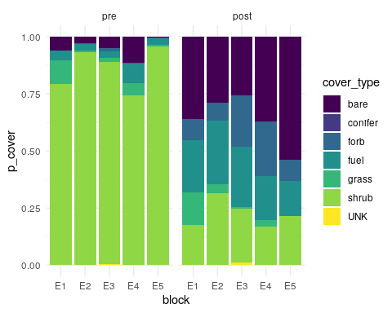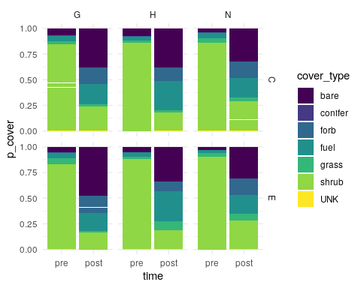

## Spatial structure

# Analyses

## Fuel loads

Note the distributions with lots of 0s and highly skewed positive-continuous values: Good candidates for a tweedie (compound poisson gamma) model.

Fit LMEs on log-transformed data:

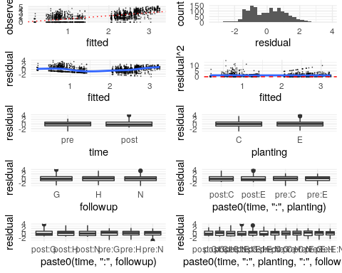

This looks worse at first glance than I think it actually is. Theres a clear bimodal distribution to the residuals, which is a real problem. There’s also two clear groups of fitted values, which is not a real problem. The zero- truncation at the low end is evident in the residuals, but the residuals do appear homoskedastic. Litter-duff was the most skewed of the fuel components.

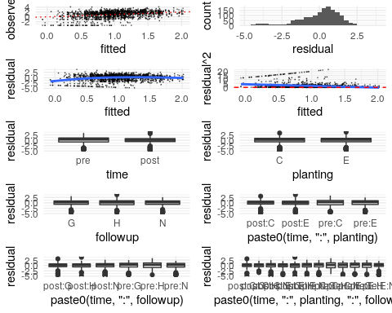

So-so. Again zero-truncation is skewing the residual distribution, even for a log-transformed response.

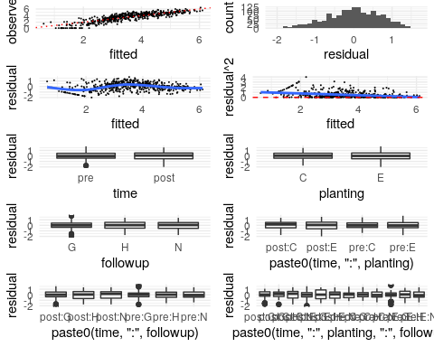

These look OK.

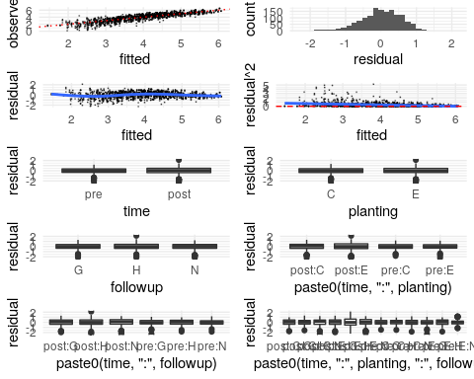

This looks OK, but not great. There is an obvious decrease in the residual variance as the fitted values increase. The residuals are slightly skewed but pretty good. I also ran these models as a glmm with a tweedie-distributed response. Those models had good-but-not-perfect validation plots, but are more difficult to interpret. The fixed effect parameter estimates were very similar between the LME and GLMM versions, which is good evidence that the LME findings are robust.

## Cover continuity

We run a GLMM on the poisson-distributed response, the number of patches per transect. The more patches per transect, the more discontinuous the cover. I’ve aggregated patches which using the high/low/no fuels categories described in the paper. Using a generalized poisson model ( $Var=μ×exp(η)$) because the standard poisson $Var=μ$ was overdispersed. Using the transect length / 90 as an offset to account for cut-off transects. The response is the number of patches per transect.

## Family: genpois ( log )  
## Formula:   
## n_patches ~ time * planting * followup + (1 | block/plot/transect)  
## Data: count_patches  
## Offset: count_patches$transect_length/90  
##   
## AIC BIC logLik deviance df.resid   
## 1462.5 1513.4 -715.2 1430.5 162   
##   
## Random effects:  
##   
## Conditional model:  
## Groups Name Variance Std.Dev.   
## transect:(plot:block) (Intercept) 9.558e-10 3.092e-05  
## plot:block (Intercept) 9.113e-14 3.019e-07  
## block (Intercept) 1.311e-02 1.145e-01  
## Number of obs: 178, groups:   
## transect:(plot:block), 89; plot:block, 30; block, 5  
##   
## Overdispersion parameter for genpois family (): 7.22   
##   
## Conditional model:  
## Estimate Std. Error z value Pr(>|z|)   
## (Intercept) 1.81357 0.17374 10.438 < 2e-16 ***  
## timepost 1.35974 0.18716 7.265 3.73e-13 ***  
## plantingE 0.05729 0.22686 0.253 0.801   
## followupH -0.22411 0.24009 -0.933 0.351   
## followupN -0.03415 0.22784 -0.150 0.881   
## timepost:plantingE -0.10504 0.25823 -0.407 0.684   
## timepost:followupH 0.25097 0.26820 0.936 0.349   
## timepost:followupN 0.13224 0.25694 0.515 0.607   
## plantingE:followupH 0.12497 0.32409 0.386 0.700   
## plantingE:followupN -0.25300 0.32182 -0.786 0.432   
## timepost:plantingE:followupH -0.09201 0.36607 -0.251 0.802   
## timepost:plantingE:followupN 0.36870 0.36197 1.019 0.308   
## ---  
## Signif. codes: 0 '***' 0.001 '**' 0.01 '*' 0.05 '.' 0.1 ' ' 1

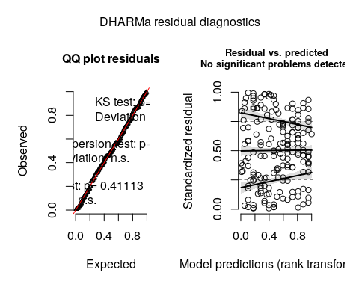

Validation plots look great!

Also doing an LME on log(patch size):

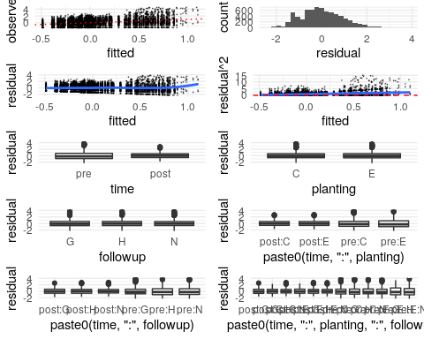

Validation plots look pretty good.

## Cover composition

Fitting a multinomial model is hard, and a multinomial mixed model is harder. Instead just report summary statistics as in the current draft:

This could be turned into an actual statistical model if reviewers want us to.

## Spatial structure

# Results

## Fuel loads

Note that these parameters are for a linear model for the *log* fuel loads. Intercept group is pretreatment:cluster:grubbing.

## Value Std.Error DF t-value p-value  
## (Intercept) 2.498 0.171 750 14.615 0.000  
## timepost -1.609 0.144 750 -11.206 0.000  
## plantingE 0.031 0.172 20 0.181 0.858  
## followupH -0.204 0.168 20 -1.213 0.239  
## followupN 0.324 0.171 20 1.888 0.074  
## timepost:plantingE -0.275 0.202 750 -1.362 0.173  
## timepost:followupH 0.232 0.196 750 1.181 0.238  
## timepost:followupN -0.311 0.201 750 -1.550 0.122  
## plantingE:followupH 0.167 0.239 20 0.701 0.492  
## plantingE:followupN -0.166 0.239 20 -0.694 0.496  
## timepost:plantingE:followupH 0.058 0.279 750 0.208 0.836  
## timepost:plantingE:followupN 0.358 0.280 750 1.279 0.201

## Value Std.Error DF t-value p-value  
## (Intercept) 1.081 0.216 750 4.993 0.000  
## timepost 0.050 0.181 750 0.278 0.781  
## plantingE -0.193 0.231 20 -0.834 0.414  
## followupH -0.217 0.226 20 -0.958 0.350  
## followupN -0.282 0.230 20 -1.225 0.235  
## timepost:plantingE 0.143 0.254 750 0.562 0.574  
## timepost:followupH 0.512 0.247 750 2.072 0.039  
## timepost:followupN 0.072 0.253 750 0.284 0.777  
## plantingE:followupH 0.155 0.321 20 0.482 0.635  
## plantingE:followupN 0.447 0.322 20 1.390 0.180  
## timepost:plantingE:followupH -0.447 0.351 750 -1.273 0.203  
## timepost:plantingE:followupN -0.558 0.352 750 -1.585 0.113

## Value Std.Error DF t-value p-value  
## (Intercept) 4.268 0.267 750 15.982 0.000  
## timepost -1.254 0.099 750 -12.726 0.000  
## plantingE 0.001 0.272 20 0.005 0.996  
## followupH 0.075 0.269 20 0.277 0.784  
## followupN 0.357 0.272 20 1.313 0.204  
## timepost:plantingE -0.068 0.138 750 -0.491 0.624  
## timepost:followupH 0.117 0.135 750 0.866 0.387  
## timepost:followupN -0.353 0.138 750 -2.565 0.011  
## plantingE:followupH -0.067 0.381 20 -0.175 0.863  
## plantingE:followupN -0.366 0.382 20 -0.959 0.349  
## timepost:plantingE:followupH -0.623 0.191 750 -3.257 0.001  
## timepost:plantingE:followupN -0.185 0.192 750 -0.962 0.336

## Value Std.Error DF t-value p-value  
## (Intercept) 4.556 0.232 750 19.676 0.000  
## timepost -1.120 0.082 750 -13.747 0.000  
## plantingE 0.049 0.210 20 0.234 0.818  
## followupH 0.024 0.207 20 0.116 0.909  
## followupN 0.342 0.209 20 1.632 0.118  
## timepost:plantingE -0.197 0.115 750 -1.718 0.086  
## timepost:followupH 0.129 0.111 750 1.156 0.248  
## timepost:followupN -0.362 0.114 750 -3.178 0.002  
## plantingE:followupH -0.072 0.293 20 -0.245 0.809  
## plantingE:followupN -0.346 0.294 20 -1.178 0.252  
## timepost:plantingE:followupH -0.329 0.158 750 -2.076 0.038  
## timepost:plantingE:followupN 0.038 0.159 750 0.237 0.813

## Cover continuity

## Family: genpois ( log )  
## Formula:   
## n_patches ~ time * planting * followup + (1 | block/plot/transect)  
## Data: count_patches  
## Offset: count_patches$transect_length/90  
##   
## AIC BIC logLik deviance df.resid   
## 1462.5 1513.4 -715.2 1430.5 162   
##   
## Random effects:  
##   
## Conditional model:  
## Groups Name Variance Std.Dev.   
## transect:(plot:block) (Intercept) 9.558e-10 3.092e-05  
## plot:block (Intercept) 9.113e-14 3.019e-07  
## block (Intercept) 1.311e-02 1.145e-01  
## Number of obs: 178, groups:   
## transect:(plot:block), 89; plot:block, 30; block, 5  
##   
## Overdispersion parameter for genpois family (): 7.22   
##   
## Conditional model:  
## Estimate Std. Error z value Pr(>|z|)   
## (Intercept) 1.81357 0.17374 10.438 < 2e-16 ***  
## timepost 1.35974 0.18716 7.265 3.73e-13 ***  
## plantingE 0.05729 0.22686 0.253 0.801   
## followupH -0.22411 0.24009 -0.933 0.351   
## followupN -0.03415 0.22784 -0.150 0.881   
## timepost:plantingE -0.10504 0.25823 -0.407 0.684   
## timepost:followupH 0.25097 0.26820 0.936 0.349   
## timepost:followupN 0.13224 0.25694 0.515 0.607   
## plantingE:followupH 0.12497 0.32409 0.386 0.700   
## plantingE:followupN -0.25300 0.32182 -0.786 0.432   
## timepost:plantingE:followupH -0.09201 0.36607 -0.251 0.802   
## timepost:plantingE:followupN 0.36870 0.36197 1.019 0.308   
## ---  
## Signif. codes: 0 '***' 0.001 '**' 0.01 '*' 0.05 '.' 0.1 ' ' 1

## Cover composition

## # A tibble: 14 x 4  
## # Groups: time [2]  
## time cover_type p_cover.mean p_cover.sd  
## <fct> <chr> <dbl> <dbl>  
## 1 pre bare 0.0522 0.0928   
## 2 pre conifer 0.0000654 0.00104  
## 3 pre forb 0.00420 0.0193   
## 4 pre fuel 0.0436 0.0690   
## 5 pre grass 0.0365 0.0771   
## 6 pre shrub 0.861 0.159   
## 7 pre UNK 0.00221 0.0128   
## 8 post bare 0.366 0.197   
## 9 post conifer 0.000131 0.00165  
## 10 post forb 0.147 0.164   
## 11 post fuel 0.222 0.130   
## 12 post grass 0.0414 0.0995   
## 13 post shrub 0.220 0.133   
## 14 post UNK 0.00333 0.0164

## Spatial structure of shrub patches

# Tables for publication

## Table 1: Changes in fuel loads

# Figures for publication

## Figures 1 and 2: Photos

## Figure 3: Sampling design

## Figure 4: Patch size distributions by cover type and time

## Figure 5: CDF functions for patch size distributions by time and intensity class

## Figure 6: Correlograms for shrub cover

# Write outputs