Demographic status, trajectory, and stressors of *Pinus lambertiana*

# Introduction

Sugar pine (*Pinus lambertiana*) is the largest Pinus species, an important timber species, and a component of several dry western conifer forest types, in particular the extensive Sierra Nevada Mixed Conifer forest where it typically composes 5-25% of basal area (Kinloch and Scheuner 1990, Safford and Stevens 2017). Its range extends through much of the North American Mediterranean zone throughout mountain ranges in California and central Oregon (Safford and Stevens 2017), with most of the growing stock located in California (Kinloch and Scheuner 1990). Like many other plant and animal species, Sugar pine faces numerous challenges in the Anthropocene, and managers and policymakers are concerned about the future status of the species.

First, there is evidence that modern densified forest structure poses a threat to the ability of sugar pine to successfully reproduce. Sugar pine is a fire-tolerant species with moderate shade intolerance (Yeaton 1984) and persisted in frequent fire forest types with mean fire return intervals of 11-16 years. Effective fire suppression, which was instituted across much of sugar pine’s range in the 20th century, has resulted in an overall densification of these forests and shifted species composition (especially of younger cohorts) towards shade-tolerant firs and incense-cedar (Stephens et al. 2015, Levine et al. 2016, Ansley and Battles 1998). Historical logging practices tended to target large and valuable sugar pines, further altering forest composition and structure (Cermak 1996, Safford and Stevens 2017).

Second, one result of densification and a warming climate has been an increase in the annual area burned by high severity wildfire throughout the range of sugar pine (Parks et al. 2020). Sugar pine is not serotinous and has adaptations for large adults to survive wildfire (Schwilk & Ackerly 2001). However, the novel fire regime is creating large swaths of landscape with no surviving reproductive adults, and thus no seed source for the next generation (North et al. 2020, Stevens SDC paper).

Third, the changing climate may increase the duration and severity of droughts and associated bark beetle epidemics, which are already causing mass mortality events in sugar pine’s range (Fettig et al. 2019). Once these epidemics are underway, bark beetles tend to preferentially target large and reproductively-valuable sugar pines, independent of individuals’ stress (Stephenson 2019).

Finally, an invasive fungal pathogen, *Cronartium ribicola* (white pine blister rust; WPBR) has spread across much of sugar pine’s range since its introduction and has caused substantial mortality (van Mantgem et al. 2004, Dudney et al. 2020). Maloney et al. 2014 found that some subpopulations of sugar pine in the Lake Tahoe basin exhibited negative population growth rates and high levels of WPBR infection. Sugar pine may have been facing these challenges for some time: some subpopulations of sugar pine showed evidence of inbreeding, potentially caused by population bottlenecks which may the result of historical logging, fire suppression, and/or more recent white pine blister rust outbreaks (Maloney et al. 2011).

Given these numerous challenges, there are widespread concerns about the future of the species (Kinloch et al. 1996). Management options to benefit sugar pine are available, ranging from restoration thinning and prescribed fire to restore forest structure (Restaino et al. 2019) to outplanting seedlings with genetic resistance to WPBR (Kinloch et al. 1996, Aitken 2013, North et al. 2020). However, many of these options are expensive. In a context where natural resource management funding is constrained, it is important to understand the status and demographic outlook for sugar pine as a species. This study seeks to inform decisions about when and where to prioritize management actions to conserve sugar pine. To that end, I address two questions:

1. What is the current status and trajectory of the ensemble of sugar pine populations across its range?
2. What is the relative importance of the various stressors acting on sugar pine?

# Methods

## Study Area

The area of interest for this study is that part of the range of sugar pine which is within the contiguous United States (Figure 1), which is the vast majority of the species’ range. The range of sugar pine extends from LATITUDE to LATITUDE throughout much of the Sierra Nevada and Klamath mountains, and parts of the Transverse and Southern Cascades ranges in the US states of California and Oregon. Sugar pine is widely distributed throughout this range as an important element of the mixed conifer forest belt at elevations ranging from LOWER MCF ELEVATION to UPPER MCF ELEVATION. The climate throughout this range is Mediterranean, with a cool-wet season extending from MONTH through MONTH and a warm-dry season extending from MONTH through MONTH.

The range delineation used for this study was generated using the raster files provided by (Wilson et al. 2013). The USFS RMRS Live Tree Species Basal Area of the Contiguous United States 2000-2009 (CITE) provides species-specific rasters of predicted basal area at 250m resolution across the contiguous US, with each raster cell giving a predicted value for the basal area (ft2/acre) of the selected species. The abundance predictions are generated using k-nearest neighbors and canonical correspondence analysis on MODIS imagery, raster data describing relevant environmental parameters, and Forest Inventory and Analysis (FIA) field plot data. This continuous raster was converted to a discrete polygon by first aggregating the resolution from 250m to 3km and filtering to cells where predicted sugar pine basal area was greater than 0.46 m2/ha. This level of aggregation and filtering provided the best combination of sensitivity and specificity when comparing the resulting range polygon against the actual presence of sugar pine on FIA plots (at their nominal locations).

## Inventory Data

The FIA plots are part of a US Forest Service-run nationwide inventory network operating in its current form since 2001 (Bechtold 2005). Here, I use FIA plots from California, Oregon, and Nevada restricted to the processed sugar pine range map. The geographic coordinates listed for the FIA plots are not exact; to preserve plot integrity, the plot coordinates are randomly perturbed, and some plot locations are swapped. Most perturbations are to a random location within 0.8km of the true location, and all perturbations are to within 1.6 km of the actual location. Between 0 and 10 percent of plot locations are swapped with a similar plot in the same county. FIA plots are placed on a hexagonal grid with a density of approximately 1 plot per 2429 ha. Each plot is revisited once every 10 years. On each FIA plot, trees >= 12.7 cm diameter at breast height (1.37 m, DBH) are inventoried on four 168 m2 permanent subplots. Small trees from 2.54-12.7 cm DBH are inventoried on a 13.5 m2 microplot, and large trees on an optional 1012 m2 macroplot. Data inventoried for each individual stem include the species, live/dead status, DBH, and a “damage agent” code indicating whether some agent (e.g. white pine blister rust) is visibly affecting the individual’s health. Trees which are individually inventoried (all stems >= 2.54 cm DBH) are physically tagged to facilitate relocation of specific individuals at remeasurement. The smallest stems surveyed (height >= 0.15 m and DBH < 2.54 cm) are not inventoried as individuals but tallied by species, and remain untagged. Individuals which are either new recruits or were not tagged due to small size at initial measurement thus are untagged at remeasurement.

In addition to the tree-level data collected, the FIA program also records information about forest conditions, including the presence of significant disturbances (e.g., fire) and the ecological subsection (CITE) the plot is located within, and the nominal GPS coordinates of the plot center. For this study I selected only the subset of FIA plots whose nominal centers were within the sugar pine range polygon described above. The range polygon was used, rather than simply using all plots where sugar pine was actually present, in order to better capture the range of environmental conditions existing within sugar pine’s range.

## Climate Data

To assess the level of drought sugar pine individuals were exposed to, I extracted monthly climatic water deficit (CWD) estimates for each nominal plot location from the TerraClimate dataset (CITE). The TerraClimate dataset provides modeled estimates of CWD at approximately 4km resolution for years 1958-2020. The 4 km resolution approximately matches the degree of fuzzing associated with the nominal FIA plot locations, so that fuzzing is unlikely to add substantial error in the estimation of CWD experienced at the true plot location. Mean growing season (May-October) CWD estimates for each year between a plot’s initial measurement and its revisit provide a proxy for the drought and heat stress experienced by individuals between the two censuses. The annual mean growing season CWD estimates were summarized in two ways: First, the 20-year mean of the annual CWD estimates provides a measure of the usual climatic dryness characteristic of each site, enabling the comparison of typically-wetter vs. typically-drier locations across space. Second, the 90th percentile of the annual departures from the site-specific mean CWD provide a measure of the most severe drought (departure from usual climatic conditions) experienced by each plot location between the initial observation and the remeasurement.

## Vital Rates Model

The modelling approach for this study broadly follows that described in Shriver et al. (2021), and the following description paraphrases their methods except where the details of implementation differed for this study. This study models three vital demographic rates for sugar pine as functions of individual states and environmental covariates. The vital rates modeled are survival, growth, and recruitment. The sub model for survival is:

Equation

Equation

Where is an integer indicating the live/dead status (1 if live, 0 if dead) of individual at time (the revisit measurement, approximately 10 years after initial measurement), is the probability of survival from time to time , is a vector of covariates (described below) for individual , is a column vector of fixed effect coefficients for the survival sub model, is a vector of plot-level random effects indexed by the plot for individual with , and is a vector of ecoregion subsection-level random effects indexed by the ecoregion subsection for individual with .

The fixed effects covariates for each individual in the vector are: The intercept (), the DBH in meters at time (), a binary flag indicating whether the individual’s subplot experienced a fire at least 0.404 ha in size that killed or damaged at least 25% of trees (), a binary flag indicating whether any trees in the individual’s subplot displayed signs of white pine blister rust infection at time (), the subplot-level basal area at time (), the plot-level 90th percentile of growing season departure from mean climatic water deficit (), the plot-level growing season mean climatic water deficit over the period 2000-2020 (), and interactions between and all other variables (, , , , and ). Continuous variables other than (, , and ) were centered and scaled to have 0 mean and unit variance across all subplots. Meters were selected as the unit for DBH to facilitate parameter estimation and interpretation by keeping all variables on a similar scale.

The sub model for growth is:

Equation

Equation

Where is the DBH in meters of individual at time drawn from a truncated normal distribution (to prevent biologically impossible negative size), is the residual variance, is a vector of the same fixed effects coefficients used in the survival sub model, and the other parameters are as defined for the survival sub model, though here indexed to indicate that they are the parameters specifically for the growth sub model.

As noted in Shriver et al. 2021, analysis of recruitment is complicated by the fact that seedlings (stems whose height >= 0.15 m and DBH < 2.54 cm) are not individually surveyed and tagged, but instead tallied by species. Thus, there is uncertainty as to which of the seedlings present at time are true new recruits (vs. individuals which were already present at time ). I followed Shriver et al.’s approach to address this issue by building a recruitment model which is itself an integral projection model estimating the survival, growth, and recruitment of seedlings and saplings (all stems < 25.4 cm DBH). In this way, the (uncertain) number of new recruits on a subplot can be estimated based on a count of the untagged seedlings and saplings and estimated (from the survival and growth sub models) rates of growth and survival among pre-existing seedlings and saplings. The recruitment sub model is described briefly below, paraphrasing Shriver et al. 2021, and readers are directed to Shriver et al. 2021 for more details.

The response distribution for the recruitment sub model is:

Equation

Where is a vector giving the observed counts of untagged individuals in the smallest two size classes (0-12.7 cm DBH and 12.7-25.4 cm DBH), which are composed of both new recruits and individuals which were present but untagged due to their small size at the initial measurement, on subplot at time . is a vector of area-standardized occurrence rates, is a vector giving the total subplot area surveyed for each size class, and is the dispersion parameter for the negative binomial distribution. Only the smallest two size classes were included in the responses for the recruitment model because new individuals larger than 25.4 cm DBH are much more likely to be individuals which were simply missed due to observer error in the first survey.

Equation

Where each is a discretized integral projection model kernel describing the rates of transition from each of the size classes to each of the smallest size classes, which includes fecundity as well as growth and survival. A separate exists for each subplot . is the vector giving the area-standardized occurrence rates of individuals in each of the 20 size classes at time on subplot . The elements of for each subplot in time are given by:

Equation

Where describes the growth of preexisting individuals from the smallest size class into the smallest two size classes, is the probability that an individual in the smallest size class will survive from time to time , is the probability that a new recruit will transition into size class by time , and is the number of new recruits generated per existing individual in size class (the fecundity). Recall that each element of is also indexed by subplot and census interval , but that these indices have been omitted for clarity. is given by:

Equation

Where is the cumulative probability density function of a normal distribution with mean and variance evaluated at the upper bound of size class (), the lower bound of size class (), or 0. is calculated for each subplot from Equation 4 using the mean DBH of all trees (of all species) in size class 1 (0.0103 m) as an approximation for the size of an individual in the smallest size bin. Likewise, is calculated using Equation 2 to predict the survival of an individual with m on subplot . Shriver et al. estimated using a normalized gaussian kernel, but had difficulty estimating the mean and variance of this recruit size kernel. Model testing for this study revealed that the parameters for this kernel were not identifiable, and attempting to estimate them resulted in divergent transitions in the Hamiltonian Monte Carlo algorithm described below. Rather than attempt to estimate the mean and variance of a gaussian recruitment size kernel, I approximated the recruitment size kernel (the probability that a new recruit will grow into size class ) as the proportion of untagged individuals found within that size class, giving . Finally, the parameter of primary interest in the recruitment sub model is , the fecundity of individuals in size class :

Equation

Where is a vector of fixed effects coefficients for size class on subplot , again using the mean DBH of all stems in size class to approximate the size of an individual in class . The covariates and parameters are as described for the growth and survival sub models, though here indexed by to indicate that they are the parameters for the fecundity sub model.

I chose to use 12.7 cm wide bins for size classes to balance computational requirements against resolution needs in describing the size distribution of sugar pines, which ranges from 0 cm to 246 cm in DBH in this dataset. The 12.7 cm wide bins align with the changes in sampling area associated with different size classes in the FIA protocol and avoid the computational costs which would be associated with using 2.54 cm bins (as did Shriver et al.) for a tree species which can grow to more than 200 cm DBH. The relative coarseness of the 12.7 cm size bins is mitigated here by the use of the mean size rule (rather than the midpoint size rule) to assign specific sizes to each bin for the purposes of estimating survival, growth, and fecundity of each size class, following suggestions from Doak et al. 2021.

The three sub models were analyzed as a single model, so that the findings of the survival and growth sub models could inform the recruitment model. Model data was prepared using the tidyverse package in R Version 4.1.1, and Bayesian parameter estimation was performed using Hamiltonion Monte Carlo as implemented in stan version 2.28.2 and the cmdstanr package. The sampler was run in four chains for 2000 iterations per chain (discarding the first 1000 iterations as warmup). The prior distribution specified for all parameters was (with variance terms restricted to positive values) except for the negative binomial dispersion parameter , which received a prior following Shriver et al. 2021. Fewer size bins in the recruitment sub model, the use of normal distributions instead of spatial gaussian predictive processes for random effects, and more efficient stan code allowed me to substantially reduce the wall time required for parameter estimation from the week reported by Shriver et al. to approximately one hour. Other R packages used for data acquisition, data management, and plotting include here, sf, spdata, bayesplot, posterior, units, raster, ggplot2, USAboundaries, truncnorm, cowplot, foreach, doParallel.

## Model Validation

The basic diagnostics provided by cmdrstan (R-hat values, trace plots, per-chain posterior density plots, posterior pair plots, and assessment of divergences) were inspected for evidence of convergence and between-chain consistency or signs of difficulty estimating parameters. In addition, I plotted posterior retrodictions (observations simulated from the posterior distribution of parameters against the real data used to train the model) and posterior predictions (observations simulated from the posterior distribution against real data held out from model training and used solely for validation). 10% of plots were randomly held out from the training dataset and only used to assess the out-of-sample predictive performance of the model. The central tendency and spread of posterior predictions and retrodictions were compared to the true observed values of individual growth, individual survival, and subplot count of untagged individuals.

## Evaluation of vital rate functions and integral projection model

Once parameters were estimated and model validity checked, the fitted model was used to assess the impact of the various stressors on sugar pine (fire, WPBR, stand density, drought, and site dryness) on the vital rates of growth, survival, and fecundity. Artificial explanatory data were constructed representing a suite of environmental scenarios correspond to situations where a single stressor is present (in the case of the discrete explanatory variables and ) or elevated/depressed by one standard deviation (in the case of the continuous variables , , and ), while other stressors are absent or held at their mean value (0 for scaled variables). Given these environmental contexts, vital rates for individuals ranging in size from 0.01-1.25 m DBH were predicted using the parameters from each posterior sample, and the predicted response plotted against DBH and stressor. The resulting plots provide valuable insight into how each stressor interacts with individual size to shape vital rates.

Likewise, I used the estimated vital rate functions generated by the posterior parameter values to generate an integral projection model and estimate posterior asymptotic growth rates under the same suite of scenarios. I discretized the continuous vital rate functions for survival, growth, and fecundity using 20 size classes to describe the state of sugar pine individuals to generate a transition matrix for each environmental context and posterior sample . Each has rows and columns corresponding to 20 12.7 cm DBH size bins used to discretize the sugar pine populations. The subscripts and are omitted below for clarity, and I discuss only a single matrix corresponding to expected transitions given a single environmental context and set of vital rate parameters. The elements of are calculated as:

Equation

Where is the probability that an individual in size class will grow into size class by time (calculated using Equation 4 and Equation 8, the mean DBH of , the environmental context associated with and the parameters from posterior sample ). Similarly, is the probability that an individual in size class at time will survive to time (calculated using Equation 2). is the probability that a new recruit will grow into size class by the second census at time . is the expected number of new recruits per individual in size class , calculated using Equation 9.

Following the recommendations of Doak 2021, individuals in each size class were approximated using the mean DBH of all trees in each size class, rather than the bin midpoint. The growth transition probabilities were evaluated using the cumulative density function of a normal distribution (as in Equation 8, but evaluating growth between each size class and every other size class). The largest real eigenvalue of each full transition matrix corresponds to the asymptotical population growth rate for posterior draw and environmental context . The distribution of for each environmental context was plotted to understand how the presence or absence of different stressors is expected to shape the asymptotic population growth rate of sugar pine.

# Results

## Model Validation

Diagnostics for mixing, convergence, R-hat, and transitions all indicated that the model fitting algorithm performed well. Comparisons of posterior distributions with prior distributions showed that the posterior was strongly informed by the data, rather than the prior, for most parameters (Supplementary Materials). The exception, where the posterior was only weakly informed by the data, were the estimates , the interaction of WPBR with size affecting fecundity. This uncertainty regarding the effect of WPBR on fecundity was likely due to the relatively low frequency of WPBR presence, combined with the fact that fecundity was not directly observed. Retrodictive simulations generated using the posterior parameter samples and the training data as explanatory variables were consistent with the true values observed in the training data (Supplementary Materials). Likewise, predictive simulations using the posterior parameter samples and the held-out validation data as explanatory variables were consistent with the true values observed in the validation data (Supplementary Materials).

## Survival

Fire had by far the strongest negative main effect on individual survival out of the suite of stressors considered in this study (Figure 2). The interaction between size and fire was also important: Small burned individuals were much more likely to die than either their large burned or small unburned counterparts. Indeed, stems which were less than 0.5 m DBH and experienced fire were the only fixed effect group to be more likely to die than live. In all other groups, predicted survival was greater than 0.5 despite the presence of other stressors interacting with size.

The positive main effect of size on survival probability is clear across all panels of Figure 2: Larger individuals were more likely to survive, including in the face of stressors. Size interactions with stressors were mostly either positive (fire and WPBR), indicating that larger individuals were more resistant to the stressor, or weak / absent (drought, dryness), indicating that the stressor impacted individuals consistently regardless of size (Supplementary Materials). The interaction between size and basal area, however, was weak but clearly negative, indicating that while small individuals were more likely to survive on sites with high neighborhood basal area than low basal area, larger individuals were less likely to survive on sites with high neighborhood basal area than low basal area. Other than basal area, the other stressors consistently reduced survival probability across the range of individual sizes, though none so strongly as fire.

## Individual Growth

## Fecundity

## Asymptotic Population Growth Rates

# Discussion

* Talk about potential interactions among stressors
  + Warming climate -> more fire, changes to wpbr range
  + Warming climate -> regeneration failures, incl. potentially of planted seedlings
  + Fire and drought effects on forest composition / densification
* Weigh potential management responses

# Figures

Figure 1: Range delineation for sugar pine (green), developed from the USFS RMRS Live Tree Species Basal Area of the Contiguous United States 2000-2009. Inset shows position relative to North America.

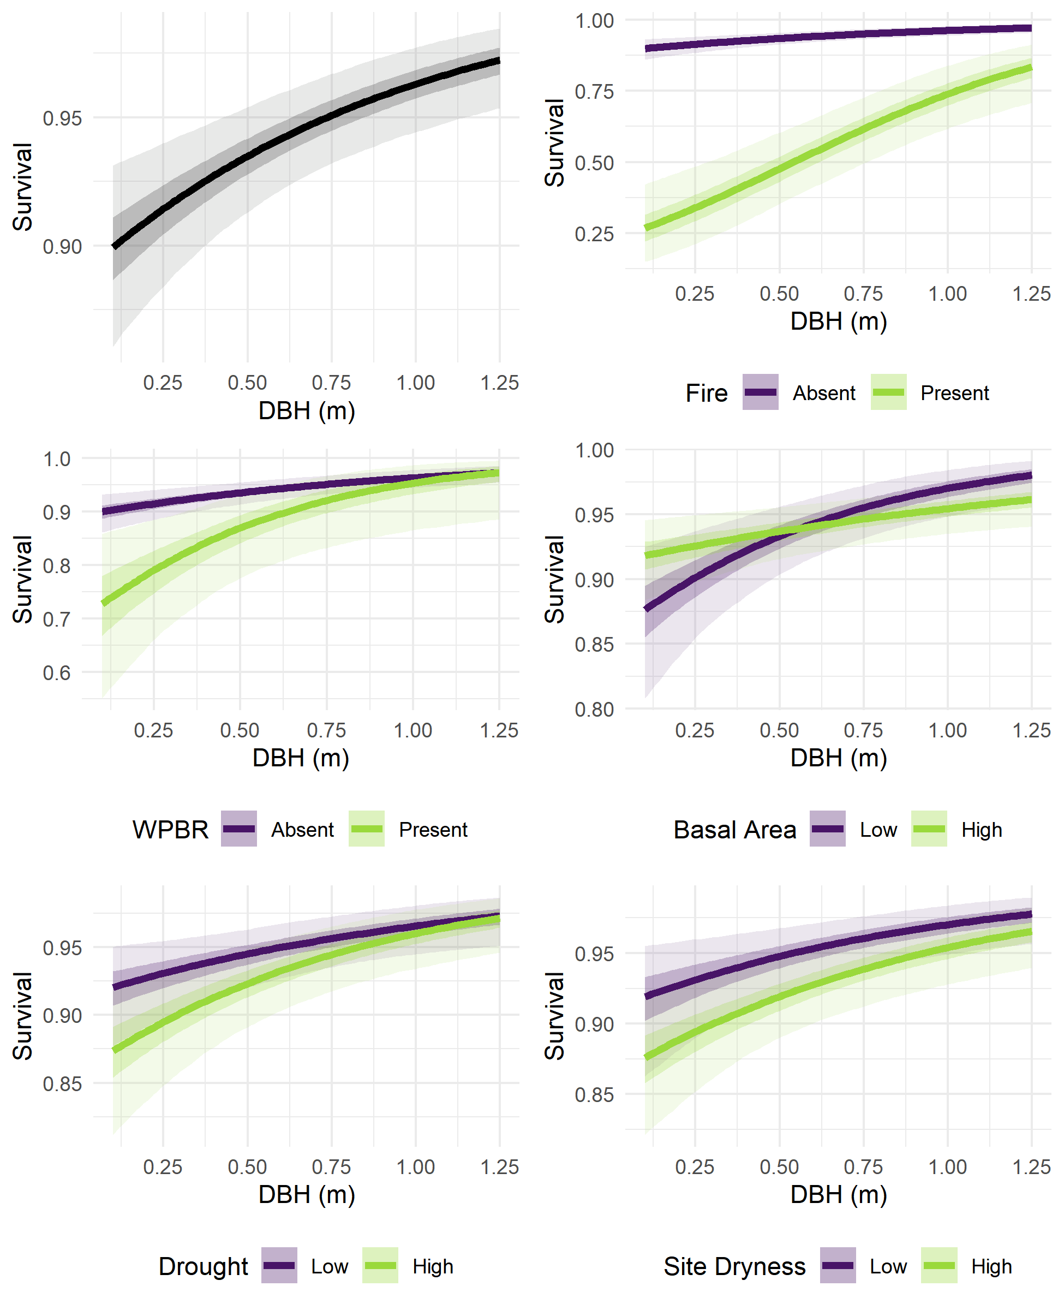

Figure : Fixed effects of initial DBH, fire, WPBR, neighborhood basal area, drought, and site dryness on survival. In the top left panel, probability of survival (Y-axis) is predicted for stems of various initial size (X-axis), holding other variables at “Absent” (for fire and WPBR) or 0 (scaled mean, for basal area, drought, and site dryness). In the other panels, probability of survival is predicted for stems of various sizes and across two levels of each other explanatory variable: with or without disturbance, or at high (1.0) or low (-1.0) values for scaled continuous variables. Predictions were generated using the posterior samples for model parameters, resulting in a range of predicted survival for each set of explanatory variable values. Lines show the median predicted survival, darker ribbons show a 50% credible interval, and lighter ribbons show a 95% credible interval. Random effects were held at 0. Note the varying scales on the Y-axis.

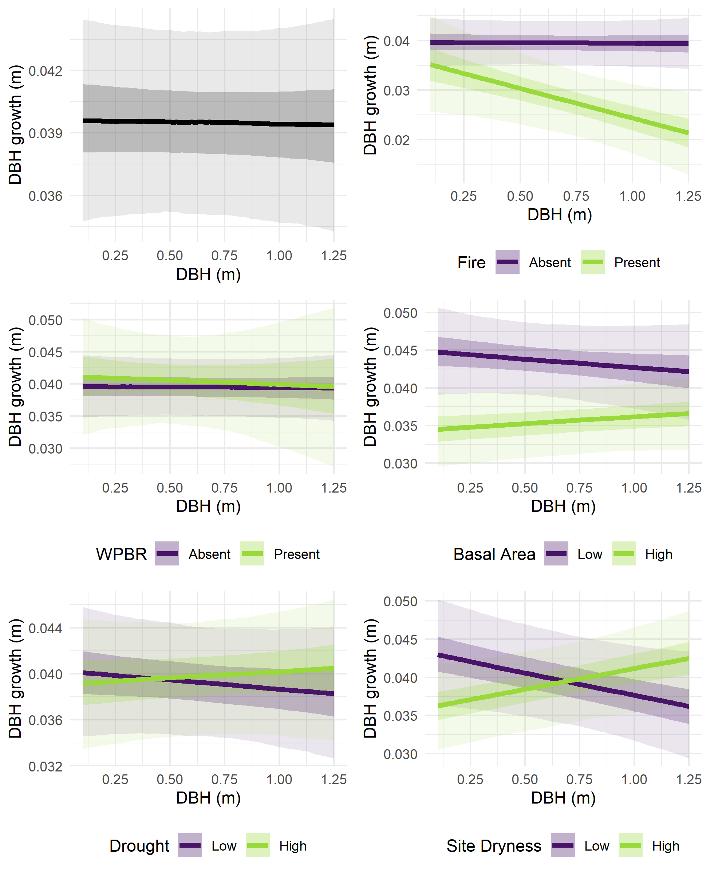

Figure : Fixed effects of initial DBH, fire, WPBR, neighborhood basal area, drought, and site dryness on growth. In the top left panel, DBH growth over the 10 years between censuses (Y-axis) is predicted for stems of various initial size (X-axis), holding other variables at “Absent” (for fire and WPBR) or 0 (scaled mean, for basal area, drought, and site dryness). In the other panels, growth is predicted for stems of various sizes and across two levels of each other explanatory variable: with or without disturbance, or at high (1.0) or low (-1.0) values for scaled continuous variables. Predictions were generated using the posterior samples for model parameters, resulting in a range of predicted survival for each set of explanatory variable values. Lines show the median predicted survival, darker ribbons show a 50% credible interval, and lighter ribbons show a 95% credible interval. Random effects were held at 0. Note the varying scales on the Y-axis.

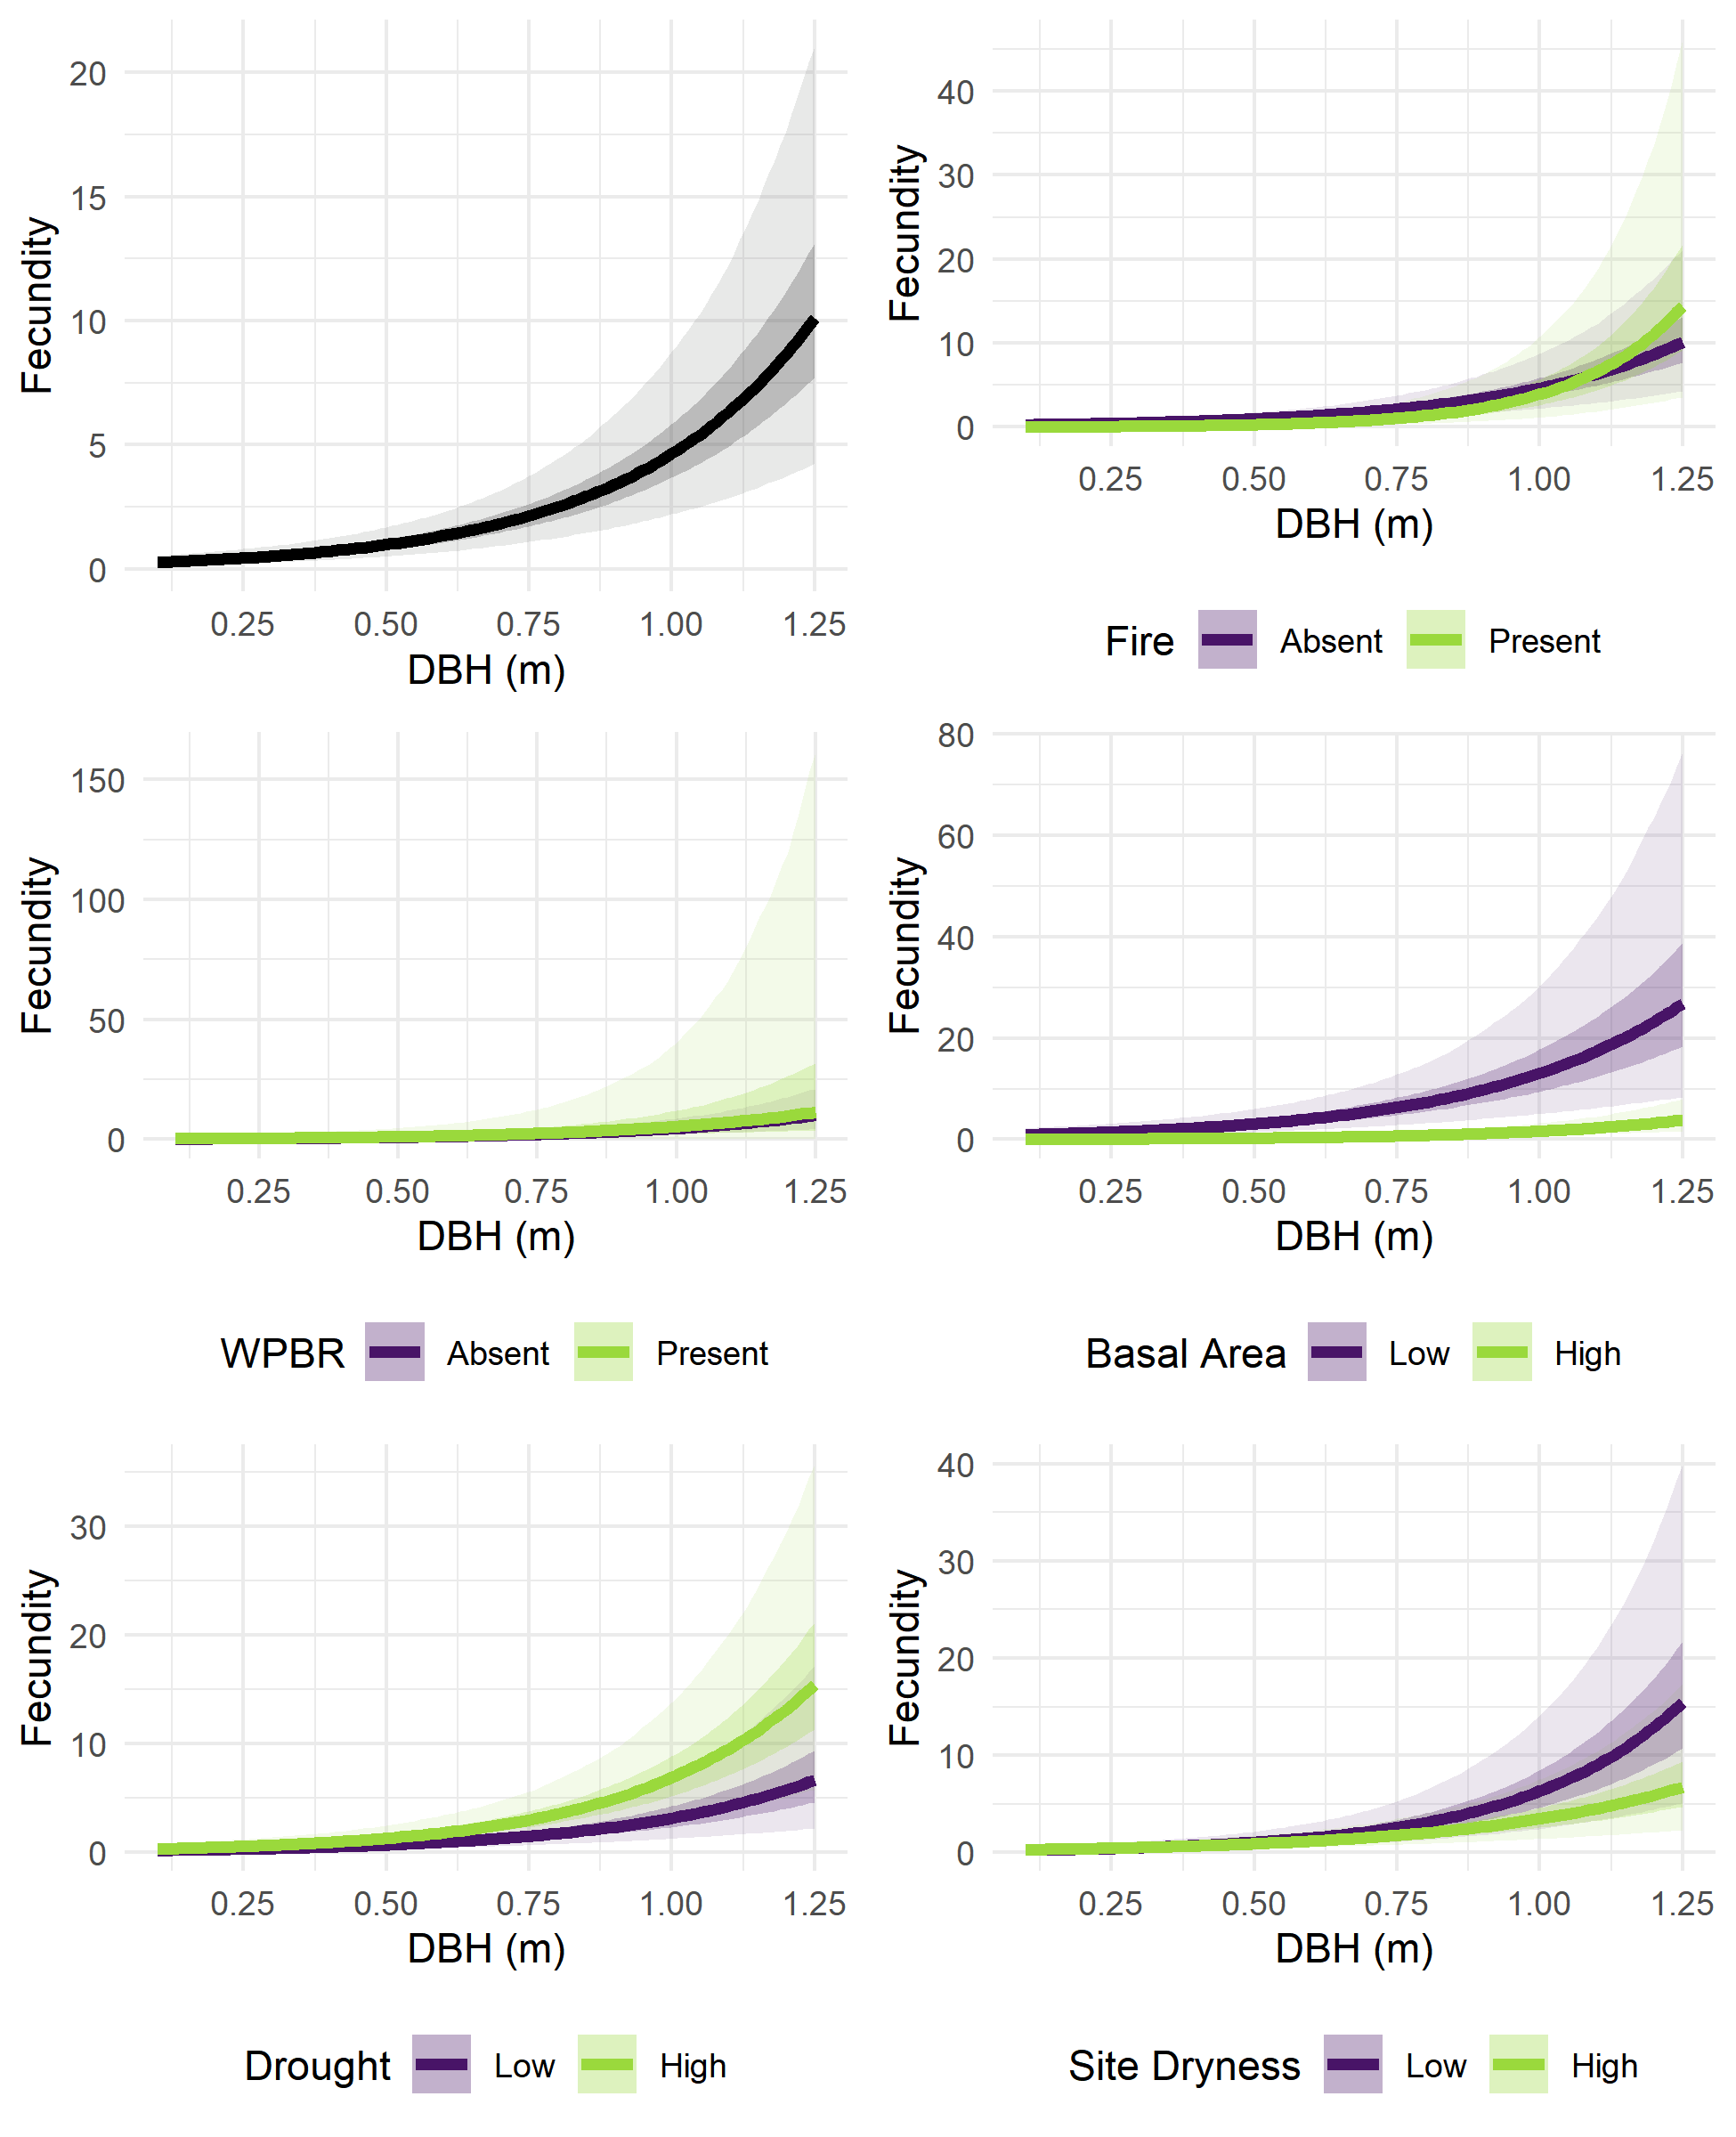

Figure : Fixed effects of initial DBH, fire, WPBR, neighborhood basal area, drought, and site dryness on fecundity. In the top left panel, fecundity (Y-axis) is predicted for stems of various initial size (X-axis), holding other variables at “Absent” (for fire and WPBR) or 0 (scaled mean, for basal area, drought, and site dryness). In the other panels, fecundity is predicted for stems of various sizes and across two levels of each other explanatory variable: with or without disturbance, or at high (1.0) or low (-1.0) values for scaled continuous variables. Predictions were generated using the posterior samples for model parameters, resulting in a range of predicted survival for each set of explanatory variable values. Lines show the median predicted survival, darker ribbons show a 50% credible interval, and lighter ribbons show a 95% credible interval. Random effects were held at 0. Note the varying scales on the Y-axis.

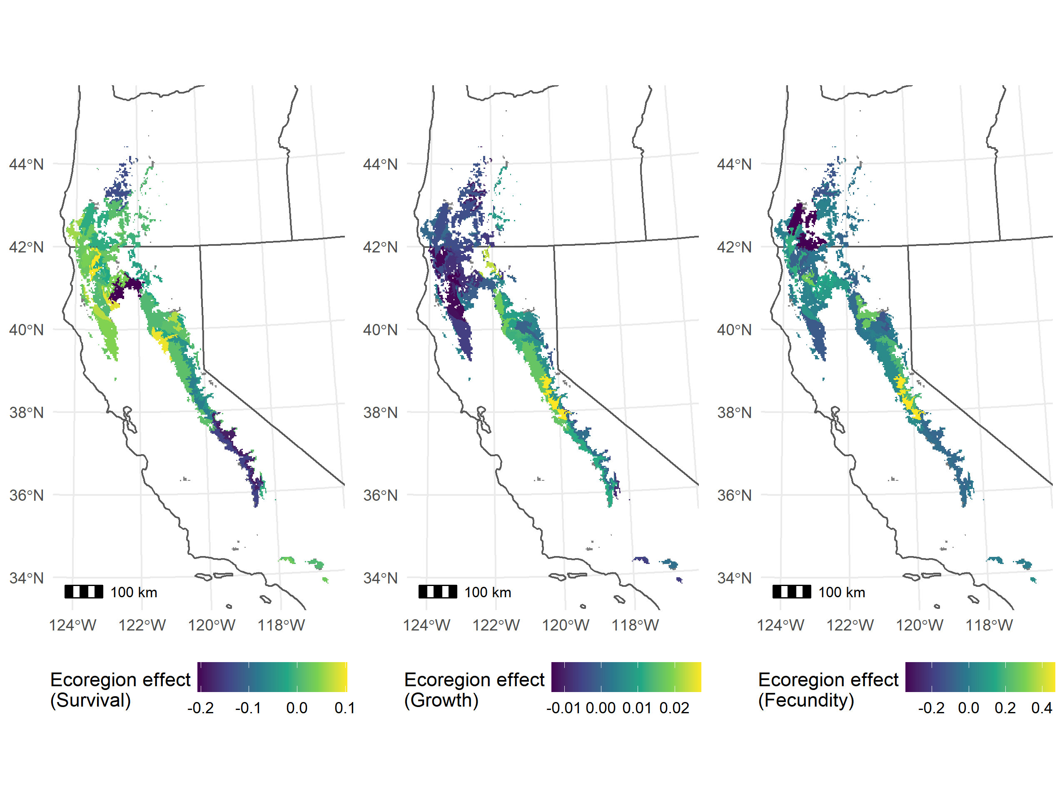

Figure : Posterior median random effect values for ecoregion subsections where sugar pine was present in the training data. The three panels show the random effect values for the survival, growth, and fecundity sub models. Ecoregion random effects drawn from a normal distribution with mean 0 and variance , , and for the survival, growth, and fecundity sub models, respectively. Ecoregions have been clipped by the sugar pine range polygon. Ecoregion effects should be interpreted as representing broad-scale variation in vital rates across the range of sugar pine which is not explained by the other variables in the model (i.e., by individual size and its interactions with fire, WPBR, basal area, drought, and site dryness, or by plot-scale variation).

# Supplementary Materials

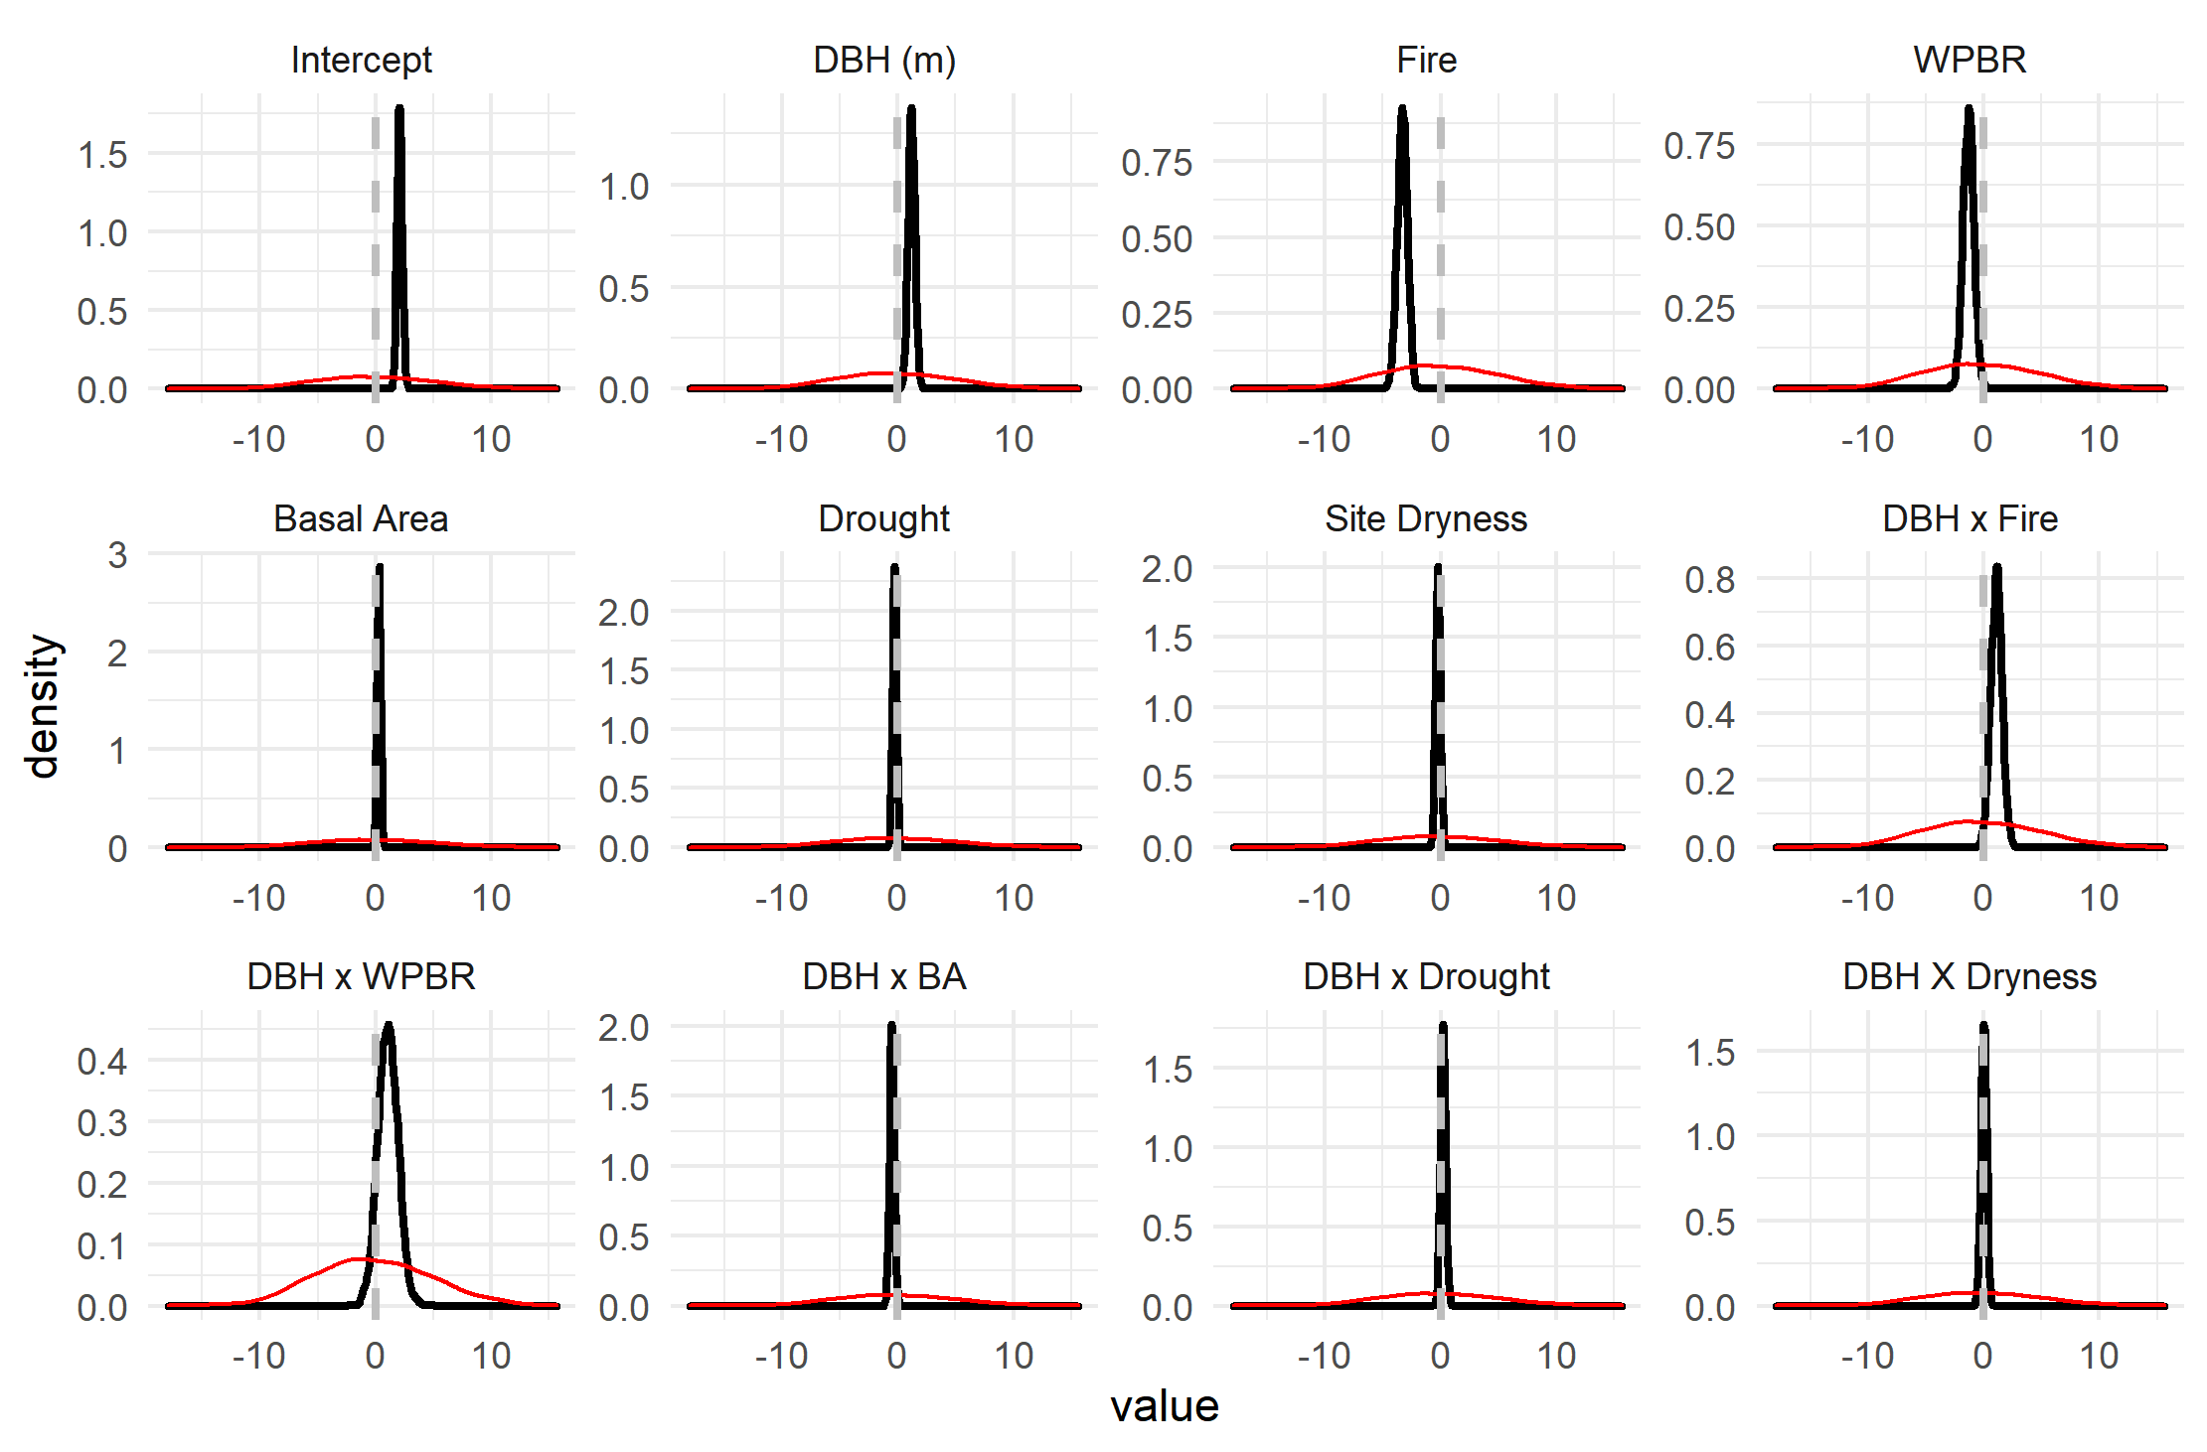

Supplementary Figure 1: Posterior distributions (black) and prior distributions (red) for , the fixed effect coefficients for survival. The magnitude of the discrepancy between the two indicates the extent to which the posterior distribution was informed by the data, rather than the prior.

Supplementary Figure 2: Posterior distributions (black) against prior distributions (red) for the standard deviations of the plot and ecoregion random effects in the survival model.

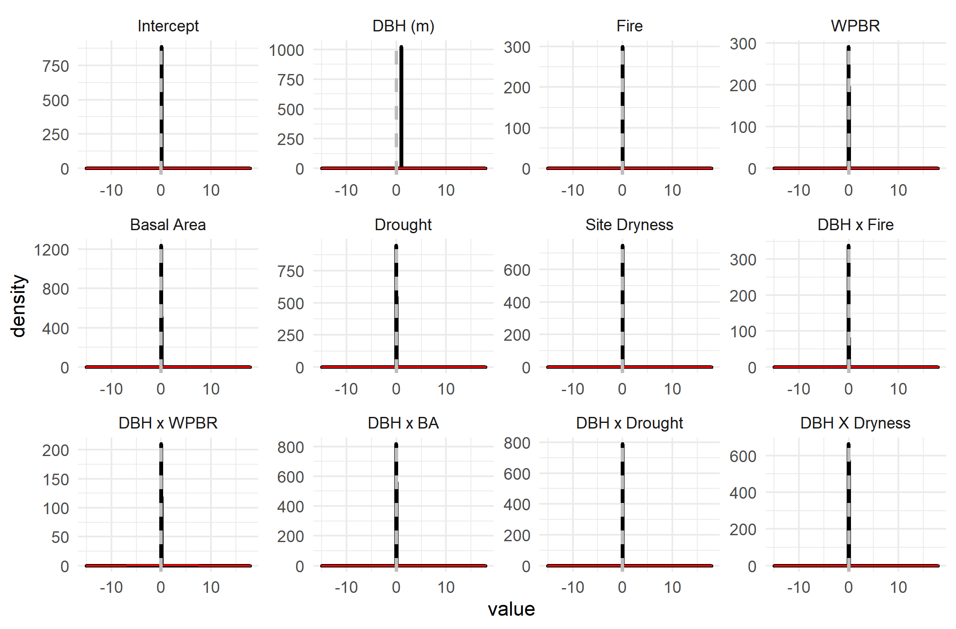

Supplementary Figure 3: Posterior distributions (black) against prior distributions (red) for fixed effect coefficients in the growth model.

Supplementary Figure 4: Posterior distributions (black, along Y axis) against prior distributions (red, along X axis) for the standard deviations of the plot random effect, the ecoregion random effect, and the residuals in the growth model.

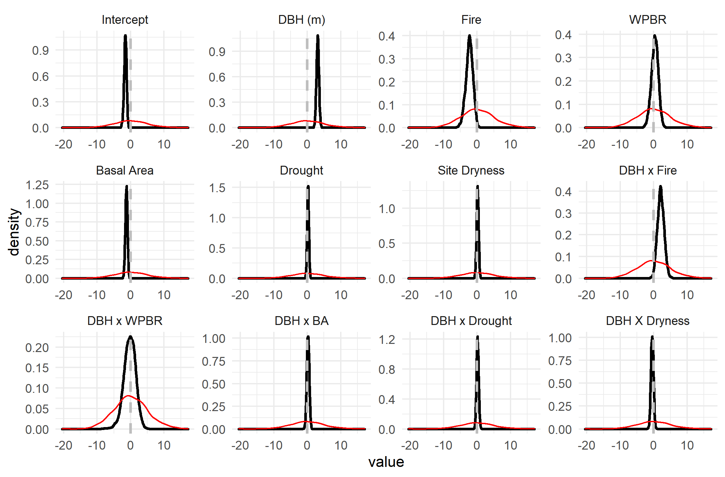

Supplementary Figure 5: Posterior distributions (black) against prior distributions (red) for the fixed effect coefficients affecting fecundity in the recruitment model.

Supplementary Figure 6: Posterior distribution (black, along Y axis) against prior distribution (red, along X axis) for the dispersion term of the negative binomial response in the recruitment model.

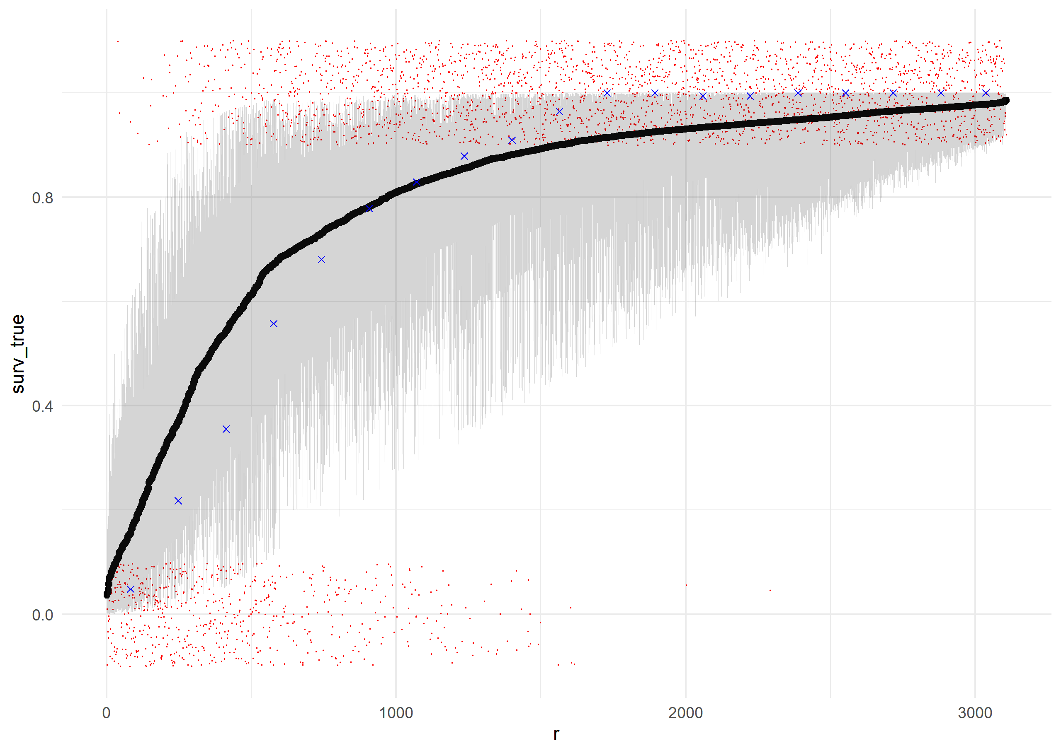

Supplementary Figure 7: Results of posterior retrodictive simulations for survival of individual trees. Posterior samples of the parameters were used to predict the survival probability of each individual tree using Equation 2 and the training data used to fit the model. Individual trees (red points) are ranked along the X-axis by their mean predicted survival probability, and their actual survival (0 or 1) is plotted along the Y-axis (including a jitter for readability). Blue points indicate the actual proportion of individuals in each rank bin which survived. Black points indicate the mean predicted survival for each individual, with a gray ribbon showing a 95% credible interval for survival probability for each individual. The model does a good job ranking trees by their actual survival probability, as shown by the red points. However, the model is slightly under-certain about survival probability, relative to reality: It slightly overpredicts survival for the least-likely-to-survive trees, and slightly underpredicts survival for the most-likely-to-survive trees.

Supplementary Figure 8: Posterior retrodictions for the growth model, using posterior parameter values and the training data. Individual trees (black points) are plotted with their median predicted size at remeasurement along the X-axis, and their true size at remeasurement along the y axis. The blue line has slope 1 and intercept 0, i.e. perfect prediction. The gray ribbon gives a 95% credible interval for size at remeasurement as predicted by the model, and contains nearly all of the true sizes.

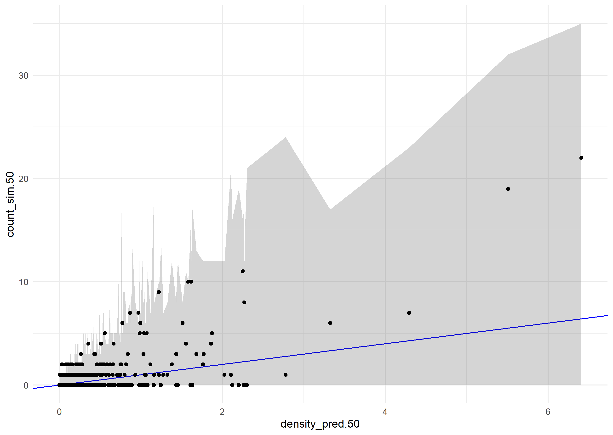

Supplementary Figure 9: Posterior retrodictions for the recruitment model. The black points show the observed count of untagged individuals (new recruits and preexisting small stems) on each subplot on the Y-axis, and the median predicted density on the X-axis. The blue line has slope 1 and intercept 0, i.e. perfect prediction. The bounds of the grey ribbon correspond to the 2.5th and 97.5th percentiles of simulated counts drawn from a negative binomial distribution with location parameter predicted from the posterior distribution of the model. The gray ribbon contains all the true values, indicating that all of the observed counts are consistent with the variability expected from the model.

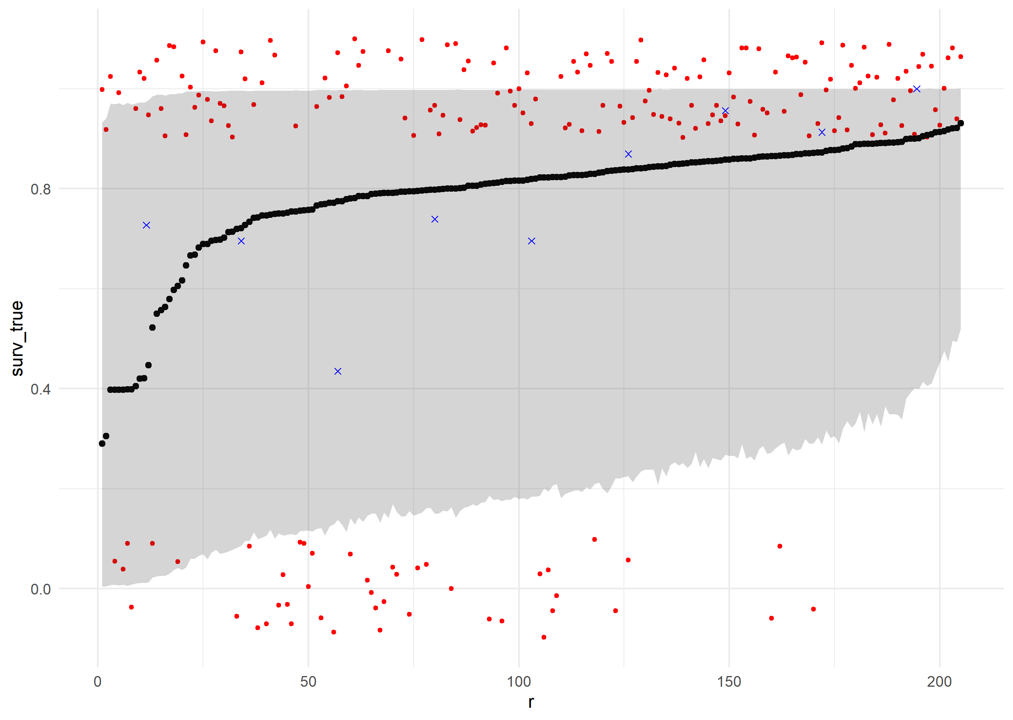

Supplementary Figure 10: Results of posterior predictive simulations for survival of individual trees. Posterior samples of the parameters were used to predict the survival probability of each individual tree using Equation 2 and the validation data. Individual trees (red points) are ranked along the X-axis by their mean predicted survival probability, and their actual survival (0 or 1) is plotted along the Y-axis (including a jitter for readability). Blue points indicate the actual proportion of individuals in each rank bin which survived. Black points indicate the mean predicted survival for each individual, with a gray ribbon showing a 95% credible interval for survival probability for each individual.

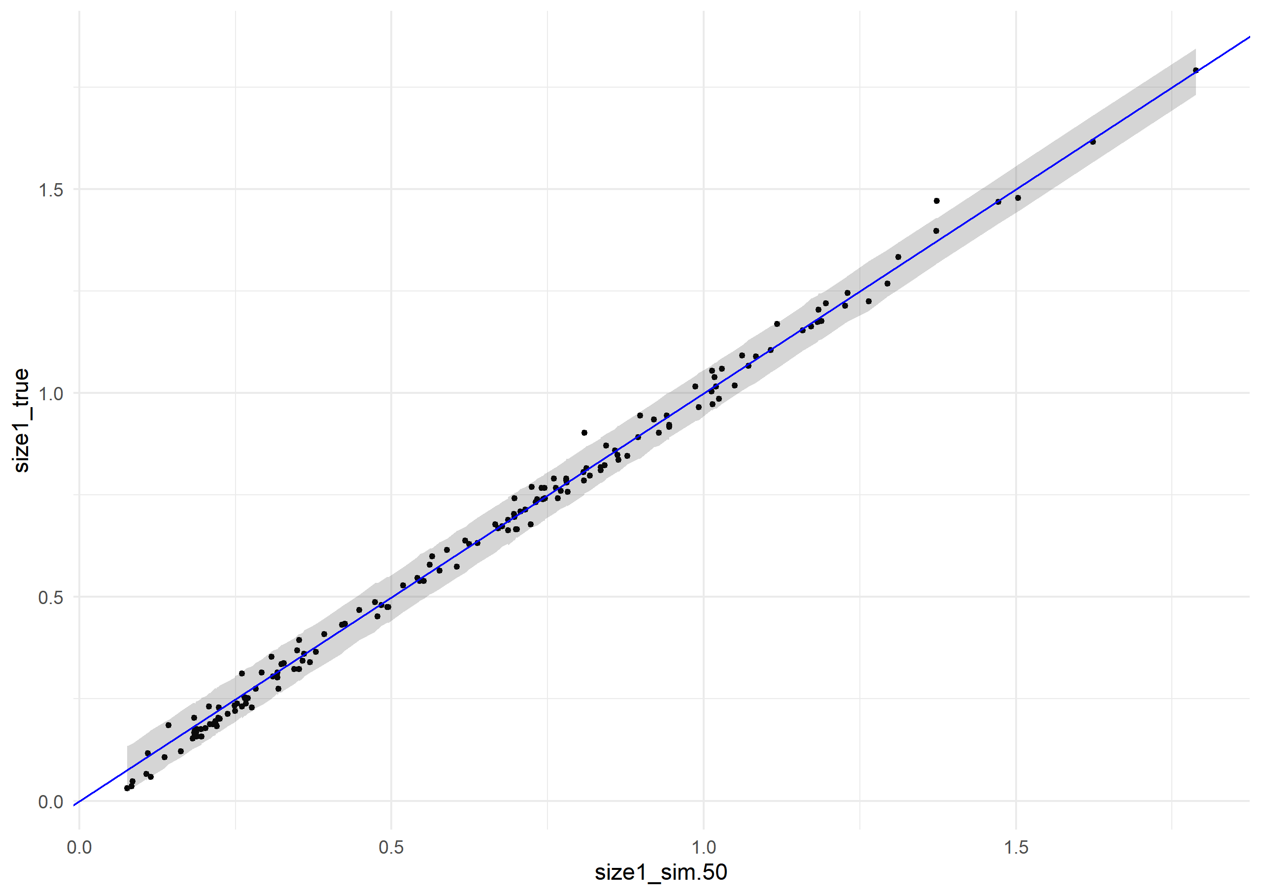

Supplementary Figure 11: Posterior retrodictions for the growth model, using posterior parameter values and the validation data. Individual trees (black points) are plotted with their median predicted size at remeasurement along the X-axis, and their true size at remeasurement along the y axis. The blue line has slope 1 and intercept 0, i.e. perfect prediction. The gray ribbon gives a 95% credible interval for size at remeasurement as predicted by the model, and contains nearly all of the true sizes.

Supplementary Figure 12: Posterior predictions for the recruitment model, using the out-of-sample validation data. The black points show the observed count of untagged individuals (new recruits and preexisting small stems) on each subplot on the Y-axis, and the median predicted density on the X-axis. The blue line has slope 1 and intercept 0, i.e. perfect prediction. The bounds of the grey ribbon correspond to the 2.5th and 97.5th percentiles of simulated counts drawn from a negative binomial distribution with location parameter predicted from the posterior distribution of the model. The gray ribbon contains all the true values, indicating that all the observed counts are consistent with the variability expected from the model.

|  |  |  |  |  |  |  |  |  |
| --- | --- | --- | --- | --- | --- | --- | --- | --- |
| **Parameter** | **Mean** | **Median** | **StDev** | **q5** | **q95** | **rhat** | **ess_bulk** | **ess_tail** |
| **Intercept** | 2.08 | 2.07 | 0.22 | 1.72 | 2.44 | 1.00 | 1967.95 | 2695.36 |
| **DBH (m)** | 1.19 | 1.19 | 0.29 | 0.71 | 1.68 | 1.00 | 1870.04 | 2741.38 |
| **Fire** | -3.32 | -3.31 | 0.43 | -4.03 | -2.63 | 1.00 | 1933.64 | 2758.74 |
| **WPBR** | -1.32 | -1.31 | 0.47 | -2.08 | -0.53 | 1.00 | 2820.09 | 2908.17 |
| **Basal Area** | 0.28 | 0.28 | 0.15 | 0.03 | 0.53 | 1.00 | 2338.83 | 2796.97 |
| **Drought** | -0.27 | -0.27 | 0.17 | -0.55 | 0.00 | 1.00 | 1653.54 | 2330.94 |
| **Site Dryness** | -0.24 | -0.24 | 0.20 | -0.57 | 0.10 | 1.00 | 1674.60 | 2170.42 |
| **DBH x Fire** | 1.10 | 1.11 | 0.48 | 0.30 | 1.89 | 1.00 | 2311.19 | 2298.86 |
| **DBH x WPBR** | 1.08 | 1.07 | 0.85 | -0.28 | 2.48 | 1.00 | 3377.36 | 3101.19 |
| **DBH x BA** | -0.50 | -0.50 | 0.20 | -0.82 | -0.18 | 1.00 | 2333.07 | 2741.33 |
| **DBH x Drought** | 0.20 | 0.19 | 0.22 | -0.15 | 0.56 | 1.00 | 2548.19 | 2457.03 |
| **DBH x Dryness** | 0.01 | 0.02 | 0.24 | -0.38 | 0.39 | 1.00 | 2362.03 | 3201.45 |
| **SD Plots** | 1.95 | 1.94 | 0.16 | 1.70 | 2.23 | 1.00 | 1005.62 | 2217.70 |
| **SD Ecoregions** | 0.29 | 0.27 | 0.18 | 0.03 | 0.61 | 1.01 | 464.98 | 1286.87 |

Supplementary Table 1: Summary of results for survival sub model, giving the mean, median, standard deviation, 5th percentile, and 95th percentile of posterior samples for each parameter, plus diagnostics R-hat, effective sample size (bulk), and effective sample size (tail).