Demographic status, trajectory, and stressors of *Pinus lambertiana* across the western USA

# Abstract

Sugar pine (*Pinus lambertiana*) is the largest Pinus species, an important timber species, and a component of several dry conifer forest types of western North America, in particular the extensive Sierra Nevada mixed conifer forest. The species faces several challenges in the Anthropocene, including a disrupted fire regime, an invasive pathogen, forest structure changes, and drought with ensuing bark beetle epidemics. Managers are concerned about the conservation outlook for sugar pine, but it is unclear where and how to best invest conservation resources. In this study, we use data from the US Forest Service's Forest Inventory and Analysis dataset to assess how these various stressors shape the vital rates (survival, growth, and fecundity) of sugar pine across the vast majority of its range. We synthesize the vital rate functions by constructing an integral projection model which predicts the effects of various stressors on the asymptotic population growth rate. The analysis reveals that wildfire and forest density are key drivers of the demographic rates of sugar pine across its range. Fire has strong negative effects on survival (particularly of small individuals) and reduces the growth of surviving large trees, resulting in a negative asymptotic population growth rate on burned sites. Conversely, lower than average forest density (neighborhood basal area) results in a strongly positive population growth rate via beneficial effects on growth and fecundity. These results highlight the value of fire hazard mitigation, particularly where it also reduces forest density, in the conservation of this important species.

# Introduction

1. This study as an example of using national inventory data to build demographic models which inform management decisions about anthropogenic stressors
   1. Novel Anthropogenic stressors threaten species, but may be amenable to management
   2. They may be amenable to management, but conservation resources are scarce, so is often necessary to prioritize some stressors over others
   3. Demographic models built around large-scale longitudinal datasets (such as FIA) can provide detailed insight how stressors impact species of concern across wide geographic ranges.
   4. By including multiple stressors in the model and comparing their effects on vital rates and demographic summary statistics (such as the asymptotic population growth rate), we can assess the relative importance of the stressors and the highlight the mechanisms by which they influence the population trajectory.
   5. Findings from these analyses can provide crucial information about how best to prioritize varied stressors in making management decisions.

Sugar pine (*Pinus lambertiana*) is the largest Pinus species, an important timber species, and a component of several dry western conifer forest types, in particular the extensive Sierra Nevada Mixed Conifer forest, where sugar pine typically composes 5-25% of basal area (Kinloch and Scheuner, 1990; Safford and Stevens, 2017; Bohlman, Safford and Skinner, 2021). Its range extends through much of the North American Mediterranean zone throughout mountain ranges in California, central Oregon, and a small population in northwestern Mexico but most of the growing stock located in California. Sugar pine seeds are an important food source for animal species (Murray and Tomback, 2010), and mature sugar pines are large-diameter trees which play a key role in the structure and function of ecosystems they occur in (Lutz *et al.*, 2018). Like many other plant and animal species, Sugar pine faces numerous challenges in the Anthropocene, and managers and policymakers are concerned about the future status of the species (Kinloch Jr., Marosy and Huddleston, 1996).

First, disruptions to the fire regime have challenged sugar pine. Sugar pine is a fire-tolerant species with moderate shade intolerance (Yeaton, 1983, 1984; Bohlman, Safford and Skinner, 2021) and persisted in frequent fire forest types with mean fire return intervals of at most 11-16 years (Safford and Stevens, 2017; Bohlman, Safford and Skinner, 2021). Sugar pine has traits associated with a fire-surviving strategy (Schwilk and Ackerly, 2001), whereby large adults survive wildfires and provide offspring that can take advantage of reduced competition for light and water in the postfire environment. However, intensive historical logging and fire suppression in the 20th century have altered forest structure and a warming climate have increased the area affected by high severity fire within sugar pine’s range (Safford and Stevens, 2017; Stevens *et al.*, 2017; Parks and Abatzoglou, 2020; Bohlman, Safford and Skinner, 2021). This novel fire regime has increased the proportion of the sugar pine’s range where there are no surviving adult conifers to produce the next generation, threatening not just sugar pine but the mixed conifer forest type as a whole (Steel, Safford and Viers, 2015; Shive *et al.*, 2018; Coop *et al.*, 2020).

Second, an invasive fungal pathogen, *Cronartium ribicola* (white pine blister rust; WPBR) has spread across much of sugar pine’s range since its introduction to North America in the early 20th century and has caused substantial mortality (Van Mantgem *et al.*, 2004; Maloney *et al.*, 2011; Dudney *et al.*, 2020). WPBR affects white pines (subgenus *Strobus*, excluding the pinyon pines in subsection *Cembroides*) by parasitizing foliage, shoots, inner bark, and outer xylem, causing the formation of cankers which can reduce vigor and kill outright by girdling the stem (Geils, Hummer and Hunt, 2010). The epidemic in the western United States has been severe enough to cause the related species, *Pinus albicaulis*, to be listed as endangered (Mahalovich and Stritch, 2013), and there has been considerable concern about the outlook for sugar pine as well (Kinloch Jr., Marosy and Huddleston, 1996).

Third, there is evidence that the modern densified forest structure threatens sugar pine in numerous ways. Effective fire suppression, which was instituted across much of sugar pine’s range in the 20th century, has resulted in an overall densification of these forests (Stephens *et al.*, 2015; Safford and Stevens, 2017; Bohlman, Safford and Skinner, 2021; North *et al.*, 2022). Sugar pine is only moderately shade tolerant (Yeaton, 1983; Bohlman, Safford and Skinner, 2021) and there is evidence that it is outcompeted by species such as *Abies concolor* and *Calodecrus decurrens* under modern dense canopies. Species composition (especially of younger cohorts) has shifted towards shade-tolerant firs and incense-cedar (Ansley and Battles, 1998; Levine *et al.*, 2016). There is also evidence that the densified forest structure has reduced the vigor of adult sugar pines, thus reducing their ability to resist other stresses (Young *et al.*, 2017; Restaino *et al.*, 2019; Furniss *et al.*, 2021).

Finally, the changing climate may increase the duration and severity of droughts and associated bark beetle epidemics, which are already causing mass mortality events in sugar pine’s range (Fettig *et al.*, 2019; Stephenson *et al.*, 2019; Steel *et al.*, 2021). Once these epidemics are underway, bark beetles tend to preferentially target large and reproductively-valuable sugar pines, independent of individuals’ stress (Stephenson *et al.*, 2019), exacerbating the impact of this stressor on the demographic outlook for sugar pine. Drought can also kill trees, especially small individuals, more directly via hydraulic failure and/or carbon starvation (Moran *et al.*, 2019).

Given these numerous challenges, there are widespread concerns about the future of the species (Kinloch Jr., Marosy and Huddleston, 1996). Management options to benefit sugar pine are available, ranging from restoration thinning and prescribed fire to restore forest structure (Restaino *et al.*, 2019; Steel *et al.*, 2021) to out planting seedlings with genetic resistance to WPBR (Aitken and Whitlock, 2013; North *et al.*, 2019). However, many of these options are expensive. In a context where natural resource management funding is constrained, it is important to understand the status and demographic outlook for sugar pine as a species. This study seeks to inform decisions about when and where to prioritize management actions to conserve sugar pine. To that end, we address two questions:

1. What is the current status and trajectory of the ensemble of sugar pine populations across its range?
2. What is the relative importance of the various stressors acting on sugar pine?

# Methods

## Study Area

The area of interest for this study is that part of the range of sugar pine which is within the contiguous United States (Figure 1), which is the vast majority of the species’ range (excluding only an isolated population in Baja California). The range of sugar pine in the United States extends from 33.7°N to 45.3°N throughout much of the Sierra Nevada and Klamath mountains, and parts of the Transverse, Peninsular, and Southern Cascades ranges in the US states of California and Oregon. Sugar pine is widely distributed throughout this range as an important element of the mixed conifer forest belt at elevations ranging from 1000 m to 2700 m, depending on latitude (Safford and Stevens, 2017). The climate throughout this range is Mediterranean, with a cool-wet season and a warm-dry season (Safford and Stevens, 2017).

The range delineation used for this study was generated using the raster files provided by (Wilson *et al.*, 2013). The USFS RMRS Live Tree Species Basal Area of the Contiguous United States (2000-2009) provides species-specific rasters of predicted basal area at 250 m resolution across the contiguous US, with each raster cell giving a predicted value for the basal area (ft2/acre) of the selected species. The abundance predictions are generated using k-nearest neighbors and canonical correspondence analysis on MODIS imagery, raster data describing relevant environmental parameters, and Forest Inventory and Analysis (FIA) field plot data (CITE). This continuous raster was converted to a discrete polygon by first aggregating the resolution from 250m to 3km and filtering to cells where predicted sugar pine basal area was greater than 0.46 m2/ha. This level of aggregation and filtering provided the best combination of sensitivity and specificity when comparing the resulting range polygon against the actual presence of sugar pine on FIA plots (at their nominal locations).

## Inventory Data

The FIA plots are part of a US Forest Service-run nationwide inventory network operating in its current form since 2001 (Bechtold and Patterson, 2005). Here, we use FIA plots from California, Oregon, and Nevada restricted to the processed sugar pine range map. The geographic coordinates listed for the FIA plots are not exact; to preserve plot integrity, the plot coordinates are randomly perturbed, and some plot locations are swapped. Most perturbations are to a random location within 0.8 km of the true location, and all perturbations are to within 1.6 km of the actual location. Between 0 and 10 percent of plot locations are swapped with a similar plot in the same county. FIA plots are placed on a hexagonal grid with a density of approximately 1 plot per 2429 ha. Each plot is revisited approximately once every 10 years, which we treat as the census interval for the purpose of calculating vital rates and constructing an IPM. Of the 1,221 plots used for this study, 90% had an inventory interval from 9.5 to 10.4 years, with a mean interval of 10.0 years, a minimum interval of 7.9 years, and a maximum interval of 12.3 years. On each FIA plot, trees >= 12.7 cm diameter at breast height (1.37 m, DBH) are inventoried on four 168 m2 permanent subplots. Small trees from 2.54-12.7 cm DBH are inventoried on a 13.5 m2 microplot, and large trees on an optional 1012 m2 macroplot. Data inventoried for each individual stem include the species, live/dead status, DBH, and a “damage agent” code indicating whether some agent (e.g. white pine blister rust) is visibly affecting the individual’s health. Trees which are individually inventoried (all stems ≥ 2.54 cm DBH) are physically tagged to facilitate relocation of specific individuals at remeasurement. The survival or death of 3,476 sugar pine individuals was tracked to estimate the parameters of the survival function, and growth of the 2,766 surviving individuals was used to estimate the parameters of the growth function. The smallest stems surveyed (height ≥ 0.15 m and DBH < 2.54 cm) are not inventoried as individuals but tallied by species and remain untagged. Thus, the individuals which are untagged at the time of the second census are either new recruits or were not tagged due to small size at initial measurement. The counts of untagged individuals on

In addition to the tree-level data collected, the FIA program also records information about forest conditions, including the presence of significant disturbances (e.g., fire) and the ecological subsection the plot is located within, and the nominal GPS coordinates of the plot center. For this study we selected only the subset of FIA plots whose nominal centers were within the sugar pine range polygon described above. The range polygon was used, rather than simply using all plots where sugar pine was actually present, in order to better capture the range of environmental conditions existing within sugar pine’s range.

## Climate Data

To assess the level of drought sugar pine individuals were exposed to, we extracted monthly climatic water deficit (CWD) estimates for each nominal plot location from the TerraClimate dataset (Abatzoglou *et al.*, 2018). The TerraClimate dataset provides modeled estimates of CWD at approximately 4km resolution for years 1958-2020. The 4 km resolution approximately matches the degree of fuzzing associated with the nominal FIA plot locations, so that fuzzing is unlikely to add substantial error in the estimation of CWD experienced at the true plot location. Mean growing season (May-October) CWD estimates for each year between a plot’s initial measurement and its revisit provide a proxy for the drought stress experienced by individuals between the two censuses. The annual mean growing season CWD estimates were summarized in two ways: First, the 20-year mean of the annual CWD estimates provides a measure of the usual climatic dryness characteristic of each site, enabling the comparison of typically-wetter vs. typically-drier locations across space. Second, the 90th percentile of the annual departures from the site-specific mean CWD provide a measure of the most severe drought (departure from usual climatic conditions) experienced by each plot location between the initial observation and the remeasurement.

## Vital Rates Model

The modelling approach for this study broadly follows that described in (Shriver *et al.*, 2021), and the following description paraphrases their methods except where the details of implementation differed for this study. This study models three vital demographic rates for sugar pine as functions of individual states and environmental covariates. The vital rates modeled are survival, growth, and recruitment. The sub model for survival is:

Equation 1

Equation 2

Where is an integer indicating the live/dead status (1 if live, 0 if dead) of individual at time (the revisit measurement, approximately 10 years after initial measurement), is the probability of survival from time to time , is a vector of covariates (described below) for individual , is a column vector of fixed effect coefficients for the survival sub model, is a vector of plot-level random effects indexed by the plot for individual with , and is a vector of ecoregion subsection-level random effects indexed by the ecoregion subsection for individual with .

The fixed effects covariates for each individual in the vector are: The intercept (), the DBH in meters at time (), a binary flag indicating whether the individual’s subplot experienced a fire at least 0.404 ha in size that killed or damaged at least 25% of trees (), a binary flag indicating whether any trees in the individual’s subplot displayed signs of white pine blister rust infection at time (), the subplot-level basal area at time (), the plot-level 90th percentile of growing season departure from mean climatic water deficit (), the plot-level growing season mean climatic water deficit over the period 2000-2020 (), and interactions between and all other variables (, , , , and ). Continuous variables other than (, , and ) were centered and scaled to have 0 mean and unit variance across all subplots. Meters were selected as the unit for DBH to facilitate parameter estimation and interpretation by keeping all variables on a similar scale.

The sub model for growth is:

Equation 3

Equation 4

Where is the DBH in meters of individual at time drawn from a truncated normal distribution (to prevent biologically impossible negative size), is the residual variance, is a vector of the same fixed effects coefficients used in the survival sub model, and the other parameters are as defined for the survival sub model, though here indexed to indicate that they are the parameters specifically for the growth sub model.

As noted in (Shriver *et al.*, 2021), analysis of recruitment is complicated by the fact that seedlings (stems whose height >= 0.15 m and DBH < 2.54 cm) are not individually surveyed and tagged, but instead tallied by species. Thus, there is uncertainty as to which of the seedlings present at time are true new recruits (vs. individuals which were already present at time ). I followed Shriver et al.’s approach to address this issue by building a recruitment model which is itself an integral projection model estimating the survival, growth, and recruitment of seedlings and saplings (all stems < 25.4 cm DBH). In this way, the (uncertain) number of new recruits on a subplot can be estimated based on a count of the untagged seedlings and saplings and estimated (from the survival and growth sub models) rates of growth and survival among pre-existing seedlings and saplings. The recruitment sub model is described briefly below, paraphrasing (Shriver *et al.*, 2021), and readers are directed to that text for more details.

The response distribution for the recruitment sub model is:

Equation 5

Where is a vector giving the observed counts of untagged individuals in the smallest two size classes (0-12.7 cm DBH and 12.7-25.4 cm DBH), which are composed of both new recruits and individuals which were present but untagged due to their small size at the initial measurement, on subplot at time . is a vector of area-standardized occurrence rates, is a vector giving the total subplot area surveyed for each size class, and is the dispersion parameter for the negative binomial distribution. Only the smallest two size classes were included in the responses for the recruitment model because new individuals larger than 2.54 cm DBH are much more likely to be individuals which were simply missed due to observer error in the first survey.

Equation 6

Where each is a discretized integral projection model kernel describing the rates of transition from each of the size classes to each of the smallest size classes, which includes fecundity as well as growth and survival. A separate exists for each subplot . is the vector giving the area-standardized occurrence rates of individuals in each of the 20 size classes at time on subplot . The elements of for each subplot in time are given by:

Equation 7

Where describes the growth of preexisting individuals from the smallest size class into the smallest two size classes, is the probability that an individual in the smallest size class will survive from time to time , is the probability that a new recruit will transition into size class by time , and is the number of new recruits generated per existing individual in size class (the fecundity). Recall that each element of is also indexed by subplot and census interval , but that these indices have been omitted for clarity. is given by:

Equation 8

Where is the cumulative probability density function of a normal distribution with mean and variance evaluated at the upper bound of size class (), the lower bound of size class (), or 0. is calculated for each subplot from Equation 4 using the mean DBH of all trees (of all species) in size class 1 (0.0103 m) as an approximation for the size of an individual in the smallest size bin. Likewise, is calculated using Equation 2 to predict the survival of an individual with m on subplot . Shriver et al. estimated using a normalized gaussian kernel but had difficulty estimating the mean and variance of this recruit size kernel. Model testing for this study revealed that the parameters for this kernel were not identifiable and attempting to estimate them resulted in divergent transitions in the Hamiltonian Monte Carlo algorithm described below. Rather than attempt to estimate the mean and variance of a gaussian recruitment size kernel, we approximated the recruitment size kernel (the probability that a new recruit will grow into size class ) as the proportion of untagged individuals found within that size class, giving . Finally, the parameter of primary interest in the recruitment sub model is , the fecundity of individuals in size class :

Equation 9

Where is a vector of fixed effects coefficients for size class on subplot , again using the mean DBH of all stems in size class to approximate the size of an individual in class . The covariates and parameters are as described for the growth and survival sub models, though here indexed by to indicate that they are the parameters for the fecundity sub model.

We chose to use 12.7 cm wide bins for size classes to balance computational requirements against resolution needs in describing the size distribution of sugar pines, which ranges from 0 cm to 246 cm in DBH in this dataset. The 12.7 cm wide bins align with the changes in sampling area associated with different size classes in the FIA protocol and avoid the computational costs which would be associated with using 2.54 cm bins (as did Shriver et al.) for a tree species which can grow to more than 200 cm DBH. The relative coarseness of the 12.7 cm size bins is mitigated here by the use of the mean size rule (rather than the midpoint size rule) to assign specific sizes to each bin for the purposes of estimating survival, growth, and fecundity of each size class, following suggestions from (Doak *et al.*, 2021).

The three sub models were analyzed as a single model, so that the findings of the survival and growth sub models could inform the recruitment model. Model data was prepared using the tidyverse package in R Version 4.1.1, and Bayesian parameter estimation was performed using Hamiltonion Monte Carlo as implemented in stan version 2.28.2 and the cmdstanr package. The sampler was run in four chains for 2000 iterations per chain (discarding the first 1000 iterations as warmup). The prior distribution specified for all parameters was (with variance terms restricted to positive values) except for the negative binomial dispersion parameter , which received a prior following Shriver et al. 2021. Fewer size bins in the recruitment sub model, the use of normal distributions instead of spatial gaussian predictive processes for random effects, and more efficient stan code allowed me to substantially reduce the wall time required for parameter estimation from the week reported by Shriver et al. to approximately one hour. Other R packages used for data acquisition, data management, and plotting include: here, sf, spdata, bayesplot, posterior, units, raster, ggplot2, USAboundaries, truncnorm, cowplot, foreach, and doParallel.

## Model Validation

The basic diagnostics provided by cmdrstan (R-hat values, trace plots, per-chain posterior density plots, posterior pair plots, and assessment of divergences) were inspected for evidence of convergence and between-cahain consistency or signs of difficulty estimating parameters. In addition, we plotted posterior retrodictions (observations simulated from the posterior distribution of parameters against the real data used to train the model) to evaluate the fit of the model (???) and posterior predictions (observations simulated from the posterior distribution against real data held out from model training) to validate the accuracy of the model(???). 10% of plots were randomly held out from the training dataset and only used to assess the out-of-sample predictive performance of the model. The central tendency and spread of posterior predictions and retrodictions were compared to the true observed values of individual growth, individual survival, and subplot count of untagged individuals to assess whether model results were consistent with real data.

## Evaluation of vital rate functions and integral projection model

Once parameters were estimated and model validity checked, the fitted model was used to assess the impact of the various stressors on sugar pine (fire, WPBR, stand density, drought, and site dryness) on the vital rates of growth, survival, and fecundity. Artificial explanatory data were constructed representing a suite of environmental scenarios correspond to situations where a single stressor is present (in the case of the discrete explanatory variables and ) or elevated/depressed by one standard deviation (in the case of the continuous variables , , and ), while other stressors are absent or held at their mean value (0 for scaled variables). Given these environmental contexts, vital rates for individuals ranging in size from 0.01-1.25 m DBH were predicted using the parameters from each posterior sample, and the predicted response plotted against DBH and stressor.

Likewise, we used the estimated vital rate functions generated by the posterior parameter values to generate an integral projection model and estimate posterior asymptotic growth rates under the same suite of scenarios. We discretized the continuous vital rate functions for survival, growth, and fecundity using 20 size classes to describe the state of sugar pine individuals to generate a transition matrix for each environmental context and posterior sample . Each has rows and columns corresponding to 20 12.7 cm DBH size bins used to discretize the sugar pine populations. The subscripts and are omitted below for clarity, and we discuss only a single matrix corresponding to expected transitions given a single environmental context and set of vital rate parameters. The elements of are calculated as:

Equation 10

Where is the probability that an individual in size class will grow into size class by time (calculated using Equation 4 and Equation 8, the mean DBH of , the environmental context associated with and the parameters from posterior sample ). Similarly, is the probability that an individual in size class at time will survive to time (calculated using Equation 2). is the probability that a new recruit will grow into size class by the second census at time . is the expected number of new recruits per individual in size class , calculated using Equation 9.

Following the recommendations of (Doak *et al.*, 2021), individuals in each size class were approximated using the mean DBH of all trees in each size class, rather than the bin midpoint. The growth transition probabilities were evaluated using the cumulative density function of a normal distribution (as in Equation 8, but evaluating growth between each size class and every other size class). The largest real eigenvalue of each full transition matrix corresponds to the asymptotical population growth rate for posterior draw and environmental context . The distribution of for each environmental context was plotted to understand how the presence or absence of different stressors is expected to shape the asymptotic population growth rate of sugar pine.

# Results

## Model Validation

Diagnostics for mixing, convergence, R-hat, and transitions all indicated that the model fitting algorithm performed well. Comparisons of posterior distributions with prior distributions showed that the posterior was strongly informed by the data, rather than the prior, for most parameters (Supplementary Materials). The exception, where the posterior was only weakly informed by the data, were the estimates , the interaction of WPBR with size affecting fecundity. This uncertainty regarding the effect of WPBR on fecundity was likely due to the relatively low frequency of WPBR presence, combined with the fact that fecundity was not directly observed. Retrodictive simulations generated using the posterior parameter samples and the training data as explanatory variables were consistent with the true values observed in the training data (Supplementary Materials). Likewise, predictive simulations using the posterior parameter samples and the held-out validation data as explanatory variables were consistent with the true values observed in the validation data (Supplementary Materials).

## Survival

The posterior median estimate of the intercept for the survival model was 2.08, with a 90% credible interval spanning the range 1.72 to 2.44 (Supplementary Table 1). Survival generally increased with size (Figure 2; median 1.19, CI 0.71 to 1.68). Fire had a strong negative main effect on survival (median -3.31, CI -4.03 to -2.63) and a positive interaction with size (median 1.11, CI 0.30 to 1.89) indicating that larger trees were more likely to survive a wildfire (Figure 2). The presence of WPBR on a subplot also had a negative main effect (median -1.31, CI -2.08 to -0.53), indicating reduced survival for the smallest trees, and an ambiguous interaction with size (median 1.07, CI -0.28 to 2.48). This indicates that the presence of WPBR was associated with reduced survival of the smallest trees, but the negative effect may have been reduced for larger trees (Figure 2). Basal area had a positive main effect on survival (median 0.28, CI 0.03 to 0.53) and a negative interaction with size (median -0.5, CI -0.82 to -0.18). Subplots with higher basal area had increased survivorship of smaller trees and reduced survivorship of larger trees (Figure 2). Drought had a less severe negative impact on survival (median -0.27, CI -0.55 to 0.00) and a weak or nonexistent interaction with size (median 0.19, CI -0.15 to 0.56). The effects of site dryness and its interaction with size were weak or nonexistent (medians -0.24 and 0.02, CIs -0.57 to 0.1 and -0.38 to 0.39, respectively). The standard deviation of the plot effect (median 1.94, CI 1.70 to 2.23) was larger than the standard deviation of the ecoregion effect (median 0.27, CI 0.03 to 0.61). Several ecoregions in the southern Sierra Nevada, and one in the southern Cascades, exhibited negative effects on survival (Figure 5).

## Individual Size (growth)

The posterior median for the intercept of the model for size at the second census was 0.040, with a 90% credible interval from 0.035 to 0.044 (Supplementary Table 2). The effect of initial size was, as expected, very close to 1 (median 1.000, CI 0.996 to 1.003). Together, these results indicate that surviving trees grew an average of 0.04 meters (4 cm) in the 10 years between initial and follow-up census, regardless of size (Figure 3). Fire had an ambiguous main effect on size at follow-up (median -0.003, CI -0.012 to 0.005) and a negative interaction with initial size (median -0.012, CI -0.021 to -0.003); the growth of larger trees was more negatively impacted by fire than the growth of smaller trees (Figure 3). Neither WPBR nor the interaction of WPBR with initial size had strong effects on size at follow-up (medians 0.002 and -0.001, CIs -0.006 to 0.009 and -0.013 to 0.011, respectively). The main effect of basal area on follow-up size was negative (median -0.005, CI -0.008 to -0.003), and the interaction between basal area and initial size was weak or nonexistent (median 0.002, CI -0.001 to 0.005). Higher neighborhood basal area reduced the growth of all trees (Figure 3). The 90% credible interval included 0 for the main effect of drought (median -0.001, CI -0.003 to 0.002) and the interaction of drought with initial size (median 0.001, CI -0.002 to 0.004), indicating that drought had weak or no effect on growth. The main effect of site dryness was negative (median -0.004, CI -0.007 to 0.000), and the interaction between site dryness and initial size was positive (median 0.006, CI 0.003 to 0.009), indicating that while the growth of smaller trees was lower on dry sites, the growth of larger trees was higher on dry sites (Figure 3). The standard deviation of the plot random effect on size at follow up (median 0.018, CI 0.017 to 0.019) was larger than the standard deviation of the ecoregion random effect (median 0.012, CI 0.009 to 0.016), though both were less than the residual standard deviation (median 0.022, CI 0.021 to 0.022). There is a broad-scale pattern of ecoregions in the Klamath and Cascades mountain ranges exhibiting negative effects on growth, while the effects of ecoregions in the Sierra Nevada mountain range tend to be more positive (Figure 5).

## Fecundity

The posterior median intercept for (log) fecundity was -1.57, with a 90% credible interval from -2.23 to -1.02 (Supplementary Table 3). Individual size had a strong positive effect on expected fecundity (Figure 4; median 3.11, CI 2.49 to 3.73). Fire had a strongly negative main effect (median -2.26, CI -4.10 to -0.65), and there was a strong positive interaction between initial size and fire (median 2.11, CI 0.52 to 3.76): Fire strongly reduced the fecundity of small trees (Figure 4). The credible intervals for WPBR and its interaction with size (medians 0.35 and -0.18, CIs -1.43 to 1.95 and -3.14 to 2.45, respectively) both included 0 but were quite wide, indicating high uncertainty as to the effects of WPBR on fecundity (Figure 4). Neighborhood basal area had a negative effect on fecundity (median -1.25, CI -1.81 to -0.74), which was neither enhanced nor decreased by an interaction with individual size (Figure 4; median 0.23, CI -0.36 to 0.83). Neither drought nor its interaction with individual size had a strong effect on fecundity (medians 0.23 and 0.15, CIs -0.21 to 0.65 and -0.37 to 0.71, respectively). Likewise, neither the main effect of site dryness (median 0.15, CI -0.37 to 0.65) nor its interaction with individual size (median -0.45, CI -1.07 to 0.17) had clear effects on fecundity. The standard deviation of the plot random effect (median 1.31, CI 0.90 to 1.77) was greater than that of the ecoregion random effect (median 0.46, CI 0.05 to 0.93). The posterior median for the negative binomial dispersion parameter was 0.54, with a 90% CI from 0.41 to 0.75. The spatial distribution of ecoregion effects on fecundity was mixed and uneven (Figure 5).

## Asymptotic Population Growth Rates

Figure 6 shows the posterior distribution of the asymptotic population growth rate (lambda) predicted from IPMs built on a variety of hypothetical scenarios. In each scenario, each posterior sample of the parameters is used to calculate a transition matrix for a population of sugar pines on an idealized subplot where the fixed effects (other than size) for the vital rate models are held to specific values representing each scenario. For each of the nine scenarios, one transition matrix is constructed using the parameter values from each of the 4,000 posterior draws. The dominant eigenvalue of each matrix gives the estimate of Lambda for that scenario and draw.

In the undisturbed scenario, categorical stressors (fire and WPBR) were absent, while continuous stressors (BA, drought, and site dryness) were held at 0 (their scaled means). Under these circumstances, the asymptotic growth rate is above 1, with a median posterior value of lambda of 1.14 and a 90% credible interval from 1.04 to 1.31 (Figure 6, Supplementary Table 4). Where fire is present, lambda is below 1 (median 0.98, CI 0.94 to 0.99). Where WPBR is present, the posterior distribution for lambda straddles 1, but is generally lower than that of the undisturbed scenario (median 1.08, CI 0.98 to 2.19). When basal area is lower than average, there posterior distribution of lambda is very wide but well above one (median 1.69, CI 1.25 to 2.57). By contrast, when basal area is higher than average the posterior distribution of lambda is narrow and straddles one (median 1.00, CI 0.98 to 1.07). In the absence of other stressors, lambda is expected to be positive (median and 90% CI is above 1) for the low drought, high drought, wet site, and dry site scenarios (Supplementary Table 4).

Figure 7 shows the expected distribution of lambda, holding all vital rate model parameters (including ecoregion- and plot-specific random effects) at their posterior medians, across all subplots where sugar pine was observed in the initial census. The median value of lambda across all subplots is 1.07, with an inter-quartile range of 0.98 to 1.29. Lambda was predicted to be below one on 34.6% of subplots.

# Discussion

The results of this study highlight fire as a key stressor negatively impacting key demographic rates of sugar pine. Fire strongly reduced survival of individual trees, particularly small ones. This finding is broadly consistent with the existing literature, which has documented many cases of negative (and size-dependent) impacts of fire on survival of sugar pine (Van Mantgem *et al.*, 2004; Hood, Smith and Cluck, 2010; Nesmith *et al.*, 2015; Furniss *et al.*, 2018; Dudney *et al.*, 2020). Fire can also injure surviving trees, reducing their growth rate as seen in this study and others (Foster *et al.*, 2020). Reduced growth rates may have particularly strong effects on the asymptotic population growth rate in species where large / old individuals disproportionately contribute to reproduction; Sugar pine is one such species, as seen in the strong effect of individual size on fecundity in this study (Shriver *et al.*, 2019).

The effects of fire on fecundity were nuanced in this study, where fire strongly reduced fecundity of smaller individuals (which have low fecundity to begin with) but had ambiguous effects on large individuals greater than approximately 100 cm DBH. It is possible that fire actually increased the fecundity of the largest trees by removing competing individuals of other species, increasing the recruitment of sugar pine seedlings which germinated post-fire (York *et al.*, 2012). However, the literature suggests that a core way in which fire influences the population dynamics of sugar pine is by killing large high-fecundity individuals (Van Mantgem *et al.*, 2004). The most extreme form of this dynamic results in so-called type conversion, where high severity fire locally extirpates sugar pine and other mixed conifer species, resulting in the loss of mixed conifer forest generally (Shive *et al.*, 2018; North *et al.*, 2019; Coop *et al.*, 2020).

In this study, fire’s effects on survival, growth, and fecundity combine to result in posterior lambda values below one for burned subplots (Figure 6). Fire was the only stressor which reduced the 90% credible interval of the posterior distribution of lambda to below one (Supplementary Table 4), indicating high model confidence that a wildfire during a 10-year census interval results in population decline during that interval. Existing literature has shown that most trees killed by fire die within 1 year of the fire (Furniss *et al.*, 2018) and mortality rates in stands affected by prescribed fire returned to background levels approximately six years postfire (van Mantgem *et al.*, 2011), suggesting that the negative effects of fire on survival are likely temporary. However, there is abundant evidence that the ecological footprint of fire, in particular high severity wildfire, is increasing throughout the range of sugar pine because of climate changes and biomass accumulation resulting from fire suppression (Parks and Abatzoglou, 2020; Alizadeh *et al.*, 2021). Given this context and the results of this study, it is clear that the disrupted fire regime is the main threat facing sugar pine.

Though their effects were less severe than those of fire, both WPBR and densification negatively impacted sugar pine’s population dynamics in this study. The data here show that WPBR negatively impacted survival, potentially with a greater effect on small trees (Figure 2). Numerous other studies have shown that blister rust tends to kill smaller trees (Van Mantgem *et al.*, 2004) and negatively affects survival rates of sugar pine and other vulnerable species (Maloney *et al.*, 2011; Dudney *et al.*, 2020), though (Maloney *et al.*, 2012) found WPBR to mostly affect fecundity, rather than survival, in the related pine species *Pinus albicaulis*. This study also found that relatively high neighborhood density (basal area) resulted in lower rates of growth and fecundity (Figure 3, Figure 4). There is extensive evidence in the literature that high neighborhood density and other proxies for competition negatively impact sugar pine survival (Van Mantgem *et al.*, 2004; Maloney *et al.*, 2011; Levine *et al.*, 2016) and growth (Latham and Tappeiner, 2002; Das, 2012; Eitzel *et al.*, 2013; Steel *et al.*, 2021). It is unclear from our data whether the negative impact of density on fecundity is a result of decreased reproduction due to stress of parent trees, or decreased survival and/or growth of new recruits due to competition, but both dynamics are plausible (Schubert, 1956; York *et al.*, 2004, 2012; Van Mantgem, Stephenson and Keeley, 2006; Angell, Waring and Graves, 2014; Levine *et al.*, 2016; Moran *et al.*, 2019). In this study, high neighborhood basal area and presence of WPBR both reduced the expected asymptotic growth rate relative to an unstressed site, though negative impacts were weaker than that of fire (Figure 6), and the credible intervals for lambda in both the high basal area and WPBR scenarios included 1 (Supplementary Table 4). However, reducing basal area to one standard deviation below the mean had profound positive effects lambda (Figure 6).

A surprising result of this study is that drought and climate related variables had little impact on sugar pine’s vital rates and asymptotic population growth rate. Other literature has emphasized the role of moisture stress in increased mortality rates and reduced growth among sugar pine directly and indirectly via decreased ability of trees to resist mountain pine beetle (Das *et al.*, 2007, 2013; Van Mantgem and Stephenson, 2007; Paz-Kagan *et al.*, 2017; Restaino *et al.*, 2019; Bohner and Diez, 2021), though see also (Furniss *et al.*, 2021) which found that stand density played a more important role than climate variables in shaping mortality dynamics after fire and/or drought. (Stephenson *et al.*, 2019) examined the role of mountain pine beetle as the primary mortality agent taking advantage of widespread stress among sugar pine populations affected by drought, a finding supported by other assessments of the relationship between drought and bark beetles (Fettig *et al.*, 2019; Slack, Kane and Knapp, 2021). Intermittent droughts and/or long-term mean climatic conditions may particularly challenge small trees, causing recruitment failures even on sites where adult trees are able to persist (Bell, Bradford and Lauenroth, 2014; Maloney, 2014; Davis *et al.*, 2019; Moran *et al.*, 2019; Stewart *et al.*, 2021). This study found a weak negative effect of drought on survival (Figure 2, Supplementary Table 1) and a size-dependent effect of site dryness on growth, where smaller stems grew slower on dry sites and larger stems grew faster on dry sites (Figure 3, Supplementary Table 2). However, neither effect was strong enough to substantially reduce the asymptotic population growth rate relative to the unstressed scenario (Figure 6, Supplementary Table 4). It is possible that the scale of data used in this study, with plots distributed sparsely but widely across the entire range of sugar pine, is less able to detect the often-localized effects of bark beetle outbreaks which are the primary mortality agent killing drought-stressed trees. Our way of measuring drought stress, using relatively coarse climate interpolations and fuzzed/swapped plot coordinates, may introduce measurement error which masks a true drought effect. However, it is also possible that when the entire range of sugar pine is considered (rather than the site-specific studies often appearing in the literature) that drought truly has mild effects relative to the other stressors considered here. This uncertainty regarding the effects of bioclimatic factors highlights an important avenue for future research.

An important limitation of this study is that we did not test for interaction between stressors in shaping vital rates of sugar pine. The literature suggests that a variety such interactions may be important. For example, moisture stress increases the likelihood of regeneration failure, which may be a particularly acute problem in postfire landscapes where seed sources and shade trees may be limited (Davis *et al.*, 2019; Stewart *et al.*, 2021). A warmer and dryer climate may provide some relief from WPBR for sugar pine, as the disease’s climatic envelope shifts upslope away from existing populations of sugar pine (Maloney, 2011; Dudney *et al.*, 2021). A relationship between fire exclusion, stand density, and WPBR infection has been suggested (by whom?), but evidence is mixed with some studies finding that conspecific basal area was an important driver of sugar pine mortality (Das *et al.*, 2008) but others failing to find evidence linking fire exclusion to elevated rates of WPBR infection (Van Mantgem *et al.*, 2004; Dudney *et al.*, 2020). Stress caused by drought and/or competition may decrease trees’ ability to resist wildfire (Nesmith *et al.*, 2015; Furniss *et al.*, 2018, 2021; van Mantgem *et al.*, 2018; Van Mantgem *et al.*, 2020), and beetle epidemics may kill off the largest and most fire-resistant individuals (Stephenson *et al.*, 2019; Steel *et al.*, 2021). Drought and density both alter the fuelbed in ways that may increase the intensity of wildfires (Hicke *et al.*, 2012; Stephens *et al.*, 2018; Wayman and Safford, 2021). Likewise, wildfires may decrease trees’ ability to resist bark beetles, facilitating epidemic outbreaks in the event of a post-fire drought (Davis, Hood and Bentz, 2012; Furniss *et al.*, 2021). Competition tends to reduce trees’ ability to resist drought and beetle epidemics (Young *et al.*, 2017; Furniss *et al.*, 2021). Finally, there is potential for stressors to mitigate one another, primarily by a mechanism where mortality caused by one stressor results in less competitive stress and increased resilience to other stressors (van Mantgem *et al.*, 2016; Voelker *et al.*, 2019; North *et al.*, 2022). Exploring how stressors are likely to interact and shape population dynamics is another goal for future research.

There are several other limitations to this study. First, the indirect monitoring of fecundity via size-class-tallies frustrates our ability to quantify the impact of size and stressors on recruitment. This results in uncertainty about how rare stressors, in particular WPBR, affect reproduction. Second, the limitations of the FIA data increase uncertainty about the effects of some stressors. In particular, the presence of WPBR on individual trees (and thus on their subplots) may be difficult to detect (Dudney *et al.*, 2020), and is likely that WPBR was only detected in this study where it has caused a particularly severe infection in a sampled tree. There are two likely effects of this sampling bias towards under detection: Our data may underreport the true prevalence of WPBR and overestimate the true impact of its presence on a subplot. Likewise, this study used nominal, rather than actual, FIA coordinates to extract drought and site dryness data for each plot from the terraClimate data. Though the resolution of the terraClimate data is similar to the scale at which plot coordinates are fuzzed, the fuzzing and swapping of plot coordinates likely introduced error between the true drought and site dryness experienced on a plot and the measured drought and site dryness appearing in our data. This noisy measurement of climate conditions could result in an underestimation of the true effects of drought and site dryness. Finally, the analysis here treated all census intervals as equivalent, rounding off minor differences in duration to 10 years and assuming that the relationship between stressors and vital rates has remained constant since the inception of the modern FIA program in 2001.

Despite these limitations, this study is the first range-wide assessment of stressors impacting the vital rates and population dynamics of sugar pine. The analysis described here allows direct comparison of the influence of fire, WPBR, stand density, short-term drought, and long-term site dryness, providing valuable guidance for managers seeking to conserve sugar pine. The importance of fire in shaping the population trajectory of sugar pine is a core finding here, and a core takeaway is that managers seeking to conserve sugar pine must address the threat of wildfire. Though managers may take comfort that the median asymptotic population growth rate across all sampled subplots (as predicted from posterior-median parameter values) was above one (1.07, see Figure 7), population decline is predicted for more than a third of subplots where sugar pine is currently present. Furthermore, the asymptotic population growth rate assumes that the stressors impacting sugar pine’s vital rates will remain constant, whereas in reality we expect the prevalence of these stressors, particularly fire, to increase over time (Westerling, 2018; Parks and Abatzoglou, 2020).

This study’s findings, which point at fire and neighborhood basal area as major stressors of sugar pine, suggest that fuel treatments with a density reduction component could substantially benefit sugar pine populations. Fuel treatments to reduce or rearrange the dead biomass which fuels wildfires have been proven to reduce the hazard of severe wildfire (Foster *et al.*, 2020), and in many cases have the co-benefit of reducing basal area (Hessburg *et al.*, 2016; North *et al.*, 2021). Our findings, and other studies examining the effects of prescribed fire on sugar pine mortality (Van Mantgem *et al.*, 2004; Steel *et al.*, 2021), suggest that managers should be deliberate in their application of prescribed fire to reduce wildfire hazard and consider measures such as raking or local density reduction to protect individual trees where pre-fire fuels are abundant (Nesmith *et al.*, 2010; Furniss *et al.*, 2021). Mechanical fuel treatments will provide some protection from wildfire and are often applied alongside timber harvests, for a dual benefit of reducing wildfire hazard and competition (Collins *et al.*, 2014; Restaino *et al.*, 2019). On burned landscapes, managers can take advantage of established programs producing WPBR-resistant seedlings in reforestation efforts aimed at restoring sugar pine on landscapes impacted by high severity fire (Kinloch *et al.*, 2018). Investments in artificial regeneration should likewise be made deliberately and secured with follow up treatments for wildfire hazard (North *et al.*, 2019) and pruning to limit the effects of WPBR (Bronson, Petrick and Danchok, 2018). The findings of this study indicate that managers can substantially benefit sugar pine populations by investing resources in addressing the tractable challenges posed by fire, densification, and white pine blister rust.

# References

Abatzoglou, J. T. *et al.* (2018) ‘TerraClimate, a high-resolution global dataset of monthly climate and climatic water balance from 1958-2015’, *Scientific Data*, 5, pp. 1–12. doi: 10.1038/sdata.2017.191.

Aitken, S. N. and Whitlock, M. C. (2013) ‘Assisted Gene Flow to Facilitate Local Adaptation to Climate Change’, *Annual Review of Ecology, evolution, and Systematics*, 44, pp. 367–88. doi: 10.1146/annurev-ecolsys-110512-135747.

Alizadeh, M. R. *et al.* (2021) ‘Warming enabled upslope advance in western US forest fires’, *Proceedings of the National Academy of Sciences of the United States of America*, 118(22), pp. 1–14. doi: 10.1073/pnas.2009717118.

Angell, N., Waring, K. M. and Graves, T. A. (2014) ‘Predicting height growth of sugar pine regeneration using stand and individual tree characteristics’, *Forestry*, 87(1), pp. 85–97. doi: 10.1093/forestry/cpt028.

Ansley, J.-A. S. and Battles, J. J. (1998) ‘Forest Composition , Structure , and Change in an Old-Growth Mixed Conifer Forest in the Northern Sierra Nevada Author ( s ): Jolie-Anne S . Ansley and John J . Battles Published by : Torrey Botanical Society Stable URL : http://www.jstor.org/stable/29972’, *The Journal of the Torrey Botanical Society*, 125(4), pp. 297–308.

Bechtold, W. A. and Patterson, P. L. (2005) ‘The Enhanced Forest Inventory and Analysis Program — National Sampling Design and Estimation Procedures’, *USDA General Technical Report*, SRS-80, p. 85.

Bell, D. M., Bradford, J. B. and Lauenroth, W. K. (2014) ‘Early indicators of change: Divergent climate envelopes between tree life stages imply range shifts in the western United States’, *Global Ecology and Biogeography*, 23(2), pp. 168–180. doi: 10.1111/geb.12109.

Bohlman, G. N., Safford, H. D. and Skinner, C. N. (2021) ‘Natural range of variation for yellow pine and mixed-conifer forests in northwestern California and southwestern Oregon’, *Gen. Tech. Rep. PSW-GTR-273. Albany, CA: US Department of Agriculture, Forest Service, Pacific Southwest Research Station. 146 p.*, 273(November).

Bohner, T. and Diez, J. (2021) ‘Tree resistance and recovery from drought mediated by multiple abiotic and biotic processes across a large geographic gradient’, *Science of The Total Environment*, 789, p. 147744. doi: 10.1016/j.scitotenv.2021.147744.

Bronson, J., Petrick, J. and Danchok, R. (2018) ‘Efficacy of Early Pruning to Reduce the Incidence of White Pine Blister Rust on Sugar Pine ( Pinus lambertiana )’, pp. 205–208.

Collins, B. M. *et al.* (2014) ‘Beyond Reducing Fire Hazard’, *Ecological Applications*, 24(8), pp. 1879–1886. doi: 10.1890/14-0971.1.

Coop, J. D. *et al.* (2020) ‘Wildfire-Driven Forest Conversion in Western North American Landscapes’, *BioScience*, 70(8), pp. 659–673. doi: 10.1093/biosci/biaa061.

Das, A. *et al.* (2008) ‘Spatial elements of mortality risk in old-growth forests’, *Ecology*, 89(6), pp. 1744–1756. doi: 10.1890/07-0524.1.

Das, A. (2012) ‘The effect of size and competition on tree growth rate in old-growth coniferous forests’, *Canadian Journal of Forest Research*, 42(11), pp. 1983–1995. doi: 10.1139/x2012-142.

Das, A. J. *et al.* (2007) ‘The relationship between tree growth patterns and likelihood of mortality: A study of two tree species in the Sierra Nevada’, *Canadian Journal of Forest Research*, 37(3), pp. 580–597. doi: 10.1139/X06-262.

Das, A. J. *et al.* (2013) ‘Climatic Correlates of Tree Mortality in Water- and Energy-Limited Forests’, *PLoS ONE*, 8(7). doi: 10.1371/journal.pone.0069917.

Davis, K. T. *et al.* (2019) ‘Wildfires and climate change push low-elevation forests across a critical climate threshold for tree regeneration’, *Proceedings of the National Academy of Sciences of the United States of America*, 116(13), pp. 6193–6198. doi: 10.1073/pnas.1815107116.

Davis, R. S., Hood, S. and Bentz, B. J. (2012) ‘Fire-injured ponderosa pine provide a pulsed resource for bark beetles’, *Canadian Journal of Forest Research-Revue Canadienne De Recherche Forestiere*, 42(12), pp. 2022–2036. doi: 10.1139/x2012-147.

Doak, D. F. *et al.* (2021) ‘A critical comparison of integral projection and matrix projection models for demographic analysis’, *Ecological Monographs*, 91(2). doi: 10.1002/ecm.1447.

Dudney, J. *et al.* (2021) ‘Nonlinear shifts in infectious rust disease due to climate change’, *Nature Communications*, 12(1). doi: 10.1038/s41467-021-25182-6.

Dudney, J. C. *et al.* (2020) ‘Compounding effects of white pine blister rust, mountain pine beetle, and fire threaten four white pine species’, *Ecosphere*, 11(October), p. e03263. doi: 10.1002/ecs2.3263.

Eitzel, M. *et al.* (2013) ‘Estimating tree growth from complex forest monitoring data’, *Ecological Applications*, 23(6), pp. 1288–1296. doi: 10.1890/12-0504.1.

Fettig, C. J. *et al.* (2019) ‘Tree mortality following drought in the central and southern Sierra Nevada, California, U.S.’, *Forest Ecology and Management*, 432(August 2018), pp. 164–178. doi: 10.1016/j.foreco.2018.09.006.

Foster, D. E. *et al.* (2020) ‘Potential wildfire and carbon stability in frequent-fire forests in the Sierra Nevada: trade-offs from a long-term study’, *Ecosphere*, 11(8). doi: 10.1002/ecs2.3198.

Furniss, T. J. *et al.* (2018) ‘Multi-scale assessment of post-fire tree mortality models’, *International Journal of Wildland Fire*, p. in press. doi: 10.1071/WF18031.

Furniss, T. J. *et al.* (2021) ‘Crowding, climate, and the case for social distancing among trees’, *Ecological Applications*, (June 2021), pp. 1–14. doi: 10.1002/eap.2507.

Geils, B. W., Hummer, K. E. and Hunt, R. S. (2010) ‘White pines, Ribes, and blister rust: A review and synthesis’, *Forest Pathology*, 40(3–4), pp. 147–185. doi: 10.1111/j.1439-0329.2010.00654.x.

Hessburg, P. F. *et al.* (2016) ‘Tamm Review: Management of mixed-severity fire regime forests in Oregon, Washington, and Northern California’, *Forest Ecology and Management*, 366, pp. 221–250. doi: 10.1016/j.foreco.2016.01.034.

Hicke, J. A. *et al.* (2012) ‘Effects of bark beetle-caused tree mortality on wildfire’, *Forest Ecology and Management*, 271, pp. 81–90. doi: 10.1016/j.foreco.2012.02.005.

Hood, S. M., Smith, S. L. and Cluck, D. R. (2010) ‘Predicting mortality for five California conifers following wildfire’, *Forest Ecology and Management*, 260(5), pp. 750–762. doi: 10.1016/j.foreco.2010.05.033.

Kinloch, B. B. *et al.* (2018) ‘Patterns of Variation in Blister Rust Resistance in Sugar Pine ( Pinus lambertiana )’, in *Schoettle, Anna W.; Sniezko, Richard A.; Kliejunas, John T., eds. 2018. Proceedings of the IUFRO joint conference: Genetics of five-needle pines, rusts of forest trees, and Strobusphere; 2014 June 15–20; Fort Collins, CO. Proc. RMRS-P-76. Fort Collins, CO*, pp. 124–128.

Kinloch, B. B. and Scheuner, W. H. (1990) ‘Pinus lambertiana Dougl.’, in *Silvics of North America 1*, pp. 370–380.

Kinloch Jr., B. B., Marosy, M. and Huddleston, M. E. (1996) ‘Sugar pine: status, values, and roles in ecosystems: Proceedings of a symposium presented by the California Sugar Pine Management Committee’, p. 225.

Latham, P. and Tappeiner, J. (2002) ‘Response of old-growth conifers to reduction in stand density in western Oregon forests’, *Tree Physiology*, 22(2–3), pp. 137–146. doi: 10.1093/treephys/22.2-3.137.

Levine, C. R. *et al.* (2016) ‘Long-term demographic trends in a fire-suppressed mixed-conifer forest’, *Canadian Journal of Forest Research*, 46(5), pp. 745–752. doi: 10.1139/cjfr-2015-0406.

Lutz, J. A. *et al.* (2018) ‘Global importance of large-diameter trees’, *Global Ecology and Biogeography*, 27(7), pp. 849–864. doi: 10.1111/geb.12747.

Mahalovich, M. and Stritch, L. (2013) ‘Pinus albicaulis. The IUCN Red List of Threatened Species 2013’. Available at: https://dx.doi.org/10.2305/IUCN.UK.2013-1.RLTS.T39049A2885918.en.

Maloney, P. E. (2011) ‘Incidence and distribution of white pine blister rust in the high-elevation forests of California’, *Forest Pathology*, 41(4), pp. 308–316. doi: 10.1111/j.1439-0329.2011.00732.x.

Maloney, P. E. *et al.* (2011) ‘Population biology of sugar pine (Pinus lambertiana Dougl.) with reference to historical disturbances in the Lake Tahoe Basin: Implications for restoration’, *Forest Ecology and Management*, 262(5), pp. 770–779. doi: 10.1016/j.foreco.2011.05.011.

Maloney, P. E. *et al.* (2012) ‘Ecology of whitebark pine populations in relation to white pine blister rust infection in subalpine forests of the Lake Tahoe Basin, USA: Implications for restoration’, *Forest Ecology and Management*, 280, pp. 166–175. doi: 10.1016/j.foreco.2012.05.025.

Maloney, P. E. (2014) ‘The multivariate underpinnings of recruitment for three Pinus species in montane forests of the Sierra Nevada, USA’, *Plant Ecology*, 215(2), pp. 261–274. doi: 10.1007/s11258-013-0295-6.

van Mantgem, P. J. *et al.* (2011) ‘Long-term effects of prescribed fire on mixed conifer forest structure in the Sierra Nevada, California’, *Forest Ecology and Management*, 261(6), pp. 989–994. doi: 10.1016/j.foreco.2010.12.013.

van Mantgem, P. J. *et al.* (2016) ‘Does Prescribed Fire Promote Resistance To Drought in Low Elevation Forests of the Sierra Nevada, California, Usa?’, *Fire Ecology*, 12(1), pp. 5–15. doi: 10.4996/fireecology.1201013.

van Mantgem, P. J. *et al.* (2018) ‘Pre-fire drought and competition mediate post-fire conifer mortality in western U.S. National Parks’, *Ecological Applications*, 28(7), pp. 1730–1739. doi: 10.1002/eap.1778.

Van Mantgem, P. J. *et al.* (2004) ‘Effects of an introduced pathogen and fire exclusion on the demography of sugar pine’, *Ecological Applications*, 14(5), pp. 1590–1602. doi: 10.1890/03-5109.

Van Mantgem, P. J. *et al.* (2020) ‘The influence of pre-fire growth patterns on post-fire tree mortality for common conifers in western US parks’, *International Journal of Wildland Fire*, 29(6), pp. 513–518. doi: 10.1071/WF19020.

Van Mantgem, P. J. and Stephenson, N. L. (2007) ‘Apparent climatically induced increase of tree mortality rates in a temperate forest’, *Ecology Letters*, 10(10), pp. 909–916. doi: 10.1111/j.1461-0248.2007.01080.x.

Van Mantgem, P. J., Stephenson, N. L. and Keeley, J. E. (2006) ‘Forest reproduction along a climatic gradient in the Sierra Nevada, California’, *Forest Ecology and Management*, 225(1–3), pp. 391–399. doi: 10.1016/j.foreco.2006.01.015.

Moran, E. V. *et al.* (2019) ‘Negative impacts of summer heat on Sierra Nevada tree seedlings’, *Ecosphere*, 10(6). doi: 10.1002/ecs2.2776.

Murray, M. P. and Tomback, D. F. (2010) ‘Clark’s nutcrackers harvest sugar pine seeds from cones’, *Western North American Naturalist*, 70(3), pp. 413–414. doi: 10.3398/064.070.0314.

Nesmith, J. C. B. *et al.* (2010) ‘The effects of raking on sugar pine mortality following prescribed fire in sequoia and kings canyon national parks, California, USA’, *Fire Ecology*, 6(3), pp. 97–116. doi: 10.4996/fireecology.0603097.

Nesmith, J. C. B. *et al.* (2015) ‘The influence of prefire tree growth and crown condition on postfire mortality of sugar pine following prescribed fire in Sequoia National Park’, *Canadian Journal of Forest Research*, 45(7), pp. 910–919. doi: 10.1139/cjfr-2014-0449.

North, M. P. *et al.* (2019) ‘Tamm Review: Reforestation for resilience in dry western U.S. forests’, *Forest Ecology and Management*, 432(July 2018), pp. 209–224. doi: 10.1016/j.foreco.2018.09.007.

North, M. P. *et al.* (2021) ‘Pyrosilviculture needed for landscape resilience of dry western United States forests’, *Journal of Forestry*, pp. 1–25. doi: 10.1093/jofore/fvab026.

North, M. P. *et al.* (2022) ‘Operational resilience in western US frequent-fire forests’, *Forest Ecology and Management*, 507(November 2021), p. 120004. doi: 10.1016/j.foreco.2021.120004.

Parks, S. A. and Abatzoglou, J. T. (2020) ‘Warmer and Drier Fire Seasons Contribute to Increases in Area Burned at High Severity in Western US Forests From 1985 to 2017’, *Geophysical Research Letters*, 47(22), pp. 1–10. doi: 10.1029/2020GL089858.

Paz-Kagan, T. *et al.* (2017) ‘What mediates tree mortality during drought in the southern Sierra Nevada’, *Ecological Applications*, 27(8), pp. 2443–2457. doi: 10.1002/eap.1620.

Restaino, C. *et al.* (2019) ‘Forest structure and climate mediate drought-induced tree mortality in forests of the Sierra Nevada , USA’, *Ecological Applications*, 29(December 2017), pp. 1–14. doi: 10.1002/eap.1902.

Safford, H. D. and Stevens, J. T. (2017) ‘Natural Range of Variation (NRV) for yellow pine and mixed conifer forests in the bioregional assessment area, including the Sierra Nevada, southern Cascades, and Modoc and Inyo National Forests’, *Gen. Tech. Rep. PSW-GTR-2562*, (October), pp. 1–151.

Schubert, G. H. (1956) *Effect of fertilizer on cone production of sugar pine*.

Schwilk, D. W. and Ackerly, D. D. (2001) ‘Flammability and Serotiny as Strategies : Correlated Evolution in Pines evolution correlated as strategies : and serotiny Flammability in pines’, *Oikos*, 94, pp. 326–336.

Shive, K. L. *et al.* (2018) ‘From the stand scale to the landscape scale: predicting the spatial patterns of forest regeneration after disturbance’, *Ecological Applications*, 28(6), pp. 1626–1639. doi: 10.1002/eap.1756.

Shriver, R. K. *et al.* (2019) ‘Transient population dynamics impede restoration and may promote ecosystem transformation after disturbance’, *Ecology Letters*, 22(9), pp. 1357–1366. doi: 10.1111/ele.13291.

Shriver, R. K. *et al.* (2021) ‘Quantifying the demographic vulnerabilities of dry woodlands to climate and competition using range‐wide monitoring data’, *Ecology*, 0(0), pp. 1–12. doi: 10.1002/ecy.3425.

Slack, A. W., Kane, J. M. and Knapp, E. E. (2021) ‘Growth and defense inform large sugar pine ( Pinus lambertiana ) mortality in a fire ‐ excluded forest of the central Sierra Nevada’, *Trees*, (0123456789). doi: 10.1007/s00468-021-02098-8.

Steel, Z. *et al.* (2021) ‘Do Forest Fuel Reduction Treatments Confer Resistance to Beetle Infestation and Drought Mortality?’, *Ecosphere*, 12(January). doi: 10.1002/ecs2.3344.

Steel, Z. L., Safford, H. D. and Viers, J. H. (2015) ‘The fire frequency-severity relationship and the legacy of fire suppression in California forests http://www.esajournals.org/doi/pdf/10.1890/ES14-00224.1’, *Ecosphere*, 6(1). doi: 10.1890/ES14-00224.1.

Stephens, S. C. L. S. *et al.* (2015) ‘Historical and current landscape-scale ponderosa pine and mixed conifer forest structure in the Southern Sierra Nevada’, *Ecosphere*, 6(May), pp. 1–63.

Stephens, S. L. *et al.* (2018) ‘Drought, Tree Mortality, and Wildfire in Forests Adapted to Frequent Fire’, *BioScience*, XX(X), pp. 1–12. doi: 10.1093/biosci/bix146.

Stephenson, N. L. *et al.* (2019) ‘Which trees die during drought? The key role of insect host-tree selection’, *Journal of Ecology*, 107(5), pp. 2383–2401. doi: 10.1111/1365-2745.13176.

Stevens, J. T. *et al.* (2017) ‘Changing spatial patterns of stand-replacing fire in California conifer forests’, *Forest Ecology and Management*, 406(August), pp. 28–36. doi: 10.1016/j.foreco.2017.08.051.

Stewart, J. A. E. *et al.* (2021) ‘Effects of postfire climate and seed availability on postfire conifer regeneration’, *Ecological Applications*, 31(3), pp. 1–14. doi: 10.1002/eap.2280.

Voelker, S. L. *et al.* (2019) ‘Fire deficits have increased drought sensitivity in dry conifer forests: Fire frequency and tree-ring carbon isotope evidence from Central Oregon’, *Global Change Biology*, 25(4), pp. 1247–1262. doi: 10.1111/gcb.14543.

Wayman, R. B. and Safford, H. D. (2021) ‘Recent bark beetle outbreaks influence wildfire severity in mixed-conifer forests of the Sierra Nevada, California, USA’, *Ecological Applications*, 31(3), pp. 1–19. doi: 10.1002/eap.2287.

Westerling, A. L. (2018) *Wildfire Simulations for the Fourth California Climate Assessment: Projecting Changes in Extreme Wildfire Events with a Warming Climate*. CCCA4-CEC-2018–014. Available at: http://www.climateassessment.ca.gov/techreports/docs/20180827-Projections_CCCA4-CEC-2018-014.pdf.

Wilson, B. T. *et al.* (2013) ‘Live tree species basal area of the contiguous United States (2000-2009)’. Newton Square, PA: USDA Forest Service, Rocky Mountain Research Station. Available at: https://doi.org/10.2737/RDS-2013-0013.

Yeaton, R. I. (1983) ‘The Successional Replacement of Ponderosa Pine by Sugar Pine in the Sierra Nevada Author ( s ): Richard I . Yeaton Source : Bulletin of the Torrey Botanical Club , Jul . - Sep ., 1983 , Vol . 110 , No . 3 ( Jul . - Published by : Torrey Botanical Society ’, 110(3), pp. 292–297.

Yeaton, R. I. (1984) ‘Aspects of the Population Biology of Sugar Pine ( Pinus lambertiana Dougl .) on an Elevational Gradient in the Sierra Nevada of Central California’, *The American Midland Naturalist*, 111(1), pp. 126–137. Available at: https://www.jstor.org/stable/2425550.

York, R. A. *et al.* (2004) ‘Group selection management in conifer forests: Relationships between opening size and tree growth’, *Canadian Journal of Forest Research*, 34(3), pp. 630–641. doi: 10.1139/x03-222.

York, R. A. *et al.* (2012) ‘A gap-based approach for regenerating pine species and reducing surface fuels in multi-aged mixed conifer stands in the Sierra Nevada, California’, *Forestry*, 85(2), pp. 203–213. doi: 10.1093/forestry/cpr058.

Young, D. J. N. *et al.* (2017) ‘Long-term climate and competition explain forest mortality patterns under extreme drought’, *Ecology Letters*, 20(1), pp. 78–86. doi: 10.1111/ele.12711.

# Figures

Figure : Range delineation for sugar pine (green), developed from the USFS RMRS Live Tree Species Basal Area of the Contiguous United States 2000-2009. Inset shows position relative to North America.

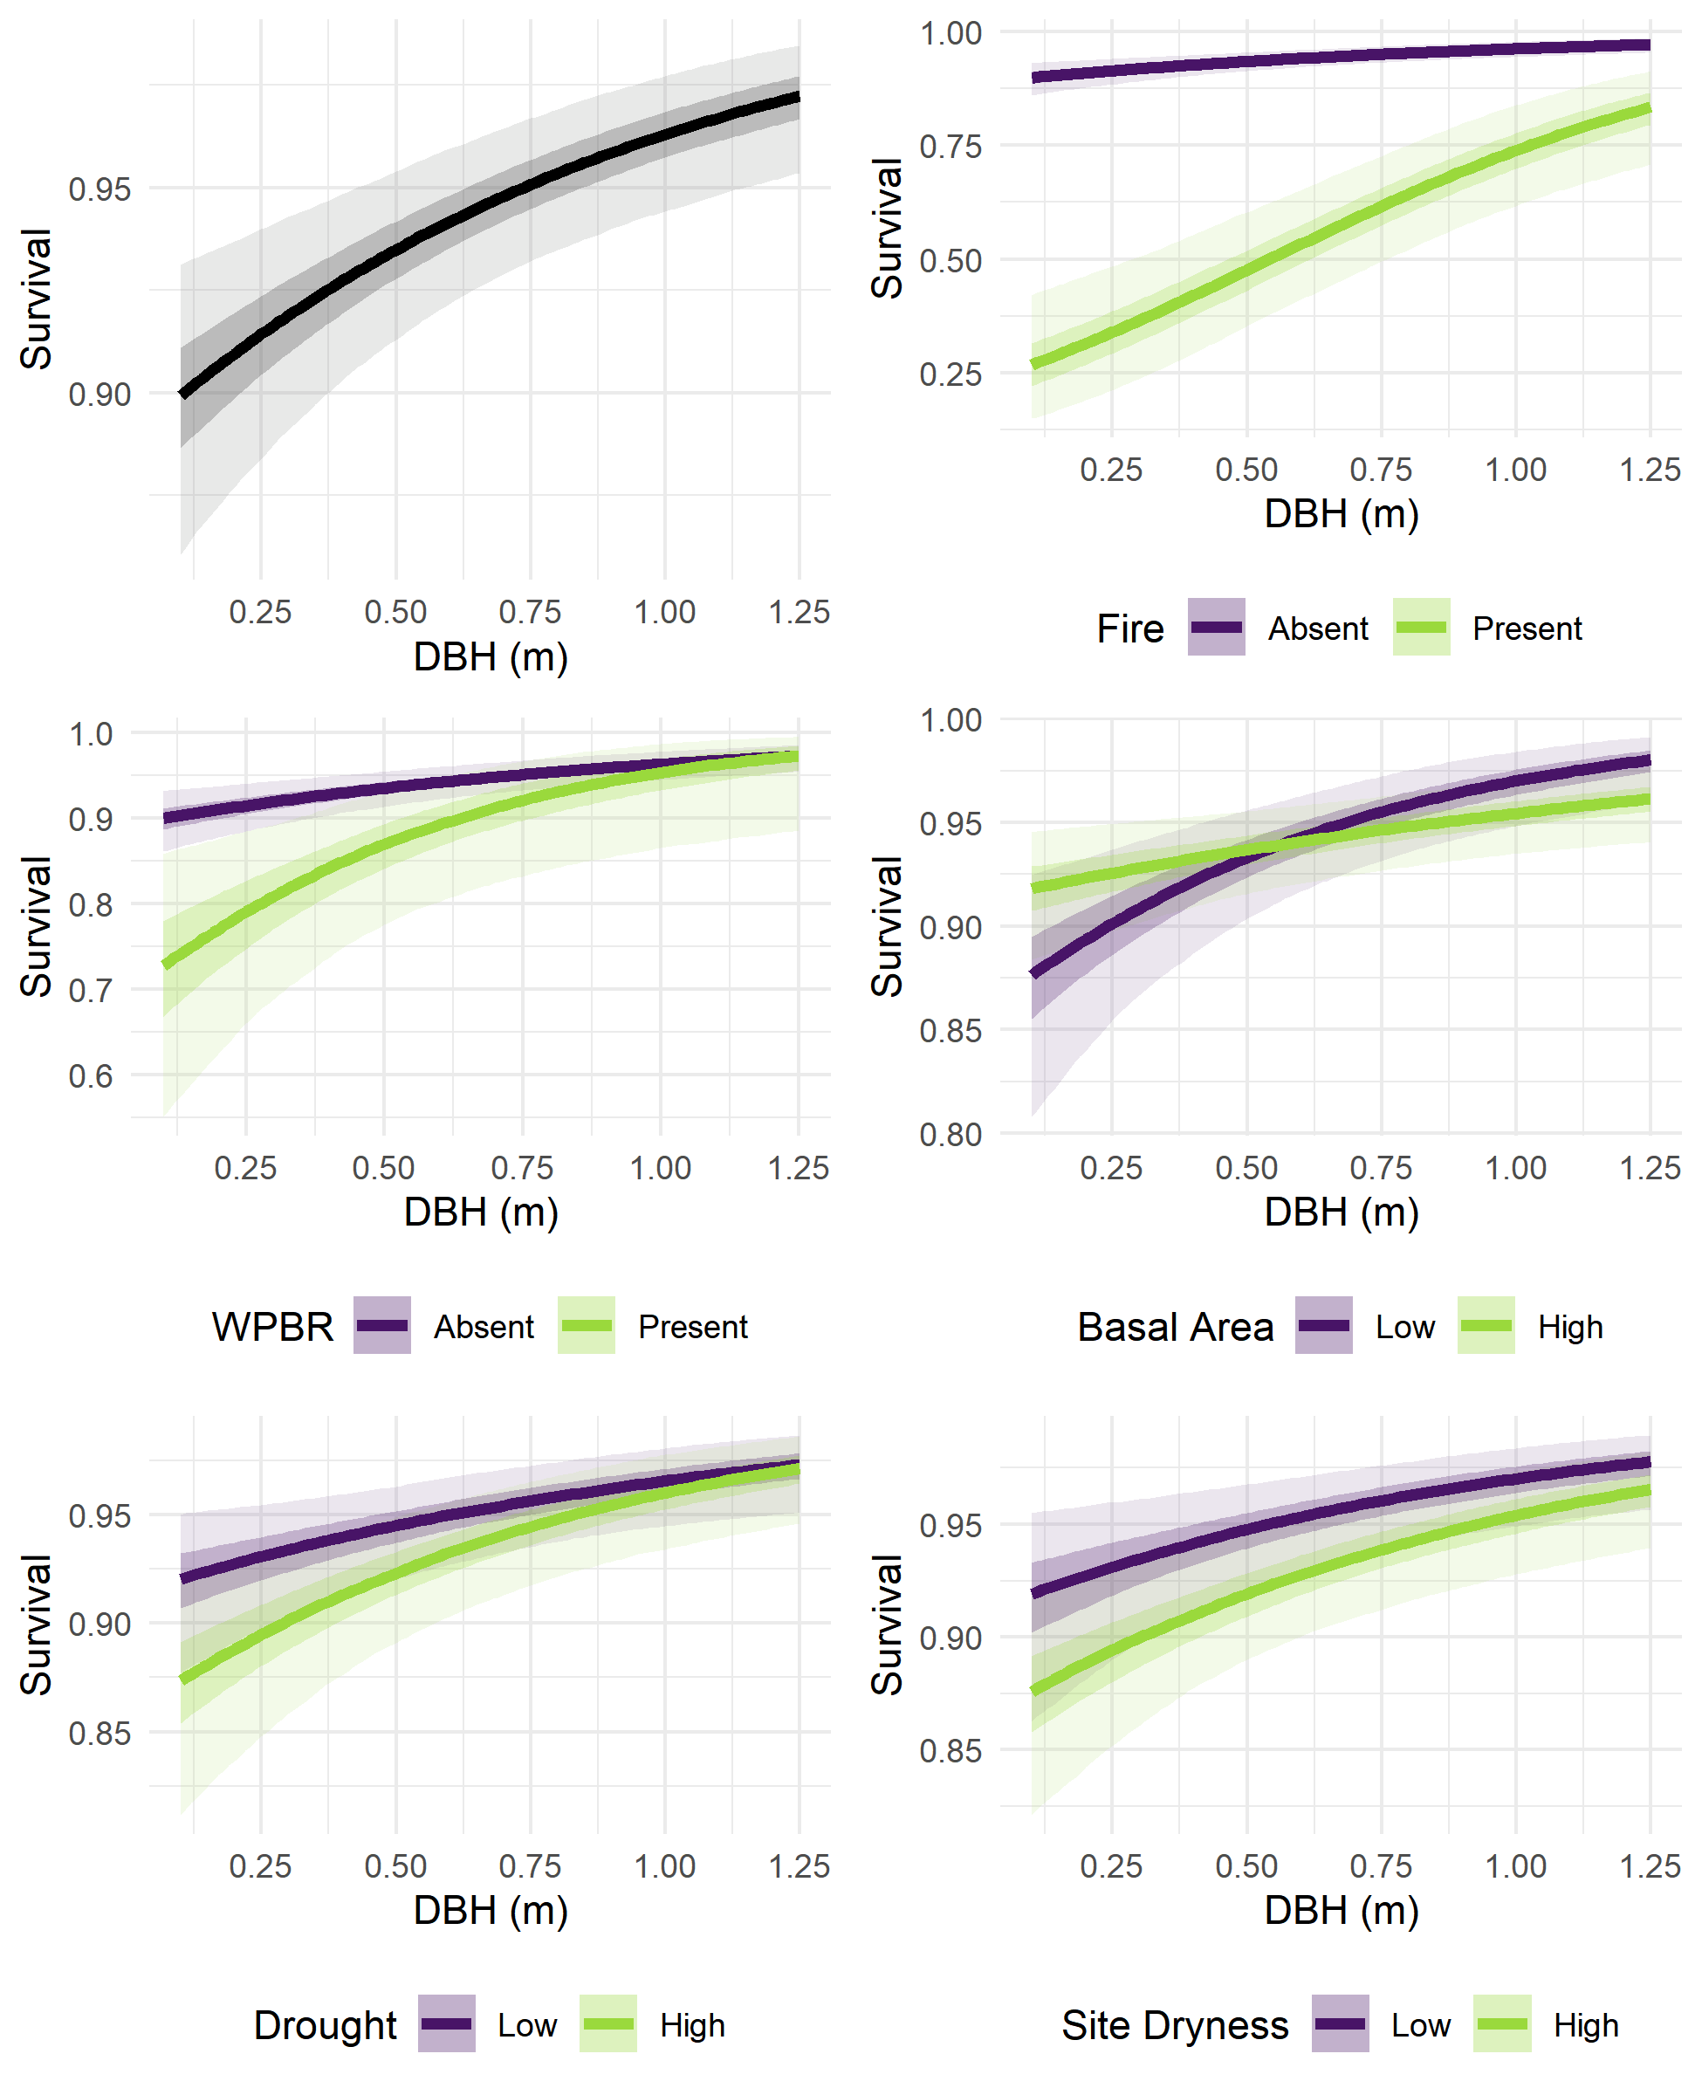

Figure 2: Fixed effects of initial DBH, fire, WPBR, neighborhood basal area, drought, and site dryness on survival. In the top left panel, probability of survival (Y-axis) is predicted for stems of various initial size (X-axis), holding other variables at “Absent” (for fire and WPBR) or 0 (scaled mean, for basal area, drought, and site dryness). In the other panels, probability of survival is predicted for stems of various sizes and across two levels of each other explanatory variable: with or without disturbance, or at high (1.0) or low (-1.0) values for scaled continuous variables. Predictions were generated using the posterior samples for model parameters, resulting in a range of predicted survival for each set of explanatory variable values. Lines show the median predicted survival, darker ribbons show a 50% credible interval, and lighter ribbons show a 95% credible interval. Random effects were held at 0. Note the varying scales on the Y-axis. 1.25 m is approximately the 95th percentile DBH of trees used to train the model.

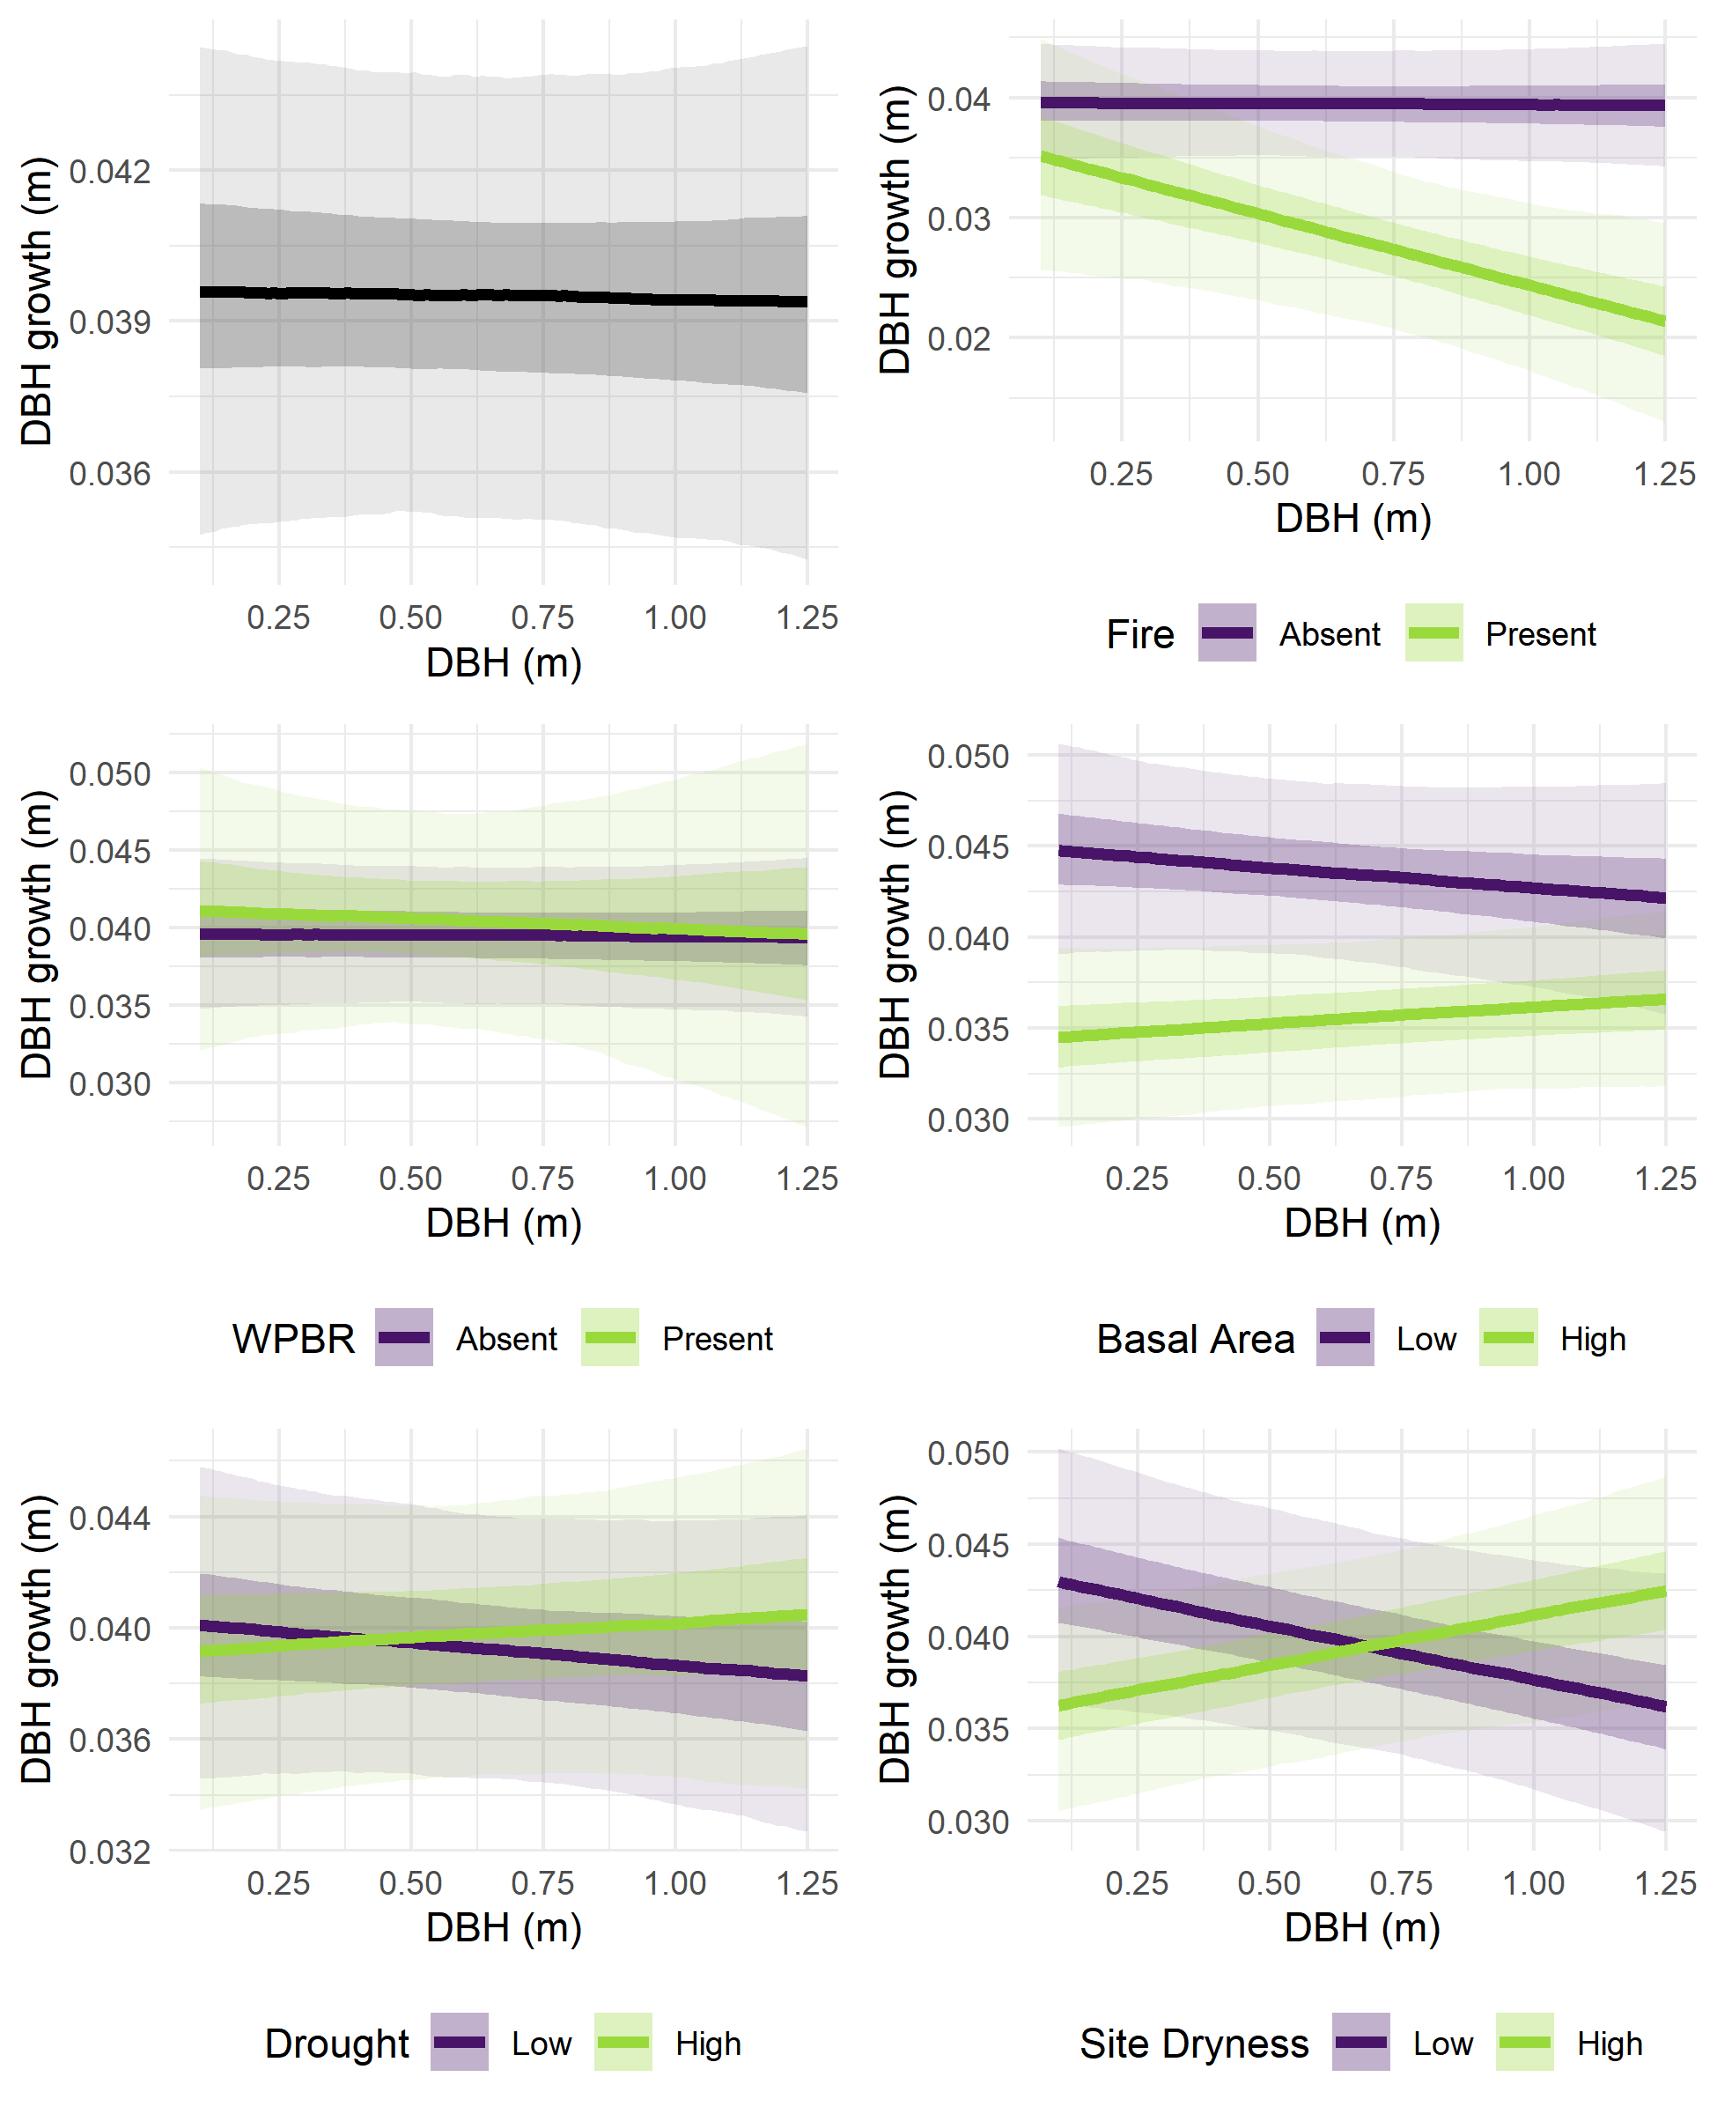

Figure 3: Fixed effects of initial DBH, fire, WPBR, neighborhood basal area, drought, and site dryness on growth. In the top left panel, DBH growth over the 10 years between censuses (Y-axis) is predicted for stems of various initial size (X-axis), holding other variables at “Absent” (for fire and WPBR) or 0 (scaled mean, for basal area, drought, and site dryness). In the other panels, growth is predicted for stems of various sizes and across two levels of each other explanatory variable: with or without disturbance, or at high (1.0) or low (-1.0) values for scaled continuous variables. Predictions were generated using the posterior samples for model parameters, resulting in a range of predicted survival for each set of explanatory variable values. Lines show the median predicted survival, darker ribbons show a 50% credible interval, and lighter ribbons show a 95% credible interval. Random effects were held at 0. Note the varying scales on the Y-axis. 1.25 m is approximately the 95th percentile DBH of trees used to train the model.

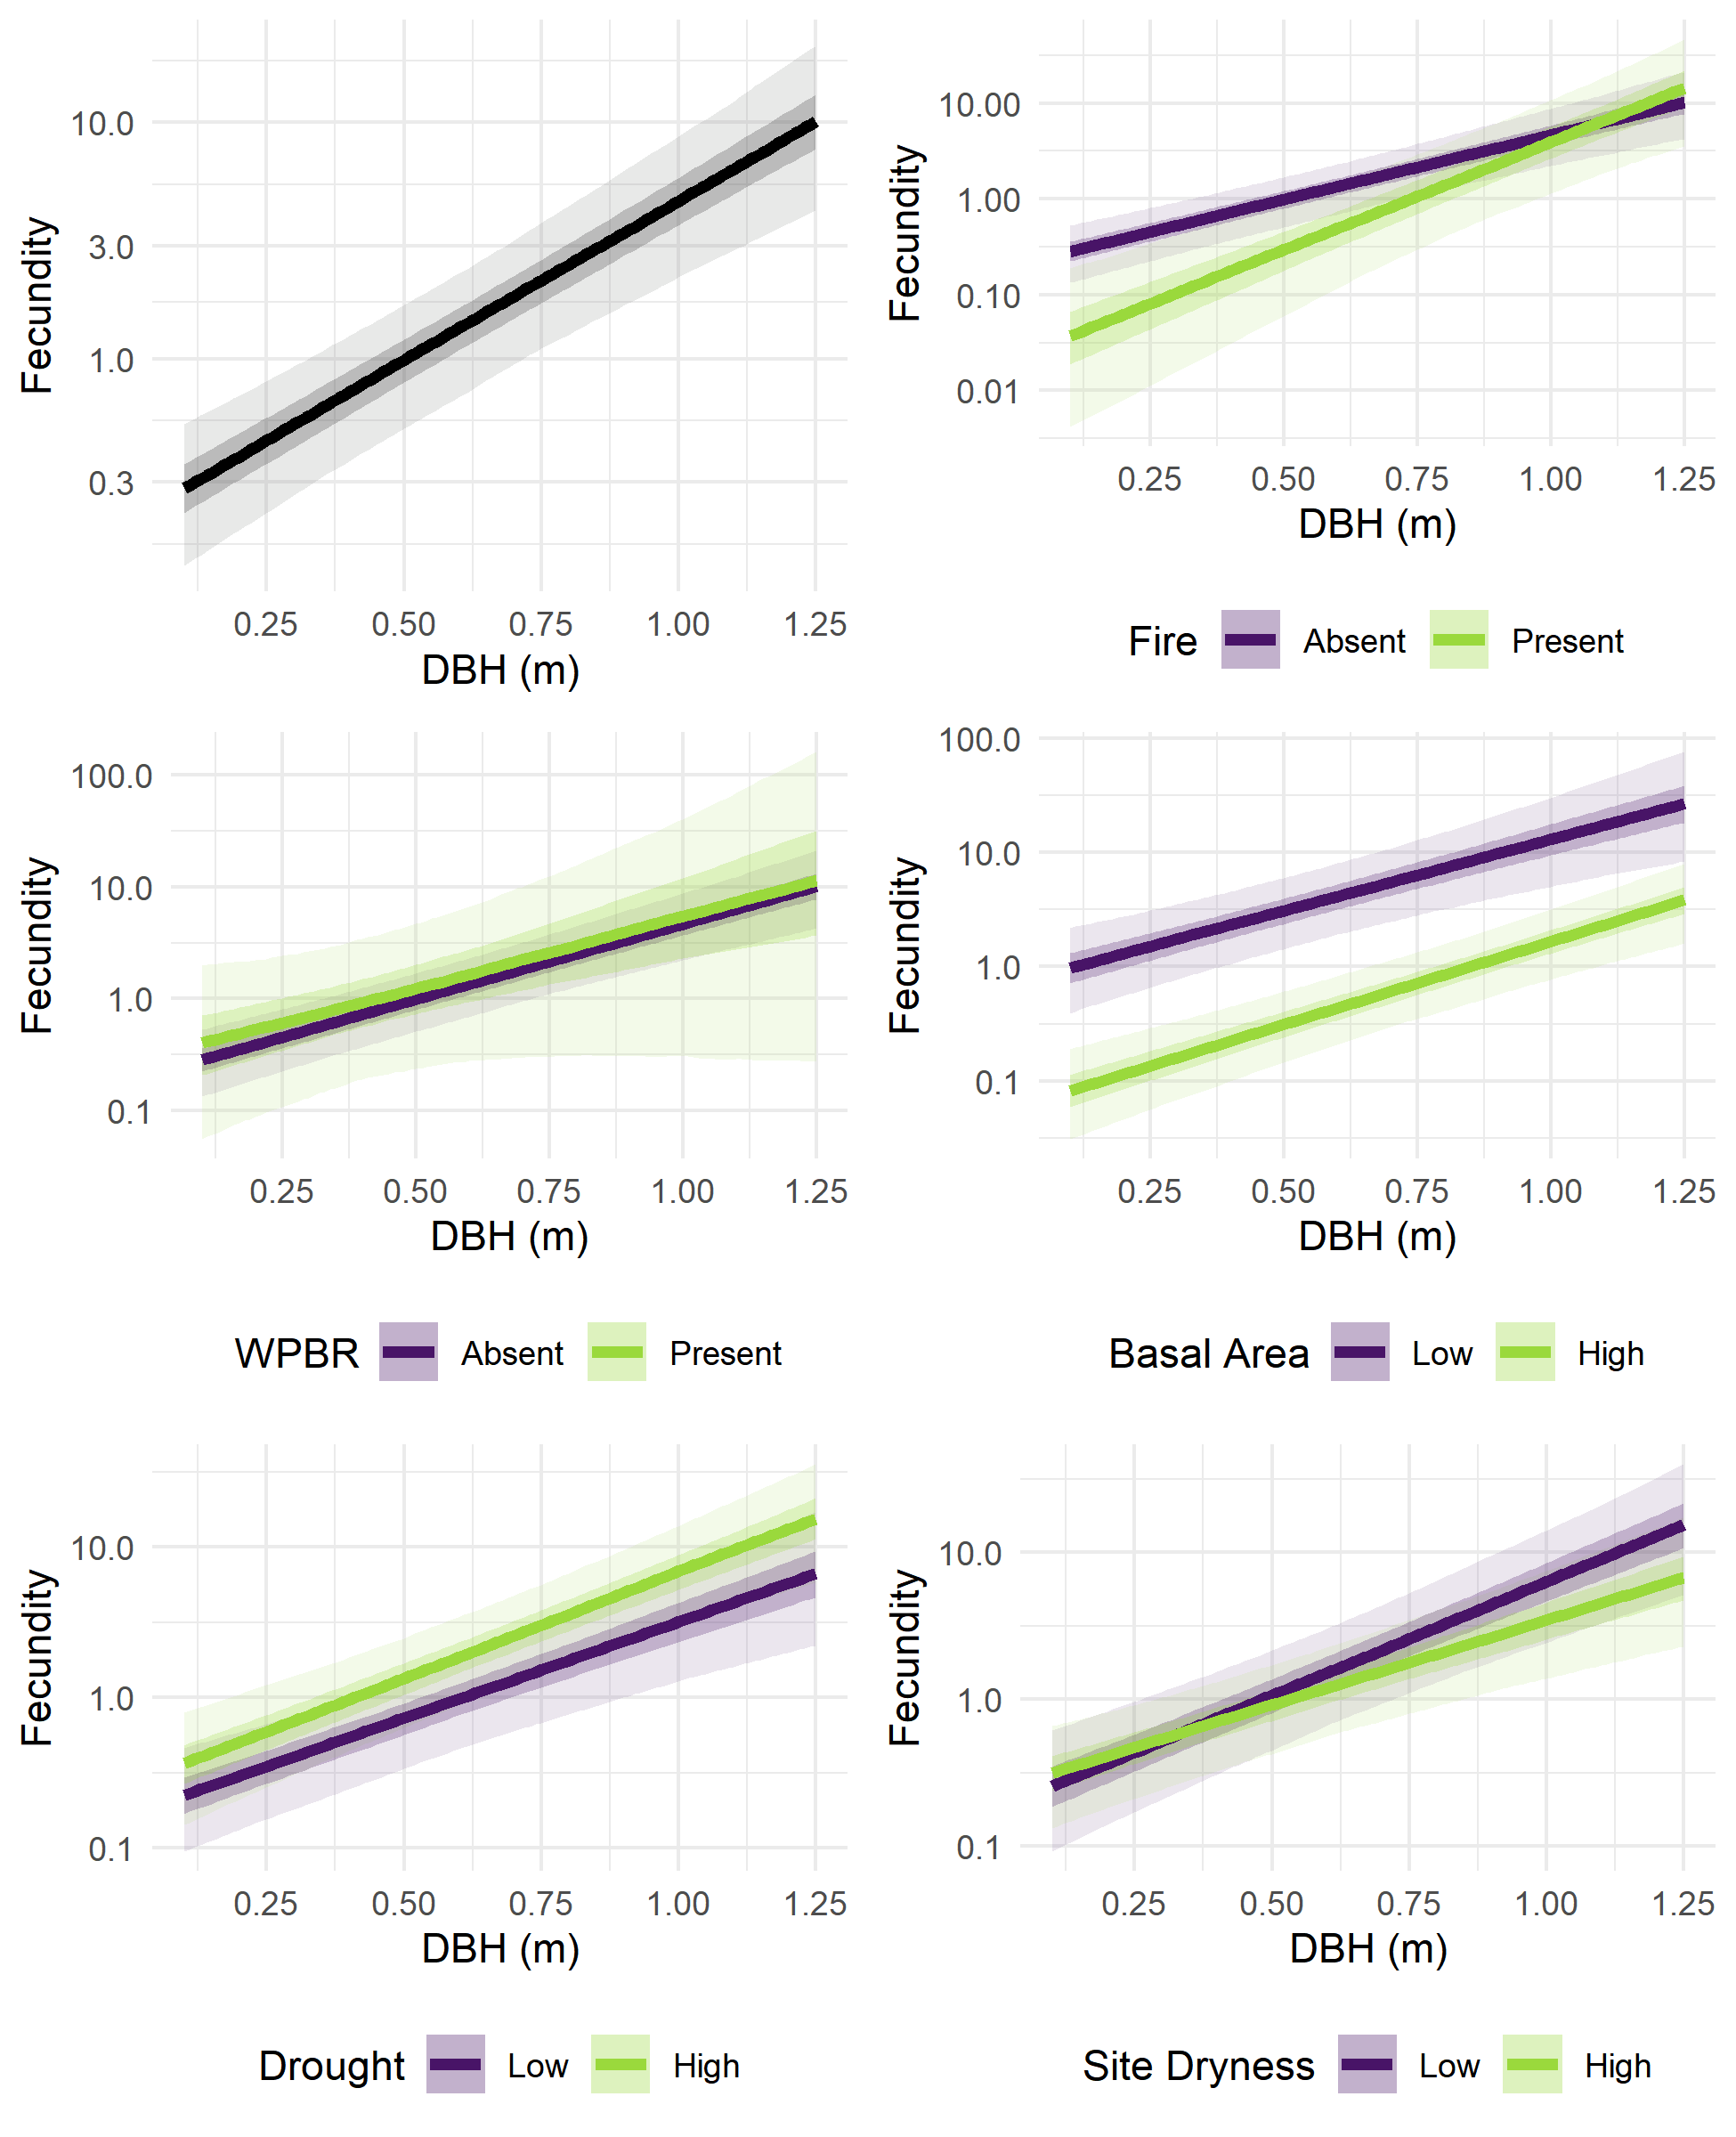

Figure 4: Fixed effects of initial DBH, fire, WPBR, neighborhood basal area, drought, and site dryness on fecundity. In the top left panel, fecundity (Y-axis) is predicted for stems of various initial size (X-axis), holding other variables at “Absent” (for fire and WPBR) or 0 (scaled mean, for basal area, drought, and site dryness). In the other panels, fecundity is predicted for stems of various sizes and across two levels of each other explanatory variable: with or without disturbance, or at high (1.0) or low (-1.0) values for scaled continuous variables. Predictions were generated using the posterior samples for model parameters, resulting in a range of predicted survival for each set of explanatory variable values. Lines show the median predicted survival, darker ribbons show a 50% credible interval, and lighter ribbons show a 95% credible interval. Random effects were held at 0. Note the varying scales and log10 scaling on the Y-axis. 1.25 m is approximately the 95th percentile DBH of trees used to train the model.

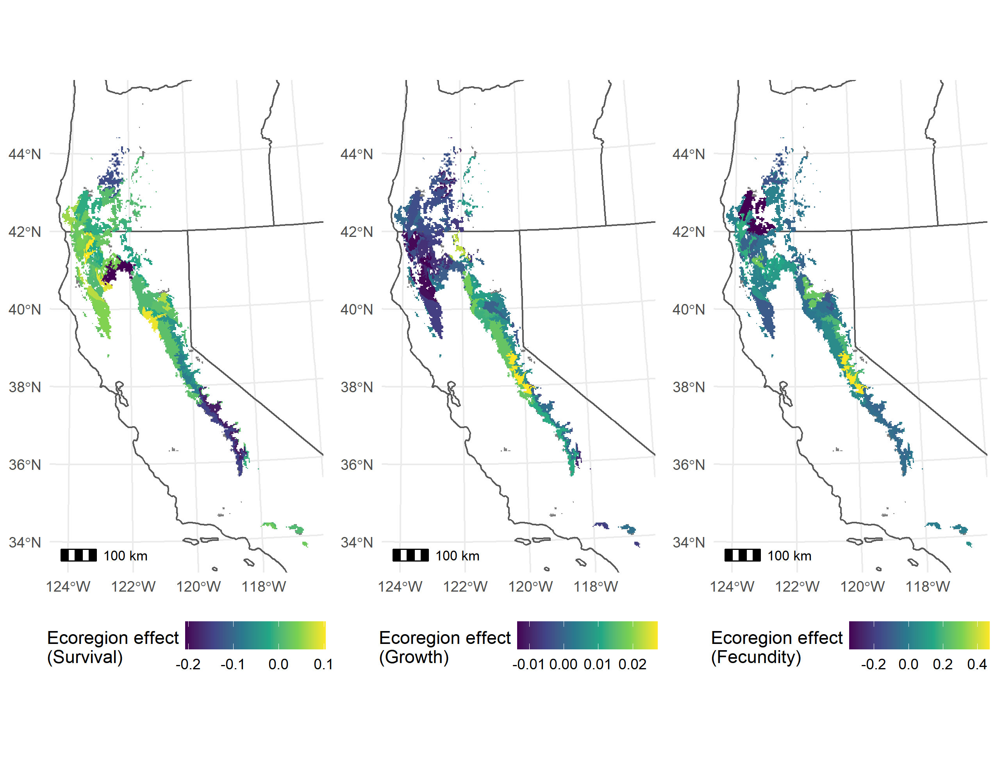

Figure 5: Posterior median random effect values for ecoregion subsections where sugar pine was present in the training data. The three panels show the random effect values for the survival, growth, and fecundity sub models. Ecoregion random effects drawn from a normal distribution with mean 0 and variance , , and for the survival, growth, and fecundity sub models, respectively. Ecoregions have been clipped by the sugar pine range polygon. Ecoregion effects should be interpreted as representing broad-scale variation in vital rates across the range of sugar pine which is not explained by the other variables in the model (i.e., by individual size and its interactions with fire, WPBR, basal area, drought, and site dryness, or by plot-scale variation).

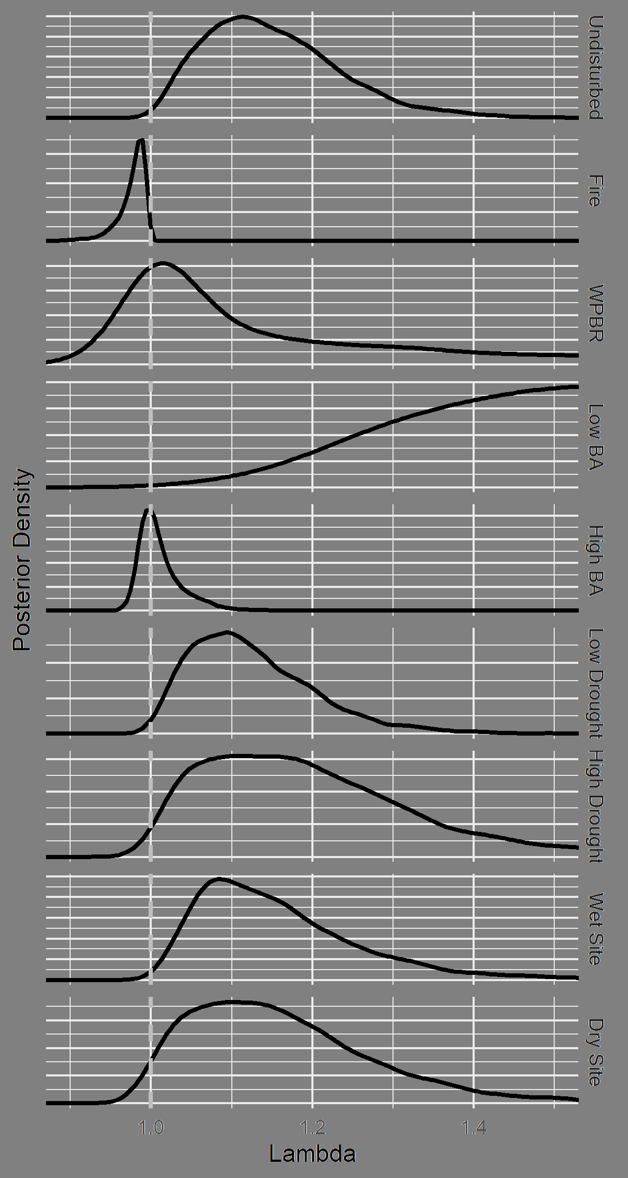

Figure 6: Posterior distribution of asymptotic population growth rate (Lambda) under a variety of hypothetical scenarios, each corresponding to the presence or absence of a specific stressor. In the “Undisturbed” scenario, all fixed effect covariates other than the intercept are held at 0 (representing the absence of fire and WPBR, and basal area, drought, and site dryness at average levels). In each other scenario, a single stressor is set to TRUE (for fire and WPBR), -1 (low levels of basal area, drought, or site dryness), or +1 (high levels of basal area, drought, or site dryness). Random effect values are held at 0, representing an average plot in an average ecoregion. The bounds of the figure have been restricted for readability of scenarios other than “Low BA.”

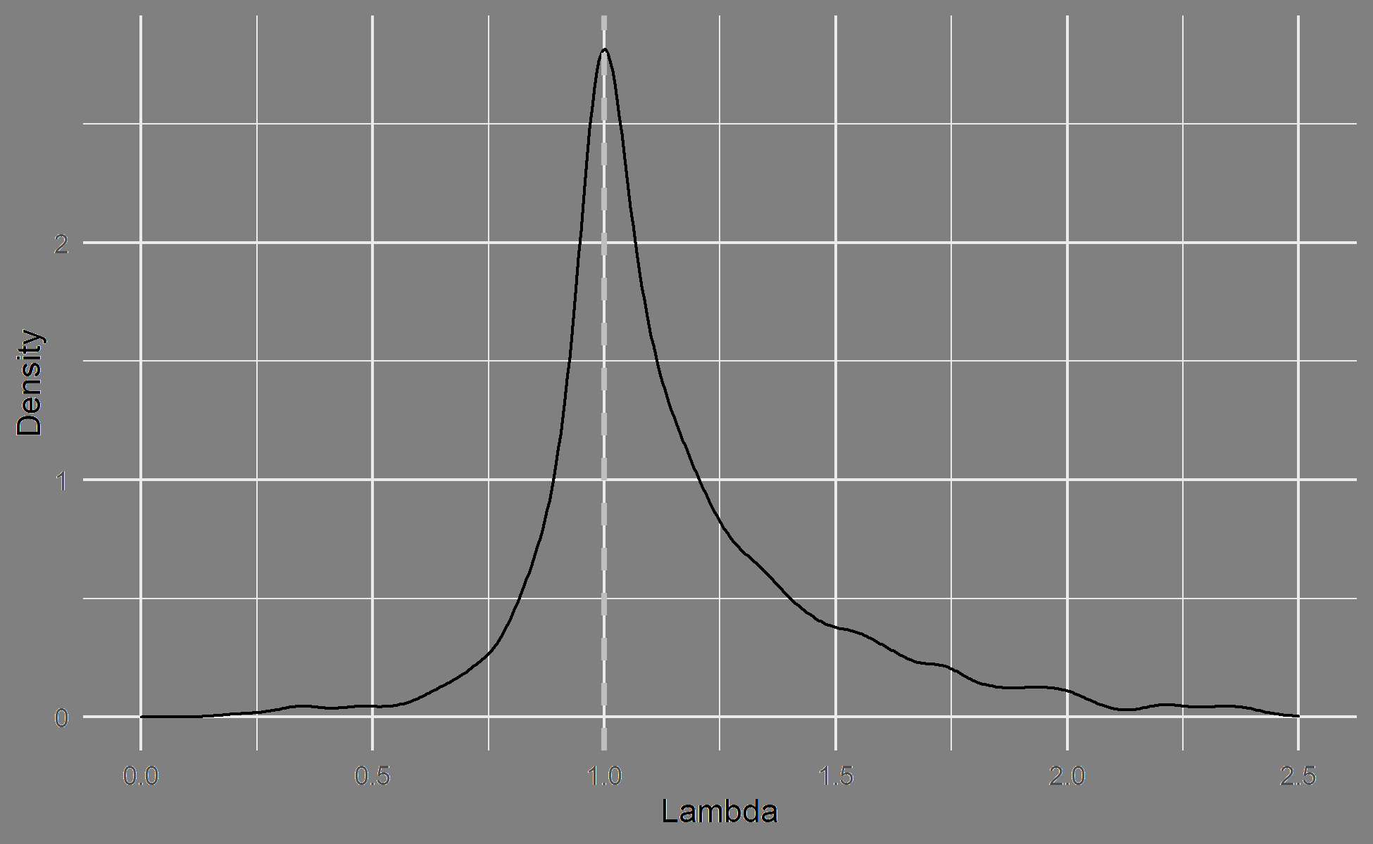

Figure 7: Distribution of predicted asymptotic population growth rates (Lambda) across observed subplots where sugar pine was present during the initial census. The asymptotic population growth rate was predicted for each subplot using model parameter values held at their posterior medians. The bounds of the figure have been restricted for readability.

# Supplementary Materials

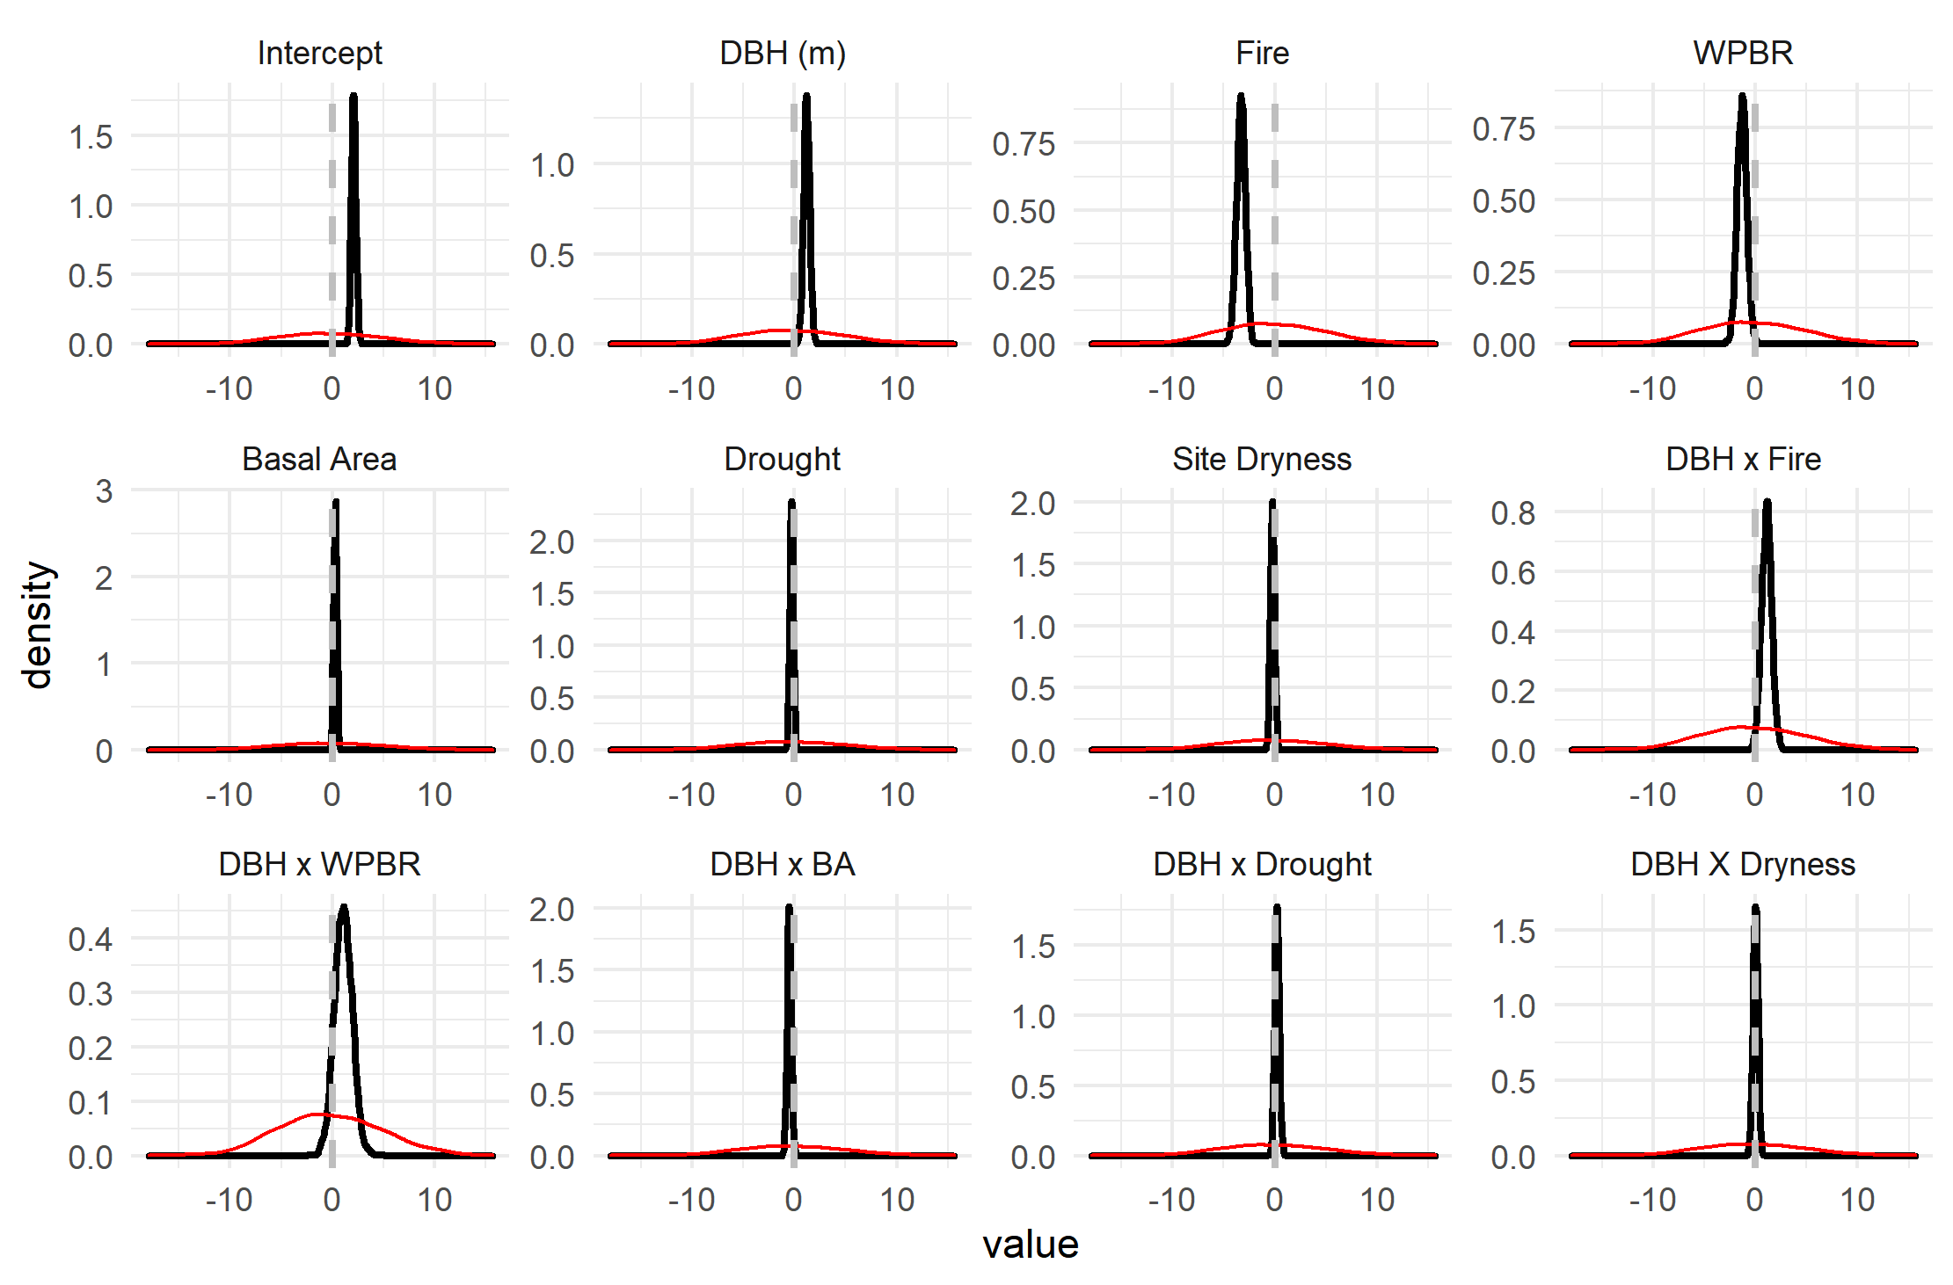

Supplementary Figure : Posterior distributions (black) and prior distributions (red) for , the fixed effect coefficients for survival. The magnitude of the discrepancy between the two indicates the extent to which the posterior distribution was informed by the data, rather than the prior.

Supplementary Figure : Posterior distributions (black) against prior distributions (red) for the standard deviations of the plot and ecoregion random effects in the survival model.

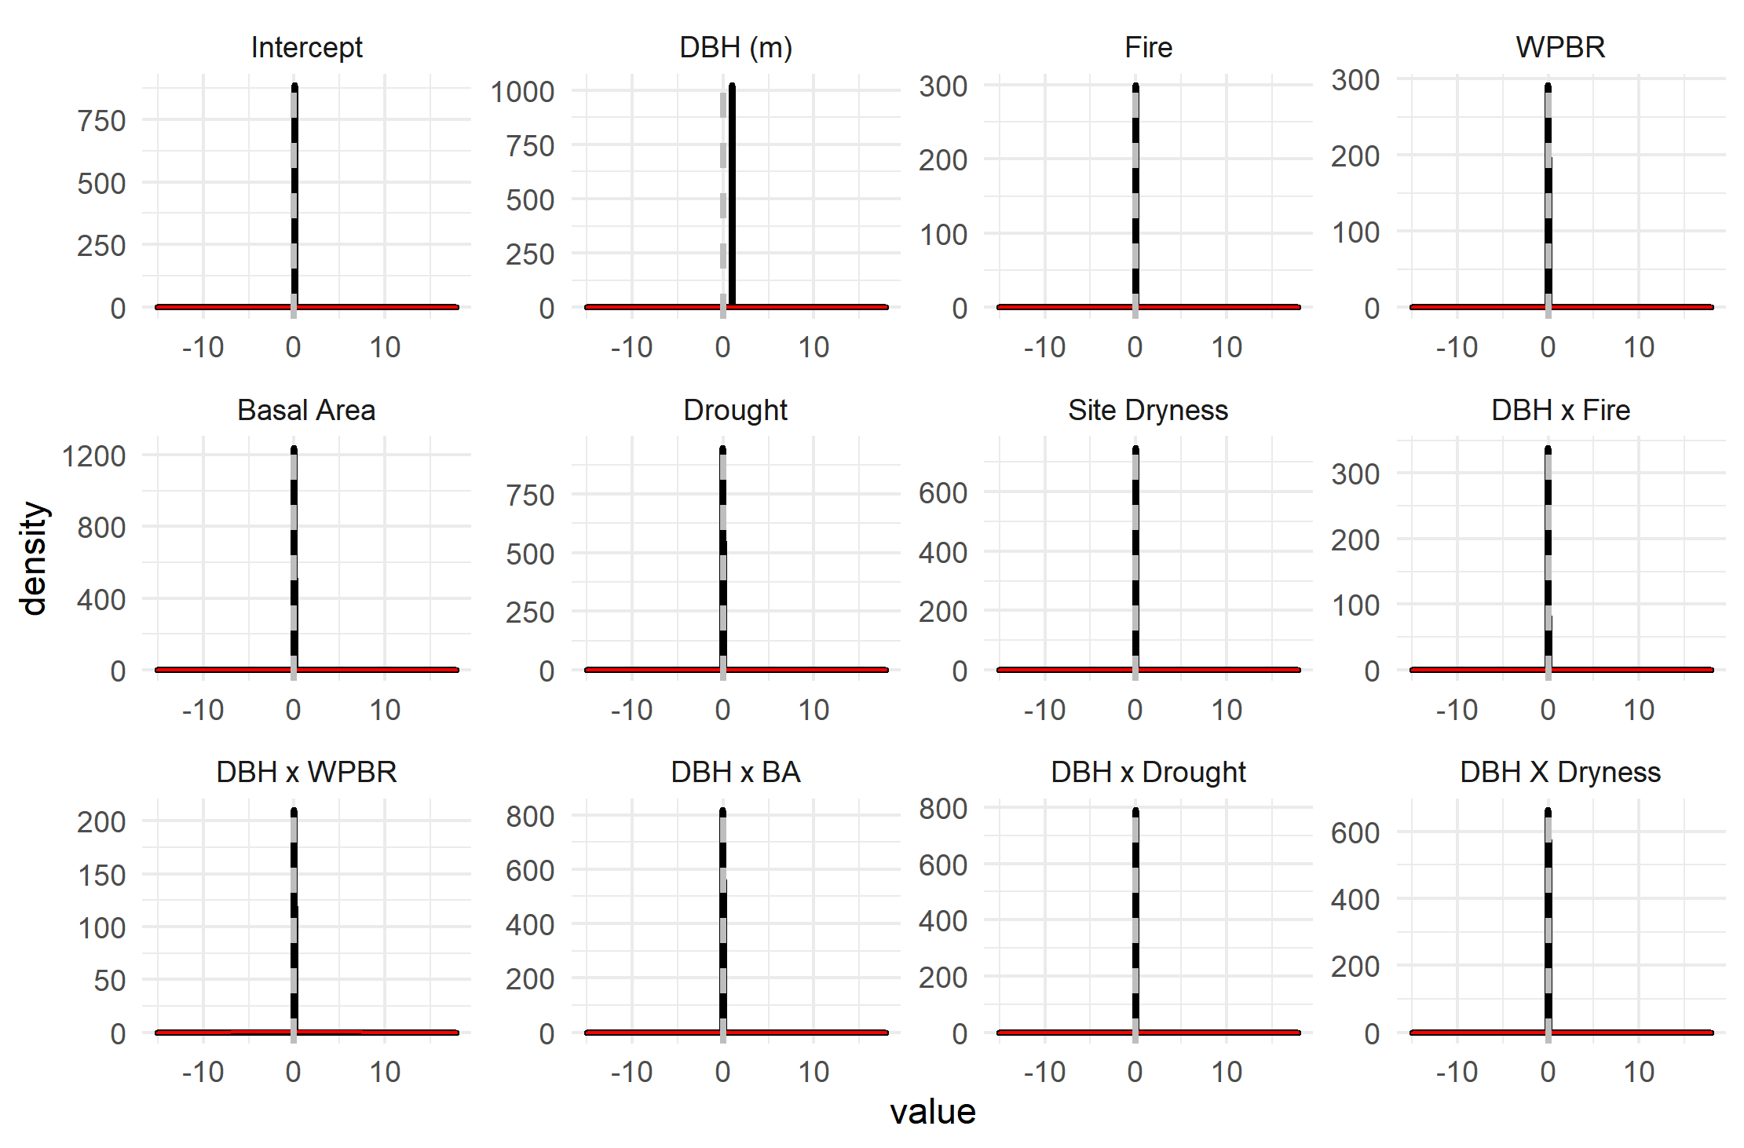

Supplementary Figure : Posterior distributions (black) against prior distributions (red) for fixed effect coefficients in the growth model.

Supplementary Figure : Posterior distributions (black, along Y axis) against prior distributions (red, along X axis) for the standard deviations of the plot random effect, the ecoregion random effect, and the residuals in the growth model.

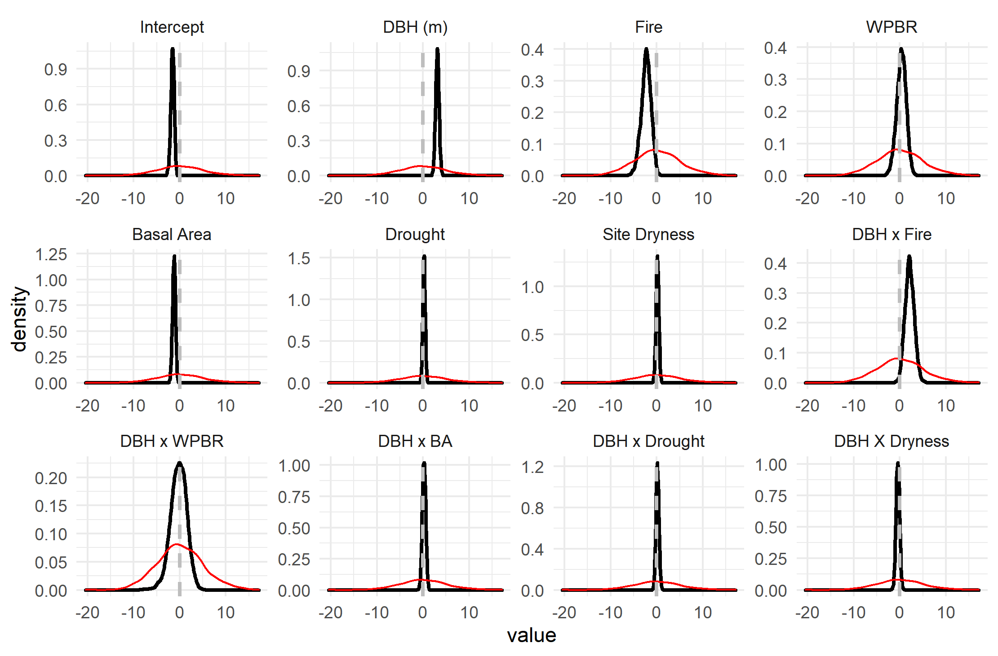

Supplementary Figure : Posterior distributions (black) against prior distributions (red) for the fixed effect coefficients affecting fecundity in the recruitment model.

Supplementary Figure : Posterior distribution (black, along Y axis) against prior distribution (red, along X axis) for the dispersion term of the negative binomial response in the recruitment model.

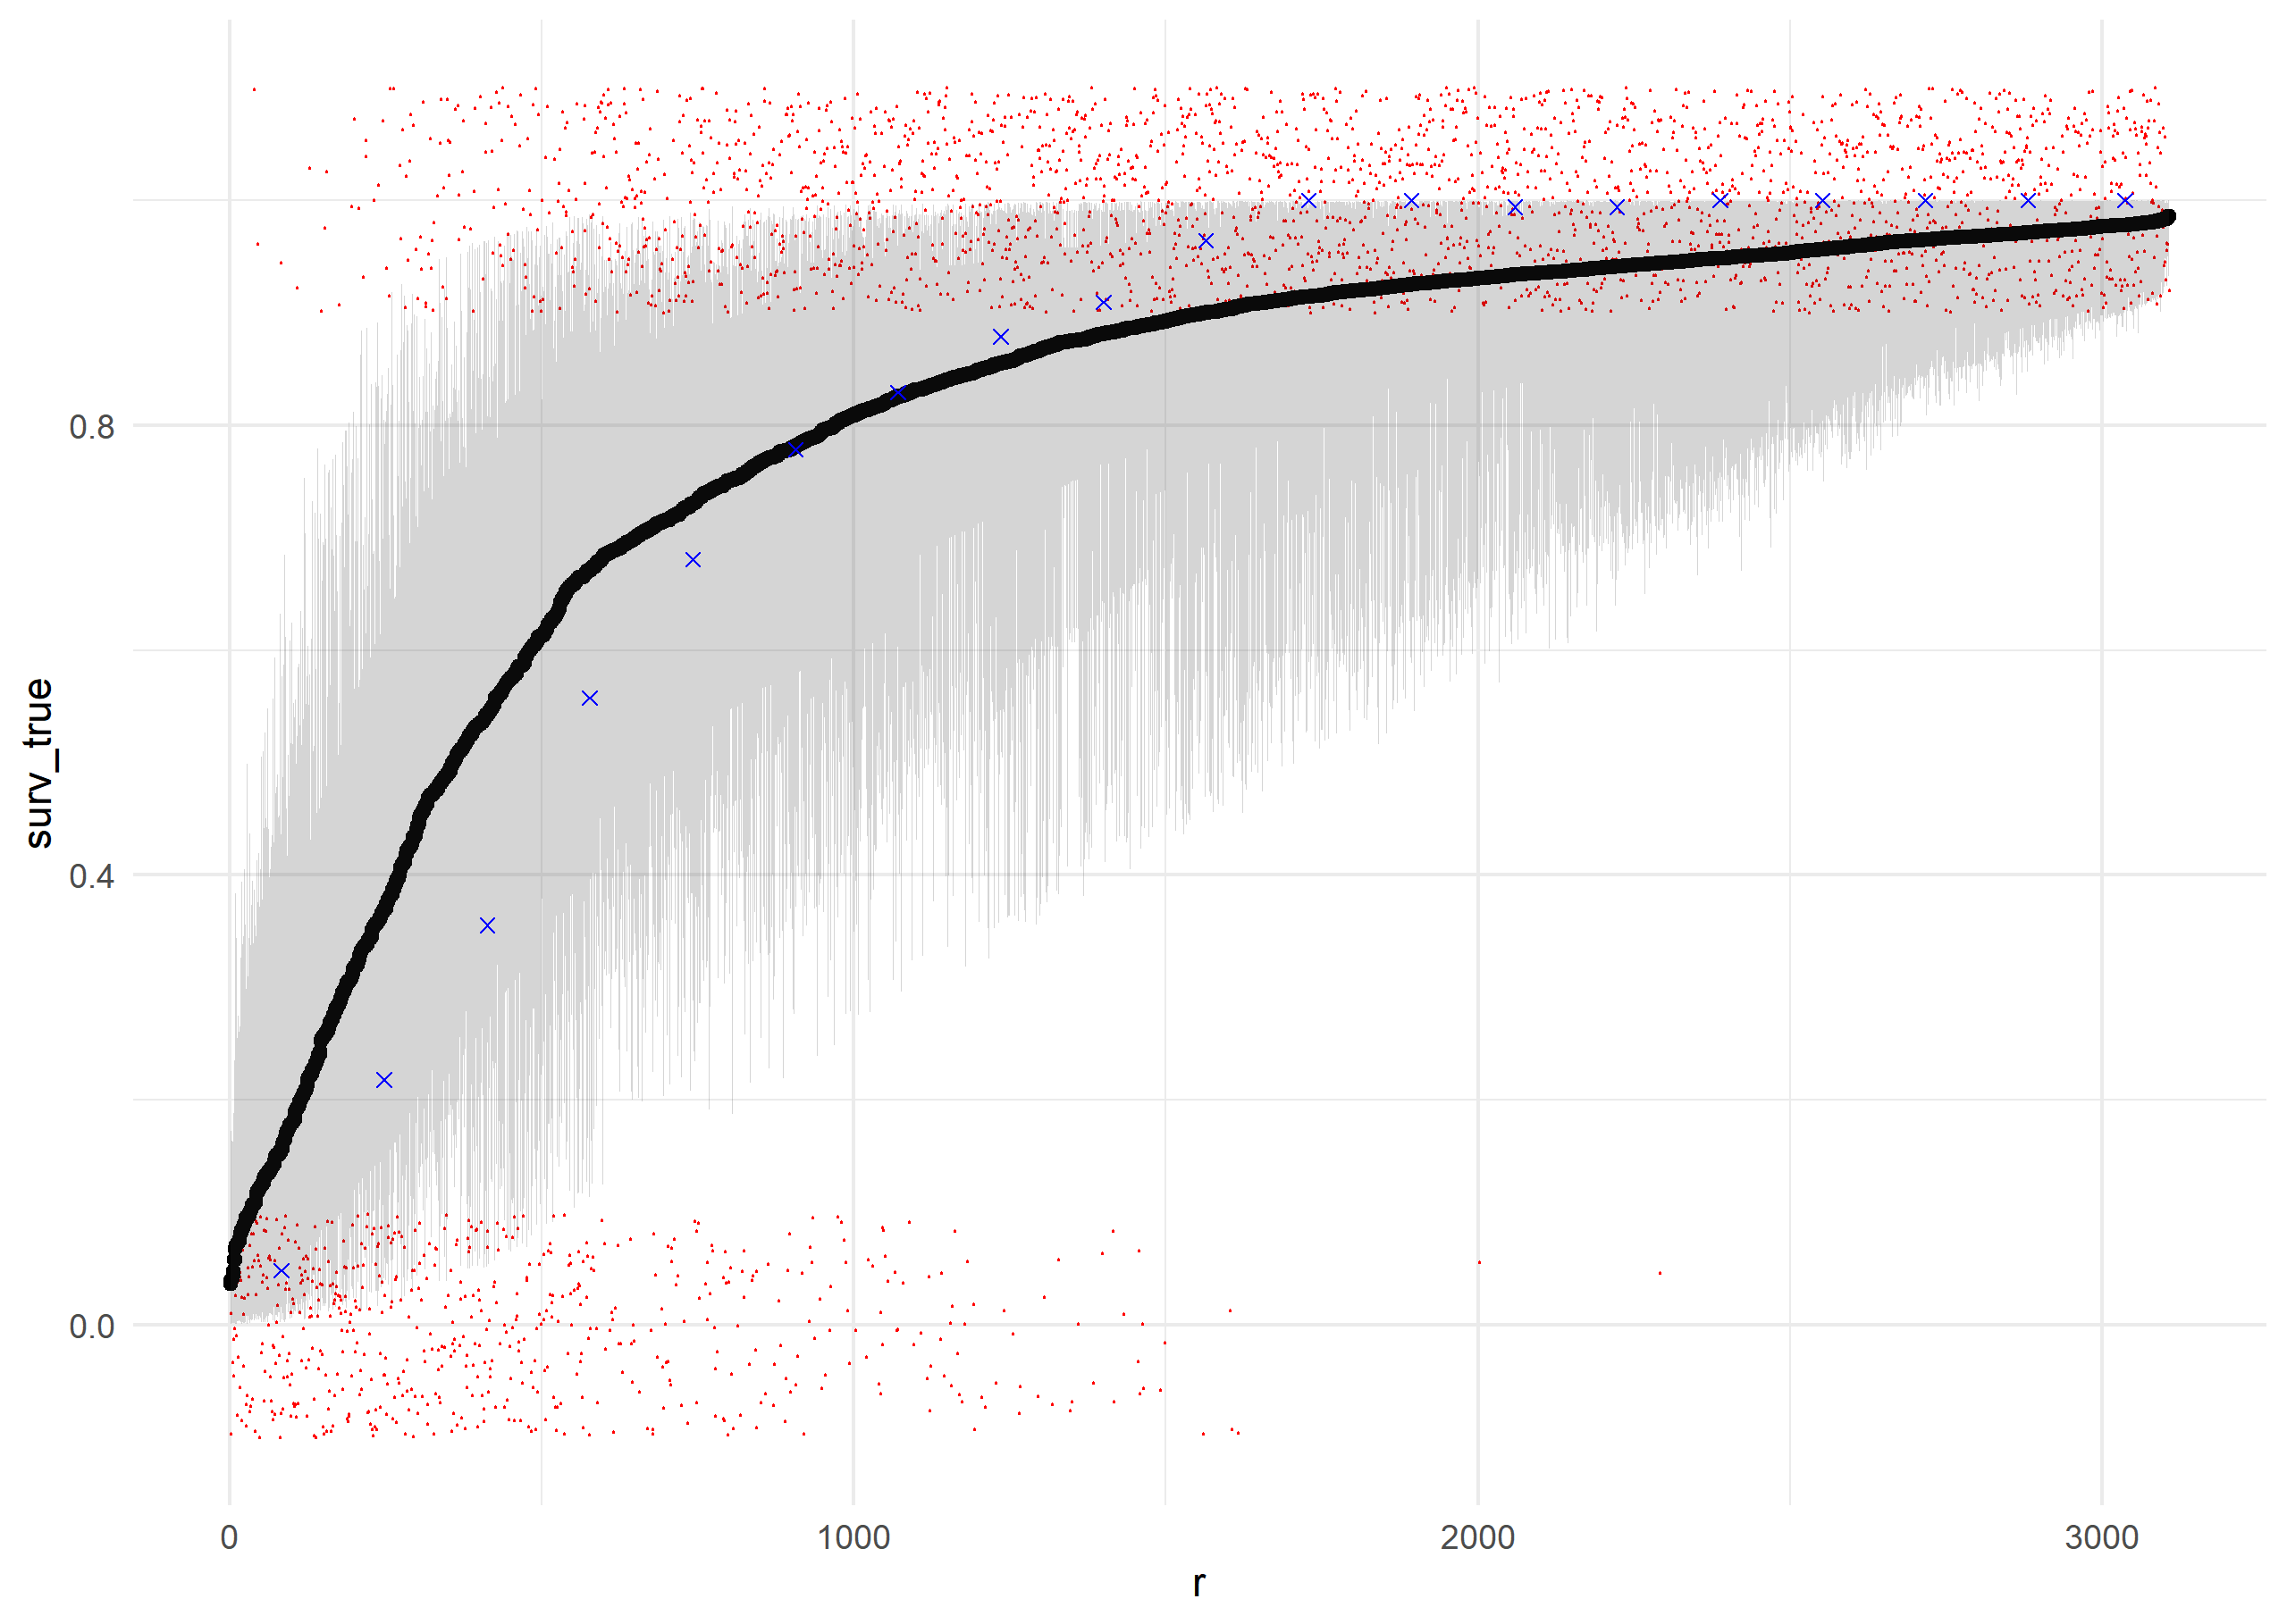

Supplementary Figure : Results of posterior retrodictive simulations for survival of individual trees. Posterior samples of the parameters were used to predict the survival probability of each individual tree using Equation 2 and the training data used to fit the model. Individual trees (red points) are ranked along the X-axis by their mean predicted survival probability, and their actual survival (0 or 1) is plotted along the Y-axis (including a jitter for readability). Blue points indicate the actual proportion of individuals in each rank bin which survived. Black points indicate the mean predicted survival for each individual, with a gray ribbon showing a 95% credible interval for survival probability for each individual. The model does a good job ranking trees by their actual survival probability, as shown by the red points. However, the model is slightly under-certain about survival probability, relative to reality: It slightly overpredicts survival for the least-likely-to-survive trees, and slightly underpredicts survival for the most-likely-to-survive trees.

Supplementary Figure : Posterior retrodictions for the growth model, using posterior parameter values and the training data. Individual trees (black points) are plotted with their median predicted size at remeasurement along the X-axis, and their true size at remeasurement along the y axis. The blue line has slope 1 and intercept 0, i.e. perfect prediction. The gray ribbon gives a 95% credible interval for size at remeasurement as predicted by the model, and contains nearly all of the true sizes.

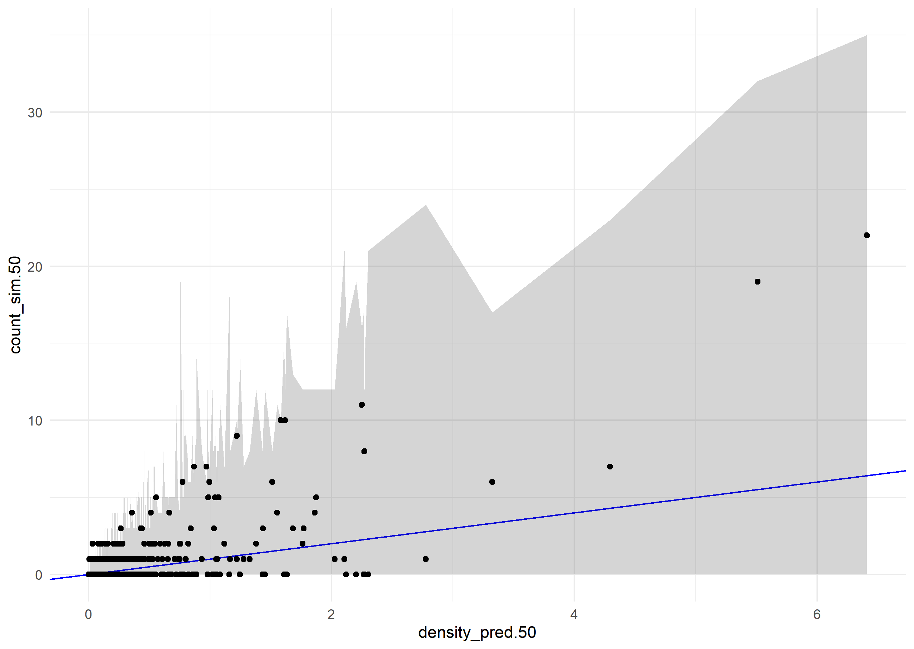

Supplementary Figure : Posterior retrodictions for the recruitment model. The black points show the observed count of untagged individuals (new recruits and preexisting small stems) on each subplot on the Y-axis, and the median predicted density on the X-axis. The blue line has slope 1 and intercept 0, i.e. perfect prediction. The bounds of the grey ribbon correspond to the 2.5th and 97.5th percentiles of simulated counts drawn from a negative binomial distribution with location parameter predicted from the posterior distribution of the model. The gray ribbon contains all the true values, indicating that all of the observed counts are consistent with the variability expected from the model.

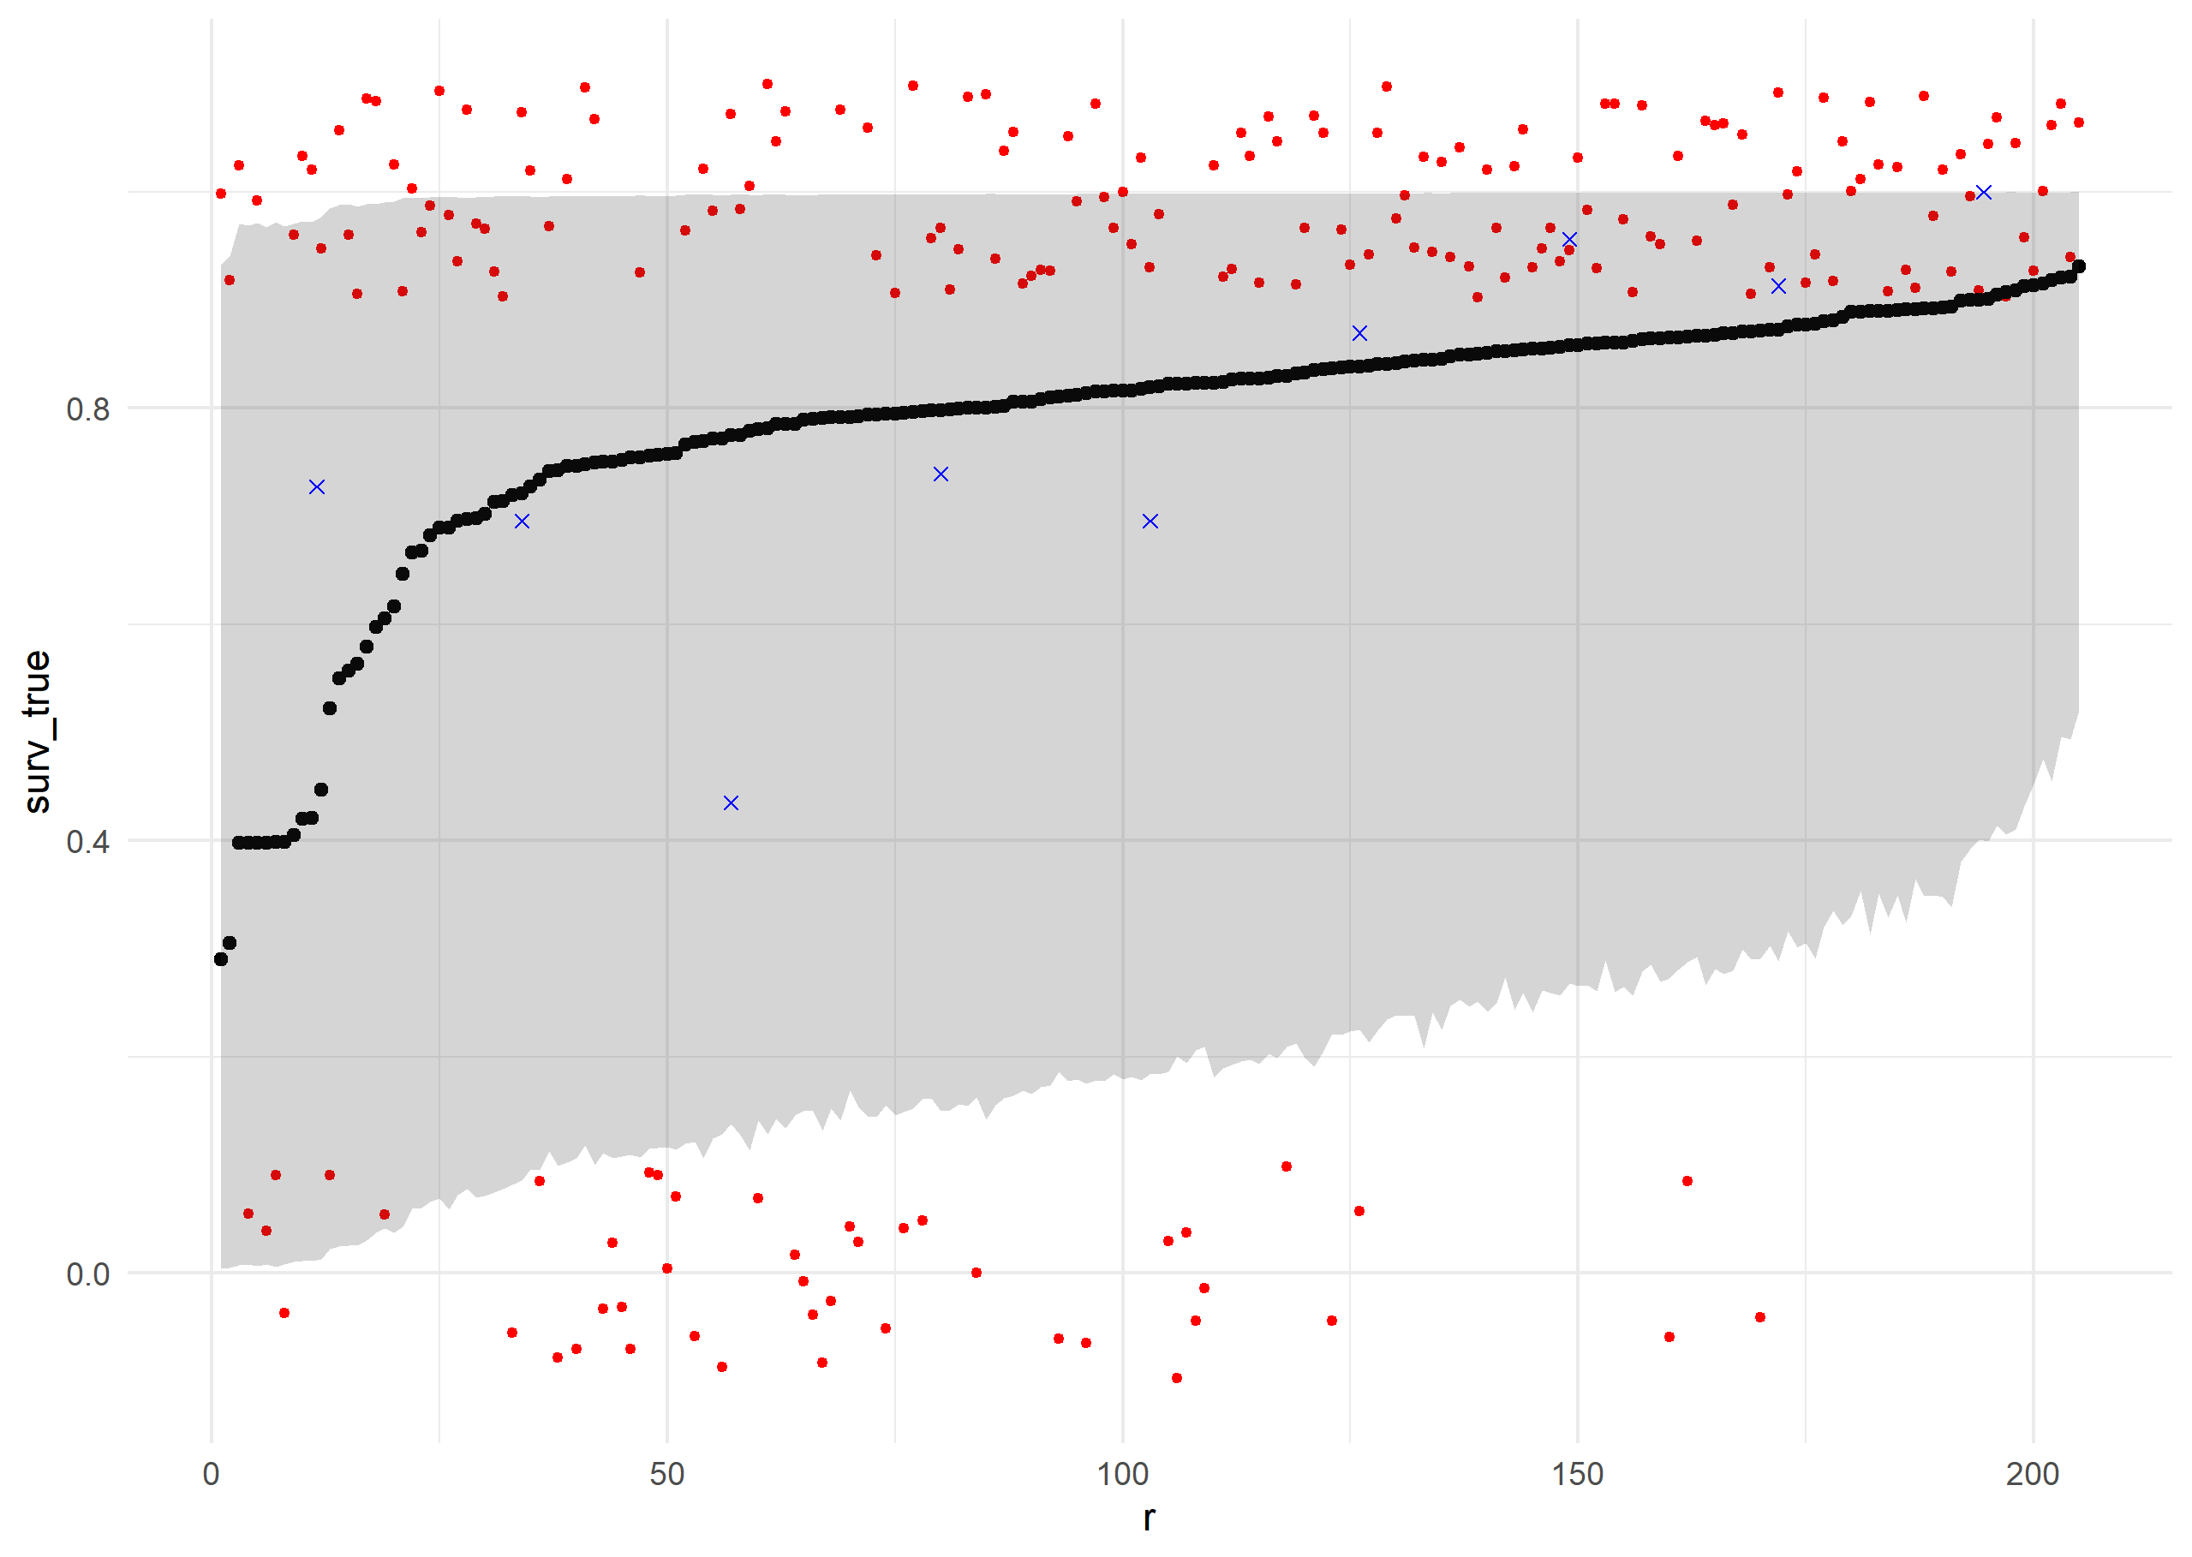

Supplementary Figure : Results of posterior predictive simulations for survival of individual trees. Posterior samples of the parameters were used to predict the survival probability of each individual tree using Equation 2 and the validation data. Individual trees (red points) are ranked along the X-axis by their mean predicted survival probability, and their actual survival (0 or 1) is plotted along the Y-axis (including a jitter for readability). Blue points indicate the actual proportion of individuals in each rank bin which survived. Black points indicate the mean predicted survival for each individual, with a gray ribbon showing a 95% credible interval for survival probability for each individual.

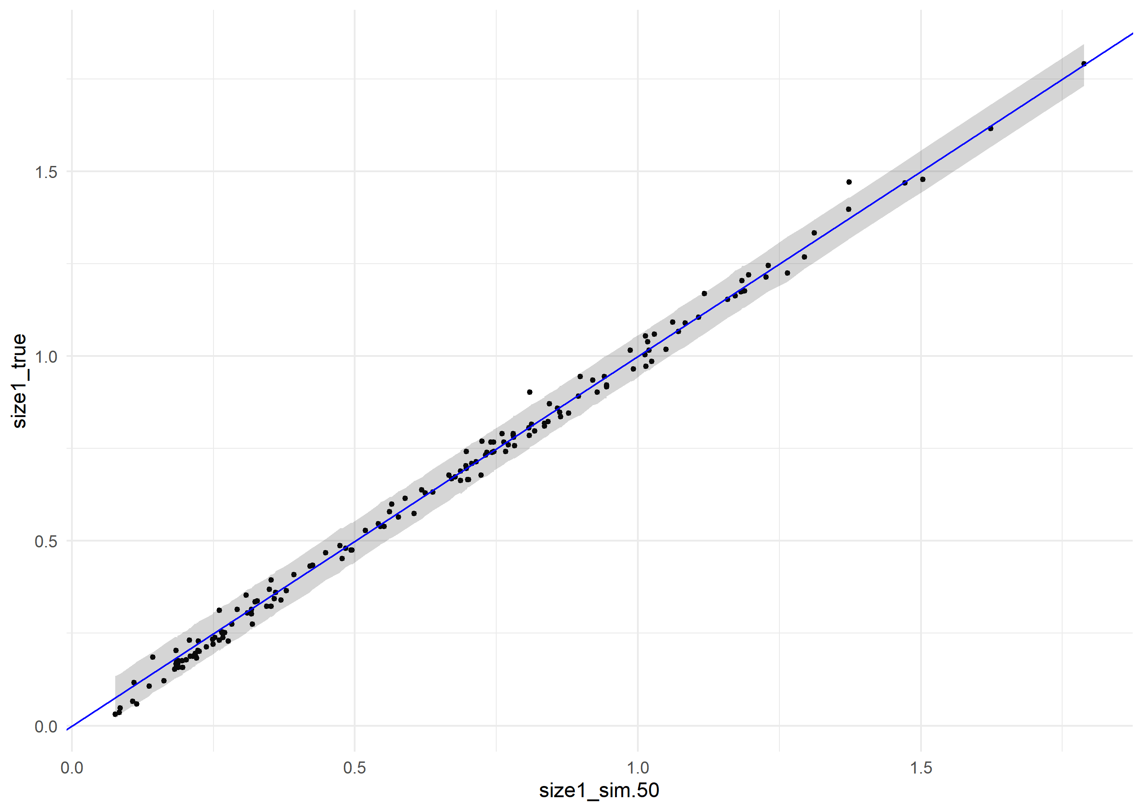

Supplementary Figure : Posterior retrodictions for the growth model, using posterior parameter values and the validation data. Individual trees (black points) are plotted with their median predicted size at remeasurement along the X-axis, and their true size at remeasurement along the y axis. The blue line has slope 1 and intercept 0, i.e. perfect prediction. The gray ribbon gives a 95% credible interval for size at remeasurement as predicted by the model, and contains nearly all of the true sizes.

Supplementary Figure : Posterior predictions for the recruitment model, using the out-of-sample validation data. The black points show the observed count of untagged individuals (new recruits and preexisting small stems) on each subplot on the Y-axis, and the median predicted density on the X-axis. The blue line has slope 1 and intercept 0, i.e. perfect prediction. The bounds of the grey ribbon correspond to the 2.5th and 97.5th percentiles of simulated counts drawn from a negative binomial distribution with location parameter predicted from the posterior distribution of the model. The gray ribbon contains all the true values, indicating that all the observed counts are consistent with the variability expected from the model.

|  |  |  |  |  |  |  |  |  |
| --- | --- | --- | --- | --- | --- | --- | --- | --- |
| **Parameter** | **Mean** | **Median** | **StDev** | **q5** | **q95** | **rhat** | **ess_bulk** | **ess_tail** |
| **Intercept** | 2.08 | 2.07 | 0.22 | 1.72 | 2.44 | 1.00 | 1967.95 | 2695.36 |
| **DBH (m)** | 1.19 | 1.19 | 0.29 | 0.71 | 1.68 | 1.00 | 1870.04 | 2741.38 |
| **Fire** | -3.32 | -3.31 | 0.43 | -4.03 | -2.63 | 1.00 | 1933.64 | 2758.74 |
| **WPBR** | -1.32 | -1.31 | 0.47 | -2.08 | -0.53 | 1.00 | 2820.09 | 2908.17 |
| **Basal Area** | 0.28 | 0.28 | 0.15 | 0.03 | 0.53 | 1.00 | 2338.83 | 2796.97 |
| **Drought** | -0.27 | -0.27 | 0.17 | -0.55 | 0.00 | 1.00 | 1653.54 | 2330.94 |
| **Site Dryness** | -0.24 | -0.24 | 0.20 | -0.57 | 0.10 | 1.00 | 1674.60 | 2170.42 |
| **DBH x Fire** | 1.10 | 1.11 | 0.48 | 0.30 | 1.89 | 1.00 | 2311.19 | 2298.86 |
| **DBH x WPBR** | 1.08 | 1.07 | 0.85 | -0.28 | 2.48 | 1.00 | 3377.36 | 3101.19 |
| **DBH x BA** | -0.50 | -0.50 | 0.20 | -0.82 | -0.18 | 1.00 | 2333.07 | 2741.33 |
| **DBH x Drought** | 0.20 | 0.19 | 0.22 | -0.15 | 0.56 | 1.00 | 2548.19 | 2457.03 |
| **DBH x Dryness** | 0.01 | 0.02 | 0.24 | -0.38 | 0.39 | 1.00 | 2362.03 | 3201.45 |
| **SD Plots** | 1.95 | 1.94 | 0.16 | 1.70 | 2.23 | 1.00 | 1005.62 | 2217.70 |
| **SD Ecoregions** | 0.29 | 0.27 | 0.18 | 0.03 | 0.61 | 1.01 | 464.98 | 1286.87 |

Supplementary Table : Summary of results for survival sub model, giving the mean, median, standard deviation, 5th percentile, and 95th percentile of posterior samples for each parameter, plus diagnostics R-hat, effective sample size (bulk), and effective sample size (tail).

|  |  |  |  |  |  |  |  |  |
| --- | --- | --- | --- | --- | --- | --- | --- | --- |
| **Parameter** | **Mean** | **Median** | **StDev** | **q5** | **q95** | **rhat** | **ess_bulk** | **ess_tail** |
| **Intercept** | 0.040 | 0.040 | 0.003 | 0.035 | 0.044 | 1.002 | 1563.786 | 2037.420 |
| **DBH (m)** | 1.000 | 1.000 | 0.002 | 0.996 | 1.003 | 1.000 | 4852.064 | 3711.382 |
| **Fire** | -0.003 | -0.003 | 0.005 | -0.012 | 0.005 | 1.001 | 2242.081 | 2468.383 |
| **WPBR** | 0.002 | 0.002 | 0.005 | -0.006 | 0.009 | 1.001 | 3474.428 | 3252.897 |
| **Basal Area** | -0.005 | -0.005 | 0.001 | -0.008 | -0.003 | 1.000 | 4498.668 | 3306.307 |
| **Drought** | -0.001 | -0.001 | 0.002 | -0.003 | 0.002 | 1.001 | 2633.481 | 3010.413 |
| **Site Dryness** | -0.004 | -0.004 | 0.002 | -0.007 | 0.000 | 1.003 | 2016.892 | 2684.394 |
| **DBH x Fire** | -0.012 | -0.012 | 0.006 | -0.021 | -0.003 | 1.002 | 2761.307 | 3153.945 |
| **DBH x WPBR** | -0.001 | -0.001 | 0.007 | -0.013 | 0.011 | 1.000 | 3633.764 | 3293.020 |
| **DBH x BA** | 0.002 | 0.002 | 0.002 | -0.001 | 0.005 | 1.000 | 5032.684 | 3609.049 |
| **DBH x Drought** | 0.001 | 0.001 | 0.002 | -0.002 | 0.004 | 1.000 | 4394.254 | 3376.167 |
| **DBH x Dryness** | 0.006 | 0.006 | 0.002 | 0.003 | 0.009 | 1.001 | 4803.129 | 3802.862 |
| **SD Plots** | 0.018 | 0.018 | 0.001 | 0.017 | 0.019 | 1.005 | 1324.991 | 2237.302 |
| **SD Ecoregions** | 0.012 | 0.012 | 0.002 | 0.009 | 0.016 | 1.001 | 998.024 | 1942.918 |
| **SD Residual** | 0.022 | 0.022 | 0.000 | 0.021 | 0.022 | 1.000 | 2967.798 | 3024.243 |

Supplementary Table 2: Summary of results for growth sub model, giving the mean, median, standard deviation, 5th percentile, and 95th percentile of posterior samples for each parameter, plus diagnostics R-hat, effective sample size (bulk), and effective sample size (tail).

|  |  |  |  |  |  |  |  |  |
| --- | --- | --- | --- | --- | --- | --- | --- | --- |
| **Parameter** | **Mean** | **Median** | **StDev** | **q5** | **q95** | **rhat** | **ess_bulk** | **ess_tail** |
| **Intercept** | -1.59 | -1.57 | 0.37 | -2.23 | -1.02 | 1.00 | 1758.74 | 2393.71 |
| **DBH (m)** | 3.11 | 3.12 | 0.38 | 2.49 | 3.73 | 1.00 | 3649.67 | 2976.48 |
| **Fire** | -2.30 | -2.26 | 1.06 | -4.10 | -0.65 | 1.00 | 3105.33 | 2973.01 |
| **WPBR** | 0.33 | 0.35 | 1.03 | -1.43 | 1.95 | 1.00 | 3702.80 | 3159.12 |
| **Basal Area** | -1.26 | -1.25 | 0.32 | -1.81 | -0.74 | 1.00 | 3271.34 | 3365.68 |
| **Drought** | 0.23 | 0.23 | 0.26 | -0.21 | 0.65 | 1.00 | 2607.42 | 2742.80 |
| **Site Dryness** | 0.15 | 0.15 | 0.31 | -0.37 | 0.65 | 1.00 | 2932.90 | 3309.83 |
| **DBH x Fire** | 2.11 | 2.09 | 0.99 | 0.52 | 3.76 | 1.00 | 3083.27 | 2716.53 |
| **DBH x WPBR** | -0.26 | -0.18 | 1.73 | -3.14 | 2.45 | 1.00 | 3928.05 | 3055.86 |
| **DBH x BA** | 0.23 | 0.23 | 0.37 | -0.36 | 0.83 | 1.00 | 3143.14 | 3162.84 |
| **DBH x Drought** | 0.16 | 0.15 | 0.33 | -0.37 | 0.71 | 1.00 | 2934.51 | 2844.34 |
| **DBH x Dryness** | -0.45 | -0.45 | 0.38 | -1.07 | 0.17 | 1.00 | 2930.73 | 2876.23 |
| **SD Plots** | 1.32 | 1.31 | 0.26 | 0.90 | 1.77 | 1.00 | 1242.46 | 1959.87 |
| **SD Ecoregions** | 0.47 | 0.46 | 0.27 | 0.05 | 0.93 | 1.01 | 473.90 | 551.29 |
| **NB Dispersion** | 0.56 | 0.54 | 0.10 | 0.41 | 0.75 | 1.00 | 4907.52 | 3159.77 |

Supplementary Table 3: Summary of results for recruitment sub model, giving the mean, median, standard deviation, 5th percentile, and 95th percentile of posterior samples for each parameter, plus diagnostics R-hat, effective sample size (bulk), and effective sample size (tail).

|  |  |  |  |
| --- | --- | --- | --- |
| **Scenario** | **Lambda (median)** | **Lambda (5th percentile)** | **Lambda (95th percentile)** |
| **Undisturbed** | 1.14 | 1.04 | 1.31 |
| **Fire** | 0.98 | 0.94 | 0.99 |
| **WPBR** | 1.08 | 0.98 | 2.19 |
| **Low BA** | 1.69 | 1.25 | 2.57 |
| **High BA** | 1.00 | 0.98 | 1.07 |
| **Low Drought** | 1.11 | 1.03 | 1.27 |
| **High Drought** | 1.18 | 1.03 | 1.47 |
| **Wet Site** | 1.14 | 1.04 | 1.37 |
| **Dry Site** | 1.14 | 1.02 | 1.38 |

Supplementary Table 4: Summary of posterior distributions of population asymptotic growth rate (Lambda) under a variety of idealized scenarios. In each scenario, the relevant stressor is either present (for fire and WPBR), elevated (BA, drought, and site dryness), or depressed (BA, drought, and site dryness), while other stressors are held at absent (fire and WPBR) or their mean value (BA, drought, and site dryness). Lambda was estimated for each posterior sample by constructing a transition matrix using the posterior sample parameters and the vital rate as described in the methods, and taking the dominant eigenvalue of the transition matrix.