National Park Service
U.S. Department of the Interior
Natural Resource Stewardship and Science

Assessment of the current condition and future vulnerability of sugar pine (Pinus lambertiana) in the Sierra Nevada: Evaluating the drivers of change in a declining species.
Natural Resource Report NPS/XXXX/NRR—202X/XXXX
John J. Battles¹ and Daniel Foster¹

¹University of California Berkeley
Department of Environmental Science, Policy, and Management
130 Mulford Hall #3114
Berkeley, CA, 94720

February 2024

U.S. Department of the Interior
National Park Service
Natural Resource Stewardship and Science
Fort Collins, Colorado

Contents
Page
Figures iii
Tables iii
Abstract vi
Introduction 1
Methods 3
Results 9
Discussion 12
Conclusions 27
Literature Cited 30

Figures
Page
Figure 1. The range map for sugar pine in the United States…….…………………….…..…………4
Figure 2. Relative dominance of sugar pine in FIA plots by ecoregion subsection…….… …………9
Figure 3. Changes in plot-level basal area and stems per hectare for 1,221 FIA plots.……………..10
Figure 4. Size distributions of most common conifer species………………………….……………11
Figure 5. Population growth rate for adult sugar pine across its range……………………………...14
Figure 6. Basal area trends for live trees in the USGS plots……………………………….……..…15
Figure 7. Trends in the relative dominance for sugar pine in the USGS plots………………………16
Figure 8. The size distribution of the common tree species in the USGS plots……………………..17
Figure 9. Trends in the size distribution of sugar pine in the USGS plots…………………………..18
Figure 10. Fixed effects of 10-year survival probability……………………………….……………22
Figure 11. Fixed effects of 10-year diameter growth..………………………………………………23
Figure 12 Posterior distribution of asymptotic population growth rate……………………………...24
Figure 13. Asymptotic population growth rate by ecoregion………..………………………………25
Figure 14. Population growth rate on each of the USGS demography plots………………………...26

Tables
Page
Table 1. Forest composition and structure in the range of sugar pine……………………………………………….10
Table 2. Summary of the empirically derived vital rates…………………………………………………………….12
Table 3. Forest composition and structure for research sites………………………………………………...………15

Abstract
Sugar pine (Pinus lambertiana) is the largest Pinus species, an important timber species, and a component of several dry conifer forest types of western North America, in particular the extensive Sierra Nevada mixed conifer forest. The species faces several challenges in the Anthropocene, including a disrupted fire regime, an invasive pathogen, forest structure changes, and drought with ensuing bark beetle epidemics. Managers are concerned about the conservation outlook for sugar pine, but it is unclear where and how to best invest conservation resources. In this study, we used data from the US Forest Service's Forest Inventory and Analysis dataset to assess how these various stressors shape the vital rates (survival, growth, and fecundity) of sugar pine across the vast majority of its range. We augmented this region-wide perspective with long-term (30+ years) trends of sugar pine composition, structure, and population dynamics at three research sites in the Sierra Nevada.
We synthesized the vital rate functions by constructing an integral projection model which predicts the effects of various stressors on the asymptotic population growth rate. Region-wide, the asymptotic population growth rate is near or slightly below one even under undisturbed conditions, and the actual abundance (in terms of both stem density and basal area) slightly declined over the duration of the study. A similar analysis for the United States Geological Survey Demography Study located in Sequoia and Kings Canyon and Yosemite national parks, indicate that sugar pine abundance has been decreasing for the last three decades. Projections from the population models confirm this empirical finding: sugar pine populations are declining throughout much of their range.
The analysis reveals that wildfire, white pine blister rust, and forest density are key drivers of the demographic rates of sugar pine across its range. Drought and site dryness had lesser, but still meaningful, effects. Fire has strong negative effects on survival, resulting in a strongly negative population trajectory on burned sites. Conversely, lower than average forest density (neighborhood basal area) results in a positive population growth rate via beneficial effects on growth. These results highlight the value of fire hazard mitigation, particularly where it also reduces forest density, in the conservation of this important species.

Introduction
Sugar pine is without doubt one of the healthiest of our coniferous trees: Even the younger parts, such as the twigs and needles, are rarely attacked by the ordinary enemies of associated tree species…
Forest examiner’s report to Henry S. Graves, Forest Service (Larsen and Woodbury 1916)

Overview
In the western United States, there has been a long-standing concern about the persistence of sugar pine (Pinus lambertiana Dougl., Kinloch et al. 1996). Sugar pine is the largest Pinus species, an important timber species, and a component of several dry western conifer forest types. It reaches its maximum importance in the extensive Sierra Nevada Mixed Conifer Forest where it typically composes 5-25% of basal area (Kinloch and Scheuner 1990, Safford and Stevens 2017). Its range extends through much of the North American Mediterranean zone throughout mountain ranges in California and central Oregon (Safford and Stevens 2017), with most of the growing stock located in California (Kinloch and Scheuner 1990).
Sugar pine faces a suite of novel stressors including an invasive pathogen, hotter droughts, and an altered fire regime (van Mantgem et al. 2004, Maloney et al. 2011, Dudney et al. 2020). However, despite the perception of resource professionals and public stakeholders “that sugar pine as a species might be in imminent jeopardy” (Kinloch and Marosy 1996), global and national assessments do not consider sugar pine a species currently at risk of extinction. NatureServe classifies the conservation status of sugar pine as “secure” (NatureServe 2023); the IUCN Red List describes it as a species of “Least Concern” (International Union for the Conservation of Nature 2024); and Stanke et al.’s (2021) forest stability index ranks sugar pine as a stable tree species (i.e., not in decline). Moreover, a recent review of plants likely to be winners and losers in the Anthropocene identifies sugar pine as a “winner useful to humans” (Kress and Krupnick 2022). Even detailed, site-specific studies conducted of sugar pine populations exposed to known stressors do not report consistent evidence of decline (van Mantgem et al. 2004, Maloney et al. 2011).
This contrast between perception and evidence presents a major challenge to forest management. To date, efforts to protect sugar pine have been extensive (e.g., Waring and Goodrich 2012, Stevens et al. 2016, Hood et al. 2022). And yet, resources for conservation and restoration are limited. These scarce resources must be prioritized given the broad risks posed by novel anthropogenic stressors (Millar and Stephenson 2015).
Managers of national parks in the southern Sierra Nevada share the widespread concern about the status of sugar pine. This tree species is a foundational element of the forests they are charged to conserve. Sugar pine seeds are an important food source for animal species (Fowells and Schubert 1956, Murray and Tomback 2010). Mature sugar pine produce the large-diameter trees that play a key role in the structure and function of ecosystems they occur in (Lutz et al.2013, Lutz et al. 2020). However, sugar pines face numerous challenges in the Anthropocene. In this study we addressed three questions:
- What are the trends in structural attributes of sugar pine stands across the region (e.g., abundance and size distribution) over the last 10 years?
- What are recent changes in recruitment, mortality, and growth?
- Are there detectable temporal or geographic patterns in the drivers of sugar pine demography?

Background
Demographic models built around large-scale longitudinal datasets (such as the FIA and USGS datasets) can provide detailed insight into how stressors impact species of concern across wide geographic ranges (Davis et al. 2019, Shriver et al. 2021). For this project, we first quantified the observed vital rates and then developed population models to attribute the effects of these stressors. By comparing the effects stressors on vital rates and demographic summary statistics (such as the asymptotic population growth rate), we assessed the relative importance of the stressors and highlight the processes by which they influence the population trajectory. Findings from such demographic analyses help identify priorities for management interventions (Shriver et al. 2019, Bradford et al. 2022, McCauley et al. 2022).
Disruptions to the fire regime have placed sugar pine at risk of increased mortality. Sugar pine is a fire-tolerant species with moderate shade intolerance (Yeaton 1983, Yeaton 1984, Bohlman et al. 2021) that most often occur in frequent fire forest types with mean fire return intervals of at most 11-16 years (Safford and Stevens 2017, Bohlman et al. 2021). Sugar pine has traits associated with a fire-surviving strategy (Schwilk and Ackerly 2001), whereby large adults survive wildfires and provide offspring that can take advantage of reduced competition for light and water in the postfire environment. However, intensive historical logging and fire suppression in the 20th century have altered forest structure, particularly within the mixed conifer forest. These changes and a warming climate have increased the frequency and area affected by high severity fire within sugar pine’s range (Safford and Stevens 2017, Stevens et al. 2017, Parks and Abatzoglou 2020, Bohlman et al. 2021). This novel fire regime has increased the proportion of the sugar pine’s range where there are no surviving adult conifers to produce the next generation, threatening not just sugar pine but the mixed conifer forest type as a whole (Steel et al. 2015, Safford and Viers 2015, Shive et al. 2018, Coop et al. 2020).
Second, an invasive fungal pathogen, Cronartium ribicola (white pine blister rust; WPBR) has spread across much of sugar pine’s range since its introduction to North America in the early 20th century and has caused substantial mortality (van Mantgem et al. 2004, Maloney et al. 2011, Dudney et al. 2020). WPBR affects white pines (subgenus Strobus, excluding the pinyon pines in subsection Cembroides) by parasitizing foliage, shoots, inner bark, and outer xylem, causing the formation of cankers which can reduce vigor and kill outright by girdling the stem (Geils et al. 2010). The epidemic in the western United States has been severe enough to cause the related species, whitebark pine (Pinus albicaulis), to be listed as endangered (Mahalovich and Stritch 2013), and there has been considerable concern about the outlook for sugar pine as well (Kinloch et al. 1996).
Third, there is evidence that the modern densified forest structure threatens sugar pine in numerous ways. Effective fire suppression, which was instituted across much of sugar pine’s range in the 20th century, has resulted in an overall densification of these forests (Stephens et al. 2015, Safford and Stevens 2017, Bohlman et al. 2021, North et al. 2022). Sugar pine is only moderately shade tolerant (Yeaton 1983, Bohlman et al. 2021) and there is evidence that it is outcompeted by species such as Abies concolor and Calodecrus decurrens under modern dense canopies. Species composition (especially of younger cohorts) has shifted towards shade-tolerant firs and incense-cedar (Ansley and Battles 1998, Levine et al. 2016). There is also evidence that the densified forest structure has reduced the vigor of adult sugar pines, thus reducing their ability to resist other stresses (Young et al. 2017, Restaino et al. 2019, Furniss et al. 2021, North et al. 2022).
Finally, the changing climate is increasing the duration and severity of droughts and associated bark beetle epidemics, which are already causing mass mortality events in sugar pine’s range (Fettig et al. 2019, Stephenson et al. 2019, Steel et al. 2021). Once these epidemics are underway, bark beetles tend to preferentially target large and reproductively-valuable sugar pines, independent of the individuals’ stress (Stephenson et al. 2019), exacerbating the impact of this stressor on the demographic outlook for sugar pine. Drought can also kill trees, especially small individuals, more directly via hydraulic failure and/or carbon starvation (Moran et al. 2019).

Methods
Data Sources
The USFS map product, Live Tree Species Basal Area of the Contiguous United States 2000-2009 (Wilson et al. 2013), provides species-specific rasters of predicted basal area at 250m resolution across the contiguous US, with each raster cell giving a predicted value for the basal area of the selected species. The abundance predictions are generated using k-nearest neighbors and canonical correspondence analysis on MODIS imagery, raster data describing relevant environmental parameters, and Forest Inventory and Analysis (FIA) field plot data.
We converted this map of predicted sugar pine range from a continuous raster to a discrete polygon by first aggregating the resolution from 250m to 3km and filtering to cells where predicted sugar pine basal area was greater than 0.34 m²/ha (Figure 1). This level of aggregation and filtering provided the best combination of sensitivity and specificity when comparing the resulting range polygon against the presence of sugar pine on FIA plots (at their nominal locations).
The Forest Inventory and Analysis (FIA) plots are part of a US Forest Service-run nationwide inventory network operating in its current form since 2001. Here, we use data from California, Oregon, and Nevada clipped to the processed sugar pine range map. The purpose of using plots within this area of interest, rather than plots where sugar pine is present, is to correctly estimate the abundance of sugar pine (including plots where it could have been present but was not). The geographic coordinates listed for the FIA plots are not exact. To preserve plot integrity, the plot coordinates are randomly perturbed, and some plot locations are swapped. Most perturbations include a move to a random location within 0.8 km of the true location; thus most perturbations are within 1.6 km of the actual location. Between 0 and 10 percent of plot locations are swapped with a similar plot in the same county (USDA Forest Inventory and Analysis Program 2024). FIA plots are placed on a hexagonal grid with a density of approximately 1 plot per 2,429 ha. Each plot is revisited once every 10 years. On each FIA plot, trees ≥ 12.7 cm DBH are inventoried on four 168m² permanent subplots. Small trees from 2.54-12.7cm DBH are measured on a 13.5m² microplot, and large trees > 61 cm on an optional 1,012m² macroplot.

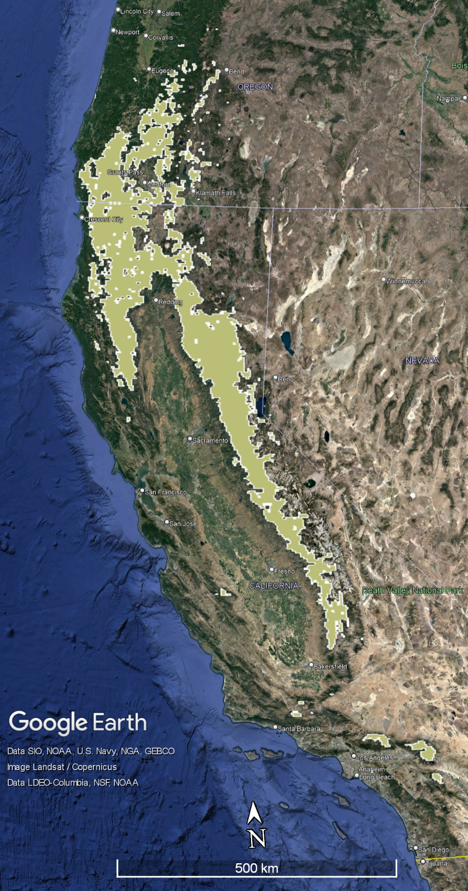
Figure 1. The range map for sugar pine in the United States. Polygons were informed by basal area projections in Wilson et al. (2013) and the presence of FIA plots with sugar pine present. It would be great to also include the four large ecoregion boundaries maybe as the same colors you use in figure 2 on this map. Also, is the top of the range cut off on purpose?
Also – original text box was not stretched enough to show all of the caption text.

Data collected for each individual stem include the species, live/dead status, DBH, and a “damage agent” code indicating whether some agent (e.g., white pine blister rust) is visibly affecting the individual’s health. All trees with stems ≥ 2.54 cm DBH are physically tagged to facilitate relocation of specific individuals at remeasurement. We used the demographic information from the tagged trees inventory for two different analyses. First, we calculated the observed mortality and recruitment of all trees ≥ 12.7 cm DBH. We estimated the population growth rate as the difference between recruitment and mortality. See below for analytical details. We also used these data to estimate the parameters of an integral projection population model. Specifically, the survival or death of 3,530 sugar pine individuals was tracked to estimate the parameters of the survival function, and growth of the 2,821 surviving individuals was used to estimate the parameters of the growth function. The number of new recruits (stems with DBH between 2.54 cm and 12.7 cm which were not present on the microplot at initial census but appeared in the second census) was calculated on 967 plots with sugar pine present at initial census to estimate the fecundity, the number of new recruits per existing individual. We included harvested trees as mortalities in the survival data for two reasons. First, our goal is to understand the actual population dynamics of sugar pine across its range, inclusive of mortality caused by harvests. Second, the prevalence of postfire salvage harvests on some land ownerships across the range of sugar pine make it likely that some mortalities caused by fire, competition, drought, or disease were later harvested, and we wanted to include these mortalities in vital rates estimation. In addition to the tree-level data collected, the FIA program also records information about forest conditions, including the presence of significant disturbances (e.g., fire), the ecological subsection the plot is located within, and the nominal GPS coordinates of the plot center. FIA forest condition data were used to construct the plot-level explanatory variables FIRE and WPBR (see below for analytical details).
The USGS Demography Plots (USGS) are a collection of large (~1ha) demography plots which were established at various times (1982-2017) for various purposes, which have been enrolled into a common monitoring program. The plots were not placed randomly, but instead were selected to be accessible and representative of a given forest type at Yosemite and Sequoia-Kings Canyon National Parks. The common features of the dataset are that tree stems > 1 cm DBH are individually mapped, with DBH recorded for every stem approximately once every five years, and annual updates to check for new deaths or ingrowth. Information about the health status of each tree (e.g., evidence of beetle damage, fungal infestation) was recorded annually at least since 2001. For this paper, we analyzed the USGS demography data as a series of 10-year censuses on each plot. Censuses which included a fire (prescribed or wild) on the plot were excluded, as were censuses without any sugar pine presence. For vital rates estimation, only trees greater than 2.54 cm DBH were included, and trees growing into this size class are considered new recruits. The data used for the USGS survival model includes 2,456 individuals, of which 1,752 survived and are also included in the USGS growth model, and the number of new recruits across 41 censuses was tracked for the USGS fecundity model.
The Baker inventory plot (Baker) is in the Plumas National Forest, California at an elevation of 1,158-,1219m. The inventoried stand is an old-growth mixed conifer forest which has no record of fire activity since at least 1954 and with minimal fire activity in the surrounding area since 1900. The plot is 4.7 ha in area, within which all trees >9.5cm DBH were tagged and inventoried in 1996, 2001, 2008, and 2013. More details about the Baker plot can be found in Levine et al. (2016).
The Blodgett Fire-Fire-Surrogate (FFS) plots are located near Georgetown, California between 1,100 and 1,410m elevation. The stands included for this study are the Control (no treatment) stands from the Fire-Fire-Surrogate study which began at Blodgett Forest in 2001. A grid of 0.04ha inventory plots was installed in each of three stands, none of which received management in the study period. Live trees > 11.4cm DBH were inventoried on all plots in 2001, 2003, 2009, and 2016. Further details about data collection and the study site can be found in Foster et al. (2020).
To assess the level of drought sugar pine individuals were exposed to, we extracted monthly climatic water deficit (CWD) estimates for each nominal plot location from the TerraClimate dataset (Abatzoglou et al. 2018). CWD is a measure of evaporative demand not met by available water (Stephenson, 1998). The TerraClimate dataset provides modeled estimates of CWD at approximately 4km resolution for the years 1958-2020. The 4 km resolution approximately matches the degree of fuzzing associated with the nominal FIA plot locations, so that fuzzing is unlikely to add substantial error in the estimation of CWD experienced at the true plot location. Mean growing season (May-October) CWD estimates for each year between a plot’s initial measurement and its revisit provide a proxy for the drought stress experienced by individuals between the two censuses. The annual mean growing season CWD estimates were summarized in two ways: First, the 20-year mean of the annual CWD estimates provides a measure of the usual climatic dryness characteristic of each site, enabling the comparison of typically-wetter vs. typically-drier locations across space. Second, the 90th percentile of the annual departures from the site-specific mean CWD provide a measure of the most severe drought (departure from usual climatic conditions) experienced by each plot location between the initial observation and the remeasurement.

Analysis
We used the FIA revisit data (observations since 2010) for trees ≥ 2.54 cm DBH to explore patterns in population abundance and structure. Specifically, we grouped trees according to species, binned DBH class, and plot to assess the proportion of each species’ total population (on a plot) occupied by each size class. We included all the FIA plots in our range map for sugar pine (Figure 1).
To assess the current trajectory of sugar pine abundance across its range, we calculated the per-plot basal area and stem densities for individuals greater than 2.54 cm DBH on every plot where sugar pine was present at initial measurement or remeasurement (1,221 plots). Across-plot means and standard errors were calculated and plotted for both basal area and stem density. For each of the five mixed conifer species: white fir (Abies concolor), incense-cedar (Calocedrus decurrens), sugar pine, ponderosa pine (Pinus ponderosa), and Douglas-fir (Pseudotsuga menziesii), we averaged these plot-level relative DBH distributions to assess the characteristic DBH distribution of each major species.
We similarly aggregated the USGS data by plot and species to quantify changes in basal area and stem density by species on each plot at each full inventory year (i.e., those years where DBH of all live stems were recorded). In some cases a DBH inventory was conducted over two years. In these cases we analyzed the data as if all the DBH data were collected in the first year. For each DBH inventory, we calculated the basal area per hectare and stems per hectare represented by each tree and grouped trees by plot and observation year. Summaries of stand structure by species, year, and size class provide context for the demographic rate estimates.
Per capita, instantaneous mortality, recruitment, and population growth rates (%/yr) were estimated using the Bayesian analysis described by Kohyama et al. (2018). To enable comparison among populations sampled with different minimum tree size cut-offs, we only included “adult” trees, generally trees with a DBH ≥ 10 cm. For the USGS data, the models included a random effect of plot to account for heterogeneity among study sites. Models did not include species-by-plot nested random effects because A) models showed poor convergence for such small subpopulations and B) with 5-year census intervals the bias from within-site heterogeneity is minimal, even when lumping the 5-year censuses into decade-spanning analyses (Kohyama et al. 2018). Vital rates were calculated by decade for sugar pine and for all species combined. Traceplots were checked for convergence and weighted mean estimates of the population growth rate, instantaneous recruitment rate, and instantaneous mortality rate were calculated for each MCMC sample using the code provided by Kohyama et al (2018). The parameter estimate distributions for the growth rate, recruitment rate, and mortality rate were plotted for interpretation. The same approach was used to estimate vital rates for the FIA data (random effect of ecoregion subsection, a single time span using initial censuses from 2001-2010 and follow-up censuses from 2011-2019), the Baker plot (for time spans 1995-2001, 2001-2008, and 2008-2013) and the FFS plots (for time spans 2001-2003, 2003-2009, and 2009-2016).
To attribute the drivers of sugar pine population dynamics across its range, we developed integral projection models (IPM) using the FIA data (Foster et al. 2024). The relevant results of this NPS sponsored research are included in this report. A brief overview of the methods is provided here. Please see Foster et al. (2024) for the details.
While demographic modeling provides valuable insights regarding the range-wide vulnerability of trees (Ohse et al. 2023), the FIA data (e.g., Shriver et al. 2021) and the demographic modeling (e.g., Doak et al. 2021) present challenges. To navigate these challenges, we followed the workflow for building an integral projection model (IPM) outlined in Doak et al. (2021). We used data for individuals greater than 2.54 cm DBH on every plot where sugar pine was present at initial measurement or remeasurement (1,221 plots). We then fit statistical models to the vital rate data extracted from FIA. Given the well-established influence of tree size on vital rates (Needham et al. 2018), we modeled survival, growth, and recruitment as continuous functions of tree size. We generated covariates based on the presence or severity of known stressors and included them as continuous state variables in our survival and growth functions. Next, we built a structured population model from these vital rates. We combined the vital rate functions into projection kernels to forecast decadal trends in sugar pine abundance. We integrated each projection kernel across 99 size classes and analyzed the results to estimate the asymptotic population growth for sugar pine under various scenarios. Throughout, we relied on advice distilled from recent comments in the literature to guide how we built and tested our structured population model (Ellner et al. 2022, Doak et al. 2022).
For the vital rate models, we included covariates representing the major stressors facing sugar pine. We defined major stressors as those likely to impact sugar pine persistence. Thus, we included four major stressors as covariates in our vital rate models: fire, white pine blister rust (WPBR), competition, and water stress. We modeled these major stressors as fixed effects covariates. Specifically, the fixed effects are: The intercept ($INTERCEPT$), the DBH in meters at initial measurement ($DBH$), the squared DBH (${DBH}^{2}$), a binary flag indicating whether the individual’s plot experienced a fire at least 0.404 ha in size that killed or damaged at least 25% of trees between initial measurement and remeasurement ($FIRE$), a binary flag indicating whether any trees in the individual’s plot displayed signs of white pine blister rust infection at initial measurement ($WPBR$), the plot-level live basal area (BA) at initial measurement ($BA$; a proxy for competition, Eitzel et al. 2013), the plot-level 90th percentile of growing season departure from mean climatic water deficit ($DROUGHT$) between initial measurement and remeasurement, the plot-level growing season mean climatic water deficit over the period 2000-2020 ($DRYNESS$), and interactions between $DBH$ and ${DBH}^{2}$ and all other variables ($DBH×FIRE$, ${DBH}^{2}×FIRE$, $DBH×WPBR$, ${DBH}^{2}×WPBR$, $DBH×BA$, ${DBH}^{2}×BA$, $DBH×DROUGHT$, ${DBH}^{2}×DROUGHT$, $DBH×DRYNESS$, and ${DBH}^{2}×DRYNESS$). We included size (and quadratic size) and added the interactions between size (and quadratic size) and the stressors given that the impacts of these stressors are size-contingent (Hood et al. 2007, Stephenson et al. 2019, Dudney et al. 2020). $BA$, $DROUGHT$, and $DRYNESS$ were centered and scaled to have 0 mean and unit variance across all plots. We used size on the meter scale so that size was on a similar scale as the other explanatory variables, which improved the model’s performance during parameter estimation.
We also built IPM’s for the USGS data. Our goal was to gain detailed insights of the trajectory of sugar pine in Sequoia Kings-Canyon and Yosemite national parks. We used the same modeling framework applied to the FIA data. However, we lacked detailed information on the major stressors. Thus the IPM models for the USGS data were dependent only on tree size. To compare trajectories, we constructed separate model projections for each plot.

Results

Range-wide (FIA database)
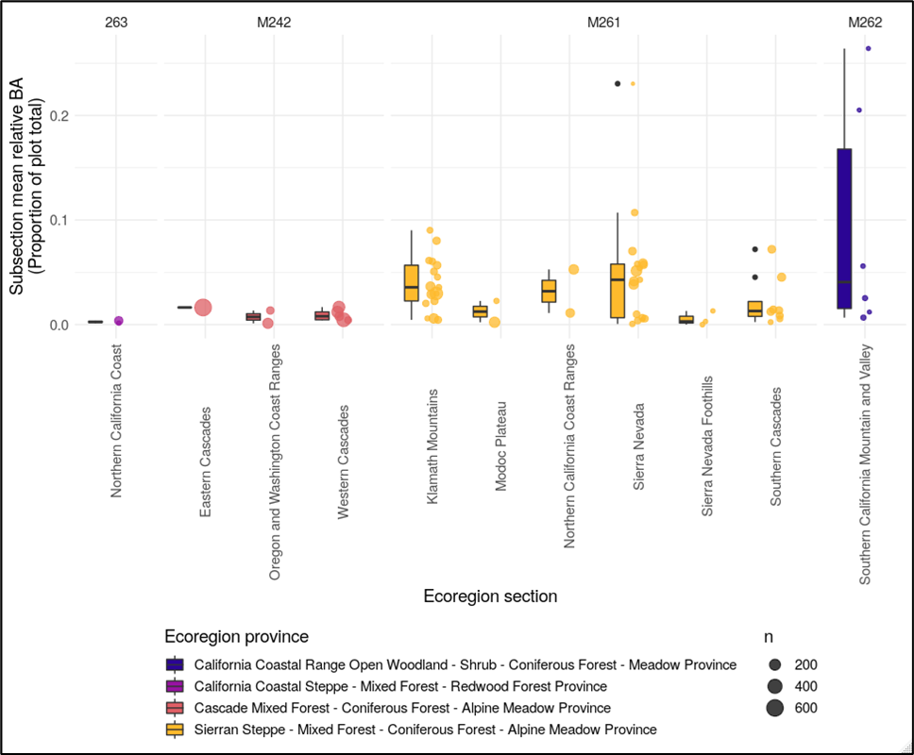
Across its range, sugar pine tends to be a common but not dominant constituent of conifer forests. For example for the four ecological sections that account for 87% of its range (Figure 2), the relative dominance ranged from 1% of live tree basal area (Cascades) to 2.2% of live tree basal area (Sierra Nevada, Table 1). During the last decade, sugar pine basal area and density declined (Figure 3) with the reduction in mean density (Fig 3b; 9.4%) double the reduction in mean basal area (Fig 3a; 4.7%). However, these mean decadal declines were less than the variation in the means. For basal area, the coefficient of variation (standard error/mean) was ± 7%; for density, it was ± 21%. The size structure of the sugar pine population followed a bimodal size distribution (Figure 4). There were relatively few small individuals (DBH ≤ 63.5 cm) but proportionately more large individuals (DBH > 63.5 cm). All the other tree species that commonly occur with sugar pine showed the more typical “reverse-J” shaped size distributions with smaller trees far more abundant than larger trees (Figure 4).
Figure 2. Relative dominance of sugar pine in FIA plots by ecoregion subsection. Relative dominance measured as the proportion of live tree basal area contributed by sugar pine. Results from the 2011-2019 inventory. Only trees with DBH ≥ 12.7 cm included.

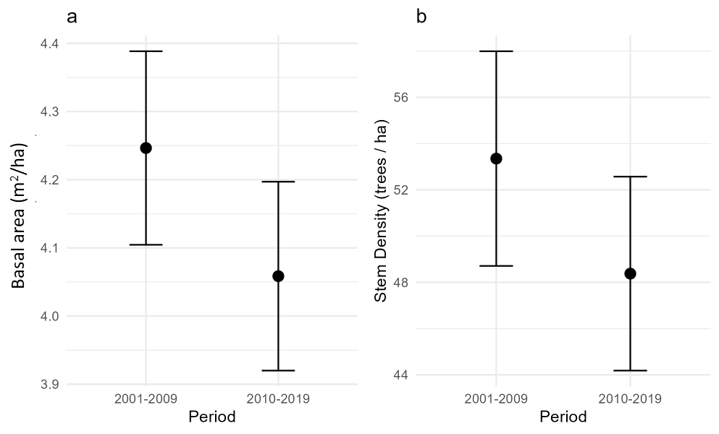
Figure 3. Changes in plot-level basal area and stems per hectare for 1,221 FIA plots where sugar pine was present at initial measurement (2001-2009) or remeasurement (2010-2019). Points are means and error bars are ± one standard error across plots. Totals include only stems ≥ 2.54 cm DBH. Panel a: changes in basal area. Panel b: changes in density.
Table 1. Forest composition and structure for ecoregion sections in the range of sugar pine. Results from the 2011-2019 FIA inventory. Only trees with DBH ≥ 12.7 cm included. Dominance was defined as relative basal area.
Section | Extent | Density | Basal area | Sugar pine | Dominant Species
Section | (% of area) | (trees/ha) | (m²/ha) | (% dominance) | Dominant Species
Klamath | 35 | 469 | 33.6 | 1.3 | Douglas-fir (48%), white fir (8%)
Sierra Nevada | 31 | 396 | 35.1 | 2.2 | white fir (26%), incense-cedar (15%), ponderosa pine (11%),
Southern and Western Cascades | 21 | 430 | 36.8 | 1 | Douglas-fir (37%), white fir (18%)

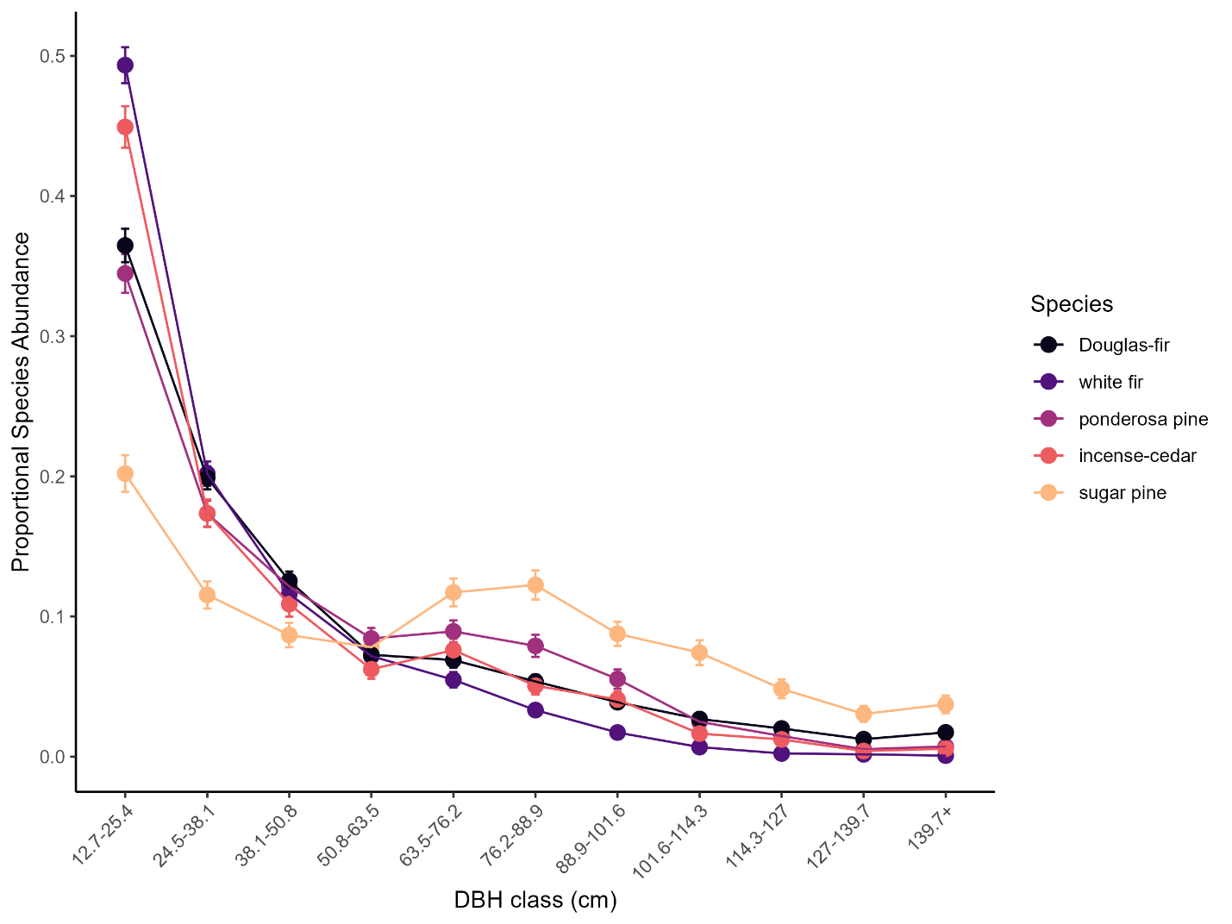
Figure 4. Size distributions of most common conifer species that co-occur in the sugar pine range. Proportional species abundances measured as the relative density of each species in the plot. Size expressed as DBH classes. Results based on the FIA plots inventoried between 2011-2019. Only trees with DBH ≥ 12.7 cm included.

Table 2. Summary of the empirically derived vital rates (% yr⁻¹) for sugar pine and all trees for the populations sampled in this study. Rates were calculated for trees above a minimum diameter at breast height (1.37m, DBH). The minimum DBH’s for each population were: FIA ≥ 12.7 cm; USGS ≥ 10cm; Baker ≥ 9.5 cm; FFS ≥ 11.4 cm. Median values in bold represent population growth rates were the 95% credibility interval does not intersect 0 or positive values.
Population | Time interval | Sugar pine |  |  |  |  |  | All trees
Population | Time interval | Mortality |  | Recruitment |  | Growth |  | Mortality |  | Recruitment |  | Growth
Population | Time interval | median | 95%CI | median | 95%CI | median | 95%CI | median | 95%CI | median | 95%CI | median | 95%CI
FIA | [2001-2010] to [2011-2019] | 1.84 | 0.23 | 1.36 | 0.22 | -0.27 | 0.29 | 1.15 | 0.02 | 1.70 | 0.03 | 0.55 | 0.03
USGS | 1985-1995 | 2.19 | 0.39 | 0.72 | 0.23 | -1.46 | 0.45 | 1.17 | 0.09 | 0.88 | 0.08 | -0.30 | 0.12
USGS | 1995-2005 | 4.79 | 0.65 | 0.81 | 0.28 | -3.97 | 0.68 | 1.16 | 0.09 | 0.83 | 0.07 | -0.33 | 0.11
USGS | 2005-2015 | 3.75 | 0.63 | 0.97 | 0.32 | -2.78 | 0.68 | 1.74 | 0.11 | 0.92 | 0.08 | -0.82 | 0.13
Baker | 1996-2001 | 0.00 | 0.00 | 0.00 | 0.00 | 0.00 | 0.00 | 0.10 | 0.04 | 1.18 | 0.13 | 1.08 | 0.13
Baker | 2001-2008 | 2.53 | 1.29 | 0.18 | 0.37 | -2.30 | 1.35 | 1.19 | 0.11 | 1.14 | 0.11 | -0.05 | 0.15
Baker | 2008-2013 | 0.97 | 1.04 | 0.00 | 0.00 | -0.97 | 1.04 | 0.45 | 0.08 | 0.07 | 0.03 | -0.38 | 0.09
FFS | 2001-2003 | 0.00 | 0.00 | 1.37 | 2.87 | 1.36 | 2.86 | 1.36 | 0.37 | 0.27 | 0.18 | -1.09 | 0.42
FFS | 2003-2009 | 1.85 | 1.85 | 0.00 | 0.00 | -1.84 | 1.85 | 1.03 | 0.20 | 0.04 | 0.04 | -0.99 | 0.20
FFS | 2009-2016 | 0.46 | 0.93 | 0.00 | 0.00 | -0.45 | 0.94 | 1.76 | 0.25 | 1.22 | 0.21 | -0.54 | 0.31

During the last decade, adult sugar pine mortality exceeded recruitment across its range (Table 2). The median sugar pine mortality (1.8 ± 0.2%/yr) was 60% higher than the median mortality of all species in its range (1.2 ± 0.2 %/yr). On the other hand, sugar pine recruitment (1.4 ± 0.2%/yr) lagged adult recruitment of all species (1.7 ± 0.03%/yr; Table 2). The net effect on population growth during the decade was that sugar pine declined by 0.27 %/yr while all species increased by 0.55%/ yr.
While there was a range-wide decrease in adult sugar pine population density, population growth varied by ecoregion subsection (Figure 5). For much of its range, the status of adult populations was uncertain, meaning there was no evidence of either decreases or increases. However, sugar pine populations were declining along the western slope of the southern Sierra Nevada while in more northern regions of the Sierra Nevada, adult populations increased during the decade (Figure 5).

USGS
The 19 USGS Demography Study Plots (USGS) located in the sugar pine range of Sequoia-Kings Canyon and Yosemite national parks include multiple forest types representing a range of compositions and structures (Table 3). The relative dominance of sugar pine in these plots spans a gradient from uncommon (<1% dominance) to dominant (36% dominance). For the subset of 11 plots where there was a live sugar pine present at every census, plot-level, live-tree basal area significantly declined during the last 30+ years at the rate of 0.12 m²/ha/year (Figure 6). The cumulative decrease during the measurement interval was approximately 4 m²/ha. Despite this overall trend, there were three plots that increased in live-tree basal area since establishment. In contrast, the relative dominance of sugar pine declined in every plot except one (Figure 7). Moreover, the relative decline of sugar pine was steeper than the overall decline in live tree basal area.
The size structure of sugar pine in these USGS plots matched the overall pattern for the dominant conifers in these plots: “reverse J” with a “bump” in the largest DBH-class (Figure 8). In other words, for trees with a DBH < 60, the smaller trees were more abundant than the bigger trees. But in these old-growth forests, there was also a sizeable fraction of large trees (DBH > 60 cm) for all constituent species. Sugar pine was one of the least abundant species in these plots (Figure 8). Moreover its abundance has been decreasing for the last 40 years and is consistent across all tree size classes > 20cm DBH (Figure 9).
In the USGS plots, the tree population declined every decade with the most severe decline (median population growth rate = -0.82 %/yr) occurring between 2005-2015 (Table 2). During the same interval, the median growth rate of the sugar pine population declined 3x to 12x faster than the all-tree population. Moreover, the 95% credible intervals for these rates do not include positive values and are statistically significant. The driver of the population decrease for sugar pine was increased mortality. For example, between 1995-2005 the median annual mortality rate was near 5%/yr (Table 2), which is substantially higher than historic background rates of mortality in these forests (van Mantgem and Stephenson 2007) .

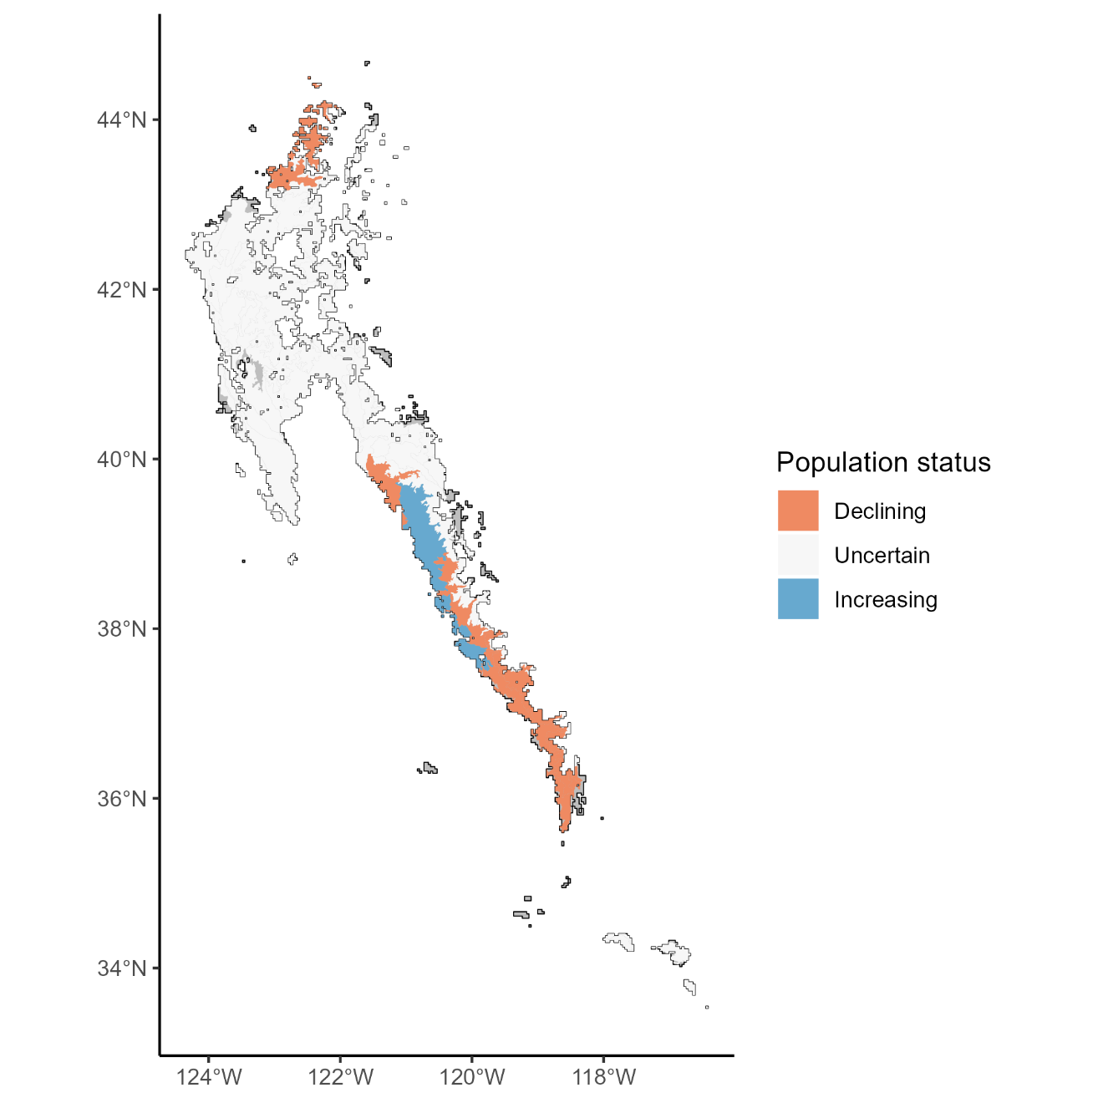
Figure 5. Population growth rate (recruitment-mortality) for adult sugar pine across its range. The status is reported by ecoregion subsection for the last decade. Declining subsections areas defined by growth rates during the last decade significantly < 1 and increasing subsections with growth rates significantly > 1. Uncertain subsections had growth rates around 1. Results from the 1,221 FIA plots where sugar pine was present at initial measurement (2001-2009) or remeasurement (2010-2019).
Table 3. Forest composition and structure for research sites with longitudinal data in the range of sugar pine. Only trees ≥ a minimum diameter at breast height (1.37 m, DBH) were included. The minimum DBH’s for each population were: USGS ≥ 10cm; Baker ≥ 9.5 cm; FFS ≥ 11.4 cm. Dominance was defined as relative basal area.
Site | Density | Basal area | Sugar Pine | Forest Type | Last Measured
Site | (trees/ha) | (m²/ha) | (% dominance) | Forest Type | Last Measured
USGS Demography Study | 78-591 | 14.6 - 148.6 | <1 to 36 | multiple | 2015-2019
Baker Old-Growth Reserve Site | 789 | 86.1 | 15 | mixed conifer | 2013
Blodgett Fire and Fire Surrogate Study | 505 | 67.9 | 6 | mixed conifer | 2020

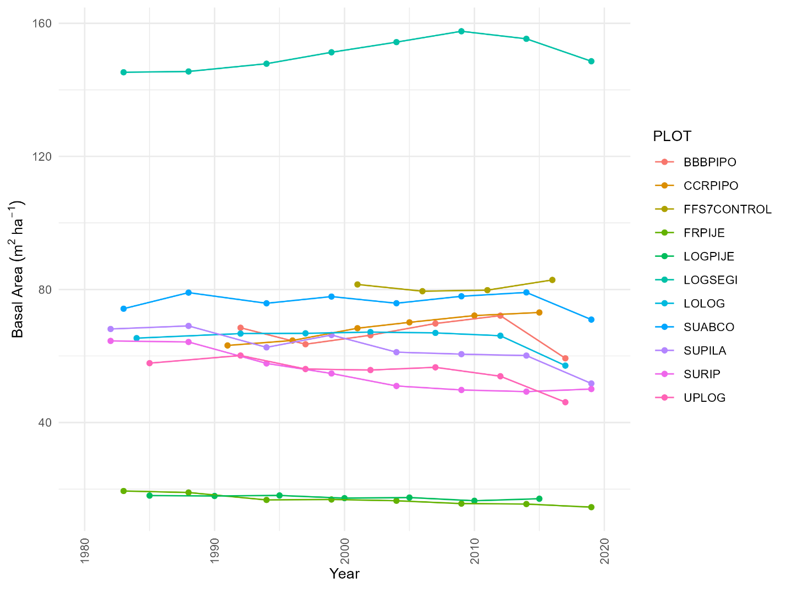
Figure 6. Basal area trends for live trees in the USGS plots. Stupid SEGIs. Aways throwing everything out of wack. I don’t think this figure is needed.

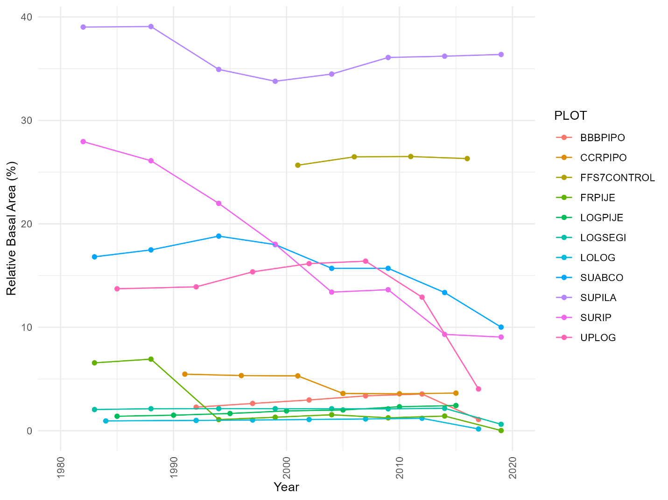
Figure 7. Trends in the relative dominance (as measured by relative basal area) for sugar pine in the USGS plots.

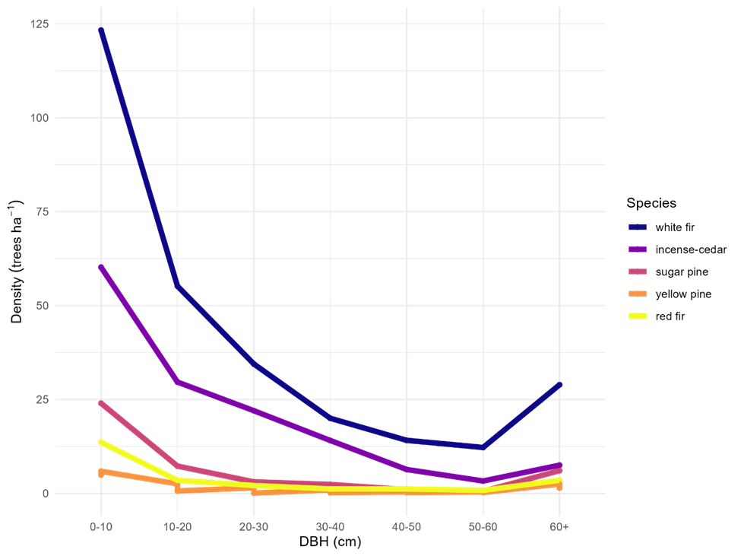
Figure 8. The size distribution of the common tree species in the USGS plots. Tree size expressed as DBH-classes. Results from the most recent census for each plot. I don’t think this figure is needed since it is showing the same thing as figure 4, just with a different dataset. If you want to keep it, I’d suggest having similar formatting to figure 4.

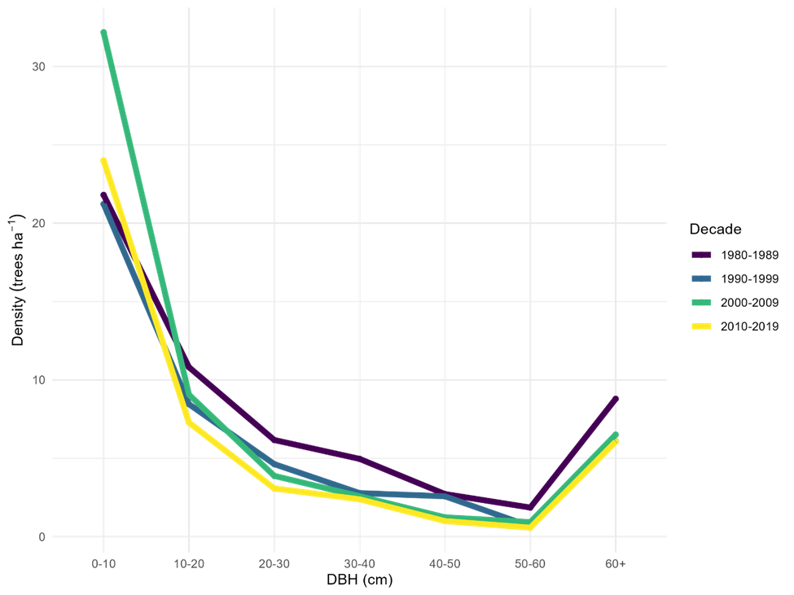
Figure 9. Trends in the size distribution of sugar pine in the USGS plots. Tree size expressed as DBH-classes. I think this figure would be much easier to interpret if it were presented as bar graphs by size class. Or maybe as a lattice chart with density by decade for each size class?

Baker and FFS
Both the Baker Old-Growth Reserve (Baker) and the Blodgett Fire and Fire Surrogate Study (FFS) represent sites located in the Sierran mixed conifer forest (Table 3). Sugar pine was a more important constituent at Baker (15% relative dominance) compared to FFS (6% relative dominance). During the last 30 years, both sites had an overall decline in tree populations. But in contrast to the decline in sugar populations observed region-wide and in the USGS plots, sugar pine populations faired better than the all-tree population at Baker and FFS (Table 2). Only one decade in the last 30 years was the median growth rate for sugar pine < 0 (Baker 2001-2008: -2.3%/yr).

IPM

Model diagnostics
For the vital rate models fit on the FIA data, diagnostics for mixing, convergence, R-hat, and transitions all indicated that the model fitting algorithm performed well. Comparisons of posterior distributions with prior distributions showed that the posterior was strongly informed by the data, rather than the prior, for most parameters. For the models fit on the USGS demography plot data, diagnostics for mixing, convergence, R-hat and transitions all indicated satisfactory algorithm performance. Comparisons of the prior and posterior distribution showed that most parameters were strongly informed by the data, rather than the prior.

Survival
In the model fit on the FIA data, there was a strong positive effect of size on survival. Median posterior predicted 10-year survival rates increased from approximately 84% for stems with 0.0254 m DBH up to a maximum of 96.5% for stems with 0.88 m DBH, before falling off for the largest stems (Figure 10), though with relatively large uncertainty because there were few extremely large individuals. There was a strong negative main effect of fire, a positive interaction between fire and size, and a negative interaction between fire and squared size, indicating that fire substantially reduced survival, particularly for the smallest and largest trees (Figure 10). There were moderate negative effects of WPBR and basal area on survival. Other effects were weak or uncertain (their 90% credible intervals overlapped 0). In the model fit on the USGS data, there was likewise a strong positive effect of size on survival with a negative quadratic effect.

Individual Size (growth)
In the model fit on the FIA data, the posterior median for the intercept of the model for size at the second census was 0.018, with a 90% credible interval from 0.014 to 0.022. The effect of initial size was, as expected, very close to 1, and the quadratic effect of initial size was negative. Together, these results indicate that the smallest and largest trees grew approximately 2.5 cm DBH in the 10 years between initial and follow-up census, with midsize trees (initial DBH ~70 cm) growing faster, at around 4.4 cm in 10 years (Figure 11). White pine blister rust actually increased the growth of the smallest stems, perhaps due to cankers increasing stem diameter. By contrast, basal area reduced the growth of small stems but not large ones. Site dryness also had a negative main effect and a positive interaction with initial size, plus a negative interaction with quadratic size: For the smallest and largest stems growth was lower on dry sites, whereas for stems between approximately 40 cm and 110 cm DBH growth was higher on dry sites. Other effects were weak or uncertain. In the model fit on the USGS demography plot data, the effect of size was also close to 1 and the effect of squared size negative.

Fecundity
The posterior median value for the intercept of the fecundity model fit from FIA data was -2.92, with a 90% CI from -3.29 to -2.56. These results indicate that the average number of new recruits produced per existing tree per 10 years was 0.05 (0.04-0.08). In the fecundity model fit from the USGS demography plots, the posterior median value for the intercept was -4.11, with a 90% CI from -5.88 to -2.7. These results indicate that the average number of new recruits produced per existing tree per 10 years was 0.02 (0.00 to 0.06).

Asymptotic Population Growth Rates
Figure 12 shows the posterior distribution of the asymptotic population growth rate ($λ$) predicted from IPMs built from the FIA data for a variety of hypothetical scenarios. In each scenario, each posterior sample of the parameters is used to calculate a transition matrix for a population of sugar pines on an idealized plot where the fixed effect covariates (other than size) for the vital rate models are held to specific values representing each scenario. For each of the nine scenarios, one transition matrix is constructed using the parameter values from each of the 4,000 posterior draws. The dominant eigenvalue of each matrix gives the estimate of $λ$ for that scenario and draw.
In the undisturbed scenario, categorical stressors (fire and WPBR) were absent, while continuous stressors (BA, drought, and site dryness) were held at zero (their scaled means). Under these circumstances, the asymptotic growth rate is near or slightly below one, with a median posterior value of $λ$ of 0.980 and a 90% credible interval from 0.953 to 1.005 (Figure 12). Where fire is present, $λ$ is strongly reduced (median 0.643, CI 0.521 to 0.788). Where WPBR is present, the posterior distribution for $λ$ is below 1 (median 0.948, CI 0.857 to 0.994). When basal area is lower than average, there posterior distribution of $λ$ is near or slightly above one (median 1.002, CI 0.974 to 1.029). By contrast, when basal area is higher than average the posterior distribution of $λ$ is below one (median 0.946, CI 0.912 to 0.977) and is clearly lower than the undisturbed scenario. For sites experiencing low amounts of drought, the median is 0.991 and the 90% CI of $λ$ straddles one, while for sites experiencing high drought the posterior distribution of $λ$ is below one (median 0.967, 90% CI from 0.933 to 0.998). Likewise, on particularly dry sites the posterior distribution of $λ$ is below one (median 0.953, 90% CI from 0.918 to 0.986). Fire had the clearest effect on $λ$, followed by WPBR and high basal area, and then drought and site dryness. However, the posterior median value of $λ$ was below one even in the undisturbed scenario, suggesting that even under “unstressed” conditions the population of sugar pine may be declining.
There were stark regional differences in the asymptotic population growth rate ($λ$) of sugar pine populations (Figure 13). The posterior median value of $λ$ was below one in every ecoregion, and below 0.90 in several ecoregions in the southern Sierra Nevada. The 90% credible interval for $λ$ excluded one (the model was highly confident in predicting decline) in 15 out of 65 ecoregions.
Figure 14 shows the posterior distribution of the asymptotic population growth rate for each plot included in the USGS demography plot network. The 90% credible interval lies entirely below 1 for 12 of the 19 plots and does not lie entirely above 1 for any of them. These results indicate that the sugar pine population is in decline on most sites within the network, while potentially holding steady on a minority of them.

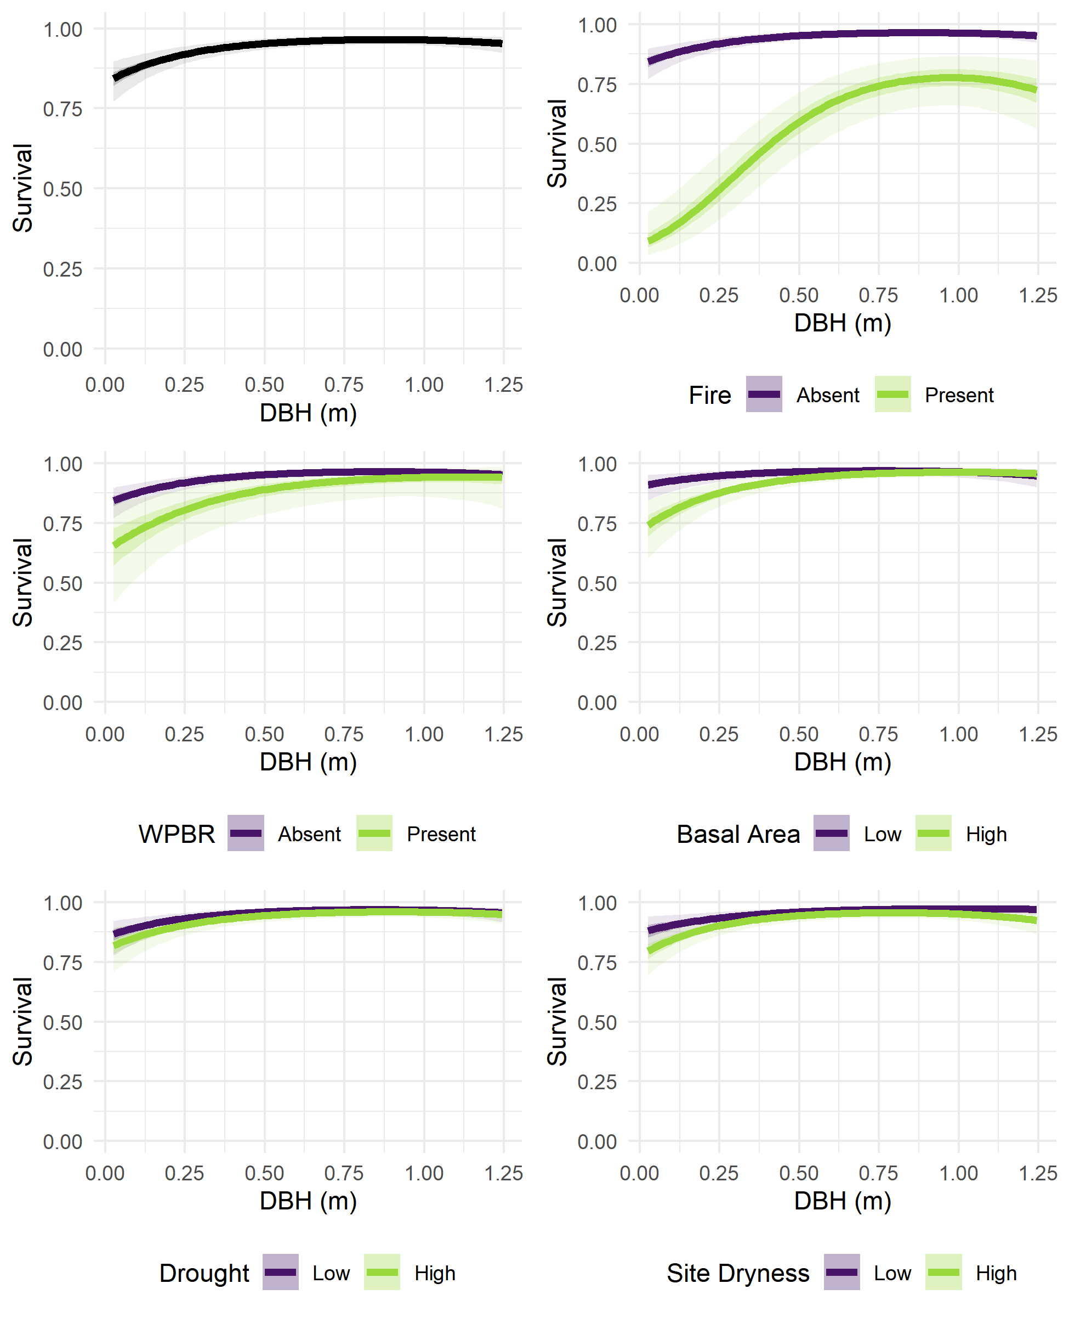
Figure 10. Fixed effects of initial DBH, fire, WPBR, neighborhood basal area, drought, and site dryness on 10-year survival probability, estimated from the FIA data. In the top left panel, probability of survival (Y-axis) is predicted for stems of various initial size (X-axis), holding other variables at “Absent” (for fire and WPBR) or 0 (scaled mean, for basal area, drought, and site dryness). In the other panels, probability of survival is predicted for stems of various sizes and across two levels of each other explanatory variable: with or without disturbance, or at high (1.0) or low (-1.0) values for scaled continuous variables. Please vary the min value of the Y axis to make the figures easier to see.
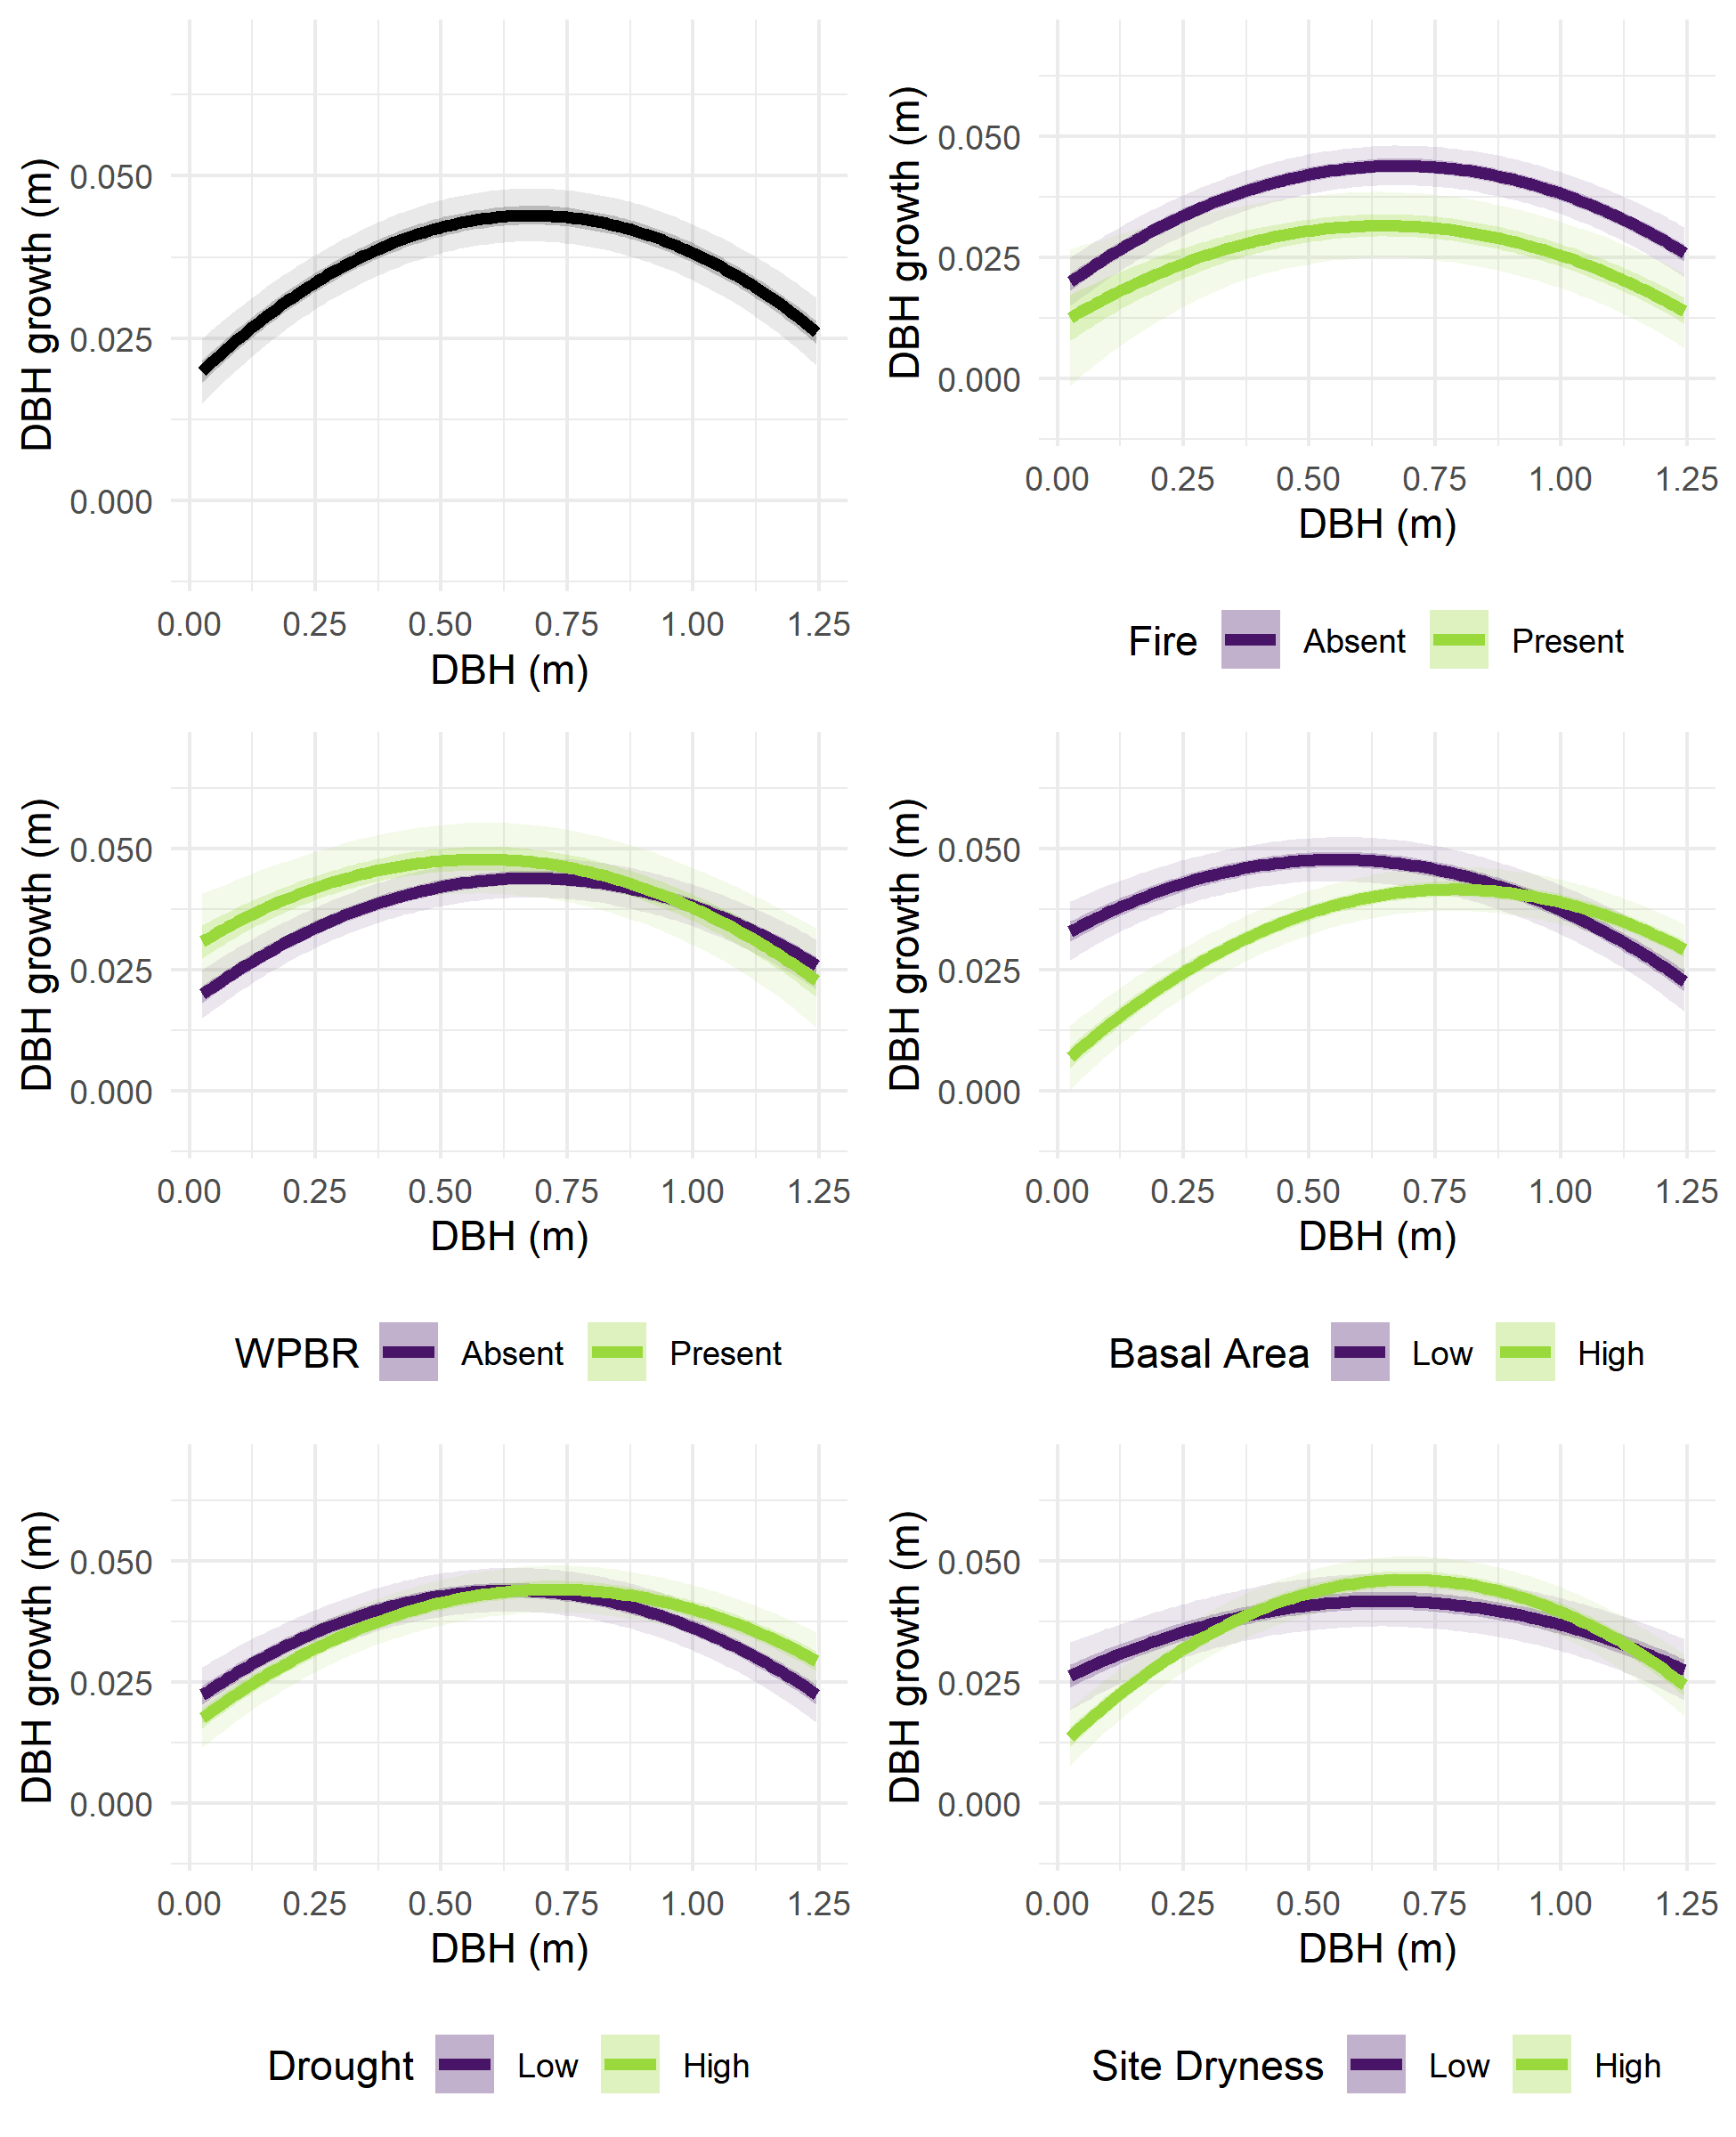
Figure 11. Fixed effects of initial DBH, fire, WPBR, neighborhood basal area, drought, and site dryness on 10-year diameter growth, estimated from the FIA data. In the top left panel, DBH growth over the 10 years between censuses (Y-axis) is predicted for stems of various initial size (X-axis), holding other variables at “Absent” (for fire and WPBR) or 0 (scaled mean, for basal area, drought, and site dryness). In the other panels, growth is predicted for stems of various sizes and across two levels of each other explanatory variable: with or without disturbance, or at high (1.0) or low (-1.0) values for scaled continuous variables. Predictions were generated using the posterior samples for model parameters, resulting in a range of predicted survival for each set of explanatory variable values. Lines show the median predicted survival, darker ribbons show a 50% credible interval, and lighter ribbons show a 95% credible interval. Random effects were held at 0.
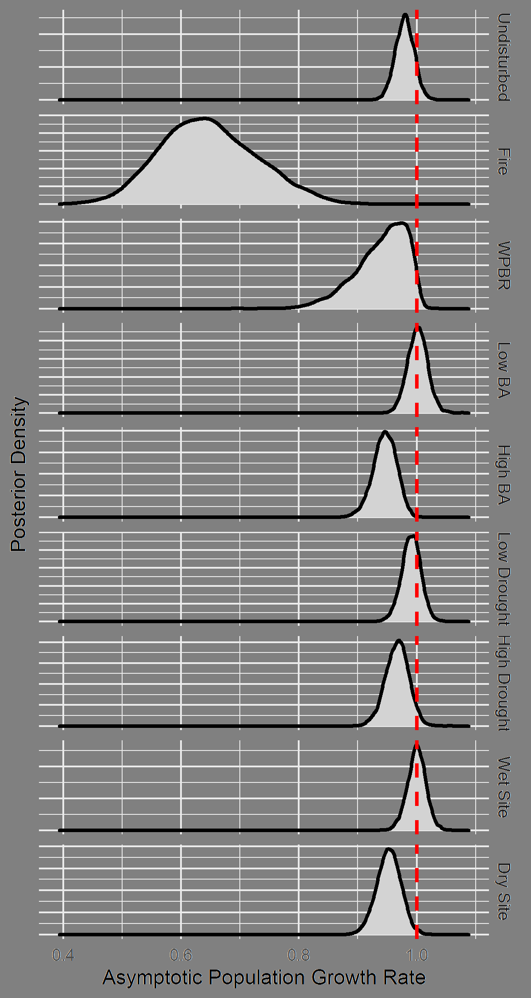
Figure 12 Posterior distribution of asymptotic population growth rate, using vital rates as estimated from the FIA data. In the “Undisturbed” scenario, all fixed effect covariates other than the intercept are held at 0 (representing the absence of fire and WPBR, and basal area, drought, and site dryness at average levels). In each other scenario, a single stressor is set to TRUE (for fire and WPBR), -1 (low levels of basal area, drought, or site dryness), or +1 (high levels of basal area, drought, or site dryness). Random effect values are held at 0, representing an average plot in an average ecoregion.

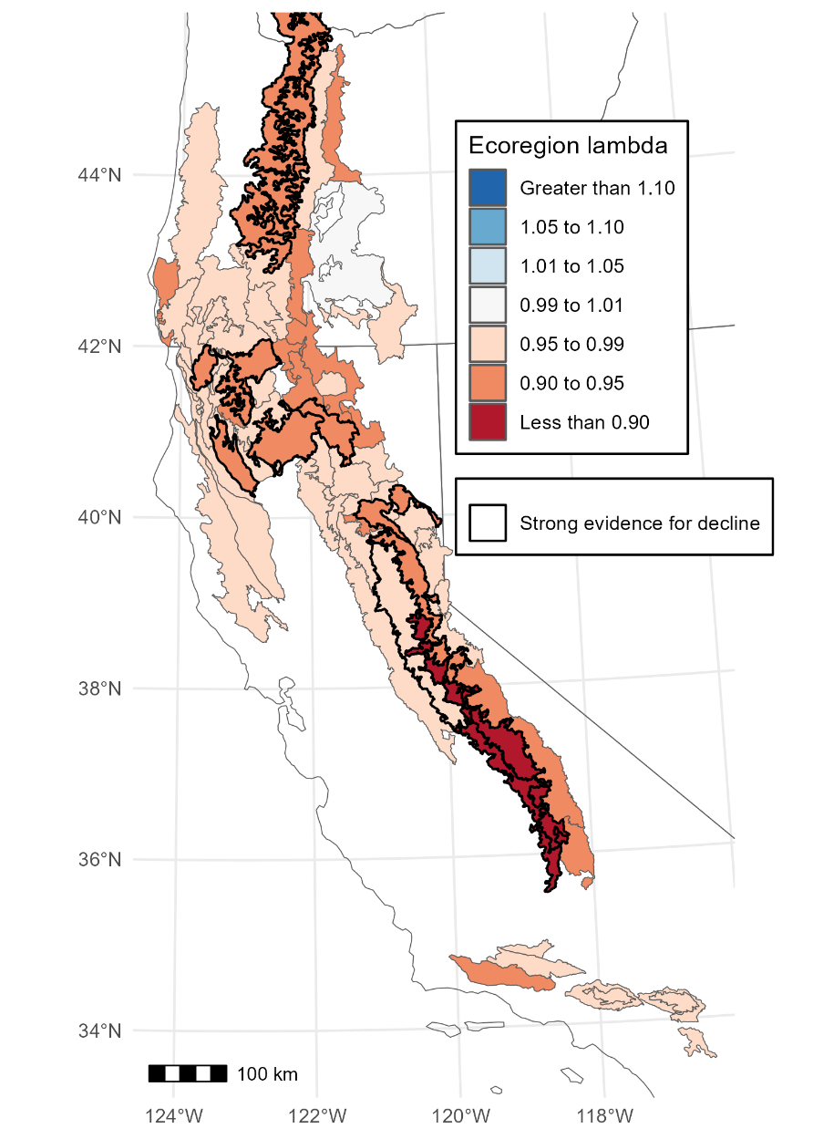
Figure 13. Asymptotic population growth rate by ecoregion. Ecoregions are filled according to the posterior median asymptotic population growth rate from the IPM for each ecoregion. The vital rate functions for each IPM were developed using the posterior parameter values for growth and mortality as a function of size plus random-intercept ecoregion and plot effects and fecundity as an intercept only model. For the purposes of predicting ecoregion-level asymptotic growth rates, local-scale plot effects were assumed to sum to 0. Thicker black borders indicate that the 95th percentile posterior asymptotic population growth rate is below one, i.e., that there is strong evidence for population decline in the indicated ecoregion. The posterior median asymptotic population growth rate in below one in all ecoregions, and the 90% credible interval for the asymptotic population growth rate excludes one in several of them, with particularly severe population declines predicted in the southern Sierra Nevada. All categories in the legend >1 don’t exist in the figure and are not needed.

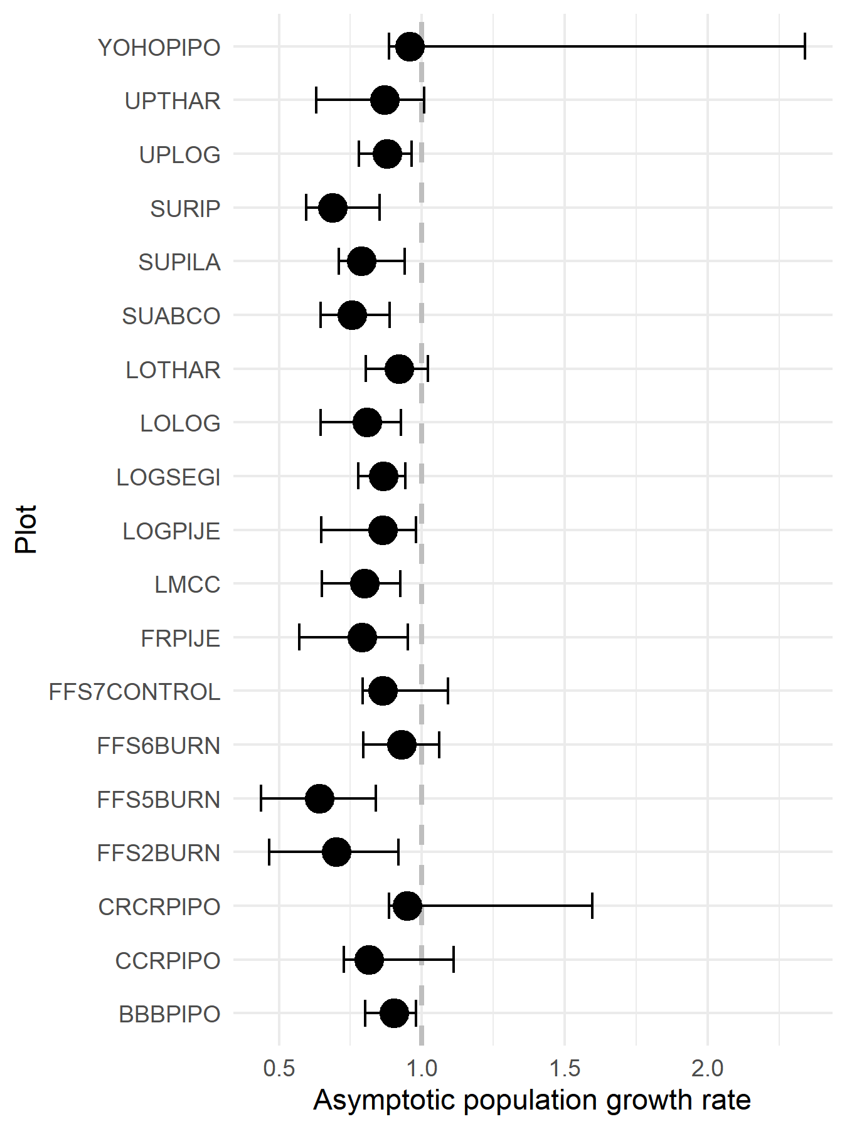
Figure 14. Posterior distribution of the asymptotic population growth rate on each of the USGS demography plots, using vital rates estimated from the USGS demography plot data. Points show the posterior median value, and error bars show a 90% credible interval. The credible interval lies entirely below 1 for 12 of 19 plots and does not lie entirely above 1 for any of them.

Discussion
This study is the first range-wide assessment of the demographic rates of sugar pine and the stressors impacting the population dynamics of sugar pine. During the last decade, we found the abundance of sugar pine has decreased both in terms of basal area and stem density across its range (Figure 3). This observed decrease in abundance was consistent with the asymptotic population growth rates which projected the abundance of sugar pine to decline even in the undisturbed scenario (Figure 12). Furthermore, the sugar pine population was clearly declining on 12 of the 19 USGS demography plots and its trajectory is unclear on the remaining seven (Figure 14). The analysis described here allows direct comparison of the influence of fire, WPBR, stand density, short-term drought, and long-term site dryness, providing valuable guidance for managers seeking to prioritize efforts to prevent further decline.
The results of this study highlight fire as a key stressor negatively impacting demographic rates of sugar pine. Fire strongly reduced the survival of individual trees, particularly small ones. This finding is broadly consistent with the existing literature, which has documented many cases of negative (and size-dependent) impacts of fire on survival of sugar pine (van Mantgem et al. 2004, Hood et al. 2010, Nesmith et al. 2015, Furniss et al. 2018, Dudney et al. 2020). Fire can also injure surviving trees, reducing their growth rate as seen in this study and others (Foster et al. 2020). Reduced growth rates may have particularly strong effects on the asymptotic population growth rate in species where large / old individuals disproportionately contribute to reproduction (Shriver et al. 2019). Sugar pine is one such species, though we were unable to estimate a relationship between size and fecundity in this study. The literature suggests that a core way in which fire influences the population dynamics of sugar pine is by killing large high-fecundity individuals (van Mantgem et al. 2004). The most extreme form of this dynamic results in so-called type conversion, where high severity fire locally extirpates sugar pine and other mixed conifer species, resulting in the loss of mixed conifer forest generally (Shive et al. 2018, North et al. 2019, Coop et al. 2020).
In this study, fire’s effects on survival, growth, and fecundity combine to result in posterior $λ$ values well below one for burned plots (Figure 12). However, we caution that the asymptotic population growth rates presented in this study should not be interpreted as predictions, because in reality fire is unlikely to repeatedly occur on the same site during every census interval. Instead, the asymptotic population growth rates give some insight into the overall influence of each stressor on population dynamics, which is supplemented by the single-step projections. Existing literature has shown that most trees killed by fire die within one year of the fire (Furniss et al. 2018) and mortality rates in stands affected by prescribed fire returned to background levels approximately six years postfire (van Mantgem et al. 2011), suggesting that the negative effects of fire on survival are transient. Furthermore, fire reduces stand basal area, which can improve recruitment and growth of surviving trees. However, there is abundant evidence that the ecological footprint of fire, in particular high severity wildfire, is increasing throughout the range of sugar pine because of climate changes and biomass accumulation resulting from fire suppression (Parks and Abatzoglou 2020, Alizadeh et al. 2021). Given this context and the results of this study, the disrupted fire regime is a core threat facing sugar pine.
Though their effects were less severe than those of fire, both WPBR and densification negatively impacted sugar pine’s population dynamics in this study. The data here show that WPBR negatively impacted survival (Figure 10). Numerous other studies have shown that blister rust tends to kill smaller trees (van Mantgem et al. 2004) and negatively affects survival rates of sugar pine and other vulnerable species (Maloney et al. 2011, Dudney et al. 2020). The presence of WPBR on individual trees (and thus on their plots) may be difficult to detect (Dudney et al. 2020), and is likely that WPBR was only detected in this study where it has caused a particularly severe infection in a sampled tree. There are two likely effects of this sampling bias towards under detection: Our data may underreport the true prevalence of WPBR and overestimate the true impact of its presence on a subplot.
This study also found that relatively high neighborhood density (basal area) resulted in lower rates of survival (Figure 10) and for small individuals, growth (Figure 11). There is extensive evidence in the literature that high neighborhood density and other proxies for competition negatively impact sugar pine survival (van Mantgem et al. 2004, Maloney et al. 2011, Levine et al. 2016) and growth (Latham and Tappeiner 2002, Das 2012, Eitzel et al. 2013, Steel et al. 2021). Though we were unable to estimate how stressors affected fecundity, the literature suggests that competition may result in decreased reproduction due to stress of parent trees or decreased survival and/or growth of new recruits (Schubert 1956, York et al. 2004, York et al.2012, van Mantgem et al. 2006, Angell et al. 2014, Levine et al. 2016, Moran et al. 2019). In this study, high neighborhood basal area and presence of WPBR both reduced the expected asymptotic growth rate relative to an unstressed site, though negative impacts were weaker than that of fire (Figure 12). However, reducing neighborhood basal area to one standard deviation below the mean had positive effects on $λ$ (Figure 12).
This study found that long-term site dryness had clearer effects on population dynamics than did drought (departure from average climate), with site dryness having a negative impact on the growth of the largest and smallest trees. However, the asymptotic population growth rate was below one for both populations on dry sites and those experiencing drought. Other literature has emphasized the role of moisture stress in increased mortality rates and reduced growth among sugar pine directly and indirectly via decreased ability of trees to resist mountain pine beetle (Das et al. 2007, Das et al. 2013, van Mantgem and Stephenson 2007, Paz-Kagan et al. 2017, Restaino et al. 2019, Bohner and Die, 2021), though see Furniss et al. (2021) which found that stand density played a more important role than climate variables in shaping mortality dynamics after fire and/or drought. Stephenson et al. (2019) examined the role of mountain pine beetle as the primary mortality agent taking advantage of widespread stress among sugar pine populations affected by drought, a finding supported by other assessments of the relationship between drought and bark beetles (Fettig et al. 2019, Slack et al. 2021). Intermittent droughts and/or long-term mean climatic conditions may particularly challenge small trees, causing recruitment failures even on sites where adult trees are able to persist (Bell et al. 2014, Maloney 2014, Davis et al. 2019, Moran et al. 2019, Stewart et al. 2021). However, we did not find strong effects of drought on survival. Though the extreme drought from 2012-2016 resulted in beetle epidemics that caused massive mortality among sugar pine (Stephenson et al. 2019), drought may be a necessary but not sufficient condition for causing such epidemics, with some droughts not resulting in widespread mortality.
One unexplained but troubling finding of this study was the declining survival rates observed for the largest sugar pines (Figure 10). One possible explanation is bark beetles, which are a driver of mortality for these trees: Once an outbreak is underway, beetles often preferentially kill large individuals (Stephenson et al. 2019), and localized beetle outbreaks could explain the low survival of the largest trees in our data. However, this finding is based on relatively few data points and should be interpreted with caution. This uncertainty regarding the outlook for the largest individuals, which are an important ecological resource (Lutz et al. 2013), highlights a need for further research.
An important limitation of this study is that we did not test for interaction between stressors in shaping vital rates of sugar pine. We did not test for interactions because including numerous three-way interactions between size and two stressors would have resulted in difficult-to-interpret vital rate models. The literature suggests that a variety of such interactions may be important. For example, moisture stress increases the likelihood of regeneration failure, which may be a particularly acute problem in postfire landscapes where seed sources and shade trees may be limited (Davis et al. 2019, Stewart et al. 2021). A warmer and dryer climate may provide some relief from WPBR for sugar pine, as the disease’s climatic envelope potentially shifts upslope away from existing populations of sugar pine (Maloney 2011, Dudney et al. 2021). A relationship between fire exclusion, stand density, and WPBR infection has been suggested (Dudney et al. 2020), but evidence is mixed with some studies finding that conspecific basal area was an important driver of sugar pine mortality (Das et al. 2008) but others failing to find evidence linking fire exclusion to elevated rates of WPBR infection (van Mantgem et al. 2004, Dudney et al. 2020). Stress caused by drought and/or competition may decrease trees’ ability to resist wildfire (Nesmith et al. 2015, Furniss et al. 2018, Furniss et al. 2021, van Mantgem et al. 2018, van Mantgem et al. 2020), and beetle epidemics may kill off the largest and most fire-resistant individuals (Stephenson et al. 2019, Steel et al. 2021). Drought and density both alter the fuelbed in ways that may increase the intensity of wildfires (Hicke et al. 2012, Stephens et al. 2018, Wayman and Safford, 2021). Likewise, wildfires may decrease trees’ ability to resist bark beetles, facilitating epidemic outbreaks in the event of a post-fire drought (Davis et al. 2012, Furniss et al. 2021). Competition tends to reduce trees’ ability to resist drought and beetle epidemics (Young et al. 2017, Furniss et al. 2021, Bradford et al. 2022). Finally, there is potential for stressors to mitigate one another, primarily by a mechanism where mortality caused by one stressor results in less competitive stress and increased resilience to other stressors (van Mantgem et al. 2016, Voelker et al. 2019, North et al. 2022). For example, wildfire could reduce basal area, leaving the surviving trees better able to resist drought over the long term. Exploring how stressors are likely to interact and shape population dynamics is another goal for future research.

Conclusions
This study’s findings, which point at fire, WPBR, and neighborhood basal area as major stressors of sugar pine, suggest that fuel treatments with a density reduction component could substantially benefit sugar pine populations. Fuel treatments to reduce or rearrange the dead biomass which fuels wildfires have been proven to reduce the hazard of severe wildfire (Stephens and Moghaddas 2005, Foster et al. 2020), and in many cases have the co-benefit of reducing basal area (Hessburg et al. 2016, North et al. 2021). Our findings, and other studies examining the effects of prescribed fire on sugar pine mortality (van Mantgem et al. 2004, Steel et al. 2021), suggest that managers should be deliberate in their application of prescribed fire to reduce wildfire hazard and consider measures such as raking or local density reduction to protect individual trees where pre-fire fuels are abundant (Nesmith et al. 2010, Furniss et al. 2021). Mechanical fuel treatments will provide some protection from wildfire and can be applied in combination with timber harvests, for a dual benefit of reducing wildfire hazard and competition (Collins et al. 2014, Restaino et al. 2019). Managers can take advantage of established programs producing WPBR-resistant seedlings in reforestation efforts aimed at restoring sugar pine on landscapes impacted by high severity fire (Kinloch et al. 2018). Investments in artificial regeneration should likewise be made deliberately and secured with follow up treatments for wildfire hazard (North et al. 2019) and pruning to limit the effects of WPBR (Bronson et al. 2018). The findings of this study indicate that managers can substantially benefit sugar pine populations by investing resources in addressing the tractable challenges posed by fire, densification, and white pine blister rust.

Literature Cited
Abatzoglou, J. T. et al. (2018) ‘TerraClimate, a high-resolution global dataset of monthly climate and climatic water balance from 1958-2015’, Scientific Data, 5, pp. 1–12. doi: 10.1038/sdata.2017.191.
Alizadeh, M.R., Abatzoglou, J.T., Luce, C.H., Adamowski, J.F., Farid, A. and Sadegh, M. (2021) ‘Warming enabled upslope advance in western US forest fires’, Proceedings of the National Academy of Sciences, 118(22), p. e2009717118. Available at: https://doi.org/10.1073/pnas.2009717118.
Angell, N., Waring, K.M. and Graves, T.A. (2014) ‘Predicting height growth of sugar pine regeneration using stand and individual tree characteristics’, Forestry, 87(1), pp. 85–97. Available at: https://doi.org/10.1093/forestry/cpt028.
Ansley, J.-A.S. and Battles, J.J. (1998) ‘Forest Composition, Structure, and Change in an Old-Growth Mixed Conifer Forest in the Northern Sierra Nevada', The Journal of the Torrey Botanical Society, 125(4), pp. 297–308. Available at: http://www.jstor.org/stable/29972.
Bell, D.M., Bradford, J.B. and Lauenroth, W.K. (2014) ‘Early indicators of change: Divergent climate envelopes between tree life stages imply range shifts in the western United States’, Global Ecology and Biogeography, 23(2), pp. 168–180. Available at: https://doi.org/10.1111/geb.12109.
Bohlman, G.N., Safford, H.D. and Skinner, C.N. (2021) ‘Natural range of variation for yellow pine and mixed-conifer forests in northwestern California and southwestern Oregon’, Gen. Tech. Rep. PSW-GTR-273. Albany, CA: US Department of Agriculture, Forest Service, Pacific Southwest Research Station. 146 p., 273(November).
Bohner, T. and Diez, J. (2021) ‘Tree resistance and recovery from drought mediated by multiple abiotic and biotic processes across a large geographic gradient’, Science of The Total Environment, 789, p. 147744. Available at: https://doi.org/10.1016/j.scitotenv.2021.147744.
Bradford, J.B., Shriver, R.K., Robles, M.D., McCauley, L.A., Woolley, T.J., Andrews, C.A., Crimmins, M. and Bell, D.M. (2022) ‘Tree mortality response to drought-density interactions suggests opportunities to enhance drought resistance’, Journal of Applied Ecology, 59(2), pp. 549–559. Available at: https://doi.org/10.1111/1365-2664.14073.
Bronson, J., Petrick, J. and Danchok, R. (2018) ‘Efficacy of Early Pruning to Reduce the Incidence of White Pine Blister Rust on Sugar Pine (Pinus lambertiana)’. In: Schoettle, A.W., Sniezko, R. A., Kliejunas, J. T., eds. Proceedings of the IUFRO joint conference: Genetics of five-needle pines, rusts of forest trees, and Strobusphere; 2014 June 15-20. Fort Collins, CO. Proc. RMRS-P-76. Fort Collins, CO: U.S. Department of Agriculture, Forest Service, Rocky Mountain Research Station. p. 205-208. Available at: https://www.fs.usda.gov/research/treesearch/56737
Collins, B.M., Das, A.J., Battles, J.J., Fry, D.L., Krasnow, K.D. and Stephens, S.L. (2014) ‘Beyond Reducing Fire Hazard’, Ecological Applications, 24(8), pp. 1879–1886. Available at: https://doi.org/10.1890/14-0971.1.
Coop, J.D. et al. (2020) ‘Wildfire-Driven Forest Conversion in Western North American Landscapes’, BioScience, 70(8), pp. 659–673. Available at: https://doi.org/10.1093/biosci/biaa061.
Das, A. (2012) ‘The effect of size and competition on tree growth rate in old-growth coniferous forests’, Canadian Journal of Forest Research, 42(11), pp. 1983–1995. Available at: https://doi.org/10.1139/x2012-142.
Das, A., Battles, J., Van Mantgem, P.J. and Stephenson, N.L. (2008) ‘Spatial elements of mortality risk in old-growth forests’, Ecology, 89(6), pp. 1744–1756. Available at: https://doi.org/10.1890/07-0524.1.
Das, A.J., Battles, J.J., Stephenson, N.L. and Van Mantgem, P.J. (2007) ‘The relationship between tree growth patterns and likelihood of mortality: A study of two tree species in the Sierra Nevada’, Canadian Journal of Forest Research, 37(3), pp. 580–597. Available at: https://doi.org/10.1139/X06-262.
Das, A.J., Stephenson, N.L., Flint, A., Das, T. and van Mantgem, P.J. (2013) ‘Climatic Correlates of Tree Mortality in Water- and Energy-Limited Forests’, PLoS ONE, 8(7). Available at: https://doi.org/10.1371/journal.pone.0069917.
Davis, K.T., Dobrowski, S.Z., Higuera, P.E., Holden, Z.A., Veblen, T.T., Rother, M.T., Parks, S.A., Sala, A. and Maneta, M.P. (2019) ‘Wildfires and climate change push low-elevation forests across a critical climate threshold for tree regeneration’, Proceedings of the National Academy of Sciences of the United States of America, 116(13), pp. 6193–6198. Available at: https://doi.org/10.1073/pnas.1815107116.
Doak, D.F., Waddle, E., Langendorf, R.E., Louthan, A.M., Isabelle Chardon, N., Dibner, R.R., Keinath, D.A., Lombardi, E., Steenbock, C., Shriver, R.K., Linares, C., Begoña Garcia, M., Funk, W.C., Fitzpatrick, S.W., Morris, W.F. and Peterson, M.L. (2021) ‘A critical comparison of integral projection and matrix projection models for demographic analysis’, Ecological Monographs, 91(2). Available at: https://doi.org/10.1002/ecm.1447.
Dudney, J., Willing, C.E., Das, A.J., Latimer, A.M., Nesmith, J.C.B. and Battles, J.J. (2021) ‘Nonlinear shifts in infectious rust disease due to climate change’, Nature Communications, 12(1). Available at: https://doi.org/10.1038/s41467-021-25182-6.
Dudney, J.C., Nesmith, J.C.B., Cahill, M.C., Cribbs, J.E., Duriscoe, D.M., Das, A.J., Stephenson, N.L. and Battles, J.J. (2020) ‘Compounding effects of white pine blister rust, mountain pine beetle, and fire threaten four white pine species’, Ecosphere, 11(October), p. e03263. Available at: https://doi.org/10.1002/ecs2.3263.
Eitzel, M., Battles, J., York, R., Knape, J. and De Valpine, P. (2013) ‘Estimating tree growth from complex forest monitoring data’, Ecological Applications, 23(6), pp. 1288–1296. Available at: https://doi.org/10.1890/12-0504.1.
Ellner, S. P., Adler, P. B., Childs, D. Z., Hooker, G., Miller, T. E., & Rees, M. (2022). A critical comparison of integral projection and matrix projection models for demographic analysis: Comment. Ecology.
Fettig, C.J., Mortenson, L.A., Bulaon, B.M. and Foulk, P.B. (2019) ‘Tree mortality following drought in the central and southern Sierra Nevada, California, U.S.’, Forest Ecology and Management, 432(August 2018), pp. 164–178. Available at: https://doi.org/10.1016/j.foreco.2018.09.006.
Foster, D. E., Stephens, S. S., de Valpine, P., & Battles, J. J. (2024). Threats to the persistence of sugar pine (Pinus lambertiana) in the western USA. Forest Ecology and Management, 554, 121659.
Foster, D.E., Battles, J.J., Collins, B.M., York, R.A. and Stephens, S.L. (2020) ‘Potential wildfire and carbon stability in frequent-fire forests in the Sierra Nevada: trade-offs from a long-term study’, Ecosphere, 11(8). Available at: https://doi.org/10.1002/ecs2.3198.
Fowells, H.A. and Schubert, G.H. (1956) ‘Seed crops of forest trees in the pine region of California’. Technical Bulletin 1150. Washington, DC: USDA. 48 p. Available at: https://www.fs.usda.gov/research/treesearch/41063
Furniss, T.J., Das, A.J., Mantgem, P.J., Stephenson, N.L. and Lutz, J.A. (2021) ‘Crowding, climate, and the case for social distancing among trees’, Ecological Applications, (June 2021), pp. 1–14. Available at: https://doi.org/10.1002/eap.2507.
Furniss, T.J., Larson, A.J., Kane, V.R. and Lutz, J.A. (2018) ‘Multi-scale assessment of post-fire tree mortality models’, International Journal of Wildland Fire, p. in press. Available at: https://doi.org/10.1071/WF18031.
Geils, B.W., Hummer, K.E. and Hunt, R.S. (2010) ‘White pines, Ribes, and blister rust: A review and synthesis’, Forest Pathology, 40(3–4), pp. 147–185. Available at: https://doi.org/10.1111/j.1439-0329.2010.00654.x.
Hessburg, P.F., Spies, T.A., Perry, D.A., Skinner, C.N., Taylor, A.H., Brown, P.M., Stephens, S.L., Larson, A.J., Churchill, D.J., Povak, N.A., Singleton, P.H., McComb, B., Zielinski, W.J., Collins, B.M., Salter, R.B., Keane, J.J., Franklin, J.F. and Riegel, G. (2016) ‘Tamm Review: Management of mixed-severity fire regime forests in Oregon, Washington, and Northern California’, Forest Ecology and Management, 366, pp. 221–250. Available at: https://doi.org/10.1016/j.foreco.2016.01.034.
Hicke, J.A., Johnson, M.C., Hayes, J.L. and Preisler, H.K. (2012) ‘Effects of bark beetle-caused tree mortality on wildfire’, Forest Ecology and Management, 271, pp. 81–90. Available at: https://doi.org/10.1016/j.foreco.2012.02.005.
Hood, S.M., McHugh, C.W., Ryan, K.C., Reinhardt, E. and Smith, S.L. (2007) ‘Evaluation of a post-fire tree mortality model for western USA conifers’, International Journal of Wildland Fire, 16(6), pp. 679–689. Available at: https://doi.org/10.1071/WF06122.
Hood, S.M., Schaupp, W.C., Goheen, D.J. (2022) ‘Radial thinning ineffective at increasing large sugar pine survival’, Forest Ecology and Management, 520(9). Available at: https://doi.org/10.1016/j.foreco.2022.120351
International Union for Conservation of Nature (IUCN). 2024. Red List website. Available at: https://www.iucnredlist.org/search?query=sugar%20pine&searchType=species (accessed 03 June 2023).
IUCN (2022). The IUCN Red List of Threatened Species. Version 2022-2. https://www.iucnredlist.org/search?query=sugar%20pine&searchType=species. Accessed on: 8/4/2023.
Kinloch Jr., B. B., Marosy, M. and Huddleston, M. E. (1996) ‘Sugar pine: status, values, and roles in ecosystems: Proceedings of a symposium presented by the California Sugar Pine Management Committee’, p. 225.
Kinloch, Jr., B.B. and Scheuner, W.H. (1990) ‘Pinus lambertiana Dougl.’, in Burns, R.M. and Honkala, B.H., eds. Silvics of North America Vol. 1: Conifers. Washington, D.C.: Agriculture Handbook 654. U.S. Department of Agriculture, Forest Service, pp. 370–380. Available at: https://www.fs.usda.gov/research/treesearch/1547
Kinloch, Jr., B.B., Marosy, M. and Huddleston, M.E., eds. (1996) Sugar pine: status, values, and roles in ecosystems: Proceedings of a symposium presented by the California Sugar Pine Management Committee, March 30 - April 1, 1992. University of California, Division of Agriculture and Natural Resources, Davis, CA. Publication 3362. Available at: https://books.google.com/books?id=VwRj7T5-kNEC&printsec=frontcover&source=gbs_ge_summary_r&cad=0#v=onepage&q&f=false
Kinloch, Jr., B.B., Sniezko, R.A., Savin, D.P., Danchok, R. and Kegley, A. (2018) ‘Patterns of Variation in Blister Rust Resistance in Sugar Pine ( Pinus lambertiana )’, in Schoettle, Anna W.; Sniezko, Richard A.; Kliejunas, John T., eds. 2018. Proceedings of the IUFRO joint conference: Genetics of five-needle pines, rusts of forest trees, and Strobusphere; 2014 June 15–20; Fort Collins, CO. Proc. RMRS-P-76. Fort Collins, CO, pp. 124–128.
Kohyama, T.S., Kohyama, T.I. and Sheil, D. (2018) ‘Definition and estimation of vital rates from repeated censuses: Choices, comparisons and bias corrections focusing on trees’, Methods in Ecology and Evolution, 9(4), pp. 809–821. Available at: https://doi.org/10.1111/2041-210X.12929.
Kress, W.J. and Krupnick, G.A. (2022) ‘Lords of the biosphere: Plant winners and losers in the Anthropocene’, Plants People Planet, 4(4), pp. 350–366. Available at: https://doi.org/10.1002/ppp3.10252.
Larsen, L.T., and Woodbury, T.D. (1916). Sugar Pine. USDA Bulletin No. 426
Latham, P. and Tappeiner, J. (2002) ‘Response of old-growth conifers to reduction in stand density in western Oregon forests’, Tree Physiology, 22(2–3), pp. 137–146. Available at: https://doi.org/10.1093/treephys/22.2-3.137.
Levine, C.R., Krivak-Tetley, F., van Doorn, N.S., Ansley, J.-A.S. and Battles, J.J. (2016) ‘Long-term demographic trends in a fire-suppressed mixed-conifer forest’, Canadian Journal of Forest Research, 46(5), pp. 745–752. Available at: https://doi.org/10.1139/cjfr-2015-0406.
Lutz, J.A., Larson, A.J., Freund, J.A., Swanson, M.E. and Bible, K.J. (2013) ‘The importance of large-diameter trees to forest structural heterogeneity’, PLoS ONE, 8(12). Available at: https://doi.org/10.1371/journal.pone.0082784.
Lutz, J.A., Struckman, S., Furniss, T.J., Cansler, C.A., Germain, S.J., Yocom, L.L., McAvoy, D.J., Kolden, C.A., Smith, A.M.S., Swanson, M.E. and Larson, A.J. (2020) ‘Large-diameter trees dominate snag and surface biomass following reintroduced fire’, Ecological Processes, 9(1). Available at: https://doi.org/10.1186/s13717-020-00243-8.
Mahalovich, M. and Stritch, L. (2013) ‘Pinus albicaulis. The IUCN Red List of Threatened Species 2013’. Available at: https://dx.doi.org/10.2305/IUCN.UK.2013-1.RLTS.T39049A2885918.en.
Maloney, P.E. (2014) ‘The multivariate underpinnings of recruitment for three Pinus species in montane forests of the Sierra Nevada, USA’, Plant Ecology, 215(2), pp. 261–274. Available at: https://doi.org/10.1007/s11258-013-0295-6.
Maloney, P.E., Vogler, D.R., Eckert, A.J., Jensen, C.E. and Neale, D.B. (2011) ‘Population biology of sugar pine (Pinus lambertiana Dougl.) with reference to historical disturbances in the Lake Tahoe Basin: Implications for restoration’, Forest Ecology and Management, 262(5), pp. 770–779. Available at: https://doi.org/10.1016/j.foreco.2011.05.011.
McCauley, L.A., Bradford, J.B., Robles, M.D., Shriver, R.K., Woolley, T.J. and Andrews, C.A. (2022) ‘Landscape-scale forest restoration decreases vulnerability to drought mortality under climate change in southwest USA ponderosa forest’, Forest Ecology and Management, 509(February), p. 120088. Available at: https://doi.org/10.1016/j.foreco.2022.120088.
Millar, C. I. and Stephenson, N. L. (2015) ‘Temperate forest health in an era of emerging megadisturbance’, Science, 349(6250), pp. 823–826. doi: 10.1126/science.aaa9933.
Moran, E. V., Das, A.J., Keeley, J.E. and Stephenson, N.L. (2019) ‘Negative impacts of summer heat on Sierra Nevada tree seedlings’, Ecosphere, 10(6). Available at: https://doi.org/10.1002/ecs2.2776.
Murray, M.P. and Tomback, D.F. (2010) ‘Clark’s nutcrackers harvest sugar pine seeds from cones’, Western North American Naturalist, 70(3), pp. 413–414. Available at: https://doi.org/10.3398/064.070.0314.
NatureServe (2023) 'Sugar Pine.' https://explorer.natureserve.org/Taxon/ELEMENT_GLOBAL.2.161150/Pinus_lambertiana. Accessed on: 8/4/2023.
Nesmith, J.C.B., Das, A.J., O’Hara, K.L. and van Mantgem, P.J. (2015) ‘The influence of prefire tree growth and crown condition on postfire mortality of sugar pine following prescribed fire in Sequoia National Park’, Canadian Journal of Forest Research, 45(7), pp. 910–919. Available at: https://doi.org/10.1139/cjfr-2014-0449.
Nesmith, J.C.B., O’Hara, K.L., van Mantgem, P.J. and de Valpine, P. (2010) ‘The effects of raking on sugar pine mortality following prescribed fire in sequoia and kings canyon national parks, California, USA’, Fire Ecology, 6(3), pp. 97–116. Available at: https://doi.org/10.4996/fireecology.0603097.
North, M.P. et al. (2019) ‘Tamm Review: Reforestation for resilience in dry western U.S. forests’, Forest Ecology and Management, 432(July 2018), pp. 209–224. Available at: https://doi.org/10.1016/j.foreco.2018.09.007.
North, M.P., Tompkins, R.E., Bernal, A.A., Collins, B.M., Stephens, S.L. and York, R.A. (2022) ‘Operational resilience in western US frequent-fire forests’, Forest Ecology and Management, 507(November 2021), p. 120004. Available at: https://doi.org/10.1016/j.foreco.2021.120004.
North, M.P., York, R.A., Collins, B.M., Hurteau, M.D., Jones, G.M., Knapp, E.E., Kobziar, L., Mccann, H., Meyer, M.D., Stephens, S.L., Tompkins, R.E. and Tubbesing, C.L. (2021) ‘Pyrosilviculture needed for landscape resilience of dry western United States forests’, Journal of Forestry, pp. 1–25. Available at: https://doi.org/10.1093/jofore/fvab026.
Ohse, B., Compagnoni, A., Farrior, C.E., McMahon, S.M., Salguero-Gómez, R., Rüger, N., and Knight, T.M. (2023) ‘Demographic synthesis for global tree species conservation’, Trends in Ecology & Evolution, 38(6). Available at: https://doi.org/10.1016/j.tree.2023.01.013.
Parks, S.A. and Abatzoglou, J.T. (2020) ‘Warmer and Drier Fire Seasons Contribute to Increases in Area Burned at High Severity in Western US Forests From 1985 to 2017’, Geophysical Research Letters, 47(22), pp. 1–10. Available at: https://doi.org/10.1029/2020GL089858.
Paz-Kagan, T., Brodrick, P.G., Vaughn, N.R., Das, A.J., Stephenson, N.L., Nydick, K.R. and Asner, G.P. (2017) ‘What mediates tree mortality during drought in the southern Sierra Nevada’, Ecological Applications, 27(8), pp. 2443–2457. Available at: https://doi.org/10.1002/eap.1620.
Restaino, C., Young, D.J.N., Estes, B., Gross, S., Wuenschel, A., Meyer, M. and Safford, H. (2019) ‘Forest structure and climate mediate drought-induced tree mortality in forests of the Sierra Nevada , USA’, Ecological Applications, 29(December 2017), pp. 1–14. Available at: https://doi.org/10.1002/eap.1902.
Safford, H.D. and Stevens, J.T. (2017) ‘Natural Range of Variation (NRV) for yellow pine and mixed conifer forests in the bioregional assessment area, including the Sierra Nevada, southern Cascades, and Modoc and Inyo National Forests’, Gen. Tech. Rep. PSW-GTR-2562, (October), pp. 1–151.
Schubert, G.H. (1956) 'Effect of fertilizer on cone production of sugar pine', Res. Note 116. Berkeley, CA: USDA Forest Service, California Forest and Range Experiment Station. 4 p. Available at: https://www.fs.usda.gov/psw/pubs/60127
Schwilk, D.W. and Ackerly, D.D. (2001) ‘Flammability and Serotiny as Strategies : Correlated Evolution in Pines evolution correlated as strategies : and serotiny Flammability in pines’, Oikos, 94, pp. 326–336. Available at: https://www.jstor.org/stable/3547577
Shive, K.L., Preisler, H.K., Welch, K.R., Safford, H.D., Butz, R.J., O’Hara, K.L. and Stephens, S.L. (2018) ‘From the stand scale to the landscape scale: predicting the spatial patterns of forest regeneration after disturbance’, Ecological Applications, 28(6), pp. 1626–1639. Available at: https://doi.org/10.1002/eap.1756.
Shriver, R.K., Andrews, C.M., Arkle, R.S., Barnard, D.M., Duniway, M.C., Germino, M.J., Pilliod, D.S., Pyke, D.A., Welty, J.L. and Bradford, J.B. (2019) ‘Transient population dynamics impede restoration and may promote ecosystem transformation after disturbance’, Ecology Letters, 22(9), pp. 1357–1366. Available at: https://doi.org/10.1111/ele.13291.
Shriver, R.K., Yackulic, C.B., Bell, D.M. and Bradford, J.B. (2021) ‘Quantifying the demographic vulnerabilities of dry woodlands to climate and competition using range‐wide monitoring data’, Ecology, 102(8), pp. 1–12. Available at: https://doi.org/10.1002/ecy.3425.
Slack, A. W., Kane, J. M. and Knapp, E. E. (2021) ‘Growth and defense inform large sugar pine ( Pinus lambertiana ) mortality in a fire ‐ excluded forest of the central Sierra Nevada’, Trees, (0123456789). doi: 10.1007/s00468-021-02098-8.
Stanke, H., Finley, A. O., Domke, G. M., Weed, A. S., & MacFarlane, D. W. (2021). Over half of western United States' most abundant tree species in decline. Nature Communications, 12(1), 451.
Steel, Z.L., Goodwin, M., Meyer, M., Fricker, G.A., Zald, H. and Hurteau, M.D. (2021) ‘Do Forest Fuel Reduction Treatments Confer Resistance to Beetle Infestation and Drought Mortality?’, Ecosphere, 12(January). Available at: https://doi.org/10.1002/ecs2.3344.
Steel, Z.L., Safford, H.D. and Viers, J.H. (2015) ‘The fire frequency-severity relationship and the legacy of fire suppression in California forests http://www.esajournals.org/doi/pdf/10.1890/ES14-00224.1’, Ecosphere, 6(1). Available at: https://doi.org/10.1890/ES14-00224.1.
Stephens, S.L. and Moghaddas, J.J. (2005) ‘Experimental fuel treatment impacts on forest structure, potential fire behavior, and predicted tree mortality in a California mixed conifer forest’, Forest Ecology and Management, 215(1–3), pp. 21–36. Available at: https://doi.org/10.1016/j.foreco.2005.03.070.
Stephens, S.L., Collins, B.M., Fettig, C.J., Finney, M.A., Hoffman, C.M., Knapp, E.E., North, M.P., Safford, H. and Wayman, R.B. (2018) ‘Drought, Tree Mortality, and Wildfire in Forests Adapted to Frequent Fire’, BioScience, 68(2), pp. 77–88. Available at: https://doi.org/10.1093/biosci/bix146.
Stephens, S.L., Lydersen, J., Collins, B.M. and Fry, D. (2015) ‘Historical and current landscape-scale ponderosa pine and mixed conifer forest structure in the Southern Sierra Nevada’, Ecosphere, 6(May), pp. 1–63.
Stephenson, N.L. (1998) ‘Actual evapotranspiration and deficit: Biologically meaningful correlates of vegetation distribution across spatial scales’, Journal of Biogeography, 25(5), pp. 855–870. Available at: https://doi.org/10.1046/j.1365-2699.1998.00233.x.
Stephenson, N.L., Das, A.J., Ampersee, N.J., Bulaon, B.M. and Yee, J.L. (2019) ‘Which trees die during drought? The key role of insect host-tree selection’, Journal of Ecology, 107(5), pp. 2383–2401. Available at: https://doi.org/10.1111/1365-2745.13176.
Stevens, J.T., Collins, B.M., Miller, J.D., North, M.P. and Stephens, S.L. (2017) ‘Changing spatial patterns of stand-replacing fire in California conifer forests’, Forest Ecology and Management, 406(August), pp. 28–36. Available at: https://doi.org/10.1016/j.foreco.2017.08.051.
Stevens, K.A., Wegrzyn, J.L., Zimin, A., Puiu, D., Crepeau, M., Cardeno, C., Paul, R., Gonzalez-Ibeas, D., Koriabine, M., Holtz-Morris, A.E. (2016) ‘Sequence of the sugar pine megagenome’, Genetics, 204(4), 1613-1626. Available at: https://doi.org/10.1534/genetics.116.193227.
Stewart, J.A.E., van Mantgem, P.J., Young, D.J.N., Shive, K.L., Preisler, H.K., Das, A.J., Stephenson, N.L., Keeley, J.E., Safford, H.D., Wright, M.C., Welch, K.R. and Thorne, J.H. (2021) ‘Effects of postfire climate and seed availability on postfire conifer regeneration’, Ecological Applications, 31(3), pp. 1–14. Available at: https://doi.org/10.1002/eap.2280.
USDA Forest Inventory and Analysis Program (FIA). 2024. Spatial Data Services. Available at: https://www.fs.usda.gov/research/programs/fia/sds (accessed 15 December 2022).
van Mantgem, P.J. and Stephenson, N.L. (2007) ‘Apparent climatically induced increase of tree mortality rates in a temperate forest’, Ecology Letters, 10(10), pp. 909–916. Available at: https://doi.org/10.1111/j.1461-0248.2007.01080.x.
van Mantgem, P.J., Caprio, A.C., Stephenson, N.L. and Das, A.J. (2016) ‘Does Prescribed Fire Promote Resistance To Drought in Low Elevation Forests of the Sierra Nevada, California, Usa?’, Fire Ecology, 12(1), pp. 5–15. Available at: https://doi.org/10.4996/fireecology.1201013.
van Mantgem, P.J., Stephenson, N.L. and Keeley, J.E. (2006) ‘Forest reproduction along a climatic gradient in the Sierra Nevada, California’, Forest Ecology and Management, 225(1–3), pp. 391–399. Available at: https://doi.org/10.1016/j.foreco.2006.01.015.
van Mantgem, P.J., Stephenson, N.L., Keifer, M.B. and Keeley, J. (2004) ‘Effects of an introduced pathogen and fire exclusion on the demography of sugar pine’, Ecological Applications, 14(5), pp. 1590–1602. Available at: https://doi.org/10.1890/03-5109.
van Mantgem, P.J., Stephenson, N.L., Knapp, E., Battles, J. and Keeley, J.E. (2011) ‘Long-term effects of prescribed fire on mixed conifer forest structure in the Sierra Nevada, California’, Forest Ecology and Management, 261(6), pp. 989–994. Available at: https://doi.org/10.1016/j.foreco.2010.12.013.
Voelker, S.L., Merschel, A.G., Meinzer, F.C., Ulrich, D.E.M., Spies, T.A. and Still, C.J. (2019) ‘Fire deficits have increased drought sensitivity in dry conifer forests: Fire frequency and tree-ring carbon isotope evidence from Central Oregon’, Global Change Biology, 25(4), pp. 1247–1262. Available at: https://doi.org/10.1111/gcb.14543.
Waring, K. M., & Goodrich, B. A. (2012). Artificial regeneration of five-needle pines of western North America: a survey of current practices and future needs. Tree Planters Notes, 55(2), 55-71.
Wayman, R.B. and Safford, H.D. (2021) ‘Recent bark beetle outbreaks influence wildfire severity in mixed-conifer forests of the Sierra Nevada, California, USA’, Ecological Applications, 31(3), pp. 1–19. Available at: https://doi.org/10.1002/eap.2287.
Wilson, B. T., Lister, A. J., Riemann, R. I., & Griffith, D. M. (2013). Live tree species basal area of the contiguous United States (2000-2009). Available at: https://www.fs.usda.gov/rds/archive/Catalog/RDS-2013-0013
Yeaton, R. I. (1983) ‘The Successional Replacement of Ponderosa Pine by Sugar Pine in the Sierra Nevada Author ( s ): Richard I . Yeaton Source : Bulletin of the Torrey Botanical Club , Jul . - Sep ., 1983 , Vol . 110 , No . 3 ( Jul . - Published by : Torrey Botanical Society ’, 110(3), pp. 292–297.
Yeaton, R.I. (1984) ‘Aspects of the Population Biology of Sugar Pine ( Pinus lambertiana Dougl .) on an Elevational Gradient in the Sierra Nevada of Central California’, The American Midland Naturalist, 111(1), pp. 126–137. Available at: https://www.jstor.org/stable/2425550.
York, R.A., Battles, J.J., Wenk, R.C. and Saah, D. (2012) ‘A gap-based approach for regenerating pine species and reducing surface fuels in multi-aged mixed conifer stands in the Sierra Nevada, California’, Forestry, 85(2), pp. 203–213. Available at: https://doi.org/10.1093/forestry/cpr058.
York, R.A., Heald, R.C., Battles, J.J. and York, J.D. (2004) ‘Group selection management in conifer forests: Relationships between opening size and tree growth’, Canadian Journal of Forest Research, 34(3), pp. 630–641. Available at: https://doi.org/10.1139/x03-222.
Young, D.J.N., Stevens, J.T., Earles, J.M., Moore, J., Ellis, A., Jirka, A.L. and Latimer, A.M. (2017) ‘Long-term climate and competition explain forest mortality patterns under extreme drought’, Ecology Letters, 20(1), pp. 78–86. Available at: https://doi.org/10.1111/ele.12711.

