Prescribed fires alter spatial pattern of wildland fuels
Daniel Foster*, Lisa Rosenthal, Andrew Johnson¹, Perry de Valpine¹, Rob York¹, Ariel Thompson¹, Mark Finney, Adrian Das, Brandon Collins¹, Scott Stephens¹, Alan Goldstein¹, Kelley Barsanti, John Battles¹
Keywords: Wildfire, wildland fuels, Sierra Nevada mixed conifer forests, spatial statistics, Gaussian processes, drought, Bayesian statistics, prescribed fire, fuel reduction treatments
Abstract
We apply Bayesian hierarchical spatial models with Gaussian process spatial random effects to describe the spatial pattern of litter and fine woody debris both before and prescribed fires in a Sierra Nevada mixed conifer forest. The analysis reveals that prescribed fire alters not only mean fuel loads, but also the fine-scale spatial pattern of biomass. Prescribed fire increased the relative strength of the fine-scale spatial pattern for litter, 1-hour fine woody debris, and 10-hour fine woody debris. The burns also increased the length scale of the spatial pattern (the distance over which autocorrelation occurs) for litter and 1-hour fine woody debris. Finally, the Gaussian process noise parameter describing very fine-scale autocorrelation increased for 1-hour fuels after the prescribed burns. Changes to the fine-scale spatial pattern of litter and fine woody debris are likely to impact the behavior of future fires and the ecological function of these forests.
Short summary for non-experts
This work introduces a novel application of spatial statistics to quantify the fine scale (sub-meter to tens of meters) spatial pattern of wildland fuels (the fallen litter, sticks, and duff that provide the fuel for wildland fires). The method is applied to quantify the impacts of prescribed fire on the spatial pattern of these surface fuels. We find that prescribed fire significantly alters the spatial pattern of surface fuels, with implications for the fire ecology of forests managed with prescribed fire.

Keywords
Fire, prescribed fire, fuels, spatial statistics, forest management, mixed conifer forests

Introduction
Mixed-severity fire regime forests across much of the western United States are facing challenges associated with a disrupted disturbance regime (Perry et al. 2011; Hessburg et al. 2016). In this context, a warming climate has combined with structural changes associated with a century of fire suppression to disrupt the disturbance regime that historically maintained these forests (Westerling et al. 2006, 2011; Liang et al. 2017; Alizadeh et al. 2021). Mixed conifer forests (MCF), which occupy more than 3 million hectares throughout the Sierra Nevada, Klamath, and Cascades mountain ranges, were historically maintained by a regime of high frequency and mixed severity wildfires (Hessburg et al. 2016; Safford and Stevens 2017). Today, that regime has been replaced by one of infrequent high severity wildfires (North et al. 2009; Taylor et al. 2014; Steel et al. 2015; Stephens et al. 2015; Stevens et al. 2017). This change threatens the ability of mixed conifer forests to persist throughout much of their range (Airey Lauvaux et al. 2016; Coppoletta et al. 2016; Coop et al. 2020; Steel et al. 2021).
Amid these macro-scale concerns, there is evidence for the importance of fine-scale (submeter to tens of meters) spatial distribution of the fuel loads (biomass per unit area) of forest fuels in shaping combustion processes that drive fire behavior and effects (Hiers et al. 2009; Wiggers et al. 2013; Loudermilk et al. 2014; Lutz et al. 2017). Forest fuels are the live and dead biomass which is combusted during fire events, and fuel load is one of the most important characteristics of a fuel bed, the complex realized arrangement of fuels in some area (Keane 2015). Features of the fine-scale pattern of fuel loads affect combustion processes. For example, submeter scale gaps in fuel can be sufficient to stop forward progress of a flaming front (Finney et al. 2010). Meter-scale manipulation of surface fuels can significantly alter prescribed fire behavior and effects (Thaxton and Platt 2006). Likewise, local (within 10m) density of trees can affect the presence of small (1-900 m²) patches of unburned refugia within a wildfire, with higher tree survival in refugia (Blomdahl et al. 2019). Multiple studies have revealed the importance of fine-scale canopy fuel patterns in shaping fire behavior. For example, the different stem patterns resulting from varying silvicultural prescriptions have been shown to significantly affect modeled wildfire behavior (Ziegler et al. 2017) and the scale and strength of patchiness in canopy fuels can significantly affect the spread rate of simulated wildfires (Atchley et al. 2021).
Fire and other ecological processes likewise shape the fine-scale spatial pattern of fuels, completing a pattern-process feedback loop between fire and fuels. Different disturbance regimes produce characteristic patterns of individual trees, clumps, and openings (Lydersen et al. 2013; Jeronimo et al. 2019; Pawlikowski et al. 2019). The strength and scale of spatial autocorrelation of various surface and ground fuels (duff, litter, fine woody debris, coarse woody debris, and understory vegetation) has been found to vary across ecosystems (Keane et al. 2012a) and with disturbance history (Vakili et al. 2016). The surface and ground fuels under individual trees vary according to the characteristics of those trees, including their size, crown condition, and whether they have been killed by bark beetles (Hille and Stephens 2005; Gray et al. 2021). Germination rates of different species can be altered by fine-scale variation in fuels and fire behavior, shaping the distribution and composition of post-fire vegetation (Wiggers et al. 2013).
Given the importance of fine-scale heterogeneity in pattern-process feedbacks shaping the role of wildfire, an understanding of fine-scale spatial patterns and how they interact with disturbances is essential for management of MCF (Hiers et al. 2020). A management practice of particular importance in MCF is prescribed fire, which restores several important ecosystem processes and is a cost-effective way to reduce fuel loads and thereby reduce wildfire hazard (Moghaddas and Stephens 2007; Hartsough et al. 2008; Schwilk et al. 2009; Stephens et al. 2012; Hessburg et al. 2016; McCaskill 2018; Foster et al. 2020; York et al. 2021). However, because spatially explicit data describing surface and ground fuels are costly to collect, there are important gaps in our knowledge. This study applies hierarchical spatial models with a Gaussian process spatial random effect for fuel loads of duff, litter, and fine woody debris to better understand the effects of prescribed fire on the fine-scale spatial pattern of fuel loads for these fuel components. These components are those whose fuel loads are most strongly affected by prescribed fire (Levine et al. 2020; Foster et al. 2020) and their fuel loads likewise shape fire behavior and effects (Thaxton and Platt 2006; Keane 2015; O’Brien et al. 2016). This study addresses two outstanding questions:
- What are the characteristics of the fine-scale spatial patterns of fuel loads for duff, litter, and fine woody debris in the Sierra Nevada mixed conifer forest ecosystem?
- What effects does prescribed fire have on the fine-scale spatial pattern of duff, litter, and fine woody debris loads?

Methods

Study site
The study site is located at Blodgett Forest Research Station, located near Georgetown, California, USA (38°54’45” N; 120°39’27” W) at approximately 1300 m elevation. Soils range in depth from 85 to 115 cm and are composed of well-developed and drained sandy loam Ultic Haploxeralfs (Alfisols), with mean slopes generally <30%. The climate is Mediterranean: A long dry-warm season with temperatures from 10-29° C is followed by a cool-wet winter with temperatures 0-8° C and approximately 160 cm per year of precipitation falling mostly in the winter and spring (Hart et al. 1992; Stephens and Collins 2004; Stephens et al. 2009). The site is a mixed conifer forest with Abies concolor, Calocedrus decurrens, Pinus lambertiana, Pinus ponderosa, Pseudotsuga menziesii, and Quercus kellogii as the dominant tree species. Similar to many MCF, the area historically experienced a regime of frequent low- to moderate-severity fires, with fire return intervals ranging from 8 to 15 years at most (Stephens and Collins 2004). Forest structure has been altered from historical norms by intensive logging in the early 20th century and effective fire suppression in the decades since. The stands included in this study have experienced single tree selection harvests using conventional methods on approximately a 10-year interval. In recent years efforts were made during harvests to avoid depositing substantial leaf and branch biomass into the litter and fine woody debris components of the fuel bed (York 2021 pers. comm.). This disturbance history has created stands typical of second-growth MCF with high tree density, high surface fuel loads, and high wildfire hazard (Stephens et al. 2009; York et al. 2012).

Prescribed fire
In the spring of 2021, a series of prescribed fires were implemented on the three experimental units included in this study. The objective of each burn was to reduce surface fuel loads by 50% (primarily through the consumption of litter and fine woody debris) while limiting crown scorch of canopy trees to less than 50% on average and limiting post-burn mortality of trees greater than 50.8 cm diameter at breast height (DBH) to less than 10%. The three units are contiguous but were separated by containment lines and burned on separate days. Unit A (9.8 ha) was burned on April 20 and 21 of 2021, Unit B (7.5 ha) was burned on April 22, 2021, and Unit C (6.6 ha) was burned on April 23, 2021. Unit A was burned over the course of two days because poor weather conditions (high winds and low relative humidity) created control difficulties on the first day. Active ignitions occurred between 10:30 and 16:00 each day using strip head fires. Dry bulb temperature during active ignitions ranged from 14-18 °C, relative humidity ranged from 33-53%, average midflame windspeeds ranged from 1.0-2.0 kph, and 10-hour fuel moisture at 10:00 hours ranged from 11-15% (Grevatt 2021 pers. comm.). Fuels were sampled as described below both before (July 2020) and after (July 2021) the prescribed burns.

Data collection and processing
Data describing the overstory, shrub cover, surface fuels, and duff were collected at 19 pre-existing permanent inventory plots. This study focuses on the surface fuels: the litter and fine woody debris observations. Surface fuels were inventoried using Brown’s transects (Brown 1974), with four transects per plot established at cardinal directions from plot center. Litter depths were sampled to the nearest 0.5 cm at points 2.0, 2.1, 2.2, 2.3, 2.4, 2.5, 3.0, 3.5, 4.0, 4.5, 5.5, 7.0, 7.5, 9.5, 19.5, and 29.5 m along each transect. Fine woody debris (FWD; woody particles < 7.62 cm diameter) was tallied by time lag class (1-hour: 0-0.64 cm; 10-hour: 0.64-2.54 cm; 100-hour: 2.54-7.62 cm) along a series of 1-meter subtransects located from 2-3 m, 3-4 m, 4-5 m, 5-6 m, 7-8 m, 9-10 m, 19-20 m, and 29-30 m along each transect and a series of 1m subtransects placed orthogonal to the main transect and crossing at 2.5, 2.5, 4.5, 5.5, 7.6, 9.5, 19.5, and 29.5 m. This arrangement of subsamples was selected to provide a range of between-subsample distances on each plot from 1-60 m for FWD and from 0.1-60 m for litter with a large number of pairwise distances observed in the 1-10 m range. Previous studies have found that most of the spatial autocorrelation in litter and fine woody debris occurs within 10 meters (Keane et al. 2012a), and this sampling arrangement was designed to maximize ability to detect changes in the spatial pattern.
Forest structure metrics for ground fuels, surface fuels, and trees were calculated using the plot data alongside allometric equations as described in Foster et al. (2020) to produce across-plot means and standard deviations at both the pre-burn and post-burn times for tree density (trees/ha), basal area (m²/ha), duff and litter depths (cm) and loads (Mg/ha), fine woody debris densities (particles/m) and loads (Mg/ha), coarse woody debris loads (Mg/ha) and shrub loads (Mg/ha; Table 1). The unit of observation for litter depths is a single depth sample, and the unit of observation for fine woody debris tallies is a single 1-meter subtransect. The within-plot relative easting and northing coordinates of each observation were calculated using the geometry of the sampling scheme, and these coordinates were used in constructing the covariance matrix during parameter estimation (details below).

Statistical analysis
To quantify the effects of prescribed fire on the fine-scale spatial patterns of litter and fine woody debris we applied hierarchical spatial statistical models (Diggle and Ribiero 2007). The model for depth of litter is:
Equation 1
$$Y_{i}\sim \text{NegBinomial}(μ_{i},κ)$$
where $Y_{i}$ is the observed depth of litter (rounded to the nearest centimeter) at observation $i$, $μ_{i}$ is the unobserved mean depth at observation $i$, and $κ$ is the dispersion parameter controlling the overdispersion in the negative binomial distribution, which is here assumed constant across all observations.
The mean depth of litter is predicted (with a log link) by a hierarchical (generalized) linear model:
Equation 2
$$\log{μ_{i} }= X_{i}β+\left({GPPRE}_{l[i],p[i]}×{PRE}_{i}\right)+\left({GPPOST}_{l[i],p[i]}×{POST}_{i}\right)+{PLOT}_{p[i]}$$
where $X_{i}$ is the $1×6$ row-vector of fixed effect covariates for observation $i$, $β$ is the $6×1$ column vector of fixed effect coefficients. The fixed effects for this study are the experimental unit (Unit A, Unit B, or Unit C) crossed with the time (pre-burn or post-burn). $GPPRE$ is an $L×P$ matrix of realized Gaussian process spatial random effects for pre-burn observations with a row for each of the $L=64$ within-plot spatial locations and a column for each of the $P=19$ plots. ${PRE}_{i}$ is a dummy variable whose value is 1 if observation $i$ is a pre-burn sample and 0 otherwise. $GPPOST$is an $L×P$ matrix of realized Gaussian process spatial random effects for post-burn observations. ${POST}_{i}$ is a dummy variable whose value is 1 if observation $i$ is a post-burn sample and 0 otherwise, and $PLOT$ is a $1×P$ vector of normally distributed random plot intercepts, $PLOT\sim \text{Normal}(0,σ)$. $l[i]$ is the index of the within-plot spatial locations for observation $i$, and $p[i]$ is the index for the plot containing observation $i$. Thus, the mean depth for observation $i$ is the sum of the fixed effects, the Gaussian process spatial random effect for either the pre-burn or post-burn time, and the random intercept for the plot containing the observation.
The realized Gaussian process spatial random effects within each plot for the pre-burn time are drawn from a multivariate normal distribution:
Equation 3
$${GPPRE}_{1:L,p[i]}\sim \text{MVN(}\text{0}\text{,}Σ_{pre})$$
where ${GPPRE}_{1:L,p[i]}$ is the $L$-length vector of realized Gaussian process spatial random effects for all $L$ unique locations within plot $p[i]$, the plot containing observation $i$. $Σ_{pre}$ is an $L×L$ covariance matrix for the $L$ spatial locations within a plot. The Gaussian process parameters, and thus the covariance matrix, are constant across plots. However, each plot gets a separate draw from the multivariate normal distribution (MVN). Thus, the observations from within the same plot are spatially autocorrelated, but observations from separate plots do not share any spatial autocorrelation. This assumption is sound given the distances between plots (56-1,234 m), which are substantially greater than the plausible range of spatial autocorrelation between samples (0.5-15.0 m; Keane et al. 2012a; Keane et al. 2012b).
Finally, the primary parameters of interest for this study are those controlling the structure of the fine-scale spatial autocorrelation:
Equation 4
$$Σ_{pre}= α_{pre}^{2}×\text{exp(}\frac{-D^{2}}{2υ_{pre}^{2}}\text{)}$$
where $α_{pre}$ is the magnitude of the Gaussian process spatial random effect for the pre-burn time. $D$ is the $L×L$ matrix of pairwise distances (in meters) between samples within a plot. $υ_{pre}$ is the length scale parameter for the Gaussian process spatial random effect for the pre-burn time, controlling the rate at which the autocorrelation between samples decays as the distance between them increases. Likewise, ${GPPOST}_{1:L,p[i]}\sim \text{MVN(}\text{0}\text{,}Σ_{post}\text{)}$. $Σ_{post}$ is constructed in the same way as $Σ_{pre}$ but with parameters $α_{post}$ and $υ_{post}$.
Each fine woody debris component (tally of 1-hour, 10-hour, and 100-hour fuels) is modeled separately: Though the models share the same structure, the data and parameters are separate for each component. The structure of the fine woody debris models is identical to that used for litter, with two exceptions. First, $L=32$ for the fine woody debris data. Second, the covariance matrix for the fine woody debris models is composed as:
Equation 5
$$Σ_{pre}= α_{pre}^{2}×\text{exp(}\frac{-D^{2}}{2υ_{pre}^{2}}\text{)+(}I{×τ}_{pre})$$
where $α_{pre}$, $D$, and $υ_{pre}$ are as above (Equation 4). $I$ is an $L×L$ identity matrix with 1s on the diagonal and 0s otherwise. $τ_{pre}$ is Gaussian process nugget, controlling the covariance between samples which share a common location (beyond that which would be expected by their pairwise distance being 0 m). There is likewise a parameter $τ_{post}$ for the post-burn observations. We include the parameters $τ_{pre}$ and $τ_{post}$ for the fine woody debris models because there were replicate observations (two orthogonal 1-meter subtransects) for each spatial location (the center point of each subtransect).
Data preparation, statistical analysis, and processing of results were performed in R version 4.1.1 (R Core Team 2021) using the packages bayesplot (Gabry and Mahr 2021), bayestestR (Makowski et al. 2019), cmdstanr (Gabry et al. 2022), cowplot (Wilke 2020), elevatr (Hollister 2021), here (Müller 2020), posterior (Bürkner et al. 2021), raster (Hijmans 2021), sf (Pebesma 2018), tidyverse (Wickham et al. 2019), and tmap (Tennekes 2018). Models for litter depths and tallies of 1-hour, 10-hour, and 100-hour fine woody debris were fit separately using Bayesian parameter estimation (specifically, Hamiltonian Monte Carlo) as implemented in Stan version 2.36.0 (Stan Development Team 2022). Parameters were estimated using four chains of 10,000 samples each, with the first 1,000 samples of each chain discarded as warmup. For all models, $\text{Normal}(0,5)$ priors were used for $β$, $σ$, $α_{pre}$ and $α_{post}$, $\text{InvGamma}\text{(5,40)}$ priors were used for $υ_{pre}$ and $υ_{post}$, and a $\text{Half-Cauchy(0,5)}$ prior was used for $κ$ (Betancourt 2020). These priors were selected to be as broad as possible while still allowing for model convergence.
In order to visualize the changes in fuel bed spatial pattern resulting from the prescribed burns, we used the median posterior parameter values to simulate continuous 60m by 60m fuel beds for each fuel component both preburn and postburn. Simulated observation values for each square meter (depths for litter, particle counts along a 1m subtransect for FWD) were transformed into fuel loading estimates (kg/m²) on each square meter using the methods described in Foster et al. (2020).

Model validation
The basic diagnostics provided by cmdstanr (assessment of divergences, R-hat values, and effective sample sizes) were inspected for evidence of convergence and between-chain consistency or signs of difficulty estimating parameters. Posterior distributions for all parameters were visually compared with prior distributions to assess the degree to which the data informed posterior parameter estimates. 10% of observations (i.e., individual scalar observations) were randomly held out of the training dataset used to estimate parameters and were only used to assess the out-of-sample predictive performance of the models. For both the training and validation datasets, posterior prediction data were generated using the posterior parameter values. Numerous data visualizations and summary statistics were used to explore the relationship between the observed data and the posterior predictions to validate the models. To evaluate the error in model predictions, we calculated mean absolute errors (MAEs) and weighted mean absolute percentage errors (wMAPEs; MAE divided by the observed mean) for the mean posterior predicted observations against the observed value for each observation in both the training and validation datasets. We also plotted the mean predicted values against the observed values to check for bias (a linear relationship between observed and predicted whose slope is far from one). To check that the observed distributions were consistent with model-predicted distributions, the distributions of observed data (e.g. the histogram of observed litter depths) were compared against the ensemble of simulated distributions from the posterior predictions (Gabry et al. 2019).
For the ease of readers familiar with frequentist statistics, we adopt a hypothesis testing framework to evaluate whether the prescribed burns affected the fine-scale spatial patterns of fuel loads. Specifically, we consider fixed effects whose 89% credible interval (CI; specifically, an equal-tailed probability interval, Makowski et al. 2019) excludes 0 to be significantly different from 0. For the Gaussian process parameters which are of primary interest in this study, we consider the prescribed fire to have altered some feature of the spatial pattern if the 89% CIs for the pre-burn and post-burn parameters do not overlap. 89% was selected as the threshold per the recommendation of McElreath (2016), with the acknowledgement that the selection of any significance threshold is somewhat arbitrary.

Results
Prescribed burns caused large (≥ 30%) proportional reductions in the fuel loads of most fuel components, while also causing a mild (16%) proportional reduction in the stem density of trees and only weakly (5%) reducing stem densities (Table 1).
Basic model diagnostics performed by the cmdstan_diagnose function (Gabry et al. 2022) indicate that the Hamiltonian Monte Carlo algorithm performed satisfactorily for all models. Posterior distributions are clearly different from prior distributions for most parameters (Supplementary Figures 1-4), indicating that posterior estimates are almost always strongly informed by the data rather than the prior assumptions. The sole exception is the posterior estimate for $ν_{post}$ for the 100-hour fine woody debris model, which substantially overlaps with the prior distribution for that parameter. This indicates that the posterior estimates for $ν_{post}$ for the 100-hour fine woody debris model are only weakly informed by the data and should not be considered meaningful.
Visual diagnostics and assessment of error statistics indicated that all models performed well (Supplementary Table 1), except that for 100-hour fine woody debris. Given the poor wMAPE values and the influence of the prior on the posterior estimates for $ν_{post}$, we refrain from further interpretation of the model for 100-hour fine woody debris.
Fixed effects for the remaining components show that the prescribed fires reduced the overall amount of fuel consistently across all experimental units for litter depths, 1-hour tallies, and 10-hour tallies (Table 2). 89% credible intervals for the main effects of experimental unit include 0, meaning that the units had similar fuel loads pre-burn. Credible intervals for the main effects of post-burn time are negative and exclude 0, indicating that post-burn loads were significantly lower than pre-burn loads in Unit A. Finally, credible intervals for an interaction between experimental unit and time include 0, meaning that the fire’s effect on fuel loads was not significantly different on units A, B, and C.
For depth of litter and tally of 1-hour and 10-hour fuels, the magnitude of the Gaussian process effect is higher post-burn than pre-burn (Figure 1 and Table 2). For both litter depths and the 1-hour fine woody debris tallies, the Gaussian process length scale (representing the spatial range of autocorrelation) parameter is significantly higher for post-burn observations (Figure 2). The length scale parameter did not change for the 10-hour fine woody debris. The Gaussian process nugget is higher for the post-burn time in the 1-hour fine woody debris model (Figure 3). The noise parameter is equivalent in the pre-burn and post-burn times for the 10-hour fine woody debris.

Discussion
To our knowledge, this is the first study to examine the effects of prescribed fire on the fine-scale spatial distribution of surface fuel loads using a replicated experiment study design. This is also the first study to describe the patterns of spatial autocorrelation for surface and ground fuels in a typical unburned second-growth Sierra Nevada mixed conifer forest and in a Sierra Nevada mixed conifer forest after the reintroduction of fire. The fitted parameter values for the hierarchical spatial models for fuel loads of litter and fine woody debris are given in Table 2. This table addresses our first question by providing a quantitative description of the fine-scale spatial pattern of fuel loads for these fuel components in two contexts: Unburned second-growth MCF and recently burned second-growth MCF. These parameter values can be used to compare to other contexts (assuming they are modeled using the approach described in this study) and/or used to generate continuous simulated fuel beds to feed into a spatially explicit physical or empirical fire model (e.g Linn et al. 2002, 2020).
The second question for this study is what effects prescribed fire, a crucial practice in the management of MCF (North 2012; Hessburg et al. 2016), has on the fine-scale spatial pattern surface fuels. The effects of prescribed fire on the magnitude of the Gaussian process effect (describing the strength of the spatial pattern on fuel loads), the length scale of the Gaussian process effect (describing the distance at which the spatial pattern occurs), and the nugget of the Gaussian process effect (describing additional covariance between co-located observations not accounted for by the spatial pattern) are all affected by the prescribed fire, at least for some fuel components.
Examples of simulated fuel beds are presented in Figure 4, which also reveals the impact of the changes to model parameters on the arrangement of surface fuels. For litter, 1-hour FWD, and 10-hour FWD, the mean fuel load decreases substantially in the Postburn fuel bed. Likewise, the intensity of the spatial pattern increases (overall smoothness decreases) for all three fuel components in the Postburn fuel beds, which is a result of the increased magnitude of the Gaussian process random effect (Figure 1). Thus, the processes of fuel consumption and post-fire deposition had the effect of magnifying the difference between jackpots (spatial regions with relatively high fuel loads) and gaps (regions with low fuel loads) within each fuel component. The spatial size of the jackpots and bare patches increases for both litter and 1-hour FWD, while remaining relatively constant for 10-hour FWD, showing the burns’ effects on the Gaussian process length scale parameter (Figure 2). Finally, the 1-hour FWD postburn bed shows the telltale noise associated with an increased Gaussian process nugget parameter (Figure 3). Spatial variation in the effects of consumption and deposition could have contributed to these changes in the spatial pattern (Hiers et al. 2009; Loudermilk et al. 2014), though more research is needed to better understand the mechanisms by which prescribed fire alters the fuel arrangement.
This is not the first study to find that disturbances alter fine-scale spatial patterns of surface fuels: Vakili et al. (2016) examined the effect of thinning and thin-and-burn treatments on the spatial pattern of surface fuels and found that disturbances affected semi-variogram sills and ranges, which are analogous (respectively) to the Gaussian process magnitude and length scale. The specific results related to the effect of disturbances on the strength of the spatial patterns and the characteristic length scales of the patterns differed between this study and the results Vakili et al. (2016). For example, this study found that prescribed fire alone increased the length scale of autocorrelation for litter and 1-hour FWD, and did not affect it for 10-hour fuels (Table 2, Figure 2). By contrast, Vakili et al. (2016) found that thin-and-burn treatments reduced the range of autocorrelation (analogous to the Gaussian process length scale) for 1-hour fine woody debris, increased it for 100-hour fine woody debris, and did not affect it for duff, litter, or 10-hour fuels. This contrast in results could be due to the fact that the different disturbances altered the fuel bed in different ways: Prescribed fire consumes fuel in a spatially heterogeneous pattern (Robichaud and Miller 2000) and leads to a spatially heterogeneous flush of post-burn deposition from scorched crowns (York et al. 2022). By contrast, the cut-to-length thinning treatments studied by Vakili et al. (2016) result in the movement of foliage and branch biomass from the canopy onto the surface where the trees are processed and in skid trails which break up continuity of surface fuels. This study also examined fuels shortly after (within a few months of) the prescribed burns, while Vakili et al. (2016) sampled fuels 3 to 7 years post-disturbance, giving more time for the processes of deposition and decomposition to influence the post-disturbance fuel bed (Keane 2008; Fry et al. 2018).
Both Vakili et al. (2016) and this study found that the effect of disturbances on the parameters of spatial autocorrelation varied by fuel component. One explanation for this finding is that, like thinning and thin-and-burn treatments, prescribed fire affects different fuel components differently. Fine fuels such as litter and 1-hour fine woody debris tend to be more completely consumed and thus more strongly affected by prescribed fire than 10-hour or 100-hour fuels (Levine et al. 2020). This expectation is consistent with the results of this study (Table 1), which found that prescribed fire changed the magnitude and the length scale of the Gaussian process spatial random effect for litter, and changed the magnitude, length scale, and nugget parameters for 1-hour fine woody debris but changed only the magnitude of the Gaussian process spatial random effect for 10-hour fine woody debris. Unlike Vakili et al. (2016) and Keane et al. (2012), this study did not find that the range of spatial autocorrelation consistently increased with increased particle size. While litter had the shortest length scale in this study, the length scales for 1-hour fine woody debris, and 10-hour fine woody debris were similar pre-burn. Furthermore, the length scale for 1-hour fuels was longer than that for 10-hour fuels post-burn (Figure 2). However, this study concurs with existing research showing that surface fuel loads vary at fine spatial scales (Keane et al. 2012a; Vakili et al. 2016).
The prescribed fires studied here had clear effects on both the overall fuel loads (Table 1) and the fine-scale spatial pattern of litter and duff and fine woody debris. The reduction in fuel loads is a well-understood effect of prescribed fires and is likely to reduce the severity of any subsequent fires (Agee and Skinner 2005; Hille and Stephens 2005; Stephens et al. 2009, 2012; van Mantgem et al. 2011; Ritter et al. 2022). The pre-fire pattern of surface fuels in this long unburned forest was likely the result of spatially heterogeneous deposition and decomposition (Hille and Stephens 2005; Keane 2008, 2016) as well as the site’s history of timber harvests. The altered spatial pattern of surface fuels implies that the pattern of fuel consumption in the prescribed burns was itself spatially heterogeneous (Robichaud and Miller 2000; Hiers et al. 2009; Loudermilk et al. 2014; Ritter et al. 2020). Fine-scale spatial variation in fire behavior and effects was likely driven by fine-scale variation in microclimate (Miyanishi and Johnson 2002; Hille and Stephens 2005; Kreye et al. 2020), airflow (Banerjee 2020; Ritter et al. 2020; Atchley et al. 2021), and pre-fire fuel characteristics (Mitchell et al. 2009; O’Brien et al. 2016).
Changes to the fine-scale spatial patterns of fuels have important ecological implications (Loudermilk et al. 2022). The altered spatial pattern of the fine fuels which drive fire behavior is likely to change fire behavior and effects at multiple scales (Thaxton and Platt 2006; O’Brien et al. 2016; Ziegler et al. 2017; Atchley et al. 2021). For example, tree mortality is elevated by high litter and duff depths because these contribute to long-duration smoldering combustion which damages fine roots and cambium. Therefore, changes to the spatial pattern of litter are likely to affect the spatial pattern of tree survival in the event of a wildfire or prescribed fire (Stephens and Finney 2002; Hille and Stephens 2005). Likewise, jackpots of fine woody debris release greater amounts of heat and are likely to result in local areas of increased crown damage and canopy mortality (Reinhardt and Ryan 1988). Tree species have evolved to take advantage of such fine-scale variation in fuel properties and fire behavior to exclude competitor species (Williamson and Black 1981). The altered spatial distribution of bare mineral soils (regions where litter and duff depth is zero) will likely affect the spatial distribution of tree regeneration and understory vegetation (Rice 1993; Hiers et al. 2007; York et al. 2012), shaping the future spatial pattern of the forest. This study demonstrates the use of hierarchical spatial models to quantify fine-scale spatial patterns in fuel loads, a crucial first step in understanding how management decisions are likely to affect fine-scale spatial patterns and thus forest processes.
This study describes the fine-scale spatial pattern of litter, 1-hour FWD, and 10-hour FWD surface fuels both before and after prescribed fires in a second-growth Sierra Nevada mixed conifer forest. It finds that prescribed fire not only reduces the amount of fuel but also alters the fine-scale spatial distribution. These results suggest that pattern-process feedbacks shaping the interplay between fine-scale forest structure and fire (Mitchell et al. 2009; Ritter et al. 2020; Loudermilk et al. 2022) are not limited to the realm of canopy fuels. Fire also has clear effects on the spatial distribution of surface fuels, likely with important implications for the behavior and effects of future fires. This study also provides important insight into the structure of fine-scale spatial variation in surface fuels in a second-growth mixed conifer forest both before and after prescribed fire, which will be crucial for studying how fine-scale spatial pattern influences coarse-scale fire behavior and effects. Ultimately, more research is needed to provide managers with a better understanding of how disturbance processes shape, and are shaped by, fine-scale spatial patterns of surface fuel loads.

Tables
Metric | Pre-burn mean (SD) | Post-burn mean (SD)
Stem density (trees/ha) | 382.1 (104.1) | 321.1 (102.5)
Basal area (m²/ha) | 44.5 (17.7) | 42.1 (16.9)
Duff depth (cm) | 2.4 (1.1) | 1.4 (1)
Duff load (Mg/ha) | 37.5 (16.8) | 22.3 (15.6)
Litter depth (cm) | 3.8 (0.9) | 1.3 (0.7)
Litter load (Mg/ha) | 33.9 (7.8) | 11.8 (7.2)
1-hour count (particles/m) | 16.3 (5.5) | 3.4 (2.1)
1-hour load (Mg/ha) | 1.2 (0.4) | 0.3 (0.1)
10-hour count (particles/m) | 4.4 (1.1) | 1.3 (0.6)
10-hour load (Mg/ha) | 4.1 (1) | 1.3 (0.5)
100-hour count (particles/m) | 0.7 (0.3) | 0.3 (0.2)
100-hour load (Mg/ha) | 8.3 (3.8) | 3.6 (1.7)
1000-hour load (Mg/ha) | 17.3 (8.4) | 9.9 (4.9)
Shrub biomass (Mg/ha) | 1.3 (1.2) | 0.9 (0.8)
Table 1: Summary statistics for forest structure metrics both pre- and post-burn. Values are the mean and standard deviation across all 19 inventory plots, where within-plot subsamples (e.g., duff depths) were averaged to create plot-level means.

 | Litter and duff | 1-hour FWD | 10-hour FWD
Intercept | 1.17 (1.05, 1.28) | 2.63 (2.46, 2.8) | 1.3 (1.16, 1.44)
compB | -0.01 (-0.21, 0.19) | -0.27 (-0.56, 0.02) | -0.17 (-0.41, 0.07)
compC | 0.2 (0.01, 0.4) | -0.25 (-0.53, 0.03) | -0.23 (-0.47, 0.01)
timePost | -1.56 (-1.8, -1.33) | -2.29 (-2.63, -1.97) | -1.44 (-1.65, -1.24)
compBtimePost | 0.17 (-0.2, 0.54) | 0.01 (-0.54, 0.56) | 0.09 (-0.24, 0.43)
compCtimePost | 0.26 (-0.11, 0.62) | -0.36 (-0.92, 0.19) | 0.17 (-0.17, 0.51)
Plot SD | 0.12 (0.02, 0.23) | 0.23 (0.12, 0.38) | 0.16 (0.04, 0.28)
GP magnitude (pre) | 0.54 (0.49, 0.6) | 0.63 (0.57, 0.7) | 0.61 (0.54, 0.69)
GP magnitude (post) | 0.98 (0.87, 1.12) | 1.36 (1.2, 1.56) | 0.89 (0.77, 1.01)
GP length scale (pre) | 1.99 (1.75, 2.24) | 3.5 (2.98, 4.14) | 2.86 (2.31, 3.48)
GP length scale (post) | 3.17 (2.43, 4.04) | 6.85 (5.83, 8.07) | 2.97 (2.5, 3.54)
GP nugget (pre) | NA | 0.08 (0.06, 0.11) | 0.13 (0.08, 0.18)
GP nugget (post) | NA | 0.44 (0.34, 0.56) | 0.16 (0.06, 0.29)
NB Dispersion | 503.71 (120.72, 6178.26) | 36.15 (27.21, 50.28) | 151.66 (46.46, 1611.27)
Table 2: Parameter estimates for litter, 1-hour FWD, and 10-hour FWD models, all of which include a negative binomial response and a log link. Parameter values are the posterior median and an 89% equal tail probability interval credible interval in parenthesis. The fixed effects are compartment crossed with time: Intercept is the (log) mean value in compartment A pre-burn, “compB” is the main effect of compartment B, “compC” is the main effect of compartment C, “timePost” is the main effect of the post-burn time, “compBtimePost” is the interaction between compartment B and the post-burn time, and “compCtimePost” is the interaction between compartment C and the post-burn time. “Plot SD” is the standard deviation of the plot random effect. “GP magnitude (pre)” AND “GP magnitude (post)” are the effect magnitudes of the Gaussian process spatial random effects for pre-burn and post-burn observations, respectively. “GP length scale (pre)” and “GP length scale (post)” are the length scale parameters controlling the decay rate of the spatial autocorrelation in the Gaussian process spatial random effects for the pre-burn and post-burn observations, respectively. “GP nugget (pre)” and “GP nugget (post)” are the Gaussian process noise parameters describing the covariance between observations from the same spatial location in the pre-burn and post-burn times, respectively. “NB Dispersion” is the parameter controlling the overdispersion in the negative binomial response distribution (with higher values reducing the overdispersion).

Figures

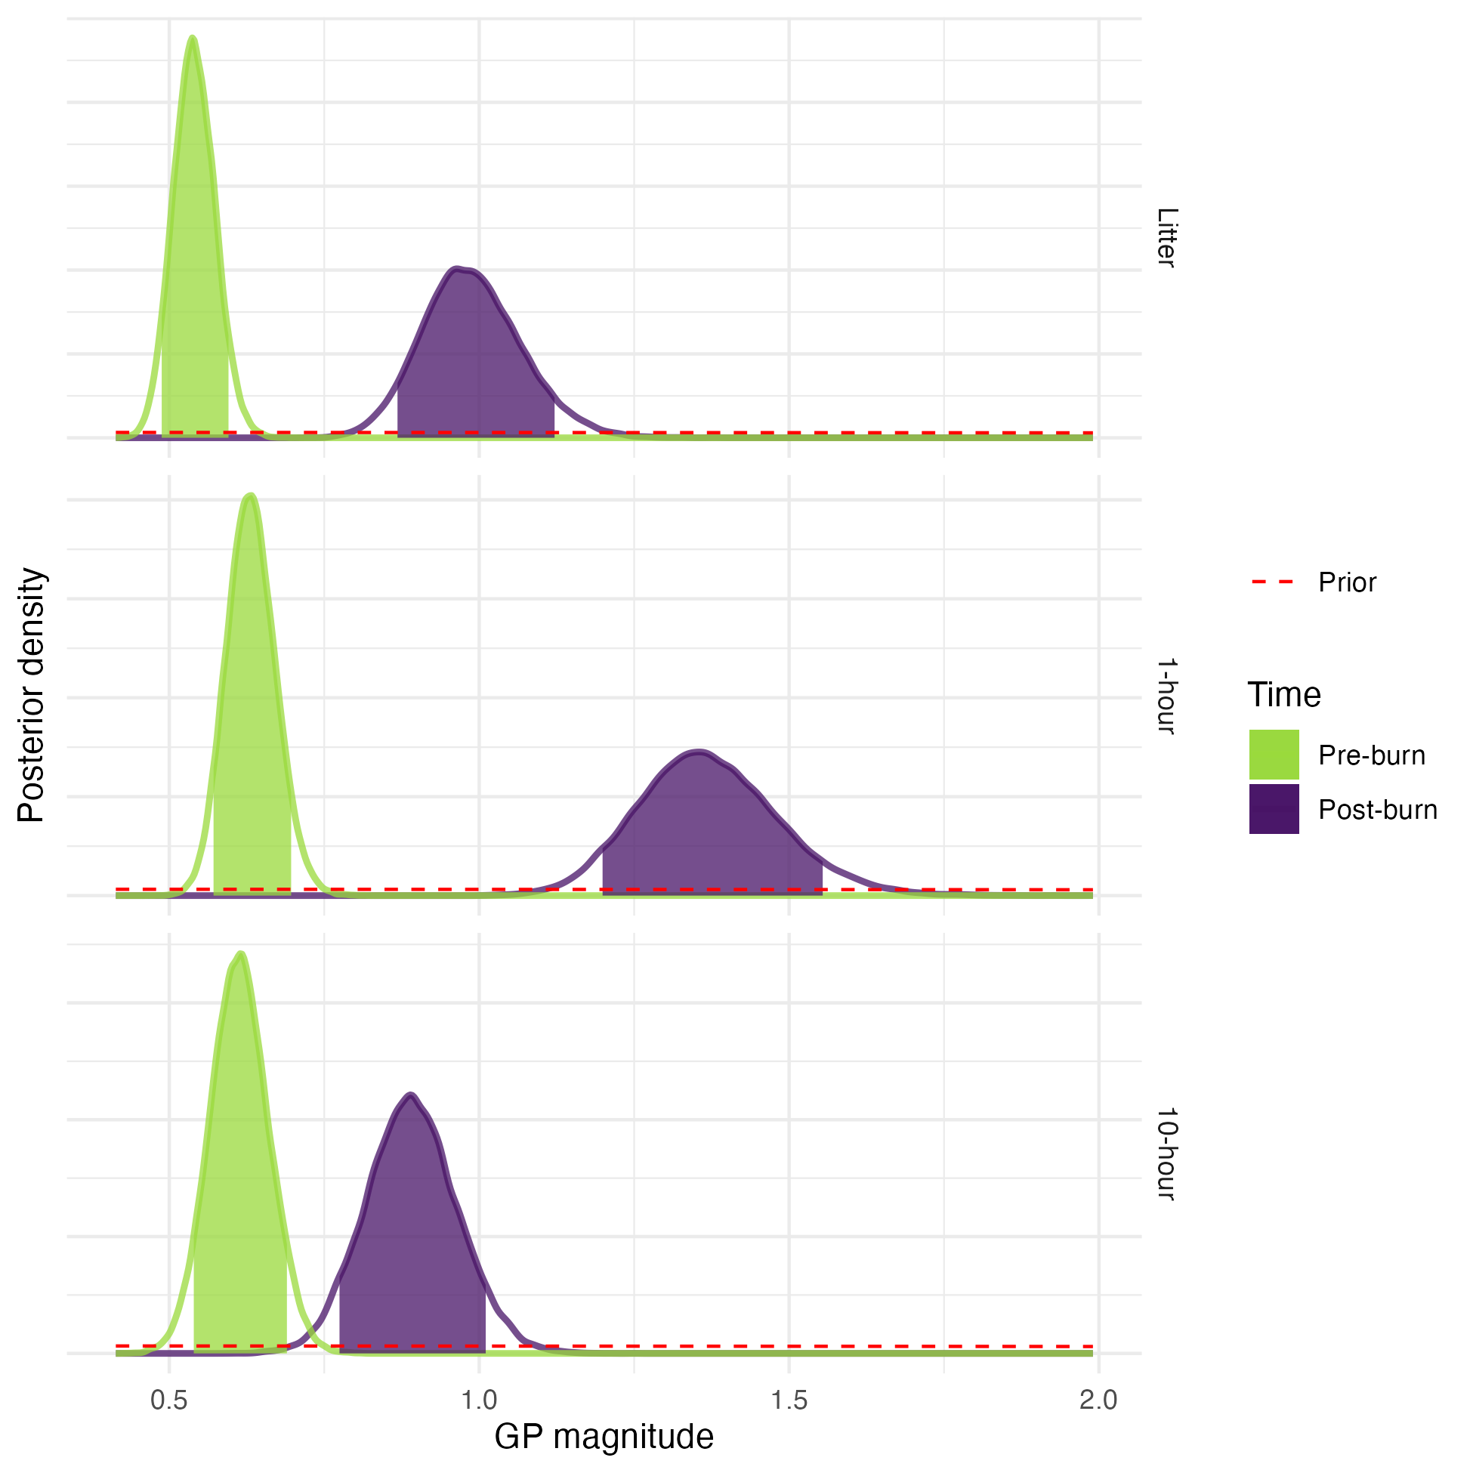
Figure 1: Posterior distributions for Gaussian process magnitudes in pre-burn and post-burn times for litter, 1-hour fine woody debris, and 10-hour fine woody debris fuels. Parameter values are on the x-axis, probability density on the y-axis. The shaded region under each curve is an 89% credible interval (specifically, an equal tail probability interval). The prior probability density is shown as the dashed red line.

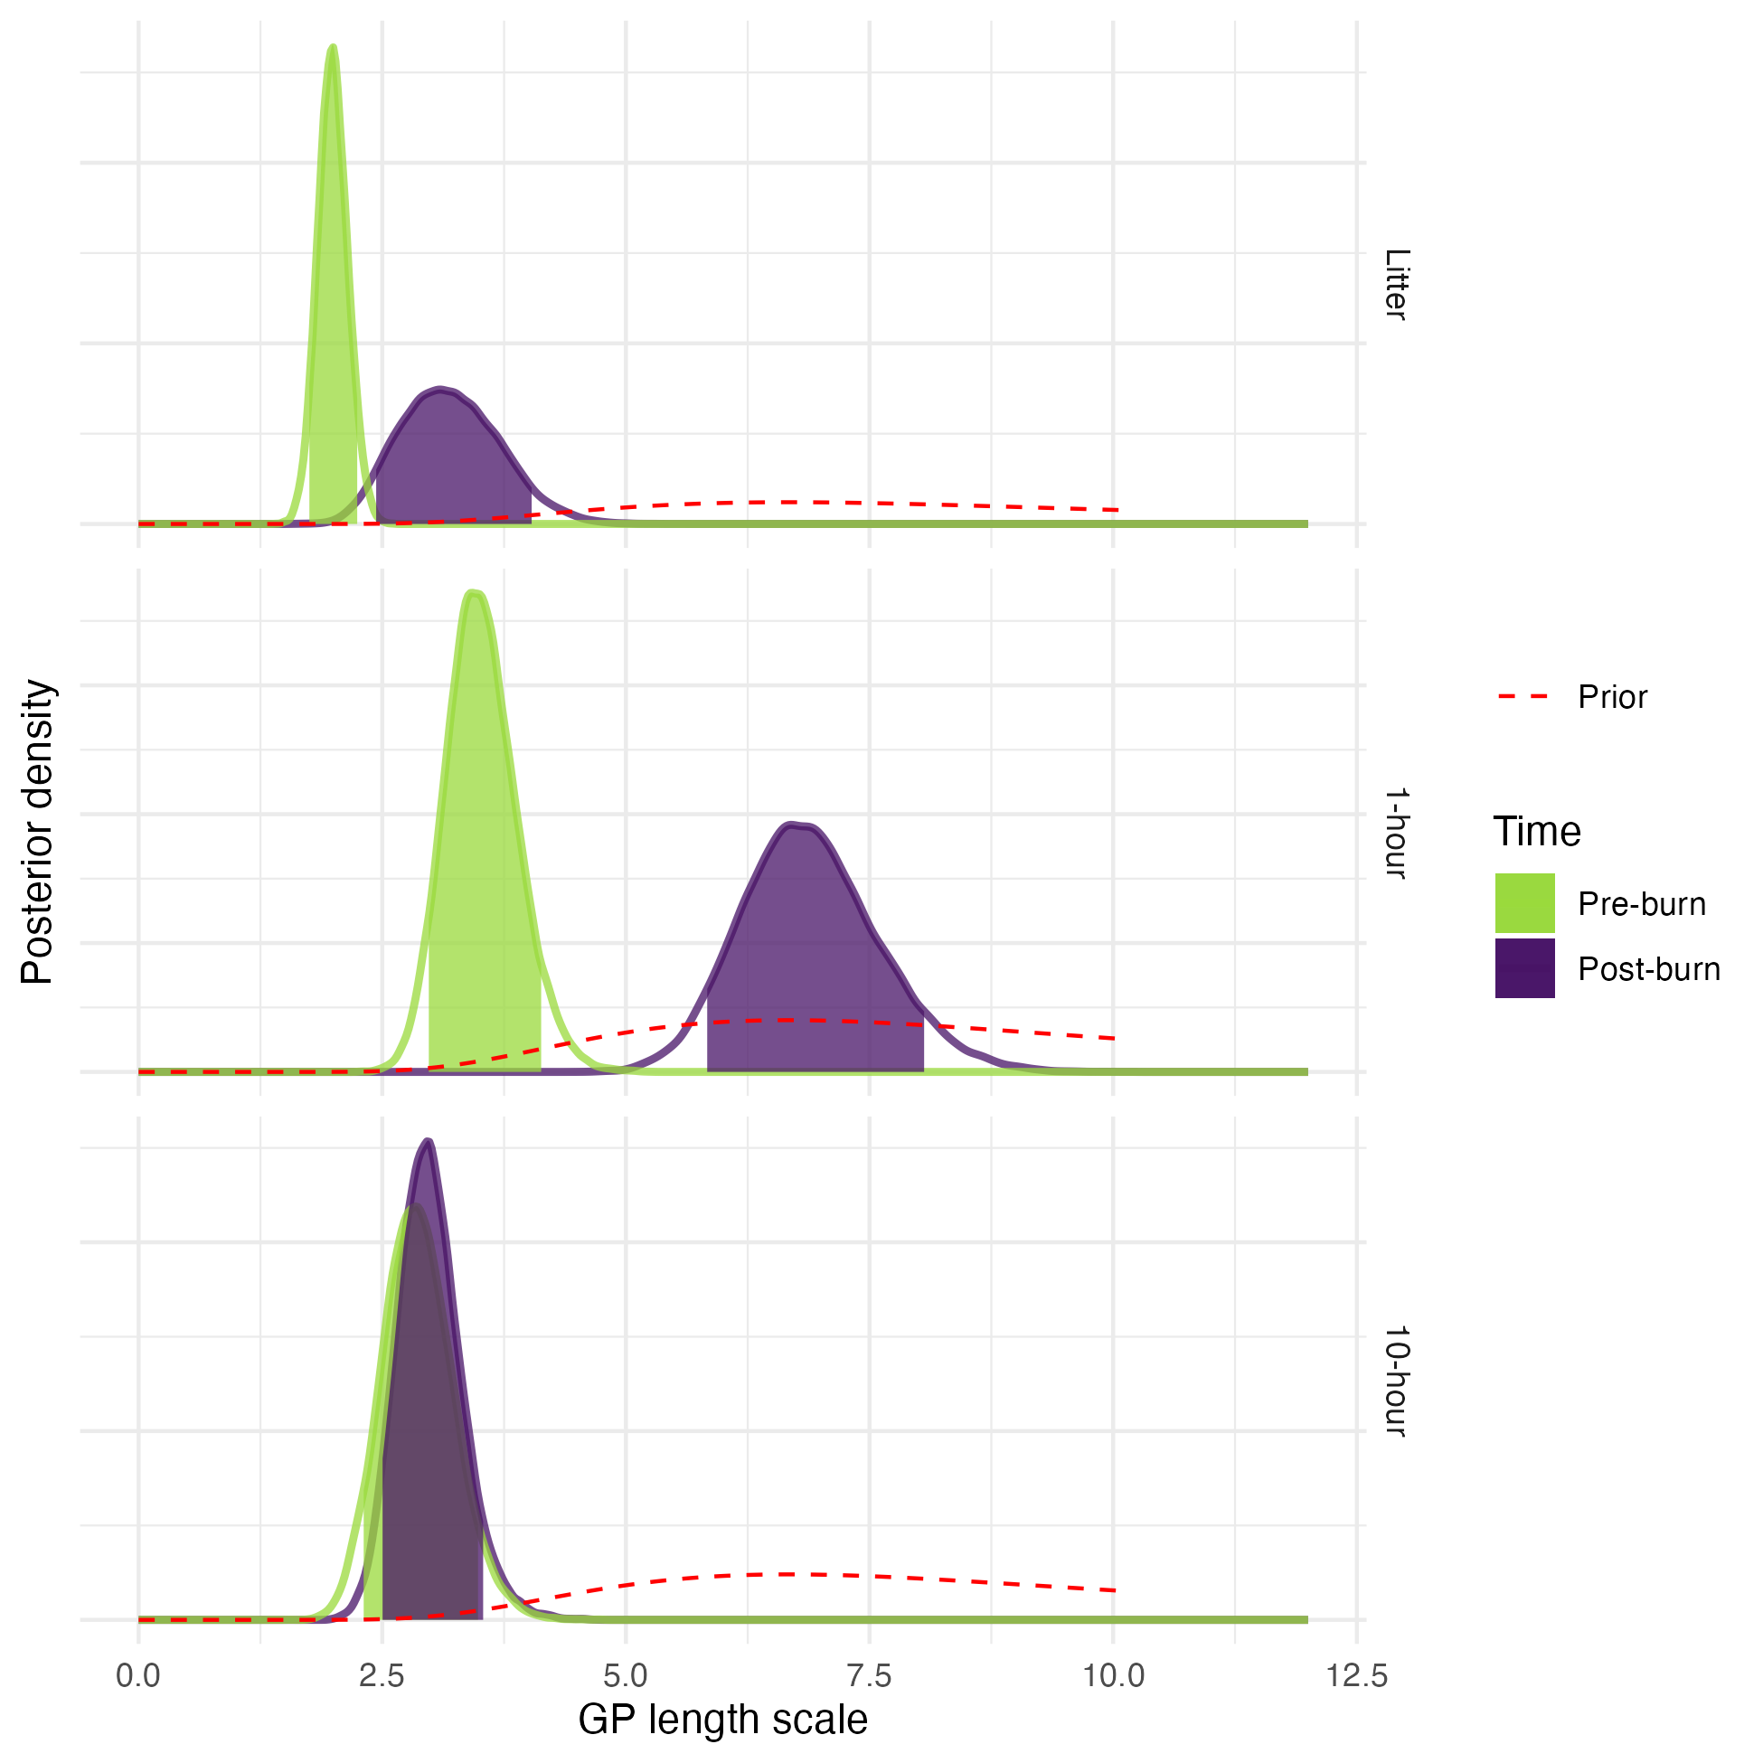
Figure 2: Posterior distributions for Gaussian process length scale parameters in pre-burn and post-burn times for litter, 1-hour fine woody debris, and 10-hour fine woody debris fuels. Parameter values are on the x-axis, probability density on the y-axis. The shaded region under each curve is an 89% credible interval (specifically, an equal tail probability interval). The prior probability density is shown as the dashed red line.

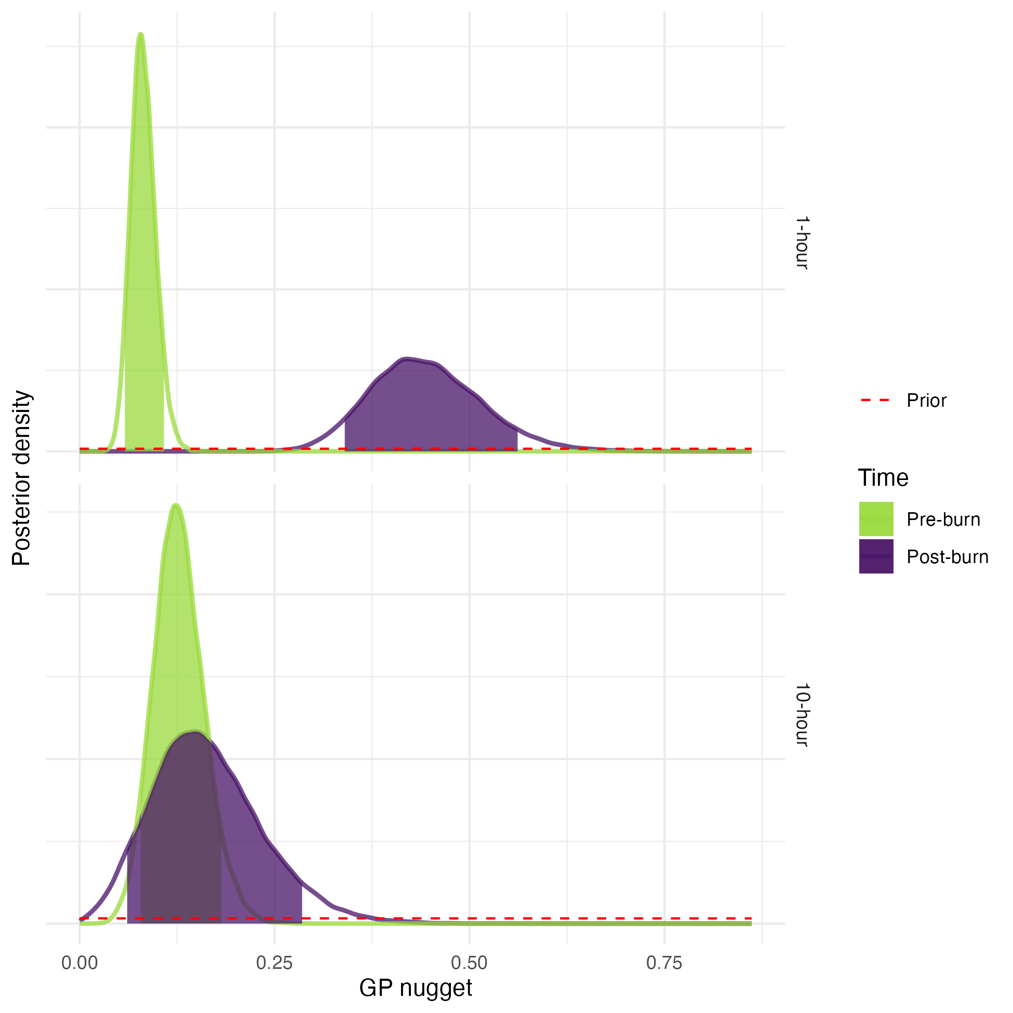
Figure 3: Posterior distribution for Gaussian process noise parameters in pre-burn and post-burn times for 1-hour and 10-hour fine woody debris fuels. No noise parameter was included in the litter model because there was only a single observation at each spatial location in the litter. Parameter values are on the x-axis, probability density on the y-axis. The shaded region under each curve is an 89% credible interval (specifically, an equal tail probability interval). The prior probability density is shown as the dashed black line.
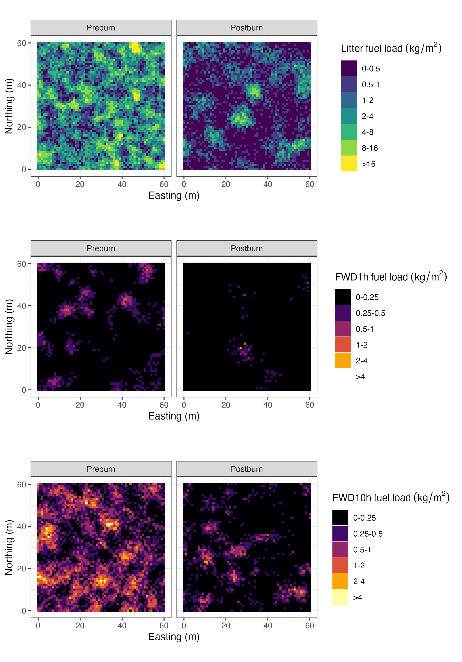
Figure 4: Simulated fuel beds. Within each panel, a 60m by 60m grid (1m resolution) of observations of litter, 1-hour FWD, and 10-hour FWD were simulated using median posterior parameter values and the models described in the methods, for both the Preburn and Postburn time steps. The raw depths (for litter) and tallies on 1m subtransects (for FWD) at each spatial location were transformed into fuel loading estimates using the methods described in Foster et al. (2020). The plots show these simulated fuel beds as observed from above, with the x-axis and y-axis representing Easting and Northing spatial location, respectively. The fill value for each pixel shows the simulated mean fuel loading (kg/m2) over that square meter. Different fuel components (litter, 1-hour FWD, and 10-hour FWD) and timesteps (Preburn and Postburn) are shown in the separate panels.

Author Statements

Conflicts of interest
The authors declare no conflicts of interest.

Data availability
Data are available from the corresponding author upon reasonable request.

Declaration of funding
The authors would like to acknowledge funding from the California Air Resources Board (CARB) under contract 19RD008.

References
Agee, J.K. and Skinner, C.N. (2005) ‘Basic principles of forest fuel reduction treatments’, Forest Ecology and Management, 211(1–2), pp. 83–96. Available at: https://doi.org/10.1016/j.foreco.2005.01.034.
Airey Lauvaux, C., Skinner, C.N. and Taylor, A.H. (2016) ‘High severity fire and mixed conifer forest-chaparral dynamics in the southern Cascade Range, USA’, Forest Ecology and Management, 363, pp. 74–85. Available at: https://doi.org/10.1016/j.foreco.2015.12.016.
Alizadeh, M.R., Abatzoglou, J.T., Luce, C.H., Adamowski, J.F., Farid, A. and Sadegh, M. (2021) ‘Warming enabled upslope advance in western US forest fires’, Proceedings of the National Academy of Sciences, 118(22), p. e2009717118. Available at: https://doi.org/10.1073/pnas.2009717118.
Atchley, A.L., Linn, R.R., Jonko, A., Hoffman, C.M., Hyman, J.D., Pimont, F., Sieg, C. and Middleton, R. (2021) ‘Effects of fuel spatial distribution on wildland fire behavior’, International Journal of Wildland Fire, 30(3), pp. 179-189; Available at: https://doi.org/10.1071/WF20096.
Banerjee, T. (2020) ‘Impacts of forest thinning on wildland fire behavior’, Forests, 11(9). Available at: https://doi.org/10.3390/F11090918.
Betancourt, M. (2020) Robust Gaussian Process Modeleing. Available at: https://github.com/betanalpha/knitr_case_studies/tree/master/gaussian_processes.
Blomdahl, E.M., Kolden, C.A., Meddens, A.J.H. and Lutz, J.A. (2019) ‘The importance of small fire refugia in the central Sierra Nevada, California, USA’, Forest Ecology and Management, 432(October 2018), pp. 1041–1052. Available at: https://doi.org/10.1016/j.foreco.2018.10.038.
Brown, J.K. (1974) 'Handbook for Inventorying Downed Woody Material,' General Technical Report INT-16. Ogden, UT: USDA Forest Service, Intermountain Forest and Range Experiment Station. 24 p. Available at: https://www.fs.usda.gov/research/treesearch/28647
Bürkner, P., Gabry, J., Kay, M. and Vehtari, A. (2021) ‘posterior: Tools for Working with Posterior Distributions’. Available at: https://mc-stan.org/posterior/.
Coop, J.D. et al. (2020) ‘Wildfire-Driven Forest Conversion in Western North American Landscapes’, BioScience, 70(8), pp. 659–673. Available at: https://doi.org/10.1093/biosci/biaa061.
Coppoletta, M., Merriam, K.E. and Collins, B.M. (2016) ‘Post-fire vegetation and fuel development influences fire severity patterns in reburns’, Ecological Applications, 26(3), pp. 686–699. Available at: https://doi.org/10.1890/15-0225.
Diggle, P.J. and Ribiero, P.J. (2007) Model-based geostatistics. New York, NY: Springer Science+Business Media, LLC. Available at: https://doi.org/10.1007/978-0-387-48536-2
Finney, M.A., Cohen, J.D., Grenfell, I.C. and Yedinak, K.M. (2010) ‘An examination of fire spread thresholds in discontinuous fuel beds’, International Journal of Wildland Fire, 19(2), pp. 163–170. Available at: https://doi.org/10.1071/WF07177.
Foster, D.E., Battles, J.J., Collins, B.M., York, R.A. and Stephens, S.L. (2020) ‘Potential wildfire and carbon stability in frequent-fire forests in the Sierra Nevada: trade-offs from a long-term study’, Ecosphere, 11(8). Available at: https://doi.org/10.1002/ecs2.3198.
Fry, D.L., Stevens, J.T., Potter, A.T., Collins, B.M. and Stephens, S.L. (2018) ‘Surface fuel accumulation and decomposition in old-growth pine-mixed conifer forests, northwestern Mexico’, Fire Ecology, 14(2). Available at: https://doi.org/10.1186/s42408-018-0017-5.
Gabry, J., Simpson, D., Vehtari, A., Betancourt, M. and Gelman, A. (2019) ‘Visualization in Bayesian workflow’, Journal of the Royal Statistical Society. Series A: Statistics in Society, 182(2), pp. 389–402. Available at: https://doi.org/10.1111/rssa.12378.
Gabry, J., Češnovar, R., Bales, B., Morris, M., Popov, M., Lawrence, M., Michael Landau, W. and Socolar, J. (2022) ‘cmdstanr’. Available at: https://github.com/stan-dev/cmdstanr/.
Gabry, J. and Mahr, T. (2021) ‘bayesplot: Plotting for Bayesian Models’. Available at: https://mc-stan.org/bayesplot/.
Gray, C.A., Toone, C., Jenkins, M.J., Null, S.E. and Yocom, L.L. (2021) ‘Spatial and temporal fuels changes in whitebark pine (Pinus albicaulis) from mountain pine beetle (Dendroctonus ponderosae)’, Forest Ecology and Management, 482(November 2020), p. 118789. Available at: https://doi.org/10.1016/j.foreco.2020.118789.
Hart, S.C., Firestone, M.K. and Paul, E.A. (1992) ‘Decomposition and nutrient dynamics of ponderosa pine needles in a Mediterranean-type climate’, Canadian Journal of Forest Research, 22(3), pp. 306–314. Available at: https://doi.org/10.1139/x92-040.
Hartsough, B.R., Abrams, S., Barbour, R.J., Drews, E.S., McIver, J.D., Moghaddas, J.J., Schwilk, D.W. and Stephens, S.L. (2008) ‘The economics of alternative fuel reduction treatments in western United States dry forests: Financial and policy implications from the National Fire and Fire Surrogate Study’, Forest Policy and Economics, 10(6), pp. 344–354. Available at: https://doi.org/10.1016/j.forpol.2008.02.001.
Hessburg, P.F., Spies, T.A., Perry, D.A., Skinner, C.N., Taylor, A.H., Brown, P.M., Stephens, S.L., Larson, A.J., Churchill, D.J., Povak, N.A., Singleton, P.H., McComb, B., Zielinski, W.J., Collins, B.M., Salter, R.B., Keane, J.J., Franklin, J.F. and Riegel, G. (2016) ‘Tamm Review: Management of mixed-severity fire regime forests in Oregon, Washington, and Northern California’, Forest Ecology and Management, 366, pp. 221–250. Available at: https://doi.org/10.1016/j.foreco.2016.01.034.
Hiers, J.K., O’Brien, J.J., Will, R.E. and Mitchell, R.J. (2007) ‘Forest floor depth mediates understory vigor in xeric Pinus palustris ecosystems’, Ecological Applications, 17(3), pp. 806–814. Available at: https://doi.org/10.1890/06-1015.
Hiers, J.K., O’Brien, J.J., Mitchell, R.J., Grego, J.M. and Loudermilk, E.L. (2009) ‘The wildland fuel cell concept: An approach to characterize fine-scale variation in fuels and fire in frequently burned longleaf pine forests’, International Journal of Wildland Fire, 18(3), pp. 315–325. Available at: https://doi.org/10.1071/WF08084.
Hiers, J.K. et al. (2020) ‘Prescribed fire science: the case for a refined research agenda’, Fire Ecology, 16(1). Available at: https://doi.org/10.1186/s42408-020-0070-8.
Hijmans, R.J. (2021) ‘raster: Geographic Data Analysis and Modeling’. Available at: https://cran.r-project.org/package=raster.
Hille, M.G. and Stephens, S.L. (2005) ‘Mixed conifer forest duff consumption during prescribed fires: Tree crown impacts’, Forest Science, 51(5), pp. 417–424. Available at: https://doi.org/10.1093/forestscience/51.5.417
Hollister, J.W. (2021) ‘elevatr: Access Elevation Data from Various APIs’. Available at: https://cran.r-project.org/package=elevatr/.
Jeronimo, S.M.A., Kane, V.R., Churchill, D.J., Lutz, J.A., North, M.P., Asner, G.P. and Franklin, J.F. (2019) ‘Forest structure and pattern vary by climate and landform across active-fire landscapes in the montane Sierra Nevada’, Forest Ecology and Management, 437(January), pp. 70–86. Available at: https://doi.org/10.1016/j.foreco.2019.01.033.
Keane, R.E. (2008) ‘Biophysical controls on surface fuel litterfall and decomposition in the northern Rocky Mountains, USA’, Canadian Journal of Forest Research, 38(6), pp. 1431–1445. Available at: https://doi.org/10.1139/X08-003.
Keane, R.E., Gray, K., Bacciu, V. and Leirfallom, S. (2012a) ‘Spatial scaling of wildland fuels for six forest and rangeland ecosystems of the northern Rocky Mountains, USA’, Landscape Ecology, 27(8), pp. 1213–1234. Available at: https://doi.org/10.1007/s10980-012-9773-9.
Keane, R.E., Gray, K. and Bacciu, V. (2012b) 'Spatial Variability of Wildland Fuel Characteristics in Northern Rocky Mountain Ecosystems', Res. Pap. RMRS-RP-98. Fort Collins, CO: U.S. Department of Agriculture, Forest Service, Rocky Mountain Research Station. 56 p.
Keane, R.E. (2015) Wildland Fuel Fundamentals and Application. Springer Cham. ISBN 978-3-310-09015-3. Available at: https://doi.org/10.1007/978-3-319-09015-3.
Keane, R.E. (2016) ‘Spatiotemporal Variability of Wildland Fuels in US Northern Rocky Mountain Forests’, Forests, 7(7), p. 129. Available at: https://doi.org/10.3390/f7070129.
Kreye, J.K., Kane, J.M., Varner, J.M. and Hiers, J.K. (2020) ‘Radiant heating rapidly increases litter flammability through impacts on fuel moisture’, Fire Ecology, 16(1). Available at: https://doi.org/10.1186/s42408-020-0067-3.
Levine, J.I., Collins, B.M., York, R.A., Foster, D.E., Fry, D.L. and Stephens, S.L. (2020) ‘Forest stand and site characteristics influence fuel consumption in repeat prescribed burns’, International Journal of Wildland Fire, 29(2), pp. 148–159. Available at: https://doi.org/10.1071/WF19043.
Liang, S., Hurteau, M.D. and Westerling, A.L.R. (2017) ‘Response of Sierra Nevada forests to projected climate–wildfire interactions’, Global Change Biology, 23(5), pp. 2016–2030. Available at: https://doi.org/10.1111/gcb.13544.
Linn, R., Reisner, J., Colman, J.J. and Winterkamp, J. (2002) ‘Studying wildfire behavior using FIRETEC’, International Journal of Wildland Fire, 11(3–4), pp. 233–246. Available at: https://doi.org/10.1071/wf02007.

Linn, R.R., Goodrick, S.L., Brambilla, S., Brown, M.J., Middleton, R.S., O’Brien, J.J. and Hiers, J.K. (2020) ‘QUIC-fire: A fast-running simulation tool for prescribed fire planning’, Environmental Modelling and Software, 125(August 2019). Available at: https://doi.org/10.1016/j.envsoft.2019.104616.
Loudermilk, E.L., Achtemeier, G.L., O’Brien, J.J., Hiers, J.K. and Hornsby, B.S. (2014) ‘High-resolution observations of combustion in heterogeneous surface fuels’, International Journal of Wildland Fire, 23(7), pp. 1016–1026. Available at: https://doi.org/10.1071/WF13160.
Loudermilk, E.L., O’Brien, J.J., Goodrick, S.L., Linn, R.R., Skowronski, N.S. and Hiers, J.K. (2022) ‘Vegetation’s influence on fire behavior goes beyond just being fuel’, Fire Ecology, 18(1). Available at: https://doi.org/10.1186/s42408-022-00132-9.
Lutz, J.A., Furniss, T.J., Germain, S.J., Becker, K.M.L., Blomdahl, E.M., Jeronimo, S.M.A., Cansler, C.A., Freund, J.A., Swanson, M.E. and Larson, A.J. (2017) ‘Shrub communities, spatial patterns, and shrub-mediated tree mortality following reintroduced fire in Yosemite National Park, California, USA’, Fire Ecology, 13(1), pp. 104–126. Available at: https://doi.org/10.4996/fireecology.1301104.
Lydersen, J.M., North, M.P., Knapp, E.E. and Collins, B.M. (2013) ‘Quantifying spatial patterns of tree groups and gaps in mixed-conifer forests: Reference conditions and long-term changes following fire suppression and logging’, Forest Ecology and Management, 304, pp. 370–382. Available at: https://doi.org/10.1016/j.foreco.2013.05.023.
Makowski, D., Ben-Shachar, M. S., & Lüdecke, D. (2019). bayestestR: Describing Effects and their Uncertainty, Existence and Significance within the Bayesian Framework. Journal of Open Source Software, 4(40), 1541. https://doi.org/10.21105/joss.01541
McCaskill, G.L. (2018) ‘The Hungry Bob Fire&Fire Surrogate Study: A 20-Year Evaluation of the Treatment Effects’, Forests, 10(1), p. 15. Available at: https://doi.org/10.3390/f10010015.
McElreath, R. (2016) Statistical Rethinking: A Bayesian Course with Examples in R and STAN, 1st ed. 2016 Chapman and Hall / CRC. New York, NY. ISBN 9781315372495. Available at: https://xcelab.net/rm/statistical-rethinking/
Mitchell, R.J., Hiers, J.K., O’Brien, J.J. and Starr, G. (2009) ‘Ecological forestry in the southeast: Understanding the ecology of fuels’, Journal of Forestry, 107(8), pp. 391–397. Available at: https://doi.org/10.1093/jof/107.8.391.
Miyanishi, K. and Johnson, E.A. (2002) ‘Process and patterns of duff consumption in the mixedwood boreal forest’, Canadian Journal of Forest Research, 32(7), pp. 1285–1295. Available at: https://doi.org/10.1139/x02-051.
Moghaddas, E.E.Y. and Stephens, S.L. (2007) ‘Thinning, burning, and thin-burn fuel treatment effects on soil properties in a Sierra Nevada mixed-conifer forest’, Forest Ecology and Management, 250(3), pp. 156–166. Available at: https://doi.org/10.1016/j.foreco.2007.05.011.
Müller, K. (2020) ‘here: A Simpler Way to Find Your Files’. Available at: https://cran.r-project.org/package=here.
North, M., Stine, P., O’Hara, K., Zielinski, W., Stephens, S.L., Service, F. and Hara, K.O. (2009) ‘An ecosystem management strategy for Sierran mixed- conifer forests’, USDA Forest Service, Pacific Southwest Research Station, General Technical Report, (March), p. PSW-GTR-220.
North, M., ed. (2012) ‘Managing Sierra Nevada forests’, PSW-GTR-237. Albany, CA: USDA Forest Service, Pacific Southwest Research Station. 184 p. Available at: https://doi.org/10.2737/PSW-GTR-237.
O’Brien, J.J., Loudermilk, E.L., Hiers, J.K., Pokswinski, S.M., Hornsby, B., Hudak, A.T., Strother, D., Rowell, E. and Bright, B.C. (2016) ‘Canopy-Derived Fuels Drive Patterns of In-Fire Energy Release and Understory Plant Mortality in a Longleaf Pine (Pinus palustris) Sandhill in Northwest Florida, USA’, Canadian Journal of Remote Sensing, 42(5), pp. 489–500. Available at: https://doi.org/10.1080/07038992.2016.1199271.
Pawlikowski, N.C., Coppoletta, M., Knapp, E. and Taylor, A.H. (2019) ‘Spatial dynamics of tree group and gap structure in an old-growth ponderosa pine-California black oak forest burned by repeated wildfires’, Forest Ecology and Management, 434(October 2018), pp. 289–302. Available at: https://doi.org/10.1016/j.foreco.2018.12.016.
Pebesma, E. (2018) ‘Simple features for R: Standardized support for spatial vector data’, R Journal, 10(1), pp. 439–446. Available at: https://doi.org/10.32614/rj-2018-009.
Perry, D.A., Hessburg, P.F., Skinner, C.N., Spies, T.A., Stephens, S.L., Taylor, A.H., Franklin, J.F., McComb, B. and Riegel, G. (2011) ‘The ecology of mixed severity fire regimes in Washington, Oregon, and Northern California’, Forest Ecology and Management, 262(5), pp. 703–717. Available at: https://doi.org/10.1016/j.foreco.2011.05.004.
R Core Team (2021) ‘R: A language and environment for statistical computing.’ Vienna, Austria: R Foundation for Statistical Computing. Available at: https://www.r-project.org.
Reinhardt, E.D. and Ryan, K.C. (1988) ‘Predicting postfire mortality of seven western conifers’, Canadian Journal of Forest Research, 18, pp. 1291–11297.
Rice, S.K. (1993) ‘ Vegetation establishment in post-fire Adenostoma chaparral in relation to fine-scale pattern in fire intensity and soil nutrients ’, Journal of Vegetation Science, 4(1), pp. 115–124. Available at: https://doi.org/10.2307/3235739.
Ritter, S.M., Hoffman, C.M., Battaglia, M.A., Stevens-Rumann, C.S. and Mell, W.E. (2020) ‘Fine-scale fire patterns mediate forest structure in frequent-fire ecosystems’, Ecosphere, 11(7). Available at: https://doi.org/10.1002/ecs2.3177.
Ritter, S.M., Hoffman, C.M., Battaglia, M.A. and Jain, T.B. (2022) ‘Restoration and fuel hazard reduction result in equivalent reductions in crown fire behavior in dry conifer forests’, Ecological Applications, 32(7), p. e2682. Available at: https://doi.org/10.1002/eap.2682.
Robichaud, P.R. and Miller, S.M. (2000) ‘Spatial Interpolation and Simulation of Post-burn Duff Thickness after Prescribed Fire’, International Journal of Wildland Fire, 9(2), pp. 137–143. Available at: https://doi.org/10.1071/wf00018.
Safford, H.D. and Stevens, J.T. (2017) ‘Natural Range of Variation (NRV) for yellow pine and mixed conifer forests in the bioregional assessment area, including the Sierra Nevada, southern Cascades, and Modoc and Inyo National Forests’, Gen. Tech. Rep. PSW-GTR-2562. Alvany, CA: USDA Forest Service, Pacific Southwest Research Station. 229 p. Available at: https://doi.org/10.2737/PSW-GTR-256
Schwilk, D.W., Keeley, J.E., Knapp, E.E., McIver, J., Bailey, J.D., Fettig, C.J., Fiedler, C.E., Harrod, R.J., Moghaddas, J.J., Outcalt, K.W., Skinner, C.N., Stephens, S.L., Waldrop, T.A., Yaussy, D.A. and Youngblood, A. (2009) ‘The national Fire and Fire Surrogate study: effects of fuel reduction methods on forest vegetation structure and fuels’, Ecological Applications, 19(March), pp. 285–304. Available at: https://doi.org/10.1890/07-1747.1.
Stan Development Team (2022) ‘Stan Modeling Language Users Guide and Reference Manual’. Available at: https://mc-stan.org.
Steel, Z.L., Safford, H.D. and Viers, J.H. (2015) ‘The fire frequency-severity relationship and the legacy of fire suppression in California forests’, Ecosphere, 6(1), pp. 1-23. Available at: https://doi.org/10.1890/ES14-00224.1.
Steel, Z.L., Foster, D.E., Coppoletta, M., Lydersen, J.M., Stephens, S.L., Paudel, A., Markwith, S.H., Merriam, K. and Collins, B.M. (2021) ‘Ecological resilience and vegetation transition in the face of two successive large wildfires’, Journal of Ecology, 109(9), pp. 3340–3355. Available at: https://doi.org/10.1111/1365-2745.13764.
Stephens, S.L., Moghaddas, J.J., Edminster, C., Fiedler, C.E., Haase, S., Harrington, M., Keeley, J.E., Knapp, E.E., McIver, J.D., Metlen, K., Skinner, C.N. and Youngblood, A. (2009) ‘Fire Treatment Effects on Vegetation Structure, Fuels, and Potential Fire Severity in Western U.S. Forests’, Ecological Applications, 19(2), pp. 305–320. Available at: https://doi.org/10.1890/07-1755.1.
Stephens, S.L., McIver, J.D., Boerner, R.E.J., Fettig, C.J., Fontaine, J.B., Hartsough, B.R., Kennedy, P.L. and Schwilk, D.W. (2012) ‘The Effects of Forest Fuel-Reduction Treatments in the United States’, Bioscience, 62(6), pp. 549–560. Available at: https://doi.org/10.1525/bio.2012.62.6.6.
Stephens, S.L., Lydersen, J., Collins, B.M. and Fry, D. (2015) ‘Historical and current landscape-scale ponderosa pine and mixed conifer forest structure in the Southern Sierra Nevada’, Ecosphere, 6(May), pp. 1–63. Available at: https://doi.org/10.1890/ES14-00379.1.
Stephens, S.L. and Collins, B.M. (2004) ‘Fire regimes of mixed conifer forests in the north-central Sierra Nevada at multiple spatial scales’, Northwest Science, 78(1), pp. 12–23.
Stephens, S.L. and Finney, M.A. (2002) ‘Prescribed fire mortality of Sierra Nevada mixed conifer tree species: Effects of crown damage and forest floor combustion’, Forest Ecology and Management, 162(2–3), pp. 261–271. Available at: https://doi.org/10.1016/S0378-1127(01)00521-7.
Stevens, J.T., Collins, B.M., Miller, J.D., North, M.P. and Stephens, S.L. (2017) ‘Changing spatial patterns of stand-replacing fire in California conifer forests’, Forest Ecology and Management, 406(August), pp. 28–36. Available at: https://doi.org/10.1016/j.foreco.2017.08.051.
Taylor, A.H., Vandervlugt, A.M., Maxwell, R.S., Beaty, R.M., Airey Lauvaux, C. and Skinner, C.N. (2014) ‘Changes in forest structure, fuels and potential fire behaviour since 1873 in the Lake Tahoe Basin, USA’, Applied Vegetation Science, 17(1), pp. 17–31. Available at: https://doi.org/10.1111/avsc.12049.
Tennekes, M. (2018) ‘Tmap: Thematic maps in R’, Journal of Statistical Software, 84(6). Available at: https://doi.org/10.18637/jss.v084.i06.
Thaxton, J.M. and Platt, W.J. (2006) ‘Small-scale fuel variation alters fire intensity and shrub abundance in a pine savanna’, Ecology, 87(5), pp. 1331–1337. Available at: https://doi.org/10.1890/0012-9658(2006)87[1331:SFVAFI]2.0.CO;2.
Vakili, E., Hoffman, C.M., Keane, R.E., Tinkham, W.T. and Dickinson, Y. (2016) ‘Spatial variability of surface fuels in treated and untreated ponderosa pine forests of the southern Rocky Mountains’, International Journal of Wildland Fire, 25(11), pp. 1156–1168. Available at: https://doi.org/10.1071/WF16072.
van Mantgem, P.J., Stephenson, N.L., Knapp, E., Battles, J. and Keeley, J.E. (2011) ‘Long-term effects of prescribed fire on mixed conifer forest structure in the Sierra Nevada, California’, Forest Ecology and Management, 261(6), pp. 989–994. Available at: https://doi.org/10.1016/j.foreco.2010.12.013.
Westerling, A.L., Hidalgo, H.G., Cayan, D.R. and Swetnam, T.W. (2006) ‘Warming and earlier spring increase Western U.S. forest wildfire activity’, Science, 313(5789), pp. 940–943. Available at: https://doi.org/10.1126/science.1128834.
Westerling, A.L., Bryant, B.P., Preisler, H.K., Holmes, T.P., Hidalgo, H.G., Das, T. and Shrestha, S.R. (2011) ‘Climate change and growth scenarios for California wildfire’, Climatic Change, 109, pp. 445–463. Available at: https://doi.org/10.1007/s10584-011-0329-9.
Wickham, H., Averick, M., Bryan, J., Chang, W., McGowan, L.D., Francois, R., Grolemund, G., Hayes, A., Henry, L., Hester, J., Kuhn, M., Pedersen, T.L., Miller, E., Bache, S.M., Müller, K., Ooms, J., Robinson, D., Seidel, D.P., Spinu, V., Takahashi, K., Vaughan, D., Wilke, C., Woo, K., and Yutani, H. (2019) ‘Welcome to the Tidyverse’, Journal of Open Source Software, 4(43), p. 1686. Available at: https://doi.org/10.21105/joss.01686.
Wiggers, M.S., Kirkman, L.K., Boyd, R.S. and Hiers, J.K. (2013) ‘Fine-scale variation in surface fire environment and legume germination in the longleaf pine ecosystem’, Forest Ecology and Management, 310, pp. 54–63. Available at: https://doi.org/10.1016/j.foreco.2013.07.030.
Wilke, C.O. (2020) ‘cowplot: Streamline Plot Theme and Plot Annotations for “ggplot2”’. Available at: https://cran.r-project.org/package=cowplot.
Williamson, G.B. and Black, E.M. (1981) ‘High temperature of forest fires under pines as a selective advantage over oaks’, Nature, 293(5834), pp. 643–644. Available at: https://doi.org/10.1038/293643a0.
York, R.A., Battles, J.J., Wenk, R.C. and Saah, D. (2012) ‘A gap-based approach for regenerating pine species and reducing surface fuels in multi-aged mixed conifer stands in the Sierra Nevada, California’, Forestry, 85(2), pp. 203–213. Available at: https://doi.org/10.1093/forestry/cpr058.
York, R.A., Noble, H., Quinn-Davidson, L.N. and Battles, J.J. (2021) ‘Pyrosilviculture: Combining prescribed fire with gap-based silviculture in mixed-conifer forests of the sierra nevada’, Canadian Journal of Forest Research, 51(6), pp. 781–791. Available at: https://doi.org/10.1139/cjfr-2020-0337.
York, R.A., Russell, K.W. and Noble, H. (2022) ‘Merging prescribed fires and timber harvests in the Sierra Nevada: Burn season and pruning influences in young mixed conifer stands’, Trees, Forests and People, 9(April), p. 100309. Available at: https://doi.org/10.1016/j.tfp.2022.100309.
Ziegler, J.P., Hoffman, C., Battaglia, M. and Mell, W. (2017) ‘Spatially explicit measurements of forest structure and fire behavior following restoration treatments in dry forests’, Forest Ecology and Management, 386, pp. 1–12. Available at: https://doi.org/10.1016/j.foreco.2016.12.002.

danfoster@berkeley.edu
Department of Environmental Science, Policy, and Management. University of California, Berkeley, 130 Mulford Hall #3114 Berkeley, CA 94720-3114, USA
US Geological Survey, Western Ecological Research Center, Sequoia-Kings Canyon Field Station, 47050 Generals Hwy, Three Rivers, CA 93271, USA
USDA Forest Service, Missoula Fire Sciences Laboratory, 5775 Highway 10 West, Missoula, MT 59808, USA. mark.finney@usda.gov
US Geological Survey, Western Ecological Research Center, Sequoia-Kings Canyon Field Station, 47050 Generals Hwy, Three Rivers, CA 93271, USA
USDA Forest Service, Pacific Southwest Region. 1323 Club Dr., Vallejo, CA 94592, USA
Chemical and Environmental Engineering Center for Environmental Research & Technology, University of California, Riverside, 1084 Columbia Avenue, Riverside, CA 92507. barsanti@ucar.edu

