Supplementary materials for “Prescribed fire alters spatial pattern of wildland fuels”
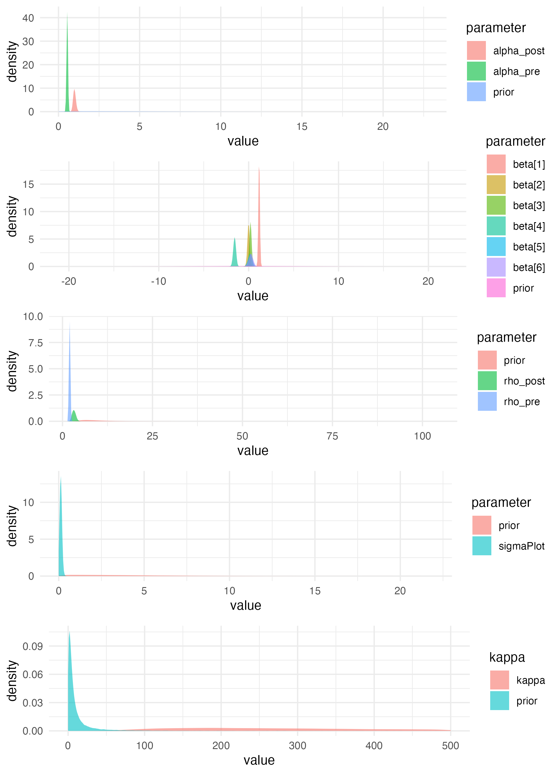
Supplementary Figure 1: Prior vs. posterior distributions for all parameters of the model for litter depths. Clear differences between the prior and posterior distributions exist for all parameters, indicating that the posterior estimates were strongly informed by the data, rather than the priors.

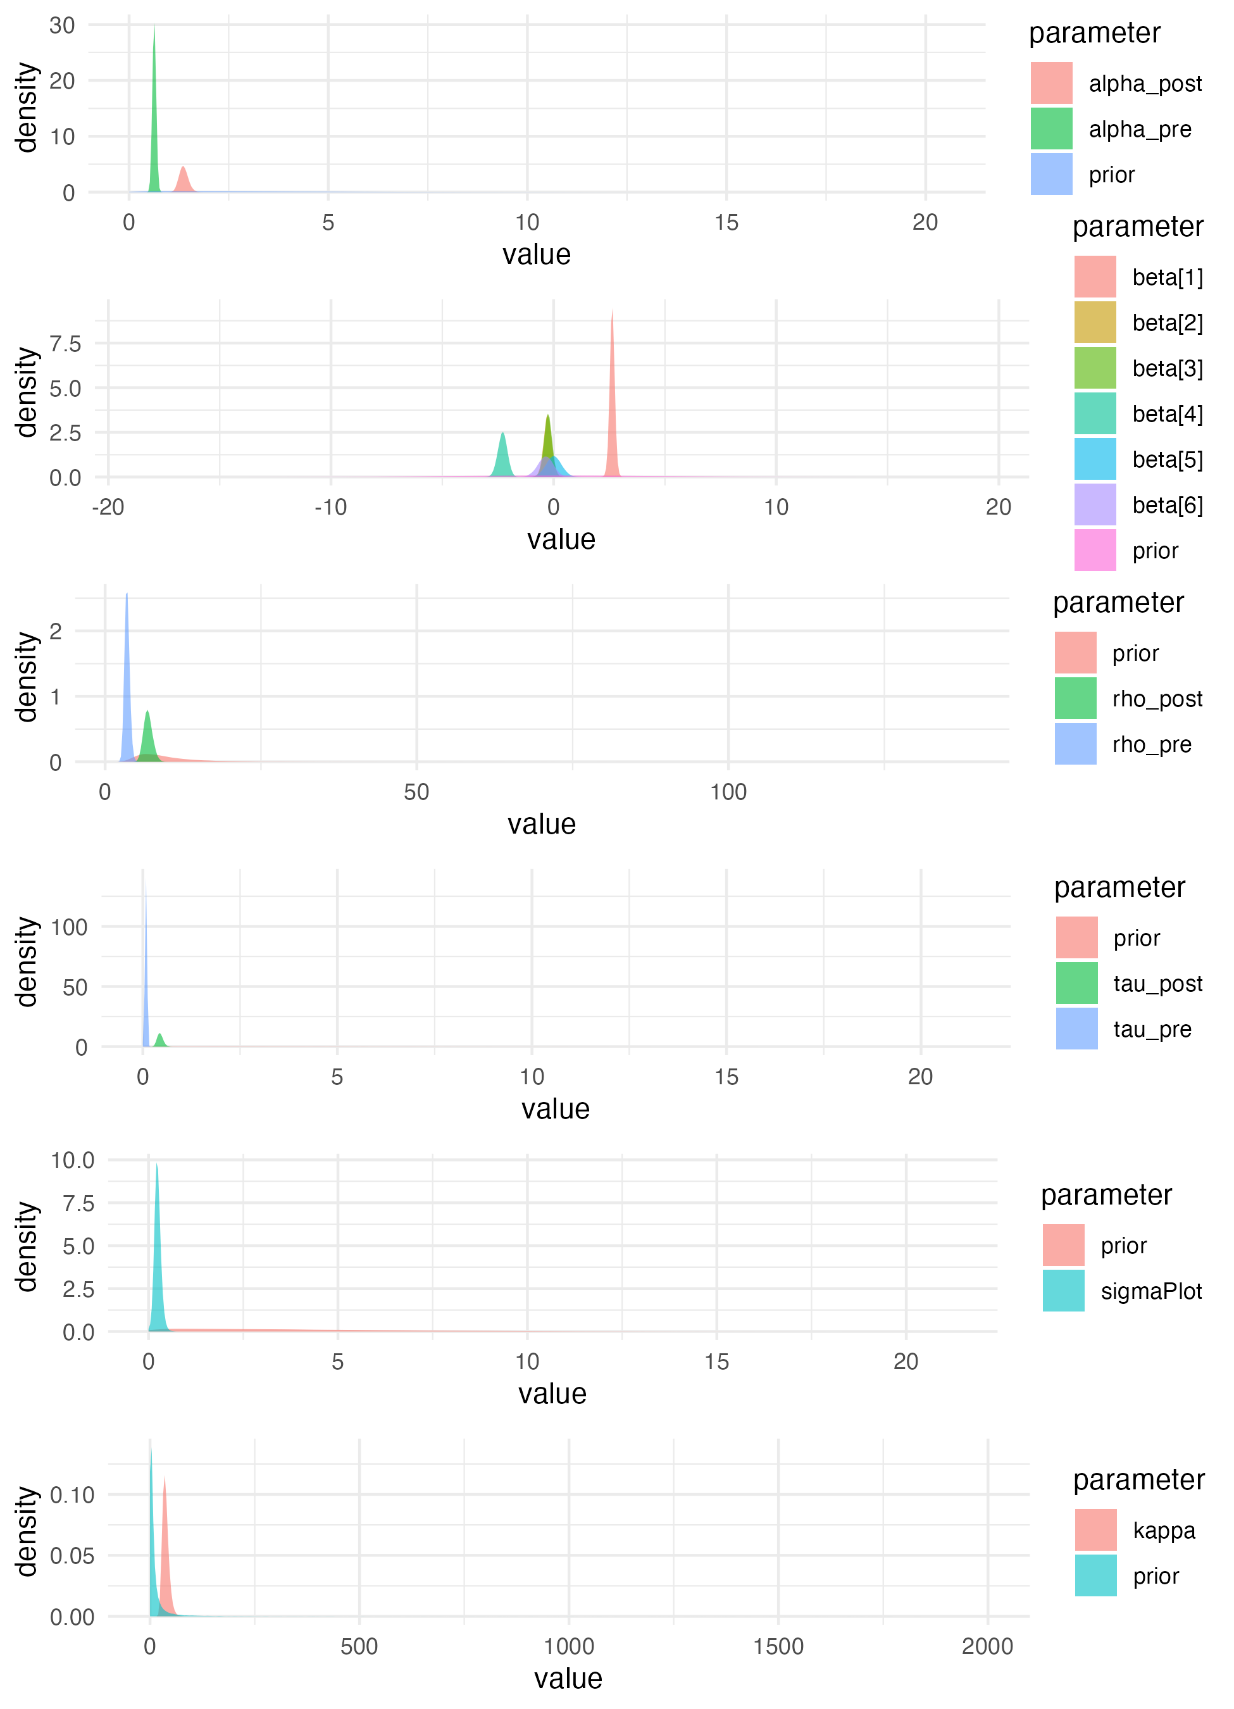
Supplementary Figure 2: Prior vs. posterior parameter distributions for all parameters in the model for 1-hour fine woody debris tallies. In all cases, there are clear differences between the prior and the posterior distributions, indicating that parameter estimates are strongly informed by the data, rather than the prior.

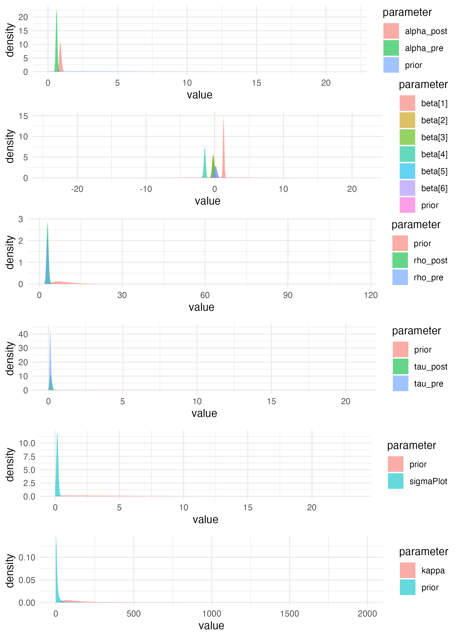
Supplementary Figure 3: Prior vs. posterior parameter distributions for all parameters in the model for 10-hour fine woody debris tallies. In all cases, there are clear differences between the prior and the posterior distributions, indicating that parameter estimates are strongly informed by the data, rather than the prior.

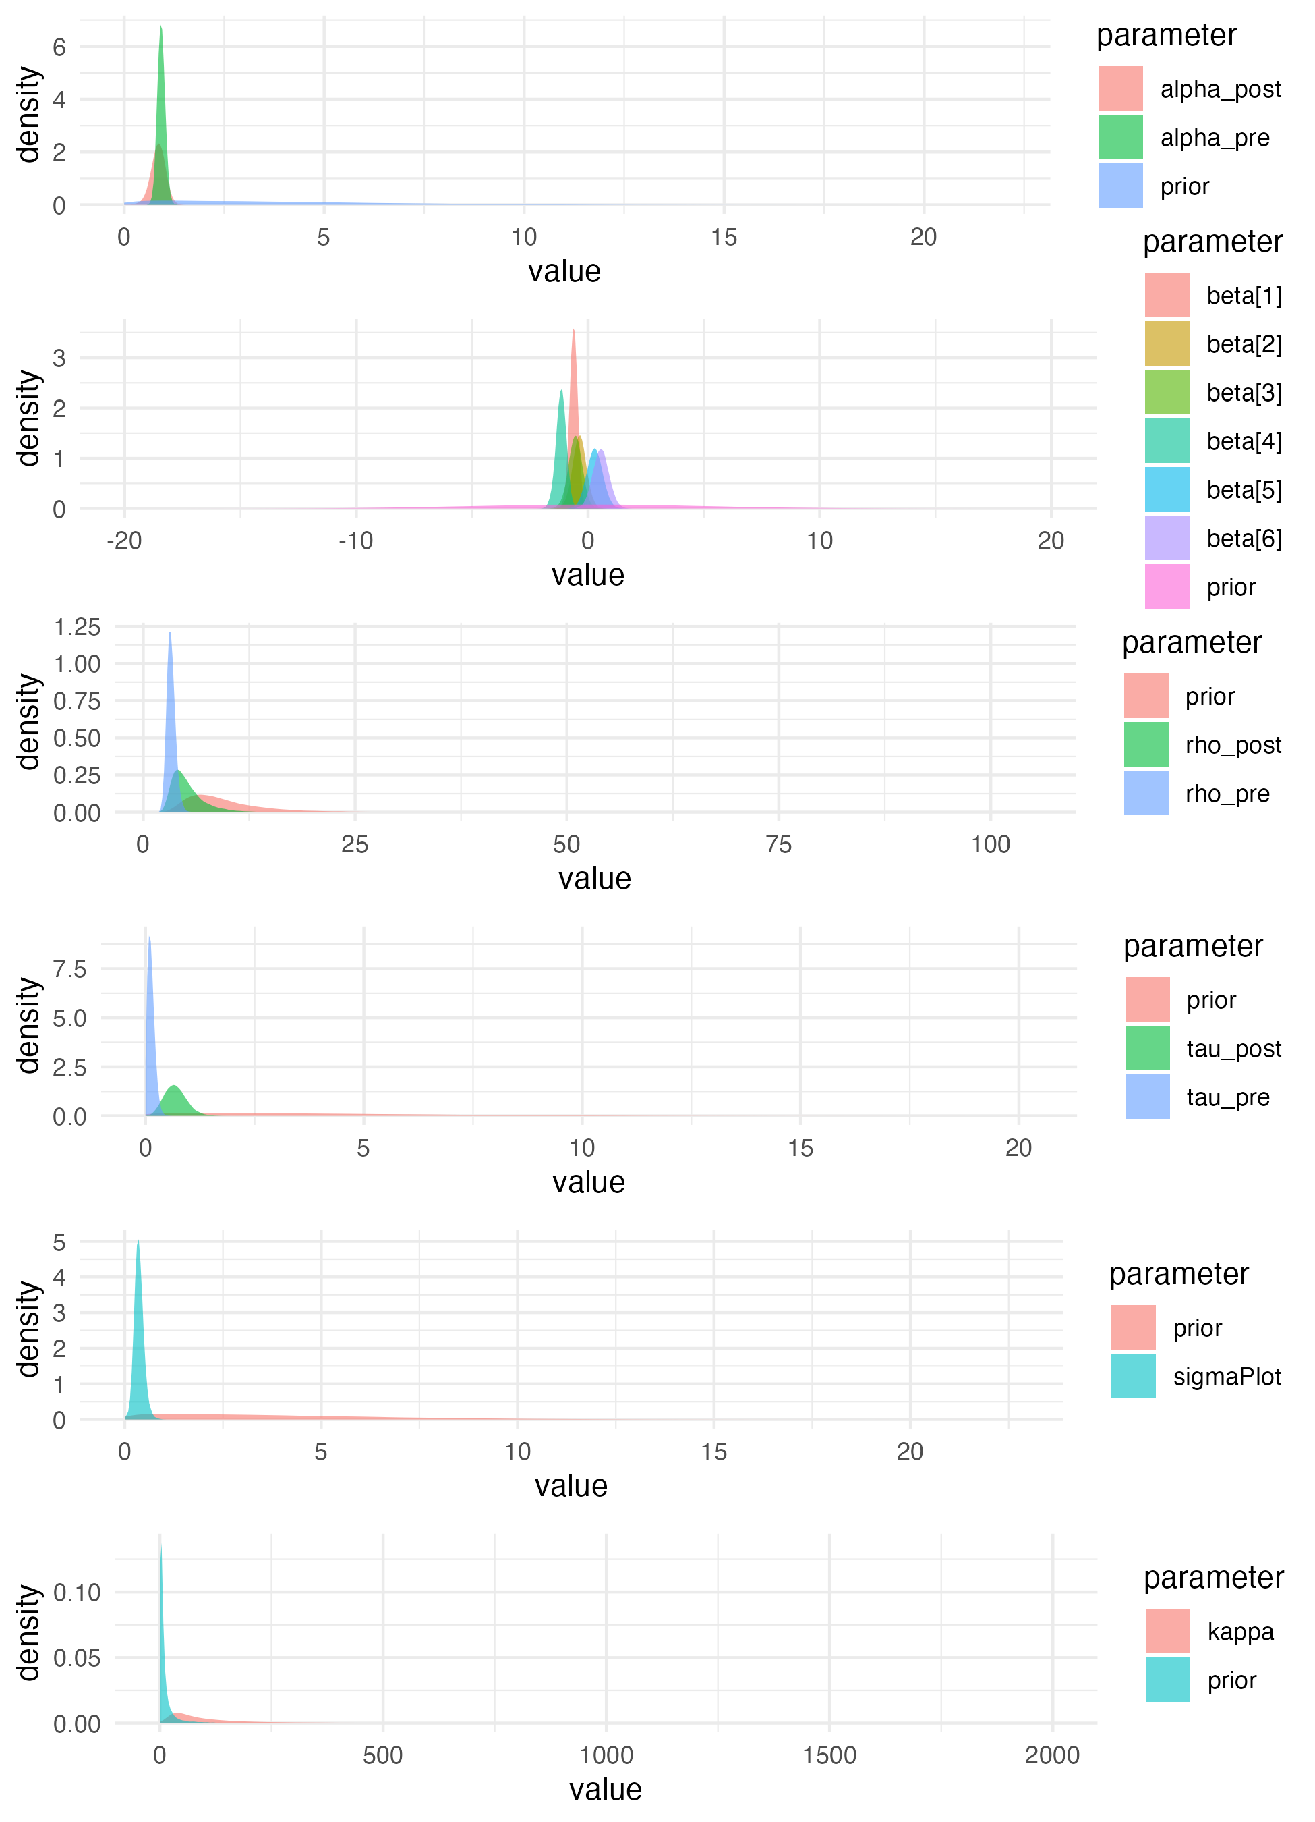
Supplementary Figure 4: Prior vs. posterior parameter distributions for all parameters in the model for 100-hour fine woody debris tallies. In most cases, there are clear differences between the prior and the posterior distributions, indicating that parameter estimates are strongly informed by the data, rather than the prior. However, the posterior distribution for $ρ_{post}$ substantially overlaps the prior, indicating that model estimates for that parameter were only moderately informed by the data, and may instead reflect prior assumptions.

Other diagnostics
The model for litter and duff depths performs well in making pointwise predictions of the training observations and the validation observations. wMAPE (MAE, mean) of the litter and duff depths is 0.30 (1.3 cm, 4.4 cm) on the training data and 0.29 (1.4 cm, 4.6 cm) on the validation data, and there is little or no bias in predicting depths (Supplementary Figure 5 and Supplementary Figure 7). However, the litter and duff observations exhibit an unmodeled tendency towards even-numbered values (Supplementary Figure 6 and Supplementary Figure 8), likely the result of observer bias.
For the 1-hour fine woody debris tallies the wMAPE (MAE, mean) values are 0.24 (2.4 particles, 9.9 particles) for the training data and 0.28 (2.5 particles, 8.9 particles) for the validation data. There is a mild bias towards underpredicting tallies above approximately 25 particles for both the training and validation datasets (Supplementary Figure 9 and Supplementary Figure 11) and the model underpredicts the frequency of 1- or 2-tally observations in both the training and validation datasets (Supplementary Figure 10 and Supplementary Figure 12).
The wMAPE values for the 10-hour fine woody debris tallies are slightly worse at 0.36 (1.0 particles, 2.9 particles) for the training data and 0.38 (1.0 particles, 2.5 particles) for the validation data. The 10-hour fine woody debris tallies model also tends to underpredict tallies above approximately 15 particles (Supplementary Figure 13 and Supplementary Figure 15). However, the frequency distribution of tallies predicted by the model is consistent with both the training and validation data (Supplementary Figure 14 and Supplementary Figure 16).
The wMAPE values for the 100-hour fine woody debris tallies are much worse at 0.78 (0.4 particles, 0.5 particles) for the training data and 0.70 (0.4 particles, 0.6 particles) for the validation data. The 100-hour fine woody debris tallies model tends to underpredict the observed tallies in the training, but not the validation data (Supplementary Figure 17 and Supplementary Figure 19). For both the training and validation datasets, the observed frequency distribution of tallies is consistent with model predictions (Supplementary Figure 18 and Supplementary Figure 20).

Dataset | Fuel Component | Statistic | value
Validation | Litter | MAE | 1.226
Validation | Litter | Mean | 2.421
Validation | Litter | wMAPE | 0.506
Validation | FWD1h | MAE | 3.838
Validation | FWD1h | Mean | 8.863
Validation | FWD1h | wMAPE | 0.433
Validation | FWD10h | MAE | 1.524
Validation | FWD10h | Mean | 2.546
Validation | FWD10h | wMAPE | 0.599
Validation | FWD100h | MAE | 0.655
Validation | FWD100h | Mean | 0.608
Validation | FWD100h | wMAPE | 1.077
Training | Litter | MAE | 0.884
Training | Litter | Mean | 2.501
Training | Litter | wMAPE | 0.353
Training | FWD1h | MAE | 2.373
Training | FWD1h | Mean | 9.902
Training | FWD1h | wMAPE | 0.240
Training | FWD10h | MAE | 1.020
Training | FWD10h | Mean | 2.877
Training | FWD10h | wMAPE | 0.355
Training | FWD100h | MAE | 0.391
Training | FWD100h | Mean | 0.504
Training | FWD100h | wMAPE | 0.777
Supplementary Table 1: Error statistics for predictions from the Litter, 1-hour FWD, 10-hour FWD, and 100-hour FWD models. Error statistics presented are described in the manuscript, and findings described in the above text.

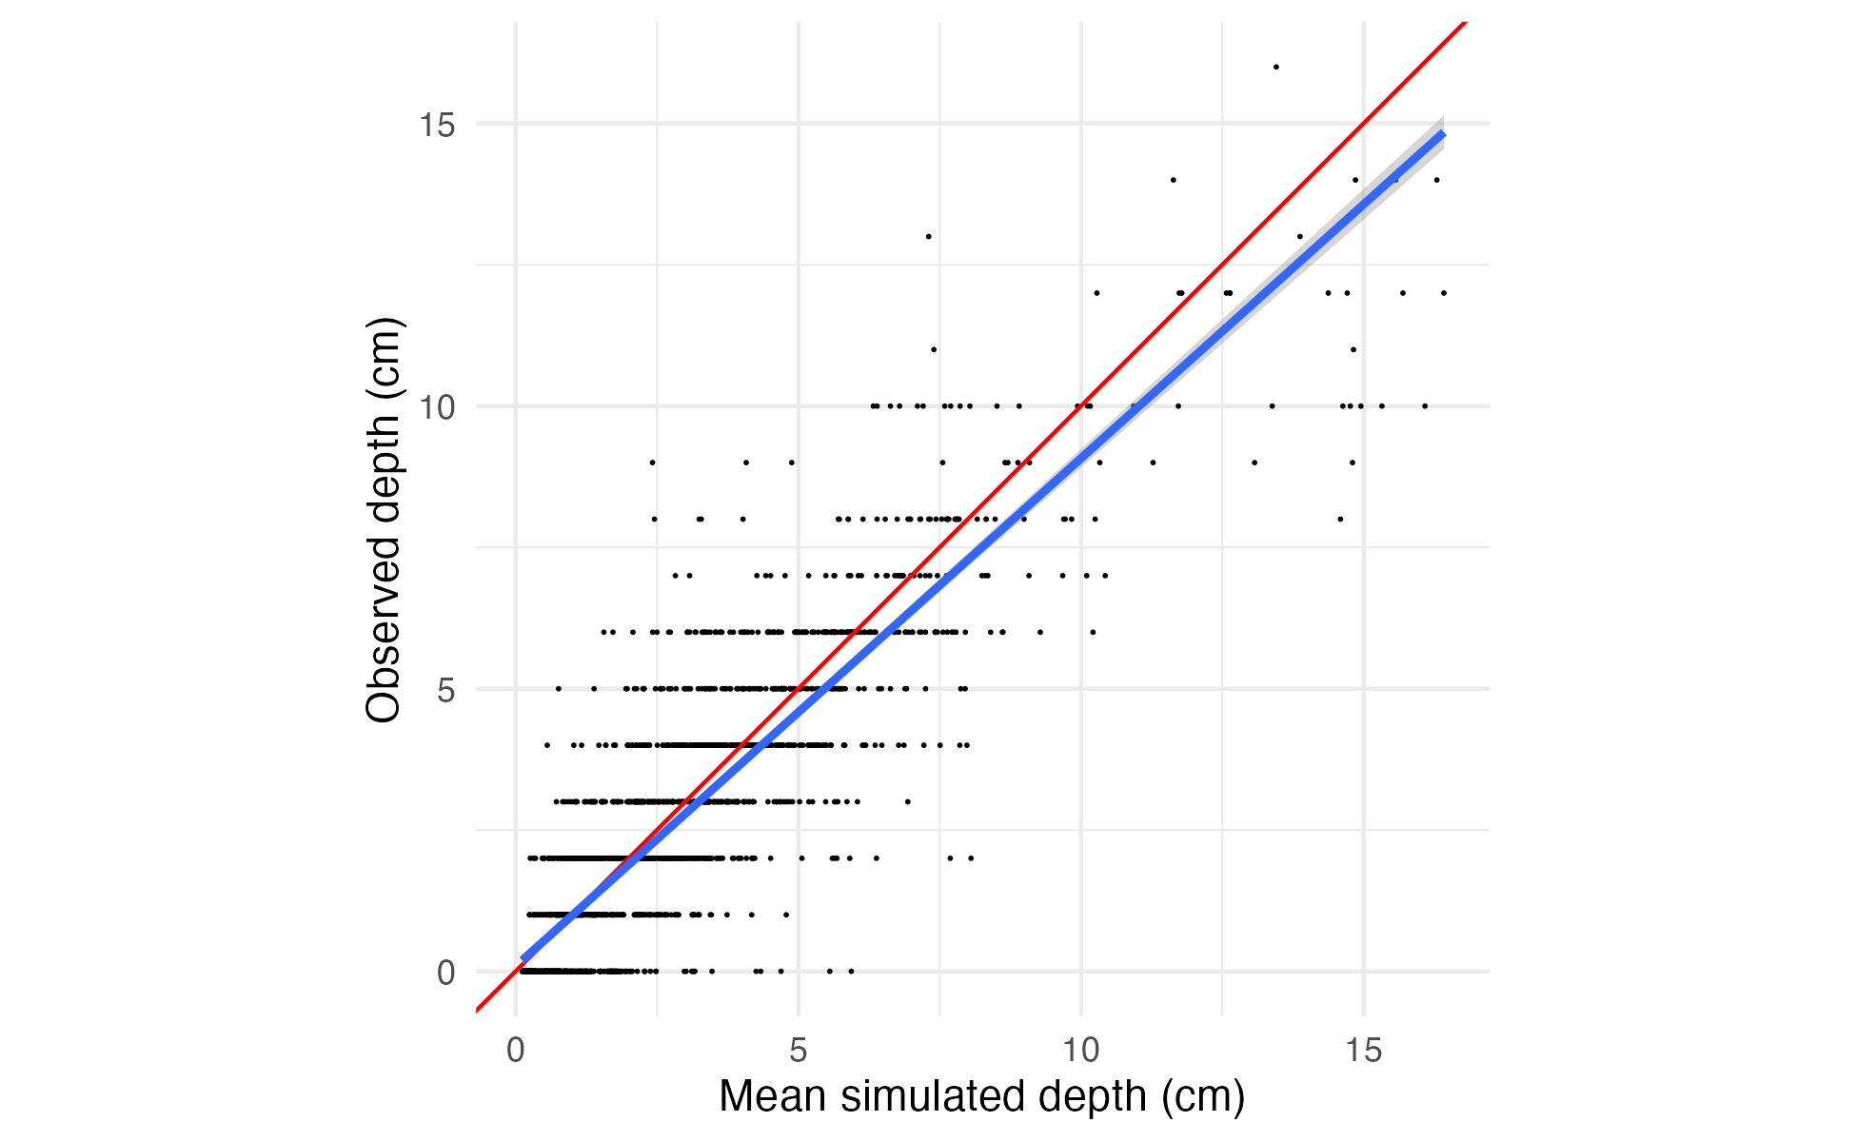
Supplementary Figure 5: Comparison between mean simulated litter depth and observed depth for the training dataset. For each of the first 4,000 draws of the posterior, litter depth was simulated for every sample in the training data. Each black point is an observed depth, plotted with its mean simulated value on the X-axis and its observed value on the Y-axis. A 1:1 line is plotted in red, and the actual linear relationship between (mean) simulated and observed counts in blue. Model predictions appear to be unbiased (slope between simulated and real data is very close to 1).

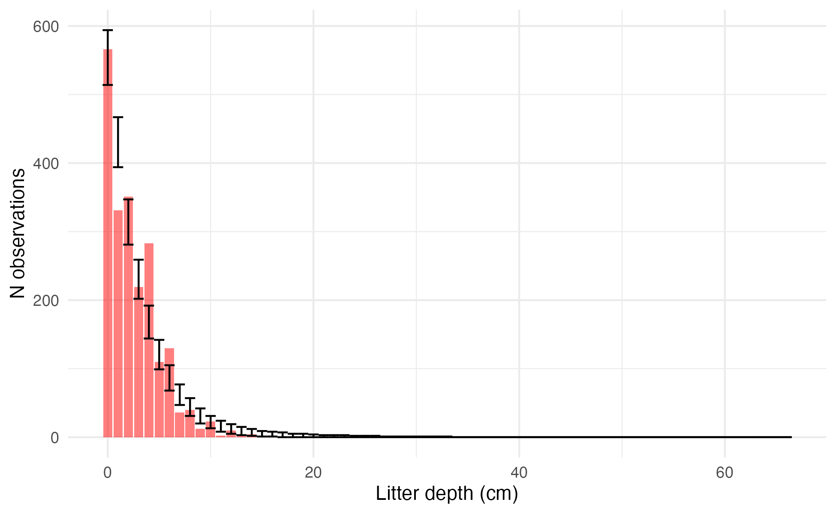
Supplementary Figure 6: Comparison of observed and simulated distribution of litter depths for the training dataset. For each of the first 4,000 draws of the posterior, litter depth was simulated for every sample in the training data. The observed frequencies are plotted as a histogram in red, with the observed value on the X-axis and the count of observations having that depth value on the Y-axis. The 2.5th and 97.5th percentiles of the count of samples for each depth value across all posterior draws are shown as the error bars. The model simulations broadly match the training data, though there is an unmodeled preference in the training data for even-numbered values of depth (even depth values appear more frequently than odd ones).

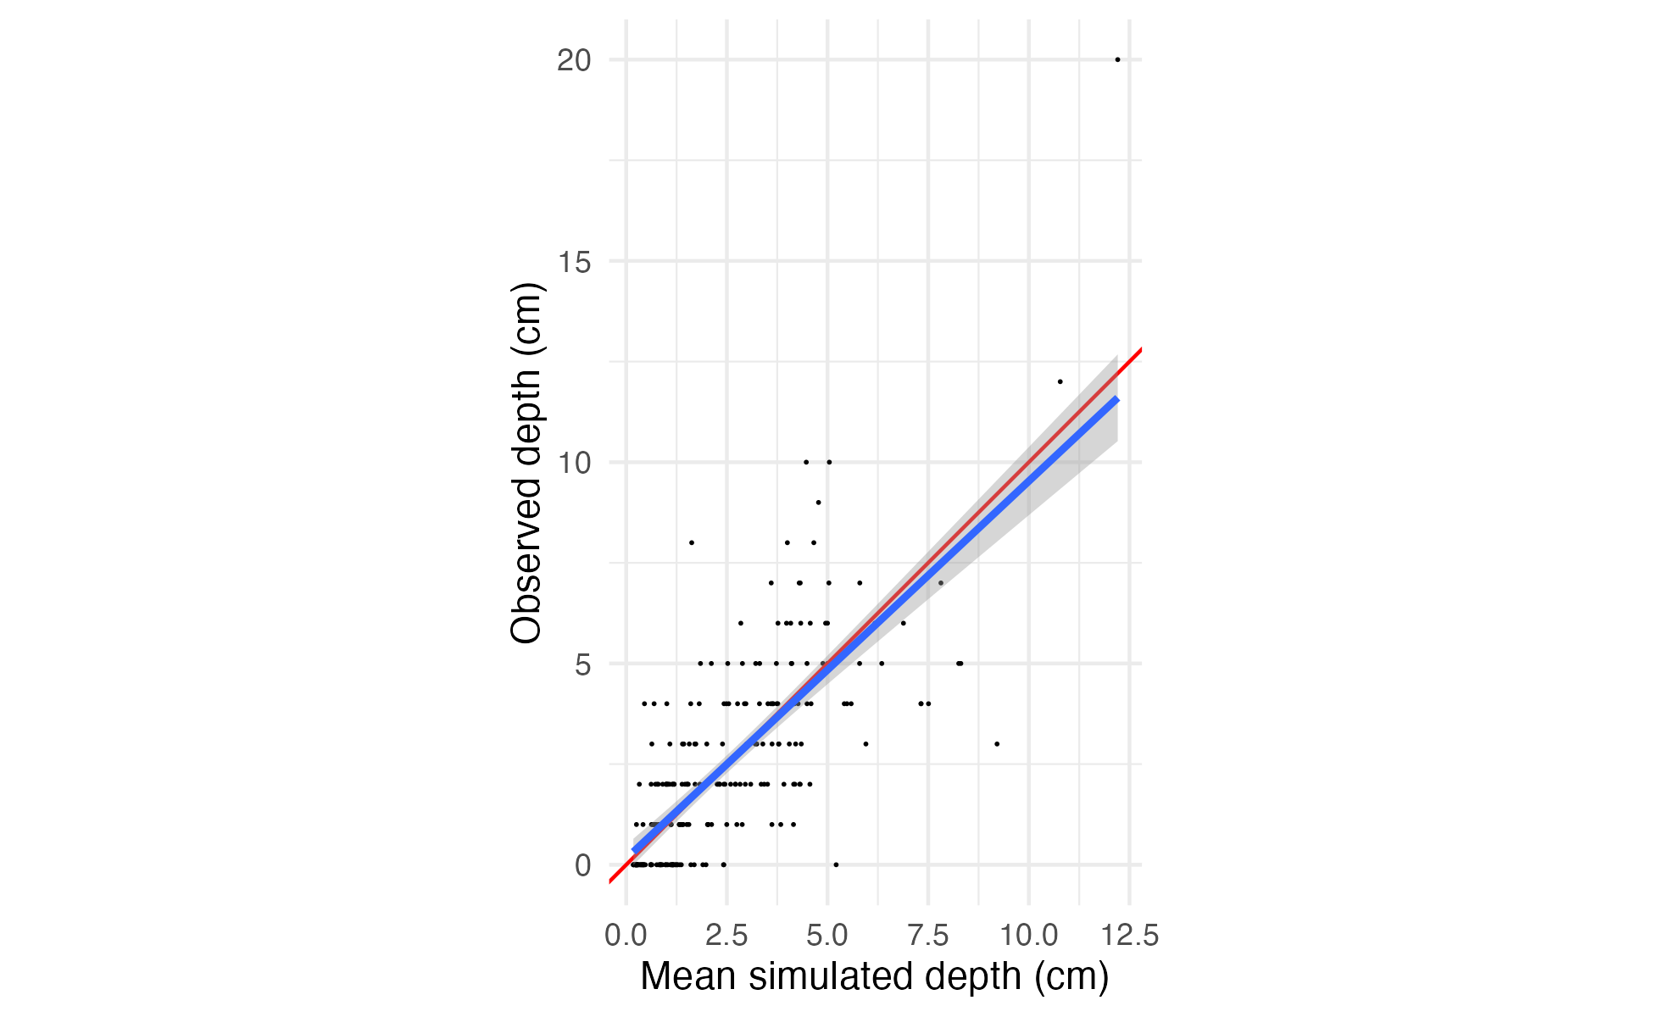
Supplementary Figure 7: Comparison between mean simulated litter depth and observed depth for the validation dataset. For each of the first 4,000 draws of the posterior, litter depth was simulated for every sample in the validation data. Each black point is an observed depth, plotted with its mean simulated value on the X-axis and its observed value on the Y-axis . A 1:1 line is plotted in red, and the actual linear relationship between (mean) simulated and observed counts in blue. Model predictions appear to be unbiased (slope between simulated and real data is very close to 1).

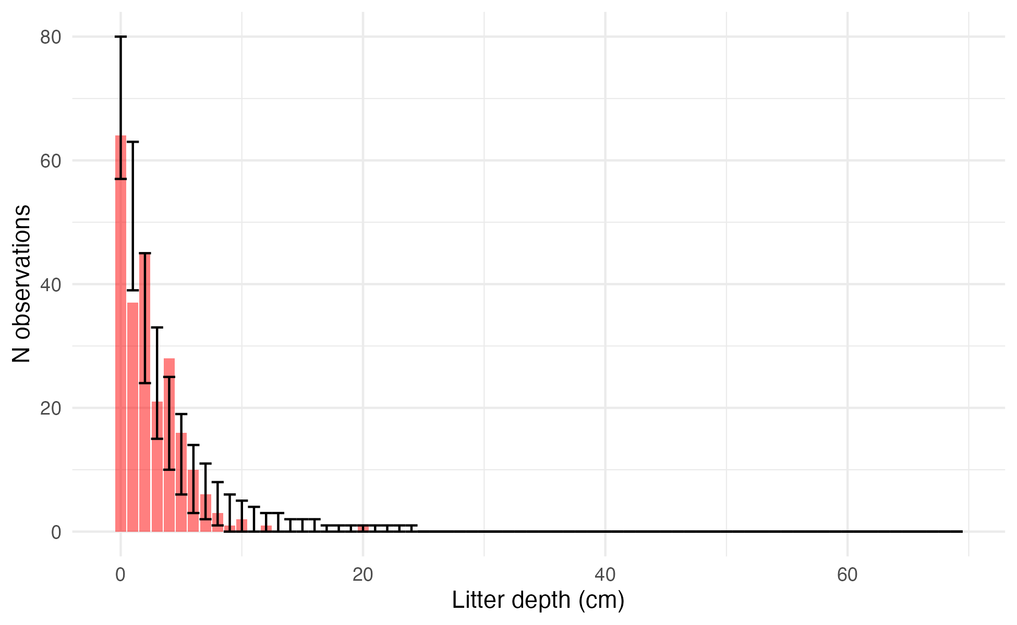
Supplementary Figure 8: Comparison of observed and simulated distribution of litter depths for the validation dataset. For each of the first 4,000 draws of the posterior, litter depth was simulated for every sample in the validation data. The observed frequencies are plotted as a histogram in red, with the observed value on the X-axis and the count of observations having that depth value on the Y-axis. The 2.5th and 97.5th percentiles of the count of samples for each depth value across all posterior draws are shown as the error bars. The model simulations broadly match the training data, though again there is an unmodeled preference in the training data for even values of depth (even depth values appear more frequently than odd ones).
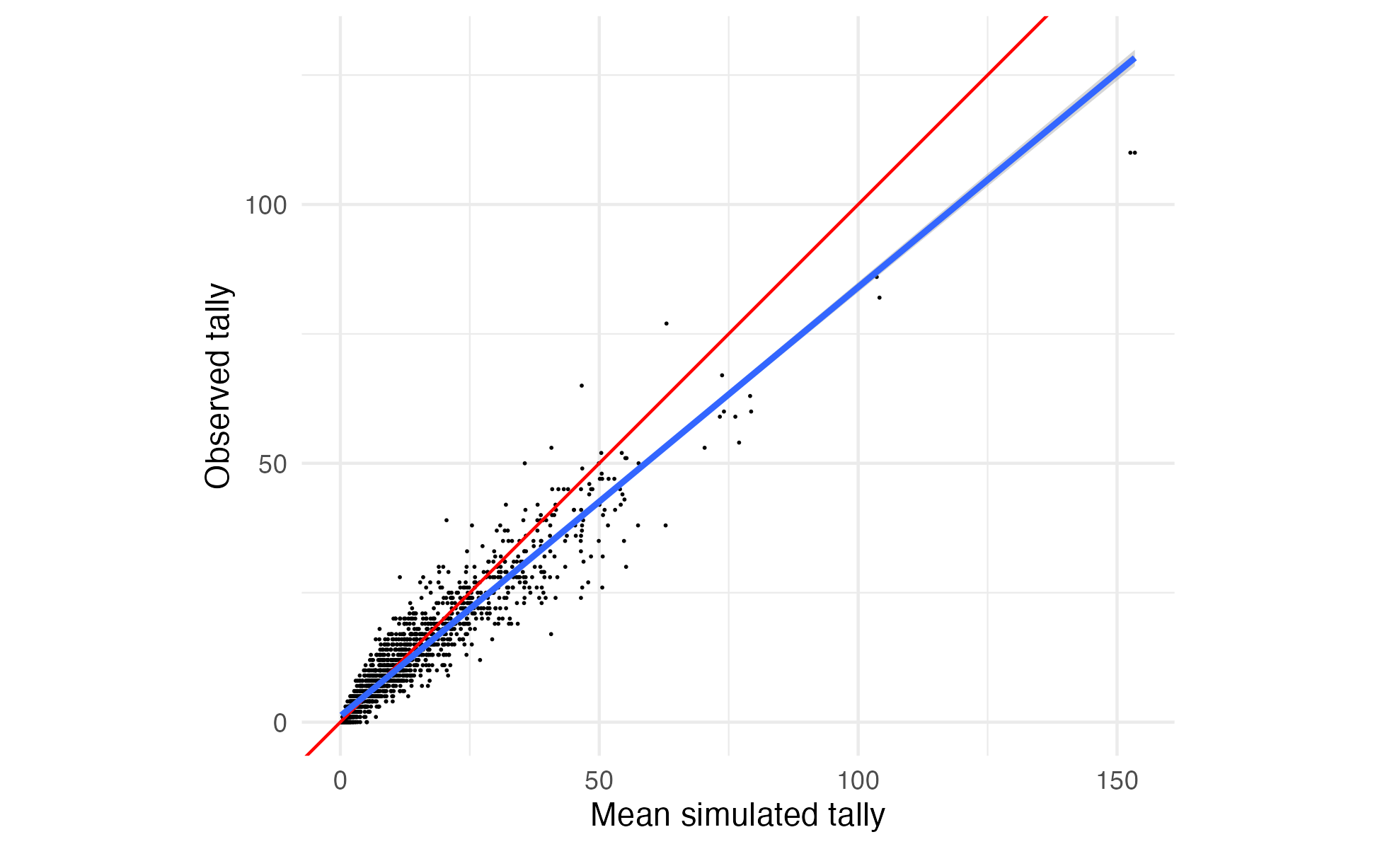
Supplementary Figure 9: Comparison between mean simulated 1-hour FWD tallies and observed tallies for the training dataset. For each of the first 4,000 draws of the posterior, 1-hour FWD tally was simulated for every sample in the training data. Each black point is an observed sample, plotted with its mean posterior predicted value on the X-axis and its observed value on the Y-axis. A 1:1 line is plotted in red, and the actual linear relationship between (mean) simulated and observed counts in blue. Again, there appears to be a mild bias towards overprediction for larger counts, with the observed values generally falling below the mean predicted value for predicted counts greater than ~25.

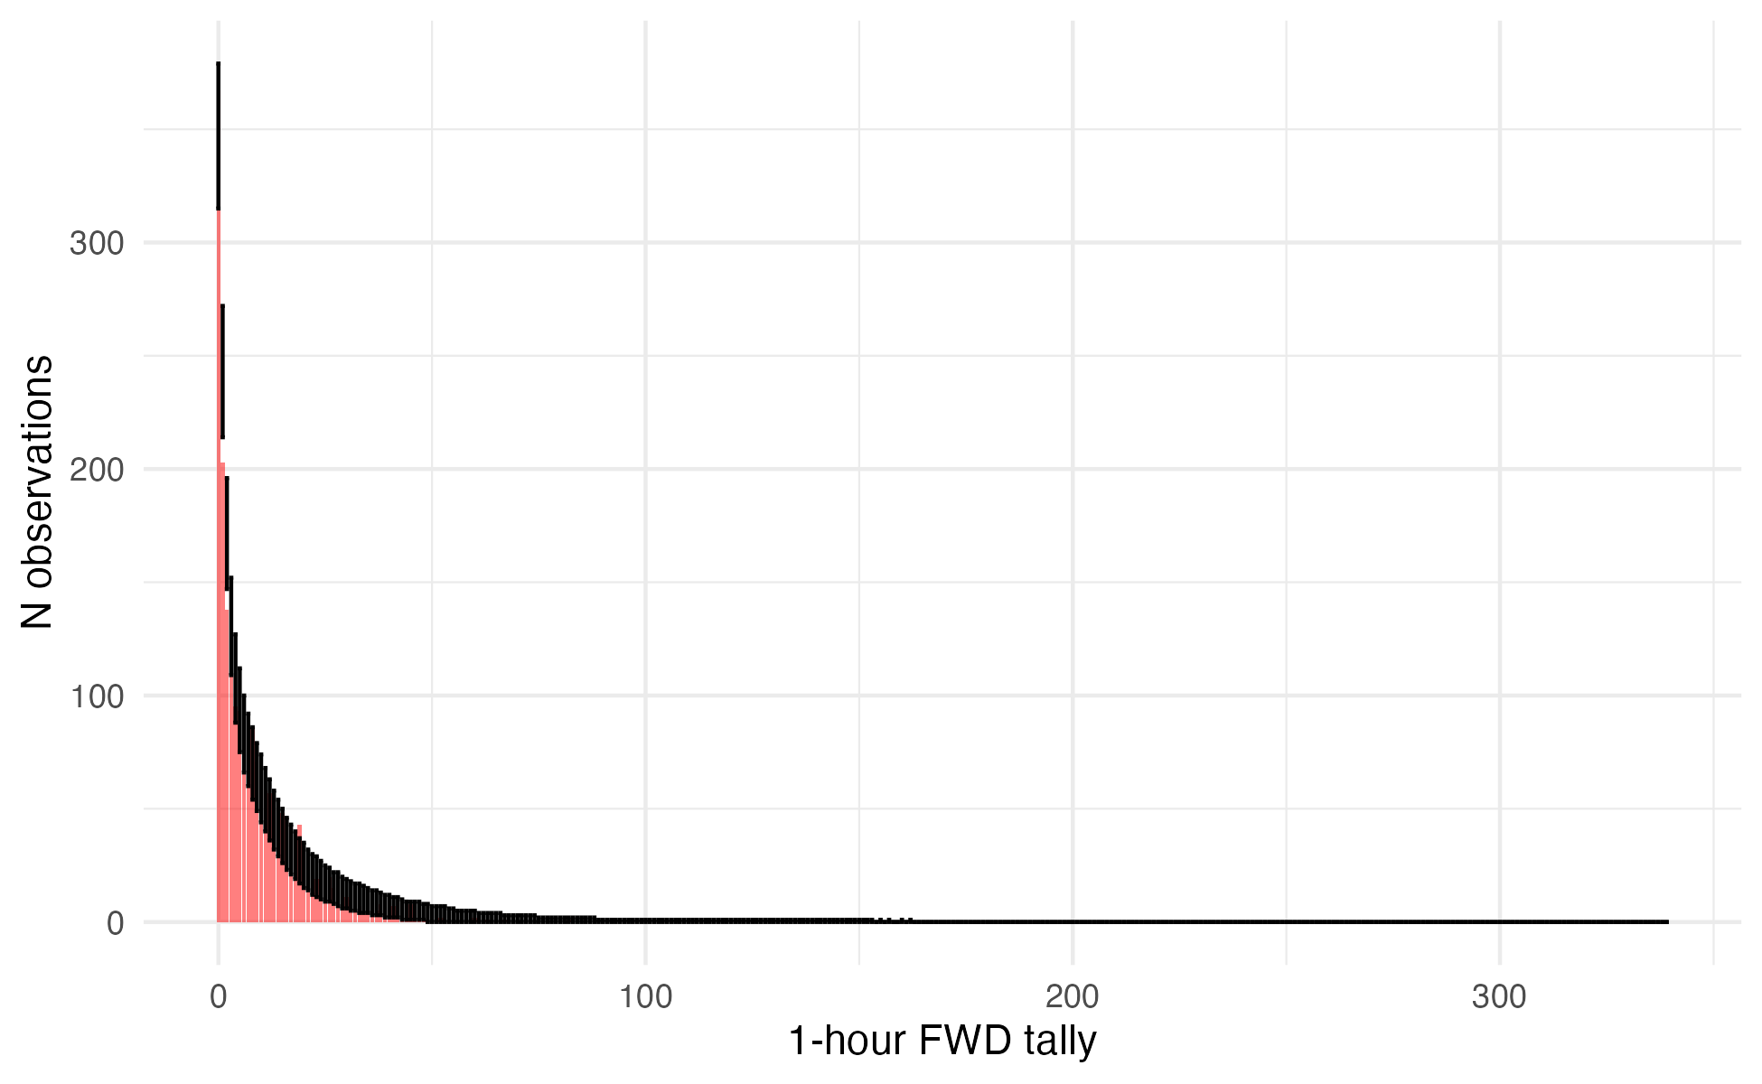
Supplementary Figure 10: Comparison of observed and simulated distribution of 1-hour FWD tallies for the training dataset. For each of the first 4,000 draws of the posterior, 1-hour FWD tally was simulated for every sample in the training data. The observed frequencies are plotted as a histogram in red, with the observed value on the X-axis and the count of observations having that tally value on the Y-axis. The 2.5th and 97.5th percentiles of the count of samples for each tally value across all posterior draws are shown as the error bars. The observed data generally fall within the range of behaviors predicted by the model, but there are fewer observations with a value of 1 or 2 tallies than the model predicts.

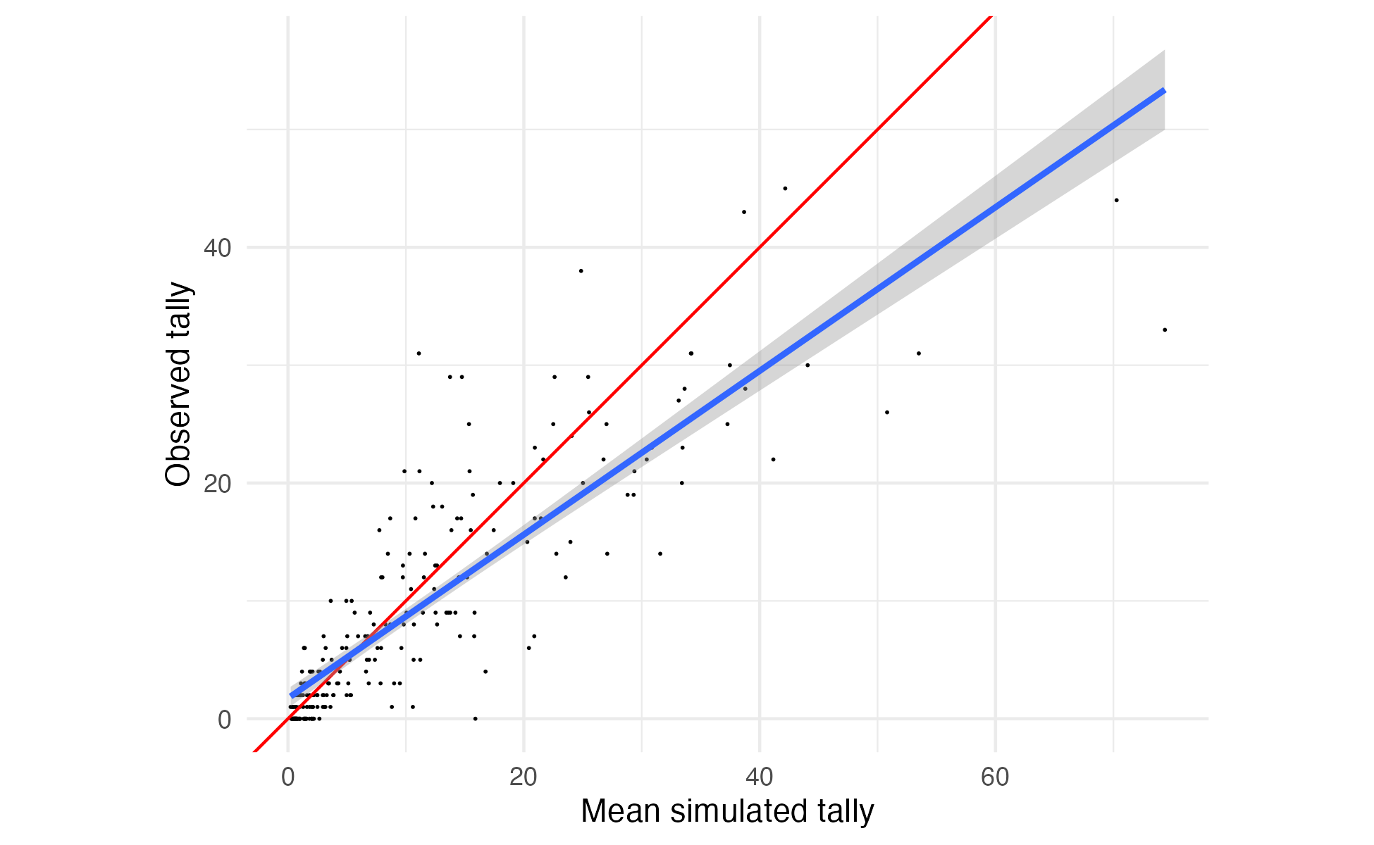
Supplementary Figure 11: Comparison between mean simulated 1-hour FWD tallies and observed tallies for the validation dataset. For each of the first 4,000 draws of the posterior, 1-hour FWD tally was simulated for every sample in the validation data. Each black point is an observed sample, plotted with its mean posterior predicted value on the X-axis and its observed value on the Y-axis. A 1:1 line is plotted in red, and the actual linear relationship between (mean) simulated and observed counts in blue. The simulated values show a mild bias towards overprediction of the observed counts above ~7, and a mild bias towards underprediction of observed counts below ~7.

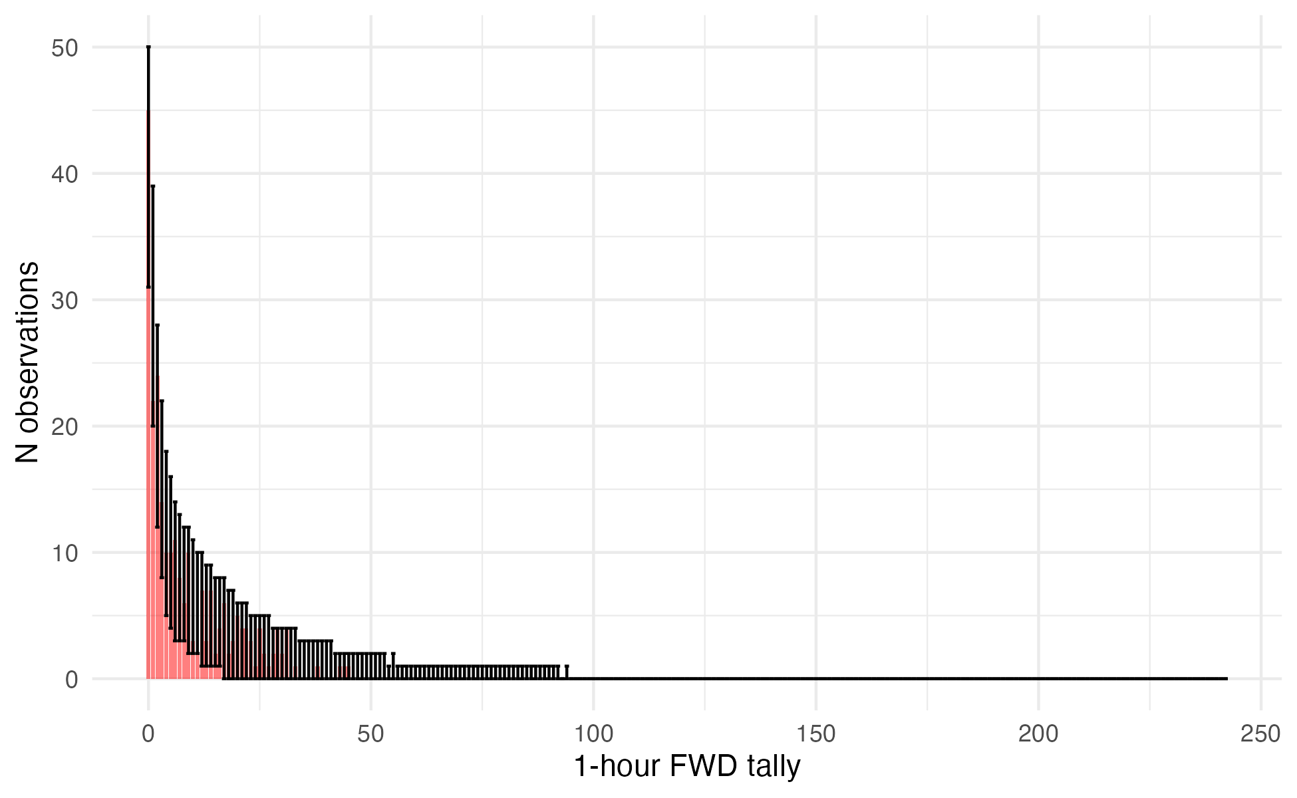
Supplementary Figure 12: Comparison of observed and simulated distribution of 1-hour FWD tallies for the validation dataset. For each of the first 4,000 draws of the posterior, 1-hour FWD tally was simulated for every sample in the validation data. The observed frequencies are plotted as a histogram in red, with the observed value on the X-axis and the count of observations having that tally value on the Y-axis. The 2.5th and 97.5th percentiles of the count of samples for each tally value across all posterior draws are shown as the error bars. The observed data fall within the range of behaviors predicted by the model.

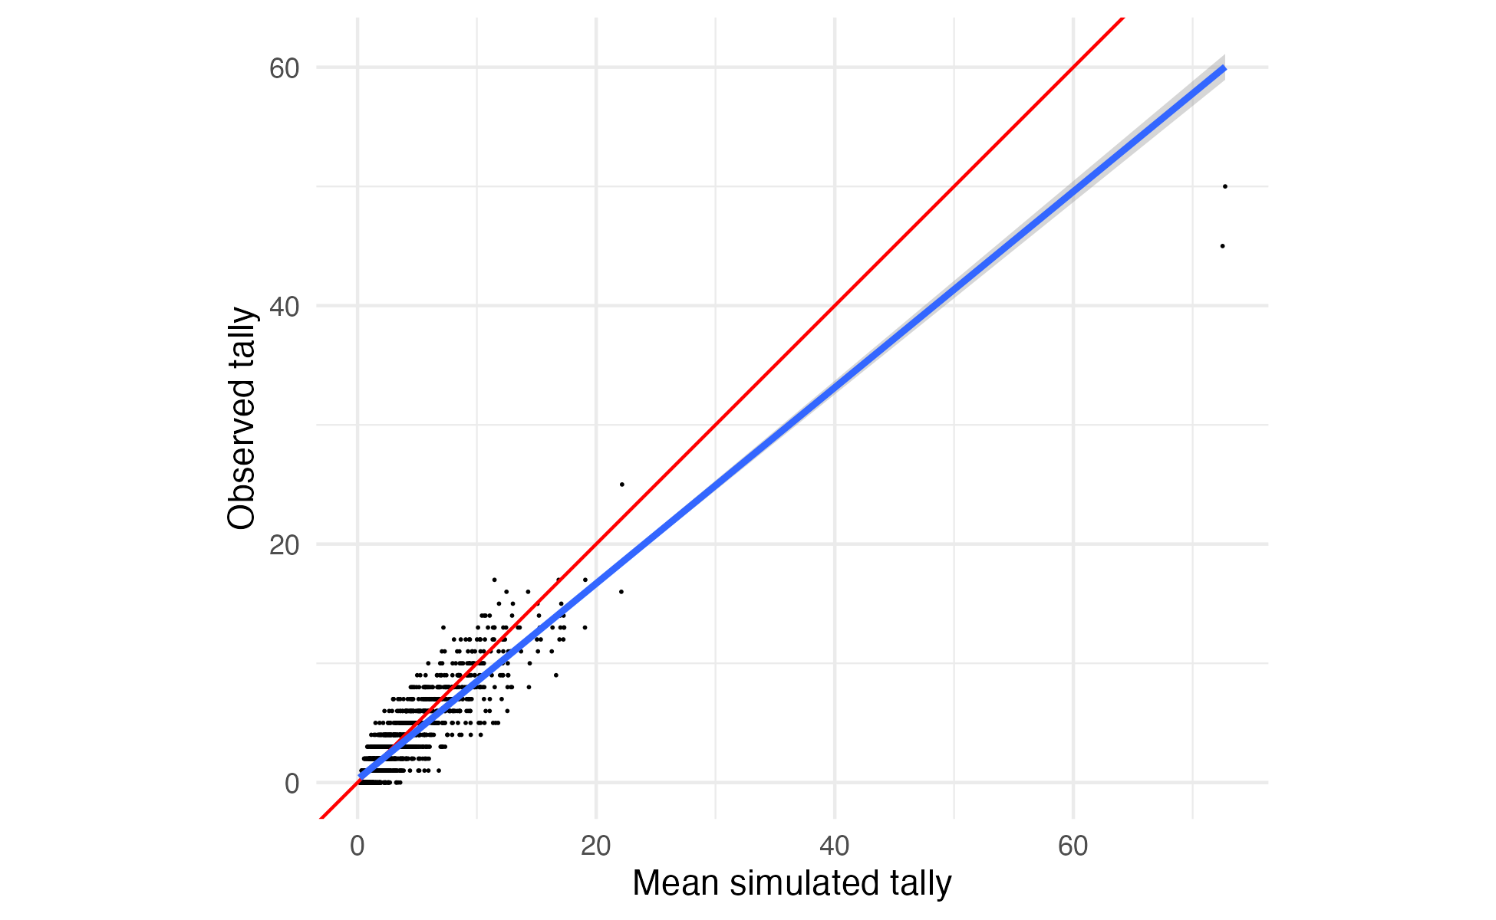
Supplementary Figure 13: Comparison between mean simulated 10-hour FWD tallies and observed tallies for the training dataset. For each of the first 4,000 draws of the posterior, 10-hour FWD tally was simulated for every sample in the training data. Each black point is an observed sample, plotted with its mean posterior predicted value on the X-axis and its observed value on the Y-axis. A 1:1 line is plotted in red, and the actual linear relationship between (mean) simulated and observed counts in blue. Again, there appears to be a mild bias towards overprediction for larger counts, with the observed values generally falling below the mean predicted value for predicted counts greater than ~25.

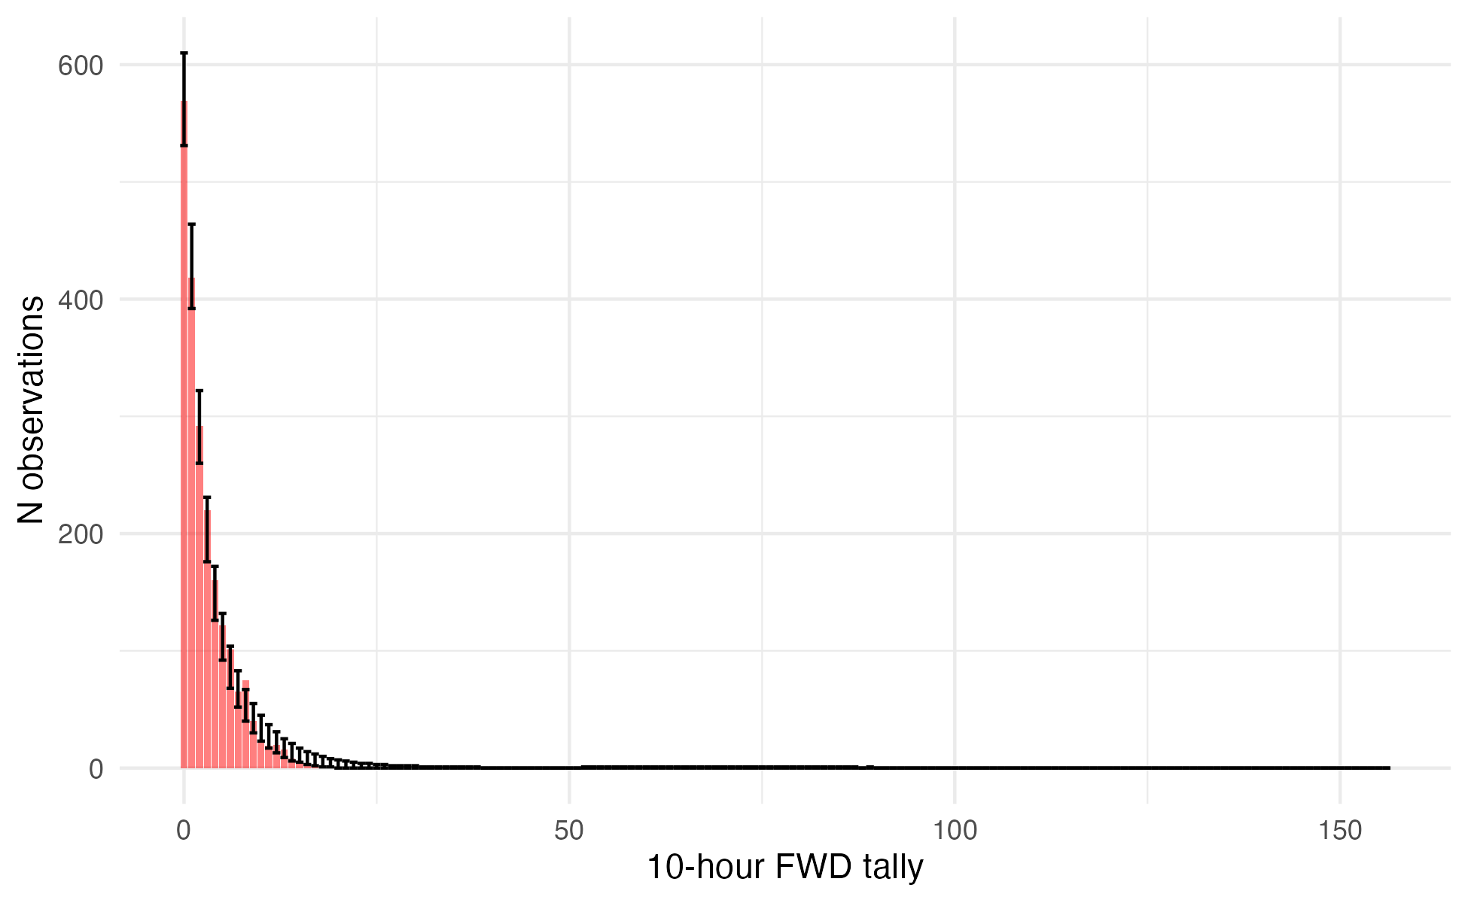
Supplementary Figure 14: Comparison of observed and simulated distribution of 10-hour FWD tallies for the training dataset. For each of the first 4,000 draws of the posterior, 10-hour FWD tally was simulated for every sample in the training data. The observed frequencies are plotted as a histogram in red, with the observed value on the X-axis and the count of observations having that tally value on the Y-axis. The 2.5th and 97.5th percentiles of the count of samples for each tally value across all posterior draws are shown as the error bars. The observed data fall within the range of behaviors predicted by the model.

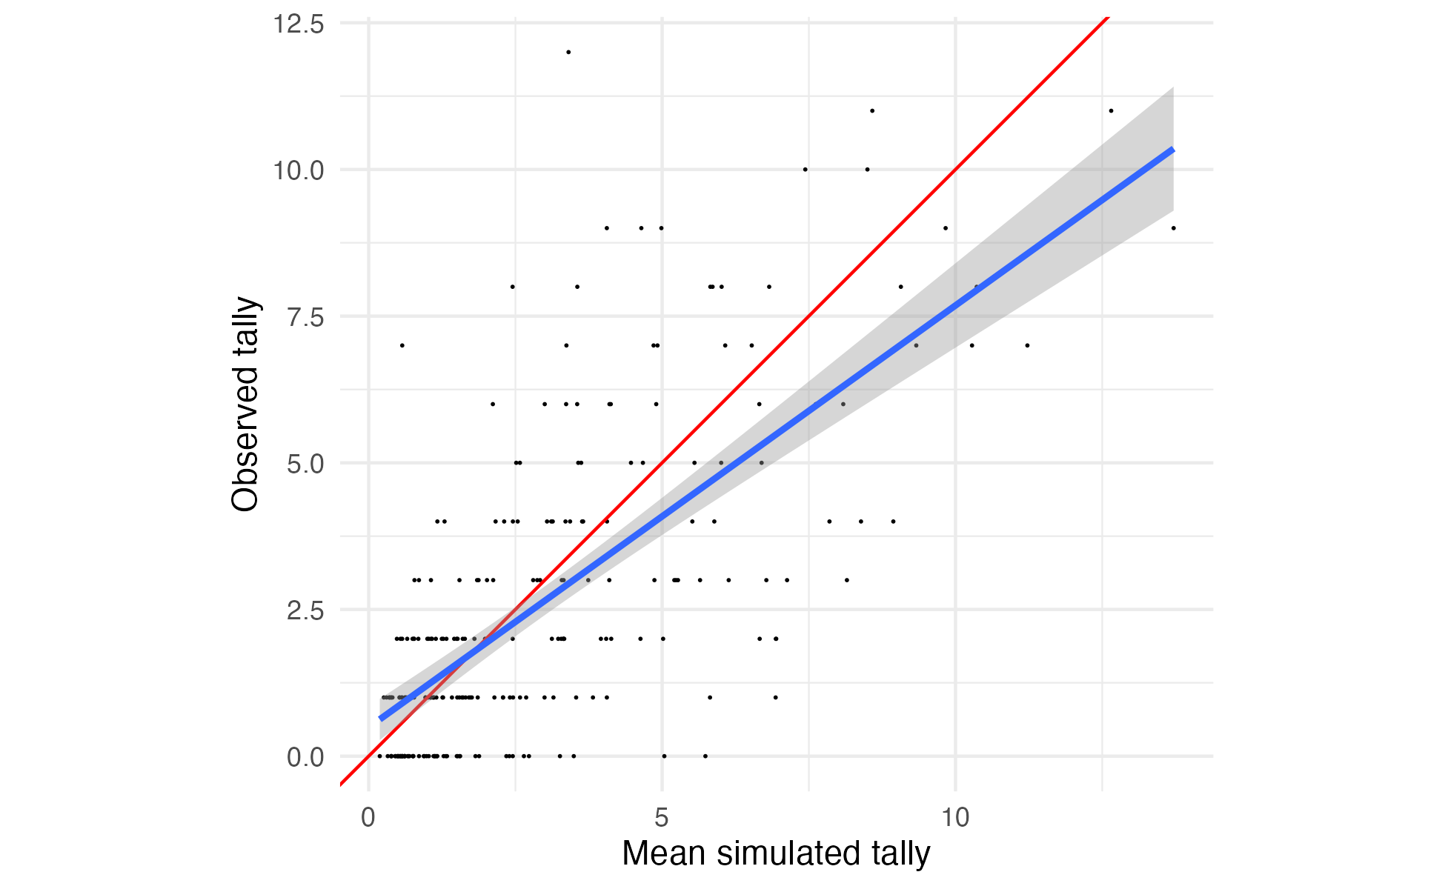
Supplementary Figure 15: Comparison between mean simulated 10-hour FWD tallies and observed tallies for the validation dataset. For each of the first 4,000 draws of the posterior, 10-hour FWD tally was simulated for every sample in the validation data. Each black point is an observed sample, plotted with its mean posterior predicted value on the X-axis and its observed value on the Y-axis. A 1:1 line is plotted in red, and the actual linear relationship between (mean) simulated and observed counts in blue. The simulated values show a mild bias towards overprediction of the observed counts above ~5.

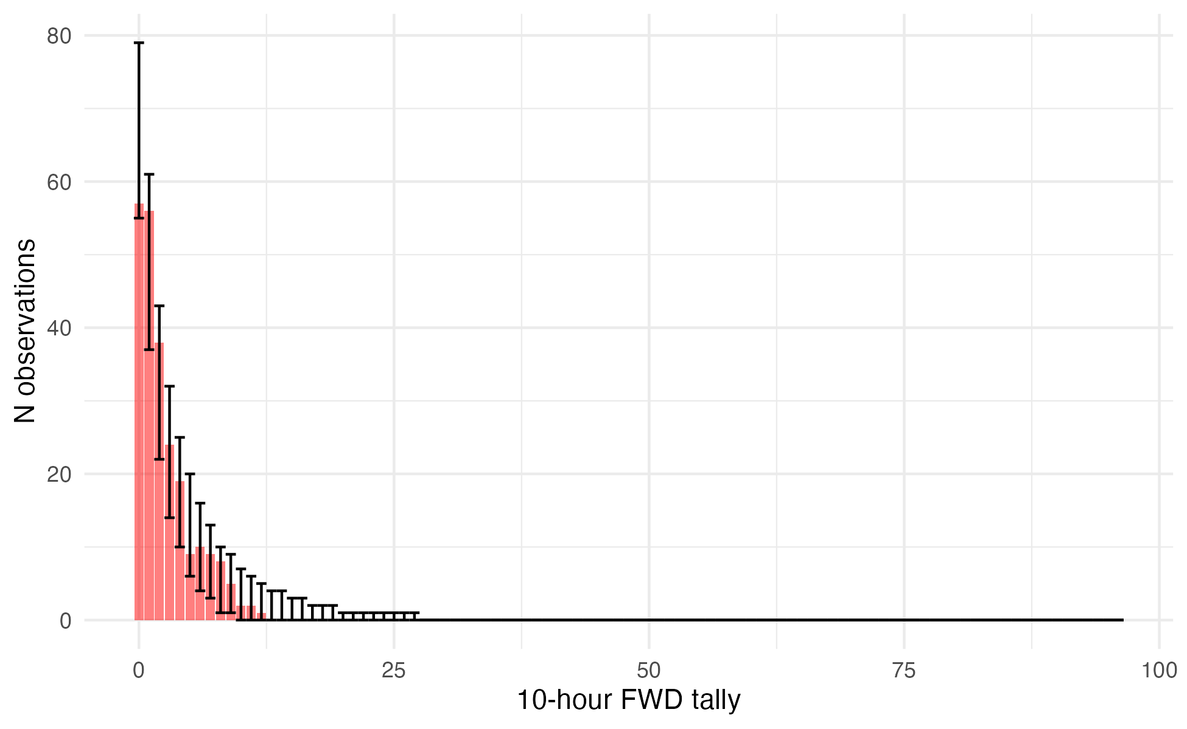
Supplementary Figure 16: Comparison of observed and simulated distribution of 10-hour FWD tallies for the validation dataset. For each of the first 4,000 draws of the posterior, 10-hour FWD tally was simulated for every sample in the validation data. The observed frequencies are plotted as a histogram in red, with the observed value on the X-axis and the count of observations having that tally value on the Y-axis. The 2.5th and 97.5th percentiles of the count of samples for each tally value across all posterior draws are shown as the error bars. The observed data fall within the range of behaviors predicted by the model.

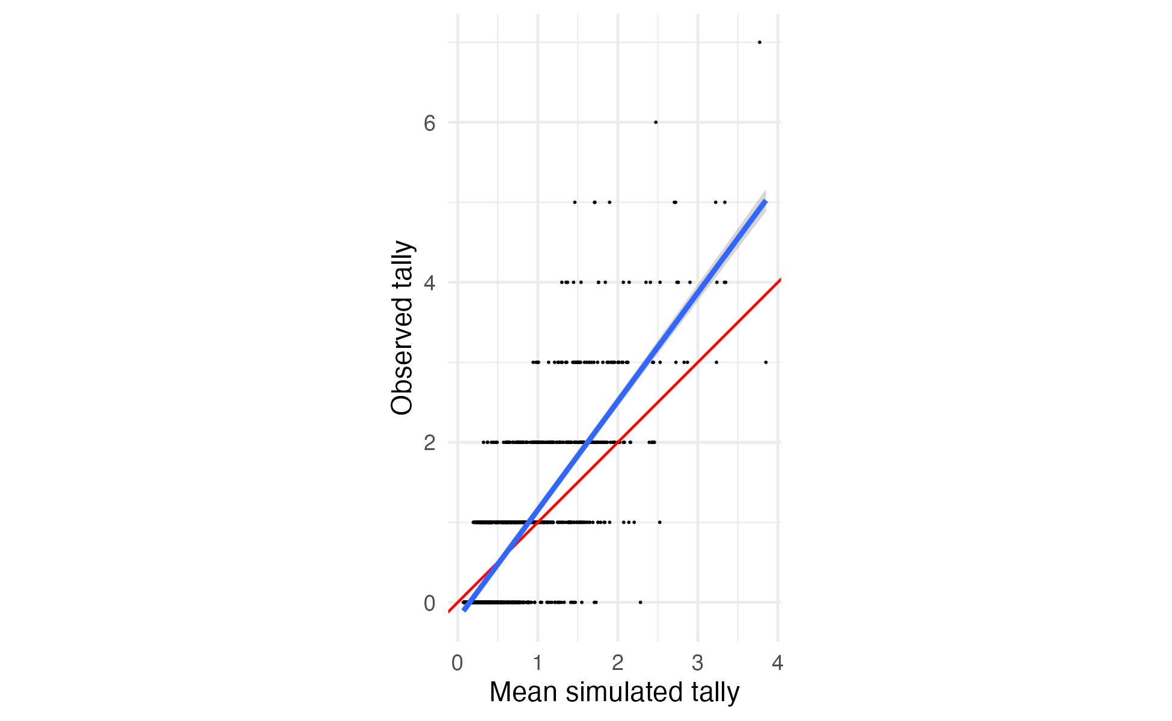
Supplementary Figure 17: Comparison between mean simulated 100-hour FWD tallies and observed tallies for the training dataset. For each of the first 4,000 draws of the posterior, 100-hour FWD tally was simulated for every sample in the training data. Each black point is an observed sample, plotted with its mean posterior predicted value on the X-axis and its observed value on the Y-axis. A 1:1 line is plotted in red, and the actual linear relationship between (mean) simulated and observed counts in blue. Again, there appears to be a mild bias towards underprediction, with the observed values generally falling above the mean predicted value for predicted values greater than approximately 0.5.

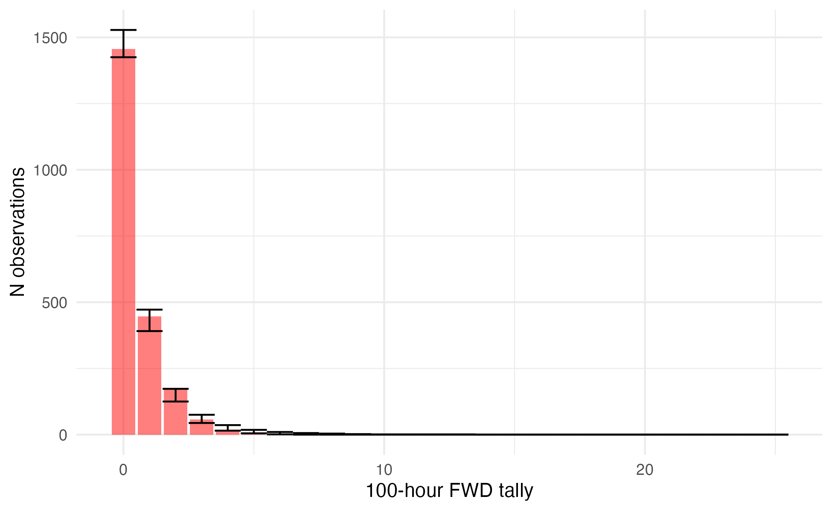
Supplementary Figure 18: Comparison of observed and simulated distribution of 100-hour FWD tallies for the training dataset. For each of the first 4,000 draws of the posterior, 100-hour FWD tally was simulated for every sample in the training data. The observed frequencies are plotted as a histogram in red, with the observed value on the X-axis and the count of observations having that tally value on the Y-axis. The 2.5th and 97.5th percentiles of the count of samples for each tally value across all posterior draws are shown as the error bars. The observed data fall within the range of behaviors predicted by the model.

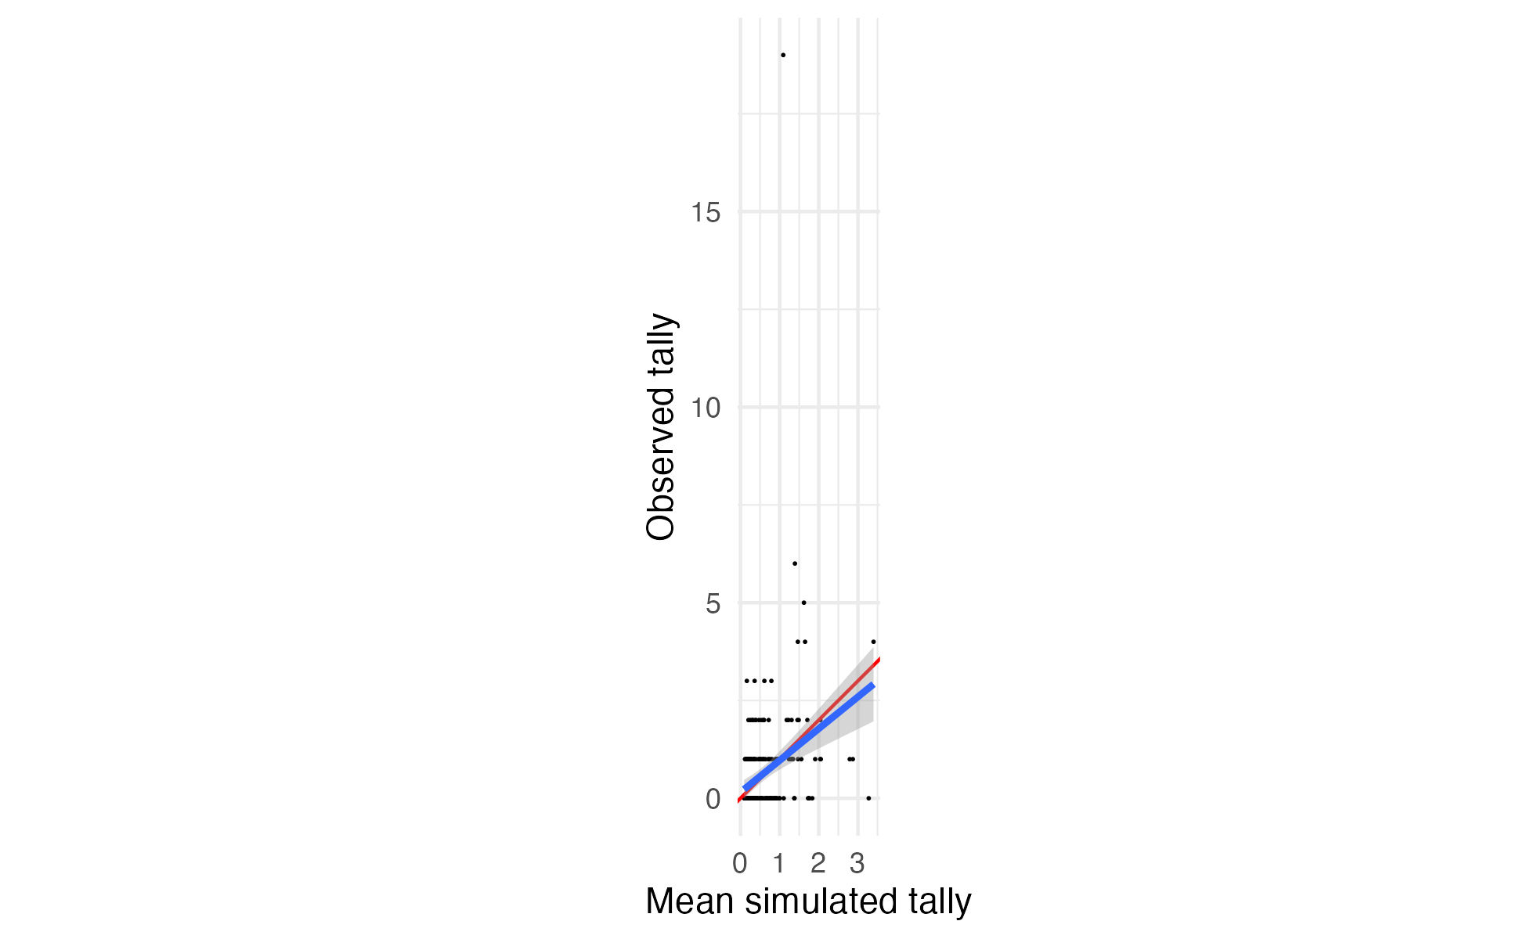
Supplementary Figure 19 Comparison between mean simulated 100-hour FWD tallies and observed tallies for the validation dataset. For each of the first 4,000 draws of the posterior, 100-hour FWD tally was simulated for every sample in the validation data. Each black point is an observed sample, plotted with its mean posterior predicted value on the X-axis and its observed value on the Y-axis. A 1:1 line is plotted in red, and the actual linear relationship between (mean) simulated and observed counts in blue. The simulated values show a mild bias towards underprediction of the observed counts.

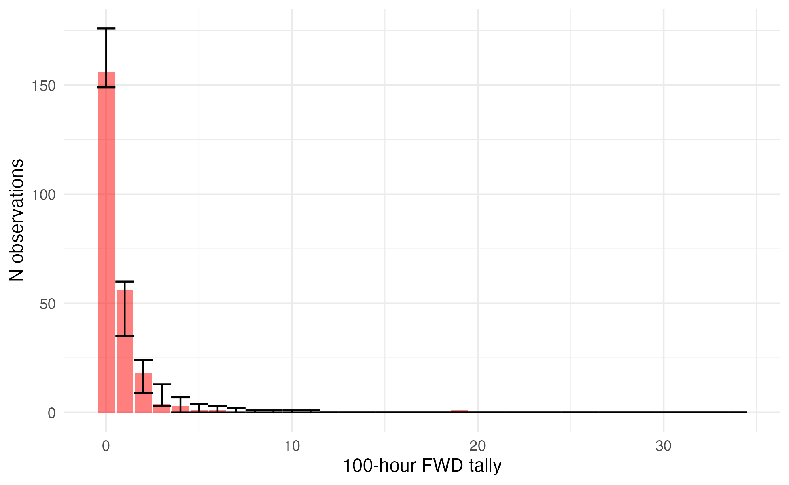
Supplementary Figure 20: Comparison of observed and simulated distribution of 100-hour FWD tallies for the validation dataset. For each of the first 4,000 draws of the posterior, 100-hour FWD tally was simulated for every sample in the validation data. The observed frequencies are plotted as a histogram in red, with the observed value on the X-axis and the count of observations having that tally value on the Y-axis. The 2.5th and 97.5th percentiles of the count of samples for each tally value across all posterior draws are shown as the error bars. The observed data fall within the range of behaviors predicted by the model.

