Beyond fuel reduction: Prescribed fires alter spatial pattern of wildland fuels

Abstract
Pattern-process feedbacks characterize the relationship between the fine-scale spatial pattern of forest ecosystems and the disturbance process of fire. Fine-scale spatial variation in surface fuels is an important, but poorly understood, axis of forest structure in forests adapted to frequent fire. In this study, we applied generalized linear mixed effects models with gaussian process random effects describing fine-scale spatial variation to describe the spatial pattern of litter and duff and fine woody debris, both before and after three replicate prescribed fires in a Sierra Nevada mixed conifer forest. We find that prescribed fire altered not just on fuel loading, but on the fine-scale spatial pattern of fuels. Prescribed fire increased the magnitude of fine-scale spatial autocorrelation for litter and duff, 1-hour fine woody debris, and 10-hour fine woody debris. The burns decreased the length-scale of spatial autocorrelation for litter and duff, increased it for 1-hour fuels, and did not change it for 10-hour fuels. The gaussian process noise parameter increased for 1-hour fuels as a result of the prescribed burns. Changes to the fine-scale spatial pattern of surface fuels are likely to impact the behavior of future fires and the ecological function of these forests.

Introduction
Dry conifer forests across much of the western United States are facing challenges associated with a disrupted disturbance regime. In this context, a warming climate has combined with structural changes associated with a century of effective fire suppression to disrupt the disturbance regime which historically maintained these forests (Alizadeh et al., 2021; Liang et al., 2017; Westerling et al., 2006, 2011). The mixed conifer forests (MCF) which are extensive throughout the Sierra Nevada, Klamath, and Cascades mountain ranges were historically preserved by a regime of high frequency and mixed severity wildfires (Hessburg et al., 2016; Safford & Stevens, 2017). Today, that regime has been replaced by one of infrequent high severity wildfires as warming conditions and densified structure overwhelm the ability of fire-suppressed forests to resist wildfire (North et al., 2009; Steel et al., 2015; S. Stephens et al., 2015; Stevens et al., 2017; Taylor et al., 2014). These changes threaten the stability of mixed conifer forests to persist throughout much of their former range (Airey Lauvaux et al., 2016; Coop et al., 2020; Coppoletta et al., 2016; Steel et al., 2021).
Amid these macro-scale concerns, there is evidence for the importance of fine-scale patterns of forest fuels (submeter to tens of meters) in shaping combustion processes that drive fire behavior and effects (Hiers et al., 2009; Loudermilk et al., 2014; Wiggers et al., 2013). Forest fuels are the live and dead biomass which is combusted during fire events (Keane, 2015), and their fine scale pattern affect combustion processes in numerous ways. For example, submeter scale gaps in fuel can be sufficient to stop forward progress of a flaming front (Finney et al., 2010), and meter-scale experimental manipulation of surface fuels can significantly alter prescribed fire behavior and effects (Thaxton & Platt, 2006). Likewise, local (within 10m) density of trees affected the presence of small (1-900m2) patches of unburned refugia within a wildfire in a mixed conifer forest, and the survival of trees in refugia was significantly higher (Blomdahl et al., 2019). Multiple studies have revealed the importance of fine-scale canopy fuel patterns in shaping fire behavior: The different stem patterns resulting from varying silvicultural prescriptions have been shown to significantly affect modeled wildfire behavior (Ziegler et al., 2017), and the scale and strength of patchiness in canopy fuels significantly affected the spread rate of simulated wildfires (Atchley et al., 2021).
Fire and other ecological processes likewise shape the fine-scale spatial pattern of fuels, completing a pattern-process feedback loop between fire and fuels. Different disturbance regimes have been shown to result in an array of characteristic patterns of individual trees, clumps, and openings (Jeronimo et al., 2019; Lydersen et al., 2013; Pawlikowski et al., 2019). The strength and scale of spatial autocorrelation of surface fuel components (duff, litter, fine woody debris, and coarse woody debris) has been found to vary across ecosystems (Keane, Gray, Bacciu, et al., 2012) and with disturbance history (Vakili et al., 2016). The surface fuels under individual trees vary according to the characteristics of those trees, including their size, crown condition, and whether they have been killed by bark beetles (Gray et al., 2021; Hille & Stephens, 2005). Germination rates of different species can be altered by fine-scale variation in fuels and fire behavior, shaping the distribution and composition of post-fire vegetation (Wiggers et al., 2013).
Given the importance of fine-scale heterogeneity in pattern-process feedbacks shaping the role of wildfire, an understanding of fine-scale spatial patterns and how they interact with disturbances is essential for management of mixed conifer forests (Hiers et al., 2020). However, because spatially explicit data describing surface fuels are costly to collect, there are important gaps in our knowledge. This study addresses two outstanding questions:
- What are the characteristics of the fine-scale spatial pattern of surface fuels in the Sierra Nevada mixed conifer forest ecosystem?
- What effects does prescribed fire have on the fine-scale spatial pattern of surface fuels?

Materials and methods

Study site
The study site is located at Blodgett Forest Research Station, located near Georgetown, California, USA (38°54’45” N; 120°39’27” W) at approximately 1300 m elevation. Soils range in depth from 85 to 115 cm, and are composed of well-developed and drained sandy loam Ultic Haploxeralfs (Alfisols), with mean slopes generally <30%. The climate is Mediterranean: A long dry-warm season with temperatures from 10-29° C is followed by a cool-wet winter with temperatures 0-8° C and approximately 160 cm per year of precipitation falling mostly in the winter and spring (Hart et al., 1992; S L Stephens & Collins, 2004; Scott L. Stephens et al., 2009). The site is a mixed conifer forest with Abies concolor, Calocedrus decurrens, Pinus lambertiana, Pinus ponderosa, Pseudotsuga menziesii, and Quercus Kellogii as the dominant tree species. Like many MCF, the area historically experienced a regime of frequent low- to moderate-severity fires, with fire return intervals ranging from 8 to 15 years at most (S L Stephens & Collins, 2004). Forest structure has been altered from historical norms by intensive logging in the early 20th century and effective fire suppression in the decades since. The stands included in this study have experienced selection harvests using conventional methods on approximately a 10 year interval, though in recent harvests measures have been taken to avoid generating significant activity fuels (R. York pers. comm.). This disturbance history has created stands typical of second-growth MCF with dense trees, high surface fuel loads, and high wildfire hazard (Scott L. Stephens et al., 2009; York et al., 2012).

Prescribed fire
In the spring of 2021, a series of prescribed fires were implemented on the three experimental units included in this study. The objective of each burn was to reduce surface fuel loads by 50% (primarily through the consumption of litter and fine woody debris) while limiting crown scorch of canopy trees to less than 50% on average and limiting post-burn mortality of trees greater than 50.8 cm DBH to less than 10%. The three units are contiguous but were separated by containment lines and burned on separate days. Unit A (9.8 ha) was burned on April 20 and 21 of 2021, Unit B (7.5 ha) was burned on April 22, 2021, and Unit C (6.6 ha) was burned on April 23, 2021. Unit A was burned over the course of two days because poor weather conditions (high winds and low relative humidity) created control difficulties on the first day. Active ignitions occurred between 10:30 and 16:00 each day using strip head fires. Dry bulb temperatures during active ignitions ranged from approximately 14-18 °C, relative humidities ranged from approximately 33-53%, average midflame windspeeds ranged from 1.0-2.0 kph, and 10-hour fuel moistures at 10:00 hours ranged from 11-15% (K. Grevatt pers. comm.). Fuels were sampled as described below both before (July 2020) and after (July 2021) the prescribed burns.

Data collection and processing
Data describing the overstory, shrub cover, surface fuels, and duff were collected at 19 pre-existing permanent inventory plots. This paper focuses on the litter, duff, and fine woody debris observations, and descriptions of the sampling protocol for trees, shrubs, and course woody debris are omitted. Surface and ground fuels were inventoried using Brown’s transects (Brown, 1974), with four transects per plot established at cardinal directions from plot center. Litter and duff depths were sampled to the nearest 0.5 cm at points 2.0, 2.1, 2.2, 2.3, 2.4, 2.5, 3.0, 3.5, 4.0, 4.5, 5.5, 7.0, 7.5, 9.5, 19.5, and 29.5 m along each transect. Fine woody debris (woody particles < 7.62 cm diameter) was tallied by timelag class (1-hour: 0-0.64 cm; 10-hour: 0.64-2.54 cm; 100-hour: 2.54-7.62 cm) along a series of 1 m subtransects located from 2-3 m, 3-4 m, 4-5 m, 5-6 m, 7-8 m, 9-10 m, 19-20 m, and 29-30 m along each transect. This arrangement of subsamples was selected to provide a range of between-subsample distances on each plot from 1-60 m for FWD and from 0.1-60 m for litter and duff with a large number of pairwise distances around the range of spatial autocorrelation identified for surface fuels in other ecosystems (Keane, Gray, Bacciu, et al., 2012) to maximize our ability to detect changes in the spatial pattern.

Statistical analysis
The model for depth of litter and duff is:
Equation 1
$$Y_{i}\sim \text{NegBinomial}(μ_{i},κ)$$
where $Y_{i}$ is the observed depth of litter and duff (combined), rounded to the nearest centimeter at observation $i$, $μ_{i}$ is the unobserved mean depth at observation $i$, and $κ$ is the dispersion parameter controlling the overdispersion in the negative binomial distribution, which is here assumed constant across all observations. We chose to analyze the combined depth of litter and duff, rather than analyze each separately, for two reasons. First, the distinction between litter and duff in dry mixed conifer forests can be difficult and somewhat subjective. Second, when analyzed separately, models for litter and duff performed relatively poorly in the validation tests described below.
The mean depth of litter and duff is predicted (with a log link) by a hierarchical (generalized) linear model:
$$\log{μ_{i} }= X_{i}β+\left({GPPRE}_{l[i],p[i]}×{PRE}_{i}\right)+\left({GPPOST}_{l[i],p[i]}×{POST}_{i}\right)+{PLOT}_{p[i]}$$
where $X_{i}$ is the $1×6$ row-vector of fixed effect covariates for observation $i$, $β$ is the $6×1$ column vector of fixed effect coefficients, $GPPRE$ is an $L×P$ matrix of realized gaussian process random effects for pre-burn observations with a row for each of the $L$ within-plot spatial locations and a column for each of the $P$ plots, ${PRE}_{i}$ is a dummy variable whose value is 1 if observation $i$ is a pre-burn sample and 0 otherwise, $GPPOST$is an $L×P$ matrix of realized gaussian process random effects for post-burn observations, ${POST}_{i}$ is a dummy variable whose value is 1 if observation $i$ is a post-burn sample and 0 otherwise, and $PLOT$ is a $1×P$ vector of normally distributed random plot intercepts, $PLOT\sim \text{Normal}(0,σ)$. $l[i]$ is the index of the within-plot spatial location for observation $i$, and $p[i]$ is the index for the plot containing observation $i$. Thus, the mean depth for observation $i$ is the sum of the fixed effects, the spatial random effect for either the pre-burn or post-burn timestep, and the random intercept for the plot containing the observation. The fixed effects for this study are the experimental unit (Unit A, Unit B, or Unit C) crossed with the timestep (pre-burn or post-burn).
The realized gaussian process random effects within each plot for the preburn timestep are drawn from a multivariate normal distribution:
$${GPPRE}_{1:L,p[i]}\sim \text{MVN(0,}Σ_{pre})$$
where $Σ_{pre}$ is an $L×L$ covariance matrix for the $L$ spatial locations within a plot. The gaussian process parameters, and thus the covariance matrix, are constant across plots. However, each plot gets a separate draw from the multivariate normal distribution. Thus, the observations from within the same plot are spatially autocorrelated, but observations from separate plots do not share any spatial autocorrelation. This assumption is sound given the distances between plots, which are substantially greater than the plausible range of spatial autocorrelation between samples (Keane, Gray, & Bacciu, 2012; Keane, Gray, Bacciu, et al., 2012).
Finally, the primary parameters of interest for this study are those controlling the structure of the fine-scale spatial correlation:
$$Σ_{pre}= α_{pre}^{2}×\text{exp(}\frac{-D^{2}}{2ρ_{pre}^{2}}\text{)}$$
where $α_{pre}$ is the magnitude of the gaussian process random effect for the pre-burn timestep (commonly known as the sill in geostatistics), $D$ is the $L×L$ matrix of pairwise distances between samples within a plot, and $ρ_{pre}$ is the length-scale parameter for the gaussian process random effect for the pre-burn timestep (the range), controlling the rate at which the autocorrelation between samples decays as the distance between them increases. Likewise, ${GPPOST}_{1:L,p[i]}\sim \text{MVN(}\text{0,}Σ_{post}\text{)}$ with $Σ_{post}$ constructed in the same way but with parameters $α_{post}$ and $ρ_{post}$.
Each fine woody debris component (tally of 1-hour, 10-hour, and 100-hour fuels) is modeled separately: though the models share the same structure, the data and parameters are separate for each component. The structure of the fine woody debris models is identical to that used for litter and duff, with one exception. The covariance matrix for the fine woody debris models is composed via:
$$Σ_{pre}= α_{pre}^{2}×\text{exp(}\frac{-D^{2}}{2ρ_{pre}^{2}}\text{)+(}I{×τ}_{pre})$$
where $α_{pre}$, $D$, and $ρ_{pre}$ are as above, and $I$ is an $L×L$ identity matrix with 1s on the diagonal and 0s otherwise, and $τ_{pre}$ is the noise parameter for the gaussian process random effect (the nugget), controlling the covariance between samples which share a common location. There is likewise a parameter $τ_{post}$ for the post-burn observations. We include the parameters $τ_{pre}$ and $τ_{post}$ for the fine woody debris models because there were replicate observations (two orthogonal 1 m subtransects) for each spatial location (the center point of each subtransect).
Models for litter and duff depths and tallies of 1-hour, 10-hour, and 100-hour fine woody debris were fit separately using Bayesian parameter estimation (specifically, Hamiltonian Monte Carlo) as implemented in Stan version 2.29.1 via the cmdstanr package in R version 4.4.1 (Gabry et al., 2022; R Core Team, 2021; Stan Development Team, 2022). Parameters were estimated using four chains of 2,000 samples each, with the first 1,000 samples of each chain discarded as warmup. For all models, $\text{Normal}(0,5)$ priors were used for $β$, $σ$, $α_{pre}$ and $α_{post}$, $\text{InvGamma(}\text{5,40)}$ priors were used for $ρ_{pre}$ and $ρ_{post}$, and a $\text{Half-Cauchy(0,5)}$ prior was used for $κ$.

Model Validation
The basic diagnostics provided by cmdstanr (R-hat values, trace plots, per-chain posterior density plots, posterior pair plots, and assessment of divergences) were inspected for evidence of convergence and between-chain consistency or signs of difficulty estimating parameters. Posterior distributions for all parameters were visually compared with prior distributions to assess the degree to which the data informed posterior parameter estimates. 10% of observations were randomly held out of the training dataset used to estimate parameters and were only used to assess the out-of-sample predictive performance of the models. For both the training and validation datasets, posterior prediction data were generated using the posterior parameter values. In order to assess model performance, numerous data visualizations were used to explore the relationship between the observed data and the posterior predictions (Supplementary Materials).

Results
Basic model diagnostics indicated that the Hamiltonian Monte Carlo algorithm performed satisfactorily for all models. Posterior distributions were clearly different from prior distributions for most parameters (Supplementary Materials), indicating that posterior estimates were almost always strongly informed by the data rather than the prior assumptions. The sole exception was the posterior estimate for $ρ_{post}$ for the 100-hour fine woody debris model, which substantially overlapped with the prior distribution for that parameter. This indicates that the posterior estimates for $ρ_{post}$ for the 100-hour fine woody debris model were only weakly informed by the data and should not be considered meaningful.
Posterior predictive checks using both training and validation datasets showed generally good agreement between model predictions and observed data (Supplementary Materials). The litter and duff observations exhibited an unmodeled tendency towards even values, likely the result of observer bias. The litter and duff model also did not reproduce a bimodal distribution of observed depths for Unit C in the post-burn timestep. The 1-hour and 10-hour fine woody debris models tended to slightly overpredict the value of large tallies, and the 100-hour fine woody debris model tended to slightly underpredict the value of large tallies. Model performance was satisfactory for the purposes of describing the characteristics of the fine-scale spatial pattern of each fuel component pre-burn and post-burn.
Fixed effects for all components were consistent with the prescribed fires reducing the overall amount of fuel consistently across all experimental units: 95% credible intervals for the main effects of experimental unit included 0 (the units had similar fuel loadings pre-burn), credible intervals for the main effects of post-burn timestep were negative and excluded 0 (post-burn loads were lower than pre-burn loads in Unit A), and credible intervals for an interaction between experimental unit and timestep included 0 (the fire’s effect on fuel loading in Unit B and Unit C was equivalent to its effect in Unit A; Table 1). For depth of litter and duff and tally of 1-hour and 10-hour fuels, the magnitude of the gaussian process effect (the sill) was higher in the post-burn timestep than the pre-burn timestep (Figure 1). For 100-hour fuels, the magnitude of the gaussian process effect was similar between the pre-burn and post-burn timesteps. The length-scale parameter for the gaussian process random effect (the range) was smaller in the post-burn timestep than the pre-burn timestep for the litter and duff model, whereas in the 1-hour fine woody debris model the length-scale parameter was higher for post-burn observations (Figure 2). The length-scale parameter did not change for the 10-hour fine woody debris, and data were not informative as to the effect of prescribed fire on the length-scale of the 100-hour fine woody debris autocorrelation. The gaussian process noise parameter (the nugget) was higher in the post-burn timestep for the 1-hour fine woody debris model (Figure 3). The noise parameter was equivalent in the pre-burn and post-burn timesteps for the 10-hour fine woody debris. The noise parameter may have been higher in the post-burn timestep for the 100-hour fine woody debris, though the posteriors of the pre-burn and post-burn nugget parameters substantially overlap for that model. For all fuel components, the magnitude of the gaussian process random effect was larger than the standard deviation of the plot-level random effect, indicating that spatial variation within a plot exceeded the variation between plot means (Table 1).

Discussion
To our knowledge, this is the first study to examine the effects of prescribed fire on the fine-scale spatial distribution of surface fuels and the first to describe the patterns of spatial autocorrelation for surface fuels in long-unburned (but actively managed) Sierra Nevada mixed conifer forest and the same forest after the introduction of prescribed fire. This paper found that prescribed fire increased the strength of the spatial autocorrelation (the magnitude of the gaussian process random effect) for litter and duff, 1-hour fine woody debris, and 10-hour fine woody debris samples. Thus, the processes of fuel consumption and post-fire deposition had the effect of magnifying the difference between jackpots (spatial regions with relatively high fuel loading) and gaps (regions with low fuel loading) within each fuel component. These results align with those of another study which examined the effect of thinning and thinning+burning treatments on the spatial pattern of surface fuels and found that disturbances affected semivariogram sills (Vakili et al., 2016). Spatial variation in the effects of consumption and deposition could have contributed to this magnification in the intensity of spatial pattern (Hiers et al., 2009; Loudermilk et al., 2014), though more research is needed to better understand the mechanisms by which prescribed fire alters spatial pattern. The analysis presented here precludes making inferences about the correlation (spatial or otherwise) among the different fuel components, though this is also an important avenue for future research.
Vakili et al. (2016) also studied the effects of disturbances on the range of spatial autocorrelation, with results broadly similar to those of this study: the effect of disturbances on the range of autocorrelation varied across fuel components. This study found that prescribed fire alone decreased the range of autocorrelation (the spatial size of jackpots and gaps) for litter and duff, increased it for 1-hour fuels, and did not affect it for 10-hour fuels (Table 1, Figure 2). Vakili et al. (2016) found that thin+burn treatments reduced the range of autocorrelation for 1-hour fine woody debris, increased it for 100-hour fine woody debris, and did not affect the range of autocorrelation for duff, litter, or 10-hour fuels. Whether these differences are due to the different disturbances, the different ecosystems, or some other factor will need to be explored by gathering more data describing the spatial pattern of surface fuels in different contexts.
This study also included analysis of changes in the gaussian process noise parameter (residual variation which is either at a scale finer than our 1 m minimum distance or entirely aspatial; also known as the nugget) for 1-hour, 10-hour, and 100-hour fuels. We found that prescribed fire increased the value of the noise parameter for 1-hour fuels, did not affect it for 10-hour fuels, and may have increased it for 100-hour fuels (the 95% credible intervals for pre-burn and post-burn values overlap, though the bulk of the 95% CI post-burn is higher than the bulk of the 95% CI pre-burn; Table 1, Figure 3).
Both Vakili et al. (2016) and this paper found that the effect of disturbances on the parameters of spatial autocorrelation varied by fuel component. One explanation for this finding is that, like thinning and thinning+burning treatments, prescribed fire affects different fuel components differently. Fine fuels such as litter and 1-hour fuels tend to be more completely consumed and thus more strongly affected by prescribed fire than 10-hour or 100-hour fuels (Scott L. Stephens & Moghaddas, 2005). This expectation is consistent with the results of this study, which found that prescribed fire changed both the strength and range of spatial autocorrelation for litter and duff and 1-hour fine woody debris, changed only the strength of spatial autocorrelation of 10-hour fine woody debris, and did not change the strength of spatial autocorrelation (with inconclusive results for the range) of 100-hour fine woody debris. Unlike Vakili et al. (2016) and Keane et al. (2012) this study did not find that the range of spatial autocorrelation consistently increased with increased particle size: While litter and duff had the shortest autocorrelation range in this study, the ranges for 1-hour, 10-hour, and 100-hour fuels were similar (Figure 2). However, this study concurs with existing research showing that surface fuels vary at fine spatial scales (Keane, Gray, Bacciu, et al., 2012; Vakili et al., 2016).
The prescribed fires studied here had clear effects on both the overall loading and the fine-scale spatial pattern of litter and duff and fine woody debris. The reduction in fuel loading is a well-understood effect of prescribed fires and is likely to reduce the severity of any subsequent fires (Agee & Skinner, 2005; Hille & Stephens, 2005; Ritter et al., 2022; S L Stephens et al., 2012; Scott L. Stephens et al., 2009; van Mantgem et al., 2011). The pre-fire pattern of surface fuels in this long unburned forest was likely the result of spatially heterogeneous deposition and decomposition (Hille & Stephens, 2005; Keane, 2008, 2016) as well as the site’s history of timber harvests. The altered spatial pattern of surface fuels implies that the pattern of fuel consumption in the prescribed burns was itself spatially heterogeneous (Hiers et al., 2009; Loudermilk et al., 2014; Ritter et al., 2020). Spatial variation in fire behavior and effects was likely driven by variation in microclimate (Hille & Stephens, 2005; Kreye et al., 2020; Miyanishi & Johnson, 2002), airflow (Atchley et al., 2021; Banerjee, 2020; Ritter et al., 2020), and pre-fire fuel characteristics (Mitchell et al., 2009; O’Brien et al., 2016).
Changes to the fine-scale spatial patterns of fuels also have important ecological implications (Loudermilk et al., 2022). The altered spatial pattern of the fine fuels which drive fire behavior is likely to change fire behavior and effects at multiple scales (Atchley et al., 2021; O’Brien et al., 2016; Thaxton & Platt, 2006; Ziegler et al., 2017). For example, tree mortality is elevated by high litter and duff depths which contribute to long-duration smoldering combustion which damages fine roots and cambium, so changes to the spatial pattern of litter and duff are likely to affect the spatial pattern of tree survival in the event of a wildfire (Scott L. Stephens & Finney, 2002) and jackpots of fine woody debris release greater amounts of heat and are likely to result in local areas of increased crown damage and canopy mortality (Reinhardt & Ryan, 1988). Likewise, the altered spatial distribution of bare mineral soils (regions where litter and duff depth is zero) will likely affect the spatial distribution of tree regeneration and understory vegetation (Hiers et al., 2007; Rice, 1993; York et al., 2012), shaping the future spatial pattern of the forest. However, more study is needed to conclusively demonstrate a causal connection whereby different fine-scale spatial patterns of surface fuel produce different patterns of coarse-scale fire behavior and effects.

Conclusions
This study describes the fine-scale spatial pattern of litter and duff and 1-hour, 10-hour, and 100-hour fine woody fuels both before and after prescribed fires, finding that prescribed fire not only reduces the amount of fuel but also alters the fine-scale spatial distribution. These results suggest that pattern-process feedbacks shaping the interplay between fine-scale forest structure and fire (Loudermilk et al., 2022; Mitchell et al., 2009; Ritter et al., 2020) are not limited to the realm of canopy fuels: Rather, fire has clear effects on the spatial distribution of surface fuels as well, likely with important implications for the behavior and effects of future fires. This study also provides important insight into the structure of fine-scale spatial variation in surface fuels in a managed mixed conifer forest, both before and after prescribed fire, which will be crucial for studying how fine-scale spatial pattern influences coarse-scale fire behavior and effects. Ultimately, more research is needed to arm managers with a better understanding of how disturbance processes shape, and are shaped by, fine scale spatial patterns of forest fuels.

References

Agee, J. K., & Skinner, C. N. (2005). Basic principles of forest fuel reduction treatments. Forest Ecology and Management, 211(1–2), 83–96. https://doi.org/10.1016/j.foreco.2005.01.034
Airey Lauvaux, C., Skinner, C. N., & Taylor, A. H. (2016). High severity fire and mixed conifer forest-chaparral dynamics in the southern Cascade Range, USA. Forest Ecology and Management, 363, 74–85. https://doi.org/10.1016/j.foreco.2015.12.016
Alizadeh, M. R., Abatzoglou, J. T., Luce, C. H., Adamowski, J. F., Farid, A., & Sadegh, M. (2021). Warming enabled upslope advance in western US forest fires. Proceedings of the National Academy of Sciences, 118(22), e2009717118. https://doi.org/10.1073/pnas.2009717118
Atchley, A. L., Linn, R. R., Jonko, A., Hoffman, C. M., Hyman, J. D., Pimont, F., Sieg, C., & Middleton, R. (2021). Effects of fuel spatial distribution on wildland fire behavior. International Journal of Wildland Fire, 30(3), 179-189; https://doi.org/10.1071/WF20096
Banerjee, T. (2020). Impacts of forest thinning on wildland fire behavior. Forests, 11(9). https://doi.org/10.3390/F11090918
Blomdahl, E. M., Kolden, C. A., Meddens, A. J. H., & Lutz, J. A. (2019). The importance of small fire refugia in the central Sierra Nevada, California, USA. Forest Ecology and Management, 432(October 2018), 1041–1052. https://doi.org/10.1016/j.foreco.2018.10.038
Brown, J. K. (1974). Handbook for Inventorying Downed Woody Material. USDA Forest Service General Technical Report, 24. https://doi.org/10.1017/CBO9781107415324.004
Coop, J. D., Parks, S. A., Stevens-Rumann, C. S., Crausbay, S. D., Higuera, P. E., Hurteau, M. D., Tepley, A., Whitman, E., Assal, T., Collins, B. M., Davis, K. T., Dobrowski, S., Falk, D. A., Fornwalt, P. J., Fulé, P. Z., Harvey, B. J., Kane, V. R., Littlefield, C. E., Margolis, E. Q., … Rodman, K. C. (2020). Wildfire-Driven Forest Conversion in Western North American Landscapes. BioScience, 70(8), 659–673. https://doi.org/10.1093/biosci/biaa061
Coppoletta, M., Merriam, K. E., & Collins, B. M. (2016). Post-fire vegetation and fuel development influences fire severity patterns in reburns. Ecological Applications, 26(3), 686–699. https://doi.org/10.1890/15-0225
Finney, M. A., Cohen, J. D., Grenfell, I. C., & Yedinak, K. M. (2010). An examination of fire spread thresholds in discontinuous fuel beds A. International Journal of Wildland Fire, 19(2), 163–170. https://doi.org/10.1071/WF07177
Gabry, J., Češnovar, R., Bales, B., Morris, M., Popov, M., Lawrence, M., Michael Landau, W., & Socolar, J. (2022). cmdstanr (0.4.0). https://github.com/stan-dev/cmdstanr/
Gray, C. A., Toone, C., Jenkins, M. J., Null, S. E., & Yocom, L. L. (2021). Spatial and temporal fuels changes in whitebark pine (Pinus albicaulis) from mountain pine beetle (Dendroctonus ponderosae). Forest Ecology and Management, 482(November 2020), 118789. https://doi.org/10.1016/j.foreco.2020.118789
Hart, S. C., Firestone, M. K., & Paul, E. A. (1992). Decomposition and nutrient dynamics of ponderosa pine needles in a Mediterranean-type climate. Canadian Journal of Forest Research, 22(3), 306–314. https://doi.org/10.1139/x92-040
Hessburg, P. F., Spies, T. A., Perry, D. A., Skinner, C. N., Taylor, A. H., Brown, P. M., Stephens, S. L., Larson, A. J., Churchill, D. J., Povak, N. A., Singleton, P. H., McComb, B., Zielinski, W. J., Collins, B. M., Salter, R. B., Keane, J. J., Franklin, J. F., & Riegel, G. (2016). Tamm Review: Management of mixed-severity fire regime forests in Oregon, Washington, and Northern California. Forest Ecology and Management, 366, 221–250. https://doi.org/10.1016/j.foreco.2016.01.034
Hiers, J. K., O’Brien, J. J., Mitchell, R. J., Grego, J. M., & Loudermilk, E. L. (2009). The wildland fuel cell concept: An approach to characterize fine-scale variation in fuels and fire in frequently burned longleaf pine forests. International Journal of Wildland Fire, 18(3), 315–325. https://doi.org/10.1071/WF08084
Hiers, J. K., O’Brien, J. J., Varner, J. M., Butler, B. W., Dickinson, M., Furman, J., Gallagher, M., Godwin, D., Goodrick, S. L., Hood, S. M., Hudak, A., Kobziar, L. N., Linn, R., Loudermilk, E. L., McCaffrey, S., Robertson, K., Rowell, E. M., Skowronski, N., Watts, A. C., & Yedinak, K. M. (2020). Prescribed fire science: the case for a refined research agenda. Fire Ecology, 16(1). https://doi.org/10.1186/s42408-020-0070-8
Hiers, J. K., O’Brien, J. J., Will, R. E., & Mitchell, R. J. (2007). Forest floor depth mediates understory vigor in xeric Pinus palustris ecosystems. Ecological Applications, 17(3), 806–814. https://doi.org/10.1890/06-1015
Hille, M. G., & Stephens, S. L. (2005). Mixed conifer forest duff consumption during prescribed fires: Tree crown impacts. Forest Science, 51(5), 417–424.
Jeronimo, S. M. A., Kane, V. R., Churchill, D. J., Lutz, J. A., North, M. P., Asner, G. P., & Franklin, J. F. (2019). Forest structure and pattern vary by climate and landform across active-fire landscapes in the montane Sierra Nevada. Forest Ecology and Management, 437(January), 70–86. https://doi.org/10.1016/j.foreco.2019.01.033
Keane, R. E. (2008). Biophysical controls on surface fuel litterfall and decomposition in the northern Rocky Mountains, USA. Canadian Journal of Forest Research, 38(6), 1431–1445. https://doi.org/10.1139/X08-003
Keane, R. E. (2015). Wildland Fuel Fundamentals and Application. In Journal of Chemical Information and Modeling (Vol. 53, Issue 9).
Keane, R. E. (2016). Spatiotemporal Variability of Wildland Fuels in US Northern Rocky Mountain Forests. Forests, 7(7), 129. https://doi.org/10.3390/f7070129
Keane, R. E., Gray, K., & Bacciu, V. (2012). Spatial Variability of Wildland Fuel Characteristics in Northern Rocky Mountain Ecosystems.
Keane, R. E., Gray, K., Bacciu, V., & Leirfallom, S. (2012). Spatial scaling of wildland fuels for six forest and rangeland ecosystems of the northern Rocky Mountains, USA. Landscape Ecology, 27(8), 1213–1234. https://doi.org/10.1007/s10980-012-9773-9
Kreye, J. K., Kane, J. M., Varner, J. M., & Hiers, J. K. (2020). Radiant heating rapidly increases litter flammability through impacts on fuel moisture. Fire Ecology, 16(1). https://doi.org/10.1186/s42408-020-0067-3
Liang, S., Hurteau, M. D., & Westerling, A. L. R. (2017). Response of Sierra Nevada forests to projected climate–wildfire interactions. Global Change Biology, 23(5), 2016–2030. https://doi.org/10.1111/gcb.13544
Loudermilk, E. L., Achtemeier, G. L., O’brien, J. J., Hiers, J. K., & Hornsby, B. S. (2014). High-resolution observations of combustion in heterogeneous surface fuels. International Journal of Wildland Fire, 23(7), 1016–1026. https://doi.org/10.1071/WF13160
Loudermilk, E. L., O’Brien, J. J., Goodrick, S. L., Linn, R. R., Skowronski, N. S., & Hiers, J. K. (2022). Vegetation’s influence on fire behavior goes beyond just being fuel. Fire Ecology, 18(1). https://doi.org/10.1186/s42408-022-00132-9
Lydersen, J. M., North, M. P., Knapp, E. E., & Collins, B. M. (2013). Quantifying spatial patterns of tree groups and gaps in mixed-conifer forests: Reference conditions and long-term changes following fire suppression and logging. Forest Ecology and Management, 304, 370–382. https://doi.org/10.1016/j.foreco.2013.05.023
Mitchell, R. J., Hiers, J. K., O’Brien, J., & Starr, G. (2009). Ecological forestry in the southeast: Understanding the ecology of fuels. Journal of Forestry, 107(8), 391–397. https://doi.org/10.1093/jof/107.8.391
Miyanishi, K., & Johnson, E. A. (2002). Process and patterns of duff consumption in the mixedwood boreal forest. Canadian Journal of Forest Research, 32(7), 1285–1295. https://doi.org/10.1139/x02-051
North, M., Stine, P., O’Hara, K., Zielinski, W., Stephens, S., Service, F., & Hara, K. O. (2009). An ecosystem management strategy for Sierran mixed- conifer forests. USDA Forest Service, Pacific Southwest Research Station, General Technical Report, March, PSW-GTR-220.
O’Brien, J. J., Loudermilk, E. L., Hiers, J. K., Pokswinski, S. M., Hornsby, B., Hudak, A. T., Strother, D., Rowell, E., & Bright, B. C. (2016). Canopy-Derived Fuels Drive Patterns of In-Fire Energy Release and Understory Plant Mortality in a Longleaf Pine (Pinus palustris) Sandhill in Northwest Florida, USA. Canadian Journal of Remote Sensing, 42(5), 489–500. https://doi.org/10.1080/07038992.2016.1199271
Pawlikowski, N. C., Coppoletta, M., Knapp, E., & Taylor, A. H. (2019). Spatial dynamics of tree group and gap structure in an old-growth ponderosa pine-California black oak forest burned by repeated wildfires. Forest Ecology and Management, 434(December 2018), 289–302. https://doi.org/10.1016/j.foreco.2018.12.016
R Core Team. (2021). R: A language and environment for statistical computing. R Foundation for Statistical Computing. https://www.r-project.org
Reinhardt, E. D., & Ryan, K. C. (1988). Predicting postfire mortality of seven western conifers. Canadian Journal of Forest Research, 18, 1291–11297.
Rice, S. K. (1993). Vegetation establishment in post-fire Adenostoma chaparral in relation to fine-scale pattern in fire intensity and soil nutrients . Journal of Vegetation Science, 4(1), 115–124. https://doi.org/10.2307/3235739
Ritter, S. M., Hoffman, C. M., Battaglia, M. A., & Jain, T. B. (2022). Restoration and fuel hazard reduction result in equivalent reductions in crown fire behavior in dry conifer forests. 4. https://doi.org/10.1002/eap.2682
Ritter, S. M., Hoffman, C. M., Battaglia, M. A., Stevens-Rumann, C. S., & Mell, W. E. (2020). Fine-scale fire patterns mediate forest structure in frequent-fire ecosystems. Ecosphere, 11(7). https://doi.org/10.1002/ecs2.3177
Safford, H. D., & Stevens, J. T. (2017). Natural Range of Variation (NRV) for yellow pine and mixed conifer forests in the bioregional assessment area, including the Sierra Nevada, southern Cascades, and Modoc and Inyo National Forests. Gen. Tech. Rep. PSW-GTR-2562, October, 1–151.
Stan Development Team. (2022). Stan Modeling Language Users Guide and Reference Manual (2.28.2). https://mc-stan.org
Steel, Z. L., Foster, D., Coppoletta, M., Lydersen, J. M., Stephens, S. L., Paudel, A., Markwith, S. H., Merriam, K., & Collins, B. M. (2021). Ecological resilience and vegetation transition in the face of two successive large wildfires. Journal of Ecology, 109(9), 3340–3355. https://doi.org/10.1111/1365-2745.13764
Steel, Z. L., Safford, H. D., & Viers, J. H. (2015). The fire frequency-severity relationship and the legacy of fire suppression in California forests http://www.esajournals.org/doi/pdf/10.1890/ES14-00224.1. Ecosphere, 6(1). https://doi.org/10.1890/ES14-00224.1
Stephens, S., Lydersen, J., Collins, B., & Fry, D. (2015). Historical and current landscape-scale ponderosa pine and mixed conifer forest structure in the Southern Sierra Nevada. Ecosphere, 6(May), 1–63.
Stephens, S L, & Collins, B. M. (2004). Fire regimes of mixed conifer forests in the north-central Sierra Nevada at multiple spatial scales. Northwest Science, 78(1), 12–23.
Stephens, S L, McIver, J. D., Boerner, R. E. J., Fettig, C. J., Fontaine, J. B., Hartsough, B. R., Kennedy, P. L., & Schwilk, D. W. (2012). The Effects of Forest Fuel-Reduction Treatments in the United States. Bioscience, 62(6), 549–560. https://doi.org/10.1525/bio.2012.62.6.6
Stephens, Scott L., & Finney, M. A. (2002). Prescribed fire mortality of Sierra Nevada mixed conifer tree species: Effects of crown damage and forest floor combustion. Forest Ecology and Management, 162(2–3), 261–271. https://doi.org/10.1016/S0378-1127(01)00521-7
Stephens, Scott L., & Moghaddas, J. J. (2005). Experimental fuel treatment impacts on forest structure, potential fire behavior, and predicted tree mortality in a California mixed conifer forest. Forest Ecology and Management, 215(1–3), 21–36. https://doi.org/10.1016/j.foreco.2005.03.070
Stephens, Scott L., Moghaddas, J. J., Edminster, C., Fiedler, C. E., Haase, S., Harrington, M., Keeley, J. E., Knapp, E. E., McIver, J. D., Metlen, K., Skinner, C. N., & Youngblood, A. (2009). Fire Treatment Effects on Vegetation Structure , Fuels , and Potential Fire Severity in Western U . S . Forests. Ecological Applications, 19(2), 305–320. https://doi.org/10.1890/07-1755.1
Stevens, J. T., Collins, B. M., Miller, J. D., North, M. P., & Stephens, S. L. (2017). Changing spatial patterns of stand-replacing fire in California conifer forests. Forest Ecology and Management, 406(August), 28–36. https://doi.org/10.1016/j.foreco.2017.08.051
Taylor, A. H., Vandervlugt, A. M., Maxwell, R. S., Beaty, R. M., Airey Lauvaux, C., & Skinner, C. N. (2014). Changes in forest structure, fuels and potential fire behaviour since 1873 in the Lake Tahoe Basin, USA. Applied Vegetation Science, 17(1), 17–31. https://doi.org/10.1111/avsc.12049
Thaxton, J. M., & Platt, W. J. (2006). Small-scale fuel variation alters fire intensity and shrub abundance in a pine savanna. Ecology, 87(5), 1331–1337. https://doi.org/10.1890/0012-9658(2006)87[1331:SFVAFI]2.0.CO;2
Vakili, E., Hoffman, C. M., Keane, R. E., Tinkham, W. T., & Dickinson, Y. (2016). Spatial variability of surface fuels in treated and untreated ponderosa pine forests of the southern Rocky Mountains. International Journal of Wildland Fire, 25(11), 1156–1168. https://doi.org/10.1071/WF16072
van Mantgem, P. J., Stephenson, N. L., Knapp, E., Battles, J., & Keeley, J. E. (2011). Long-term effects of prescribed fire on mixed conifer forest structure in the Sierra Nevada, California. Forest Ecology and Management, 261(6), 989–994. https://doi.org/10.1016/j.foreco.2010.12.013
Westerling, A. L., Bryant, B. P., Preisler, H. K., Holmes, T. P., Hidalgo, H. G., Das, T., & Shrestha, S. R. (2011). Climate change and growth scenarios for California wildfire. Climatic Change, 109(SUPPL. 1), 445–463. https://doi.org/10.1007/s10584-011-0329-9
Westerling, A. L., Hidalgo, H. G., Cayan, D. R., & Swetnam, T. W. (2006). Warming and earlier spring increase Western U.S. forest wildfire activity. Science, 313(5789), 940–943. https://doi.org/10.1126/science.1128834
Wiggers, M. S., Kirkman, L. K., Boyd, R. S., & Hiers, J. K. (2013). Fine-scale variation in surface fire environment and legume germination in the longleaf pine ecosystem. Forest Ecology and Management, 310, 54–63. https://doi.org/10.1016/j.foreco.2013.07.030
York, R. A., Battles, J. J., Wenk, R. C., & Saah, D. (2012). A gap-based approach for regenerating pine species and reducing surface fuels in multi-aged mixed conifer stands in the Sierra Nevada, California. Forestry, 85(2), 203–213. https://doi.org/10.1093/forestry/cpr058
Ziegler, J. P., Hoffman, C., Battaglia, M., & Mell, W. (2017). Spatially explicit measurements of forest structure and fire behavior following restoration treatments in dry forests. Forest Ecology and Management, 386, 1–12. https://doi.org/10.1016/j.foreco.2016.12.002

Tables

 | Litter and duff | 1-hour FWD | 10-hour FWD | 100-hour FWD
Intercept | 1.51 (1.3, 1.74) | 2.63 (2.42, 2.85) | 1.3 (1.12, 1.48) | -0.6 (-0.95, -0.24)
compB | -0.11 (-0.48, 0.26) | -0.27 (-0.63, 0.07) | -0.17 (-0.49, 0.14) | -0.38 (-1, 0.2)
compC | 0.29 (-0.05, 0.64) | -0.24 (-0.61, 0.13) | -0.23 (-0.52, 0.08) | -0.56 (-1.16, 0)
timePost | -1.45 (-1.73, -1.19) | -2.3 (-2.71, -1.88) | -1.44 (-1.69, -1.18) | -1.17 (-1.61, -0.75)
compBtimePost | -0.03 (-0.48, 0.43) | 0.01 (-0.66, 0.69) | 0.09 (-0.33, 0.51) | 0.29 (-0.4, 0.98)
compCtimePost | 0.27 (-0.16, 0.71) | -0.36 (-1.07, 0.32) | 0.17 (-0.25, 0.57) | 0.55 (-0.09, 1.27)
Plot SD | 0.23 (0.09, 0.41) | 0.24 (0.1, 0.42) | 0.16 (0.03, 0.32) | 0.35 (0.16, 0.62)
GP Magnitude (pre) | 0.77 (0.7, 0.85) | 0.63 (0.56, 0.72) | 0.61 (0.52, 0.7) | 0.92 (0.75, 1.12)
GP Magnitude (post) | 1.4 (1.26, 1.56) | 1.37 (1.16, 1.62) | 0.89 (0.75, 1.04) | 0.85 (0.41, 1.21)
GP Range (pre) | 1.58 (1.23, 1.89) | 3.52 (2.87, 4.3) | 2.86 (2.19, 3.67) | 3.25 (2.44, 4.34)
GP Range (post) | 1.03 (0.9, 1.15) | 6.84 (5.55, 8.43) | 2.96 (2.39, 3.67) | 4.71 (2.7, 10.35)
GP Noise (pre) | NA | 0.08 (0.05, 0.12) | 0.13 (0.07, 0.2) | 0.11 (0.01, 0.3)
GP Noise (post) | NA | 0.44 (0.32, 0.6) | 0.15 (0.04, 0.31) | 0.67 (0.22, 1.27)
NB Inverse Dispersion | 29.58 (17.05, 72.25) | 36.37 (25.56, 56.02) | 149.62 (37.83, 3398.4) | 87.27 (18.67, 1985.75)
Table 1: Parameter estimates for litter and duff and 1-hour, 10-hour, and 100-hour fine woody debris models, all of which include a negative binomial response and a log link. Parameter values are the posterior median and a 95% credible interval in parenthesis. The fixed effects are compartment crossed with timestep: Intercept is the (log) mean value in compartment A pre-burn, “compB” is the main effect of compartment B, “compC” is the main effect of compartment C, “timePost” is the main effect of the post-burn timestep, “compBtimePost” is the interaction between compartment B and the post-burn timestep, and “compCtimePost” is the interaction between compartment C and the post-burn timestep. “Plot SD” is the standard deviation of the plot random effect. “GP SD (pre)” AND “GP SD (post)” are the standard deviations of the gaussian process spatial random effects for pre-burn and post-burn observations, respectively. “GP Range (pre)” and “GP Range (post)” are the length-scale parameters controlling the decay rate of the spatial correlation in the gaussian process spatial random effects for the pre-burn and post-burn observations, respectively. “GP Noise (pre)” and “GP Noise (post)” are the gaussian process noise parameters describing the covariance between observations from the same spatial location in the pre-burn and post-burn timesteps, respectively. “NB Inverse Dispersion” is the parameter controlling the overdispersion in the negative binomial response distribution (with higher values reducing the overdispersion).

Figures

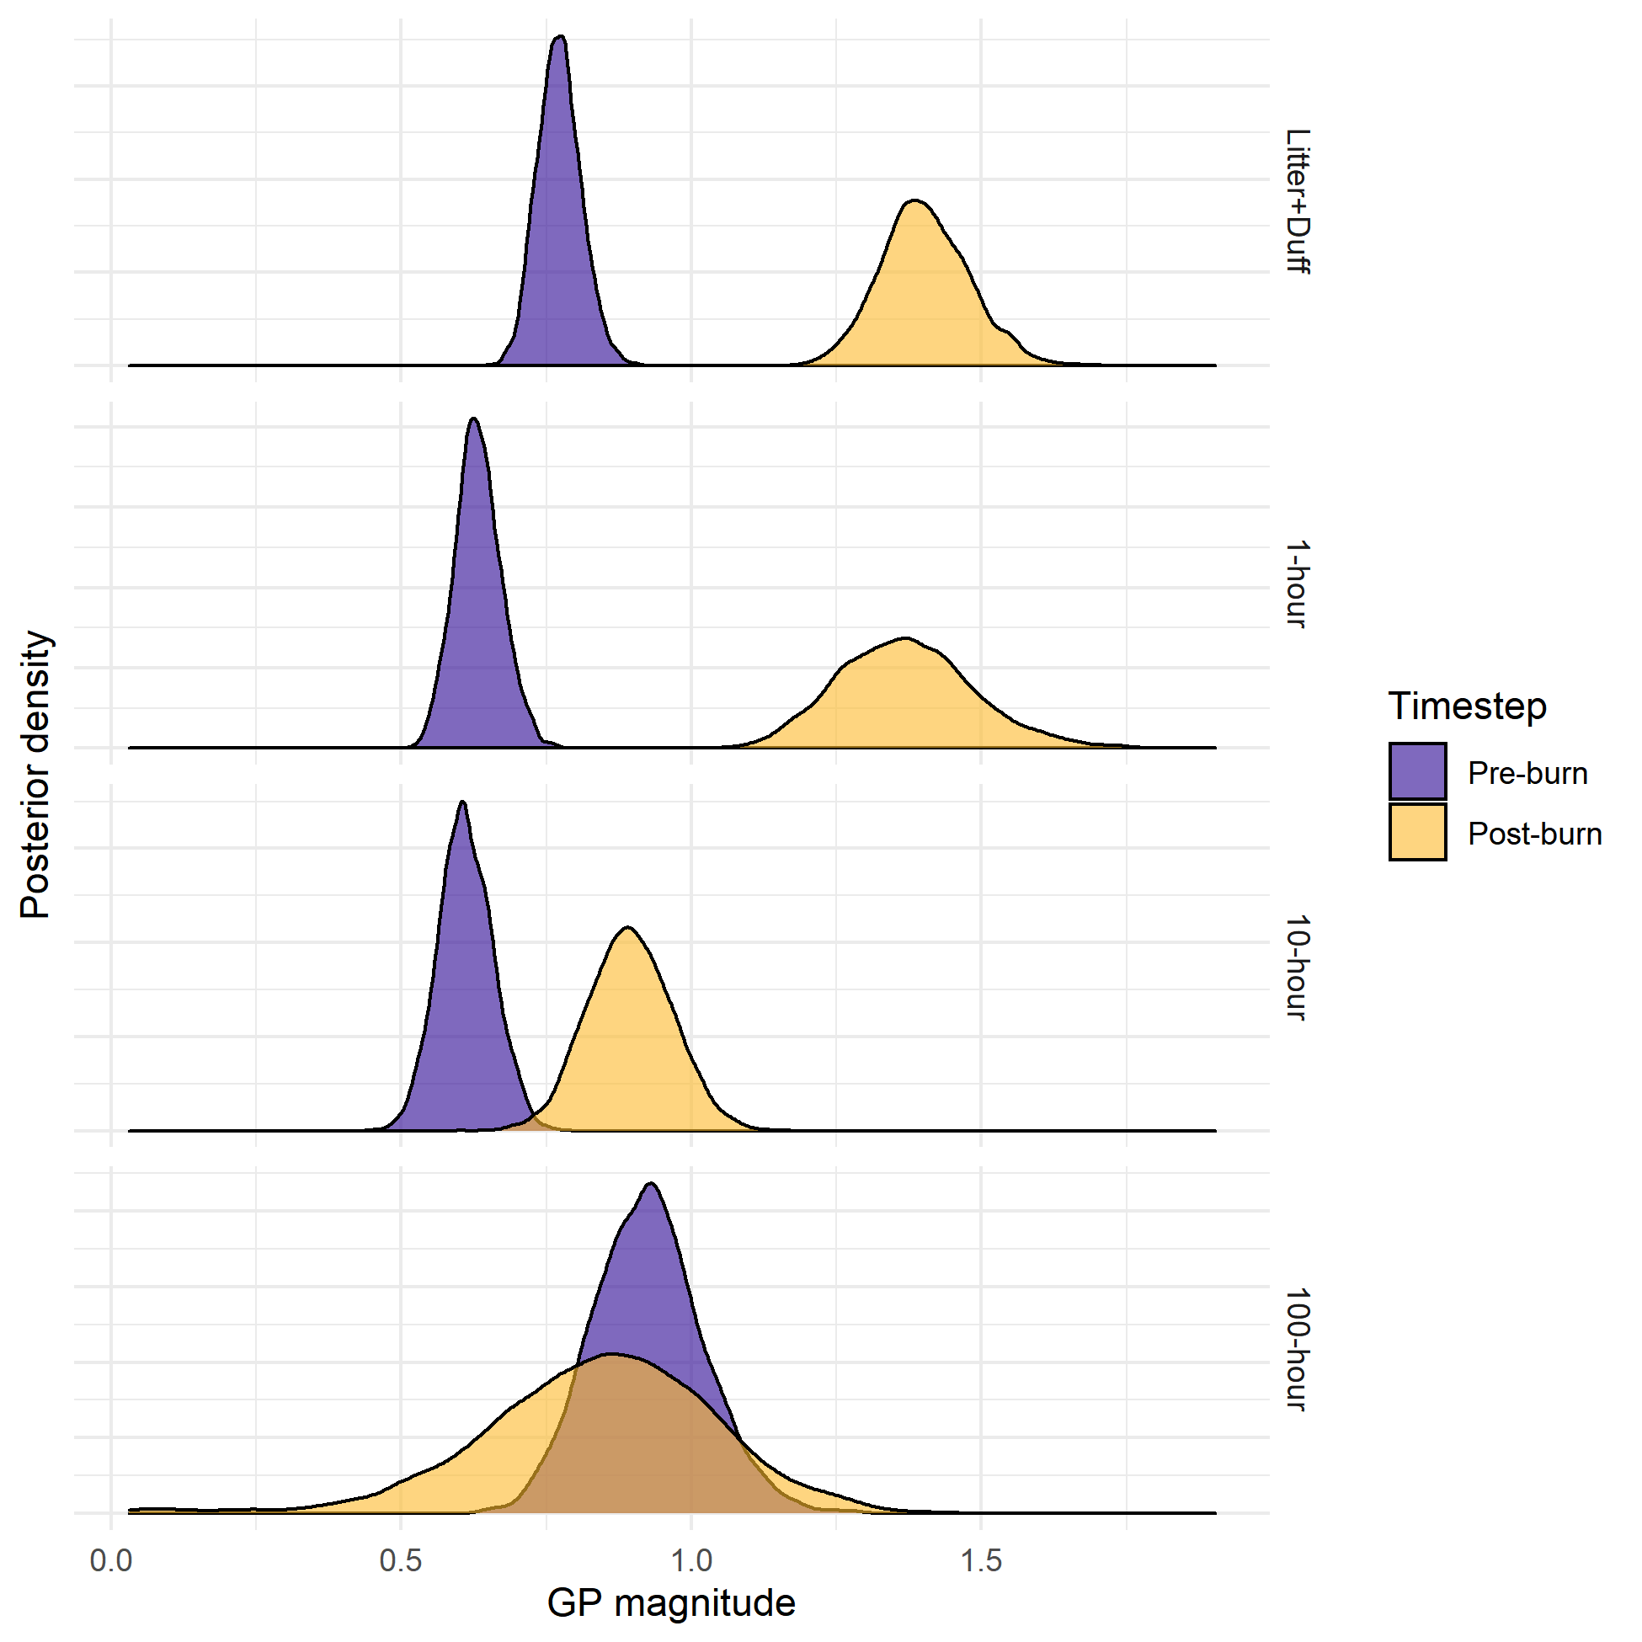
Figure 1: Posterior distributions for gaussian process magnitudes in pre-burn and post-burn timesteps for litter and duff and 1-hour, 10-hour, and 100-hour fine woody debris fuels.

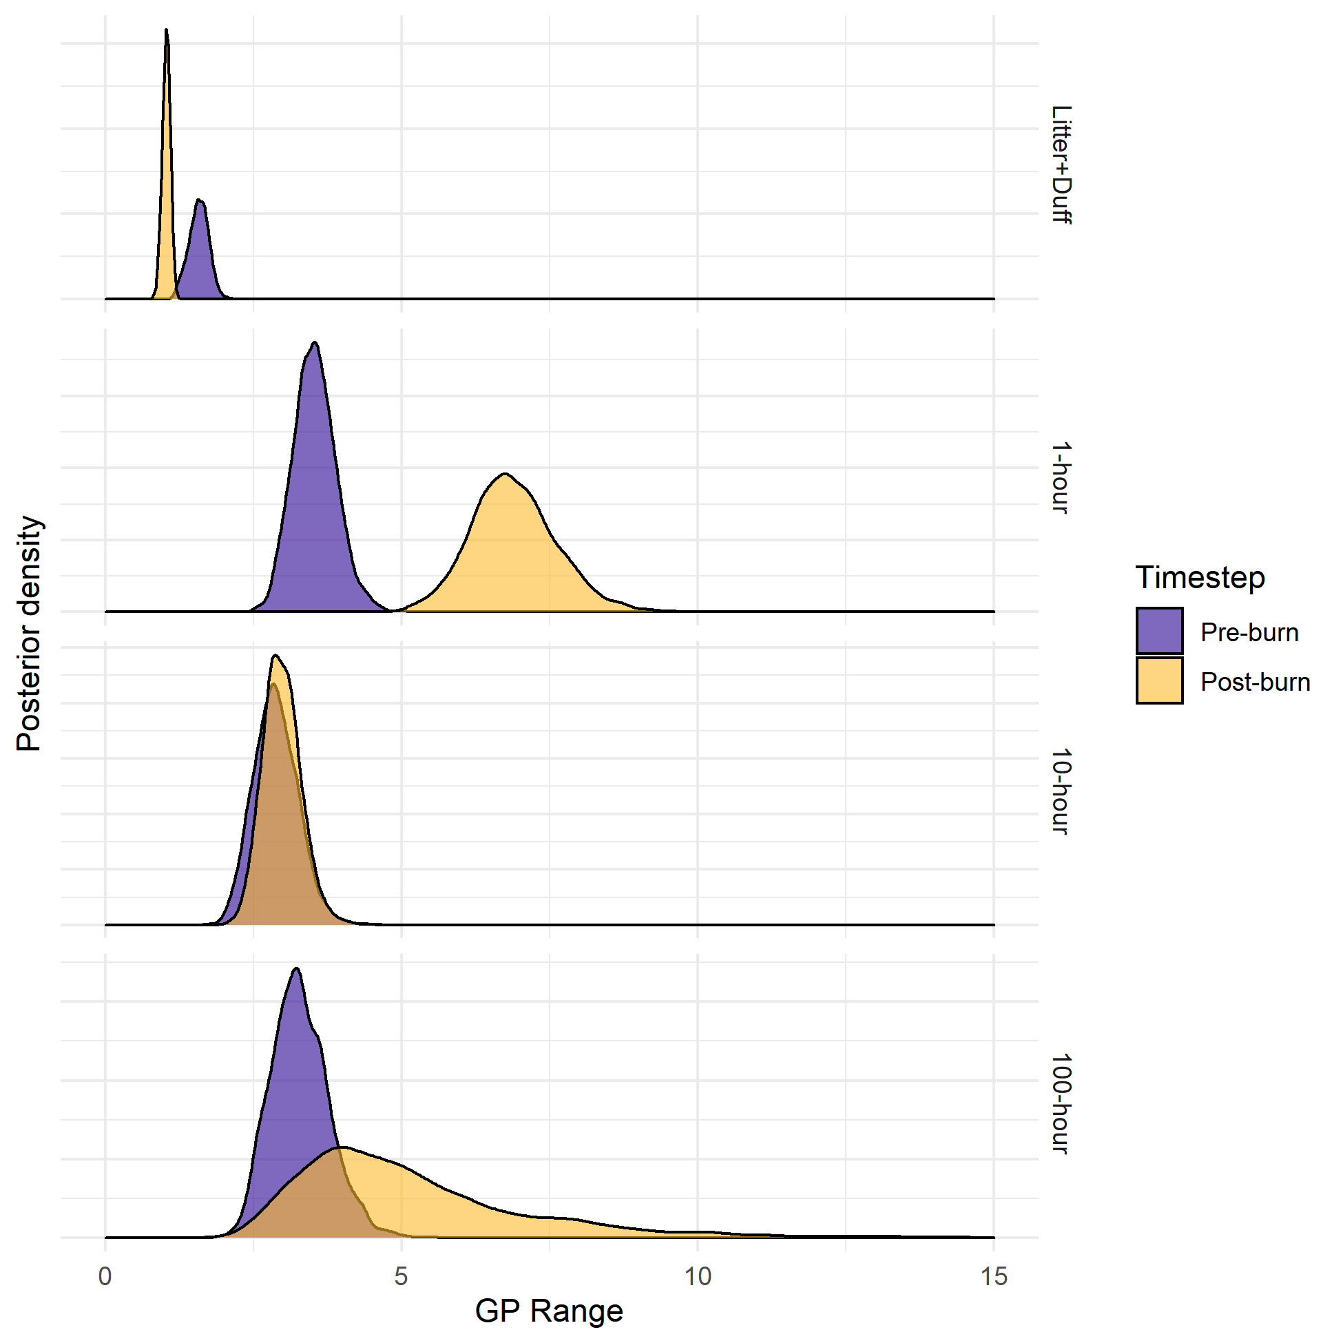
Figure 2: Posterior distributions for gaussian process length-scale parameters in pre-burn and post-burn timesteps for litter and duff, 1-hour, 10-hour, and 100-hour fine woody debris fuels.

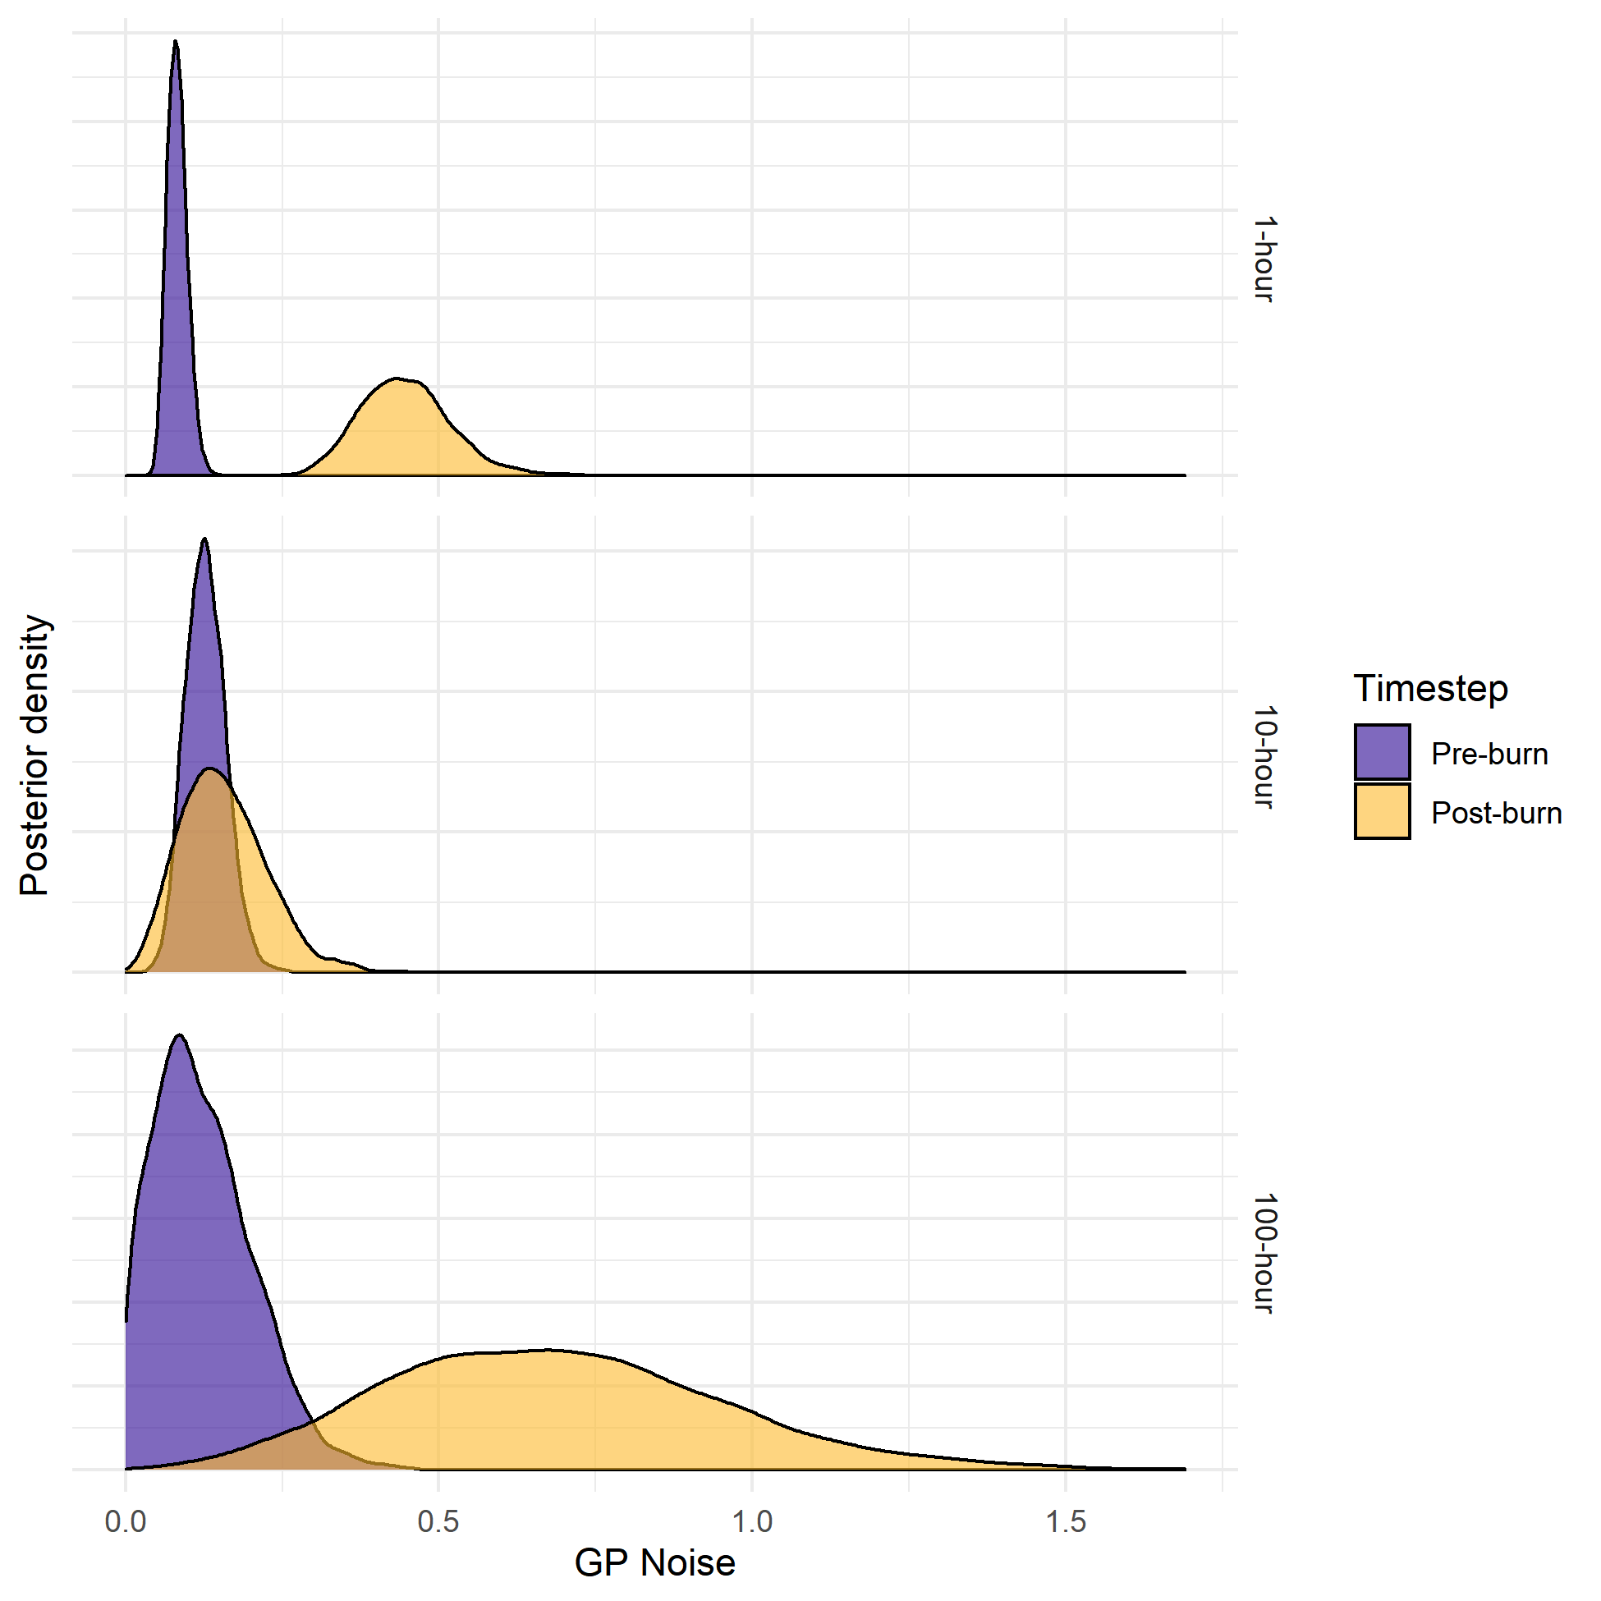
Figure 3: Posterior distribution for gaussian process noise parameters in pre-burn and post-burn timesteps for 1-hour, 10-hour, and 100-hour fine woody debris fuels. No noise parameter was included in the litter and duff models because there was only a single observation at each spatial location in the litter and duff data.

Supplementary Materials

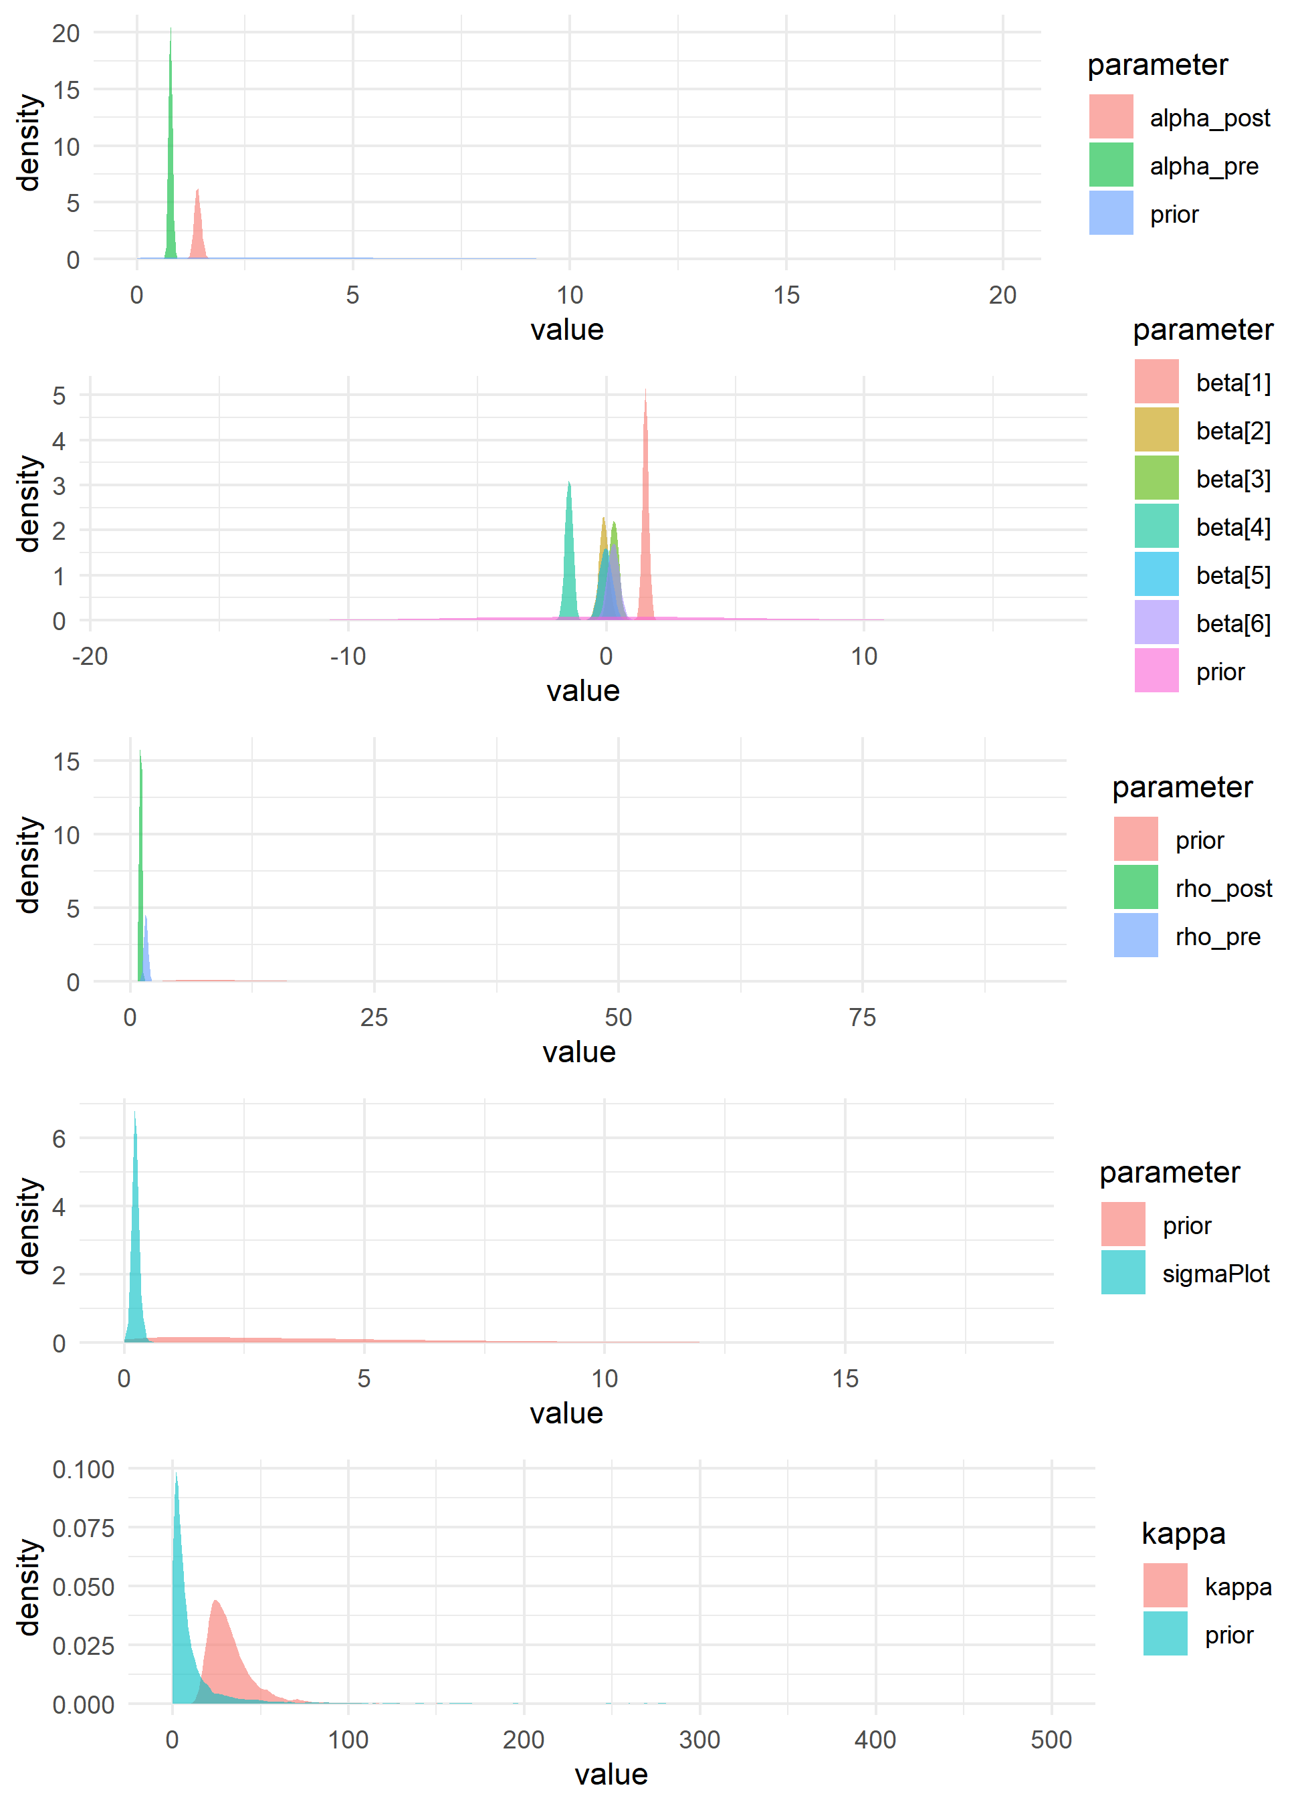
Supplementary Figure 1: Prior vs. posterior distributions for all parameters of the model for litter and duff depths. Clear differences between the prior and posterior distributions exist for all parameters, indicating that the posterior estimates were strongly informed by the data, rather than the priors.

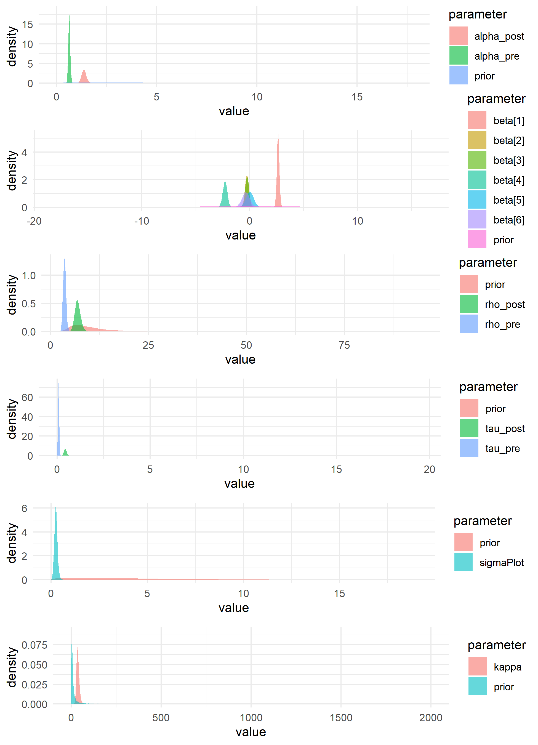
Supplementary Figure 2: Prior vs. posterior parameter distributions for all parameters in the model for 1-hour fine woody debris tallies. In all cases, there are clear differences between the prior and the posterior distributions, indicating that parameter estimates are strongly informed by the data, rather than the prior.

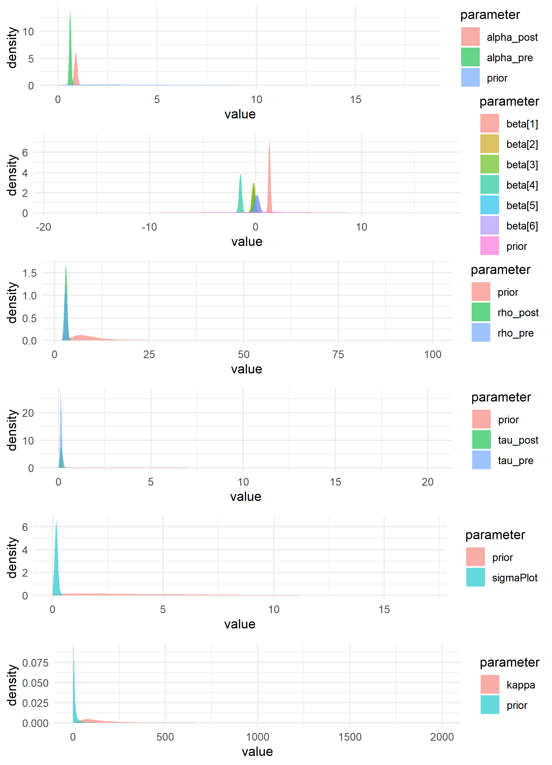
Supplementary Figure 3: Prior vs. posterior parameter distributions for all parameters in the model for 10-hour fine woody debris tallies. In all cases, there are clear differences between the prior and the posterior distributions, indicating that parameter estimates are strongly informed by the data, rather than the prior.

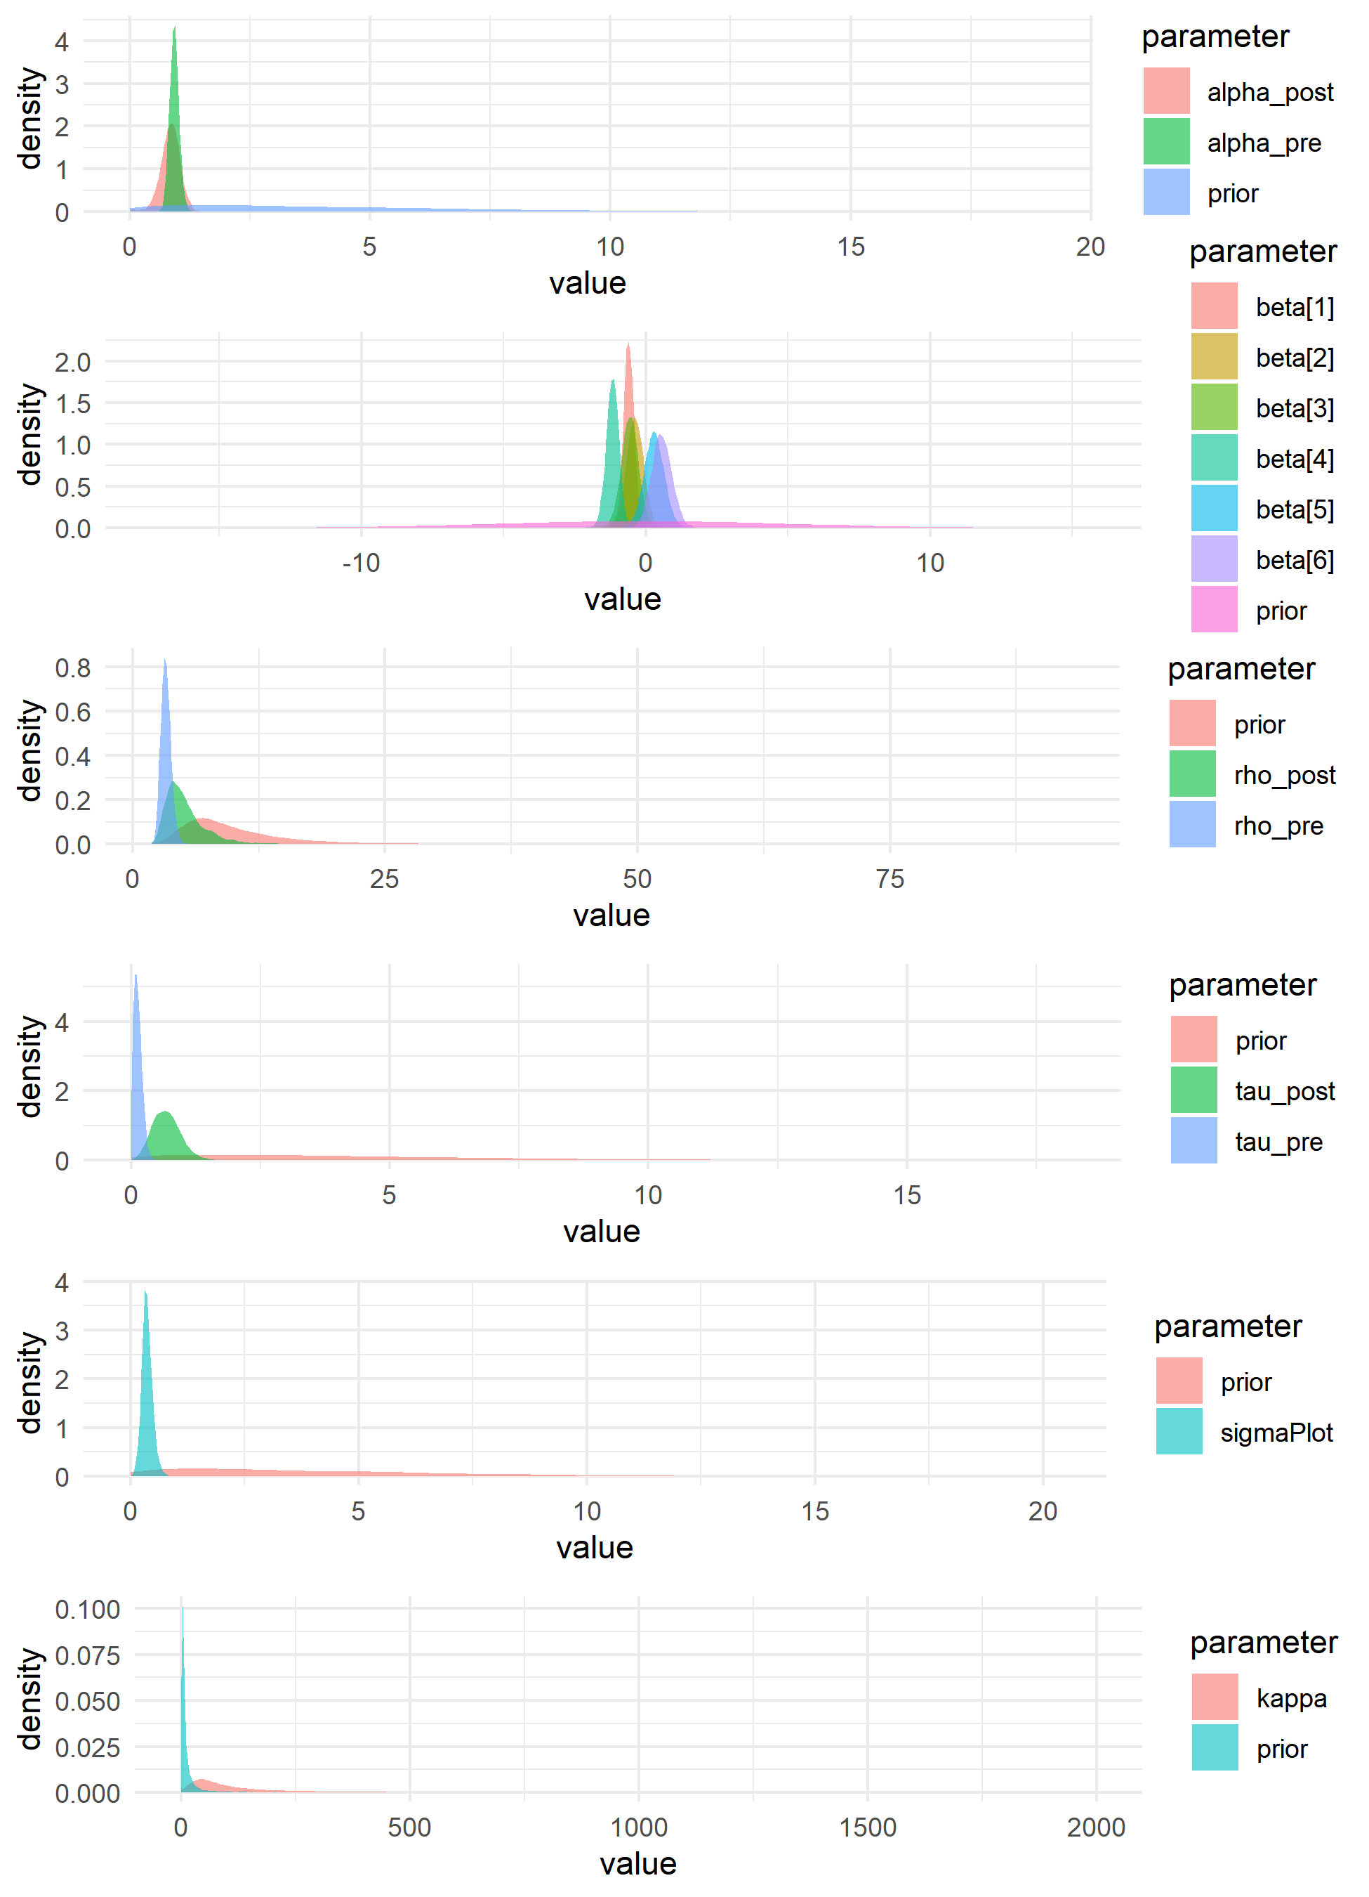
Supplementary Figure 4: Prior vs. posterior parameter distributions for all parameters in the model for 100-hour fine woody debris tallies. In most cases, there are clear differences between the prior and the posterior distributions, indicating that parameter estimates are strongly informed by the data, rather than the prior. However, the posterior distribution for $ρ_{post}$ substantially overlaps the prior, indicating that model estimates for that parameter were only moderately informed by the data, and may instead reflect prior assumptions.

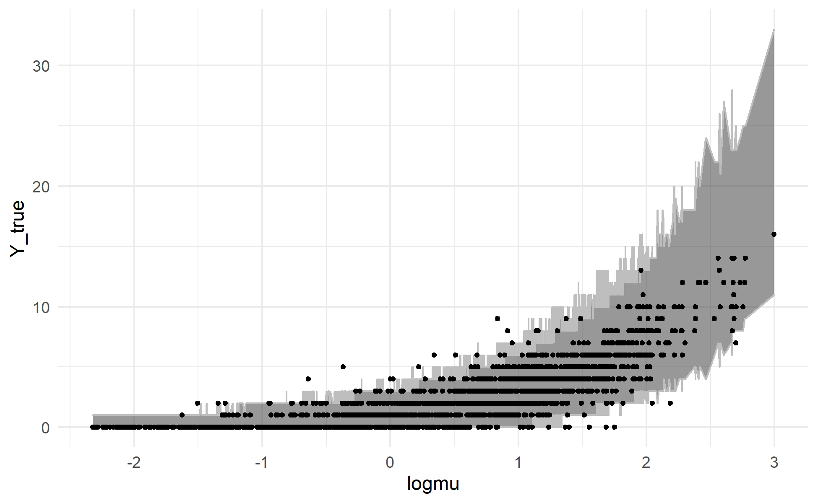
Supplementary Figure 5: Posterior predictions for the litter and duff depths model generated using the training data and posterior parameter estimates. For each draw of the posterior, litter and duff depth was simulated for every sample in the training data. Each observation in the training dataset (black points) is plotted with its posterior mean value for $\log{μ}$ (the linear predictor) on the X-axis and the observed depth for that observation on the Y-axis. The grey ribbon covers a 95% credible interval for the litter and duff depth for each observation (the range between the 2.5th and 97.5th percentiles of simulated counts). The model generally shows good agreement between simulated and observed data, though the variance in observed data is less than the model predicts for high values of $\log{μ}$.

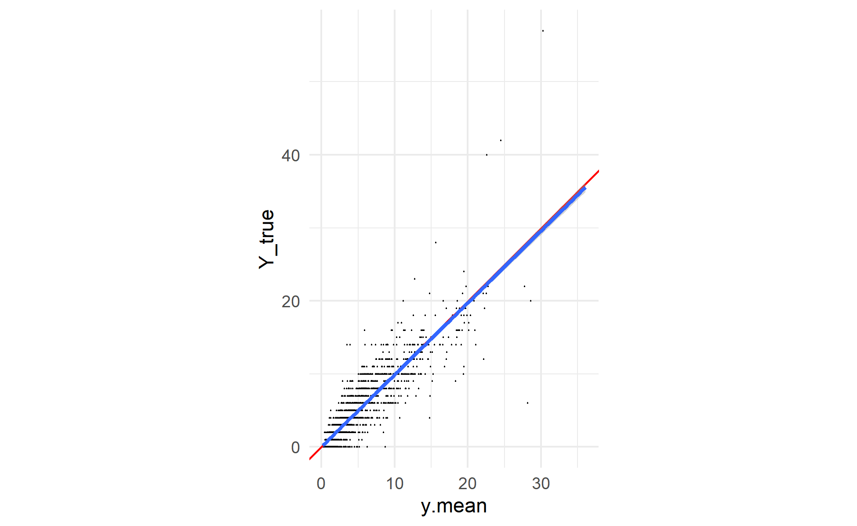
Supplementary Figure 6: Posterior predictions for the litter and duff depths model generated using the training data and posterior parameter values. For each draw of the posterior, litter and duff depth was simulated for every sample in the training data. Each black point is an observed sample, plotted with its mean posterior predicted value on the X-axis and its observed value on the Y-axis. A 1:1 line is plotted in red, and the actual linear relationship between (mean) simulated and observed counts in blue. Model predictions appear to be unbiased (slope between simulated and real data is very close to 1).

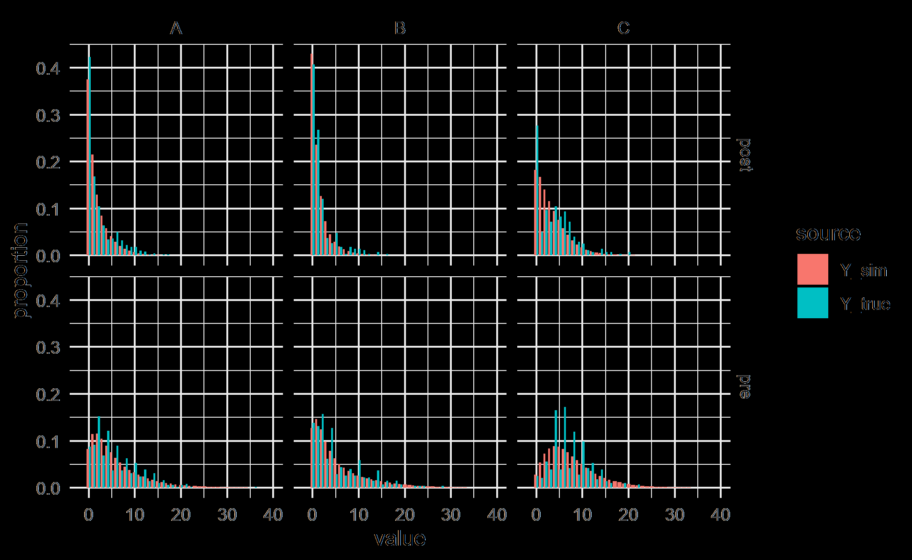
Supplementary Figure 7: Posterior predictions for the litter and duff model generated using the training data and posterior parameter estimates. For each draw of the posterior, litter and duff depth was simulated for every sample in the training data. The bar charts show the distribution of simulated (red) and observed (blue) litter and duff depths. The panels break the predictions out by fixed effect group (crossing experimental unit A, B, or C with timestep pre-fire or post-fire). The models satisfactorily, though not perfectly, reproduce the distribution of values in the observed data. Though broad trends are similar, there appears to be an unmodeled bias in the observed data favoring even depth observations (i.e., observations of 4, 6, or 8 cm are substantially more common than observations of 3, 4, or 5 cm). Also, the observed data for Unit C in the post-burn timestep show a bimodal distribution with many 0s and a secondary peak around 4-6 cm, rather than the unimodal distribution in the simulated data.

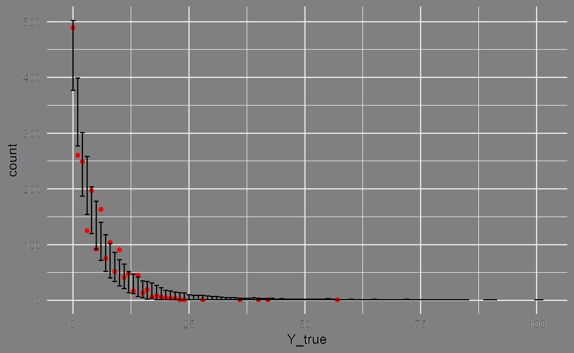
Supplementary Figure 8: Posterior predictions for the litter and duff model generated using the training data and posterior parameter estimates. For each draw of the posterior, litter and duff depth was simulated for every sample in the training data. The observed data are plotted as red points, with the observed value on the X-axis and the count of observations having that depth value on the Y-axis (similar to a histogram). The 2.5th and 97.5th percentiles of the count of samples for each depth value across all posterior draws are shown as the error bars. The model simulations broadly match the training data, though again there is an unmodeled preference in the training data for even values of depth (even depth values appear more frequently than odd ones).

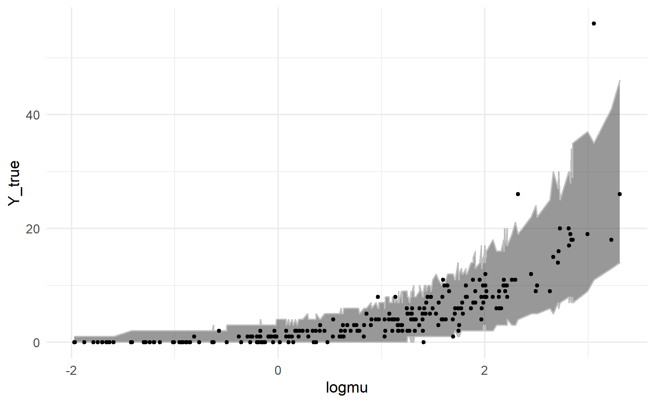
Supplementary Figure 9: Posterior predictions for the litter and duff depths model generated using the validation data and posterior parameter estimates. For each draw of the posterior, litter and duff depth was simulated for every sample in the validation data. Each observation in the validation dataset (black points) is plotted with its posterior mean value for $\log{μ}$ (the linear predictor) on the X-axis and the observed depth for that observation on the Y-axis. The grey ribbon covers a 95% credible interval for the litter and duff depth for each observation (the range between the 2.5th and 97.5th percentiles of simulated counts). The model generally shows good agreement between simulated and observed data, though the variance in observed data is less than the model predicts for high values of $\log{μ}$.

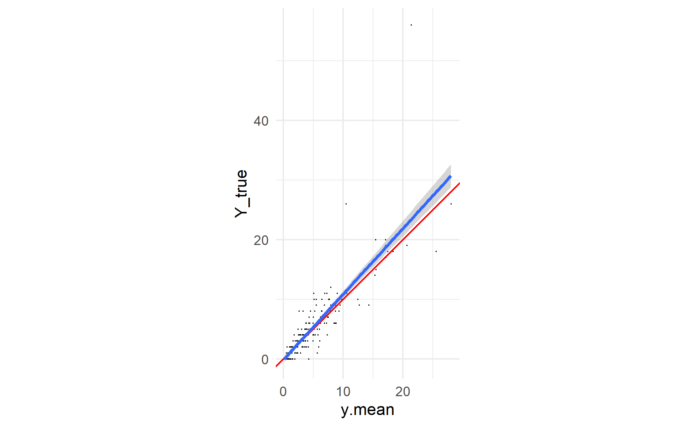
Supplementary Figure 10: Posterior predictions for the litter and duff depths model generated using the validation data and posterior parameter values. For each draw of the posterior, litter and duff depth was simulated for every sample in the validation data. Each black point is an observed sample, plotted with its mean posterior predicted value on the X-axis and its observed value on the Y-axis. A 1:1 line is plotted in red, and the actual linear relationship between (mean) simulated and observed counts in blue. Model predictions appear to be unbiased (slope between simulated and real data is very close to 1).

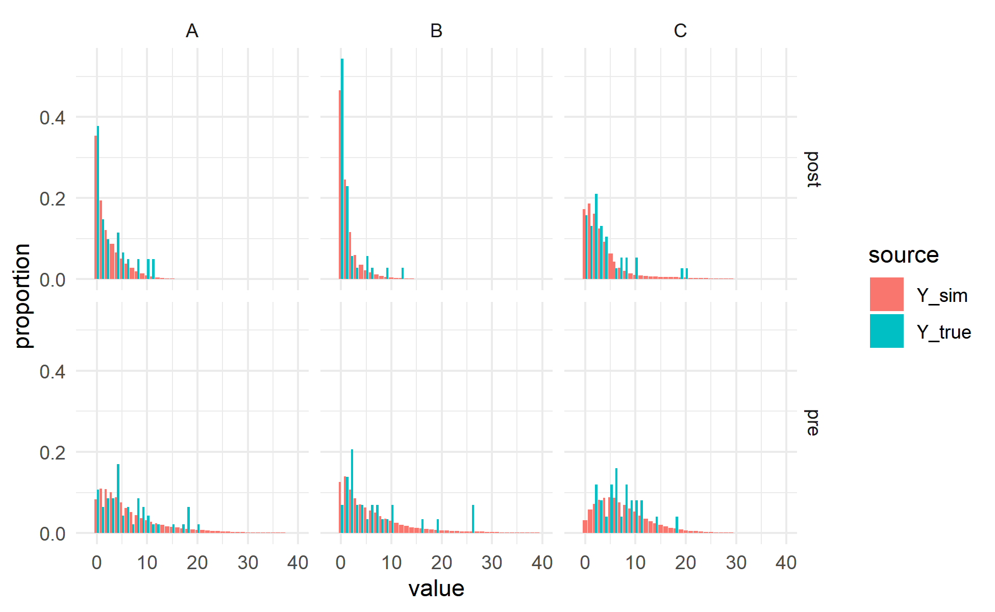
Supplementary Figure 11: Posterior predictions for the litter and duff model generated using the validation data and posterior parameter estimates. For each draw of the posterior, litter and duff depth was simulated for every sample in the validation data. The bar charts show the distribution of simulated (red) and observed (blue) litter and duff depths. The panels break the predictions out by fixed effect group (crossing experimental unit A, B, or C with timestep pre-fire or post-fire). The models satisfactorily, though not perfectly, reproduce the distribution of values in the observed data. There are relatively many large depth values in the observed data, though the small number of samples from the observed data (relative to the simulated data) makes the distribution less smooth.
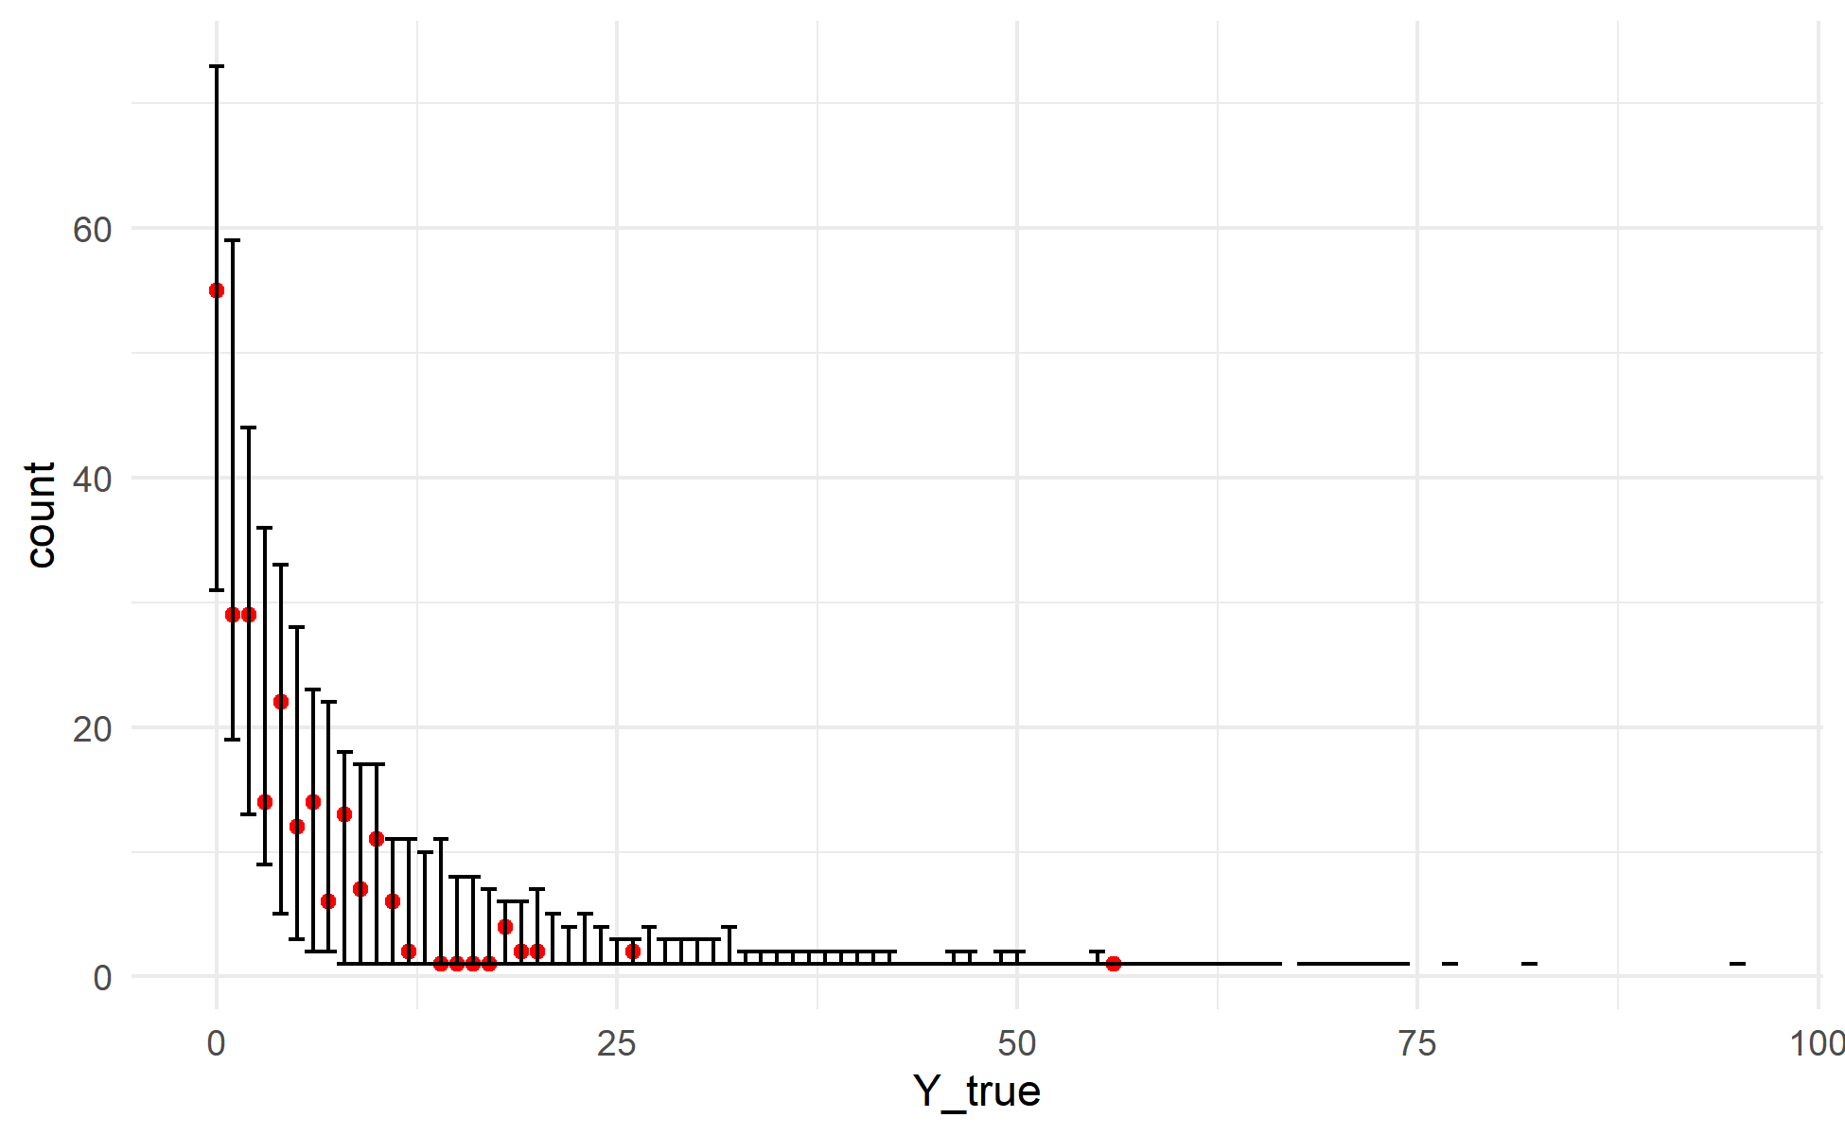
Supplementary Figure 12: Posterior predictions for the litter and duff model generated using the validation data and posterior parameter estimates. For each draw of the posterior, litter and duff depth was simulated for every sample in the validation data. The observed data are plotted as red points, with the observed value on the X-axis and the count of observations having that depth value on the Y-axis (similar to a histogram). The 2.5th and 97.5th percentiles of the count of samples for each depth value across all posterior draws are shown as the error bars. The model simulations broadly match the training data, though again there is an unmodeled preference in the training data for even values of depth (even depth values appear more frequently than odd ones).
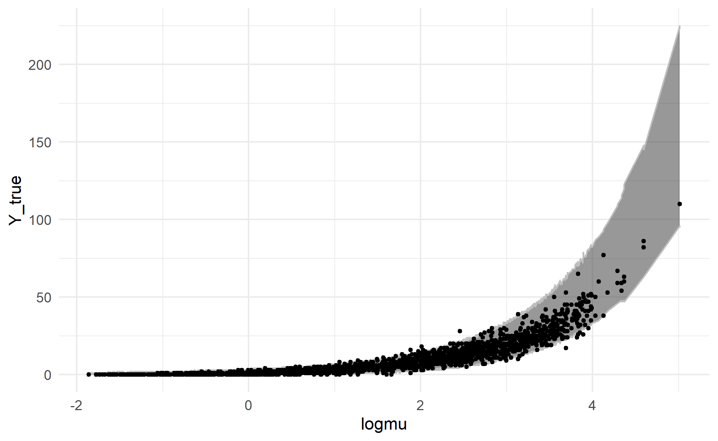
Supplementary Figure 13: Posterior predictions for the 1-hour FWD tallies model generated using the training data and posterior parameter estimates. For each draw of the posterior, 1-hour FWD tally was simulated for every sample in the training data. Each observation in the training dataset (black points) is plotted with its posterior mean value for $\log{μ}$ (the linear predictor) on the X-axis and the observed depth for that observation on the Y-axis. The grey ribbon covers a 95% credible interval for the tally for each observation (the range between the 2.5th and 97.5th percentiles of simulated counts). The model generally shows good agreement between simulated and observed data, but appears to have a mild bias towards overprediction for large values of $\log{μ}$, with observed values generally falling in the lower end of what the model predicts is the plausible range.
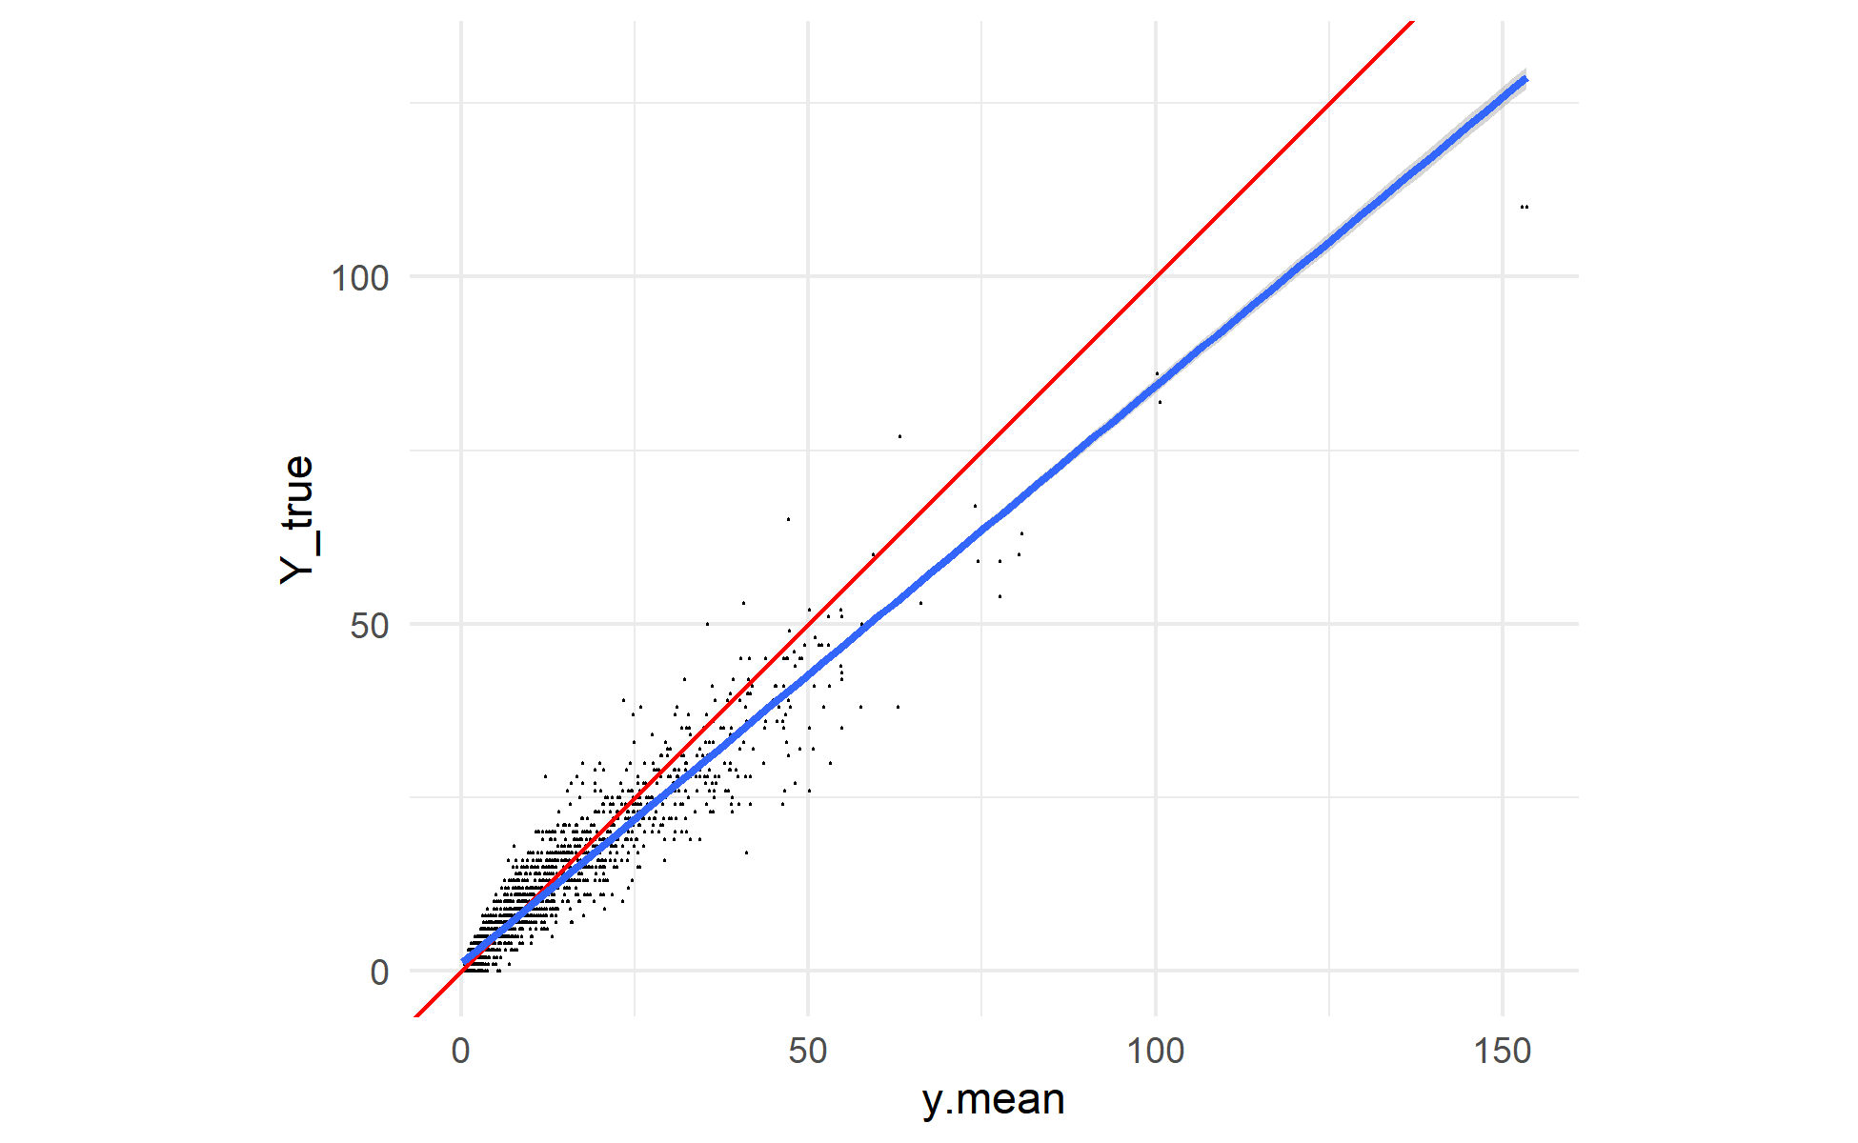
Supplementary Figure 14: Posterior predictions for the 1-hour FWD tallies model generated using the training data and posterior parameter values. For each draw of the posterior, 1-hour FWD tally was simulated for every sample in the training data. Each black point is an observed sample, plotted with its mean posterior predicted value on the X-axis and its observed value on the Y-axis. A 1:1 line is plotted in red, and the actual linear relationship between (mean) simulated and observed counts in blue. Again, there appears to be a mild bias towards overprediction for larger counts, with the observed values generally falling below the mean predicted value for predicted counts greater than ~25.

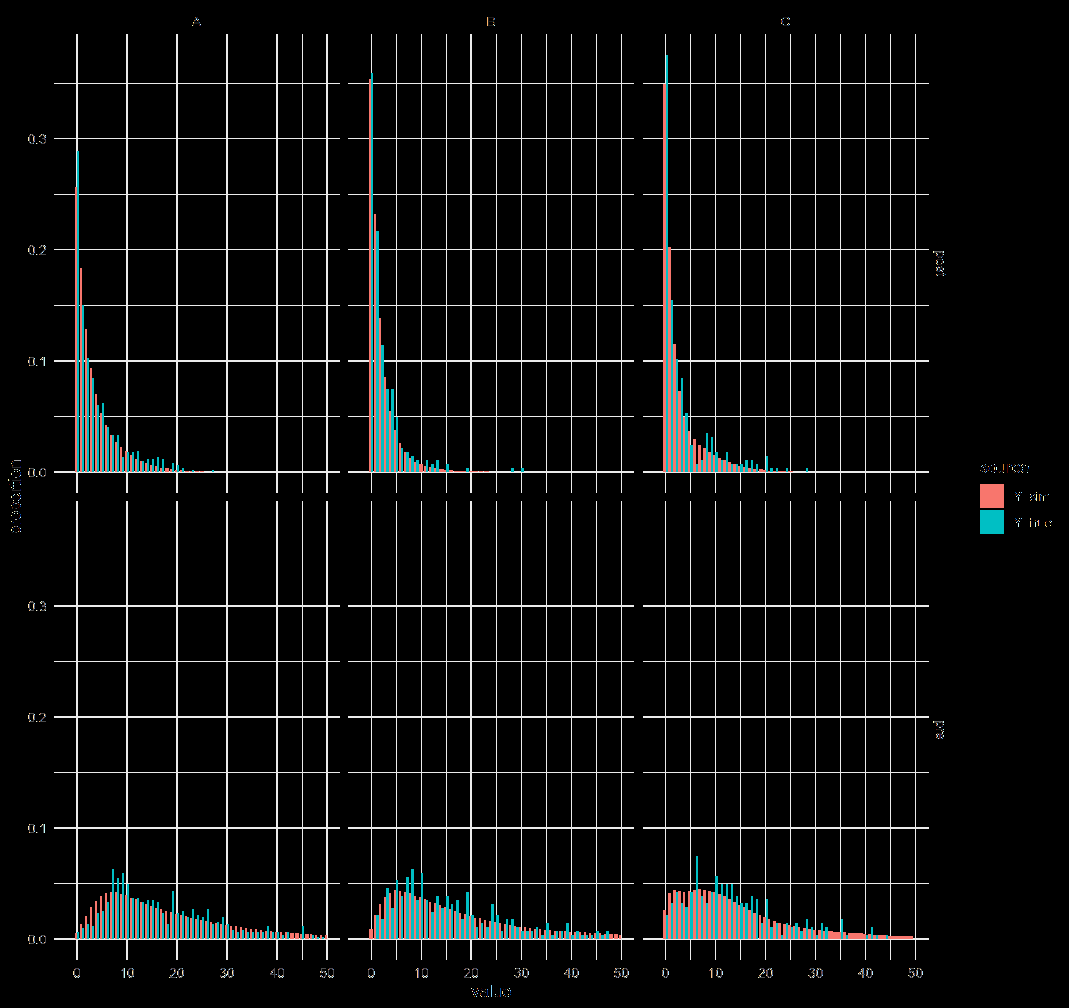
Supplementary Figure 15: Posterior predictions for the 1-hour FWD model generated using the training data and posterior parameter estimates. For each draw of the posterior, 1-hour FWD tally was simulated for every sample in the training data. The bar charts show the distribution of simulated (red) and observed (blue) tallies. The panels break the predictions out by fixed effect group (crossing experimental unit A, B, or C with timestep pre-fire or post-fire). The distribution of values in the simulated data is similar to the distribution of values in the observed data. There are many more samples (4000 times as many) in the simulated data distributions, so it is to be expected that the resulting distribution is smoother than the distribution of observed values, but the broad behavior is reproduced well.
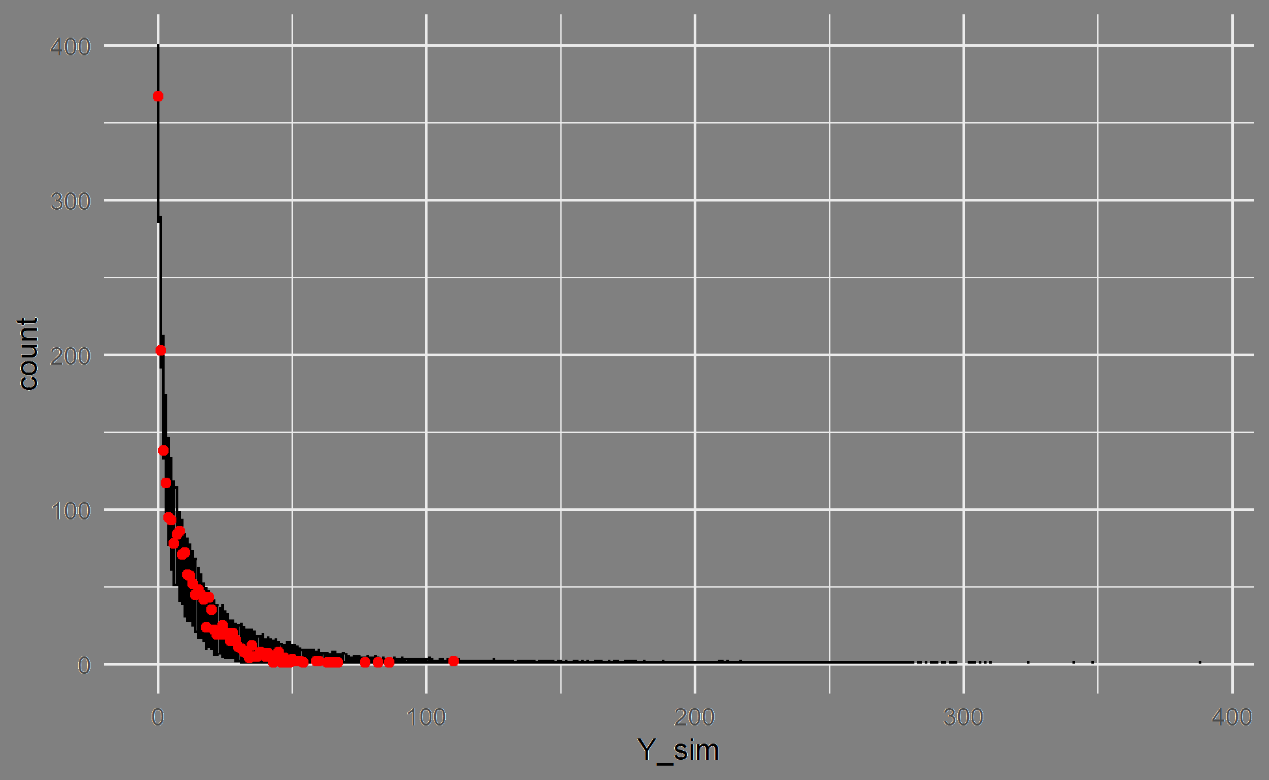
Supplementary Figure 16: Posterior predictions for the 1-hour FWD model generated using the training data and posterior parameter estimates. For each draw of the posterior, 1-hour FWD tally was simulated for every sample in the training data. The observed data are plotted as red points, with the observed value on the X-axis and the count of observations having that depth value on the Y-axis (similar to a histogram). The 2.5th and 97.5th percentiles of the count of samples for each depth value across all posterior draws are shown as the error bars. The observed data fall within the range of behaviors predicted by the model.

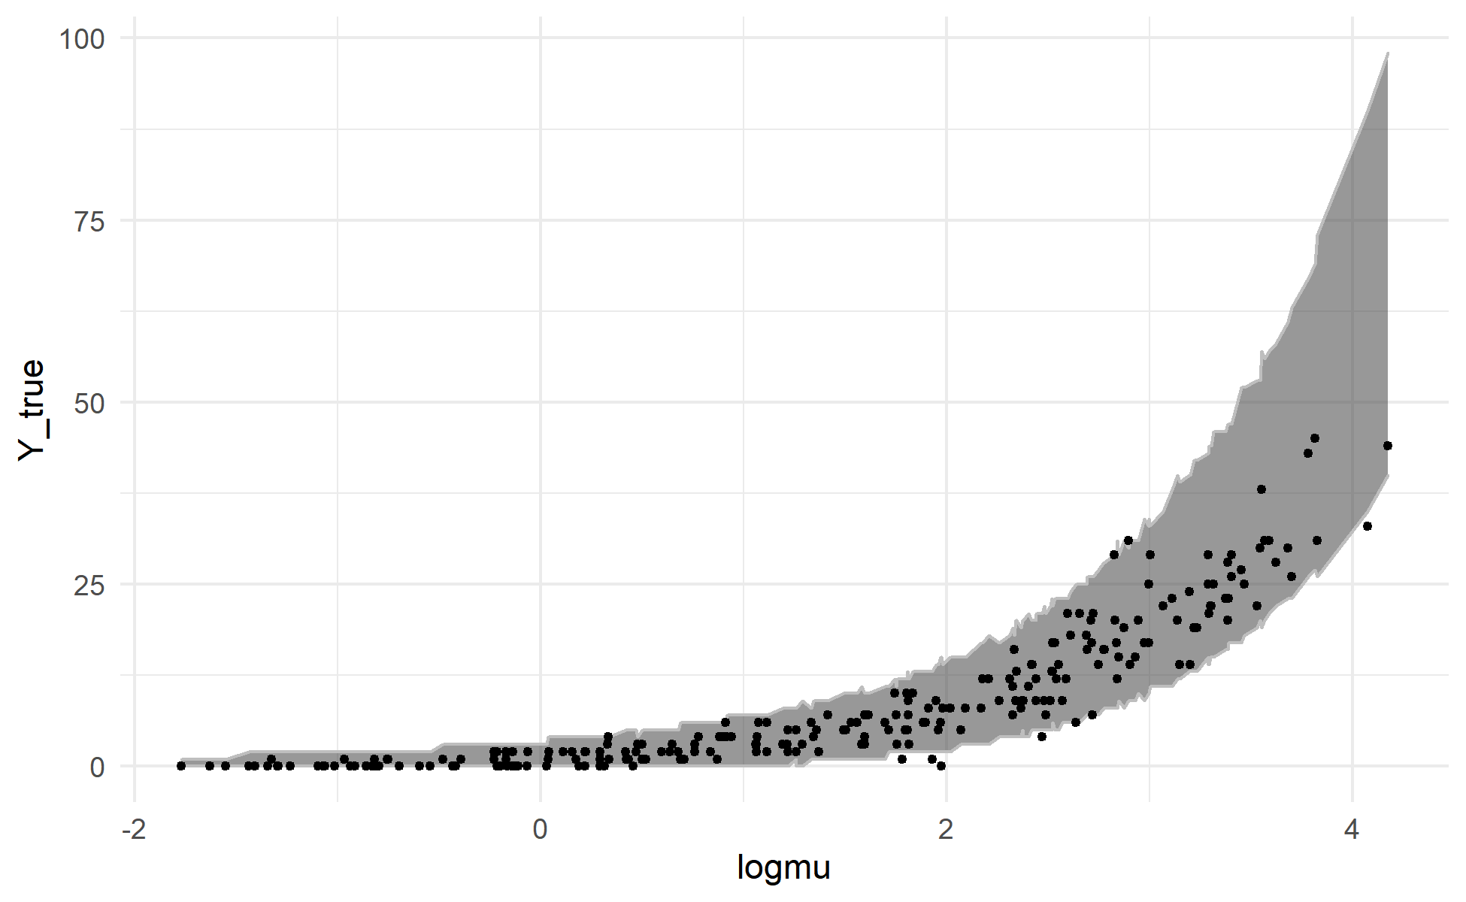
Supplementary Figure 17: Posterior predictions for the 1-hour FWD tallies model generated using the validation data and posterior parameter estimates. For each draw of the posterior, 1-hour FWD tally was simulated for every sample in the validation data. Each observation in the validation dataset (black points) is plotted with its posterior mean value for $\log{μ}$ (the linear predictor) on the X-axis and the observed tally for that observation on the Y-axis. The grey ribbon covers a 95% credible interval for the tally for each observation (the range between the 2.5th and 97.5th percentiles of simulated counts). The model generally shows good agreement between simulated and observed data, but appears to have a mild bias towards overprediction for large values of $\log{μ}$, with observed values generally falling in the lower end of what the model predicts is the plausible range.
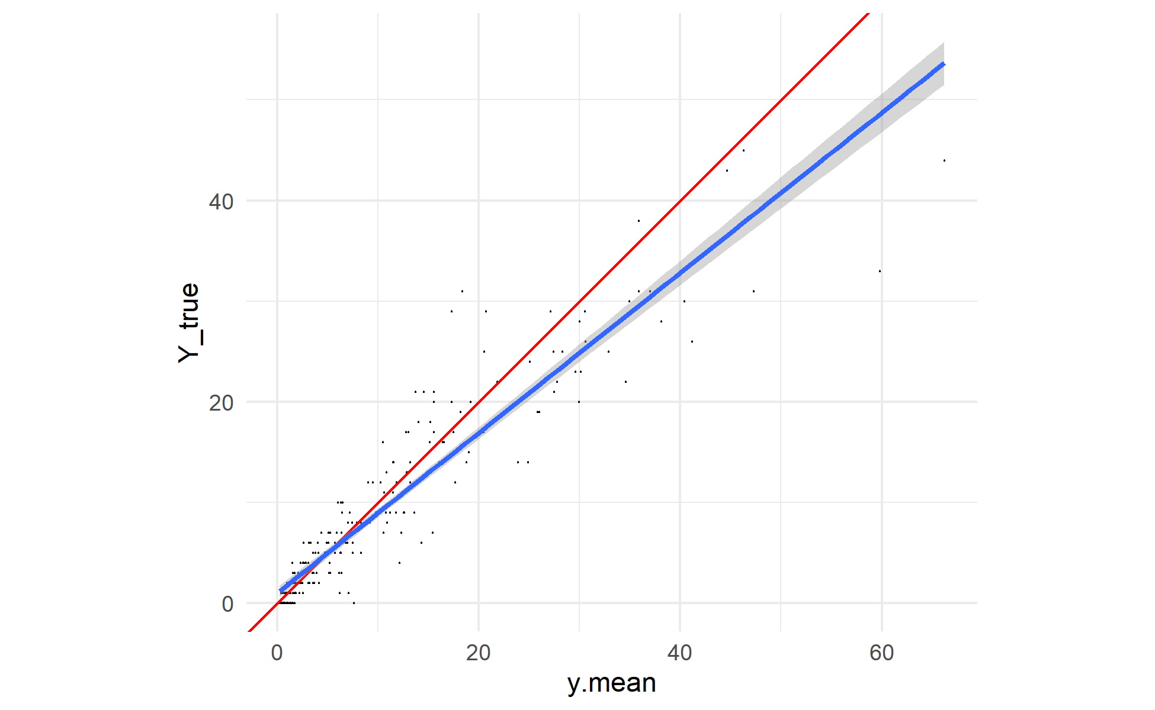
Supplementary Figure 18: Posterior predictions for the 1-hour FWD tallies model generated using the validation data and posterior parameter values. For each draw of the posterior, 1-hour FWD tally was simulated for every sample in the validation data. Each black point is an observed sample, plotted with its mean posterior predicted value on the X-axis and its observed value on the Y-axis. A 1:1 line is plotted in red, and the actual linear relationship between (mean) simulated and observed counts in blue. The simulated values show a mild bias towards overprediction of the observed counts above ~7, and a mild bias towards underprediction of observed counts below ~7.

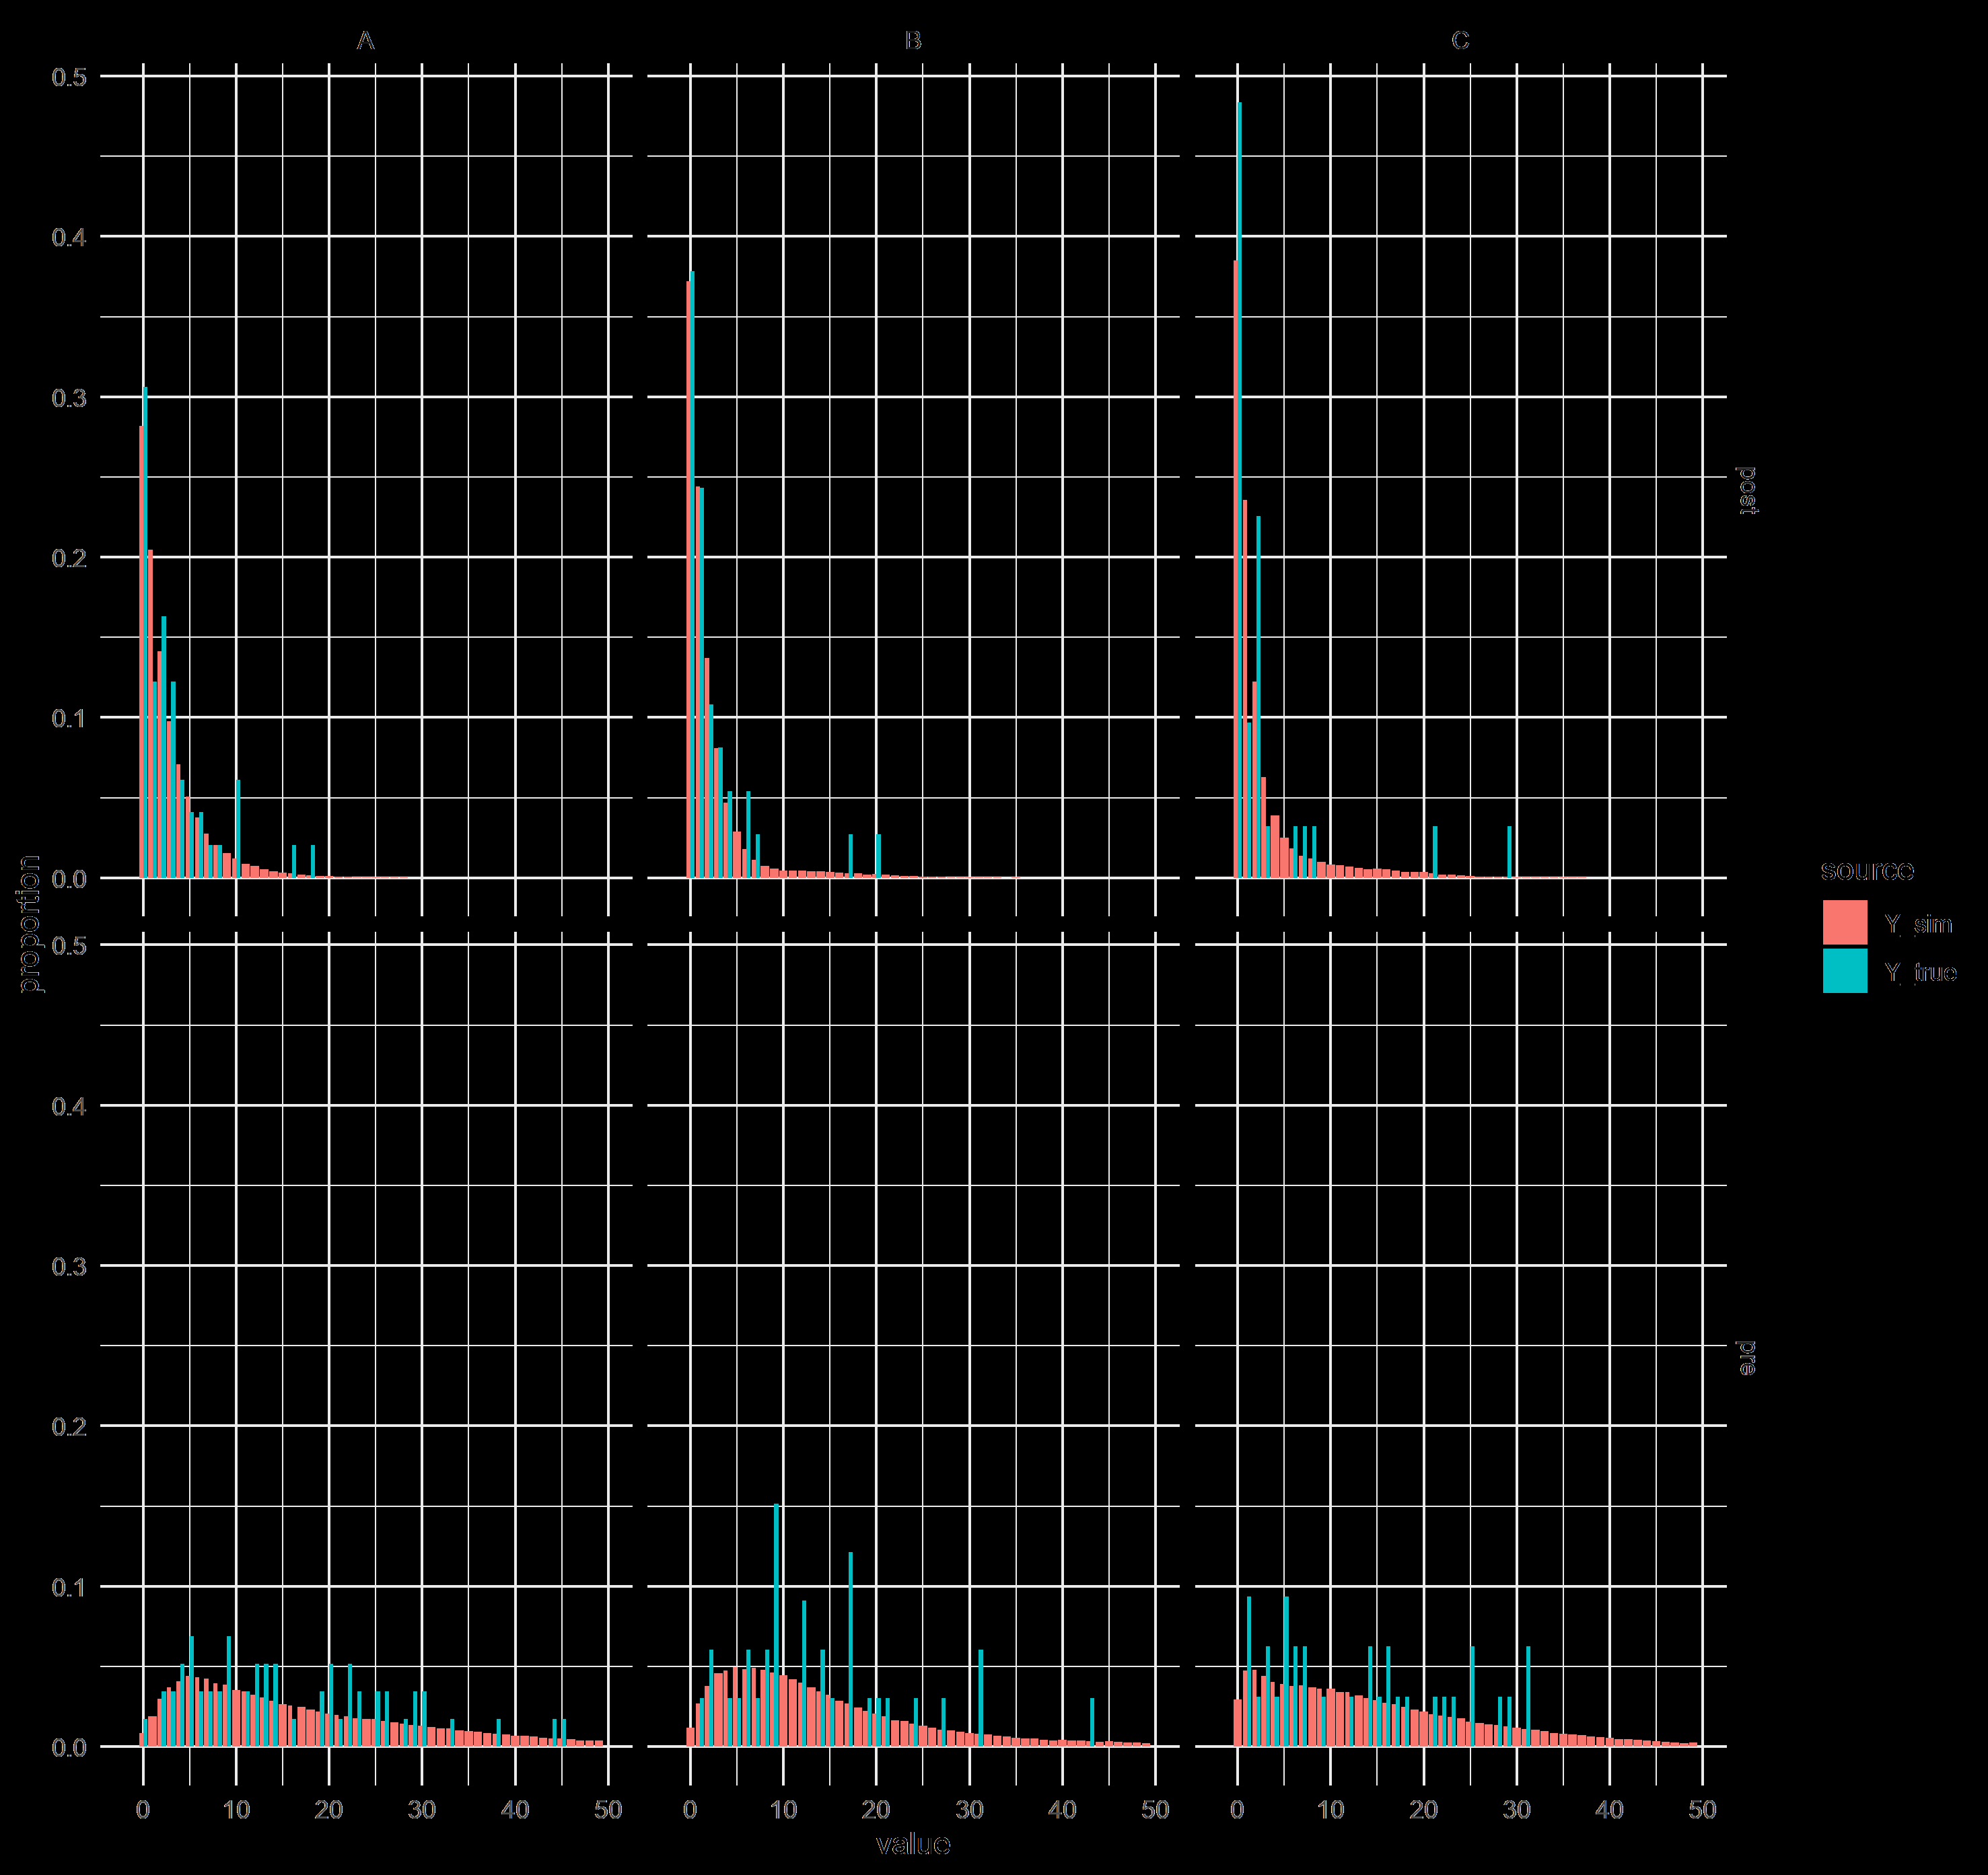
Supplementary Figure 19: Posterior predictions for the 1-hour FWD model generated using the validation data and posterior parameter estimates. For each draw of the posterior, 1-hour FWD tally was simulated for every sample in the validation data. The bar charts show the distribution of simulated (red) and observed (blue) tallies. The panels break the predictions out by fixed effect group (crossing experimental unit A, B, or C with timestep pre-fire or post-fire). The distribution of values in the simulated data is similar to the distribution of values in the observed data. There are many more samples (4000 times as many) in the simulated data distributions, so it is to be expected that the resulting distribution is smoother than the distribution of observed values, but the broad behavior is reproduced well.

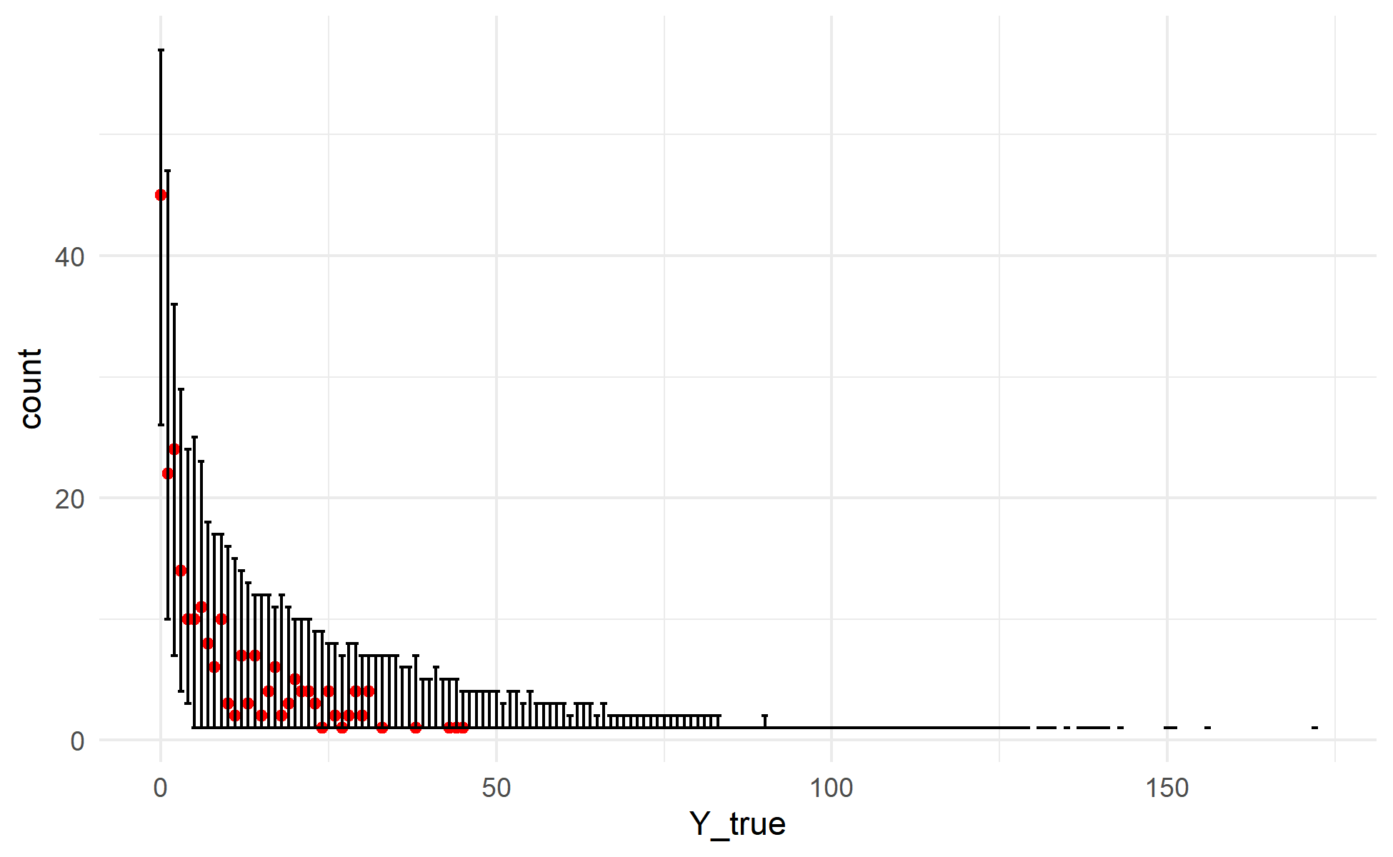
Supplementary Figure 20: Posterior predictions for the 1-hour FWD model generated using the validation data and posterior parameter estimates. For each draw of the posterior, 1-hour FWD tally was simulated for every sample in the validation data. The observed data are plotted as red points, with the observed value on the X-axis and the count of observations having that depth value on the Y-axis (similar to a histogram). The 2.5th and 97.5th percentiles of the count of samples for each depth value across all posterior draws are shown as the error bars. The observed data fall within the range of behaviors predicted by the model.

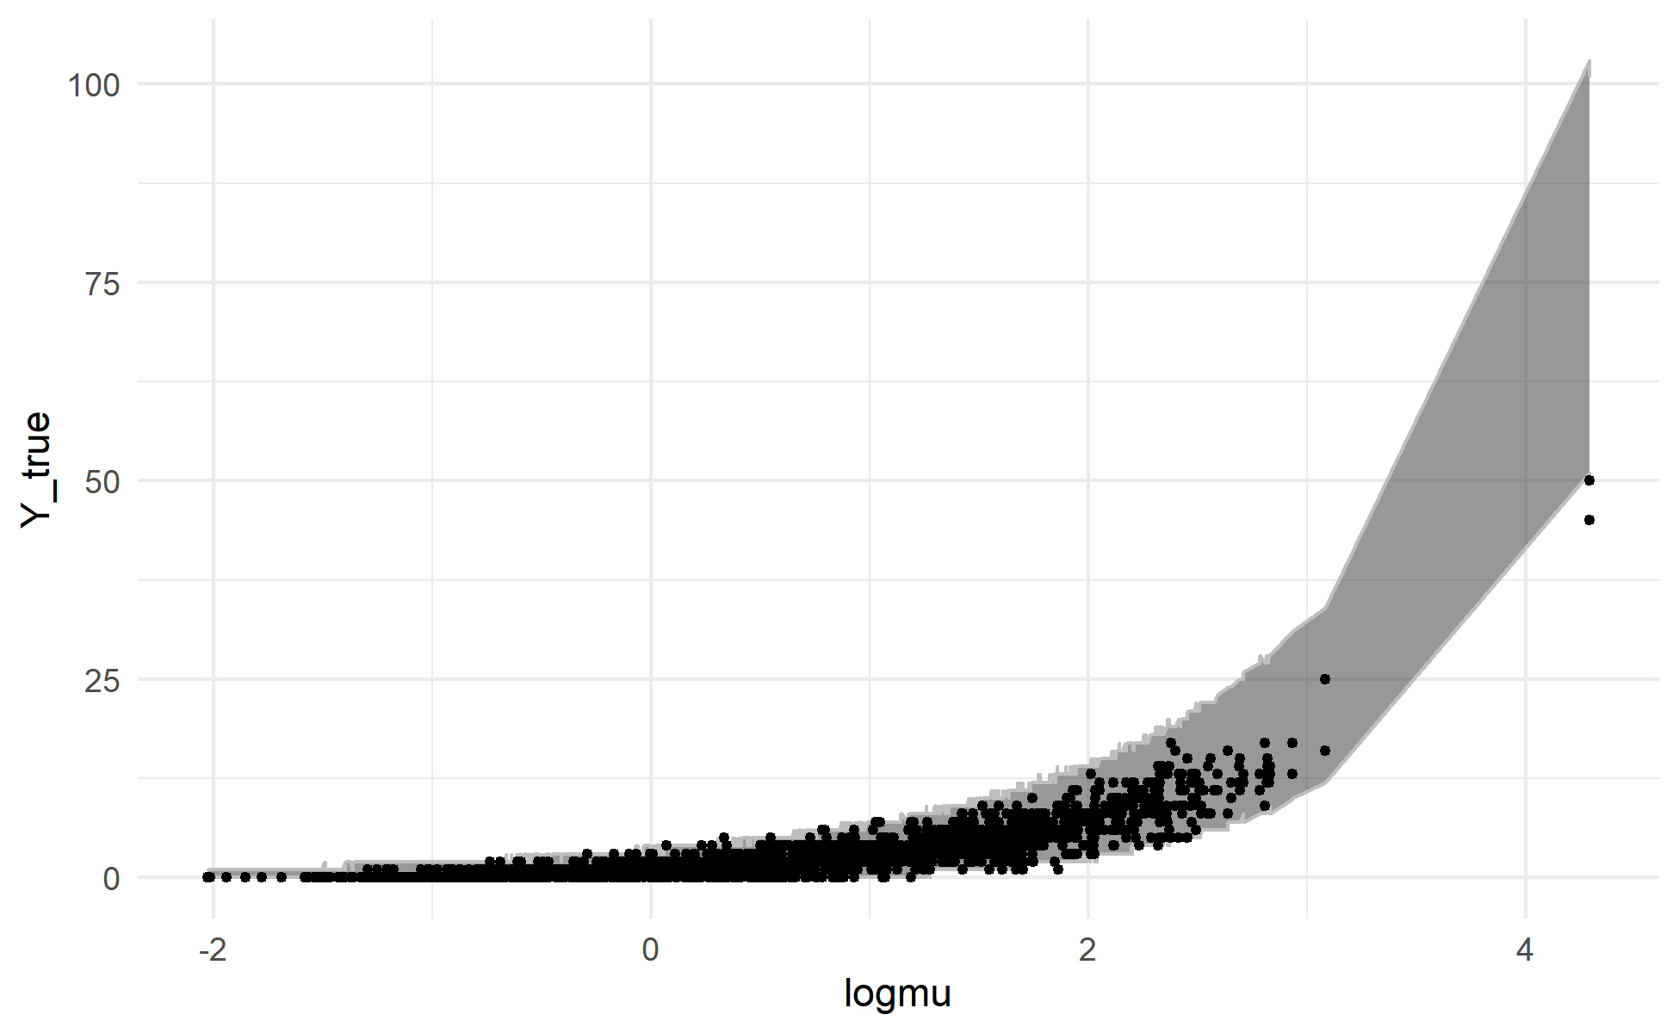
Supplementary Figure 21: Posterior predictions for the 10-hour FWD tallies model generated using the training data and posterior parameter estimates. For each draw of the posterior, 10-hour FWD tally was simulated for every sample in the training data. Each observation in the training dataset (black points) is plotted with its posterior mean value for $\log{μ}$ (the linear predictor) on the X-axis and the observed depth for that observation on the Y-axis. The grey ribbon covers a 95% credible interval for the tally for each observation (the range between the 2.5th and 97.5th percentiles of simulated counts). The model generally shows good agreement between simulated and observed data, but appears to have a mild bias towards overprediction for large values of $\log{μ}$, with observed values generally falling in the lower end of what the model predicts is the plausible range.

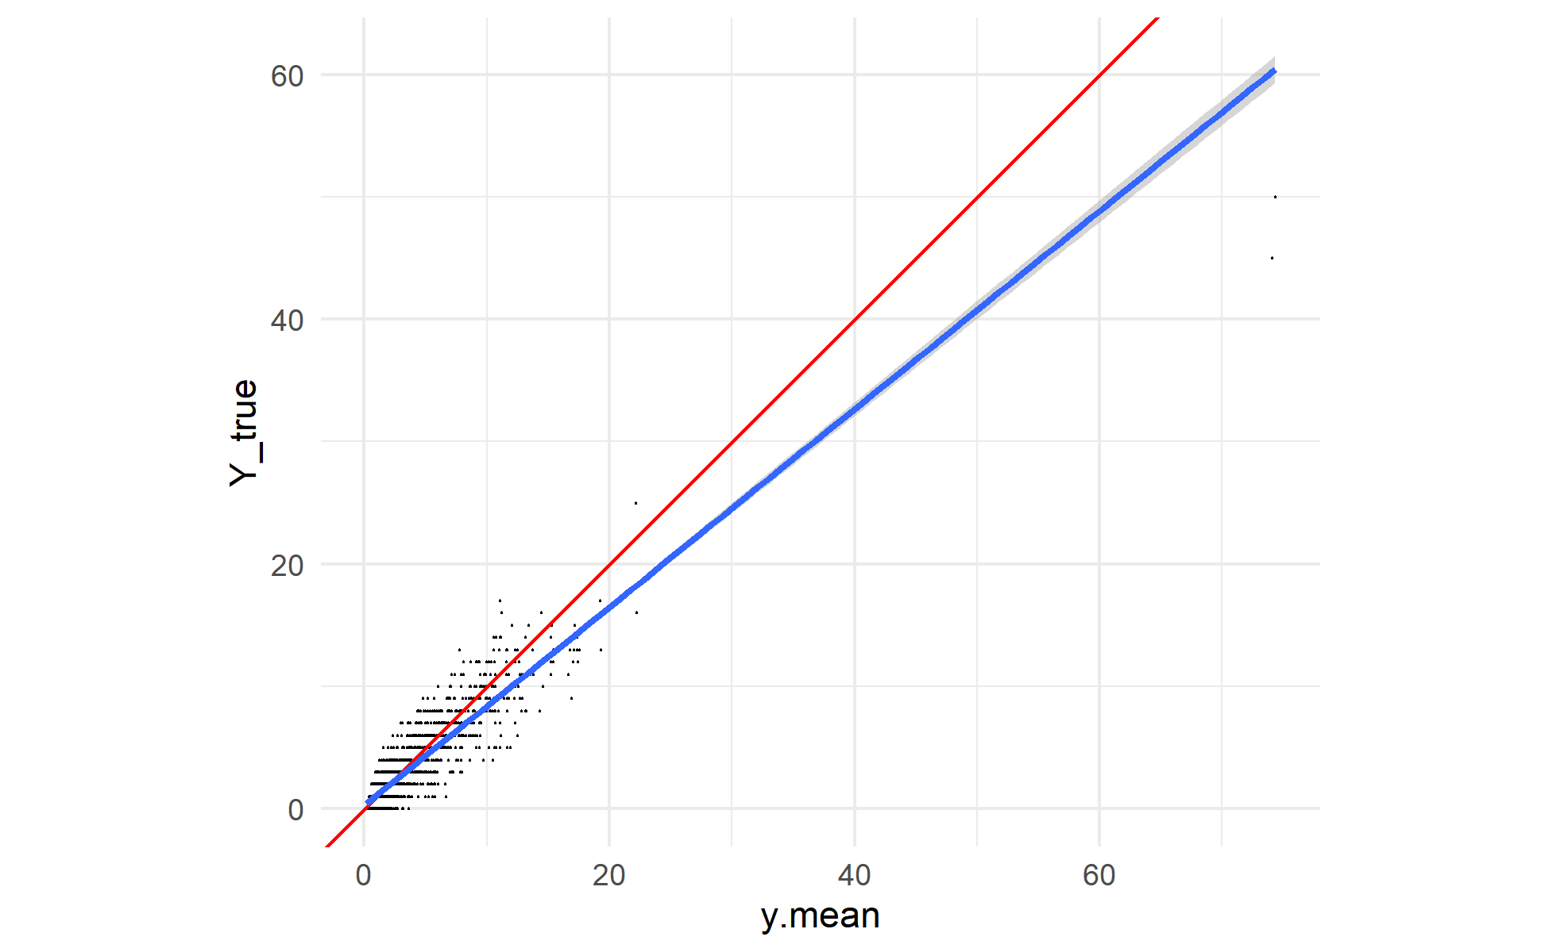
Supplementary Figure 22: Posterior predictions for the 10-hour FWD tallies model generated using the training data and posterior parameter values. For each draw of the posterior, 10-hour FWD tally was simulated for every sample in the training data. Each black point is an observed sample, plotted with its mean posterior predicted value on the X-axis and its observed value on the Y-axis. A 1:1 line is plotted in red, and the actual linear relationship between (mean) simulated and observed counts in blue. Again, there appears to be a mild bias towards overprediction for larger counts, with the observed values generally falling below the mean predicted value for predicted counts greater than ~25.

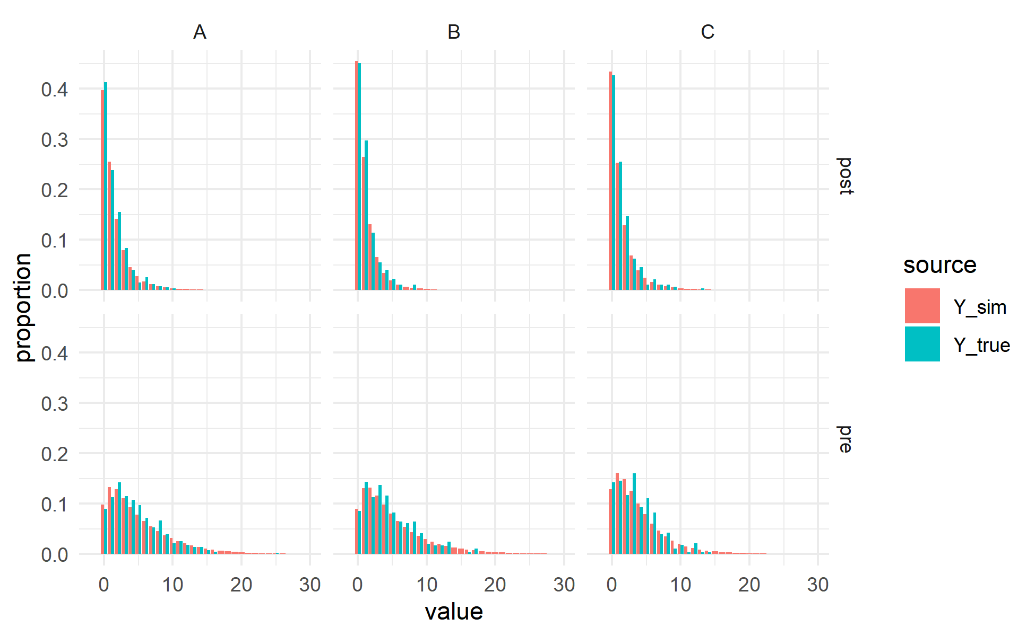
Supplementary Figure 23: Posterior predictions for the 10-hour FWD model generated using the training data and posterior parameter estimates. For each draw of the posterior, 10-hour FWD tally was simulated for every sample in the training data. The bar charts show the distribution of simulated (red) and observed (blue) tallies. The panels break the predictions out by fixed effect group (crossing experimental unit A, B, or C with timestep pre-fire or post-fire). The distribution of values in the simulated data is very similar to the distribution of values in the observed data. There are many more samples (4000 times as many) in the simulated data distributions, so it is to be expected that the resulting distribution is smoother than the distribution of observed values, but the broad behavior is reproduced very well.

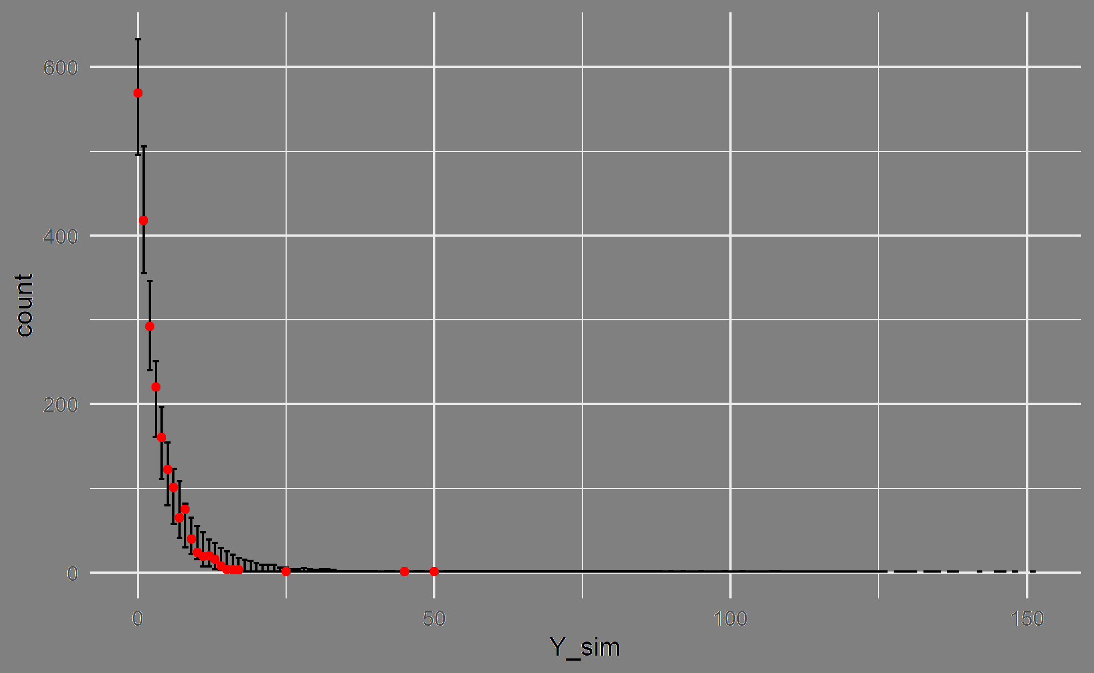
Supplementary Figure 24: Posterior predictions for the 10-hour FWD model generated using the training data and posterior parameter estimates. For each draw of the posterior, 10-hour FWD tally was simulated for every sample in the training data. The observed data are plotted as red points, with the observed value on the X-axis and the count of observations having that depth value on the Y-axis (similar to a histogram). The 2.5th and 97.5th percentiles of the count of samples for each depth value across all posterior draws are shown as the error bars. The observed data fall within the range of behaviors predicted by the model.

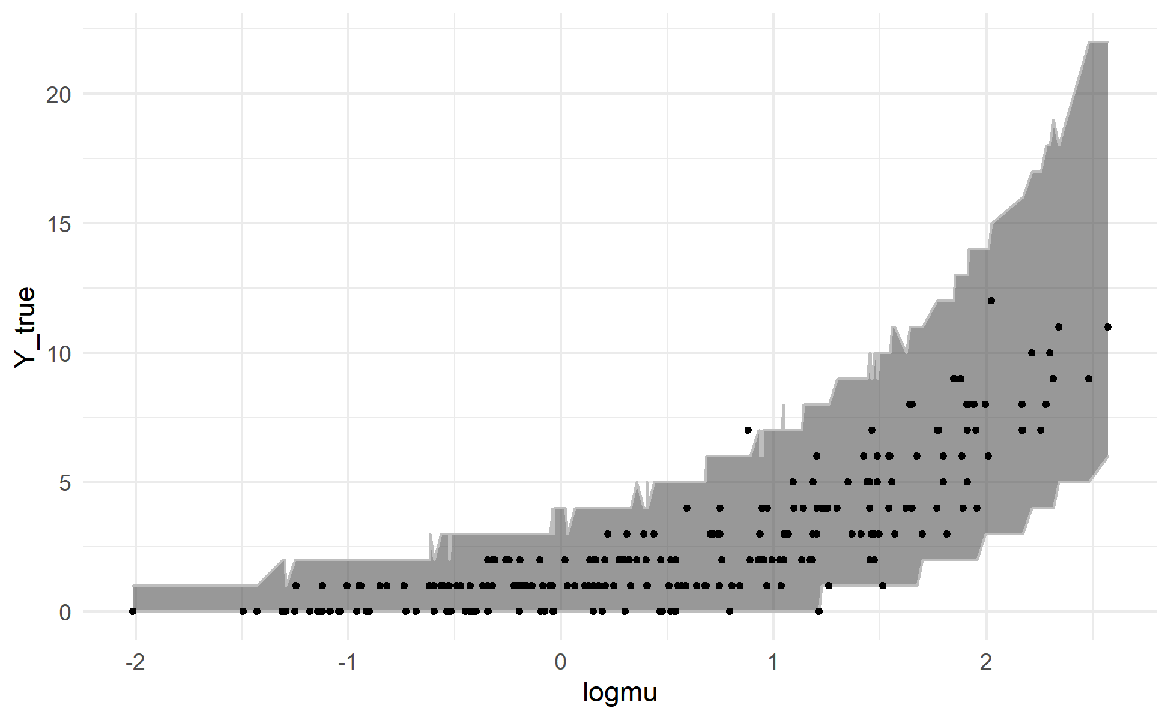
Supplementary Figure 25: Posterior predictions for the 10-hour FWD tallies model generated using the validation data and posterior parameter estimates. For each draw of the posterior, 10-hour FWD tally was simulated for every sample in the validation data. Each observation in the validation dataset (black points) is plotted with its posterior mean value for $\log{μ}$ (the linear predictor) on the X-axis and the observed tally for that observation on the Y-axis. The grey ribbon covers a 95% credible interval for the tally for each observation (the range between the 2.5th and 97.5th percentiles of simulated counts). The model shows good agreement between simulated and observed data.

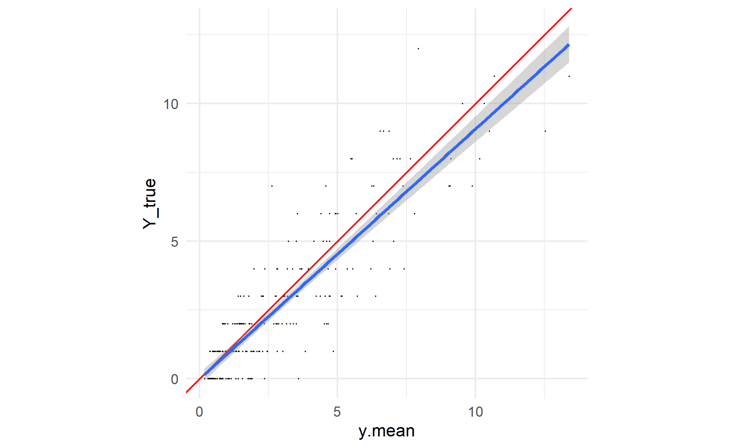
Supplementary Figure 26: Posterior predictions for the 10-hour FWD tallies model generated using the validation data and posterior parameter values. For each draw of the posterior, 10-hour FWD tally was simulated for every sample in the validation data. Each black point is an observed sample, plotted with its mean posterior predicted value on the X-axis and its observed value on the Y-axis. A 1:1 line is plotted in red, and the actual linear relationship between (mean) simulated and observed counts in blue. The simulated values show a mild bias towards overprediction of the observed counts above ~5.

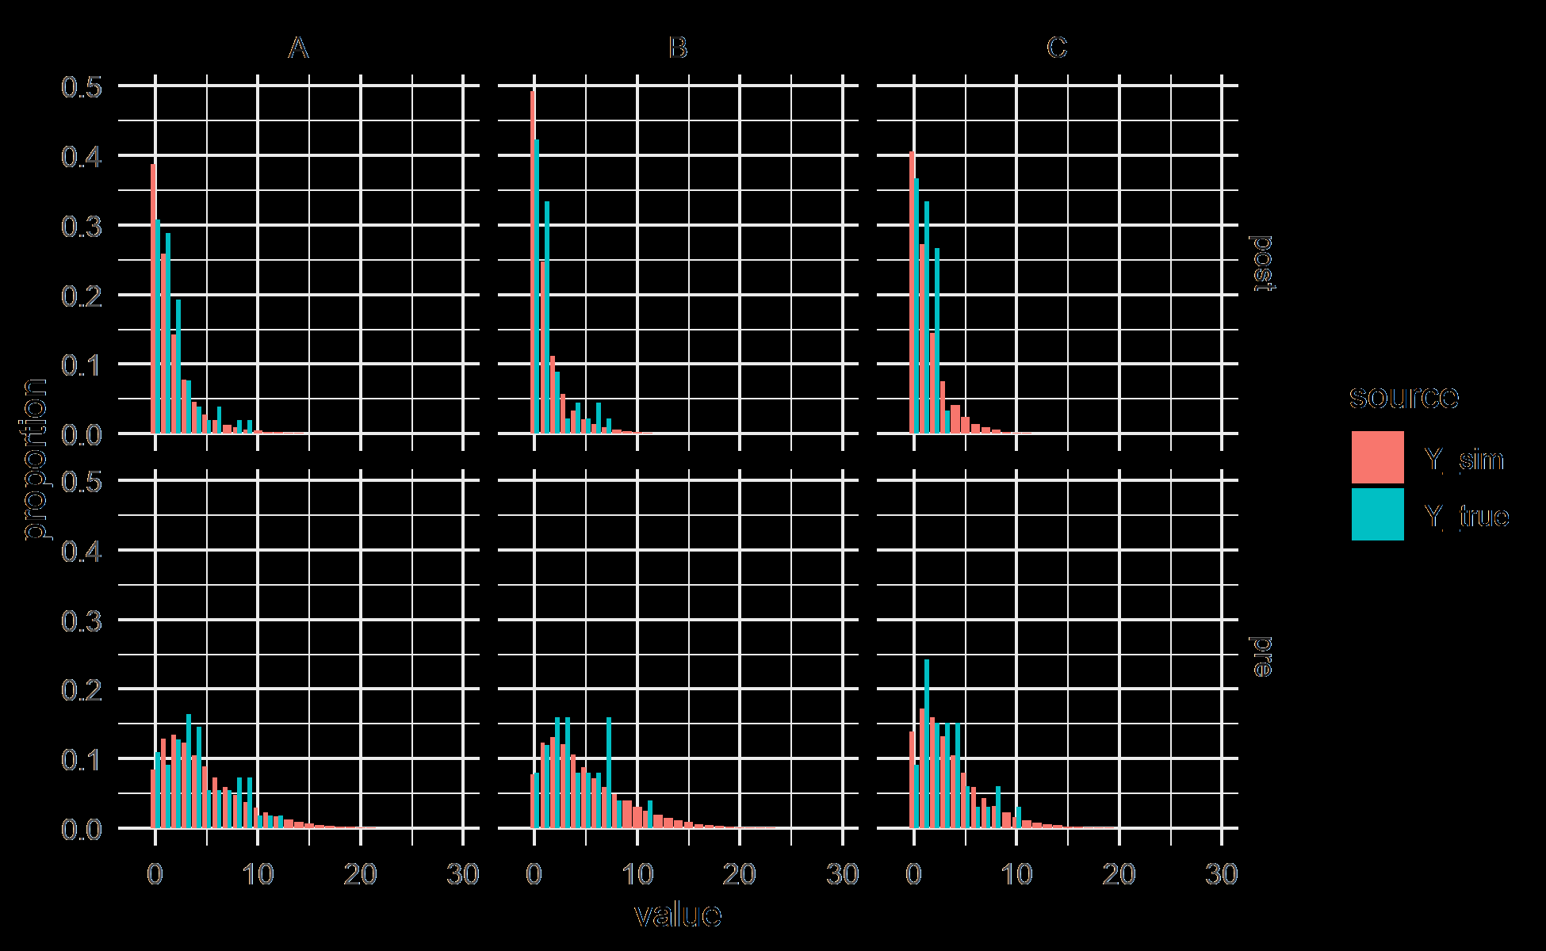
Supplementary Figure 27: Posterior predictions for the 10-hour FWD model generated using the validation data and posterior parameter estimates. For each draw of the posterior, 10-hour FWD tally was simulated for every sample in the validation data. The bar charts show the distribution of simulated (red) and observed (blue) tallies. The panels break the predictions out by fixed effect group (crossing experimental unit A, B, or C with timestep pre-fire or post-fire). The distribution of values in the simulated data is similar to the distribution of values in the observed data. There are many more samples (4000 times as many) in the simulated data distributions, so it is to be expected that the resulting distribution is smoother than the distribution of observed values, but the broad behavior is reproduced well.

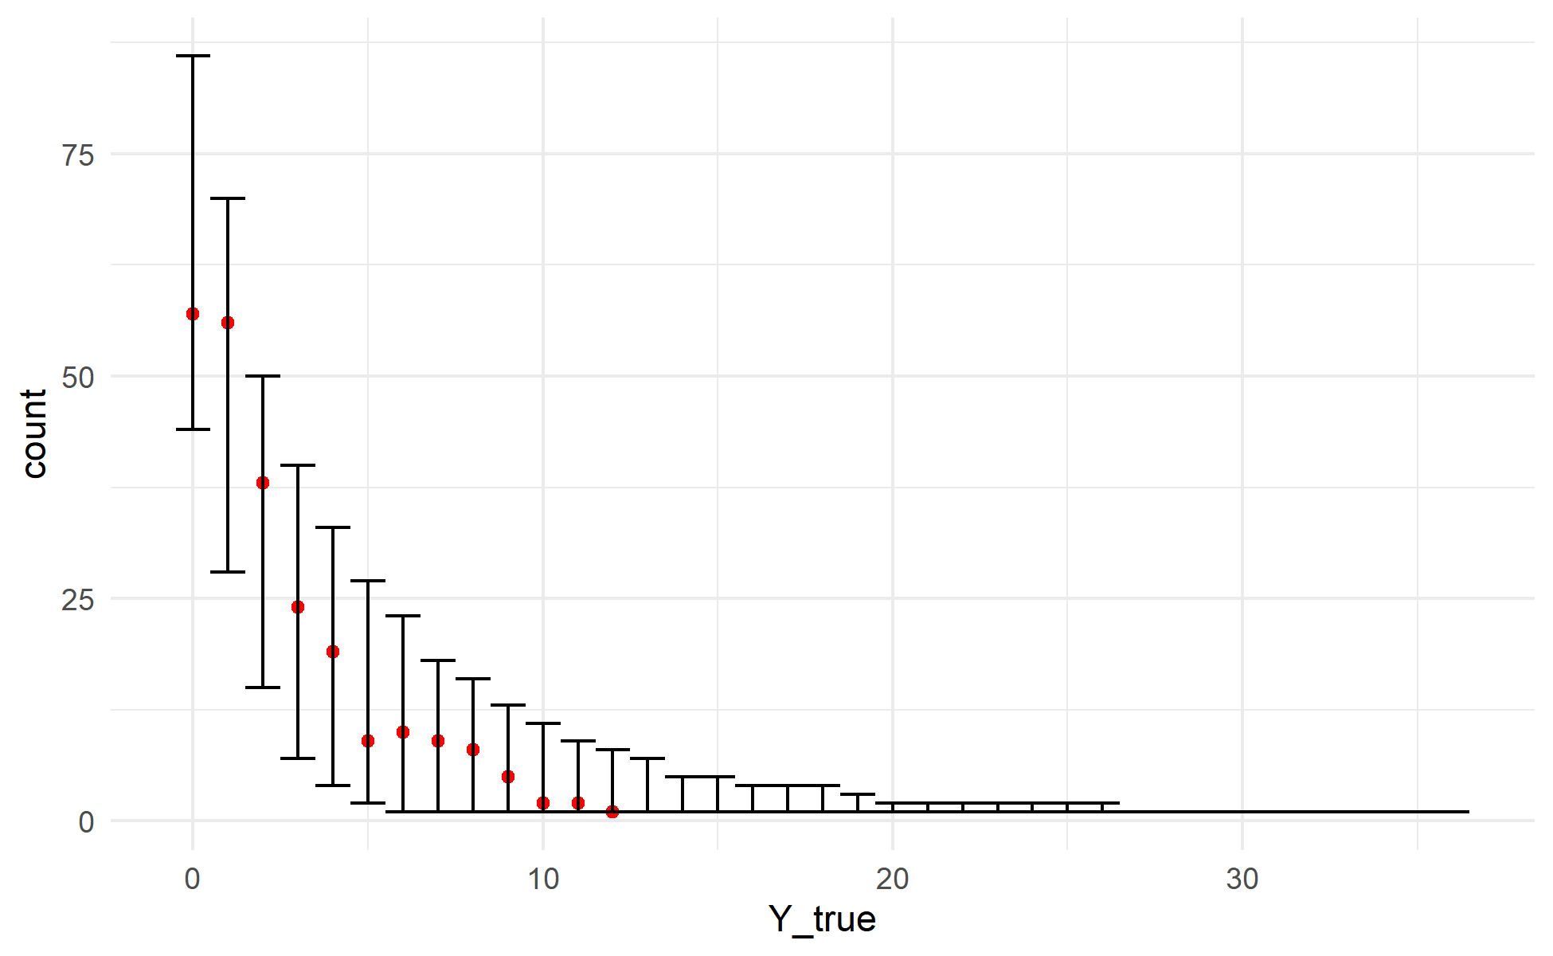
Supplementary Figure 28: Posterior predictions for the 10-hour FWD model generated using the validation data and posterior parameter estimates. For each draw of the posterior, 10-hour FWD tally was simulated for every sample in the validation data. The observed data are plotted as red points, with the observed value on the X-axis and the count of observations having that depth value on the Y-axis (similar to a histogram). The 2.5th and 97.5th percentiles of the count of samples for each depth value across all posterior draws are shown as the error bars. The observed data fall within the range of behaviors predicted by the model.

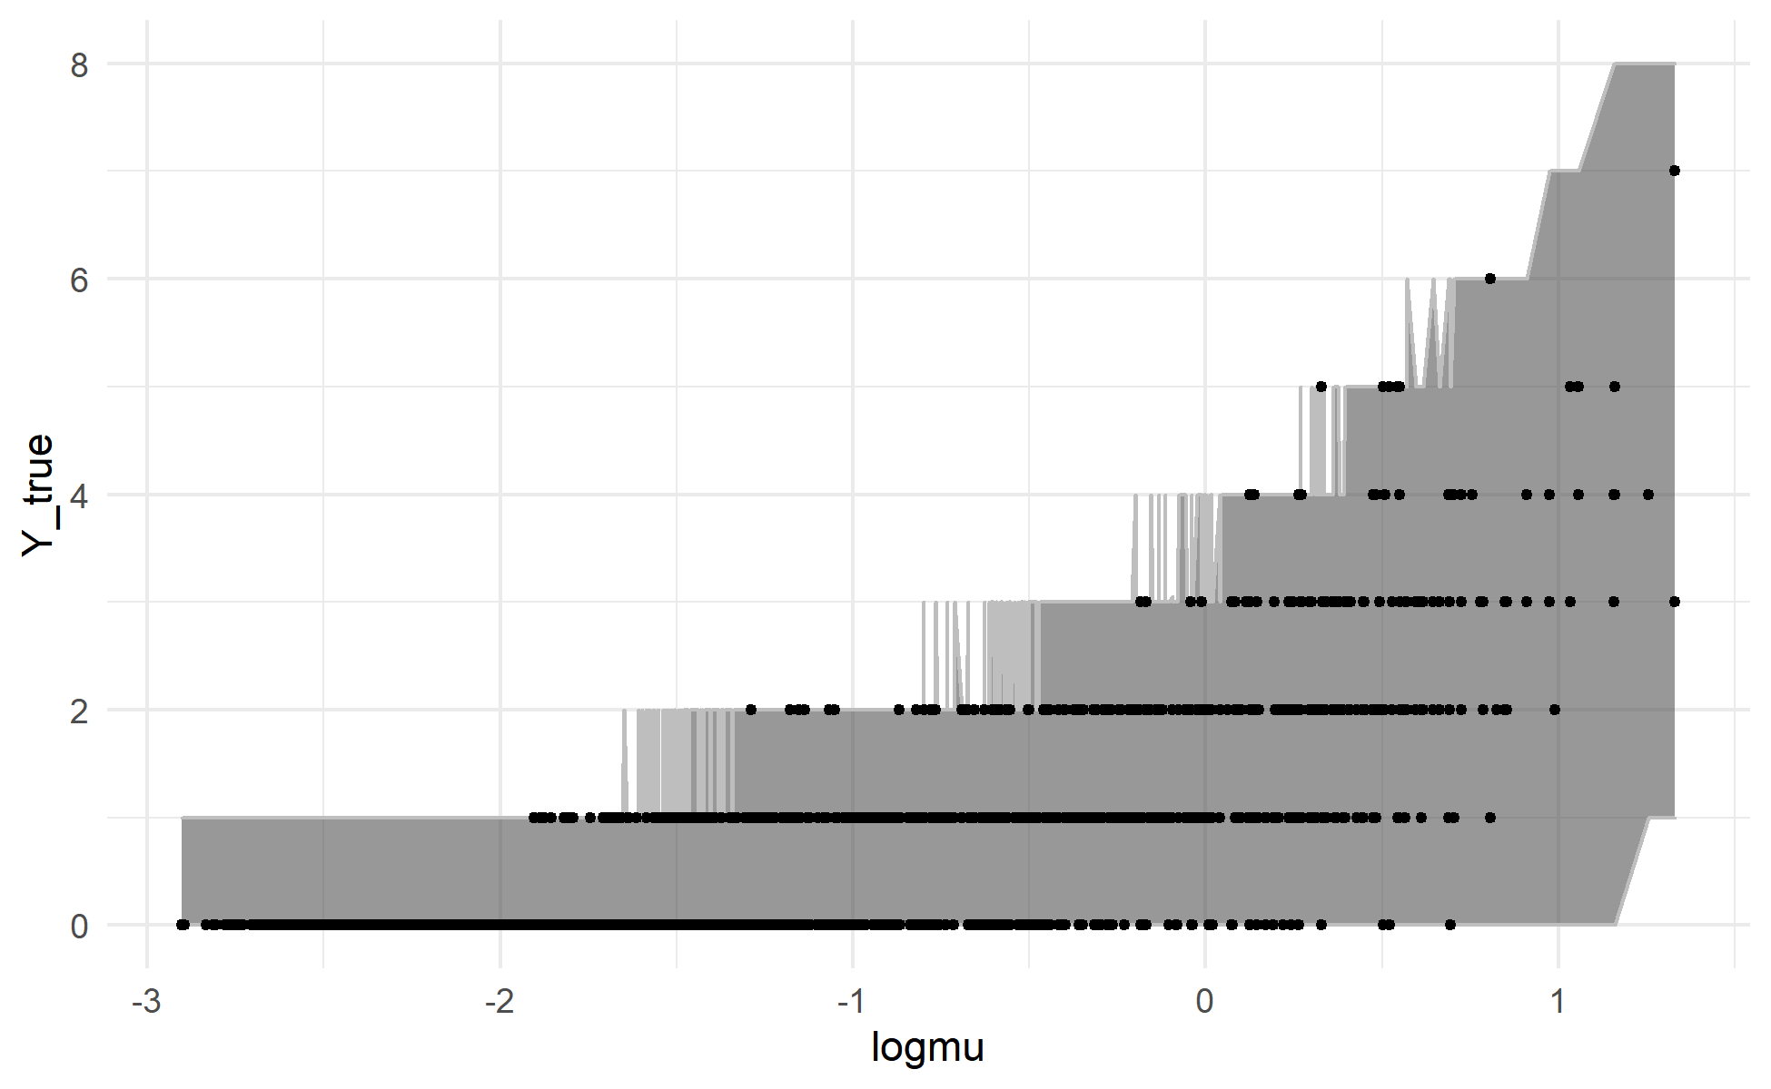
Supplementary Figure 29: Posterior predictions for the 100-hour FWD tallies model generated using the training data and posterior parameter estimates. For each draw of the posterior, 100-hour FWD tally was simulated for every sample in the training data. Each observation in the training dataset (black points) is plotted with its posterior mean value for $\log{μ}$ (the linear predictor) on the X-axis and the observed depth for that observation on the Y-axis. The grey ribbon covers a 95% credible interval for the tally for each observation (the range between the 2.5th and 97.5th percentiles of simulated counts). The model generally shows good agreement between simulated and observed data.

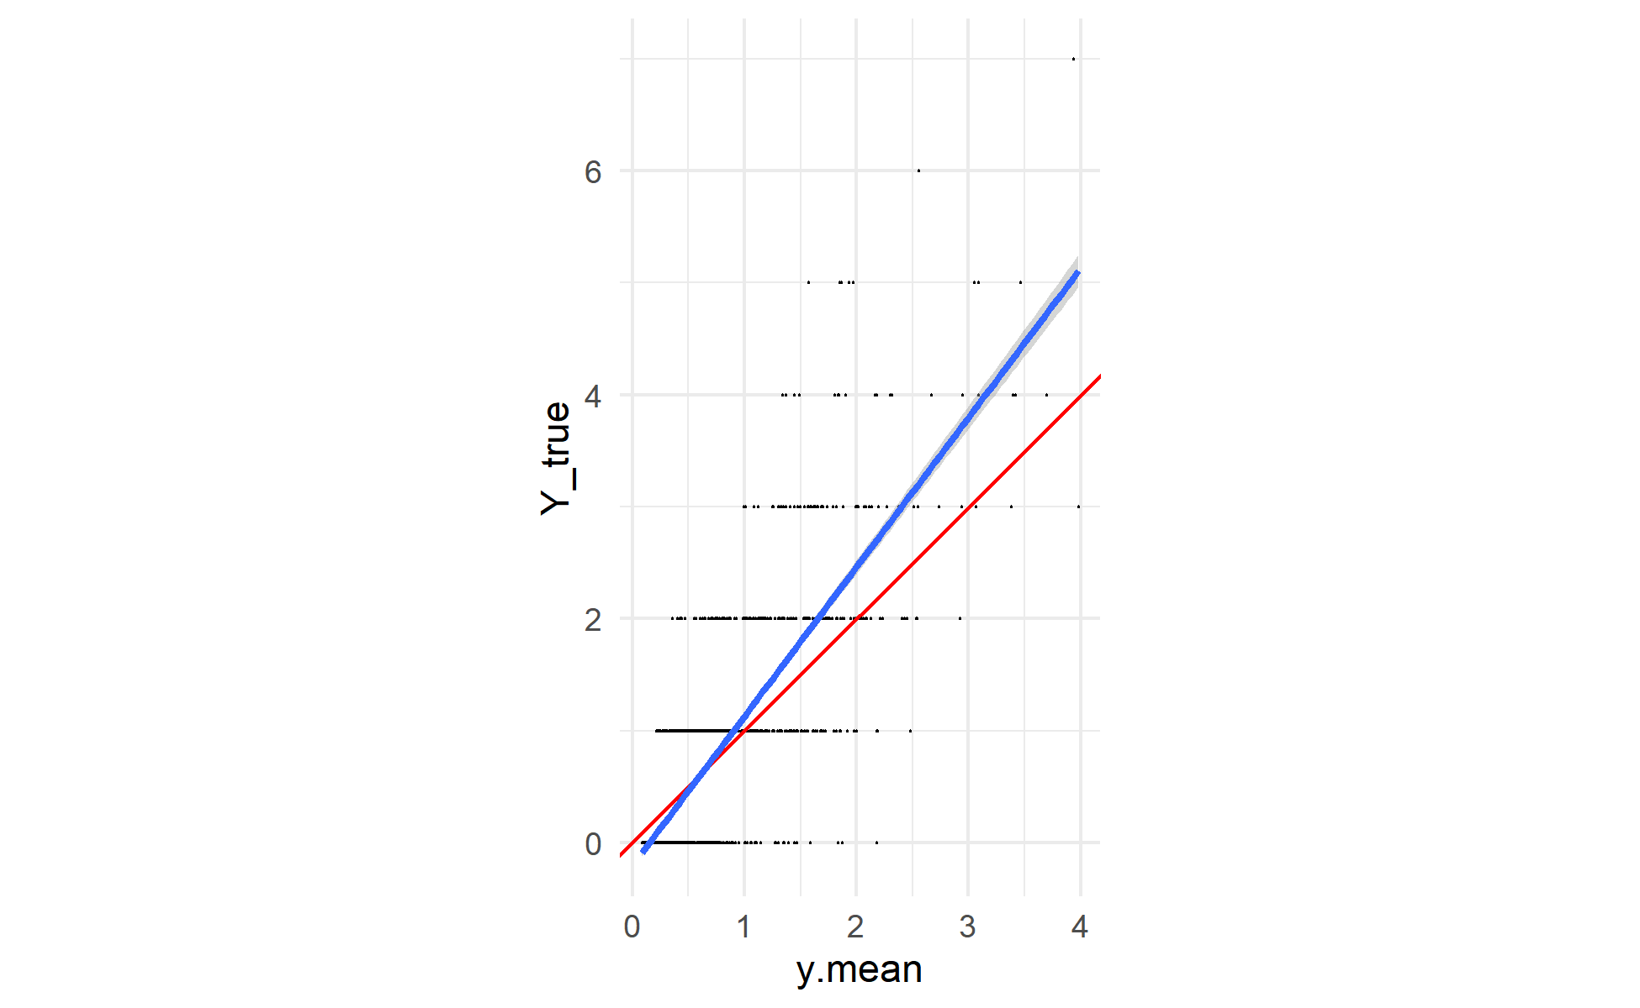
Supplementary Figure 30: Posterior predictions for the 100-hour FWD tallies model generated using the training data and posterior parameter values. For each draw of the posterior, 100-hour FWD tally was simulated for every sample in the training data. Each black point is an observed sample, plotted with its mean posterior predicted value on the X-axis and its observed value on the Y-axis. A 1:1 line is plotted in red, and the actual linear relationship between (mean) simulated and observed counts in blue. Again, there appears to be a mild bias towards underprediction, with the observed values generally falling above the mean predicted value for predicted values greater than approximately 0.5.

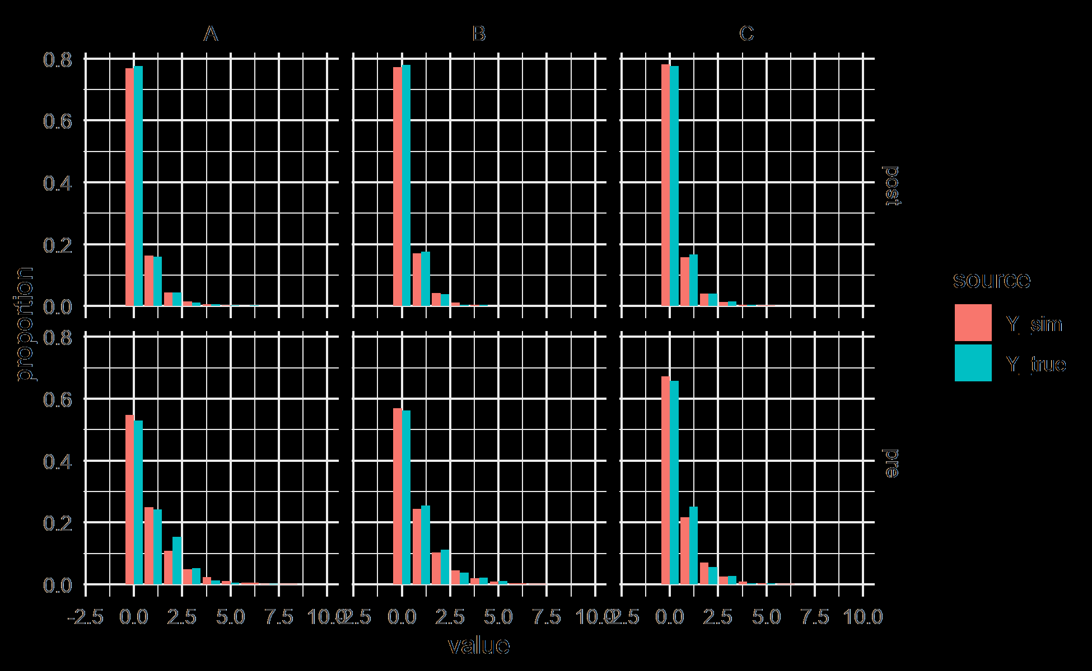
Supplementary Figure 31: Posterior predictions for the 100-hour FWD model generated using the training data and posterior parameter estimates. For each draw of the posterior, 100-hour FWD tally was simulated for every sample in the training data. The bar charts show the distribution of simulated (red) and observed (blue) tallies. The panels break the predictions out by fixed effect group (crossing experimental unit A, B, or C with timestep pre-fire or post-fire). The distribution of values in the simulated data is very similar to the distribution of values in the observed data. There are many more samples (4000 times as many) in the simulated data distributions, so it is to be expected that the resulting distribution is smoother than the distribution of observed values, but the broad behavior is reproduced very well.

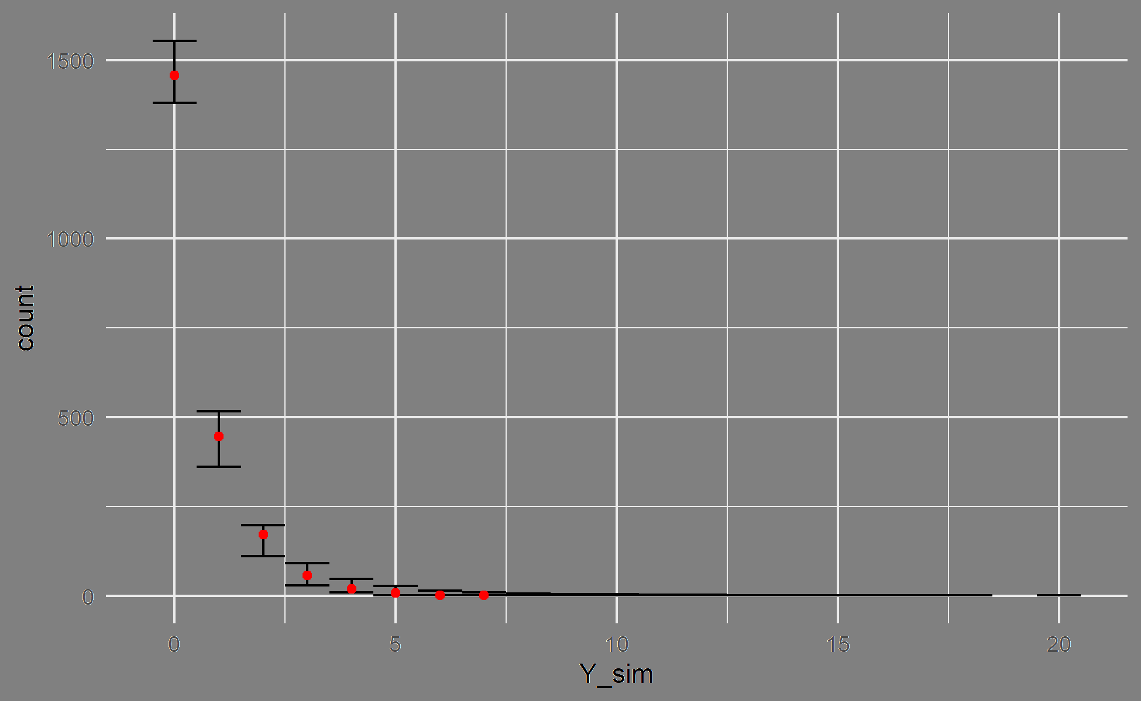
Supplementary Figure 32: Posterior predictions for the 100-hour FWD model generated using the training data and posterior parameter estimates. For each draw of the posterior, 100-hour FWD tally was simulated for every sample in the training data. The observed data are plotted as red points, with the observed value on the X-axis and the count of observations having that depth value on the Y-axis (similar to a histogram). The 2.5th and 97.5th percentiles of the count of samples for each depth value across all posterior draws are shown as the error bars. The observed data fall within the range of behaviors predicted by the model.

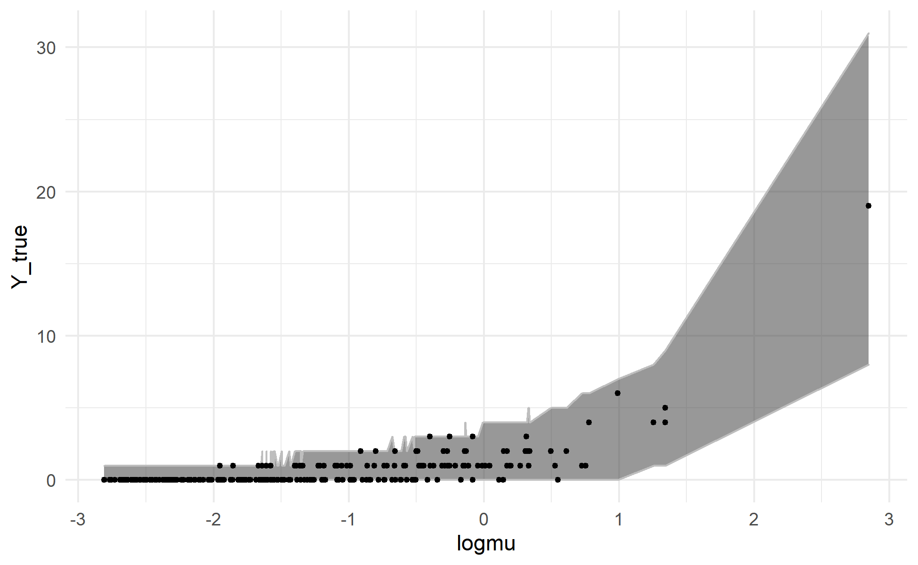
Supplementary Figure 33: Posterior predictions for the 100-hour FWD tallies model generated using the validation data and posterior parameter estimates. For each draw of the posterior, 100-hour FWD tally was simulated for every sample in the validation data. Each observation in the validation dataset (black points) is plotted with its posterior mean value for $\log{μ}$ (the linear predictor) on the X-axis and the observed tally for that observation on the Y-axis. The grey ribbon covers a 95% credible interval for the tally for each observation (the range between the 2.5th and 97.5th percentiles of simulated counts). The model shows good agreement between simulated and observed data.

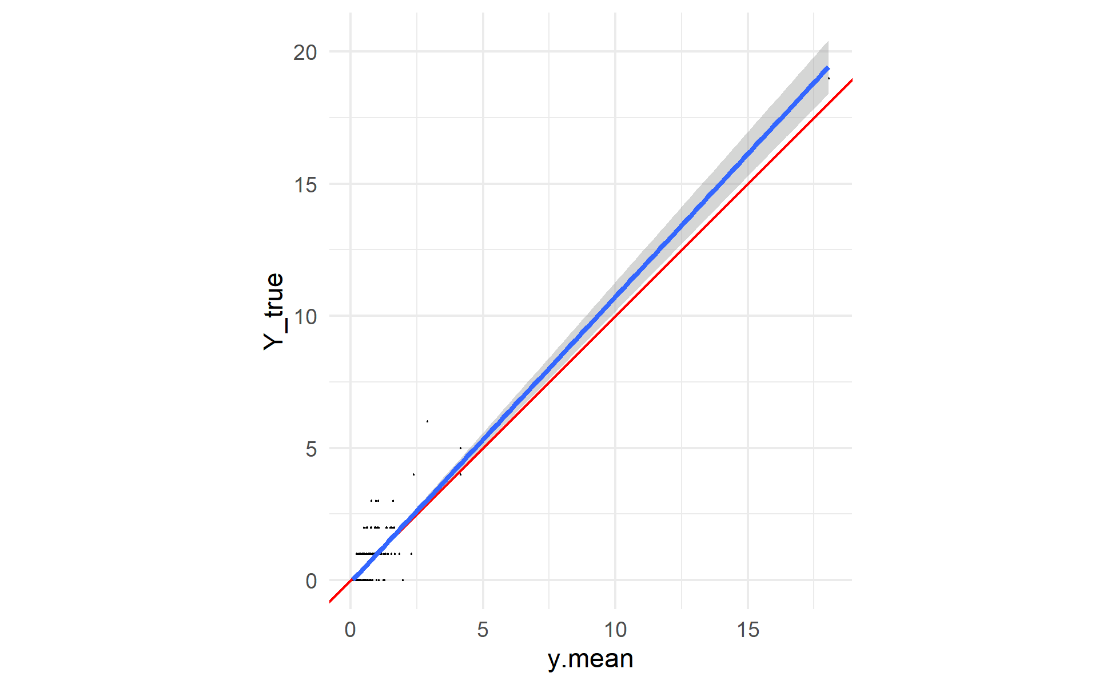
Supplementary Figure 34 Posterior predictions for the 10-hour FWD tallies model generated using the validation data and posterior parameter values. For each draw of the posterior, 10-hour FWD tally was simulated for every sample in the validation data. Each black point is an observed sample, plotted with its mean posterior predicted value on the X-axis and its observed value on the Y-axis. A 1:1 line is plotted in red, and the actual linear relationship between (mean) simulated and observed counts in blue. The simulated values show a mild bias towards underprediction of the observed counts.

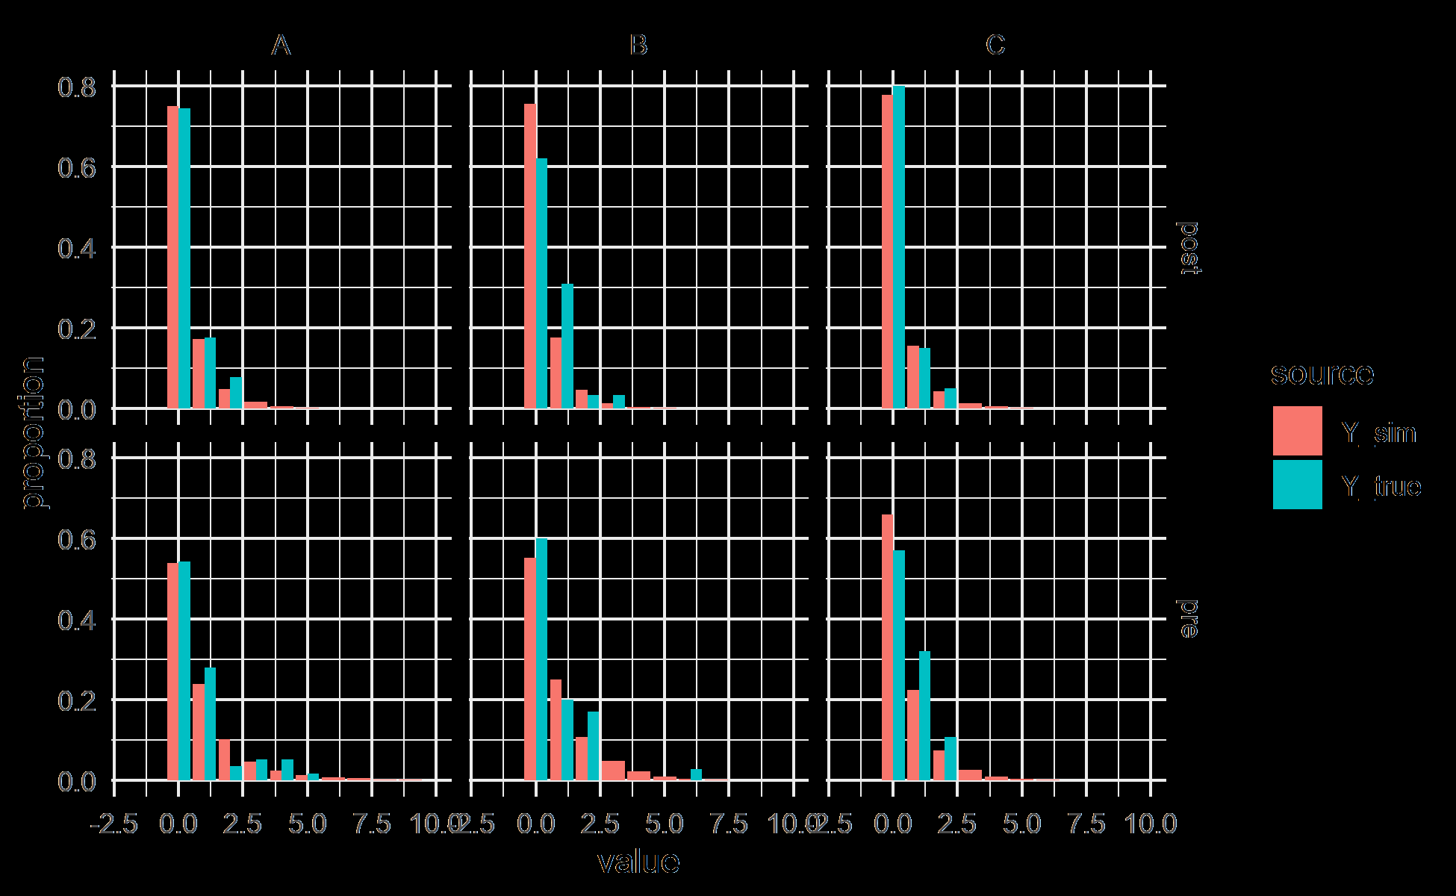
Supplementary Figure 35: Posterior predictions for the 100-hour FWD model generated using the validation data and posterior parameter estimates. For each draw of the posterior, 100-hour FWD tally was simulated for every sample in the validation data. The bar charts show the distribution of simulated (red) and observed (blue) tallies. The panels break the predictions out by fixed effect group (crossing experimental unit A, B, or C with timestep pre-fire or post-fire). The distribution of values in the simulated data is similar to the distribution of values in the observed data. There are many more samples (4000 times as many) in the simulated data distributions, so it is to be expected that the resulting distribution is smoother than the distribution of observed values, but the broad behavior is reproduced well.

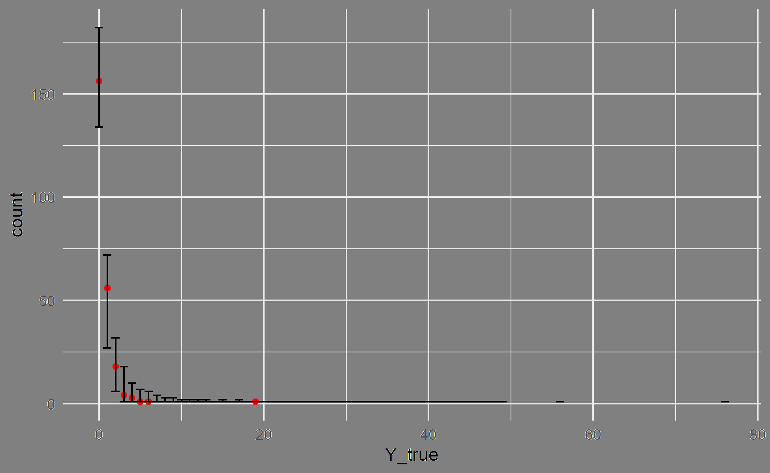
Supplementary Figure 36: Posterior predictions for the 100-hour FWD model generated using the validation data and posterior parameter estimates. For each draw of the posterior, 100-hour FWD tally was simulated for every sample in the validation data. The observed data are plotted as red points, with the observed value on the X-axis and the count of observations having that depth value on the Y-axis (similar to a histogram). The 2.5th and 97.5th percentiles of the count of samples for each depth value across all posterior draws are shown as the error bars. The observed data fall within the range of behaviors predicted by the model.

