Using Gaussian processes to quantify fine-scale heterogeneity in wildland fuels
Daniel Foster, Lisa Rosenthal, Andrew Johnson¹, Adrian Das, Perry de Valpine¹, Brandon Collins¹, Mark Finney, Scott L. Stephens¹, John Battles¹
Keywords: Wildfire, wildland fuels, Sierra Nevada mixed conifer forests, spatial statistics, Gaussian processes, drought, Bayesian statistics
Abstract: Using Gaussian processes to quantify fine-scale spatial heterogeneity in wildland fuels
A suite of hierarchical spatial statistical models using Gaussian process spatial random effects is proposed to quantify fine-scale spatial patterns in the fuel load of several wildland fuel components (duff, litter, and fine woody debris). A sampling protocol and associated statistical models are described and applied in a Sierra Nevada mixed conifer forest affected by extensive drought caused tree mortality. Model validation reveals varying performance in three tasks: 1) Making pointwise predictions, 2) reproducing the distribution of fine-scale load observations, and 3) reproducing the distribution of coarse-scale mean fuel loads. Models for the depth of duff, depth of litter, and count of fine woody debris particles particles perform well in all three tasks and parameter estimates are well informed by the data. The sampling protocol and statistical analysis described in this study enable quantitative description and simulation of the fine-scale spatial patterns of fuel loads, an important step towards the creation of fuel model inputs for next-generation fire spread modeling with fine-scale spatial processes.

Summary text for table of contents
This study explores the application of hierarchical spatial statistical models featuring Gaussian process random effects in the description of wildland fuel beds.

Keywords
Wildland fire; fuels; spatial heterogeneity; gaussian process;

Introduction
Wildland fuels are the live and dead vegetation whose biomass is burned during wildland fire events. Conceptually, these fuels are often separated into distinct strata (canopy fuels > 2m above the ground, surface fuels < 2m above the ground, and ground fuels i.e. duff) and these strata are separated into distinct fuel components (e.g. duff, litter, fine woody debris, coarse woody debris, understory vegetation, saplings, and trees) (Sandberg et al. 2001; Keane 2015). Multiple characteristics of these fuel components are important for predicting how they will combust, such as the fuel moisture, mineral content, and particle size (Burgan and Rothermel 1984). However, fuel load (mass per unit area), which quantifies the aggregated mass of the fuel strata, is a critical characteristic of wildland fuels for determining fire behavior (Burgan and Rothermel 1984; Finney 1998; Linn et al. 2002; Sandberg et al. 2007) and emissions (Weise and Wright 2014; Keane and Lutes 2016). This is why fire hazard reduction treatments are often focused on reducing fuel loads (Agee and Skinner 2005; Stephens and Moghaddas 2005). Describing fuel loads is also important to quantify carbon stocks (Hurteau et al. 2008; Eskelson et al. 2016; Eskelson and Monleon 2018; Foster et al. 2020) and to understand how fuel loads affect other ecosystem processes such as tree reproduction (Lanini and Radosevich 1986) and wildlife movement (Ucitel et al. 2003). Given the importance of fuel loads, it is crucial to quantify them accurately and precisely.
Most existing classification systems describe fuel abundance in terms of mean load for the various fuel components (Anderson 1982; Sandberg et al. 2001; Scott and Burgan 2005; Ottmar et al. 2007). This practice is largely driven by the Rothermel fire behavior model (Rothermel 1972), which is the backbone of many tools used to predict wildfire behavior and effects in the United States (Burgan and Rothermel 1984; Finney 1998, 2006; Sandberg et al. 2007). Operational applications of the Rothermel model assume that fuel loads are uniformly distributed across an arbitrary spatial domain, which mapping resolution for many applications is a square 900 m² area (Reeves et al. 2009). In reality, loads and arrangements of most fuel components are highly variable at fine scales (sub-meter to tens of meters) for most constituent components (Keane et al. 2012a, 2013; Kreye et al. 2014; Vakili et al. 2016a; Fry et al. 2018). Furthermore, research has shown that fine-scale heterogeneity in fuel characteristics impacts fire behavior and effects (Finney et al. 2010). For example, different leaf morphologies cause the physical properties of the litter layer to vary under the crowns of different tree species, creating variation in maximum air temperature during prescribed fires (Williamson and Black 1981). In multiple ecosystems, experimental manipulations of fuel loads at fine scales have altered the composition of the post-fire community by changing rates of mortality and germination (Thaxton and Platt 2006; Rocca 2009; Wiggers et al. 2013). Varying patterns of meter-scale tree crowns and gaps have altered hectare-scale fire behavior in a simulation study (Atchley et al. 2021) and meter to meter variation in surface fuels has led to fine-scale variation in fire behavior in real fires (Loudermilk et al. 2012, 2014). An example is during portions of the 2013 Rim Fire, small shrub patches (mean size 30 m²) moderated fire behavior and reduced tree mortality within the patches (Lutz et al. 2017).
Given the importance of fine-scale spatial heterogeneity in fuel component loads, it is critical to quantify this variation in arrangement and to understand its impact on fire behavior (Loudermilk et al. 2022; Tinkham et al. 2023). Despite progress, initial efforts suffer from important limitations such as limited abilities to model actual fuel characteristics or fuel-fire behavior processes. Researchers have leveraged various methods to create highly detailed fuels maps that describe the heterogeneity of fuel structure across large areas such as Terrestrial Laser Scan (TLS) (Hiers et al. 2009, 2021; Loudermilk et al. 2009, 2012, 2014, 2023; O’Brien et al. 2016; Hawley et al. 2018; Wallace et al. 2022; Hut) and interpolation using field collected data, photoload samples, and topographic variables (Hoffman et al. 2023). Some studies incorporating TLS have classified high-resolution photographs to develop fine-scale fuel-bed maps that link fuels to fire behavior via statistical comparison with post fire effects (Hiers et al. 2009, 2021; Loudermilk et al. 2009, 2012, 2014, 2023; O’Brien et al. 2016; Hawley et al. 2018). Research using various interpolation methods to map fuels with forest structure and topography have found weak relationships between selected variables and actual surface fuel loads (Hoffman et al. 2023). Statistical linkages are limited due to their mechanistic nature, meaning predictions of fire behavior are based on the empirical correlation between fuels and fire behavior, rather than on the underlying physical process of combustion (Finney et al. 2012). Such empirically based statistical models are unable to predict fire behavior outside the range observed in the original context (i.e., frequently-burned pine savannahs in the southern US). Another approach has been to use variogram analysis to describe the structure of spatial autocorrelation within various fuel components across different ecosystem types and disturbance histories (Keane et al. 2012a, 2012b; Bivand et al. 2013; Vakili et al. 2016a). However, this variogram approach is purely descriptive and provides a spatially sparse set of observed loads. Without the ability to produce a continuous map of fuel loads, study of the connection between the spatial properties of fuel beds and fire behavior is impossible without physically burning the sampled fuel beds.
Another line of research has focused on coupled fire-atmosphere models. Depending on the resolution, some of these models are capable of predicting wildfire behavior in forests with spatially heterogeneous fuel beds (Linn et al. 2005; Ziegler et al.,2017; Atchley et al. 2021; Mueller et al. 2021; Tutland et al. 2025). The main drawbacks are that resolving the underlying fluid dynamics is too computationally intensive to be helpful for predicting fire behavior in real time and that the fuel structure is not explicitly described at resolutions finer than the simulation allows (typically meters for fires of a few hectares in size). Moreover, applications of these models, sometimes known as computational fluid dynamics (CFD) models, have been primarily focused on canopy fuels and mid-story ladder fuels (Tutland et al. 2025). They either assume that surface fuels are homogeneously distributed or that their distribution mirrors the distribution of the canopy fuels. Neither assumption reflects reality. Surface fuels are rarely distributed homogeneously (Keane et al. 2012a) and the canopy is often a poor predictor of surface fuels (Lydersen et al. 2015; Leite et al. 2022).
In this study, we describe and test novel methods for sampling and quantifying the spatial heterogeneity of wildland surface fuels. These methods are designed to increase the reality of any physical or empirical model. New models are in development that will be able to incorporate information on fine-scale heterogeneity of fuel loads into predictions of wildfire behavior (Finney et al. 2013; Mueller et al. 2021). In this study we first collected extensive and spatially explicit field data describing fuel loads. These data are used to estimate the parameters of hierarchical spatial models using Gaussian process spatial random effects to describe fine-scale spatial patterns in the fuel load of key fuel components. Of particular importance are the surface and ground fuels, which have not yet been accurately measured using airborne or satellite based remote sensing (Jakubowksi et al. 2013) but which are crucial drivers of fire behavior (Rothermel 1972; Burgan and Rothermel 1984; Agee and Skinner 2005).
Hierarchical spatial models have proven to be an effective tool for 1) quantifying fine-scale spatial pattern, 2) controlling for the effects of fine-scale spatial autocorrelation when estimating other model parameters, and 3) making predictions that incorporate information about spatial patterns (Diggle and Ribiero 2007). They are particularly well suited for cases where the response variable is non-normally distributed, unlike the related approach of kriging (Hoffman et al. 2023). Like variogram analysis, these models are capable of quantifying spatial patterns in fuel loads, facilitating study on the causes and effects of such patterns. However, once model parameters have been estimated, these models can also be used to simulate new data with realistic spatial properties. In this way, sparse observations can be interpolated to continuous fuel beds, and a limited number of observed locations can be extrapolated to an infinite array of realizations with realistic spatial properties. The effects of these spatial properties on fire behavior could be studied using a CFD or other fire model. Such extrapolation beyond the observed locations would provide two benefits: First, parameter uncertainty could be propagated through the simulations, ensuring that the modeled fire behavior reflects the uncertainty about the spatial pattern of fuel loads. Second, and more importantly, ensembles of simulated fuel beds are necessary to predict fire behavior across the combinations of actual fuel beds existing on the landscape because modeled fire behavior is dependent upon the specific realized arrangement of fuel biomass (Atchley et al. 2021). Without these ensembles of simulated fuel beds, predictions of fire behavior would likely be overfit to the characteristics of sampled locations.
However, there are numerous challenges in attempting to apply these hierarchical spatial models to the study of wildland fuels. First and foremost, these models require many replicate observations with explicit spatial information and therefore require costly and time-intensive labor in the field. At the same time, the computational requirements for parameter estimation scale exponentially with the number of observations, imposing a major hurdle to estimating the model parameters even when there are sufficient data (Heaton et al. 2019). Finally, because realistic simulations are a core goal of this work, models must strike a balance between being complex enough to capture the real patterns of spatial correlation within and between fuel components and flexible enough to avoid overfitting or issues with identifiability.
An important and understudied type of real fuel bed is that of a Sierra Nevada mixed conifer forest which has suffered from extensive tree mortality. These conditions have become widespread, especially in the southern Sierra Nevada, in the wake of California’s 2012-2015 drought (Asner et al. 2015; Fettig et al.,2019; Stephenson et al.,2019). It is well documented that tree mortality alters the fuel bed and subsequent fire behavior as biomass falls from standing snags to the surface, increasing fuel hazard (Hoffman et al. 2012b; Donato et al. 2013; Stephens et al. 2018, 2022; Wayman and Safford 2021). It is logical that the same processes driving change in coarse-scale (sub-hectare scale) fuel loads also alter the fine-scale spatial patterns of fuel loads. Given the importance of the fine-scale spatial pattern of fuel loads for determining wildfire behavior and effects and the extensive areas in which mass tree mortality has occurred in the Sierra Nevada, it is crucial to quantify the fine-scale spatial pattern of fuel loads in this context so that we can predict wildfire behavior (Stephens et al. 2022). However, not all parts of the landscape experience drought mortality equally (Baguskas et al. 2014). Therefore, quantification of the spatial pattern of fuel loads is necessary across varying levels of drought mortality. Furthermore, linking the fine-scale spatial patterns to drought mortality would enable us to apply fine-scale models to predict fuel bed characteristics across entire landscapes because the severity of drought mortality can be measured using available remote sensing data.
In this study we demonstrate the use of this sampling protocol and statistical approach in the context of a Sierra Nevada mixed conifer forest which experienced extensive mortality during California’s 2012-2015 drought (Asner et al. 2015; Stephens et al. 2018; Fettig et al. 2019; Stephenson et al. 2019). To that end, this study focuses on two questions:
- Can hierarchical spatial statistical models simulate realistic fuel beds with continuous fine-grain information on fuel loads for a suite of wildland fuel components?
- Do the parameters of these statistical models vary across different levels of drought mortality severity?

Methods

Site description
The area of interest (AOI) for this study is a 17 km² site dominated by Sierra Nevada mixed conifer forest. The AOI is located in the Kaweah River watershed in Sequoia National Park (approximately 36.76° N by 118.80° W) between 1,500 m and 1,850 m elevation (Stephenson et al. 2019; Figure 1). The climate is Mediterranean, with mean annual temperature approximately of 10° C and annual precipitation of 110-140 cm falling approximately half as snow (Stephenson et al. 2019). Based on the CALVEG classification system (Vegetation Classification and Mapping 2022), the AOI is dominated by the following vegetation alliances: “Mixed Conifer – Pine” (1,160 ha, 68% of the AOI), “Black Oak” (224 ha, 13%), and “Canyon Oak” (130 ha, 8%). For this study, we restricted sampling to the “Mixed Conifer – Pine” alliance, the most widespread conifer alliance in the southern Sierra Nevada. Constituent species of this alliance are ponderosa pine (Pinus ponderosa) and sugar pine (Pinus lambertiana), alongside white fir (Abies concolor), incense-cedar (Calocedrus decurrens) and various hardwoods such as black oak (Quercus kelloggii) and canyon live oak (Quercus chrysolepis). Mountain misery (Chamaebatia foliosa), whitethorn ceanothus (Ceanaothus cordulatus), whiteleaf manzanita (Arctostaphylos viscida ssp. mariposa), and greenleaf manzanita (Arctostaphylos patula) are important understory shrub species (USDA Forest Service 2009). Mixed conifer forests across the southern Sierra Nevada experienced extensive tree mortality following a severe drought from 2012-2015 (Asner et al. 2015; Stephens et al. 2018; Fettig et al. 2019; Stephenson et al. 2019).

Drought mortality classification and plot network
Geospatial analysis of remote sensing data was used to randomly place twenty-one inventory plots across three levels of drought mortality severity within the AOI using a random stratified sampling design. Drought mortality severity was assessed using the Magnitude of Mortality Index (MMI) data product from the Ecosystem Disturbance and Recovery Tracker (eDaRT) system. eDaRT uses a time series of LANDSAT data to detect and quantify mortality events of overstory vegetation (Koltunov et al. 2020). MMI provides an estimate of cumulative overstory percent-cover mortality at a 30 m² resolution for a specific 5-year period. Given the importance of drought-induced mortality, we selected the 5-year period that bracketed the start and end of the historic hotter drought in California, namely 2012 to 2015 (Stephenson et al. 2018). The MMI raster was smoothed by taking the mean over a 90 m by 90 m window and clipped to just the Mixed Conifer – Pine vegetation alliance. Continuous MMI values were binned into low (<25th percentile, 0-7% cumulative mortality), medium (25th to 75th percentile, 7% to 18% cumulative mortality), and high (>75th percentile, 18% to 100% cumulative mortality) categories (Figure 1). Finally, pixels of the same category were aggregated into polygons and a 30 m inward buffer on each polygon was used to identify core zones of each mortality class.
To ensure safe and efficient access to remote field sites, plot placement was restricted to these core mortality zones with slopes less than 25° and at a distance of 50 to 600 m from a road or trail. This restricted accessible area was representative of the wider area of interest (Mixed Conifer – Pine vegetation alliance from 1,500 to 1,850 m elevation) based on a comparison of the topographic characteristics (slope, elevation, aspect) of the full AOI and the accessible area (Supplementary Figure 1). The accessible area had slightly lower slopes on average but was generally representative of the full AOI (Supplementary Figure 1). Seven plots per mortality class, for a total of twenty-one inventory plots, were randomly placed using a geographic information system within the accessible area of the core mortality zones in a stratified random design.

Data collection
On each inventory plot, data were collected describing seven fuel components: Duff, litter, fine woody debris (FWD; woody particles < 7.6 cm diameter), coarse woody debris (CWD; woody particles ≥ 7.6 cm diameter), understory vegetation (forbs, graminoids, shrubs, and trees less than 1.37 m height), trees, and saplings (Figure 2 and Supplementary Figure 2). This study focuses on the key fuel components for fire spread: duff, litter, and FWD. Plots were sampled in the summer of 2021, approximately five years after the main pulse of drought mortality. The core approach for data collection was to modify a standard forest inventory protocol. The line-intercept method (Brown 1974) was used to observe the fuel load of duff, litter, and fine woody debris at specific spatial locations selected to provide a useful set of pairwise distances between observations (Figure 2).
The placement of samples for duff, litter, and fine woody debris were arranged such that the distribution of pairwise distances between samples within a plot spanned the range 0-60 m, with the bulk of pairwise distances being between 0 and 10 meters. The depth of duff and litter was recorded to the nearest 0.5 cm at subsamples located at 2.0, 2.1, 2.2, 2.3, 2.4, 2.5, 3.0, 3.5, 4.0, 4.5, 5.5, 7.0, 7.5, 9.5, 19.5, and 29.5 meters along each of four transects arranged at cardinal directions from plot center (Figure 2 and Supplementary Figure 2b). Based on previous research in other ecosystems, this arrangement ensured the ability of the data to capture a full gradient of spatial autocorrelation between observations (Keane et al. 2012a).
Tallies of fine woody debris particles intersecting 1-meter subtransects were recorded by time lag classification (1-hour: 0 to 0.6 cm; 10-hour: 0.6 to 2.5 cm; 100-hour: 2.5 to 7.6 cm). Sixteen 1-meter subtransects were observed on each transect, eight of which lay along the transect from 2 to 3 m, 3 to 4 m, 4 to 5 m, 5 to 6 m, 7 to 8 m, 9 to 10 m, 19 to 20 m, and 29 to 30 m from plot center, and eight of which lay orthogonal to the main transect at 2.5, 3.5, 4.5, 5.5, 7.5, 9.5, 19.5, and 29.5 m along the main transect (Figure 2 and Supplementary Figure 2d). The standard time lag classes are coarse, and future fire models may require more fine-resolution definition of particle sizes. To supply that data, individual diameters of fine woody debris particles crossing the main transect from 9 to 10 m from plot center were measured with calipers to the nearest millimeter and recorded (Supplementary Figure 2c).
For analysis of the fine-scale spatial patterns within each plot, every observation was assigned easting / northing coordinates relative to plot center. For the duff and litter depths, these coordinates were simply the location of the subsamples, with sixteen subsamples per transect and four transects per plot giving sixty-four unique locations within each plot. For the fine woody debris tallies, each 1-meter subtransect was assigned the coordinates of the center of the subtransect, with sixteen subtransects per transect and four transects per plot giving thirty-two unique locations within each plot (because the along-transect and orthogonal-to-transect subtransects share the same center point). In other words, fine woody debris was observed on thirty-two 1 m² quadrats on each plot, and each quadrat was sampled by two orthogonal 1-meter subtransects along which fine woody debris was tallied.
For each fuel component, the individual observations were randomly assigned to one of two datasets. 90% of observations from each drought mortality class were assigned to the training dataset and used to estimate model parameters. The remaining 10% of observations from each drought mortality class were assigned to the validation dataset to test model performance.

Exploratory analysis
If there is spatial autocorrelation between fuel elements and among the different components, the hierarchical spatial statistical models must capture this behavior to reproduce it in simulations. Empirical variograms were created to detect positive spatial autocorrelation between fuel components (e.g., between duff and litter; Diggle and Ribiero 2007: Supplementary Figures 2, 3, and 4).

Duff and litter depths
Duff and litter are analyzed separately, though the structure of each model is identical. Litter and duff depths were analyzed separately for two reasons. First, a model for the joint distribution of litter and duff depths, including both autocorrelation and cross-correlation, performed poorly in the parameter estimation diagnostics described below. Second, the cross-correlation between litter and duff was relatively weak (Supplementary Figures 2, 3, and 4).
Each plot is assigned to a drought severity group $g∈(1,2,…,G)$. All observations within a plot share the same group, and all model parameters are specific to each group. This approach allows researchers to flexibly define and compare spatial models for various ecological or research contexts. In this study, there are three groups ($G=3$) for the three levels of drought severity. We emphasize that the approach presented here is agnostic as to how groups are defined. For example, a landscape could be stratified into groups based on vegetation type, disturbance history, or edaphic setting. Because the parameters for each group are independent (and the model likewise assumes that the data from different groups are independent), simultaneous estimation of all groups is equivalent to fitting a separate model for each group. We describe and perform simultaneous estimation of parameters for different groups to facilitate cross-group comparisons, which may provide useful insight to how the patterns of fine-scale heterogeneity vary across contexts.
The hierarchical spatial model for the depth of litter or duff is:
Equation 1
$$Y_{i}\sim \text{Neg.Binomial}(μ_{i},κ_{g[i]})$$
where $Y_{i}$ is the observed depth of duff (or litter) at observation $i$ (rounded to the nearest whole cm), $μ_{i}$ is the unobserved mean depth of duff or litter at observation $i$, and $κ_{g[i]}$ is the dispersion parameter for the negative binomial distribution for group $g[i]$, the group containing observation $i$.
The choice of a discrete distribution often used for count data to model a continuous quantity (the depth of duff or litter) bears some explanation. A normal distribution was clearly inappropriate for the observed depths, whose empirical distribution is non-negative, skewed, and with a probability mass at zero. Neither a Gaussian response for log(depths) nor a distribution with positive-continuous support (such as the gamma, inverse gamma, or lognormal) were appropriate because none of these distributions are capable of generating simulated realizations with a depth of 0 cm (lack of litter or duff) at some locations. Such bare patches are present and ecologically important in the real data. A positive-continuous distribution with a mixture model allowing for zero inflation would likewise have been a poor choice because such a model would separate the spatial pattern of zeroes from the spatial pattern of the nonzero depths. In reality, the zeros occur adjacent to areas of low depth, and this feature of the data is an important characteristic to reproduce in simulations.
The negative binomial distribution, by contrast with the above approaches, allows a probability mass at zero and non-negative values resulting from the same underlying spatial random effect. A compound Poisson-gamma distribution, which models the sum of gamma-distributed particle sizes for a Poisson-distributed count of particles (Dunn and Smyth, 2005, 2008; Zhang, 2013) would have been a reasonable candidate for analyzing fuel loads, but we were unable to successfully implement a compound Poisson-gamma distribution with a Gaussian process spatial random effect in Stan (see parameter estimation details below), with all attempts failing to converge on simulated data. (Because the distribution does not have a closed-form analytic expression for the probability density, statistical software is forced to approximate the density using Fourier inversion and/or series evaluation when calculating the likelihood; it is likely that minor discontinuities in the densities given by these approximations frustrated the Hamiltonian Monte Carlo (HMC) algorithm described below.) The conversion of the observed depths (at 0.5 cm resolution) to the depths used for the negative binomial distribution (0, 1, 2, … cm) introduces relatively little error in the modeling of fuel load (van Wagtendonk et al. 1998).
The mean $μ_{i}$ is log-linked to a linear predictor:
Equation 2
$$\log{μ_{i}=β_{g[i]}+z_{p[i]}+S_{l\left[i\right],p[i]}}$$
where $β_{g[i]}$ is the overall intercept for group $g[i]$. $z$ is a $1×P$ vector of normally distributed random plot intercepts for each of the $P=21$ plots with $z_{p}\sim \text{Normal}(\text{0,}σ_{g[p]})$ so that the standard deviation of the plot random effect for plot $p$ depends on which group $p$ is in ($g[p]$). $S$ is an $L×P$ matrix of realized Gaussian process spatial random effects with a row for each of the $L=64$ within-plot spatial locations and a column for each of the $P$ plots. $l[i]$ is the index for the location containing observation $i$ and $p[i]$ is the index for the plot containing observation $i$. The Gaussian process spatial random effect $S_{l\left[i\right],p[i]}$ models fine-scale spatial autocorrelation within a plot, while coarse-scale variation between plots within a group is modeled by the plot random effect $z_{p[i]}$.
The vector of Gaussian process realizations for all the locations within a plot, $S_{*,p}$, is the result of a Gaussian process modeling fine-scale spatial autocorrelation:
Equation 3
$$S_{*,p}\text{\sim MVN(}\text{0}\text{,}Σ_{g[p]})$$
where $Σ_{g}$ is the $L×L$ covariance matrix for the $L$ spatial locations within each plot belonging to group $g$, and $g[p]$ is the index for the group containing plot $p$. The Gaussian process parameters, and thus the covariance matrix, are identical across plots within a group, but vary between groups. Each plot gets a separate draw from the multivariate normal distribution (MVN). Thus, the observations from within the same plot are spatially autocorrelated, but observations from separate plots are independent. This assumption greatly eases the computational burden of estimating parameters for the Gaussian process (Heaton et al. 2019) by enabling likelihood calculations to work with $P=21$ separate $L×L$ covariance matrices rather than a single $N×N$ covariance matrix with all the observations and $N≫L$ (where $N$ is the number of observations, e.g. $N=1,107$ observations for the duff training dataset). This assumption is sound given the distances between plots (ranging from 150 to 3,700 meters; Figure 1), which are substantially greater than the plausible range of spatial autocorrelation between observations of litter or duff depths (Keane et al. 2012a, 2012b).
The covariance matrix for each group $g$ is constructed using an exponentiated quadratic kernel:
Equation 4
$$Σ_{g}=α_{g}^{2}×\text{exp(}\frac{-D^{2}}{2ν_{g}^{2}})$$
where $α_{g}$ is the magnitude of the Gaussian process spatial random effect for group $g$, $D$ is the $L×L$ matrix of pairwise distances between observations within a plot, and $ν_{g}$ is the length scale parameter of the Gaussian process spatial random effect for group $g$, which controls the rate at which the autocorrelation between observations decays as the distance between them increases (higher values of $ν_{g}$ lead to autocorrelation at longer distances).

Fine woody debris tallies
The cross-correlation and direct correlation among 1-hour, 10-hour, and 100-hour fine woody debris tallies (Supplementary Figures 2, 3, and 4) demands that the model incorporate some correlation among these components. Therefore, analysis of 1-hour, 10-hour, and 100-hour fuel loads is distributed across two models. The first model is for the total tally of fine woody debris particles (including 1-hour, 10-hour, and 100-hour fuels) at different spatial locations and the second model is for the size distribution of the individual particles without explicit consideration of space.
The model for fine woody debris tallies follows the model for duff and litter depths, with two exceptions. First, there are only thirty-two unique locations observed on each plot, so $L=32$. Second, because there are multiple observations per spatial location in the fine woody debris tallies sampling design, there is an additional parameter used to construct the between-locations covariance matrix:
Equation 5
$$Σ_{g}=α_{g}^{2}×\text{exp(}\frac{-D^{2}}{2ν_{g}^{2}})+(I×τ_{g})$$
where $Σ_{g}$, $α_{g}$, $D$, and $ν_{g}$ are as defined for the duff and litter depths model (Equation 4). $I$ is an $L×L$ matrix whose entries are 1 on the diagonal and 0 otherwise. The new parameter $τ_{g}$ is the Gaussian process nugget parameter for group $g$ describing additional covariance between samples from the same location beyond that which would be expected between samples separated by a distance of 0 m. Estimation of $τ_{g}$ was not possible for other fuel components because there is only a single observation per spatial location in those data. Without replicate observations at each spatial location, it is not possible to distinguish between variation explained by $τ_{g}$ and residual variation.

Fine woody debris diameters
The diameters of individual particles of fine woody debris are modeled using an inverse gamma distribution truncated at the upper end at 7.6 ($\text{T[,7.6]}$):
Equation 6
$$Y_{i}\sim \text{Inv-gamma}(γ_{i},δ_{i})\text{T[,7.6]}$$
where $Y_{i}$ is the diameter (cm) of particle $i$ (with $Y_{i}<7.6$ cm per the definition of fine woody debris), $γ_{i}$ is the shape parameter and $δ_{i}$ is the rate parameter for the inverse gamma distribution for observation $i$. Initial attempts to fit a model using the standard rate/shape parameterization failed model diagnostic tests (described below), so we instead applied the mean/precision parameterization for the inverse gamma (Bourguignon and Gallardo 2020), which gives a mean parameter $μ$ and a precision parameter $ϕ$. These are related to $γ$ and $δ$ by the equations
Equation 7
$$γ_{i}=ϕ_{g[i]}+2$$
and
Equation 8
$$δ_{i}= μ_{i}(1+ϕ_{g[i]})$$
where $ϕ_{g[i]}$ is the precision for group $g[i]$, the group containing observation $i$, and $μ_{i}$ is the mean of the inverse gamma distribution for observation $i$. The precision for observation $i$ simply varies according to the group $g[i]$ containing observation $i$: $ϕ_{i}=ϕ_{g[i]}$. $\text{E[}Y\text{]}= μ$ and $\text{Var[}Y]= \frac{μ^{2}}{ϕ}$.
The mean for observation $i$ is given by a linear function with a log link:
Equation 9
$$\text{log(}μ_{i})= β_{g[i]}+z_{p[i]}+b_{u[i]}$$
where $β_{g[i]}$ is the intercept for group $g[i]$, $z_{p[i]}$ is a normally distributed plot random effect for plot $p[i]$, and $b_{u[i]}$ is a normally distributed random effect for subtransect $u[i]$. $z_{p}\sim \text{Normal(}0, σ_{g[p]}^{PLOT})$ and $b_{u}\sim \text{Normal}(0, σ_{g\left[t\right]}^{SUBTRANSECT})$. Thus, this model does incorporate fine-scale variation within a plot, but without an explicit consideration of space. It was not feasible to collect individual particle diameters on enough 1-meter subtransects within each plot to estimate the parameters for an explicitly spatial gaussian process random effect, which is why the fine woody debris diameters model does not include an explicit consideration of space.

Parameter estimation and model validation
Priors were defined for each parameter in each fuel component model using prior predictive sampling to define plausible prior distributions (Betancourt 2020b). Priors were the same across the drought mortality levels (groups). For all models including a Gaussian process, the prior for the length scale parameters was $\text{Inv-Gamma(5,40)}$, giving a prior probability distribution whose bulk lay in the interval 0.1 to 60.0 m, the range of within-plot pairwise distances sampled according to our study design (Betancourt 2020a). Posterior parameter values were estimated using HMC as implemented in the Stan software language version 2.30.1 (Gabry et al. 2022; Stan Development Team 2022b). Bayesian parameter estimation software such as Stan provides the flexibility needed to describe models with per-plot Gaussian processes, which is rare in the current R package ecosystem. All models were run with four chains, each running for 2,000 samples and discarding the first 1,000 samples as a warmup. Data preparation, statistical analysis, and processing of results were performed in R version 4.1.1 (R Core Team 2021) using the packages bayesplot (Gabry and Mahr 2021), bayestestR (Makowski et al. 2019), cmdstanr (Gabry et al. 2022), cowplot (Wilke 2020), elevatr (Hollister 2021), ggspatial (Dunnington 2021), gstat (Pebesma 2004), here (Müller 2020), posterior (Bürkner et al. 2021), raster (Hijmans 2021), sf (Pebesma 2018), tidyverse (Wickham et al. 2019), tmap (Tennekes 2018), and USAboundaries (Mullen and Bratt 2018).
For each model, performance of the HMC algorithm in estimating the model parameters was assessed by inspecting standard diagnostics (divergences, R-hat values, effective sample sizes) for signs of poor performance using the cmdstanr package (Gabry et al. 2022). Specifically, a feature of HMC is that where the sampler has difficulty capturing regions of high curvature in parameter space the sampler registers divergences, which indicate that there is likely a problem with biased parameter estimation (Stan Development Team 2022a). R-hat indicates whether the multiple HMC chains have converged to the same posterior distribution, while effective sample size estimates the number of effectively independent samples for each parameter in the posterior (Gelman et al. 2021). For this study we use 1.05 as the threshold of acceptance for the split R-hat, following the diagnostics built into the cmdstanr package (Gelman et al. 2021). To evaluate the extent to which the posterior distributions were informed by the data rather than the prior assumptions, we plotted posterior parameter distributions against the prior probability density for each parameter.
Models were evaluated on their ability to: 1) Make pointwise predictions of both training and validation data, 2) produce response distributions similar to those observed in the training and validation data, and/or 3) produce realistic plot-scale (i.e., sub hectare scale, the standard scale to describe fuel loads) simulated fuel beds to assess the realism of the emergent plot-scale behaviors implied by the fine-scale models. To accomplish these validations, we generated three sets of posterior predictions (datasets simulated using each draw of the posterior samples).
First, new simulated responses were drawn for the training data. For the negative binomial and Poisson models (duff and litter depths and fine woody debris tallies) we compared the observed data and the mean simulated value for each observation and calculated the mean absolute error (MAE) and weighted mean absolute percentage error (wMAPE; MAE divided by the mean) for predictions. wMAPE and MAE were not calculated for either the fine woody debris diameters or the coarse woody debris diameters, because making pointwise predictions of individual diameters is not a goal for these models. wMAPE values below 0.5 were considered acceptable. Visual comparisons between the observed and simulated data used a simple linear fit between the mean simulated values and the observed values to assess model bias in making pointwise predictions. To assess models’ ability to generate realistic response histograms, empirical density functions and/or cumulative density functions for both observed and simulated data were compared.
Second, the validation observations for each model were randomly held out from the training dataset and only used to validate model performance using the same techniques, again using fitted estimates for the random effect realizations.
Finally, we simulated new datasets of twenty-one plots using posterior parameter values but drawing new random effect realizations, converted simulated values to biomass estimates using the methods described in Foster et al. (2020), and aggregated the observations to the plot level mean. This final validation is an important check that the fuel beds simulated by the models are realistic. To evaluate whether model parameters varied according to drought mortality severity, 89% shortest probability interval (Liu et al. 2015) credible intervals (CIs) were calculated for each parameter and CIs compared across groups; where the CIs do not overlap we interpret this as a strong effect of drought mortality severity on the parameters describing the fine-scale spatial distribution of fuel loads. 89% credible intervals were selected based on the recommendation of McElreath (2016), with the understanding that any specific threshold is somewhat arbitrary.

Results

Duff depths
R-hat values, lack of divergences, and effective sample sizes indicate satisfactory performance of the Hamiltonian Monte Carlo algorithm in estimating the parameters for the duff model. Posterior predictions indicate good model performance in predicting both the training data and the validation data, with wMAPE of 0.33 (MAE 1.5 cm and mean 4.6 cm) for the training data and 0.47 (MAE 2.2 cm and mean 4.6 cm) for the validation data (Figure 3 and Supplementary Figure 8). Comparisons between the histogram of training observations and the distribution of simulated depths reveal that the model-predicted behavior is broadly consistent with the observed data. However, the model tends to under-predict the number of 0 cm duff depths, over-predict the number of 1 cm duff depths, and under-predict the number of 3 cm duff depths, suggesting zero inflation (Supplementary Figure 6). The validation data histogram was consistent with the simulated distributions for the validation sample (Supplementary Figure 9). The cumulative density function of the observed duff depths in both the training and the validation data falls within the range of cumulative density functions generated from simulated observations, indicating consistency between the model and reality (Supplementary Figure 7 and 11). When simulating plot-level fuel loads using posterior parameter values and drawing new random effect realizations, the observed distribution of plot-level fuel loads is within the range of behaviors predicted by the model (Supplementary Figure 11). However, the model simulations include rare outcomes with extreme plot-level duff loads greater than 1,000 Mg/ha or less than 1 Mg/ha which are ecologically implausible.
Comparison between the posterior distributions and the prior distribution for each model parameter indicate that the posterior distributions for all parameters are strongly informed by the data, rather than the prior (Supplementary Figure 12a-e). However, the 89% credible intervals for each parameter overlap among the drought mortality classes (Supplementary Figure 12a-e and Supplementary Table 1). These results suggest that there are weak or no effects of the different drought mortality levels on the spatial pattern of duff depths, including on the overall mean depth.

Litter depths
Diagnostics for parameter estimation indicate good convergence of the HMC algorithm for the litter model, though a high setting of the adapt_delta algorithm tuning parameter of 0.99 was required to avoid divergent transitions. There is a positive correlation between the posterior mean predicted values and the observed values for the training dataset, though with a bias towards under-prediction of depths greater than approximately 5 cm in the posterior predictions for the training dataset (Supplementary Figure 13). This bias is not evident in predictions for the validation dataset (Supplementary Figure 15). wMAPE for the posterior predictions from the training dataset was 0.36 (MAE 1.71 cm, mean 4.8 cm) and wMAPE for the predictions from the validation dataset was 0.38 (MAE 1.8 cm, mean 4.7 cm). There is generally good agreement between the depth distribution of observations from the training dataset and validation datasets and the depth distribution of simulated datasets. The model tends to overpredict the proportion of 1 cm depths while slightly underpredicting the proportion of 2 cm depths (Figure 4 and Supplementary Figure 16). However, the observed cumulative density function for training data depths is within the envelope of cumulative density functions found in the posterior predictions, indicating that the true behavior is within the range of possibilities predicted by the model (Supplementary Figure 14 and 18). The observed cumulative density function of plot-level fuel loads falls within the range of behaviors simulated using posterior parameter values and drawing new random effects realizations, though again the model occasionally simulates plot-level fuel loads with extremely high or extremely low fuel loads (Supplementary Figure 18).
The posterior distributions for the group intercept, the Gaussian process magnitude, the plot random effect standard deviation, and the negative binomial dispersion are all very constrained relative to the prior distribution, indicating that the posterior estimates for these parameters are well informed by the data rather than the prior (Figure 6a, Figure 6b, Figure 6d, and Figure 6e). By contrast, the data are less informative about the length scale parameters. There is extensive overlap between the posterior and prior distributions for the length scale parameters for the medium and high drought mortality sub models and between the posterior and prior distributions (Figure 6c). The posterior distributions suggest that increasing levels of drought mortality may result in increased values for the group-level intercept and decreased values for the Gaussian process magnitude (Figure 6a, Figure 6b, and Table 1). The 89% credible intervals for the Gaussian process magnitude do not overlap between the low and high levels of drought mortality. This indicates that the relative strength of the fine-scale spatial random effect was higher for areas with low levels of drought mortality than it was for areas experiencing high levels of drought mortality. For the group-level intercept parameter, representing (log) average litter depths within a drought mortality class, uncertainty is wide relative to any differences and the 89% credible intervals across the different levels of drought mortality overlap (Figure 6, Table 1).

Fine woody debris tallies
HMC diagnostics for the fine woody debris tallies model indicate good convergence, again requiring an adapt_delta of 0.99. Posterior predictions generated using the training data show that the model is adept at predicting individual observations (Supplementary Figure 19), with wMAPE of 0.19 (MAE 3.8 particles/m and mean 19.7 particles/m). Posterior predictions generated using the validation dataset tend to overpredict observed tallies for counts above approximately 25 for both medium and high drought mortality sub-models (Supplementary Figure 21), with wMAPE of 0.38 (MAE 8.0 particles and mean 21.2 particles). The model did a good job reproducing the overall distribution of observations in both the training and validation datasets (Figure 5, Supplementary Figure 22, and 24).
Comparison of posterior distributions for each model parameter with the prior distributions indicate that posterior estimates for most parameters are strongly informed by the data, rather than the prior distribution (Supplementary Figure 24a and Figure 24c-f). The exceptions are the Gaussian process length scale parameters for the low and medium drought mortality classes, which are only moderately well informed by the data (Figure 24b). Varying levels of drought mortality do not have strong effects on the parameters describing the fine-scale distribution of fine woody debris tallies relative to the uncertainty in those parameters: 89% credible intervals overlap among all levels of drought mortality for all parameters (Supplementary Table 2).

Fine woody debris diameters
As with fine woody debris tallies, model diagnostics for the fine woody debris diameters model are satisfactory, but only after setting adapt_delta to 0.99. Posterior predictive plots generated using the training data show broad agreement between the model predictions and the observed data (Supplementary Figure 25). However, the observed cumulative density function for the training data exhibits a stepwise pattern (corresponding to the rounding of diameters to the nearest 0.1 cm) which pushes the empirical cumulative density function to the edges of the envelope of cumulative density functions generated using model predictions (which include truly continuous diameters; Supplementary Figure 26). This is a minor issue because the rounding of diameters to the nearest 0.1 cm was a result of the sampling protocol; in this case, the model predictions are likely closer to the underlying physical reality (diameters are continuously distributed) than the observed data.
The probability density function and cumulative density function constructed from the validation data fall within the envelope of posterior predictions for those observations (Supplementary Figure 27 and 29), with the exception that there is a smaller proportion of 0.1 cm diameters in the observed data than the model predicts. Again, this is likely an artifact of the way physically continuous diameters were rounded to the nearest 0.1 cm in measurement of diameters. When combining simulations from the fine woody debris tallies model and the fine woody debris diameters model (both with new realizations of random effects) to simulate plot-level mean fuel loads, the observed data fall within the range of cumulative density functions for simulated plots. However, the observed spread of plot-level means is very tight relative to model predictions (Figure 7).
Comparison of the posterior probability density functions with the prior probability density functions indicates that the intercept and the precision parameter are strongly informed by the data (Figure 30a and Figure 30d). For the plot random effect standard deviation, the high drought mortality parameter is well informed by the data, but for the low and medium levels of drought mortality the posterior is very similar to the prior (Figure 30b). For the subtransect random effect standard deviation, results are moderately well informed by the data, with the model ruling out values less than approximately 0.1 for all three levels of drought mortality (Figure 30c). The 89% credible intervals for the three levels of drought mortality overlap for all parameters except the plot random effect standard deviation, which should not be interpreted because the posteriors for the low and medium levels of drought mortality are so similar to the prior (Supplementary Table 3). Median posterior values for the standard deviations of the plot random effect and the subtransect random effect are comparable to the differences in median intercept values across the three levels of drought mortality, indicating that there is as much variation in the mean fine woody debris particle diameter between different locations within a level of drought mortality as there is between levels of drought mortality.

Discussion
In this study, the primary question is whether hierarchical spatial statistical models can simulate realistic fuel beds with continuous fine-grain information on fuel loads for a suite of wildland fuel components. The answer is a qualified yes (Table 2). The key features of any attempt to simulate spatially continuous fuel beds are realistic fine-scale (sub-meter to tens of meters) autocorrelation and realistic coarse-scale (hundreds of meters to hectares) bulk properties. The models’ ability to make predictions for fuel loads at specific spatial locations ranges from good (fine woody debris tallies) to moderate (duff and litter depths). However, the purpose of these models is not to make precise or accurate predictions for individual locations, but to generate fuel beds with realistic spatial patterns and bulk properties. All models performed reasonably well in reproducing the overall response distributions of depths, tallies, and particle sizes. The main weakness here was with the duff model where missing zero inflation seems to play a minor role.
Bulk properties (plot-level means) are usually used to characterize the load of fuel components in fuel description systems (Anderson 1982; Scott and Burgan 2005; Ottmar et al. 2007; Keane 2013). All component models in this study perform well overall for simulating bulk properties, showing consistency between the observed cumulative density function of plot-level means and the cumulative density functions of simulated plot-level means. However, most of the models tend to overestimate the frequency of extreme plot-level fuel loads (very low or very high loads) relative to both the observed plots and the literature (Vilanova et al. 2023; Keane et al. 2013).
Models also vary in their ability to quantify the parameters describing both fine-scale (Gaussian process magnitude and length scale) and coarse-scale (plot random effect standard deviation and group-level intercept) variation in fuel loads. Posterior estimates for all parameters are at least moderately well informed by the data for the duff depths and fine woody debris tallies (Supplementary Figures 12 and 24). Results are mixed for the litter depths model (Figure 6) and the fine woody debris diameters model (Supplementary Figure 30). Overall, the duff depths, litter depths, and fine woody debris tallies hierarchical spatial models appear fit for further use in generating realistic fuel beds or exploring ecological questions related to fine-scale spatial pattern. The aspatial model for fine woody debris diameters also performs well.
The secondary question for this study is whether the various parameters of the models for fuel loads of different fuel components vary across different levels of drought mortality severity. The answer is that they generally do not (or at least, parameter uncertainty is large relative to any differences across the levels of drought mortality). There is one exception with clear differences across drought mortality classes (i.e., the 89% credible intervals do not overlap, and all posterior estimates are well informed by the data): For litter depths, it is clear that the Gaussian process magnitude (which describes the relative strength of the spatial pattern) is greater on the low mortality plots than on the high mortality plots. This indicates that high levels of drought severity appear to weaken the influence of fine-scale spatial pattern on litter depth, resulting in a more spatially homogeneous fuel bed (Figure 6).
There are also differences in the intercept which were not strong enough to result in distinct CIs, with high mortality plots generally having deeper litter beds than medium plots, which have deeper litter beds than low mortality plots. Fresh foliage biomass, or litter, is the first fuel to move from the canopy to the surface in the wake of drought- or beetle-related mortality (Stephens et al. 2018; Gray et al. 2021), which likely explains why one of the few clear signals of drought mortality in the data appears in litter depths. The fine-scale spatial pattern of litter is the result of an array of spatially heterogeneous processes such as primary productivity in the canopy, abscission of foliage from live trees, loss of foliage from newly-dead trees, wind dispersal of foliage between the canopy and the surface, and decomposition of litter into duff (Ferrari 1999; Keane 2008; Vanderwel et al. 2016; Schaedel et al.,2017; DiMario et al. 2018; Fry et al. 2018). Varying levels of drought mortality could be causally or correlatively connected to several of these processes. For example, the decreased spatial heterogeneity evident on high drought mortality plots could be the result of the relatively high numbers of recently killed trees creating a spatially homogeneous pulse of litter deposition (Stephens et al. 2018).
It is interesting that this study generally finds minimal effects of drought mortality level on fuels, given the clear mechanistic ties between tree mortality and fuels and existing research linking changes in fuels to drought mortality (Stephens et al. 2018; Gray et al. 2021). Several explanations are plausible. First, it is possible that for some fuel components this study simply did not sample enough data, and that more plots would allow the models to detect relatively subtle differences between the drought mortality classes. It is also possible that the eDaRT MMI data product does a poor job capturing mortality. However, this seems unlikely, because exploratory analysis for this study revealed a positive correlation between dead basal area at the plot level and the MMI detected on the plot. Another explanation is that the low/medium/high bins used for this study do not reflect an ecologically meaningful variation in drought mortality levels. In comparison to tree mortality levels conventionally used in fire severity classification, our three classes used here were heavily skewed towards lower mortality levels (Lydersen et al. 2016). As a result, our “high” mortality class had a large range (18-100% compared to ~ 95-100% for high fire severity), making distinguishing among mortality classes very difficult. Finally, it is clear that time-since-death is an important factor in the relationship between canopy mortality and fuels (Keane 2008; Hicke et al. 2012; Eskelson and Monleon 2018; Stephens et al. 2018; Lydersen et al. 2019) and this study only examines fuels at a single snapshot in time. The stands studied here are still in the early “grey” stage of mortality, i.e., foliage has fallen to the surface, but most of the woody material in dead trees is still standing. With the litter models showing some of the greatest differences among drought mortality classes, it is very plausible that the approximately five years between mortality pulse and fuels observation was enough time for litter deposition to vary with the level of drought mortality, but not enough time for that pulse to decompose into duff, or for substantial amounts of woody material to have fallen.
The data collection and statistical approach proposed here has both advantages and disadvantages in meeting the goal of generating high resolution fuel loads data for input into fine-scale physical fire models. The results of this study highlight some of the disadvantages. First, a common problem is that the models described here tend to overpredict the abundance of (still quite rare) instances of extreme emergent behaviors (implausibly high plot-level fuel loads) which do not appear in the real data. Second, the models proposed here are very flexible, and some parameter values may be very difficult to estimate. For medium and high drought mortality fuelbeds, the litter depth model failed to learn much about the Gaussian process length scale from the data. Third, subtle or complex relationships may exist in reality while being difficult or impossible to represent in a statistical model. For example, the cross correlation between litter and duff depths, which is relatively weak but present in the observed data, was excluded from statistical modelling in favor of split models that passed diagnostic tests.
Despite these disadvantages, the methods described here offer important benefits. First, the quantification of a continuous distribution of particle sizes for fine woody debris is an important step towards providing high resolution information about particle sizes to combustion models (Vakili et al. 2016b). Second, and more importantly, the fitted hierarchical spatial statistical models are capable of generating simulated data with realistic spatial properties. These simulations could be used to interpolate between sparse measurements to continuous high-resolution data (and unlike kriging, they can do so in a context where the response variable is not normally distributed; Bivand et al. 2013; Hoffman et al. 2023). Alternatively, simulations from the fitted models could be used to extrapolate into an infinite number of hypothetical fuel beds, each having realistic spatial properties, which would enable realistic predictions of fire behavior incorporating fire-atmosphere feedbacks from a CFD fire model. Such ensembles of fuel beds are necessary to study the effects of spatial pattern on fire behavior because generalized spatial patterns are realized in a diverse array on the landscape. The hierarchical spatial models used here are flexible and could be modified to incorporate covariates if variables relevant to fuel loads are identified.
One challenge in applying these models to generate high-resolution simulated fuel beds is that the per-plot Gaussian process approach used here may not scale well to simulating larger areas in two dimensions (e.g., 1 ha) at high resolution. Doing so would require performing a Cholesky factorization of an $L×L$ covariance matrix, for which the computational requirements increase exponentially with $L$, making large $L$ impractical to simulate (Heaton et al., 2019). One solution would be to fit the models using a nearest neighbor Gaussian process (Datta et al. 2016; Finley et al. 2020) rather than estimating a full Gaussian process for each plot. This solution is not a drastic departure from the models described here, which are effectively nearest neighbor Gaussian processes where neighbors are observations from the same plot. Another solution to this problem would be to use a fire model which operates in one dimension, as some in-development spatially explicit models do (Forthofer et al. 2022).
Feeding data generated from these hierarchical spatial models (using either parameters estimated from real data or parameters chosen to explore their effects) into a CFD fire model is an important next step for research. Such a study would increase our fundamental understanding of how and when fire behavior changes as a result of different fuel spatial patterns. This is a clear knowledge gap when it comes to surface and ground fuels (Hoffman et al. 2012a; Ziegler et al. 2017; Atchley et al. 2021). An additional avenue for further study is that other fuel bed properties (e.g. moisture) also exhibit spatial patterns and will likely also be important data for realistic predictions from a fire model (Raaflaub et al. 2012; Kreye et al. 2014, 2020; Rakhmatulina et al. 2021).
A final benefit of the methods described in this paper is that these hierarchical spatial models offer a more robust framework for testing hypotheses about the ecology of fine-scale spatial patterns than do the variogram or classification analyses often applied in the literature (Hiers et al. 2009; Keane et al. 2012a; Loudermilk et al. 2014; Vakili et al. 2016a). They accomplish this by providing uncertainty intervals for random effects parameters from either Bayesian parameter estimation or profile likelihood testing. In this framework random effects are not nuisances but themselves important objects of study (Ives 2022). In future studies we hope to apply these methods for quantifying fine-scale spatial heterogeneity of surface fuels to explore the effects of various disturbance and management regimes.

References
Agee, J.K. and Skinner, C.N. (2005) ‘Basic principles of forest fuel reduction treatments’, Forest Ecology and Management, 211(1–2), pp. 83–96. Available at: https://doi.org/10.1016/j.foreco.2005.01.034.
Anderson, H.E. (1982) ‘Aids to determining fuel models for estimating fire behavior’, Gen. Tech. Rep. INT-122. Ogden, UT: USDA Forest Service, Intermountain Forest and Range Experiment Station. 22p. Available at: https://doi.org/10.2737/INT-GTR-122.
Asner, G.P., Brodrick, P.G., Anderson, C.B., Vaughn, N., Knapp, D.E. and Martin, R.E. (2015) ‘Progressive forest canopy water loss during the 2012–2015 California drought’, Proceedings of the National Academy of Sciences, 113(2), pp. 249-255; Available at: https://doi.org/10.1073/pnas.1523397113.
Atchley, A.L., Linn, R.R., Jonko, A., Hoffman, C.M., Hyman, J.D., Pimont, F., Sieg, C. and Middleton, R. (2021) ‘Effects of fuel spatial distribution on wildland fire behavior’, International Journal of Wildland Fire, 30(3), pp. 179-189; Available at: https://doi.org/10.1071/WF20096.
Baguskas, S.A., Peterson, S.H., Bookhagen, B. and Still, C.J. (2014) ‘Evaluating spatial patterns of drought-induced tree mortality in a coastal California pine forest’, Forest Ecology and Management, 315, pp. 43–53. Available at: https://doi.org/10.1016/j.foreco.2013.12.020.
Betancourt, M. (2020a) Robust Gaussian Process Modeleing. Available at: https://github.com/betanalpha/knitr_case_studies/tree/master/gaussian_processes.
Betancourt, M. (2020b) Towards a Principled Bayesian Workflow. Available at: https://betanalpha.github.io/assets/case_studies/principled_bayesian_workflow.html.
Bivand, R.S., Pebesma, E., Gómez-Rubio, V. (2013) Applied Spatial Data Analysis with R. Springer Science+Business Media, New York, NY. eBook ISBN: 978-1-4614-7618-4. Available at: https://doi.org/10.1007/978-1-4614-7618-4
Bivand, R.S., Nowosad, J. and Lovelace, R. (2021) ‘spData: Datasets for Spatial Analysis’. Available at: https://cran.r-project.org/package=spData.
Bourguignon, M. and Gallardo, D.I. (2020) ‘Reparameterized inverse gamma regression models with varying precision’, Statistica Neerlandica, 74(4), pp. 611–627. Available at: https://doi.org/10.1111/stan.12221.
Brown, J.K. (1974) 'Handbook for Inventorying Downed Woody Material,' General Technical Report INT-16. Ogden, UT: USDA Forest Service, Intermountain Forest and Range Experiment Station. 24 p. Available at: https://www.fs.usda.gov/research/treesearch/28647
Burgan, R.E. and Rothermel, R.C. (1984) BEHAVE: Fire Behavior Prediction and Fuel Modeling. GTR INT-194. Ogden, Utah. Available at: https://doi.org/10.2737/INT-GTR-167
Bürkner, P., Gabry, J., Kay, M. and Vehtari, A. (2021) ‘posterior: Tools for Working with Posterior Distributions’. Available at: https://mc-stan.org/posterior/.
Das, A., Battles, J., van Mantgem, P.J. and Stephenson, N.L. (2008) ‘Spatial elements of mortality risk in old-growth forests’, Ecology, 89(6), pp. 1744–1756. Available at: https://doi.org/10.1890/07-0524.1.
Datta, A., Banerjee, S., Finley, A.O. and Gelfand, A.E. (2016) ‘Hierarchical Nearest-Neighbor Gaussian Process Models for Large Geostatistical Datasets’, Journal of the American Statistical Association, 111(514), pp. 800–812. Available at: https://doi.org/10.1080/01621459.2015.1044091.
Diggle, P.J. and Ribiero, P.J. (2007) Model-based geostatistics. New York, NY: Springer Science+Business Media, LLC. Available at: https://doi.org/10.1007/978-0-387-48536-2
DiMario, A.A., Kane, J.M. and Jules, E.S. (2018) ‘Characterizing Forest Floor Fuels Surrounding Large Sugar Pine (Pinus lambertiana) in the Klamath Mountains, California’, Northwest Science, 92(3), pp. 181–190. Available at: https://doi.org/10.3955/046.092.0305.
Donato, D.C., Harvey, B.J., Romme, W.H., Simard, M. and Turner, M.G. (2013) ‘Bark beetle effects on fuel profiles across a range of stand structures in Douglas-fir forests of Greater Yellowstone’, Ecological Applications, 23(1), pp. 3–20. Available at: https://doi.org/10.1890/12-0772.1.
Dunn, P.K. and Smyth, G.K. (2005) ‘Series evaluation of Tweedie exponential dispersion model densities’, Statistics and Computing, 15(4), pp. 267–280. Available at: https://doi.org/10.1007/s11222-005-4070-y.
Dunn, P.K. and Smyth, G.K. (2008) ‘Evaluation of Tweedie exponential dispersion model densities by Fourier inversion’, Statistics and Computing, 18(1), pp. 73–86. Available at: https://doi.org/10.1007/s11222-007-9039-6.
Dunnington, D. (2021) ‘ggspatial: Spatial Data Framework for ggplot2’. Available at: https://cran.r-project.org/package=ggspatial.
Eskelson, B.N.I. and Monleon, V.J. (2018) ‘Post-fire surface fuel dynamics in California forests across three burn severity classes’, International Journal of Wildland Fire, 27(2), pp. 114–124. Available at: https://doi.org/10.1071/WF17148.
Eskelson, B.N.I., Monleon, V.J. and Fried, J.S. (2016) ‘A 6 year longitudinal study of post-fire woody carbon dynamics in California’s forests’, Canadian Journal of Forest Research, 46(5), pp. 610–620. Available at: https://doi.org/10.1139/cjfr-2015-0375.
Ferrari, J.B. (1999) ‘Fine-scale patterns of leaf litterfall and nitrogen cycling in an old-growth forest’, Canadian Journal of Forest Research, 29(3), pp. 291–302. Available at: https://doi.org/10.1139/cjfr-29-3-291.
Fettig, C.J., Mortenson, L.A., Bulaon, B.M. and Foulk, P.B. (2019) ‘Tree mortality following drought in the central and southern Sierra Nevada, California, U.S.’, Forest Ecology and Management, 432(August 2018), pp. 164–178. Available at: https://doi.org/10.1016/j.foreco.2018.09.006.
Finley, A.O., Datta, A. and Banerjee, S. (2020) ‘spNNGP R package for Nearest Neighbor Gaussian Process models’, (2017). Available at: http://arxiv.org/abs/2001.09111.
Finney, M.A. (1998) 'FARSITE: Fire Area Simulator - Model Development and Evaluation', Res. Pap. RMRS-RP-4, Revised 2004. Ogden, UT: USDA Forest Service, Rocky Mountain Research Station. 47p. Available at: https://doi.org/10.2737/RMRS-RP-4
Finney, M.A. (2006) ‘A Computational Method for Optimizing Fuel Treatment Locations’. In: Andrews, P.L., Butler, B.W., comps. 2006. Fuels Management—How to Measure Success: Conference Proceedings 28-30 March 2006, Portland, OR. Proceedings RMRS-P-41. Fort Collins, CO: USDA Forest Service, Rocky Mountain Research Station. pp. 107–123. Available at: https://www.fs.usda.gov/research/treesearch/25940.
Finney, M. A., J. D. Cohen, I. C. Grenfell, and K. M. Yedinak. 2010. An examination of fire spread thresholds in discontinuous fuel beds. International Journal of Wildland Fire 19:163-170.
Finney, M. A., Cohen, J. D., McAllister, S. S., & Jolly, W. M. (2012). On the need for a theory of wildland fire spread. International journal of wildland fire, 22(1), 25-36.
Foster, D.E., Battles, J.J., Collins, B.M., York, R.A. and Stephens, S.L. (2020) ‘Potential wildfire and carbon stability in frequent-fire forests in the Sierra Nevada: trade-offs from a long-term study’, Ecosphere, 11(8). Available at: https://doi.org/10.1002/ecs2.3198.
Forthofer, J. M., Finney, M. A., Grumstrup, T. P., Ahmed, M. M., & Trouvé, A. (2022). LIHTFire: A high-resolution 1D physics-based wildfire spread model. In IX International Conference on Forest Fire Research, Coimbra, Portugal, accepted for presentation.
Fry, D.L., Stevens, J.T., Potter, A.T., Collins, B.M. and Stephens, S.L. (2018) ‘Surface fuel accumulation and decomposition in old-growth pine-mixed conifer forests, northwestern Mexico’, Fire Ecology, 14(2). Available at: https://doi.org/10.1186/s42408-018-0017-5.
Gabry, J., Češnovar, R., Bales, B., Morris, M., Popov, M., Lawrence, M., Michael Landau, W. and Socolar, J. (2022) ‘cmdstanr’. Available at: https://github.com/stan-dev/cmdstanr/.
Gabry, J. and Mahr, T. (2021) ‘bayesplot: Plotting for Bayesian Models’. Available at: https://mc-stan.org/bayesplot/.
Gelman, A., Carlin, J.B., Stern, H.S., Dunson, D.B., Vehtari, A. and Rubin, D.B. (2021) Bayesian Data Analysis. 3rd edn. Available at: http://www.stat.columbia.edu/~gelman/book/.
Gray, C.A., Toone, C., Jenkins, M.J., Null, S.E. and Yocom, L.L. (2021) ‘Spatial and temporal fuels changes in whitebark pine (Pinus albicaulis) from mountain pine beetle (Dendroctonus ponderosae)’, Forest Ecology and Management, 482(November 2020), p. 118789. Available at: https://doi.org/10.1016/j.foreco.2020.118789.
Hawley, C.M., Loudermilk, E.L., Rowell, E.M. and Pokswinski, S. (2018) ‘A novel approach to fuel biomass sampling for 3D fuel characterization’, MethodsX, 5(September), pp. 1597–1604. Available at: https://doi.org/10.1016/j.mex.2018.11.006.
Heaton, M.J., Datta, A., Finley, A.O., Furrer, R., Guinness, J., Guhaniyogi, R., Gerber, F., Gramacy, R.B., Hammerling, D., Katzfuss, M., Lindgren, F., Nychka, D.W., Sun, F. and Zammit-Mangion, A. (2019) ‘A Case Study Competition Among Methods for Analyzing Large Spatial Data’, Journal of Agricultural, Biological, and Environmental Statistics, 24(3), pp. 398–425. Available at: https://doi.org/10.1007/s13253-018-00348-w.
Hicke, J.A., Johnson, M.C., Hayes, J.L. and Preisler, H.K. (2012) ‘Effects of bark beetle-caused tree mortality on wildfire’, Forest Ecology and Management, 271, pp. 81–90. Available at: https://doi.org/10.1016/j.foreco.2012.02.005.
Hiers, J.K., O’Brien, J.J., Mitchell, R.J., Grego, J.M. and Loudermilk, E.L. (2009) ‘The wildland fuel cell concept: An approach to characterize fine-scale variation in fuels and fire in frequently burned longleaf pine forests’, International Journal of Wildland Fire, 18(3), pp. 315–325. Available at: https://doi.org/10.1071/WF08084.
Hiers, Q.A., Loudermilk, E.L., Hawley, C.M., Hiers, J.K., Pokswinski, S., Hoffman, C.M. and O’Brien, J.J. (2021) ‘Non-Destructive Fuel Volume Measurements Can Estimate Fine-Scale Biomass across Surface Fuel Types in a Frequently Burned Ecosystem’, Fire, 4(3), 36. Available at: https://doi.org/10.3390/fire4030036.
Hijmans, R.J. (2021) ‘raster: Geographic Data Analysis and Modeling’. Available at: https://cran.r-project.org/package=raster.
Hoffman, C., Morgan, P., Mell, W., Parsons, R., Strand, E.K. and Cook, S. (2012a) ‘Numerical simulation of crown fire hazard immediately after bark beetle-caused mortality in lodgepole pine forests’, Forest Science, 58(2), pp. 178–188. Available at: https://doi.org/10.5849/forsci.10-137.
Hoffman, C.M., Sieg, C.H., McMillin, J.D. and Fuĺ, P.Z. (2012b) ‘Fuel loadings 5 years after a bark beetle outbreak in south-western USA ponderosa pine forests’, International Journal of Wildland Fire, 21(3), pp. 306–312. Available at: https://doi.org/10.1071/WF11019.
Hoffman, C. M., Ziegler, J. P., Tinkham, W. T., Hiers, J. K., & Hudak, A. T. (2023). A comparison of four spatial interpolation methods for modeling fine-scale surface fuel load in a mixed conifer forest with complex terrain. Fire, 6(6), 216.
Hollister, J.W. (2021) ‘elevatr: Access Elevation Data from Various APIs’. Available at: https://cran.r-project.org/package=elevatr/.
Hurteau, M.D., Koch, G.W. and Hungate, B.A. (2008) ‘Carbon protection and fire risk reduction: Toward a full accounting of forest carbon offsets’, Frontiers in Ecology and the Environment, 6(9), pp. 493–498. Available at: https://doi.org/10.1890/070187.
Ives, A.R. (2022) ‘Random errors are neither: On the interpretation of correlated data’, Methods in Ecology and Evolution, 13(10), pp. 2092-2105. Available at: https://doi.org/10.1111/2041-210X.13971.
Jakubowksi, M.K., Guo, Q., Collins, B.M., Stephens, S.L. and Kelly, M. (2013) ‘Predicting Surface Fuel Models and Fuel Metrics Using Lidar and CIR Imagery in a Dense, Mountainous Forest’, Photogrammetric Engineering and Remote Sensing, 79(1), pp. 37–49. Available at: https://doi.org/10.14358/PERS.79.1.37.
Jeronimo, S.M.A., Kane, V.R., Churchill, D.J., McGaughey, R.J. and Franklin, J.F. (2018) ‘Applying LiDAR individual tree detection to management of structurally diverse forest landscapes’, Journal of Forestry, 116(4), pp. 336–346. Available at: https://doi.org/10.1093/jofore/fvy023.
Keane, R. and Lutes, D. (2016) ‘First Order Fire Effects Model (FOFEM)’. Available at: https://www.firelab.org/project/fofem.
Keane, R.E. (2008) ‘Biophysical controls on surface fuel litterfall and decomposition in the northern Rocky Mountains, USA’, Canadian Journal of Forest Research, 38(6), pp. 1431–1445. Available at: https://doi.org/10.1139/X08-003.
Keane, R.E., Gray, K., Bacciu, V. and Leirfallom, S. (2012a) ‘Spatial scaling of wildland fuels for six forest and rangeland ecosystems of the northern Rocky Mountains, USA’, Landscape Ecology, 27(8), pp. 1213–1234. Available at: https://doi.org/10.1007/s10980-012-9773-9.
Keane, R.E., Gray, K. and Bacciu, V. (2012b) 'Spatial Variability of Wildland Fuel Characteristics in Northern Rocky Mountain Ecosystems', Res. Pap. RMRS-RP-98. Fort Collins, CO: U.S. Department of Agriculture, Forest Service, Rocky Mountain Research Station. 56 p.
Keane, R.E. (2013) ‘Describing wildland surface fuel loading for fire management: A review of approaches, methods and systems’, International Journal of Wildland Fire, 22(1), pp. 51–62. Available at: https://doi.org/10.1071/WF11139.
Keane, R.E., Herynk, J.M., Toney, C., Urbanski, S.P., Lutes, D.C. and Ottmar, R.D. (2013) ‘Evaluating the performance and mapping of three fuel classification systems using Forest Inventory and Analysis surface fuel measurements’, Forest Ecology and Management, 305, pp. 248–263. Available at: https://doi.org/10.1016/j.foreco.2013.06.001.
Keane, R.E. (2015) Wildland Fuel Fundamentals and Application. Springer Cham. ISBN 978-3-310-09015-3. Available at: https://doi.org/10.1007/978-3-319-09015-3.
Koltunov, A., Ramirez, C.M., Ustin, S.L., Slaton, M. and Haunreiter, E. (2020) ‘eDaRT: The Ecosystem Disturbance and Recovery Tracker system for monitoring landscape disturbances and their cumulative effects’, Remote Sensing of Environment, 238(September 2019), p. 111482. Available at: https://doi.org/10.1016/j.rse.2019.111482.
Kreye, J.K., Kane, J.M., Varner, J.M. and Hiers, J.K. (2020) ‘Radiant heating rapidly increases litter flammability through impacts on fuel moisture’, Fire Ecology, 16(1). Available at: https://doi.org/10.1186/s42408-020-0067-3.
Kreye, J.K., Varner, J.M. and Dugaw, C.J. (2014) ‘Spatial and temporal variability of forest floor duff characteristics in long-unburned Pinus palustris forests’, Canadian Journal of Forest Research, 44(12), pp. 1477–1486. Available at: https://doi.org/10.1139/cjfr-2014-0223.
Lanini, W.T. and Radosevich, S.R. (1986) ‘Response of three conifer species to site preparation and shrub control.’, Forest Science, 32(1), pp. 61–77. Available at: https://doi.org/10.1093/forestscience/32.1.61.
Leite, R. et al. (2022) ‘Large scale multi-layer fuel load characterization in tropical savanna using GEDI spaceborne lidar data’, Remote Sensing of Environment, 268(October 2021). Available at: https://doi.org/10.1016/j.rse.2021.112764.
Linn, R., Reisner, J., Colman, J.J. and Winterkamp, J. (2002) ‘Studying wildfire behavior using FIRETEC’, International Journal of Wildland Fire, 11(3–4), pp. 233–246. Available at: https://doi.org/10.1071/wf02007.
Linn, R., Winterkamp, J., Colman, J.J., Edminster, C. and Bailey, J.D. (2005) ‘Modeling interactions between fire and atmosphere in discrete element fuel beds’, International Journal of Wildland Fire, 14(1), pp. 37–48. Available at: https://doi.org/10.1071/WF04043.
Liu, Y., Gelman, A. and Zheng, T. (2015) ‘Simulation-efficient shortest probability intervals’, Statistics and Computing, 25(4), pp. 809–819. Available at: https://doi.org/10.1007/s11222-015-9563-8.
Loudermilk, E.L., Hiers, J.K., O’Brien, J.J., Mitchell, R.J., Singhania, A., Fernandez, J.C., Cropper, W.P. and Slatton, K.C. (2009) ‘Ground-based LIDAR: A novel approach to quantify fine-scale fuelbed characteristics’, International Journal of Wildland Fire, 18(6), pp. 676–685. Available at: https://doi.org/10.1071/WF07138.
Loudermilk, E.L., O’Brien, J.J., Mitchell, R.J., Cropper, W.P., Hiers, J.K., Grunwald, S., Grego, J. and Fernandez-diaz, J.C. (2012) ‘Linking complex forest fuel structure and fire behaviour at fine scales’, International Journal of Wildland Fire, 21(7), pp. 882–893. Available at: https://ezp.lib.unimelb.edu.au/login?url=https://search.ebscohost.com/login.aspx?direct=true&db=edswsc&AN=000310004400008&scope=site%5Cnhttp://www.publish.csiro.au.ezp.lib.unimelb.edu.au/?paper=WF10116.
Loudermilk, E.L., Achtemeier, G.L., O’Brien, J.J., Hiers, J.K. and Hornsby, B.S. (2014) ‘High-resolution observations of combustion in heterogeneous surface fuels’, International Journal of Wildland Fire, 23(7), pp. 1016–1026. Available at: https://doi.org/10.1071/WF13160.
Loudermilk, E. L., O’Brien, J. J., Goodrick, S. L., Linn, R. R., Skowronski, N. S., & Hiers, J. K. (2022). Vegetation’s influence on fire behavior goes beyond just being fuel. Fire Ecology, 18(1), 9

Loudermilk, E. L., Pokswinski, S., Hawley, C. M., Maxwell, A., Gallagher, M. R., Skowronski, N. S., ... & Hiers, J. K. (2023). Terrestrial laser scan metrics predict surface vegetation biomass and consumption in a frequently burned southeastern US ecosystem. Fire, 6(4), 151.

Lutes, D.C., Keane, R.E., Caratti, J.F., Key, C.H., Benson, N.C., Sutherland, S. and Gangi, L.J. (2006) ‘FIREMON: Fire effects monitoring and inventory system', RMRS-GTR-164-CD. Fort Collins, CO: USDA Forest Service, Rocky Mountain Research Station. Available at: https://doi.org/10.2737/RMRS-GTR-164.
Lutz, J.A., Furniss, T.J., Germain, S.J., Becker, K.M.L., Blomdahl, E.M., Jeronimo, S.M.A., Cansler, C.A., Freund, J.A., Swanson, M.E. and Larson, A.J. (2017) ‘Shrub communities, spatial patterns, and shrub-mediated tree mortality following reintroduced fire in Yosemite National Park, California, USA’, Fire Ecology, 13(1), pp. 104–126. Available at: https://doi.org/10.4996/fireecology.1301104.
Lydersen, J.M., North, M.P., Knapp, E.E. and Collins, B.M. (2013) ‘Quantifying spatial patterns of tree groups and gaps in mixed-conifer forests: Reference conditions and long-term changes following fire suppression and logging’, Forest Ecology and Management, 304, pp. 370–382. Available at: https://doi.org/10.1016/j.foreco.2013.05.023.
Lydersen, J.M., Collins, B.M., Knapp, E.E., Roller, G.B. and Stephens, S.L. (2015) ‘Relating fuel loads to overstorey structure and composition in a fire-excluded Sierra Nevada mixed conifer forest’, International Journal of Wildland Fire, 24(4), pp. 484–494. Available at: https://doi.org/10.1071/WF13066.
Lydersen, J. M., B. M. Collins, J. D. Miller, D. L. Fry, and S. L. Stephens. 2016. Relating fire-caused change in forest structure to remotely sensed estimates of fire severity. Fire Ecology 12:99-116.
Lydersen, J.M., Collins, B.M., Coppoletta, M., Jaffe, M.R., Northrop, H. and Stephens, S.L. (2019) ‘Fuel dynamics and reburn severity following high-severity fire in a Sierra Nevada, USA, mixed-conifer forest’, Fire Ecology, 15(1). Available at: https://doi.org/10.1186/s42408-019-0060-x.
Makowski, D., Ben-Shachar, M. and Lüdecke, D. (2019) ‘bayestestR: Describing Effects and their Uncertainty, Existence and Significance within the Bayesian Framework’, Journal of Open Source Software, 4(40), p. 1541. Available at: https://doi.org/10.21105/joss.01541.
McElreath, R. (2016) Statistical Rethinking: A Bayesian Course with Examples in R and STAN, 1st ed. 2016 Chapman and Hall / CRC. New York, NY. ISBN 9781315372495. Available at: https://xcelab.net/rm/statistical-rethinking/
Mueller, E. V., Skowronski, N.S., Clark, K.L., Gallagher, M.R., Mell, W.E., Simeoni, A. and Hadden, R.M. (2021) ‘Detailed physical modeling of wildland fire dynamics at field scale - An experimentally informed evaluation’, Fire Safety Journal, 120, p. 103051. Available at: https://doi.org/10.1016/j.firesaf.2020.103051.
Mullen, L.A. and Bratt, J. (2018) ‘USAboundaries: Historical and Contemporary Boundaries of the United States of America’, Journal of Open Source Software, 3(23), p. 314. Available at: https://doi.org/10.21105/joss.00314.
Müller, K. (2020) ‘here: A Simpler Way to Find Your Files’. Available at: https://cran.r-project.org/package=here.
O’Brien, J.J., Loudermilk, E.L., Hornsby, B., Hudak, A.T., Bright, B.C., Dickinson, M.B., Hiers, J.K., Teske, C. and Ottmar, R.D. (2016) ‘High-resolution infrared thermography for capturing wildland fire behaviour: RxCADRE 2012’, International Journal of Wildland Fire, 25(1), pp. 62–75. Available at: https://doi.org/10.1071/WF14165.
Ottmar, R.D., Sandberg, D. V., Riccardi, C.L. and Prichard, S.J. (2007) ‘An overview of the Fuel Characteristic Classification System — Quantifying, classifying, and creating fuelbeds for resource planningThis article is one of a selection of papers published in the Special Forum on the Fuel Characteristic Classification Syste’, Canadian Journal of Forest Research, 37(12), pp. 2383–2393. Available at: https://doi.org/10.1139/X07-077.
Pawlikowski, N.C., Coppoletta, M., Knapp, E. and Taylor, A.H. (2019) ‘Spatial dynamics of tree group and gap structure in an old-growth ponderosa pine-California black oak forest burned by repeated wildfires’, Forest Ecology and Management, 434(October 2018), pp. 289–302. Available at: https://doi.org/10.1016/j.foreco.2018.12.016.
Pebesma, E. (2018) ‘Simple features for R: Standardized support for spatial vector data’, R Journal, 10(1), pp. 439–446. Available at: https://doi.org/10.32614/rj-2018-009.
Pebesma, E.J. (2004) ‘Multivariable geostatistics in S: The gstat package’, Computers and Geosciences, 30(7), pp. 683–691. Available at: https://doi.org/10.1016/j.cageo.2004.03.012.
R Core Team (2021) ‘R: A language and environment for statistical computing.’ Vienna, Austria: R Foundation for Statistical Computing. Available at: https://www.r-project.org.
Raaflaub, L.D., Valeo, C. and Johnson, E.A. (2012) ‘Slope effects on the spatial variations in duff moisture’, Ecohydrology, 5(6), pp. 819–825. Available at: https://doi.org/10.1002/eco.272.
Rakhmatulina, E., Stephens, S.L. and Thompson, S. (2021) ‘Soil moisture influences on Sierra Nevada dead fuel moisture content and fire risks’, Forest Ecology and Management, 496(June), p. 119379. Available at: https://doi.org/10.1016/j.foreco.2021.119379.Rocca, M.E. (2009) ‘Fine-scale Patchiness in Fuel Load Can Influence Initial Post-fire Understory Composition in a Mixed Conifer Forest, Sequoia National Park, California’, Natural Areas Journal, 29(2), pp. 126–132. Available at: https://doi.org/10.3375/043.029.0204.
Reeves, M. C., Ryan, K. C., Rollins, M. G., & Thompson, T. G. (2009) 'Spatial fuel data products of the LANDFIRE project', International Journal of Wildland Fire, 18(3), pp. 250-267.
Rothermel, R.C. (1972) ‘A Mathematical Model for Predicting Fire Spread in Wildland Fuels’, Research Paper INT-115. Ogden, UT: USDA Forest Service, Intermountain Forest and Range Experiment Station. Available at: https://www.fs.usda.gov/research/treesearch/32533.
Sandberg, D. V., Ottmar, R.D. and Cushon, G.H. (2001) ‘Characterizing fuels in the 21st century’, International Journal Of Wildland Fire, 10(4), pp. 381–387. Available at: https://doi.org/10.1071/WF01036.
Sandberg, D. V., Riccardi, C.L. and Schaaf, M.D. (2007) ‘Reformulation of Rothermel’s wildland fire behaviour model for heterogeneous fuelbeds’, Canadian Journal of Forest Research, 37(12), pp. 2438–2455. Available at: https://doi.org/10.1139/X07-094.
Schaedel, M.S., Larson, A.J., Weisbrod, C.J. and Keane, R.E. (2017) ‘Density-dependent woody detritus accumulation in an even-aged, single-species forest’, Canadian Journal of Forest Research, 47(9), pp. 1215–1221. Available at: https://doi.org/10.1139/cjfr-2017-0129.
Scott, J.H. and Burgan, R.E. (2005) ‘Standard fire behavior fuel models: A comprehensive set for use with Rothermel’s surface fire spread model’, RMRS-GTR-153. Fort Collins, CO: USDA Forest Service, Rocky Mountain Research Station. 72 p. Available at: https://doi.org/10.2737/RMRS-GTR-153.
Stan Development Team (2022a) 'Divergent transitions', in Stan Reference Manual v2.31. Available at: https://mc-stan.org/docs/reference-manual/divergent-transitions.html.
Stan Development Team (2022b) ‘Stan Modeling Language Users Guide and Reference Manual’. Available at: https://mc-stan.org.
Stephens, S.L., Collins, B.M., Fettig, C.J., Finney, M.A., Hoffman, C.M., Knapp, E.E., North, M.P., Safford, H. and Wayman, R.B. (2018) ‘Drought, Tree Mortality, and Wildfire in Forests Adapted to Frequent Fire’, BioScience, 68(2), pp. 77–88. Available at: https://doi.org/10.1093/biosci/bix146.
Stephens, S. L., A. A. Bernal, B. M. Collins, M. A. Finney, C. Lautenberger, and D. Saah. 2022. Mass fire behavior created by extensive tree mortality and high tree density not predicted by operational fire behavior models in the southern Sierra Nevada. Forest Ecology and Management 518:120258.
Stephens, S.L. and Moghaddas, J.J. (2005) ‘Experimental fuel treatment impacts on forest structure, potential fire behavior, and predicted tree mortality in a California mixed conifer forest’, Forest Ecology and Management, 215(1–3), pp. 21–36. Available at: https://doi.org/10.1016/j.foreco.2005.03.070.
Stephenson, N.L., Das, A.J., Ampersee, N.J., Cahill, K.G., Caprio, A.C., Sanders, J.E. and Williams, A.P. (2018) ‘Patterns and correlates of giant sequoia foliage dieback during California’s 2012–2016 hotter drought’, Forest Ecology and Management, 419–420(November 2017), pp. 268–278. Available at: https://doi.org/10.1016/j.foreco.2017.10.053.
Stephenson, N.L., Das, A.J., Ampersee, N.J., Bulaon, B.M. and Yee, J.L. (2019) ‘Which trees die during drought? The key role of insect host-tree selection’, Journal of Ecology, 107(5), pp. 2383–2401. Available at: https://doi.org/10.1111/1365-2745.13176.
Tennekes, M. (2018) ‘Tmap: Thematic maps in R’, Journal of Statistical Software, 84(6). Available at: https://doi.org/10.18637/jss.v084.i06.
Thaxton, J.M. and Platt, W.J. (2006) ‘Small-scale fuel variation alters fire intensity and shrub abundance in a pine savanna’, Ecology, 87(5), pp. 1331–1337. Available at: https://doi.org/10.1890/0012-9658(2006)87[1331:SFVAFI]2.0.CO;2.
Tinkham, W. T., Lad, L. E., & Smith, A. M. (2023). Preface: Special Issue on Advances in the Measurement of Fuels and Fuel Properties. Fire, 6(3), 108.
Tutland, N. J., Wion, A. P., May, C. J., Hutchings, G. C., Nowak, H. A., Gattiker, J. R., ... & Margolis, E. Q. (2025). Representing 3-dimensional fuels for physics-based fire behavior models: a general framework and case study in a type-converted post-fire shrubfield. Fire Ecology, 21(1), 43.
Ucitel, D., Christian, D.P. and Graham, J.M. (2003) ‘Vole Use of Coarse Woody Debris and Implications for Habitat and Fuel Management’, The Journal of Wildlife Management, 67(1), pp. 65–72. Available at: http://www.jstor.org/stable/3803.
USDA Forest Service (2009) ‘Vegetation Descriptions: South Sierran Ecological Province’, pp. 1–24. Available at: https://www.fs.usda.gov/Internet/FSE_DOCUMENTS/fsbdev3_046270.pdf.
Vakili, E., Hoffman, C.M., Keane, R.E., Tinkham, W.T. and Dickinson, Y. (2016a) ‘Spatial variability of surface fuels in treated and untreated ponderosa pine forests of the southern Rocky Mountains’, International Journal of Wildland Fire, 25(11), pp. 1156–1168. Available at: https://doi.org/10.1071/WF16072.
Vakili, E., Hoffman, C.M. and Keane, R.E. (2016b) ‘Fine woody fuel particle diameters for improved planar intersect fuel loading estimates in Southern Rocky Mountain ponderosa pine forests’, International Journal of Wildland Fire, 25(7), pp. 780–784. Available at: https://doi.org/10.1071/WF15029.
Vanderwel, M.C., Zeng, H., Caspersen, J.P., Kunstler, G. and Lichstein, J.W. (2016) ‘Demographic controls of aboveground forest biomass across North America’, Ecology Letters, 19(4), pp. 414–423. Available at: https://doi.org/10.1111/ele.12574.
van Wagner, C.E. (1982) ‘Practical aspects of the line intersect method’, Information Report PI-X-12E. Fredericton, New Brunswick: Canadian Forestry Service, Maritimes Forest Research Centre. 11 p. Available at: https://cfs.nrcan.gc.ca/publications?id=6862.
van Wagtendonk, J.W., Benedict, J.M. and Sydoriak, W.M. (1998) ‘Fuel bed characteristics of Sierra Nevada conifers’, Western Journal of Applied Forestry, 13(3), pp. 73–84. Available at: https://doi.org/10.1093/wjaf/13.3.73
Vegetation Classification and Mapping (2022) USDA Forest Service Region 5. Available at: https://www.fs.usda.gov/detail/r5/landmanagement/resourcemanagement/?cid=stelprdb5347192 (Accessed: 11 February 2022).
Vilanova, E., Mortonson, L.A., Cox, L.E., Bulaon, B.M., Lydersen, J.M., Fettig, C.J., Battles, J.J. and Axelson, J.N. (2023) ‘Characterizing ground and surface fuels across Sierra Nevada forests shortly after the 2012-2016 drought’, Forest Ecology and Management, 537(6). Available at: https://doi.org/10.1016/j.foreco.2023.120945.
Wallace, L., Hillman, S., Hally, B., Taneja, R., White, A., & McGlade, J. (2022). Terrestrial laser scanning: An operational tool for fuel hazard mapping?. Fire, 5(4), 85.
Wayman, R.B. and Safford, H.D. (2021) ‘Recent bark beetle outbreaks influence wildfire severity in mixed-conifer forests of the Sierra Nevada, California, USA’, Ecological Applications, 31(3), pp. 1–19. Available at: https://doi.org/10.1002/eap.2287.
Weise, D.R. and Wright, C.S. (2014) ‘Wildland fire emissions, carbon and climate: Characterizing wildland fuels’, Forest Ecology and Management, 317, pp. 26–40. Available at: https://doi.org/10.1016/j.foreco.2013.02.037.
Wickham, H., Averick, M., Bryan, J., Chang, W., McGowan, L.D., Francois, R., Grolemund, G., Hayes, A., Henry, L., Hester, J., Kuhn, M., Pedersen, T.L., Miller, E., Bache, S.M., Müller, K., Ooms, J., Robinson, D., Seidel, D.P., Spinu, V., Takahashi, K., Vaughan, D., Wilke, C., Woo, K., and Yutani, H. (2019) ‘Welcome to the Tidyverse’, Journal of Open Source Software, 4(43), p. 1686. Available at: https://doi.org/10.21105/joss.01686.
Wiggers, M.S., Kirkman, L.K., Boyd, R.S. and Hiers, J.K. (2013) ‘Fine-scale variation in surface fire environment and legume germination in the longleaf pine ecosystem’, Forest Ecology and Management, 310, pp. 54–63. Available at: https://doi.org/10.1016/j.foreco.2013.07.030.
Wilke, C.O. (2020) ‘cowplot: Streamline Plot Theme and Plot Annotations for “ggplot2”’. Available at: https://cran.r-project.org/package=cowplot.
Williamson, G.B. and Black, E.M. (1981) ‘High temperature of forest fires under pines as a selective advantage over oaks’, Nature, 293(5834), pp. 643–644. Available at: https://doi.org/10.1038/293643a0.
Woodall, C.W. and Graham, J.M. (2004) ‘A technique for conducting point pattern analysis of cluster plot stem-maps’, Forest Ecology and Management, 198(1–3), pp. 31–37. Available at: https://doi.org/10.1016/j.foreco.2004.03.037.
Woodall, C.W. and Monleon, V.J. (2008) ‘Sampling protocol, estimation, and analysis procedures for the down woody materials indicator of the FIA Program’, GTR-NRS-22. Newton Square, PA: USDA Forest Service, Northern Research Station. 68 p. Available at: https://doi.org/10.2737/NRS-GTR-22
Zhang, Y. (2013) 'Likelihood-based and Bayesian methods for Tweedie compound Poisson linear mixed models', Statistical Computing, 23, pp. 743-757. Available at: https://doi.org/10.1007/s11222-012-9343-7.
Ziegler, J.P., Hoffman, C., Battaglia, M. and Mell, W. (2017) ‘Spatially explicit measurements of forest structure and fire behavior following restoration treatments in dry forests’, Forest Ecology and Management, 386, pp. 1–12. Available at: https://doi.org/10.1016/j.foreco.2016.12.002.

Tables

Parameter | Low drought mortality | Medium drought mortality | High drought mortality
Intercept (β) | 1.31 (1.11, 1.53) | 1.42 (1.2, 1.65) | 1.61 (1.4, 1.83)
GP magnitude (α) | 0.51 (0.41, 0.62) | 0.44 (0.32, 0.57) | 0.23 (0.11, 0.35)
GP length scale (ν) | 2.38 (1.88, 2.95) | 7.47 (3.91, 12.85) | 6.37 (2.88, 11.2)
Plot effect SD (σ) | 0.22 (0, 0.41) | 0.2 (0, 0.42) | 0.29 (0.1, 0.53)
NB Dispersion (κ) | 7.26 (5.6, 8.87) | 7.99 (6.36, 9.69) | 7.57 (6.04, 9.17)
Table 1: Posterior parameter values for the litter depths model.
Posterior median values for each parameter are given alongside an 89% credible interval in parentheses.

Table 2: Model validation results summary.
Parameters poorly informed by the data | None | GP length scales | None | Plot effect SD
Distribution of simulated plot-level means consistent with observed data | Simulated extremes are implausibly low or high | Simulated extremes are implausibly low or high | Simulated extremes are implausibly low or high
Distribution of simulated samples consistent with the observed data | Missing zero inflation | Yes | Yes | Yes
Bias in pointwise predictions | No | Yes (training only) | No | NA
wMAPE validation data | 0.47 | 0.38 | 0.38 | NA
wMAPE training data | 0.33 | 0.36 | 0.19 | NA
Model diagnostics satisfactory | Yes | Yes | Yes | Yes
Model | Duff depths (cm) | Litter depths | FWD tallies | FWD diameters

Figures

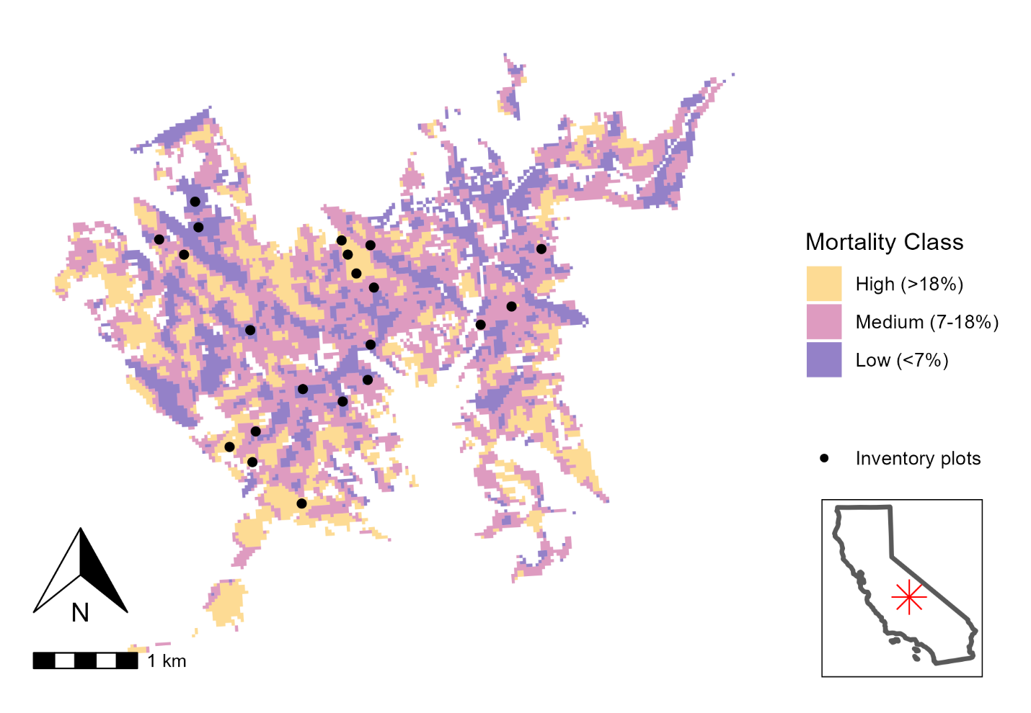
Figure 1: Area of interest, drought mortality classes, and plot locations. Area of interest (CALVEG-mapped mixed conifer forest - pine from 1,500-1,850 m elevation) shown with colors indicating the level of cumulative drought mortality from 2012-2016 as mapped by the (smoothed) eDaRT data product. Plot locations shown as black points. Plots were randomly located within the core area of each zone of drought mortality and limited to locations 50-600m from a road or trail. Inset shows position of the study site within California state boundaries.
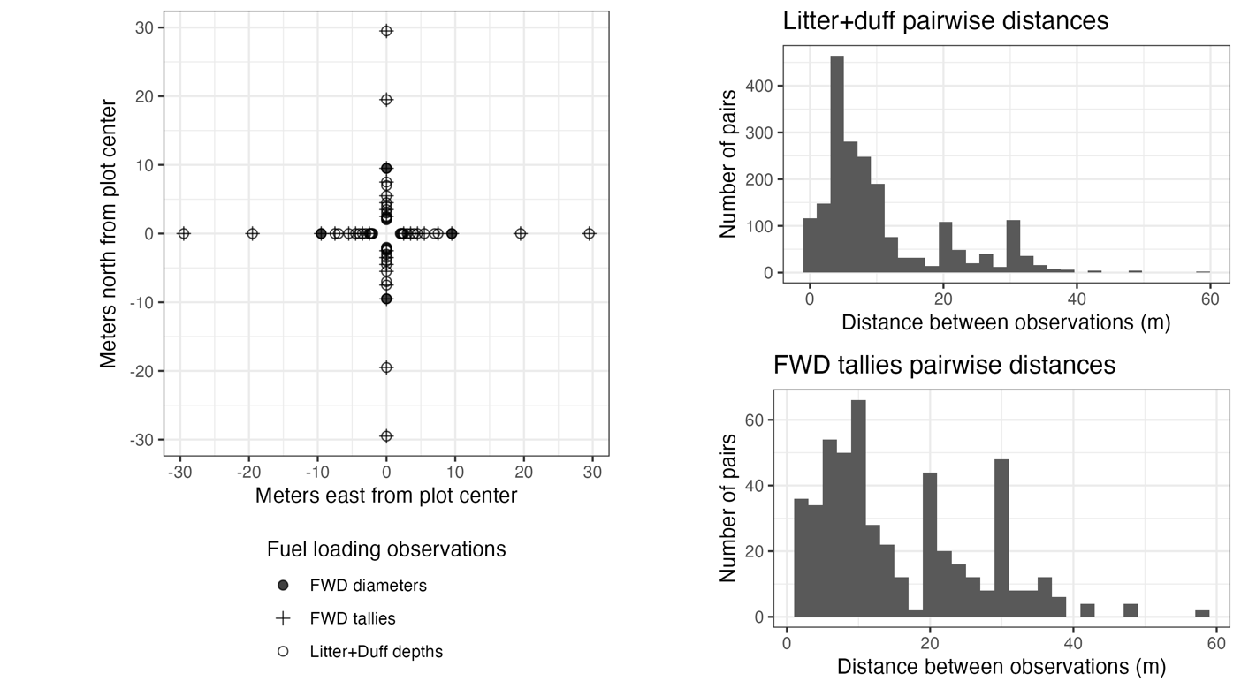
Figure 2: Plot layout. There are four 30-meter main transects (blue) extending from plot center at cardinal directions. Depths of duff and of litter were sampled at locations 2.0, 2.1, 2.2, 2.3, 2.4, 2.5, 3.0, 3.5, 4.0, 4.5, 5.5, 7.0, 7.5, 9.5, 19.5, and 29.5 meters from plot center along each of the four main transects. 1-hour, 10-hour, and 100-hour fine woody debris particles were tallied on 1-meter subtransects located along each main transect from 2-3, 3-4, 4-5,5-6, 7-8, 9-10, 19-20, and 29-30 meters along each main transect and orthogonal to (bisected by) the main transect and intersecting it at 2.5, 3.5, 4.5, 5.5, 7.5, 9.5, 19.5, and 29.5 meters). On one of these subtransects per transect, individual diameters of fine woody debris particles were recorded.

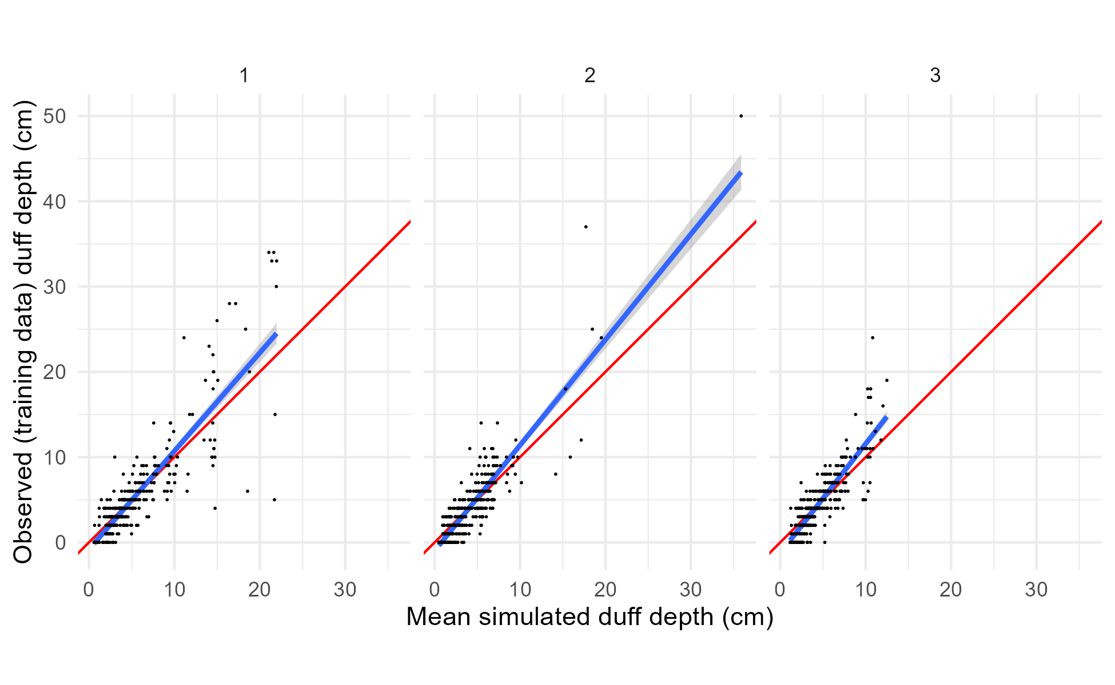
Figure 3: Per-observation comparisons of mean predicted and observed values for the training data and the duff depths model. Panels show posterior predictions generated using the posterior parameter values and the training data for each of the three submodels representing low, medium, and high drought mortality (1, 2, and 3, respectively). In each panel, the posterior mean value of simulated duff depth for each observation is on the x-axis, and the observed depth for that observation on the y-axis, with points for each observation in the training dataset. Simulated data are conditional on the posterior samples of random effect realizations. A 1:1 line (representing perfect prediction) is shown in red, and a linear fit between the simulated and observed values shown in blue. There is a generally good but noisy fit between the simulated and observed data, though the model tends to underpredict slightly for higher observed depths and overpredict slightly for lower observed depths.

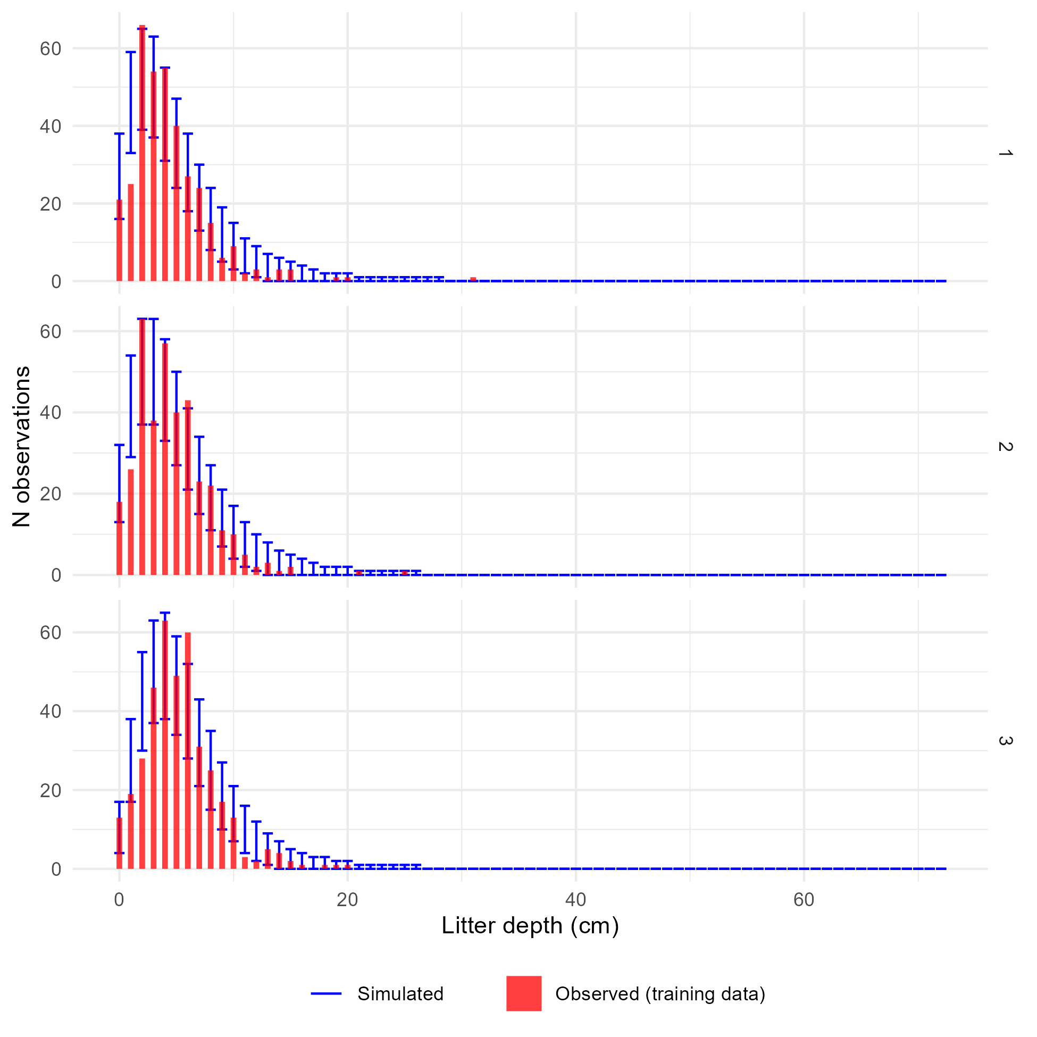
Figure 4: Comparison of observed and simulated frequency distributions for the training data and the litter depths model. Panels show posterior predictions generated using the posterior parameter values and the training data for each of the three submodels representing low, medium, and high drought mortality (1, 2, and 3, respectively). In each panel, the x-axis shows an (observed or simulated) depth of litter and the y-axis shows the frequency of samples from a dataset of 1,107 litter depth measurements having that depth (i.e., a histogram). The observed distribution of litter depths is plotted as the red histogram. The error bars within each depth value show the 2.5th and 97.5th percentile of the frequency of simulated samples having that depth value, across each of the 4,000 posterior draws showing the variation in model-predicted frequency distributions. The observed data are generally within the range of behaviors predicted by the model, except that the model appears to overpredict the proportion of 1 cm samples, and underpredict the proportion of 2 cm samples.
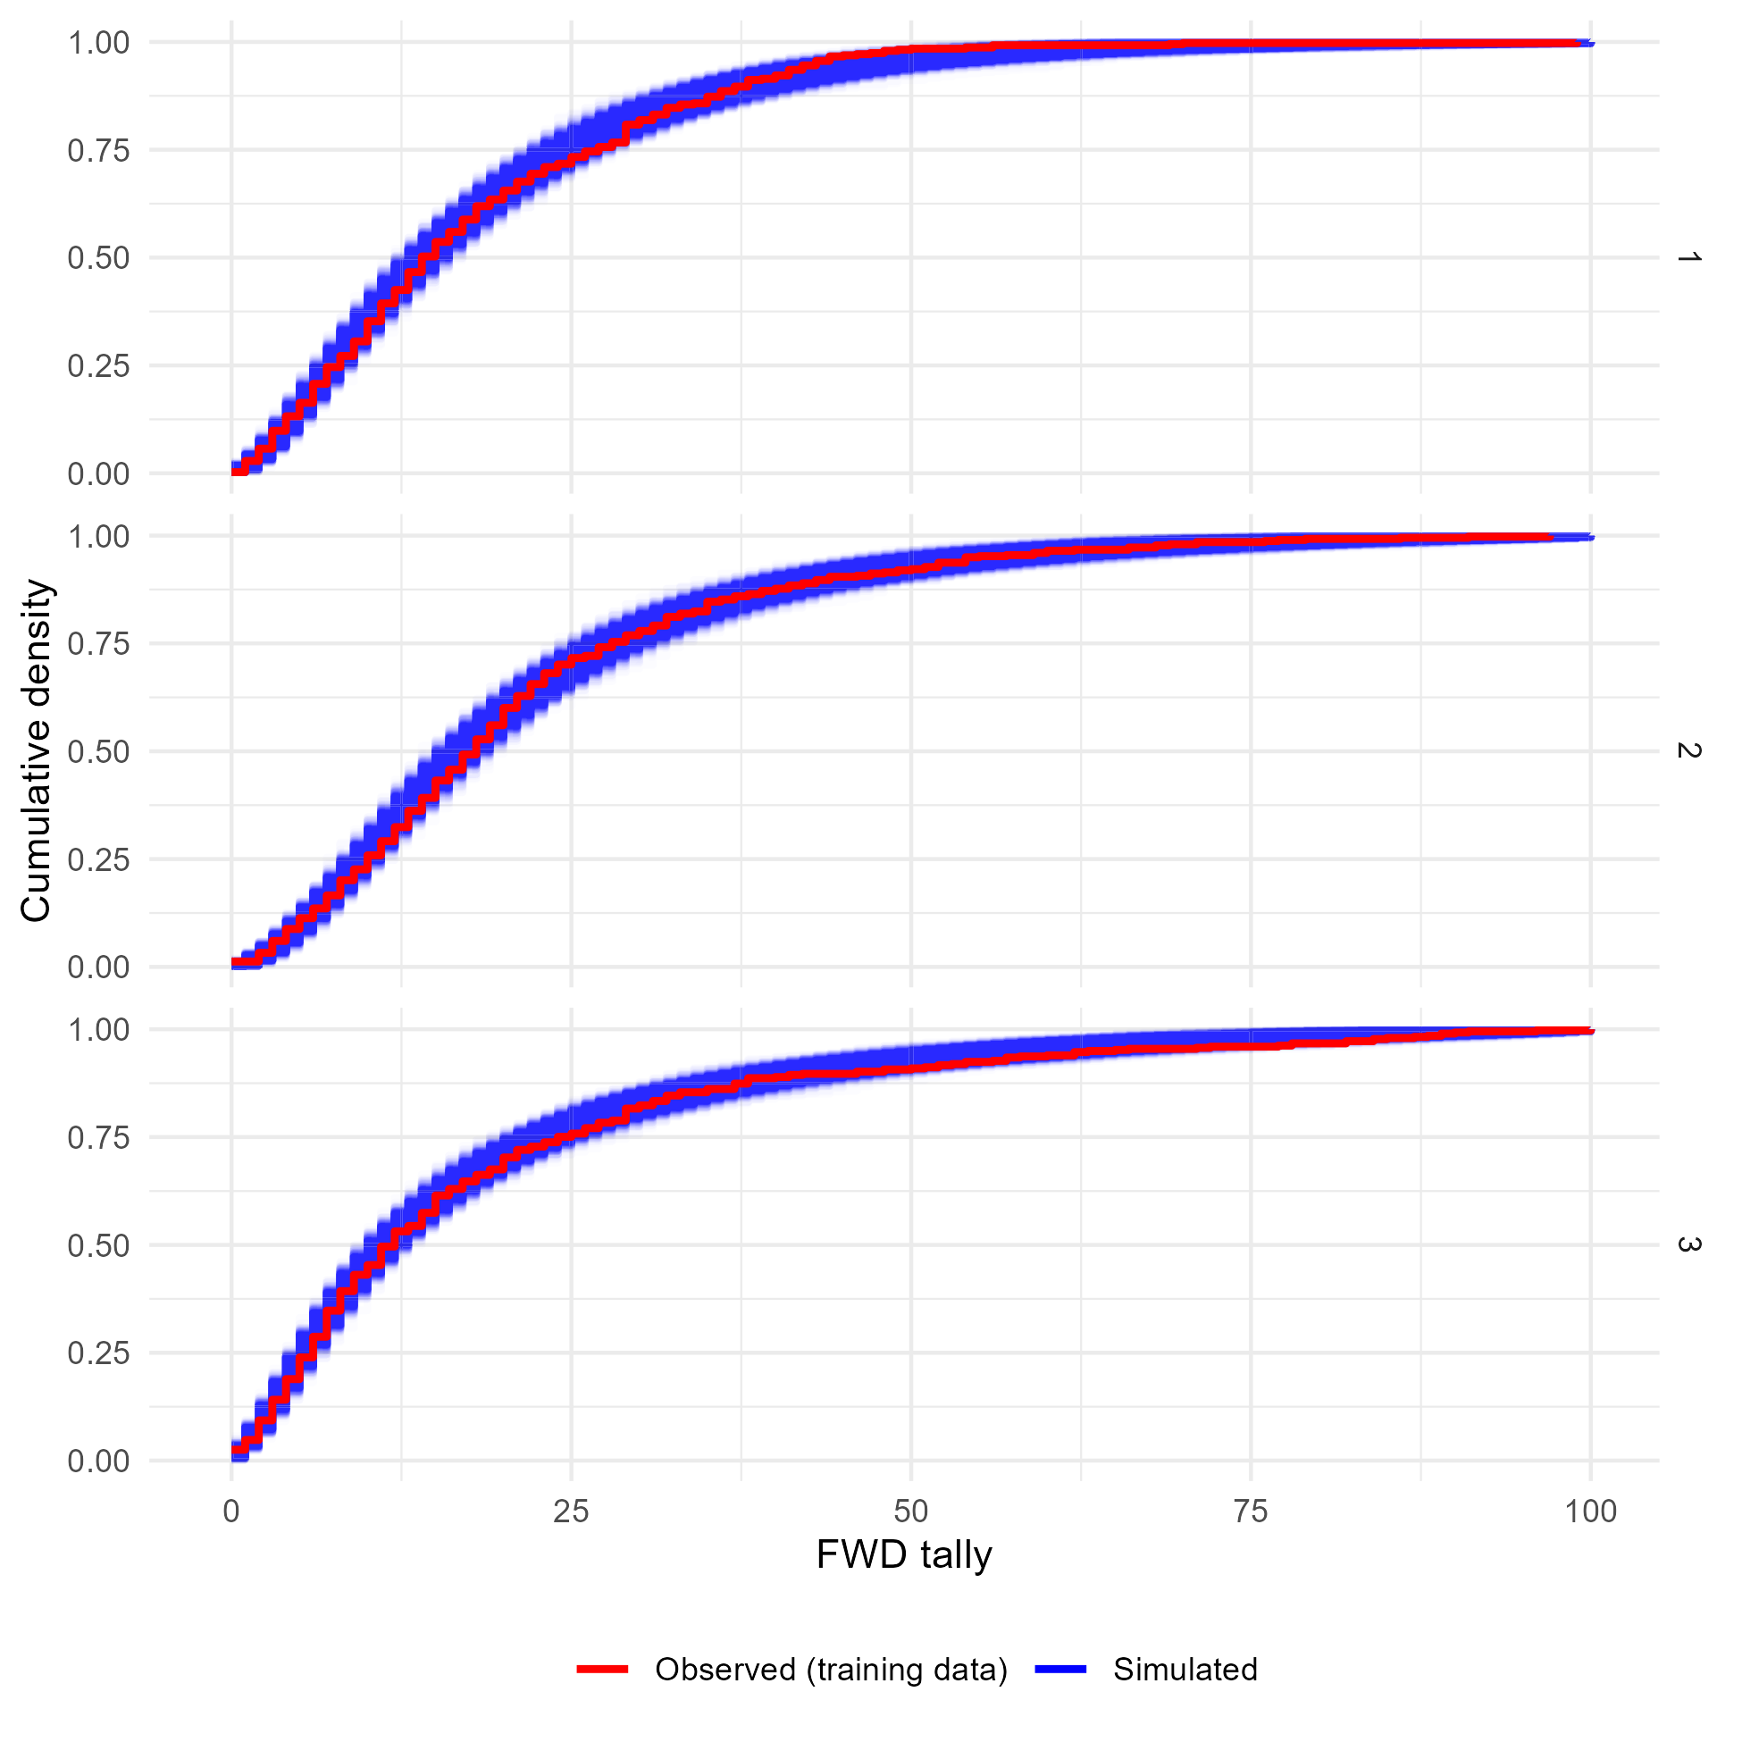
Figure 5: Comparison of the observed and simulated cumulative density functions for the training data and the fine woody debris tallies model. Panels show the cumulative density functions of the observed training data (red) and each of 4,000 simulated datasets generated using posterior parameter values and random effect realizations (blue) for each of the three sub-models corresponding to low, medium, or high levels of drought mortality. The x-axis bounds have been limited to improve readability. The observed cumulative density functions fall within the range of behaviors predicted by the model, indicating good agreement between the model and reality.
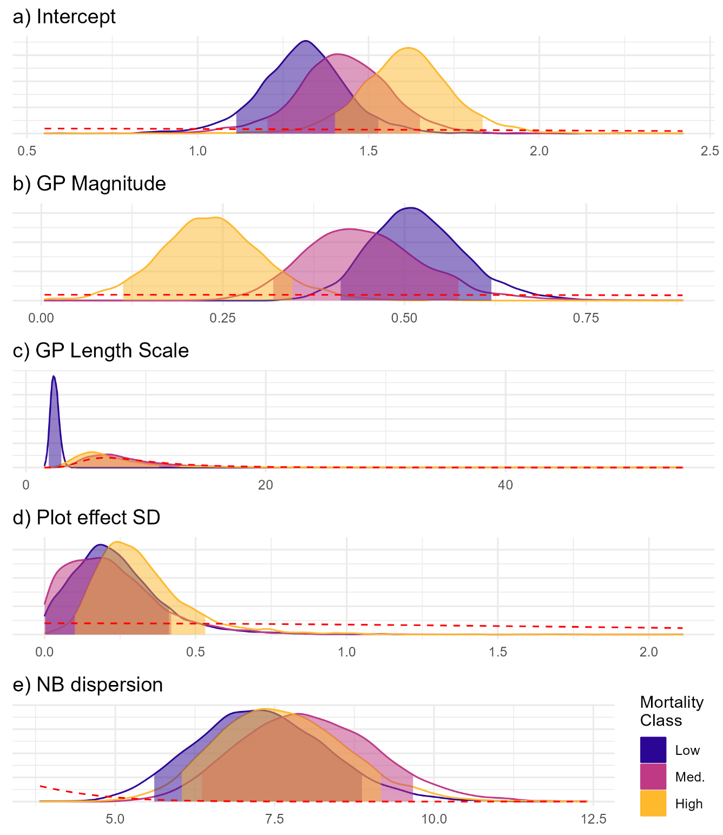
Figure 6: Posterior probability distributions for parameters of the litter depths model. Fill colors indicate the group (drought mortality class). Each panel is for a model parameter, with the parameter value on the x-axis and the posterior probability density on the y-axis. The shaded portion of each posterior probability density curve shows an 89% credible interval for each parameter. Prior distributions for each parameter are shown as the red dashed lines. The posterior distributions suggest that high drought mortality plots may have had a higher mean, lower Gaussian process magnitude, and greater Gaussian process length scale than did plots with low levels of drought mortality. However, the differences are small relative to the parameter uncertainty and the 95% credible intervals of the drought mortality classes overlap for all parameters except the GP magnitudes for low and high drought mortality. Furthermore, the posterior distributions for the length scale of the Gaussian process effect for medium and high drought mortality classes substantially overlap with the prior distribution, suggesting that the posterior distributions for those parameters are only weakly informed by the data, rather than the prior.

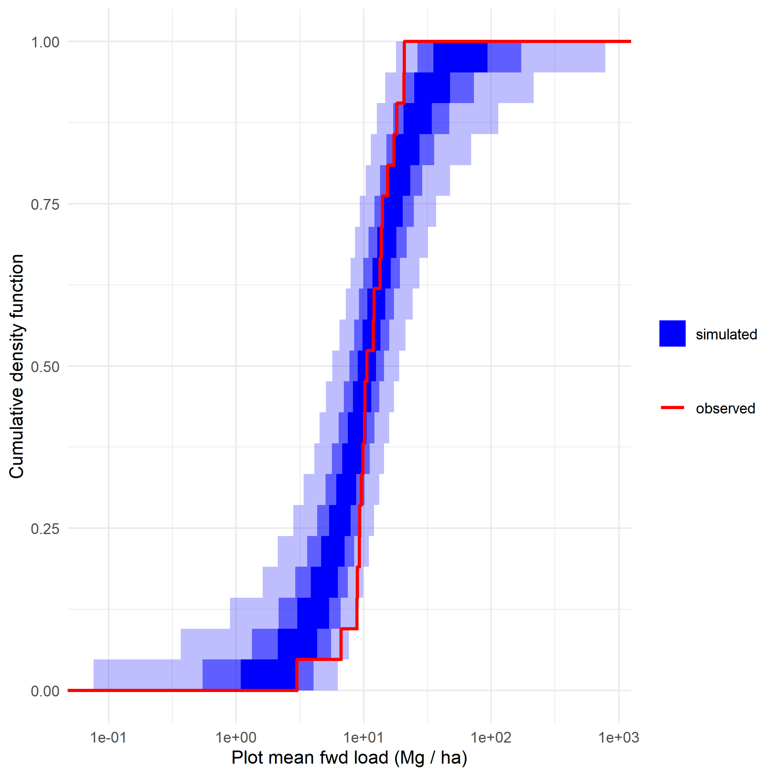
Figure 7: Plot-level fine woody debris simulations. For each of 4,000 posterior draws, 1,183 tallies of fine woody debris on 1-meter subtransects were simulated using posterior parameter values from the fine woody debris tallies model and drawing new random effect realizations for both fine-scale (Gaussian process) and coarse-scale (normally distributed plot intercepts) random effects. Then, for each simulated particle, a diameter was simulated using the fine woody debris diameters model. The simulated particles on each subtransect were aggregated by size class, converted to biomass estimates and averaged at the plot level, giving 21 simulated plot-level fuel loads per posterior draw. The red cumulative density function is the cumulative density function of plot-level fuel loads calculated from the observed data. The blue bands show an envelope containing 50% (darkest), 90%, and 99% (lightest) of the cumulative density functions from the simulated draws. The observed data are within the range of behaviors predicted by the model, but the observed distribution of plot-level means is very tight relative to model predictions. This can be seen in the way the lowest fuel load observed plots have higher fuel loads than most of the lowest-load simulated plots (red line is on the right edge of the envelope at the bottom of the figure), while the highest-load simulated plots are generally more heavily loaded than the highest-loaded observed plots (red line is on the left edge of the envelope at the top of the figure).
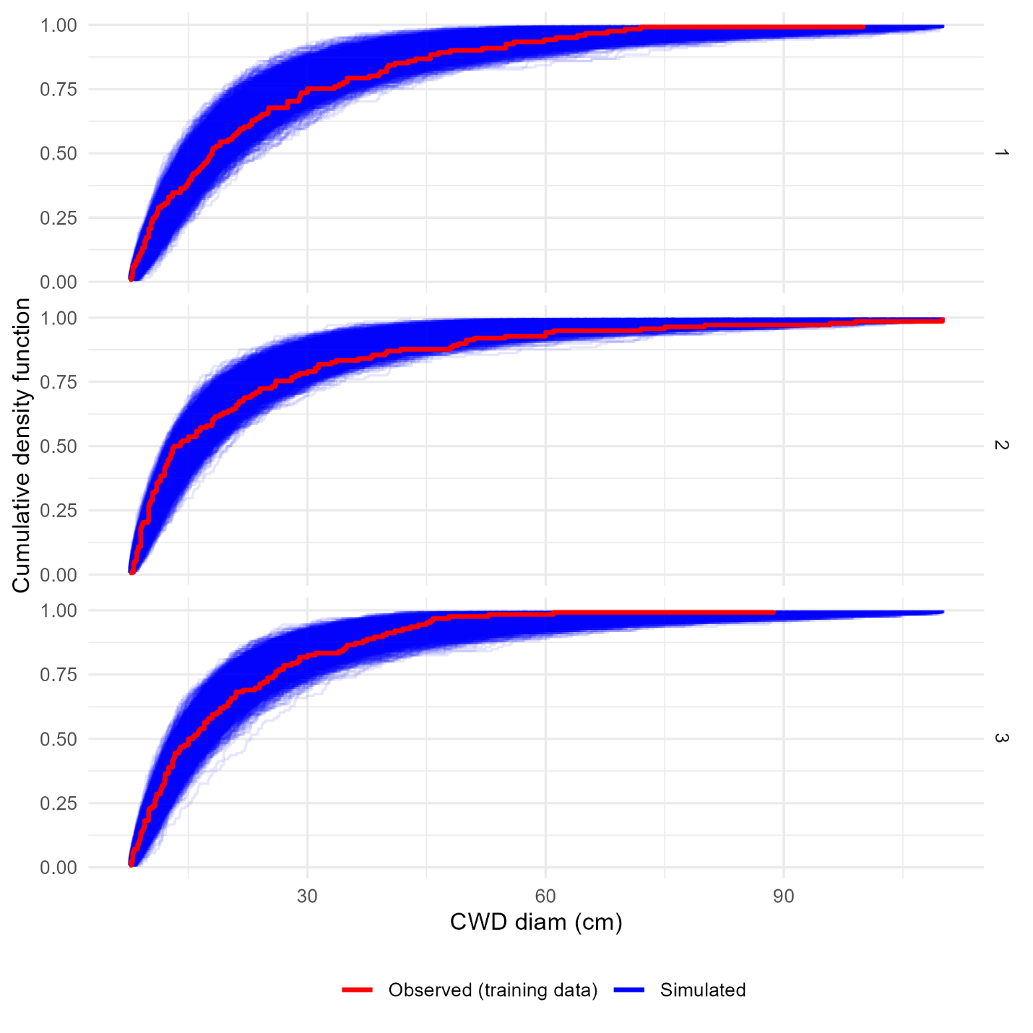
Figure 8: Comparison of the observed and simulated cumulative density functions for the training data and the coarse woody debris diameters model. Panels show the cumulative density functions of the observed training data (red) and each of 4,000 simulated datasets generated using posterior parameter values and random effect realizations (blue) for each of the three sub-models corresponding to low, medium, or high levels of drought mortality. Observed cumulative density functions fall within the range of behaviors predicted by the model, indicating good agreement between the model and reality.

Data availability statement
Data are available from the corresponding author upon request.

Conflicts of interest
The authors declare no conflicts of interest.

Declaration of funding
This work was sponsored in part by the California Energy Commission—Energy Program Investment Charge (EPIC) program under Grant #EPC-18-026.

Department of Environmental Science, Policy, and Management. University of California, Berkeley, 130 Mulford Hall #3114 Berkeley, CA 94720-3114, USA
US Geological Survey, Western Ecological Research Center, Sequoia-Kings Canyon Field Station, 47050 Generals Hwy, Three Rivers, CA 93271, USA
US Geological Survey, Western Ecological Research Center, Sequoia-Kings Canyon Field Station, 47050 Generals Hwy, Three Rivers, CA 93271, USA
USDA Forest Service, Pacific Southwest Region. 1323 Club Dr., Vallejo, CA 94592, USA
USDA Forest Service, Missoula Fire Sciences Laboratory, 5775 Highway 10 West, Missoula, MT 59808, USA. mark.finney@usda.gov
Corresponding author; jbattles@berkeley.edu

