GLSOF-FILEMONITOR
Glsof (http://glsof.sourceforge.net) is two separate utilities (Queries and FileMonitor) to the command line utility Lsof (http://people.freebsd.org/~abe/) by Vic Abell. Glsof is released under GPL 3 license (http://www.gnu.org/licenses/gpl.html).
You can contact me at: danielef@users.sourceforge.net

Donations
If you use and appreciate my open source project, please consider making a donation. All donations are handled by PayPal. Any amount is greatly appreciated.
Thank you for supporting the project.
Link to donate
Introduction
FileMonitor monitors the activity of open or closed files/processes in 'real time' using lsof, returning them in a list. To launch it just use:
$> java -jar path/filemonitor.jar
Of course FileMonitor cannot ensure an authentic 'real time' of open & closed files or processes but it can work well in many situations.
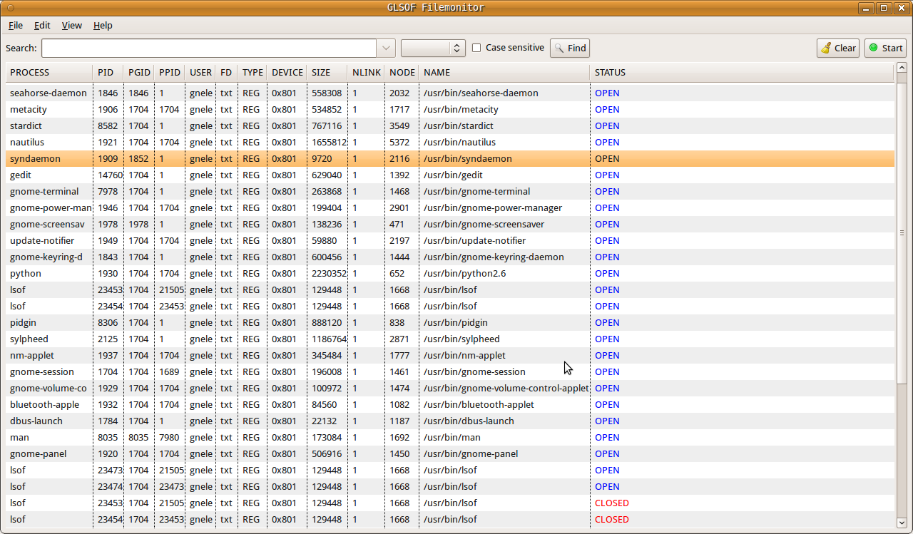
Menu
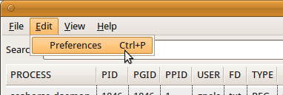
FileMonitor has a main menu at the top, composed of:
- File->Exit (Ctrl+Q): close application and save main window coordinates and internal widgets dispositions.
- Edit->Preferences (Ctrl+P): open 'Preferences' dialog.
- View->Fullscreen (F11): enable/disable fullscreen mode.
- Help->About: show dialog with logo, author info and license.
Search bar
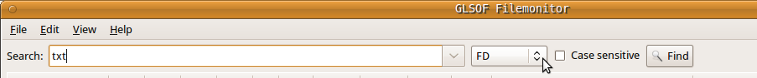
Search bar enables the user to search for a specific text from the list.
A search has the following parameters:
- Input field represents text to search.
- Column is the column to search in. If no column is specified, the search will be executed for every column.
- Case sensitive enables case sensitive for text to search.
To execute a search press the Find button. If input text and/or column and/or case-sensitive change before executing the next search, it will be restarted from the top row. When a search reaches the last table's row, a dialog comes up with the choice to restart the search from the beginning or not.
Run FileMonitor
Before starting FileMonitor it is necessary to add the directories that the user intends to monitor. To do this, choose 'Preferences' from the menu or just press 'Ctrl+P'. Afterwards the Preferences dialog will come up.
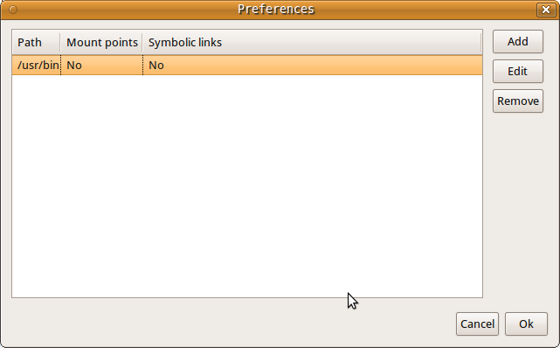
Dialog is composed of a table with columns:
- Path search for all open instances of the specified directory and all the files and directories it contains to its complete depth.
- Mount points search or not for open files on file system mount points on subdirectories of Path.
- Symbolic links follow or not symbolic links within Path.
Note: the authority of the user of this option limits it to searching for files that the user has permission to examine with the system stat(2) function.
Further note: lsof may process this option slowly and require a large amount of dynamic memory to do it. This is because it must descend the entire directory tree, rooted at D, calling stat(2) for each file and directory, building a list of all the files it finds, and searching that list for a match with every open file. When directory D is large, these steps can take a long time, so use this option prudently.
Preferences-dialog has three button ('Add', 'Edit', 'Remove'):
- Add opens a dialog that permits the user to input a new directory and two check buttons to choose if following or not symbolic links and search in mount points directories.
- Edit opens a dialog that permits the addition of an existing table's row similar to the Add dialog.
- Remove removes an existing table's row.
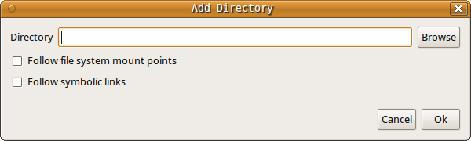
Finally to start FileMonitor press the Start button on the top right of the main table. Shortly afterwards, depending on the chosen directories, the main table will be populated. The last column on the right (Status) returns when a file/process is open or closed.

The main table has the following columns:
- PROCESS contains the name of the UNIX command associated with the process.
- PID is the Process IDentification number of the process.
- PGID is the process group IDentification number associated with the process.
- PPID is the Parent Process IDentification number of the process.
- USER is the user ID number or login name of the user to whom the process belongs, usually the same as reported by ps(1). However, on Linux USER is the user ID number or login that owns the directory in /proc where lsof finds information about the process. Usually that is the same value reported by ps(1), but may differ when the process has changed its effective user ID.
- FD is the File Descriptor number of the file (lsof-man for more info).
- TYPE is the type of the node associated with the file (lsof-man for more info).
- DEVICE contains the device numbers, separated by commas, for a character special, block special, regular, directory or NFS file (lsof-man for more info).
- SIZE is the size of the file or the file offset in bytes. A value is displayed in this column only if it is available (lsof-man for more info).
- NLINK contains the file link count.
- NODE is the node number of a local file (lsof-man for more info).
- NAME is the name of the mount point and file system on which the file resides (lsof-man for more info).
- STATUS return OPEN/CLOSED if a file is respectively open or closed.
While FileMonitor is running, the Start button changes to Stop. Now it permits the user to stop monitoring processes, changing to Start again and so on. Next to it there is the Clear button. It removes all the lines in the tables.
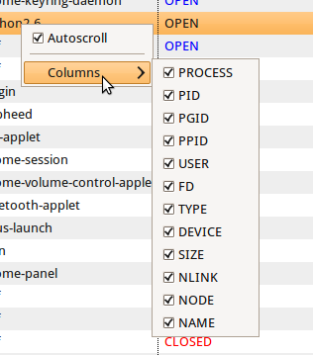
Clicking with the second mouse button on the main table, a popup menu will come up. It has two options:
- Autoscroll enables the list to scroll automatically to the bottom when a new row is added.
- Columns enables the user to hide undesired columns.
All of these options will be automatically saved if changed.

