Healthcare Knowledge Base & Inference Engine Report

Domain
Healthcare - disease information and symptom-based retrieval. This small system loads a CSV of disease records (disease name, overview, symptoms, treatment, and appointment preparation), stores them as facts and rules, and provides a lightweight inference engine to match user queries to the most relevant disease entry. The engine performs simple full-text matching (fuzzy) over the fact keys and returns associated rule fields when a match is found. This report summarizes the domain, shows example facts and rules, illustrates sample input/output, and reflects on how the inference works.

Facts and rules
Facts
* Facts are loaded into the system’s dictionary as:
- Key: concatenation of Disease and Symptoms column (to enhance search capability)
- Value: overview column
Disease | Overview | Symptoms
Hyperhidrosis | Hyperhidrosis (hi-pur-hi-DROE-sis) is excessive sweating that's not always related to heat or exercise. You may sweat so much that it soaks through your clothes or drips off your hands. Heavy sweating can disrupt your day and cause social anxiety and embarrassment.  Hyperhidrosis treatment usually helps. It often begins with antiperspirants. If these don't help, you may need to try different medications and therapies. In severe cases, your health care provider may suggest surgery to remove the sweat glands or to disconnect the nerves related to producing too much sweat.  Sometimes an underlying condition may be found and treated. | Excessive sweating, clammy skin, skin irritation, body odor, social discomfort
Bartholin's cyst | The Bartholin's (BAHR-toe-linz) glands are located on each side of the vaginal opening. These glands secrete fluid that helps lubricate the vagina.  Sometimes the openings of these glands become obstructed, causing fluid to back up into the gland. The result is relatively painless swelling called a Bartholin's cyst. If the fluid within the cyst becomes infected, you may develop a collection of pus surrounded by inflamed tissue (abscess).  A Bartholin's cyst or abscess is common. Treatment of a Bartholin's cyst depends on the size of the cyst, how painful the cyst is and whether the cyst is infected.  Sometimes home treatment is all you need. In other cases, surgical drainage of the Bartholin's cyst is necessary. If an infection occurs, antibiotics may be helpful to treat the infected Bartholin's cyst. | Vaginal lump, pain while walking or sitting, discomfort during intercourse, swelling, redness if infected
Infant reflux | Infant reflux is when a baby spits up liquid or food. It happens when stomach contents move back up from a baby's stomach into the esophagus. The esophagus is the muscular tube that connects the mouth to the stomach.  Reflux happens in infants many times a day. If your baby is content and growing well, reflux is not a cause for concern. Sometimes called gastroesophageal reflux, also called GER, the condition becomes less common as a baby gets older. It's unusual for infant reflux to continue after age 18 months.  Rarely, infant reflux leads to weight loss or growth that lags behind that of other children of the same age and sex. These symptoms may mean that your baby has a medical issue. This issue could be an allergy, a blockage in the digestive system or gastroesophageal reflux disease, also called GERD. GERD is a form of GER that causes serious health issues. | Spitting up, irritability after feeding, coughing, poor feeding, arching of back
Hidradenitis suppurativa | Hidradenitis suppurativa (hi-drad-uh-NIE-tis sup-yoo-ruh-TIE-vuh), also known as acne inversa, is a condition that causes small, painful lumps to form under the skin. The lumps usually develop in areas where your skin rubs together, such as the armpits, groin, buttocks and breasts. The lumps heal slowly, recur, and can lead to tunnels under the skin and scarring.  Hidradenitis suppurativa tends to start after puberty, usually before age 40. It can persist for many years and worsen over time. It can affect your daily life and emotional well-being. Combined medical and surgical therapy can help manage the disease and prevent complications.  Women are three times more likely to develop hidradenitis suppurativa, though this ratio can differ by location around the world. Also, Black people are more likely to develop this disease than people of other races. This could be attributed to genetic factors. | Painful lumps, skin abscesses, blackheads, draining tunnels, scarring
HIV/AIDS | Acquired immunodeficiency syndrome (AIDS), is an ongoing, also called chronic, condition. It's caused by the human immunodeficiency virus, also called HIV.HIVdamages the immune system so that the body is less able to fight infection and disease. IfHIVisn't treated, it can take years before it weakens the immune system enough to becomeAIDS. Thanks to treatment, most people in the U.S. don't getAIDS.  HIVis spread through contact with genitals, such as during sex without a condom. This type of infection is called a sexually transmitted infection, also called an STI.HIValso is spread through contact with blood, such as when people share needles or syringes. It is also possible for a person with untreatedHIVto spread the virus to a child during pregnancy, childbirth or breastfeeding.  There's no cure forHIV/AIDS. But medicines can control the infection and keep the disease from getting worse. Antiviral treatments forHIVhave reducedAIDSdeaths around the world. There's an ongoing effort to make ways to prevent and treatHIV/AIDSmore available in resource-poor countries. | Fever, fatigue, swollen lymph nodes, weight loss, night sweats, recurrent infections
Acute myelogenous leukemia | Acute myelogenous leukemia, also called AML, is a cancer of the blood and bone marrow. Bone marrow is the soft matter inside bones where blood cells are made.  The word "acute" in acute myelogenous leukemia means the disease tends to get worse quickly. It's called myelogenous (my-uh-LOHJ-uh-nus) leukemia because it affects cells called the myeloid cells. These typically develop into mature blood cells, including red blood cells, white blood cells and platelets.  AML is the most common type of acute leukemia in adults. The other type is acute lymphoblastic leukemia, also called ALL. Although AML can be diagnosed at any age, it is less common before age 45. AML also is called acute myeloid leukemia, acute myeloblastic leukemia, acute granulocytic leukemia and acute nonlymphocytic leukemia.  Unlike other cancers, there are no numbered stages of acute myelogenous leukemia. | Fatigue, frequent infections, bruising, nosebleeds, bone pain, pale skin
Guillain-Barre syndrome | Guillain-Barre (gee-YAH-buh-RAY) syndrome is a condition in which the body's immune system attacks the nerves. It can cause weakness, numbness or paralysis.  Weakness and tingling in the hands and feet are usually the first symptoms. These sensations can quickly spread and may lead to paralysis. In its most serious form, Guillain-Barre syndrome is a medical emergency. Most people with the condition need treatment in a hospital.  Guillain-Barre syndrome is rare, and the exact cause is not known. But two-thirds of people have symptoms of an infection in the six weeks before Guillain-Barre symptoms begin. Infections can include a respiratory or a gastrointestinal infection, includingCOVID-19. Guillain-Barre also can be caused by the Zika virus.  There's no known cure for Guillain-Barre syndrome. Several treatment options can ease symptoms and help speed recovery. Most people recover completely from Guillain-Barre syndrome, but some serious illnesses can be fatal. While recovery may take up to several years, most people are able to walk again six months after symptoms first began. Some people may have lasting effects, such as weakness, numbness or fatigue. | Weakness in legs, tingling, paralysis, difficulty breathing, loss of reflexes
Acute kidney injury | Acute kidney injury happens when the kidneys suddenly can't filter waste products from the blood. When the kidneys can't filter wastes, harmful levels of wastes may build up. The blood's chemical makeup may get out of balance.  Acute kidney injury used to be called acute kidney failure. Acute kidney injury is most common in people who are in the hospital, mostly in people who need intensive care.  Acute kidney injury ranges from mild to severe. If severe, ongoing and not treated, it can be fatal. But it also can be reversed. People in otherwise good health may get back typical or nearly typical use of their kidneys. | Decreased urine output, swelling, fatigue, confusion, nausea
Acute lymphocytic leukemia | Acute lymphocytic leukemia (ALL) is a type of cancer of the blood and bone marrow â€” the spongy tissue inside bones where blood cells are made.  The word "acute" in acute lymphocytic leukemia comes from the fact that the disease progresses rapidly and creates immature blood cells, rather than mature ones. The word "lymphocytic" in acute lymphocytic leukemia refers to the white blood cells called lymphocytes, whichALLaffects. Acute lymphocytic leukemia is also known as acute lymphoblastic leukemia.  Acute lymphocytic leukemia is the most common type of cancer in children, and treatments result in a good chance for a cure. Acute lymphocytic leukemia can also occur in adults, though the chance of a cure is greatly reduced. | Fever, bone pain, bruising, swollen lymph nodes, fatigue, frequent infections
Radiation sickness | Radiation sickness is damage to the body caused by a large dose of radiation often received over a short time. This is called acute radiation sickness. The amount of radiation absorbed by the body, called the absorbed dose, determines how bad the illness will be.  Radiation sickness also is called acute radiation syndrome or radiation poisoning. Radiation sickness is not caused by common medical imaging tests that use low-dose radiation, such as X-rays, CT scans and nuclear medicine scans.  Although radiation sickness is serious and often fatal, it's rare. Since the atomic bombings of Hiroshima and Nagasaki, Japan, during World War II, most cases of radiation sickness have occurred after nuclear industrial accidents, such as the 1986 fire that damaged the nuclear power plant at Chernobyl, Ukraine. | Nausea, vomiting, diarrhea, skin burns, fatigue, hair loss
ARDS | Acute respiratory distress syndrome (ARDS) occurs when lung swelling causes fluid to build up in the tiny elastic air sacs in the lungs. These air sacs, called alveoli, have a protective membrane, but lung swelling damages that membrane. The fluid leaking into the air sacs keeps the lungs from filling with enough air. This means less oxygen reaches the bloodstream, so the body's organs don't get the oxygen they need to work properly.  ARDS usually occurs in people who are already critically ill or have major injuries. People usually are severely short of breath â€” the main symptom of ARDS â€” within a few hours to a few days after the injury or infection that caused ARDS.  Many people who get ARDS don't survive. The risk of death gets higher with age and how severe the illness is. Of the people who survive ARDS, some fully recover. But others have lasting lung damage. | Severe shortness of breath, rapid breathing, low oxygen levels, confusion, fatigue
Acute sinusitis | Acute sinusitis causes the spaces inside the nose, known as sinuses, to become inflamed and swollen. Acute sinusitis makes it hard for the sinuses to drain. Mucus builds up.  Acute sinusitis can make it hard to breathe through the nose. The area around the eyes and the face might feel swollen. There might be throbbing face pain or a headache.  The common cold is the usual cause of acute sinusitis. Most often, the condition clears up within a week to 10 days unless there's also an infection caused by bacteria, called a bacterial infection. Home remedies might be all that's needed to treat acute sinusitis. Sinusitis that lasts more than 12 weeks even with medical treatment is called chronic sinusitis. | Facial pain, nasal congestion, thick nasal discharge, headache, reduced smell
Autoimmune epilepsy | Autoimmune epilepsy is a type of epilepsy where seizures are caused by the immune system mistakenly attacking brain cells. It can occur with conditions that affect the immune system, especially autoimmune encephalitis.  Autoimmune epilepsy also is known as autoimmune associated epilepsy and acute symptomatic seizures secondary to autoimmune encephalitis.  The immune system protects the body from viruses, bacteria and other substances that can cause illnesses. Antibodies are proteins that are part of the immune system. In autoimmune epilepsy, antibodies mistakenly target receptors in the brain. This leads to swelling in the brain, also known as inflammation, and seizures.  Antiseizure medicines usually don't do enough to manage seizures in people with autoimmune epilepsy. Instead, immunotherapy medicines help reduce the immune response on the brain.  When immunotherapy is started early, it can reduce inflammation and improve seizures. For some people, treatment can stop seizures completely. For others, seizures may continue after treatment. | Recurrent seizures, memory issues, behavioral changes, confusion
Alcohol use disorder | Alcohol use disorder is a pattern of alcohol use that involves problems controlling your drinking, being preoccupied with alcohol or continuing to use alcohol even when it causes problems. This disorder also involves having to drink more to get the same effect or having withdrawal symptoms when you rapidly decrease or stop drinking. Alcohol use disorder includes a level of drinking that's sometimes called alcoholism.  Unhealthy alcohol use includes any alcohol use that puts your health or safety at risk or causes other alcohol-related problems. It also includes binge drinking â€” a pattern of drinking where a male has five or more drinks within two hours or a female has at least four drinks within two hours. Binge drinking causes significant health and safety risks.  If your pattern of drinking results in repeated significant distress and problems functioning in your daily life, you likely have alcohol use disorder. It can range from mild to severe. However, even a mild disorder can escalate and lead to serious problems, so early treatment is important. | Cravings, loss of control, withdrawal symptoms, tolerance, social or work problems

Rules
* Rules are loaded into the system’s dictionary as:
- Condition: concatenation of Disease and Symptoms column (to match facts’ keys)
- Value: Treatment and Preparing for you appointment column
Disease | Symptoms | Treatment | Preparing for your appointment
Hyperhidrosis | Excessive sweating, clammy skin, skin irritation, body odor, social discomfort | Treating hyperhidrosis may start with treating the condition causing it. If a cause isn't found, treatment focuses on controlling heavy sweating. If new self-care habits don't improve your symptoms, your health care provider may suggest one or more of the following treatments. Even if your sweating improves after treatment, it may recur. | You may start by seeing your primary care provider. You may then be referred to a specialist in diagnosing and treating conditions of the hair and skin (dermatologist). If your condition is not responding to treatment, you may be referred to a specialist in the nervous system (neurologist) or a surgeon.  Here's some information to help you get ready for your appointment.
Bartholin's cyst | Vaginal lump, pain while walking or sitting, discomfort during intercourse, swelling, redness if infected | Often a Bartholin's cyst requires no treatments especially if the cyst causes no signs or symptoms. When needed, treatment depends on the size of the cyst, your discomfort level and whether it's infected, which can result in an abscess.  Treatment options your doctor may recommend include:  Surgical drainage.You may need surgery to drain a cyst that's infected or very large. Drainage of a cyst can be done using local anesthesia or sedation.  For the procedure, your doctor makes a small incision in the cyst, allows it to drain, and then places a small rubber tube (catheter) in the incision. The catheter stays in place for up to six weeks to keep the incision open and allow complete drainage.  Rarely, for persistent cysts that aren't effectively treated by the above procedures, your doctor may recommend surgery to remove the Bartholin's gland. Surgical removal is usually done in a hospital under general anesthesia. Surgical removal of the gland carries a greater risk of bleeding or complications after the procedure. | Your first appointment will likely be with either your primary care provider or a doctor who specializes in conditions that affect women (gynecologist).
Infant reflux | Spitting up, irritability after feeding, coughing, poor feeding, arching of back | For most babies, making some changes to feeding eases infant reflux until it gets better on its own. | You may start by seeing your baby's primary healthcare team. Or you may be referred to a specialist in children's digestive diseases, called a pediatric gastroenterologist.
Hidradenitis suppurativa | Painful lumps, skin abscesses, blackheads, draining tunnels, scarring | Treatment with medicines, surgery or both can help control symptoms and prevent complications of hidradenitis suppurativa. Talk with your health care provider about the risks and benefits of the treatment options and how to develop an approach that's right for you.  Expect to have regular follow-up visits with your dermatologist. Some people might need the comprehensive care provided by a health care team with members from multiple medical specialties. | You'll likely first see your primary care provider. You might then be referred to a health care provider who specializes in diagnosing and treating skin diseases, also known as a dermatologist. Depending on the severity of your condition, your care also might involve specialists in colorectal surgery, plastic surgery or gastroenterology.  Here's some information to help you get ready for your appointment.
HIV/AIDS | Fever, fatigue, swollen lymph nodes, weight loss, night sweats, recurrent infections | There's no cure forHIV/AIDS. Once you have the infection, your body can't get rid of it. But there are medicines that can controlHIVand prevent complications.  Everyone diagnosed withHIVshould take antiretroviral therapy medicines, also called ART. This is true no matter what stage the disease is in or what the complications are.  ARTis usually a mix of two or more medicines from several classes. This approach has the best chance of lowering the amount ofHIVin the blood. There are manyARToptions that mix more than oneHIVmedicine into a single pill, taken once daily.  Each class of medicines blocks the virus in different ways. Treatment involves mixing medicines from different classes to:  Account for medicine resistance, called viral genotype.  Keep from creating new medicine-resistant strains ofHIV.  Suppress the virus in the blood as much as possible.  Two medicines from one class, plus a third medicine from another class, are most often used.  The classes of anti-HIVmedicines include the following:  Non-nucleoside reverse transcriptase inhibitors (NNRTIs)turn off a protein needed byHIVto make copies of itself.Examples include efavirenz, rilpivirine (Edurant) and doravirine (Pifeltro).  Nucleoside or nucleotide reverse transcriptase inhibitors (NRTIs)are faulty versions of the building blocks thatHIVneeds to make copies of itself.Examples include abacavir (Ziagen), tenofovir disoproxil fumarate (Viread), emtricitabine (Emtriva), lamivudine (Epivir) and zidovudine (Retrovir). Retrovir is no longer suggested for routine use in the U.S. because of high rates of toxic effects.Mixes of medicines also are available, such as emtricitabine-tenofovir disoproxil fumarate (Truvada) and emtricitabine-tenofovir alafenamide fumarate (Descovy).  Protease inhibitors (PIs)makeHIVprotease inactive.HIVprotease is another protein thatHIVneeds to make copies of itself.Examples include atazanavir (Reyataz), darunavir (Prezista) and lopinavir-ritonavir (Kaletra).  Integrase inhibitorsstop the action of a protein called integrase.HIVuses integrase to put its genetic material into CD4 T cells.Examples include bictegravir sodium-emtricitabine-tenofovir alafenamide fumarate (Biktarvy), raltegravir (Isentress), dolutegravir (Tivicay) and cabotegravir (Vocabria).  Entry or fusion inhibitorsblockHIV'sentry into CD4 T cells.Examples include enfuvirtide (Fuzeon) and maraviroc (Selzentry). Newer medicines include ibalizumab-uiyk (Trogarzo) and fostemsavir (Rukobia). | If you think you might have anHIVinfection, you're likely to start by seeing your family healthcare professional. You may be sent to an infectious disease specialist who focuses on treatingHIV/AIDS.
Acute myelogenous leukemia | Fatigue, frequent infections, bruising, nosebleeds, bone pain, pale skin | Many types of treatment exist for acute myelogenous leukemia, also called AML. Treatment depends on several factors, including the subtype of the disease, your age, your overall health, your prognosis and your preferences.  Treatment usually has two phases:  Remission induction therapy.This first phase aims to kill the leukemia cells in your blood and bone marrow. But it doesn't usually destroy all the leukemia cells. You will need further treatment to keep the disease from coming back.  Consolidation therapy.This phase also is called post-remission therapy or maintenance therapy. It aims to kill the remaining leukemia cells. Consolidation therapy is crucial to helping lower the risk of relapse.  Treatments include:  Chemotherapy.Chemotherapy treats cancer with strong medicines. Most chemotherapy medicines are given through a vein. Some come in pill form. Chemotherapy is the main type of remission induction therapy. It also may be used for consolidation therapy.  People with AML usually stay in the hospital during chemotherapy treatments because the medicines kill many healthy blood cells while destroying leukemia cells. If the first chemotherapy cycle doesn't cause remission, it can be repeated.  Side effects of chemotherapy depend on the medicines you're given. Common side effects are nausea and hair loss. Serious, long-term complications may include heart disease, lung damage, fertility problems and other cancers.  Targeted therapy.Targeted therapy for cancer is a treatment that uses medicines that attack specific chemicals in the cancer cells. By blocking these chemicals, targeted treatments can cause cancer cells to die. Your leukemia cells will be tested to see if targeted therapy may be helpful for you. Targeted therapy may be used alone or in combination with chemotherapy during induction therapy.  Bone marrow transplant.A bone marrow transplant, also called a bone marrow stem cell transplant, involves putting healthy bone marrow stem cells into the body. These cells replace cells hurt by chemotherapy and other treatments. A bone marrow stem cell transplant may be used for both remission induction and consolidation therapy.  Before a bone marrow transplant, you receive very high doses of chemotherapy or radiation therapy to destroy your leukemia-producing bone marrow. Then you receive infusions of stem cells from a compatible donor. This is called an allogeneic transplant.  There is an increased risk of infection after a transplant.  Clinical trials.Some people with leukemia choose to enroll in clinical trials to try experimental treatments or new combinations of known therapies. | Make an appointment with your healthcare professional if you have symptoms that worry you. You may be referred to a doctor who specializes in blood cell diseases. This type of doctor is called a hematologist.  Appointments can be brief, and there's a lot of information to discuss. It's a good idea to be prepared. Here's some information to help you get ready:
Guillain-Barre syndrome | Weakness in legs, tingling, paralysis, difficulty breathing, loss of reflexes | There's no cure for Guillain-Barre syndrome. But two types of treatments can speed recovery and reduce symptoms:  Plasma exchange, also known as plasmapheresis.Plasma is the liquid portion of part of your blood. In a plasma exchange, plasma is removed and separated from your blood cells. The blood cells are then put back into your body, which makes more plasma to replace what was removed. Plasmapheresis may work by ridding plasma of certain antibodies that contribute to the immune system's attack on the peripheral nerves.  Immunoglobulin therapy.Immunoglobulin containing healthy antibodies from blood donors is given through a vein. High doses of immunoglobulin can block the damaging antibodies that may contribute to Guillain-Barre syndrome.  These treatments are equally effective. Mixing them or using one after the other is no more effective than using either method alone.  You are also likely to be given medicine to:  Relieve pain, which can be severe.  Prevent blood clots, which can develop if you're not mobile.  People with Guillain-Barre syndrome need physical help and therapy before and during recovery. Your care may include:  Movement of your arms and legs by caregivers before recovery, to help keep your muscles flexible and strong.  Physical therapy during recovery to help you cope with fatigue and regain strength and proper movement.  Training with adaptive devices, such as a wheelchair or braces, to give you mobility and self-care skills. | You may be referred to a doctor who specializes in disorders of the brain and nervous system, known as a neurologist.
Acute kidney injury | Decreased urine output, swelling, fatigue, confusion, nausea | Treatment for acute kidney injury most often means a hospital stay. Most people with acute kidney injury are already in the hospital. How long you'll stay in the hospital depends on the reason for your acute kidney injury and how quickly your kidneys recover. | Most people are in a hospital when they get acute kidney injury. If you aren't in the hospital and have symptoms of kidney failure, make an appointment with your family healthcare professional right away. You may be referred to a specialist in kidney disease, called a nephrologist.  Before your appointment, write down questions. Consider asking:  What's the most likely cause of my symptoms?  Have my kidneys stopped working? What could have caused my kidney failure?  What tests do I need?  What are my treatment choices, and what are the risks?  Do I need to go to the hospital?  Will my kidneys recover or will I need dialysis?  I have other health conditions. How can I best manage these conditions together?  Do I need to eat a special diet? If so, can you refer me to a dietitian to help me plan what to eat?  Do you have printed materials about acute kidney injury that I can have? What websites do you suggest?
Acute lymphocytic leukemia | Fever, bone pain, bruising, swollen lymph nodes, fatigue, frequent infections | In general, treatment for acute lymphocytic leukemia falls into separate phases:  Induction therapy.The purpose of the first phase of treatment is to kill most of the leukemia cells in the blood and bone marrow and to restore normal blood cell production.  Consolidation therapy.Also called post-remission therapy, this phase of treatment is aimed at destroying any remaining leukemia in the body.  Maintenance therapy.The third phase of treatment prevents leukemia cells from regrowing. The treatments used in this stage are usually given at much lower doses over a long period of time, often years.  Preventive treatment to the spinal cord.During each phase of therapy, people with acute lymphocytic leukemia may receive additional treatment to kill leukemia cells located in the central nervous system. In this type of treatment, chemotherapy drugs are often injected directly into the fluid that covers the spinal cord.  Depending on your situation, the phases of treatment for acute lymphocytic leukemia can span two to three years.  Treatments may include:  Chemotherapy.Chemotherapy, which uses drugs to kill cancer cells, is typically used as an induction therapy for children and adults with acute lymphocytic leukemia. Chemotherapy drugs can also be used in the consolidation and maintenance phases.  Targeted therapy.Targeted drug treatments focus on specific abnormalities present within cancer cells. By blocking these abnormalities, targeted drug treatments can cause cancer cells to die. Your leukemia cells will be tested to see if targeted therapy may be helpful for you. Targeted therapy can be used alone or in combination with chemotherapy for induction therapy, consolidation therapy or maintenance therapy.  Radiation therapy.Radiation therapy uses high-powered beams, such as X-rays or protons, to kill cancer cells. If the cancer cells have spread to the central nervous system, your doctor may recommend radiation therapy.  Bone marrow transplant.A bone marrow transplant, also known as a stem cell transplant, may be used as consolidation therapy or for treating relapse if it occurs. This procedure allows someone with leukemia to reestablish healthy bone marrow by replacing leukemic bone marrow with leukemia-free marrow from a healthy person.A bone marrow transplant begins with high doses of chemotherapy or radiation to destroy any leukemia-producing bone marrow. The marrow is then replaced by bone marrow from a compatible donor (allogeneic transplant).  Engineering immune cells to fight leukemia.A specialized treatment called chimeric antigen receptor (CAR)-T cell therapy takes your body's germ-fighting T cells, engineers them to fight cancer and infuses them back into your body.CAR-T cell therapy might be an option for children and young adults. It might be used for consolidation therapy or for treating relapse.  Clinical trials.Clinical trials are experiments to test new cancer treatments and new ways of using existing treatments. While clinical trials give you or your child a chance to try the latest cancer treatment, the benefits and risks of the treatment may be uncertain. Discuss the benefits and risks of clinical trials with your doctor. | Make an appointment with your family doctor if you or your child has signs and symptoms that worry you. If your doctor suspects acute lymphocytic leukemia, you'll likely be referred to a doctor who specializes in treating diseases and conditions of the blood and bone marrow (hematologist).  Because appointments can be brief, and because there's often a lot of information to discuss, it's a good idea to be prepared. Here's some information to help you get ready, and what to expect from the doctor.
Radiation sickness | Nausea, vomiting, diarrhea, skin burns, fatigue, hair loss | The treatment goals for radiation sickness are to prevent further radioactive contamination; treat life-threatening injuries, such as from burns and trauma; reduce symptoms; and manage pain.
ARDS | Severe shortness of breath, rapid breathing, low oxygen levels, confusion, fatigue | The first goal in treating ARDS is to improve the levels of oxygen in your blood. Without oxygen, your organs can't work properly.
Acute sinusitis | Facial pain, nasal congestion, thick nasal discharge, headache, reduced smell | Most cases of acute sinusitis get better on their own. Self-care is usually all that's needed to ease symptoms. | Here's information to help you get ready for your appointment.
Autoimmune epilepsy | Recurrent seizures, memory issues, behavioral changes, confusion | Autoimmune epilepsy treatment differs from the treatment used for other types of epilepsy. Healthcare professionals use immunotherapy to reduce the immune system activity and treat seizures.  If cancer is the cause of autoimmune epilepsy, treating the cancer is an important part of treatment. | If your symptoms are serious, you might need emergency medical care.  If your symptoms are less serious, you may start by seeing your healthcare professional. Or you may be referred right away to a doctor who specializes in nervous system conditions, known as a neurologist.
Alcohol use disorder | Cravings, loss of control, withdrawal symptoms, tolerance, social or work problems | Treatment for alcohol use disorder can vary, depending on your needs. Treatment may involve a brief intervention, individual or group counseling, an outpatient program, or a residential inpatient stay. Working to stop alcohol use to improve quality of life is the main treatment goal.  Treatment for alcohol use disorder may include:  Detox and withdrawal.Treatment may begin with a program of detoxification â€” withdrawal that's medically managed. Sometimes called detox, this generally takes 2 to 7 days. You may need to take sedating medications to prevent withdrawal symptoms. Detox is usually done at an inpatient treatment center or a hospital.  Learning new skills and making a treatment plan.This process usually involves alcohol treatment specialists. It may include goal setting, behavior change techniques, use of self-help manuals, counseling and follow-up care at a treatment center.  Psychological counseling.Counseling and therapy for groups and individuals help you better understand your problem with alcohol and support recovery from the psychological aspects of alcohol use. You may benefit from couples or family therapy â€” family support can be an important part of the recovery process.  Oral medications.A drug called disulfiram may help prevent you from drinking, although it won't cure alcohol use disorder or remove the urge to drink. If you drink alcohol while taking disulfiram, the drug produces a physical reaction that may include flushing, nausea, vomiting and headaches.Naltrexone, a drug that blocks the good feelings alcohol causes, may prevent heavy drinking and reduce the urge to drink. Acamprosate may help you combat alcohol cravings once you stop drinking. Unlike disulfiram, naltrexone and acamprosate don't make you feel sick after taking a drink.  Injected medication.Vivitrol, a version of the drug naltrexone, is injected once a month by a health care professional. Although similar medication can be taken in pill form, the injectable version of the drug may be easier for people recovering from alcohol use disorder to use consistently.  Continuing support.Aftercare programs and support groups help people recovering from alcohol use disorder to stop drinking, manage relapses and cope with necessary lifestyle changes. This may include medical or psychological care or attending a support group.  Treatment for psychological problems.Alcohol use disorder commonly occurs along with other mental health disorders. If you have depression, anxiety or another mental health condition, you may need talk therapy (psychotherapy), medications or other treatment.  Medical treatment for health conditions.Many alcohol-related health problems improve significantly once you stop drinking. But some health conditions may warrant continued treatment and follow-up care.  Spiritual practice.People who are involved with some type of regular spiritual practice may find it easier to maintain recovery from alcohol use disorder or other addictions. For many people, gaining greater insight into their spiritual side is a key element in recovery. | Here's some information to help you get ready for your appointment, and what to expect from your health care provider or mental health provider.  Consider your drinking habits. Take an honest look at how often and how much you drink. Be prepared to discuss any problems that alcohol may be causing. You may want to take a family member or friend along, if possible.  Before your appointment, make a list of:  Any symptoms you've had,including any that may seem unrelated to your drinking  Key personal information,including any major stresses or recent life changes  All medications,vitamins, herbs or other supplements that you're taking and their dosages  Questions to askyour provider  Some questions to ask include:  Do you think I drink too much or show signs of problem drinking?  Do you think I need to cut back or quit drinking?  Do you think alcohol could be causing or worsening my other health problems?  What's the best course of action?  What are the alternatives to the approach that you're suggesting?  Do I need any medical tests for underlying physical problems?  Are there any brochures or other printed material that I can have? What websites do you recommend?  Would it be helpful for me to meet with a professional experienced in alcohol treatment?  Don't hesitate to ask any other questions.

Interface
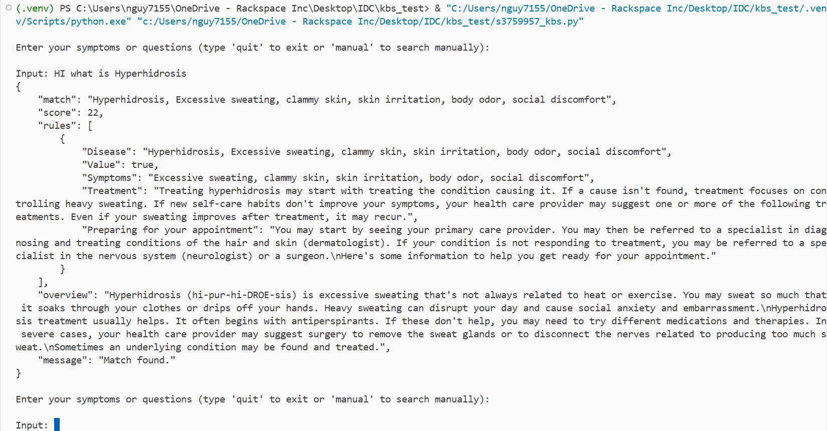
Figure: Inference Engine retrieved answer for user’s query about Hyperhidrosis
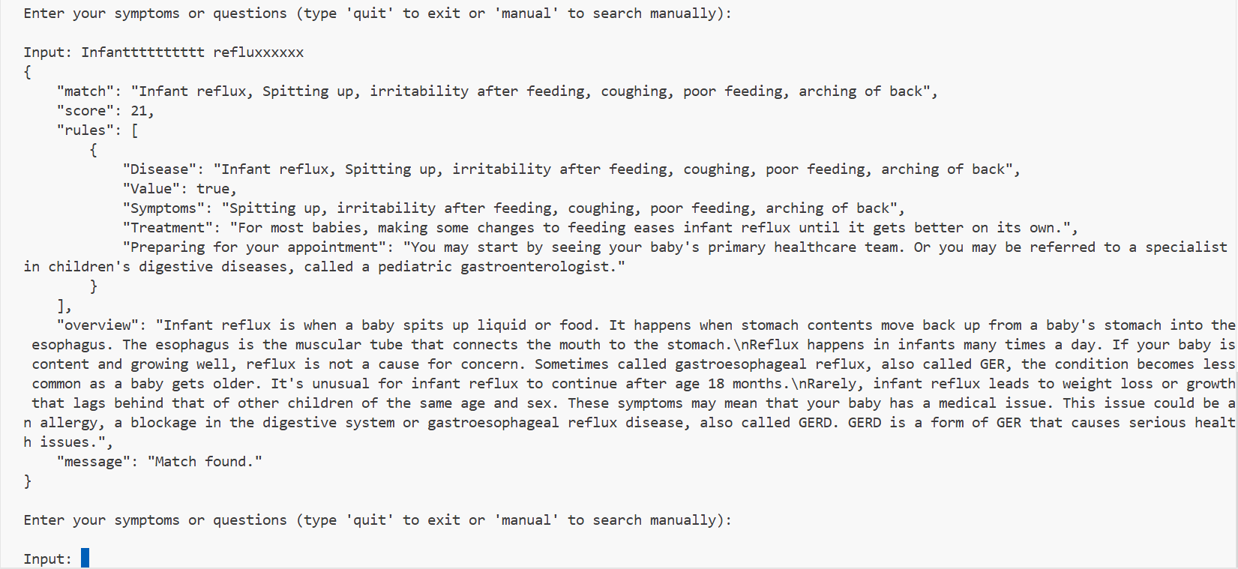
Figure: System allowed similarity search to handle typo
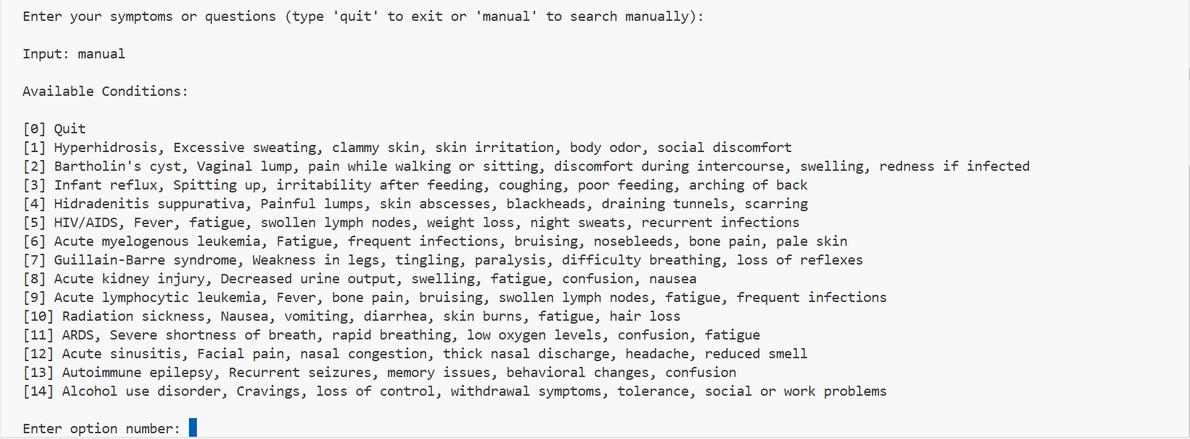
Figure: System allowed manual mode to search all options in the Knowledge Base
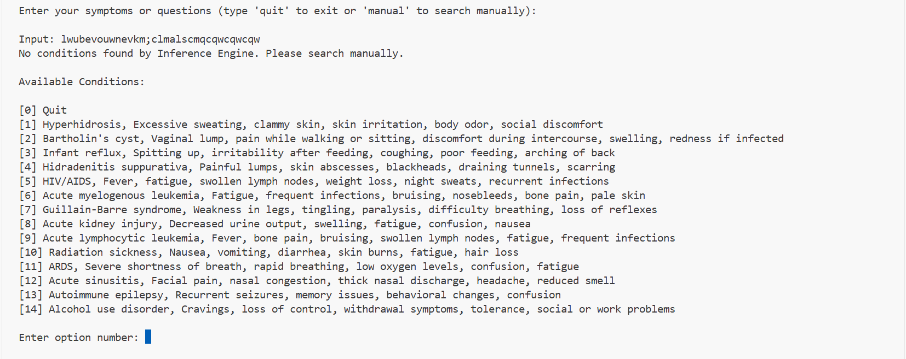
Figure: System automatically switched to manual mode if Inference Engine could not manage to retrieve an answer

Inference engine
The provided InferenceEngine implements a simple, deterministic matching pipeline:
- Preprocessing: An optional NLPProcessor cleans user input (lowercasing, punctuation removal, stopword filtering, and stemming) to produce compact search keywords.
- Matching: The engine computes a fuzzy similarity score between the processed user input and each fact key using Python's difflib.SequenceMatcher. The similarity is expressed as a 0–100 integer score.
- Selection: The fact key with the highest score is selected as the best match. If the best score is 0 or no keys exist, the engine reports no match.
- Retrieval: Once a best match is found, the engine retrieves associated rules (rule dictionaries whose 'Disease' field equals the matched fact key) and returns them, along with the fact overview and match score. This approach is fast and simple to implement but has limitations: it relies on surface-level fuzzy matching (susceptible to false positives/negatives), does not perform semantic understanding, and does not chain rules or perform logical inference beyond retrieval.
- For improved accuracy, one could integrate token-based scoring, TF-IDF / vector embeddings, or implement backward/forward chaining for multi-step reasoning.

