Activity

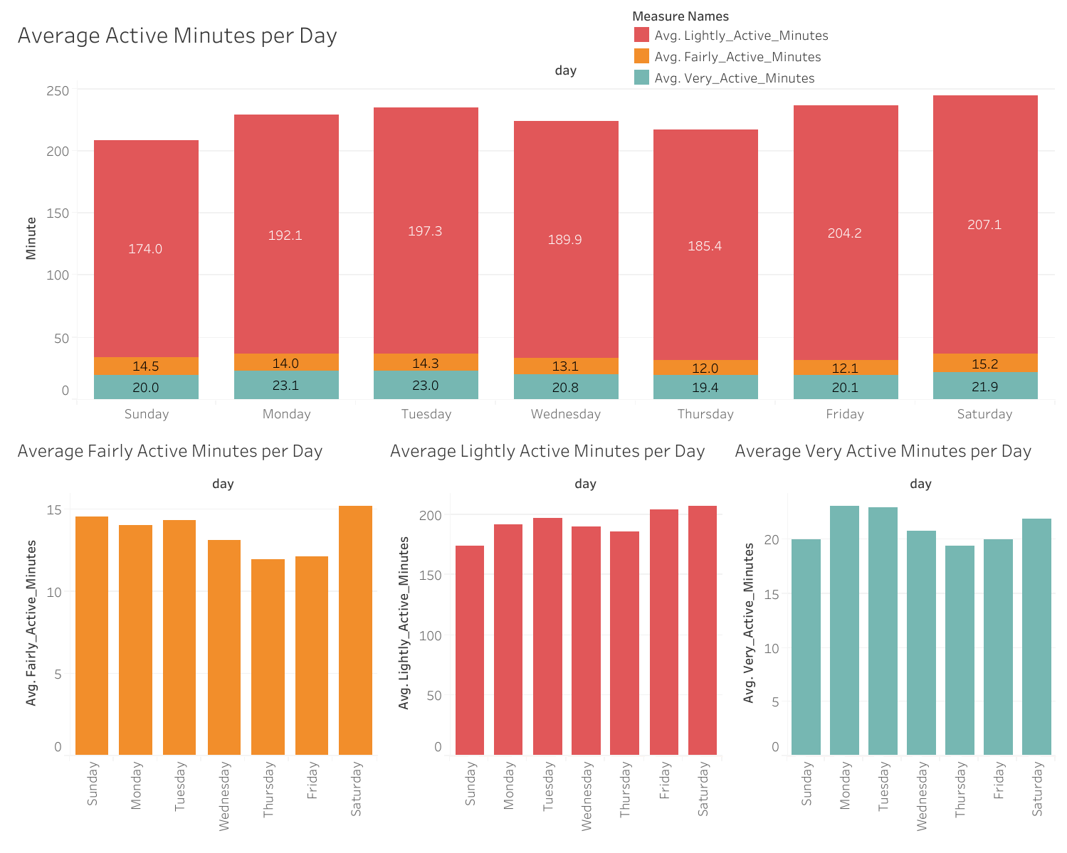

Overall, it can be seen that the activity trends