VNShop Marketplace Search

Dynamic Search Facets and Seller Tags

STATUS  Proposed |  | OWNER  Search and Catalog owners |  | LAST UPDATED  July 27, 2026

Authors | VNShop engineering draft
Reviewers | Catalog, Search, Frontend, and Security reviewers
Related docs | docs/FE-DATA-SEARCH-REVIEW-2026-07-22.md; .ua/domain-graph.json
Scope | Designs seller-tag data flow and dynamic search filters across catalog, search, gateway, and storefront.

1. Abstract
VNShop search currently exposes static category and brand facets, while seller-created product tags are not persisted through the product event and search projection. This proposal introduces a typed, dynamic facet contract with seller tags as its first extension point. Catalog remains the source of truth; Search owns an asynchronous Elasticsearch read model and returns the facet descriptors that the storefront renders.
Tags become public immediately after server-side policy checks, then appear in search through the existing event projection. Tag values are normalized, deduplicated, and bounded by typed configuration properties. Buyer selection is OR within the tag group and AND across filter groups. Rating and free-shipping constraints must be executed by the backend against source-derived fields, never against a loaded browser page or a hardcoded shipping fee.

2. Goals and Non-Goals
Goals | Non-goals
Publish seller-created tags through the product event and search projection. | A seller-defined arbitrary attribute schema or nested metadata map.
Normalize, deduplicate, and bound tags at the catalog boundary. | Manual pre-publication approval for every new tag.
Apply tags, rating, and shipping filters server-side across all pages. | Client-side post-filtering of a previously loaded product page.
Render filter controls from API facet descriptors and test the contract end to end. | A taxonomy, synonym, or relevance-ranking redesign.

3. Background and Problem Statement
The current Search V2 request accepts only fixed query fields. `minRating` and `freeShip` are not represented in the backend query contract, and the storefront does not select backend search for those filters. The page then filters only the already loaded catalog data. In addition, the product mapper assigns `shippingFee: 0`, making the free-shipping control appear to match every mapped product instead of reflecting real delivery data.
Product Service owns canonical product tags and emits them with product lifecycle events. Search Service consumes those events into a denormalized read model, evaluates typed filters, and returns bounded dynamic facets. The API Gateway and React storefront pass normalized filter selections without local semantic reinterpretation. The governing invariant is that an applied filter, its results, and its facet counts are derived from the same server-side query contract.

4. Proposed Architecture

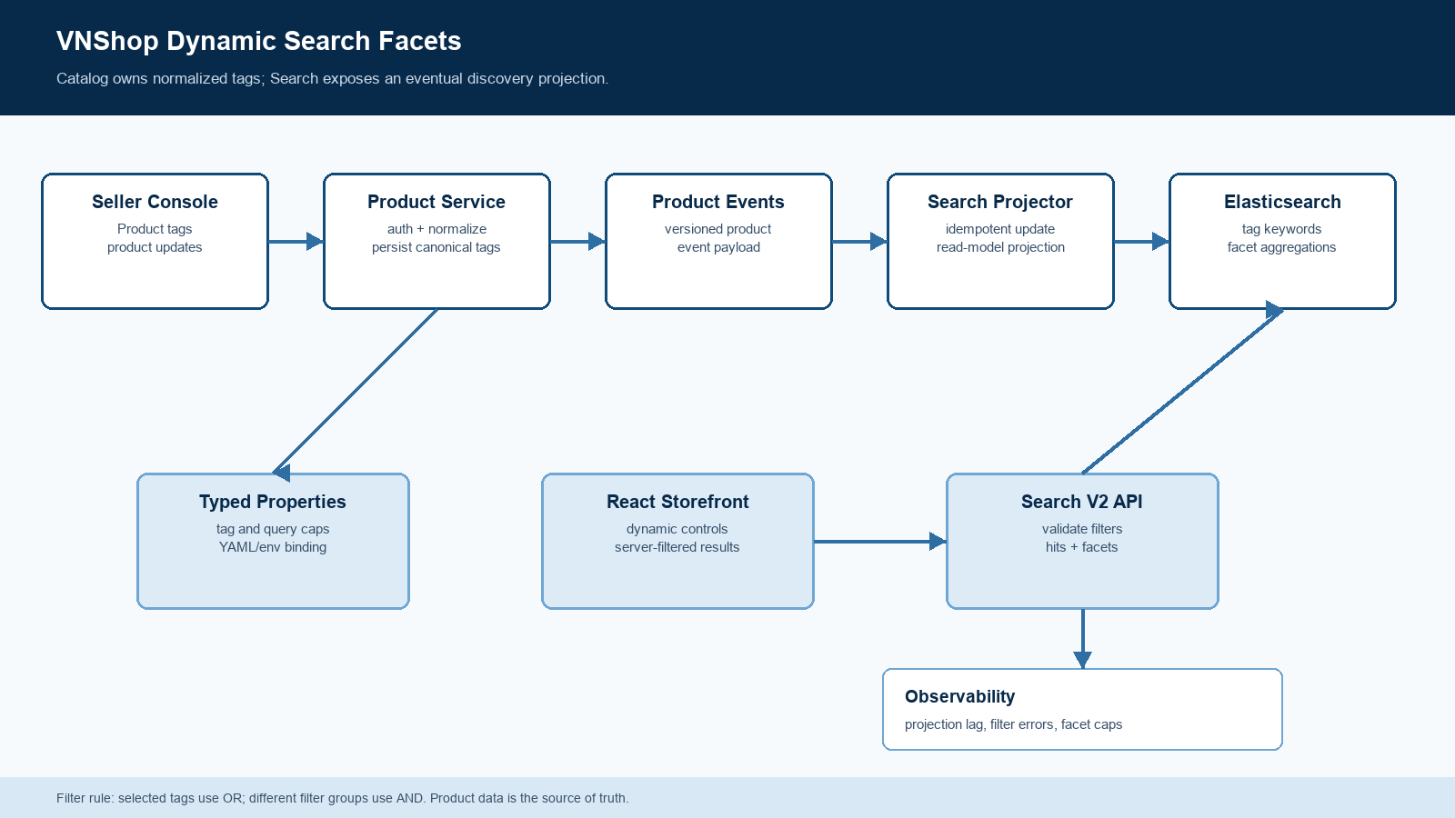
Figure 1. Dynamic facet and seller-tag data flow.

Core components

Component | Responsibility | Primary storage | Failure behavior
Seller Console | Submits product tags and renders server-returned facet controls. | Browser route state | Shows validated server results; never post-filters the current catalog page.
Product Service | Authorizes the seller, normalizes and persists tags, then emits product events. | Product database | Rejects invalid values without a partial tag update or event.
Product Events and Search Projector | Carries tag and source-derived filter facts into an idempotent search projection. | Kafka and Elasticsearch | Retries projection failures and exposes index lag for recovery.
Elasticsearch Product Read Model | Stores canonical tag keywords and filterable product facts; computes bounded facets. | Elasticsearch | Serves last known indexed state while projection recovery is observable.
Search V2 API | Validates typed filters, runs the query, and returns products plus facet descriptors. | Search Service and typed properties | Rejects malformed or unknown filters instead of silently ignoring them.

5. Request Lifecycle
- Seller submits product tags through the existing product command flow.
- Product Service verifies seller ownership, validates the inputs, and normalizes each tag into a display label and canonical key.
- Product Service persists the canonical values and emits a product event that includes the tag set and source-derived filter facts.
- The Search projector consumes the event idempotently and updates the Elasticsearch product document.
- A buyer sends a V2 search request with repeatable filter selections, a sort, and an optional cursor.
- Search V2 validates the request and applies all predicates server-side. Selected tag values use OR; different filter groups use AND.
- The response returns product hits, cursor metadata, and bounded facet descriptors. React updates the route and renders those descriptors without local result filtering.

6. API and Data Contracts

Primary data contract

Field | Type | Required | Description
tags | TagValue[] | No | Optional seller input. The product record owns the canonical tag set.
tag.canonicalKey | string | Yes when tagged | Server-derived normalized key used for indexing and filtering.
tag.displayLabel | string | Yes when tagged | Customer-facing label retained after validation and normalization.
filters | FacetSelection[] | No | Repeatable search selections. Tag values use OR; filter groups use AND.
facets | FacetDefinition[] | No | Returned when facets are requested; each entry supplies key, label, kind, values, and counts.
minRating | decimal | No | Backend predicate that must select Search V2 and affect cursor-stable results.
shippingFee | money | No | Source-derived product fact. It must never default to zero in a client mapper.

Contract guarantees

- Catalog validates and durably persists canonical tags before its product event becomes eligible for projection.
- The event contract must carry product identity and an ordering value so the projector can make replay idempotent and prevent stale document writes.
- A cursor is valid only for the normalized filter selection, sort, and page size that created it; mismatches are rejected rather than reinterpreted.
- The search document is a derived discovery projection. Product Service remains the source of truth for tags and delivery facts.
The versioned event and Search V2 schemas are published with the service contracts.
Update each contract and its consumer tests with every compatible release.

7. Consistency, Idempotency, and Replay

Search is eventually consistent with the catalog write path. A successful product update is durable in Catalog before projection, while buyer search may observe the prior index until the event is applied. Duplicate events must be safe; malformed buyer filters must never silently become an unfiltered request. Reindexing and replay rebuild the same document from the product event contract.
Scenario | Expected behavior | Reasoning
Duplicate or replayed product event | The projector reaches the same document state; the newest ordering value wins. | Idempotent projection prevents duplicate tag values and stale writes.
Search projection temporarily unavailable | Catalog keeps the durable change; projection retries and index lag is reported. | Search may be briefly stale, but the tag update is not lost or falsely acknowledged as indexed.
Malformed or unknown buyer filter | Search V2 returns a typed validation error without a full-catalog fallback. | The current silent-ignore behavior is replaced by an observable contract failure.
Facet cap or configuration change | The request uses a validated bounded selection and one configuration snapshot. | Limits remain deterministic and prevent unbounded query or aggregation cost.

8. Security and Privacy Considerations

- Only an authorized seller may add or remove tags on that seller's product. Buyer search accepts only public, validated facet values.
- Tags are customer-facing data. Reject control characters and policy-disallowed content, and do not place credentials, personal data, or raw authorization material in product events or search logs.
- Operational tag and query limits are configuration, not seller data. They are bound from YAML or environment values through typed properties classes with normal deployment secret controls.
- Replay and reindex tools must be scoped to authorized operators, default to non-destructive mode, and emit auditable job records.
- Retain only the product data required for discovery. Apply the existing product deletion and privacy lifecycle to the search projection and its event history.

9. Operational Readiness
Signal | SLO or alert | Owner | Launch gate
Tag validation and rejection rate | Alert on sustained deviation from the launch baseline. | Catalog owner | Required
Product-event-to-index latency | Alert when projection lag exceeds the agreed launch threshold. | Search owner | Required
Filter contract synthetic checks | Seeded tags, rating, and shipping results match API and UI expectations. | Search and Frontend | Required
Facet cardinality and cap rejections | Alert on cap pressure, truncation, or anomalous tag growth. | Search owner | Required
Search error and malformed-filter rate | Alert on a sustained 4xx or 5xx change from baseline. | Search owner | Required
Rollout constraint: use a feature-flagged path, reindex a representative catalog, run API and UI contract tests, begin with a canary audience, and promote only after projection lag and error signals meet agreed thresholds.

10. Alternatives Considered

Alternative | Why it was considered | Why it was not selected
Tags-only endpoint parameters | Fastest path to expose a tag filter. | Creates another special-case contract and does not prepare the UI for future dynamic facets.
Arbitrary metadata map | Allows sellers to define any key and value. | Unbounded dynamic mappings and facet cardinality create operational and relevance risk.
Client-side post-filtering | Avoids Search V2 changes in the short term. | Breaks global results, cursor pagination, counts, and deep-link correctness.
Manual tag moderation gate | Provides stronger human review before public use. | Conflicts with the decision that seller tags become searchable after automatic policy checks.

11. Open Questions
- What configured limits should govern tags per product, tag length, request selections, and facet bucket count?
- Should tag facet counts exclude the currently selected tag group so buyers can expand a selection without losing options?
- Which product-domain field and event owner will provide real shipping-fee or free-shipping eligibility data?
- What ordering/version field and reindex procedure will make product-event replay deterministic for existing products?

12. Decision and Next Steps
Recommended decision: introduce a generic typed facet contract with seller tags as the first dynamic group. First add canonical tag persistence, event propagation, and Elasticsearch projection; then make Search V2 and React consume the same facet contract. Correct rating and free-shipping semantics in the same API work. Do not expose free-shipping filtering until the product domain supplies an actual fee or eligibility source.
Milestone | Deliverable | Exit criteria
M1 | Canonical tags, typed properties, and product-event projection | Unit and projection tests prove normalized tags reach the search document idempotently.
M2 | Search V2 filter and facet contract plus React dynamic rendering | API, URL-state, pagination, and UI tests prove server-side semantics.
M3 | Representative reindex and feature-flagged canary | Synthetic checks, lag monitoring, and rollback validation pass.
M4 | Broader storefront rollout | Agreed operational gates hold and reviewers approve the remaining open decisions.

Use footnotes for definitions, assumptions, or terms that need precision without interrupting the main narrative.

