Listening-Test 1506

Part 1

1,

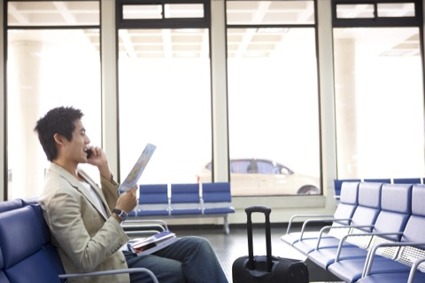

2,



3,

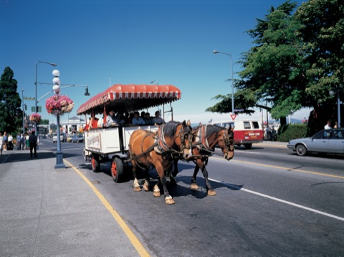

4,

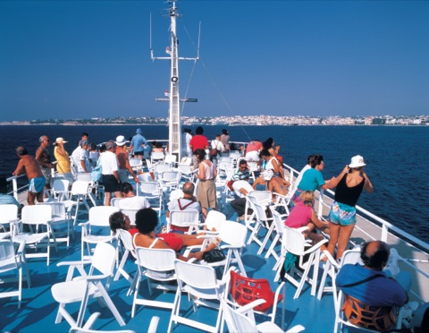

5,



6,

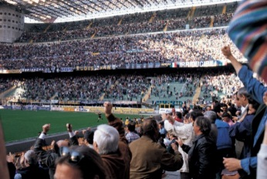

7,

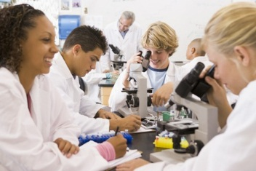

8,

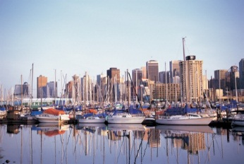

9,

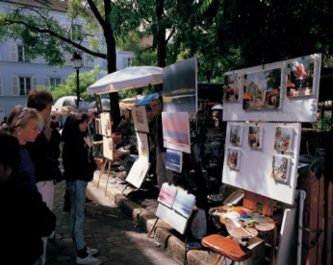

10,

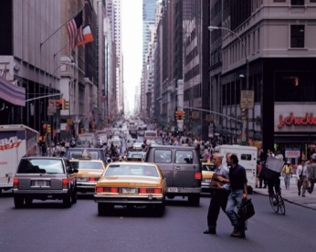

Part 2:

11, 21, 31,

12, 22, 32,

13, 23, 33,

14, 24, 34,

15, 25, 35,

16, 26, 36,

17, 27, 37,

18, 28, 38,

19, 29, 39,

20, 30, 40,

Part 3:

Question 41

Where is the conversation most likely taking place?

**A**At a bus stop

**B**At a parkffice

C, In an office

**D**In a car

Question 42

What does the man offer to do?

**A**Meet the managern a ride

B, Give the woman a ride

**C**Check the bus schedule

**D**Extend a deadline

Question 43

What did the woman probably do last week?

**A**Visit a museum

**B**Attend a meeting

**C**Rent a care a reprite a report

D, write a report

Question 44

Why is the woman calling?

**A,**A shipping address is wrong.item is missing.

B, an item is missing

**C**An invoice is incorrect.

**D**A product is damaged.

Question 45

What does the man say caused the problem?

**A**The order wasn’t well packed.

**B**The product materials were reused

**C**An item was out of stock.

C, An item was out of stock

**D**He received two different invoices.

Question 46

What does the man say he will do next?

**A**Find some numbers

**B**Reorder an item

**C**Use a faster delivery service

**D**Talk to a manager

**47:**What does the woman want to do?

**A**Get an earlier ticket

A, Get an earlier ticket

**B**Receive a refund

**C**Cancel a meeting

**D**Change seats

Question 48

What is the problem?

**A**An arrival has been delayed.

**B**The weather is bad

**C**Seats are unavailable

C, Seats are unavailable

**D**Tickets are expensive

Question 49

When will the woman leave?

**A**At 8 A.M.

**B**At 1 P.M.

B, at 1 P.M

**C** At 4 P.M.

**D**At 5 P.M

Question 50

Where do the speakers most likely work?

**A**At a community park

**B** At a magazine publisher

B At a magazine publisher

**C**At a photo studio

**D**At a camera store

Question 51

Who most likely is Justin Son?

**A**An editor

**B**A reporter

**C**A writer

**D**A photographer

D, A photographer

Question 52

Why is the man going to the community park?

**A**To conduct an interview

A To conduct an interview

**B**To exercise outdoors

**C**To apply for a job

**D**To have lunch

Question 53

Why is the man calling the library?

**A**He doesn’t know where the library is.

**B**e hasn’t received a new library card.

**C**He cannot log onto the library Web site.

**D**He cannot return his books on time.

D, He cannot return his books on time.

Question 54

What does the woman offer to do?

**A**Order new books for the man

**B**Renew the books by telephone

B, Renew the books by telephone

**C**Give the man an application form

**D**Place a book on hold

Question 55

How can the man get a new library card?

**A**By applying online

A, By applying online

**B**By calling a librarian

**C**By mailing a written form

**D**By visiting the library

Question 56

What product are the speakers discussing?

**A**A computer

**B**A chair

**C**A hybrid car

C, A hybrid car

**D**A toothpaste

Question 57

According the man, what feature of the product are the buyers concerned about?

**A**Its exterior design

A, Its exterior design

**B**Its price

**C**Its usefulness

**D**Its style

Question 58

What does the woman suggest?

**A**Delaying a product’s launch

**B**Conducting a customer survey

**C**Changing a marketing plan

**D**Talking with an expert

D, Talking with an expert

Question 59

Why does the woman want to meet the man?

**A**To talk about the man’s business trip

**B**To arrange a training session

**C**To update some computer software

**D**To review a business proposal

D, To review a business proposal

Question 60

Why is the man unable to meet?

**A**He is running a training session.

A, He is running a training session.

**B**He is writing a software program.

**C**He is finishing a report.

**D**He is attending a conference.

Question 61

What do the speakers decide to do?

**A**Meet tomorrow

**B**Assist their colleagues together

**C**Exchange a document by e-mail

C, Exchange a document by e-mail

**D**Postpone the deadline

Question 62

What was the main topic of the presentation?

**A**Important customers

**B**Product materials

**C**Office efficiency

C office efficiency

**D**Meeting times

Question 63

Why did the man miss the presentation?

**A**He got lost.

**B**He had to attend a meeting.

B He ha to attend a meeting.

**C**He left the office early.

**D**He moved to a different office.

Question 64

What suggestion did the woman like?

**A**Installing office lockers

A, Installing office lockers

**B**Holding a concert for loyal customers

**C**Rearranging work schedules

**D**Increasing next year’s budget

Question 65

What has the man misplaced?

**A**A credit card

**B**A car

**C**A key

C, A key

**D**A watch

Question 66

What does the woman say will happen next week?

**A**A manufacturing procedure will change.

**B**A charge will be introduced.

B, A charge will be introduced.

**C**A new credit card will be issued.

**D**Car keys will be made.

Question 67

What does the woman suggest the man do?

**A**Call the security department

A, Call the security department

**B**Make an identification tag

**C**Purchase a new watch

**D**Go to the maintenance office

Question 68

Who is the woman?

**A**A teacher

**B**An interviewer

B, An interviewer

**C**A career counselor

**D**A job applicant

Question 69

What field did the man work in?

**A**Public welfare

**B**Counseling

**C**Education

**D**Broadcasting

D Broadcasting.

Question 70

What will probably happen next Tuesday?

**A**There will be another interview.

A, There will be another interview.

**B**A graduation ceremony will be held.

**C**A welfare policy will be announced.

**D**A new reporter will be hired.

Part 4

Question 71

Where is the announcement being made?

**A**At an auditorium

**B**At an airport

B At an airport

**C**At a cafeteria

**D**At a train station

Question 72

What is the reason for the announcement?

**A**An airplane has departed late.

**B**An additional delay has occurred.

B An additional delay has occurred

**C**A show has been postponed.

**D**Refreshments have sold out.

Question 73

What are the listeners advised to do?

**A**Ask for free drinks

A Ask for free drinks.

**B**Wait at the platform

**C**See a show later

**D**Go to a departure gate

Question 74

What type of firm does Mr. Singh probably work for?

**A**A cleaning company

A, A cleaning company

**B**A law firm

**C**A building contractor

**D**An electronics corporation

Question 75

What does the speaker want from Mr. Singh?

**A**An employee recommendation

**B**A revised contract

**C**A price estimate

C, A price estimate

**D**Some cleaning equipment

Question 76

What does the speaker say about Mr Singh’s firm?

**A**It has special requirements.

**B**It is located downtown.

**C**It provides different levels of service.

DIt has satisfied some customers.

Question 77

Who most likely is the speaker?

**A**A department manager

A, A department manager

**B**A financial specialist

**C**A computer programmer

**D**A data analyst

Question 78

What is the speaker announcing?

**A**A change of plan

A, A change of plan

**B**A financial investment

**C**A new data system

**D**An improved contract

Question 79

According to the speaker, what will happen?

**A**Financial results will be announced.

**B**Projects will be postponed.

B, Project will be postponed

**C**A schedule will be moved forward.

**D**Data will be analyzed.

Question 80

What is the purpose of the talk?

**A**To present a manager

**B**To announce a publication

**C**To change an event

**D**To introduce a speaker

D, To introduce a speaker

Question 81

Who is Suzanne Wong?

**A**A non-fiction writer

A, A non-fiction writer

**B**A talk show host

**C**A senior manager

**D**An event organizer

Question 82

What are the listeners asked to do?

**A**Call a radio station

A, Call a radio station

**B**Purchase a book

**C**Welcome a new employee

**D**Go to a different location

Question 83

Where does the introduction take place?

**A**At a garden

A, At a garden

**B**At a museum

**C**At a zoo

**D**At a theater

Question 84

What are the listeners asked to do?

**A**Follow a different route

**B**Take photographs

**C**Keep off the grass

C, Keep off the grass

**D**Take garbage home

Question 85

What can the listeners do after the tour?

**A**Meet actors

**B**Bake cakes

**C**Purchase souvenirs

**D**Eat snacks

D, Eat snacks

Question 86

What is the message mainly about?

**A**Booking a trip

**B**Managing sales

**C**Ordering food

**D**Organizing a visit

D, Organizing a visit

Question 87

What does the speaker ask Aisha to do?

**A**Change a reservation

A, Change a reservation

**B**Alter a schedule

**C**Visit an overseas office

**D**Arrange a party

Question 88

Why does the speaker want to meet with Aisha?

**A**To finalize costs

**B**To plan a promotion

**C**To check a product

**D**To confirm a schedule

D, To confirm a schedule

Question 89

Why is the speaker calling?

**A**To report an error

A To report an error

**B**To return a call

**C**To schedule a delivery

**D**To place an order

Question 90

How many items did the company order in August?

**A**Four

**B**Five

B, Five

**C**Six

**D**Ten

Question 91

What does the speaker request?

**A**A corrected bill

A, A corrected bill

**B**A meeting

**C**An advance payment

**D**A replacement item

Question 92

How should the employees record their working hours?

**A**By writing on a timesheet

**B**By talking with their managers

**C**By contacting the personnel officer

**D**By using an on-line system

D, By using an on-line system

Question 93

What does the speaker say about the projects?

**A**They are unique.

**B**They have codes.

B, They have codes.

**C**They must be completed by Friday.

**D**They each have different managers.

Question 94

What will the speaker give to the listeners later on?

**A**Access details

A, Access details

**B**Distribution information

**C**A company guide

**D**A tour of a factory

Question 95

What did the speaker receive earlier in the week?

**A**New product lines

**B**Customer feedback

**C**Product samples

**D**Financial data

D, Financial data

Question 96

Which items did customers buy more of?

**A**Furniture

**B**Clothing

**C**Electrical appliances

**D**Foods

D, Foods

Question 97

What will the Marketing Department probably do?

**A**Conduct an investigation

A, Conduct an investigation

**B**Design fashion items

**C**Prepare a customer dinner

**D**Take a summer vacation

Question 98

What does the factory produce?

**A**Fabrics

A, Fabrics

**B**Machinery

**C**Electronics

**D**Vehicles

Question 99

What is the purpose of the new equipment?

**A**To increase production

A, To increase production

**B**To improve safety

**C**To reduce staff numbers

**D**To work with overseas branches

Question 100

What are the workers required to do?

**A**Set up new machines

**B**Take a business trip

**C**Improve safety procedures

**D**Attend training courses

D, Attend training courses