**PART 5**   
101. Since Mr. Gordon was new at work, Ralph........him how to use the fax machine when his boss told him to send a copy of the cost estimation to the contractor.

 (A) teaches

 (B) taught;

 (C) is teaching

 (D) has taught

102. ------ the annual conference, the guest speaker addressed the importance of thinking positively.

 (A) At

 (B) On

 (C) Of

 (D) To

103. All ------- to the University of Michigan were advised to apply as early as possible by their guidance counselors.

 (A) applications

 (B) applicants

 (C) apply

 (D) applied

104. The two companies were spying on each other in order to decide on a date to release--------new products.

 (A) they

 (B) them

 (C) theirs

 (D) their

105. An organization's future depends on which direction the------- of the organization is heading.

 (A) position

 (B) leader

 (C) role

 (D) pilot

106. The new bill that Congress just passed......... smoking in any building in Miami and some other major cities in Florida.

 (A) restrict

 (B) restricts

 (C) restricting

 (D) was restricted

107. Without Kevin's ......., Mr. Park wouldn’t have been able to have access to the laboratory to complete his work from yesterday.

 (A) assist

 (B) assists

 (C) assisted

 (D) assistance

108. After only three minutes I asked Ms. Miller to.......  her intention to fire the new employee, I had to carry out the task.

 (A) confirm

 (B) comply

 (C) remind

 (D) agree

109. As a perfectionist, Jack prefers to do everything ----- at work because he does

not trust anyone.

 (A) he

 (B) his

 (C) himself

 (D) him

110. Because Isaac has ---- moved and hasn’t reported it to the post office. He hasn't been able to receive any of his mail for a month.

 (A) recently

 (B) initially

 (C) highly .

 (D) usually

111. Because the pipe system of the building is built right ------ the parking garage floor, it’s very important to make sure that the weight limit is not exceeded.

 (A) there

 (B) Open

 (C) under

 (D) away

112. When Sarah told her boss that she thinks they should change the direction of their new project and try to come up with a totally different technology, he was all -----it.

 (A) as

 (B) for

 (C) about

 (D) near

113. Although Mark wanted to attend the family meeting, he had to........tell them that he wouldn't be able to be there because he would be in China at the time.

 (A) respectfully

 (B) respected

 (C) respectful

 (D) respecting

114. Adam's boss taught him ....... when to be stubborn and when to step back and quietly

observe the situation at meetings with partner companies.

 (A) either

 (B) not only

 (C) whether

 (D) both

115. Until the necessary parts.......  the factory wasn’t able to operate at its full capacity.which resulted in a dispute with its partner company.

 (A) were installing

 (B) would be installing

 (C) have been installed

 (D) to be installed

116. The .......... of a company is measured by both the increase in the number of salesand the increase in the number of employees each year.

 (A) stow

 (B)growth

 (C) grew

 (D) growing

117. Mr. Hernandez is widely considered as quite reliable among clients and in addition, he has gained ------- trust from his colleagues.

 (A) capable

 (B) usable

 (C) sturdy

 (D) complete

118. The guest speaker was talking about his dream so ----- that everyone at the ceremony was inspired to achieve more.

 (A) eagerly

 (B) eager

 (C) eagerness

 (D) more eager

119. The operations manager ---- every part of the factory twice every day, at 11 AM and

5 PM in order to make sure that there are no malfunctions.

 (A) performs

 (B) inspects

 (C) functions

 (D) revises

120. The fact that consumers tend to save money----- economic recessions is obvious to

local businesses yet hard to accept.

 (A) while

 (B) during

 (C) between

(D) still

121. The new handbag that the BI Design Company exhibited not only looked

luxurious but also had enough room to hold belongings ........

 (A) heavily

 (B) frequently

 (C) conveniently

 (D) consistently

122. The price of BIS’s new product was not even ------ to that of LMK’s old product

because they used cheap labor in China.

 (A) comparably

 (B) comparable

 (C) comparing

 (D) comparison

123. All the members of Career Opportunity Organization were ------- to start writing their applications as early as possible because it would give them enough time to review it before submitting it.

 (A) criticized

 (B) excused

 (C) monitored

 (D) advised

124. While Jane thought that Irene was a-------- worker, Irene was only a temporary employee.

 (A) designed

 (B) scheduled

 (C) expressed

 (D) committed

125. Because of free trade and open door policies, it’s become a lot------ for a country to recover from an economic recession because one country’s economic situation affects the other’s.

 (A) harder

 (B) harden

 (C) hard

 (D) hardly

126. -------- the presentation was good, the company declined the offer because the product itself didn’t seem profitable.

 (A) Although

 (B) Despite

 (C)Only if

 (D) In case

127.The bonds issued by the government---- fairly so that each citizen is given

equal access to wealth.

 (A) allocation

 (B) allocated

 (C) have been allocating

 (D) are allocated

128. Only few know that the subway ticket vending machines near the entrance

require exact -----

 (A) number

 (B) coin

 (C) amount

 (D) change

129. At the annual Healthy promotion conference, Dr. Drake said that most smokers smoke cigarettes--------- rather than because of the addiction itself.

 (A) habit

 (B) habits

 (C) habitual

 (D) habitually

130. ------- the journalist seemed very docile outside of work, he was actually a very cynical person inside.

 (A) Even though

 (B) When

 (C) Until

 (D) In order that

131. Phone manufacturing companies are having a difficult time following the ---- --changing interests of consumers.

 (A) impulsively

 (B) rapidly

 (C) intently

 (D) patiently

132. The ------- work done by the two partner companies brought a massive profit to both companies at the same time.

 (A) collaborate

 (B) collaborative

 (C) collaborates

 (D) collaboratively

133. The industrial engineers came up with away to bring about optimal ------- with the least input sources.

 (A) qualification

 (B) dispute

 (C) entitlement

 (D) efficiency

134. Among ------ proposals, the CEO chose Julie’s because her proposal containedthorough research and sophisticated statistical analysis.

 (A) another

 (B) nothing

 (C) anything

 (D) several

135. Detectives always have to look for solid----- instead of making decisions based on

mere emotion.

  (A) trends

 (B) assent

 (C) evidence

 (D) foundation

136. The new employees are advised to work in a ------ manner in order to earn their boss's trust.

 (A) time

 (B) timing

 (C) timer

 (D) timely

137. ------ its overwhelming debt load, the government decided to increase interestrates in order to discourage loans and promote savings.

 (A) in response to

 (B) As a result

 (C) As opposed to

 (D) In place of

138. Currently, there are no certain ---- for some diseases such as AIDS, whose victims are up to 50.000 a year.

 (A) to remedy

 (B) remedial

 (C) remediable

 (D) remedies

139. Being in the military is very challenging not only because of the ---- training, but also the unfair treatment.

 (A) rigorous

 (B) various

 (C) spacious

 (D) prosperous

140. Finding a(n) ----- in the cycle. John called customer service at once and filed an

official complaint.

 (A) inclination

 (B) lapse

 (C) occasion

 (D) hint

**PART 6** : **Question 141-143 refer l0 the following letter.**   
  
Dear New Members of FMA,  
  
Welcome to the Florida Mathematicians Association.  
  
Your ----- task is to thoroughly read the membership contract attached to the letter.  
  
141.

 (A) first

 (B) last

 (C) most

 (D) ultimate

Once you finish reading the contract, please be aware of where the conference halls ------142.

 (A) locate

 (B) located

 (C) are located

 (D) have located

referring to the building map at the last page of it. Throughout the year, you'll be asked to work on some challenging math problems and attend meetings at different conference halls. Anyone who has been a part of this association for less than a year is called as a 143........member.

(A) permanent

 (B) proxy

   (C) temporary

  (D) spontaneous

One can become a permanent member of this association only by completing the assigned tasks and attending each meeting for one whole year.

We hope that you'll be able to complete the first task and discuss the problems at the next meeting.

Kevin Howard

**Questions 144-146 refer to the following letter.**   
  
December 2nd  
  
Dear Ms. Kim,  
  
Thank you for your recommendation letters. I ......... your thoughtfulness and hope to be able to pay you back for it sometime in the future.  
  
144.

 (A) appreciated

 (B) have been appreciating

 (C) will be appreciating

 (D) was appreciated

If I hadn’t had your recommendation letters, I wouldn't have been able to be hired at such a .......company.  
  
145.

 (A) reputing

 (B) reputable

 (C) reputably

 (D) reputation

Currently, our company's motto is to bring about a complete ------ to the computer industry.  
  
146.

 (A) commercial

 (B) restoration

 (C) innovation

 (D) rebel

Even though we're asked to work extra hours, it's been very rewarding because we've actually made much progress over the past three months.I just wanted to let you know how grateful I was for your help, and hope to be able to see you once this project is over.Best regards.Andrew Osborne

**Questions 147-149 refer to the following letter.**   
  
Dear Rachel,  
  
Hey, Rachel, I hope your summer is going well. I heard that you ----- a biology course last year. How was it?  
  
147.

  (A) took

 (B) are taking

 (C) will take

 (D) have been taking

I took a chemistry class last year and I was pretty ------ with my grade. I thought I worked pretty hard, but my grade was lower than expected.  
  
148.

 (A) inclined

 (B) excited

 (C) disappointed

 (D) relaxed

I'm now thinking about taking biology this year instead of any further chemistry classes. Do you think I can prepare for it ------ the two months left before school begins?

149.

 (A) within

 (B) ever since

 (C) until

 (D) by

Please write me back as soon as possible and hope the rest of your summer goes well!

Thank you.

Elizabeth

**Questions 150-152 refer to the following article.**   
  
Due to the ------ in oil prices, the development of alternative energy sources is gaining more and more attention.  
  
150.

 (A) decrease

 (B) increase

 (C) controversy

 (D) dedication

For example, Korea used to run only five nuclear power plants, and now ------ a total of eight.  
  
151.

 (A) serves

 (B) carries

 (C) operates

 (D) helps

In other words, there has been an increase in the number of power plants within the last two years.  
  
The increase in the number of nuclear power plants ------- the energy supply shortage, but will certainly create a more dangerous environment and also possible protests against it by environmentalists.  
  
152.

 (A) will eliminate

 (B) have been eliminated

 (C) eliminate

 (D) was eliminating

**PART 7**   
  
[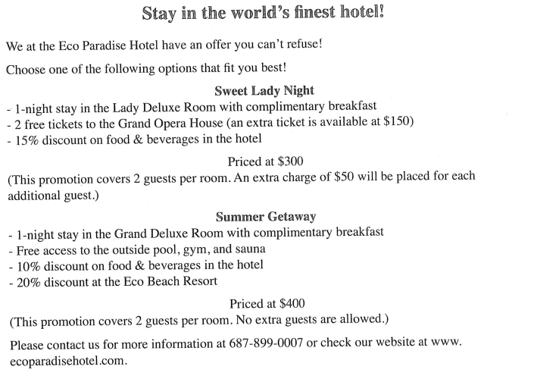](https://ece.edu.vn/wp-content/uploads/2016/06/1-21.png)

**Question 153 – 154 refer to the following advertisement.**

153. What is the discount on food & beverages in the hotel if the Summer Gateway promotion is chosen?

 (A) 10%

 (B) 15%

 (C) 20%

 (D) 25%

154. What would be the price if three guests get three Opera tickets in Sweet Lady Night?

 (A) $300

 (B) $350

 (C) $450

 (D) $500

**Question 155 – 156 refer to the following card.**[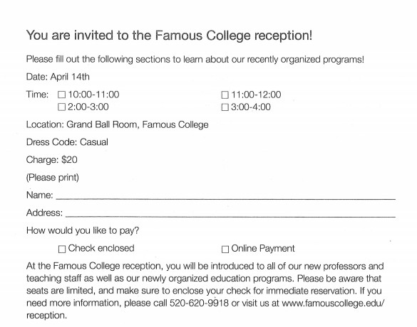](https://ece.edu.vn/wp-content/uploads/2016/06/2-20.png)

1. What the information is included in the card?

 (A) The name of the program manager

 (B) The phone numbers of the new professors

 (C) The payment method

 (D) The number of guests

1. What is one way to secure an immediate reservation?

 (A) Enclose a check in the card

 (B) Call the reception department

 (C) Fill out a membership form

 (D) Pay at the reception desk

**Question 157 – 158 refer to the following advertisement.**[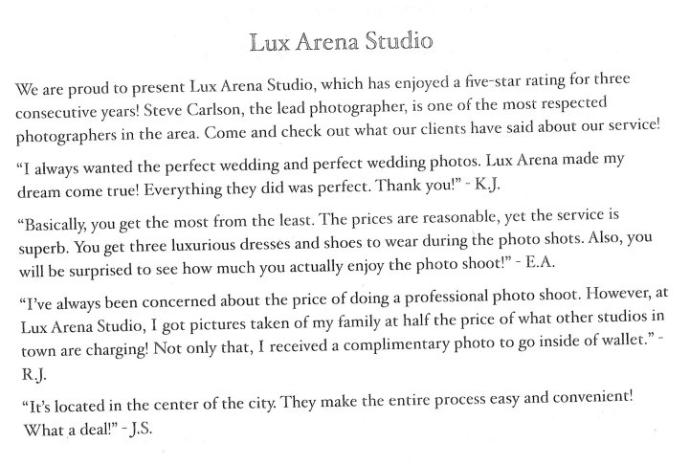](https://ece.edu.vn/wp-content/uploads/2016/06/3-20.png)   
  
157. What is NOT true about the studio?

 (A) The studio is half the price of other studios.

 (B) The studio only offers family photos.

 (C) The studio provides three dresses and shoes for wedding photos.

 (D) The studio photographer is ell respected.

158. What is offer for free to clients who take family photos?

 (A) Three dresses and shoes

 (B) A half price coupon

 (C) A wallet-size photo

 (D) An autograph from a famous photographer

**Question 159 – 161 refer to the following letter.**

[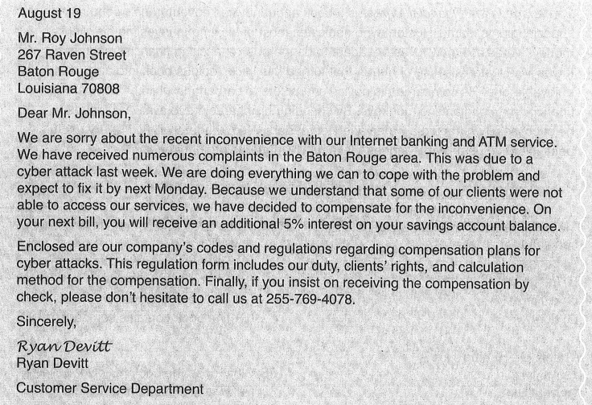](https://ece.edu.vn/wp-content/uploads/2016/06/4-19.png) 

159. What can be inferred in the letter?

 (A) Mr. Johnson is pleased with his Internet service.

 (B) Mr. Johnson suffered a loss from a hurricane.

 (C) Mr. Johnson was unable to use his Internet banking service for a couple of days.

 (D) Mr. Johnson is the manager of the Customer Service Department.

160. What is included in the letter?

 (A) A coupon

 (B) A billing report

 (C) A complain card

 (D) A regulation form

161. What is needed to collect the compensation by check?

 (A) To contact the Customer Service Department

(B) To inform Mr. Johnson

 (C) To send another complaint note

 (D) To register for a new service

**Question 162 – 165 refer to the following book review.**[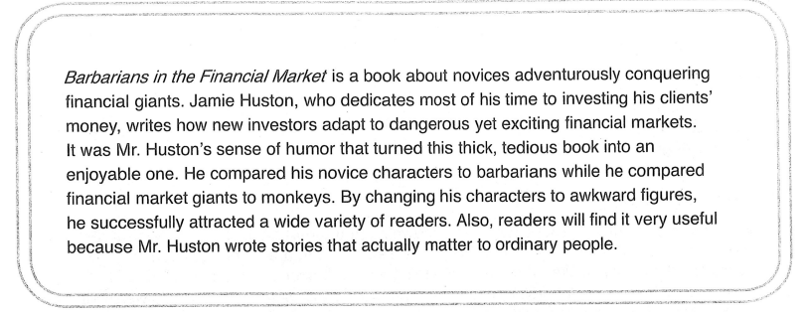](https://ece.edu.vn/wp-content/uploads/2016/06/5-17.png) 

1. The word “tedious” in the line 4 is closed in meaning to

 (A) boring

 (B) intriguing

 (C) exiting

 (D) sorrow

1. What is Mr.Huston’s job?

 (A) Analyst

 (B) Publisher

 (C) Financial company CEO

 (D) Fund manager

1. What is NOT mentioned in the book review?

 (A) The book is quite entertaining.

 (B) The book is expensive.

 (C) The book is long.

 (D) The book contains comparison techniques.

1. What does the book reviewer believe?

 (A) Financial markets are exciting.

 (B) Financial giants are barbarians.

 (C) The book is very practical.

 (D) The book offers job opportunities.

**[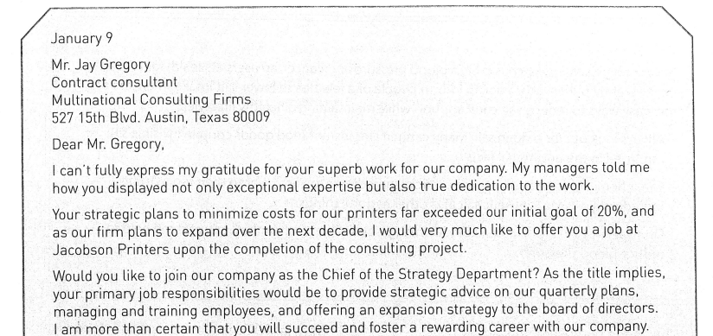](https://ece.edu.vn/wp-content/uploads/2016/06/6-16.png)**[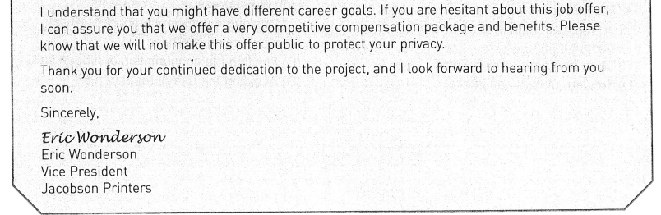](https://ece.edu.vn/wp-content/uploads/2016/06/7-15.png)   
166. What is Mr. Gregory working on?

 (A) Introducing new printer technology

 (B) Replacing Mr. Eric Wonderson

 (C) Providing strategic plans to the company

 (D) Establishing a Strategic Department

167. The word “exceptional” in paragraph 1, line 2 is closest in meaning to

 (A) Lame

 (B) Minimal

 (C) Outstanding

 (D) Eligible

168. What can be inferred about Mr. Wonderson?

 (A) He is against the company’s expansion plans.

 (B) He is a leader in the printer industry.

 (C) He knows how to reduce costs in the manufacturing process.

 (D) He is looking for a qualified emloyee.

169. What is NOT true about Mr. Gregory?

 (A) He is seeking a job at the company.

 (B) He performed the job effectively.

 (C) He is a contractual worker for Jacobson Printers.

 (D) He reduced costs more than the set goal.

**Question 170 – 171 refer to the following article.**[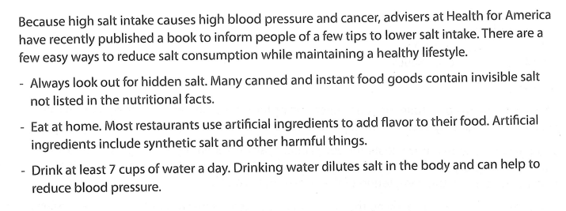](https://ece.edu.vn/wp-content/uploads/2016/06/8-13.png)   
  
170. What is the purpose of this article?

 (A) To encourage eating out

 (B) To maintain high levels of water consumption

 (C) To promote cooking at home

 (D) To warn of high salt intake

171. What is NOT mentioned as a way to reduce high blood pressure and cancer?

 (A) Drinking a sufficient amount of water

 (B) Consuming synthetic salt

 (C) Limiting the consumption of hidden salt

 (D) Avoiding the use of restaurants

**Question 172 – 175 refer to the following information.**[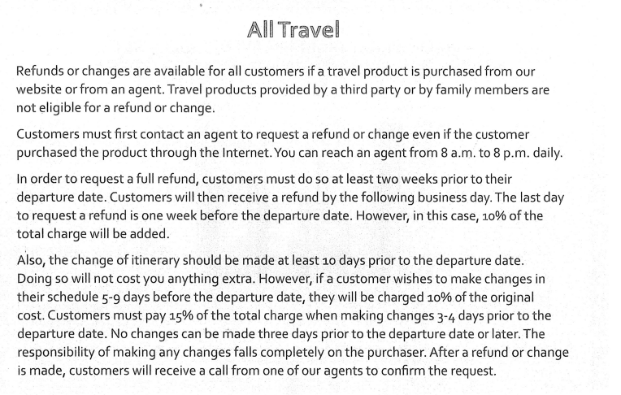](https://ece.edu.vn/wp-content/uploads/2016/06/9-10.png) 

172. What is NOT true about the information?

 (A) Any refunds or changes are made through local agents.

 (B) Travel agents confirm change requests.

 (C) Travel products can be purchased online or through an agent.

 (D) Travel products received from a family member are refundable.

173. When should customer request a refund if they do not want to pay 10% of the total charge?

 (A) 14 days prior to departure date

 (B) 10 days prior to departure date

 (C) 5 days prior to departure date

 (D) 3 days prior to departure date

174. What is required to request a change?

 (A) Customers must call at least 7 days prior to departure day.

 (B) Customers must call an agent first.

 (C) Family members should verify the changes.

 (D) Customers must fill out a lengthy form.

175. What percentage of the total charge will customers have to pay if they make a change 6 days prior to departure?

 (A) 100%

 (B) 15%

 (C) 10%

 (D) 0%

**Question 176 – 180 refer to the following survey results.**[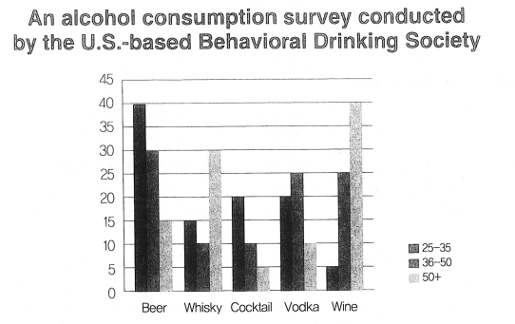](https://ece.edu.vn/wp-content/uploads/2016/06/0-2.png)[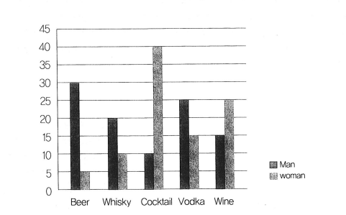](https://ece.edu.vn/wp-content/uploads/2016/06/00-2.png) 

1. Why was this survey conducted?

 (A) To learn about drinking trends and lower drinking rates

 (B) To promote alcohol consumption

 (C) To revise marketing plans

 (D) To prosecute drunk drivers

1. What is implied about wine?

 (A) Wine is more popular among older adults.

 (B) Wine is second most popular drink for men

 (C) Sales of wine will increase steadily.

 (D) Middle age people showed a strong interest on wine.

1. What choices were survey participants given?

 (A) The prices of drinks

 (B) Free sample of drinks

 (C) A variety of drinks

 (D) Drink advertisement

1. According to the survey, what type of drinks is most likely a good gift for retired men ?

 (A) Beer

 (B) Vodka

 (C) Wine

 (D) Cocktail

1. Who most likely were the participants?

 (A) Researchers

 (B) Marketing planners

 (C) Drink manufacturers

 (D) Alcohol consumers

**Question 181 – 185 refer to the following website and e-mail.**

**[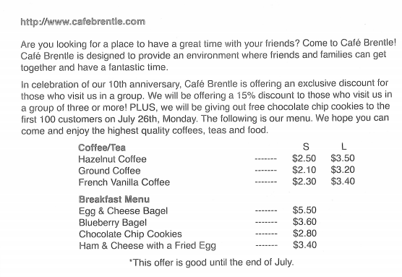](https://ece.edu.vn/wp-content/uploads/2016/06/0-3.png)**[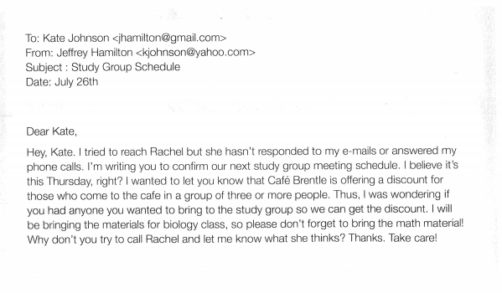](https://ece.edu.vn/wp-content/uploads/2016/06/1-22.png)

181.Why is the Café Brentle offering a discount?

 (A) They have had low sales lately.

 (B) There has been a downturn in the economy.

 (C) A different owner took over the cafe.

 (D) They are celebrating their 10th anniversary.

1. What is the condition for getting a discount?

 (A) They must be members of cafe.

 (B) They must possess a discount coupon.

 (C) They have to spend more than five dollars.

 (D) They have to be in group three or more people.

1. What is the purpose of the e-mail?

 (A) To change the study group meeting schedule

 (B) To discuss class material from the last lecture

 (C) To confirm their next study group meeting

 (D) To change the place where they’re going to meet

1. What did Jeffrey ask Kate to do?

 (A) To look for another student who wants to study together

 (B) To check if the cafe is offering any discounts

 (C) To sign up for a new math class

 (D) To bring the study material for the physics class

1. When will the meeting take place?

 (A) July 25th

 (B) July 26th

 (C) July 29th

 (D) July 31st

**Question 186 – 190 refer to the following e-mails.**[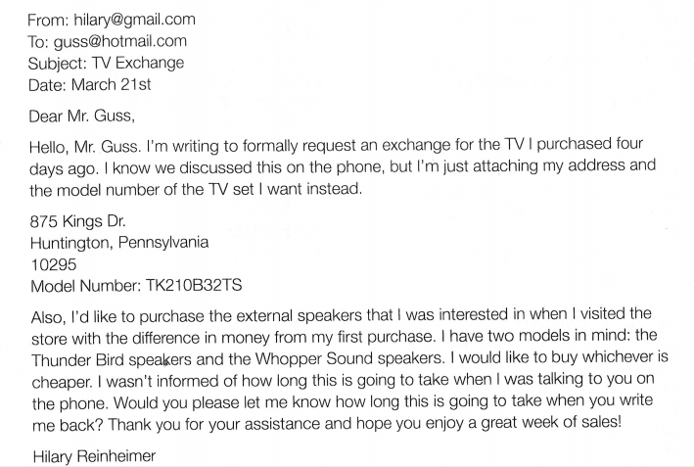](https://ece.edu.vn/wp-content/uploads/2016/06/2-21.png)[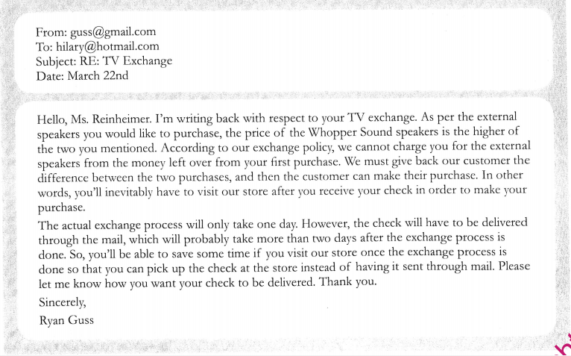](https://ece.edu.vn/wp-content/uploads/2016/06/3-21.png) 

186. Who is Mr. Guss?

 (A) A TV manufacturer

 (B) A TV repairman

 (C) A electronics salesman

 (D) A friend of Ms. Reinheimer’s

187. What does Ms. Reinheimer want Mr. Guss to do?

 (A) Find a nice TV for her

 (B) Give her a refund for the TV she purchased

 (C) Exchange a TV she purchased

 (D) Visit her house and fix a broken TV

188. What CANNOT Mr. Guss do for Ms. Reinheimer?

 (A) Sell her any electronics products

 (B) Explain about the exchange process

 (C) Send a check through the mail

 (D) Include a set of external speakers with the exchange

189. How long will the exchange process take?

 (A) A day

 (B) Three days

 (C) More than three days

 (D) It’s not certain.

190. According to the e-mail, what can be inferred?

 (A) Ms. Reinheimer is interested in buying more TV sets.

 (B) Mr. Guss wants to change his company’s exchange policy.

 (C) Ms. Reinheimer will probably buy the Whopper Sound speakers.

 (D) Ms. Reinheimer and Mr. Guss have already talked before

**Question 191 – 195 refer to the following article and letter.**[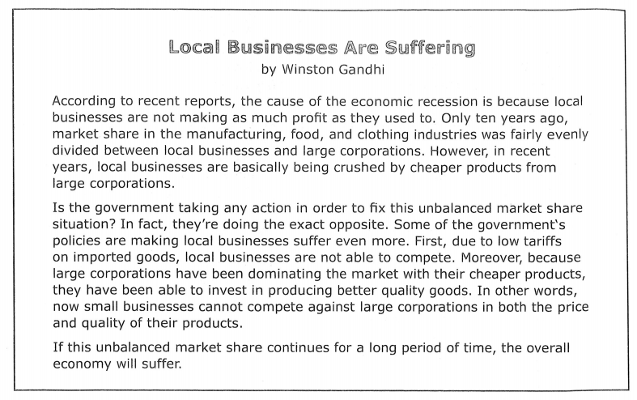](https://ece.edu.vn/wp-content/uploads/2016/06/4-20.png)[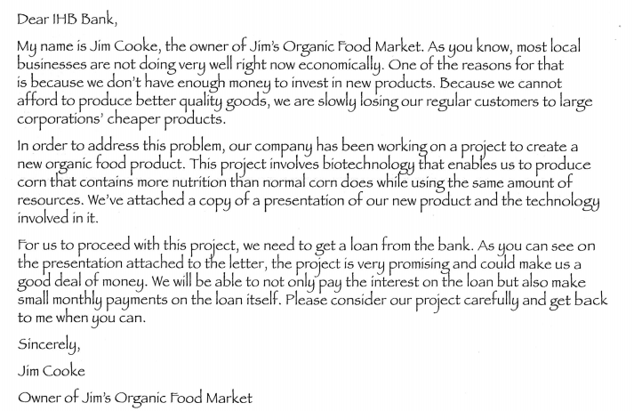](https://ece.edu.vn/wp-content/uploads/2016/06/5-18.png) 

191. Why are local businesses suffering according to the article?

 (A) Because consumers aren’t spending as much lately

 (B) Because of large corporations

 (C) Because the interest rate has gone up

 (D) Because of inflation

192. According to the article, which of the following is one of the advantages that large corporations have?

 (A) Better advertisements

 (B) Better business networks

 (C) Lower prices

 (D) Cheaper labor

193. Why does Mr. Cooke need the loan?

 (A) He needs money to invest in a new project.

 (B) He wants to advertise his product.

 (C) He wants to expand his store.

 (D) He has to hire more employees.

194. According to the passages, what is NOT true?

 (A) The government is taking measures that are worsening the problem.

 (B) Small businesses are less competitive than large corporation.

 (C) Jim’s Organic Food Market has been losing customers.

 (D) Jim Cooke cannot play the interest on a loan.

195. In the article, the word “tariffs” in paragraph 2, line 3 is closest in meaning to

 (A) Tax on imported goods

 (B) Tax on domestic goods

 (C) Price

 (D) Discount

**Question 196 – 200 refer to the following letters.**[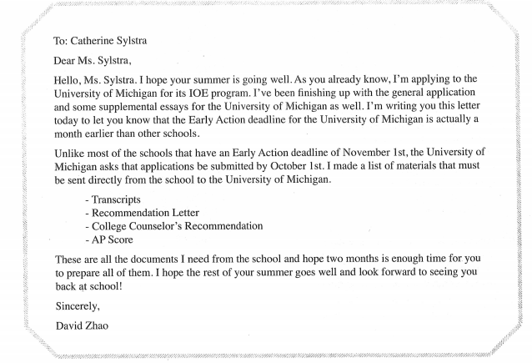](https://ece.edu.vn/wp-content/uploads/2016/06/6-17.png)[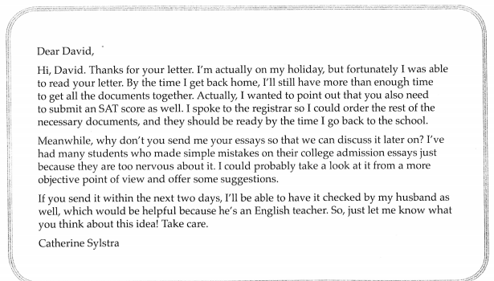](https://ece.edu.vn/wp-content/uploads/2016/06/7-16.png) 

1. Who most likely is Ms. Sylstra?

 (A) A college admissions staff

 (B) David’s parent

 (C) A college counselor

 (D) A math teacher

1. Why did David write a letter to Ms. Sylstra?

 (A) To tell her that he has been accepted to the University of Michigan

 (B) To let her know about the University of Michigan’s Early Action deadline

 (C) To convince her to write a good recommendation for him

 (D) To tell her that his documents haven’t been sent out to any colleges yet

1. In which month did David write his letter to Ms.Sylstra?

 (A) June

 (B) August

 (C) September

 (D) November

1. Which of the following is NOT a document that Ms. Sylstra is supposed to prepare?

 (A) Transcript

 (B) Recommendation letter

 (C) SAT score

 (D) An English teacher’s recommendation

1. Why does Ms. Sylstra want David to send his essay within two days?

 (A) So that her husband can read the essay as well

 (B) So that she can enjoy the rest of her vacation

 (C) Because the deadline has been moved up

 (D) Because he has to write essays for other schools as well

|  |
| --- |
|  |