Questions for Jiayin:

+1.Why the following if condition is necessary, and why it was applied on RSSI 1(tmp2) but not on RSSI 2(tmp3)?

It seems like that the code assumes that only if the fiducial probability calculated in tmp1 was larger than 1-alpha, the type 1 RSSI could be calculated, otherwise it will be NA.

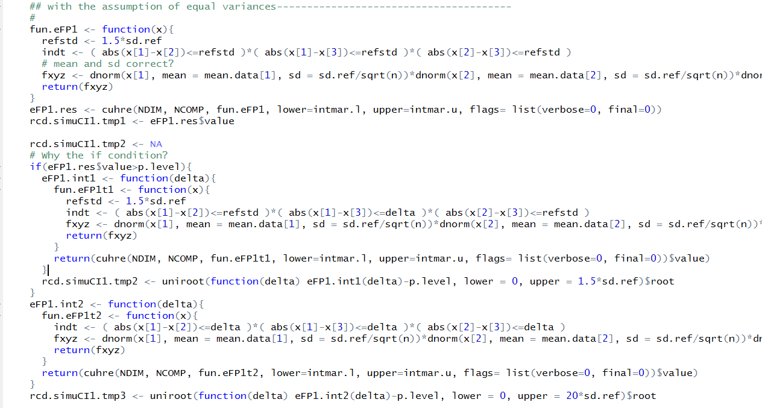

2.Questions about the coverage rate (CR):

Average rate of calculated CI covering the true parameters?

When calculating the

**Type I Restricted Simultaneous Confidence Interval (RSCI I):**

For any $Δ>0$, we want to find the minimal $Δ$ that satisfies

$$pr\left\{\left|μ_{T}-μ_{R_{1}}\right|≤Δ,\left|μ_{T}-μ_{R_{2}}\right|≤1.5σ_{R_{1}},\left|μ_{R_{1}}-μ_{R_{2}}\right|≤1.5σ_{R_{1}}|σ_{R_{1}},f\right\}≥q.$$

Denote the minimal $Δ$ by $∆_{q}^{1}$ if it exists. Then the type I restricted simultaneous confidence interval (RSCI I) of $μ_{T}-μ_{R_{1}}$ can be obtained as $(-∆_{q}^{1}, ∆_{q}^{1})$, with the confidence level of q.

And if $∆_{q}^{1}$ < 1.5 $σ_{R_{1}}$, we conclude the similarity.

summ.simuCI1[k,] <- c(mean(rcd.simuCI1[,1]),

mean(rcd.simuCI1[,1]>=p.level),

mean(rcd.simuCI1[,2]/rcd.std[,4], na.rm=T),

mean(rcd.simuCI1[,2]/rcd.std[,4]>=true1T, na.rm=T),

mean(rcd.simuCI1[,3]/rcd.std[,4]),

mean(rcd.simuCI1[,3]/rcd.std[,4]>=max(true1T,true2T,true12)),

mean(rcd.simuCI1[,4]),

mean(rcd.simuCI1[,4]>=p.level),

mean(rcd.simuCI1[,5]*1.5, na.rm=T),

mean(rcd.simuCI1[,5]*1.5>=true1T, na.rm=T),

mean(rcd.simuCI1[,6]*1.5),

mean(rcd.simuCI1[,6]*1.5>=max(true1T,true2T,true12)),

mean(rcd.simuCI1[,7]),

mean(rcd.simuCI1[,7]>=p.level),

mean(rcd.simuCI1[,8]/rcd.std[,4], na.rm=T),

mean(rcd.simuCI1[,8]/rcd.std[,4]>=true1T, na.rm=T),

mean(rcd.simuCI1[,9]/rcd.std[,4]),

mean(rcd.simuCI1[,9]/rcd.std[,4]>=max(true1T,true2T,true12))

3. Distribution

1. Equal variance scenario

$${FP}_{1}\left(σ_{R_{1}}\right)$$

$=pr\left\{\left|μ_{T}-μ_{R_{1}}\right|≤1.5σ_{R_{1}},\left|μ_{T}-μ_{R_{2}}\right|≤1.5σ_{R_{1}},\left|μ_{R_{1}}-μ_{R_{2}}\right|≤1.5σ_{R_{1}}|σ_{R_{1}},f\right\}$

$$=\iiint_{\left|x-y\right|≤1.5σ_{R_{1}},\left|x-z\right|≤1.5σ_{R_{1}},\left|y-z\right|≤1.5σ_{R_{1}}}{f\left(x,y,z\right)}dxdydz.$$

Where the joint fiducial probability density function of $(μ_{T}, μ_{R_{1}}, μ_{R_{2}})$ was calculated as $f\left(x,y,z\right)=f_{1}\left(x\right)f_{2}\left(y\right)f_{3}\left(z\right)$.

1. Different variance, one reference (R1)

$${FP}_{2}\left(σ_{R_{1}}\right)$$

$$=pr\left\{\left|μ_{T}-μ_{R_{1}}\right|≤1.5σ_{R_{1}},\left|μ_{T}-μ_{R_{2}}\right|≤1.5σ_{R_{1}},\left|μ_{R_{1}}-μ_{R_{2}}\right|≤1.5σ_{R_{1}}|σ_{R_{1}},g\right\}$$

$=\iiint_{\left|x-y\right|≤1.5σ_{R_{1}},\left|x-z\right|≤1.5σ_{R_{1}},\left|y-z\right|≤1.5σ_{R_{1}}}{g\left(x,y,z\right)}dxdydz.$

Where the joint fiducial probability density function of $(μ_{T}, μ_{R_{1}}, μ_{R_{2}})$ was changed to be $g\left(x,y,z\right)=f_{1}\left(x\right)g_{2}\left(y\right)g_{3}\left(z\right)$.

1. Different variance, two references (R1 and R2)

$${FP}_{3}\left(σ_{R_{1}}, σ_{R_{2}}\right)$$

$$=pr\left\{\left|μ_{T}-μ_{R_{1}}\right|≤1.5σ_{R_{1}},\left|μ_{T}-μ_{R_{2}}\right|≤1.5σ_{R_{2}},\left|μ_{R_{1}}-μ_{R_{2}}\right|≤1.5σ_{R_{1}}|σ_{R_{1}},σ_{R_{2}},h\right\}$$

$$=\iiint_{\left|x-y\right|≤1.5σ_{R_{1}},\left|x-z\right|≤1.5σ_{R_{2}},\left|y-z\right|≤1.5σ_{R_{1}}}{h\left(x,y,z\right)}dxdydz.$$

The joint fiducial probability density function of $(μ_{T}, μ_{R_{1}}, μ_{R_{2}})$ was further changed to be $h\left(x,y,z\right)=f_{1}\left(x\right)f_{2}\left(y\right)g_{3}\left(z\right)$.

Where the f corresponds to normal distribution, while g corresponds to t-distribution. Is there any special concern for this?