1. ComboBox:

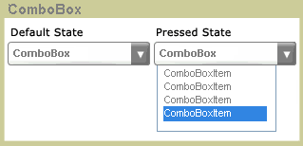

* Property:

Model: display feasible value

Default state ComboBox only has 1 row

Pressed will display value list (current value display in Box not in list)

Item contains mouse will be highlight

* Signal:

When user change index, ComboBox will emit signal with currentIndex and value

1. Long Text:

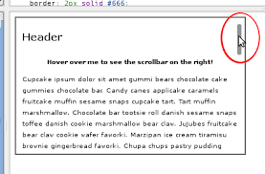

* Property:

Height of long text is higher than screen

User can flick on text to move

Long text has a scroll bar for use can know height of text, when user touch text it display for 2 second

1. A – Z List view

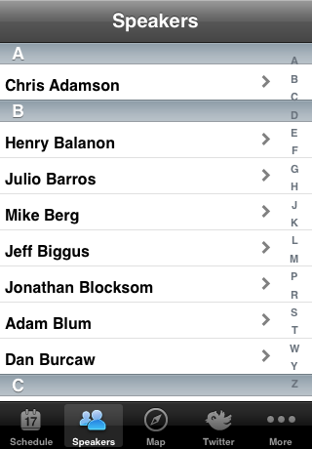

Property:

Listview was sorted from A to Z

Have A – Z character at right of listview

When user press a character, listview will jump to first word beginning with this character

1. TabView

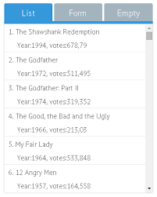

Property:

Current header of tab will be highlight

Tabview has 3 tab, when user touch header of each tab, app will load touched tab

User can drag tab to preview beside tabs (left and right)

Tab moving animation is like android

1. Calendar



Property:

Calendar has 2 sections to set date

The left user can scroll to choose year, month, day

The right user can select directly (current date will be highlight)

2 section have to synchronize

Signal:

When user choose a date, calendar emit a signal with parameter “yyyy:mm:dd”