

Prompt Vault Desktop
User Guide
A SMALLER HAMMER APP
Application v7.1 · build 2026-11-08
Guide v3

Contents

Start here
Prompt Vault Desktop keeps the text prompts you write for image generators, together with the picture each one produced, so you can find a prompt again months later instead of scrolling back through old chats and folders.
Everything is kept in one encrypted file on your own computer. There is no account, no internet connection and no server. The app asks for your passphrase when it opens, and nothing is readable without it.
Since version 6, one card in the Library can hold up to ten related prompts, called variants. A lighthouse at dusk, at night and in a storm can live together on one card instead of three.
Since version 7, a picture saved from ComfyUI with the free Prompt Vault Card node carries its prompt with it. Drop the picture on the Library and the card fills itself in: prompt, seed, size, ratio, the model and LoRAs used, and who wrote the prompt.

What this guide covers
If you want to… | Read
Turn the source files into a program you can double-click | Building the app
Know which files to copy to another PC or a USB stick | Installing, moving and upgrading
Open it for the first time | First launch
Save and find prompts | The Library, Adding and editing prompts, Finding and organising
Keep several versions of a prompt on one card | Variants, Combining cards by dragging
Look at the pictures full size | Viewing images
Bring in pictures saved from ComfyUI | Importing images, The ComfyUI nodes
See it working straight away | Try it: the sample images
Keep separate libraries | Several vaults
Keep your prompts safe | Passphrase and security, Backups
Two things that cannot be undone
Your passphrase is never stored anywhere. If you forget it, nobody can open the vault, including the author of the app. Write it down somewhere safe.
The vault is one file. If the disk it sits on dies and you have no backup, the prompts are gone. Export a backup to a second place regularly (see Backups).

Words used in this guide
Word | Meaning
Vault | An encrypted file that holds a library: promptvault.vault to begin with. You can have several.
Passphrase | The password that unlocks the vault. Also called PIN in a few places.
Card | One tile in the Library. It holds one prompt, or up to ten variants.
Variant | One of the prompts on a card. Each has its own text, image, seed, size and notes.
Primary | Variant 1 on a card. It is shown first and marked with a star in the editor.
Category | A named group of cards in the Library, such as Landscapes.
Settings | The generation settings saved with a prompt from ComfyUI: model, LoRAs, sampler, steps and so on.
Credit | Who wrote a prompt, a link to them, and a link to where the picture came from.
App folder | The folder holding PromptVault.exe. Your vault and settings live here too.
About the pictures in this guide
The screenshots were taken from the real app, version 7.1.
The cards in the cupajoelite category use real prompts written by cupajoelite, shared with permission. Their pictures were rendered from those prompts by Smaller Hammer; the originals are on Civitai (see Credits at the end of this chapter).
The other cards use simple placeholder drawings, to show how variants and combining work.

Credits
The example prompts in this guide, the README and the sample images are by cupajoelite, used with their permission. Their profile: https://civitai.com/user/cupajoelite.
The sample pictures were rendered from those prompts by Smaller Hammer. The original images are:
Example | Original on Civitai
Cosmic ape | https://civitai.com/images/147214871
Steampunk garden | https://civitai.com/images/148251721
Witch | https://civitai.com/images/147215030
Drowned king | https://civitai.com/images/147190802
Neon catgirl | https://civitai.com/images/146770843
Day of the Dead | https://civitai.com/images/147214831

Building the app
Prompt Vault Desktop is published on GitHub as source files: a folder of Python code. Building turns that folder into an ordinary Windows program, PromptVault.exe, that you can double-click. You do this once on one computer. The finished program then runs on any Windows 10 or 11 PC without Python.
Building takes about ten minutes the first time, most of it waiting for downloads. You need an internet connection for the build, but never for using the app afterwards.

What you need
Item | Notes
A Windows 10 or 11 PC | The build machine. Any reasonably recent PC will do.
Python 3.10 or newer, 64-bit | Free from python.org. Step 1 below walks through it.
The source files | From the prompt-vault-desktop page on GitHub. Step 2 below.
An internet connection | Only while installing Python and the building tools.

Step 1 — Install Python (first time only)
- Open a web browser and go to python.org. Choose Downloads, then the button for the latest Python 3 release for Windows.
- Run the downloaded installer.
- On the first screen, tick the box labelled Add python.exe to PATH at the bottom. This matters: without it, the commands below are not found.
- Click Install Now and wait for Setup was successful. Click Close.
- Check it worked: press the Windows key, type cmd and press Enter to open Command Prompt. Type the line below and press Enter.
py --version
It should answer with something like Python 3.13.1. Any version from 3.10 up is fine. If it says py is not recognised, see Troubleshooting the build at the end of this chapter.
Already have Python?
If py --version already shows 3.10 or newer, skip to Step 2.

Step 2 — Download the source from GitHub
- Open the prompt-vault-desktop page on GitHub in your web browser.
- Click the green Code button near the top right of the file list, then Download ZIP. The file prompt-vault-desktop-main.zip downloads to your Downloads folder.
- Make a working folder for the source, for example C:\Dev. Avoid putting it inside a OneDrive or Dropbox folder: their syncing can interfere with the build.
- Right-click the downloaded zip, choose Extract All…, set the destination to C:\Dev and click Extract.
- Open the extracted folder. It is called prompt-vault-desktop-main and contains app.py, build_exe.bat, a ui folder and a few others.
C:\Dev\prompt-vault-desktop-main\
app.py the program itself
vault.py encryption and saving
ui\ the screens you see
requirements.txt * the list of tools Step 3 installs
run.bat * runs the app straight from source (optional)
build_exe.bat * builds PromptVault.exe (Step 4)
promptvault.spec build settings used by build_exe.bat
README.md, LICENSE about the app and its licence
docs\ this user guide
samples\ six example pictures to try image import with
The source folder after unzipping. Only the items marked * matter to you.

Step 3 — Open Command Prompt in that folder
- With the prompt-vault-desktop-main folder open in File Explorer, click once in the address bar at the top so the path is highlighted.
- Type cmd and press Enter. A Command Prompt window opens already pointing at that folder.
- Type the line below and press Enter. It downloads the tools the app and the build need.
py -m pip install -r requirements.txt
Text scrolls past for a minute or two. It has finished when the last lines say Successfully installed … and the prompt returns. Yellow WARNING lines about scripts not being on PATH are harmless and can be ignored.
Keep this window open for the next step.

Step 4 — Build
- In the same Command Prompt window, type the line below and press Enter.
build_exe.bat
- Wait. The build prints a lot of INFO lines and takes one to three minutes.
- When it finishes you see Built dist\PromptVault\ followed by short install and upgrade reminders.
The result is a new folder inside the source folder: dist\PromptVault. That folder is the finished program.
C:\Dev\prompt-vault-desktop-main\dist\PromptVault\
PromptVault.exe the program you double-click
_internal\ everything the program needs to run
(Python, the screens, the encryption library)
What the build produces.
Run the build from Command Prompt, not by double-clicking
Double-clicking build_exe.bat works, but its window closes the moment it finishes, so you cannot read whether it succeeded. Typing it into Command Prompt keeps the messages on screen.
Do not use the app from the dist folder
Every build empties dist\PromptVault before writing the new program. If you ran the app from there, your vault would be deleted by the next build. Always copy the folder somewhere permanent first (next chapter).
As a safety net, build_exe.bat refuses to build and prints STOPPED if it finds a vault or settings file in dist\PromptVault.

Optional — Try it without building
Double-clicking run.bat in the source folder starts the app directly from the source, without building. This is handy for a quick look, but the vault it creates sits in the source folder, not with the built program. Treat it as a test vault and keep your real prompts in the built app.

Troubleshooting the build
What you see | What to do
py is not recognised as an internal or external command | Python is not installed, or the PATH box was not ticked. Run the Python installer again, choose Modify, then Next, and tick Add Python to environment variables. Close and reopen Command Prompt afterwards.
pip install stops with red ERROR lines mentioning pythonnet or a build failure | The newest Python release sometimes arrives before the tools support it. Install the previous Python release from python.org (for example 3.12) and repeat Step 3 with it.
No internet / connection errors during Step 3 | Step 3 downloads the tools. Connect, then run the same line again.
STOPPED: dist\PromptVault\ contains a vault or settings file | You have been running the app from the build folder. Move that whole PromptVault folder somewhere permanent (next chapter), then build again.
BUILD FAILED | Scroll up to the first line containing ERROR and note it. The most common cause is a file in dist\PromptVault still open: close Prompt Vault and try again.

Installing, moving and upgrading
The program has no installer. Installing means copying the PromptVault folder to where you want it to live. That folder then becomes the app folder: the vault, your settings and the automatic safety copies are all created beside PromptVault.exe. Everything Prompt Vault needs is inside that one folder.

Installing for the first time
- Choose a permanent home, for example Documents\Prompt Vault. A local drive is best (see Network drives below).
- Copy the whole dist\PromptVault folder there. You can rename the folder; the name does not matter.
- Open the copied folder and double-click PromptVault.exe.
- The first time, Windows may show Windows protected your PC. This appears because the program is not signed by a publisher. Click More info, then Run anyway. Windows remembers the choice.
- Optional: right-click PromptVault.exe, choose Show more options if needed, then Send to > Desktop (create shortcut). Use that shortcut from now on.

What is in the app folder
After the first launch the folder holds the files below. The ones you create by using the app are your data; the others are the program and can be replaced at any time.
File or folder | What it is | Kind
PromptVault.exe | The program. | Program
_internal | Everything the program needs. Never edit or move anything inside it. | Program
promptvault.vault | Your vault: every prompt, image and category, encrypted. | Your data
promptvault.vault.1, .2, .3 | The last three saved states, kept automatically. .1 is the newest. | Your data
promptvault-settings.json | Window size, card size, open categories, default folders. Holds no prompt text. | Your settings
promptvault.vault.lock | Present only while the app is open. Warns if the vault is opened twice. | Temporary
vaults | Any extra vaults you create, unless you chose another folder for them. See Several vaults. | Your data
Seeing the .1, .2 and .3 files
Windows hides some file endings. If you cannot tell the files apart, open the View menu in File Explorer and turn on File name extensions.

What is portable
The whole app folder is portable. Copy it to another Windows 10 or 11 PC, a second drive or a USB stick and it runs as it is. The other PC does not need Python or anything else installed.
Part | Portable? | Notes
PromptVault.exe + _internal | Yes | Runs on any 64-bit Windows 10 or 11 PC. Uses the Microsoft Edge WebView2 component that Windows already includes.
promptvault.vault | Yes | Opens anywhere with your passphrase. The passphrase travels in your head, not in the folder.
.vault.1 / .2 / .3 | Yes | Each is a complete, valid vault in its own right.
promptvault-settings.json | Mostly | Card size, window size and so on carry across. Any default backup or import folder you set points at a folder on the old PC; set it again on the new one.
promptvault.vault.lock | Leave behind | If copied while the app is open it causes a harmless "appears to be open already" warning on the other PC.
Encrypted backup files | Yes | Import on any copy of Prompt Vault Desktop, or the browser version.

Moving to another PC or a USB stick
- Close Prompt Vault (click the window’s X). This saves the window size and removes the lock file.
- Copy the whole app folder to the new location.
- On the new PC, double-click PromptVault.exe in the copied folder and unlock with the same passphrase.
- If you use default backup or import folders, set them again on Data & Security (see Backups).
One vault, one place at a time
If you copy the folder and use both copies, they become two separate vaults that drift apart. Nothing merges them later. Pick one as the real one, or move work between them with backups.

Upgrading to a new version
A new version replaces the program and leaves your data alone.
- Build the new version (previous chapter): download the ZIP from GitHub again, extract it over the old source folder (choose Replace when asked), then repeat Steps 3 and 4.
- Close Prompt Vault.
- From the new dist\PromptVault folder, copy PromptVault.exe and the _internal folder into your app folder. When Windows asks, choose Replace the files in the destination.
- Start Prompt Vault as usual. The version number is shown at the bottom of the left-hand rail.
Copy both, every time
PromptVault.exe and _internal belong together. The screens of the app live inside _internal, so a new exe with an old _internal still shows the old screens, and may not start at all.
Never copy promptvault.vault or promptvault-settings.json from the dist folder: there are none there, and your own must not be overwritten.
Upgrading from version 5.7 or earlier, which was a single PromptVault.exe file: put the new PromptVault.exe and _internal into the folder that holds your existing promptvault.vault. The old exe is overwritten and your vault opens as before.

Network drives
The vault can live on a network drive or NAS, but it is safest beside the program on a local drive, with encrypted backups exported to the network drive. Saving over a network has not been verified to be as robust as saving locally.

First launch

Creating your vault
The first time Prompt Vault opens in a folder, there is no vault yet, so it asks you to create one.
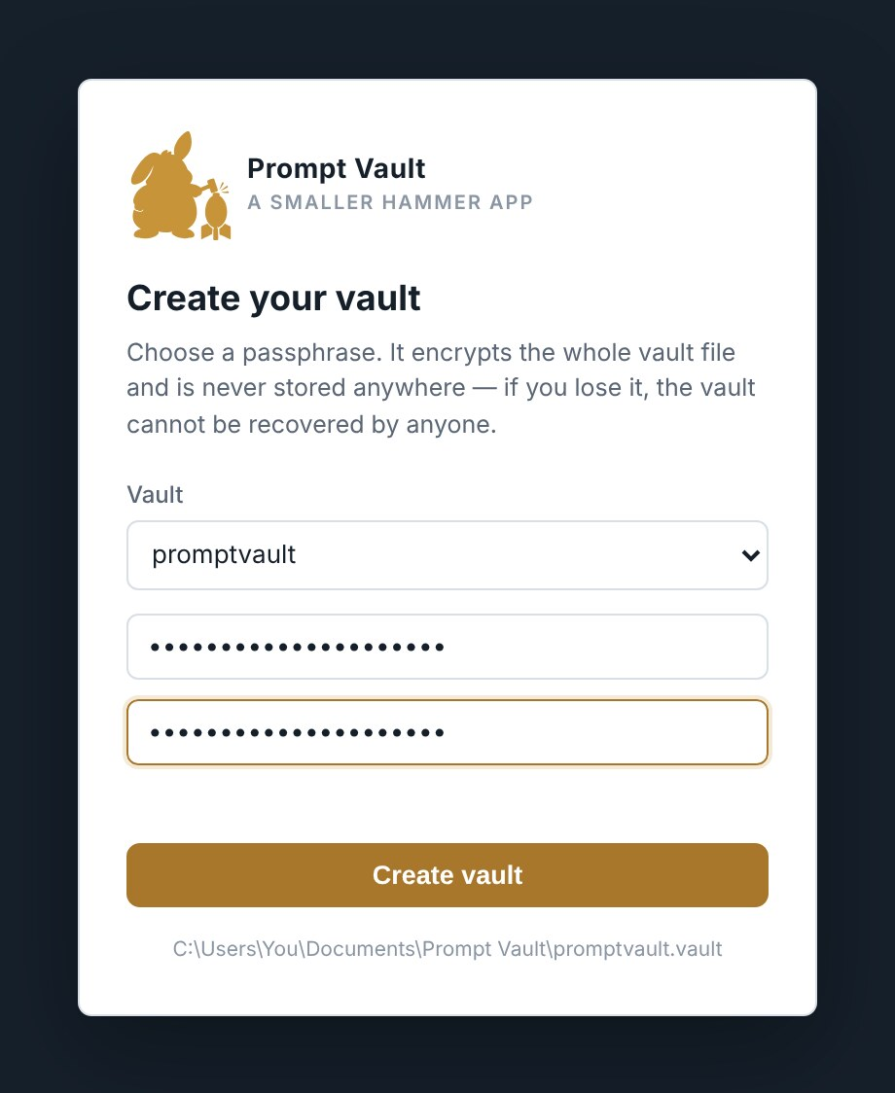
The Create your vault screen. The grey line at the bottom shows where the vault file will be written.

- Type a passphrase in the first box. It must be at least 4 characters; a long one is much better.
- Type it again in Repeat passphrase.
- Click Create vault (or press Enter).
The Library opens with one example card, a lighthouse at dusk, so the screen is not empty. Delete it whenever you like. To fill it with real examples, see Try it: the sample images.
Choosing a passphrase
Everything in the vault is encrypted with it, and it is never saved anywhere. A long phrase of several unrelated words is both strong and memorable. Keep a written copy somewhere safe away from the computer.

Opening the vault each time
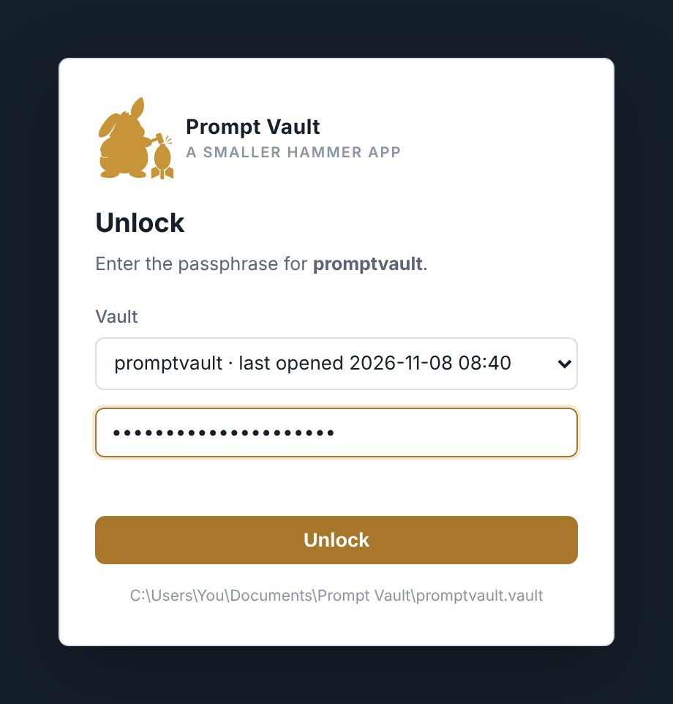
The Unlock screen shown on every later launch.

- Start Prompt Vault.
- Check the Vault box shows the vault you want. Prompt Vault offers the one you used last; with several vaults, pick another here (see Several vaults).
- Type your passphrase and press Enter or click Unlock.
Unlocking takes a moment while the key is worked out; the screen shows Deriving key… meanwhile. A wrong passphrase shows an error and you can try again; there is no lock-out.
Occasionally, after an upgrade, a message says the vault was re-encrypted with stronger key derivation. That is automatic and needs nothing from you.

"This vault appears to be open already"
If this message appears when the app starts, Prompt Vault thinks the vault is already open, either in another window on this PC or on another computer sharing the same folder. It names the computer and when it was opened.
- Click Cancel if it really is open somewhere else. The new window closes. Two copies saving to one vault would overwrite each other’s work.
- Click OK if you are sure it is not, for example after the PC crashed or the folder was copied while the app was running. The warning stops on its own once the other session has been gone for ten minutes.

Locking and closing
Click Lock now at the bottom of the left-hand rail (or on Data & Security) to hide everything and return to the Unlock screen without closing the app. Closing the window locks it too. Changes are already saved by then: the app saves as you go, never on close.

The Library
The Library is where you spend most of your time. Every card you have saved is here, grouped into categories.
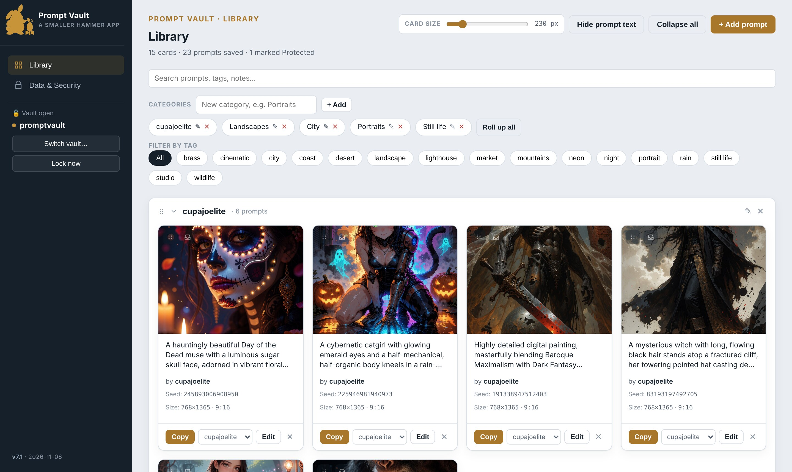
The Library at a glance: the rail on the left, the header across the top, and the categories with their cards below.

The rail
The dark strip down the left side switches between the two screens, Library and Data & Security. Below them are the name of the open vault, Switch vault… and Lock now, and at the very bottom the app version and build date.

The header
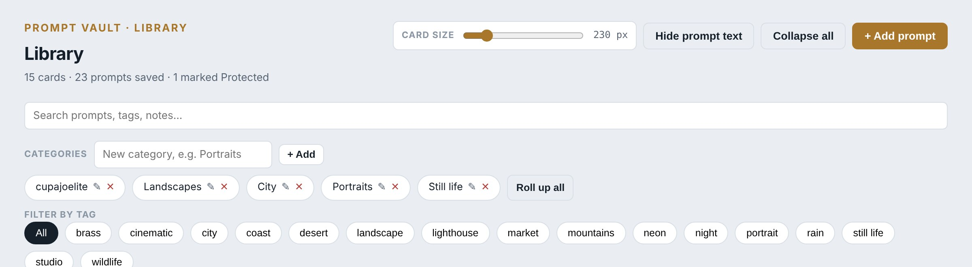
The Library header. It stays at the top while you scroll.

Control | What it does
Card size slider | Makes the cards wider or narrower. See Display options.
Hide prompt text / Show prompt text | Switches the cards to large pictures only, and back.
Collapse all | Closes every category.
+ Add prompt | Opens a blank card to fill in.
Search box | Finds cards by any word in their prompts, notes, seeds, names, tags, credit or settings.
Categories row | Add a category, and chips to jump to, rename or delete each one. Roll up all closes them all.
Filter by tag | Click tags to show only cards that have all of them. All clears the filter.
Under the title, a line counts what is saved, for example 8 cards · 16 prompts saved · 1 marked Protected. Once any card has variants, it counts cards and prompts separately.

Reading a card
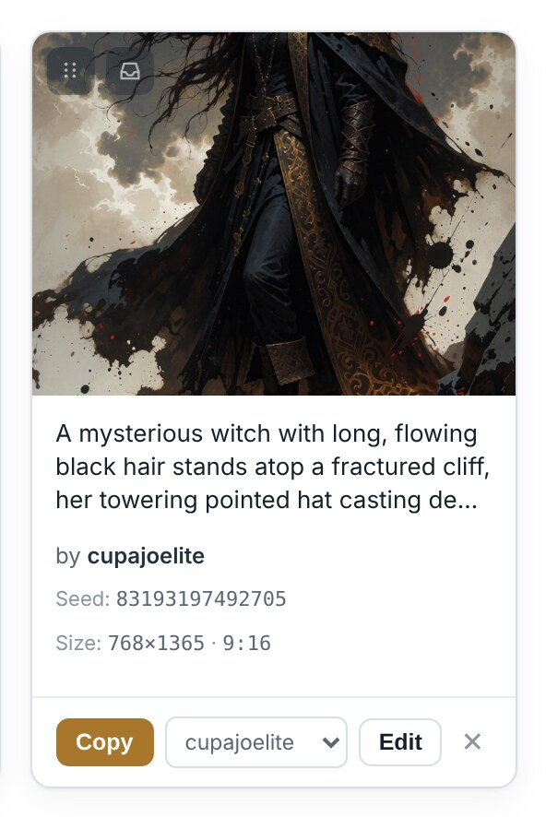
A card with a single prompt, imported from a picture. The by line credits the prompt’s author.

Part | Meaning
Picture | The reference image. Click it to see it full size. "no image" if none was attached.
Prompt text | The first three lines of the positive prompt.
Notes (with a notepad mark) | The first two lines of your notes, when there are any.
by … | Who wrote the prompt, when a prompt author is filled in.
Seed / Size | The seed and the generation size, with its ratio. The ratio is the one recorded with the prompt, such as 9:16, or the size’s own ratio when that is a standard one such as 2:3. A size like 1088 × 1920 has no standard ratio of its own, so none is shown rather than a literal 17:30.
Tags | The card’s tags.
Protected | A small amber label when the card is marked Protected.
Copy | Copies the positive prompt to the clipboard, ready to paste into your image generator.
Category dropdown | Moves the card to another category straight away.
Edit | Opens the card for editing.
X | Deletes the card, after asking.
Grip (top-left of the picture) | Drag handle for combining cards. See Combining cards by dragging.
Tray button (beside the grip) | Pins the card to the top of the Library to collect other cards into it. See Collecting many cards: the tray.
Cards are sorted newest first within each category: the most recently changed card is at the top left.

Categories
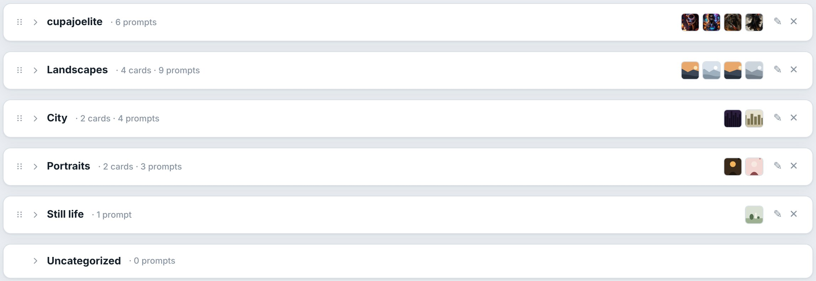
Categories rolled up. Each heading shows how many cards and prompts it holds, and a few small pictures from inside.

Click a category’s heading to open or close it. Which categories are open is remembered between sessions. Uncategorized always sits at the bottom and holds cards with no category.

Adding and editing prompts

Adding a prompt
- Click + Add prompt at the top right of the Library.
- Paste or type the prompt into Positive prompt. This is the only box you must fill in.
- Fill in any of the other boxes you want (they are described below).
- Click Add prompt at the bottom. A short message at the bottom of the window confirms it was saved.
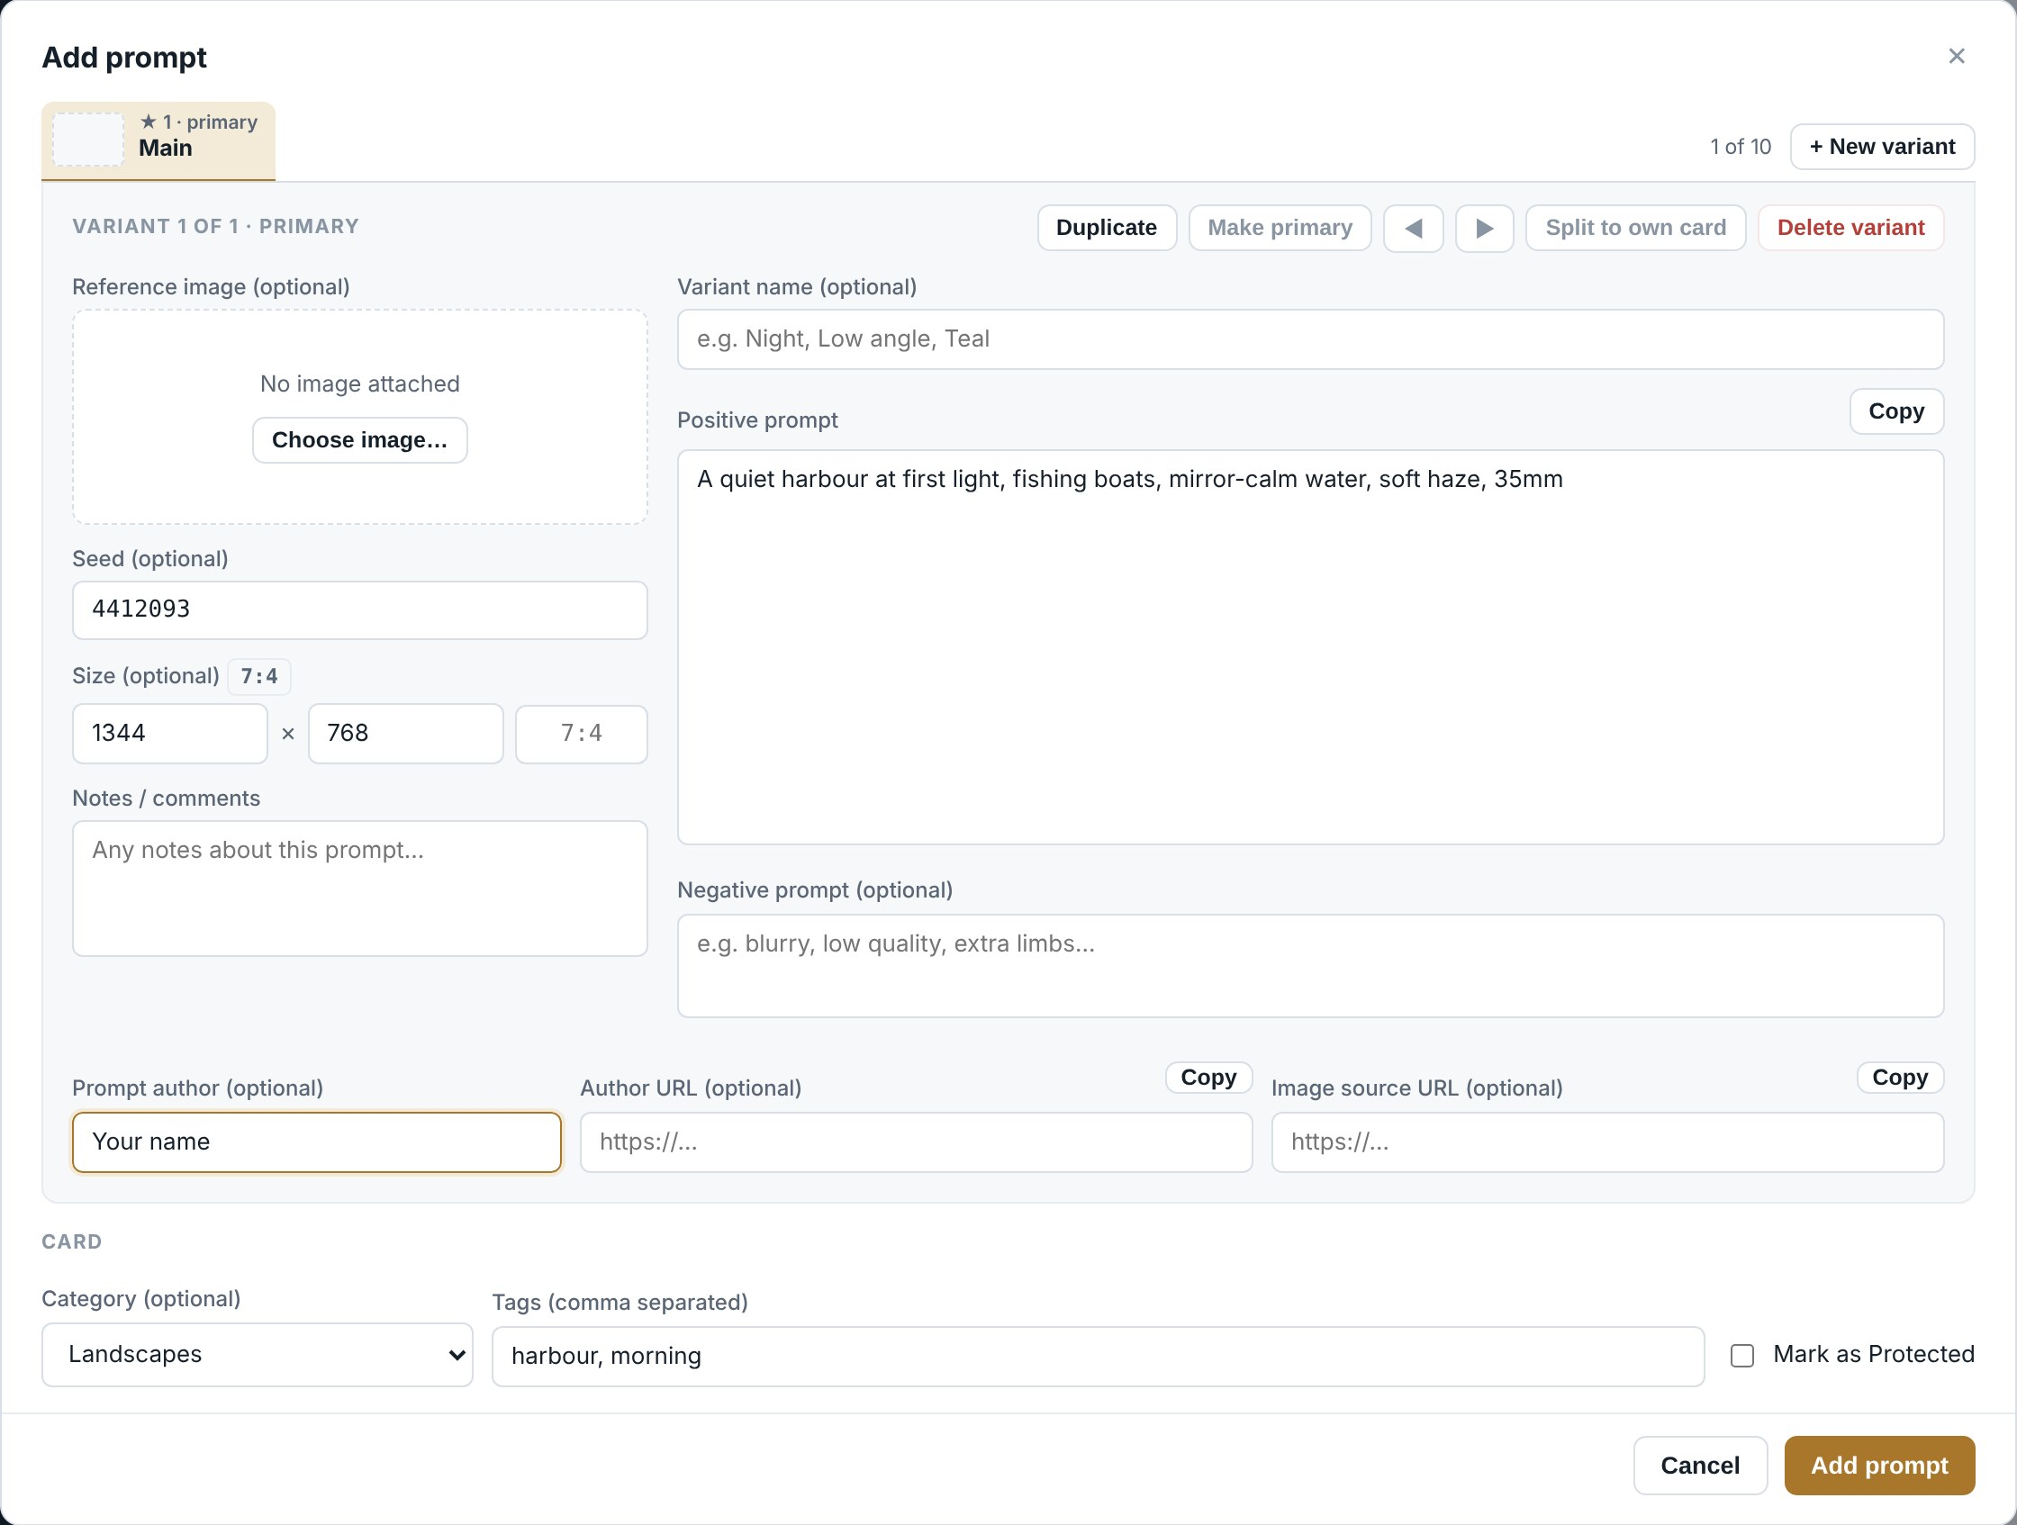
The Add prompt dialog. The picture, seed, size and notes are on the left; the name and prompts on the right; the credit below them; the card’s category, tags and Protected setting at the bottom.

The dialog fits the window. If a prompt is very long, the box grows with it and the middle of the dialog scrolls; the Save and Cancel buttons always stay in view.

The boxes
Box | What to put in it
Variant name | Optional short name such as Dusk or Low angle. Most useful once a card has variants.
Positive prompt | The prompt itself. Required. The Copy button beside it copies the text exactly as currently typed, saved or not.
Negative prompt | Optional. What you told the generator to avoid.
Reference image | Optional. Click Choose image… (or Replace…) and pick the picture the prompt produced, or drop a picture onto the dialog. Click the picture to see it full size. If the picture carries Prompt Vault data, the boxes fill in from it (see Importing images).
Seed | Optional. Stored as text, so very long seeds keep every digit.
Size and ratio | Optional. The width and height you generated at, and the ratio, such as 9:16. Leave the ratio blank to use the size’s own ratio when it is a standard one; the label beside Size shows the ratio in use.
Notes | Optional. Anything worth remembering: what worked, what to try next.
Prompt author, Author URL, Image source URL | Optional credit for this variant. The Copy buttons copy a link so you can paste it into your browser; Prompt Vault never opens links itself.
Category | Which group the card goes in. Leave as Uncategorized if you like.
Tags | Words separated by commas, for example landscape, cinematic. Earlier tags are suggested as you type.
Mark as Protected | Adds a Protected label to the card. See Passphrase and security for what it does and does not do.
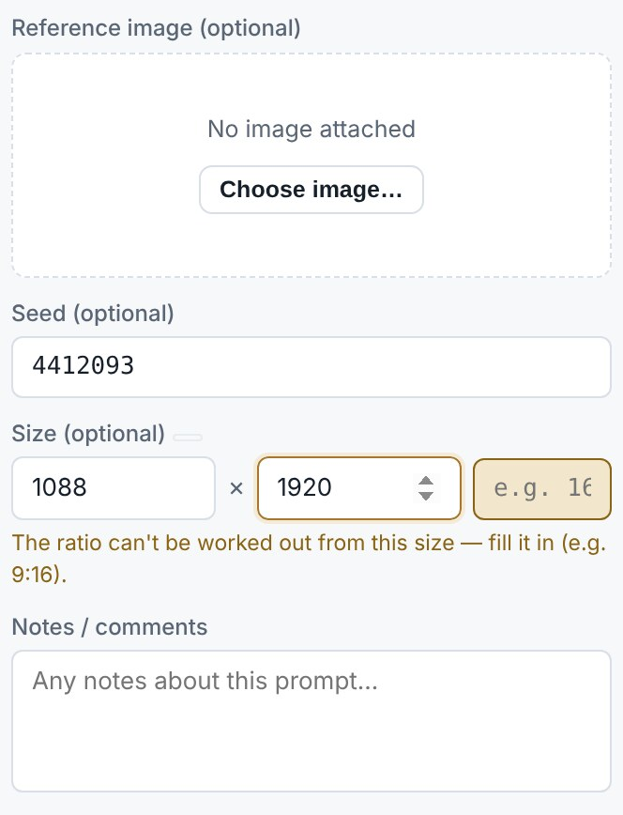
A size with no standard ratio: the Ratio box is highlighted and asks to be filled in.

When the size has no standard ratio of its own (1088 × 1920 is 17:30 exactly), the Ratio box turns amber and asks for the ratio you chose, for example 9:16. Saving without it is fine; the card then shows the size only. A ratio must look like 16:9.

Generation settings
A prompt imported from a ComfyUI picture also carries its generation settings: the model, CLIP and VAE, each LoRA with its strength, the sampler and scheduler, steps, CFG and denoise, plus anything else ticked on the Prompt Vault Card node. They appear in a Generation settings panel at the bottom of the variant, with Copy (all of them, as text) and Remove. They are searchable like everything else.
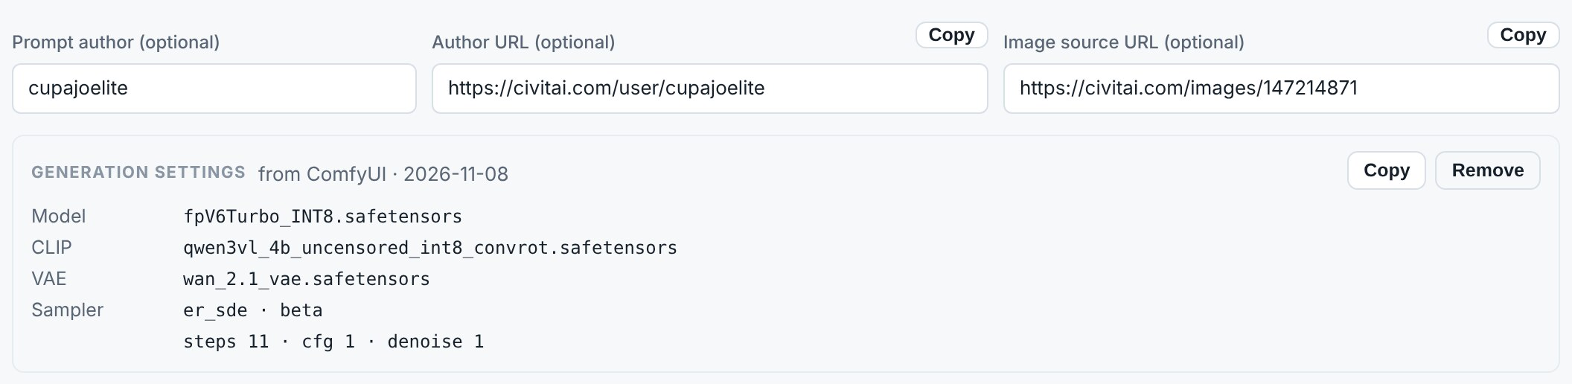
The credit boxes and the Generation settings panel of an imported prompt.

About reference images
The picture is copied into the vault, so it stays even if you delete the original file. It is resized so its longest edge is at most 1280 pixels and saved as a JPEG. That keeps the vault a manageable size while staying sharp on screen.
This is a reference copy, not an archive. Keep your full-size originals elsewhere if you need them.

Editing
- Click Edit on the card.
- Change what you need.
- Click Save changes.
Cancel, the X at the top, or clicking the dark area outside the dialog closes it without saving anything.

Deleting
Click the X at the bottom right of a card, or Delete in the editor. You are asked to confirm. For a card with variants, the question says how many prompts go with it. There is no undo inside the app; the automatic safety copies described in Backups are the way back.

Moving a card to another category
Use the category dropdown at the bottom of the card. The card moves immediately and a message confirms where it went. You can also change the Category box in the editor.

Variants
A variant is another prompt kept on the same card. Use variants for versions of one idea: the same scene at different times of day, different camera angles, or a prompt you refined over several attempts. A card holds up to 10 prompts in total.
Every variant is a complete prompt with its own text, negative prompt, picture, seed, size, name and notes. The category, tags and Protected setting belong to the card and are shared by all its variants.

Recognising a card with variants
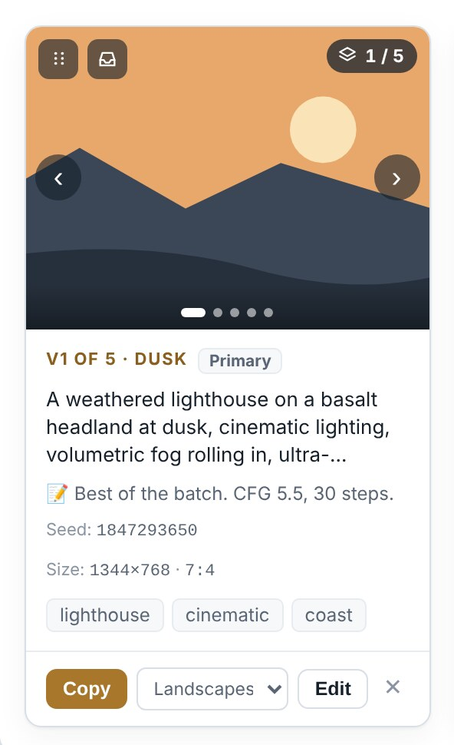
A card with five variants, with the mouse over the picture.

Sign | Meaning
Count (top-right) | Which variant is showing and how many there are, for example 1 / 5.
Dots (bottom of the picture) | One dot per variant; the long one is the variant on show.
Label above the text | For example V1 OF 5 · DUSK, and Primary on variant 1.
Arrows | Appear on the picture when the mouse is over it.

Flicking through variants on a card
- Point at the picture and click the right arrow (›) or left arrow (‹). The ends wrap around.
- Or click a dot to go straight to that variant.
Everything on the card follows: the picture, text, seed, size, notes, and the Copy and Edit buttons, which act on the variant on show. Flicking through variants never changes or saves anything. When the app restarts, each card shows its primary again.

Adding a variant
There are four ways, depending on what you start from.
Starting from… | Do this
A variant you want to tweak | Open the card with Edit, choose the tab, click Duplicate. A copy appears next to it, ready to change.
Nothing | In the editor, click + New variant at the end of the tab row for a blank variant.
The full-size picture | In the image viewer, click Duplicate as new variant.
Another card | Drag it onto this card. See Combining cards by dragging.
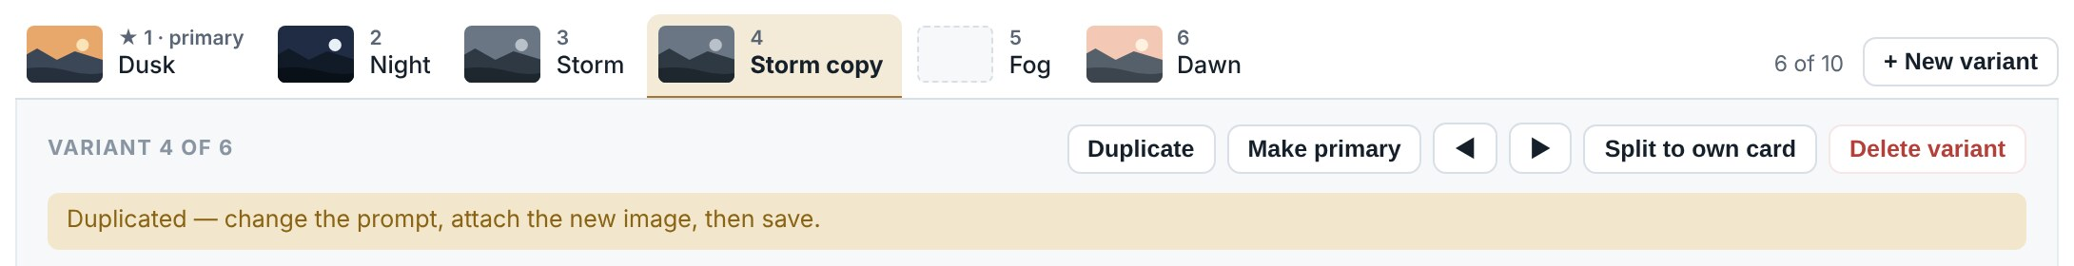
After clicking Duplicate on the Storm tab: the copy, Storm copy, is selected and a message explains what to do next.

Change the new variant’s prompt, attach its picture with Replace…, give it a name if you like, and click Save changes. Nothing is saved until you do.

The editor with variants
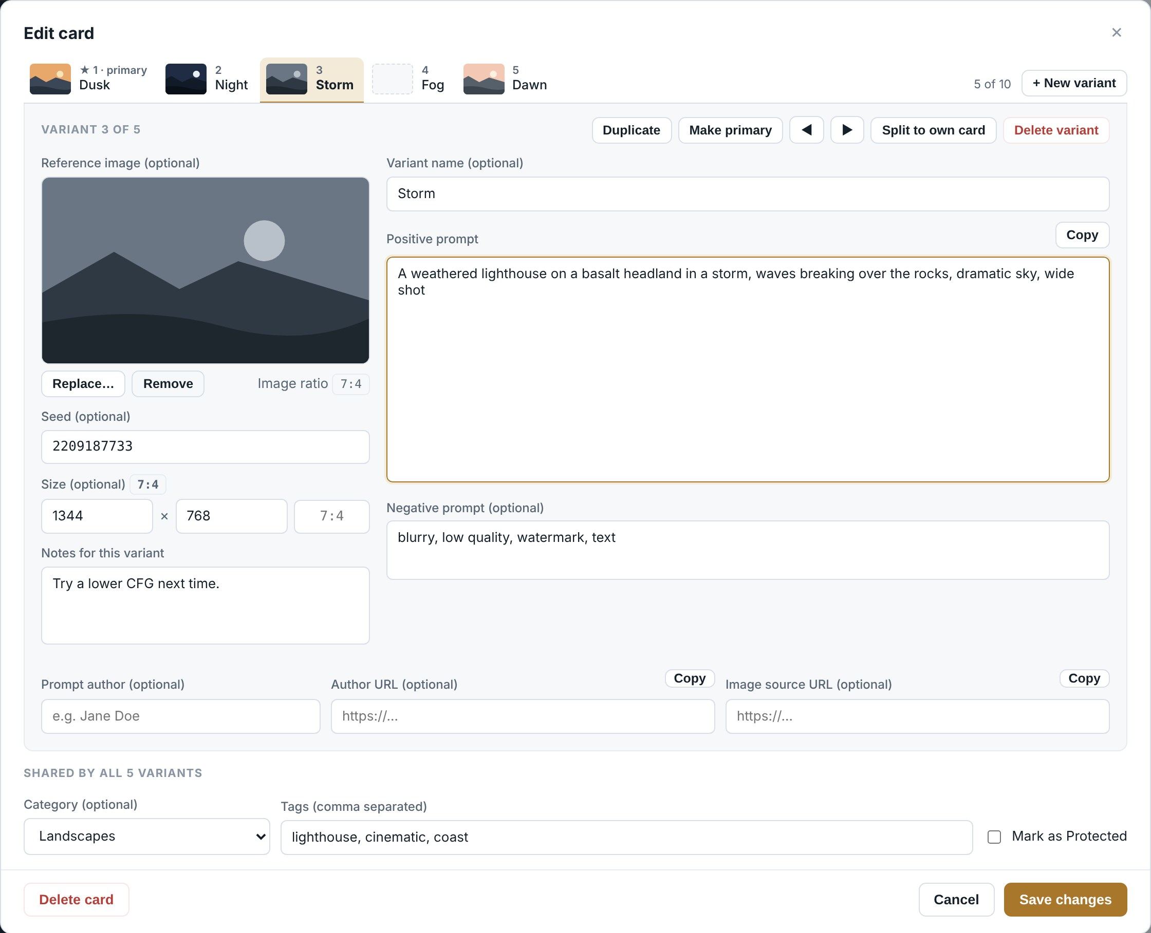
Editing a card with five variants. The tabs across the top are the variants; the panel below them belongs to the selected variant (Storm); the category, tags and Protected setting at the bottom are shared by all five.

Each tab shows a small picture, the variant’s number and its name. Tab 1 is the primary, marked with a star. Click a tab to switch to it. Anything you have typed is kept while you move between tabs, and everything is saved together when you click Save changes.
The variant tabs and the buttons that act on the selected variant.

Button | What it does
Duplicate | Copies this variant into a new tab right next to it.
Make primary | Moves this variant to position 1, so the card shows it first.
Left and right arrow buttons | Move this variant one place left or right.
Split to own card | Takes this variant out into a separate card with the same category and tags, when you save.
Delete variant | Removes this variant, when you save.
+ New variant | Adds a blank variant at the end. Shows 10 / 10 when the card is full.
Every variant needs a prompt
Save changes refuses to save while any variant has an empty Positive prompt. It switches to that tab and shows Enter a prompt for variant N. Fill it in, or delete the variant.
If a card ends up with only one prompt left, it simply becomes an ordinary card again.

Combining cards by dragging
If you already have several separate cards that are really versions of the same idea, drag one onto another to fold it in as a variant. The dragged card disappears from the Library and becomes the last variant of the card you dropped it on.
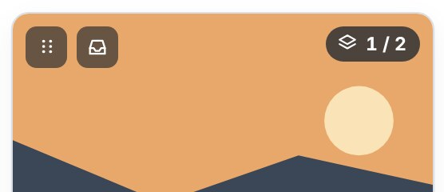
The grip in the top-left corner of every card’s picture. It brightens when the mouse is over the card.

Combining two cards
- Point at the grip (six dots) in the top-left corner of the card you want to move. The pointer changes to a hand.
- Press and hold the left mouse button, and drag towards the card you want to add it to. The card you are dragging fades.
- When the target card shows a brass dashed outline and Drop to add as a variant, release the button.
- A confirmation appears. Type a name for the new variant if you want one; it is optional.
- Click Add as variant (or press Enter). Click Cancel to change nothing.
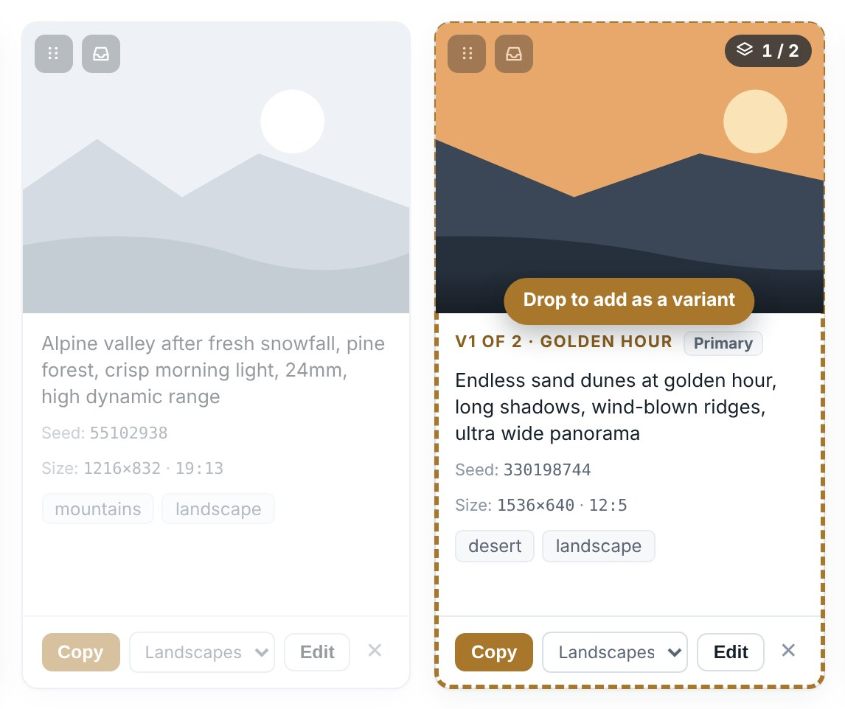
Dragging the Alpine card (left, faded) onto the dunes card (right), which is ready to accept it.

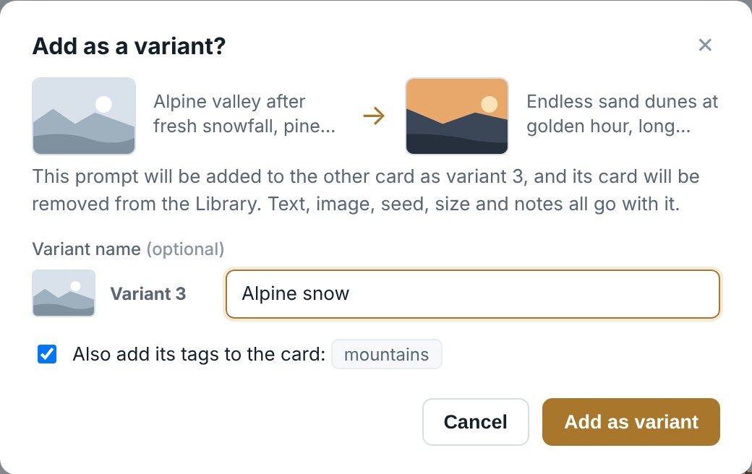
The confirmation. It shows both cards, which variant number the moved prompt becomes, and offers an optional name.

The target card then shows the newly added variant, and a message confirms its number.

What happens to the moved card
Item | What happens
Prompt, picture, seed, size, notes | All go with it, unchanged.
Its card | Removed from the Library.
Its variants | If the dragged card had variants, all of them move, in order, each with its own optional name box.
Tags | A tick box, on by default, adds any tags the target card does not already have.
Category | It takes the target card’s category. The confirmation says so when they differ.
Protected | If the moved card was Protected, the target card becomes Protected too, and the confirmation says so.

When a card will not accept a drop
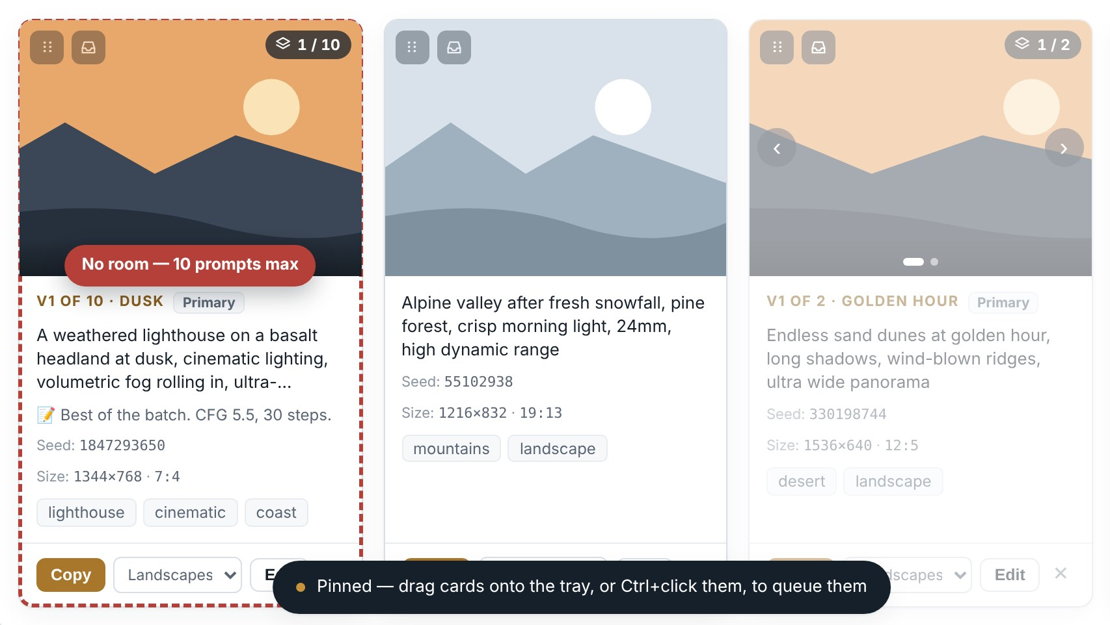
The target already holds ten prompts, so it turns red and refuses the drop.

A card turns red with No room — 10 prompts max when the prompts you are dragging would take it past ten. Releasing the mouse there does nothing. Dropping a card onto itself also does nothing.

Scrolling while you drag
Hold a dragged card near the top of the Library (just under the header) or near the bottom of the window and the Library scrolls by itself, faster the closer you go to the edge. Move away from the edge to stop.

Collecting many cards: the tray
To fold a lot of cards into one, pin that card to the top of the Library and gather the others into it, then add them all with one confirmation.
- Click the tray button beside the grip on the card that should receive the others. It turns brass, and a tray holding that card appears under the Library header, where it stays as you scroll.
- Drag other cards onto the tray, or hold Ctrl and click them. Each is queued: it stays in the Library, faded, with a Queued · 1, Queued · 2 … badge. Nothing is changed or saved yet.
- Click Add N cards in the tray. One confirmation lists the variant numbers the cards will become, with an optional name for each and a box to add their tags.
- Click Add N cards to confirm. Everything is saved at once, and the queued cards leave the Library.
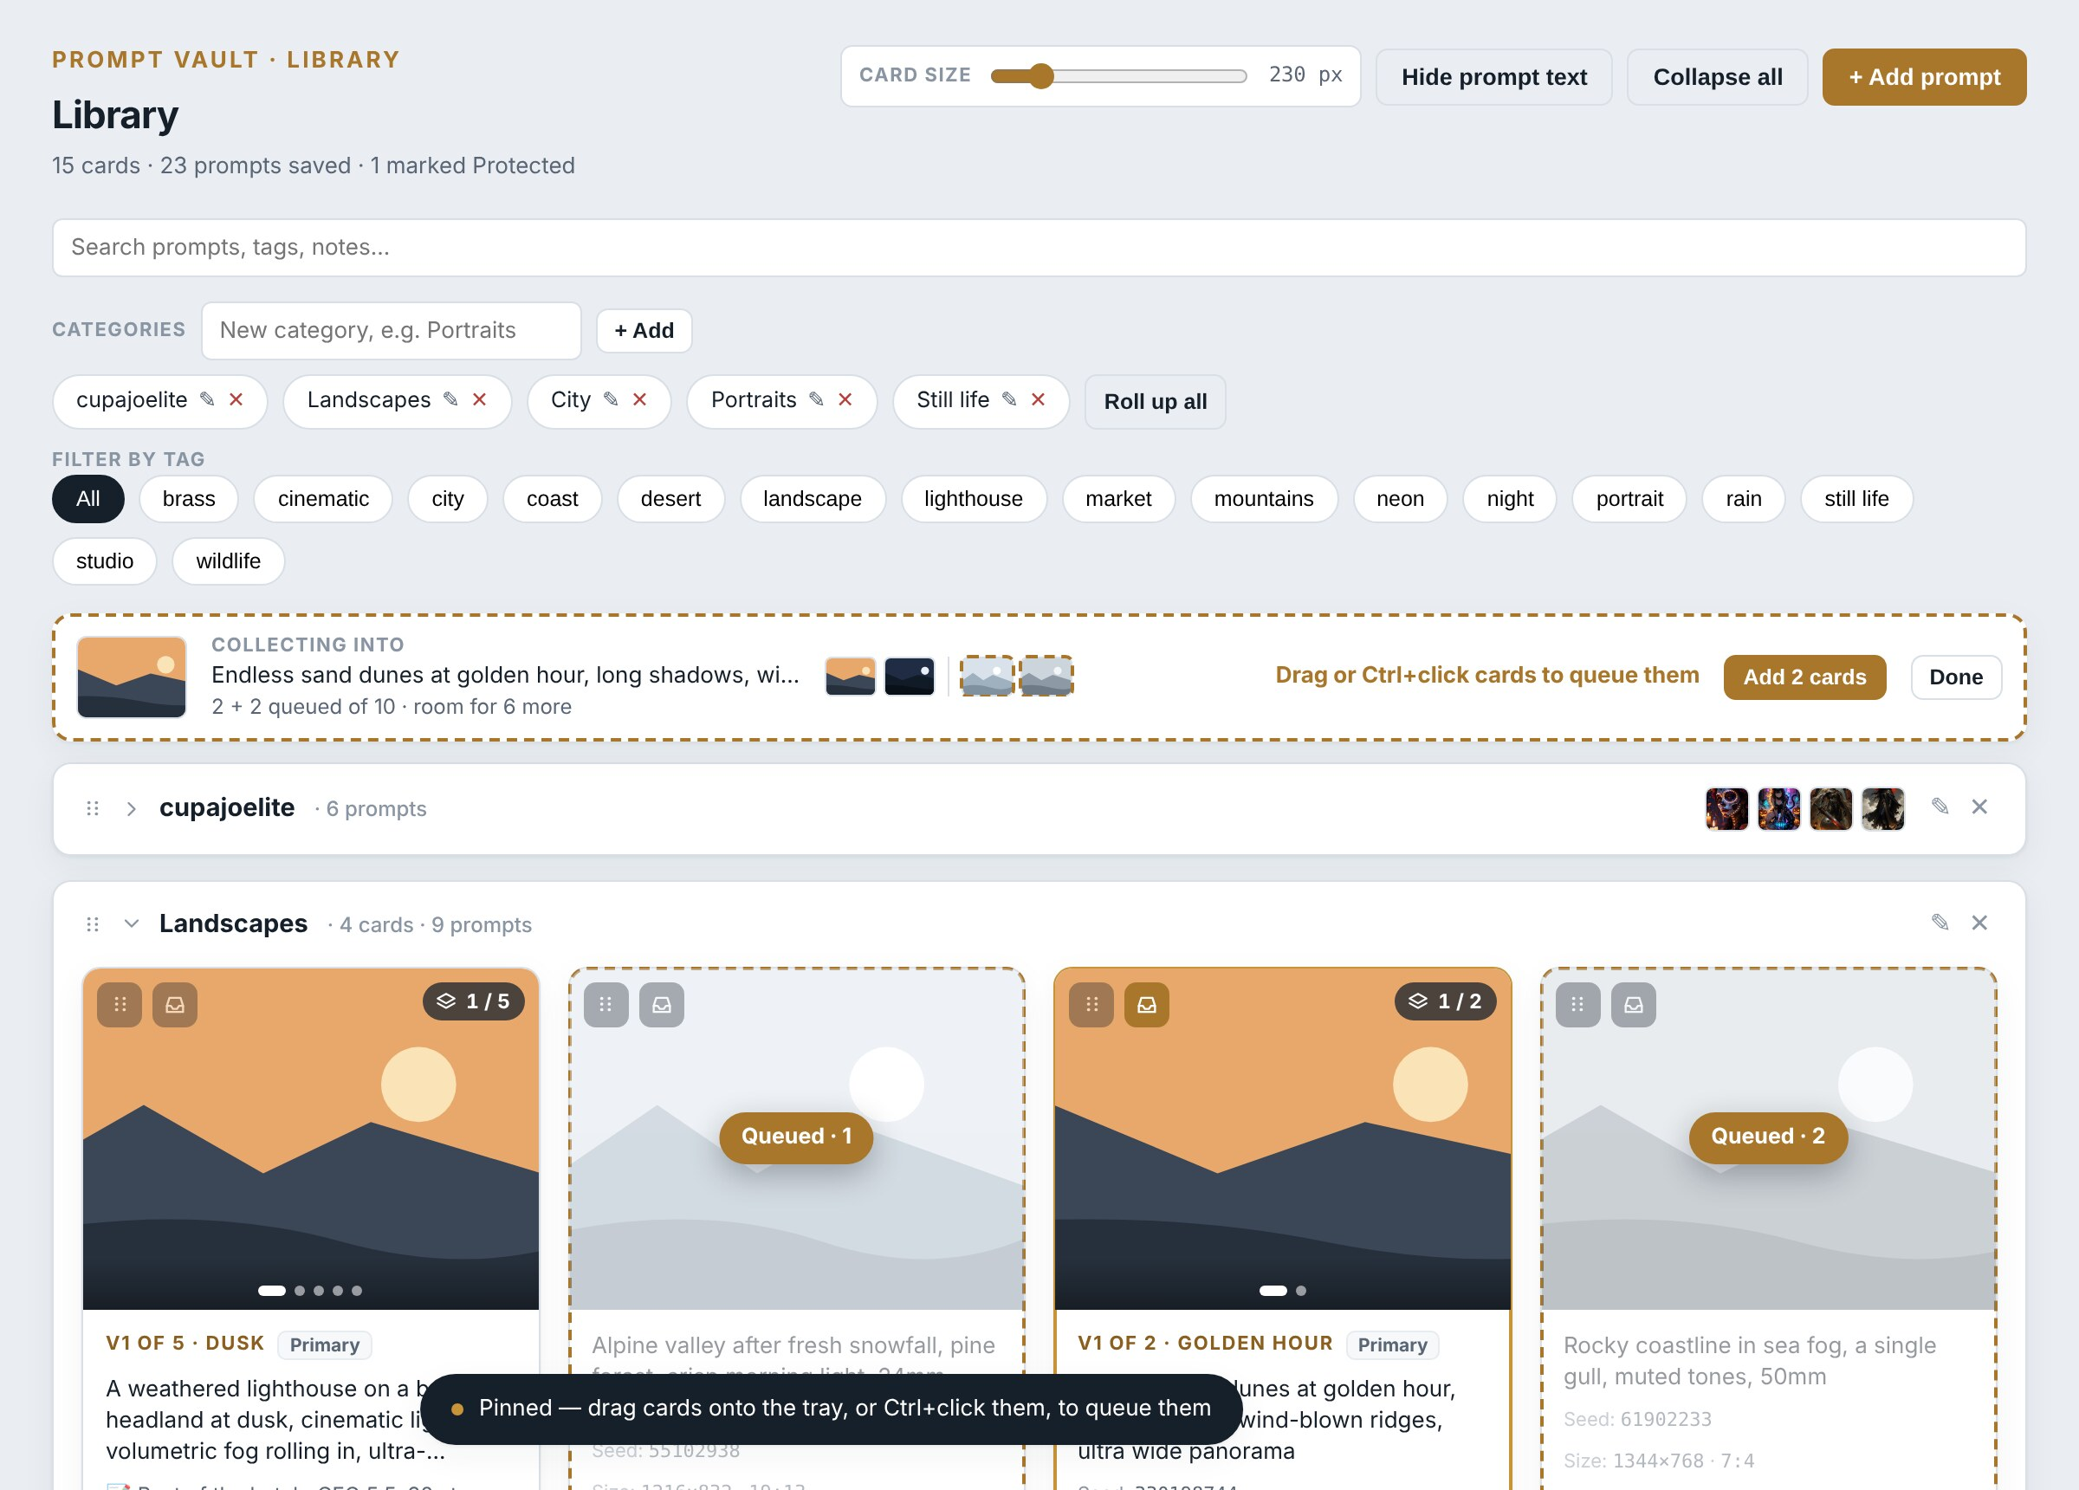
The dunes card pinned to the tray, with two cards queued. Queued cards are faded and numbered in the Library and listed in the tray.

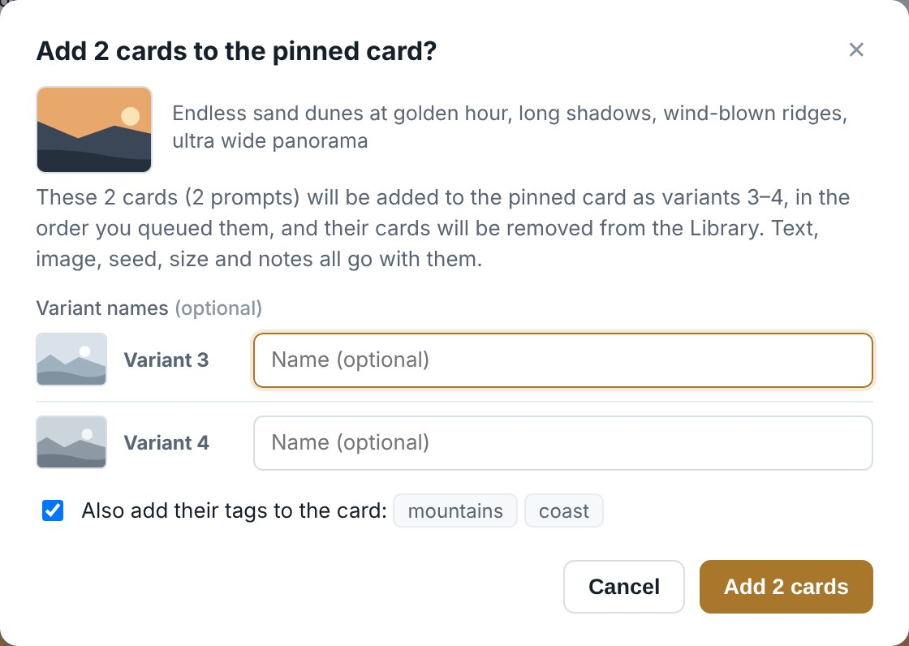
The single confirmation for the whole queue.

Click a queued card again with Ctrl held, or its X in the tray, to take it out of the queue. Done closes the tray and drops the queue. The tray shows how much room is left; a card that would take it past ten prompts is refused. Searching narrows the Library but not the tray, so pin, then search for the cards to gather.
Mouse only
Combining cards needs a mouse or touchpad drag. There is no keyboard way to do it.
To undo a combination, open the card, choose the variant, click Split to own card and save.

Importing images
A picture saved from ComfyUI with the Prompt Vault Card node (next chapters) carries a small block of Prompt Vault data inside the PNG file. Bring the picture into Prompt Vault and the card fills itself in from it. Pictures without that data can still be attached by hand in the editor, but cannot fill anything in.
From the picture | Goes into
Prompt and negative prompt | Positive prompt, Negative prompt
Seed, width, height, ratio | Seed, Size and ratio
Variant name, notes | Variant name, Notes (only if they were filled in on the node)
Prompt author, author URL, image source URL | The credit boxes
Model, CLIP, VAE, LoRAs, sampler, steps, CFG, denoise, extras | Generation settings
Category, tags, Protected | The card’s category (created if it does not exist yet), tags, and Protected
There are three ways in.

Dropping pictures on the Library
- Drag one or more PNG files from File Explorer into the Prompt Vault window, anywhere on the Library except on a card. A dashed brass frame shows the window will take them.
- Release. Prompt Vault reads each picture and opens Import images, with a row per picture.
- Check what will happen to each one in the list on the right of its row, change any you like, and click Import N images.
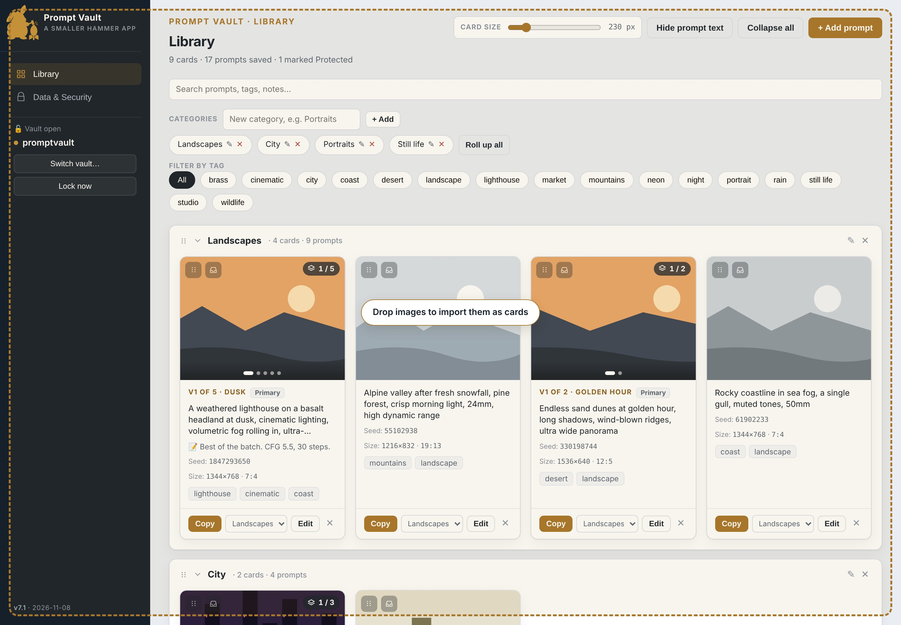
Dragging pictures over the Library.

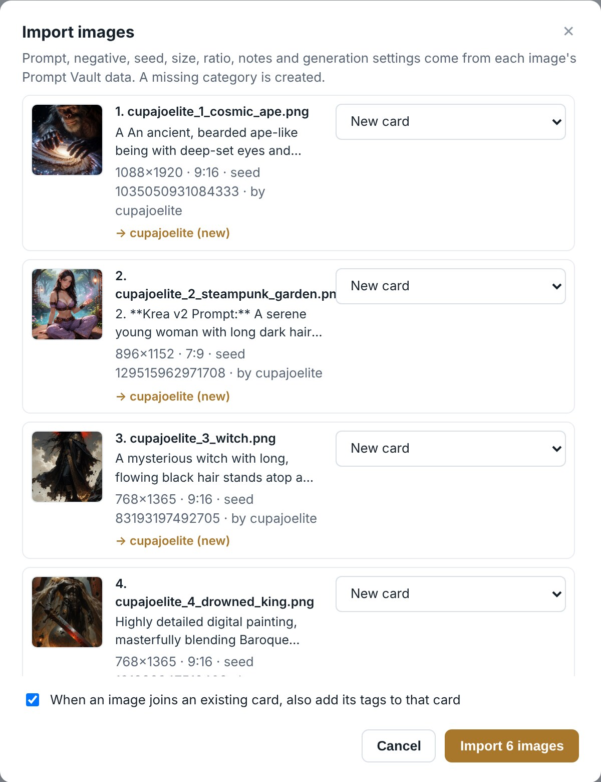
Import images, after dropping the six sample pictures. Each row shows the prompt, size, ratio, seed and author, and the category it will go into.

Choice in a row | What it does
New card | Makes a new card from the picture. The usual choice.
Add to the card with this prompt | Offered when a card already has the same prompt (a new seed of a prompt you have saved). The picture becomes a variant of that card.
Add to image N’s card | Offered when an earlier picture in the same drop has the same prompt. Both end up on one card, as variants.
Skip | Leaves the picture out. Chosen automatically for a picture already in the vault (same prompt, negative, seed and size), for a second copy in the same drop, and for a picture with no Prompt Vault data.
Import saves everything at once, and a message counts the new cards and variants. The box at the bottom adds a picture’s tags to the card it joins. A card never takes more than ten prompts: rows that would overfill one are marked red and Import tells you which to change.

Dropping a picture on a card
Drop one or more pictures straight onto a card to add them to it as variants. The same Import window opens, with Add to the card you dropped on chosen. A full card turns red and refuses the drop.
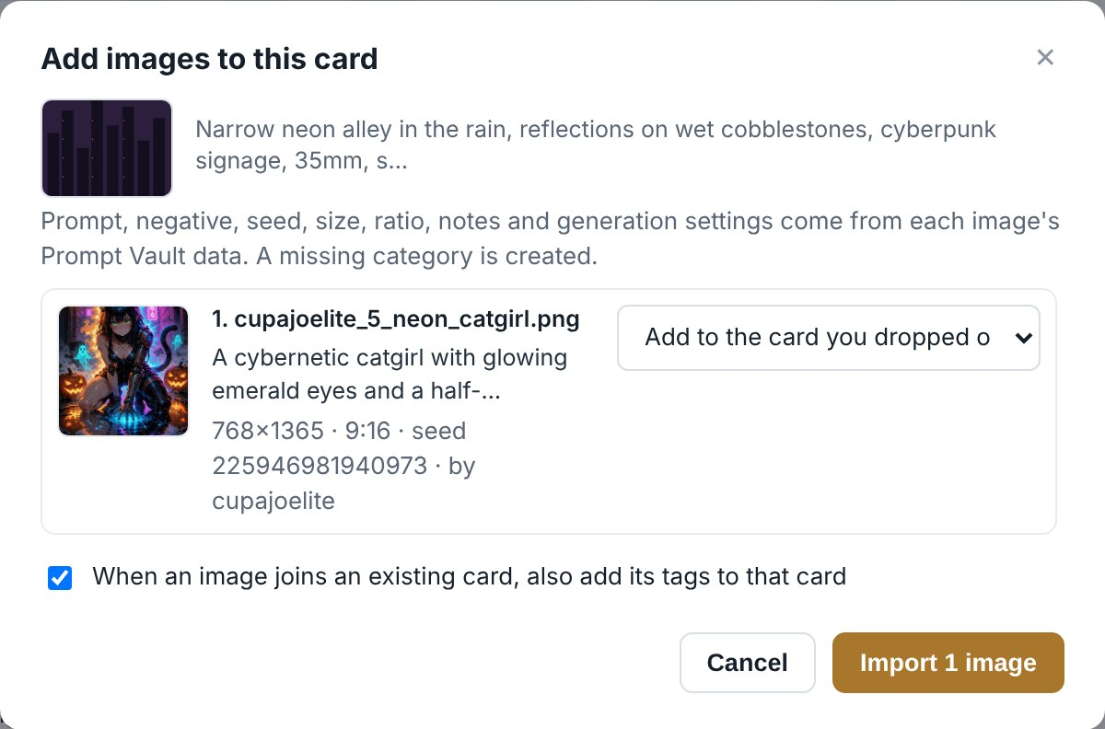
One picture dropped onto the neon alley card.

In the editor
Choose image… or Replace… in the editor, or a picture dropped onto the open editor, also reads the picture’s data. Empty boxes are filled in at once. If filling in would change something already there, the editor asks first:
The picture’s data differs from what is already on this variant.

Button | Does
Fill empty fields only | Keeps everything already typed and fills only the blanks.
Use the image’s values | Replaces the boxes with the picture’s values.
Keep mine | Changes nothing but the picture itself.
Nothing is written until you click Save. The picture itself is always attached, resized like any other reference image.
What import reads
Only PNG files saved with the Prompt Vault Card node carry the data. ComfyUI’s own workflow data, and the text other tools write into pictures, are ignored.
The data inside a picture is untrusted: Prompt Vault keeps only the fields it knows, of the right kind and a sensible length.

Try it: the sample images
The samples folder that comes with Prompt Vault holds six pictures saved with the Prompt Vault Card node. Use them to see image import working before you set anything up in ComfyUI.
File | Picture
cupajoelite_1_cosmic_ape.png | An ancient ape-like being cradling a galaxy
cupajoelite_2_steampunk_garden.png | A steampunk sorceress in a misty garden
cupajoelite_3_witch.png | A witch on a cliff under a red sky
cupajoelite_4_drowned_king.png | A crowned giant with a bloodied sword
cupajoelite_5_neon_catgirl.png | A cybernetic catgirl in a rainy neon alley
cupajoelite_6_day_of_the_dead.png | A Day of the Dead portrait by candlelight
The prompts are by cupajoelite (https://civitai.com/user/cupajoelite), shared with permission. The pictures were rendered from them by Smaller Hammer; the originals are listed under Credits in the first chapter.
- Open Prompt Vault and unlock your vault. A spare vault is a good idea for a first try (see Several vaults).
- Open the samples folder in File Explorer, select all six pictures (Ctrl+A) and drag them onto the Library.
- Import images opens with six New card rows going into a new cupajoelite category. Click Import 6 images.
- Open the new cupajoelite category. Each card has its prompt, seed, size, 9:16 or 7:9 ratio, the by cupajoelite credit, and the generation settings.
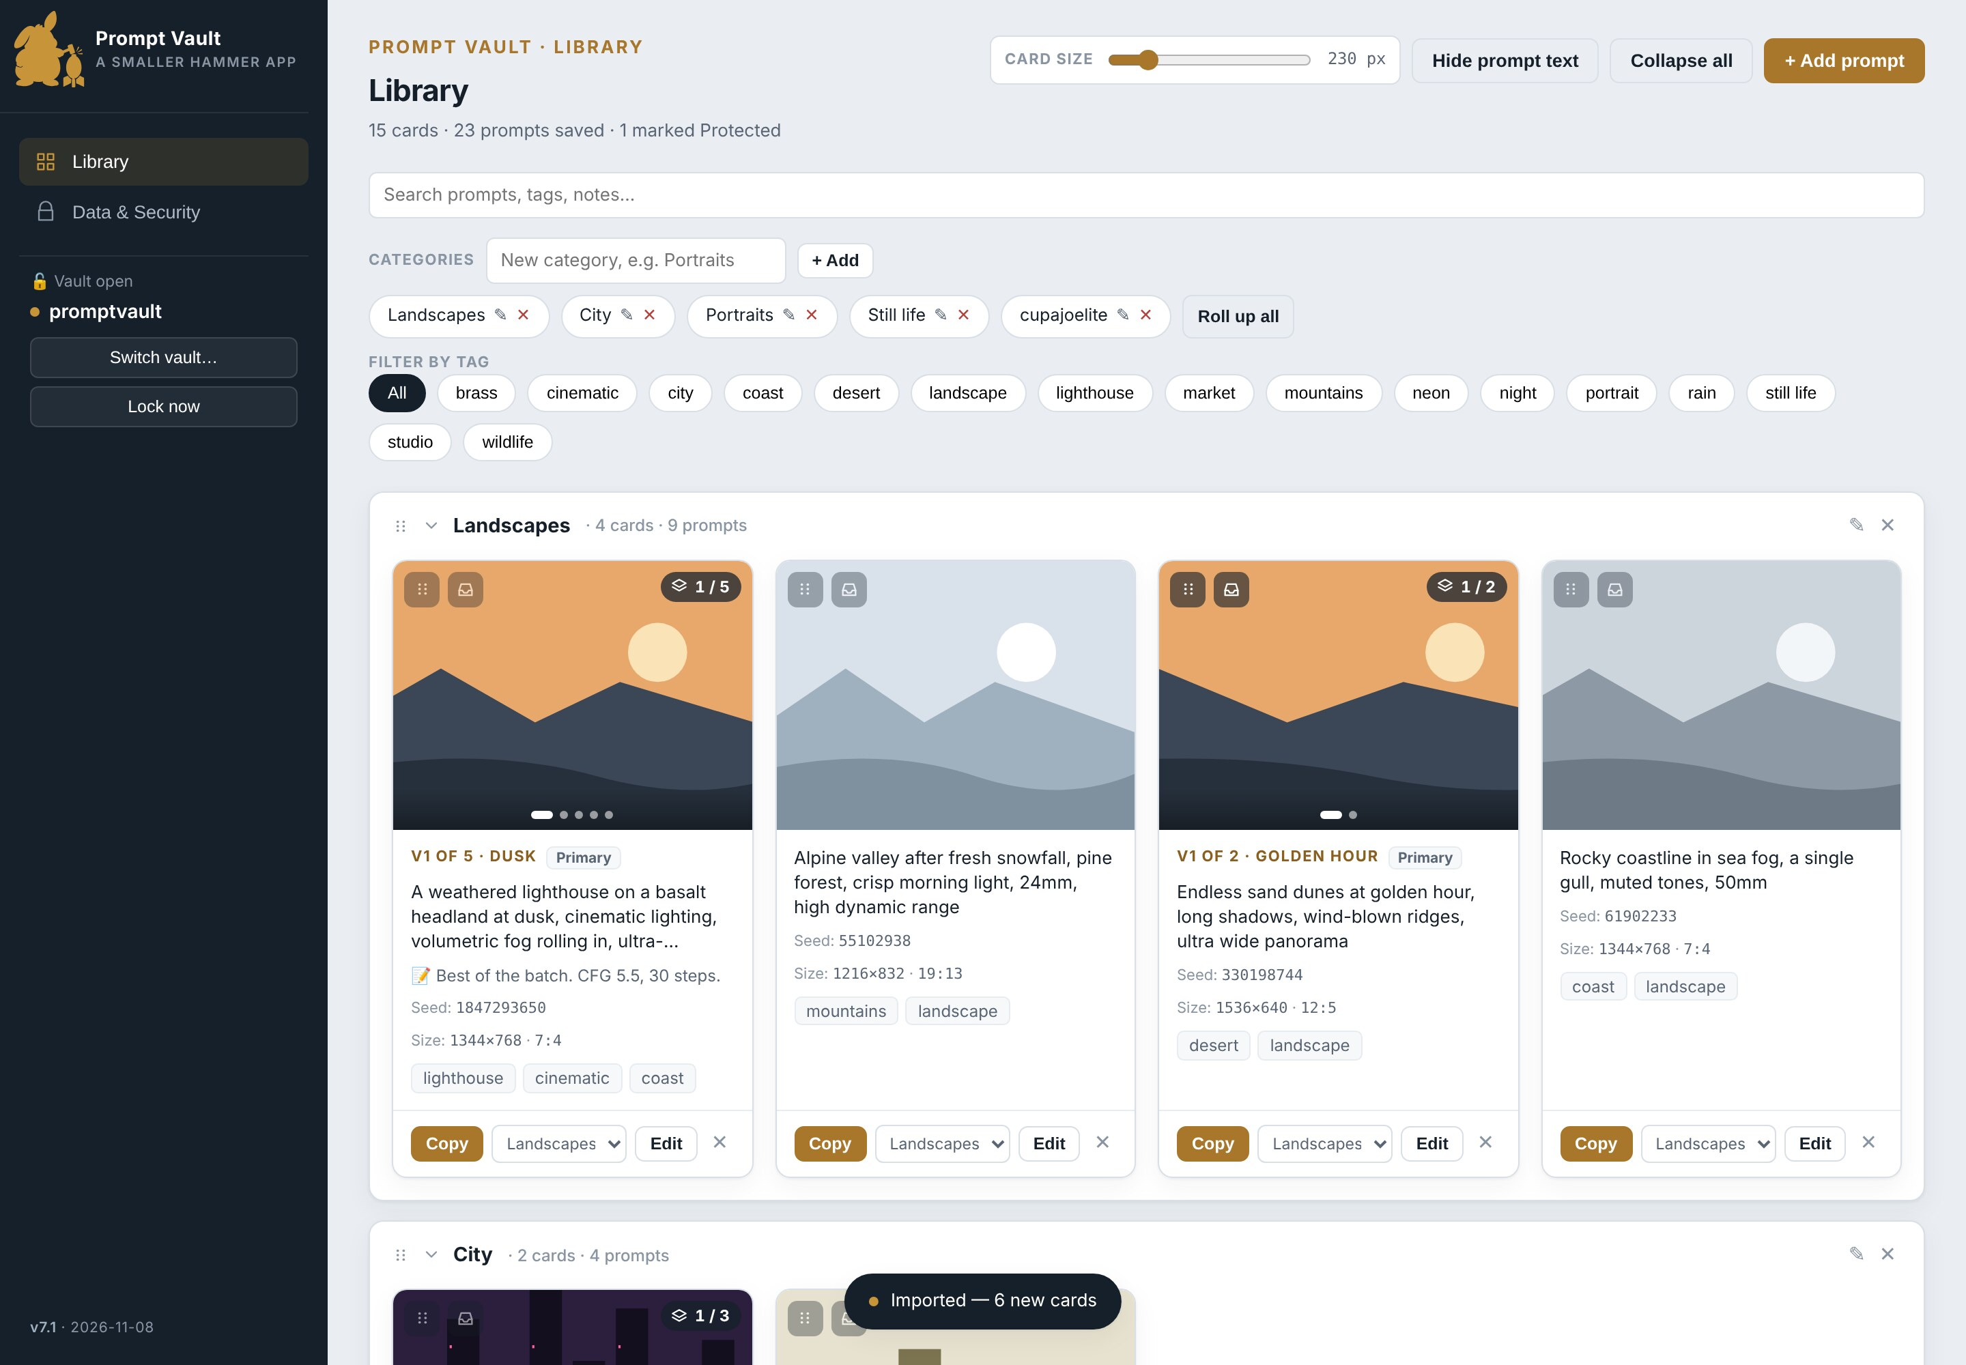
The Library just after importing the six samples. The new cupajoelite category is closed at first; click its heading to open it.

Drop the same six again and every row says Already in the vault, skipped. Open a card and drop a sample onto the editor to see the Fill empty fields only question. When you are done, delete the cards or the whole category.

The ComfyUI nodes
The Prompt Vault Card nodes are a separate, free add-on for ComfyUI, published as github.com/danger-uxb/comfyui-prompt-vault-card. They write the Prompt Vault data into the pictures ComfyUI saves. Prompt Vault itself never connects to ComfyUI: the picture file is the only link between them.
Node | Does
Prompt Vault Card | Reads the workflow: prompt, negative, seed, size, ratio, model, CLIP, VAE, the LoRAs in use and the sampler settings. Adds the category, tags, variant name, notes and credit you type on it.
Prompt Vault Save Image | Saves PNGs like ComfyUI’s Save Image, with the card inside each one.

Installing
- Download the comfyui-prompt-vault-card repository from GitHub (green Code button, Download ZIP) and extract it.
- Copy the extracted folder into ComfyUI’s custom_nodes folder.
- Restart ComfyUI and refresh its browser tab. The nodes are under Smaller Hammer › Prompt Vault.

Wiring them in
Add both nodes to the workflow you already use. The Card node needs no inputs: it reads the workflow by itself.
Loaders -> LoRAs -> KSampler -> VAE Decode --IMAGE--------------+
|
+------------------------+ +--------------------v-----+
| Prompt Vault Card | | Prompt Vault Save Image |
| (no inputs needed) |---pv_card----->| images <- VAE Decode |
| category, tags, | | pv_card <- Card |
| author, URLs ... | +--------------------------+
+------------------------+
A normal workflow. Only the two new nodes and their two wires are added; delete or bypass the old Save Image so pictures are not saved twice.
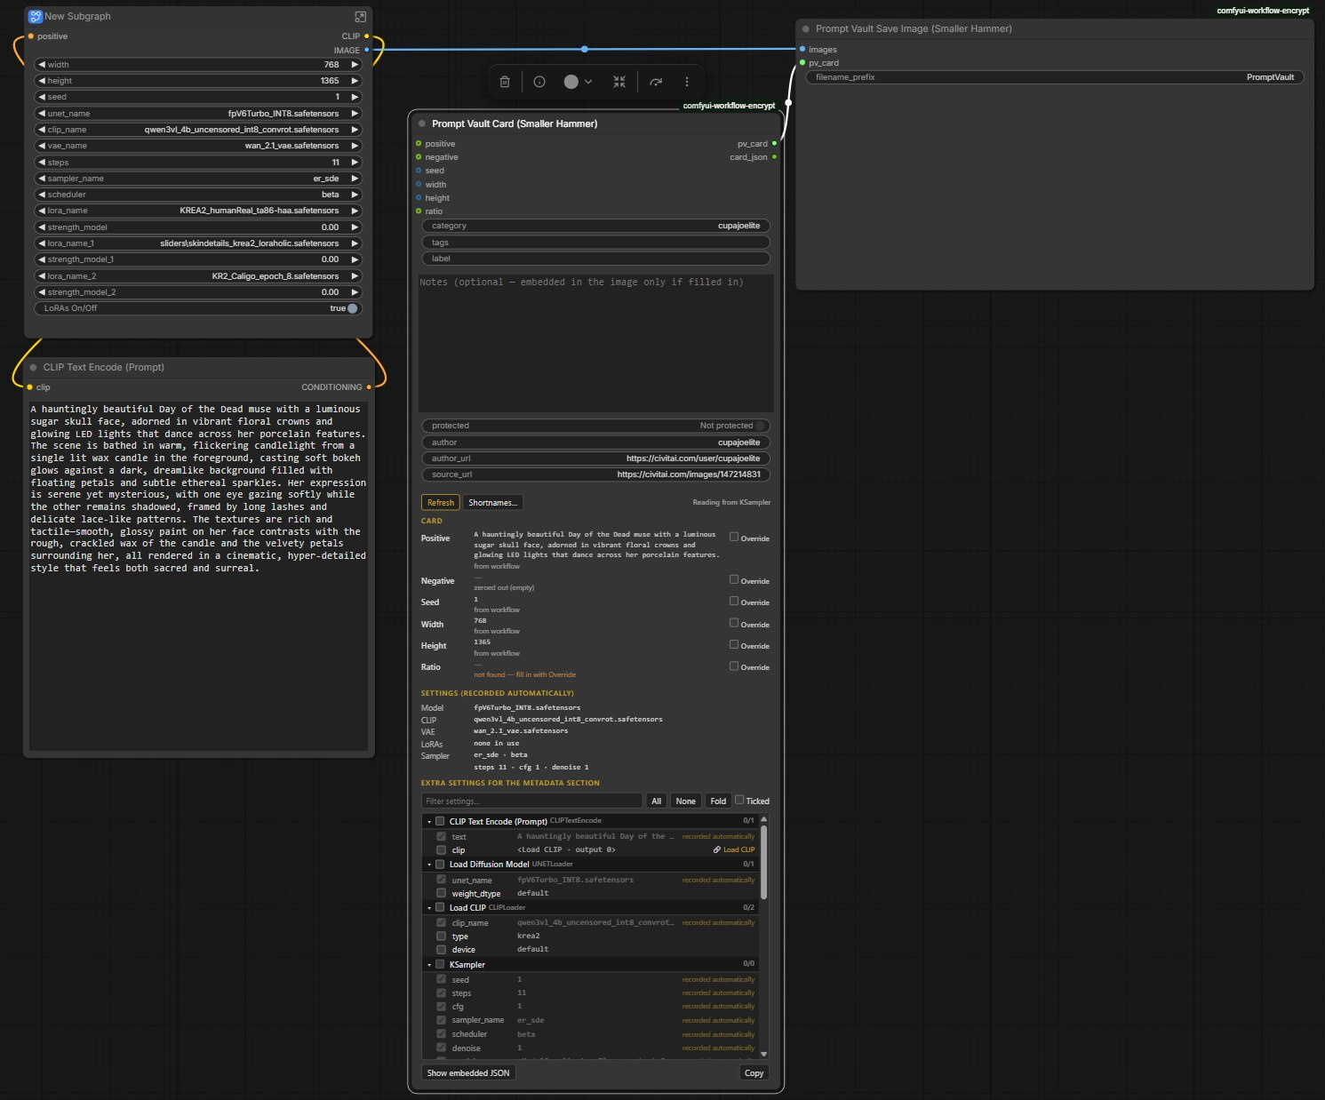
The nodes in a real workflow: the Card node (centre) needs no inputs, and its pv_card output goes to Prompt Vault Save Image (top right), which takes the images from the workflow.

Any value can also be wired in, or typed: on the Card node’s panel, tick Override beside a field to type your own value. The order is Override first, then a wired input, then what the node found in the workflow.
Prompt-list node --conditioning--> KSampler ...
--prompt (STRING)---------------> Prompt Vault Card : positive
When the prompt text is read from files while the workflow runs, wire the prompt text into the Card node’s positive input, because the workflow itself does not hold it.

The Card node’s panel
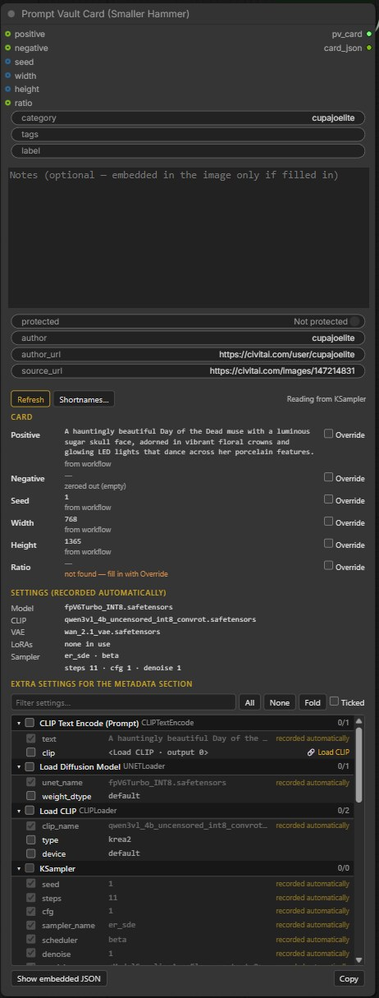
The Card node with its panel. This size has no standard ratio, so Ratio is amber and asks to be filled in with Override. All three LoRAs in this workflow are at strength 0, so none are recorded.

Part | What it shows
Card | Each field with its value and where it came from: from workflow, from Olm Resolution Picker, wired, override. Amber text means something is missing.
Settings | The model, CLIP, VAE, LoRAs (with strengths) and sampler settings that will be recorded. Only LoRAs actually in use are listed: one behind a switch that is off, or at strength 0, is left out.
Extra settings | Every other setting in the workflow, to tick into the card’s Generation settings. Settings already recorded are greyed out.
Shortnames… | Short names recorded instead of long model or LoRA file names, shared by every workflow. Folder names are always removed from file names.
Show embedded JSON | Exactly what will be written into the picture.
The size comes from the latent image, and from an Olm Resolution Picker directly, including its swap setting, with the ratio from its label. When no standard ratio can be found, the Ratio field asks you to fill it in with Override.
The data in a picture is plain text
Anyone you send the PNG to can read the prompt and settings in it, just as with ComfyUI’s own workflow data. Notes are written only if you fill them in, and Protected only if you switch it on; both are off by default.

Viewing images
Card pictures are cropped to fit. Click a picture to see the whole image as large as the window allows.
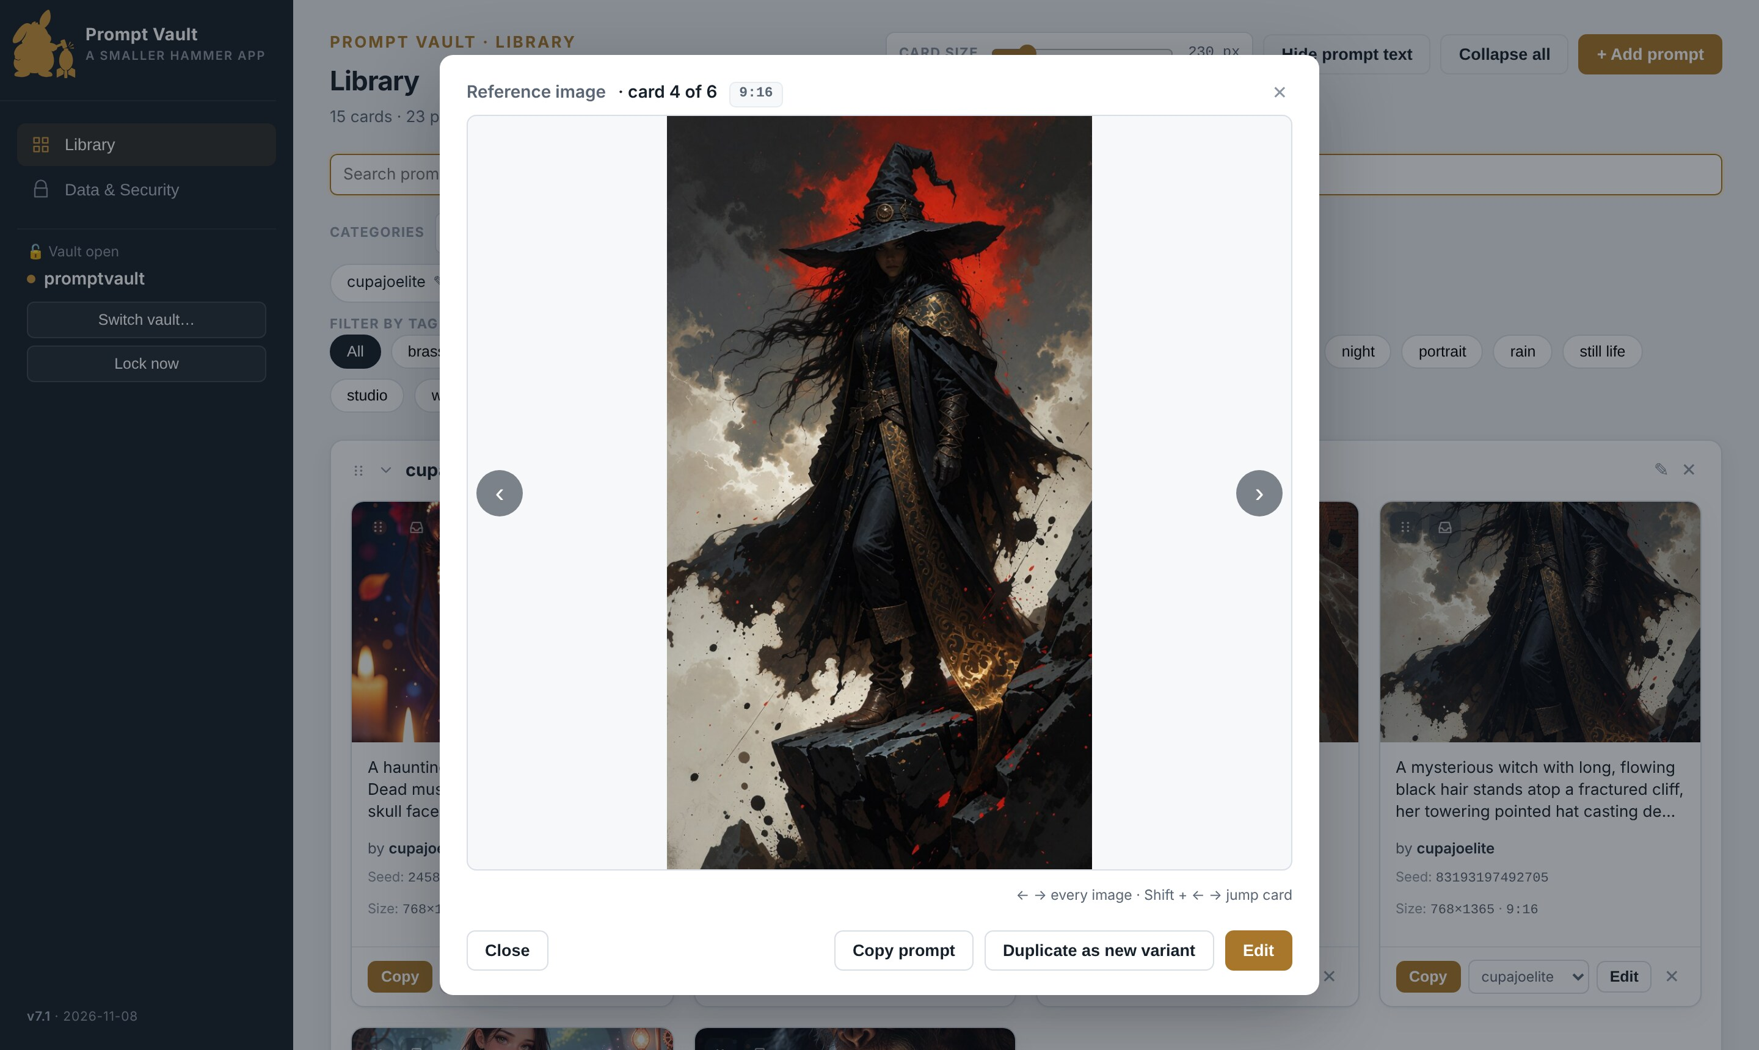
The image viewer on variant 2 of the lighthouse card. The strip below the picture shows every variant on the card.

Moving around
The arrows step through every picture in the category in order: first each variant of this card, then on to the next card. A short Card 2 of 6 message appears when you cross onto the next card. The header always says where you are, for example card 1 of 3 · variant 2 of 5.
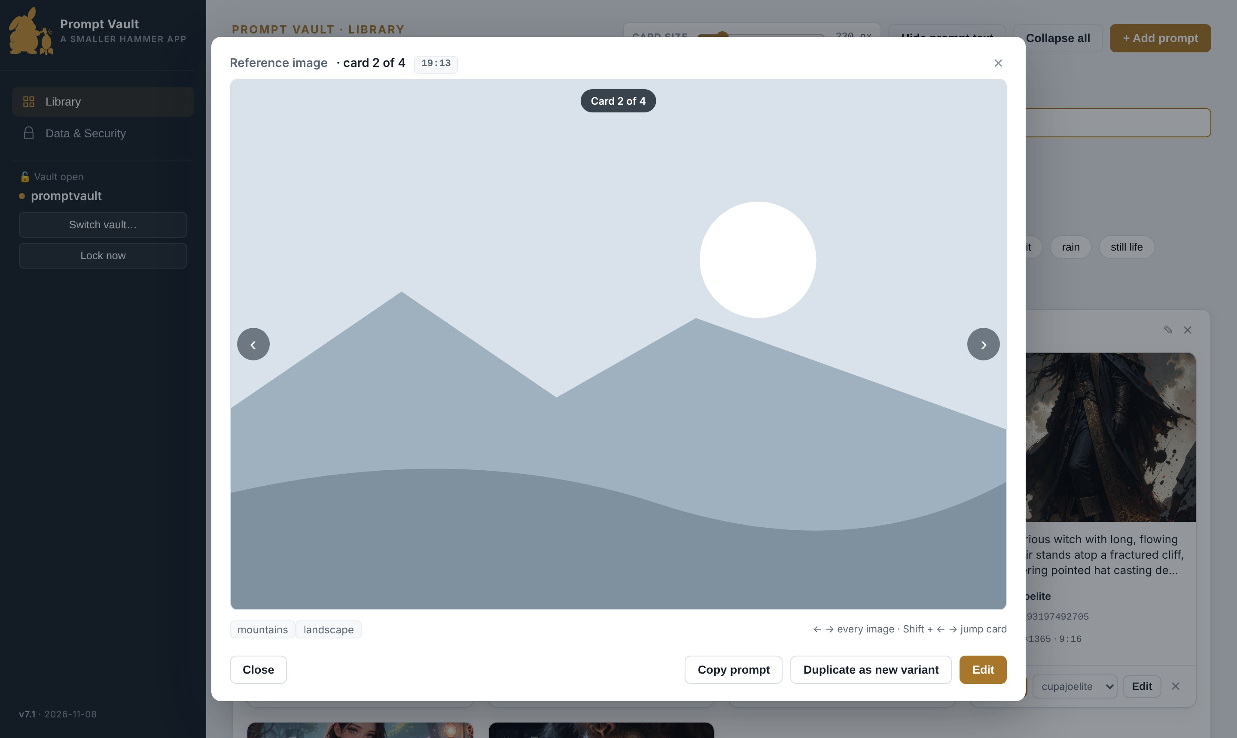
Stepping past the last variant moves on to the next card in the category.

Key or control | Does
‹ › arrows, or ← → keys | Previous or next picture.
Shift + ← → | Jump to the previous or next card.
1 to 9, and 0 for the tenth | Go straight to that variant of the current card.
Click a picture in the strip | Go to that variant.
Esc, Close, the X, or a click outside | Close the viewer.
Variants without a picture appear in the strip as "no image" tiles and are skipped by the arrows. Only cards visible in the Library take part, so an active search or tag filter narrows what the viewer steps through. When you close the viewer, the card behind it shows the last variant you looked at.

Buttons in the viewer
Button | Does
Copy prompt | Copies the positive prompt of the variant on screen.
Duplicate as new variant | Opens the editor with a copy of this variant, ready to tweak. Greyed out when the card is full.
Edit / Edit variant N | Opens the editor on this variant.
The small box beside the header shows the ratio recorded with the prompt, for example 9:16. When none is recorded it shows the picture’s shape as the nearest simple ratio, for example ≈ 13:19; ≈ means close rather than exact, which is normal after resizing.

Finding and organising

Searching
Type in the search box at the top of the Library. Results narrow as you type. The search looks at every variant’s positive and negative prompt, notes, seed, name, ratio, credit (author and both links) and generation settings, plus the card’s tags. Capital letters do not matter.
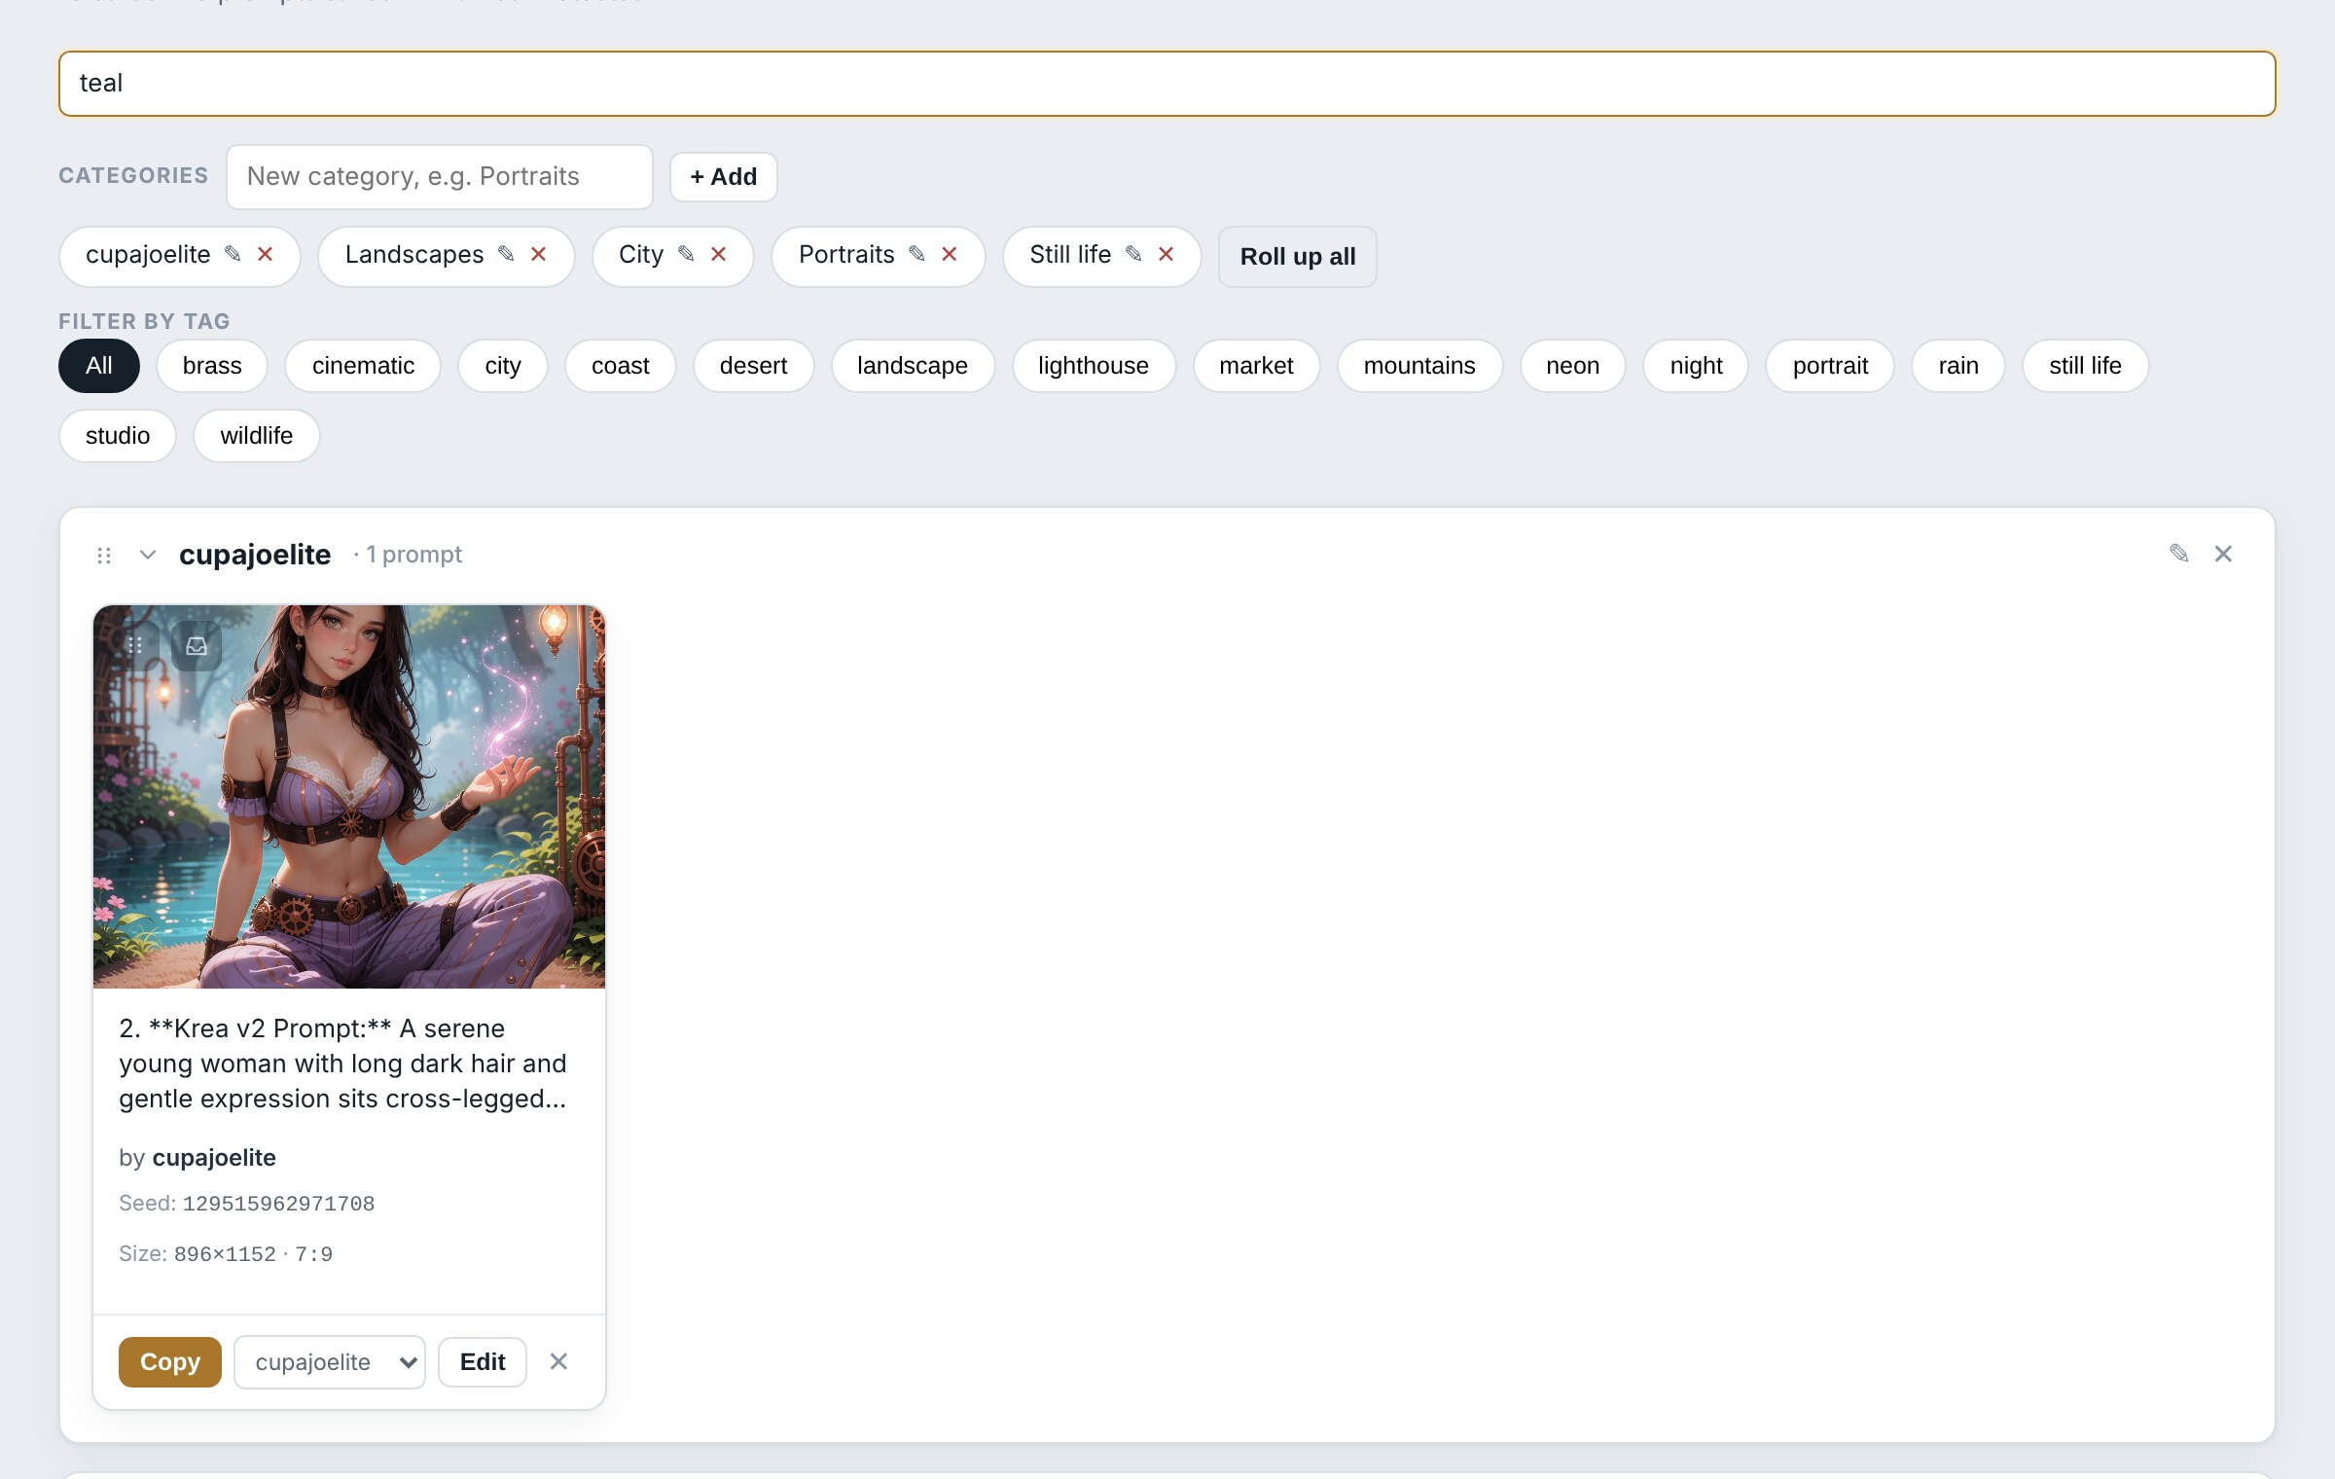
Searching for teal. The alley card further down is found through its second variant, which it now shows; any other prompt mentioning teal is found too.

While searching, categories with matches open automatically and the rest are hidden. If the match is in a variant other than the one on show, the card switches to the matching variant. Clear the box to see everything again.
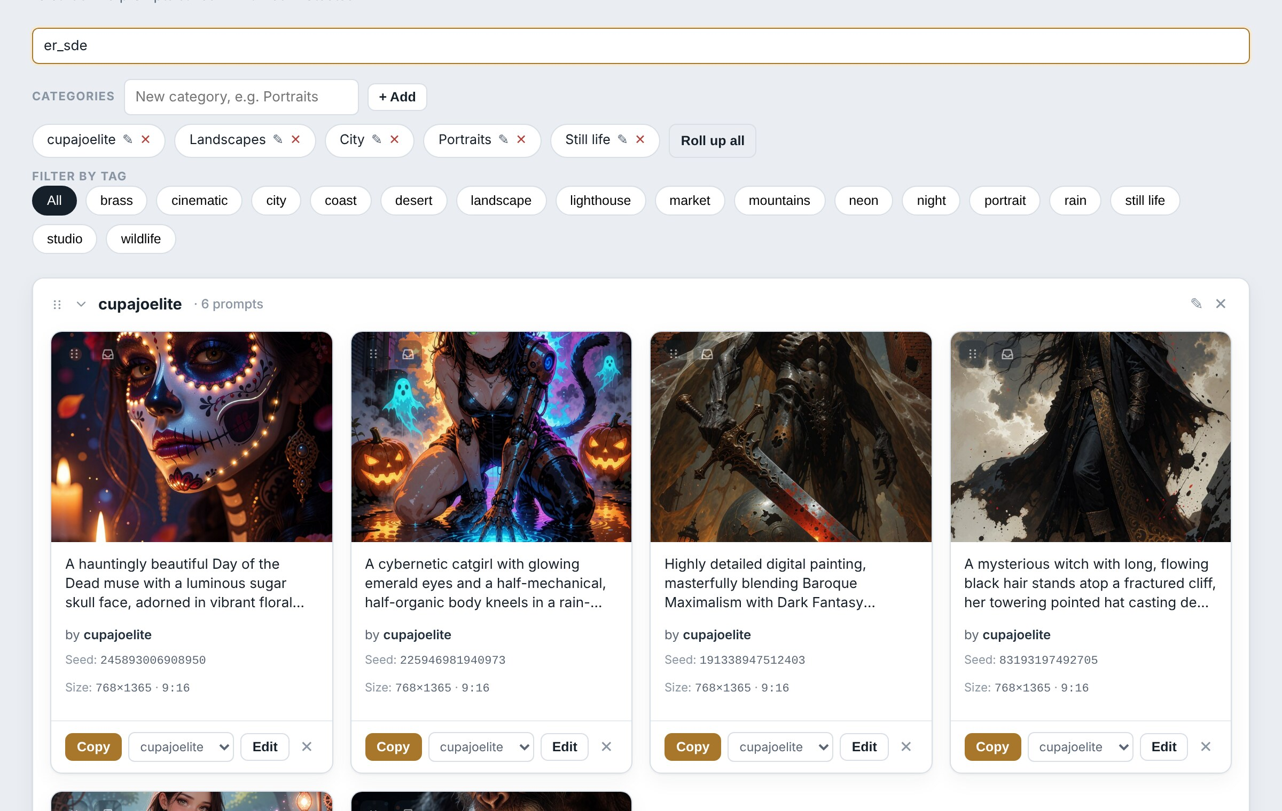
Searching for a sampler name, er_sde, finds every prompt made with it.

Filtering by tag
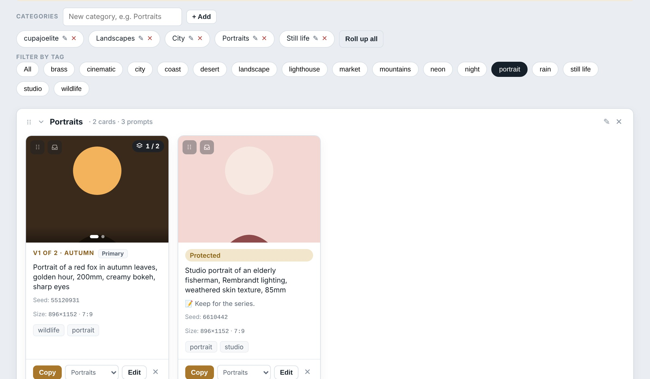
With the portrait tag selected, only the two portrait cards remain.

Click a tag under Filter by tag to show only cards carrying it. Click more tags to narrow further: a card must have all the selected tags. Click a selected tag again to remove it, or All to clear the filter. Tags and search work together.

Managing categories
To… | Do this
Add a category | Type a name in the box beside Categories and click + Add (or press Enter).
Jump to a category | Click its name in the categories row. It opens and scrolls into view.
Rename | Click the pencil beside its name, in the row or on its heading.
Delete | Click the X beside its name. Its cards move to Uncategorized; nothing else changes.
Reorder | Drag a category by the six-dot grip at the left of its heading and drop it on another heading.
Close them all | Roll up all in the categories row, or Collapse all in the header.
Uncategorized cannot be renamed, deleted or moved; it is always last. Reordering categories needs a mouse.

Copying prompts
Getting a prompt into your image generator is the most common job, so there are several Copy buttons. All copy the positive prompt only.
Where | Copies
Copy on a card | The variant the card is showing.
Copy prompt in the image viewer | The variant on screen.
Copy beside Positive prompt in the editor | Exactly what is in the box now, including unsaved changes.
A Prompt copied message confirms it. Paste with Ctrl+V as usual.

The right-click menu
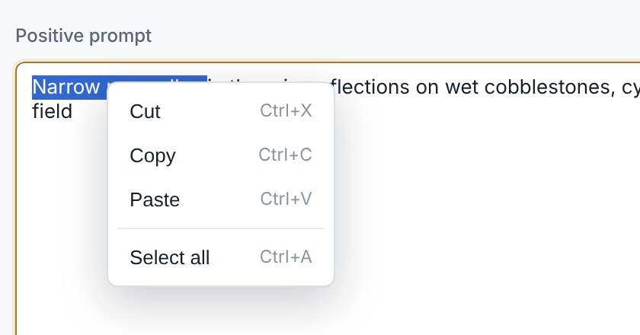
Right-clicking selected text in a box.

Right-click inside any text box for Cut, Copy, Paste and Select all, or on selected text elsewhere for Copy. The usual keyboard shortcuts (Ctrl+C, Ctrl+V, Ctrl+X, Ctrl+A, Ctrl+Z) work everywhere too. Passphrase boxes refuse Copy and Cut on purpose.

Display options
These change how the Library looks. They are saved in the settings file, not the vault, so they never affect your prompts.

Card size
Drag the Card size slider in the Library header. Cards resize as you drag. The value is a minimum width: cards stretch to share each row evenly, so they are often a little wider than the number shown. Double-click the slider to return to 230 px.
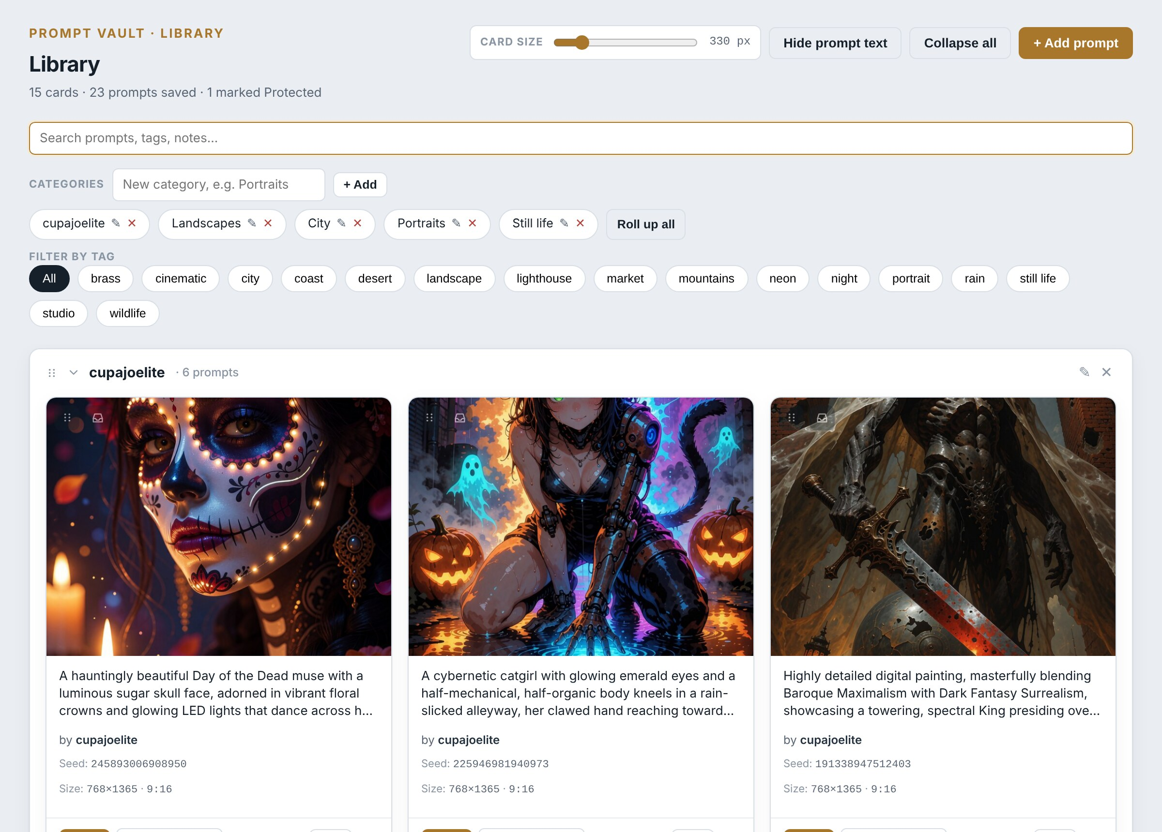
Cards at 330 px: three to a row instead of four, with larger pictures.

Pictures only
Click Hide prompt text in the header to hide the prompt text on every card and make the pictures square. Click Show prompt text to go back. Useful for browsing by eye.
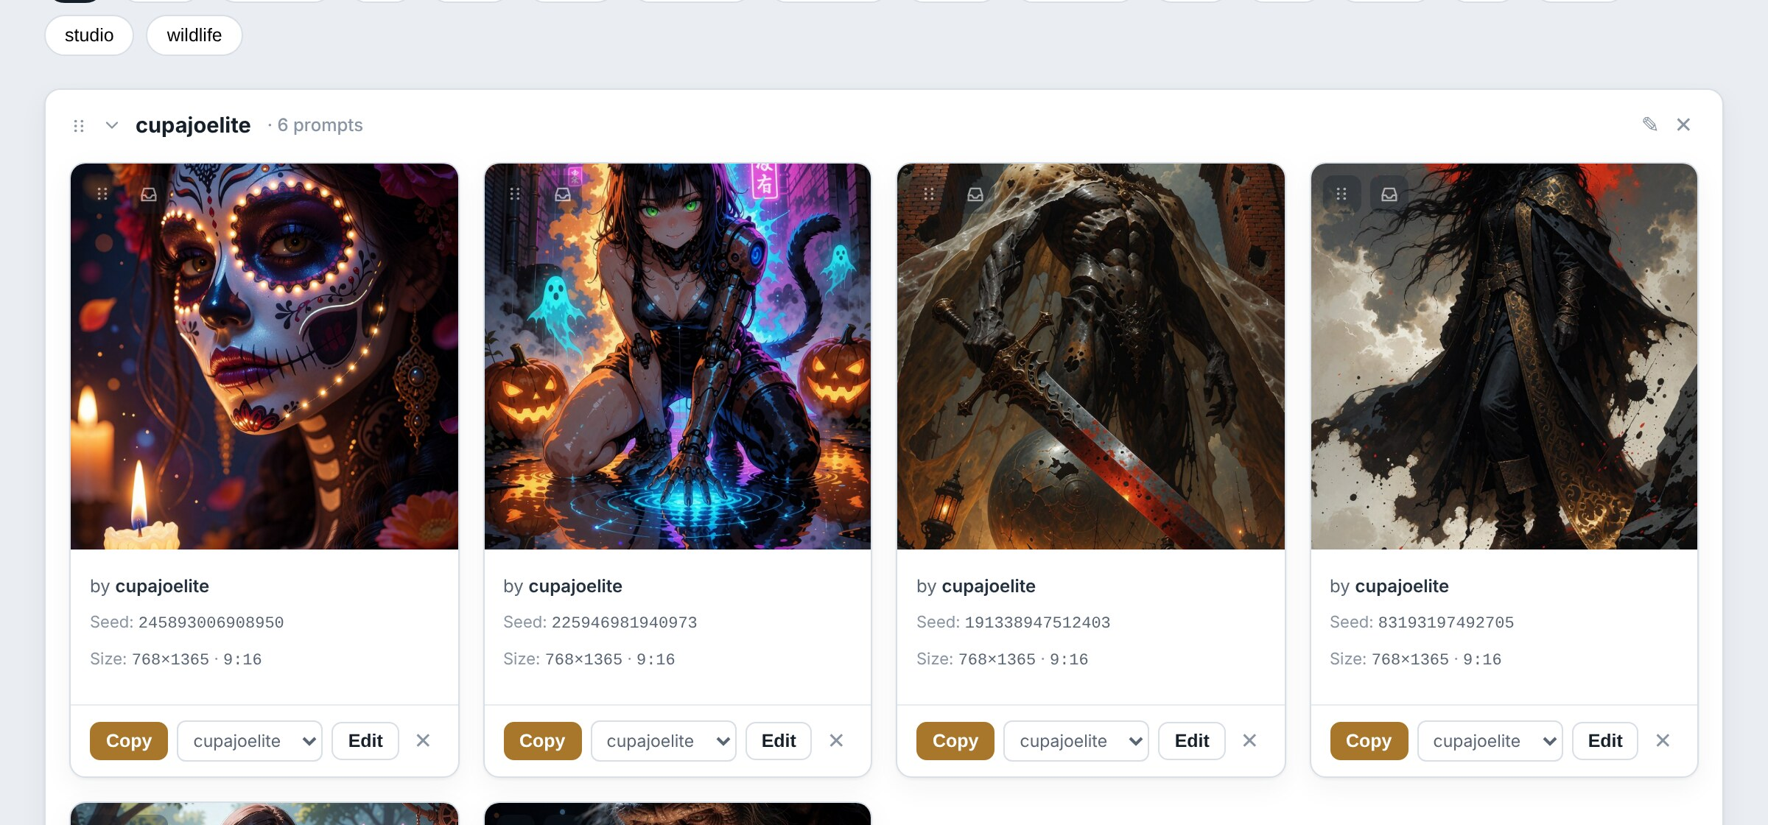
Hide prompt text turns the Library into a picture wall.

The Display section
Data & Security has the same controls in its Display section, with a preview card drawn at exactly the size cards will have in the Library at your current window size, and a Reset to 230 px button.
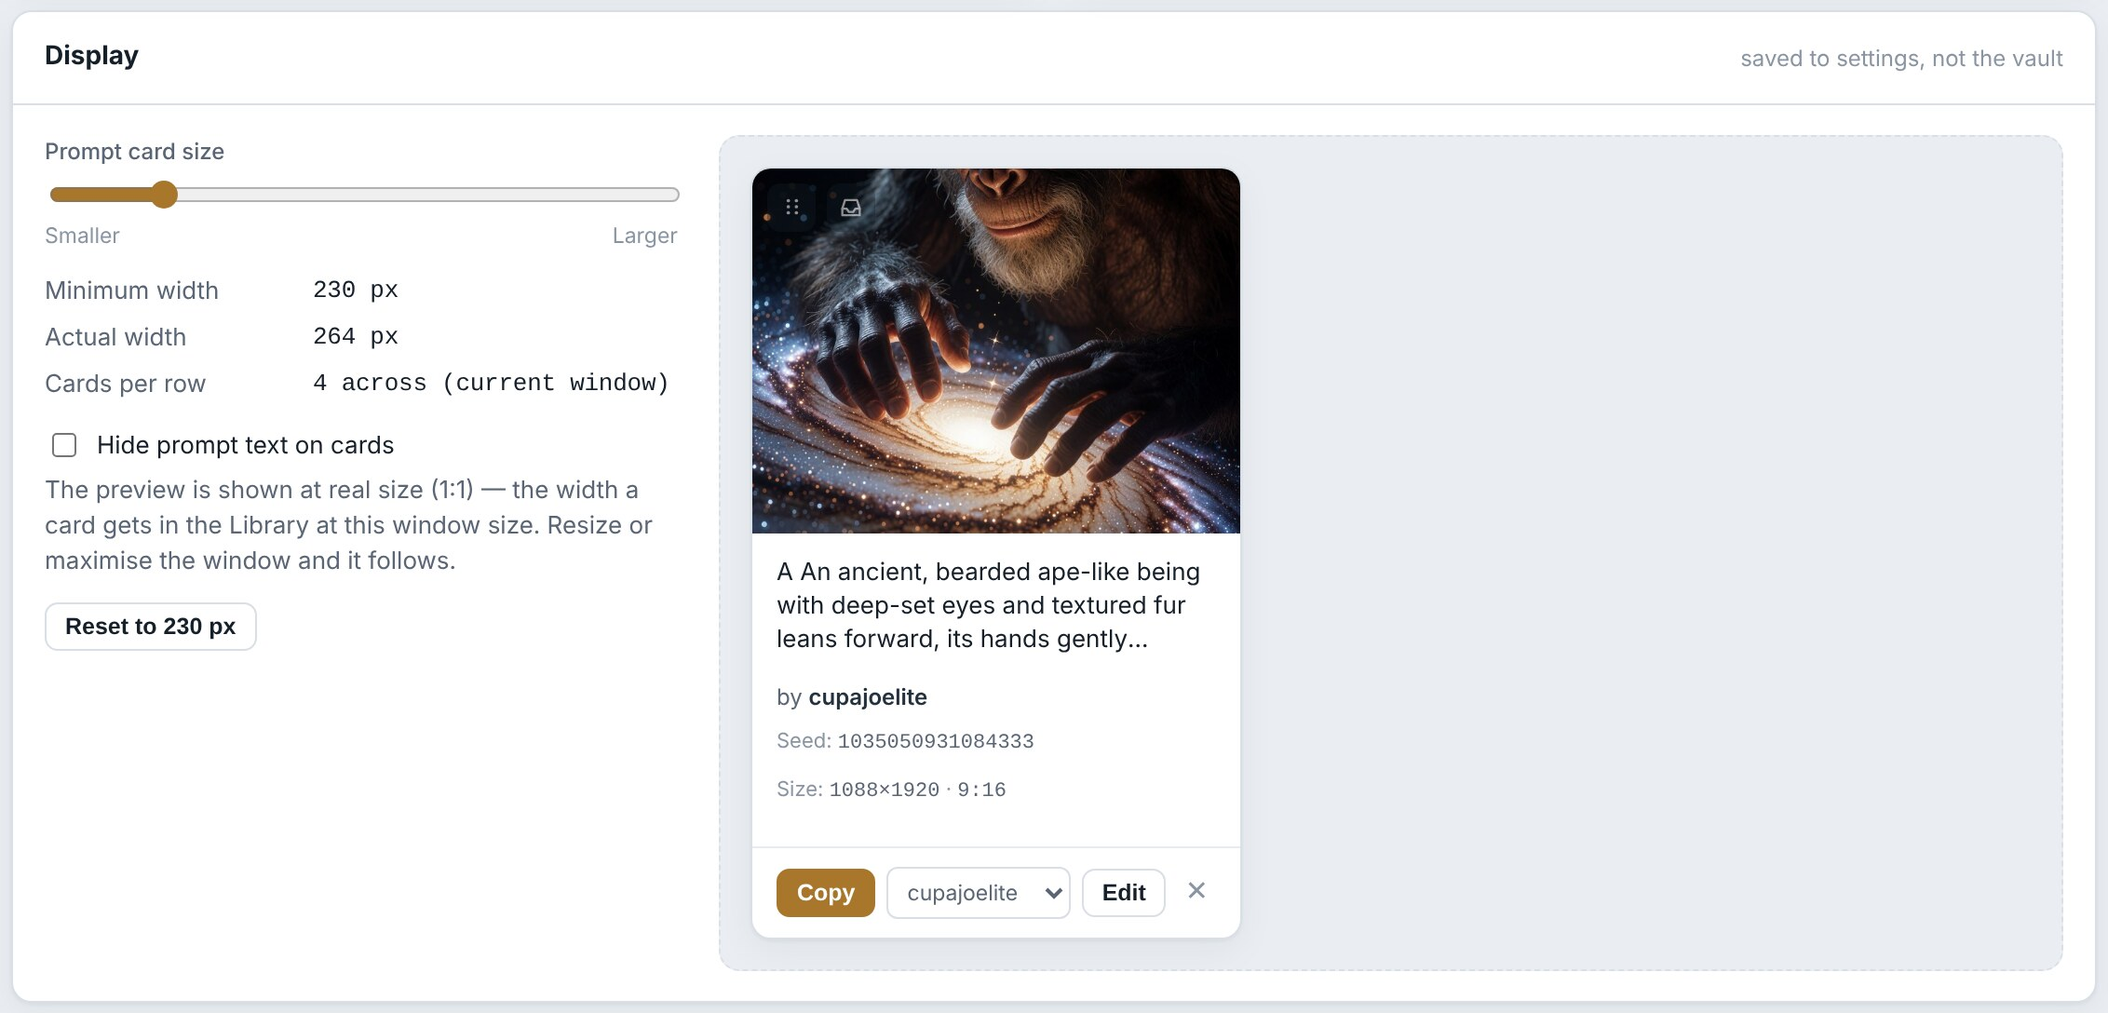
Display settings, with a full-size preview card.

Window size
Prompt Vault remembers its window size when you close it, and whether it was maximised, and opens the same way next time. The smallest window allowed is 900 × 600.

Passphrase and security
The whole vault file is encrypted with your passphrase using AES-256, a strong and widely used standard. Without the passphrase the file is unreadable. The passphrase is never written to disk, and there is no reset and no back door.
A forgotten passphrase cannot be recovered
Nobody can open the vault, or any encrypted backup made with that passphrase, without it. Keep a written copy somewhere safe.
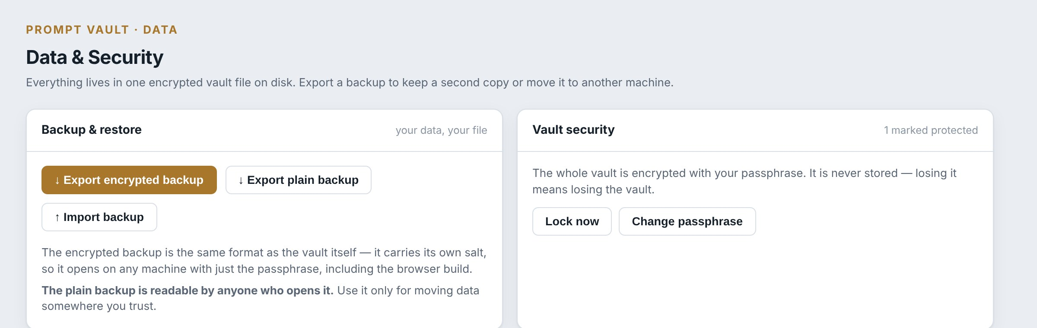
The top of Data & Security: backups on the left, the passphrase and locking on the right.

Changing the passphrase
- Open Data & Security from the rail.
- Click Change passphrase.
- Type the new passphrase twice and click Change.
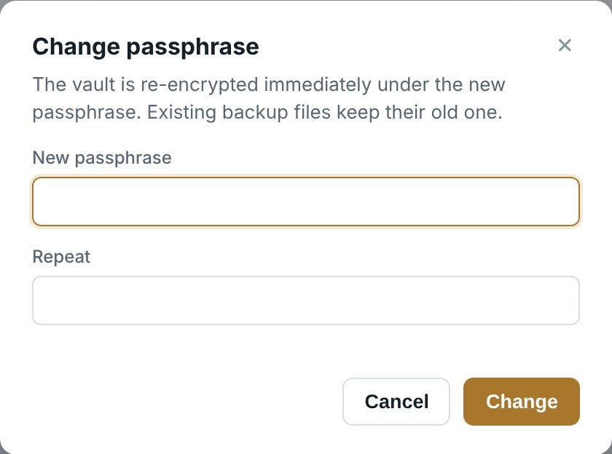
The Change passphrase dialog.

The vault is re-encrypted straight away. Backups you exported earlier still need the old passphrase, so note which passphrase goes with which backup.

What Protected does
Mark as Protected puts an amber Protected label on a card, so you can see at a glance which prompts are sensitive. It does not add extra encryption: everything in the vault, protected or not, is already encrypted by your passphrase.

Locking
Lock now, in the rail or on Data & Security, hides everything and returns to the Unlock screen. Use it when stepping away from the computer.

Backups
Your vault is the only copy
The vault is one file on one disk. A failed drive, a lost laptop or an accidental delete takes everything with it. Export an encrypted backup to somewhere else (a NAS, another drive or cloud storage) regularly, and after any big session.

Two kinds of backup
Kind | Button | Protection | Use it for
Encrypted | ↓ Export encrypted backup | Needs the passphrase that was in use when you exported it. | Everyday backups. Safe to keep anywhere.
Plain | ↓ Export plain backup | None. Anyone who opens the file can read every prompt. | Moving data somewhere you fully trust.

Exporting a backup
- Open Data & Security.
- Click ↓ Export encrypted backup.
- Choose where to save it and click Save. The suggested name is the vault’s name and the date, for example promptvault-encrypted-2026-11-08.json.gz.
A message shows where it was written. The file contains everything: all cards, variants, images and categories.
Save backups to a different place
A backup in the same folder as the vault does not help if that disk fails. Choose a different drive, a NAS, or a cloud-synced folder.

Default folders
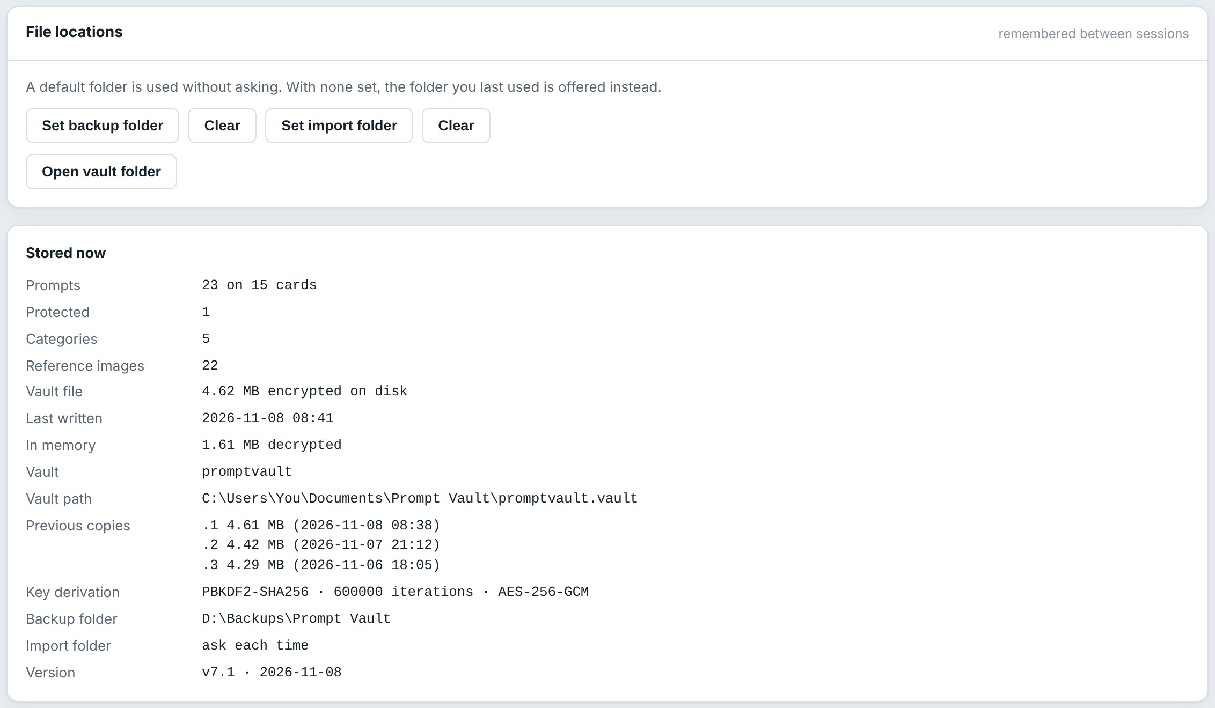
File locations, and the Stored now panel beneath it.

Under File locations, Set backup folder makes every export go to the same folder without asking where; Set import folder does the same for imports. Clear removes the default. Without a default, the folder you used last time is offered. Open vault folder shows the app folder in File Explorer.

Importing a backup: merge or replace
- Open Data & Security and click ↑ Import backup.
- Pick the backup file and click Open.
- Choose Merge into this vault (the default) or Replace the whole library, and click Continue.
- If the backup is encrypted, type the passphrase it was exported with and click Continue.
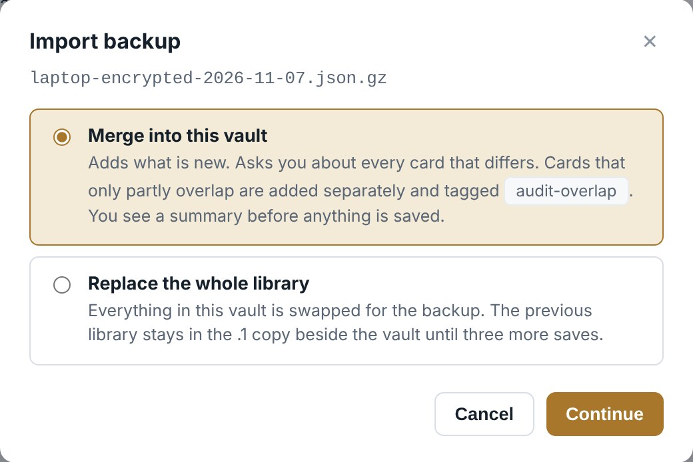
Choosing how to import.

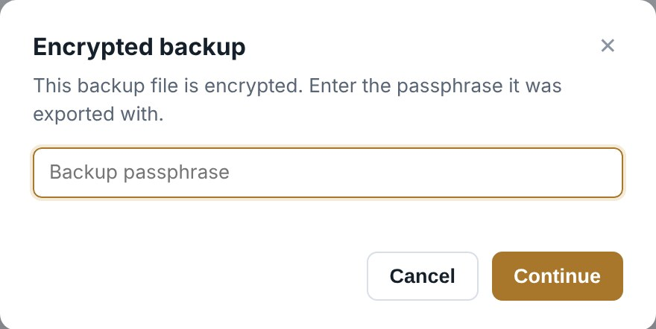
Asked for an encrypted backup’s passphrase.

The backup file itself is never changed, and this vault keeps its own passphrase whatever the backup used.

Merge
Merge brings in what is new and leaves the rest alone. Before anything is written, a summary shows what it found:
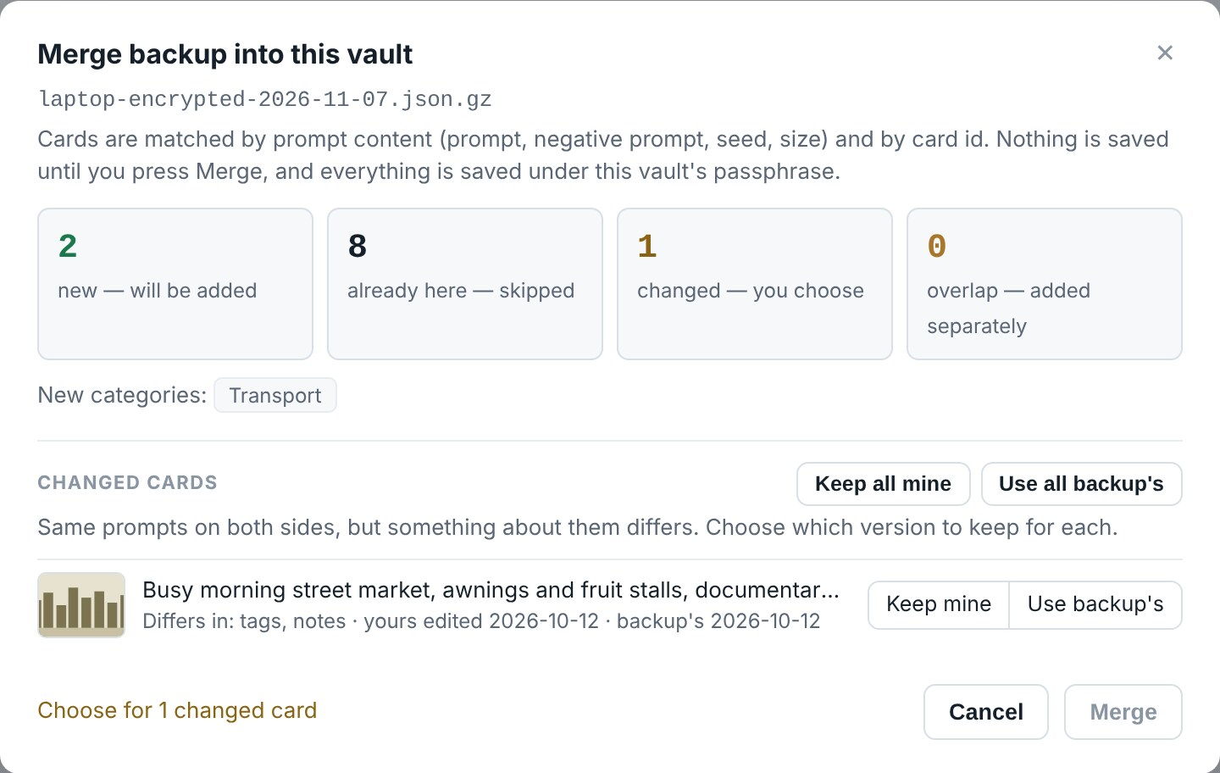
The merge summary for a backup made on another PC.

Found | What happens
New | Cards that are not here yet are added. Missing categories are created.
Already here | Identical cards are skipped.
Changed | The same prompts with something else different (tags, notes, names, pictures, ratio, credit, settings…). You choose Keep mine or Use backup’s for each; Merge stays disabled until every changed card has a choice.
Overlap | Cards that share only some prompts are added separately, and both are tagged audit-overlap so you can find and tidy them later.
Cards are matched by their prompt text, negative prompt, seed and size, and by their id. Click Merge to save, once. Merge is also how to copy cards from one of your vaults into another: import the other vault’s file and give its passphrase.

Replace
Replace swaps the whole library
Replace the whole library throws away everything in this vault and puts the backup in its place. The previous state stays in the .1 safety copy until three more saves. If in doubt, export a backup first, or use Merge.

Backups from the browser version
Backups from the older browser version of Prompt Vault (a single HTML file) import the same way. If some of its prompts were individually protected with a PIN, a second question asks for that original PIN, which may differ from this vault’s passphrase.
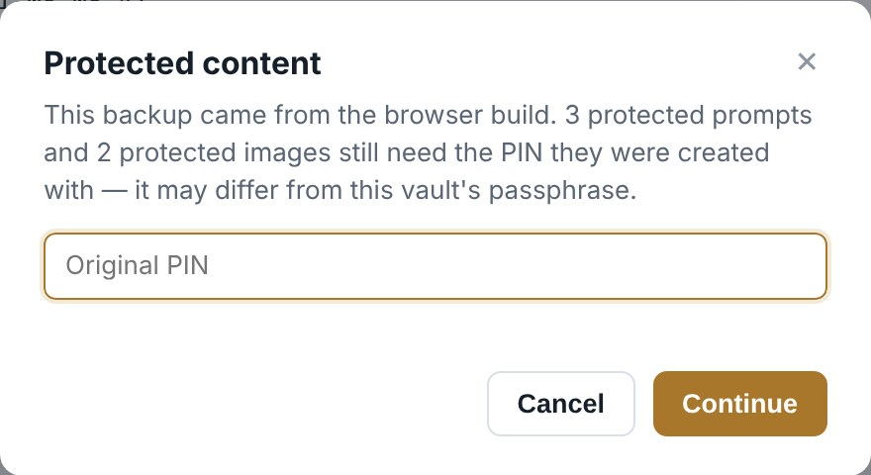
The extra question for a browser-version backup with protected prompts.

The browser version can also open this app’s encrypted backups and even the vault file itself, but it only knows about each card’s primary prompt, not its variants. Do not edit a vault that has variants in the browser version.

The automatic safety copies
Every time the app saves, it first keeps the previous state as promptvault.vault.1, moving the older ones along to .2 and .3. These protect against a crash or a mistake in the last few changes. They are not a substitute for backups: they sit on the same disk, and after three more saves an old state is gone.

Going back to a safety copy
- Close Prompt Vault.
- In the app folder, rename promptvault.vault to promptvault.vault.bad (turn on File name extensions in File Explorer’s View menu if you cannot see the endings).
- Copy promptvault.vault.1 and rename the copy to promptvault.vault. Use .2 or .3 to go further back.
- Start Prompt Vault and unlock with the passphrase that was in use at the time.

Erasing everything
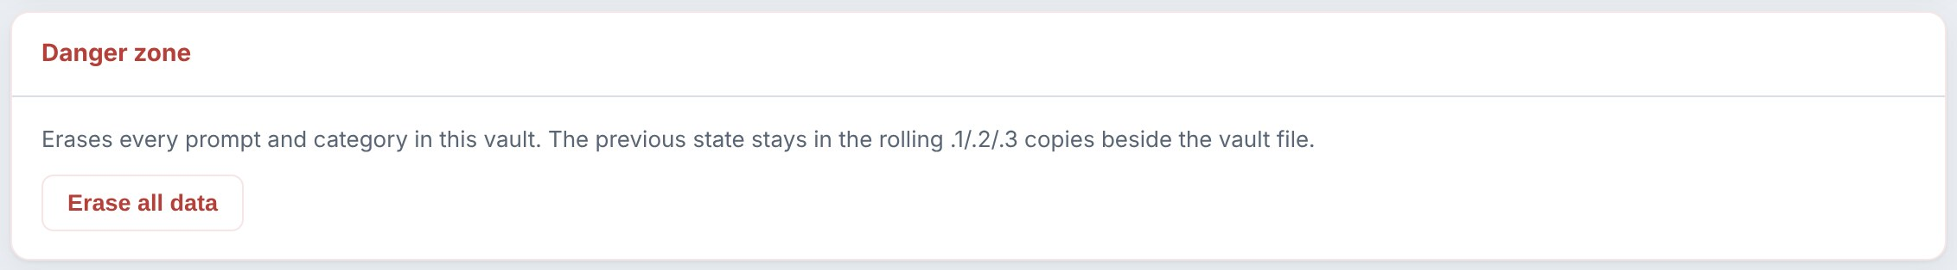
The Danger zone at the bottom of Data & Security.

Erase all data deletes every card and category in the vault after two confirmations. The previous state stays in the .1 safety copy, so it can be recovered as described above until three more saves have happened.

Several vaults
You can keep more than one vault, for example one for client work and one for personal experiments. Each vault is its own encrypted file with its own passphrase, safety copies and backups. One is open at a time.

Choosing a vault when the app opens
The Unlock screen opens the vault you used last. The Vault box above the passphrase lists every vault you have used; pick another before unlocking. The list also offers ＋ Create a new vault… and Open a vault file… (to add an existing .vault file, for example one copied from another PC).

Creating a vault
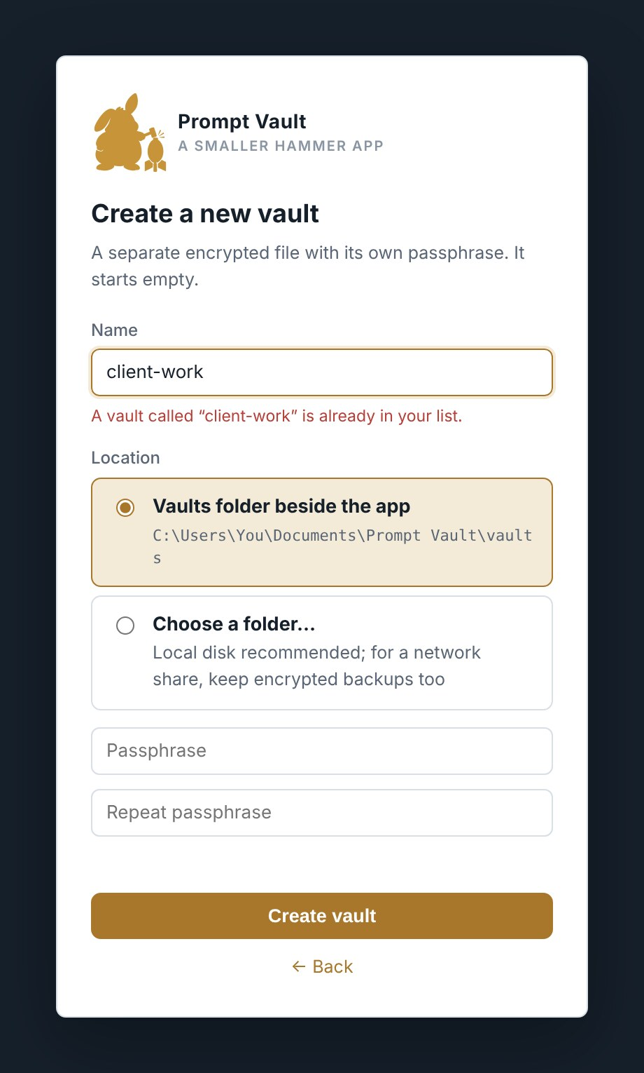
Creating a second vault from the Unlock screen.

- Choose ＋ Create a new vault… in the Vault box (or Switch vault… in the rail, then ＋ Create a new vault).
- Type a name. It becomes the file name, so the line underneath shows the file that will be written. Letters, digits, spaces, - and _ only, up to 60 characters.
- Choose where it goes: the vaults folder beside the app, or a folder you pick.
- Type its passphrase twice and click Create vault. The new vault starts empty and opens.

Switching
Click Switch vault… in the rail. The dialog confirms everything is saved, offers to export an encrypted backup of the vault you are leaving first (ticked when it has changed since its last backup), and lists the other vaults. Pick one and click Back up & switch, or Switch. The other vault’s Unlock screen follows.
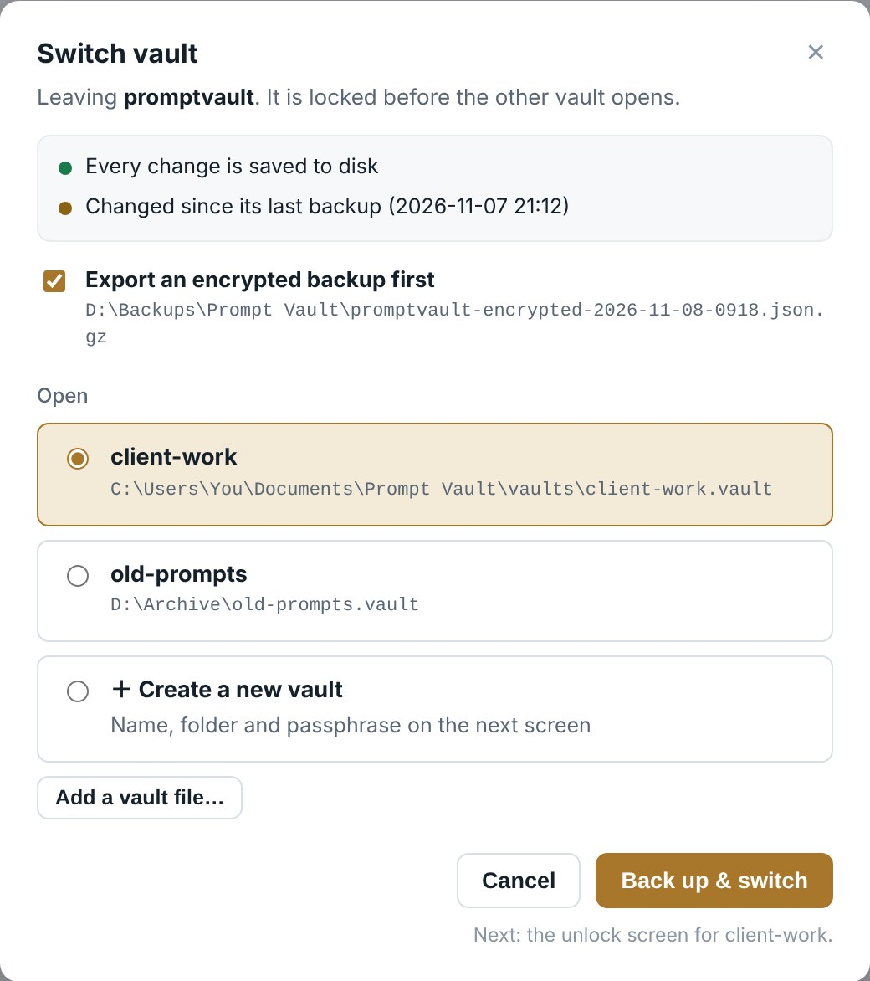
Switch vault. The backup is ticked because this vault changed since its last backup.

If the last save failed, switching is blocked until you retry the save or export a backup, so unsaved work is never left behind by accident.

The Vaults list
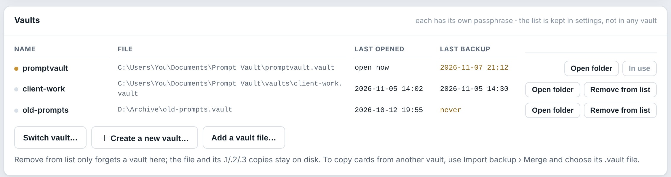
Data & Security › Vaults: every vault, when it was last opened and last backed up. An amber date means changed since that backup.

Open folder shows a vault’s file in File Explorer. Remove from list forgets a vault without touching its file; add it back later with Add a vault file…. The open vault cannot be removed. To rename a vault, close the app, rename the file in File Explorer, then Remove from list and Add a vault file….

Knowing what is stored
The Stored now panel at the bottom of Data & Security reports what is actually on disk, read back from the vault file rather than from memory.
Row | Shows
Prompts | How many prompts, and on how many cards when variants are in use.
Protected / Categories / Reference images | Counts, with images counted across all variants.
Vault file / Last written | The size of the encrypted file and when it was last saved.
In memory | How much the open, decrypted library takes in memory.
Vault path | Where the vault file is.
Previous copies | The .1, .2 and .3 safety copies with their sizes and times.
Key derivation | The encryption settings in use (for reference).
Backup folder / Import folder | The default folders, or ask each time.
Version | The app version and build date.

The red NOT SAVED banner
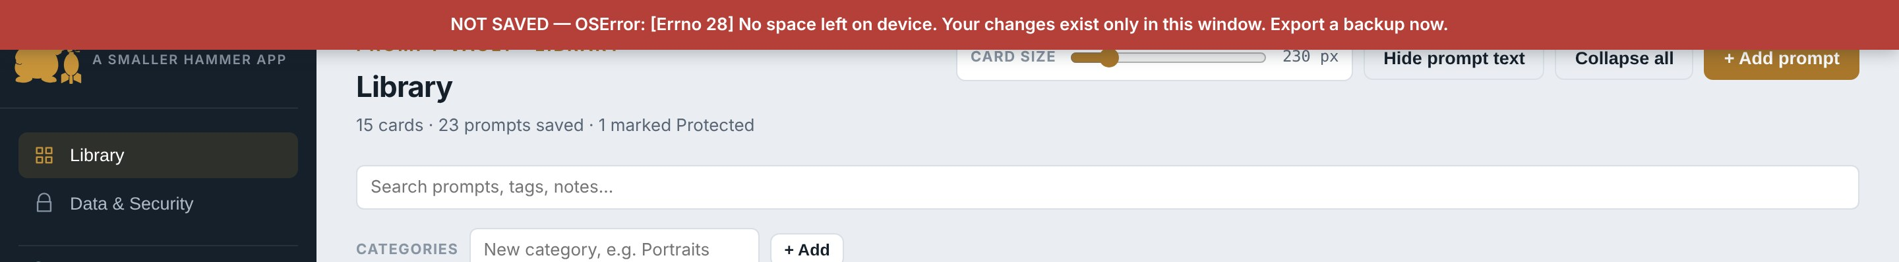
The banner that appears if a save fails.

If saving ever fails, for example because the disk is full or the folder is read-only, a red banner appears across the top of the window and stays there. Your changes still exist in the open window but are not on disk. No success message is ever shown for a save that failed.
- Do not close the app yet.
- Go to Data & Security and export an encrypted backup to a different drive.
- Fix the cause: free some disk space, or check the app folder is not read-only or on a disconnected drive.
- Make any small change, such as moving a card and back. When a save succeeds the banner disappears.

The Saving… pill
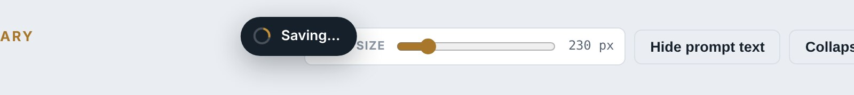
Shown while a save or other slow job is running.

While the app saves, unlocks, re-encrypts or exports, a small pill at the top of the window says what it is doing, and clicks and keys wait until it has finished, so nothing is done twice. With a large vault a save takes a second or two.

Using a vault somewhere else
A vault can live on another drive. Add it with Add a vault file… (see Several vaults); it does not move or copy the file. If its drive is missing when you start the app, the Unlock screen says Vault not found and offers Try again, rather than creating a new vault in its place.

Reference

Keyboard
Where | Key | Does
Unlock screen | Enter | Unlock or create.
Image viewer | ← → | Previous or next picture.
Image viewer | Shift + ← → | Previous or next card.
Image viewer | 1–9, 0 | Jump to variant 1–9, or 10.
Image viewer | Esc | Close.
Add category box | Enter | Add the category.
Combine confirmation | Enter | Add as variant.
Library, with a card pinned | Ctrl + click a card | Queue it on the tray, or take it off.
Editor picture viewer | Esc | Close the full-size picture, keeping the editor open.
Card size slider | Double-click | Reset to 230 px.
Text boxes | Ctrl+C / V / X / A / Z | Copy, paste, cut, select all, undo.

Limits
Thing | Limit
Prompts per card | 10 (the primary plus 9 variants).
Stored picture size | 1280 pixels on the longest edge, JPEG.
Passphrase | At least 4 characters.
Window | At least 900 × 600.
Card size | 180 to 480 px.
Safety copies | The last 3 saved states.
Dragging cards and categories | Mouse or touchpad only.
Image import | PNG files saved with the Prompt Vault Card node.
Vault names | Letters, digits, spaces, - and _, up to 60 characters.
Every save rewrites the whole vault file. With a few hundred pictures that takes a second or two; the app stays usable meanwhile.

Common questions
Question | Answer
The Library is empty after moving the app. | The vault did not come with it, or you are running a different copy. Check promptvault.vault is in the folder beside PromptVault.exe. Stored now shows the vault path in use.
Windows says it protected my PC. | Click More info, then Run anyway. It appears because the program is not signed by a publisher.
The window opens blank or not at all on another PC. | Prompt Vault uses the Microsoft Edge WebView2 component. It is part of Windows 11 and of up-to-date Windows 10. If it is missing, install the Microsoft Edge WebView2 Runtime from Microsoft’s website.
Can two people share one vault? | Not at the same time. One person at a time, with the other warned by the "appears to be open already" message. Two people saving together overwrite each other.
Where are my settings? | promptvault-settings.json in the app folder. Deleting it resets display options and default folders; it holds no prompts.
How do I make a card show a different variant first? | Edit the card, select that variant’s tab, click Make primary, save.
I combined two cards by mistake. | Edit the card, select the moved variant, click Split to own card, save.
I dropped a picture and nothing filled in. | The picture has no Prompt Vault data. Only PNGs saved with the Prompt Vault Card node carry it; a picture re-saved by another program or converted to JPEG loses it.
Clicking a link in the credit does nothing. | On purpose: Prompt Vault never opens a connection. Use Copy beside the link and paste it into your browser.
How do I copy cards from one vault to another? | Open the vault that should receive them, then Import backup › Merge with the other vault’s file and its passphrase.

Licence
Prompt Vault Desktop is released by Smaller Hammer under the MIT Licence. You may use, copy, modify and redistribute it, including commercially, provided the copyright notice and licence text travel with it. The software is provided without warranty of any kind. The full terms are in the LICENSE file.
Example prompts by cupajoelite (https://civitai.com/user/cupajoelite), used with permission; sample pictures rendered from them by Smaller Hammer.
This guide describes Prompt Vault Desktop v7.1, build 2026-11-08, and the Prompt Vault Card nodes v1.2.0. Guide v3.

