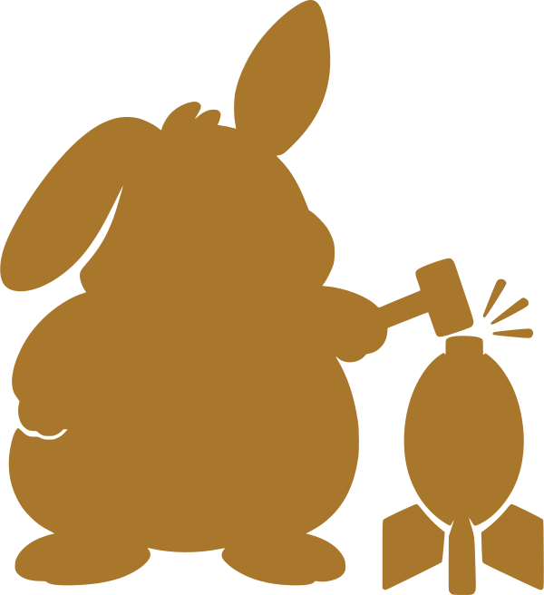

Prompt Vault
User Guide
A SMALLER HAMMER APP
Application v4.2 · build 2026-09-13
Guide v1

Contents
Contents 2
Start here 3
Opening the app 3
The two screens 3
Saving a prompt 3
The fields 3
What happens to the reference image 4
The aspect ratio line 4
Finding things again 4
Categories 4
Tags 5
Search 5
Protecting sensitive prompts 5
How the PIN works 5
Locking, unlocking, changing 5
Backups 5
The two export formats 6
Importing 6
Moving to a new computer 6
Knowing what is actually stored 6
If a red banner appears 6
Reference 7
Keyboard 7
Limits worth knowing 7
Files in the folder 7
Licence 7

Start here
Prompt Vault stores the text prompts you write for image generators, together with the picture each one produced, so you can find a prompt again months later instead of scrolling back through a chat log.
It is a single HTML file. There is no installation, no account, and no server. Open the file in your browser and it runs. Everything you save stays on the computer you saved it on.

Opening the app
- Keep all four files in the same folder: the app file, latest.js, PromptVault.html, and LICENSE.
- Double-click PromptVault.html. It reads latest.js and forwards you to the current version automatically.
- Bookmark that page. The bookmark keeps working when a new version arrives, because only latest.js changes.
Open the same file every time
Your data is tied to the exact file path. Renaming the folder, moving the app to another drive, or opening a second downloaded copy will all show you an empty library — the old data is still there, under the old path.
Use the bookmark, and if you must move things, export a backup first.

The two screens
The rail down the left side has two entries. That is the whole application.
Screen | What it is for
Library | Every prompt you have saved, grouped into categories, with search and tag filters.
Data & Security | Backups, the PIN that protects sensitive prompts, and a panel showing exactly what is stored.
+-------------+------------------------------------------------------+
| [logo] | Library Collapse all + Add |
| Prompt | +------------------------------------------------+ |
| Vault | | Search prompts, tags, comments... | |
| | +------------------------------------------------+ |
| > Library | Categories: [+ new] [Roll up all] Portraits * x |
| > Data | Tags: landscape portrait demo |
| | |
| [Unlock] | v Portraits ..................................... 3 |
| | +------+---------------------------------------+ |
| v4.2 | | img | prompt text... [Protected] | |
| | | 52px | Copy | Category v | Edit | x | |
| | +------+---------------------------------------+ |
+-------------+------------------------------------------------------+
The Library screen, top to bottom.

Saving a prompt
Click + Add prompt at the top right of the Library. The form that opens is the same one you will use to edit a prompt later.

The fields
Field | Notes
Positive prompt | Required. The prompt itself. The box is twelve rows tall and can be dragged larger.
Negative prompt | Optional. What you told the generator to avoid.
Reference image | Optional. The picture this prompt produced. See below for what happens to it.
Seed | Optional. Stored as text, not as a number, so very long seeds keep every digit.
Width / Height | Optional. A live Ratio line underneath shows the exact aspect ratio as you type.
Category | Which folder in the Library this prompt belongs to. Can be changed later without opening the form.
Tags | Comma-separated. Suggestions from tags you have used before appear as you type.
Comments | Anything you want to remember: what worked, what to try next.
Protected | Encrypts this prompt behind your PIN. Covered in its own chapter.

What happens to the reference image
The image is resized in your browser before it is stored: the long edge is capped at 640 pixels and it is re-encoded as a JPEG. This is deliberate. The stored picture is a visual reminder of what the prompt produced, not an archival copy of your original render — keep the full-resolution file wherever you normally keep it.
Clicking a thumbnail in the Library opens it full size, uncropped. The arrows either side step through the other images in the same category, and respect whatever search or tag filter you currently have applied.

The aspect ratio line
The ratio shown under Width and Height is exact, reduced by greatest common divisor. An image of 896 × 1152 reports 7:9 rather than being rounded to a familiar figure like 3:4. If the number looks unfamiliar, that is the true ratio of the numbers you entered.

Finding things again
Three mechanisms overlap here, and they do different jobs. Understanding which is which saves a lot of reorganising later.

Categories
A category is a folder. Each prompt sits in exactly one, or in none — those collect in an Uncategorized group at the bottom. Add categories from the row under the search box; the pencil renames and the cross deletes.
- Click a category name to jump straight to it and expand it.
- Drag the grip handle on a category card to reorder the Library. The order you set is saved.
- Roll up all, closes everything for a quick overview. Collapsed cards still preview up to four thumbnails.
Reordering needs a mouse
Category drag-and-drop uses the browser’s native drag support, which does not respond to touch. On a phone or tablet you can use every other feature, but not reordering.

Tags
Tags are free-form and a prompt can carry as many as you like. They exist for filtering, and they are unrelated to categories — a prompt tagged "portrait" can live in any category you please.
The tag row under the search box filters cumulatively. Selecting two tags shows only prompts carrying both, not either.

Search
The search box matches prompt text, tags and comments as you type. While a search or tag filter is active, every category containing a match opens automatically and the rest are hidden. Clearing the filter restores whatever you had expanded or collapsed by hand — the filter never overwrites your own arrangement.

Protecting sensitive prompts
Ticking Protected on a prompt encrypts it. The prompt text, negative prompt, seed, dimensions, tags, comments and image are all encrypted together; only the category is left readable, which is what lets a locked prompt still appear in the right place in your Library.

How the PIN works
The first time you protect something you will be asked to create a PIN. It is a passphrase rather than digits — any characters, four or more, no maximum length.
- The PIN itself is never stored anywhere, in any form.
- An encryption key is derived from it each time you unlock, and checked against a stored verifier.
- Unlocking lasts for the browser session. Closing the tab locks everything again.
There is no recovery
Because the PIN is never stored, nobody can reset it for you and no support process exists. A forgotten PIN means the protected prompts are unreadable permanently, including the copies inside your backups.
Choose something you will remember, and keep in mind that protected prompts are the one part of this app that a backup cannot rescue you from.

Locking, unlocking, changing
All three live on the Data & Security screen. Lock now clears the decrypted copies from memory immediately. Change PIN re-encrypts everything currently unlocked under a new key, so it only appears while you are unlocked.
There is currently no way to remove protection from a prompt in bulk or to turn the PIN off entirely. You can untick Protected on an individual prompt while unlocked.

Backups
This is the only durable copy
Browser storage is not permanent. It is tied to the file path, it can be cleared by browser settings, and the images can be discarded by the browser if the disk runs short.
Export a backup after any session where you added something you would mind losing.

The two export formats
Format | What it protects
Export backup | Everything, compressed. Prompts you marked Protected stay encrypted inside it; everything else is readable by anyone who opens the file.
Export encrypted backup | Everything, compressed and then encrypted with your PIN — including prompts that were not marked Protected. Unreadable without the PIN.
Both produce a .json.gz file. Import accepts either and works out which it is from the file itself, so you never have to remember which button made it.

Importing
Import replaces your library rather than merging into it. Importing an encrypted backup asks for the PIN it was exported with, which may be different from the PIN currently set on this machine.
A backup is self-contained: it carries its own encryption parameters, so it can be imported into a completely fresh browser on another computer with nothing but the PIN.

Moving to a new computer
- Export a backup on the old machine.
- Copy the app folder and the backup file across.
- Open the app on the new machine and import the backup.
- If you use protection, unlock once so the protected prompts and their images are restored.

Knowing what is actually stored
The Stored now panel at the bottom of Data & Security reports what is on disk right now. The figures are read back out of storage rather than calculated from what is on screen, so they tell you what a reload would really find.
Row | Meaning
Prompts / Protected | How many prompts exist, and how many are encrypted.
Categories | Library folders defined.
Reference images | Images held in the image store.
Metadata | Size of the text half of your data, held in browser localStorage.
Images | Size of the image half, held in IndexedDB.
Storage key | Where the text half lives, for troubleshooting.
Image store | Whether the image store opened successfully in this browser.
Version | The app version and build date you are running.
Prompts and images are stored separately on purpose. Browser text storage is capped at a few megabytes and is shared between every local page you open, so images kept there would fill it and quietly break other tools. Images therefore live in a second store measured in gigabytes.

If a red banner appears
A red bar across the top of the window means a save failed. Your changes exist in the open tab and nowhere else, and closing it will lose them. Export a backup immediately, then investigate. The banner stays until a save succeeds; it cannot be dismissed, because dismissing it would hide the one thing you need to know.

Reference

Keyboard
Key | Where | Does
Escape | Anywhere | Closes the open dialog.
← → | Image viewer | Steps to the previous or next image in the same category.
Enter | Category and tag inputs | Confirms what you typed.

Limits worth knowing
- Category reordering is mouse-only; touch devices cannot drag.
- Copy copies the positive prompt only — not the negative prompt, seed or dimensions.
- A forgotten PIN cannot be recovered, and protected prompts cannot be bulk-unprotected.
- Aspect ratios are exact, never rounded to a common ratio.
- Reference images are capped at 640 pixels on the long edge.

Files in the folder
File | Purpose
PromptVault.html | The stub you open and bookmark. Never changes.
latest.js | One line naming the current version. Updated with each release.
PromptVault_v4.2.html | The application itself. A new file arrives with each version; old ones can be kept or deleted.
LICENSE | MIT licence text.

Licence
Prompt Vault is released by Smaller Hammer under the MIT Licence. You may use, copy, modify and redistribute it, including commercially, provided the copyright notice and licence text travel with it. The software is provided without warranty of any kind. The full terms are in the LICENSE file.

