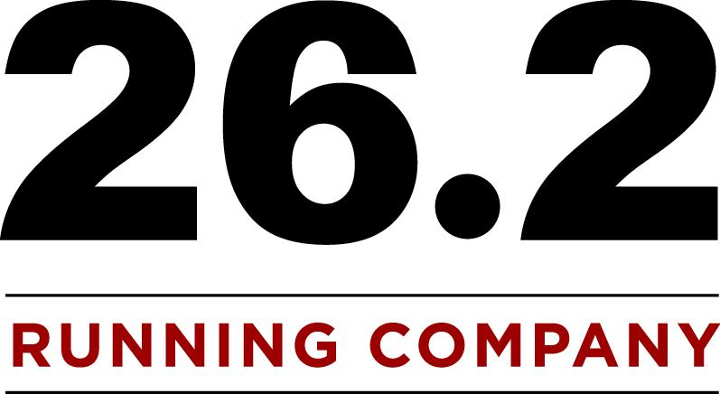

Race Equipment Rental Packages

Complete Timing Package: $500.00

- Registration on-line on runthatrace.com
- Coupons to put in goodie bags
- Computers, printer and scanners for race registration, timing, and results
- 26.2 RunningCo.Employee’s to help Set up/ take down equipment and time results.
- Preliminary results given after the first 100 runners or 40 minutes of race time whichever comes first.
- Overall results given after final runner crosses finish line.
- Equipment only $100
  - Access to all race equipment
  - Professional Clock & Stand
  - Finish Line Banner and Stand
  - Small and Large Cones
  - Mile Markers
  - Finish Chute
  - Starter Horn
  - Measuring Wheel
  - Slow Caution Signs
  - Registration Banner
  - Generator
Equipment Only Package: $300.00

- Access to all race equipment
  - Professional Clock & Stand
  - Finish Line Banner and Stand
  - Small and Large Cones
  - Mile Markers
  - Finish Chute
  - Starter Horn
  - Measuring Wheel
  - Slow Caution Signs
  - Registration Banner
  - Generator
Sponsorship Timing Package: $250.00

- If race will give 26.2 RunningCo. access to put a logo on the race T-shirt and have access to publicize at the race via flyers in bags, banner display, etc. You’ll get the great rate of the sponsorship package!
- Includes all accommodations of the Complete Timing Package at HALF PRICE! Includes all listed below for only 250 dollars!
- Registration on-line on runthatrace.com
- Coupons to put in goodie bags Computers, printer and scanners for race registration, timing, and results
- 26.2 RunningCo. Employee’s to help Set up/ take down equipment and time racers for results.
- Preliminary results given after the first 100 runners or 40 minutes of race time whichever comes first.
- Overall results given after final runner crosses finish line.
- Equipment only $100
  - Access to all race equipment
  - Professional Clock & Stand
  - Finish Line Banner and Stand
  - Small and Large Cones
  - Mile Markers
  - Finish Chute
  - Starter Horn
  - Measuring Wheel
  - Slow Caution Signs
  - Registration Banner
  - Generator

91 East 100 North•American Fork•UT•(801) 756-4747

