

**BUSINESS ADMINISTRATION DEPARTMENT**

**SUBJECT: PRINCIPLES OF ACCOUNTING (ACC101)**

**SUMMER 2020**

**GROUP ASSIGNMENT**

**Teacher : Giang Thị Minh Thảo**

|  |
| --- |
|  |
| **Class : IS1317** |
|  |
|  |
|  |

**Student Information**

|  |  |  |  |
| --- | --- | --- | --- |
| **Name 1:** | **Nguyễn Văn Đạt** | **Roll number:** | **HE130670** |
| **Name 2:** | **Kiều Minh Đức** | **Roll number:** | **HE130998** |
| **Name 3:** | **Trần Minh Quý** | **Roll Number** | **HE130415** |
| **Name 4:** | **Nguyễn Hữu Đạt** | **Roll Number** | **HE130427** |

# **The company’s business operations**

1. Contact

* Name : Viet Nam National Petroleum Group
* Abbreviation : Petrolimex
* Stock code : PLX
* Address : o. 1 - Kham Thien Quarter - Kham Thien Ward - Dong Da District - Ha Noi City
* Telephone : (84.24) 3851 2603
* Fax : (84.24) 3851 9203
* Email : [banbientapweb@petrolimex.com.vn](mailto:banbientapweb@petrolimex.com.vn)
* Website : [http://www.petrolimex.com.vn](http://www.petrolimex.com.vn/)

1. Listing

* Exchange: HOSE
* Sector: Wholesale Trade
* Industry: Merchant Wholesalers, Nondurable Goods
* Listing date: 04/21/2017
* Chartered capital: 12,938,780,810,000
* Listed shares: 1,293,878,081
* Shares outstanding: 1,218,813,235

1. Business Reg.

* Status: Operating
* Tax code: 0100107370
* Establishment license: 224/TTg
* Issued date: 04/17/1995
* Business license: 0100107370
* Main business scope:

- Manufacturing and trading in: petroleum, petrochemical products, liquefied gas

- Transportation and petroleum services

- Construction of petroleum, refining and petrochemical works

- Invest capital in other businesses to do business in the business lines that Petrolimex is doing.

1. Milestones

* 17/04/1995: Vietnam National Petroleum Corporation was established under the Decision No.224/TTg issued by the Prime Minister of Vietnam Government
* 20/11/2011: Vietnam National Petroleum Group (Petrolimex) was established and put in operation under the model of a joint stock company
* 28/07/2011: Initial Public Offering (IPO) was launched at Hanoi Stock Exchange (HNX)
* 17/08/2012: Became a public company under the Document No.2946/UBCK-QLPH issued by the State Securities Commission of Vietnam
* 14/04/2017: Listed on Ho Chi Minh Stock Exchange (HOSE)
* 21/04/2017: Traded on Ho Chi Minh Stock Exchange (HOSE)

1. Business information

* Business registration standards thong thrimg : 12 months
* Structure : Parent company(Viet Nam National Petroleum Group) and member companies
* Market share : Viet Nam (all of country)
* Key success factors in the industry:
* To ensure petrol and oil for remote and deep-lying areas
* Going further in key economic region
* The imprint from the product other than petroleum
* Human factors

1. Members (31/12/2019)

* Member companies:
* 55 Subsidiaries (43 owned and 12 other)
* 9 Joint venture companies
* Staff members: 24.009 staffs

1. Company’s prizes and awards

* Group:
* First Class Independence Medal (Decision No. 2601 / QD-CTN dated November 24, 2015) for the second time on January 12, 2016
* Ho Chi Minh Medal (Decision No. 439/2006 / QD-CTN dated 31.3.2006 & received photo 1, 2)
* Independence Medal (classes)
* Labor Medal (classes)
* Victory Medal (classes)
* Labor Hero Title (Decision No. 1121/2005 / QD-CTN dated September 29, 2005)
* Title Hero of the People's Armed Forces (Decision No. 371/2006 / QD-CTN dated March 17, 2006 & received photo)
* Person:

1. Mr. Le Van Thiem - Labor Hero title
2. Mr. Nguyen Ba Huu - Labor Hero title
3. Mrs. Nguyen Thi Ngoc Thu - Labor Hero title (Decision No. 1121/2005 / QD-CTN dated September 29, 2005)

# **Overall financial statements**

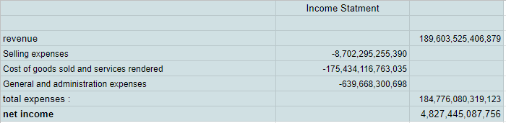

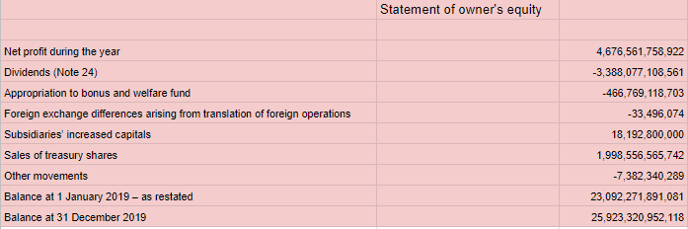

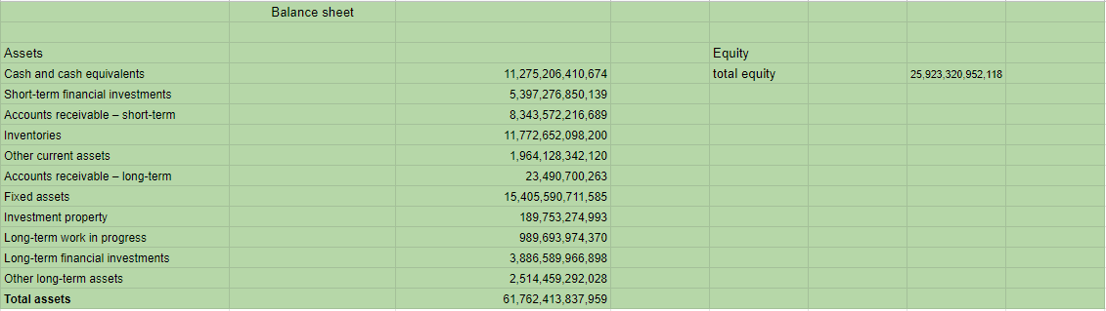

1. Content of the financial statement
   1. Assets
      * Cash and cash equivalents
      * Short-term financial investments
      * Accounts receivable – short-term
      * Inventories
      * Other current assets
      * Accounts receivable – long-term
      * Fixed assets
      * Investment property
      * Long-term work in progress
      * Long-term financial investments
      * Other long-term assets
   2. Liabilities
      * Current liabilities
      * Long-term liabilities
   3. Capital expenditure
   4. Depreciation of tangible fixed assets
   5. Amortisation of intangible fixed assets
   6. Depreciation of investment property
   7. Total net revenue
      * In which: Internal revenue
      * Net revenue from external sales
   8. Operating expenses
      * Cost of goods sold and services rendered
      * Selling expenses
      * General and administration expenses
   9. Operating profit (before financial activities)
      * Share of profit in associates and joint ventures
      * Financial income
      * Financial expenses
      * Results of other activities
   10. Accounting profit before tax
       * Income tax expense – current
       * Income tax benefit – deferred
   11. Net profit after tax
2. Company audit
   1. Auditor
      * Phan My Linh
   2. Type of audit opinion
      * 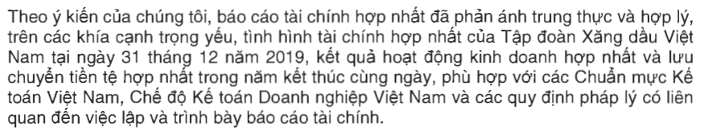
   3. My opinion
      * Through the opinion of the auditor, I believe that the financial statements of the company are honest, accurate and reliable.
      * I am an investor, I will believe in the transparency and honesty of the information in the financial statements because this financial statement have audited by an well-know audit company and receive Unqualified opinion-clean report from auditor.
   4. Summary of significant accounting policies

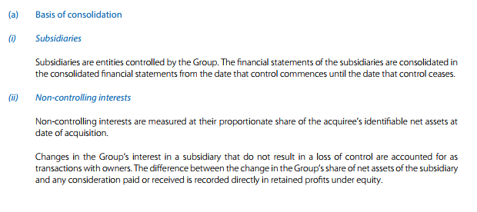

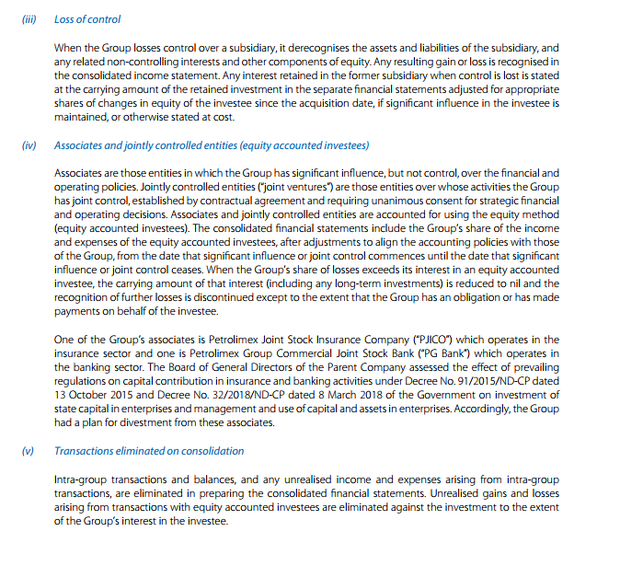

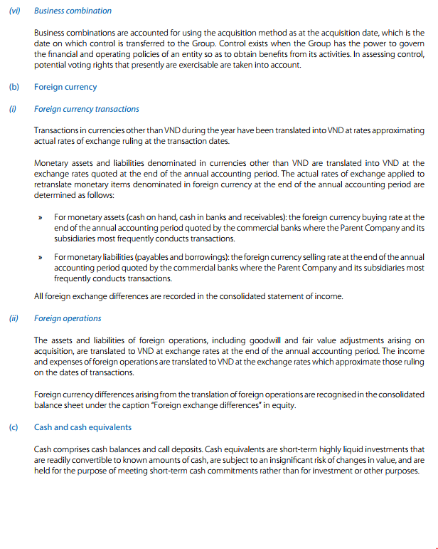

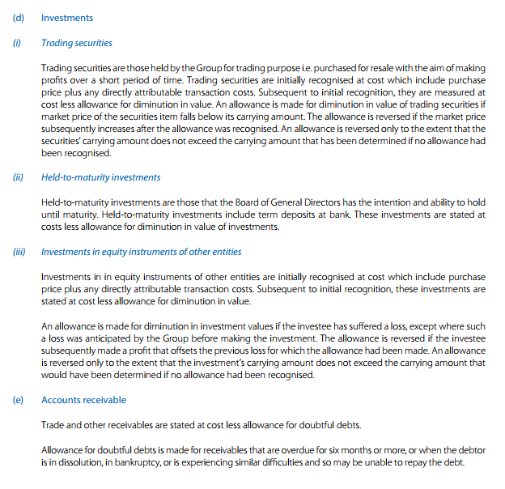

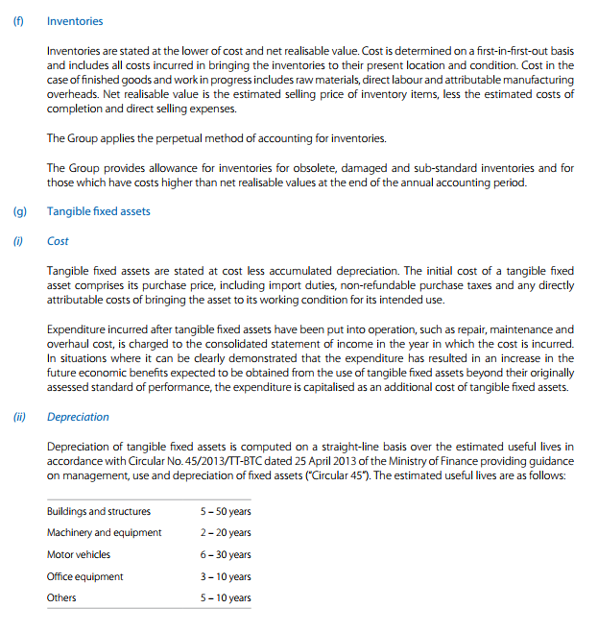

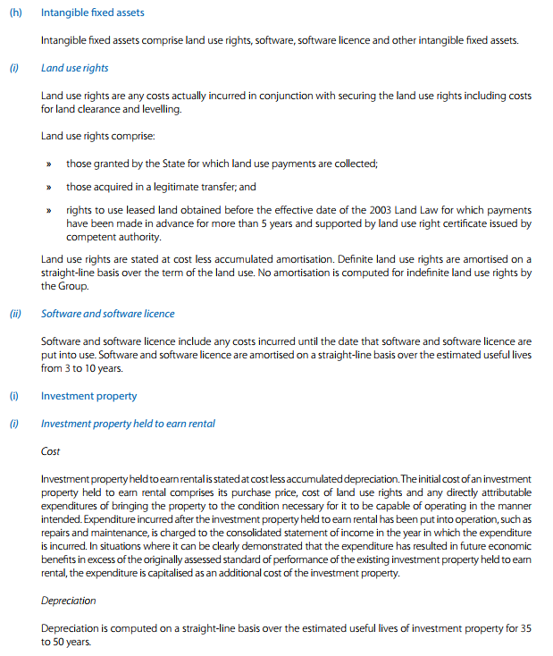

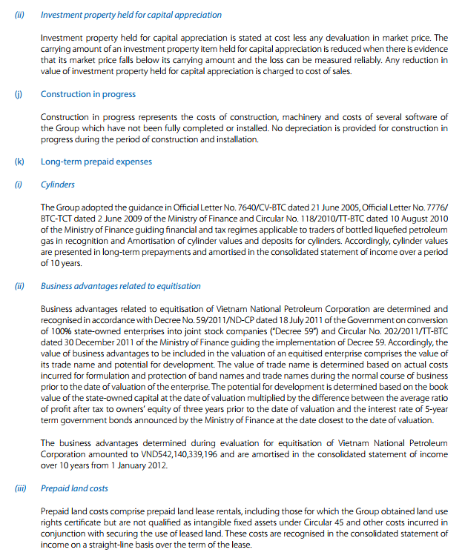

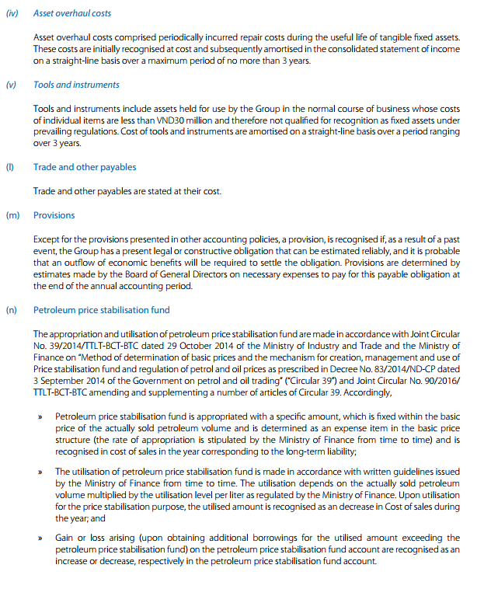

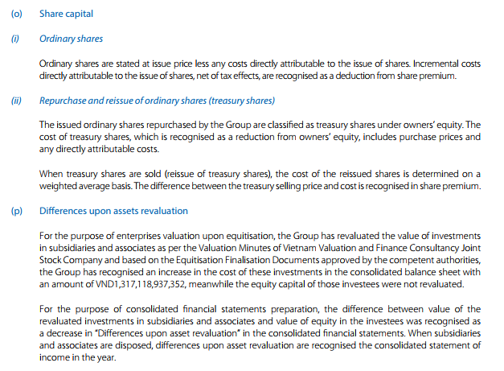

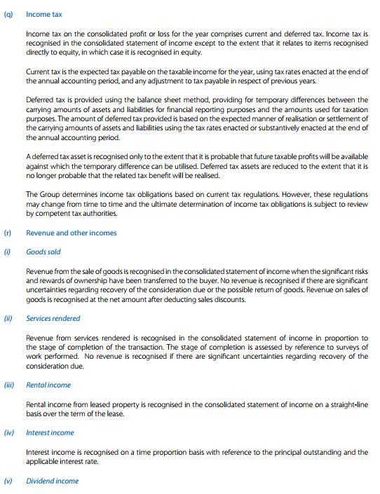

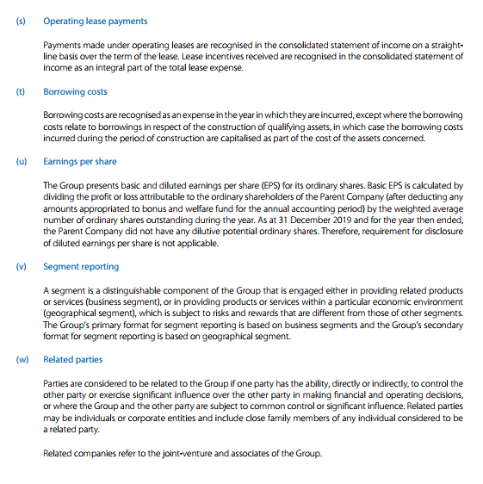

# **The detailed figures in the financial statements**

· - Balance sheet items:

* Cash and Cash equivalents

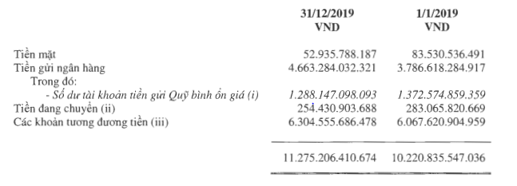

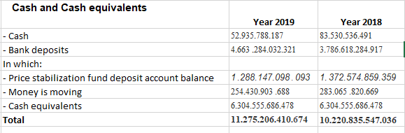

* Short-term accounts receivable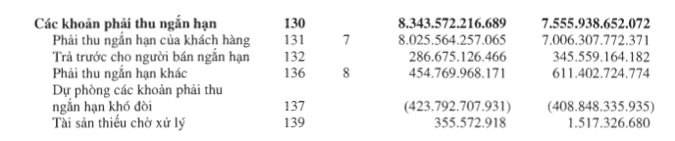

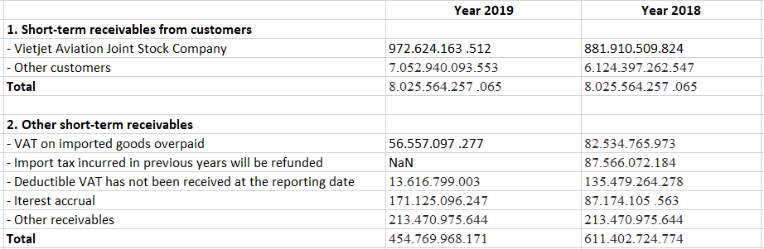

* Inventory (if any)

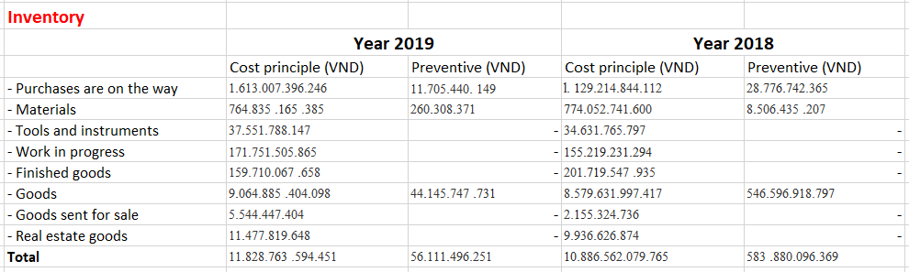

* Other short-term assets

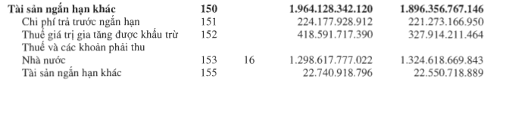

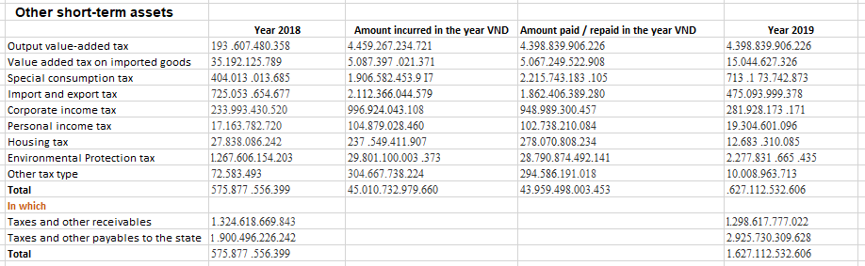

* Long-term assets

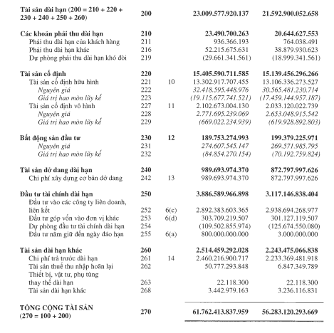

* Short-term liabilities

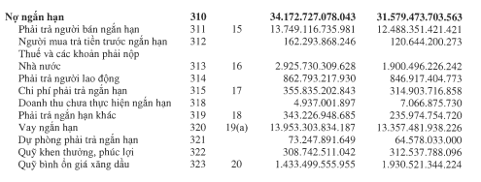

* Long-term liabilities

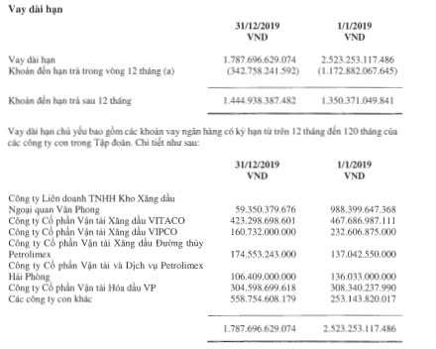

* Equity

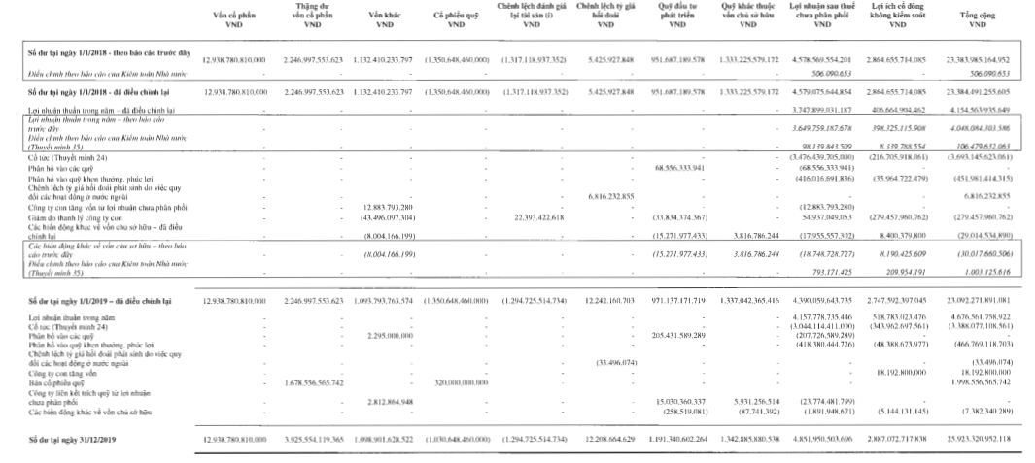

· - - Income statement items:

* Revenue

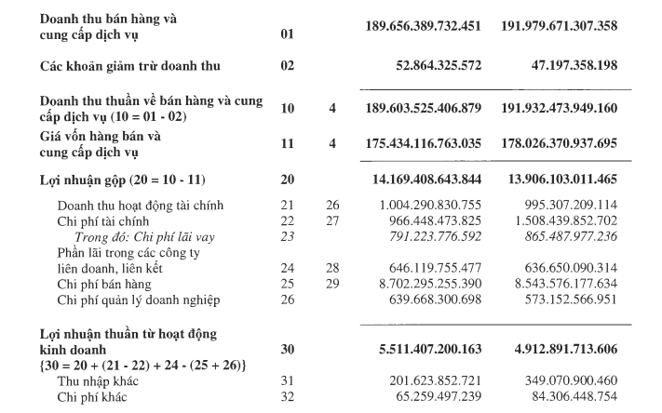

* Cost of goods sold



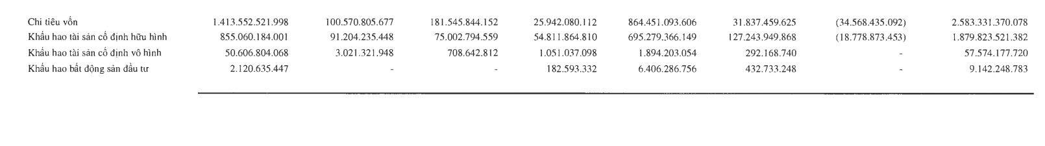

* Selling expense

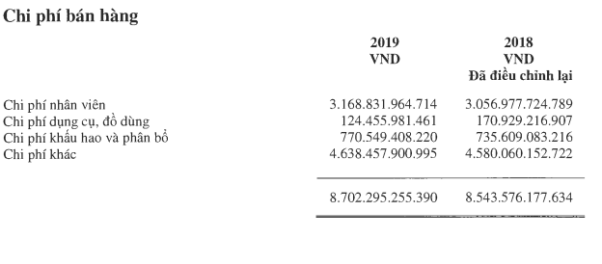

* General and administrative expense



# **Assess the performance**

1. Calculate the percentage change of net revenue*, cost of goods sold*, selling expenses*, general and administrative expenses*, and net income* in the recent two years. Then comment on the how these numbers changed (improving or declining), and how the company’s business performance changed (better or worse).

* Percentage change of net revenue / net sales : -1.21%
* Percentage change of cost of goods sold : -1.46%
* Percentage of selling expense : 1.87%
* Percentage change of general and administrative expenses:11.61%
* Percentage change of net income : 12.56%

=> **Comment** :In spite of the net revenue being mitigated but the net income is strongly increased. It shows the financial status of Petrolimex is stably developing. The numbers also present that the performance of the company is improving.

1. Calculate the percentage of the following in terms over net revenue: cost of goods sold*, selling expenses*, general and administrative expenses*, and net income* in the recent two years. Then comment on how these numbers changed (improving or declining), and how the company’s business performance changed (better or worse). (E.g.: Cost of goods sold/Net sales = ?%).

In 2019 :

* Cost of goods sold ratio : 92.53%
* Selling expenses ratio : 4.59%
* General and administrative expenses ratio : 0.34%
* Net income ratio : 2.47%

In 2018 :

* Cost of goods sold ratio : 92.75%
* Selling expenses ratio : 4.54%
* General and administrative expenses ratio : 0.32%
* Net income ratio : 2.16%

=> **Comment** : All the changes of numbers above are trivial. In my point of view, The company’s business performance is stable.

1. Calculate and assess the gross margin* for the two most recent years. Then comment on how the gross margin changed (improving or declining), and how the company’s business performance changed (better or worse).

In 2019 :

* Gross Profit Margin : 7.47%

In 2018 :

* Gross Profit Margin : 7.25%

=> **Comment** : The gross of profit margin is increased (~0.22%). This number shows that the company's business performance is improving.

1. From the above calculations, give your overall comments on whether net income improved or declined over the years and explain the primary cause of the change. (Look at your calculations from two points above, for example, did the gross margin on their products or services change? Or did revenues/ expenses change? Or did they have any unusual gains or losses that contributed to the overall change in net income?)

The numbers above is a comparative analysis of the performance of the company. The primary business activity of this company is distributing processed fossil fuel (gasoline, fuel, ect…). Because of that, the ratio of cost of goods sold over net revenue is high (~ 92%). The gross profit margin slightly raised about ~0.22% and the percentage change of cost of goods sold decreased about ~(1.46)% are the reason why revenue of Petrolimex might be mitigated but the net income reached 11.61% of growth. To conclude, Petrolimex in 2019 is significantly improving.

# **Assess the financial situation**

1. percentage of each asset as compared to total assets

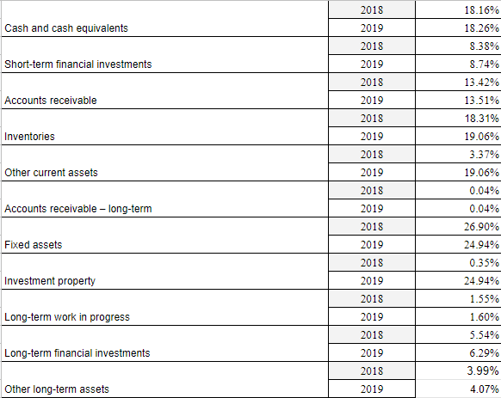

1. percentage of liabilities and equity of the company for the recent two years as compared to total assets

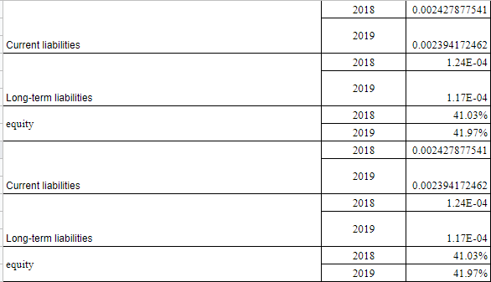

A . This company rely more on equity

B. the change for recent two yeah is slight up

C. I don’t worry. Because total liabilities is very small(~0.0024%) and equity is grow

# **Assess the profitability**

|  |  |  |
| --- | --- | --- |
| **Profitability** | **2018** | **2019** |
| Profit margin | 0.02165 | 0.02467 |
| Percentage change of Profit margin (%) | 13.95 % | |
| Return on Assets (ROA) | 0.07382 | 0.07572 |
| Percentage change of ROA (%) | 2.57 % | |
| Return on Equity (ROE) | 0.07970 | 0.08192 |
| Percentage change of ROE (%) | 2.79 % | |

Table 4.0 The profitability for each year 2018 and 2019

# **Conclude by briefly explaining whether you would recommend investing in your chosen firm and why.**

* Look at this statistical data from a safe investor perspective, I will invest in this company. Reason:
* Vietnam National Petroleum Corporation (Petrolimex, code PLX) said that in 2019, the Group achieved a consolidated profit before tax of VND 5,486 billion, an increase of 9% compared to 2018. Sales volume was over 13.6 million m3 / ton. , up 5.9%.
* 2019 is the third consecutive year that Petrolimex has held the position of the revenue champion in the Top 50 best listed companies in Vietnam ranked by Forbes Vietnam and in the Top 10 most valuable brands in Vietnam as announced by Forbes Vietnam. Brand Finance.