Automated Spindle Dynamics Identification Using a Self-Mounted Gauss Exciter and Inverse Receptance Decoupling
Guseon Kang, Dong Yoon Lee, Simon S. Park
Abstract
Accurate spindle dynamics are essential for tool-tip frequency-response prediction and chatter analysis, yet conventional impact testing is operator dependent and difficult to automate. This study presents a self-mounted Gauss exciter for automated in-situ spindle identification. A pulsed electromagnetic coil launches a ferromagnetic projectile to generate repeatable point impacts within an automatic-tool-changer-compatible module. Because the attached module alters the dynamics being measured, its independently characterized receptances are removed through inverse receptance coupling to recover the spindle-side receptance. The recovered dynamics are coupled with cutting-tool models for tool-point prediction and milling-stability analysis, and are validated against conventional impact tests and cutting experiments.
Keywords: dynamics, chatter, excitation, receptance coupling, identification

1. Introduction
The dynamic behavior of the spindle-tool assembly governs machining stability, surface finish, tool life, and achievable material-removal rate. In milling, tool-tip frequency response functions (FRFs) are particularly important because they provide the structural input required for chatter-stability prediction [1-4]. Receptance-coupling approaches can efficiently synthesize tool-point dynamics for different tool geometries, but their practical accuracy depends on reliable identification of the spindle-side receptance at the coupling interface [2-4,9].
Obtaining this spindle-side information remains a practical bottleneck. Conventional impact-hammer testing is flexible and widely used, but the applied impulse depends on operator skill, impact angle, and accessibility of the measurement location. Repeating the test after tool changes, setup modifications, or machine-state changes is therefore difficult to integrate into a routine production workflow. Electromagnetic impulse excitation has been reported as a means to reduce operator dependence [5], yet automated deployment becomes more challenging when the excitation device must be carried by the machine tool itself rather than positioned externally.
A self-mounted exciter creates a fundamental measurement problem. The device that enables autonomous excitation also adds mass, compliance, and its own structural dynamics to the spindle assembly. Consequently, the directly measured FRF belongs to the spindle-holder-module assembly rather than to the uninstrumented spindle-side structure required for receptance-based tool prediction. An automated identification system must therefore provide repeatable excitation while also separating the dynamics of the measurement device from those of the spindle.
To address this limitation, this study proposes an automated in-situ dynamic identification approach that combines a tool-holder-integrated Gauss exciter, accelerometer-based response measurement, and inverse receptance coupling. The system is designed for compatibility with automatic tool changer operation, enabling automated deployment on the machine tool without manual intervention. Compared with conventional manual excitation methods, the proposed Gauss exciter provides a pulsed coil accelerates a ferromagnetic striker, which subsequently generates a point impact on the target and direct synchronization with data acquisition. Mounting the exciter on the tool holder, however, introduces two issues that are absent in bench-top impulse devices [7,8]: the module adds its own mass and compliance to the spindle, such that the measured receptance represents the spindle–module assembly rather than the spindle alone; and the small electromagnetically launched projectile produces a much shorter contact duration than a hammer tip, causing its spectral energy to extend beyond the frequency band of interest and preferentially excite parasitic modes of the module. In this work, the first issue is addressed by inverse receptance coupling, while the second is addressed using a Hertzian-designed soft contact interface that confines the excitation energy to the desired frequency band (<3kHz).
The objective of this work is to establish a practical method for repeated spindle dynamic identification directly on the machine tool. The novelty lies in integrating automated, repeatable, and bandwidth-shaped Gauss excitation, module-dynamics compensation, and spindle-dynamics reconstruction within a single ATC-compatible framework. The identified dynamics are further used for tool-point receptance prediction, chatter stability analysis, and periodic tracking of spindle-condition changes over time. The resulting framework provides an operator-independent approach for repeatable spindle dynamic identification and extends receptance-based analysis toward practical shop-floor implementation.

2. Methodology and experimental setup
The measurement module is mounted below the spindle-holder assembly and combines a Gauss exciter, an impact target, and a structural-response sensor. A capacitor-discharge pulse accelerates a small steel projectile through a guide barrel. The projectile strikes the target and separates after impact, producing transient point excitation rather than continuous forcing. The excitation sequence can be initiated electronically and repeated without operator intervention. Figure 1 summarizes the identification concept.
The measurement architecture is intentionally self-mounted to support automatic deployment. This creates the central identification challenge of the study: the measured receptance G_mm belongs to the spindle-holder-module assembly rather than to the spindle-side structure alone. The module is therefore treated as a removable dynamic substructure. Its free-free receptances are characterized independently and used in IRC to reconstruct the spindle-side receptance G_s at the coupling interface. Once G_s is available, conventional receptance coupling combines it with a cutting-tool substructure to synthesize the tool-point FRF G_11,est. The synthesized FRF is then used for stability-lobe construction and is independently compared with direct tool-tip impact measurements and milling tests.
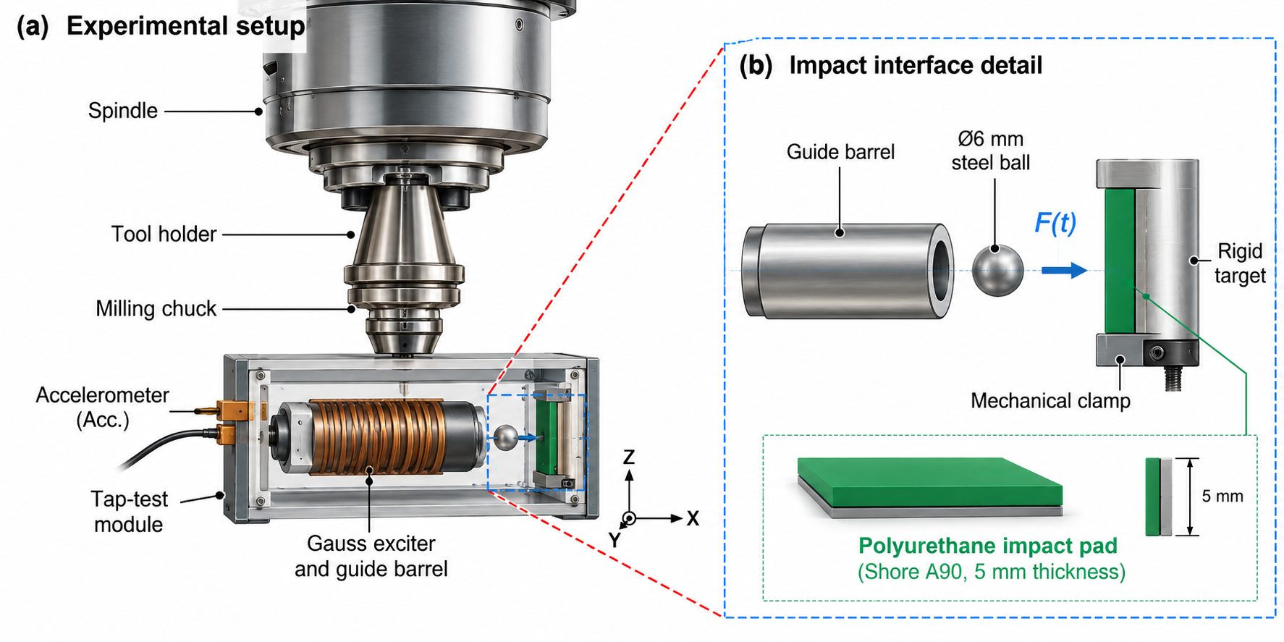
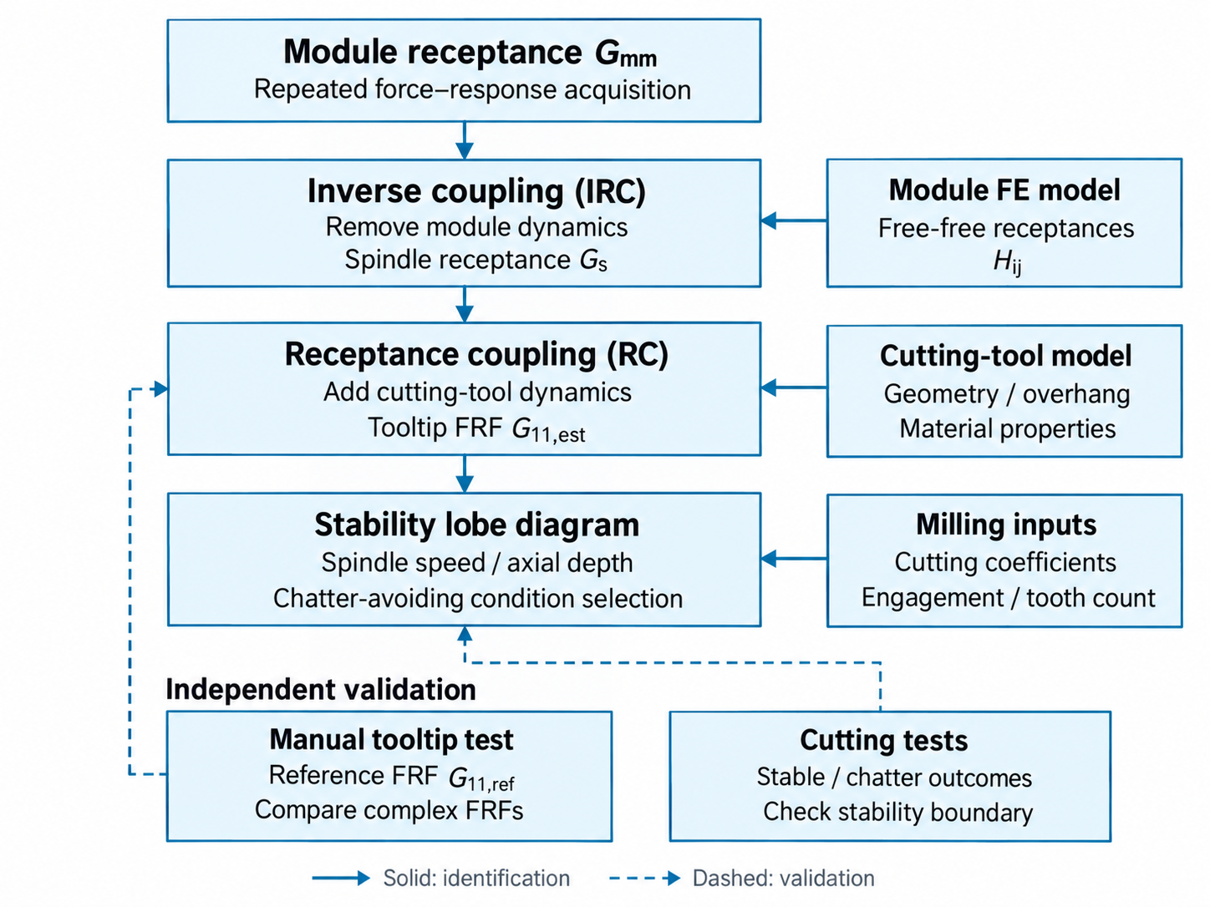

Fig. 1. Self-mounted dynamic-identification concept and validation workflow. The Gauss-exciter module provides repeated point-impact excitation and response acquisition on the spindle side. IRC removes the characterized module substructure to reconstruct the spindle-side receptance G_s; conventional RC then combines G_s with the cutting-tool model to predict the tool-point FRF and milling stability.
The experimental configuration implements this workflow on a high-precision machining center with a commercial spindle and tool-holder interface. A dedicated tap-test module is integrated into the tool holder below the milling chuck and carries the electromagnetic impact actuator and accelerometer. A synchronized data-acquisition unit records the excitation and structural response. This arrangement provides controlled spindle-side measurements and a basis for automated deployment through the machine interface.
Impulse excitation is generated by a custom-built Gauss accelerator. The actuator uses a pulsed electromagnetic mechanism to accelerate a striker and produce a controlled short-duration impact on the spindle–tool assembly. Compared with conventional manual hammer testing, this approach reduces operator dependency and provides improved repeatability through electronically controlled triggering. In addition, the excitation level can be adjusted through the actuator input conditions, enabling control of the usable frequency range for dynamic identification. The striker impacts the module through a clamped 5 mm Shore A90 polyurethane pad on the target surface (Fig. 2(a)), which sets the contact duration and hence the excitation bandwidth of the module.
The structural response is measured using a piezoelectric accelerometer (model, ±500 g) mounted on the tool-holder-side structure. A synchronized data-acquisition system (Yokogawa ScopeCorder, XX kS/s) is used to capture the excitation and response signals for subsequent FRF estimation.
Based on this setup, dynamic identification tests were performed by applying controlled impacts to the spindle–tool assembly and recording the corresponding accelerometer responses. The acquired force and motion data were then used to estimate the spindle-side frequency response functions for the subsequent identification and modeling steps. Reference measurements were obtained by manual hammer testing (Dytran 5800B4) on the same structure with a short WC blank tool, and tooltip reference FRFs by hammer testing directly at the tool tip.
Reference spindle/tool-point measurements are obtained by conventional impact testing using a Dytran 5800B4 hammer. A short WC blank tool is used for the spindle-side reference measurements, and independent impacts are applied directly at the cutting-tool tip to obtain G_11,ref. The module-side measurement is processed through IRC to reconstruct G_s, after which a finite-element cutting-tool model is coupled to G_s to obtain G_11,est. This creates two independent routes to the tool-point FRF: direct impact testing and automated module-side identification followed by IRC and RC. The comparison separates measurement repeatability from the accuracy of dynamic reconstruction.
The predicted tool-point FRF is subsequently supplied to the milling stability model. Cutting coefficients, engagement conditions, tooth count, and spindle speed are treated as independent milling inputs. Chatter tests are then used only to validate the predicted stability boundaries; they are not used to tune the reconstructed FRF.

3. Gauss excitation and inverse dynamic identification
This section presents a simplified model of the proposed coilgun-based excitation system. The purpose is to obtain rough estimates of the striker motion, impact behavior, and usable excitation bandwidth for spindle dynamics identification.

3.1 Coilgun design model
The coilgun (Gauss accelerator) serves as the core excitation source in the proposed tap-test module. Unlike conventional impact hammers that rely on manual operation, the coilgun electromagnetically accelerates a ferromagnetic projectile toward the target structure, enabling automated and repeatable impulse excitation without operator intervention. The Gauss accelerator is modeled as a capacitor-discharge actuator [9]. The initial electrical energy stored in the capacitor is
$$\begin{matrix} & E_{0}=\frac{1}{2}CV_{0}^{2} & & \text{(1)}\end{matrix}$$
where $C$is the capacitance and $V_{0}$is the charging voltage. A first-order estimate of the striker impact velocity is obtained by assuming that part of this energy is converted into projectile kinetic energy,
$$\begin{matrix} & \frac{1}{2}m_{p}v_{imp}^{2}≈η\frac{1}{2}CV_{0}^{2} & & \text{(2)}\end{matrix}$$
where $m_{p}$is the striker mass, $v_{imp}$is the impact velocity, and $η$is an overall efficiency factor accounting for electrical and magnetic losses.
A more practical description is based on the calibrated inductance profile of the launcher. The circuit equation is written as
$$\begin{matrix} & V_{c}=Ri+\frac{d}{dt}\left(L(x)i\right) & & \text{(3)}\end{matrix}$$
and the electromagnetic driving force is approximated by
$$\begin{matrix} & F_{em}(x,i)=\frac{1}{2}i^{2}\frac{dL(x)}{dx} & & \text{(4)}\end{matrix}$$
where $R$is the circuit resistance, $i$is the coil current, and $L(x)$is the position-dependent inductance. In the present work, $L(x)$is calibrated experimentally and used directly in the model, allowing rough prediction of striker motion without detailed electromagnetic field analysis. As shown in Fig. 3(a), the projectile velocity immediately before impact is measured using a chronograph, and the trend in Fig. 3(b) confirms that increasing charging voltage increases both projectile velocity and peak impact force.

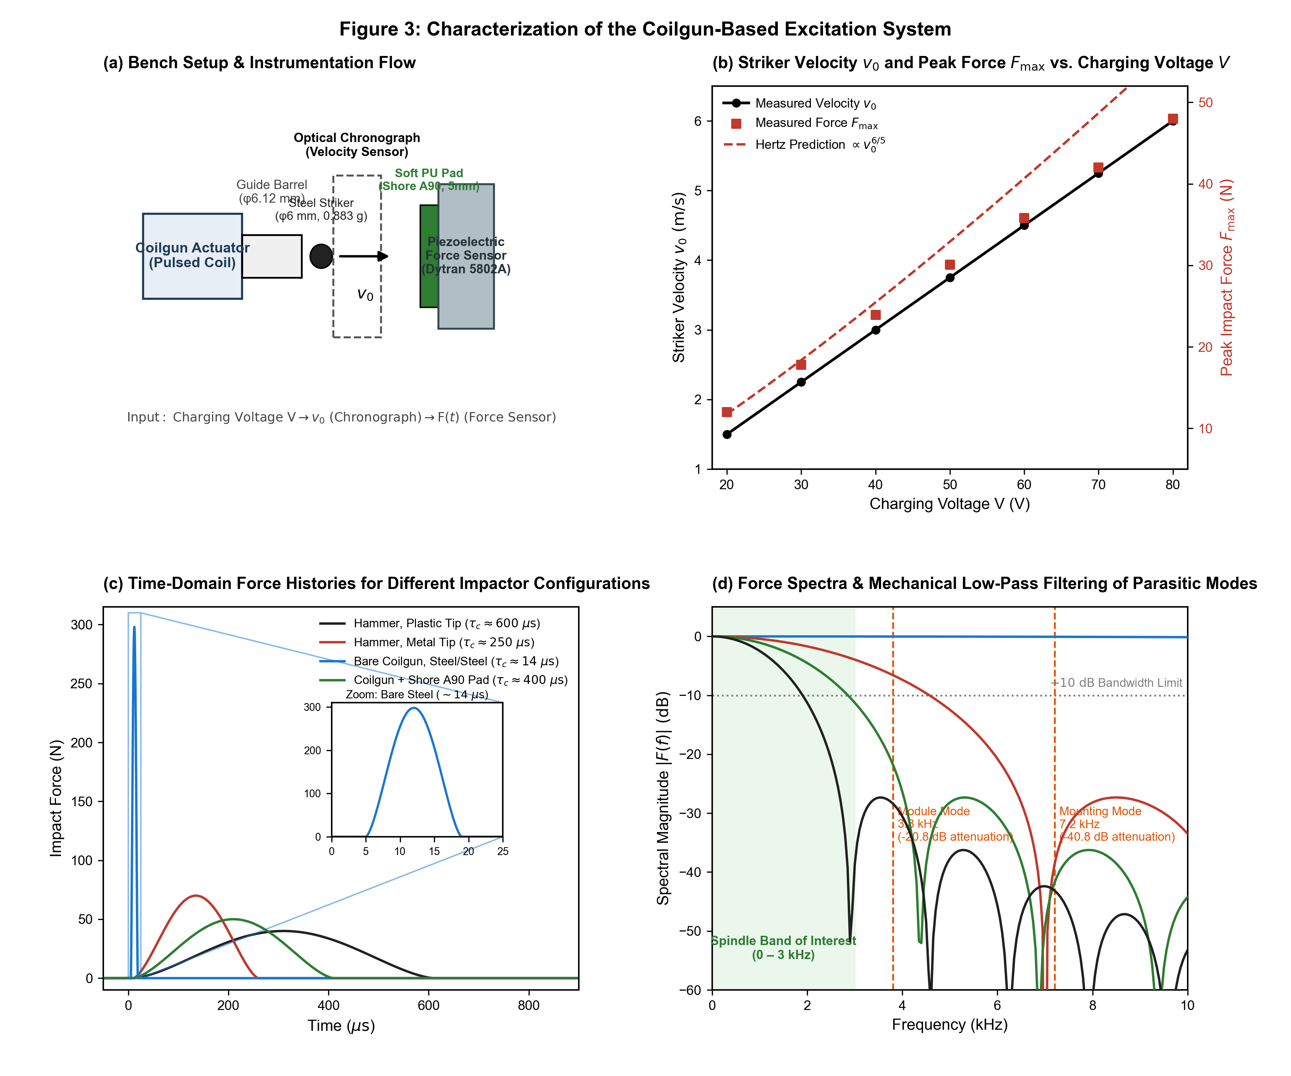
Fig. 3. Characterization of the coilgun-based excitation system. (a) Bench setup with the coilgun, guide barrel, chronograph for velocity measurement and force sensor. (b) Projectile velocity (left axis) and peak impact force (right axis) as a function of charging voltage, with the Hertz prediction overlaid. (c) Time-domain impact force signals for the manual hammer with plastic tip (black), the manual hammer with metal tip (red), the bare coilgun (blue) and the coilgun with soft pad (green). (d) Corresponding force spectra with the −10 dB bandwidth; the soft pad confines the excitation to the 0–3 kHz band and attenuates the module and mounting modes near 3.8 and 7.2 kHz.

The excitation performance of the Gauss accelerator was characterized prior to spindle identification experiments (Fig. 3). Force measurements were obtained using a piezoelectric force sensor (Dytran 5802A), and the corresponding excitation bandwidth was evaluated under different actuator input conditions. These tests were used to assess the repeatability and tunability of the generated impacts and to define operating conditions suitable for broadband spindle-dynamics measurement.
The experimental setup for characterizing the coilgun performance is illustrated in Fig. 3(a). The coilgun launches a steel projectile through a guide barrel. A chronograph placed between the coilgun muzzle and the target measures the projectile velocity immediately before impact. The projectile strikes a piezoelectric force sensor (Dytran 5802A), which records the time-domain impact force profile. The projectile is a φ6 mm steel ball (0.883 g) launched through a φ6.12 mm barrel, reaching about 6 m/s at XX V.

3.2 Impact force model
Since the striker is spherical and the target surface is assumed flat, the impact is modeled using Hertzian contact [10,11]. The contact force is expressed as
$$\begin{matrix} & F_{c}(t)=k_{H} δ(t)^{3/2} & & \text{(5)}\end{matrix}$$
with
$$\begin{matrix} & k_{H}=\frac{4}{3}E^{*}\sqrt{R} & & \text{(6)}\end{matrix}$$
where $R$is the striker radius and $E^{*}$is the effective elastic modulus of the striker-target pair. The peak contact force scales with impact velocity as
$$\begin{matrix} & F_{max}∝k_{H}^{2/5}m_{eff}^{3/5}v_{imp}^{6/5} & & \text{(7)}\end{matrix}$$
where $m_{eff}$is the effective impact mass. This relation explains the monotonic increase in peak impact force with charging voltage shown in Fig. 3(b).
A theoretical force curve based on the Hertz elastic contact model is overlaid in Fig. 3(b) for comparison. The experimentally measured peak forces show good agreement with the theoretical prediction, confirming that the coilgun produces well-defined elastic impacts whose force magnitude can be reliably controlled through voltage adjustment.

3.3 Frequency bandwidth model
For spindle dynamics identification, the main quantity of interest is the contact duration, since it governs the spectral content of the impact. For Hertzian sphere-flat impact, the contact time is approximated as
$$\begin{matrix} & t_{c}≈2.94{\left(\frac{m_{eff}^{2}}{k_{H}^{2} v_{imp}}\right)}^{1/5} & & \text{(8)}\end{matrix}$$
and the corresponding excitation bandwidth can be estimated as
$$\begin{matrix} & f_{bw}∼\frac{1}{t_{c}} & & \text{(9)}\end{matrix}$$
Thus, shorter contact time produces broader usable frequency content. This trend is illustrated in Fig. 3(c) and Fig. 3(d), where the shorter coilgun impact yields a wider excitation bandwidth than manual hammer excitation. For the φ6 mm steel striker on a steel target, however, the contact time is only about 14 μs, corresponding to a usable bandwidth of about 70 kHz and a peak contact pressure of 4.4 GPa that exceeds the yield strength of the target. Since the elastic modulus is nearly identical for all ferromagnetic steels (200–210 GPa), the contact cannot be lengthened by changing the striker material; only the interface compliance or the striker mass can.

A key advantage of the coilgun over manual impact hammers lies in the excitation bandwidth. Fig. 3(c) compares the time-domain force signals from three excitation methods: a manual impact hammer with a plastic tip (black), a manual impact hammer with a metal tip (red), and the coilgun (blue). The plastic tip produces a relatively broad pulse with a long contact duration, while the metal tip generates a shorter but higher-amplitude pulse. The coilgun produces the shortest contact duration among the three, yielding a sharp, well-defined impulse.
The corresponding frequency spectra obtained via Fourier transform are shown in Fig. 3(d). The effective excitation bandwidth, defined here as the frequency range over which the spectral amplitude remains above −10 dB relative to the DC level, is directly governed by the contact duration: a shorter impulse in the time domain produces a wider flat region in the frequency domain. The manual plastic tip provides the narrowest bandwidth, suitable only for low-frequency modal analysis. The metal tip extends the bandwidth further but introduces a steeper spectral roll-off at higher frequencies. The coilgun achieves the widest effective bandwidth. For spindle identification, however, this bandwidth is excessive rather than advantageous, as discussed next; the value of the coilgun lies in the fact that its bandwidth is deterministic and can be prescribed by the contact interface, whereas that of a hand-held hammer varies with every strike.

3.4 Interface design for bandwidth shaping
An impulse whose energy is spread over a band more than twenty times wider than the 0–3 kHz range containing the dominant spindle modes is detrimental for two reasons. Only a small fraction of the impulse energy excites the modes of interest, while the parasitic modes of the module body, the accelerometer mounting and the holder interface are excited with equal efficiency, so that ringing dominates the acceleration record and consumes the dynamic range of the acquisition. Moreover, aliasing, plastic deformation at the contact and contamination of the force measurement all occur inside the band of interest and cannot be recovered by post-filtering. The bandwidth must therefore be limited at the excitation stage.
This is achieved by inserting a soft polymer pad between the striker and the target. Replacing the steel target by a polyurethane pad (Shore A90, E ≈ XX MPa, 5 mm thick) extends the contact time from 14 μs to about 400 μs, a factor of 28, and moves the first spectral zero of the pulse to about 2.5 kHz so that the impulse energy is concentrated in the band of interest. At 0.5 and 2 kHz the pad attenuates the excitation by only 0.3 and 4.5 dB, whereas at the module mode near 3.8 kHz and the mounting-related mode near 7.2 kHz the attenuation is 20.8 and 40.8 dB, respectively. The pad thus acts as a mechanical low-pass filter that selectively suppresses the parasitic modes by 20–40 dB without any change to the module structure.
The pad thickness is bounded on both sides. A pad thinner than the maximum indentation (about 0.8 mm for the φ6 mm ball) behaves as a thin layer backed by steel, so the contact stiffens and the interface bottoms out; pads thicker than about 5 mm approach the semi-infinite-body condition assumed in the Hertz model and give a thickness-independent contact time. A 5 mm pad, mechanically clamped rather than adhesively bonded to avoid an additional compliant layer, was therefore adopted. For a fixed coilgun energy the transferred momentum (1 + e)m_{p}v₀ scales with √m_{p}, so the low-frequency excitation level is governed by the striker mass rather than by its velocity; the reduced impulse of the small striker relative to a hammer is recovered statistically by shot averaging.
These bench results fixed the exciter design. The projectile velocity scales monotonically with the charging voltage and the peak force follows the Hertzian trend (Fig. 3(b)), so the excitation level is set electrically and the φ6 mm steel ball was retained as the striker; the contact-time analysis and the measured spectra (Fig. 3(c), Fig. 3(d)) fixed the interface as the clamped 5 mm Shore A90 pad used in the measurement configuration summarized in Fig. 2(a).

3.5 Module substructure compensation and FRF estimation
The tap-test module, however, introduces its own structural dynamics into the measured response. The receptance measured on the module, G_{mm}, is that of the spindle–holder–module assembly. Denoting the free-free receptances of the module substructure by H_{ij} (subscript 1 at the impact/measurement point, 2 at the holder interface) and the unknown spindle receptance at the holder interface by G_{s}, the assembly receptance is [2,12]
G_{mm} = H₁₁ − H₁₂ (H₂₂ + G_{s})⁻¹ H₂₁ (10)
To compensate for this, the module substructure was independently characterized and modeled as a lumped-parameter system. Its dynamic contribution was removed from the measured response through inverse receptance coupling, isolating the spindle-side dynamics, i.e. the relation above is inverted for G_{s}. The module body was machined from AL7075-T6 rather than steel: the specific stiffness is nearly unchanged, but the lower mass raises the rigid-body rocking modes of the module on the holder interface by a factor of about 1.7, moving them above the dominant spindle modes and making the inversion better conditioned.
Because the coilgun is electronically triggered, the module fires N shots in an unattended sequence and the FRF is estimated with the H₁ estimator from the averaged cross- and auto-spectra of force and acceleration, so that uncorrelated noise is reduced in proportion to √N; with N = 100 the signal-to-noise ratio improves by an order of magnitude compared with the few averages typical of manual testing. Averaging is effective only when the individual impulses are consistent, which is the case for the coilgun but not for manual hammering, where trial-to-trial variation of the contact duration shifts the spectral roll-off and biases the average. Since the H₁ estimator normalizes by the input spectrum, two excitations with equal transferred momentum yield the same FRF even when their force histories differ in shape.

4. Experimental results and validation

4.1 Excitation repeatability
The first validation step isolates excitation repeatability from the subsequent IRC and tool-coupling calculations. One hundred impacts were acquired for the manual hammer and the Gauss exciter under identical test conditions. Figure 3 compares the distributions of the measured force histories. Manual impacts show visibly larger variation in peak force and contact duration, whereas the electronically triggered Gauss exciter produces a narrow family of nearly coincident force traces.
The current dataset gives a peak-force standard deviation of 7.334 N for manual excitation and 1.258 N for the Gauss exciter, an 82.8% reduction. The contact-duration scatter decreases from 0.019 ms to 0.002 ms, corresponding to an 89.5% reduction. These results establish that the Gauss exciter provides substantially more consistent impact conditions for repeated averaging and unattended acquisition.
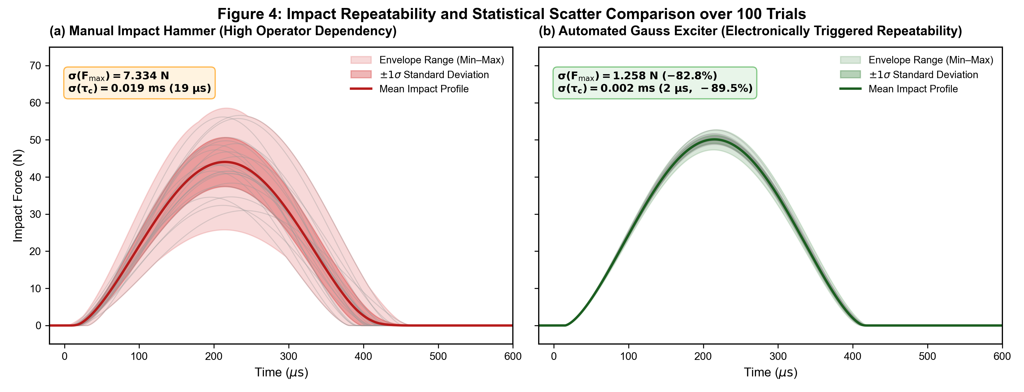
Fig. 3. Repeatability of manual hammer and Gauss-exciter impacts over 100 trials. Force histories for (a) the manual impact hammer and (b) the Gauss exciter. Solid curves represent the mean traces and shaded regions indicate trial-to-trial variation; standard deviations of peak force and contact duration are annotated.
[TO UPDATE] Add FRF convergence versus number of Gauss impacts (e.g., N = 1, 5, 10, 20, 50, 100) to show how many shots are practically required.

4.2 Recovery of spindle-side dynamics
The second validation step tests whether the self-mounted module can recover the spindle-side dynamics that would be obtained without the module. The uncorrected automated result contains additional FRF features associated with the module housing and mounting interfaces. These features become important when the module response is comparable to the underlying spindle response. Applying IRC suppresses the module contribution and brings the reconstructed response toward the direct hammer-test reference.
The most important comparison is therefore an ablation between the automated result before and after module decoupling. The final quantitative assessment should report, over the declared valid frequency range, the natural-frequency error, peak-receptance error, damping-ratio error, and a frequency-domain FRF error metric for both cases. This will separate the contribution of repeatable Gauss excitation from the contribution of IRC and demonstrate that module compensation is necessary rather than cosmetic.
[TO UPDATE] Insert final spindle-side FRF comparison and quantitative error table/metrics for: manual reference, Gauss measurement without IRC, and Gauss measurement with IRC.

4.3 Tool-point FRF synthesis and transferability
The reconstructed spindle-side receptance G_s is next coupled with the cutting-tool model to predict the tool-point receptance G_11,est. Figure 4(a) shows the current comparison between the direct tool-tip hammer reference and the automated estimates. The uncorrected automated route retains module-related spectral content, whereas the IRC-corrected route reproduces the dominant tool-point modes more closely over the frequency range relevant to chatter stability.
This step is intended to demonstrate that the output of the identification procedure is a reusable spindle-side dynamic model rather than a curve fitted to one tool. A particularly strong final validation would therefore use the same identified G_s to predict at least two substantially different tool configurations or overhangs, with direct tool-tip impacts used only as independent references. No repeated spindle-side identification should be required between those tool predictions unless the spindle state or coupling interface changes.
[TO UPDATE] Preferred final validation: add a second tool or substantially different overhang using the same recovered spindle-side receptance. Report tool-point natural-frequency, compliance, and damping errors for each configuration.

4.4 Chatter-stability validation
The final validation propagates the identified dynamics to a manufacturing decision. Stability lobe diagrams are constructed from the direct reference FRF and the IRC-corrected automated FRF using the same milling-model inputs. Experimental cutting tests are then overlaid as stable and chatter cases. Agreement between the two predicted boundaries indicates whether the residual FRF error is small enough to preserve the practically important stable pockets and critical axial-depth predictions.
In the current working result, the reference and IRC-based stability diagrams show similar lobe locations and critical-depth trends, and the experimental outcomes are consistent with the predicted boundary. Final reporting should distinguish two errors: the difference between stability boundaries generated by the reference and automated FRFs, and the difference between each predicted boundary and the measured chatter threshold. This avoids attributing cutting-model or coefficient uncertainty to the dynamic-identification method.
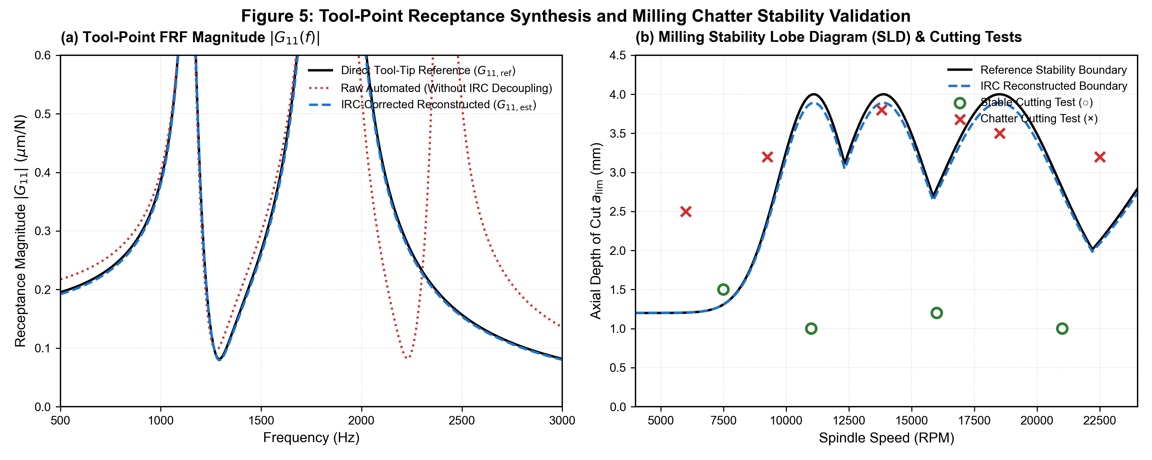
Fig. 4. Tool-point and chatter-stability validation. (a) Direct tool-tip FRF reference (black), automated result without module compensation (red), and IRC-corrected automated result (blue). (b) Stability-lobe comparison with stable (○) and chatter (×) cutting tests. Current sketch/working result to be replaced by final measured data.
[TO UPDATE] Insert final cutting-test matrix, cutting coefficients, tool/workpiece details, and numerical critical-depth error. Remove any unverified “5-8%” statement unless it is supported by the final dataset.

5. Conclusions
This work presents an automated spindle-identification approach based on a self-mounted Gauss exciter and inverse receptance decoupling. The Gauss exciter generates electronically triggered projectile impacts that can be repeated without manual positioning, while the self-mounted architecture enables deployment directly on the machine tool. Because the attached module alters the dynamics being measured, its independently characterized receptances are removed through IRC to recover the spindle-side dynamics required for subsequent tool coupling.
The present experiments establish two key features of the approach. First, projectile velocity and impact level can be controlled electrically, and the Gauss exciter produces markedly lower trial-to-trial scatter in peak force and contact duration than manual hammer excitation. Second, preliminary IRC results show that compensating the attached module removes module-related FRF features and improves agreement with independent reference measurements. The recovered spindle dynamics can then be combined with cutting-tool models and propagated to chatter-stability prediction.
The final validation will quantify FRF reconstruction error, inverse-coupling robustness, multi-tool transferability, and stability-boundary error. These metrics are required to define the operating limits of the method and to separate random repeatability gains from systematic errors associated with force calibration, striker alignment, impact-pad wear, and module/interface modeling. The broader contribution is a self-mounted identification architecture in which a compact Gauss exciter can be carried by the machine structure while inverse dynamic decoupling reconstructs the uninstrumented spindle-side receptance.

References
[1] Altintas, Y., Budak, E., 1995, Analytical prediction of stability lobes in milling, CIRP Annals, 44(1), 357-362.
[2] Schmitz, T.L., Donalson, R.R., 2000, Predicting high-speed machining dynamics by substructure analysis, CIRP Annals, 49(1), 303-308.
[3] Smith, S., Snyder, J., 2001, A cutting performance based template for spindle dynamics, CIRP Annals, 50(1), 259-262.
[4] Schmitz, T.L., Davies, M.A., Medicus, K., Snyder, J., 2001, Improving high-speed machining material removal rates by rapid dynamic analysis, CIRP Annals, 50(1), 263-268.
[5] Altintas, Y., et al., 2021, Electromagnetic impulse actuator for FRF measurement, CIRP Annals, 70(1).
[6] Niu, X., Liu, K., Zhang, Y., Xiao, Z., Xiao, G., Gong, Y., 2018, Research on self-consistent control strategy of multistage synchronous induction coil launcher, Energy, 144, 1-9.
[7] Raman, R.V., 1990, Prediction of impact forces using Hertzian contact theory and structural measurements, Mathematical and Computer Modelling, 14, 457-462.
[8] Falcon, E., Laroche, C., Coste, C., et al., 2000, Inelastic collision and the Hertz theory of impact, American Journal of Physics, 68(10), 920-924.
[9] Park, S.S., Altintas, Y., Movahhedy, M., 2003, Receptance coupling for end mills, International Journal of Machine Tools and Manufacture, 43(9), 889-896.
[TO UPDATE] Complete and verify bibliographic details for Ref. [5] and check all references against the final CIRP format.

Working-draft notes for the next experimental update
• Force path: explicitly document the in-situ impact-force measurement/reconstruction and assess any launcher reaction transmitted to the self-mounted module before projectile impact.
• Inverse robustness: add a conditioning or uncertainty-amplification measure for IRC and use it to define the valid reconstruction range.
• Ablation: compare Gauss and manual impact repeatability, and compare automated FRFs before and after IRC so that each contribution has a measurable effect.
• Transferability: reuse one recovered spindle-side receptance for at least two tool configurations or overhangs.
• Industrial timing: report the minimum number of Gauss impacts required for converged FRFs and the total automated identification time.

