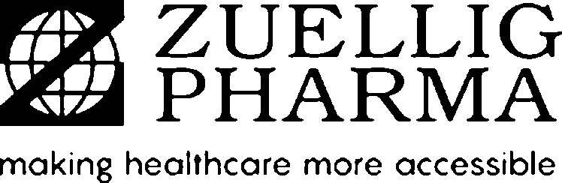Zuellig Pharma Specialty Solutions Group Pte Ltd

15 Changi North Way #01-01, Singapore

Singapore 498770

Tel #: 65468188 • Fax #: 65468288

GST Registration No. 200907752M **TAX INVOICE**

<<[SoldToCode]>>

<<[SoldToName12]>>

<<[SoldToName34]>>

<<[SoldToStreet1]>>

<<[SoldToStreet2]>>

<<[SoldToStreet3]>>

<<[SoldToPostalCodeCity]>>

<<[SoldToCountry]>>

Attention: <<[AttentionSoldTo]>>

**SOLD TO:**

<<[BillToCode]>>

<<[BillToName12]>>

<<[BillToName34]>>

<<[BillToStreet1]>>

<<[BillToStreet2]>>

<<[BillToStreet3]>>

<<[BillToPostalCodeCity]>>

<<[BillToCountry]>>

Attention: <<[AttentionBillTo]>>

**BILL TO:**

|  |  |  |  |
| --- | --- | --- | --- |
| Invoice No. | Invoice Date | Currency | Page |
| <<[InvoiceNo]>> | <<[InvoiceDate]>> | <<[Currency]>> | 1 of 1 |
| Payment Terms | Due Date | Customer PO No. | Special Instruction |
| <<[PaymentTerms]>> | <<[DueDate]>> | <<[CustomerPONumber]>> | <<[SpecialInstructions]>> |

|  |  |  |  |  |
| --- | --- | --- | --- | --- |
| Description | | Product Hierarchy | Tax Code | Amount |
| <<[DistributionChannel]>> | | | | |
| <<foreach[item in Materials]>><<[item.MaterialDesc]>> | |  | <<[item.TaxCode]>> | <<[item.Amount]>><</foreach>> |
|  | |  |  |  |
|  | |  |  |  |
|  | |  |  |  |
|  | | Sub-total |  | <<[Subtotal]>> |
| <<[TaxCode]>> <<[TaxOnSale]>> | <<if[!string.IsNullOrEmpty(TaxCode)||!string.IsNullOrEmpty(TaxOnSales)]>><<[NetInvoiceAmount]>><</if>> | GST |  | <<[GST]>> |
|  | | **NET INVOICE AMOUNT** |  | <<[NetInvoiceAmount]>> |

Please notify us in writing w/in 14 days should there be any discrepancy. Otherwise this document will be considered as correct and valid.

The provision of services and/or products as described in this invoice are subject solely to the terms & conditions expressly agreed by the parties in the applicable master purchase / services agreement or ZP’s Quotation, to the exclusion of all other terms and the conditions which either Party may purport to apply under any purchase order, confirmation order or similar, or any other ancillary document.

Beneficiary: Zuellig Pharma Specialty Solutions Group Pte Ltd Banker: The Hong Kong and Shanghai Banking Corporation Limited Address: 21 Collyer Quay, #04-02 HSBC Building, Singapore 049320 Bank Account No. (SGD): 147-785737-003

Bank Account No. (USD): 260-668470-180

Bank Swift Code (USD/SGD): HSBCSGSGXXX Bank Account No. (AUD): 808-695613-203

Bank Swift Code (AUD): HSBCHKHHHKH

Authorized Signatory