SWINBURNE VIETNAM
ALLIANCE PROGRAM


Assignment 1 Report

Department: Swinburne University of Technology
Course Name: INF20029 - Systems Analysis and Design
Student Name: Duong Nguyen Dang
Student ID: 105508444 / SWS01389
Instructor Name: Minh Huy Doan
Submission Date: 21th February, 2026
Word count: 2135 words

Table of Content

1. INTRODUCTION 2
2. REQUIREMENT GATHERING AND INITIAL ANALYSIS 2
2.1 Stakeholder Identification 2
2.1.1 Operations Manager 2
2.2.2 Administrative Officer 2
2.2.3 Undergraduate Student 2
2.2 Interview Questions 2
2.2.1 Operations Manager 3
2.2.2 Administrative Officer 3
2.2.3 Student 3
2.3 Survey Design 4
2.4 Functional Requirements 4
2.5 Non-Functional Requirements 5
3. SYSTEM ANALYSIS MODELLING 6
3.1 Epics 6
3.2 Use Case Diagram 7
3.3 Activity Diagram 8
3.4 ERD 9
4. LITERATURE REVIEW ON AI 10
References 11
5. REFLECTION ON AI USE 12
6. CONCLUSION 13

INTRODUCTION
ABC University Student Services manages student enquiries related to enrolment, finance, academic advice, and administrative support. However, increasing student numbers and split manual processes have reduced efficiency and obviousness.
This report analyses the current enquiry management system and suggests improvements through structured systems analysis techniques. Requirements were gathered using AI help in stakeholder role simulation and translated into functional and non-functional requirements.
The report presents requirement findings, system modelling, a literature review on AI, and a reflection on AI use in the development process.

REQUIREMENT GATHERING AND INITIAL ANALYSIS

Stakeholder Identification
These stakeholders represent strategic and end-user perspectives, making sure that the current system meets business targets, workflow efficiency, and user satisfaction:

2.1.1 Operations Manager
The Operations Manager controls enquiry management performance, staff connection, risks, and service quality. This stakeholder provides a strategic view on business goals, KPIs, progress blocks, and legal requirements.

2.2.2 Administrative Officer
Administrative Officers are first-of-all staff responsible for handling student enquiries through many channels. They provide information about daily workflows, system issues, level processes, and workload limits.

2.2.3 Undergraduate Student
Students are the main users of the system. Their viewpoint provides user experience, response time belief, communication accuracy, and difficult points during stressful academic periods.

Interview Questions
Structured interview questions were developed to guide stakeholder find and ensure awareness of strategic, operational, and user-level requirements.

Operations Manager
No | Question | Objective
1 | What are the biggest problems you face in managing student enquiries? | Identify core pain points
2 | Which periods of the year are the most stressful and why? | Define peak workload
3 | How do you currently measure service performance? | Understand KPIs
4 | What causes delays in resolving cases? | Identify bottlenecks
5 | Are there compliance risks in the current process? | Know legal concerns
6 | If you had limited budget, what would you fix first? | Define priorities

Administrative Officer
No | Question | Objective
1 | Walk me through a typical day handling enquiries. | Understand workflow
2 | What systems or tools do you use daily? | Find existing tools
3 | What frustrates you most about the current system? | See usability issues
4 | Do you often need to escalate cases? Why? | Identify escalation triggers
5 | What kind of enquiries take the longest to resolve? | Categorize complexity
6 | What would make your job significantly easier? | Capture improvement ideas

Student
No | Question | Objective
1 | When do you usually contact Student Services? | Understand contact triggers
2 | How long do you usually wait for a response? | Measure perceived delay
3 | Have you ever had to repeat your issue to multiple staff? | Identify duplication
4 | What frustrates you the most during enrolment or exam periods? | Find stress points
5 | If you could change one thing about the system, what would it be? | Capture user priorities
6 | Do you feel your issue is tracked properly after submission? | Define transparency gaps

Survey Design
A short survey was designed to collect estimated feedback about response time, clarity, and communication accuracy. The survey included multiple-choice and Likert-scale questions to measure satisfaction, behaviour, and stress levels during peak periods. Survey results supported approving and prioritising requirements.
No | Survey Question | Type | Purpose
1 | How often do you contact Student Services? | Multiple choice | Identify frequency of use
2 | How satisfied are you with response time? (1–5) | Likert scale | Measure time satisfaction
3 | On average, how long do you wait for a response? | Multiple choice | Quantify delay
4 | Have you ever submitted multiple enquiries for the same issue? | Yes/No | Identify duplication
5 | During enrolment/exam periods, how stressful is the support process? (1–5) | Likert scale | Measure emotional impact
6 | What one improvement would most improve your experience? | Short answer | Capture open feedback

Functional Requirements
Functional requirements were built from stakeholder interviews (manager, operation, and student points of view) and survey design results. The requirements define the system behaviours and capabilities necessary to improve enquiry management, operational efficiency, and user clarity.

ID | Functional Requirement | Source | Priority
FR-01 | The system shall allow students to submit enquiries via an online portal. | Student | High
FR-02 | The system shall generate a unique case ID for each enquiry. | Admin Officer | High
FR-03 | The system shall send automatic confirmation notifications upon submission. | Student | High
FR-04 | The system shall allow staff to manually create cases for walk-in or phone enquiries. | Admin Officer | High
FR-05 | The system shall automatically assign cases based on enquiry category. | Manager | High
FR-06 | The system shall allow staff to reassign cases to another department. | Admin Officer | High
FR-07 | The system shall allow escalation of cases with tracking history. | Admin Officer | High
FR-08 | The system shall maintain a complete audit trail of case interactions. | Manager | High
FR-09 | The system shall allow students to track case status in real time. | Student | High
FR-10 | The system shall display estimated response time for each case. | Student | Medium
Additional requirements are documented in Appendix

Non-Functional Requirements
Non-functional requirements clarify the quality, performance standards, security restrictions, and follow the proposed system. These requirements were taken from stakeholder concerns about response time, data privacy (FERPA), system reliability, and usability trust.

ID | Category | Requirement
NFR-01 | Performance | The system shall respond to user actions within 2 seconds under normal load conditions.
NFR-04 | Security | The system shall enforce role-based access control (RBAC) for all users.
NFR-05 | Compliance | The system shall comply with FERPA regulations regarding student data privacy.
NFR-08 | Availability | The system shall maintain at least 99% uptime annually.
NFR-09 | Reliability | The system shall automatically back up data daily.
NFR-11 | Usability | The student portal shall be accessible via desktop and mobile devices.
NFR-14 | Scalability | The system shall support increasing enquiry volume without performance degradation.
Additional requirements are documented in Appendix

SYSTEM ANALYSIS MODELLING

Epics
Based on stakeholder interviews and current process analysis, the following high-level business processes (epics) were identified in the existing Student Services enquiry management system.
- ENQUIRY IN TAKE – Receiving Student Enquiries: The system currently allows students to submit enquiries through multiple channels (directly, phone, email, portal).
- CASE DIVISION– Manual Categorisation and Routing: Enquiries are manually reviewed and forwarded to the appropriate departments.
- CASE RESOLUTION – Handling and Resolving Cases: Staff investigate issues, provide responses, and close cases manually.
- CASE FORWARDING– Transferring Complex Issues: Complex cases are sent to specialised departments (Finance, Housing, Faculty).
- STATUS ANNOUNCEMENT – Informing Students of Progress: Students are up-to-date through email replies, but there is no single controlling system.
- REPORTING – Monitoring Performance: Managers manually make up performance reports (FCR, resolution time, volume).

Use Case Diagram
The use case diagram models the current (As-Is) enquiry management process by illustrating the interactions between key stakeholders and the system.
The primary actors identified include:
- Student – submits enquiries, follows up, and receives responses.
- Administrative Officer – conducts manually categorisation, forwarding, response handling, and case closure.
- Operations Manager – reviews performance metrics and generates operational reports.
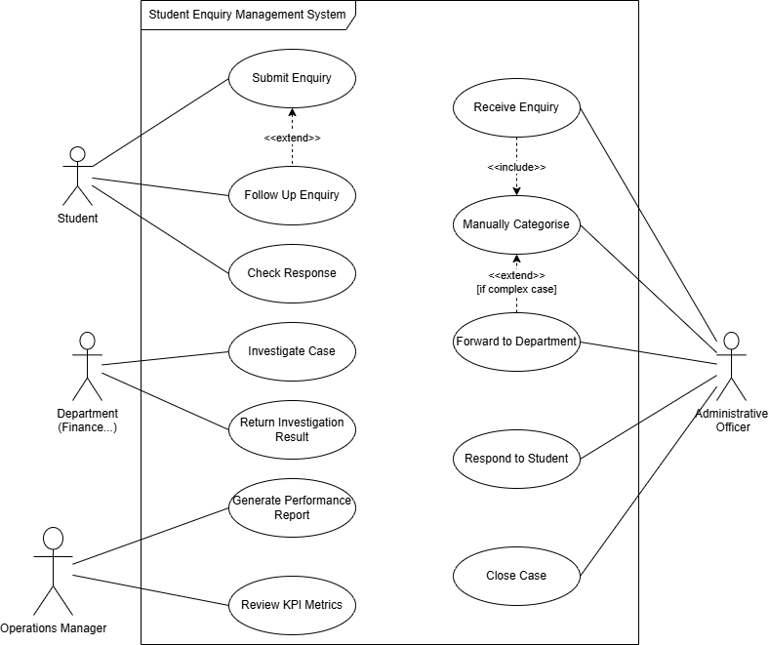
Figure 1: As-Is Use Case Diagram of Student Enquiry Management System
The diagram demonstrates that the current system is highly dependent on manual processing. Enquiry categorisation, escalation, and case resolution require human control at several stages. There is no automated routing tool or case display between departments, resulting in delays, repeated enquiries, and limited performance clarity.

Activity Diagram
The activity diagram illustrates the current (As-Is) workflow of the Student Enquiry Management System, showing the step-by-step operational process from enquiry submission to case closure.
Unlike the use case diagram, which focuses on stakeholder interactions, the activity diagram models the internal process flow, decision points, and manual handling steps related to enquiry resolution.
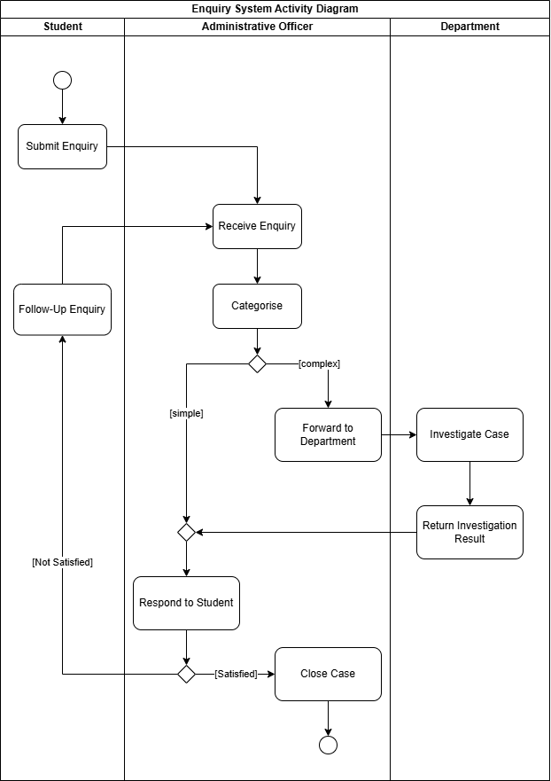
Figure 2: As-Is Activity Diagram of Student Enquiry Handling Process
The process is highly dependent on manual categorisation and transfer. Complex cases require departmental coordination, and once sent, students have limited follow-up on case progress. Additionally, notable enquiries re-enter the process, increasing workload and contributing to response delays during peak periods.

ERD
The Entity Relationship Diagram (ERD) illustrates the data structure of the current Student Enquiry Management System. It identifies the key entities, including Student, Enquiry, Administrative Officer, Department, Response, and Case Investigation, as well as their relationships and primary/foreign keys.
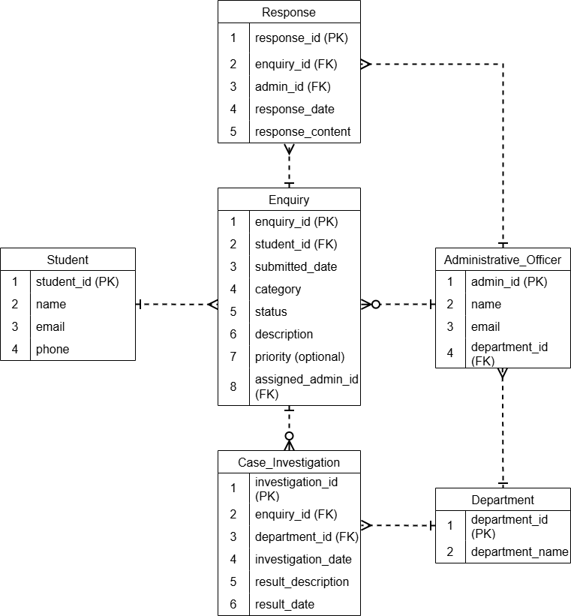
Figure 3: Entity Relationship Diagram of Student Enquiry Handling Process
• Each enquiry must be linked to exactly one student.
• A department may have multiple administrative officers.
Overall, the ERD supports enquiry follow-up, response management, departmental transfer, and performance reporting while ensuring data accuracy through clearly defined relationships.

LITERATURE REVIEW ON AI
Artificial Intelligence (AI) is being more and more combined with business and systems analysis practices to enhance decision-making, improve productivity, and support complex analytical tasks. In recent years, generative AI (GenAI) tools have appeared as powerful assistants capable of supporting requirement collection, documentation writing, stakeholder analysis, and data explanation. Not replacing analysts, AI technologies are widely positioned as advanced tools that enhance human cognitive capabilities (Jarrahi, 2018).
One main application of AI in business analysis is in requirement engineering and knowledge discovery. AI systems can deal with large volumes of structured and unstructured data to identify, extract details, and detect unreliability that may not be immediately visible to human analysts (Davenport & Ronanki, 2018). Machine learning techniques have also been used in process mining and workflow analysis to display inefficiencies and recommend improvement opportunities. In documentation-heavy environments, generative AI tools assist in writing requirement descriptions, user stories, and reports, reducing workload and improving completion time (Dwivedi et al., 2023).
The benefits of AI integration in analysis practices include improved efficiency, enhanced recognition, and support for exploratory thinking. AI tools can generate alternative scenarios, simulate stakeholder viewpoints, and assist in brainstorming activities, thereby expanding the analytical scope of professionals. Research suggests that AI-human collaboration often produces higher outcomes compared to working independently (Brynjolfsson & McAfee, 2017). Additionally, AI systems can contribute to unity in documentation and help communication between teams.
However, significant limitations and risks come with the acceptance of AI in analytical environments. Generative AI models are seen as “hallucination,” producing reasonable but inaccurate information (Bubeck et al., 2023). Such inaccuracies risk in requirement gathering and system modelling, where accuracy is critical. AI systems may also lack awareness of organizational culture, legal frameworks, and limitations. Over-reliance on AI may reduce critical thinking skills among analysts and introduce automation unfairness, where human users overly trust system outputs (Jarrahi, 2018). Furthermore, ethical concerns related to data privacy, bias, clarity, and responsibility must be carefully managed, particularly when AI tools handle sensitive business information (Dwivedi et al., 2023).

References

Brynjolfsson, E. , & McAfee, A. (2017). Machine, Platform, Crowd: Harnessing our digital future. Wwnorton.com; W.W. Norton & Company. https://wwnorton.com/books/9780393254297
Bubeck, S., Chandrasekaran, V., Eldan, R., Gehrke, J., Horvitz, E., Kamar, E., Lee, P., Lee, Y. T., Li, Y., Lundberg, S., Nori, H., Palangi, H., Ribeiro, M. T., & Zhang, Y. (2023). Sparks of Artificial General Intelligence: Early experiments with GPT-4. ArXiv:2303.12712 [Cs]. https://arxiv.org/abs/2303.12712
Davenport, T. H., & Ronanki, R. (2018). Artificial Intelligence for the Real World. Harvard Business Review. https://hbr.org/2018/01/artificial-intelligence-for-the- real-world
Dwivedi, Y. K. (2023). “So What If ChatGPT Wrote it?” Multidisciplinary Perspectives on opportunities, Challenges and Implications of Generative Conversational AI for research, Practice and Policy. International Journal of Information Management, 71(0268-4012), 102642. https://doi.org/10.1016/j.ijinfomgt.2023.102642
Jarrahi, M. H. (2018). Artificial Intelligence and the Future of work: Human-AI Symbiosis in Organizational Decision Making. Business Horizons, 61(4), 577–586. https://doi.org/10.1016/j.bushor.2018.03.007

REFLECTION ON AI USE
Artificial Intelligence tools were integrated into this assignment primarily to simulate stakeholder interviews and support early-stage requirement collection. Particularly, AI was used to role key stakeholders, including an Operations Manager, an Administrative Officer, and an Undergraduate Student. This approach enabled the generation of diverse viewpoints that would be difficult to access without direct contact. AI also assisted in drafting structured interview questions and exploring potential operational difficulties within the current enquiry management system.
However, the AI output was not accepted easily. During the collection process, several limitations were identified. For example, performance metrics and workload statistics generated by AI were examples and lacked practical verifications. Some suggested efficiency improvements appeared too optimistic and did not account for organizational limitations such as legacy systems or legal follow-up requirements. Additionally, emotional descriptions from the simulated student role sometimes became excessive. These issues required careful human verification and clarification. Rather than directly applying AI-generated responses, make sure the outputs are filtered, compared between simulated roles, and translated into structured functional and non-functional requirements.
Human judgment played a central role in transforming narrative AI responses into formal system models. The identification of epics, development of use case diagrams, activity diagrams, and ERD modelling were independently structured and verified. Decisions such as modelling the system in an “as-is” state, defining quantity restrictions, and distinguishing between manual and automated processes required analytical argumentation over AI-generated content. AI worked as an ideation partner rather than a design authority.
The use of AI presented clear opportunities, including time efficiency, access to multiple stakeholder viewpoints, and structured brainstorming support. Nevertheless, it also introduced risks such as hallucinated data, contextual inaccuracies, and potential over-reliance. Therefore, ethical and professional considerations were resolved by remembering all AI interactions in the appendix, clearly acknowledging AI assistance, and ensuring clarity in how outputs were adjusted.
Overall, this assignment strengthens that AI is most valuable when used as a cognitive support tool under human monitoring. The experience built critical evaluation skills, technical capabilities, and awareness of responsible AI integration in systems analysis practice.

CONCLUSION
This report analysed the current Student Services enquiry management system through structured requirement elicitation and system modelling techniques. Stakeholder perspectives were explored to identify operational inefficiencies, clarity issues, and follow-up concerns. Based on these findings, key functional and non-functional requirements were defined and modelled using epics, use case diagrams, activity diagrams, and an ERD.
The analysis demonstrates that the current system relies heavily on manual processes and fragmented workflows, leading to delays and duplication. The modelling method provides a clear foundation for future system improvement creativity.

