SWINBURNE VIETNAM
ALLIANCE PROGRAM


Assignment 2:
Requirement System Design
by Lai Vu Chi An | Huynh Tuan An | Duong Nguyen Dang

Department: Swinburne University of Technology
Course Name: INF20029-Systems Analysis and Design
Group Number: HCM 1
Instructor Name: Dr. Minh Doan
Submission Date: 11-April-2026
Word count: 2660 words

Table of Content

SECTION 1: PROJECT MANAGEMENT AND CONTROL 2
SECTION 2: INTRODUCTION 2
2.1 Problem Statement 2
2.2 Project Overview and Objectives 2
SECTION 3: PART A – SYSTEM ANALYSIS AND DESIGN 3
3.1 Requirements Gathering Techniques 3
3.2 Functional Specifications: User Stories & Acceptance Criteria 3
Functional Requirements 3
Non-Functional Requirements 3
3.3 Use Case Narratives 4
3.4 System Sequence Diagram (SSD) 7
3.5 State Machine Diagram: Appointment Lifecycle 8
3.6 CRUD UI Modeling 8
3.6.1 Screen Navigation Diagram 8
3.6.2 Interface Design Assets & Principles 8
3.6.3 Screen Mockups 10
3.7 CRUD Technique on Event Table 10
SECTION 4: PART B – TESTING AND DISCUSSION 11
4.1 Test Scripts 11
4.2 Ethics and AI Governance in Automated Systems 13
SECTION 5: CONCLUSION 15
REFERENCES 15
APPENDIX: GENAI TRACEABILITY LOG 15

SECTION 1: PROJECT MANAGEMENT AND CONTROL
Through structured planning, continuous monitoring, and effective team collaboration, the project was successfully managed and controlled. The use of task allocation, scheduling tools, and regular communication ensured that the system development and documentation progressed smoothly and were completed within the required timeframe.
Collaboration practices included:
- Sharing documents through cloud storage
- Providing peer feedback on completed sections
- Reviewing diagrams and artefacts collectively
- Conducting final cross-checking before submission

SECTION 2: INTRODUCTION

2.1 Problem Statement
Current student interaction processes at the university are fragmented across manual channels like email and phone, leading to data tracking difficulties and security risks due to a lack of mandatory authentication. Administrative overhead is further increased by manual enquiry classification and disjointed scheduling, which often results in outdated "ghost" bookings.

2.2 Project Overview and Objectives
- The suggested system is a centralized digital platform designed to manage student requests and appointments efficiently. It replaces unique communication channels such as email, phone, or in-person interactions with a single online portal, therefore synchronizing processes and reducing information division.
- First, the system requires user authentication. Students need to log in before submitting requests or scheduling appointments, making sure all requests are linked to student profiles. This mechanism not only enhances security but also allows students to track and review their request history conveniently.
- Next, the system provides a structured interface for submitting requests. Students can select the appropriate category, attach relevant documents, and receive support in classifying their requests. After submission, the system automatically records the information and sends confirmation notifications, increasing clarity and reducing confusion.
- Finally, the system integrates a smart appointment booking function. Staff can create work time slots, while students can view available schedules and choose a suitable time or suggest an alternative. Once an appointment is confirmed, the system automatically updates the schedule and sends notifications to both sides, ensuring smooth and timely collaboration.

SECTION 3: PART A – SYSTEM ANALYSIS AND DESIGN

3.1 Requirements Gathering Techniques
To identify and refine the functional specifications for this system, the team utilized the following techniques:s
- Document Analysis: The team reviewed the previous requirements analysis and modelling report to ensure all consolidated data was captured and to identify gaps in the existing workflow.
- Stakeholder Consultation (Correspondence): Detailed requirements were gathered through follow-up communications with the Operation Manager roled by AI.
- Interface & Logic Analysis: By analyzing the desired user journey - from clicking a booking link sent by an officer to viewing specific preparation notes - the team derived the necessary UI components and backend logic for the appointment system.
Generative AI Collaboration: In accordance with the submission requirements, GenAI tools were used to support diagramming and analysis, with every iteration documented to ensure a traceable development process.

3.2 Functional Specifications: User Stories & Acceptance Criteria
Functional Requirements | Non-Functional Requirements
FR1 – User Authentication  The system shall require students to log in before submitting enquiries or booking appointments. | NFR1 – Security  The system must ensure secure authentication and protect student data from unauthorized access.
FR2 – Enquiry Submission  The system shall allow students to submit enquiries through a structured online form. | NFR2 – Availability  The system should be available to users at all times except during scheduled maintenance.
FR3 – File Attachment Support  The system shall allow students to attach supporting documents when submitting enquiries or booking appointments. | NFR3 – Reliability  The system should maintain accurate booking and enquiry records to prevent duplicate or lost appointments.
FR4 – Enquiry Classification  The system shall allow students to select an enquiry category or receive guidance from the system to classify their request. | NFR4 – Usability  The system interface should be simple and easy for students and staff to navigate.
FR5 – Enquiry History Tracking  The system shall allow students to view their previous enquiries and related responses. | NFR5 – Performance  The system should respond to user requests, such as enquiry submission or booking confirmation, within a reasonable time.
FR6 – Automatic Acknowledgement  The system shall send an acknowledgement notification after an enquiry is submitted. | NFR6 – Scalability  The system should support a large number of students accessing the platform simultaneously.
FR7 – Appointment Booking  The system shall allow students to book appointments with staff using a booking link. | NFR7 – Data Privacy  Student information and enquiry records must be stored securely and handled according to institutional privacy policies.
FR8 – Smart Time Suggestions
The system shall propose suitable appointment time slots based on staff availability.
FR9 – Calendar Synchronization
The system shall update the calendars of both students and staff once an appointment is confirmed.
FR10 – Notification System
The system shall notify both students and staff about enquiry updates and appointment confirmations.

3.3 Use Case Narratives
Use Case 1: Student Enquiry Submission
- User Story: As a student, I want to submit an enquiry through the centralized system so that I can receive support for my academic issues.
- Stakeholders: Student, Administrative Staff
- Preconditions:
  - Authenticated Student.
  - The centralized enquiry platform is operational.
- Trigger: The student selects the option to submit a new enquiry in the system.
- Minimal Guarantee: If the process fails, the enquiry is not stored in the system. The student receives an error message explaining the issue.
- Success Guarantee:
  - The enquiry is stored in the system database and linked to the student’s profile.
  - The student receives a confirmation notification.
- Main Success Scenario:
- The student logs into the centralized system.
- The student selects the “Submit Enquiry” option.
- The system displays the enquiry submission form.
- The student enters the enquiry details describing their issue or request.
- The student selects an enquiry category or receives guidance from the system.
- The student attaches supporting documents if required.
- The student submits the enquiry.
- The system records the enquiry in the database and associates it with the student profile.
- The system sends an acknowledgement notification confirming that the enquiry has been received.
- Extensions
4*. Student provides incomplete information: The system prompts the student to complete the required fields before submission.
6*. Invalid file attachment: The system rejects the file and requests a valid format.
Use Case 2: Making Student Appointments
- User Story: As a student, I want to schedule an appointment with staff through the centralized system so that I can discuss my request in more detail.
- Stakeholders: Student, Administrative Staff
- Preconditions:
  - The student is authenticated and logged into the system.
  - The student has an existing enquiry or reason for scheduling an appointment.
  - The system calendar and booking system are functioning.
- Trigger: The student opens a booking link provided by staff or selects the appointment booking option in the system.
- Minimal Guarantee: If the booking process fails, no appointment is scheduled. The system informs the student that the booking was unsuccessful.
- Success Guarantee:
  - The appointment is successfully scheduled.
  - The selected time slot is reserved and cannot be double-booked.
  - Notifications are sent to both the student and staff member.
- Main Success Scenario
- The student logs into the centralized system.
- The student accesses the appointment booking page through a provided booking link.
- The system displays available time slots from the staff calendar.
- The student selects a preferred date and time.
- The system checks whether the selected time slot is still available.
- The student confirms the appointment request.
- The system records the appointment in the booking system.
- The system updates the staff and student calendars.
- The system sends confirmation notifications to both the student and the staff member.
- Extensions
4*. Selected time slot is no longer available: The system prompts the student to select another available time slot.
5*. System detects a scheduling conflict: The system prevents double booking and asks the student to choose a different time.

3.4 System Sequence Diagram (SSD)

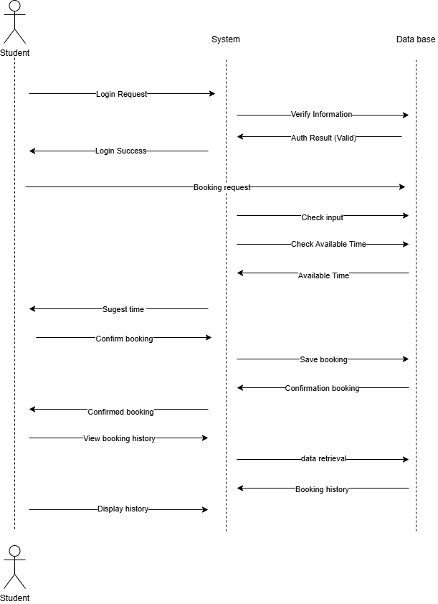

3.5 State Machine Diagram: Appointment Lifecycle

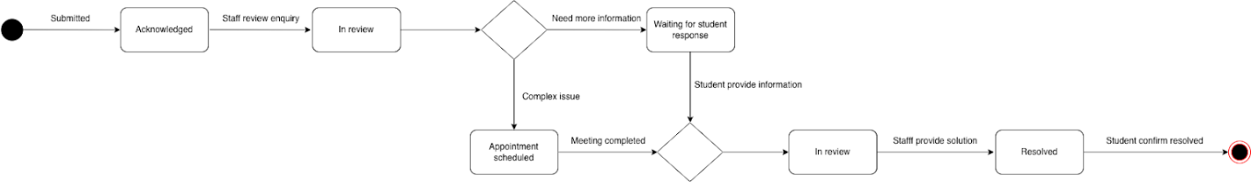

3.6 CRUD UI Modeling

3.6.1 Screen Navigation Diagram
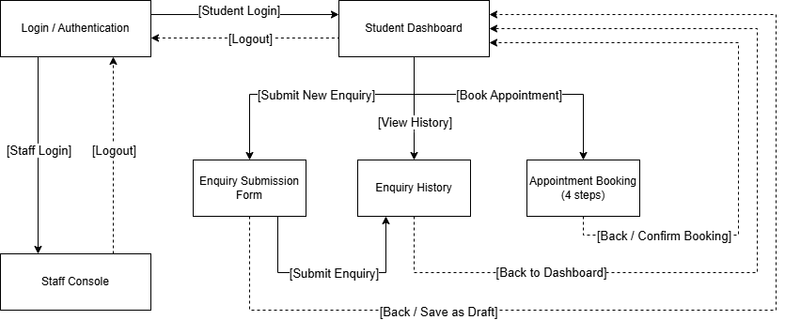

3.6.2 Interface Design Assets & Principles
Category | Component | Functional Logic
Security | Dual Auth Tabs | Distinct portals for Student vs. Staff with icon-enhanced labels.
 | Role-Based Header | Persistent ID and accessible logout; visual UI distinction by role.
Smart Booking | 4-Step Wizard | Linear progress (Staff → Date → Time → Confirm) with breadcrumbs.
 | Smart Date/Time Grid | Real-time availability; "Grey-out" logic for conflicts/past dates.
 | Summary Card | Final confirmation view with purpose-specific notes and attachments.
Centralization | Searchable Triage | Real-time filtering by ID, category, and priority for staff/students.
 | Sliding Detail Sheet | Non-disruptive overlay for conversation threads and history.
 | Multi-File Uploader | Drag-and-drop zone with visual feedback for .pdf and .jpg uploads.

Asset: Multi-Step Progress Indicator (Smart Booking)
- Principles: Visibility of System Status (Nielsen #1) & Progressive Disclosure.
- Logic: Complex booking is "chunked" into 4 logical steps to reduce cognitive load. Connecting lines and active highlighting (#2563eb) provide immediate feedback on progression.
- Rationale: Prevents decision fatigue by separating the "Who, When, and Why" of an appointment.

Asset: Status Badge System (Centralized Platform)
- Principles: Recognition over Recall (Nielsen #6) & Consistency.
- Logic: Color-coded badges (Yellow/Blue/Green) provide instant semantic meaning across all user roles.
- Rationale: Color-coded badges with text labels for rapid status identification and WCAG accessibility.

3.6.3 Screen Mockups
Link Figma: https://www.figma.com/make/BqNbo6fy8q3rCn6m4logoL/University-Requirement-System?t=YEd1YS8tXsvGeAj3-20&fullscreen=1

3.7 CRUD Technique on Event Table
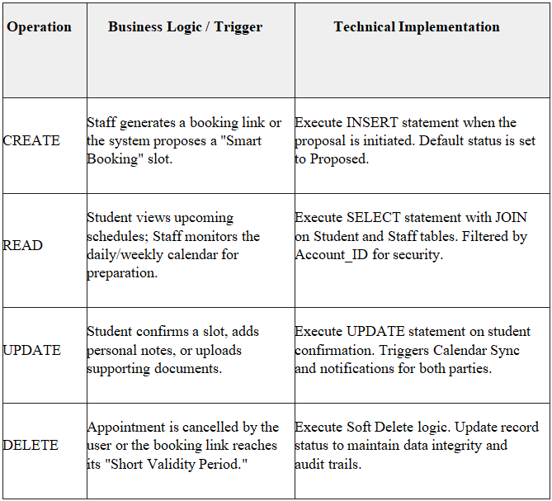

SECTION 4: PART B – TESTING AND DISCUSSION

4.1 Test Scripts
Test Script ID: TS-01
Test Title: Successful Appointment Booking and Confirmation
Test Script Description: To verify that a student can successfully book an appointment through the system and receive confirmation after selecting an available time slot.
Preconditions:
- Student has a registered account.
- Student is logged into the system.
- Staff calendar contains available appointment time slots.
- System database is operational.
Expected Outcome: The appointment is successfully booked, stored in the system database, and confirmation is displayed to the student.
Step No. | Step Description | Inputs | Expected Outcome | Pass / Fail / Blocked | Actual Outcome | Bug ID
1 | Student logs into the system | Valid username & password | System authenticates user and redirects to dashboard | Pass | User successfully logged in and dashboard loaded within acceptable time | N/A
2 | Student selects “Book Appointment” | Click booking feature | Appointment booking interface is displayed | Pass | Booking interface loaded correctly without UI issues | N/A
3 | Student enters booking details | Enquiry topic, preferred date & time | System validates input fields successfully | Pass | System validated inputs and highlighted required fields correctly | N/A
4 | System checks available time slots | Date & time entered | System retrieves and displays available slots | Pass | Available time slots displayed correctly from staff calendar | N/A
5 | Student selects suggested time slot | Select available time | System prompts booking confirmation | Pass | Confirmation screen displayed with correct booking summary | N/A
6 | Student confirms booking | Click confirm | System saves booking to database | Pass | Booking stored successfully in system database | N/A
7 | System sends confirmation | Booking information | Confirmation message and acknowledgement displayed | Pass | Confirmation message displayed and confirmation email sent to student | N/A
8 | Student views booking history | Click “View History” | Newly created booking appears in history list | Pass | Booking appeared correctly in booking history list | N/A

Test Script ID: TS-02
Test Title: Expired Booking Link Handling
Test Script Description: To verify that the system properly handles expired booking links and prompts the student to restart the booking process.
Preconditions:
- Student previously received booking link.
- Booking link has passed its validity period.
- Student attempts to access expired link.
Expected Outcome: The system prevents the use of expired booking links and allows the student to safely restart and complete a new booking.
Step No. | Step Description | Inputs | Expected Outcome | Pass / Fail / Blocked | Actual Outcome | Bug ID
1 | Student clicks expired booking link | Expired booking URL | System detects link expiration | Pass | System immediately detected expired link and blocked access | N/A
2 | System displays expiry notification | Expired link access | Error message indicating link has expired is shown | Pass | Clear error message displayed informing the link has expired | N/A
3 | System provides rebooking option | Click “Book New Appointment” | Student redirected to booking page | Pass | Student successfully redirected to booking page | N/A
4 | Student logs in again (if required) | Valid login credentials | Dashboard is displayed | Pass | Student logged in successfully and accessed dashboard | N/A
5 | Student restarts booking process | Enter new booking details | System validates inputs | Pass | Inputs validated successfully without errors | N/A
6 | Student selects new available time slot | Select time slot | System confirms booking successfully | Pass | Booking confirmed successfully with new appointment slot | N/A
7 | Confirmation message displayed | Booking information | New booking confirmation shown to student | Pass | Confirmation message displayed and email notification received | N/A

4.2 Ethics and AI Governance in Automated Systems
In modern systems, the integration of smart scheduling, centralized models, and student data security are crucial for managing student appointments. The student experience and user trust are also important. As we know, the world now relies heavily on AI, and this system is well-suited to the current global context. For example, the European Union's guidelines on artificial intelligence provide users with a reliable and trustworthy platform. The implementation of AI principles and risk management guidelines from NIST emphasizes reliability.
Smart scheduling involves the system automatically scheduling appointments based on available system data in real time and according to the system's logic. This minimizes the need for anyone wanting to schedule an appointment to do so through other platforms such as email or messaging, and even reduces common errors like scheduling conflicts or missed appointments due to lack of notifications. Another benefit is that if a student schedules an appointment but forgets, the system can check and send a reminder when the appointment is approaching, helping students and system administrators manage their time. However, the system is highly dependent on accurate data management and its operational stability. According to the NIST AI Risk Management Framework, managing system risks and consumer trust throughout the system's lifecycle is essential to maintaining consumer confidence and system effectiveness. Even if the system itself is trouble-free, the benefits of automation can still turn into inefficiencies.
The centralized model enhances student capabilities by integrating all services into a single system. Instead of students using multiple applications for communication, such as chat or messaging apps, all students interact through a single system. This allows the organization to track student needs and ensure information is stored within the system. From an administrator's perspective, the OECD's AI principles emphasize the importance of accountability and traceability in systems. A centralized system supports users by clearly recording interactions and decisions, thereby improving service quality. However, this centralization still carries risks such as system errors, and users will have reduced flexibility due to having to follow system instructions.
Security is a crucial component supporting both systems. These platforms often handle sensitive personal data, requiring robust authentication, access control, and protection of essential information. The OECD's AI principles regarding privacy and human rights clearly state that the system must protect user data and ensure user safety. However, this enhanced security may be inconvenient for users, such as time-consuming verification processes or the need for users to know how to use the system.
Combining these three elements creates a comprehensive system that meets consumer expectations. Intelligent self-booking systems improve efficiency through automated booking, augmented reality models enhance organization and access, and secure systems build user trust and safety. According to NIST, monitoring and risk reduction are crucial; successful implementation increases user confidence in the system over time. The OECD emphasizes the importance of secure and accountable systems throughout their operation.
In conclusion, integrating a self-booking system, a centralized model, and security to address student needs, particularly student request management, remains crucial. While challenges such as over-reliance on the system, potential system failures, reduced flexibility, and system adaptation to EU guidelines, OECD AI principles, and NIST AI risk management guidelines are necessary, organizations can create a reliable, secure system that values user input.

SECTION 5: CONCLUSION
In summary, the proposed Student Enquiry and Appointment System successfully solved the identified difficulties. By integrating a centralized management model, smart scheduling logic, and authentication, the design ensures a secure user journey for both students and staff. The system not only reduces administrative overhead but also enhances the overall quality of student support services. Its design follows technical standards and ethical AI guidelines, providing a scalable and reliable foundation for the university's future digital infrastructure.

Link for Slides: https://gamma.app/docs/Making-Student-Appointments-6z2kbvlnb0wm0j5

REFERENCES
European Commission. (2019). Ethics guidelines for trustworthy AI | Shaping Europe’s digital future. European Commission. https://digital- strategy.ec.europa.eu/en/library/ethics-guidelines-trustworthy-ai
Luciano Floridi et al. (2018). AI4People—An Ethical Framework for a Good AI Society (Springer).
National Institute of Standards and Technology. (2023, July 12). AI Risk Management Framework. NIST. https://www.nist.gov/itl/ai-risk-management-framework
O’neil, C. (2016). Weapons of Math Destruction: How big data increases inequality and threatens democracy. Penguin Books.
OECD. (2019). The OECD Artificial Intelligence (AI) Principles. Oecd.ai; OECD. https://oecd.ai/en/ai-principles

APPENDIX: GENAI TRACEABILITY LOG

- Gen AI tool: GEMINI
Conversation link: https://gemini.google.com/share/be022429b2d9
Date: 14/03/2026
- Initial input prompt:
“Working as a business analyst gave me the idea about designing a CRUD UI for a requirement system. Here is some useful information about this system: Description of the proposed system:
The proposed system is a centralized digital platform designed to manage student enquiries and appointment bookings more efficiently. It replaces fragmented communication channels such as email, phone calls, and walk-ins with a single online platform.
First, the system enforces authentication. Students must log in before submitting enquiries or booking appointments, ensuring that all requests are linked to verified student profiles and allowing users to review their enquiry history.
Second, the platform provides a structured interface for submitting enquiries. Students can attach supporting documents and optionally select a category, while the system may also guide classification. After submission, the system records the enquiry and sends an acknowledgement.
Finally, the system includes a smart appointment booking feature. Staff can generate booking links, and students can view available time slots or select alternatives. Once confirmed, the system updates calendars and sends notifications to both parties.”
- Raw Output Summary:
AI has generated a configuration system comprising four main layers:
- Authentication Layer: Manages reading/updating personal information after login.
- Inquiry Module (CRUD): Interface for creating requests (Creating), supporting attachments, searching history (Reading), and saving drafts (Updating).
- Smart Appointment Module: Uses a Calendar/Grid UI instead of a list of essentials. Supports creating (setting appointments), updating (changing appointments), and synchronizing time between staff and students.
- UX Template: Suggests using a Progress Bar for document uploads and search suggestions to automatically request categorized requests.

- Gen AI tool: GEMINI
Conversation link: https://gemini.google.com/share/81df27e2b904
Date: 14/03/2026
- Initial input prompt:
“Working as a business analyst, how many screens should I have, and what should they contain?
- Raw Output Summary:
AI has proposed a system architecture consisting of 6 core screens:
- Authentication Screen: Authenticates information via SSO or school account.
- Student Dashboard: A general dashboard displaying request status and upcoming appointments.
- Enquiry Submission Form (Create): An entry form with category categorization and file attachments.
- Enquiry History (Read/Update): A list of request history with "Status badges".
- Appointment Booking Calendar (Smart Screen): A calendar interface (Grid UI) with integrated conflict warning logic.
- Staff Management Console (Admin): An interface for staff to triage requests and manage free time.
- Gen AI tool: GEMINI
Conversation link: https://gemini.google.com/share/85560855c146
Date: 16/03/2026
- Initial input prompt:
“As a business analyst, can I divide the Interface Design Assets into 3 parts (Design System & Visual Identity; Core Interactive Components; Design Principles Application)?”
- Raw Output Summary:
AI has proposed a three-part framework for organizing design assets, optimized for CRUD system development:
- Layer 1: Design System & Visual Identity (Standard Data Sources): Establishes the university's platform identity (brand colors, typography, icon system for Enquiry/Calendar) and grid rules to ensure the CRUD data table is not cluttered.
- Layer 2: Core Interactive Components: Builds functional blocks with "state-aware" capabilities. This includes input fields, button types (Submit, Save Draft, Cancel), and feedback loops (Toast messages, Loaders/Skeleton screens) when the system retrieves data.
- Layer 3: Design Principles Application (Logic and Experience): Explains the thinking behind UI choices. Focus on accessibility, information hierarchy, data control logic (validation - e.g., not allowing past appointments), and responsive flow.
- Human Revision & Critical Thinking:
- Based on the 3-part structure proposed by the AI, I made specific adjustments:
- Regarding Component Logic: I specified the Status Badges in the Data Display section to match the business states (Pending, Resolved) in Karen's email.
- Regarding User Feedback: I requested the addition of specific Toast Messages for the "File Attachment Successful" case to support the student's submission of supporting documents.
- Regarding Validation Logic: I applied the "Propose Suitable Time" rule to the Principles layer, ensuring the system not only blocks past dates but also prioritizes displaying suggested time slots from staff before allowing students to choose their own.
- Gen AI tool: GEMINI
Conversation link: https://gemini.google.com/share/412d399d5551
Date: 19/03/2026
- Initial input prompt:
“As a business analyst, can you give me an example of CRUD technique on event table?”
- Raw Output Summary:
Action | Business Logic (The "Why") | UI Implementation (The "What")
Create | A student selects an available slot to "book" an appointment. | The student clicks a "Confirm Booking" button on the calendar. This generates a new EventID with a status of Confirmed.
Read | Both parties need to see their upcoming schedule. | The Dashboard fetches all events where StudentID or StaffID matches the logged-in user and the Date is $\ge$ today.
Update | A student needs to change the time or add a note/document before the meeting. | The student clicks "Reschedule." The system updates the StartTime and EndTime fields in the existing record.
Delete | An appointment is cancelled by either party. | Instead of a hard delete (erasing the row), BAs often recommend a Soft Delete: changing the Status column to Cancelled.

- Human Revision & Critical Thinking:
I modified this table by adding the Expiry_Timestamp and Proposed_Time fields to meet the Operation Manager's "Short Validity Period" and "Smart Booking" requirements. I also integrated authorization logic (Role-Based Access) into the READ commands to ensure the security of the university system.
- Gen AI tool: ChatGPT
Date: 11/03/2026
- Initial input prompt:
““I am working on a system analysis assignment and need to write a system description for a centralized student enquiry and appointment booking system.
The system should replace fragmented communication methods such as emails, phone calls, and walk-ins with a single digital platform.
It should include features such as authentication, enquiry submission, and appointment booking.
Can you help me draft a clear system description that explains how the system works?”
- Raw Output Summary:
AI generated an initial system description including the following elements:
- System Overview: Described a centralized platform that allows students to submit enquiries and book appointments with staff, replacing traditional communication methods.
- User Interaction Flow: Suggested that students interact with the system by entering requests and selecting available time slots for appointments.
- Basic Enquiry Handling: Mentioned that enquiries can be submitted through an online form and accessed by staff.
- Appointment Booking Feature: Included a simple booking function where students choose available time slots and confirm appointments.
- System Purpose: Highlighted improving communication efficiency and providing a more organized way to manage student requests.
- Gen AI tool: ChatGPT
Date: 11/03/2026
- Initial input prompt:
“Working as a business analyst, I want to define the functional and non-functional requirements for a student enquiry and appointment system. Here is some useful information about this system:
Description of the proposed system:
The system is a centralized digital platform that allows students to submit enquiries and book appointments. It replaces communication methods such as email, phone calls, and walk-ins.
The system includes authentication, enquiry submission with document attachments, and appointment booking with available time slots. It also records enquiries and provides confirmation messages.
Can you help me identify the key functional and non-functional requirements for this system?”
- Raw Output Summary:
AI generated a draft requirement structure comprising the following components:
- User Access Module: Includes login functionality and basic user identification before accessing system features.
- Enquiry Management Module: Allows students to submit enquiries, add supporting information, and store enquiry records for later viewing.
- Tracking & Feedback Module: Provides basic status checking and confirmation messages after submission.
- Appointment Scheduling Module: Supports selecting available time slots and recording appointment bookings.
- Notification Feature: Includes simple system notifications for updates and confirmations.
- System Quality Attributes: Suggests general non-functional aspects such as security, usability, performance, reliability, and data handling.

- Gen AI tool: ChatGPT
Date: 11/03/2026
- Initial input prompt:
“Working as a business analyst, I want to develop use case narratives for a student enquiry and appointment system. Here is some useful information about this system:
Description of the proposed system:
The system is a centralized digital platform that allows students to submit enquiries and book appointments. It replaces communication methods such as email, phone calls, and walk-ins.
The system includes authentication, enquiry submission with document attachments, and appointment booking with available time slots. It also records enquiries and sends confirmation messages.
I want to translate these system features into structured use case narratives with actors and flows. Can you help me outline the main use cases?”
- Raw Output Summary:
AI generated a draft use case structure comprising the following components:
- Authentication Interaction: Describes user login before accessing system features.
- Enquiry Use Case: Includes steps for submitting enquiries, entering details, attaching documents, and receiving confirmation.
- Enquiry Tracking Use Case: Covers viewing enquiry history and checking status of submitted requests.
- Appointment Booking Use Case: Outlines selecting available time slots and confirming bookings.
- Appointment Management Use Case: Includes rescheduling or canceling existing appointments.
- Staff Interaction: Describes staff reviewing enquiries, responding to requests, and managing availability.
Gen AI tool: ChatGPT
Date: 11/03/2026
- Initial input prompt:
“Working as a business analyst, I want to design a state machine diagram for a student enquiry and appointment system. Here is some useful information about this system:
Description of the proposed system:
The system is a centralized digital platform that allows students to submit enquiries and book appointments. It replaces communication methods such as email, phone calls, and walk-ins.
The system includes authentication, enquiry submission with document attachments, and appointment booking with available time slots. It also records enquiries and sends confirmation messages.
I want to represent how different entities change states over time. Can you help me identify the key states and transitions for this system?”
- Raw Output Summary:
AI has generated a state-based system structure comprising the following components:
- Enquiry State Flow: Includes states such as Draft, Submitted, In Progress, Resolved, and Closed, representing the lifecycle of an enquiry.
- Enquiry Transitions: Defines movements between states, such as submitting an enquiry, processing requests, resolving issues, and closing cases.
- Appointment State Flow: Includes states such as Available, Booked, Confirmed, Completed, and Cancelled, representing the lifecycle of an appointment.
- Appointment Transitions: Describes actions such as selecting time slots, confirming bookings, completing appointments, and handling cancellations or rescheduling.
- System Interaction Logic: Suggests that state changes are triggered by user actions, staff actions, and system events such as notifications or time-based updates.

Gen AI tool: ChatGPT
Date: 11/03/2026
- Initial input prompt:
“Working as a business analyst, I want to design test cases for a student enquiry and appointment system. Here is some useful information about this system:
Description of the proposed system:
The system is a centralized digital platform that allows students to submit enquiries and book appointments. It replaces communication methods such as email, phone calls, and walk-ins.
The system includes authentication, enquiry submission with document attachments, and appointment booking with available time slots. It also records enquiries and sends confirmation messages.
I want to validate that the system functions correctly based on its requirements. Can you help me identify key test scenarios for this system?”
- Raw Output Summary:
AI has generated a testing structure comprising the following components:
- Authentication Testing: Includes validating user login, handling incorrect credentials, and restricting access without authentication.
- Enquiry Module Testing: Covers creating enquiries with valid and invalid inputs, handling missing information, and supporting document attachments.
- Enquiry Tracking Testing: Includes viewing enquiry history, displaying enquiry details, and checking status updates.
- Appointment Module Testing: Covers selecting available time slots, confirming bookings, and preventing conflicts such as double booking.
- Appointment Management Testing: Includes rescheduling and canceling appointments, as well as updating booking information.
- System Feedback & Notification: Suggests validating confirmation messages, system notifications, and error handling during user interactions.

