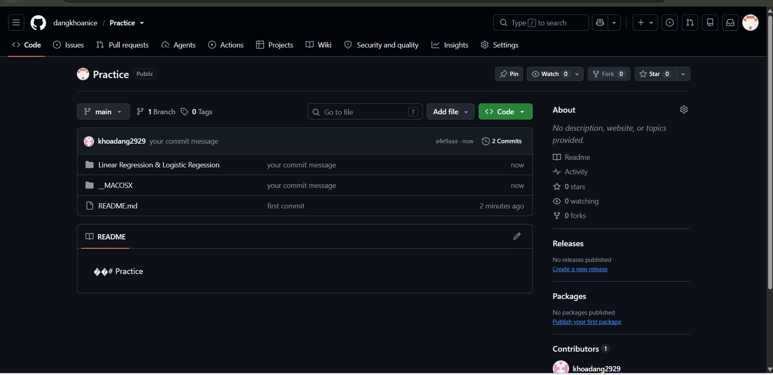https://github.com/dangkhoanice/Practice

