Intuit Tank Recording Proxy Tool

# Download Proxy Tool

1. First Download the proxy tool from Tank by going to the Tools tab
2. Under the Downloadable Tools Section click on the “Intuit Tank Proxy Package”
3. Unzip the file to the desired directory

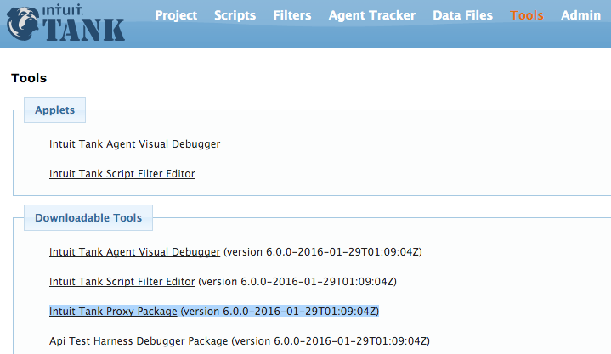

# Configure Proxy Settings for Chrome (Windows)

1. Type the following in the URL section: chrome://settings/
2. Scroll down and click on the “Show advanced settings…” link
3. Next scroll down to the Network section and click on the “Change proxy Settings…” button
4. The Internet Properties window will pop up. Click the “LAN settings” button
5. The Local Area Network (LAN) Settings window will appear. In the Proxy server section click on the check-box “Use a proxy server for your LAN …”. Followed by clicking the “Advanced” button.
6. The Proxy Settings window will appear. For “HTTP” type, type 127.0.0.1 for the proxy address to use. For the Port use 8888 which is used by the Proxy tool.
7. Next click the check-box “Use the same proxy server for all protocols followed by clicking the “Ok” button to close the proxy settings window.
8. Click the “Ok” button on the Local Area Network (LAN) Settings windows to close it.
9. Finally click the “Ok” button on the Internet Properties window to close it.

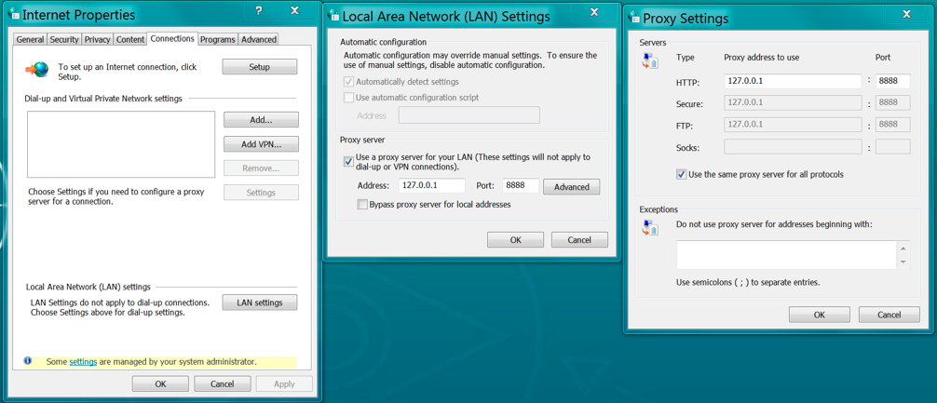

# Import Proxy certificate in Chrome (Windows)

1. From the Chrome settings page, scroll down to the HTTPS/SSL section and click on the “Mange certificates…” button. (chrome://settings/)
2. The Certificates window will appear then click on the “Trusted Root Certification Authorities” tab.
3. Click on the “Import…” button to import Proxy’s certificate. The Windows Explorer will appear.
4. In the Windows Explorer window change the certificate type dropdown from “X.509 Certificate (*.cer;*crt)” to “All Files (*.*)”
5. Next go to the Proxy directory
6. Select “auto_generated_ca.pem” file follow by clicking the “Open” button.
7. At the Certificate Import Wizard, click the “Next >” button.
8. Once again click the “Next >” button.
9. Finally click on the “Finish” button.
10. A Security Warning window will appear, click the “Yes” button to proceed.
11. You should see a pop-window that the import was successful. Click the “Ok” button which takes you back to the Certificates window.
12. To verify the proxy certificate was imported scroll down till you see the “OWASP Custom CA for Tank”. Once verified click on the “Close” button.

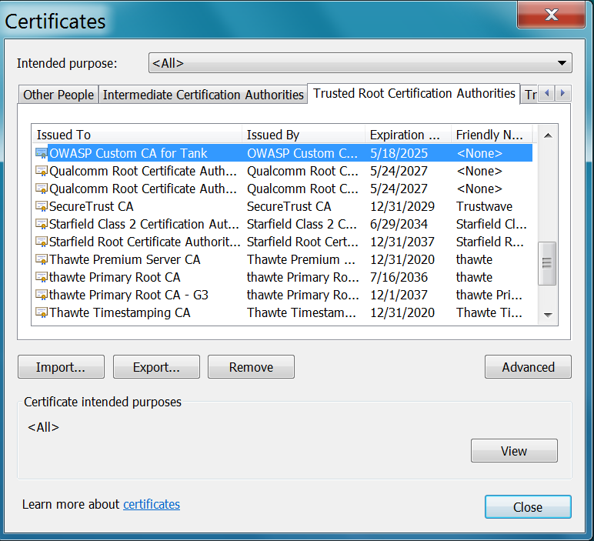

# Configure Proxy settings for Firefox (Windows)

1. Launch Firefox and type the following in the URL section: about:preferences#advanced
2. In the Advanced section, click on the “Network” Tab
3. Click the “Settings…” button on the right side of “Configure how Firefox connects to the Internet”. A Connection Settings window will appear.
4. Next click on the “Manual proxy configuration:” radio button.
5. Type in 127.0.0.1 in the “HTTP Proxy:” field
6. Type in 8888 in the “Port:” field
7. Click on the “Use This proxy server for all protocols”
8. Last step is to click on the “OK” button

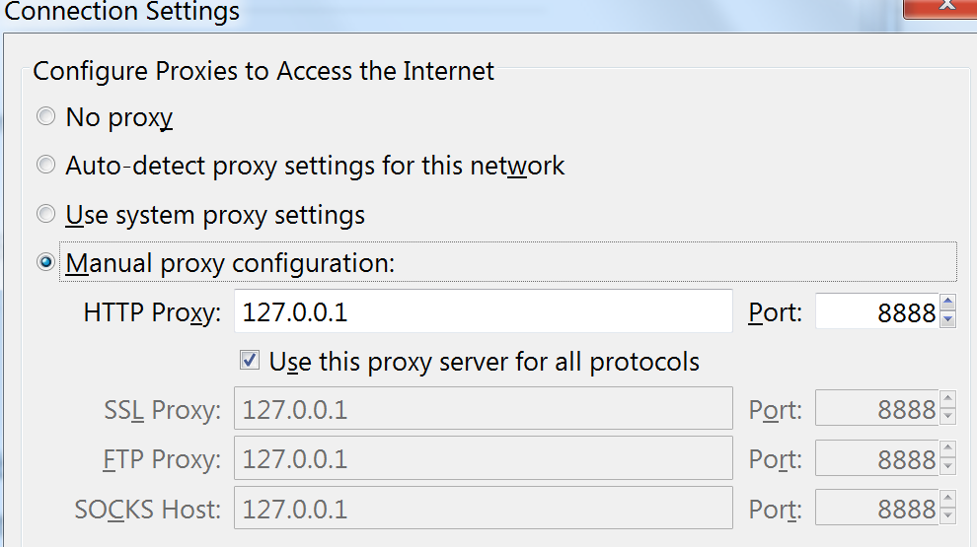

# Import Proxy certificate in Firefox (Window)

1. In the Firefox browser type in the following in the URL section: about:preferences#advanced
2. Click on the Certificates Tab
3. Next click on the “View Certificates” button which results in the Certificate Manger appearing.
4. Click on the Authorities tab in the Certificate Manger
5. To import the proxy certificate, click on the “Import” button near the bottom of the Certificate Manager window.
6. Go to the Proxy recorder directory where the “Auto_generated_ca.pem” file exists. Once selected click on the “Open” button.
7. Click on all three check box (See below) followed by clicking the “OK” button. You should be returned to the Certificate Manager window.
8. Next verify the certificate was imported by looking for “OWASP Custom CA for Tank” in the list of certificates.

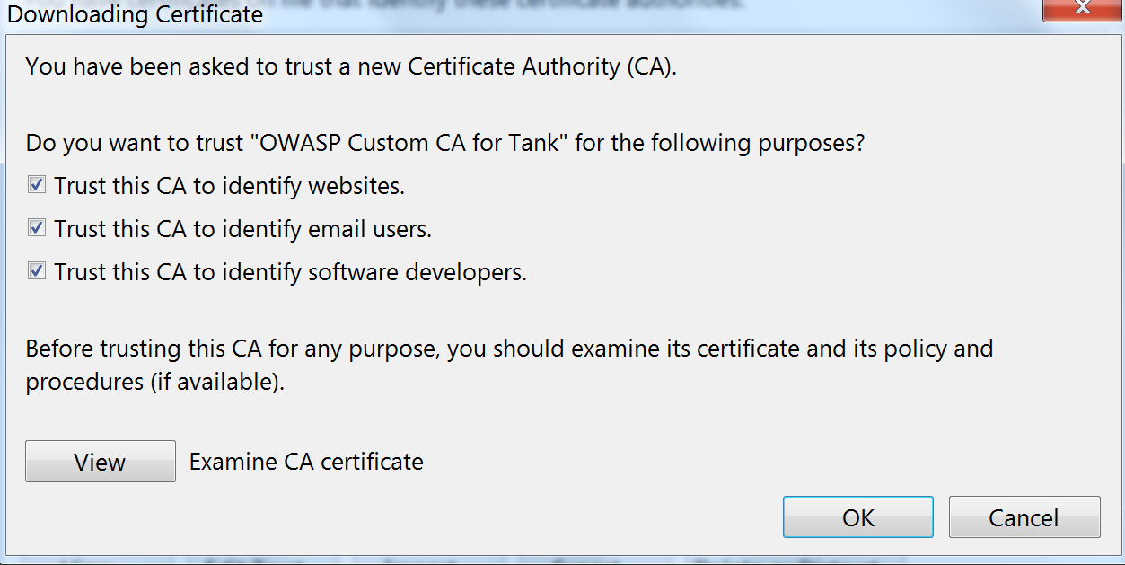

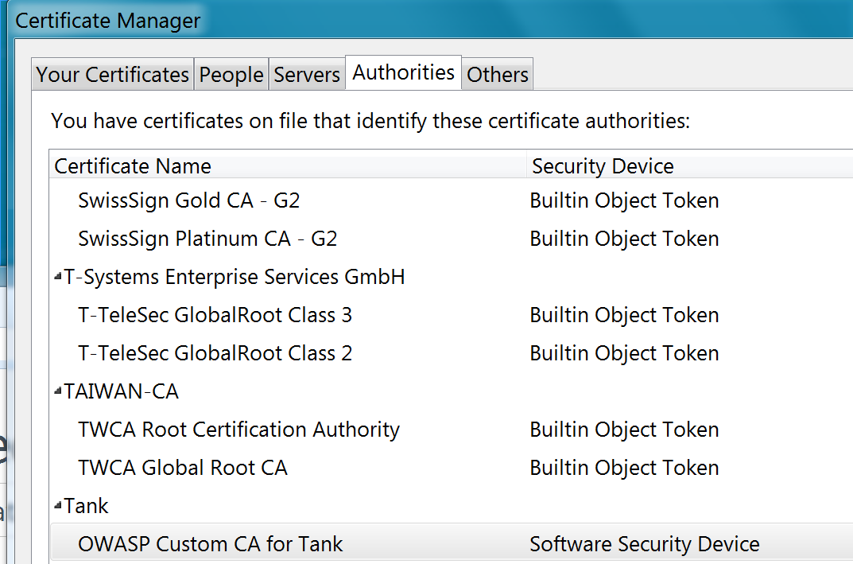

# Using the proxy recorder

1. First make sure your Chrome bowser is properly configured to use the proxy server
2. You may want to clear your browser cache before recording
3. Next launch the Tank Recording Proxy by double clicking on the “Tank-Proxy-all.jar”
4. If you are ready to record, then first click on the “Play button” ../Desktop/Screen%20Shot%202016-02-16%20at%2010.23.19%20AM.png
5. Next type in the target URL in your browser.
6. As you navigate through your application you will start to see the http(s) requests in the recording proxy.
7. Once you have completed your flow, make sure to click on the “Stop button”../Desktop/Screen%20Shot%202016-02-16%20at%2010.29.40%20AM.png before closing your browser and recorder.
8. Make sure to undo the proxy servers settings in your browser.
9. By default, a file named “outputFile.xml” is generated and located in Tank Proxy directory.

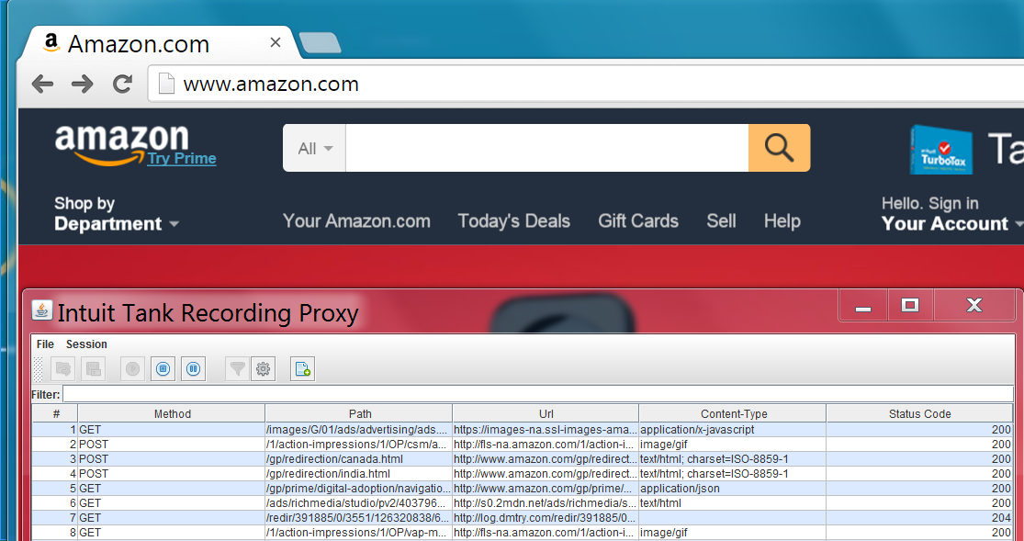

# Import Proxy Recording into Tank

1. Login to your Tank Controller
2. Click on the “Scripts” Tab
3. At the Scripts section, click on the “New Script” button (Next to the “Import Intuit Tank XML” button.../Desktop/Screen%20Shot%202016-02-16%20at%2010.40.22%20AM.png
4. Fill in a name for your script in the “Script Name” field
5. Click on the “Choose File” button to select your outputFile.xml. Note by default your file is located in home directory of the proxy recorder.
6. If you have any pre-created filter go ahead select them.
7. Finally click on the “Save” button to generate the Tank script. If successfully you will be returned to the Scripts view and should see your generated script.