Lab Report 1

Introduction to ModelSim, RARS, Venus and Git

Mai Dang

D

1. **RARS Tutorial**
2. **Screenshot of RARS with the console window showing the results of the swaps.s program and the contents of the RISC-V registers at the end of your program**

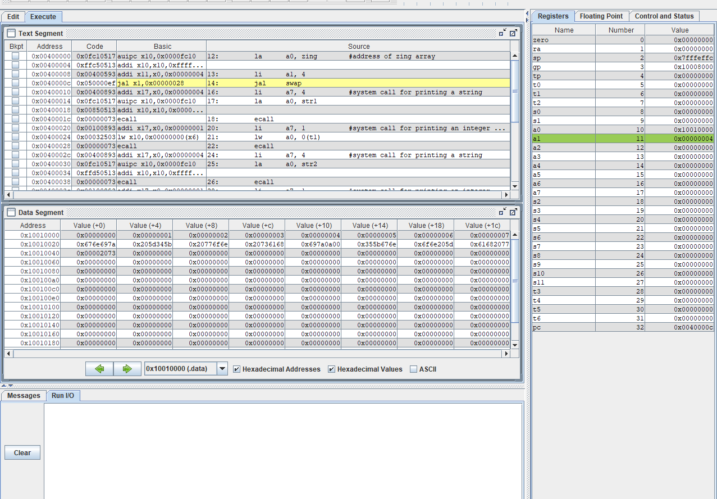

1. **Venus Online Simulator Tutorial**

1. ***What address is zing located at?***

* Zing is first addressed at a0, after running the program, address of zing is now t0.
* There are 17 registers in the swap.s and t0 is the 13th register.
* The address of t0 is 0x10000030.

Therefore, the address that zing is located at is 0x10000030.

1. The program is working because there is no errors detected and it shows all the address of 17 registered as long as all the result needed, the machine code, basic code and original code.
2. **Screenshot of the running swap.s on Venus Online**

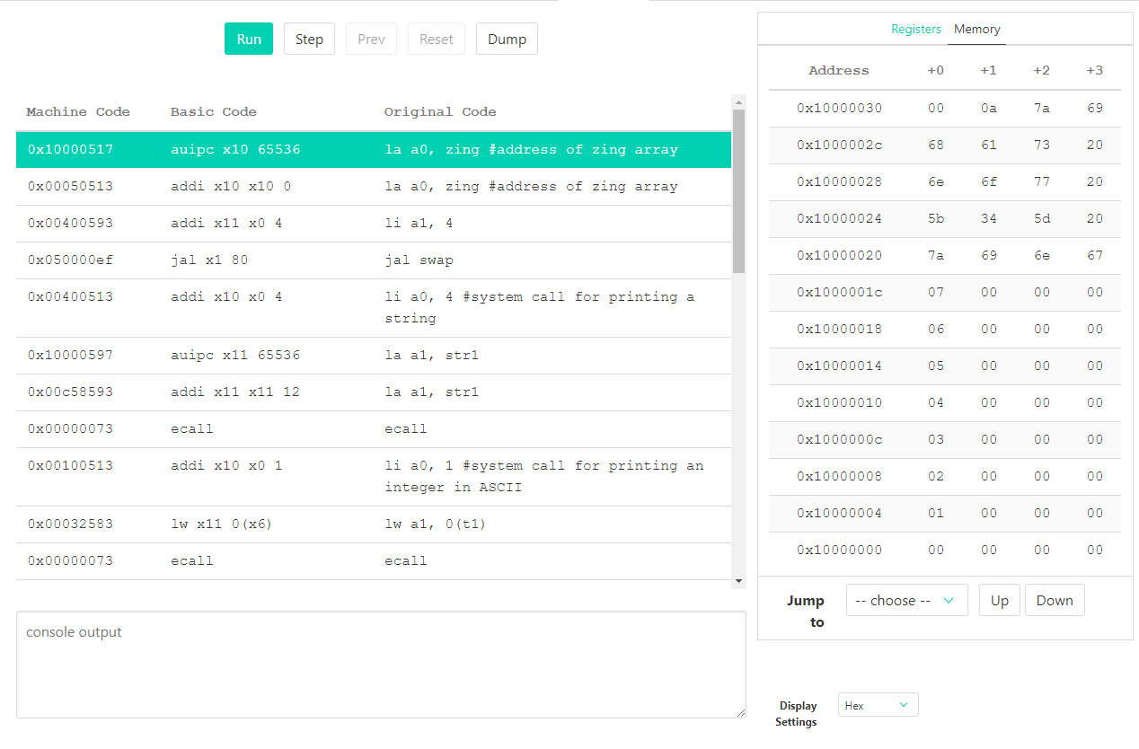

1. **Questa/ ModelSim Tutorial**

Screenshot of ModelSim simulating the intro VHDL project with the waveform of the signals

