Họ tên: Kiều Đăng Nam

MSSV: 20176830

**Báo cáo thực hành tuần 6**

**Asignment 1**

1. Source code:

#Laboratory Exercise 6, Assignment 1

.data

A: .word 1, 5, -4, 3, -6, 2, 7

.text

main:

la $a0, A #address of A[0]

li $a1, 7 #number of element in A

j mspfx

nop

continue:

lock:

j lock

nop

end_of_main:

#-----------------------------------------------------------------

#Procedure mspfx

# @brief find the maximum-sum prefix in a list of integers

# @param[in] a0 the base address of this list(A) need to be processed

# @param[in] a1 the number of elements in list(A)

# @param[out] v0 the length of sub-array of A in which max sum reachs.

# @param[out] v1 the max sum of a certain sub-array

#-----------------------------------------------------------------

#Procedure mspfx

#function: find the maximum-sum prefix in a list of integers

#the base address of this list(A) in $a0 and the number of

#elements is stored in a1

mspfx:

addi $v0, $zero, 0 #init length of sub-array in $v0 to 0

addi $v1, $zero, 0 #init max sum of sub-array in $v1 to 0

addi $t0, $zero, 0 #init index i in $t0 to 0

addi $t1, $zero, 0 #init running sum in $t1 to 0

loop:

add $t2, $t0, $t0

add $t2, $t2, $t2 #put 4i in $t2

add $t3, $t2, $a0 #put 4i + A = Adress og A[i] in $t3

lw $t4, 0($t3) #load A[i] value from address $t3 into $t4

add $t1, $t1, $t4 #update sum = sum + A[i]

slt $t5, $v1, $t1 #compare sum and sum + A[i]

bne $t5, $zero, mdfy #if max sum is less, modify result

j test #done ?

mdfy:

addi $v0, $t0, 1 #update new leng = new index + 1

addi $v1, $t1, 0 #update new max sum

test:

addi $t0, $t0, 1 #advanxe the index i

slt $t5, $t0, $a1 #compare i != no. element

bne $t5, $zero, loop #repeat if i < n

done:

j continue

mspfx_end:

1. Kết quả chạy chương trình

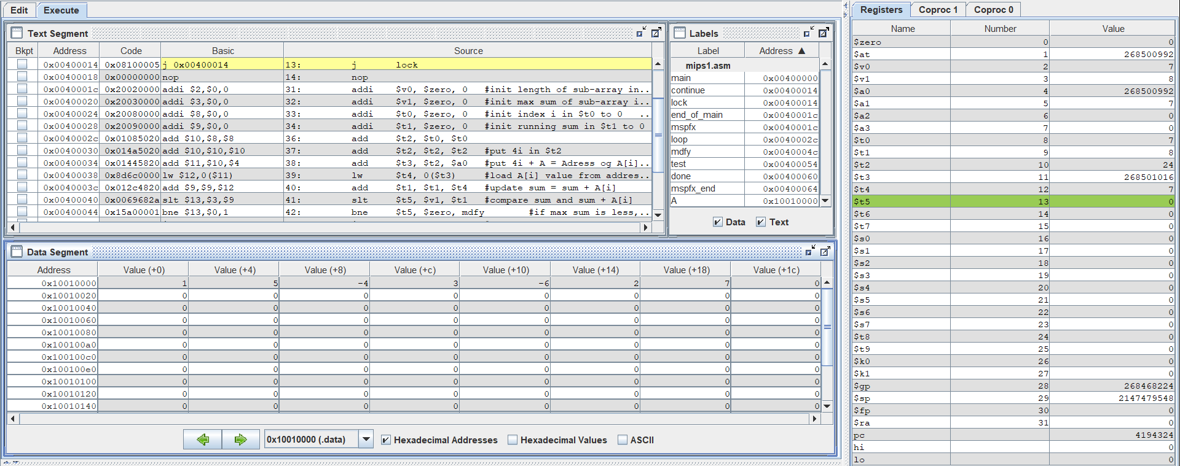



Kết quả là chính xác: ban đầu cho mảng A[7] = {1,5,-4,3,-6,2,7}

* Max của sub-array tính từ A[0] = 8 (=$v1). Độ dài sub-array này là 7 (=$v0)

**Asignment 2:**

1. Source code

#Laboratory 6, Assignment 2

.data

A: .word 10, -2, 5, 1, -5, 6, 0 , 3, 6, 8, 8, 48, 9

Aend: .word

.text

main:

la $a0,A #$a0 = Address(A[0])

la $a1,Aend

addi $a1,$a1,-4 #$a1 = Address(A[n-1])

j sort #sort

after_sort:

li $v0, 10 #exit

syscall

end_main:

#--------------------------------------------------------------

#procedure sort (ascending selection sort using pointer)

#register usage in sort program

#$a0 pointer to the first element in unsorted part

#$a1 pointer to the last element in unsorted part

#$t0 temporary place for value of last element

#$v0 pointer to max element in unsorted part

#$v1 value of max element in unsorted part

#--------------------------------------------------------------

sort:

beq $a0,$a1,done #single element list is sorted

j max #call the max procedure

after_max:

lw $t0,0($a1) #load last element into $t0

sw $t0,0($v0) #copy last element to max location

sw $v1,0($a1) #copy max value to last element

addi $a1,$a1,-4 #decrement pointer to last element

j sort #repeat sort for smaller list

done:

j after_sort

#------------------------------------------------------------------------

#Procedure max

#function: fax the value and address of max element in the list

#$a0 pointer to first element

#$a1 pointer to last element

#------------------------------------------------------------------------

max:

addi $v0,$a0,0 #init max pointer to first element

lw $v1,0($v0) #init max value to first value

addi $t0,$a0,0 #init next pointer to first

loop:

beq $t0,$a1,ret #if next=last, return

addi $t0,$t0,4 #advance to next element

lw $t1,0($t0) #load next element into $t1

slt $t2,$t1,$v1 #(next)<(max) ?

bne $t2,$zero,loop #if (next)<(max), repeat

addi $v0,$t0,0 #next element is new max element

addi $v1,$t1,0 #next value is new max value

j loop #change completed; now repeat

ret:

j after_max

1. Kết quả chạy:

Input: 10, -2, 5, 1, -5, 6, 0, 3, 6, 8, 8, 48, 9

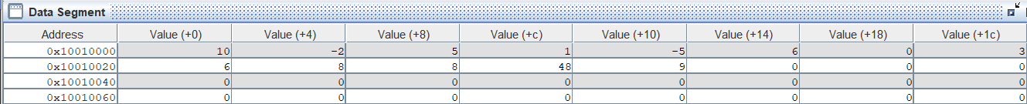

Output: -5, -2, 0, 1, 3, 5, 6, 6, 8, 8, 9, 10, 48

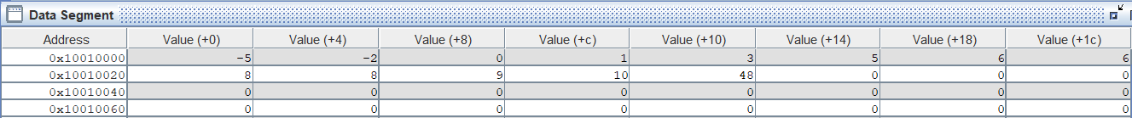

**Assignment 3:**

1. Source code

#Laboratory Exercise 6, Assignment 3 - Home Assignment 2

.data

A: .word 10, -2, 5, 1, -5, 6, 0 , 3, 6, 8, 8, 48, 9

Aend: .word

.text

main: la $a0,A #$a0 = Address(A[0])

la $a1,Aend

addi $a1,$a1,-4 #$a1 = Address(A[n-1])

j sort #sort

after_sort:

li $v0, 10 #exit

syscall

end_main:

sort:

beq $a0,$a1,done #single element list is sorted

j max #call the max procedure

after_loop:

addi $a1,$a1,-4 #decrement pointer to last element

j sort #repeat sort for smaller list

done:

j after_sort

max:

addi $t0,$a0,0 #init pointer to first

loop:

beq $t0,$a1,after_loop #if j = last or n - i -1, return

addi $t1,$t0,0 # init j

addi $t0,$t0,4 # init j + 1

lw $t3,0($t1) #load j element into $t3

lw $t4,0($t0) #load j+1 element into $t4

slt $t5,$t4,$t3 #(A[j+1])<(A[j]) ?

bne $t5,$zero,swap #if A[j+1])<(A[j]), repeat

j loop #if not, repeat

swap:

sw $t3,0($t0)

sw $t4,0($t1)

j loop

1. Kết quả:

Input: 10, -2, 5, 1, -5, 6, 0, 3, 6, 8, 8, 48, 9



Output: -5, -2, 0, 1, 3, 5, 6, 6, 8, 8, 9, 10, 48



**Asignment 4**

1. Source Code

#Laboratory Exercise 6, Assignment 4

.data

A: .word 10, -2, 5, 1, -5, 6, 0 , 3, 6, 8, 8, 48, 9

Aend: .word

.text

main:

la $a0,A #$a0 = Address(A[0])

la $a1,Aend #address A[n]

addi $a2,$a0,4 #$a2 = i = A[1] cuz i run from 1

j sort #sort

after_sort:

li $v0, 10 #exit

syscall

end_main:

sort:

beq $a2,$a1,done # i = n ? or i > n - 1 ( that why we use Aend not Aend -4)

j loop #call the loop procedure

after_loop:

addi $a2,$a2,4 #increment pointer of i

j sort #repeat sort

done:

j after_sort

loop:

addi $t0,$a2,-4 #j = i -1

lw $t1,0($a2) # $t1 = key = A[i]

condition1:

slt $t2,$t0,$a0 # j < 0 ? 1:0 or j is before the first element

bne $t2,$0,ret

condition2:

lw $t3,0($t0) #$t3 = A[j]

slt $t2,$t1,$t3 #key < A[j]

beq $t2,$0,ret # if not, ret

sw $t3,4($t0) # A[j+1] = A[j]

addi $t0,$t0,-4 # j = j -1

j condition1 #repeat while loop

ret:

sw $t1,4($t0) # A[j+1] = key

j after_loop

1. Kết quả:

Input: 10, -2, 5, 1, -5, 6, 0, 3, 6, 8, 8, 48, 9



Output: -5, -2, 0, 1, 3, 5, 6, 6, 8, 8, 9, 10, 48

