The Battle of Neighborhoods

*Dang Nguyen Hoang*

*December 2020*

1. **Introduction:**
2. Background

New York is one of the most populous city in the United States, and also the [most densely populated](https://en.wikipedia.org/wiki/List_of_United_States_cities_by_population_density" \o "List of United States cities by population density) major city in the United States with an estimated 2019 population of 8,336,817 distributed over about 302.6 square miles (784 km2).

With this population and dense, it seems that opening a Restaurant in New York is both a chance and challenge.

Besides, for people who is looking for a chance to work in New York, this is also a guide as it provides the density of Airbnb, price, and restaurants around.

1. Problem

The most challenging is to locate the for the Restaurant under some conditions:

* High Density of living
* Low competitors

1. Solution

The problem of finding High Density should be solved by NY_Airbnb database, using ‘DBScan’ and ‘K-means’ Technology while checking for Competitors can be done by Foursquare API

1. **Data Acquisition and Cleaning**
2. Data Sources

The data for New York Airbnb is acquired from [this link](https://www.kaggle.com/dgomonov/new-york-city-airbnb-open-data) of Kaggle.

The API that used for checking the Restaurants around the locations is [FourSquare](https://foursquare.com/)

1. Data Cleaning

Data of Airbnb that downloaded from Kaggle that only need longitude, latitude, neighbour and neighbour_group which were enough and no need to clean.

Data that get from FourSquare need to be extracted, especially in Categories column

1. Feature Selection

As mentioned above, the Features were selected by 2 datasets are:

**New York Airbnb:**

* + Neighbourhood_group
  + Neighbourhood
  + Longitude
  + Latitude

**FourSquare:**

* + Longitude
  + Latitude
  + Categories
  + Name

1. **Exploratory Data Analysis**
   1. **Locating Center of each Neighborhood in each Neighborhood group:**

There are 48895 locations of Airbnb found from the dataset. According to my experience, the Airbnb are dense in the center of the districts. However, there are some located far from the center of the District/Neighbourhood. If we use coordiantes of those Airbnb, then we can not find the center of the District. For this reason, DB-Scan was used in first hand to remove the ‘outliers’ in coordinates. After that, K-means was used to find Centers of each Neighbors

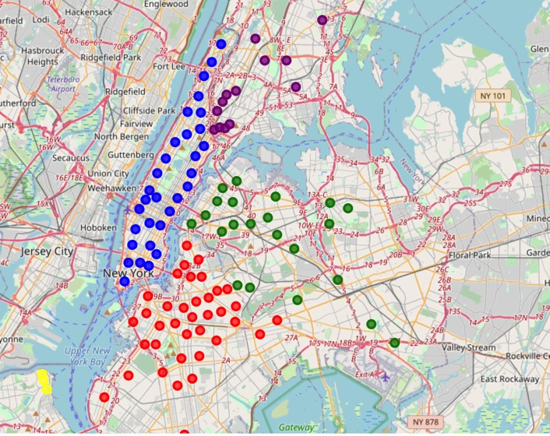

After cleaning and applying DB-scan, K-means, we can estimate the Center of Dense Zone in each neighbor as above

* 1. **Using Four-Square API to locate Restaurants in radius of 500m from the Centers:**

As the limitation of a free-account, I can only get Italian Restaurants information.

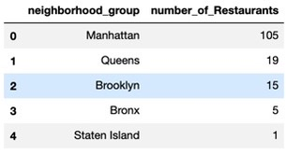

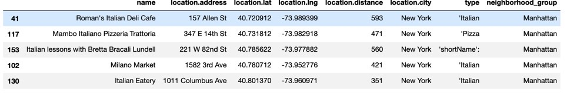

* 1. **Visualize the Location of Restaurant on Folium Map:**

It is not difficult to see that almost Italian Restaurant are located in the Center of Manhattan

Note: blue dots are center-of-neighborhoods in Manhattan

reds are centers of Brooklyn,

green for Queens

violet for Bronx

yellow for Staten Island

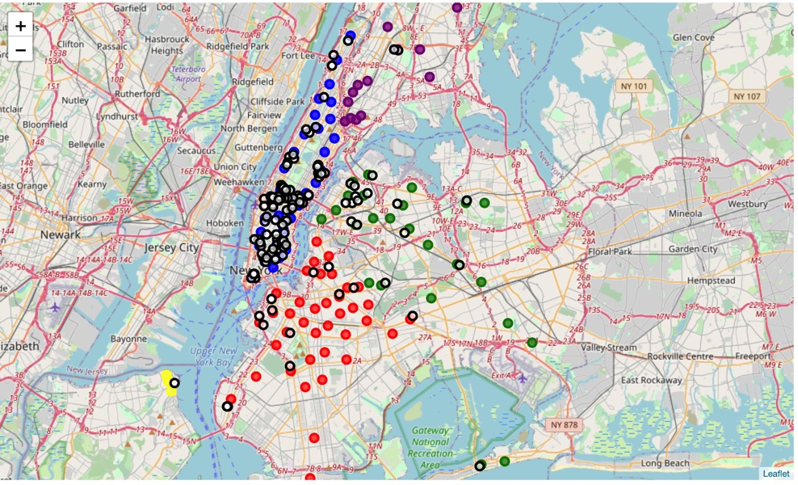

1. **Conclusion:**

Of course there should be further investigation for the potential of opening a restaurant in New York, we can see that Manhattan is a promising place, with over 70% of Airbnb and Restaurants here. However, if we decide to start in Brooklyn and Bronx or Staten Island, the pressure of competition should be lower.

1. **Future Directions:**

Indian Restaurants, Chinese Restaurants and Vietnamese Restaurants also should be in the list, as they will give us a better overview of the market here. However, the density should have been represented well here already.