Github link: <https://github.com/dangnha/py-remote-box.git>

My app is a multithreaded remote desktop application where the client can authenticate with the remote system using a password and then view and control the remote desktop using the mouse and keyboard as well as chat and transfer files at the same time. No networking library was used, implemented a communication protocol over the TCP sockets for connection.

**Server side:**

- This is UI of server, when we click “Start Listener”, the server will bind and wait for connection from client

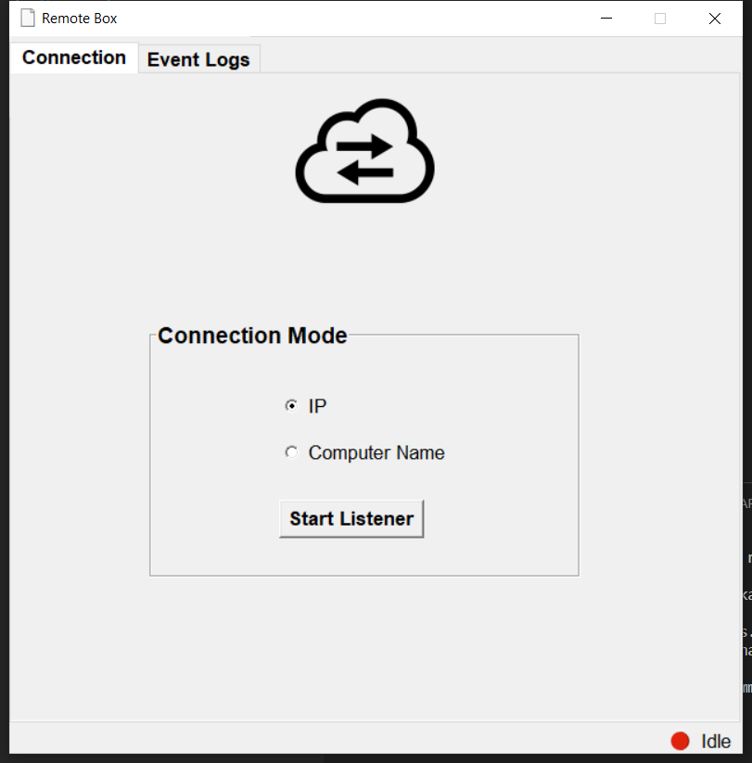

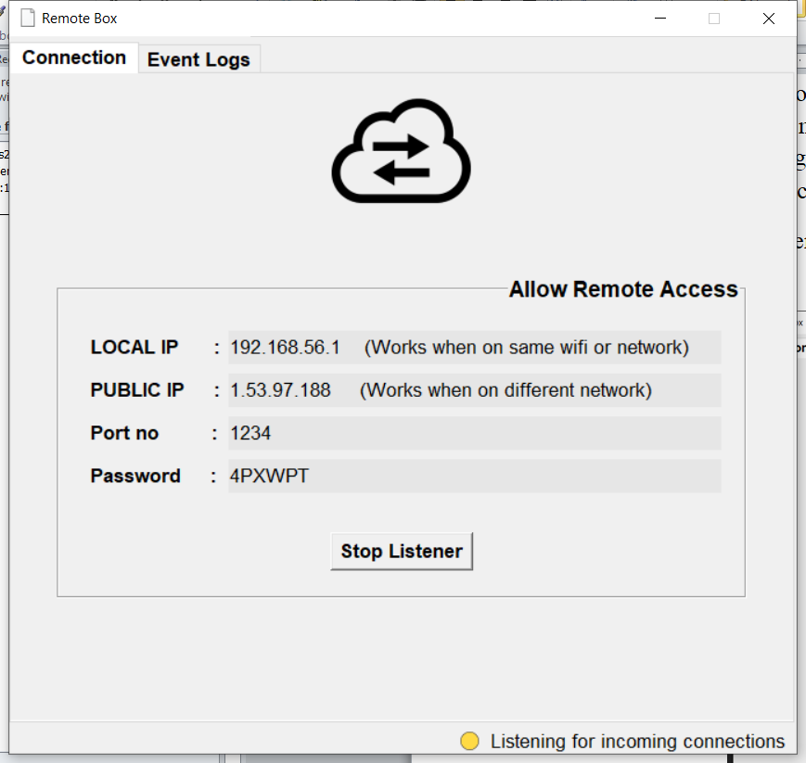

- We have **local IP** is used for connecting client and server when they are in the same network (LAN). The **Public IP** is used when client and server are in the different network (WAN). (I used ngrok for digital hosting)

- The password will generate random 6 characters each time we bind server.

- We have the connection notification red, yellow, green for display the connection state. And the Event logs tab will display the information during the connection are connecting.

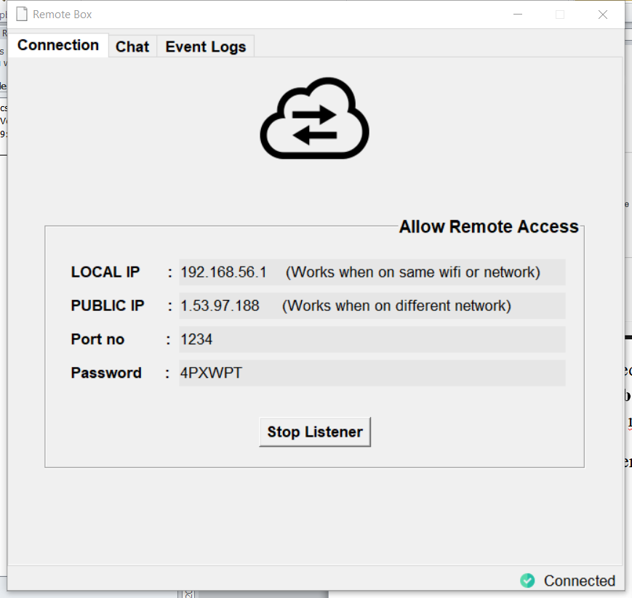

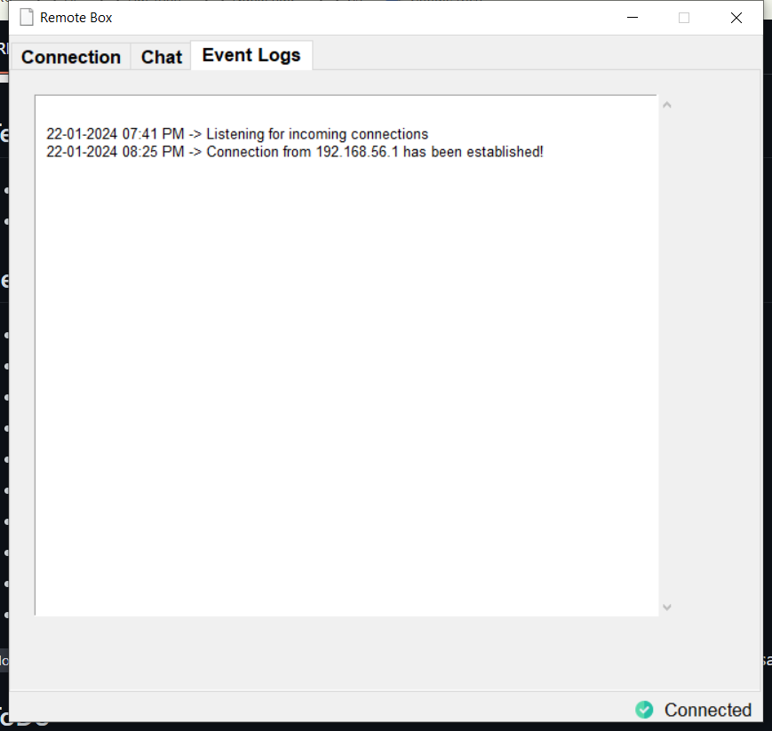

**Client side:**

We have chat, file transfer and remote desktop

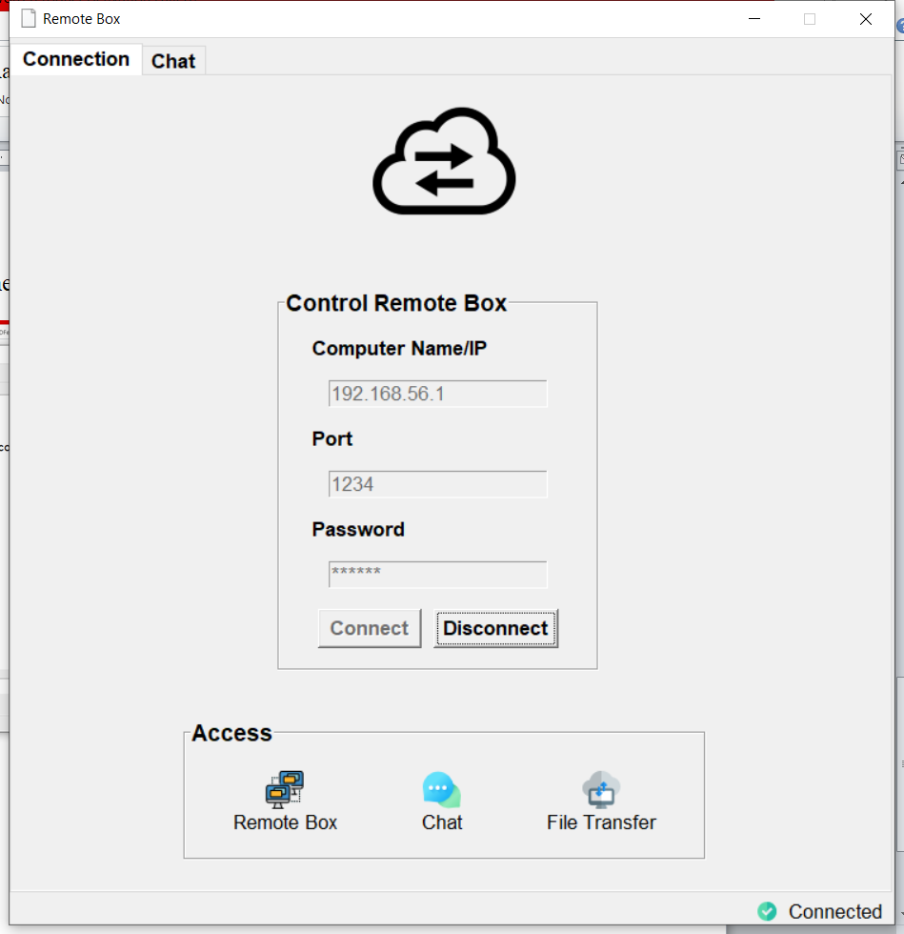

- Chat feature during the connection:

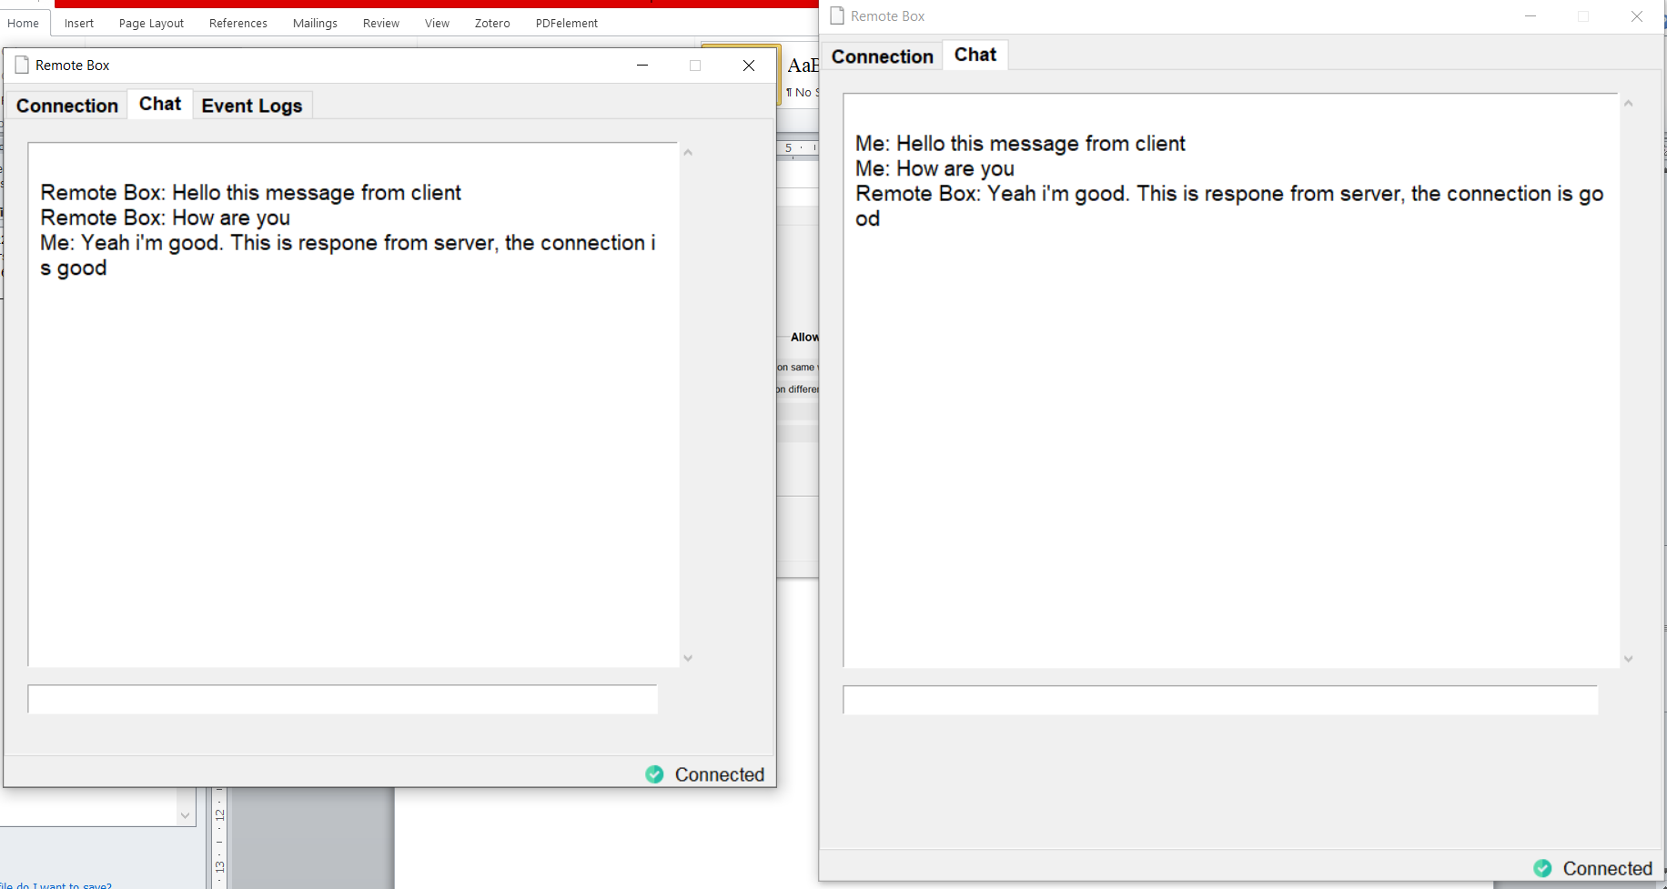

- File transfer:

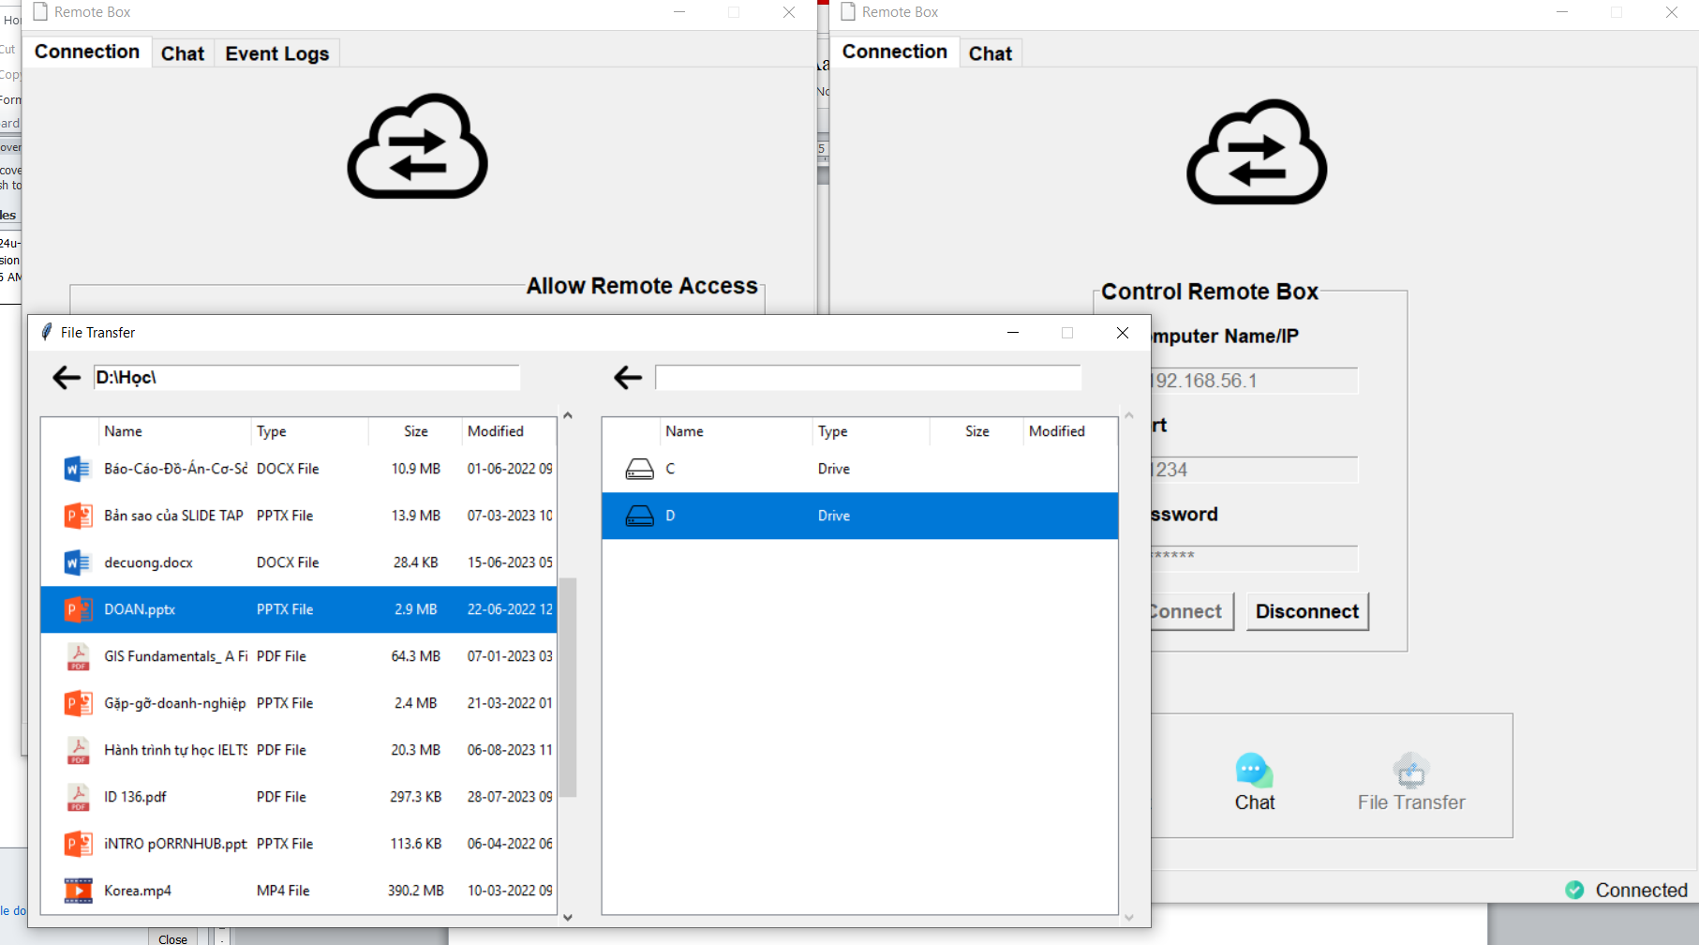

- Remote desktop: (because I tested it in 1 laptop both run client and server, that why the remote screen has overlapped)

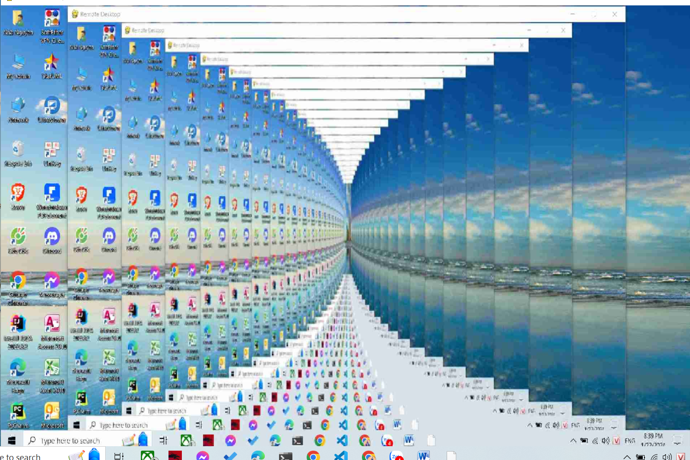

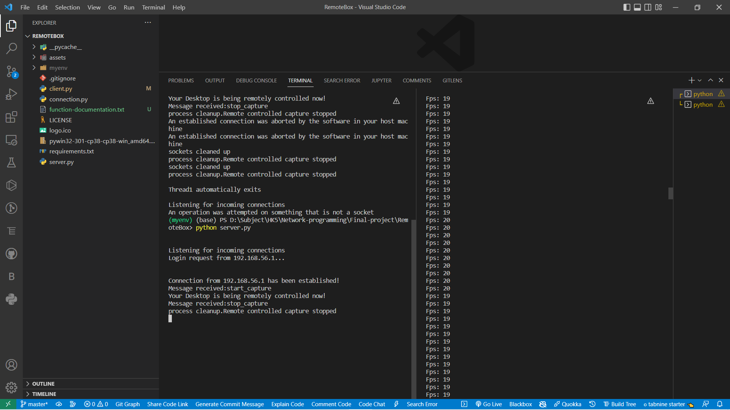

The PFS: 19 or 20 mean in 1s the server take 19 or 20 screenshot and seen it to client. And all the event mouse, keyboard of client will wait in queue and send to server sequentially.

And the special is that the size of each screen is difference, then I calculate the coordinate of mouse, scale the windown fit with the real screen of remote desktop.