

Requirement & Design Specification

**Watch Shop (WS)**

**Version: 1.0**

|  |  |  |  |
| --- | --- | --- | --- |
| **SE1804_SU24_G4** | | | |
| **Group Members** | **1** | **Nguyễn Tiến Đăng (Leader)** | **HE172471** |
| **2** | **Lê Duy Quý** | **HE173432** |
| **3** | **Bùi Minh Dũng** | **HE172218** |
| **4** | **Bùi Khánh Duy** | **HE181114** |
| **Supervisor** | **Nguyễn Văn An** | |  |

– Hanoi, May 2024 –

# Record of Changes

|  |  |  |  |  |
| --- | --- | --- | --- | --- |
| Version | Date | A* M, D | In charge | Change Description |
| V1.0 | 15/2 | A | KienNTHE11 |  |
|  |  |  |  |  |
|  |  |  |  |  |
|  |  |  |  |  |
|  |  |  |  |  |
|  |  |  |  |  |
|  |  |  |  |  |
|  |  |  |  |  |
|  |  |  |  |  |
|  |  |  |  |  |
|  |  |  |  |  |
|  |  |  |  |  |

*A - Added M - Modified D - Deleted

Contents

Record of Changes 2

I. Overview 5

1. User Requirements 5

1.1 Actors 5

1.2 Use Cases 5

2. Overall Functionalities 6

2.1 Screens Flow 6

2.2 Screen Descriptions 6

2.3 Screen Authorization 6

2.4 Non-UI Functions 7

3. System High Level Design 7

3.1 Database Design 7

3.2 Code Packages 7

II. Requirement Specifications 9

1. <<Feature Name>> 9

1.1 << UC Name>> 9

2. Common Functions 11

2.1 Login System 11

3. Patron Feature 12

3.1 Order a Meal 12

3.2 Register for Payroll Deduction 13

III. Screen Designs 14

1. <<Feature Name>> 14

1.1 <<SubFeature Name>> 14

1.2 System Access 14

IV. Code Designs 17

1. <Feature/Function Name1> 17

1.1 Class Diagram 17

1.2 Sequence Diagram(s) 17

1.3 Database Queries 18

2. <Feature/Function Name2> 18

V. Appendix 18

1. Assumptions & Dependencies 18

2. Limitations & Exclusions 18

3. Business Rules 18

4. .. 19

# I. Overview

## 1. User Requirements

### 1.1 Actors

|  |  |  |
| --- | --- | --- |
| **#** | **Actor** | **Description** |
| 1 | Manager | The manager in the organization |
| 2 | Staff | They are employees within the organization |
| 3 | Customer | They are registered users who are actual customers |
| 4 | Shipper | They are registered shipper |
| 5 | Guest | User who aren’t registered |

### 1.2 Context diagram

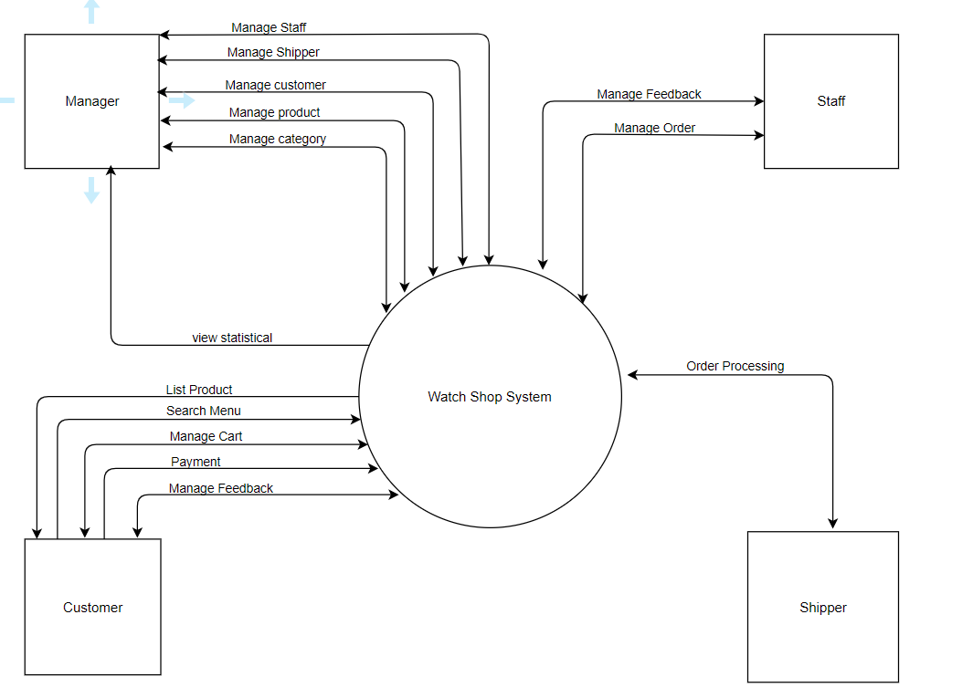

### 1.3 Use Cases

#### a. Diagram(s)

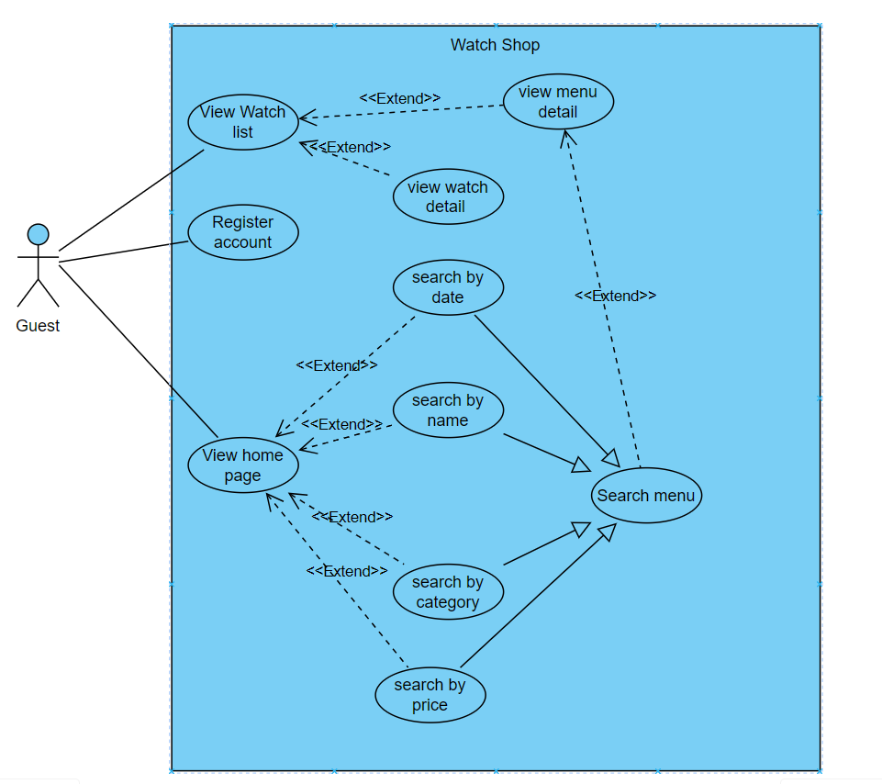

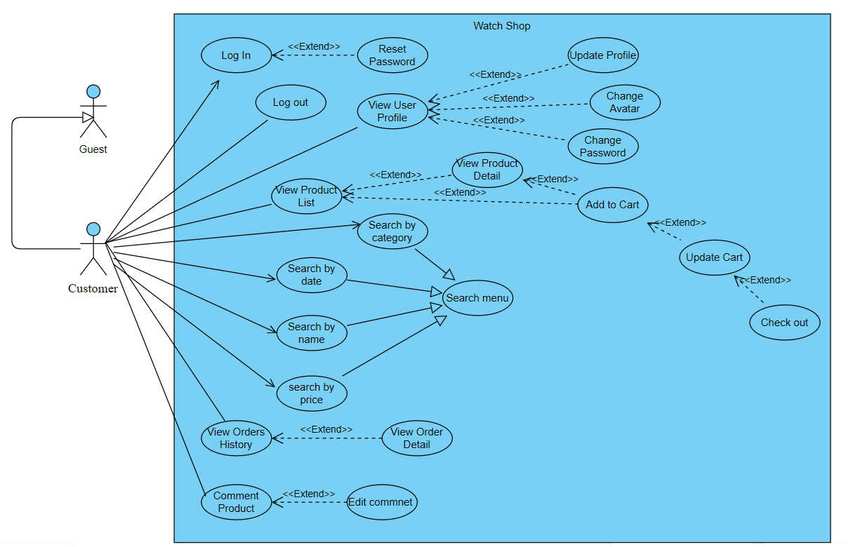 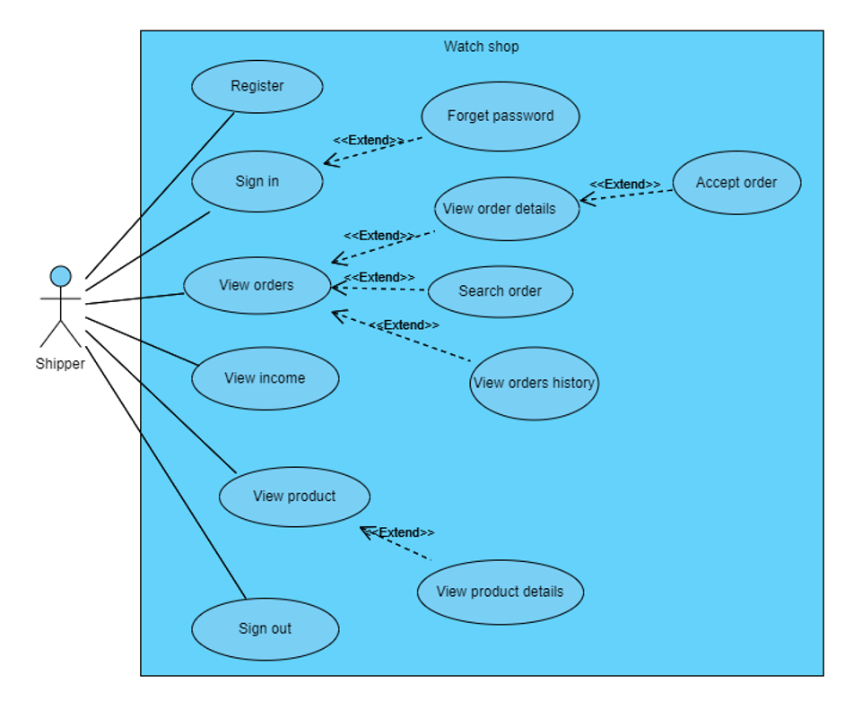

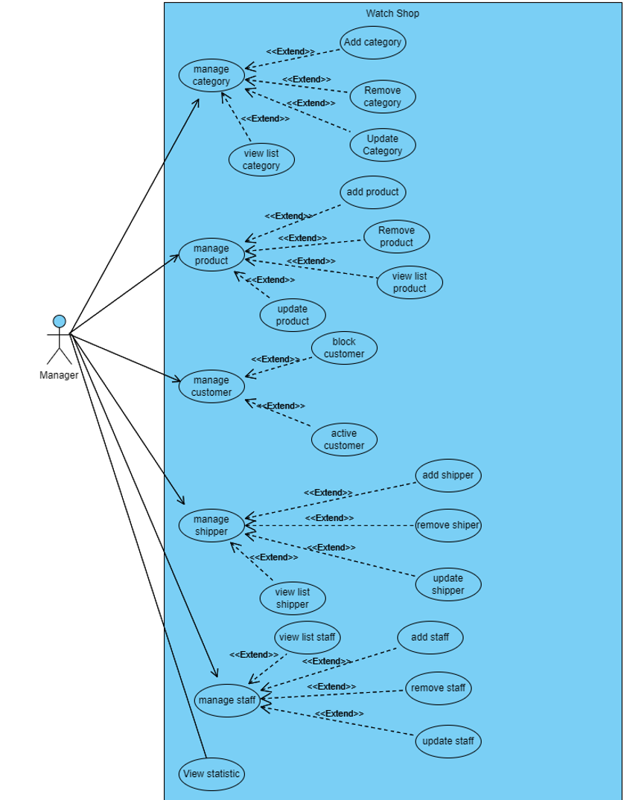

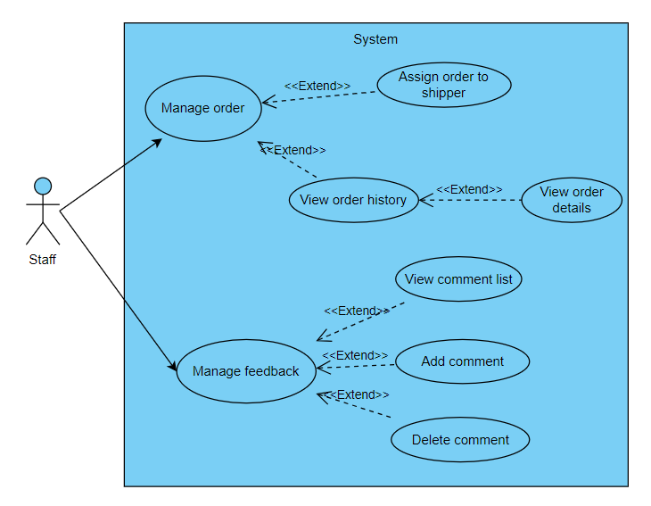

#### b. Descriptions

|  |  |  |  |
| --- | --- | --- | --- |
| **ID** | **Feature** | **Use Case** | **Use Case Description** |
| UC1 | Common | View Home | This use case is responsible for presenting the main landing page of the e-commerce website to the Customer |
| UC2 | Common | View Product | This use case is responsible for displaying a list of available products to Customer. |
| UC3 | View product list | View Product Detail | This use case allows Customer to view details of an individual product. |
| UC4 | Search menu | Search product by category | This use case allows Customer to search a product with category |
| UC5 | Search menu | Search product by filter | This use case allows Customer to search a product with filter |
| UC6 | Search menu | Search product by price | This use case allows Customer to search a product with price |
| UC7 | Search menu | Search product by date | This use case allows Customer to search a product with date |
| UC8 | Common | Login System | This use case allows Customer who has register before can access to personalised features |
| UC9 | Common | Logout | This use case allow Customer to log out the system |
| UC10 | Common | Register | This use case allows guests to create a new Customer account on the website. |
| UC11 | Common | Forgot Password | This use case allows the registered who forgot their password to reset it |
| UC12 | Customer | Change Password | This use case allows Customer to change their password. |
| UC13 | Customer | Change Avatar | This use case allows Customer to change their avatar. |
| UC14 | Customer | Update Profile | This use case allows Customer to manager their personal information, edit it and update their personal information |
| UC15 | Customer | Add to cart | This use case allows Customer to view, manage, and finalise the items they have selected for purchase |
| UC16 | Customer | Cart detail | This use case allows Customer to view detailed information about items in their own cart. |
| UC17 | Customer | Update cart | This use case allows customers to adjust the quantity or remove products from the cart |
| UC18 | Customer | Check out | This use case allows customers to adjust the quantity or remove products from the cart |
| UC19 | Customer | View Order History | This use case allows Customer to review their orders list |
| UC20 | Customer | View Order Detail | This use case provides Customer with detailed information about orders |
| UC21 | Customer | Comment Product | This use case provides customers to send comment to discuss about the new |
| UC22 | Customer | Edit Comment | This use case involves Customer editing their comments on products. |
| UC23 | Customer | View User Profile | This use case allows Customer to review their profile . |
| UC24 | Manage Order | View Order | This use case allows shipper to view order need ship |
| UC25 | Manage Order | View Order Detail | This use case allows shipper to view order detail |
| UC26 | Manage Order | View Order History | This use case allows the shipper to review the order list |
| UC27 | Shipper | Search Order | This use case allows shipper to search order |
| UC28 | Shipper | View Income | This use case allows shipper to review the income |
| UC29 | Manage Category | View list category | This use case allows Manager to view list of category |
| UC30 | Manage Category | Add Category | This use case allows Manager to add a new category |
| UC31 | Manage Category | Remove Category | This use case allows Manager to delete category |
| UC32 | Manage Category | Update Category | This use case allows Manager to update category |
| UC33 | Manage product | View list Product | This use case allows Manager to view list of product |
| UC34 | Manage product | Add Product | This use case allows Manager to add a new product |
| UC35 | Manage product | Remove Product | This use case allows Manager to delete product |
| UC36 | Manage product | Update Product | This use case allows Manager to update product |
| UC37 | Manage customer | View list User | This use case allows Manager to view list of user |
| UC38 | Manage customer | Block User | This use case allows Manager to block user |
| UC39 | Manage customer | Active User | This use case allows Manager to active user |
| UC40 | Manage Shipper | Add Shipper | This use case allows Manager to add a new shipper |
| UC41 | Manage Shipper | Remove Shipper | This use case allows Manager to delete shipper |
| UC42 | Manage Shipper | View List Shipper | This use case allows Manager to views list of shipper |
| UC43 | Manage Comment | View list comment | This use case allows Staff to view list of comment |
| UC44 | Manage Comment | Add Comment | This use case allows Staff to add a new comment |
| UC45 | Manage Comment | Remove Comment | This use case allows Staff to delete comment |
| UC46 | Manager  Order | View List Order | This use case allows Staff to views list of order history |
| UC47 | Manager  Order | View shipper accepting orders | This use case allows Staff to views list of shipper accepting orders |
| UC48 | Manager | View statistical | This use case allows Manager to views statistical of shop |
| UC49 | Manage Staff | View list staff | This use case allows Manager to view list of staff |
| UC50 | Manage Staff | Add Staff | This use case allows Manager to add a new staff |
| UC51 | Manage Staff | Update Staff | This use case allows Manager to update staff |
| UC52 | Manage Staff | Delete Staff | This use case allows Manager to delete staff |

## 

## 2. Overall Functionalities

### 2.1 Screens Flow

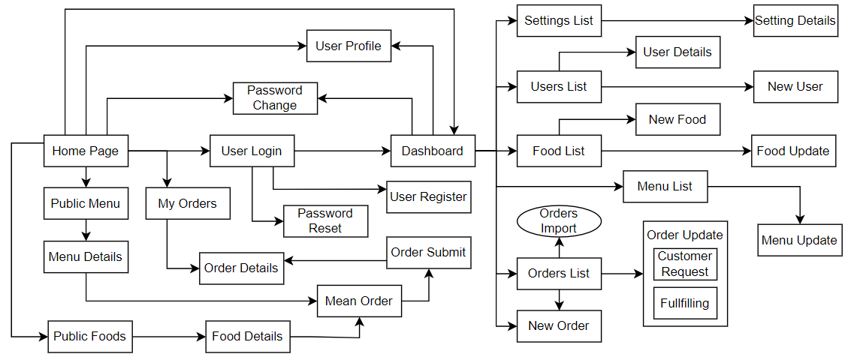đ

### 2.2 Screen Descriptions

|  |  |  |  |
| --- | --- | --- | --- |
| **#** | **Feature** | **Screen** | **Description** |
| 1 | Order Meals | Create Order | <<brief description of the screen>> |
| 2 | Order Meals | Change Order | .. |
| 3 | .. |  |  |

### 2.3 Screen Authorization

|  |  |  |  |  |
| --- | --- | --- | --- | --- |
| **Screen** | **Role-Name1** | **Role-Name2** | **Role-Name3** | **…** |
| <<Screen Name1>> | X |  | X | X |
| <<Screen Activity>> |  |  | X | X |
| <<Screen Name2>> | X |  | X |  |
| Query All Data | X |  |  |  |
| Query Own Data |  |  | X |  |
| Query Managed Data |  |  | X |  |
| Add New Data |  |  | X | X |
| Update All Data |  |  |  | X |
| Update Own Data |  |  |  | X |
| Update Managed Data |  |  |  | X |
| Delete Data |  |  |  |  |
| … |  |  |  |  |

### 2.4 Non-UI Functions

*[Provide the descriptions for the functions which have no UI (or not screens), i.e batch/cron job, service, API, etc.]*

|  |  |  |  |
| --- | --- | --- | --- |
| **#** | **Feature** | **System Function** | **Description** |
| 1 | <<Feature Name>> | <<Function Name1>> | <<Function Name1 Description>> |
| 2 | … |  |  |

## 3. System High Level Design

### 3.1 Database Design

*[Provide the tables relationship like example below]*

#### a. Database Schema

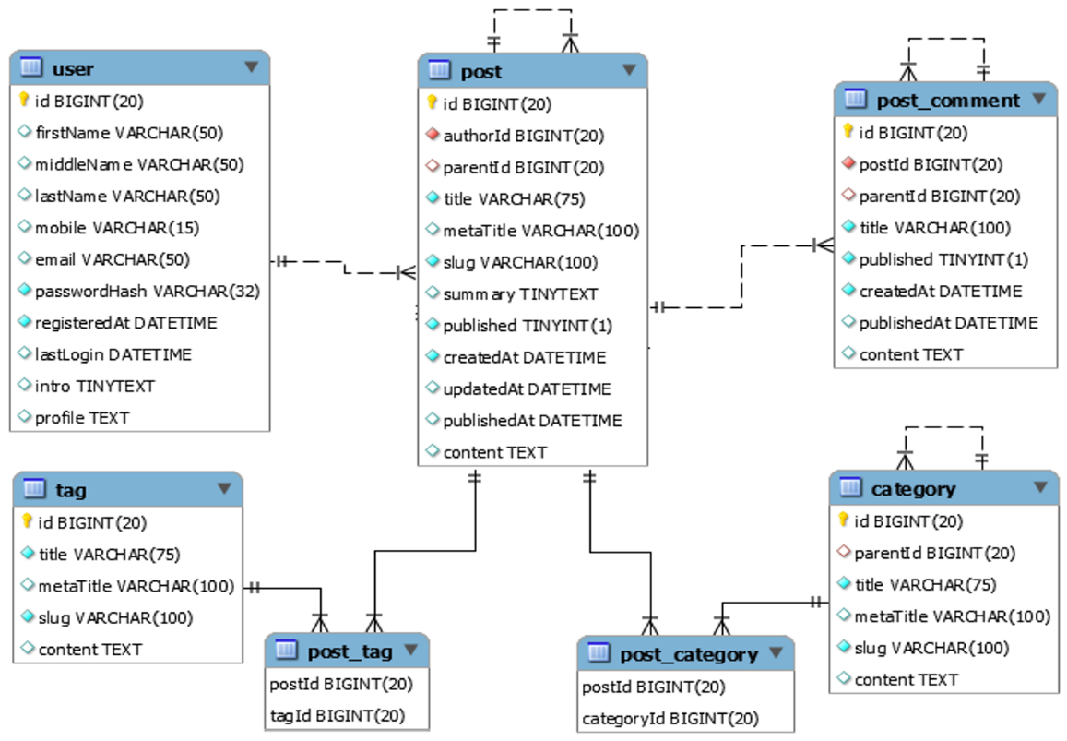

#### b. Table Descriptions

|  |  |  |
| --- | --- | --- |
| **No** | **Table** | **Description** |
| *01* | *<Table name>* | *<Description of the table>*  *- Primary keys: <<list of primary key fields>>*  *- Foreign keys: <<list of foreign key fields>>* |
| *02* | *<Table name2>* | *…* |

### 3.2 Code Packages

*[Provide the package diagram for each sub-system. The content of this section including the overall package diagram, the explanation, package and class naming conventions in each package. Please see the sample & description table format below]*

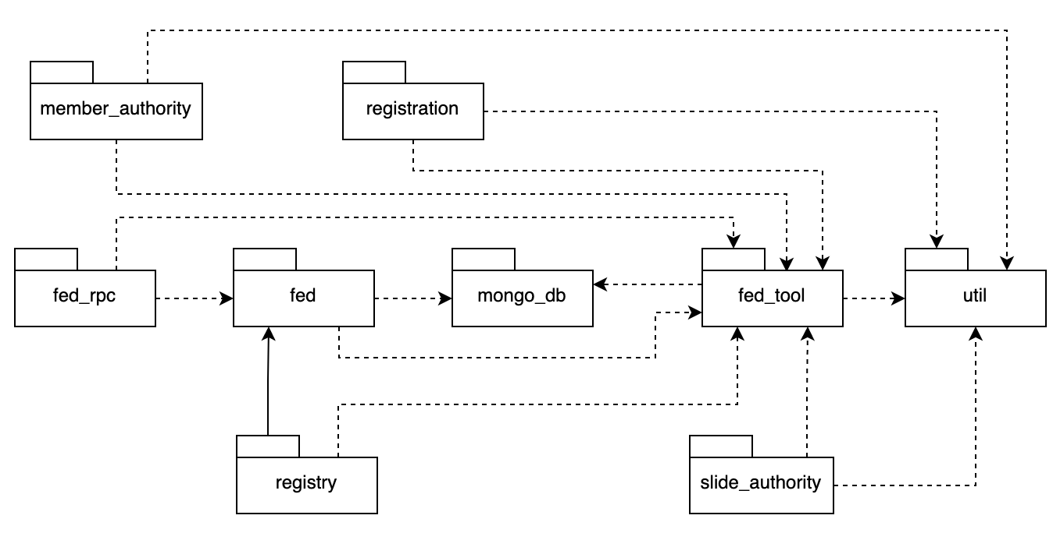

***Package descriptions***

|  |  |  |
| --- | --- | --- |
| **No** | **Package** | **Description** |
| *01* | *member_authority* | *<Description of the package: purpose, contents,..>* |
| *02* | *registration* | *<Description of the package: purpose, contents,..>* |
| *03* | *…* |  |

# II. Requirement Specifications

## 1. <<Feature Name>>

### 1.1 << UC Name>>

#### a. UC Specifications

Provide the functional description for the use cases using the template/guides below

**Functional Description Template**

|  |  |  |  |
| --- | --- | --- | --- |
| UC Name: |  | | |
| Primary Actor: |  | Secondary Actors: |  |
| Trigger: |  | | |
| Description: |  | | |
| Preconditions: |  | | |
| Postconditions: |  | | |
| Normal Flow: |  | | |
| Alternative Flows: |  | | |
| Exceptions: |  | | |
| Business Rules: |  | | |

**Functional Description Contents**

***UC Name***

State a concise name for the use case that indicates the value the use case would provide to some user. Begin with an action verb, followed by an object.

***Primary and Secondary Actors***

An actor is a person or other entity external to the software system being specified who interacts with the system and performs use cases to accomplish tasks. Different actors often correspond to different user classes, or roles, identified from the customer community that will use the product. Name the primary actor that will be initiating this use case and any other secondary actors who will participate in completing execution of the use case.

***Trigger***

Identify the business event, system event, or user action that initiates the use case. This trigger alerts the system that it should begin testing the preconditions for the use case so it can judge whether to proceed with execution.

***Description***

Provide a brief description of the reason for and outcome of this use case, or a high-level description of the sequence of actions and the outcome of executing the use case.

***Preconditions***

List any activities that must take place, or any conditions that must be true, before the use case can be started.

***Postconditions***

Describe the state of the system at the successful conclusion of the use case execution.

***Normal Flow***

Provide a description of the user actions and corresponding system responses that will take place during execution of the use case under normal, expected conditions.

***Alternative Flows***

Document other successful usage scenarios that can take place within this use case. State the alternative flow, and describe any differences in the sequence of steps that take place.

***Exceptions***

Describe any anticipated error conditions that could occur during execution of the use case and how the system is to respond to those conditions.

***Business Rules***

List any business rules that influence this use case. Don’t include the business rule text here, just its identifier so the reader can find it in another repository when needed.

#### b. Business Rules

Provide the business rules those are applied only to the use case

|  |  |  |
| --- | --- | --- |
| **ID** | **Business Rule** | **Business Rule Description** |
| FR1 | Password Encoding | User’s password must be encoded with MD5 hashing |

## 2. Common Functions

### 2.1 Login System

#### a. UC Specification

|  |  |  |  |
| --- | --- | --- | --- |
| UC Name: | **Login System** | | |
| Primary Actor: | Customer | Secondary Actors: | None |
| Trigger: | User clicks Login button from the page header, or  User accesses an authenticated feature (from a link or type the page URL directly into the address bar) | | |
| Description: | As a user, I want to be able to log into the system so that I can use the system’s authenticated features and access my personalized account. | | |
| Preconditions: | User account has been created & authorized | | |
| Postconditions: | * User logs in the system successfully * The system tracked successful login into the Activity Log | | |
| Normal Flow | **Login System**  1. User accesses the User Login screen  2. User types in the login details or choo other login options (see alternative flows AF1, AF2 in the next section)  3. User clicks the Login button  4. System validates the login details (see E1)  5. System allows user to access  6. System tracks user’s success login to the Activity Log  7. System accesses the Home Page (or the previous calling page if any) | | |
| Alternative Flows: | ***AF1. Google Login***  1. User chooses to login system using Google account  2. System redirects the user to the Google’s Login screen  3. User types in the Google account details and chooses to login  4. Google validates user’s login information successfully and redirect him/her back to the system  5. Return to step 5 of normal flow.  ***AF2. Facebook Login***  1. User chooses to login system using Facebook account  2. System redirects the user to the Facebook’s Login screen  3. User types in the Facebook account details and chooses to login  4. Facebook validates user’s login information successfully and redirect him/her back to the system  5. Return to step 5 of normal flow. | | |
| Exceptions: | ***E1. System can’t authenticate the user***  1. The Error Message screen is shown to the user  2. User cancels the logging in *=> UC stops, change to other UC-View Home Page*  3. User clicks “Forgot Password?” link *=> change to the other UC-Reset Password*  4. User clicks “Register” link *=> change to other UC-Register User Account* | | |
| Business Rules: | FR1, FR2, FR3 | | |

#### b. Business Rules

|  |  |  |
| --- | --- | --- |
| **ID** | **Business Rule** | **Business Rule Description** |
| FR1 | Password Encoding | User’s password must be encoded with MD5 hashing |
| FR2 | Invalid Logging In | User can’t be authenticated to login the system if below cases   * His/her logging-in details are incorrect * His/her account has not been verified * His/her account has been locked or blocked |
| FR3 | Account Locking | If user inputs wrong logging-in details 6 times continuously, his/her account would be locked in 30 minutes |

## 3. Patron Feature

### 3.1 Order a Meal

#### a. UC Specification

|  |  |  |  |
| --- | --- | --- | --- |
| UC Name: | **Order a Meal** | | |
| Primary Actor: | Patron | Secondary Actors: | Cafeteria Inventory System |
| Description: | A Patron accesses the Cafeteria Ordering System from the corporate intranet or from home, views the menu for a specific date if desired, selects food items, and places an order for a meal to be delivered to a specified location within a specified 15-minute time window. | | |
| Trigger: | A Patron indicates that he wants to order a meal | | |
| Preconditions: | 1. Patron is logged into COS.  2. Patron is registered for meal payments by payroll deduction. | | |
| Postconditions: | 1. Meal order is stored in COS with a status of “Accepted”.  2. Inventory of available food items is updated to reflect items in this order.  3. Remaining delivery capacity for the requested time window is updated. | | |
| Normal Flow: | **Order a Single Meal**   1. Patron asks to view menu for a specific date (see exceptions E1 and E2). 2. COS displays menu of available food items and the daily special. 3. Patron selects one or more food items from menu (see AF1). 4. Patron indicates that meal order is complete (see AF2). 5. COS displays ordered menu items, individual prices, and total price, including taxes and delivery charge. 6. Patron either confirms meal order (continue normal flow) or requests to modify meal order (return to step 2). 7. COS displays available delivery times for the delivery date. 8. Patron selects a delivery time and specifies the delivery location. 9. Patron specifies payment method. 10. COS confirms acceptance of the order. 11. COS sends Patron an email message confirming order details, price, and delivery instructions. 12. COS stores order, sends food item information to Cafeteria Inventory System, and updates available delivery times. | | |
| Alternative Flows: | **AF1. Order multiple identical meals**   1. Patron requests a specified number of identical meals (see exception E3) 2. Return to step 4 of normal flow.   **AF2. Order multiple meals**   1. Patron asks to order another meal. 2. Return to step 1 of normal flow. | | |
| Exceptions: | **E1. Requested date is today and current time is after today’s order cutoff time**  1. COS informs Patron that it’s too late to place an order for today.  2a. If Patron cancels the meal ordering process, then COS terminates use case.  2b. Else if Patron requests another date, then COS restarts use case.  **E2. No delivery times left**  1. COS informs Patron that no delivery times are available for the meal date.  2a. If Patron cancels the meal ordering process, then COS terminates use case.  2b. Else if Patron requests to pick the order up at the cafeteria, then continue with normal flow, but skip steps 7 and 8.  **E3. Insufficient inventory to fulfill multiple meal order**  1. COS informs Patron of the maximum number of identical meals he can order, based on current available inventory.  2a. If Patron modifies number of meals ordered, then return to step 4 of normal flow.  2b. Else if Patron cancels the meal ordering process, then COS terminates use case. | | |
| Business Rules: | BR-1, BR-2, BR-3, BR-4, BR-11, BR-12, BR-33 | | |

#### b. Business Rules

None

### 3.2 Register for Payroll Deduction

#### a. UC Specification

|  |  |  |  |
| --- | --- | --- | --- |
| UC Name: | **Register for Payroll Deduction** | | |
| Primary Actor: | Patron | Secondary Actors: | Payroll System |
| Description: | Cafeteria patrons who use the COS and have meals delivered must be registered for payroll deduction. For noncash purchases made through the COS, the cafeteria will issue a payment request to the Payroll System, which will deduct the meal costs from the next scheduled employee payday direct deposit. | | |
| Trigger: | Patron requests to register for payroll deduction, or Patron says yes when COS asks if he wants to register | | |
| Preconditions: | 1. Patron is logged into COS. | | |
| Postconditions: | 1. Patron is registered for payroll deduction. | | |
| Normal Flow: | **Register for Payroll Deduction**   1. COS asks Payroll System if Patron is eligible to register for payroll deduction. 2. Payroll System confirms that Patron is eligible to register for payroll deduction. 3. COS asks Patron to confirm his desire to register for payroll deduction. 4. If so, COS asks Payroll System to establish payroll deduction for Patron. 5. Payroll System confirms that payroll deduction is established. 6. COS informs Patron that payroll deduction is established. | | |
| Alternative Flows: | None | | |
| Exceptions: | E1. Patron is not eligible for payroll deduction  E2. Patron is already enrolled for payroll deduction | | |
| Business Rules: | BR-86 and BR-88 govern an employee’s eligibility to enroll for payroll deduction. | | |

#### b. Business Rules

None

# III. Screen Designs

## 1. <<Feature Name>>

### 1.1 <<SubFeature Name>>

#### a. <<Screen/Function Name>>

*[Provide brief description of the screen/function here and other details as in the sub-sections]*

*[This is to describe the UI layout (Mockup prototype) & descriptions for screen fields/components]*

<<Mockup prototype>>

|  |  |  |
| --- | --- | --- |
| **Field Name** | **Field Type** | **Description** |
| ***Field Group Name*** | | |
| <<Field-Name>> | <<Type, Length>> | <<Field description & data initializing design>> |

##### Database Access

*[Provide the design description for the screen/function to access the database here: what table the screen/function would access, which transactions does it make (C-Create, R-Read, U-Update, or D-Delete), and how/purpose of the access (by providing Description and SQL commands)]*

|  |  |  |
| --- | --- | --- |
| **Table** | **CRUD** | **Description** |
| <<Table Name>> | <<transaction(s)>> | <<Table access description: purpose, how,…>> |
| .. |  |  |

### 1.2 System Access

#### a. User Login

This screen allows user to be authenticated to the system screens/functionalities.

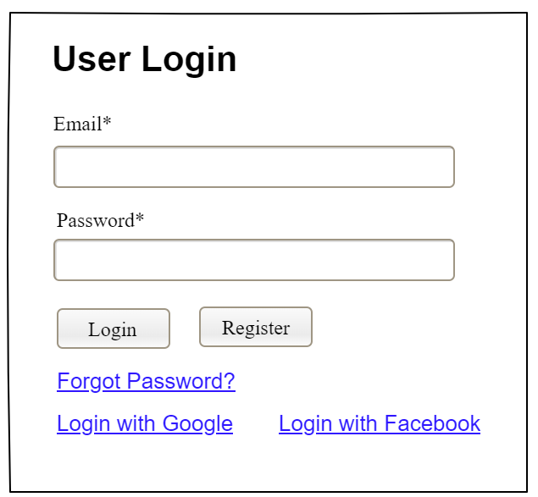

|  |  |  |
| --- | --- | --- |
| **Field Name** | **Field Type** | **Description** |
| Email* | String(30) | This is for user to input valid email address for logging in |
| Password* | String(8-20) | This is for user to input password for logging in |
| Login | Button | User clicks to authenticate him/herself into the system with provided email & password |
| Register | Button | User clicks to redirect to the User Register page for registering new user account to access the system |
| Forgot Password? | Hyperlink | User clicks to redirect to the Password Reset page for resetting his/her forgot password |
| Login with Google | Hyperlink | Allow user to login with his/her Google account |
| Login with Facebook | Hyperlink | Allow user to login with his/her Facebook account |

##### Database Access

|  |  |  |
| --- | --- | --- |
| **Table** | **CRUD** | **Description** |
| User | R | Verify UserName & Password information |
| Setting, User | R | Specify the authorizations of the logged-in user |

#### b. Setting List

##### This is for the administrator to view the list of current system settings. On the screen, s/he can also activate or deactivate (change status) of a specific setting.

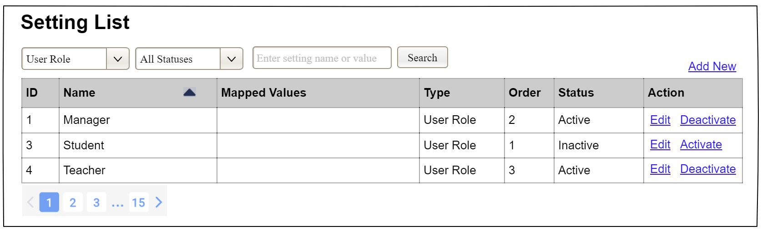

|  |  |  |
| --- | --- | --- |
| **Field Name** | **Field Type** | **Description** |
| ***Filter/Search Fields*** | | |
| Setting Type |  | Filled with the list of current active setting types  Allow to filter the list by setting type;  Default value is “All Types” |
| Setting Status |  | Values: All Statuses (default), Active, and Inactive  Allow to filter the list by status  Default value: “All Statuses” |
| Search Phase | String (30) | Allow to search using the name or map values  Default value: blank |
| Search |  | Click to refresh the list with the defined filter(s) and search phrase. |
| Add New |  | Click to open the Setting Details page for adding new setting (master data) |
| ***Data Table*** | | |
| ID | Integer | Auto-increased identifier of the setting |
| Name | Text | Name of the setting |
| Mapped Values | Text | Supplementary information for the setting |
| Type | Text | Type of the setting |
| Order | Integer | Display order of the setting: the order of the setting type, displayed among the list of settings with the same type |
| ***Action Links*** | | |
| Edit | icon | Click to open the Setting Details page for updating the relevant setting (master data) |
| Activate | icon | Shown when the data status is inactive. This is to activate the relevant setting (master data) |
| Deactivate | icon | Shown when the data status is active. This is to deactivate the relevant setting (master data) |

##### Database Access

|  |  |  |
| --- | --- | --- |
| **Table** | **CRUD** | **Description** |
| Setting | RU | Query the list of current settings from the database  Update status of a specific setting |

#### c. Setting Details

##### UI Design

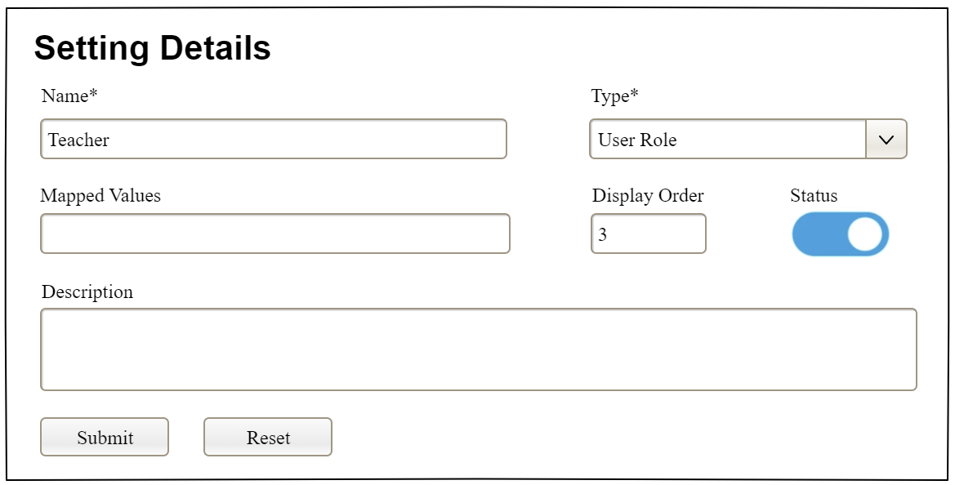

|  |  |  |
| --- | --- | --- |
| **Field Name** | **Field Type** | **Description** |
| Name* | Text Box  String (20) | Name of the setting |
| Type* | Combo Box  (Single Choice) | Type of the setting, filled with the list of setting types  Default value: the first type in the list |
| Mapped Values | Text Box  String (50) | Supplementary information for the setting (if any) |
| Order | Text Box  Integer (>=0) | Display order of the setting: the order of the setting type, displayed among the list of settings with the same type |
| Status | On/Off button | Status of the setting: Active or Inactive  Default value: Active |
| Description | Text Area  String (200) | Description of the setting |
| Submit | Button | Click to store new or updated setting details |
| Reset | Button | Click to reset the changes use has made on the screen fields back to the initial values when the screen is loaded |

##### Database Access

…

# IV. Code Designs

## 1. <Feature/Function Name1>

*[Provide the detailed design for the function <Feature/Function Name1>. It includes class diagram and sequence diagram(s)]*

### 1.1 Class Diagram

*[This part presents the class diagram for the relevant feature]*

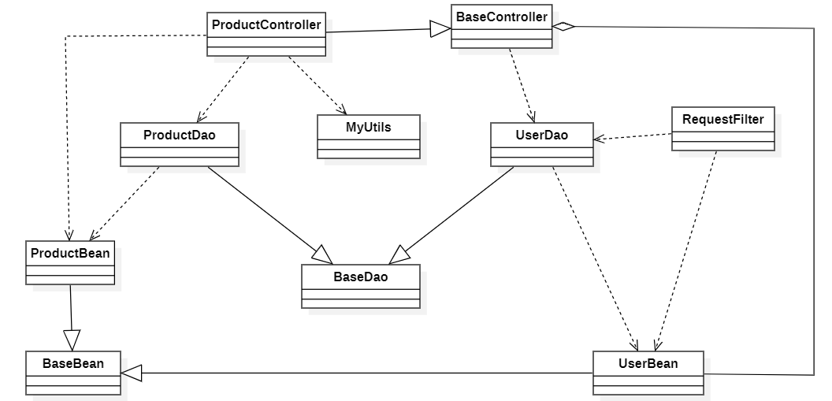

### 1.2 Sequence Diagram(s)

*[Provide the sequence diagram(s) for the feature/function, see the sample below. Sequence diagrams with similar message flow can be omitted, but you need to mention the appropriate reference to the similar sequence diagram]*

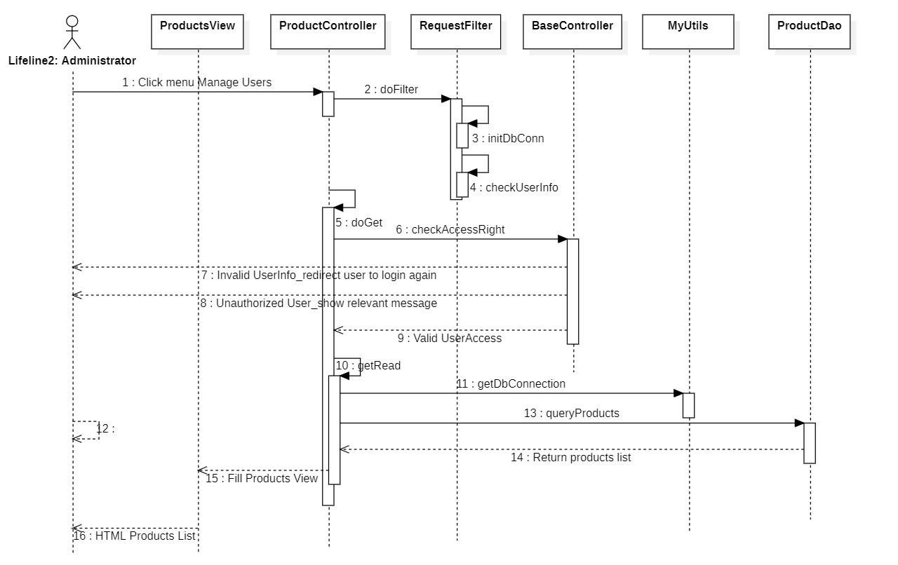

### 1.3 Database Queries

*[Provide the detailed SQL (select, insert, update...) which are used in implementing the function/screen]*

## 2. <Feature/Function Name2>

…

# V. Appendix



## 1. Assumptions & Dependencies

*[Record any assumptions that were made when conceiving the project and writing this vision and scope document. Note any major dependencies the project must rely upon for success, such as specific technologies, third-party vendors, development partners, or other business relationships.]*

<<Sample:

AS-1: Systems with appropriate user interfaces will be available for cafeteria employees to process the expected volume of meals ordered.

AS-2: Cafeteria staff and vehicles will be available to deliver all meals for specified delivery time slots within 15 minutes of the requested delivery time.

DE-1: If a restaurant has its own on-line ordering system, the Cafeteria Ordering System must be able to communicate with it bi-directionally.

>>

## 2. Limitations & Exclusions

*[Identify any product features or characteristics that a stakeholder might anticipate, but which are not planned to be included in the new product]*

## 3. Business Rules

*[Provide common business rules that you must follow. The information can be provided in the table format as the sample below]*

<<Sample

|  |  |  |
| --- | --- | --- |
| **ID** | **Category** | **Rule Definition** |
| BR-01 | Constraints | Delivery time windows are 15 minutes, beginning on each quarter hour |
| BR-02 | Constraints | Deliveries must be completed between 10:00 A.M. and 2:00 P.M. local time, inclusive. |
| BR-03 | Facts | All meals in a single order must be delivered to the same location. |
| BR-04 | Facts | All meals in a single order must be paid for by using the same payment method. |
| BR-11 | Constraints | If an order is to be delivered, the patron must pay by payroll deduction. |
| BR-12 | Computations | Order price is calculated as the sum of each food item price times the quantity of that food item ordered, plus applicable sales tax, plus a delivery charge if a meal is delivered outside the free delivery zone. |
|  |  |  |

>>

## 4. ..