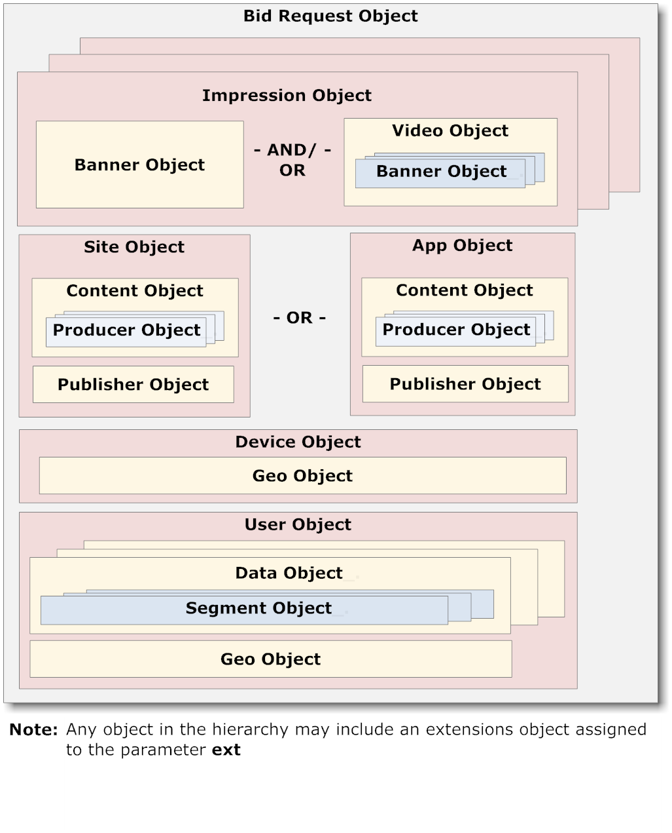

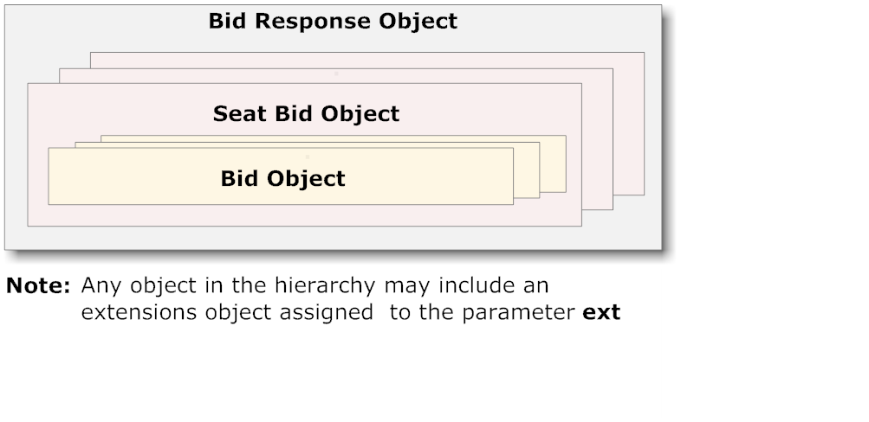

**Note:** Any object in the hierarchy may include an extensions object assigned to the parameter **ext**

**User Object**

**Segment Object**

**Data Object**

**Geo Object**

**Geo Object**

**Device Object**

**Regulations Object**

**Content Object**

**Producer Object**

**App Object**

**Publisher Object**

**OR**

**Site Object**

**Publisher Object**

**Producer Object**

**Content Object**

**PMP Object**

**Banner Object**

**Bid Request Object**

**Direct Deals Object**

**AND/**

**OR**

**Video Object**

**Banner Object**

**Impression Object**