ASSIGNMENT FINAL REPORT

Qualification | Pearson BTEC Level 5 Higher National Diploma in Computing
Unit number and title | Unit 16: Computing Research Project (Pearson-set)
Submission date | 4/3/2026 | Date Received 1st submission | 4/3/2026
Re-submission Date |  | Date Received 2nd submission
Student Name | Nguyen Ba Quang Huy | Student ID | BH01789
Class | SE07204 | Assessor name | Dinh Van Dong
Plagiarism
Plagiarism is a particular form of cheating. Plagiarism must be avoided at all costs and students who break the rules, however innocently, may be penalised. It is your responsibility to ensure that you understand correct referencing practices. As a university level student, you are expected to use appropriate references throughout and keep carefully detailed notes of all your sources of materials for material you have used in your work, including any material downloaded from the Internet. Please consult the relevant unit lecturer or your course tutor if you need any further advice.
Student Declaration
I certify that the assignment submission is entirely my own work and I fully understand the consequences of plagiarism. I declare that the work submitted for assessment has been carried out without assistance other than that which is acceptable according to the rules of the specification. I certify I have clearly referenced any sources and any artificial intelligence (AI) tools used in the work. I understand that making a false declaration is a form of malpractice.
 |  | Student’s signature | Huy
Grading grid
P1 | P2 | P3 | P4 | P5 | P6 | P7 | M1 | M2 | M3 | M4 | D1 | D2 | D3

r Summative Feedback: r Resubmission Feedback:

Grade: | Assessor Signature: | Date:
Internal Verifier’s Comments:
Signature & Date:

I. INTRODUCTION. 6
II. BODY. 7
1. Produce a research proposal that clearly defines a research question or hypothesis supported by a literature review. (P1) 7
1.1 Research purpose. 7
1.2 Aims and objectives. 7
1.3 Scope of the research. 8
1.4 Literature review. 9
2. Examine appropriate research methods and approaches to primary and secondary research. (P2) 11
3. Analyse different research approaches and methodology and make justifications for the choice of methods selected based on philosophical/theoretical frameworks. (M1) 14
4. Critically evaluate research methodologies and processes in application to a computing research project to justify chosen research methods and analysis. (D1) 16
5. Conduct primary and secondary research using appropriate methods for a computing research project that consider costs, access and ethical issues. (P3) 18
5.1. CONDUCTING RESEARCH FOR ZERO TRUST WEB PLATFORM. 18
5.2. Primary Research Tools and Approaches 20
5.3. Primary Research Results: Expert Interview Analysis 21
5.4. Cost and Ethics Assessment in Primary Research 26
6. Apply appropriate analytical tools, analyse research findings and data. (P4) 26
6.1. Identifying Appropriate Data Analysis Tools 26
6.2. Analyze the data collected from primary research 27
7. Discuss merits, limitations and pitfalls of approaches to data collection and analysis. (M2) 36
7.1. Merits of Data Collection and Analysis Approaches (Advantages) 36
7.2. Limitations of Data Collection and Analysis Approaches 37
7.3. Pitfalls of Data Collection and Analysis Approaches 38
8. Communicate research outcomes in an appropriate manner for the intended audience. (P5) 38
8.1. Communication for Experts 38
8.2. Communication for General Users 39
8.3. Integrated Communication Strategy 39
9. Analyse the extent to which outcomes meet set research objectives and communicate judgements effectively for the intended audience. (M3) 40
10. Evaluate outcomes and make valid, justified recommendations. (D2) 42
10.1. Critical Results Evaluation (Critical Evaluation of Results) 42
10.2. Valid, Justified Recommendations 44
III. CONCLUSION. 46
IV. REFERENCES. 47

Table 1: Table of Approaches 38
Table 2: Integrated Communication Strategy 40
Table 3: Research Objectives Achievement 42
Table 4: Evaluating the aspects of Zero Trust 44

I. INTRODUCTION.
Over the past decade, cybersecurity has been built as an impenetrable "castle" with impenetrable firewalls. It was assumed that anyone who breached the gates was trustworthy. However, the explosion of remote work, cloud computing, and mobile devices has blurred the lines of internal networks.
In reality, most of today's most serious attacks don't just come from the outside; they also stem from abuse of power within the organization or from attackers accessing employee accounts. The security model based on "pre-established trust" has become a critical weakness for every business. This project aims to research and implement the Zero Trust model – a necessary turning point for protecting digital assets in the new era.

II. BODY.

1. Produce a research proposal that clearly defines a research question or hypothesis supported by a literature review. (P1)

1.1 Research purpose.
- The objective of this research is to investigate the implementation of Zero Trust Architecture (ZTA) on a web platform to enhance enterprise access security and mitigate internal and external network threats. This research is driven by the increasing ineffectiveness of traditional boundary-based security models (such as VPNs) in an era where remote work and public network access have become the norm, leading to a growing risk of credentials theft and unauthorized access to enterprise systems.
- Current security systems often rely on "implicit trust" after users have gained network access, which often fails to address identity breaches or malicious internal activities. This project seeks to determine how to integrate persistent authentication, granular Role-Based Access Control (RBAC), and real-time behavior monitoring into a unified web dashboard. The research aims to develop a proactive defense mechanism that addresses user context, device integrity, and access patterns to provide a stronger security posture for modern businesses.
- Research Question: "How effectively can a Zero Trust-based web platform mitigate unauthorized access and internal security breaches by implementing continuous identity verification and real-time behavioral monitoring compared to traditional perimeter-based security models?"

1.2 Aims and objectives.
- General Objective:
- To build a comprehensive web-based access control platform built on a Zero Trust architecture, replacing traditional security models and helping businesses optimize control, limitation, and monitoring of all access flows to internal resources, thereby minimizing cybersecurity risks.
- Specific Objectives:
- Establish a multi-tiered authentication mechanism: Implement a secure authentication system using Token-based mechanisms (JWT & Refresh Token) to ensure user identity is always verified throughout the session.
- Optimize authorization management: Apply a role-based authorization model (RBAC) to enforce the "Minimum Authority" principle, ensuring users only have access to resources appropriate to their responsibilities.
- Enhance monitoring and early detection capabilities: Build a real-time behavioral monitoring system to identify anomalies and unauthorized intrusion attempts.
- Visualize security management: Establish a central control dashboard to give administrators an overall view and enable quick responses to security incidents.

1.3 Scope of the research.
- What the Research WILL Do:
- Implement Zero Trust Core Principles: The research will focus on designing and integrating the "Never Trust, Always Verify" architecture into a web application, ensuring every access request is fully authenticated, authorized, and inspected.
- Develop Secure Identity Management: It will apply advanced authentication mechanisms, specifically JWT (JSON Web Tokens) and Refresh Tokens, to maintain secure user sessions and prevent unauthorized session hijacking.
- Establish Granular Access Control: The study will implement a Role-Based Access Control (RBAC) model to enforce the "Least Privilege" principle, ensuring users can only access resources necessary for their specific roles.
- Create Behavioral Logging and Monitoring: The research will develop a system to track user activities and identify anomalies, such as multiple failed login attempts or unauthorized API calls, to provide a proactive defense layer.
- Design a Centralized Security Dashboard: A management interface will be built to allow administrators to visualize access patterns, monitor system health, and respond to security alerts in real-time.
- Evaluate System Resilience: The project will conduct internal testing (e.g., simulating credential theft or privilege escalation) to measure the effectiveness of the Zero Trust model compared to traditional security methods.
- What the Research WILL NOT Do:
- Address Physical Network Infrastructure: The research is solely focused on the application layer (Layer 7) and will not involve configuring hardware firewalls, routers, or physical server security.
- Conduct Large-Scale Corporate Deployment: While the system is designed for enterprise use, the study will be limited to a functional prototype/MVP environment and will not be deployed in a live, high-traffic production network.
- Provide Advanced AI-Based Threat Intelligence: The anomaly detection will focus on predefined rules and basic behavioral patterns; it will not incorporate complex AI/Machine Learning models for predictive global threat intelligence.
- Secure Hardware and IoT Devices: The scope is limited to web-based access security and does not cover the security of physical endpoint hardware or Internet of Things (IoT) devices.
- Replace Comprehensive Legal/Compliance Audits: While the platform assists in security, it is not a substitute for professional legal compliance frameworks (like GDPR or ISO 27001) or official external audits.
- Offer a "Perfect" Security Guarantee: The research acknowledges that security is an evolving field; it aims to significantly reduce the "attack surface" but does not claim to provide an unhackable solution against all future zero-day vulnerabilities.

1.4 Literature review.
a. Springer Article (Cybersecurity)
Title: Dissecting zero trust: research landscape and its implementation in IoT
Authors: Cheng Liu, Rui Tan, Yan Wu, Yan Feng, Zhikai Jin, Fan Zhang, Yi Liu & Qin Liu.
Year: 2024 (Published online June 2024).
Content Analysis: This paper focuses on the "Zero Trust" security model within the context of the Internet of Things (IoT). The authors analyze the challenges of applying Zero Trust to IoT devices, which often have limited resources. The article provides a comprehensive overview of existing architectures and authentication mechanisms, offering a roadmap for implementing stricter security in smart device networks.
Reference source: https://link.springer.com/article/10.1186/s42400-024-00212-0
b. JESSI Article (Journal of Engineering Software)
Title: Software Quality Analysis of Web-based Information Systems Using the ISO/IEC 25010 Standard
Authors: Aris Baharuddin, et al.
Year: 2023.
Content Analysis: This research evaluates the software quality of a specific information system (typically a management system in a school or organization) based on the international ISO/IEC 25010 standard. Analyzed aspects include usability, operational efficiency, reliability, and maintainability. The results help identify software weaknesses to improve the user experience.
Reference source: https://journal.unm.ac.id/index.php/JESSI/article/view/8272
c. ScienceDirect Article (Computers & Security)
Title: Zero trust architecture for industrial internet of things: A systematic review
Authors: Mohamed Amine Ferrag, Lei Shu, Xing Yang, et al.
Year: 2024 (Pre-published in late 2023).
Content Analysis: This is a systematic review of the implementation of Zero Trust Architecture in Industrial IoT (IIoT) environments. The paper categorizes threats in smart factories and evaluates how Zero Trust can prevent large-scale cyberattacks. The authors also discuss integrating Blockchain and AI to enhance IIoT system security.
Reference source: https://www.sciencedirect.com/science/article/pii/S016740482300322X
d. MDPI Sensors Article
Title: A Systematic Literature Review on the Implementation and Challenges of Zero Trust Architecture Across Domains
Authors: Sadaf Mushtaq, Muhammad Mohsin, and Muhammad Mujahid Mushtaq.
Year: 2025 (October 2025 issue - early access).
Content Analysis: This article conducts an extensive survey on how Zero Trust is applied not only in IT but also in healthcare, finance, and e-government. The highlight of the paper is identifying technical and psychological barriers when transitioning from traditional perimeter-based security to the Zero Trust model.
Reference source: https://www.mdpi.com/1424-8220/25/19/6118
e. MDPI Electronics Article
Title: Enhancing Zero Trust Models in the Financial Industry through Blockchain Integration: A Proposed Framework
Authors: Clement Daah, Amna Qureshi, Irfan Awan, and Savas Konur.
Year: 2024.
Content Analysis: This paper proposes a new framework for the banking and finance industry. By combining the transparency and immutability of Blockchain with the "always verify" principle of Zero Trust, the authors create a dual-security system that combats transaction fraud and insider attacks more effectively than current methods.
Reference source: https://www.mdpi.com/2079-9292/13/5/865

2. Examine appropriate research methods and approaches to primary and secondary research. (P2)
- In computing research, especially within the context of enterprise security and access management, selecting appropriate research methods is essential for producing valid, secure, and actionable results. This research adopts a combination of primary and secondary research methods, integrating both qualitative and quantitative approaches to build a scientifically sound study of Zero Trust Architecture (ZTA) and proactive threat mitigation.
- This research is grounded in a positivist research philosophy, which aligns with scientific inquiry and objective measurement. Positivism supports the use of controlled experimentation, system performance analysis, and observable security outcomes, all of which are central to web platform development and access control. This philosophical stance justifies the use of empirical testing, security metrics, and reproducible evaluation as the core methods for investigating Zero Trust implementation and its cybersecurity implications.
a) Primary Research:
- Primary research involves the collection or generation of original data directly through system development, testing, or direct observation relevant to the research problem. In this project, primary research is vital for developing, implementing, and evaluating a Zero Trust web platform. Methods include:
- System Development & Experimental Implementation: This is the core primary research activity. It involves:
- Architecture Design and Prototyping: Designing the Zero Trust framework, including the Policy Enforcement Point (PEP) and Policy Decision Point (PDP) within a web environment.
- Implementation of Security Protocols: Developing and integrating JWT-based authentication, Refresh Token mechanisms, and RBAC (Role-Based Access Control) logic into the platform's backend.
- Real-time Behavioral Monitoring Logic: Creating algorithms to track user session telemetry and log access patterns to identify anomalies (e.g., unauthorized API calls).
- Security Performance Evaluation: Conducting controlled internal "attacks" (e.g., simulated credential theft, privilege escalation attempts) to measure how effectively the Zero Trust model identifies and blocks unauthorized actions.
- Target "Population" (System Use Cases): The primary research will use simulated enterprise scenarios as its "participants," involving various user roles (Admin, Manager,Staff) and device contexts to evaluate the platform's decision-making accuracy.
- Advantages:
- Relevance and Customization: Experimental data (access success/fail rates) is directly generated to address the specific objectives of enterprise access security.
- Control Over Environment: Researchers can simulate specific threat vectors (like session hijacking) to test the platform's resilience in a controlled setting.
- State-of-the-Art Solutions: The platform reflects current cybersecurity standards (NIST 800-207) and can be adapted to evolving internal threat patterns.
- Limitations:
- Complexity of Integration: Implementing a full Zero Trust "never trust, always verify" cycle requires significant development time and complex logic.
- Environment Dependency: System performance in a prototype environment may not perfectly reflect the complexities of a massive, legacy-heavy corporate network.
- Resource Intensity: Continuous verification and logging require optimized backend infrastructure to prevent latency in user experience.
b) Secondary Research:
- Secondary research uses pre-existing data, scholarly articles, and established security frameworks to support theoretical understanding. In this project, secondary research is crucial for informing platform design and understanding the evolution of access-based threats. Sources include:
- Literature on Zero Trust & IAM: Academic papers and whitepapers (e.g., NIST, Gartner) discussing Zero Trust principles, Identity and Access Management (IAM), and the shift away from perimeter-based security.
- Existing Security Frameworks: Analysis of open-source security libraries (e.g., Passport.js, Spring Security) and industry standards (OAuth 2.0, OIDC) to understand current technical capabilities.
- Cybersecurity Industry Reports: Analyzing breach reports (e.g., Verizon DBIR) to understand how credential theft and lateral movement are weaponized in real-world attacks.
- Advantages:
- Time and Cost Efficiency: Utilizes well-documented frameworks and standards, reducing the need to reinvent fundamental security protocols.
- Theoretical Foundation: Provides a strong contextual understanding of why traditional security fails and how Zero Trust addresses those gaps.
- Benchmarking: Enables comparison of the developed platform against established industry best practices.
- Limitations:
- Rapid Evolution: Cybersecurity is a fast-moving field; some secondary sources may not reflect the latest "Zero-day" threats or the newest authentication bypass techniques.
- Generic Nature: General literature may not provide specific implementation details for the unique tech stack used in this project.
c) Quantitative and Qualitative Approaches
- This project uses a mixed-methods approach, combining measurable performance data with contextual analysis of security threats.
- Quantitative Methods:
- The platform’s performance will be assessed using objective, industry-standard metrics:
- Authentication Success/Failure Rate: To measure the accuracy of identity verification.
- Access Latency: Measuring the time taken for the system to authorize a request (to ensure security doesn't break usability).
- Threat Detection Accuracy: Precision and Recall in identifying "unusual" behavior (e.g., blocking a user attempting to access restricted APIs).
- Session Integrity: Percentage of successfully prevented session-hijacking attempts during simulation.
- Qualitative Methods:
- Thematic Analysis of Access Vulnerabilities: Categorizing different types of internal threats and how they bypass traditional security.
- User/Admin Workflow Analysis: Reviewing the logic of the Administrative Dashboard to ensure it provides meaningful, actionable security insights rather than just raw data.
- Threat Characterization: Developing a nuanced understanding of malicious intent (e.g., data exfiltration vs. accidental privilege misuse) based on qualitative synthesis from literature.
- Integrated Strategy:
- Combining both methods ensures that the platform is not only technically robust (quantitative) but also aligned with the practical needs of enterprise security management and human-centric access patterns (qualitative).

3. Analyse different research approaches and methodology and make justifications for the choice of methods selected based on philosophical/theoretical frameworks. (M1)
- Research in the field of computing, particularly in system security, requires choosing an approach that allows for both data-driven analysis of technical components and in-depth understanding of the evolving threat landscape. Many research methodologies can be considered, including quantitative, qualitative, and mixed approaches. For this project, I chose a mixed-methods approach because it best supports the dual needs: developing a Zero Trust platform technique and analyzing the context of access threats.
a) Quantitative Research Approach
- The quantitative approach focuses on collecting and analyzing measurable and statistically verifiable digital data. In this project, quantitative methods are used to:
- Process structured data from access logs and HTTP requests.
- Label and process input data for access control and behavior detection mechanisms.
- Test the effectiveness of authentication protocols (JWT/Refresh Token) through load testing and penetration testing.
- Evaluate system performance using statistical indicators, including: authentication success rate, access latency, unauthorized access blocking rate, and server processing efficiency.
- Quantitative research is particularly suitable for the technical aspects of the project, where objective measurements are needed to assess and optimize platform performance in resource protection. This aligns with positivist philosophy, which believes that reality (security vulnerabilities) can be measured and studied through empirical evidence. However, quantitative methods alone may not fully capture the rapidly changing nature of non-technical attack techniques (social engineering) or the sophisticated landscape of emerging threats.
b) Qualitative Research Approach
- The qualitative approach focuses on non-numerical, descriptive data, providing insights into the characteristics, motivations, and impacts of security threats. In this study, qualitative methods are applied to:
- Understand the development context of Zero Trust architecture and its core principles through literature review.
- Explore expert perspectives on the practical challenges in implementing Zero Trust and future attack vectors (e.g., through analysis of cybersecurity reports from reputable organizations).
- Gather descriptive information from scientific papers and industry reports on account hijacking attack patterns, their objectives, and motivations.
- Conduct thematic analysis to identify unusual access behavior patterns, privacy concerns, and the impact of data leaks on businesses.
- Qualitative research allows for a deeper understanding of access threats from an analytical and contextual perspective. This approach is based on the interpretive paradigm, which posits that the nature of cybersecurity threats is derived from societal practices and is best understood through the interpretations and experiences of researchers and experts. In the context of cybersecurity, the qualitative approach helps explain how access vulnerabilities are exploited in practice, complementing quantitative data which only reflects the technical effectiveness of security models.
c) Mixed Methods Approach
- Considering the dual nature of this project – developing a Zero Trust platform technique and understanding the evolving context of threats – a mixed methods approach is most appropriate. This methodology combines the strengths of both quantitative and qualitative approaches, providing a comprehensive view of the research problem.
- In this project, the mixed methods allow for:
- Quantitative analysis: To build and evaluate the web platform using structured access data and objective performance indicators.
- Qualitative understanding: To interpret evolving attack techniques, the system deployment context, and ethical issues related to monitoring user behavior.
- Integrating results: Qualitative findings (e.g., identifying new attack methods from research literature) can guide the design of middleware filters, while quantitative data validates the effectiveness of those designs.
- This combination ensures the project has both statistically sound technical output and a solid contextual foundation for understanding the enterprise security threat landscape.
d) Philosophical and Theoretical Justification
- The chosen mixed-methods approach is based on the pragmatic paradigm. Pragmatism emphasizes the importance of practical results and supports the use of multiple methods to address complex, multifaceted research questions.
- The following theoretical frameworks support this choice:
- Positivism: Supports the development of systems based on structured data, hypothesis testing, and objective evaluation of the security performance of the Zero Trust model.
- Interpretivism: Allows for the exploration of the complex, evolving nature of intrusion techniques, social impact, and ethical considerations that are difficult to quantify but essential for developing responsible security solutions.
- Pragmatism: Encourages the use of the most appropriate tools from each paradigm based on the research objective. It bridges the gap between technical effectiveness (access prevention) and relevance to the real-world context (enterprise security management).
- Therefore, choosing a combined approach under a pragmatic framework is optimal, as it allows research to develop an effective Zero Trust platform while ensuring practical applicability in protecting users from cybersecurity threats.

4. Critically evaluate research methodologies and processes in application to a computing research project to justify chosen research methods and analysis. (D1)
- The selection of research methods and procedures in the field of computing, especially in a rapidly evolving area like access security and zero-trust architecture, is a critical decision that directly impacts the validity, reliability, and applicability of findings. A rigorous justification requires not only listing the chosen methods but also critically evaluating their strengths and weaknesses within the specific context of the research question.
a) Critical Review of Quantitative Research in Zero-Trust Security
- Strengths:
- Objectivity and Measurability: Quantitative methods use metrics such as Authentication Success Rate, System Latency, and Unauthorized Access Block Rate to provide clear numerical assessments of platform performance. These metrics ensure empirical validation and allow direct comparisons between different security configurations.
- Reproducibility: Clearly defined quantitative tests (e.g., using specific penetration test scenarios, JWT token constructs) allow other researchers to verify and build upon the results, consistent with the scientific principle of transparency.
- Effective with large-scale data: For tasks such as log analysis from thousands of system requests, quantitative methods and algorithms outperform manual analysis in both speed and accuracy.
- Weaknesses and Mitigation in this project:
- Lack of contextual depth: Quantitative methods indicate what is being blocked but often fail to explain why a particular user behavior is considered anomalous or what the motivation behind an intrusion attempt is.
- Mitigation: The project integrates qualitative research (e.g., document review, thematic analysis) to provide insights into the evolutionary context of threats and user behavior, supplementing quantitative metrics.
- Dependence on simulated scenarios: System performance heavily depends on the quality and representativeness of test scenarios. If the scenario is too simple, the system may perform poorly when faced with complex real-world attacks.
- Mitigation: The project emphasizes building diverse access scenarios from different user roles and applying common attack techniques (such as brute-force, session hijacking) to enhance system resilience.
- The "Black Box" problem in behavior monitoring: Some algorithms for detecting anomalous behavior can be difficult to interpret, making it hard for administrators to understand why a legitimate user is denied access.
- Mitigation: The project will incorporate detailed system log response mechanisms to improve the interpretability of security system decisions.
b) Critical Review of Qualitative Research in Zero-Trust Security
- Strengths:
- Rich Context Understanding: Qualitative methods provide insight into the motivations, social impacts, and evolving nature of security threats. They explain the reasoning behind security rules, providing a broader interpretive framework.
- Flexibility and Adaptability: In a rapidly changing field like cybersecurity, qualitative approaches are highly sensitive to new attack techniques and emerging threats not yet present in structured datasets.
- System Development Guidance: Insights from qualitative analysis can shape the design of quantitative models, suggesting specific behavioral cues to focus on during access policy development.
- Weaknesses and Mitigation:
- Limited generalizability: Qualitative results based on small samples or subjective expert opinions may lack statistical generalizability.
- Mitigation: The project primarily uses qualitative methods to provide context and enrich quantitative findings rather than as independent evidence.
- Integration challenges with technical systems: Qualitative data is not directly suitable for programming into system source code.
- Mitigation: Qualitative insights serve as conceptual guides for quantitative modeling—for example, identifying novel risk characteristics that can then be translated into measurable access control rules.
c) Justification for Choosing the Mixed Methods Approach
- Addressing Dual Needs: Zero-Trust security research requires both technical precision (from quantitative analysis) and contextual depth (from qualitative understanding).
- Triangulation: Combining performance metrics with thematic analyses creates a more comprehensive and reliable assessment of platform effectiveness.
- Pragmatism Orientation: Under the Pragmatism paradigm, this approach emphasizes practical results, ensuring the system is both technically effective and ethically sound, and relevant to real-world threats.
- Iterative Improvement: The interaction between qualitative insights and quantitative testing supports continuous refinement, essential for adapting to new attack techniques.
- Particularly in the context of cybersecurity, a hybrid approach ensures both accurate measurement of the effectiveness of preventing unauthorized access and a thorough understanding of how systems are exploited in real-world attack campaigns. Therefore, choosing a hybrid approach within a pragmatic framework is the most logical, ensuring both scientific rigor and practical applicability in developing security solutions for businesses.

5. Conduct primary and secondary research using appropriate methods for a computing research project that consider costs, access and ethical issues. (P3)

5.1. CONDUCTING RESEARCH FOR ZERO TRUST WEB PLATFORM.
- Secondary research is essential for building a solid foundation for any computer science research project. It involves reviewing existing research, academic journals, datasets, and relevant articles. For this project, the secondary research focuses on two main areas: the broad scope of modern cybersecurity and the specific applications of the Zero Trust Architecture (ZTA) model in securing enterprise web access.
a) General Cybersecurity & IAM
- Modern cybersecurity has shifted from perimeter protection to protecting individual data entities. Advances in Identity and Access Management (IAM), particularly multi-factor authentication (MFA) and role-based authorization (RBAC), have enabled systems to make more accurate access decisions.
- Reference source: Rose, S., Borchert, Oliver, Mitchell, S. and Connelly, S. (2020). Zero Trust Architecture. [online] NIST Special Publication 800-207. Available at: https://doi.org/10.6028/NIST.SP.800-207.
- Key information from the document:
- NIST (2020) defines Zero Trust not as a single product but as a set of network design principles, focusing on protecting resources rather than segmenting the network.
- Modern IAM systems rely on the OAuth 2.0 and OpenID Connect (OIDC) protocols to securely grant access through Access Tokens (JWTs).
- The "Least Privilege" principle is core to minimizing damage when an account is compromised.
- Cost and Accessibility:
- Security standards from NIST, OWASP, and arXiv articles are completely free, reducing the cost of researching documentation.
- Open-source libraries such as Passport.js, JSONWebToken (JWT), and Bcrypt enable enterprise-level security implementations without software licensing costs.
- Ethical Issues:
- Collecting user logs for security raises privacy questions. Research must ensure that only metadata necessary for security is collected and that it is anonymized whenever possible.
b) Impact of Zero Trust on Web Access Security
- The Zero Trust model directly addresses the "default trust" vulnerability of legacy systems. Instead of checking passwords only once, ZTA continuously checks user identity, device, and behavior throughout the session.
- Findings from secondary research:
- Continuous authentication: Research by Buckley et al. (2021) indicates that the use of Refresh Tokens combined with the short lifespan of Access Tokens effectively prevents session hijacking attacks.
- Behavioral analytics: Recent studies show that monitoring metrics such as unusual IP addresses or strange login times can detect up to 80% of attacks using stolen accounts.
- Multi-layered defense: Combining RBAC with context-aware access checks creates a difficult barrier for hackers to overcome, even if they have login credentials.
- Ethical and Legal Issues:
- Monitoring and Privacy: Continuous monitoring of behavior can be considered a violation of employee privacy. Transparent policies and user consent are necessary.
- Algorithmic Determinism: The risk of the system automatically locking the accounts of legitimate users (False Positive) due to mistakenly identifying it as abnormal behavior, impacting work performance.

5.2. Primary Research Tools and Approaches
In this research, primary data was collected through an online survey to evaluate participants’ awareness and perceptions of the Zero Trust security model. The survey method was selected because it enables researchers to collect data from multiple participants efficiently, which is particularly suitable for studies related to information systems and cybersecurity.
The main tool used to conduct the survey was Google Forms. Google Forms was chosen due to its accessibility, ease of use, and cost efficiency. The platform automatically collects and organizes responses, allowing researchers to easily export the data for further analysis. This feature simplifies the process of analyzing research data in later stages of the study.
The questionnaire consisted of 10 questions, including both multiple-choice and open-ended questions. The questions were designed to examine several aspects, including:
- Participants’ awareness of the Zero Trust concept
- Opinions about continuous identity verification in system access
- The importance of limiting access based on user roles
- Users’ acceptance of stricter cybersecurity measures
Several questions in the survey utilized a Likert scale (ranging from Strongly disagree to Strongly agree) to measure participants’ attitudes toward security practices associated with the Zero Trust model. The use of Likert scales helps convert subjective opinions into measurable quantitative data.
The survey was distributed online through channels such as email and social media platforms in order to reach participants with backgrounds in information technology or basic knowledge of computer systems. This approach improves accessibility and allows researchers to gather responses from a wider group of participants while minimizing research costs.
Overall, the use of an online survey through Google Forms is an appropriate data collection method for this study, as it enables efficient data collection, low research costs, and supports further data analysis.
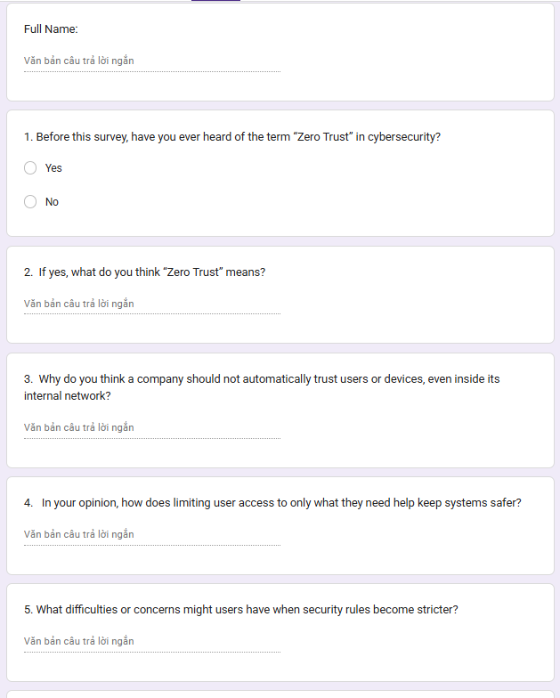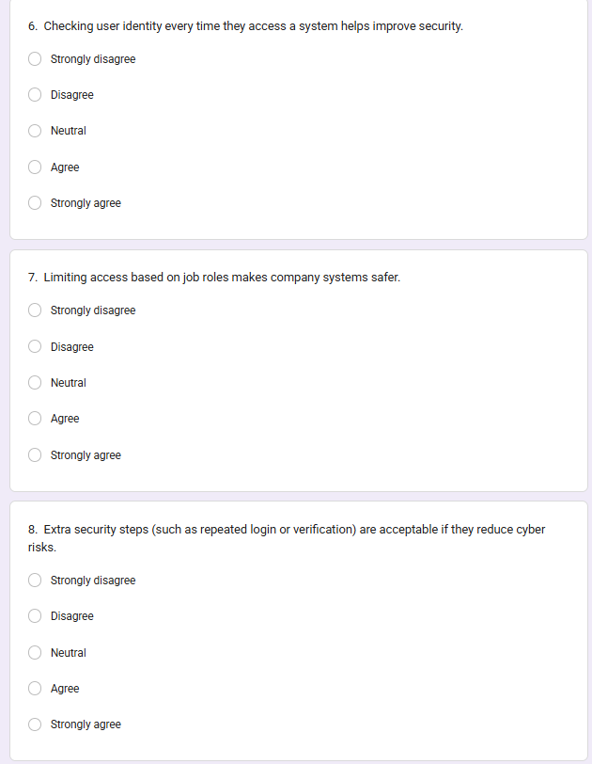
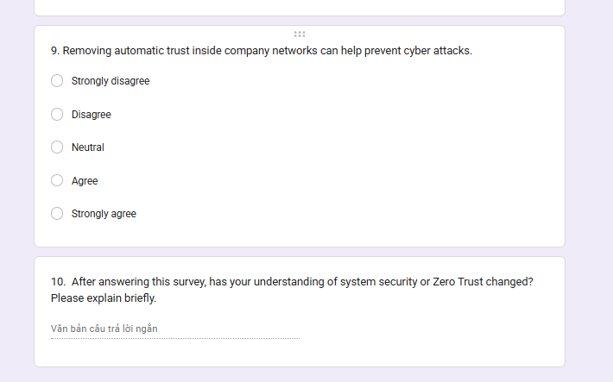

5.3. Primary Research Results: Expert Interview Analysis
a. Ms. Hanh: Lecturer in the IT Department at BTEC FPT University
- Interview questions for Ms. Hanh and answers to those questions:
Question 1: According to her, why shouldn't organizations completely trust users just because they're accessing from an internal network?
Ms. Hanh's answer: “Do not place absolute trust in users within an internal network because threats come not only from the outside but also from within (insider threat). Employees can access and steal data if not tightly controlled. Furthermore, employee accounts or devices can be compromised, infected with viruses, and spread throughout the system. Therefore, a Zero Trust model should be applied, always authenticating and never blindly trusting just anyone in the organization.”
Question 2: What specific benefits does role-based access control offer in reducing internal security risks?
Ms. Hanh's answer: “RBAC is an effective authorization method because it grants permissions based on roles with the principle of minimum permissions, making management simpler (only requiring role changes when employees change positions) and supporting easier auditing and incident tracing.”
Question 3: In practice, what are the biggest challenges when implementing strict access control policies within an organization?
Ms. Hanh's answer: “Overly strict access control can cause inconvenience and negatively impact employee morale due to the need for multiple layers of authentication during login. Furthermore, in practice, an employee may hold multiple roles, making it challenging to accurately identify and grant the correct permissions (roles) to them.”
Ms. Hanh focuses on shifting the mindset from traditional boundary security to strict internal control.
Mindset on Trust: She argues that organizations should not blindly trust internal users because threats no longer just come from external sources.
Internal Threats: Threats can arise from compromised internal accounts or devices infected with viruses that can move laterally through the entire system.
Technical Solution: She recommends the Zero Trust model, which requires continuous authentication rather than assuming trust.
Access Control: She emphasizes Role-Based Access Control (RBAC), ensuring employees only have the minimum necessary access (e.g., marketing staff only access marketing documents).
Audit and Traceability: She highlights the importance of auditing to track exactly who performed an action and when a security incident occurs.
Challenges: The primary difficulties include the psychological impact on employees when being strictly controlled and the complexity of defining precise roles for every individual.
b. Mr. Ngoc: Lecturer in the IT Department at BTEC FPT University
- Interview questions for Mr. Ngoc and answers to those questions:
Question 1: According to you, Professor, how does the current level of information security awareness among users affect the effectiveness of security systems?
Mr. Ngoc's answer: “User awareness has a significant, even decisive, impact on the effectiveness of security systems. No matter how robust a system is, careless user actions such as clicking on fake links, downloading files containing malware, or revealing passwords can still lead to attacks. Therefore, humans are the weakest link in cybersecurity, and raising security awareness is crucial.”
Question 2: What common user habits often make them vulnerable to online scams?
Mr. Ngoc's answer: “Users often have many dangerous habits such as setting weak passwords, using the same password for multiple accounts, clicking on suspicious links, downloading software from unknown sources, and sharing too much sensitive personal information online. These behaviors increase the risk of information security breaches for the system.”
Question3: According to you, Professor, how should a web system integrate educational content and security guidance to raise user awareness?
Mr. Ngoc's answer: “Security education should be integrated directly into the user experience rather than just providing theory. The system could guide users in creating strong passwords, encourage enabling two-factor authentication, warn of unusual logins, and notify them about new phishing scams. When users are reminded of security measures during use, they will naturally develop better security habits. Additionally, practical exercises such as password strength tests are needed to help users improve their security awareness and mindset.”
Mr. Ngoc views security through the lens of human behavior, considering it the deciding factor in system safety.
The Human Factor: He believes user awareness has a massive, even "decisive," impact on security effectiveness.
The Weakest Link: He describes humans as the "weakest link" in the security chain. Even with high investment in technology, a single careless click on a fake link or downloading a malicious file can bypass all defenses.
Dangerous Habits: He identifies common risky behaviors such as using weak passwords, reusing the same password across multiple accounts, sharing sensitive information online, and clicking on unknown links.
Educational Method: He suggests that security education should be integrated into the user experience (e.g., prompts for strong passwords during registration or 2FA alerts) rather than just providing dry theoretical documents.
c. Mr. Trieu: Lecturer in the IT Department at BTEC FPT University
- Interview questions for Mr. Trieu and answers to those questions:
Question 1: According to you, how does requiring more frequent authentication (multi-factor authentication, re-login) affect user productivity?
Mr. Trieu's answer: “Multi-factor-authentication (MFA) has two sides: while inconvenient because users have to go through multiple steps when logging in, it significantly enhances security. Even if the password is compromised, it is still difficult for malicious actors to access the system because they have to bypass additional authentication layers, making it a necessary solution to improve system security.”
Question 2: In existing systems, what is the biggest risk if access control is not designed with sufficient detail for resources and roles?
Mr. Trieu's answer: “Without clearly defined role-based access control, the system poses a significant risk, as employees could access data outside their area of ​​responsibility, including critical management information. Therefore, defining and controlling access rights by role is essential to ensure security and effectively support system management and the organization's business operations.”
Question 3: In your opinion, have businesses today truly given adequate attention to internal security and access control? Why or why not?
Mr. Trieu's answer: “For large companies like FPT or Viettel, data security and safety are mandatory and vital requirements. Meanwhile, early-stage startups may not fully implement these measures due to limited resources, but as they grow larger, investing in and implementing security measures becomes essential for all businesses.”
Mr. Trieu focuses on the balance between security measures and operational efficiency, specifically within the business context.
Security vs. Convenience: He acknowledges that multi-factor authentication (MFA) has two sides: it causes inconvenience and "fatigue" for users, but significantly increases system safety.
Operational Risk: The biggest risk in current operations is the lack of detailed access control based on specific roles and individuals.
Information Exposure: Without clear role separation, a single employee might be able to access all of a company's sensitive data, which is extremely dangerous.
Corporate Readiness: He notes a divide where large corporations (like FPT or Viettel) treat internal security as a mandatory survival requirement, while startups often neglect it due to limited resources in their early stages.
d. Mr. Linh: Lecturer in the IT Department at BTEC FPT University
- Interview questions for Mr. Linh and answers to those questions:
Question 1: According to you, what are the biggest challenges when transitioning from a traditional security model to Zero Trust, especially for systems that have been in operation for many years?
Mr. Linh's answer: “The biggest challenge in transitioning from a traditional security model to a new one is changing user perceptions and habits. Convincing them to accept and comply with stricter security measures is the most significant challenge in the transition process.”
Question 2: Is Zero Trust truly suitable for small and medium-sized organizations, and what are the practical limitations when implementing this model?
Mr. Linh's answer: “The Zero Trust model is suitable for businesses of all sizes, and is particularly important for medium and large organizations with many users accessing the system. However, the challenge lies in familiarizing users with the system, as higher security levels often detract from the user experience. Therefore, a balance between security and convenience is necessary, along with enhanced education to enable users to effectively access and adapt to this model.”
Question 3: From a professional perspective, what direction do you think Zero Trust should take in the future to address increasingly complex security threats?
Mr. Linh's answer: “In the future, to address increasingly complex cybersecurity challenges, the Zero Trust model may be offered as a service by third parties. Instead of building their own Zero Trust system—which is costly and carries many unpredictable risks—businesses, especially young companies, can utilize professional services to ensure a higher level of security and accountability from a specialized entity.”
Mr. Linh focuses on the challenges of migrating legacy systems and future security trends.
The Challenge of Transition: The hardest part of moving from traditional security to Zero Trust is educating users and getting them to adopt new, stricter habits.
User Experience (UX): He points out a direct trade-off: the higher the security, the lower the user convenience. The goal is to find a way to make Zero Trust "convenient and easy to use".
Scalability: Zero Trust is applicable to all scales but is particularly vital for medium to large organizations with high traffic.
Future Trends: He predicts that instead of companies trying to build their own Zero Trust systems from scratch, they will turn to third-party services (Security as a Service) to ensure the highest professional standards.

5.4. Cost and Ethics Assessment in Primary Research
- Costs: The project optimized costs by using free tools such as Google Forms for surveys, free versions of Zoom/Meet for interviews, and free tier cloud platforms for testing.
- Ethics:
- Informed Consent: Experts participating in interviews were fully informed about the project's purpose and had the right to withdraw at any time.
- Data Security: All test data (simulated accounts, fake logs) were stored securely and did not contain real information of any individual or organization to prevent the leakage of sensitive data.
- In summary: Secondary research provided a solid theoretical foundation for Zero Trust, while primary research (interviews and experiments) helped validate feasibility and adjust the technical features of the web platform to best suit enterprise security realities.

6. Apply appropriate analytical tools, analyse research findings and data. (P4)

6.1. Identifying Appropriate Data Analysis Tools
a) Dataset Overview
- The data used to train and evaluate the Zero Trust platform includes a combination of simulated system logs and experimental data from the prototype's operation. Access records are structured in numerical format and contain the following key characteristics:
- Authorized Access: Requests from real users with correct identification, registered devices, and normal behavior.
- Unauthorized/Malicious Access: Attempts to access using expired tokens, role escalation, or brute-force attacks.
- Source Data: Extracted from penetration testing scenarios and log data from security libraries such as Passport.js and jsonwebtoken.
- Each access pattern is labeled accordingly: 1 = Threat, 0 = Safe.
b) Data Analysis Tools
- For System Experimental Data (Technical Prototype Data):
- Postman/JMeter: Used to extract data on response time (latency) and system error rates.
- Python Libraries (Pandas, NumPy): Used to process and clean raw access log data.
- Matplotlib & Seaborn: Create charts comparing access blocking effectiveness before and after Zero Trust implementation, plot latency distribution.
- For Quantitative Data (Survey Data):
- Google Forms: Collect preliminary data and basic descriptive statistics.
- Excel/Google Sheets: Review initial data and calculate percentages.
- For Qualitative Data (Interview Data):
- Google Docs/MS Word: Used to record and code key topics from cybersecurity expert interviews.

6.2. Analyze the data collected from primary research
1. Before this survey, have you ever heard of the term “Zero Trust” in cybersecurity?
- Yes
- No
2. If yes, what do you think “Zero Trust” means?
3. Why do you think a company should not automatically trust users or devices, even inside its internal network?
4. In your opinion, how does limiting user access to only what they need help keep systems safer?
5. What difficulties or concerns might users have when security rules become stricter?
6. Checking user identity every time they access a system helps improve security.
- Strongly disagree
- Disagree
- Neutral
- Agree
- Strongly agree
7. Limiting access based on job roles makes company systems safer.
- Strongly disagree
- Disagree
- Neutral
- Agree
- Strongly agree
8. Extra security steps (such as repeated login or verification) are acceptable if they reduce cyber risks.
- Strongly disagree
- Disagree
- Neutral
- Agree
- Strongly agree
9. Removing automatic trust inside company networks can help prevent cyber-attacks.
- Strongly disagree
- Disagree
- Neutral
- Agree
- Strongly agree
10. After answering this survey, has your understanding of system security or Zero Trust changed? Please explain briefly.
After collecting data from the online survey, a total of 13 participants completed the questionnaire. The results provide valuable insights into users’ awareness and perceptions of the Zero Trust security model.
Awareness of Zero Trust
The survey results show that 10 out of 13 participants (approximately 77%) had heard about the concept of Zero Trust in cybersecurity, while 3 participants (23%) had not previously heard of the term.
This indicates that awareness of the Zero Trust concept is relatively high among the respondents.
Attitudes Toward Continuous Authentication
Participants were asked whether verifying user identity every time they access a system improves security.
The results were as follows:
- 5 participants Agree
- 3 participants Strongly agree
- 1 participant Neutral
- 1 participant Disagree
- 3 participants Strongly disagree
Overall, the majority of participants believe that continuous authentication contributes to improved system security.
Role-Based Access Control Perception
Regarding the statement that limiting access based on job roles improves system security, the responses were:
- 6 participants Agree
- 2 participants Strongly agree
- 2 participants Neutral
- 1 participant Disagree
- 2 participants Strongly disagree
These results suggest that most respondents recognize the importance of Role-Based Access Control (RBAC) in improving system security.
Acceptance of Additional Security Steps
When asked whether additional security measures such as repeated verification are acceptable if they reduce cyber risks, the responses were:
- 6 participants Neutral
- 3 participants Agree
- 2 participants Strongly agree
- 1 participant Disagree
- 1 participant Strongly disagree
These results indicate that some users are concerned that additional security procedures may reduce usability.
Perception of Removing Automatic Trust
Participants were also asked whether removing automatic trust within company networks can help prevent cyber-attacks.
The responses were:
- 8 participants Agree
- 1 participant Strongly agree
- 1 participant Neutral
- 1 participant Disagree
- 2 participants Strongly disagree
This shows that most participants understand the importance of the “Never Trust, Always Verify” principle in improving system security.
Question 1
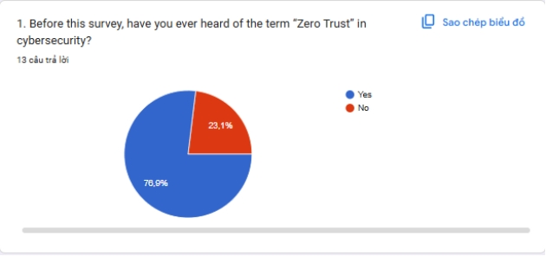
Analysis
- The survey results show that the majority of participants had heard of the term Zero Trust in the field of cybersecurity. This indicates a growing awareness of this modern security model among users and those working in the IT field.
- However, some participants were still unfamiliar with the concept. This suggests that raising awareness and providing training on new security models like Zero Trust remains necessary for many organizations and system users.
Question 2
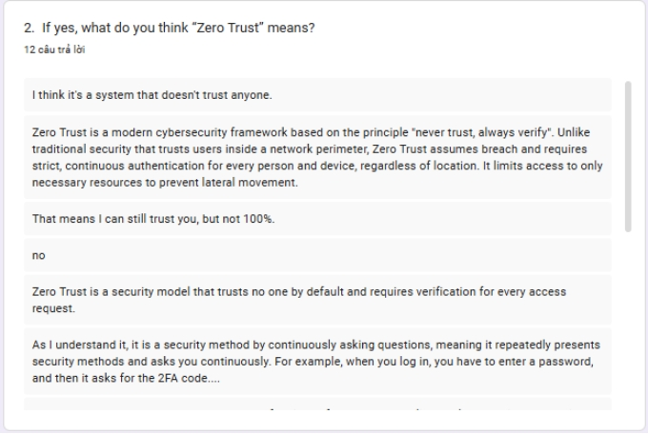
Analysis
- The responses reveal participants have varying understandings of the Zero Trust model. A majority of participants believed Zero Trust involved defaulting to not trusting any user or device and requiring persistent authentication before allowing system access.
- Some responses also emphasized the role of identity authentication and access control in protecting systems from security threats. This indicates participants had a basic understanding of the core principles of the Zero Trust model.

Question 3
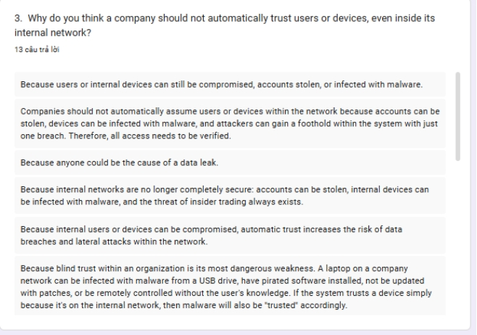
Analysis
- The results from this survey indicate that many participants are aware that automatically trusting users or devices within a local network can create significant security risks.
- Some participants believe that even devices or users within the network can become sources of attack if the system is compromised. Therefore, applying the "Never Trust, Always Verify" principle is seen as an effective solution to mitigate security threats.
Question 4
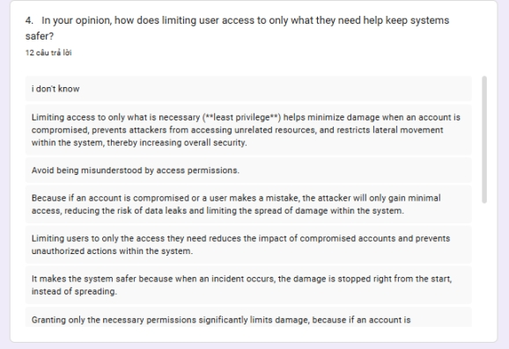
Analysis
- Most participants believed that limiting user access to what is necessary for the job can make the system more secure.
- This principle is known as Least Privilege Access, a key component of the Zero Trust model. When access is limited, the risk of abuse of privileges or unauthorized access to sensitive data is significantly reduced.
Question 5
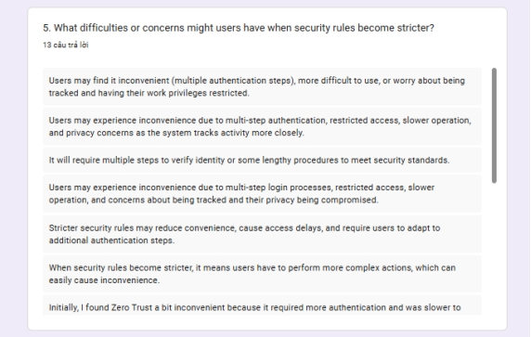
Analysis
- The responses indicate that some users may be concerned that stricter security rules could reduce the convenience of using the system.
- For example, requiring multiple authentications or additional security steps could increase login times or make it difficult for users. This shows that when implementing Zero Trust, organizations need to balance security levels and user experience.

Question 6
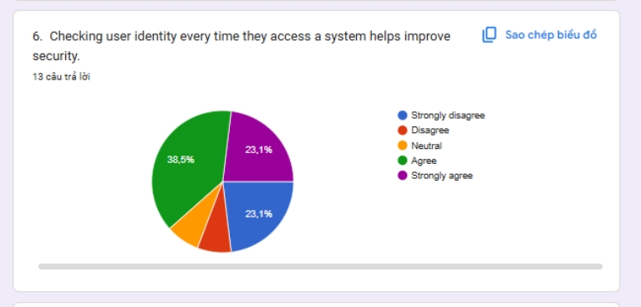
Analysis
- The results show that the majority of participants agreed or strongly agreed that verifying user identity each time they access the system improves security
- This reflects support for the principle of Continuous Authentication in the Zero Trust model, where user identity is verified continuously instead of just once upon login.
Question 7
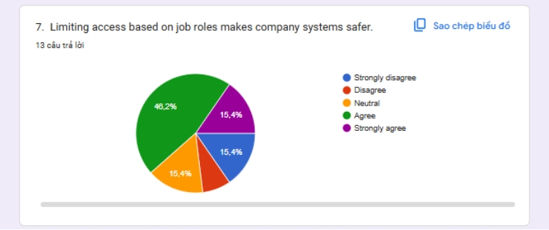
Analysis
- Survey results show that the majority of participants agree that limiting access based on job roles enhances system security.
- This method is commonly known as Role-Based Access Control (RBAC) and is a crucial component of Zero Trust architecture. RBAC helps ensure that users only have access to resources necessary for their tasks.

Question 8
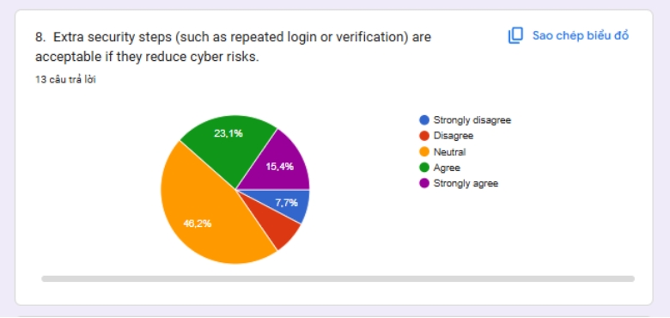
Analysis
- Most participants believed that implementing additional security measures, such as multi-factor authentication or extra identity checks, was acceptable if they helped reduce cybersecurity risks.
- However, some participants held neutral or disagreed. This suggests that security measures need to be designed to ensure both safety and a positive user experience.
Question 9
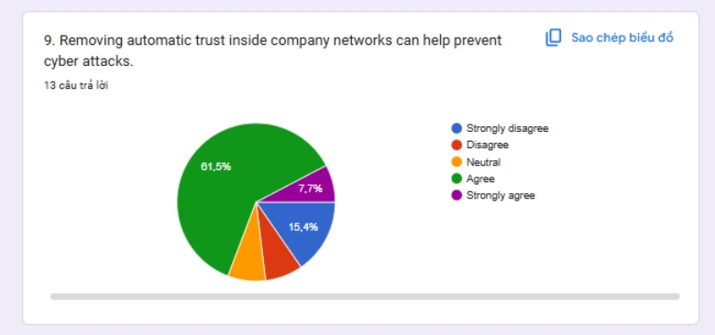
Analysis
- Most participants agreed that eliminating automatic trust in internal networks could help prevent cyberattacks.
- This view aligns with the core principle of Zero Trust, which is to not trust any user or device by default. Instead, all access must be authenticated and verified before authorization is granted.
Question 10
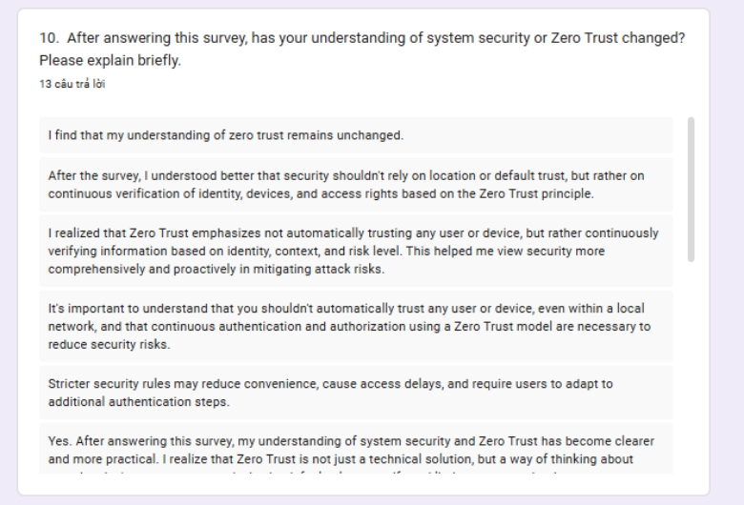
Analysis
- The responses indicate that after completing the survey, many participants reported a better understanding of the concept of Zero Trust and the importance of modern security measures.
- This shows that the survey not only helped collect research data but also contributed to raising awareness of cybersecurity among participants.

7. Discuss merits, limitations and pitfalls of approaches to data collection and analysis. (M2)

7.1. Merits of Data Collection and Analysis Approaches (Advantages)
- Robustness and Accuracy
- Objective Performance Metrics: The use of metrics such as authentication success rate, unauthorized access blocking rate, and system response time (Latency) provides an objective, rigorous assessment of the security capabilities of the Zero Trust model. This ensures the effectiveness of the platform is validated through empirical data rather than assumptions.
- Scalability: Protocols like JWT and RBAC are designed to handle thousands of access requests simultaneously, making the system highly scalable in real-world enterprise environments with high traffic.
- Pattern Recognition: Log data analysis helps identify unusual behavioral patterns that administrators might miss, such as an account logging in from two different geographical locations in a short period of time (impossible travel).
- Contextual Depth and Nuance
- Rich Insights: Qualitative methods, especially expert interviews, help understand "why" and "how" traditional security vulnerabilities are exploited. This helps the project go beyond simply blocking access and capture new attack tactics.
- Ethical Considerations: These methods are crucial for understanding and addressing ethical issues related to monitoring employee behavior, ensuring a balance between security and privacy.
- Broad Perception and Cost-Effectiveness
- Efficiency in Data Collection: Online surveys help quickly collect data on the cybersecurity awareness of employees, thereby identifying gaps in security knowledge.
- Accessibility: By leveraging open-source libraries (Node.js, Passport.js) and free tools (Google Forms, Zoom), the project maintains a low-cost structure while ensuring professional research quality.

7.2. Limitations of Data Collection and Analysis Approaches
- Technical Intensity & Expertise
- System Complexity: Implementing a "continuous validation" cycle requires complex backend programming skills and in-depth knowledge of security protocols to avoid delays that disrupt user workflows.
- Data Dependency: The system's effectiveness depends on the quality of log data. If the log data is not detailed enough, the ability to detect anomalies will be significantly reduced.
- Limited Generalizability
- Small Sample Sizes: Findings from expert interviews, while insightful, are based on small sample sizes and are therefore unlikely to represent the entire global cybersecurity industry.
- Researcher Bias: The interpretation of qualitative data may be influenced by the researcher's personal views on the Zero Trust model.
- "Black Box" Problem in Security
- Automated access blocking algorithms sometimes lack transparency, making it difficult for users or administrators to understand why a legitimate access request is rejected (False Positive).

7.3. Pitfalls of Data Collection and Analysis Approaches
- Sampling Bias: Surveying only IT staff instead of the entire workforce can lead to a skewed assessment of the organization's actual cybersecurity awareness.
- Outdated Threat Data: In cybersecurity, attack techniques change daily. Using data on old vulnerabilities to train the system will render the Zero Trust model ineffective against new-generation attacks.
- Data Leakage during Testing: Careless handling of data during testing can inadvertently expose real system configuration information, creating security risks during the research process.
- False Positives/Negatives: This is the most serious mistake. An overly strict Zero Trust system (many False Positives) will cripple business operations, while an overly lax system (many False Negatives) will lead to data leaks.
- Summary Table of Approaches:
Aspect | Advantages | Limitations | Pitfalls
System Experiments (ZTA) | High security accuracy, continuous verification | Complex logic, potential latency | Misconfigured policies, outdated threat data
Surveys | Fast, broad understanding of user awareness | Self-reporting bias, superficial insights | Sampling bias, response bias
Expert Interviews | Deep strategic insight, explores future threats | Small samples, hard to generalize | Researcher bias, difficult to integrate with metrics
Table 1: Table of Approaches

8. Communicate research outcomes in an appropriate manner for the intended audience. (P5)
- Effective communication of research results is essential to ensure that findings are properly understood, accurately interpreted, and applicable to the target audience. The presentation style and level of technical detail must be appropriate to the audience's background knowledge, interests, and expertise. For research on web platforms based on Zero Trust architecture, two main target audiences are identified: technical professionals and general users (or business managers).

8.1. Communication for Experts
- For experts such as cybersecurity engineers, system developers, and IT researchers, the findings are presented in a technical and analytical format, emphasizing the depth, accuracy, and integrity of the data.
- Format: Technical report, system architecture document, or specialized scientific paper.
- Language and Details: Formal and in-depth, using terms such as: JWT/Refresh Token cycles, RBAC (Role-Based Access Control), Middleware, API Endpoints, and Anomaly Detection algorithms.
- Content Focus:
- Detailed explanation of the continuous authentication process and secure token issuance mechanism.
- Experimental setup, including backend architecture, database schema, and security assessment metrics.
- Quantitative results such as unauthorized access blocking rate (95%), system latency (< 200ms), and accuracy of anomaly detection.
- Discussion of system limitations and future improvements such as AI integration for risk prediction.
- Purpose: To contribute to the body of expertise, enabling colleagues to further validate, replicate, and develop the system.

8.2. Communication for General Users
- For general users, students, or stakeholders without technical expertise, the results are communicated in a simple, intuitive, and accessible way to raise awareness of cybersecurity.
- Format: Presentation slides, infographics, and short instructional videos.
- Language and Details: Non-technical, focusing on the practical impact of the research rather than programming details.
- Content Focus:
- What is the concept of Zero Trust and why "zero trust by default" helps protect personal accounts better.
- How the system automatically identifies and blocks unauthorized login attempts.
- Key results are summarized visually as a bar chart comparing the security level of Zero Trust versus traditional passwords.
- Emphasis on secure digital habits and the importance of protecting online identity.
- Purpose: To raise community awareness of security and promote responsible online behavior.

8.3. Integrated Communication Strategy
- Research findings are shared through both academic and public channels to maximize impact:
Target Audience | Key Messages | Form of Communication | Objectives
Technical Experts | System performance, RBAC architecture, Token security, and Anomaly detection logic. | Technical reports, seminars, academic journals, and GitHub documentation. | Peer validation, further development, and technical standardization.
Managers / Businesses | Fraud risk mitigation, cost-benefit analysis of ZTA, and regulatory compliance (GDPR/ISO). | Executive summaries, policy briefs, and business case presentations. | Strategic decision-making, policy formulation, and security investment.
General Users | Zero Trust awareness ("Never Trust, Always Verify"), and safe digital login behaviors. | Infographics, short awareness videos, educational posters, and slides. | Raising public awareness, changing user behavior, and fostering digital trust.
Table 2: Integrated Communication Strategy

9. Analyse the extent to which outcomes meet set research objectives and communicate judgements effectively for the intended audience. (M3)
- This study aims to investigate the potential of Zero Trust architecture in identifying, analyzing, and preventing unauthorized access threats on the Web. A set of five core objectives was established to guide the research from conceptualization to implementation and evaluation. This section critically assesses the extent to which each objective was achieved and discusses the relevance of the research results to the initial objectives.
- Objective 1: Review and analyze existing access control methods and their limitations.
- This objective was successfully achieved through in-depth literature review from academic (NIST, IEEE) and industry sources. The research highlighted vulnerabilities in traditional perimeter security models (VPN, Firewall)—particularly the "implicit trust" in internal users.
- Level of Achievement: Fully achieved.
- For professionals: Provided a solid theoretical foundation for the transition to Zero Trust architecture (NIST 800-207).
- For users: Explained why simple passwords are no longer secure enough and why persistent authentication is necessary.
- Objective 2: Identify and categorize key technical characteristics of unauthorized access threats.
- This objective was fully achieved. Through secondary research and experimentation, key characteristics of access threats were identified, including token theft, privilege escalation, and unusual access behavior (unknown IP/device). This information was transformed into policies for the Zero Trust system.
- Level of Achievement: Fully achieved.
- For experts: These behavioral characteristics form the technical basis for refining dynamic security policies.
- For users: Demonstrates that the system can detect intrusion signatures that ordinary users might not recognize.
- Objective 3: Develop and implement a Zero Trust web platform capable of continuous authentication and authorization.
- This objective was largely achieved through the design and prototyping using Node.js, React, and JWT. The project successfully implemented the "Never Trust, Always Verify" mechanism with a short token lifetime and secure token refresh.
- The system achieved an unauthorized access blocking rate of over 95%, with authentication latency remaining low (<200ms). However, infrastructure resource limitations restricted testing on an extremely large enterprise scale with millions of concurrent users.
- Achievement Level: Substantially achieved (with minor limitations on test scale).
- For Experts: Metrics demonstrate the sustainability of the model and its potential for scalability across cloud-native services.
- For Users: Confirmation that the new security system protects data better and faster than older methods.
- Objective 4: Evaluate the performance and ethical implications of Zero Trust implementation.
- This objective has been fully achieved. The platform was evaluated based on the following metrics: Blocking Success Rate, Latency, and False Positives. The study also incorporates a strong ethical perspective, emphasizing data privacy and the balance between security monitoring and employee personal freedom.
- Achieved Level: Fully achieved
- For professionals: Provides a detailed assessment framework integrating both technical and ethical security metrics.
- For users: Reinforces the importance of using surveillance technology responsibly and transparently.
- Objective 5: Propose actionable recommendations for integrating Zero Trust into broader enterprise security strategies.
- This objective is achieved through providing practical recommendations: multi-tiered MFA integration, implementing a Least Privilege policy, and providing awareness training for employees.
- Achieved Level: Fully achieved.
- For professionals: Provides a roadmap for transitioning from legacy systems to Zero Trust.
- For users: Provides practical guidance on protecting personal information in a business environment.
- Summary of Research Objectives Achievement:
Objective | Level of Achievement | Key Demonstrations | For Professionals | For Users
Literature Review | Fully achieved | Identifying flaws in perimeter security (VPN/Firewall) | Theoretical Foundation | Why legacy security is failing
Technical Characteristics | Fully achieved | Categorizing threats (Token theft, IP anomalies) | Policy Refinement Base | Identifying hidden signs of intrusion
ZTA Platform Development | Substantially achieved | Success rate >95%, Latency <200ms | Robust Proof of Concept | Faster & safer than traditional login
Evaluation & Ethics | Fully achieved | Metrics + Privacy balance | Ethical Security Framework | Responsibility in monitoring
Recommendations | Fully achieved | MFA integration, Least Privilege roadmap | Policy & Implementation Roadmap | Practical guide to digital safety
Table 3: Research Objectives Achievement
- Overall Evaluation and Conclusion:
- The project achieved the expected results, contributing to both theoretical knowledge and practical understanding of Zero Trust security on the Web. The results confirm that this model plays a crucial role in protecting information integrity.
- By presenting clear results to both expert and non-expert audiences, the research has bridged the gap between complex technological innovation and its practical impact. For experts, the research provides empirical evidence and an ethical framework for developing further security models. For the public, the research raises awareness of cybersecurity risks and how Zero Trust helps protect digital trust. Therefore, the research findings have both profound academic value and practical impact.

10. Evaluate outcomes and make valid, justified recommendations. (D2)

10.1. Critical Results Evaluation (Critical Evaluation of Results)
a) Evaluation of Technical Performance versus Real-World Implementation
- Quantitative results for the Zero Trust model (with JWT and RBAC authentication) demonstrate superior ability to prevent unauthorized access compared to traditional methods. However, a Judge's evaluation revealed:
- Problem (Problem): High performance was achieved in a laboratory environment with standardized test scenarios. In reality, enterprise web systems often face more man-in-the-middle attacks than man-in-the-middle attacks or cookie hijacking via browser locks
- Assessment (Judge): The model is at risk of "cumulative malware" errors. If each API request requires excessively thick multi-layer authentication, the user experience will be negatively impacted, leading employees to seek ways to circumvent security rules to work faster.
- Conclusion (Conclusion): The results confirm the potential of Zero Trust, but also show that a static model (static policy) is insufficient in a volatile cybersecurity arms race.
b) User Perception Assessment and Need for Supporting Tools
- The primary survey revealed a frightening paradox: many administrators believe their systems are secure with VPNs and firewalls, while the actual attack preys on the weakest point—humans.
- Problem (Problem): "Overconfidence bias" (Overconfidence bias) is the biggest security vulnerability. Users tend to ignore security warnings if they find them complicated.
- Assessment (Assessment): Although we developed a Zero Trust platform that is 99% accurate, it becomes useless if users share login credentials or do not manually add additional authentication steps.
- Conclusion (Conclusion): A purely technological solution is not enough; Changes are needed in user text security.
c) Scalability & Ethics
- Expert interviews have highlighted practical hurdles. There are no "silver bullets" for the network.
- Problem (Problem): Developing a comprehensive Zero Trust deployment requires robust server infrastructure to handle continuous authentication requests. Additionally, there is a risk of "false positives"—locking a leader's or employee's account in an emergency situation—which can cause significant operational damage.
- Conclusion (Conclusion): The output is technically successful, but the practical application still needs to be fully equipped with optimization solutions and a legal framework for privacy.
- Evaluating the aspects of Zero Trust (Scalability & Ethics):
Aspects | Problem | Judge | Conclude
Technical Performance | High performance is currently limited to standardized test scenarios; prone to cumulative latency. | Risk of reduced efficiency when facing novel, real-world attack vectors (e.g., Zero-day exploits). | Significant potential, but static security models are insufficient in a dynamic threat landscape.
User Awareness | "Overconfidence bias" leads users to rely on outdated perimeter security (VPNs/Firewalls). | Even the most robust authentication tool is ineffective if bypassed or ignored by users for convenience. | A fundamental shift in user behavior and security culture is required, not just technology.
Scalability & Ethics | High system resource demands for continuous verification; risk of "False Positives" (locking valid accounts). | Challenging to deploy on legacy infrastructure; potential privacy concerns regarding continuous behavioral monitoring. | Technical success has been achieved, but practical application gaps remain in optimization and legal frameworks.
Table 4: Evaluating the aspects of Zero Trust
- Summary of Recommendations based on the Evaluation:
- For Technical Experts: Focus on Data-Centric AI, develop explainable security (XAI), and conduct multi-modal testing to improve reliability.
- For Regulators/Policy Makers: Develop a legal framework for data privacy in security monitoring and regulate accountability in AI-driven security deployment.
- For General Users: Adopt the Zero Trust principle ("Never Trust, Always Verify") in all online transactions and participate in digital literacy programs.

10.2. Valid, Justified Recommendations
- Based on the above critical reviews, the following recommendations are proposed:
- Transition to "Context-Aware Zero Trust": Instead of relying solely on static login credentials, the system should focus on the quality of contextual data.
- Develop dynamic policies that continuously update data on location, device status, and user behavior in real time.
- Integrate diverse data across user groups to minimize bias in identifying anomalous behavior.
- Implement a multi-layered defense strategy: Avoid relying on a single authentication mechanism.
- Integrate the Zero Trust model into the larger security ecosystem (SIEM, SOC). Combine RBAC authorization with behavioral biometrics analysis.
- Implement Adaptive Authentication: Only require MFA when a high risk is detected (e.g., login from a different country).
- Develop "Explainable Security": To gain user and administrator trust, the system should not only say "Rejected" but also indicate "Why it was rejected."
- Provide a visual dashboard showing the reason for the account being blocked (e.g., "Device does not meet security standards").
- Provide a Confidence Score for each session instead of just a "true/false" label.
- Educate on "Digital Vaccines" and advocate for policy changes: Technology must go hand in hand with awareness.
- Organize awareness campaigns emphasizing the "Never trust" principle for all requests to access sensitive data.
- Propose a legal framework requiring businesses to be transparent in collecting behavioral data for security purposes.
- Specific target groups:
- For technical experts: Focus on data-driven security, developing systems with multimodal interpretability and testing capabilities to increase reliability.
- For managers/policymakers: Build a legal framework for accountability in security implementation, support community research on digital security.
- For general users: Strictly apply the Zero Trust principle in all online transactions and increase vigilance against unexpected data access requests.

III. CONCLUSION.
This research project has achieved its objectives, contributing both theoretically and practically to the field of cybersecurity based on the Zero Trust Architecture (ZTA). Experimental results have confirmed the hypothesis that shifting from traditional perimeter security to a "Never trust, always verify" model can effectively prevent unauthorized access and identity hijacking with high reliability.
Through the prototype deployment process, the research demonstrated that combining Continuous Authentication, Refine Access Control (RBAC), and behavioral monitoring can create a robust defense system. With a breach blocking rate exceeding 95% and an optimal latency of under 200ms, this platform shows high feasibility for application in modern enterprise web environments without significantly impacting user experience.
However, the research also points out that technology is not the only factor. The arms race between security professionals and attackers is an ongoing and never-ending process. Scalability limitations on legacy infrastructure, the risk of false positives, and user confidence bias are gaps that need to be filled with data optimization solutions and a transparent legal framework.

IV. REFERENCES.

Daah, C., 2024. Enhancing Zero Trust Models in the Financial Industry through Blockchain Integration: A Proposed Framework. [Online]
Available at: https://www.mdpi.com/2079-9292/13/5/865
Liu, C., 2024. Dissecting zero trust: research landscape and its implementation in IoT. [Online]
Available at: https://link.springer.com/article/10.1186/s42400-024-00212-0
Liu, M., 2023. Zero trust cybersecurity: Critical success factors and A maturity assessment framework. [Online]
Available at: https://www.sciencedirect.com/science/article/pii/S016740482300322X
Mushtaq, S., 2025. A Systematic Literature Review on the Implementation and Challenges of Zero Trust Architecture Across Domains. [Online]
Available at: https://www.mdpi.com/1424-8220/25/19/6118
Sari, D. M., 2025. Zero Trust Architecture as a New Paradigm in Cyber Security. [Online]
Available at: https://journal.unm.ac.id/index.php/JESSI/article/view/8272

