<https://developer.paypal.com/dashboard>

<http://shopmysqli.net/web_mysqli2/index.php>

**VNPAY**

<https://sandbox.vnpayment.vn/apis/docs/huong-dan-tich-hop/>

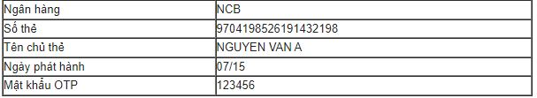

momo

<https://github.com/momo-wallet/payment/tree/master>

ONEPAY

<https://viblo.asia/q/L6lA9QxRlek>

thông tin để test onepay atm

https://mtf.onepay.vn/developer/?page=modul_noidia

link tải source code onepay

<https://mtf.onepay.vn/developer/?page=modul_noidia_php>

//Tạo tên miền ảo

https://thachpham.com/thu-thuat/cach-them-ten-mien-ao-cho-localhost-voi-xampp.html