Hệ thống cửa hàng sách

1. Yêu cầu

- Trang web bán sách (Gợi ý cho người dùng những sản phẩm bán chạy và những sản phẩm người dùng có thể quan tâm).

2. Phân tích

2.1. Sơ đồ use case

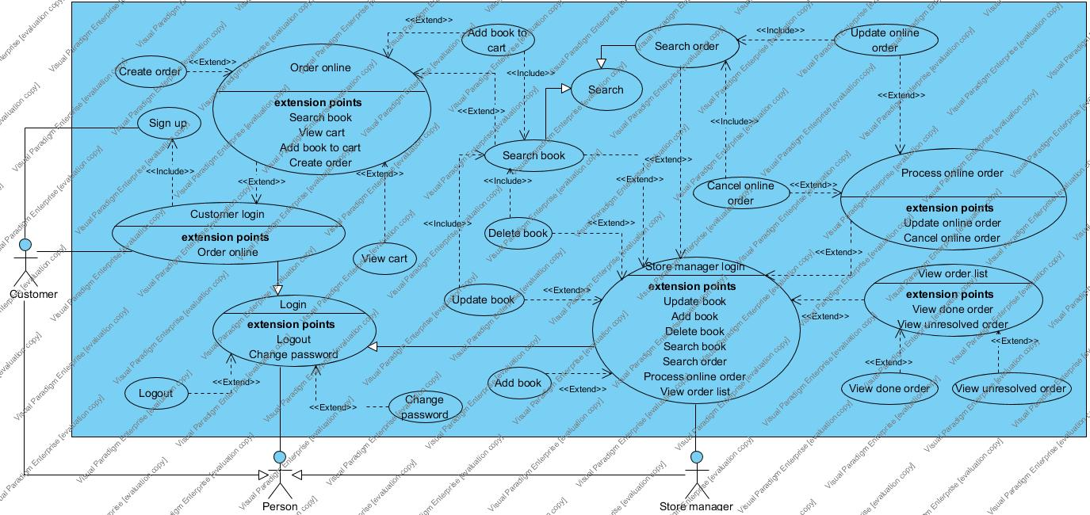

2.2. Kịch bản cho từng use case:

2.2.1. Sign up

|  |  |  |  |  |  |  |  |  |  |  |  |
| --- | --- | --- | --- | --- | --- | --- | --- | --- | --- | --- | --- |
| |  | | --- | | 1. Customer click "Sign up" button. | | 2. SYSTEM display some text-fields: username, password, confirm password, phone  number, address and a "Sign up" button. | | 3. Customer input all information into these text-fields then click "Sign up" button. | | 3.a. This username is already exist. | | 1. while Username Customer input is still exist. | | 1.1. SYSTEM show a "This username is already exist." message and request  Customer choose another username. | | 1.2. Customer input another username then click "Sign up" button. | | end while | | 4. SYSTEM display a "Success" message and a "Close" button. | | 5. Customer click "Close" button. | | 6. SYSTEM go to the homepage for Customer. | |

2.2.2. Customer login

|  |  |  |  |  |  |  |  |  |  |
| --- | --- | --- | --- | --- | --- | --- | --- | --- | --- |
| |  | | --- | | 1. Customer click "Login" button. | | 2. SYSTEM display 2 text-fields: username, password and a "Login" button. | | 3. Customer input the username, password then click "Login" button. | | 3.a. Wrong username or password. | | 1. while Wrong username or password | | 1.1. SYSTEM display a "Wrong username or password" message and request Customer input username, password again. | | 1.2. Customer input the username, password again then click "Login" button. | | end while | | 4. SYSTEM go to the homepage for Customer. | |

2.2.3. Log out

|  |  |  |  |  |
| --- | --- | --- | --- | --- |
| |  | | --- | | 1. Person click "Logout" button after Login | | 2. SYSTEM display a dialog to ask Person really want to logout. | | 3. Person click "Yes" | | 4. SYSTEM display the page before Login | |

2.2.4. Change password

|  |  |  |  |  |  |  |  |  |  |  |
| --- | --- | --- | --- | --- | --- | --- | --- | --- | --- | --- |
| |  | | --- | | 1. Person click "Change password" after Login | | 2. SYSTEM display 3 text-field: "Current password", "New password" and "Confirm new password" and "OK" button | | 3. Person input into 3 text-field and click "OK" | | 3.a. current password is wrong | | 1. SYSTEM show "current password is wrong" message and request Person input again | | 3.b. "New password" and "Confirm new password" is different | | 1. SYSTEM show ""New password" and "Confirm new password" is different" message and request Person input again | | 4. SYSTEM display "Success" message | | 5. Person click "OK" | | 6. SYSTEM back to homepage | |

2.2.5. Search book

|  |  |  |  |  |  |  |
| --- | --- | --- | --- | --- | --- | --- |
| |  | | --- | | 1. Customer click "Search" button after Customer login. | | 2. SYSTEM display a search bar for Customer input name of the book Customer want to  find and a "Search" button. | | 3. Customer input name of the book want to find then click "Search" button. | | 4. SYSTEM display  a list of books with title close to what the Customer want to find an a  "Back" button. | | 5. Customer click "Back" button. | | 6. SYSTEM back to the homepage for Customer. | |

2.2.6. Add book to cart

|  |  |  |  |  |  |  |  |  |  |  |
| --- | --- | --- | --- | --- | --- | --- | --- | --- | --- | --- |
| |  | | --- | | 1. Customer click "Search" button after Customer login. | | 2. SYSTEM display a search bar for Customer input name of the book Customer want to  find and a "Search" button. | | 3. Customer input name of the book want to find then click "Search" button. | | 4. SYSTEM display  a list of books with title close to what the Customer want to find an a \  "Back" button. | | 5. Customer click the book Customer want to add to cart. | | 6. SYSTEM display information about this book and 2 button: "Add to cart" and "Close". | | 7. Customer click "Add to cart" button. | | 8. SYSTEM display a "Added successfully" message with a Close button. | | 9. Customer click "Close" button. | | 10. SYSTEM back to the homepage for Customer. | |

2.2.7. Create order

|  |  |  |  |  |  |  |  |  |  |  |  |
| --- | --- | --- | --- | --- | --- | --- | --- | --- | --- | --- | --- |
| |  | | --- | | 1. Customer click "View cart" after Customer login | | 2. SYSTEM display list of books Customer chose and a "Create order" button | | 3. Customer click "Create order" button | | 4. SYSTEM display information of receiver, lists of books and some payment method for  Customer choose | | 4.a. there are not any book in cart | | 1. SYSTEM show "No book in cart" message for Customer | | 2. Customer click "OK" | | 5. Customer choose the payment method and click "OK" | | 6. SYSTEM display message "Create order success. Please wait for processing" | | 7. Customer click "OK" | | 8. SYSTEM back to homepage for Customer | |

2.2.8. View cart

|  |  |  |  |  |
| --- | --- | --- | --- | --- |
| |  | | --- | | 1. Customer click "View cart" button after Customer login. | | 2. SYSTEM display list of books Customer chose and a "Back" button. | | 3. Customer click "Back" button. | | 4. SYSTEM back to the homepage for Customer. | |

2.2.9. Add book

|  |  |  |  |  |  |  |  |  |  |  |  |  |  |
| --- | --- | --- | --- | --- | --- | --- | --- | --- | --- | --- | --- | --- | --- |
| |  | | --- | | 1. Store manager click "Add book" button after Store manager login. | | 2. loop | | 2.1. SYSTEM display the form to input information of a book with 6 text-fields: name,  author, publisher, cost, type, date of issue and a "Add" button. | | 2.2. Store manager input information of the book into all of text-fields then click "Add"  button. | | 2.2.a. The book is already exist. | | 1. SYSTEM show the message "This book is already exist." and "OK" button. | | 2. Store manager click "OK" button. | | 3. SYSTEM back to the form to input information of a book with 6 text-fields: name,  author, publisher, cost, type, date of issue and a "Add" button. | | 4. Store manager input information of the book into all of text-fields then click "Add"  button. | | 2.3. SYSTEM show message "Success" and "OK" button. | | 2.4. Store manager click "OK" button. | | until there are not any book to add | | 3. SYSTEM back to the homepage for Store manager. | |

2.2.10. Update book

|  |  |  |  |  |  |  |  |  |  |  |  |  |  |  |  |  |  |
| --- | --- | --- | --- | --- | --- | --- | --- | --- | --- | --- | --- | --- | --- | --- | --- | --- | --- |
| |  | | --- | | 1. Store manager click "Update book"  after Store manager login. | | 2. loop | | 2.1. SYSTEM display a search bar, a "Search" button. | | 2.2. Store manager input the name of book into search bar and click "Search" button. | | 2.2.a. There aren't any book with this name. | | 1. SYSTEM show message "There aren't any book with this name." and a "OK"  button. | | 2. Store manager click "OK" button. | | 3. SYSTEM back to the search form with a text-field to input the name of book,  a "Search" button and a table to show the result search. | | 4. Store manager input the name of book to text field and click "Search" button. | | 2.3. SYSTEM show a list of books have name like which Store manager input. | | 2.4. Store manager click the book need to update. | | 2.5. SYSTEM display the form to update with 6 text-fields: name, author, publisher,  cost, type, date of issue and information of this book and a "Update" button. | | 2.6. Store manager change the information of the book in these text-fields then click  "Update" button. | | until there are not any book need to update | | 3. SYSTEM display a "Success" message and a "Close" button. | | 4. Store manager click "Close" button. | | 5. SYSTEM back to the homepage for Store manager. | |

2.2.11. Delete book

|  |  |  |  |  |  |  |  |  |  |  |  |  |  |  |  |  |  |
| --- | --- | --- | --- | --- | --- | --- | --- | --- | --- | --- | --- | --- | --- | --- | --- | --- | --- |
| |  | | --- | | 1. Store manager click "Delete book"  after Store manager login. | | 2. loop | | 2.1. SYSTEM display a search bar, a "Search" button. | | 2.2. Store manager input the name of book into search bar and click "Search" button. | | 2.2.a. There aren't any book with this name. | | 1. SYSTEM show message "There aren't any book with this name." and a "OK"  button. | | 2. Store manager click "OK" button. | | 3. SYSTEM back to the search form with a text-field to input the name of book,  a "Search" button and a table to show the result search. | | 4. Store manager input the name of book to text field and click "Search" button. | | 2.3. SYSTEM show a list of books have name like which Store manager input. | | 2.4. Store manager click the book need to delete. | | 2.5. SYSTEM display the information of the book, a "Delete" button, a "Back" button. | | 2.6. Store manager click "Delete" button. | | until there are not any book need to delete | | 3. SYSTEM display a "Success" message and a "Close" button. | | 4. Store manager click "Close" button. | | 5. SYSTEM back to the homepage for Store manager. | |

2.2.11. View done order

|  |  |  |  |  |  |  |
| --- | --- | --- | --- | --- | --- | --- |
| |  | | --- | | 1. Store manager click "View order list" after Store manager login | | 2. SYSTEM display list of orders and 2 button "Done order" and "Processing order" | | 3. Store manager click "Done order" button | | 4. SYSTEM display list of orders that is done | | 5. Store manager click "OK" button | | 6. SYSTEM back to homepage of Store manager | |

2.2.12. Cancel online order

|  |  |  |  |  |  |  |  |  |  |  |  |
| --- | --- | --- | --- | --- | --- | --- | --- | --- | --- | --- | --- |
| |  | | --- | | 1. Store manager click "View online orders" button after Store manager login | | 2. SYSTEM display a search bar, a "Search" button, all of online orders, each order has  a "Cancel" button | | 3. Store manager input name of Customer into search bar then click "Search" button | | 3.a. There aren't any online orders which have the name of Customer like this. | | 1. SYSTEM show message to request  Store manager input again. | | 2. Store manager input another name of Customer. | | 4. SYSTEM display a list of online orders have name of Customer like the name  Store manager input | | 5. Store manager click "Cancel" on the line of orders that Store manager wants to delete | | 6. SYSTEM display a "Success" message | | 7. Store manager click "OK" button | | 8. SYSTEM back to homepage for Store manager | |

2.3. Sơ đồ lớp

