TWG WAREHOUSE MANAGEMENT SYSTEM
Scanner Setup Guide
How to Add the New WMS Link & Install as App
Prepared by: IT Department
Date: March 16, 2026
CONFIDENTIAL - Internal Use Only

IMPORTANT NOTICE
We are switching to a new, secure web address for the Warehouse Management System. The old IP address (http://...) will stop working soon.
OLD Address | NEW Address
http://x.x.x.x:5000 | https://wms.thewheelgroup.info
Will be DISABLED | Use this going forward

Why the change?
- HTTPS (secure) - protects your login from being intercepted
- Easier to remember - no more typing IP numbers
- Works as an app - install it like a real app on your home screen
- Faster and more reliable connection

SETUP INSTRUCTIONS
Follow these 5 easy steps to set up the new WMS link on your Zebra scanner. This only needs to be done once.

STEP 1: Open Chrome Browser
On your Zebra scanner, find the Chrome browser icon on your home screen and tap it to open.
STEP 2: Type the New Web Address
Tap the address bar at the top of Chrome. Clear any old text, then carefully type:
wms.thewheelgroup.info
Then press Enter (or the Go button) on the keyboard. You should see the TWG login screen as shown below.
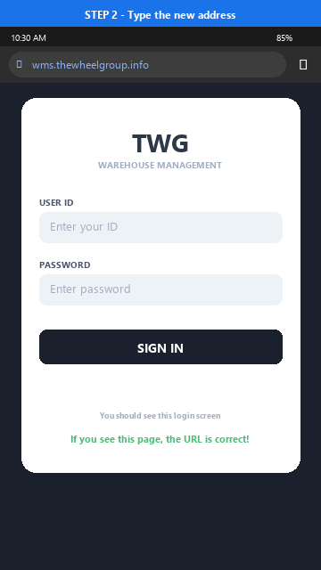
TIP: Make sure you see the lock icon (🔒) next to the address. This means the connection is secure.

STEP 3: Open Chrome Menu & Tap "Install app"
While on the login page, tap the three-dot menu button ( ⋮ ) at the top-right corner of Chrome. A menu will drop down. Scroll to bottom and click ‘Add to Home Screen’, then select ‘Install’

STEP 4: Find TWG WMS on Your Home Screen
After installation, a "TWG WMS" icon will appear on your home screen. From now on, just tap this icon to open the Warehouse Management System. You do NOT need to open Chrome first!
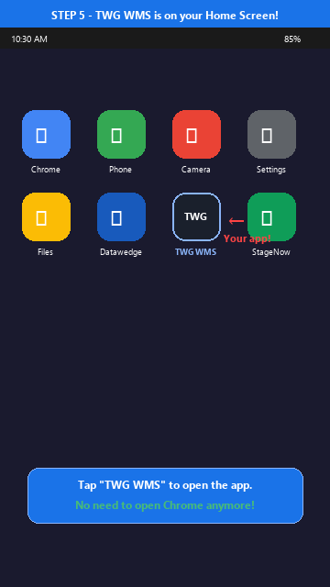
The app opens in fullscreen mode - no address bar, no Chrome buttons. Just like a real app!

QUICK REFERENCE CARD
Cut this out and keep near your workstation
New WMS Address | wms.thewheelgroup.info
How to Open | Tap "TWG WMS" icon on home screen
Login | Use your existing User ID and Password
Connection | Must be on TWG Wi-Fi network
Need Help? | Contact IT Department

