SONARLINT & FINDBUGS REPORT
- Nodejs

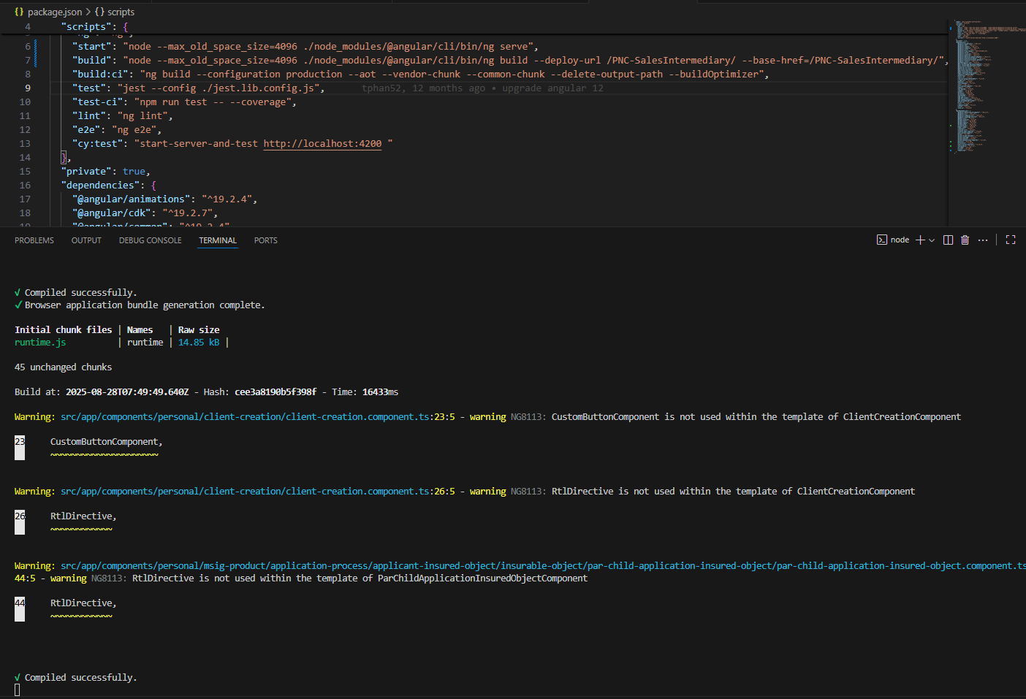

- SONARLINT

