MOP PA1 OSD

As-Is
- Tạo thư mục
export X=1
export EVIDENCE="$HOME/pa1-prelab-$(date +%Y%m%d-%H%M%S)"

mkdir -p "$EVIDENCE"

echo "X=osd.$X"
echo "Evidence=$EVIDENCE"

- As is

ceph -s | tee "$EVIDENCE/01-ceph-s.txt"

ceph health detail \
| tee "$EVIDENCE/02-health-detail.txt"

ceph versions \
| tee "$EVIDENCE/03-versions.txt"

ceph quorum_status -f json-pretty \
> "$EVIDENCE/04-quorum-status.json"

ceph osd tree \
| tee "$EVIDENCE/05-osd-tree.txt"

ceph osd df tree \
| tee "$EVIDENCE/06-osd-df-tree.txt"

ceph osd dump -f json-pretty \
> "$EVIDENCE/07-osd-dump.json"

ceph osd getcrushmap \
> "$EVIDENCE/08-crushmap.bin"

ceph config dump \
> "$EVIDENCE/09-config-dump.txt"
ceph pg ls-by-osd osd.$X \
| tee "$EVIDENCE/10-X-pgs.txt"

ceph pg ls-by-primary osd.$X \
| tee "$EVIDENCE/11-X-primary-pgs.txt"
ceph pg ls-by-osd osd.$X -f json-pretty \
> "$EVIDENCE/12-X-pgs.json"

ceph pg ls-by-primary osd.$X -f json-pretty \
> "$EVIDENCE/13-X-primary-pgs.json"
ceph pg ls-by-osd osd.$X -f json \
| jq -r '.pg_stats[].pgid' \
| while read PG; do
ceph pg map "$PG"
done \
| tee "$EVIDENCE/14-X-pg-mapping.txt"
ceph osd tree \
| tee "$EVIDENCE/15-tree-before-S.txt"

ceph osd dump \
| tee "$EVIDENCE/16-osd-dump-before-S.txt"

ceph osd dump | grep '^flags' \
| tee "$EVIDENCE/17-osd-flags.txt"

ceph osd dump | grep -E 'pg_upmap|pg_temp' \
| tee "$EVIDENCE/18-existing-overrides.txt"

ceph balancer status \
| tee "$EVIDENCE/19-balancer-status.txt"

ceph osd pool autoscale-status \
| tee "$EVIDENCE/20-autoscale-status.txt"

Ok to stop
ceph -s
ceph osd ok-to-stop 1
ceph balancer status
ceph pg ls-by-osd 1
ceph pg ls-by-primary 1
phải để unmanaged: true
tắt balancer
ceph config set osd osd_crush_initial_weight 0
ceph balancer off
ceph balancer status
rồi bắt đầu add osd
additional : phải tắt pg autoscale
ceph osd pool autoscale-status \
> "$EVIDENCE/58-autoscale-before-freeze.txt"
for POOL in $(ceph osd pool ls); do
ceph osd pool set "$POOL" pg_autoscale_mode off
done
ceph osd pool autoscale-status \
> "$EVIDENCE/59-autoscale-after-freeze.txt"
ceph orch daemon add osd ${S_HOST}:${S_DEV} (osd S backup)
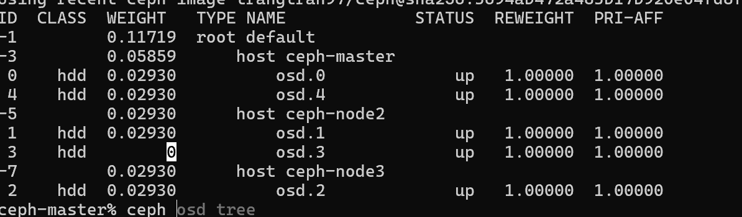
Trả initial
ceph config rm osd osd_crush_initial_weight

as is m1
EVIDENCE=~/pa1-prelab-20260923-090845
ceph -s > "$EVIDENCE/21-after-S-ceph-s.txt"
ceph osd tree > "$EVIDENCE/22-after-S-tree.txt"
ceph osd df tree > "$EVIDENCE/23-after-S-df.txt"
ceph osd dump > "$EVIDENCE/24-after-S-osd-dump.txt"
ceph osd getmap -o "$EVIDENCE/25-osdmap-S-weight0.bin"
ceph osd getcrushmap -o "$EVIDENCE/26-crush-S-weight0.bin"
ceph pg dump pgs > "$EVIDENCE/27-pgs-S-weight0.txt"
ceph pg ls-by-osd $S > "$EVIDENCE/28-S-pgs-weight0.txt"
rồi giờ tạo giả lập mô phỏng với S
ceph osd crush reweight osd.$S 0.0001
cp "$EVIDENCE/25-osdmap-S-weight0.bin" \
"$EVIDENCE/29-osdmap-S-small.bin"
osdmaptool "$EVIDENCE/29-osdmap-S-small.bin" \
--adjust-crush-weight ${S}:0.0001 \
--save
Simulation luôn với weight của 25 29
osdmaptool "$EVIDENCE/25-osdmap-S-weight0.bin" \
--test-map-pgs \
> "$EVIDENCE/30-map-weight0.txt" 2>&1

osdmaptool "$EVIDENCE/29-osdmap-S-small.bin" \
--test-map-pgs \
> "$EVIDENCE/31-map-small.txt" 2>&1

Diff
diff -u \
"$EVIDENCE/30-map-weight0.txt" \
"$EVIDENCE/31-map-small.txt" \
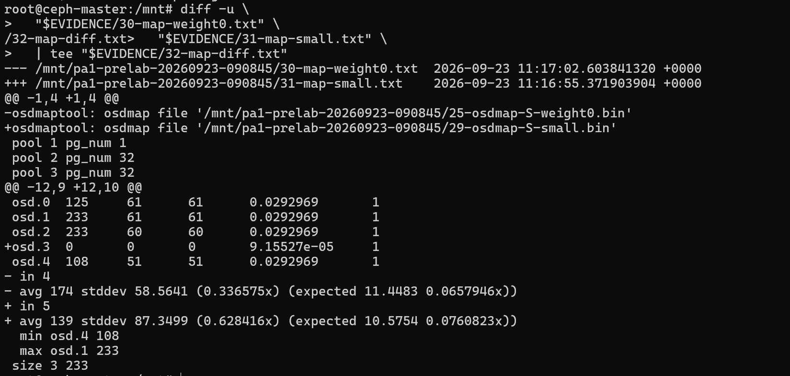
| tee "$EVIDENCE/32-map-diff.txt"

Để weight thành 0.001 để cho Vì `pg-upmap-items` tới một OSD có effective weight bằng 0 có thể bị MON coi là mapping không hợp lệ, S phải có weight dương khi thật sự nhận PG.
ceph osd crush reweight osd.$S 0.0001

đã kiểm tra và chưa được gắn thêm với PG nào
Lưu primary hiện tại:
ceph pg ls-by-primary $X > "$EVIDENCE/33-X-primary-before.txt"
Snapshot trước của bạn cho thấy osd.1 có khá nhiều primary, nên giờ:
ceph osd primary-affinity osd.$X 0
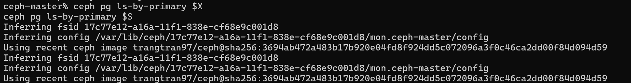
ceph osd primary-affinity osd.$S 0

chụp checkpoint
ceph osd tree > "$EVIDENCE/34-after-primary-affinity-tree.txt"
ceph pg ls-by-primary $X > "$EVIDENCE/35-X-primary-after.txt"
ceph -s > "$EVIDENCE/36-after-primary-affinity-ceph-s.txt"

lưu mapping
ceph pg map $PG \
| tee "$EVIDENCE/37-canary-${PG}-before.txt"

Canary 9.6(least affect one )
ceph osd pg-upmap-items $PG $X $S
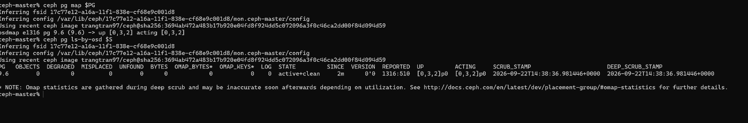

chỉ có mỗi canary PG vừa làm

lưu lại
ceph pg map $PG \
> "$EVIDENCE/38-canary-${PG}-after.txt"

ceph pg ls-by-osd $S \
> "$EVIDENCE/39-S-pgs-after-canary.txt"

ceph -s \
> "$EVIDENCE/40-after-canary-ceph-s.txt"

Lấy toàn bộ PG trên X
ceph pg ls-by-osd $X -f json \
| jq -r '.pg_stats[].pgid' \
> "$EVIDENCE/41-X-all-pgs-to-drain.txt"

wc -l "$EVIDENCE/41-X-all-pgs-to-drain.txt"

giờ drain từng pg theo batch 1
for BATCH in "$EVIDENCE"/batch-*; do
echo
echo "========================================="
echo "Running: $BATCH"
echo "========================================="

while IFS= read -r PG; do
[ -z "$PG" ] && continue

echo "UPMAP $PG : osd.$X -> osd.$S"

ceph osd pg-upmap-items "$PG" "$X" "$S" </dev/null || exit 1
done < "$BATCH"

echo "Waiting for all PGs to become active+clean..."

while :; do
BAD=$(
ceph pg dump pgs_brief -f json 2>/dev/null \
| jq '[.pg_stats[] | select(.state != "active+clean")] | length'
)

echo "PG not active+clean: $BAD"

if [ "$BAD" -eq 0 ]; then
echo "Batch converged."
break
fi

sleep 5
done
done

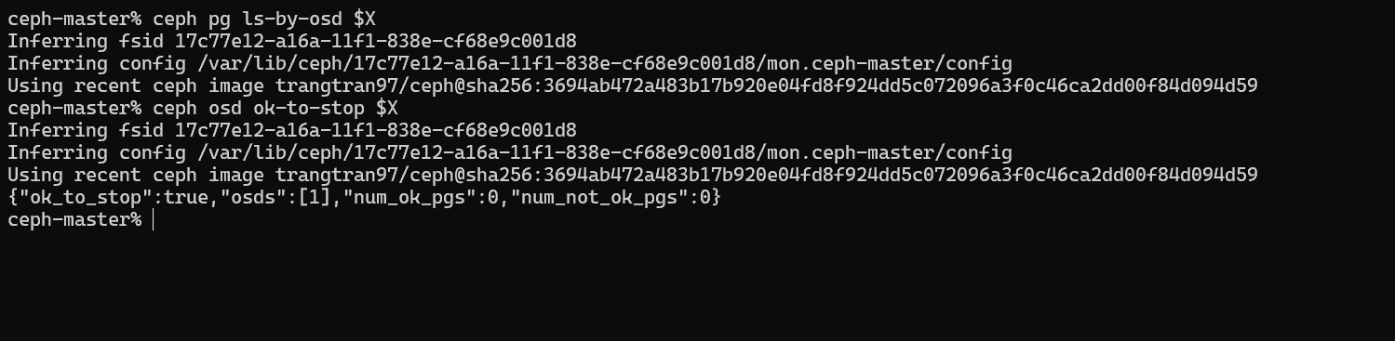
đã hết pg sau khi drain và đã ok-to-stop

A5: nâng đúng osd.$X lên 16.2.15, giữ toàn bộ PG ở S/Y/Z.

Ckpt cuối trước update:
ceph -s > "$EVIDENCE/54-dr-ready-ceph-s.txt"
ceph health detail > "$EVIDENCE/55-dr-ready-health.txt"
ceph pg ls-by-osd $X > "$EVIDENCE/56-X-pgs-before-upgrade.txt"
ceph osd ok-to-stop $X \
> "$EVIDENCE/57-X-ok-to-stop.txt" 2>&1
ceph versions > "$EVIDENCE/58-versions-before-upgrade.txt"

set noout
ceph osd set-group noout osd.$X

kiểm tra daemon hiện tại
ceph orch ps --daemon_type osd --format yaml | less

ceph orch ps --daemon_type osd --format yaml \
> "$EVIDENCE/60-osd-containers-before-X-upgrade.yaml"

ceph versions \
> "$EVIDENCE/61-versions-before-X-upgrade.txt"

ceph pg ls-by-osd $X \
> "$EVIDENCE/62-X-pgs-final-before-upgrade.txt"

Lấy public image:
export TARGET_IMAGE='quay.io/ceph/ceph:v16.2.15'
echo "$TARGET_IMAGE"
osd 1 nằm trên ceph-node2 nên là phải sang ceph node2

pull public image
sudo docker pull quay.io/ceph/ceph:v16.2.15
ceph orch daemon redeploy osd.$X --image "$TARGET_IMAGE"
kiểm tra daemon
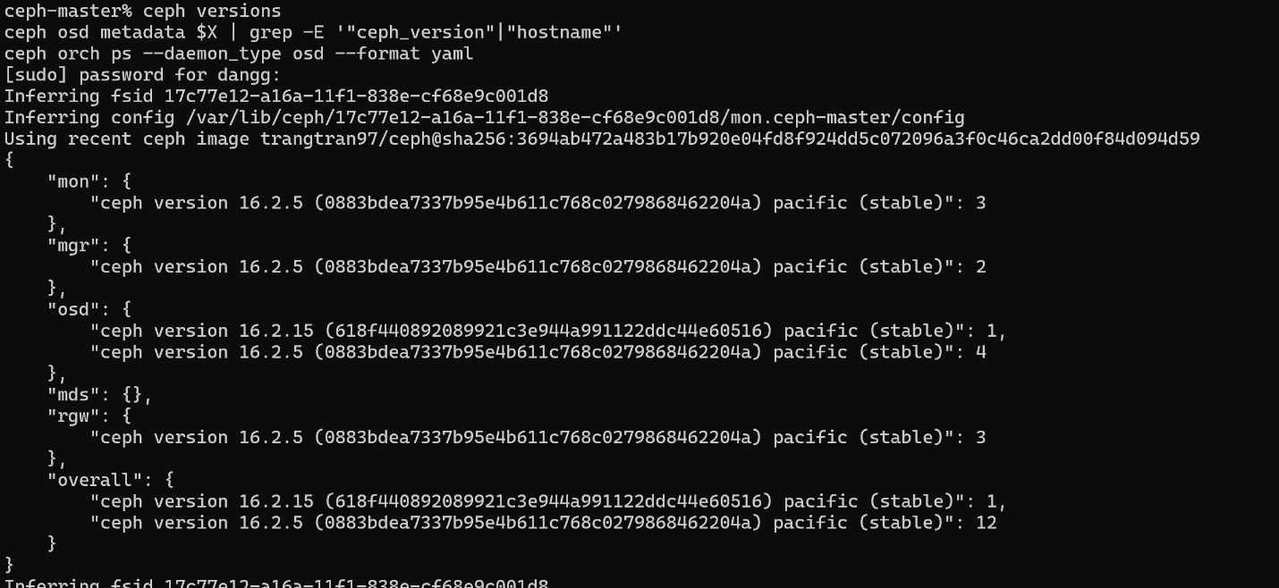
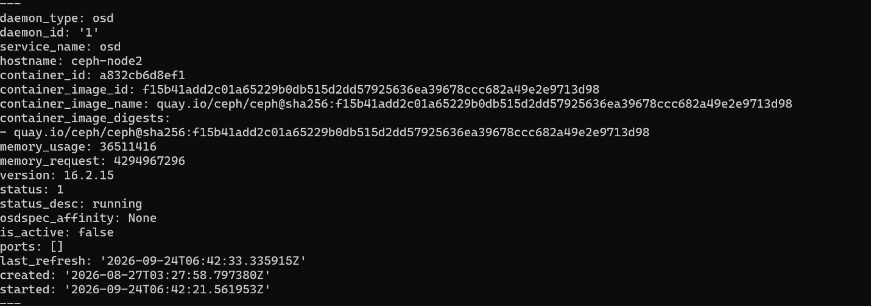
ceph versions ceph osd metadata $X | grep -E '"ceph_version"|"hostname"' ceph orch ps --daemon_type osd --format yaml

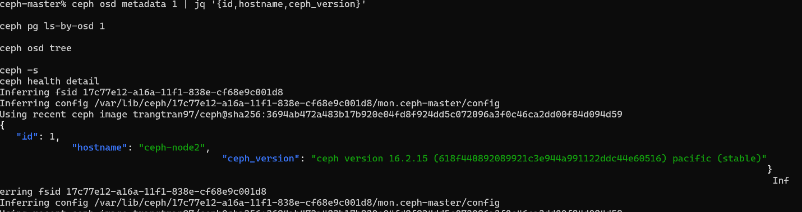
A6
ceph versions \
> "$EVIDENCE/59-versions-after-X-upgrade.txt"

ceph -s \
> "$EVIDENCE/60-after-X-upgrade-ceph-s.txt"

ceph osd tree \
> "$EVIDENCE/61-after-X-upgrade-tree.txt"

ceph pg ls-by-osd $X \
> "$EVIDENCE/62-X-pgs-after-upgrade.txt"

ceph health detail \
> "$EVIDENCE/63-after-X-upgrade-health.txt"

ceph osd rm-pg-upmap-items $PG

đây là để trả lại hết pg về
while IFS= read -r PG; do
[ -z "$PG" ] && continue

echo "RETURN $PG : clear X=$X -> S=$S upmap"

ceph osd rm-pg-upmap-items "$PG" </dev/null || true
done < "$EVIDENCE/41-X-all-pgs-to-drain.txt"

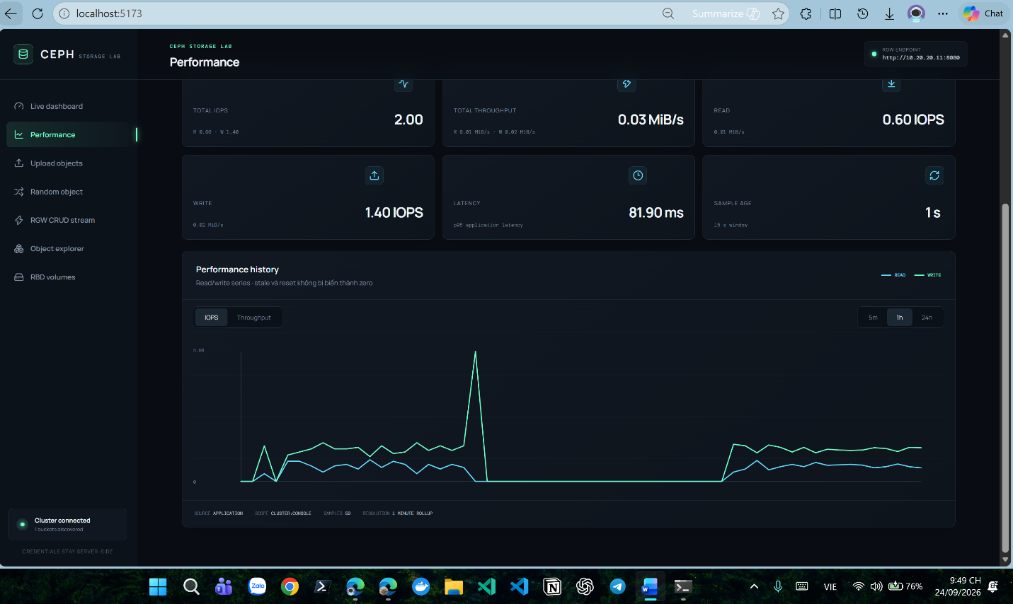
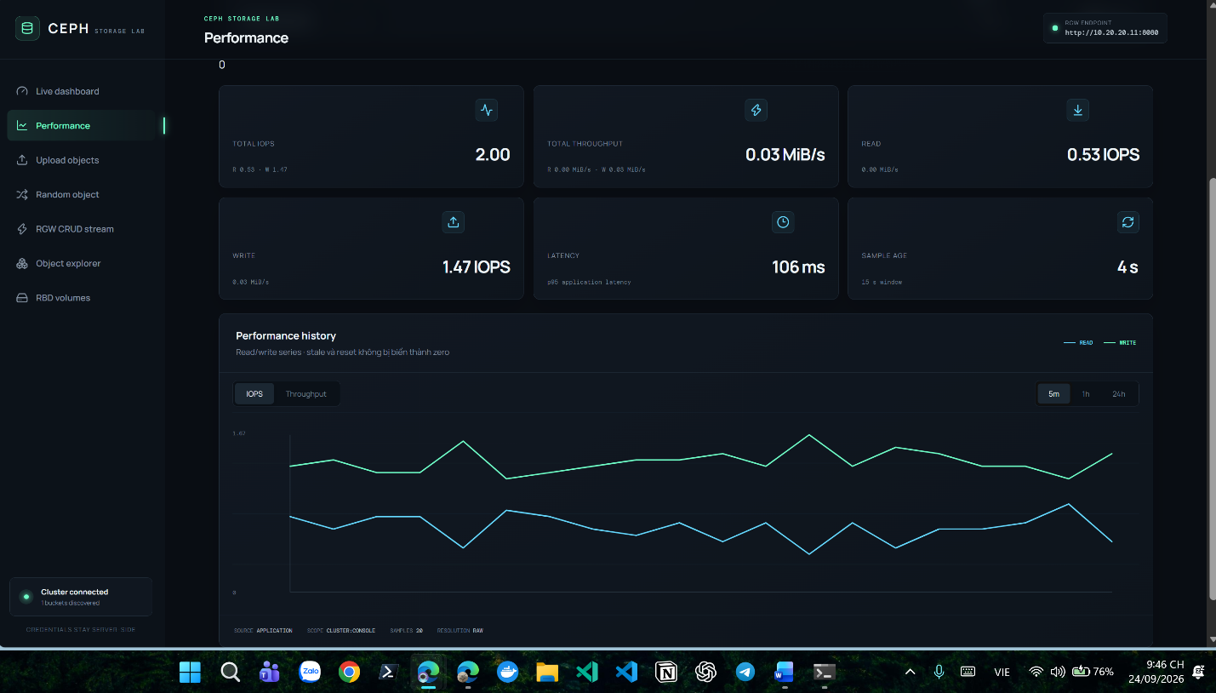

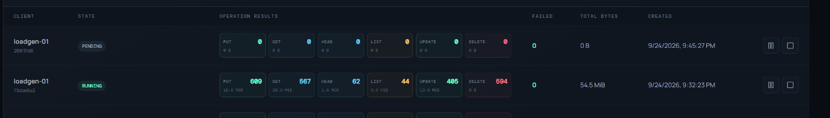
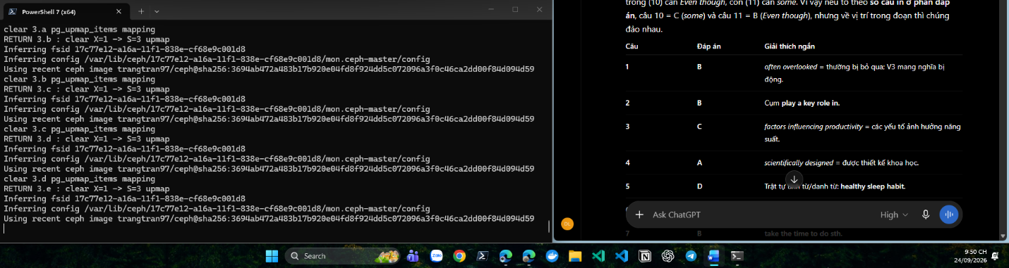
while :; do
BAD=$(
ceph pg dump pgs_brief -f json 2>/dev/null \
| jq '[.pg_stats[] | select(.state != "active+clean")] | length'
)

echo "$(date) PG not active+clean: $BAD"

if [ "$BAD" -eq 0 ]; then
echo "ALL PGs converged."
break
fi

sleep 5
done
check
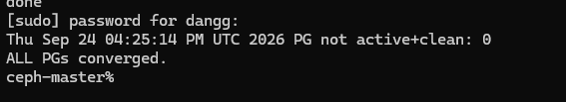

kiểm tra xem là cái upmap còn không
ceph osd dump -f json \
| jq '.pg_upmap_items'

Rétore afinity
ceph osd primary-affinity osd.$X 1

reweight lại về 0 cái S
ceph osd crush reweight osd.$S 0

kiểm tra xem osd S back up còn PG được crush map mới đẩy vào không
ceph pg ls-by-osd $S

set bỏ noout
ceph osd unset-group noout osd.$X

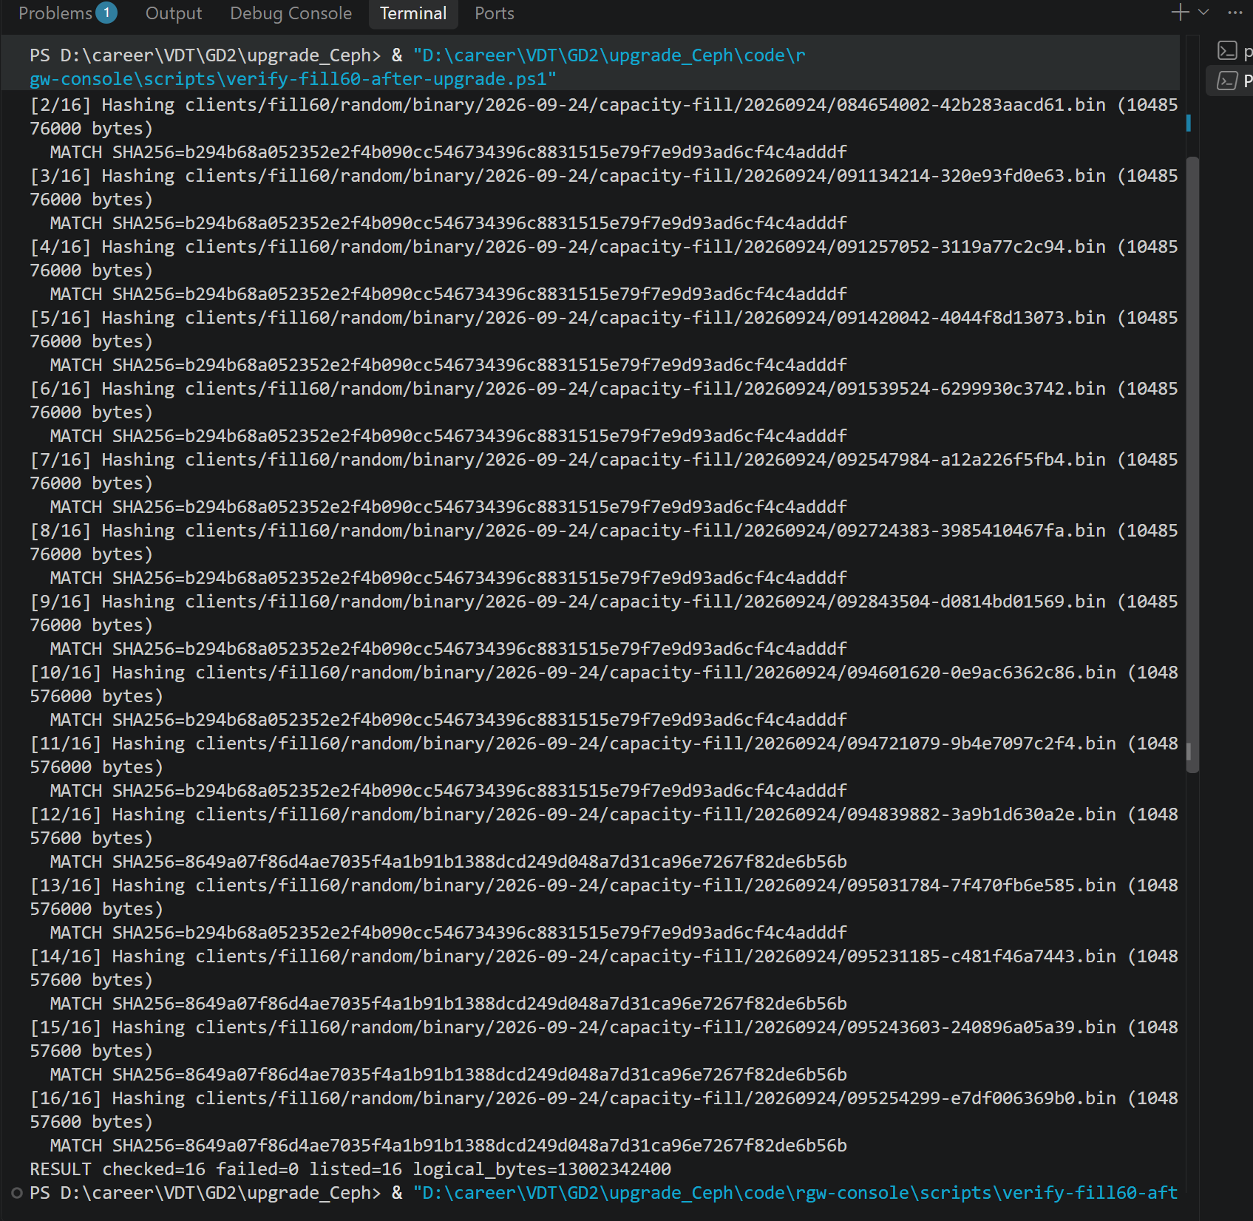
đã checksum lại so với bản gốc bản này là bản sau khi osd X được làm primary

