Dang Truong

ID# 002420309

CSc 3320 Lab4 In-lab assignment

4. This command finds the line from CSC_Course.txt file which contains ‘CSC 3’ text in it.

5. N/A, this command output the lines containing the string either ‘CSC 3’ or ‘CSC 1’.

6. This command output the lines containing the string either ‘CSC 3’ or ‘CSC 1’.

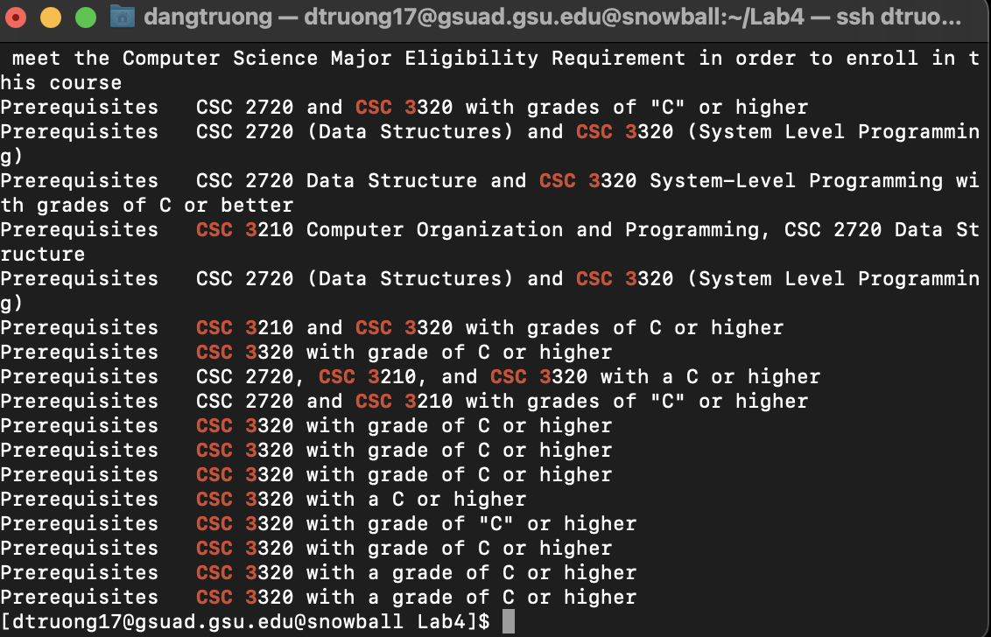

7. This command searches for those two strings CSC 3 or CSC 1in the file and return the matching characters.

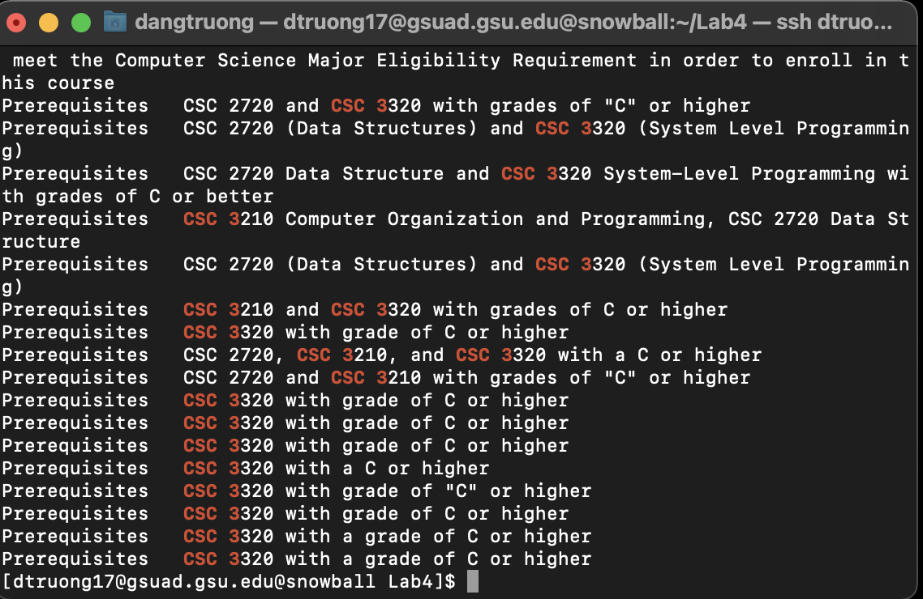

8. N/A, this command output the lines containing the string ‘3.000 Credit hours’. Fgrep is the same as grep –f.

9. N/A, this command output the lines matching the entire string ‘3.000 Credit hours’.

10. This command finds the line from the CSC_Course.txt with ‘CSC’ and end with ‘PROGRAMMING’ with any between.

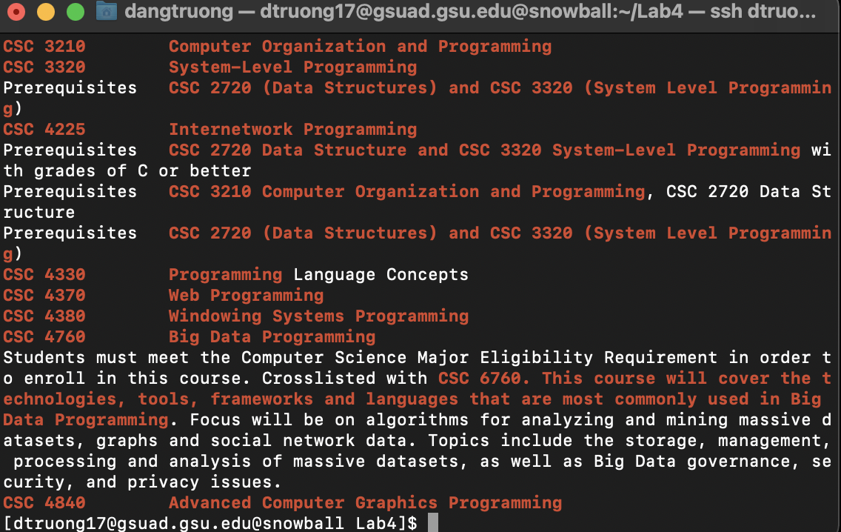

11. This command find the line from the CSC_Course.txt start with ‘CSC’ and end with “PROGRAMMING’ with anything in between.

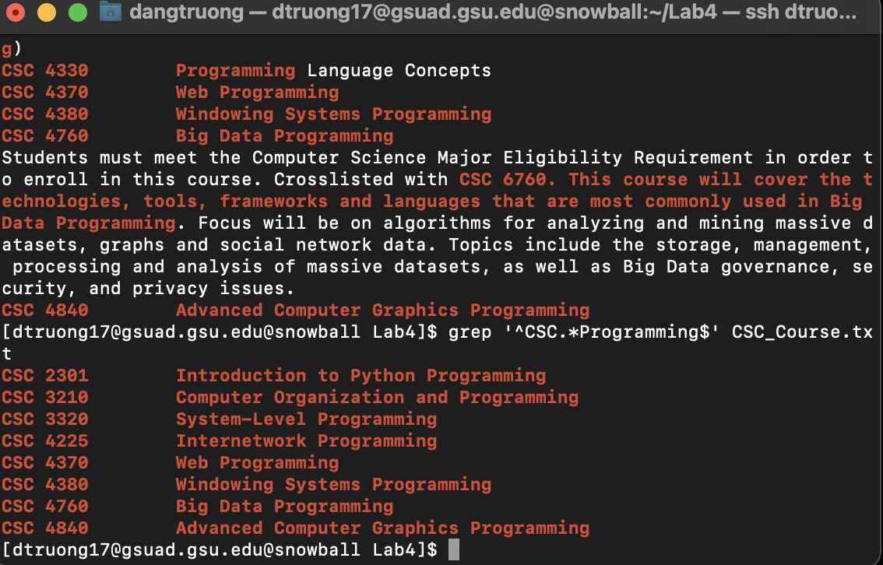

12. N/A, this command output the lines with highlighted matching words, and it outputs the lines with substring starting with ‘CSC’ and except ‘3’ after ‘CSC’ and end the line with ‘3’ two times.

13. This command output the lines with highlighted matching words, and it outputs the lines having exact string starting with ‘CSC’ and except ‘3’ after ‘CSC’ and end with ‘3’ two times then except ‘3’.

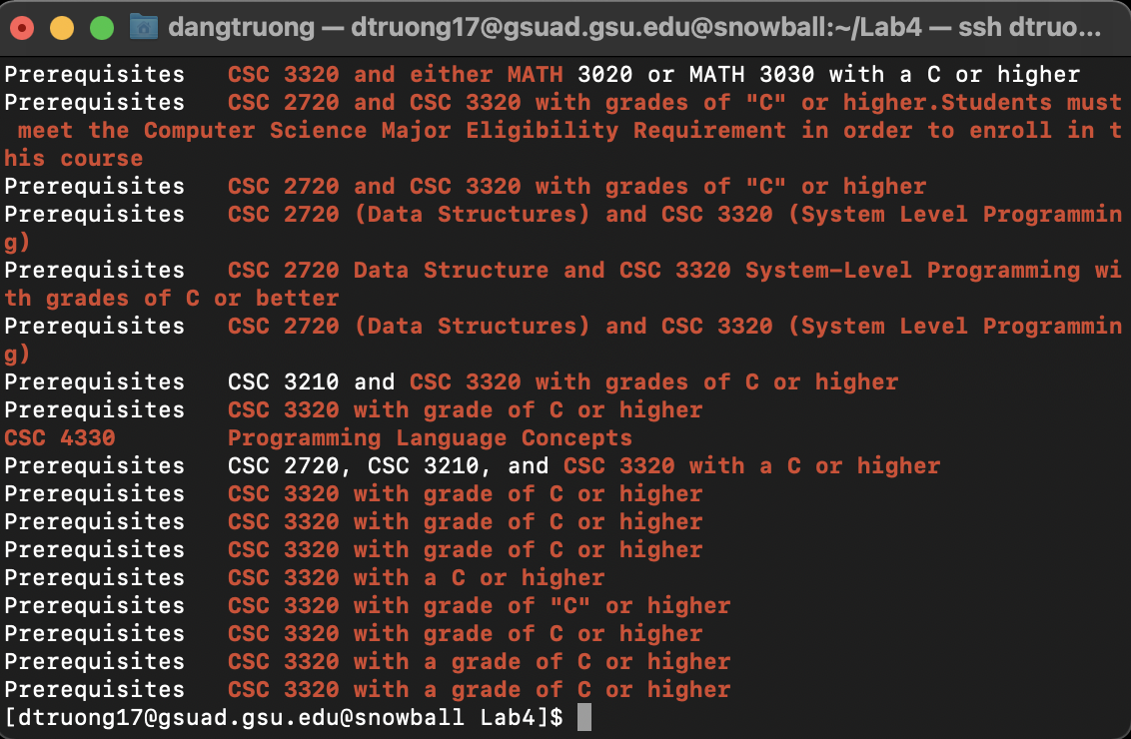

14. N/A, this command returns the line which starts with ‘CSC’ and ends with ‘C++’ in the file.

15. N/A, this command outputs the line containing the string starting with ‘CSC’ and ends with ‘C++’.

16. This command output the line containing the string with ‘CSC’ and ends with ‘C++’.

